PROGRAMME ANNUAL PROGRESS REPORT
Period: 1 January – 31 December 2020

Project Name | Building Inclusive and Accountable Parliaments for a Peaceful Somalia (PSP-II)  Project/Output Number: 00099031/ 00102267
Gateway ID | 00113070
Start date | 01 January 2018
Planned end date  (as per last approval) | 31 December 2021
Focal Person | (Name): Dragan Popovic; Abdullahi Ibrahim Ali
 | (Email): dragan.popovic@undp.org; abdullahi.ibrahim.ali@undp.org
 | (Tel): +252619869413
Participating UN entities | UNDP, UNSOM (PAMG)
NDP Pillar | PWG Pillar 1: Inclusive Politics: Achieve a stable and peaceful federal Somalia through inclusive political processes and effective decentralization
UNSF Strategic Priority | Deepening federalism and state-building, supporting conflict resolution and reconciliation, & preparing for universal elections
Location(s) | Federal; Somaliland; Puntland, Galmudug, Jubaland, Southwest, and Hirshabelle states
Gender Marker | 2

Total Budget as per ProDoc | 20,018,656
MPTF: | 2,508,632.61
Non-MPTF sources: | PBF:
 | Trac: 3,253,068
 | Other:

 | PUNO | Report approved by: | Position/Title | Signature
1. | PWG-1  UNDP | Jacqueline Olweya | Resident Representative, OIC

Total MPTF Funds Received |  |  |  | Total non-MPTF Funds Received
PUNO | Semi Annual 2020 | Cumulative | Annual 2020 | Semi Annual 2020 | Cumulative | Annual 2020
 | 1 July - 31 Dec 2020 | From prog. start date | 1 Jan – 31 Dec 2020 | 1 July - 31 Dec 2020 | From prog. start date | 1 Jan – 31 Dec 2020
UNDP | 0 | 2,508,632.61 | 0 | 400,000 | 3,253,068 | 1,400,000

JP Expenditure of MPTF Funds |  |  |  | JP Expenditure of non-MPTF Funds
PUNO | Semi Annual 2020 | Cumulative | Annual 2020 | Semi Annual 2020 | Cumulative | Annual 2020
 | 1 July - 31 Dec 2020 | From prog. start date-31 Dec 2020 | 1 Jan – 31 Dec 2020 | 1 July - 31 Dec 2020 | From prog. start date | 1 Jan – 31 Dec 2020
UNDP | 143,659.44 | 2,481,697.57 | 397,023.86 | 939,810.05 | 3,080,042.78 | 1,226,973.55

ANNUAL HIGHLIGHTS

- Electoral bill was signed into law and received the presidential assent on 21st February 2020.
- After provision of communication technology (zoom subscriptions and VTC sets) and technical assistance to amend Joint Rules of Procedures, the Federal Parliament (FP) is fully enabled to host virtual sessions, cognizant of COVID-19.
- Public Consultations were organized in Mogadishu, HirShabelle, Galmadug and South West State to collect the opinions and views of the states’ institutions, leadership, civil society and citizenry on the constitutional review. Moreover, Hirshballe, Galmudug and South West States and the Banadir Regional Administration provided their official comments on the Constitution, which together with outcomes of the consultations resulted in the drafting of the 3rd version of the Provisional Constitution.
- Technical support to establish the Second Parliament of South West State, resulted in a fully functional SWS Parliament.
- The proceedings of Puntland Parliament are being aired on Puntland TV reaching out to more than 20000 people per a session, ensuring engagement of people and transparency of parliamentary sessions.
- Needs assessment of the Jubaland, South West, Galmudug and Hirshabelle Parliaments was completed, and results are being integrated in the 2021 plans and the new programming process rolling out the UNDP Country Programme Document (2021 – 2025).
- The Joint Parliamentary Oversight Committee (OC) has completed the second review of the Provisional Constitution and released the 3rd draft of the Constitution for further consultation and debate.
- Somaliland and Puntland parliaments were supported to conduct oversight missions to a number of districts to reach out to their communities and constituencies.
HIGHLIGHTS OF KEY ACHIEVEMENTS

- President Mohamed Abdullahi Farmajo signed the Electoral Bill into law paving the way for the country to hold its first one-person-one-vote election in half a century. Following the endorsement of the Electoral Law, a Joint Parliamentary Ad Hoc Committee was established to provide recommendations on the implementation of the Law.
- Communication technology (zoom subscriptions and VTC sets) provided to the Federal Parliament to ensure hosting of virtual sessions and voting. The technology has been integrated with the VTC system and tested. Plenary halls of both houses and all committees are fully functional. Technical support to amend Joint Rules of Procedures, cognizant of COVID-19, has been provided and amendments have been drafted and submitted to the Speakers.
- Technical Advisory support was provided to OC, Ministry of Constitutional Affairs (MOCA) and the Independent Constitution Review and Implementation Commission (ICRIC) to organize consultations in Mogadishu, Hirshabelle, Galmadug and South West State, with institutional and political role players, civil society and citizenry. A total number of 2,169 Somalis participated in the consultations (Galmudug - W:234; M: 796; Southwest - W: 187; M: 454; Hirshabelle: W: 139; M: 359). The consultations resulted in drafting of the 3rd version of the Constitution, that is currently being analyzed to ensure quality and its compliance with human rights conventions.
- Based on the direct request from the President of South West State H.E. Abdiaziz Hassan Mohamed, the project coordinated with UNSOM and the House of the People of the Federal Parliament to support the establishment of the Second Parliament of the SW State. Based on the technical assistance provided, the 95 MPs (M:79 W:16) of the SWS Parliament have been selected and the Second SWS Parliament is fully functional.
- Induction and committee chairs workshops for the new MPs from Galmudug, Jubbaland, Hirshabelle and Southwest State Assemblies (M:276, W:19) were organized and the MPs are equipped with basic knowledge about Parliamentary processes, practices, and procedures, ensuring the new MPs to fulfill their tasks.
- UNDP support resulted in live broadcasting of the proceedings of the Puntland Parliament on the Puntland TV, which enables citizens to directly engage and monitor work of the Parliament.
- Institutional and capacity needs assessment of Jubaland, Galmudug, Hirshabelle and Southwest Parliaments was completed to further enhance their capacities to deliver on their mandates. 150 respondents (M 124; W 26) were interviewed including the leadership of HoRs, parliamentary staff and MPs.
- UNDP has provided operational support to oversight missions where Puntland HoR conducted oversight Mission to Bari, Nugaal, Karkaar, & Sool Regions of Puntland State of Somalia whereas Somaliland House of Elders committees conducted oversight mission to Maroodi Jeex,Togdheer, Sanag and Awdal regions. The aim of the constituency visits was to assess the situation of the regions and stay in touch with the communities.
SITUATION UPDATE

The Federal Parliament (FP) recessed in mid-February 2020. Due to outbreak of COVID-19 pandemic, the Parliament could not reconvene, as initially planned, on 20 April 2020. The seventh session of the Federal Parliament was officially opened by the President of the Federal Republic of Somalia H.E. Mohamed Abdullahi Mohamed “Farmaajo” on 27 June 2020. The opening ceremony was held at the plenary hall of the House of the People in Villa Hargeisa and was attended by the Speakers and the Deputy Speakers of both Houses of the FP, the Prime Minister, and Members of both Houses of the FP. In their remarks, both Speakers of the Houses of the Federal Parliament stated the achievements of the previous session highlighting priorities for the second part of the year including the approval of special rules of procedure for the adoption of the revised Constitution. Nevertheless, the second part of 2020 was marked by continuous tension between the Speakers of the two Houses of the FP and their relationship remained a challenge.

On 17 September, the leaders of the Federal Government of Somalia (FGS) and all five Federal Member States (FMS) agreed on an indirect electoral model for the country’s upcoming polls. Building on a series of discussions in Dhusamareb in July and August, the model was approved by the Federal Parliament in September 2020.

The FP gave a vote of no-confidence to the Prime Minister Hassan Ali Khaire on 25th July 2020. 170 MPs backed the no-confidence motion, and the removal was endorsed by President Mohamed Abdullahi Farmajo. In September, the Members of the House of the People gave unanimously a vote of confidence to the appointed Prime Minister HE Mohamed Hussein Roble. 215 MPs attended the sitting. The new PM stressed that priorities of his government will be security, elections, economic and social services development, good governance and the fight against corruption, justice reform, constitutional review, reconciliation and international cooperation.

In December 2020, the Speaker of the House of the People Mohamed Mursal, chairing the 8th session of the HoP announced that the 10th parliament would remain in office until the 11th parliament is sworn in, in order to avoid constitutional gap, as required by Article 60 of the Provisional Constitution. Going forward, it is of key importance to ensure that the 11th Parliament picks up where the 10th left off therefore the FP needs political and technical support to secure a smooth transition, safeguarding achieved results, such as those related to the constitutional review process. This will include supporting the dialogue on the remaining, politically challenging, issues among others.

SEMI-ANNUAL & ANNUAL PROGRESS REPORT RESULTS MATRIX
OUTCOME STATEMENT
SOMALI WOMAN AND MEN, GIRLS AND BOYS BENEFIT FROM MORE INCLUSIVE, EQUITABLE AND ACCOUNTABLE GOVERNANCE, IMPROVED SERVICES, HUMAN SECURITY, ACCESS TO JUSTICE AND HUMAN RIGHTS.
SUB-OUTCOME 1 STATEMENT

Output 1: House of the Peoples and Upper House capacities and structures become effective and representative institutions that promote transparency, inclusion and participation in the political process.

INDICATOR | TARGET | PROGRESS ON OUTPUT INDICATOR
 |  | REPORTING PERIOD | CUMULATIVE  Y1+ Y2 +Y3
OP indicator 1.1: # of laws debated | 1.1: 3 laws debated. | 21 | 40
OP indicator 1.2: # of public hearings held. | 1.2: 3 public hearing organized with participation of civil society, executive and media. | 28 | 36
OP indicator 1.3: # of committees with approved work plans. | 1.3. 6 committees with work plans adopted. | 2 | 3
OP indicator 1.4: % of MPs satisfied with training received. | 1.4: At least 70% of MP are satisfied with the trainings received. | 0 | 80%
UNDP ONLY: sources of evidence (as per current QPR)
Output 2: The new federal network of legislatures and assemblies is strengthened processes.
OP indicator 2.1: Speakers’ forum institutionalized. | 2.1: Speakers’ forum regularized in the SOPs of all  parliaments. | 0 | 0
OP indicator 2.2: Coordination mechanism between states and upper house established. | 2.2: Coordination mechanism  between the states and the  upper house developed. | 0 | 0
UNDP ONLY: sources of evidence (as per current QPR)
Output 3: Capacities and structures of the Emerging State Assemblies are strengthened in support of peacebuilding, state-building, federalism, and development.
OP indicator 3.1: Outreach strategy implemented in # of regions. | 3.1: continued outreach visits and joint missions with civil society conducted in 3 regions. | 0 | 1
OP indicator 3.2: # of committees with approved work plans. | 3.2: Review and evaluation of the implementation of the work plans. | 0 | 0
OP indicator 3.3: # of MPs satisfied with the training received. | 3.3: At least 80% MPs satisfied with the training received. | 100% | 100%
OP indicator 3.4: Coherent legislative roles at state level regularized | 3.4: A regulatory framework  Developed | 0 | 0
UNDP ONLY: sources of evidence (as per current QPR)
Output 4: Capacities and structures of Somaliland and Puntland Parliaments are strengthened in support of peacebuilding, state-building, federalism and development.
OP indicator 4.1: Outreach strategy is implemented in SL and PL | 4.1: continued outreach visits and joint missions with  civil society conducted in both regions. | 4 | 6
OP indicator 4.2: # of committees with approved work plans. | 4.2: Review and evaluation of the implementation of the work plans. | 0 | 0
OP indicator 4.3: # of MPs satisfied with the training received. | 4.3.: At least 80% MPs satisfied with the training received. | 0 | 80%
OP indicator 4.4: Coherent legislative roles at state level regularized for PL. | 4.4: A regulatory framework developed | 1 | 1
UNDP ONLY: sources of evidence (as per current QPR)
Output 5: Various assemblies engage with and respond to the needs of civil society, including the marginalized groups.
OP indicator 5.1: Strategic partnership established between civil society and parliaments. | 5.1: Strategic partnership  Frameworks adopted by parliaments and selected CSOs in NF and two Regional assemblies | 0 | 0
OP indicator 5.2: # of regions with youth and women’s caucus. | 5.2: Network of women’s and  youth caucus established  between at least 3 regions. | 0 | 0
OP indicator 5.3: # of legislation with inputs from civil society (including vulnerable and marginalized groups) submitted before the parliament. | 5.3: At least Curriculum  developed on engagement of  the civil society in legislation | 0 | 0
UNDP ONLY: sources of evidence (as per current QPR)
Output 6: Implementation of SDG 16 enhanced in Somalia through strengthened capacities for dialogue, research, and analysis.
OP indicator 6.1: # of outreach and analytical reports on NDP and SDG 16 produced by the parliament. | 6.1: At least 1 analytical report on NDP and SDG 16 produced. | 0 | 1
OP indicator 6.2: % of youth and women with positive perceptions the inclusivity in parliamentary processes. | 6.2: Survey conducted | 0 | 0
UNDP ONLY: sources of evidence (as per current QPR)

NARRATIVE

Output 1: House of the Peoples and Upper House capacities and structures become effective and representative institutions that promote transparency, inclusion, and participation in political processes.

Establishment of the Parliamentary Ad-Hoc Committee to provide recommendations on the implementation of the Electoral Law
Following the presidential assent to the Electoral law on 20th February, the Federal Parliament appointed a Joint Parliamentary Ad Hoc Committee to provide recommendation on smooth implementation of the Law. The Ad-Hoc Committee successfully prepared the pieces of legislation related to realization of the Electoral Law which has been tabled and later adopted by the House of the People. Below is the selection of the recommendations provided by the Joint Ad Hoc Committee:
- To ensure that 24% of the seats of the 10th Parliament, currently occupied by women MPs, is reserved for the women candidates who will be elected in the 11th Parliament.
- To ensure representation of Banadir in the Upper House of the Somali Federal Parliament
- To hold elections of the members of both Houses of the Somali Federal Parliament from Somaliland in Mogadishu
- To retain the proposed allocation of seats for the upcoming elections 2020/2021.

Completion of the technical review of the Provisional Constitution
OC and ICRIC have completed the second revised text of the Provisional Constitution in January 2020. The review board consisted of OC, ICRIC and the parliamentary committees from five Federal Member States, Hirshabelle, Galmudug, Jubaland, Puntland and Southwest. The second revised text of the Constitution was submitted to the President of Somalia, the Prime Minister, the Speakers of both Houses of the Federal Parliament, presidents of the Federal Member States and Governor of Benadir Regional Administration aiming to get feedback on the recommended amendments. Subsequently, FGS working sessions and two rounds of consultations have been organized in Banadir Region and Galmudug, Hirshabelle and South West States, resulting in drafting of the 3rd revised version of the Constitution, which are currently being translated and analyzed.

OC, MOCA and ICRIC organized consultations on the Provisional Constitution
In January 2020 the UNDP and UNSOM supported MOCA, OC and ICRIC to develop a Master Plan to complete the constitutional review process by June 2020, in line with Mutual Accountability Framework (MAF). As mentioned, MOCA, OC and ICRIC submitted the second revised version of the Provisional Constitution to Somali leaders and this version of the Constitution became the base for the consultations that were subsequently initiated at the federal and the state levels. During February 2020 MOCA, supported by MOIFAR, organized the FGS Inter-Ministerial Meetings with the purpose to get the FGS perspective on the constitutional review process and allow the FGS Ministries to find the common ground before the Cabinet Retreat. The sessions were well attended with participation of the line ministers and their technical teams, supported by experts from UN, WB and other international organizations. 700 participants (W: 118; M: 582) attended the discussions. As a result of the consultations, MoCA and MOIFAR developed various proposals with line-Ministries on power sharing and resource allocation issues.

Upon organization of the meetings with the FGS ministries, MOCA, OC and ICRIC initiated consultations with the FMS, to obtain their position on the revised constitution and secure inclusivity, ownership and buy-in. These consultations should have been organized in two phases and they were organized in the Banadir Region, Hirshabelle, Galmudug and the South West States. During the first round of consultations MOCA, OC and ICIRC handed over the reviewed chapters of the Provisional Constitution to the states’ administrations and requested for their inputs. Due to outbreak of pandemic and political impasse the second round of consultations have been organized in October and November 2020 allowing the state administrations to provide their opinion and options on the revised Constitution. The consultations gathered relevant representatives of the institutions of the government, as well as civil society and all the societal groups, including women and youth organizations and activists, think-thanks, tribal and religious leaders etc. Subsequently, MOCA, OC and ICIRC organized the inter-regional conference with the purpose to agree on further amendments of the articles, which resulted in drafting of the 3rd revised version of the Constitution that consists of 16 chapters, 157 articles and appendixes. The 3rd version of the constitution is being translated and will be analysed once the translation is completed. 2,169 Somalis participated in the consultations (Galmudug - W:234; M: 796; Southwest - W: 187; M: 454; Hirshabelle: W: 139; M: 359).

The three entities could not organize consultations in Puntland and Jubaland due to political dynamics between Puntland and Jubaland and the FGS.

Human rights compliance and audit of the Provisional Constitution
The project team supported OC and ICRIC to undertake an audit of the constitutional draft, based on the recommendations from the Istanbul retreat, that has been organized in November 2019 by Max Planck Foundation. Of 157 reviewed articles, it was concluded that only 18 articles required political negotiations. These articles refer to:
- The organization of the Federal State including:
  - The allocation of powers between the different levels of government,
  - Fiscal Federalism and Resource sharing,
  - Security Architecture, and
  - The status of Mogadishu.
- The structure of the Executive,
- The structure of the Legislative, and
- Justice and Corrections Model.

According to MOCA, OC and ICRIC, all the other articles are of technical nature and they refer (i) to the articles that are purely technical in nature (around 50.5%) and amendments here relate to the improvement of the language of the text and should not require a prolonged debate; then (ii) articles referring to the formalization of the federal member states; (iii) articles referring to the finance provisions that make it possible to transfer funds from the federal to the member states; and (iv) articles that refer to the establishment of the inter-governmental relations structure.

In coordination with other UN agencies, UNDP completed analysis of the second revised version of the Constitution for compliance with international human rights conventions. A matter of major concern raised by the international community, UN and some Somali institutions and civil society organizations was the age of maturity: article 29 of the Provisional Constitution defined a child as a person under 18 years of age, whereas the reviewed article 28 defined it as a person under 15 years of age. Upon receiving the analysis, MOCA, OC and ICRIC expressed their full commitment to the requirement to ensure compliance of the federal Constitution with international Somalia obligations.

Adoption of the proposed amendments of the Provisional Constitution
The Federal Government committed itself in the 2019 MAF to adopting the reviewed Constitution by December 2019. This date was later shifted to June 2020. However, political dynamic in the country and outbreak of the pandemic have delayed realization of this timeline too. Namely, the Federal Parliament went into recess at mid-February. In March 2020 global COVID-19 pandemic was announced, which disrupted operations of the Parliament that reconvened on 6 June 2020, while the first session was held on 27 June. The second part of 2020 has been marked by continuous tension between the Speakers of the two houses of the FP, which continued until the end of the year that impacted the project implementation. The tri-entities, MOCA, OC and ICRIC have had regular meetings with the Speakers of both houses of the Federal Parliament obtaining the approval for the technical constitutional review plan and on different occasions met with the President Faarmajo and the Prime Minister, Mohamed Hussein Roble, to ensure support for the finalize the constitutional review process. After adoption of the 10-point strategy for taking forward the Constitutional Review Process MOCA, OC and ICRIC, the UN and international partners tried to provide additional push to safeguard the gains made thus far following inclusive dialogue and consensus building between the FGS, the FMS and citizenry. However, it became clear in late November 2020 that political impasse between the Federal Government and Puntland and Jubaland will not be resolved whose leadership decided not to engage in the process with the current FGS due to various issues, that has been also confirmed at the Somalia Partnership Forum held on 7 December 2020, which made it unlikely to have any article tabled before 31 December 2020 for adoption.

Still, OC developed Rules of Procedures for the adoption of the proposed amendments of the Constitution and submitted them to the Federal Parliament’s joint session that has gone through the first reading. The purpose of the Rules of Procedures is to pave the way for the Somali Federal Parliament to start the debate on the amendments of the Provisional Constitution and adopt the reviewed Constitution. As mentioned, the President Faarmajo issued a decree on 24 December deferring review of the Constitution and the procedure of approving the Constitution and adoption of the Constitution to the 11th Parliament.

Support to ensure continuity of the Federal Parliament
Based on the direct request from the Federal Parliament, UNDP in coordination with UNSOM and WB provided zoom subscriptions and VTC sets to the both houses of the Federal Parliament and provided necessary guidance and trainings to the ICT Unit of the Parliament. Provided technology enabled the Federal Parliament to host virtual sessions and voting. In addition, informed by experiences from other countries, UNDP and UNSOM technically supported the FP to draft amendments of the Joint Rules of Procedures, enabling both houses of the FP to function in light of COVID-19. The Amendments are now under consideration of the Speakers and the relevant committees. After provision of the support the Federal Parliament is fully equipped and enabled to host virtual sessions.

Cabinet Retreat of the Federal Government of Somalia
From November 3-5, the project supported 3 days Cabinet Retreat of the Federal Government of Somalia. The Retreat which brought together H.E the Prime Minister, H.E the Deputy Prime Minister and the other 69 Cabinet members together with senior officials in the Office of the Prime Minister and line ministries. In addition, The Speaker of the of the House of the People of the Somali Federal Parliament also attended the event as a guest speaker in order to highlight the importance of congenial working relations between the Legislative and Executive branches of the government.

The retreat centered around three major items, namely: (i) Understanding the rules and regulations of the Council of Ministers; (ii) Committing to the 100 Day Government Programme primarily focused on holding the 2020-2021 elections and understanding key activities required for its implementation; and (iii) Implementing the Government Programme and the priorities of the Ministries.

The Retreat also discussed ongoing government programmes; challenges in implementation of national development priorities. One of the main outcomes was the agreement and signing of commitments by line ministries on specific deliverables within the next 100 days to implement the government's programmes.

Output 3. Capacities and structures of the Emerging State Assemblies are strengthened in support of peacebuilding, state-building, federalism and development

Training for SWS Technical Committee
On 10th February, the president of SWS of Somalia has appointed a technical committee consisting of 11 individuals (3 females, 8 males) to lead the selection process of the members of the second SWS Parliament, after the term of the sitting Parliament has ended. Following the request of SWS leaders, the House of the People of the FP in partnership with USOM and UNDP have selected technical advisors to assist and train SWS Technical Committee on the management of the selection process, voting and dispute resolution. A part of the trainings provided was dedicated to advocate for women political participation to ensure 20% quota, following the SWS Constitution. The training took place between 22nd – 29th February 20120 in Baidoa with 62 participants (2 females and 60 males). As a result of this support, the Technical Committee successfully managed to select the members of the second SWS Parliament. The SWS Parliament is fully operational.

Induction and Committee Chairs workshops to the new MPs of Galmudug, Hirshablle, Jubaland and Southwest
During the reporting period, the capacities of the new MPs of the second Parliaments of Galmudug, Hirshabelle, Jubaland and Southwest have been enhanced through the delivery of series of induction workshops on parliamentary processes, functions, roles and organization. A total number of 359 MPs (M:318; W:40) have received the training.

Induction trainings were delivered in Kismayo from 2nd-3rd November 2020 for the MPs of the Jubaland State Parliament (M: 63; W:7). Similar trainings were conducted for the MPs of the South West State Parliament (M:64 ; W:9) in Baidoa between 18th-19th November 2020, the MPs of the Galmudug State Parliament (M:50; W:5) in Mogadishu between 28th -29th November 2020, and the MPs of the Hirshabelle State Parliament (M:49; W:1) in Mogadishu between 13th -16th December 2020.

Following the induction workshops, specialized training on the effective functioning of parliamentary committees targeting committee chairs, deputy chairs and secretaries was delivered to the parliaments of Jubaland, South west and Galmudug. The trainings were conducted for in Kismayo for Jubaland MPs (M:41; W:7)on the 4th-5th November 2020; in Baidoa for South west MPs (M:28; W:6)on 21st-22nd and Lastly for Galmudug MPs (M:24; W:5) in Mogadishu on 30th November-1st December 2020.
The training topics contributed towards enhancing the knowledge of MPs on legislative and oversight functions, representation and accountability, Parliamentary etiquettes, immunities and privileges of the MPs, functions and powers of Parliamentary Committees, Committee management and other related functions and roles of the Parliament. These trainings are of key importance because great majority the MPs do not understand tasks and roles of the Parliament. The follow up trainings will be organized in coordination between UNDP and the FMS Parliaments, based on their particular needs to enable new MPs to further enhance their capacities to deliver on their mandates.

Jubaland
Jubbaland TV - Posts | Facebook
Jubbaland TV - Posts | Facebook

Southwest
https://www.facebook.com/kgstvOfficial/videos/362152161523430/
https://youtu.be/_o6Pep5W2Ao
Galmudug
https://fb.watch/2dX5KJTVkZ/
https://www.facebook.com/141754373155250/posts/715442145786467/?sfnsn=mo
Aqoon isweydarsi ku sabsan howlaha Baarlamaanka oo Muqdisho loogu qabtay Xildhibaanada Galmudug. - YouTube
Hirshabelle
Dalsan TV - Posts | Facebook
Seminaar Muqdisho looga furay xildhibaanada Baarlamaanka Hirshabeelle. - YouTube

Institutional and capacity needs assessment of Galmudug, Hirshabelle, Jubaland and Southwest Parliaments conducted
In November, the project team carried out a comprehensive needs’ assessment of Galmudug, Hirshabelle, Jubaland and SWS Parliaments, to inform future intervention and programming. The team interviewed the leadership of HoRs, parliamentary staff and the MPs. The total of 150 respondents (M 124; W 26) were interviewed. Participants were asked both closed and open-ended questions. As stated, outcomes of the need assessment will be considered while designing intervention assistance, to ensure that appropriate support is given to the national counterparts.

Output 4: Capacities and structures of Somaliland and Puntland Parliaments are strengthened in support of peacebuilding, state-building, federalism and development

4.1. Somaliland

Technical Advisory Support to Somaliland House of Representatives
During the reporting period, the project continued supporting the Somaliland House of Representatives through an embedded national Legal advisor who was 1) building capacity of Parliamentary Committees and the Office of the Secretary General and 2) reviewed legislation that would be debated in the Parliament. The advisor analyzed comparative practice to draft amendments of the selected laws: Amendment of the Law on the Organization of the Judiciary, Compendium of Electoral laws, Amendment of the Presidential and Parliamentary Immunity and Privileges Act, Rape and Sexual Offences Act, Drug Abuse Prevention Bill, Trafficking of Persons (Prevention, Protection and Rehabilitation) Bill, National Insurance Commission Draft Bill, Amendment of the Electrical Energy Act, Petroleum Exploration Law, Petroleum Revenue Draft Bill etc. The laws are under further debates in both houses of the Somaliland Parliament.

Consultation on the electoral model
Somaliland House of Elders initiated a dialogue about the legal framework of the House and the forthcoming election process. It is important to note that House has seated for more than 23 years without clarity on how the MPs will be selected. This new initiative should shape the future of the house and modality of the MPs election. The Somaliland House of Elders organized a 2-days public consultation in Burao, Togdher region collecting the views of the traditional leaders and the community. The consultation will continue to contribute to deciding on the electoral model.

Support Committees to undertake oversight mission
Economic, finance and budget Committee of Somaliland House of Elders conducted oversight mission to three main revenue points, the Extension of Berbera Port, Berbera Oil Terminal and Berbera Municipal Authority. The committee observed the operations of the port and its expansion, oil terminals and municipality. A report highlighting the findings of the mission and the recommendations were submitted to the leadership of the house. Additionally, The Social Affairs Committee of Somaliland House of Elders conducted a mission to oversee the government service delivery in Borama, Awdal Region. The members of the committee paid a visit to the extension of Borama Water Supply and Borama General Hospital. The committee identified the need to renovate and equip the hospital. Moreover, the members of the committee assessed the condition of Gabiley and Borama prisons, and the situation of rural people in Togdher region affected by the current drought. The public and roads Committee of the House of the Representatives had also conducted an oversight mission of the construction of Berbera-Hargeisa road, and Erigavo-Buroa road to oversee the progress made so far. Somaliland House of Elders visited Togdheer, Sanag and Awdal regions. The aim of the consequent constituency visits was to get information about the issues in those communities. Members of Somaliland House of Elders visited 8 districts in Maroodi Jeex region including Salahlay, Bali-gubadle, Fara-weyne, Alaybaday, Wajale, Gabiley, Arabsiyo and Abarso districts. The purpose of the visits was to reach out to communities and raise their awareness on the roles and responsibilities of the house and assess overall situation of the region. The findings and recommendations of all the missions will be presented to the houses for further actions.

Printing of Parliamentary quarterly Magazine
The project supported printing and distribution of the Parliament’s quarterly magazine. The magazine provides hands on information about the operation of the Parliament, approved laws, bills debated, committees’ reports, and other important activities to keep Somaliland people informed about the operations of the parliament to enhance accountability and transparency.

4.2. Puntland

Technical Advisory Support to Puntland House of Representatives (PL HOR)
During the reporting period the project continued providing technical and operational assistance, ensuring efficient, inclusive and transparent operations of the Puntland House of Representatives. Based on UNDP assistance, the Puntland Parliament has unanimously approved the Puntland State Urban Land Management Law, while the relevant committees reviewed the Puntland Water Management Act. The Puntland Water Management Act has been tabled for debate by the House and the House referred it back to the Cabinet for revision and improvements. In addition, the House also debated on the Puntland Koran Schools (Madrassa) Law, which aims to legalize the Koranic schools, to minimize the risk of extremists influencing the Madrassa children. Due to a need for further research on this subject matter, the bill has been postponed to a later date.

Improving Operations of the PL HOR
During the reporting period, 2 laptops were procured for the Parliament and the monthly internet services were paid by the project to ensure its proper functioning, especially during the COVID-19 pandemic. In addition, based on recommendation from the conducted HACT assessment, double entry accounting software was provided to enhance accountability and transparency of the financial and human resource system in the Parliament.

Live broadcasting of the Puntland Parliament’s sessions
Based on UNDP support, Puntland TV continued livestreaming sessions of the Puntland Parliament reaching out between 20000 – 200000 people per each session. The sessions are also livestreamed on social media. This has improved Parliament’s public outreach and allowed citizens to directly follow the parliamentary debates and educate them on the functions and the work of the Parliament, as well as on the laws and their content. On this way, work of the Parliament was brought closer to the people enabling them to closely monitor its operations.

https://www.youtube.com/watch?v=MI7J8DPXEHQ&list=UU5Igaywuob6TNzMqBy0M0Cw
https://www.youtube.com/watch?v=kQqU-F5_9GY
https://www.youtube.com/watch?v=Xno_b9pwx5I
https://www.youtube.com/watch?v=kxj8M0K7GfI
https://www.youtube.com/watch?v=Y38EuyT4lRU

The activities under

- Output 2: The new federal network of legislatures and assemblies is strengthened
- Output 5: Various assemblies engage with and respond to the needs of civil society, including the marginalized groups.
- Output 6: Implementation of SDG 16 enhanced in Somalia through strengthened capacities for dialogue, research, and analysis.

have not been implemented in the reporting period, due to budget constraints. The project will continue with fundraising activities, to ensure implementation of the outputs in the following reporting periods.
Other Key Achievements
N/A
COVID-19 response

Cognizant of COVID-19, UNDP in coordination with UNSOM was exploring options to secure continued functionality of key institutions at both federal and member states levels, Federal Parliament and other key institutions. In line with the corporate programmatic and policy offer, UNDP started reviewing its programmes to align them with the current context. Moreover, Inclusive Politics Portfolio managed to secure resources from the UNDP Rapid Resource Facility (RRF) as well as TRAC resources, which have been used to procure communication technology (zoom) and VTC sets, to assist UNDP partners to virtually communicate with all the constituencies from the FGS and the FMS. As stated, in coordination with WB and UNSOM, UNDP procured zoom subscriptions and VTC sets to the FP, enabling the FP to host virtual sessions and voting. Also, UNDP and UNSOM jointly supported the FP to draft amendments of the Joint Rules of Procedures to enable both houses of the FP to function in light of COVID-19.
Challenges (incl: Delays or Deviations) and Lessons Learnt:

The three issues have significantly impacted implementation of the project activities. Those are 1) COVID-19 that delayed reconvening of the Federal Parliament for almost six months, 2) political dynamic between the FGS and the FMS that affected all the major processes in the country, particularly completion of the constituonal review process and organization of the one person one vote election, 3) challenging dynamic between the Speakers of the both houses of the Federal Parliament, particularly in the second part of the year and 4) financial shortages – namely some donors, such as Islamic Development Bank pulled out their donation from the project ($ 135,000) due to shifted priorities, in order to support the Government of Somalia purchasing medical equipment for COVID-19.

Lesson learned: 1) Both Houses of the parliament still needs a considerable technical and operational support to fulfill their mandated roles. However, it is of key importance that the project engage experienced legal experts/drafters to provide hands on support to the Parliament, but also to analyze Bills and laws from the perspective of Somalia international commitments. 2) The project ends on 31 December 2021. However, facing financial shortages, it is necessary to review the project activities and heightens project’s outcomes, in coordination with the donors, UNSOM and the national counterparts. 3) Following the adoption of the new CPD, the new programme on effective, accountable and transparent institution should be drafted to overcome challenges that the PSP has faced since its inception. 4) Throughout 2020 implementation of the PSP has been heavily impacted by the political impasse between the FGS and the FMS, particularly completion of the constitutional review process. Functioning of the Parliament is significantly impacted by the political processes, therefore political dynamic should be factored properly in the project implementation and proactive political engagement should be agreed to ensure successfulness of the project. Therefore, joint actions of UN and the international partners is of crucial importance to secure appropriate hand over between 10th and 11th Parliament to ensure that important milestones set in MAF are achieved.
Peacebuilding impact
N/A
Catalytic effects
N/A
Gender
In coordination with the project, while debating on various laws parliamentary committees conducted public hearings and consultations with various societal groups, representatives of the institutions of the government, civil society etc., including women groups and activists. The women MPs from the women caucus of the Federal Parliament were consulted on the Electoral Law, particularly on the section related to women political participation, based on which the law was amended. In addition to that, OC, MOCA and ICRIC organized consultations with women leaders and activists to collect their views on the needs related to the constitutional review process. As a result of these consultations, women got chance to actively advocate for women rights, women political participation and gender equality in Somalia, while women MPs got empowered to bring voices of women in the Parliament and influence law drafting and constitutional review from the gender rights’ perspective.
Proportion of gender specific outputs in Joint Programme | Total no. of Joint Programme Outputs | Total no. of gender specific Outputs
 | 6 | 2
Proportion of Joint Programme staff with responsibility for gender issues | Total no. of Staff | Total no. of staff with responsibility for gender issues
 | 4 | 1
Human Rights
In coordination with Rule of Law Portfolio and embedded advisors (the support to the embedded advisors ended in March 2020), the project has built capacity of the MPs on human rights principles and conventions as well as legal and policy matters related to promotion and protection of human rights, highlighting particularly women and children’s rights. Embedded advisors, in addition, performed comparative analysis to secure human rights principles in legislation and supported MPs to organize public sessions with the various societal groups, CSOs, women, and youth on drafted bills. The Federal Parliament has adopted the International Convention of People with Disabilities and the AU Convention on IDPs in Africa, to promote and protect the rights of IDPs and persons with disabilities. In addition, as reported, in coordination with other UN agencies, UNDP analyzed human rights compliance of the second revised version of the Constitution, focusing particularly on the age of maturity issue. Details about the analysis were provided in the upper part of the report.
Has the Joint Programme included a protection risk assessment in its context analysis, including on gender issues, and taken measures to mitigate these risks to ensure they are not exacerbated or new risks created? |  |  | Result (Yes/No)
 |  |  | Yes
No. of Joint Programme outputs specifically designed to address specific protection concerns. |  |  | Result (No.)
 |  |  | 0
No. of Joint Programme outputs designed to build capacity of duty bearers to fulfil their human rights obligations towards rights holders. |  |  | Result (No.)
 |  |  | 1
Other
Does the Joint Programmes have a national cost-sharing component (i.e. funds and/or other resources provided by the FGS and/or FMS (including in-kind contributions)? (if ‘Yes’, describe below). |  |  | Results (Yes/No)
 |  |  | No
Have FMS(s) been engaged in one or more of the following: design, planning, implementation, coordination and/or monitoring of the Joint Programme. |  |  | Results (Yes/No)
 |  |  | No
Describe nature of cost sharing:
N/A
The OC media department prepared programs and messages that are being disseminated through local radio and TV channels, such as Universal TV, Somali Cable TV and Dalsan Radio and TV and social media (Facebook, Twitter, YouTube and Instagram) to enhance the awareness of the public on the constitutional review process. The relevant links can be found below:

- Universal TV:
https://www.facebook.com/watch/?v=975507822889566
https://www.facebook.com/universalsomalitv/videos/246456519968232/?v=246456519968232
https://www.facebook.com/universalsomalitv/videos/209632843459347/?v=209632843459347
https://www.youtube.com/watch?v=foHDZqq1G-Q

- Somali Cable TV:
https://www.facebook.com/SOMALICABLE/videos/vb.102752216734255/546731392704477/?type=2&theater

- Dalsan Radio and TV:
https://www.facebook.com/dalsantv/videos/1121560538217166/?v=1121560538217166
https://www.facebook.com/dalsantv/videos/380754762884141/?v=380754762884141
https://www.youtube.com/watch?v=5Gf571nLZw4

- OC Facebook and YouTube:
https://www.facebook.com/DastuurkaSoomaaliyaBFS/posts/3015964195139724?__tn__=-R
https://www.facebook.com/DastuurkaSoomaaliyaBFS/posts/3015931828476294?_
https://www.youtube.com/channel/UCirBZExF_8DYHyvLiA6tk7w

Information about amendments of the Provisional Constitution have been regularly posted at the OC’s website and social media platforms (Facebook and Twitter). For example:

https://dastuurka-bfs.so/so/
https://dastuurka-bfs.so/so/dastuurada/
https://dastuurka-bfs.so/so/dastuurka-hada-dib-u-eegista-ku-socoto/
https://www.facebook.com/DastuurkaSoomaaliyaBFS/
https://dastuurka-bfs.so/so/25-agoosto-2020-guddiyada-dib-u-eegista-dastuurka-ee-heer-federaal-oo-kala-ah-guddiga-la-socodka-dastuurka-baarlamaanka-federaalka-soomaaliya-iyo-guddiga-madaxabanaan-ee-dib-u-eegista-iyo-hirgalinta/
https://twitter.com/BFSDastuurka/status/1328316719576780800
https://twitter.com/BFSDastuurka/status/1325779496339955713
https://twitter.com/BFSDastuurka/status/1325184458954170369
https://twitter.com/BFSDastuurka/status/1316394254604947457
https://www.youtube.com/watch?v=H7HhSMMMhe8&feature=youtu.be
https://twitter.com/BFSDastuurka/status/1341955060377530368
https://www.facebook.com/DastuurkaSoomaaliyaBFS/posts/3636017243134413
https://www.facebook.com/DastuurkaSoomaaliyaBFS/posts/3544020099000795
https://www.facebook.com/DastuurkaSoomaaliyaBFS/posts/3522348287834643

In addition, OC has consulted Somalis through social media to get their opinion on the amended articles of the Constitution. More than 100,000 people voted or expressed their points of view.

https://www.facebook.com/DastuurkaSoomaaliyaBFS/photos/a.1475964972472995/2213036392099179/?type=3&theater
https://www.facebook.com/DastuurkaSoomaaliyaBFS/posts/3015931828476294?__tn__=-R
https://www.facebook.com/DastuurkaSoomaaliyaBFS/posts/2195134987222653?__tn__=-R
https://www.facebook.com/DastuurkaSoomaaliyaBFS/posts/2190648641004621?__tn__=-R
https://www.facebook.com/DastuurkaSoomaaliyaBFS/posts/2185324791537006?__tn__=-R
Looking ahead
The PSP ends on 31 December 2021. The PSP should be reviewed and aligned to the political and societal realities in Somalia. Particular attention will be given to the completion of the constitutional review process, ensuring that priority laws are adopted, enhancing the Parliamentary oversight role and collaboration with CSOs. In addition, to roll out the new CPD, a new programme focusing on effective, accountable and transparent institutions will be developed observing the actual needs of the parliaments, based on conducted consultations and assessments. Particular attention will be given to integrated programming and collaborative approach and building partnerships with the relevant national, regional and international organizations to heighten objectives and ensure impact.

ANNEX 1. RISK MANAGEMENT

Type of Risk | Description of Risk | Mitigating Measures
Environmental Security | COVID-19 affects implementation of the activities. | Project procured zoom subscriptions and VTC to the key partners and defined alternative implementation modalities to implement activities through virtual means.
Financial | Donors do not have available resources to support the project. | Prepare project’s activities focusing on quick wins and results, maximizing available resources. Organize regular joint meetings with international partners and UNSOM to prepare new project’s strategy and agree on sustainability.
Operational Organizational | Insufficient involvement of key national counterparts in defining and steering programme implementation | UN adopted a collaborative approach with the national counterparts to plan and implement activities. Established mechanism for communication with key counterparts in each region to secure implementation of the activities. Coordination meetings between UN leadership and national counterparts regularly organized to provide strategic direction on the project implementation and monitoring of project’s impact.
Environmental Political | Deterioration in relations between UNDP Somalia and the NFP or Government | Maintenance of respectful, collaborative approach and transparency. Established coordination mechanism between the UN leadership and national counterparts to provide strategic direction for the project implementation and monitoring of project’s impact
Operational Organizational | Low absorption capacity among counter-parts – slower process of capacity building than expected aligned with ongoing high expectations | Regular revisions of implementation progress and align expected time frame to current conditions for the implementation of the activities (capacity of staff, infrastructure etc.). Conduct assessment of parliaments’ technical, administrative and risk mitigation/risk management capacity to define appropriate capacity building interventions.
Political | Political conflicts between key state institutions or within Parliament hamper its ability to function as a legislative body | Prepare strategic options and joint position papers for UN and international partners, to advocate for conflict resolution. Organize regular meetings between UN, international partners and leadership of the FGS and the FMS to agree on strategic steps, to secure implementation of the Project.
Political | Predominantly male members of parliament fail to adopt gender-sensitive legislation | Project includes activities to familiarize MPs to gender-sensitive legislation and gender-sensitive budgeting. Project jointly with UNSOM, UN Women and other agencies advocate to increase number of female MPs and empower current female MPs to ensure gender sensitive law making. Implement activities jointly with Women Political Participation Project, to ensure voice of women in the legislative and parliamentary processes.
Organizational | Trained parliamentary staff leave institution for better paid positions | Apart from staff training, the project focuses on institution building, including institutional reform, preparation of guidelines and SoPs, which may contribute to enhancing efficiency of the Parliament and retaining of staff.
Political | Postponement of parliamentary elections in Somaliland may lead to lower levels of accountability and higher levels of mistrust in the public perception of MPs. | Through regional / constituency offices and other activities, the Project attempts to strengthen the linkages between citizens and Parliament to make the institution more accountable to citizens’ demands.
Social and Environmental risks | Duty-bearers do not have the capacity to meet their obligations in the Project | The project is providing capacity development activities to all duty bearers, as they are the core of the project activities and goals. These initiatives are contributing to the project’s goal to enhance operational and technical capacity of the duty bearers.
 | Rights-holders do not have the capacity to claim their rights | The project includes capacity-building activities in promoting the right holders to have the skills and knowledge to advocate for their rights and carry out awareness campaigns. MPs carry out outreach activities with their constituencies to claim for their rights.
Financial | The National Development plan- 9 that has been developed by FGS have key priorities including, security Sector Reform and Peace building. This might have affected donor decisions regarding allocation of funds. | Institutionalized project board meeting for the Parliamentary Support Project to inform, share updates on progress, achievements challenges and make decisions.

ANNEX 2. MONITORING AND OVERSIGHT ACTIVITIES

Monitoring Activity | Date | Description & Comments | Key Findings / Recommendations
Organizing regular monthly follow up meetings with the Secretary Generals of both houses and the Parliament leadership | Monthly | Monthly follow up on the implementation of activities | Define strategic orientation of the projects and revising implementation plan
Revision of the programme, cognizant of COVID-19 | One time | To align project priorities to the current situation, impacted by COVID-19 | Programme has been reviewed in coordination with the national counterparts.
Coordination meetings with UNSOM | Weekly | Weekly follow up on the implementation of the project’s activities | UNDP and UNSOM agreed on the activities and responsibilities and how to approach to international partners and national counterparts. UNDP and UNSOM were jointly changing implementation strategy depending on the political dynamic.
Coordination meetings with the international partners (on constitutional review process, but meetings touched upon PSP) | Monthly/Bi-weekly | Bi-weekly follow up on the implementation of the project’s activities. Information sharing | Donors have been informed about the activities. UNDP and UNSOM have received feedback from the international partners. Joint approaches have been agreed upon.
Regular follow up with OC (MOCA and ICRIC) | Daily | Provision of technical and administrative support for the implementation of the Master Plan. | Strengthened relationship with the national counterparts ensured achievements of the project’s goals despite challenging political environment and COVID-19.
Coordination meeting with UN senior leadership | Monthly | Strategic meetings with UNDP RR and DSRSG, to mitigate political challenges and decide on strategic approaches. | Follow up meetings with UN leaders provided guidance how to respond to donors’ requirements, create joint strategies with the international partners and ensure neutrality of UN facing challenging political dynamics.

ANNEX 3. TRAINING DATA <list here details of training activities undertaken during the reporting period; should not exceed one page>
# | Target Group |  | Dates | # of participants |  |  | Title of the training | Location of training | Training provider
 | Ministry. District or UN staff | Others
 |  |  |  | M | F | Total
 | SWS Technical committee |  | 22nd – 29th Feb 2020 | 60 | 2 | 62 | Training for SWS Technical committee and supporting Elders on the selection of Members of SWS Second Parliament | Baidoa | UNDP
 | Jubaland State Assembly |  | 2nd -3rd November | 63 | 7 | 70 | Induction training for the newly elected MPs of the second Parliament of Jubaland | Kismayo | UNDP
 | Jubaland State Assembly |  | 4th-5th Nov 2020 | 41 | 7 | 48 | Committee Chairs workshop for the Chairs, Deputy Chairs and Secretaries of the committees of Jubaland Parliament | Kismayo | UNDP
 | SWS Assembly |  | 18th -19th Nov 2020 | 64 | 9 | 73 | Induction training for the newly elected MPs of the second Parliament of SWS | Baidoa | UNDP
 | SWS Assembly |  | 21st-22nd Nov 2020 | 28 | 6 | 34 | Committee Chairs workshop for the Chairs, Deputy Chairs and Secretaries of the committees of South West Parliament | Baidoa | UNDP
 | Galmudug State Assembly |  | 28th -29th Nov 2020 | 50 | 5 | 55 | Induction training for the newly elected MPs of the second Parliament of Galmudug | Mogadishu | UNDP
 | Galmudug State Assembly |  | 30th Nov – 1st Dec 2020 | 24 | 5 | 29 | Committee Chairs workshop for the Chairs, Deputy Chairs and Secretaries of the committees of Galmudug Parliament | Mogadishu | UNDP
 | Hirshabelle State Assembly |  | 13th -16th December 2020 | 49 | 1 | 50 | Induction training for the newly elected MPs of the second Parliament of Hirshabelle | Mogadishu | UNDP
Totals: |  |  |  | 379 | 42 | 421

ANNEX4. PICTURES OF THE ACTIVITIES
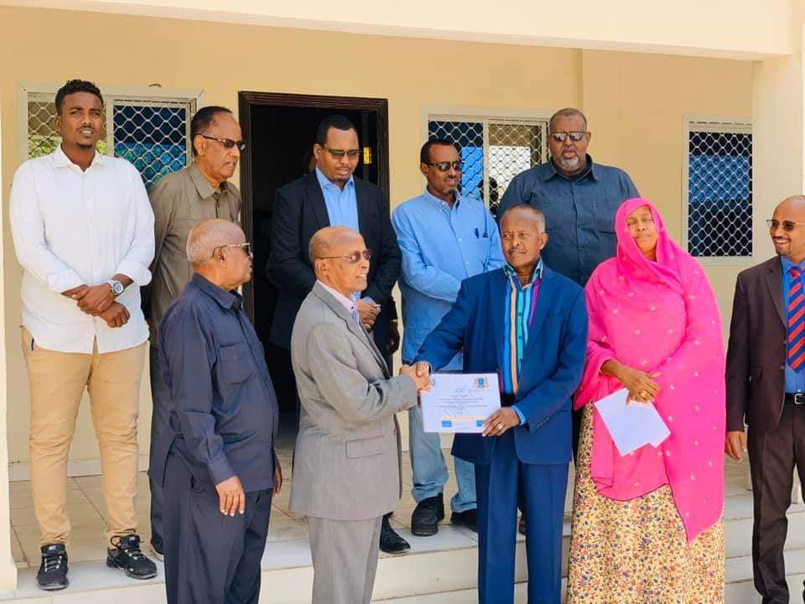
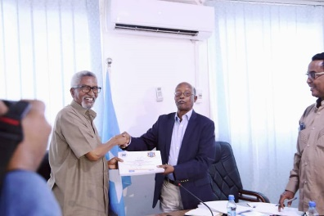
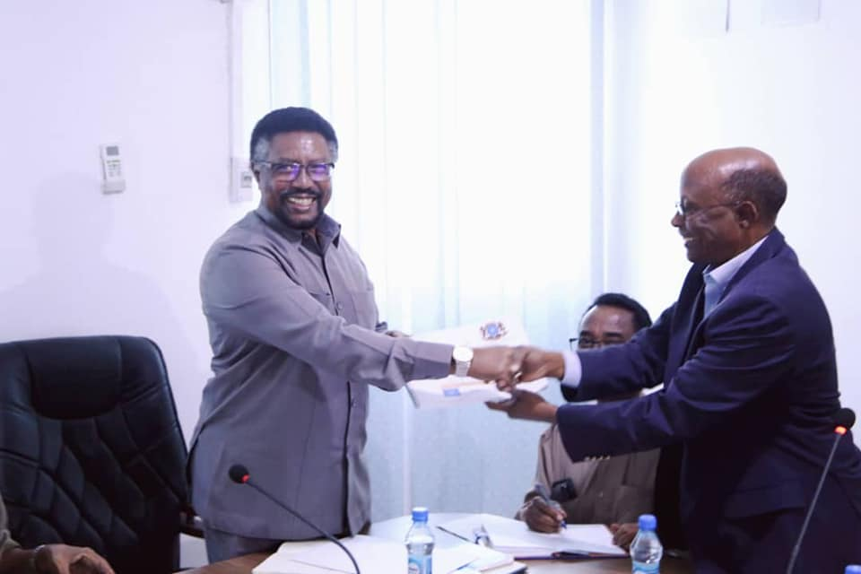

.
OC chair handed over the second draft of the constitution to the speakers of both Houses
OC chair handed over the second draft of the constitution to the speakers of both Houses.
OC and ICRIC agreed and signed the Second Draft of the Constitution.
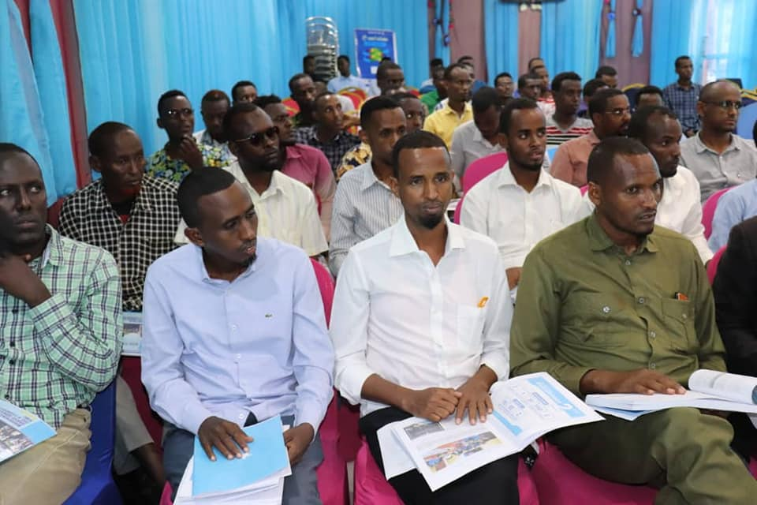
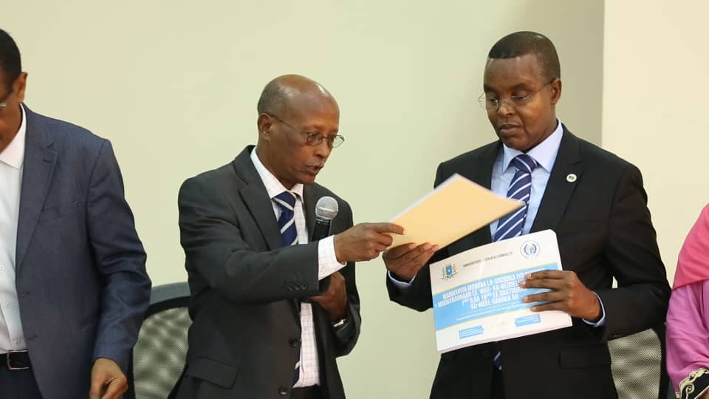
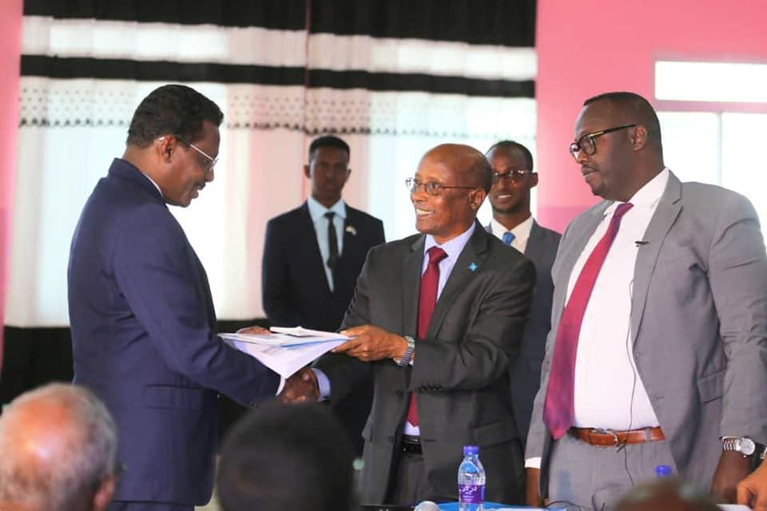

OC chair handed over the second draft of the constitution to the BRA
Public awareness and consultation with the SW community
OC chair handed over the second draft of the constitution to the Galmudug President
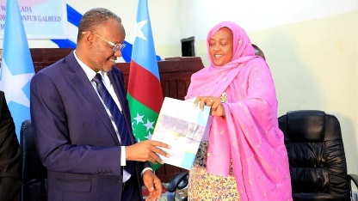
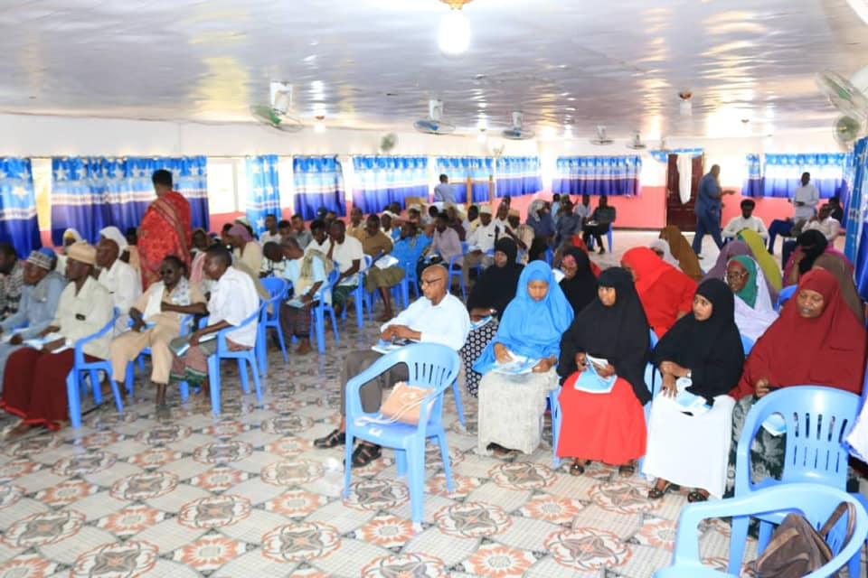
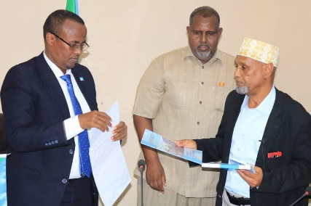

Public awareness and consultation with the Hirshabelle community

ICRIC deputy chair handed over the second draft of the constitution to the SW President
OC deputy chair handed over the second draft of the constitution to the HirShabelle Vice President

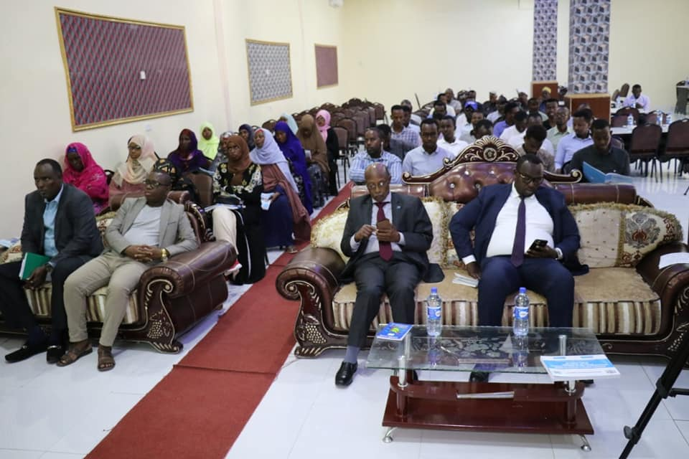
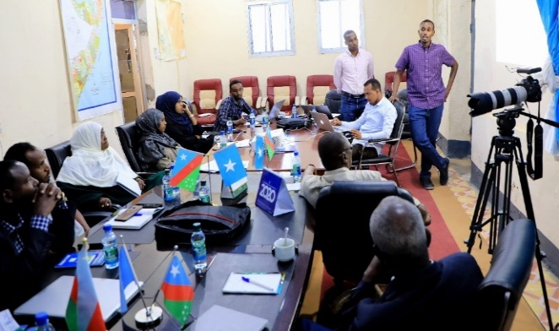
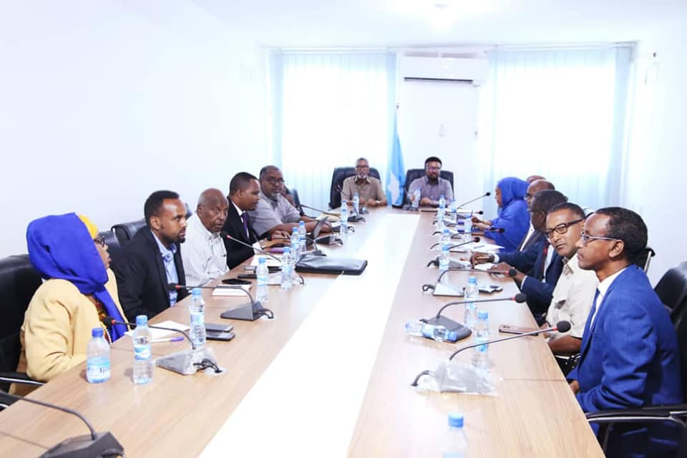

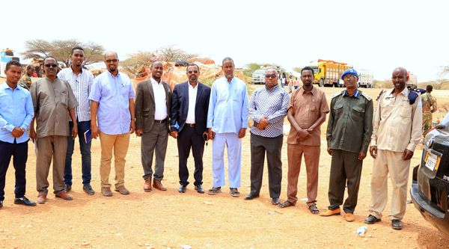
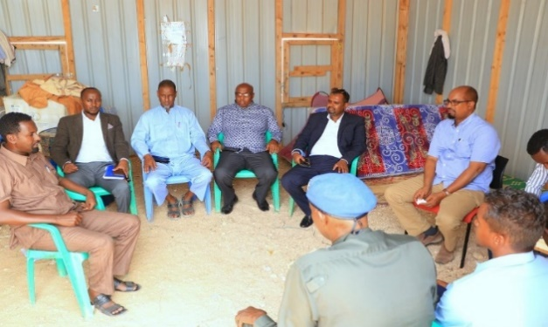
The advisor presenting one of the sessions of the SWS technical committee training
Public awareness and consultation with the Galmudug community.
OC chair handed over the second draft of the constitution to the speakers of both Houses

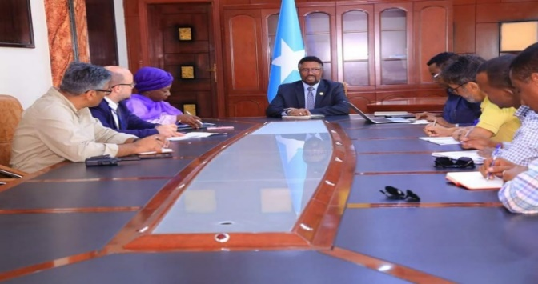

PL Public account committee meeting with the community groups

PL public account committee meeting with the community groups

UNDP staff meeting with the with the Speaker of HoP
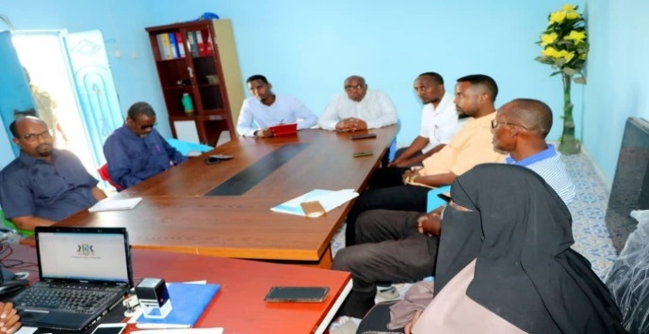
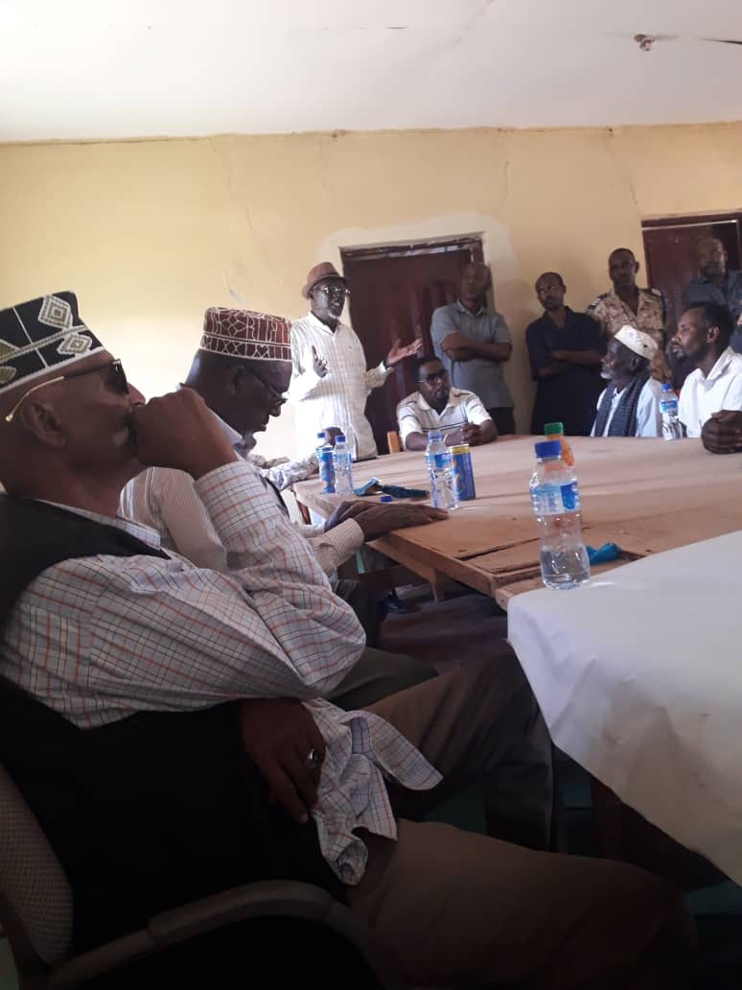
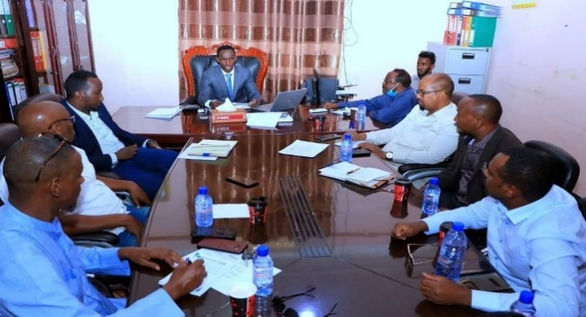

PL public account committee meeting with the community groups
HOE’s meeting with members from the community.
PL public account committee meeting with the community groups

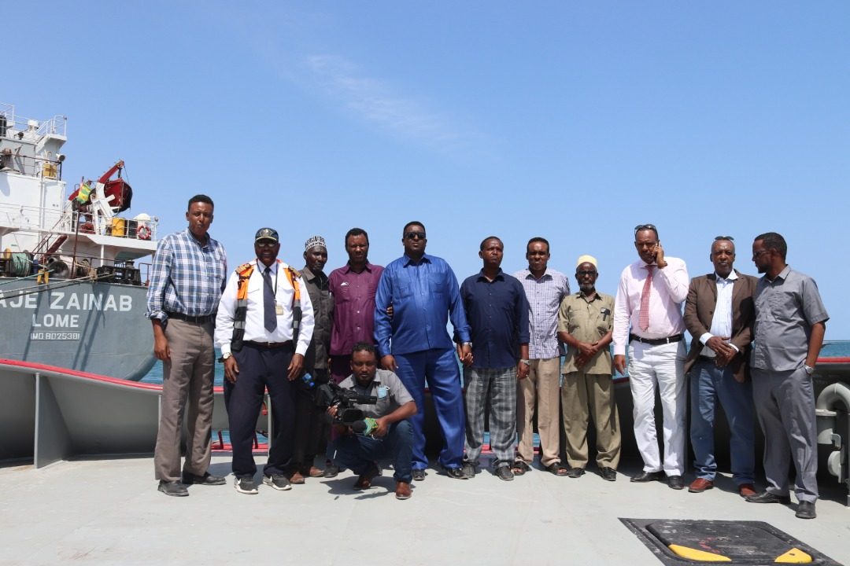
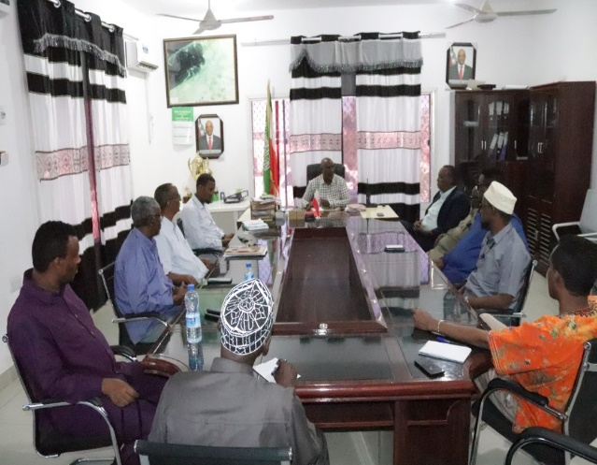

Members of the Committee visiting Berbera Port
HoE listening to the briefing given by Governor of Sahil
Eng Hammari and the MPs meeting at the office of the Somaliland Road Development Agency
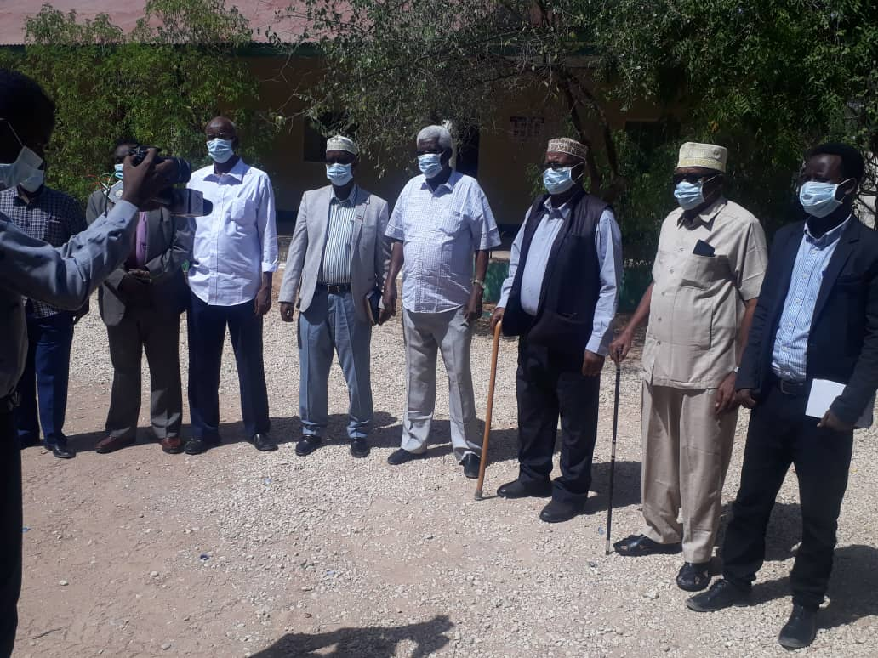
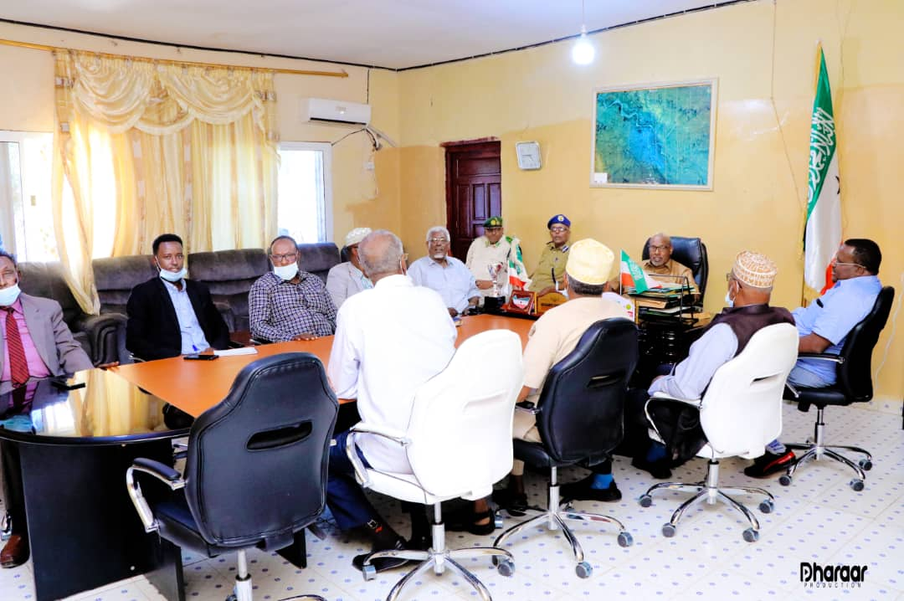
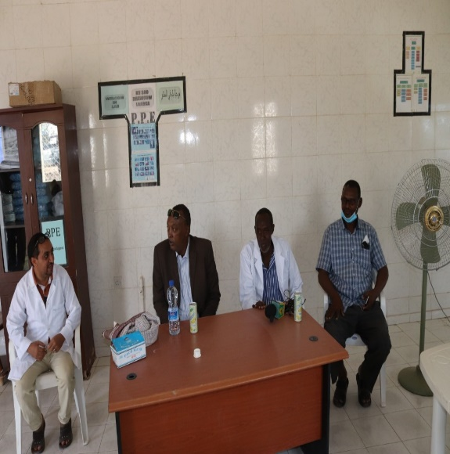

HOE visit to the Hospital of the City
Togdhere Governer briefing the member of HOE
Members Committee visiting Berbera Terminal Oil
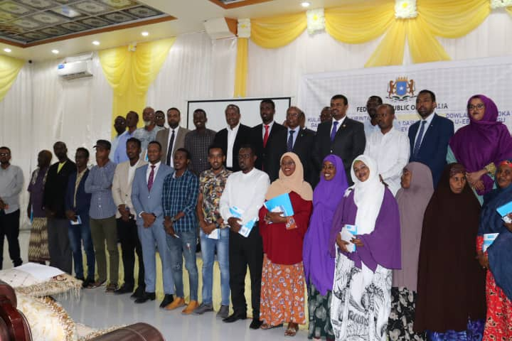
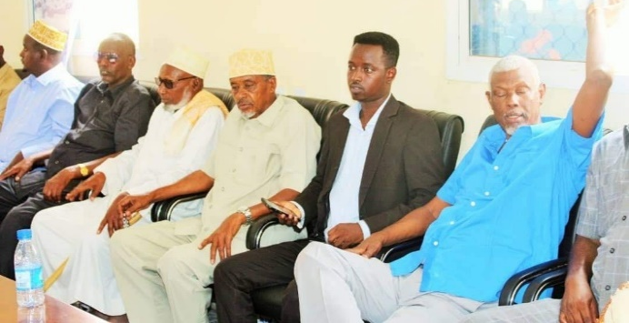
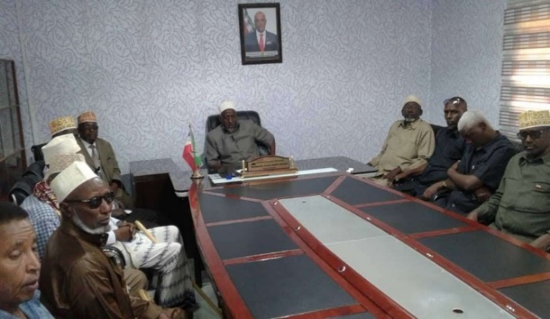

Guurti Members listening the briefing of the Sanaag senior officials
Galmudug- to get their feedback on the second reviewed draft
Mayor receives the MPs delegation in his office at Erigavo.
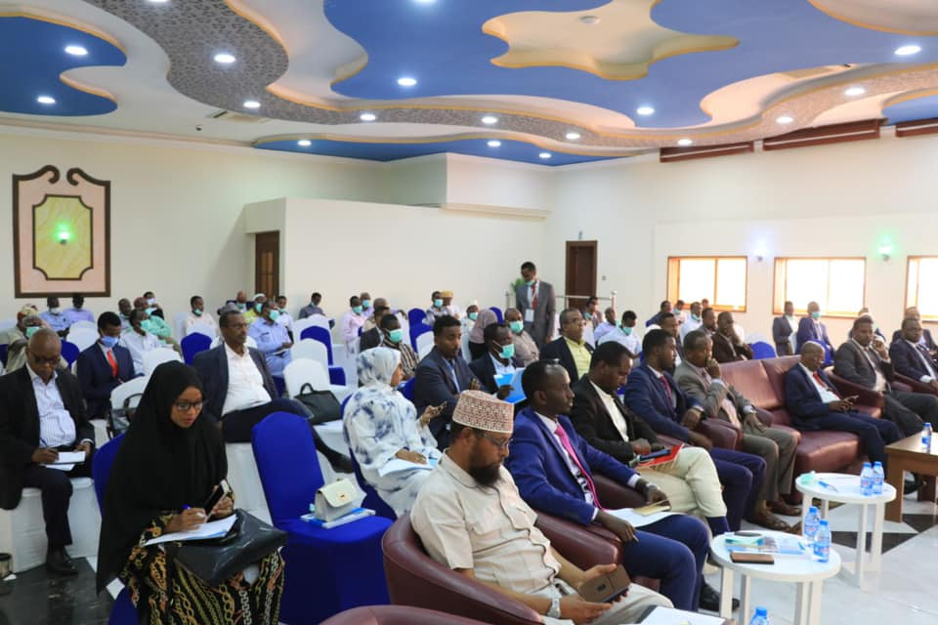
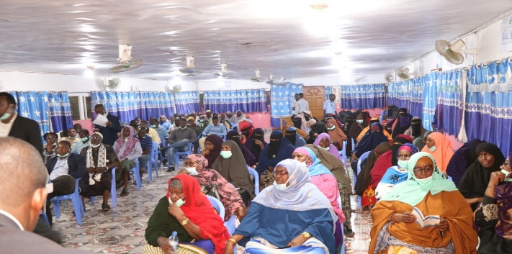
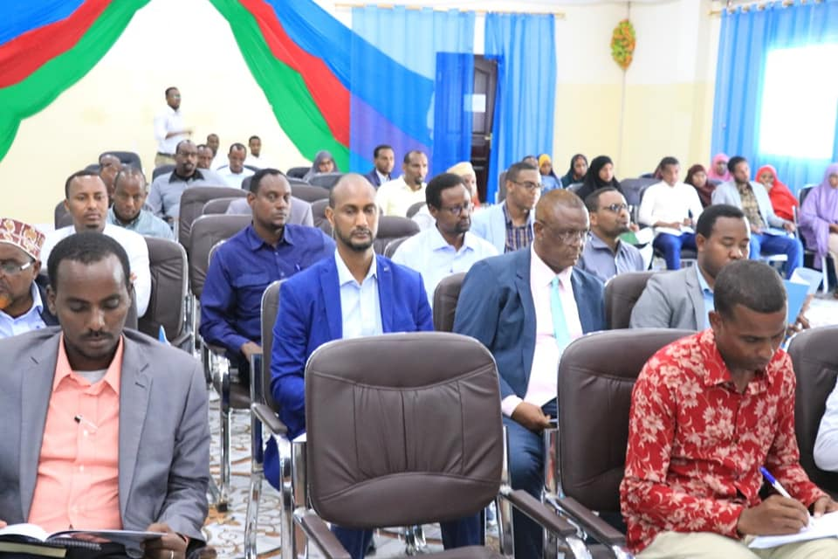

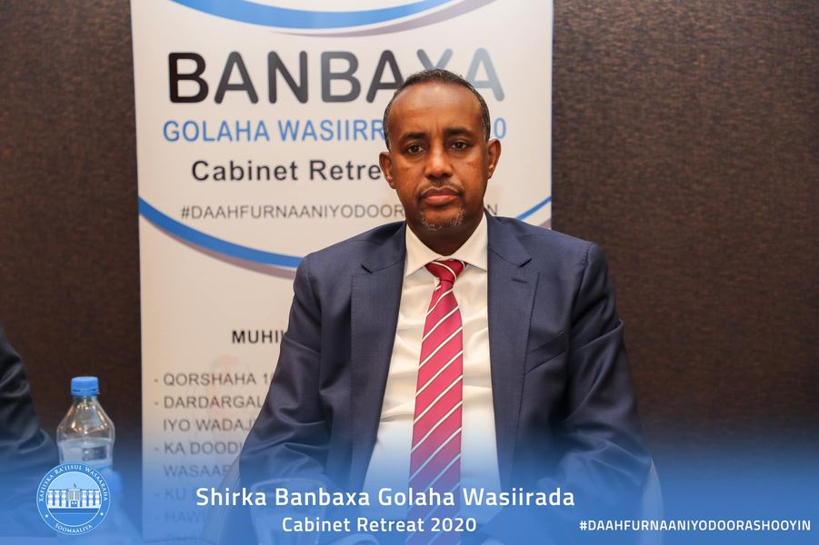
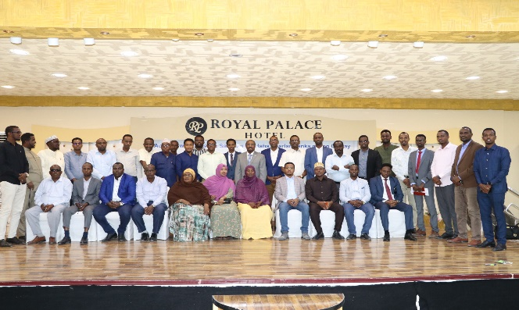
Meeting to conclude the review of 2nd draft Constitution
Hirshabelle CSO to get their feedback
SWS to get their feedback on the 2nd reviewed draft
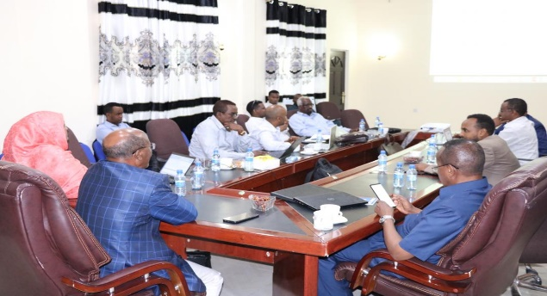

H.E Prime Minister Mohamed Hussein Roble at the Cabinet Retreat in Mogadishu 3-5 November 2020
OC &ICRIC is Presenting the 3rd draft of the constitution
Galmudug Parliament Induction Training in Mogadishu

ANNEX 5. UPDATED BILL TRACKERS AS OF 3rd February 2021
No. | Bill/Convention | Status
 | Telecommunication Law | President Assented
 | Somali-Indian Extradition Agreement | President Assented
 | Protocol to the Constitutive Act of the African Union relating to the Pan-African Parliament | President Assented
 | National Disability Agency Law | President Assented
 | Convention on the Rights of Persons with Disabilities | President Assented
 | Law on the Establishment of Anti-corruption Commission | President Assented
 | Revenue Administration Law | President Assented
 | Closing of Accounts 2017 | President Assented
 | African Union Convention for the Protection and Assistance of Internally Displaced Persons in Africa (Kampala Convention) | President Assented
 | Review of the 2019 Budget | President Assented
 | Convention for the Protection of the World Cultural and Natural Heritage | President Assented
 | Company Law | President Assented
 | Public Financial Management Law | President Assented
 | 2020 Budget | President Assented
 | Petroleum Law | President Assented
 | Convention Establishing the Multilateral Investment Guarantee Agency | President Assented
 | Amendment to the Customs Law | President Assented
 | Amendment to Public Procurement and Concessions Law | President Assented
 | Amendment to Media Law | President Assented
 | National Statistics Law | President Assented
 | Electoral Law | President Assented
 | Civil Aviation Law | President Assented
 | Standardization and Quality Control Bill | President Assented
 | Convention for the Safeguarding of the Intangible Cultural Heritage. | Sent to the President for Assent
 | Pensions and Benefits of Somali Politicians Bill | Sent to the President for Assent
 | Pensions and Gratuities of the Armed Forces Bill | Sent to the President for Assent
 | Health Practitioners Bill | Sent to the President for Assent
 | Amendment to the Political Party Law | Sent to the President for Assent
 | Somali and Turkey Education Treaty | Sent to the President for Assent
 | Review of the 2020 Budget | President Assented
 | Amendment to the Auditor General Law | Sent to the President for Assent
 | Indirect Election Law 2020/2021 | President Assented
 | Law on Continuation of the Review of Provisional Constitution | President Assented
 | Budget 2021 | President Assented
 | UN Convention against corruption | Sent to the President for Assent
 | AU Convention on Preventing and combating corruption | Sent to the President for Assent
 | Arab Convention against corruption | Sent to the President for Assent
 | Renewal of the Mandate of Independent Commission of Boundaries and Federation | Sent to the President for Assent
 | Approval of a Member of the National Independent Electoral Commission (NIEC) | Sent to the President for Assent
 | Renewal of the Mandate of the National Independent Commission for Election (NIEC | Sent to the President for Assent
 | Establishment of the Agency for registration and Issuance of National Identification Cards Bill | Sent to the President for Assent
 | Establishment of Agricultural research and Documentation of farms Bill | Sent to the President for Assent
 | Approval of Judiciary Service members | Sent to the President for Assent
 | Approval of Anti-Corruption Committee members | Sent to the President for Assent
 | Somali Notary Bill | Sent to the President for Assent
 | Resolution on Women Quota in Parliament (HOP) | Adopted on 21st June 2020. 134 yes 4 no 1 abstention
 | Resolution on the Representation of Banadir Region | Adopted on 24th June 2020. 142 yes 4 no 0 abstention
 | Resolution on the Seats of Northern Regions | Adopted on 24th June 2020. 167 yes 0 no and 1 abstention
 | Allocation of Seats of the House of the People | Adopted on 30 June 2020
 | Somali Lawyers Bill | Readied for the Upper House
 | Mandate Renewal for BFC | Sent to the Upper House
 | Bill Establishing National Registration and Identification Agency | Sent to the Upper House
 | Somali Agricultural Research and Regulatory Authority Bill | Sent to the Upper House
 | Approval of of the Judicial Service Commission | Sent to the Upper House
 | Approval of the Members of the Anti-corruption Commission | Sent to the Upper House
 | Water Resources Bill | Returned from UH and waiting for Joint discussion of committees from both Houses on the amendments made by the Upper House
 | Immigration and Naturalization Agency Bill | Committee of Interior and Security- Awaiting 3rd Reading
 | Immigration Bill | Committee of Interior and Security- Awaiting 2nd Reading
 | National Defense Bill | Defense Committee – Awaiting 2nd Reading
 | Somali-Turkey Treaty | Foreign Affairs /Trade Committee– Awaiting 2nd Reading
 | Protection of Investment and Investor Bill | Commerce Committee – Awaiting 2nd Reading
 | Establishment of Investment Promotion Agency | Commerce Committee – Awaiting 3nd Reading
 | Non-Governmental Organizations Bill | Finance Committee – Awaiting 2nd Reading
 | 1954 Convention for the Protection of Cultural Property in the Event of Armed Conflict | Foreign Affairs Committee –Awaiting for 2nd Reading
 | Closing of Accounts 2018 | Finance Committee  Awaiting 2nd Reading
 | Closing of Accounts 2019 | Finance Committee  Awaiting 1^{at} Reading
 | Somali Education Bill | Social Services Development Committee – Awaiting 2nd Reading
 | Amendment to the Civil Service Law | Social Services Development Committee – Awaiting 2nd Reading
 | Establishment of Medicines Quality Control Agency Bill | Social Services Development Committee – Awaiting 2nd Reading
 | Amendment to the Ant-Piracy Law | Justice Committee – Awaiting 2nd Reading
 | Refugees Bill | Human Rights Committee – Awaiting 2nd Reading
 | City Planning Bill | Transport and Ports Committee – Awaiting 2nd Reading
 | Heavy Goods Vehicles Bill | Transport and Ports Committee – Awaiting 2nd Reading
 | Highway Code Bill | Transport and Ports Committee – Awaiting 2nd Reading
 | Targeted Financial Sanctions Bill | Awaiting 1st Reading
 | Sexual Offences Bill | Awaiting 1st Reading
 | Membership of East Africa Trade cooperation Treaty | Awaiting 1st Reading
 | Treaty Establishing African Free Trade Zone | Awaiting 1st Reading
 | Commercial Copy Right Bill | Awaiting 1st Reading
 | Somali Federal Police Bill | Awaiting 1st Reading

Uncertified expenditures. Certified annual expenditures can be found in the Annual Financial Report of MPTF Office (http://mptf.undp.org/factsheet/fund/4SO00 )
Fill in only the numbers or yes/no; no explanations to be given here.
Amendment to the Political Party law, Public Notary Bill, Indirect Election Law 2020/2021, Convention Establishing the Multilateral Investment Guarantee Agency, Amendment to the Customs Law, Amendment to Public Procurement and Concessions Law, Amendment to Media Law , National Statistics Law, Electoral Law, Budget 2021,Resolution on Women Quota in Parliament (HOP, Resolution on the Representation of Banadir Region, Resolution on the Seats of Northern Regions, Allocation of Seats of the House of the People, Health Practitioners Bill, Convention for the Protection of the World Cultural and Natural Heritage, Petroleum Law, Company Law, Public Financial Management Law, Petroleum Law, Civil Aviation Law, Standardization and Quality Control Bill.
Public hearing on the Electoral Law, 20 OC public consultations and 7 public consultations by the ad hoc parliamentary committee on elections.
Joint Parliamentary Oversight Committee on Constitution Review and ad hoc parliamentary committee on elections.
The activities under this output were not implemented due to budget constraints
7 trainings (2-day induction to the new MP and 2day-committee training) for 4 FMS (Jubbaland, SWS, Galmudug and Hirshabelle)
The activities under this output have been suspended because of COVID 19
ICT Policy framework has been developed
The activities under this output were not implemented due to budget constraints
Islamic development Bank has diverted the funding under this output to support FGS’s fight against COVID 19, therefore activities under this output have not been implemented.
The following topics have been discussed during the consultations: (i) Allocation of powers and resource sharing, (ii) The status of Mogadishu as the Capital City; (iii) Fiscal federalism; (iv) System of Government and (v) Judiciary, Corrections and Security.
ICRIC annual report for 2020. ICRIC also prepared a detailed report on the constitutional review process, highlighting achievements, challenges and how the Provisional Constitution was amended.
Gender Specific Outputs are those that are specifically designed to directly and explicitly contribute to the promotion of Gender Equality and Women’s Empowerment.
Staff members are those contracted to undertaken work for the Joint Programme including full time staff, consultants, advisors, interns, etc. Staff members with responsibility for gender issues are those who have gender related activities included in their Terms of Reference.
Environmental; Financial; Operational; Organizational; Political; Regulatory; Security; Strategic; Other.

