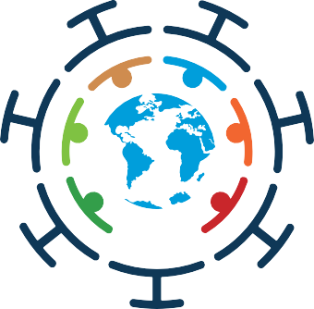
2020 Global Report of the UN COVID-19 Response and Recovery Fund

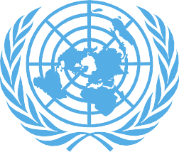
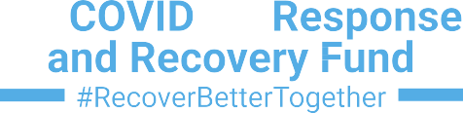

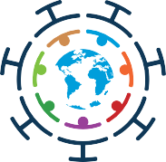
UN Multi-Partner Trust Fund Office
© 2021 UN MPTF Office. All rights reserved. May not be reproduced by any means without written permission, except when citing and/or reposting a copy of this PDF document with appropriate attribution.
Sources: Unless noted, all information and data are courtesy of the UN Multi-Partner Trust Fund Office (MPTF Office).
The views expressed in this publication are those of the authors and do not necessarily represent those of the United Nations, affiliated agencies or Member States.

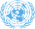
 | The COVID-19 MPTF Global Report
CONTENTS  Foreword | 3
PART I | 4
2020 Global Context | 5
Operations and Governance | 6
Highlights of 2020 Fund Programming and Results | 9
Early Lessons and Evaluability Assessment of the COVID-19 MPTF | 18
PART II | 21

SEF Pillar 1: Health First – Protecting Health Services and Systems during the Crises
SEF Pillar 2: Protecting People – Social Protection and Basic Services
SEF Pillar 3: Economic Response and Recovery – Protecting jobs, small and medium-sized enterprises, and vulnerable workers in the formal economy
SEF Pillar 4: Macroeconomic Response and Multilateral Collaboration
21

58
91

107

1

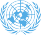
The COVID-19 MPTF Global Report

PILLARS

SEF Pillar 1:
Protecting Health Services and Systems during the Crises

Belize Cambodia Comoros Côte d’Ivoire El Salvador Eswatini The Gambia
Georgia Guatemala Guinea Honduras Jamaica Kosovo Kyrgyzstan
Lao PDR A Lao PDR B
Lesotho Madagascar Malawi Maldives Mauritania
Moldova Morocco Peru
Papua New Guinea Tajikistan
Tokelau

SEF Pillar 2:
Protecting People – Social Protection and Basic Services

Armenia Bhutan Bosnia Cabo Verde
Democratic Republic of Congo
El Salvador
Eswatini
Federated States of Micronesia
Ghana India A India B Indonesia
Jamaica Kenya Kiribati Kosovo Maldives Mongolia Nicaragua
Senegal Timor Leste Tunisia Tuvalu Uruguay Uzbekistan Viet Nam

SEF Pillar 3:
Economic Response and Recovery – Protecting jobs, small and medium-sized enterprises, and vulnerable workers in the formal economy

Argentina Armenia Bhutan Bolivia
Costa Rica Djibouti Fiji Myanmar
Nepal
Sao Tome and Principe A Sao Tome and Principe B Solomon Islands
Sri Lanka Vanuatu Zimbabwe

2
SEF Pillar 4:
Macroeconomic Response and Multilateral Collaboration
Cambodia

FOREWORD
The COVID-19 MPTF Global Report

by the UN Secretary-General’s Designate for the COVID19 Response and Recovery Fund
I
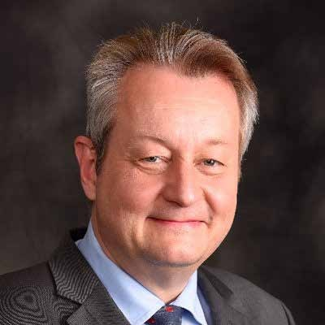
t has been a year since the UN Secretary-General launched the COVID-19 Response and Recovery Fund to help countries cope with the social and economic
impacts of the pandemic. Since its inception in March 2020, it has financed 87 programmes across 80 countries with the support of 21 donors. Over 50 of these programmes commenced within eight weeks of the Fund’s launch.
The Fund has served as a showcase of UN reform. It has brought 24 Agencies, Funds, and Programmes together to help countries cast a wide and inclusive net of protection and support. It has also grown partnerships with Member States, civil society, and private sector. Through its Solutions Catalogue, a pipeline of 206 shovel-ready and urgent programmes derived from countries’ Socio-economic

Response Plans, the Fund created an invaluable vehicle for further communicating urgent needs on the ground to potential contributors and collaborators.
In the face of lockdowns and disruptions to supply chains, travel, services, and logistics of all kinds – the Fund extended support to millions most at risk of being left behind. Its strong ‘Leave No One Behind’ (LNOB) focus expanded the inclusivity of national safety nets. In Ghana, for instance,
the UN provided technical advice to expand the Ghana Productive Safety Net Programme, which supported 1.4 million extremely poor families, including people with disabilities, through an emergency double payment with a top-up. A further 150,000 vulnerable people, including
orphans, the homeless, and people with disabilities, received a temporary cash transfer scale-up, via a new mobile money payment modality. In Indonesia, the programme helped the government expand social protection, extending it to over
30 million households as well as marginalized populations. Further, financial and digital innovations advanced gender- responsive social protection. Meanwhile in Timor-Leste, the programme helped expand the government’s COVID-19 social cash transfer scheme, which reached 313,398 low- income households – 98% of all eligible households in the country and 20% of which were female-headed. It was estimated that the programme in India, which supported the efforts led by the government to meet the immediate needs of approximately 3.3 million vulnerable and unemployed people, could, over the long-term, eventually benefit up to 100 million people.
These are a few brief examples of how, with a strong LNOB lens, the Fund was able to help grow government social protection programmes that addressed poverty and meet the needs of vulnerable people. Across the board, targeted assistance gave migrants, refugees, the elderly, ethnic and indigenous communities, and people with disabilities the support they needed to stay safe and to operate in their communities with dignity, purpose, and security.
The Fund worked to ensure its entire portfolio was gender mainstreamed. It stood-up critical results at a time when women were faced with rising unemployment and rates of violence and were shouldering ever heavier burdens as
caregivers and first responders. The Fund helped make sure that women working on the front lines had the supplies and training they needed to safely do their jobs, for instance
3
Jens Wandel

in Belize, Jamaica, Kyrgyzstan and Tajikistan. Funded programmes also assisted millions of women and girls by assuring their access to quality healthcare, safe spaces, and services, as well as enhanced livelihood opportunities. For instance, in Malawi, the joint programme supported the access of 256,282 women to quality maternal and neonatal health services, such that 88.9% of pregnant women, including adolescents, attended all of their scheduled antenatal care visits.
Innovation and learning have underwritten almost all Fund contributions towards UN reform, gender equality, and the principle of LNOB. Joint programmes helped countries close the digital divide in healthcare and education provision so that these services could have a greater reach than ever before. Funded programmes created digital payments systems, tele- and mobile-healthcare, and digital applications to link farmers and vendors to markets, and they helped formal and informal businesses enter the digital economy.
Because of these interventions, children were able to learn, businesses ran, and healthcare reached even the most marginalized of people and communities. For example,
in Senegal, the roll-out of a national radio programme on literacy and math reached 652,960 children. The programme also provided adapted learning devices for children with visual and hearing impairments. A programme in Mongolia, which also had a focus on education, used online interactive learning to reach 149,161 children, teachers, and caregivers to assure equal access to education. Meanwhile, a programme in the Maldives commenced with the intention of digitalizing and streamlining social services and creating a unified platform for national care, with a special focus on women and children.
The results in this annual report speak volumes for the effectiveness of the UN System coming together under the framework of the COVID-19 Response and Recovery Fund - a vehicle for Development Emergency Response.
The Fund has helped countries address the pandemic while putting in place steppingstones towards a more equitable and sustainable future. These outcomes matter. They matter for right now as we fight and emerge from the COVID-19 pandemic, and they will continue to matter during the Decade of Action, as we work to build the ‘World We Want.’

4
The COVID-19 MPTF Global Report

PART 1

2020 Global Context
his past year, the world faced a once-in-century event precipitated by the corona virus disease (COVID-19) pandemic. By 12 March 2021, some 119 million people
T
were infected globally and 2.6 million had died.1 Overall, the direct and indirect costs of the pandemic have been profound, with higher levels of adverse impacts among the most vulnerable countries and people. Ultimately, the international community finds itself at a place where deep collective action with global solidarity is required to
simultaneously salvage global socio-economic security and public health.
The economic impact of the pandemic on the global economy is represented by the difference between actual economic performance, measured by gross domestic product (GDP), and potential output, or the maximum amount an economy could produce at full employment, referred to as the output gap. The International Monetary Fund (IMF) estimates that the loss in economic output represented by the GDP output gap among major advanced economies, which as a group account for approximately 60% of global GDP, would be -3.6% in 2020, or that the economies would operate at a rate that was 3.6% below their combined potential.2
According to the IMF’s assessment, not only would the major advanced economies as a group operate below their full potential through 2025, but none of the individual
economies was projected to operate above potential during the 2020-2025 forecasting period. The IMF predicted3 that the impact of COVID-19 on income distribution could reverse progress made over the last decade, with the Gini coefficient increasing by 2.6 percentage points in emerging markets and developing economies as a result of the pandemic.
According to the IMF, the estimated effect from COVID-19 on income distribution was much larger than that of past pandemics. The analysis showed that the average Gini coefficient for emerging market and developing economies would rise to 42.7, which was comparable to the level in 2008. The impact would be larger for low-income developing countries despite slower progress since 2008.
With regard to the adverse social and economic effects of COVID-19, estimates suggest that more than 251 million people could be forced into poverty by the pandemic4. Public debt was also expected to rise by 17% of GDP,5 and 20 countries could face famine or lack access to food.6
The pandemic has been especially severe on workers in the informal sector given a priori structural conditions
worldwide.7 Some 60% of all workers globally operate in the informal sector, and in developing countries, this number can reach 90%.8 Informal workers typically lack rights, benefits, and social protections, which worsens the burden of the pandemic. Structural problems in this sector will deteriorate if inequality and poverty increase, and mitigation measures are not taken.9 Further, while work from home and related entrepreneurial adaptations and innovations have arisen as a response mechanism, the global digital divide has been deep and broad, causing distortions and inequality.10

With regard to healthcare, a WHO survey on hospital health systems in 105 countries from March to June 2020 showed that almost 90% experienced disruption to their health services, with developing countries most impacted. The most frequent disruptions were in the areas of outreach and facility-based services for non-communicable disease diagnosis and treatment, family planning and contraception, treatment for mental health disorders, and cancer diagnosis and treatment.11 The ability to access health systems was at an all-time low for care.12
Restrictions on global travel have limited the movement of people fleeing places of conflict and escaping from human rights abuses.13 COVID-19 has also impacted on internal migration. As people began to return from the cities to their rural areas, many brought the virus with them, raising the infection rate in places with less economic development.
This could also mean fewer domestic remittances, leaving many rural families without an important income source as has occurred in Africa and elsewhere.14
Education has also been heavily impacted. At the height of the lockdown in 2020, more than 160 countries had
mandated some form of school closures, impacting at least
1.5 billion children and youth.15 Researchers found that the aggregate economic output will be diminished due to school closing and intergenerational mobility will be negatively impacted, particularly for older children.16 This is because education equips people with abilities and skills that improve their productivity, allowing them to apply new ideas and technologies. Closing schools will cause severe long-run learning losses with impacts on the productivity of human capital and the mental development of children.17 While digital education is somewhat of a substitute, response mechanisms in education need to be designed with the most vulnerable in mind.
COVID-19 may also reverse decades-long gains by women and girls in human capital, economic
empowerment, and voice and agency.18 Female employees are also more likely to lose their jobs.19 Rising rates of all forms of violence against women and harmful practices have also been documented including child marriage and trafficking, exploitation, sexual violence, and domestic violence.20 The demand for access to hotlines related to these challenges has risen dramatically in some places.
Moreover, estimates indicate that for every three months that the pandemic ensues, an additional 15 million women are at-risk of experiencing violence. Unintended pregnancies could also increase if lockdowns continue going forward. An additional 13 million child marriages that could have been averted may take place between 2020 and 2030.21
Overall, the COVID-19 pandemic has eliminated the progress made in promoting investment in the Sustainable Development Goals (SDGs) since 2015. The considerable decline in investment was much larger in developing and transition economies than in Organisation for Economic Co- operation and Development (OECD) countries. SDG-relevant investment fell by 51% in Africa, 44% in Latin America
and the Caribbean, 33% in Asia, and 27% in transition economies.22

See Endnotes here
5

Operations and Governance

A Timeline of Operational Milestones

To date, the Fund has programmed US$75 million through two Calls for Proposals. In addition, and from its second Call for Proposals, the Fund generated the ‘Solutions Catalogue,’ which puts forth 206 additional strategic and unfunded priority programmes derived from countries’ Socio-economic Response Plans (SERPs). Below is a timeline of the Fund’s operational milestones.
TIMELINE OF EVENTS

3 April 2020: UN Secretary-General establishes the COVID-19 Response and Recovery Trust Fund.
15 April 2020: Fund issues its first Call for Proposals to 47 countries against US$45 million. The Call focuses on least developed countries (LDCs), lower and middle income countries (LMICs), and small island developing States (SIDS) not covered by the Global Humanitarian Appeal. Call response rate is 100%.
AN IMMEDIATE RESPONSE TO A GLOBAL DEVELOPMENT EMERGENCY: THE FUND’S FIRST CALL FOR PROPOSALS
Because the COVID-19-related health and development crises occurred simultaneously, this Call for Proposals fell within Window 1 and Window 2 allocations. It supported joint UN action to: directly mitigate the socio-economic impacts of the pandemic with a focus on vulnerable and COVID-19 responder groups; and close health sector related investment gaps not covered by UN development agency programming resources. The first Call prioritized the least developed countries (LDCs) not covered in the Office for the Coordination of Humanitarian Affairs (OCHA) Global Humanitarian Response Plan1, Small Island Developing States (SIDS), and middle-income countries heavily impacted by the COVID-19 pandemic. Through this Call, the Fund programmed US$45 million, supporting 56 programmes in 47 countries. The Call built a cadre of programmes that upscaled proven methodologies and adapted them to COVID-19 circumstances, while also supporting the adoption
of new technologies and innovations that could simultaneously advance resiliency and recovery. Investment examples can be found within the ‘Programme investments – 1st call for proposals’.
13 May 2020: Fund begins release of payments to 47 countries of Call 1.
15 May 2020: Fund commences an ‘After-Action Review’ to cultivate lessons learned from its first Call for Proposals and apply them to subsequent Calls.
19 June 2020: As part of the overall UN’s response to COVID-19, the Fund launches a webpage (www. un.org/recoverbetter) to share the latest programmatic announcements and key Fund updates.
26 June 2020: On the anniversary of the UN Charter, the UN Deputy Secretary-General convenes the Recover Better Together Action Forum to support capitalization of the Fund. The event hosts 330 participants, features 40 speakers, raises US$17 million from 10 new donors, and launches two data platforms.
23 July 2020: The Fund targets grants to UN Resident Coordinators (RCs) in selected countries (up to USD $50,000 each over three months) to cover feasibility and finance studies of potential Fund investments.
17 August 2020: The Fund launches a global Call for Proposals derived from Socio-economic Response Plans (SERPs). The Call has a gender target of 30% GEM3 and is digitized for the first time ever, using the Global Management System (GMS).

1 see https://fts.unocha.org/appeals/952/summary

TIMELINE OF EVENTS

Mid-August 2020: The Fund organizes several well-attended trainings to support Resident Coordinators (RCs), Resident Coordinator Offices (RCOs), and their agency partners with this Call. The Secretary- General’s Designate holds a Q&A session with approximately 120 RCs and their staff members. ILO, IOM, PAHO, UNCTAD, UNDP, UNFPA, UNICEF, UNWOMEN, WFP, and WHO colleagues from the
UN Inter-Agency Network on Women and Gender Equality (IANWGE) hold two gender-responsive programing webinars to support the Call’s gender marker (GEM) target. These are attended by 400 participants from the RCOs and UN Country Teams (UNCTs). The Secretariat holds a training on the GMS (digitization of the Call) that is attended by over 100 participants.
31 August 2020: 109 countries publish finalized SERPs (up from approximately 60 prior to Call 2). A total of 104 programmes covering 113 countries are submitted for funding. 250 Concept Notes are submitted to the pipeline of unfunded, priority programmes feeding the Solutions Catalogue.
BUILDING A PIPELINE FOR THE SOLUTIONS CATALOGUE
The Fund’s second Call for Proposals sought to fund timely, relevant, prioritized, realistic, evidence- based, joined-up, and implementable interventions. In doing so, it built a pipeline of urgent, unfunded, and high quality programmes. The Call put gender at its core, requiring a gender marker of GEM 3 for 30% of its investments. It also required that country programmes be derived from UN Socio-economic Response Plans (SERPs) published on the UN Development Coordination Office (DCO) platform. Using SERPs as a core criteria of the Call enabled the Fund advanced development planning. The Call funded 22 countries. It also built a pipeline of 206 programmes, which had been proposed by RCs as the most urgent, unfunded priority interventions, amounting to USD 252 million, that were integrated into a ‘Catalogue of Solutions’. The Catalogue serves as a novel tool to garner additional donor resources and partner engagement.
13 October 2020: The Fund begins the release of funding to 22 Call 2 countries.
30 October 2020: The Fund publishes the ‘Solutions Catalogue’, which profiles 206 urgent, unfunded, and ready to implement projects derived from SERPs. The Catalogue is accessible on the main UN Recover Better Page: https://www.un.org/recoverbetter and offers an interactive format that allows users to search programmes by country, pillar, gender marker and sector. It highlights an ask of approximately USD 252 million.
16 November 2020: The Fund hosts a donor meeting, with fifteen Member States participating. Austria, Switzerland, and Norway make an additional USD 9 million available for programming at the end of 2020.
23 November 2020: The Fund launches the Global Interim Narrative Report covering Fund progress from its inception to September 2020. It is available at: http://mptf.undp.org/document/download/25496
30 November 2020: The Secretariat launches a mini Twitter social media campaign titled, ‘Making a Difference’. The campaign runs for one month, with two to four tweets per week in the format of a Social Media Card to showcase UN agency joint achievements. The campaign recognizes UNCTs and agencies at headquarters level, who also amplify (retweet) the messages.
Early December 2020: Early lessons and evaluability exercise commences in line with the UN Secretary-General’s proposal to manage the COVID-19 Response and Recovery Fund as a system- wide evaluation. It consists of two components, one on early lessons and another on evaluability. The inception report proposes conducting seven country case studies (Cambodia, Guatemala, Kosovo, Malawi, Maldives, Moldova, and Sao Tome and Principe) and approximately 50 interviews at headquarters level. The first draft report is to be produced by end of March 2021.

17 December 2020: The Secretary-General’s Designate raises awareness of the Fund with North American Family Offices by participating as a speaker in the summit series of Cavendish Group https:// cavendishglobal.com/summit-series/.
January 2021: 10 new programmes are funded: Antigua and Barbuda and the British Virgin Islands (BVI), Benin, Brazil, Chile, Cameroon, Indonesia, Liberia, North Macedonia, Turkey, and Viet Nam.
15 January 2021: The social media campaign promoting the Fund’s results (#RecoverBetterTogether and @MPTFOffice) that launched in late-November, successfully completes. Titled, ‘Making a Difference,’ the campaign’s 19 social media cards generated over 300,000 impressions from Twitter users, with numerous country offices, embassies, and ambassadors engaging to raise the visibility of the Fund.
8 March 2021: On the occasion of the International Women’s Day 2021, the Fund briefs on its results in the document titled, ‘Promoting Gender Equality and Engendering Change,’ available at www.un.org/ sites/un2.un.org/files/emerging_results-geew-2021.pdf

Contributor Overview
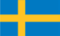
Results in this report would not have been possible without the generous contributions to the COVID-19 MPTF by the following donors.

AUSTRIA
NEW ZEALAND
SWEDEN

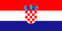
CAMBODIA |  | NORWAY |  | SWITZERLAND
CYPRUS |  | Republic of KOREA | 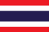 | THAILAND
CROATIA |  | PHILIPPINES |  | UNITED KINGDOM
DENMARK | 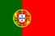 | PORTUGAL |  | UN Evaluation Group
FINLAND |  | ROMANIA

TIMELINE OF EVENTS
ICELAND

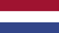
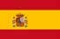
THE NETHERLANDS

SLOVAK REPUBLIC SPAIN
Private Sector Contributors

Standard Chartered Bank Zambia PLC

Highlights of 2020 Fund Programming and Results

Since its inception in first quarter of 2020, the Fund focused on ensuring swift, needs-based responses that enabled
the UN in the country to best support the government. The investments across the first call in the middle of 2020 and the second call in the third quarter of 2020 were diverse but aligned with common principles: concrete and
FUND’S INVESTMENT BY SEF PILLARS

1%
25%
36%
Pillar 1
Pillar 2
Pillar 3
Pillar 4
38%
Fund investments in 2020 were spread across four of the five the Socio-economic Framework (SEF) Pillars. Pillar 1 on Health First and Pillar 2 on Protecting People comprised close to 75% of Fund investments. This aligned to how the pandemic response evolved across countries working to ‘flatten the curve’.
Approximately 14% of the fund’s investments covered more than one SEF Pillar.
immediate action, a focus on Leaving No One Behind, and a commitment to inclusion to mitigate the roll back of progress on the Sustainable Development Goals (SDGs).
Fund investments in 2020 were spread across four of the five Socio-economic Framework (SEF) Pillars. Pillar 1 on Health First and Pillar 2 on Protecting People comprised close to 75% of Fund investments. This aligned to how the pandemic response evolved across countries working to ‘flatten the curve’. Approximately 14% of the fund’s investments covered more than one SEF Pillar.
Because the pandemic caused simultaneous health and development crises, the COVID-19 Response and Recovery Fund supported programmes that spanned the nexus of country needs to stop the pandemic, protect the most vulnerable, and enable recovery that would also preserve progress towards the SDGs. The Fund’s modus operandi
of leveraging the UN Resident Coordinator System was a testament to the reformed UN development system working collaboratively and cohesively to support each country in its pandemic response and recovery.
All UNCTs reported on the overall implementation of the socio-economic monitoring framework. This data was updated frequently and always accessible online at https:// data.uninfo.org/. Data analysis in this report derived
from overall reporting on the monitoring framework from countries supported by the Fund in 2020, and it was supplemented with reporting by each funded programme’s progress report.

Gender Marker and Programming Fund
The COVID-19 Response and Recovery Fund (the Fund) worked to make sure its entire portfolio was gender mainstreamed, recognizing that women have been a mainstay of pandemic response, and that they will be the backbone of resilient recovery. To aid this process, the Fund introduced a gender equality marker in April 2020 as a monitoring and accountability framework to ensure the application of high standards on gender equality,
promoting both dedicated targeted interventions and gender mainstreamed programming.
Consistent with the view that only programmes with a strong gender lens could be effective in addressing the socio-economic needs created by the COVID-19 pandemic,
the Fund established a financial target of 30% for the second Call for Proposal funding. It was reserved for programmes that identified gender equality as their principal objective
(i.e. proposals with an overall gender equality marker code of three (Gender Marker 3). The Fund exceeded this financial target, such that 69% of Call 2 proposals qualified as Gender Marker 3. The Fund did not approve proposals with a gender equality marker code of 0, and it discouraged interventions with a gender equality marker code of 1.

Through the gender equality marker, the Fund tracked the proportion of funding focused on advancing gender equality and empowerment of women and girls (GEEW/G) as well as information on individual programmes with a similar focus.
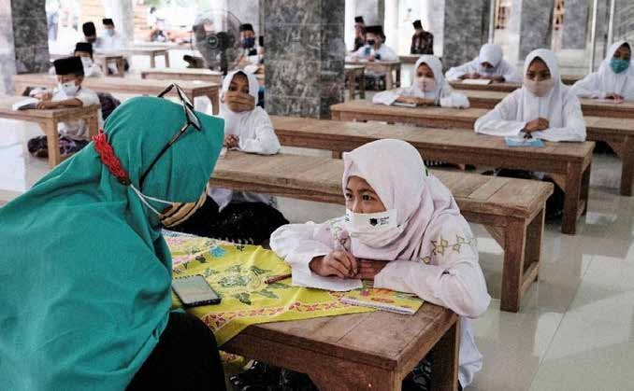
© UNICEF Indonesia

SEF Pillar 1: Health First – Protecting Health Services and Systems during the Crises
The COVID-19 pandemic was an unprecedented challenge for healthcare systems worldwide, with risks to healthcare workers proving to be one of the greatest vulnerabilities. As part of its first two Calls for Proposals, the Fund focused on priority
health sector-related investments not covered by humanitarian programming resources. This meant helping countries and governments to, inter alia, acquire essential supplies, enable cross-government situation readiness, up-scale responses, and pay their healthcare workforce. In responding to the COVID-19 pandemic, the Fund supported countries in maintaining essential health services and the systems that supported them.
Thirty programmes out of the total funded programmes reporting on 2020 activities supported Pillar 1 activities in their implementation. Approximately 12 million direct and indirect beneficiaries were reached through the implementation of programmes supported by the Fund under this Pillar.
Programmes under this Pillar built out healthcare infrastructure, and they provided essential supplies, like personal protective equipment (PPE), medications, and respiratory equipment to assure that facilities could maintain service provision and safely triage and successfully treat COVID-19 cases. In many countries, innovative programmes established mobile care units, tele-health, and digital applications to provide continuous and more robust healthcare in the pandemic context. Hotlines fielded thousands of calls by people in need of COVID-19, mental health, and domestic and gender-based violence (DGBV) care and referral.
Many programmes had an extensive focus on expanding and improving services for women and girls, especially pregnant women and their babies, and survivors of gender-based and domestic violence. Initiatives stood up hotlines, established shelters, and commenced communication campaigns to cast a line to those in need. Programmes often worked to reach those most at risk of being left behind, including women and girls, migrants, refugees, the elderly, people with disabilities, people in prisons, sex workers, and other groups often excluded from formal support mechanisms.

Country Highlights

In Belize, the programme ran an extensive communications campaign to reach vulnerable populations as well as the general public with information on how to access COVID-19- related healthcare. It reached 206,435 people (49% of the country’s population). The initiative also restored antenatal and postnatal care interrupted by the pandemic, including through tele-health measures, such that 27,731 received pediatric services, 17,136 expectant mothers received prenatal care, 1,870 received antenatal care, and 70,252 routine vaccines were administered. Also through the programme, 27 mobile clinics provided essential sexual and reproductive health (SRH) and family planning.
In Cambodia, attention turned to helping 322,809 returning migrants and their host communities understand how to protect themselves from COVID-19, with information on prevention provided at points of entry (PoEs) and quarantine centers. The programme also provided 8,543 women
and girls with maternal care and GBV information and psychological support. It distributed dignity kits to women and girls of reproductive age.
Comoros used fund support to establish the 1717 Green Line, a telephone hotline that fielded over 100,000 calls.
The initiative also trained craftsmen to produce contactless handwashing devices. They established hand washing points and were proceeding to establish facilities at care centers for COVID-19 patients, public places, and public primary schools.
Cote d’Ivoire also operationalized a hotline, and it assisted 4,062 cases of people experiencing violence, abuse, exploitation, and mistreatment. The programme also provided cash transfers to 224 centers caring for victims of violence, abuse, and exploitation and trained welfare workers to offer psychosocial first aid and therapy. Through the initiative, 104,304 parents and primary caregivers accessed community-based mental health and psychosocial support. The programme also provided psycho-social support to 1,691 women and 2,313 children victims of violence, and it gave hygiene kits to prison inmates.
El Salvador also extended support to the incarcerated by strengthening the response of 25 prisons, such that 37,190 inmates received medicine and benefited from
access to PCR testing. With a focus on vulnerable people,
the programme assured that 61,029 women and 29,117 men with chronic illnesses received medications directly in their homes to minimize their risk of COVID-19 exposure. To support women, the initiative collaborated with a non- traditional actor - the Post Office - to train postal workers to identify and refer domestic violence cases; and it added a sticker to all mail with information on how to access
the Attorney General’s Office, one of two entities offering services to victims of domestic and gender-based violence.
The Gambia also extended support to women suffering domestic and gender-based violence. It launched the National Gender-based Violence (GBV) Helpline, which responded to 2,619 survivors. The programme also built and provisioned three COVID-19 treatment centers with electricity, WASH, and sanitation supplies.
Georgia’s programme had a ‘leave no one behind’ (LNOB) focus on the elderly. It used fund resources to: equip 8,000 frontline workers and 11 state-funded institutions for the elderly with PPE. It reached 2,749 vulnerable elderly with a home care visit, and it gave 95 elderly people living alone in remote rural settlements a cell phone pre-programmed with a hotline number for help. The programme also helped equip the country’s 144 Emergency Center with specialized GPS
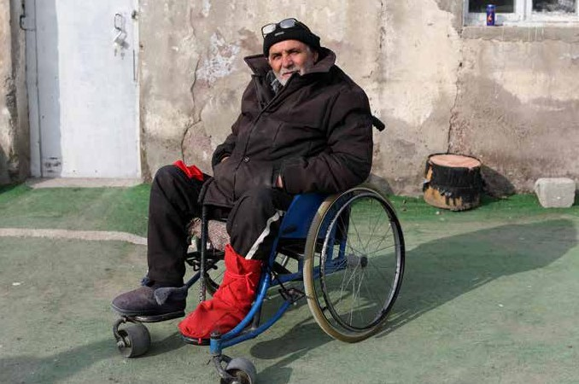
Elizbar, an older person living alone in Kaspi, received a food and hygiene parcel that included PPE and information on how to stay safe from COVID-19.
© Dina Oganova /UNFPA Georgia

dashboards to handle large call volumes (4,500 calls per day/ operating 330 ambulance crews), resulting in a 9% increase in response rate to emergency calls. The initiative also reached 1.1 million people with an information campaign on avoiding pandemic-related economic and health impacts; it provided essential healthcare services to 52,000 women and children, including immunization, prenatal and postnatal care, HIV care, and gender-based violence interventions.
The programme in Ghana proved equally robust. It built the capacity of 2,185 health workers to assure the
continuity of essential health services and trained 1,261 caregivers on infant and young child feeding (IYCF). 873 children under five were diagnosed with and treated for severe acute malnutrition (SAM). The programme’s robust communications campaign, which reached 346,931 people with health and nutrition messages and 14,156 people with WASH messaging, increased child welfare clinic attendance from 9,210 to 63,120. The programme also improved and established WASH facilities for 1,046 patients and 502 health workers as well as 8,037 children in 16 schools in the Accra Metropolitan area.
In Guatemala, health educators informed 7,350 returnees on COVID-19 and addressed their psychological care needs. The programme also delivered 1,970 food packages, 682 warm clothing kits, and 682 hygiene kits to shelters. Its model of care for unaccompanied children was institutionalized by
the Guatemalan Social Welfare Secretariat. The programme also offered technical support to 22 hospitals, trained
776 healthcare workers on WASH and 904 on IPC, and trained 1,296 healthcare workers, including 656 operators working in the field with traditional midwives, on sexual and reproductive healthcare. The programme also hired staff that registered 79,681 epidemiological records.
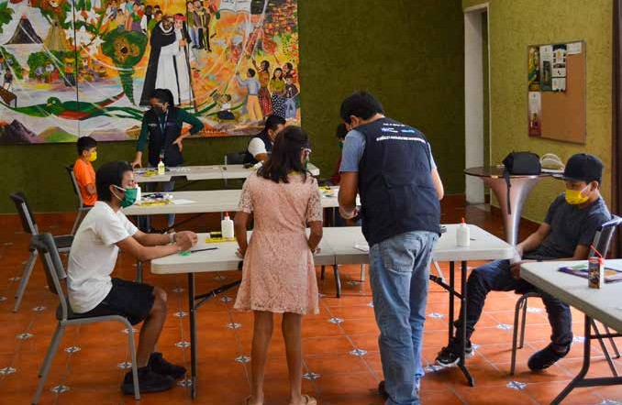
A spirituality center located on Calzada Mateo Flores, 2 Calle 31-80, in Guatemala City, was rented to support and respond to the overload of cases of returned children due to the COVID-19 pandemic.
© Andrea Urrea/UNHCR

In Guinea, the programme helped to equip treatment centers and ICUs with equipment and supplies to needed to treat COVID-19 cases. It also identified 12,115 vulnerable
people and provided them with food and nutrition assistance as well as PPE. The initiative enabled a donation from Colgate International of 850,000 bars of soap for hand washing, and it engaged 500 artisans in mask production.
Jamaica’s robust national risk communication and community engagement campaign reached 228,055 people, and the programme ensured that all healthcare workers, including sexual and reproductive health workers, had
PPE, distributing tens of thousands of items, including 28 ventilators. It also provided 16,000 doses of Depo Provera to the National Family Planning Board and deployed mobile units to reach vulnerable groups, including women and the
elderly. To further support outreach to marginalized groups, the initiative established 21 essential service hotlines for women, men, and the elderly, and trained 80 volunteers to service them.
The Kosovo programme provided PPE and other equipment to 3,614 front line workers. It also distributed support packages to 62 volunteers working the COVID-19 call center, and it furnished and supplied their workspace. The center received 20,500 calls between August and November 2020. To help people understand and cope with the pandemic,
the initiative developed the University of Pristina’s online psycho-educational platform https://shendetimendor.org and ran an outreach campaign that reached 503,500 users with 1,617,897 impressions.
In Kyrgyzstan, funding supported the provision of PPE to 1,910 healthcare workers across 42 health facilities as well as the training of 1,089 health workers and 4,000 nurses (online) on its correct use. A WASH assessment led to the procurement of 14,108 IPC items for 49 healthcare facilities across the country.
So many women benefited from the tele-health services that the Lao PDR programme helped put in place that it was recommended to become a formalized part of the health system, thereby continuing on after the pandemic. This programme increased access to antenatal care (ANC)
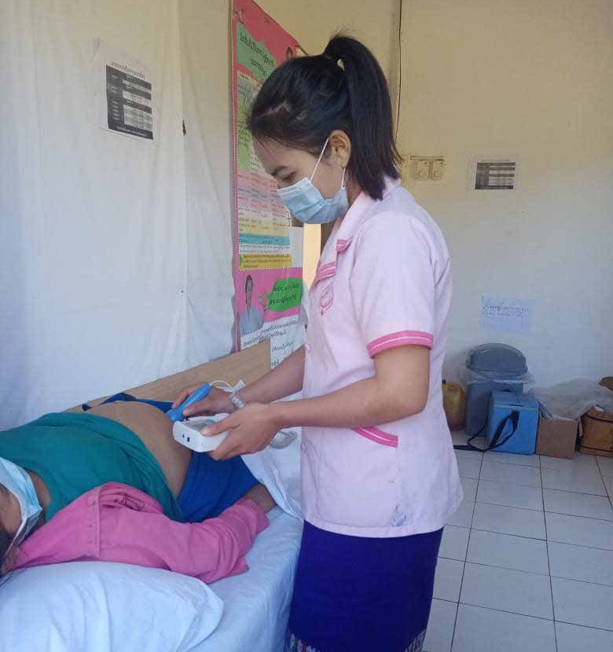
Midwives and pregnant women wearing masks for IPC in Lao PDR.
© UNFPA

services, increasing the proportion of women receiving ANC for the first time by at least 40%. At the borders, the programme refurbished seven quarantine centers, installed 37 gender sensitive WASH facilities, and trained 508 border officers on IPC while providing 3,000 officers with copies of a pocket guide on COVID-19 IPC.
The Lesotho programme created a new digital application, Bophelo-ka-Mosebeletsi, which enabled village health workers to undertake community surveillance, monitoring, and quarantining. The initiative also reached 138,618 people with COVID-19 related messaging and supported another 113,590 people with the installation and improvement of WASH services at health facilities.

The effort in Madagascar raised the COVID-19 case investigation rate from 75.9 % to 84.3 % of cases and tested 20,223 or 100 % of suspected cases. The programme operationalized and/or trained 41 Rapid Response Teams. It also provided 36 treatment centers with essential equipment and supplies, assured that targeted hospitals had oxygen, and equipped 46 resuscitation/respiratory teams. Because
of this, 100% of patients with severe symptoms received needed treatments, including oxygen therapy, 17,671 confirmed COVID-19 cases were treated, and 31 intensive care centers were able to provide 9,276 days of specialized care and oxygen therapy.
The Malawi programme met the healthcare needs of expectant mothers. It supported 256,282 women to access quality maternal and neonatal health services, such that 88.9% of pregnant women, including adolescents, attended all of their scheduled ANC visits in the targeted facilities. 1,443 women were given referrals for sexual
and reproductive health rights information and care. The programme also provisioned healthcare supplies, which improved access to care in 10 districts countrywide.
The Maldives initiative lent focus to meeting mental health needs. It provided mental health and psychosocial support services (MHPSS) training to nearly 7,000 individuals (teachers, MHPSS volunteers) and expanded access to MHPSS support, with 6,995 people across the country directly benefitting from a psycho-social helpline. Further, approximately 4,000 people received specialized mental health services from the Centre for Mental Health (CMH). A social media campaign on mental health reached 1,546,227 people. In part, as a result of the increase in service availability and the messaging regarding the universal challenges caused by COVID-19, there was a notable shift in community sentiments towards the acceptability of mental health services.
The Mauritania programme mobilized 2,288 volunteers that reached 288,000 households across the country with information on how to prevent and refer COVID-19 cases, and it deployed 300 health workers in the Nouakchott region for two months to bolster the healthcare capacity.
In Moldova, funds were used to procure 933,098 units of PPE for frontline workers and to provide 7,939 vulnerable and marginalized women, including young girls and their dependents, with access to immediate and preventive supplies, such as food and hygiene packages. The programme also operated at the borders, virtually training 200 border guards on IPC and benefiting 764,380 individuals with health screenings at PoEs.
The Mongolian programme increased daily testing capacity by ten-fold from 600 to 6,000, since last midterm progress report; increased national COVID-19 testing laboratory capacity from five to by 16 laboratories; and purchased
kits and PCR reagents needed for 40,000 tests. It also supported the testing of 559,878 people, confirming 1,074 COVID-19 positive cases. Overall, with this programme, two million people in Ulaanbaatar and seven provinces benefited indirectly by having improved access to testing services in their provinces.
In Morocco, the programme’s mobile health services benefitted 21,473 women across 30 health facilities, and its four mobile health units provided in-home palliative care for 400 bedridden cancer patients. The initiative focused on meeting women’s healthcare needs, especially victims of
domestic and gender-based violence. It: equipped 30 health facilities to ensure quality prenatal care, benefiting 3,000 women; equipped 113 health units for women victims of

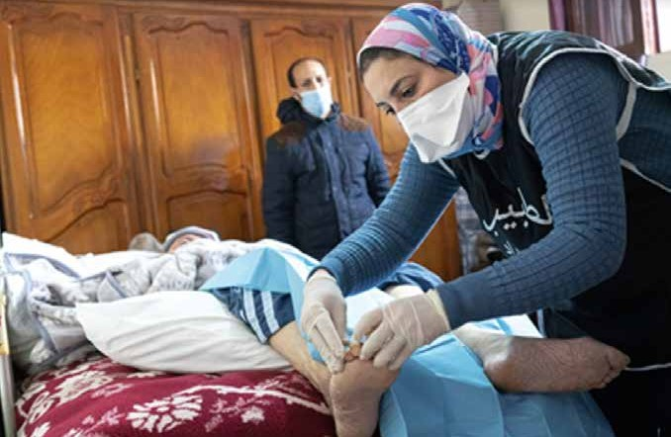
Ensuring the continuity of essential services for the most vulnerable people during COVID-19: in-home palliative care for bedridden cancer patients.
© UN Morocco/ ONU-Maroc/Hassan Chabbi

violence in provincial hospitals; hosted 139 women victims of violence in three shelters; provided 200 women victims of violence with hygiene kits; counselled another 504 women violence survivors; integrated 50 women violence survivors into cooperatives where they could earn livelihoods; and provided 4,500 women victims of violence with emergency contraceptive pills. The programme also outreached to marginalized groups, as it sensitized 3,500 sex workers on COVID-19 IPC, provided 1,050 migrants HIV prevention and sexual and reproductive health promotion programmes, and equipped 24 prisons with 13,700 inmates with PPE and tele- consultation health services.
The programme in Papua New Guinea also supported women’s healthcare in the North Fly District of Western Province, a border area with COVID-19 cases. To improve maternity and neonatal care, the programme renovated two health centers/hospitals and trained 62 healthcare providers, while also providing 400 clean reproductive health delivery kits. It provided care for 829 pregnant and postpartum women, and supported the delivery of 104 babies,
giving them neonatal care. Because of the programme’s communication initiative, 6,610 community members were reached with information on COVID-19, pregnancy complications, delivering in a health facility, newborn care,
and family planning, and as a result, the proportion of births delivered in health facilities rose to 64% from 58%.
In Tajikistan, the programme procured supplies for 100 hospitals/primary healthcare facilities, benefitting 13,000 people confirmed positive for COVID-19. The programme also helped establish tele-health technologies for the first-time, introducing alternative sexual and reproductive
health service (SRH) provision in the country. Towards this
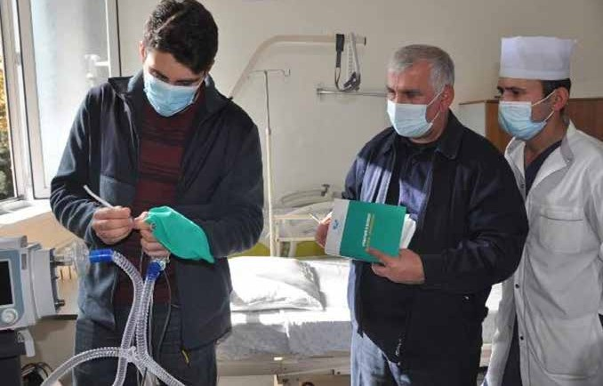
Capacity building of health professionals in the use of ventilators in Tajikistan
© Saidmurod/UNICEF Tajikistan/2020

end, 22 SRH service providers offered alternative ANC, family planning, and psychosocial support services, and an estimated 19,400 women of reproductive age received remote online consultations on SRH and gender-based violence related services. The programme also distributed 60,000 leaflets on SRH and basic hygiene practices.
An isolated pacific island State with a population of just over 1,600 residents living on three atolls, Tokelau had no reported COVID-19 cases at the time of reporting. The programme thus supported preparedness by upgrading quarantine centers on all three atolls so that 39 rooms, 64 beds and 11 isolation wards were ready. The initiative
procured and distributed 1,716 items of PPE and launched a preventive healthcare campaign that reached the country’s entire population. Finally, the programme built the capacity of 56% of the health workforce to provide essential SRH services during emergencies.

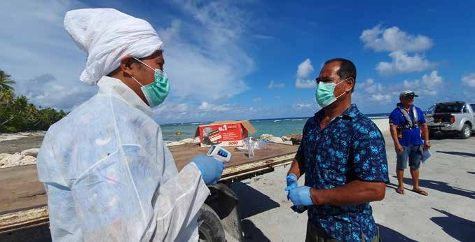
Nurse carries out arrival screening in Tokelau
© UNDP

SEF Pillar 2: Protecting People – Social Protection and Basic Services
The Fund assisted non-health ministries (social protection, education, agriculture, and transport) to provide and restore basic services that were interrupted by the pandemic. It also helped governments to support those most vulnerable to crisis, including by scaling up and expanding resilient and pro-poor social protection systems, maintaining essential food and nutrition services, ensuring continuity and quality of water and sanitation services, and securing sustained learning for children.
Under Pillar 2 on protecting people, 32 programmes were implemented, which, with Fund support, reached approximately 13.3 million direct and indirect beneficiaries.
Programmes under Pillar 2 had a very robust LNOB focus along with a strong gender lens. These interventions sought to expand assistance to marginalized people such as internally displaced people, refugees, migrants, people with disabilities, and the elderly as well as those living with HIV, drug users and the LGBTQ community. Initiatives extended the reach and accessibility of social safety nets to millions of vulnerable people, helping them to weather the pandemic’s economic shocks and meet their basic food, health, and personal security needs. They also built out WASH infrastructure in schools and communities and expanded digital education to meet the needs of all learners, regardless of their disability, language, or locality. Many of these initiatives helped countries to fight the pandemic and while also building the resilience of those least able to cope with shocks.
Country Highlights

The programme in Armenia offered direct cash support to 3,647 individuals and 247 households, including
2,932 children with disabilities, households with persons (predominantly Armenian nationals) displaced from Syria, and 715 elderly age 75 and above, and living alone. It also provided a vertical cash top-up of 26,500 AMD per child to 2,932 children with disabilities.
In Bhutan, the programme supported the provision of home- based education through TV and Google Classrooms to 170,000 children, and it delivered self instructional materials (SIM) to support the education of 32,135 children living in remote areas without access to television or smartphones.
In Cabo Verde, 1,000 of the poorest and female-headed households received a 5,500 CVE transfer for three months. Further, 150 women from the country’s poorest and most isolated areas received an integrated package of business support, and 52% of these businesses transitioned towards formality.
The programme in Cote d’Ivoire provided 1,322 women- headed households with financial assistance.
El Salvador also expanded social protections, with 2,190 vulnerable families assisted by means of a vertical and horizontal expansion of the Shock Responsive Social Protection model that was created. Further, 1,000
smallholder farmers’ households (of which 49.7% are female-headed) received agricultural incentives and training.
In the Federated States of Micronesia, the programme had a WASH focus. It installed 35 handwashing facilities, 10 toilets, and 12 water tanks in 10 healthcare facilities and provided 150 sanitary bins to support waste management, which benefited 106 healthcare staff.
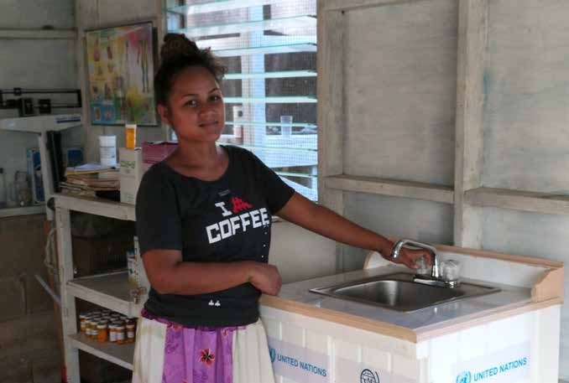
Fenfen dispensary handover sink in Federated States of Micronesia
© IOM

The programme in Georgia developed online learning resources that reached an estimated 414,000 students and helped launch a TV-school broadcast to educate children without internet connectivity. It also saw the set up of three shelters to house 200 elderly and homeless people..
In Ghana, the UN provided technical advice to expand the Ghana Productive Safety Net Programme, which supported
1.4 million extremely poor families, including people with disabilities, through an emergency double payment with a top-up. Further, 150,000 additional vulnerable people
(orphans, homeless, and people with disabilities) received a temporary cash transfer scale-up provided by a new mobile money payment modality.
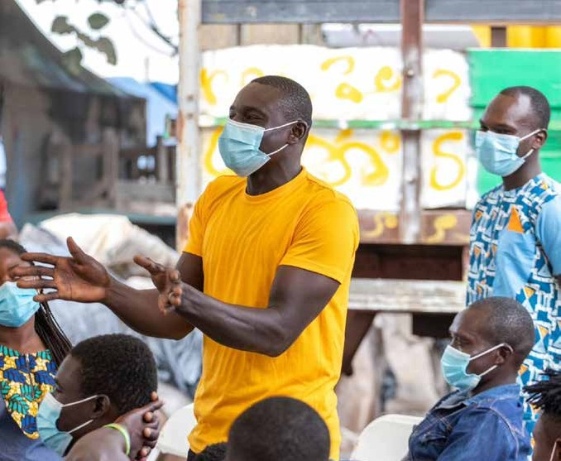
A beneficiary making contribution at training session in Ghana.
© UNFPA

The programme in India supported efforts led by the government to meet the immediate needs of approximately
3.3 million vulnerable and unemployed people. It also helped the government meet the longer-term needs of another
14 million people by linking eligible beneficiaries to all three social protection systems in the country. Further, the initiative improved access to nutritious food for 1.6 million marginalized and vulnerable people, including migrant workers; fortified 2,420 MT of rice for nearly 1.5 million beneficiaries; and established a production unit in Malwa,
Fatehpur to produce nutritious take home rations for 25,300 young children and pregnant and lactating women. The programme’s long-term impact and sustainability could eventually benefit up to 100 million people.
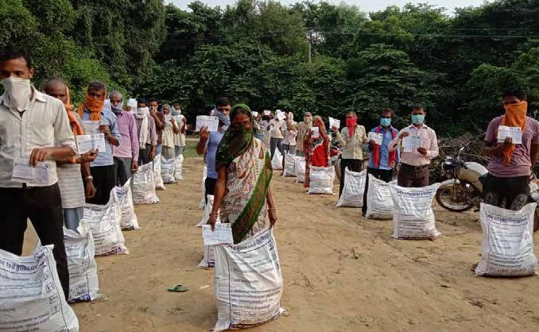
UN in India supported SAMARTH, a frontline civil society organization to distribute food packets consisting of wheat flour, pulses, oil and salt to nearly 120,000 marginalized people, including sex workers, transgender people, migrants, and persons with a disability or chronic illness.
© SAMARTH/Ajay Mishra
In Indonesia, the programme helped the government to improve social protection by reaching 443,160 individuals. Further, programmatic indirect beneficiaries were the beneficiaries of the current and expanded social protection programme for COVID-19, consisting of 10 million households of unconditional cash transfers (PKH); 20 million households of food assistance programmes (Kartu Sembako); and 11.6 million households of Village Cash Transfer.
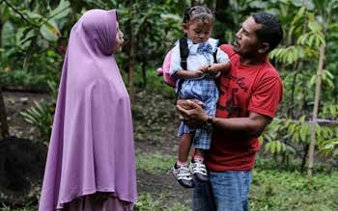
Mariun’s family is a recipient of cash assistance and is one of 312 families in Jineng Village, East Lombok district in Indonesia who received CBA assistance from UNICEF in 2020.
© UNICEF

With Fund support, Jamaica extended existing social protection programmes vertically and horizontally to approximately 3,937 households (13,000 people) who received a US$30 increase in PATH benefits, totaling 8,451 payments between August to December 2020. Further, 757 of the most poor and vulnerable households with pregnant and lactating women and 2,180 of the most poor and vulnerable households with children with disabilities were reached with additional social protections.
In Kiribati, a central focus was nutrition. The intervention provided 19,155 pregnant women and children under five- years old with essential nutrition services; messaged 50,000 community members on infant and young child feeding practices; and screened 10,884 children for severe acute malnutrition (SAM).
In Kosovo, the programme assisted 5,377 direct beneficiaries with counselling, legal aid assistance, and income generation support. Of these, at least 1,336 beneficiaries belonged to the Roma, Ashkali or Egyptian communities, and 574 persons to the Kosovo-Serb non- majority group. In addition, a referral system was established and referred 3,240 cases, relating to the needs of 7,144 vulnerable individuals.
Mongolia had a focus on education, with online interactive learning, reaching 149,161 children, parents, and teachers, including ethnic Kazakh and Tuvan minorities and people with disabilities (hearing and visual impairments), providing equal opportunities to those who are disadvantaged.
The Nicaragua programme developed a set of guidelines for the psychosocial support of children and adaption of school curricula, and these were disseminated to 60,000 teachers. The guidelines assured LNOB, as they were produced in various indigenous and Afro-Caribbean languages, such as Creole, Miskito, Mayangna, Panamaka and Tuak.
Focused on the North Fly District of Western Province of Papua New Guinea, the programme in supported nutrition and WASH, such that 9,469 children under five-years old

received vitamin A supplements; 3,725 children under five- years old received micronutrient powder; 3,272 caregivers of children under two-years old received feeding counselling; 3,993 pregnant and lactating women received nutrition education; 7,265 caregivers were counselled on child
feeding practices; and WASH interventions benefited 1,203 households, including 7,123 individuals.
Senegal also expanded the reach of education in the pandemic context. The programme reached 652,960 learners through the roll-out of a national radio learning programme focused on fundamental skills in literacy and math, while providing disabled children (visually and hearing impaired) with adapted assistance and learning devices. It also gave 1,000 refugee learners from 50 middle and high schools course materials and tablets.
In Timor Leste, the programme helped the government to expand its social protection scheme and target the most vulnerable. The government provided cash transfers to 313,398 low-income households – or 98% of all eligible households in the country, 20% of which were female- headed. Among other support, the joint programme covered 68% of the operational costs of the first stage of the cash transfer scheme.
In Tunisia, urgent cash assistance was provided to hard- hit urban refugees and asylum seekers, with some 1,000 extremely vulnerable beneficiaries countrywide receiving a one-time 250 TND (90USD) cash grant delivered in partnership with the Tunisian Post Office. The programme
also integrated 740 vulnerable women micro-entrepreneurs into capacity strengthening activities, and it launched the first hotline for psychological support for youth.
The programme in Viet Nam developed a smart phone application that was used to schedule 210,400 sexual and reproductive health visits. It also assured that 12,600
pregnant women accessed quality antenatal services, and 1,500 newborns and their mothers received a postnatal home visit. In addition, the initiative gave 60,514 HIV
key populations support in the form of information, cash transfers, and/or support packages. WASH activities benefitted 21,300 children and 11,300 villagers. The programme also gave 600 ethnic minority women cash grants of US$100 and 1,200 ethnic minority households cash for food security. Beginning in 2021, the programme will pilot take-home dose methadone to the benefit of 2,000 drug users.
The programme in Uzbekistan extended support to victims of violence, helping 301 women and children to be hosted by shelters and re-launching the national gender-based violence hotline, which received 5,623 calls. It also connected 50 rehabilitation center staff members of 14 regional offices to mobile operators and internet, which enabled them to field calls from and help gender-based violence survivors. The initiative also targeted people living with disabilities; giving 150 women with disabilities and mothers of children with disabilities sim cards to join a Telegram group and providing 154 families of women with disabilities and mothers of children with disabilities with food packages.

SEF Pillar 3: Economic Response and Recovery – Protecting jobs, small and medium-sized enterprises, and vulnerable workers in the formal economy
Based on the UNINFO data provided by countries supported by the Fund, under Pillar 3, approximately 232,819 of formal and informal sector workers were supported in the context of the COVID-19 pandemic. Approximately 1,053,647 people were direct beneficiaries of good supply protection regimes.
Out of the total funded programmes underway, 21 programmes supported implementation of Pillar 3 related activities, and they reached approximately six million direct and indirect beneficiaries.
Often with a focus on micro- small- and medium-enterprises (MSMEs), country programmes supported operational continuity and improved safety in the pandemic context for both businesses and their employees. Initiatives provided upskilling and retraining opportunities for informal workers, the unemployed, and migrants. A strong gender focus assured that many women benefitted from interventions that built capacity, offered financial assistance, and helped expand livelihood opportunities.
Country Highlights
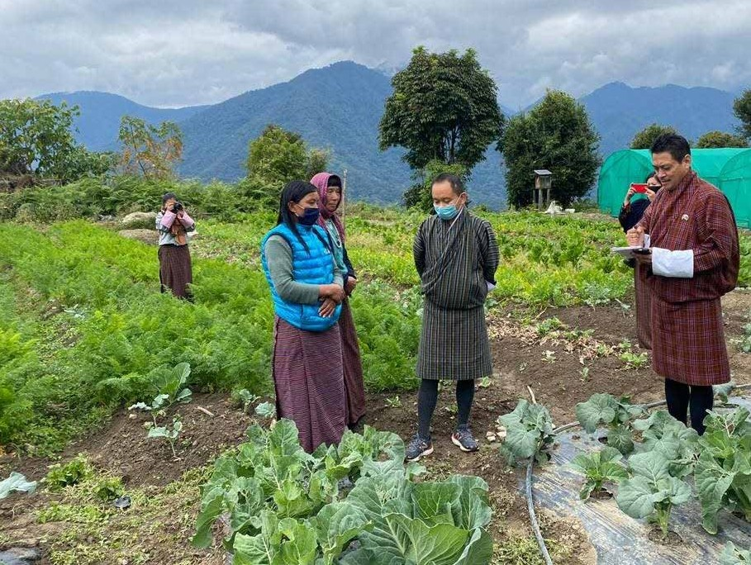
Towards economic recovery, the programme in Armenia offered 106 micro- small- and medium-enterprises (MSMEs) various mechanisms of support and provided 101 MSMEs with funding for their entrepreneurial initiatives. Further,
the initiative helped five industrial companies, with approximately 1,000 employees (95% women), to gear up to produce medical uniforms and bed linens, along with assisting 50 female employees with the organization of medical gear production. The programme also supported the
development of an online platform for labor rights protection.
Under the programme in Bhutan, licensed national cultural tour guides who were laid off completed an upskilling programme to become trekking guides. The initiative also enhanced four facilities in the tourism sector through a cash- for-work scheme, and it provided 668 smallholder farmers, of which 70% were women, (and their household members or approximately 3,340 individuals in total) with farming

inputs and training that increased agriculture production by at least 20%.
Staff of WFP, Department of Agriculture and District Agriculture officials, on field monitoring visits in Zhemgang.
© WFP

In Georgia, the programme allocated four agricultural grants to two women and two men to support innovative agriculture – the first mushroom farm in Abkhazia, and a greenhouse complex powered by bio-gas – projects that created 11 new jobs and reached 60 direct beneficiaries/ households of 15 farmers. It also provided 620 vulnerable households engaged in small family
farming in seven regions with agricultural inputs.
The programme in Madagascar supported the production of 400,000 masks in cooperation with 10 local associations and companies, which created 2,565 jobs, of which 1,500 were occupied by women. Six of the mask production shops were led by women.
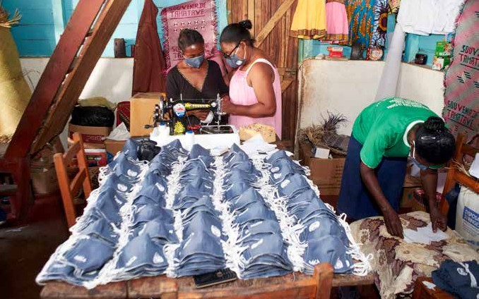
Women involved in PPE/mask production in Madagascar.
© UNIDO
In Nepal, the programme provided immediate cash assistance and recovery support of approximately US$115 (NPR 13,500) to 250 vulnerable returnee migrants. It also offered vocational and skills trainings to 244 programme beneficiaries, who, two months after training completion, had an estimated employment rate of 58%, exceeding programme targets.
The Sao Tome and Principe programme reached 3,000 beneficiaries (600 family groups of which 93% were headed by women) with trainings. The initiative also reactivated and organized school gardens from 32 national entities to the benefit of approximately 3,500 school children.
In Solomon Islands, where women are the majority of market operators, the programme supplied 400 vendors with tents and WASH equipment to enable business continuity.
Indirectly, the programme benefited 90,000 people who depend on the markets for fresh produce. In 2021, the distribution of agricultural inputs will reach an estimated 30,000 people.
In Sri Lanka, the programme undertook the entire sourcing, evaluation, quality control, procurement, transportation,
and physical distribution of PPE kits to 995 micro and small enterprises. It supported an additional 966 MSEs (468 women-led and 498 male-led) with access to finance and the resumption of business operations. A further 93 MSEs were to receive LKR 22.18 million (app. USD 120,000) as working capital loans from four companies, and to date, 15
(small suppliers to these large companies) received LKR 4.15 million.
The country programme in Uzbekistan developed special programmes to provide business and entrepreneurial skills trainings that helped nearly 400 women and youth in the communities most affected by lockdowns. It also offered 100 women informal workers, who had been hit hard by the pandemic, trainings on business and family
entrepreneurship. Further, 100 women from 80 communities
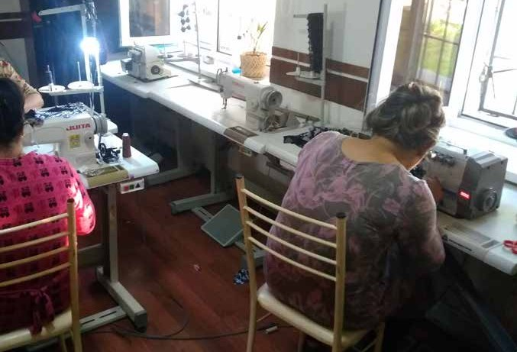
Surkhandarya Region Rehabilitation Center offering women the opportunity to rebuild their confidence through free use of equipment to acquire and enhance their sewing skills and help earn income during the COVID-19 pandemic in Uzbekistan.
© UNFPA Country Office in Uzbekistan

were selected to receive assistance from the NGO network to manage credits and bank loans for their businesses.
The initiative also supported 60 migrants, who each, on average, received $2,568 to purchase equipment for start-up businesses. It also extended 580 psychological, legal, and business counselling sessions to an additional 274 men and 306 women migrants.
The Vanuatu programme had approximately 4,500 direct beneficiaries, 90% of whom were women. It benefited 1,000 Port Villa market vendors with the delivery of WASH supplies and COVID-19 prevention interventions. Its indirect beneficiaries were 40,000 people living in this market catchment area. It also supported 3,000 vendors in Luganville Market, which indirectly benefitted a market catchment population of approximately 10,000 people.

SEF Pillar 4: Macroeconomic Response and Multilateral Collaboration

One joint programme, in Cambodia, was implemented under Pillar 4 on Macroeconomic Response and Multilateral Collaboration. This programme commenced in January 2021.
Country Highlights
Recently underway, the programme in Cambodia will assist the national government in rolling out, for the first-time ever, a $200 million credit guarantee scheme to provide low-cost and reliable financing to micro-, small-, and medium-sized enterprises (M/SME) and boost growth in this sector. With
a view to reducing poverty and increasing employment, the scheme will maximize the participation of and benefits to women-owned M/SMEs operating in the informal sector as
well as labor intensive businesses and businesses requiring low skilled labor, in particular, migrants.
The key results delivered by the time of reporting included: the legal establishment of the Credit Guarantee Corporation of Cambodia (CGCC), the formal government approval
of the CGCC policy framework, and critical partnership development between the government, neighboring countries credit guarantee organizations, and the private sector.
It is anticipated that at least 1,000 M/SMEs will benefit from this credit guarantee scheme, which will improve access to new financial products.

Partnering with Civil Society
In December 2020, Cepei, a nonprofit think tank based in Bogotá, Colombia, in collaboration with the Tableau
Foundation and approximately 20 other partners, including the COVID-19 Response and Recovery Fund, launched the COVID-19 Data & Innovation Centre, a collaborative data platform designed to inform pandemic responses and recovery strategies.
With a focus on the Global South, the Centre aimed to glean a wide range of pandemic-related data spanning various sectors and peoples and make it universally accessible.
Ultimately, the platform intended to help those leading pandemic response and recovery initiatives to work from the same trusted data and to be able to coordinate their strategies. Its focus on the Global South was to help assure that no one was left out of the architecture of response and recovery.
Highlights from the Launch
Delivering the keynote address at the Centre’s launch, Tableau CEO Adam Selipsky described 2020 as a “data tsunami.” “With the pandemic and its ripple effects, leaders and governments across the world have been seeking out robust, reliable information to understand the crisis and guide how they address it,” he noted. The places with the most effective responses, according to Selipsky, have all had something in common: a strong data strategy. For instance, Senegal has roughly seven doctors for every 100,000 people, yet it ranked second in the world—behind only New Zealand—on pandemic response. By using data to manage the response, funding allocation, and resources available
in communities, Senegal’s Ministry of Health’s Emergency Operations Center built the capacity of its healthcare systems, kept the virus under control, and delivered care to those who needed it.
COVID-19 has brought about a tremendous need not only for data itself, Selipsky said, but for data culture.
“Fundamentally, this means organizations are reshaping the way they are organized, and data is moving to the center of the conversation. It’s a big concept, and I’d argue it’s harder to achieve than the technology.” He noted that the Centre makes data broadly accessible and can therefore drive conversations and inform decisions across the board.
For Cepei, creating a data resource that everyone could understand was critically important. “User accessibility has been our main driver,” said Philipp Schönrock, Cepei’s
Director. The Centre’s data laboratory pulls from 85 different data pipelines, and that data is represented in approximately 40 Tableau dashboards. The intent is to continue working with countries and organizations to pull in as much data as possible from local, national, and global actors. “To bring this data to life, we’ve used the capabilities of our partners like Tableau and Mapbox to enhance our data and create data visualizations and stories that make it possible to incorporate data into decision-making,” Schönrock said.
Cepei’s partners, like UN Women, are optimistic about the value of the data coming out of the Centre’s platform.
Speaking at the launch event, Anita Bhatia, Deputy Executive Director of UN Women, said that they are “looking forward

to how we can take the data that comes out of this platform and use it to benefit the women and girls of the world so that recovery from the pandemic can allow us to build back equal.” Data on the uneven economic impacts of COVID-19 on women should play a critical role in shaping response strategies,” Bhatia added. “I could go blue in the face talking about the economic impact of the pandemic on women, but it’s not until I have data—ideally beautifully visualized data— that we can change the hearts and minds of people. When
I say that Bureau of Labor Statistics data shows 865,000 women dropped out of the workforce in September—as opposed to 200,000 men—people understand the burden of caretaking on women in a way they don’t if I just say that the care burden is really impacting women.” The data provided through the Centre is intended to illuminate gaps and narratives like this so policymakers can take action.

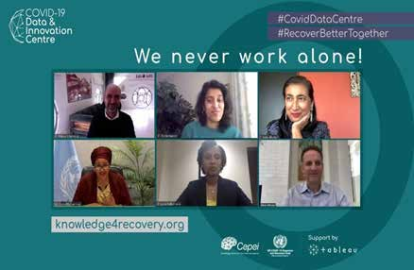
The Deputy Secretary-General (bottom left), emphasized the importance of working with civil society. Also featured: Tableau CEO Adam Selipsky, alongside CEPEI Director Philipp Schönrock, Sheila Warren Head of Blockchain, Data, and Digital Assets and Member of the Executive Committee, the World Economic Forum, Lydie Hakizimana, CEO of African Institute of Mathematical Sciences, and Anita Bhatia, Assistant Secretary-General, and Deputy Executive Director at UN Women.

With data critical to COVID-19 action and response across the world, Cepei and its partners worked quickly to refine their vision and launch the Centre in a matter of weeks. “This was possible by finding the right partners and having a team that delivers and inspires others,” Schönrock said. “We needed financial and technical support, that also allowed
us to experiment and adjust,” he elaborated. Partners like Tableau Foundation were able to offer that critical, flexible support to Cepei and collaborate with them and other partners to make the Centre’s launch possible.
Now that the Centre is launched, Schönrock emphasized that its purpose is to support response and recovery strategies for as long as necessary. “The Centre is not time-bound,” he said. “Our Centre exists to drive decision-making so we all can recover better together. This is not an abstract concept— in the end, it’s about the lives of our people and our communities, and we welcome your comments and ideas.”

To learn more about the COVID-19 Data & Innovation Centre, visit https://knowledge4recovery.org/data/.
*Highlights adapted from a blog originally drafted by Neal Myrick.

Early Lessons and Evaluability Assessment of the COVID-19 MPTF

The Early Lessons and Evaluability Assessment of the UN COVID-19 Response and Recovery Trust Fund (the Fund) responds directly to the need for learning and accountability in the context of UN development system (UNDS) reform, recognizing also the close relationship between the Fund and Socio-economic Response Plans (SERPs). The Assessment represents one of the first efforts to realize the potential of a System-Wide Evaluation (SWE) approach.
The methods used include structured document reviews at the global and country levels, key informant interviews at the global level, and case studies of Fund operation and the SERPs in the seven countries (Cambodia, Guatemala, Kosovo (SC Resolution 1244), Malawi, Maldives, Moldova,
and Sao Tome and Principe). The case study countries were selected to provide an illustrative example of the Fund and SERPs in a variety of national contexts. All findings and early lessons presented in the report are evidence-based. In all, over 100 structured interviews were carried out, gathering information from 138 key informants. In addition, the
results of the country case studies were validated through discussions and feedback with the UN Country Teams (UNCTs) involved.
The lessons learning component of the exercise found that projects approved and implemented under the Fund were relevant to meeting national needs and addressing critical gaps in the socio-economic response to COVID-19.
They did so in a timely manner during the most acute early phases of the development emergency. This rapid response was enabled by progress made in the UN development system reform process before the onset of the pandemic. The Fund and the SERPs both contributed to accelerating the ability of newly independent and empowered Resident Coordinators to coordinate a more coherent UNCT response at the country level. The Fund was also a positive factor in strengthening the pursuit of gender equality in the SERPs and in Fund-supported projects. The UNCTs noted that the Secretary-General’s ‘UN Framework for the Immediate
Socio-economic Response to COVID-19’ (the UN Framework) provided a clear and useful framework for planning within
its five pillars of intervention. Finally, experience with the Fund and the SERPS demonstrates the potential of the UN development system to achieve collective results through collaboration.

Key Early Lessons
In a development emergency, speed of response matters. The launch of the Fund on 3 April 2020 facilitated a rapid and visible response from UNCTs. Later that same month, the UN Framework established a clear structure for joint planning by UNCTs around a coherent, structured, and transparent response plan in SERPs.
To sustain collaborative action and a coherent UNCT socio-economic response, pre-existing coordinating structures and human resources matter. Key areas of UN development system reform, especially the independent and empowered Resident Coordinators and fully staffed Resident Coordinator Offices (RCOs) with key competencies, proved crucial. Global UN development system architecture in place to coordinate gender and disability focal points and human rights experts across the system played a facilitative role for a focus on gender equality, human rights, and leave-no-one behind (GE/HR/LNOB) principles in the response.
To ensure a coherent programmatic response, inclusiveness, and broad participation by the UNCT matters. The pandemic and its accompanying development emergency showed that an effective socio-economic response at the country level must be grounded in experience and expertise drawn from across the spectrum of UNCT entities, including non-resident agencies (NRA). There are many examples of smaller and NRA entities improving the quality of proposals submitted to the Fund. The same effect can be seen in the influence of these entities on the quality and technical content of the SERPs, especially for attention to GE/HR/LNOB principles.
While speed matters, it brings challenges that must be managed. The speed required to react to the development emergency brings with it stresses that must be met collectively by the UNCTs under the leadership and coordination of Resident Coordinators. In a rapid response environment, where larger UNCT entities had inherent advantages in staff capacity and operational experience, Resident Coordinators needed to ensure processes such as the identification, preparation, submission, and approval of proposals for support by MPTFs are transparent, fair, and inclusive so the full complement of UNCT expertise is accessed. Smaller entities are on the playing field, but it is not yet level.
An enabling organizational culture and readiness to be accountable for collective results are necessary when the UNDS system moves to an emergency footing. The structural and procedural investments in UN reform are not themselves sufficient to ensure a coherent response. They must be complemented by a readiness on the part of
UNCT members to act collaboratively and to be collectively accountable for results. The experience of collaborating on Fund projects and in preparing the SERPs has helped to strengthen a commitment to coordination, coherence, and collective action among UNCT entities, but there is more work to do. There is a need to move beyond structures and processes to a genuinely inclusive culture of cooperation where smaller and NRA UNCT entities inputs are valued and encouraged. Incentives for collaboration and contributions to collective results (including with regard to accountability and performance) need to be clear and strong across all UN
entities.
A global response framework and a UNCT plan at country level matter. In the pandemic’s earliest, most acute phase, the Fund, the UN Framework with its five pillars, and the SERP process were well structured and responsive to the socio-economic imperatives of the emergency. The UN Framework supported by the UN Secretary-General’s appeal, the Fund, and SERPs served UNCTs well in identifying
action and encouraging collaboration on joint work. However, as recovery appears on the horizon (at different times and
at different speeds in different countries and regions) this framework is less suited to ensuring a more equitable and sustainable recovery and return to the 2030 Agenda.
UNCTs need more specific guidance on policy engagement, advocacy, and programming to build back better, greener, and more equitably.
Given effective action, a development emergency can be leveraged to advance core values and commitments. Experience in planning and implementing Fund projects and in collaborating on SERP development has shown that

the guiding values of GE/HR/LNOB principles still require active attention to be fully integrated across the UN system. Progress is supported through collective commitment,
high level messaging, a strategy of broad coalition building, tailored guidance, and by the work of energetic, technically skilled, and agile champions among UNCT entities. Financial incentives in the form of allocation targets play a particularly important role.
In a global development emergency, agility, and technical expertise matter. The ability of the UNCT to identify opportunities for joint action quickly and to fund gap-filling projects that respond to national imperatives has an important demonstration and confidence-building effect for the UNCT and its partners. The SERP and the Fund provided an important opportunity to elevate the visibility of
UNCT comparative advantage to support and shape national responses.
Funding matters. While the size of the funding pool is not everything, the low level of resources available for the Fund is a constraint that limits Resident Coordinators’ ability to engage national governments and attract investments from development partners. It also reduces the incentive for UNCT entities to work collectively under the coordination of the Resident Coordinators. While re-purposed funding has been a major factor in ensuring resources are committed
to the five pillars of the SERP, it cannot fully substitute for the Fund or similar multi-partner trust funds. If the Fund and Joint SDG Fund come together, there is an opportunity to re-submit the case for increased support to development partners and non-traditional contributors and to re-energize the Funding Compact.
In a development emergency, credibility, transparency, and accountability matter. The case for increased investment requires transparency and accountability on the part of the UN development system. Work on open

results reporting through UNINFO for the SERPs and the work done on RBM system development by the Fund have helped to improve transparency and accountability. There are opportunities to improve the clarity of the underlying theories of change for both and to better link (in the case of the Fund) project outputs to credible outcomes. Similarly, there is a need to invest in improved gathering and reporting of output data which is disaggregated by vulnerable group membership as well as by sex.
The UNCT response to a development emergency must be tailored to the social and economic contexts of diverse countries. The negative socio-economic impacts of COVID-19 were not felt evenly among and within countries. Smaller middle-income countries (MICs) and small island developing States (SIDS) suffered almost instant and very deep declines in national income. Countermeasures to COVID-19 shut down borders, greatly reduced trade, and devastated tourism-dependent economies. Lockdowns were particularly damaging for small MICs where economies depend on remittances from expatriates who returned in large numbers to already damaged economies. While low- income countries faced their own special burdens in the pandemic, the experience of smaller MICs and SIDS shows that the UN development system needs flexible tools to respond to variabilities in country contexts.
In a development emergency, leadership matters. Key informant interviews at the global and country levels highlighted the role played by senior management of the Fund in ensuring open and transparent governance; in
communicating Fund priorities and strategies to Resident Coordinators around the world; and, in strongly advocating for measures to incorporate gender equality, human rights, and LNOB values in the work of the Fund. They also noted that this leadership was supported by a responsive Advisory Committee and an engaged Fund Secretariat.

Six Strategic Recommendations
Prepare a global report that sets out the framework for United Nations support to countries to recover better and greener.
Expected Benefits: The report will provide the global strategy for the UNDS to recover better during the Decade of Action and provide guidance for the preparation of revised or new Cooperation Frameworks. It will help the partners and public understand the collective offer of the UNDS during the Decade of Action.
Prepare and implement a strategy for deepening the UNDS reform to realize its full potential.
Expected Benefits: The most important expected result would be to maintain the important momentum gained in the past year with regard to consolidating and strengthening UNDS reforms at country level and realize its full potential.
Conduct a management review and merge the Joint SDG Fund and COVID-19 Fund to create a fund that is operationally agile and effective. Re-engage and resubmit a case to the donors to use the pooled funding mechanisms to recover better in line with the agreed commitments of the Funding Compact.
Expected Benefits: Should donors engage as per the Funding Compact commitments to fully fund a strategic Joint Recover Better Fund at the global level with more substantial financial resources, it will greatly improve the UN development system’s ability to engage with national governments on normative and programme issues. It will also incentivize the UNCT entities for joint planning, joint programming, and better collective results for the SDGs. Importantly it will improve collective results towards gender equality, human rights, support for people with disabilities, and a focus on LNOB.
Build on the lessons from UNCT collaboration on Fund projects and SERPs to consolidate and strengthen improvements in gender equality, human rights, support for people with disability, and LNOB focus across the work of all UN entities at the country level.
Expected Benefits: Embodying core values of the UN and linkages to the SDGs and a means of addressing the disproportionate effect of the pandemic on women, people with disabilities, and other vulnerable groups as well as putting human rights at the center of efforts to recover better.
Review and learn lessons from the SERPs prior to transitioning to the new or revised Cooperation Frameworks.
Expected Benefits: A more coherent and focused Cooperation Framework that does not reflect a return to normal but rather absorbs the lessons of the development emergency and builds in resilience to other shocks during the transition to recovery. The Cooperation Framework building on SERP lessons will move towards increasingly collaborative UN work at the country level in line with the Quadrennial Comprehensive Policy Review.
Implement the System-Wide Evaluation of the UNDS Response to COVID-19 with a focus on learning to support a better recovery during the Decade of Action.
Expected Benefits: Accountability of the UN development system as per the Funding Compact. Learning and continuous improvements to the UN development system during the Decade of Action to accelerate results for SDGs.

Roadmap for the Fund’s Merger into the Joint SDG Fund 2021-2022

As per the Terms of Reference, the COVID-19 Response and Recovery Trust Fund will terminate no later than March 2022 but ideally sooner pending the ability of suitable successor arrangements to take over. This will broadly follow the recalibration of analytical and planning approaches at the country level.
The Secretary General’s COVID-19 Socio-Economic Response Framework and related analytical and planning tools (the Vulnerability Assessments and the Socio-economic Response Plan, SERP) were launched as stand-alone emergency planning and financing tools to deal with the separate and immediate funding and planning needs to respond to the global development emergency, which unfolded as a result of the COVID-19 crisis in early 2020.
Therefore, all SERPs are expected to conclude by late 2021, at which point they will be integrated back into the main Joint Work Plans under the UN Sustainable Development Cooperation Frameworks (UNSDCF). Stand-alone Joint Work Plans (JWP), which were produced for the SERPs in 2020 can thus continue into 2021, but all activities should be integrated into the main JWPs by 2022. About 40 UNSDCFs will be updated in 2021 and will use the SERPs as the baseline rather than past SDCFs.
At the time of writing, the COVID-19 Response and Recovery Trust Fund was conducting an early lessons learned exercise, which was expected to deliver a report with key findings in early April 2021. The Joint SDG Fund is expected to undertake a similar review to identify key strengths and challenges in terms of decision-making, operations, and delivery throughout the pandemic.
These two reviews will collectively provide an evidence base to inform the process of merging the COVID-19 Response and Recovery Trust Fund into a revised Joint SDG Fund. The overall objective is to establish a more effective Joint SDG Fund as
a standing pooled financing mechanism, which accelerates SDG investments aligned with national development plans throughout the Decade of Action by applying innovative financing approaches. Furthermore, the revised SDG Joint Fund should pursue another key objective. Following the termination of the COVID-19 Response and Recovery Trust Fund, the
Joint SDG Fund should retain the ability to invest in preventive and anticipatory activities to mitigate the impacts of sudden onset development crises and to respond to development emergencies when they occur. This could include revised decision-making processes, planning cycles, partnerships, digitalization of application and grant management processes, and reporting either for the Joint SDG Fund as a whole or for a development emergency response window under it.

21
The COVID-19 MPTF Global Report

PART 2

PILLAR 1

Protecting Health Services and Systems during the Crises

BELIZE

COVID-19 Response to Vulnerable Populations and Frontline Workers in Belize

End Date: 31 December 2020

Programme Summary
This programme supported the standardized production and distribution of COVID-19 communications products targeting the general public and frontline workers in high-risk sectors; provided medical equipment and personal protective equipment to isolation facilities and community health workers in the Central, Western and Central-Southern Health Regions, including COVID-19 PCR tests specifically for pregnant women; and safeguarded the continuity of antenatal and prenatal care as well as sexual and reproductive health services.

Achievements under Pillar 1 on Health First
Risk communications
- Developed a Risk Communication and Community Engagement (RCCE) Strategy to inform vulnerable populations on accessing COVID-19 healthcare. Messages translated into indigenous and local languages reached 206,435 people (49% of the country’s population)
- Distributed 500 COVID-19 Quick Facts and Resources Booklets to 150 community healthcare workers (CHW)
- Printed 1,632 posters with COVID-19 preventative messages (800 posters in English, 800 posters in Spanish, 12 posters in Garifuna, 10 posters in Mopan Maya and 10 posters in Q’qechi Maya)
- Belize Family Life Association (BFLA) posted 130 of COVID-19 posters/products/flyers and audio messages on main social media pages, which reached 55,689 people (65.5% women)
- Ministry of Health placed flyers in 100% of public health facilities reaching at least 625 pregnant women accessing services from Maternal and Child Care Units in December
- MOH produced 800 posters (11 x 17) and 10,000 letter size flyers on transmission precaution measures for COVID 19 during pregnancy, with dissemination to continue in 2021
Practical guidelines and knowledge products for workers’ occupational safety and health (OSH)
- OSH public service announcements through a campaign on COIVD-19 in the workplace reached approximately 75% of the population
- The campaign, in English and Spanish, consisted of: three radio public service announcements; three newspaper public service announcements; three TV public

service announcements; three infographics and 3,000 pamphlets on workplace prevention
Facilities and community healthcare services
- Provided medical and PPE for regional isolation facilities and 200 CHW in the Central, Western and Central- Southern Health Regions, including: 1,000 KN95 masks, 1,000 surgical masks, 1,000 disposable gowns, 650 goggles, 650 face shields, medical waste bags and sharp containers; and medical equipment: ten patient monitors, ten laryngoscopes, and two AED defibrillators

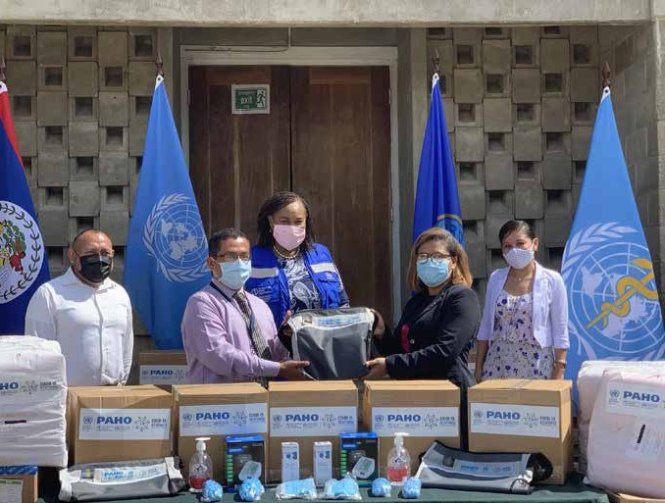
The UN handed over 30,000 sets of Personal Protective Equipment, 150 test kits and various essential health commodities to the Ministry of Health to support the Government of Belize to curb the spread of COVID-19.
© UN Belize
- Provided medical equipment and supplies as well as emergency beds and space dividers to the isolation area of the Rural Health Center of Valley of Peace - one of the few community-based COVID-19 isolation facilities in Belize
- In the three Health Regions, donated supplies benefitted an estimated 159,267 people, including 2,823 asylum- seekers
- By 31 December 2020, BFLA conducted 27 mobile clinics to provide an essential package of sexual reproductive health and family planning services to 499 people
Healthcare Workers
- Provided 150 kits with diagnostic items and PPE, as well as trainings, for CHWs in the Central and Northern Health Regions
- UNHCR provided 100 COVID-19 basic field kits to all 73 CHWs operating in the Western Health Region plus 27 CHWs operating in the Independence catchment area of the Southern Health Region
Restoring Interrupted Services for AN/PN Care
- Restored services for antenatal and postnatal care interrupted by the pandemic and conducted telehealth services to reduce COVID-19 transmission with

preliminary data indicating the number of services delivered in the last six months of 2020 to be: Child health services – 27,731; Prenatal care total - 17,136; Postnatal care - 1,870 and vaccines administered – 70,252
- 14,400 COVID-19 test kits and 2,500 extraction kits were handed over to the Maternal and Child Health unit of the MOHW to support the testing of pregnant women
- By 31 December 2020, BFLA conducted 27 mobile clinics that provided an essential package of sexual and reproductive health and family planning services to 499 people

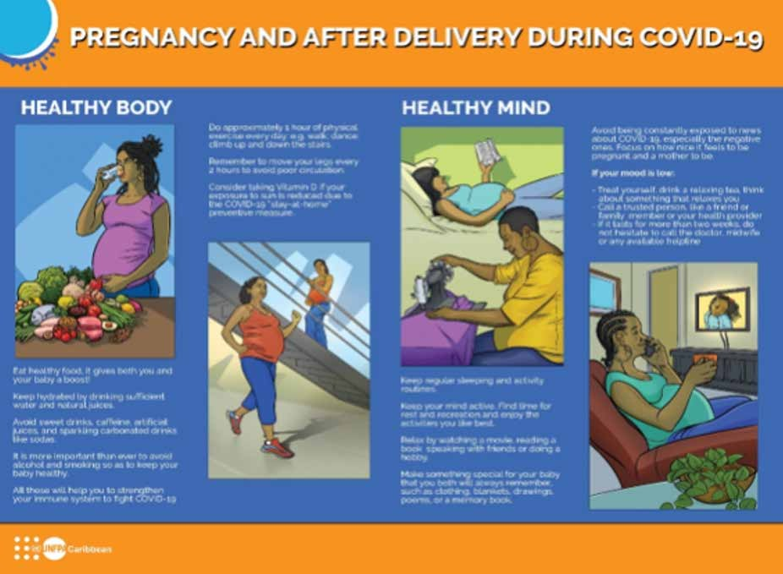

Innovation and Learning
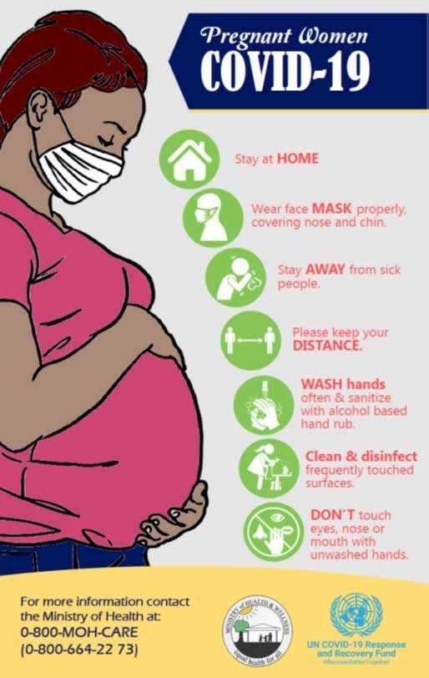
The UN collaboration with the Ministry of Health and Wellness to develop an overall Risk Communication
and Community Engagement Strategy resulted in a comprehensive exercise that created a solid basis and concrete communication products that will serve current and future risk communications needs.
Telehealth helped prevent COVID-19 transmission by reducing walk-ins and allowing health professionals to remotely follow-up with clients and schedule in-person appointments as needed (e.g. for high-risk pregnancies). Although women were targeted, the services and commodities were also delivered to men, such as for HIV testing and condoms, given the demand encountered in the communities. In addition, the supplies and trainings provided to CHWs increased their moral.
On inclusion, the National Garifuna Council and the Belize National Indigenous Council expressed appreciation for being included in the development of the language-specific (Garifuna, Mopan, and Q’eqchi) posters that reached target groups sometimes left behind.

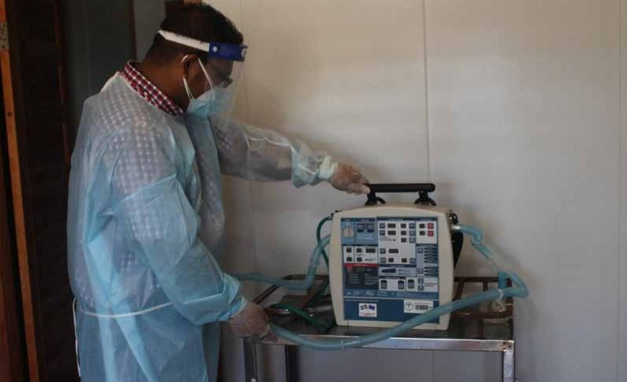
UNHCR donated medical and protective equipment to different health clinics across Belize, including Independence, Belmopan, and Valley of Peace. These supplies benefitted refugees and Belizeans living in nearby communities.
© UNCHR
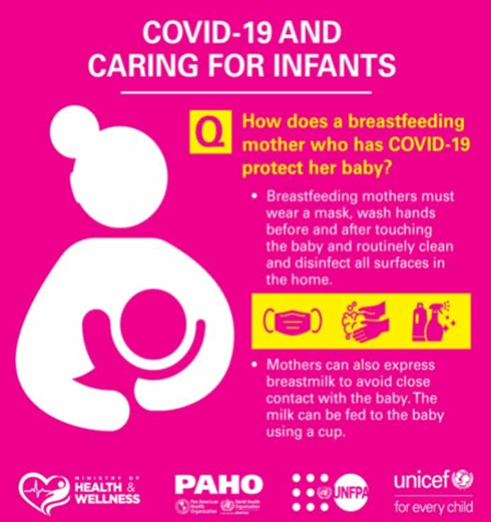

CAMBODIA

Strengthened National Preparedness, Response and Resilience to COVID-19 in Cambodia

End Date: 31 December 2020

Programme Summary
This joint programme protected migrant communities from large-scale COVID-19 transmission and mitigated the socio- economic impacts of COVID-19 in the three target provinces of Siem Reap, Beantey Meanchey, and Battambang. It delivered a comprehensive assistance package of multi-sectoral interventions to returning migrants throughout the mobility continuum. The programme also strengthened coordination at sub-national and national levels, involving government and civil society actors in COVID-19 prevention and socio-economic recovery efforts. Interventions resulted in the increased knowledge, information and utilization of essential health and Mental Health and Psychosocial Support (MHPSS) services, as well as in the increased resilience of migrants and communities through newly created income generating opportunities.

Achievements under Pillar 1 on Health First
- Provided 322,809 returning migrants and host communities immediate access to COVID-19 information and preventive measures, including audio visual educational materials, at Points of Entry (POE), quarantine centers and the community level, through outreach activities conducted by the Commune Council for Women and Children (CWCC)
- Referred 309 returning migrants and families with tuberculosis symptoms within host communities for services, while 5,799 returning migrants and families suspected of COVID-19 were referred to a healthcare facility for diagnostics and quarantine at POE
- Provided hygiene kits to 2,150 returning migrants and families that were referred for quarantine at POE
- Empowered the local Commune for Children and Women Committees to support 7,319 returning migrants and host communities on COVID-19 prevention and to provide improved access to essential health services, namely MHPSS, maternal care and gender-based violence (GBV) support at the community level
- Built the capacity of 35 district social affairs and social welfare officers to monitor the situation of children, particularly children of returning migrants, and to provide case management and to facilitate referrals
- Provided 744 vulnerable migrants, in particular women- headed households, individual economic reintegration packages consisting of short skill trainings and small grants to purchase equipment and materials in support
of income generating activities such as chicken raising, vegetable growing or small business ownership
- Trained 575 health professionals, social service workers, and staff of quarantine centers on MHPSS and on GBV risk mitigation

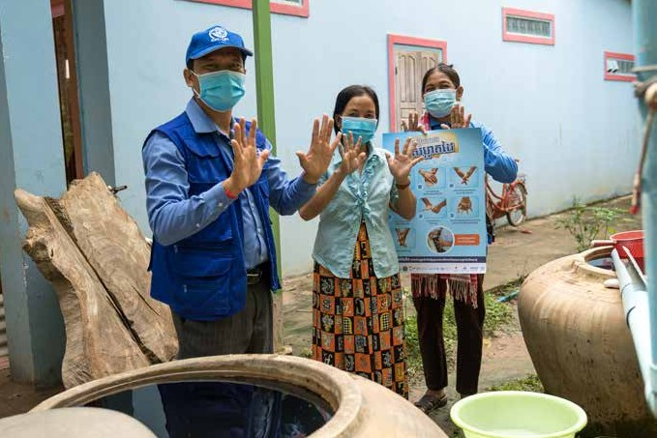
IOM field staff demonstrating hand washing procedures with returning migrants at their home.
© IOM

- Awareness raising activities and consultations on MHPSS reached 175,799 children, parents, and
caregivers, of which 8,543 women, adolescents, and youth were provided with maternal care and GBV information and psychological support
- Distributed dignity kits to 3,600 women and girls of reproductive age among the returning migrants and their communities
- Through a joint assessment on the vulnerabilities of returning migrants, 5,060 stakeholders received information related to the socio-economic impact of
COVID-19 on returning migrant workers in Cambodia, including policy recommendations

Innovation and Learning
The joint programme strengthened the collaboration with sub-national authorities at the provincial, district, communal, and village levels, as well as with civil society organizations through a participatory approach to beneficiary selection and an innovative model of sub-grantee implementation.
The programme also began the process of formalizing the function of social worker for existing civil servants, with a job description in the process of being adopted by the Ministry of Social Affairs. Once approved, it will be adopted nationwide to improve the delivery of social work services at the sub-national level.
With regard to learning, during the rapid needs assessment and beneficiary selection process for the individual economic reintegration package, it was discovered that some income generating activities were preferred over others. Few migrant women were interested in the proposed handicraft activities, most of the returning migrants did not own enough land for vegetable growing, and some of them lacked the skills and confidence to run a small business. Chicken raising was by far the most popular option pursued by migrants as an income generating activity. It was also found that a multi-sectoral and
multi-level approach involving provincial government teams, district committees for women and children, agricultural officers, CCWC, village chiefs, and village health support groups, encouraged beneficiaries to participate in the programme and resulted in better understanding of its benefits and the options on offer in terms of reintegration opportunities among the beneficiaries.

COMOROS

Improvement of COVID-19 Preparedness and Response Capacities

End Date: 31 December 2020

Programme Summary
This joint programme established three call centers, one on each of the three islands in the Union of Comoros to respond to COVID-19 related enquiries and needs. It also: trained local craftsmen to make contactless handwashing devices; trained maintenance workers on hygiene standards; and ensured that people with COVID-19 could be treated in isolated locations equipped with energy, oxygen, and ventilators.

Achievements under Pillar 1 on Health First
- Established the 1717 green line – a telephone hotline serving as a referral system and COVID-19 information provider for the people of Comoros; the call center operated 24/7 in each of the three islands (Grande Comore, Anjouan and Mohéli)
- 66 people (eight medical regulators, three center coordinators, three data collection and feedback managers, and 52 respondents) operated the call centers, which fielded 118,507 calls (through 18 September 2020), including 960 alert cases of COVID-19 and 16,459 requests for referral information
- Trained 18 craftsmen to produce contactless handwashing devices (six in Anjouan, six in Mohéli, and six in Ngazidja) with materials from two local providers
- Craftsmen established 55 hand washing points and were beginning to establish facilities at care centers for COVID-19 patients, public places, and public primary schools
- Trained 40 maintenance workers (20 in Anjouan and 20 in Mohéli) to clean health facilities so as to reduce COVID-19 transmission

Innovation and Learning

- Provided 540 m3 of clean water (enough for four months) to a COVID-19 treatment center in Grande Comore
- Distributed 900 m3 of clean water in partnership with the National Water Company (SONEDE) to 166 households across the islands. 340 m3 of water was
distributed to health centers not connected to the water supply network
- Provided PPE and IPC supplies to healthcare staff and facilities
- Treated 37 people affected by COVID-19 in a newly established and isolated health facility equipped with sanitation equipment, two respirators, and a steady and reliable supply of electricity and oxygen
- Rolled out national standards and guidelines on treating COVID-19 patients and trained health personnel on IPC

Given the significant difficulties sourcing materials and sanitation equipment due to import complications, the programme developed the capacity of local producers, which also improved long-term maintenance and programme sustainability. In this vein, the development and optimization of capacities and resources at the local level were catalytic for both efficiency and visibility.

COTE D’IVOIRE

Support to the Governance of the Overall National Response and Assistance to Populations Made Vulnerable by the COVID-19 Crisis
End Date: 31 March 2021

Programme Summary
This programme reinforced national COVID-19 response structures and governance systems. It also helped create a conducive environment for the delivery of financial and in-kind support to the most vulnerable and affected segments of the population.

Achievements under Pillar 1 on Health First
- Distributed hygiene and handwashing kits to all national social centers
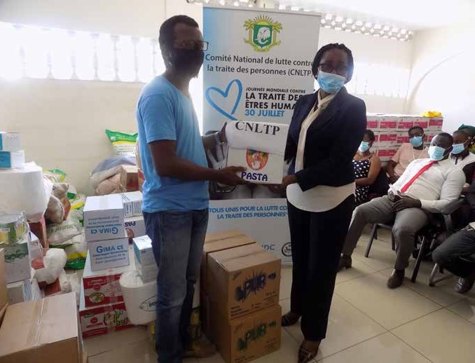
In response to the COVID-19 crisis, UNODC distributes health and food kits to victims of trafficking in Côte d’Ivoire.
© UNODC

- Provided cash transfers to 224 social centers caring for victims of violence, abuse, and exploitation
- Trained 244 social welfare workers on psychosocial first aid, parenting, family skills, and family therapy
- Operationalized a helpline that assisted 4,062 cases of violence, abuse, exploitation, and mistreatment
- Provided 104,304 parents and primary caregivers with community-based mental health and psychosocial support
- Provided psychological support to 1,691 women and girls aged 15 and older who were subject to physical, sexual, or psychological violence by an intimate partner over the past 12 months; and to 2,313 children under the age of 17, who experienced recent physical punishment and/or psychological aggression by caregivers
- Granted hygiene kits to 3,000 inmates from two major prisons in the Greater Abidjan area, with training on COVID-19 prevention measures for prison workers underway

Achievements under Pillar 2 on Protecting People

- Supported the government to undertake two studies, with a view to helping all actors plan gender-sensitive responses; one study focused on the social determinants of the prevalence and accentuation of gender-based violence; and the other on the perception of COVID-19 by populations in emergency situations
- Supported the Ministries in charge of Labour and Social Protection, Health, Solidarity and the Fight Against Poverty, the National Health Insurance Agency, and regional social protection and health divisions with the organization of a workshop series to document and share good practices and lessons learnt on the provision of cash transfers to vulnerable populations affected by COVID-19 and their enrolment to the Universal Health Coverage

Innovation and Learning
- Monetary transfer mechanisms for targeted small producers of palm oil and rubber trees were put in place by the organizations of the two sectors. The audit firm was selected for verifying disbursement procedures, checking the identification, profiling, and targeting the small rubber and oil palm producers, and assessing the impact of cash transfers relative to the mitigation of the socio-economic impacts of COVID-19
- Provided 1,322 women-headed households with financial assistance
- Initiated the process to procure sewing machines for women to produce masks

An innovative COVID-19 response result monitoring framework was developed with the support of two statistical experts assigned to the Operational Monitoring Committee of the Prime Minister’s COVID-19 Response Plan (CSOCOVID-19), in order to monitor the contribution of stakeholders in terms of financial and material resources invested in the fight against COVID-19, the recorded results, and the evolution of the pandemic.
Further, the provision of appropriate ITC tools and equipment (videoconferencing, Zoom licenses, etc.) had a significantly positive impact on business continuity, continued collaboration between various stakeholders, and the coordination of interventions.

EL SALVADOR

Protecting Lives of the Most Vulnerable People during COVID-19

End Date: December 31, 2020

Programme Summary
In the context of COVID-19, this programme extended protection to the most vulnerable of populations, including people with pre-existing medical conditions and those in prison. It also sought to reduce the number of patients in health centers during the pandemic, while maintaining their access to treatment through the home delivery of medicines and supplements.

Achievements under Pillar 1 on Health First
- This programme strengthened both the Ministry of Health (MINSAL) and the Office of Postal Services in El Salvador. For people with pre-existing co-morbidities that put them at high-risk for COVID-19 complications, the programme supported a MINSAL project for the home delivery of their medications. This reduced the risk of this population of contracting the virus, while also assuring that they received medications. The programme also extended support and health services to the incarcerated and women suffering domestic and/or gender-based violence.
- 61,029 women and 29,117 men with chronic illnesses received medications directly in their homes as an outcome of the programme
- The programme strengthened the alliance between MINSAL and the Postal Service by providing the right equipment for the delivery of medicines. This included refrigerators, coolers, thermometers, protection wrapping paper, and special envelopes

- The programme supported the El Salvadorian Postal Service to collect, classify, and distribute medications provided by MINSAL (some of which required special equipment, care, and temperature storage) to each vulnerable person’s home
- The programme trained Postal Service staff delivering medications to the doorstep to identify women who have suffered, or were suffering domestic violence and advise them on where to seek assistance
- The programme strengthened the preparedness and response capacities of 25 prisons – an outcome that innovatively linked to enhancing the prison facilities’ implementation of the Mandela Rules, which warrant respect for prisoners’ dignity and prohibits torture and other forms of mistreatment
- 37,190 incarcerated people (2,789 women and 34,401 men) received medicines and benefited from access to PCR testing

Innovation and Learning
This programmed opened up collaboration with a non- traditional actor - the Post Office. For the first time, this institution became a strategic partner in a UN project, and given its workers’ closeness to homes and families, a key actor in identifying different vulnerability profiles, such
as women who were suffering domestic violence. The programme also helped launch an innovative campaign with the Postal Service and the Attorney General’s Office (PGR) to ensure that a postmark was added to all mail with the telephone number of the PGR. The PGR is one of only two government institutions delivering psychological, crisis, and legal support to women victims of violence.

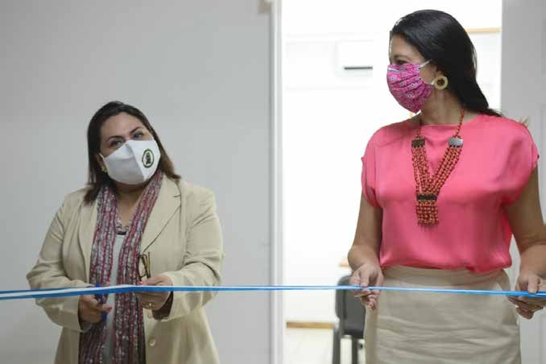
Prosecutor General of the Republic, Miriam Aldana, and the UNDP Resident Representative, Georgiana Braga-Orillard, participated in the opening event of the citizen service cabins.
© UNDP

ESWATINI

Supporting the Eswatini Government’s Urgent Need to Respond to the COVID-19 Health and Food Emergency
End Date: 31 December 2020

Programme Summary
This programme covered two critical areas, (1) the capacity building of frontline healthcare workers on COVID-19 prevention, testing, and management; and (2) the procurement of additional PPE and health commodities to support the national health system. The initiative helped the government meet the needs of frontline healthcare workers, newborns, children, adolescents and young people, and women.

Achievements under Pillar 1 on Health First
The programme:
- Provided PPE to 88% of public health facilities
- Supported the Ministry of Health in the periodic review and adaptation of technical guidelines and tools; including the provision of technical support in building frontline healthcare workers capacity, leading to an increase
in compliance in at least 88% (up from 32%) of 177 health facilities in the Manzini region rapidly assessed for continuity of services and compliance with IPC standard operating procedures
- Provided supportive supervision (continuous coaching) for an average of 48 health facilities monthly. IPC champions were identified and trained in all health facilities
- Developed and disseminated technical guidelines on maternal and newborn health (MNH), immunization, and vaccine preventable diseases in the context COVID-19 to guide health workers
- Trained 6,772 (95%) of healthcare workers on COVID-19 prevention, testing and management, thereby increasing the proportion of healthcare workers trained from 36% to 95% according to Ministry of Health COVID-19 training reports

- Developed a National MNH-COVID-19 Technical Guidance aimed at rebuilding the health system and limiting the impact of COVID-19
- Trained 120 healthcare workers, including 60 nurse midwives, on COVID-19 IPC. The participants were drawn from six health facilities that provided maternity services in the Manzini region
- Provided each of the four regions of the country with one hired vehicle and fuel for two government outreach vehicles
- 100% of health facilities, both public and private, resumed the provision of essential health services. The availability of key and/or lifesaving medicines, supplies and commodities were on the rise. All fixed health facilities were rendering MNH, immunization and nutrition catch-up activities. As per available reports, outreach services were revived and integrated MNCH services provided in all sites
- In collaboration with WHO immunization catch-up activities, regions developed micro-plans and executed them by rendering all antigens including Vitamin A supplementation and deworming, targeting high risk populations in urban and rural settings. An overall increase of DPT3 coverage was recorded from 76.7% in March 2020 to 84% by December 2020

THE GAMBIA

Increasing Access to COVID-19 Diagnostic and Treatment Centers in The Gambia

End Date: 30 March 2021

Programme Summary
This programme helped tackle the health emergency; focusing on its social impacts along with economic response and recovery, with a view to helping the country recover better. The initiative targeted the North Bank and Central River regions, which constituted a ‘catchment area’ of 447,072 people (or 22.35% of the entire population, based on 2013 census data) for the country’s COVID-19 treatment centers. It constructed and equipped treatment centers and built out services to support survivors of gender-based violence.

Achievements under Pillar 1 on Health First
The programme commenced in June 2020. To date, it has:
- Constructed three COVID-19 treatment centers, strictly complying to the SARI Design Guidelines
- For these treatment centers, it procured and fabricated containers, constructed access ramps, procured 60 beds, 60 IV stands, and 60 mattresses; and completed all internal works including electric, installation of extractor fans, painting, plumbing, smoke alarms, and internal partitioning
- Installed prefabricated sanitation facilities at these three COVID-19 treatment centers
- Installed four additional containers to set up 16 toilet cabins including eight cabins for men and eight cabins for women in Lumo, Wassu, Janjanbureh and Lamin Koto
- Purchased non-food items such as soap, chlorine, and bleach, as well as individual hygiene kits to facilitate the disinfection of centers and to ensure hygiene for patients and frontline health workers
- In collaboration with the Ministry of Health, developed IPC training modules, which in addition to a systematic response to COVID-19, will also make it possible to stop or reduce nosocomial transmissions and support good management of medical waste; 300 health workers were trained on IPC
- Launched the National Gender-based Violence (GBV) Helpline, which responded to 2,619 survivors; 356 survivors received psycho-social support and GBV case management services and 33 were referred to a shelter for children to help integrate them back into their normal lives

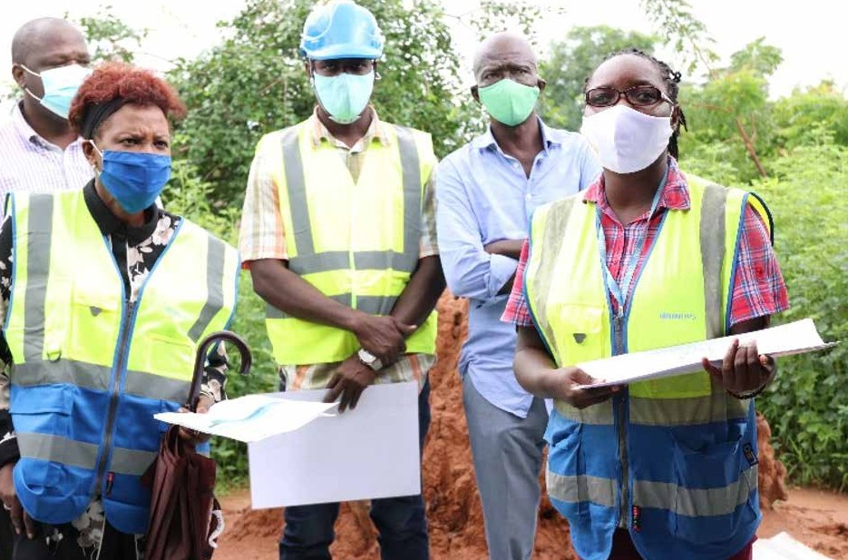
UN Resident Coordinator, Seraphine Wakana (left) with UNOPS Construction Management Engineer lead a site induction exercise during a high-level UNCT field visit to the MPTF COVID-19 funded treatment site in Soma, Lower River Region, The Gambia.
© UNOPS/Abdoulie Jammeh

- Developed a GBV referral pathway to link services and standard operating procedures to enhance the
management of the one-stop centers; four centers were expanded
- Established with the Ministry of Gender, Children and Social Welfare, a shelter to support GBV survivors. It is the first time The Gambia has such a service specifically catered to GBV survivors

Innovation and Learning
The joint programme built the treatment centers in prefabricated containers using solar power, meaning that the solution, which was both rapidly deployable, cost effective, and durable could be replicated elsewhere in the country. Further, UNICEF with UNOPS support and in collaboration with Department of Water Resources, constructed three new boreholes equipped with solar-powered pumping systems to reduce energy consumption and operating costs. This made the programme more financially and environmentally sustainable.

GEORGIA

Assisting the Georgian Government and Local Communities in Mitigating the Impact of COVID-19
End date: 31 March 2021

Programme Summary
This intervention supported Georgia’s recovery from COVID-19 by strengthening the capacities of central and local governments as well as the preparedness and resilience of community members. The programme improved facilities and created a safer environment for civil servants; offered assistance to the elderly; and it enhanced knowledge of and
access to basic farming inputs for self-subsistence farming (particularly for women-headed households). The initiative also supported the continuity of health, education, and social services for children and families.
Throughout its implementation, the programme maintained a strong focus on gender and ensured that specific threats to women and girls were understood and mitigated, noting that in the Georgian context, the three major beneficiary groups – healthcare workers; public-sector workers; and vulnerable elderly were, to a large extent, made up of women.

Achievements under Pillar 1 on Health First
- Equipped 8,000 frontline workers (60% women) at the central and local levels with PPE
- Provided personnel (approximately 97% women) of 11 state-funded institutions for older people (with approximately 250 beneficiaries total (about 80% women) with PPE and sanitizers
- Supported the Ministry of Health (MoH) elaboration and approval of the standards for prevention and management of COVID-19 in residential institutions and community care homes (LTC) for older persons and
persons with disabilities; Developed and operationalized a monitoring tool to ensure the adherence to these standards
- Helped equip the 144-emergency center with specialized GPS dashboards to handle large call volumes, resulting in a 9% increase in response rate to emergency calls. The 144 center is the focal point for the COVID-19 emergency response in Georgia, handling 4,500 calls per day and operating 330 ambulance crews
- Reached 1,122,749 people via an information campaign on how to avoid the economic and health impacts of the pandemic

- Reached 2,749 vulnerable elderly with home care visits (up to 80% women, up to 25% - ethnic minorities) that provided food and hygiene parcels, PPE, sanitizers, and information (booklets, leaflets, and sticky posters) on COVID-19 IPC in the Georgian, Azeri and Armenian
languages as well as hotline contacts with 24/7 availability for response
- Based on the findings of the UNFPA needs assessment, 95 elderly people living alone in remote rural settlements without any communication means received basic mobile phones with Georgian soft and preinstalled GRCS hotline number
- Provided WASH and hygiene supplies to 1,095 people, including 615 children who received hygiene kits
- Trained 1,200 healthcare providers in COVID-19 IPC and referral
- Provided 52,000 children and women essential healthcare services, including immunization, prenatal and postnatal care, HIV care, and gender-based violence intervention

Achievements under Pillar 2 on Protecting people

- Set up three shelters to house 200 elderly and homeless1
- Supported government efforts to develop guidelines for teachers and schools for planning and implementing online learning programmes
- Trained elementary teachers across 100 schools in distance education
- Developed online learning resources that reached an estimated 414,000 students
- Helped launch a TV-school broadcast through the Georgia Public Broadcasting to educate children without internet connectivity; The TV-school covered all levels of national education curriculum in Armenian and Azerbaijani languages and was accompanied by sign language translation

1 These three shelters have capacity to accommodate 200 beneficiaries. However, the number of beneficiaries varies due to changing seasonal and other circumstances.

Achievements under Pillar 3 on Economic Response and Recovery

- Allocated four agricultural grants to two women and two men to support innovative agriculture in Gagra, Gudauta, and Ochamchire districts – the first mushroom farm in Abkhazia, and a greenhouse complex powered by bio-gas – projects that created 11 new jobs and reached 60 direct beneficiaries/ households of 15 farmers

Innovation and Learning
- Provided 620 vulnerable households engaged in small family farming in seven regions with agricultural inputs. The beneficiary families included female-headed families, single mothers, large families, women taking care of family members with disabilities, IDPs, minorities, and families under the poverty line from six regions

Innovative virtual trainings reduced the time service providers spent going to in-person trainings, and it expanded reach. Meanwhile, mobile health services decongested health facilities by offering service at the doorstep and allowed for additional service provision.
On transport, the programme recognized bicycle ambulances as practical in rural settings and recommended reprofiling the budget to include them. In addition, a one-stop-center model created efficiency and facilitated outreach programmes where health personnel could provide SRHR services, report cases, and disseminate information on GBV and COVID-19 all at once. With regarding to training, preparing helpline workers to handle GBV cases proved essential and there was an increase in the number of callers seeking information and guidance on GBV.

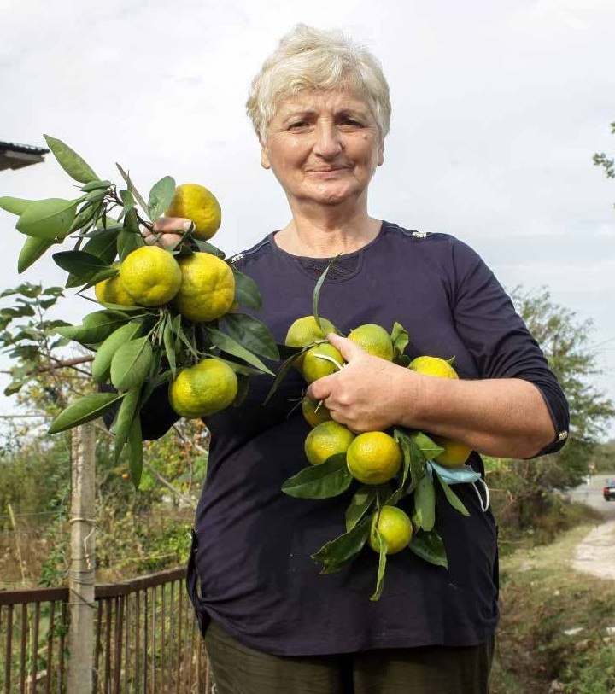
PANDEMIC COPING STRATEGIES FOR WOMEN FARMERS IN RURAL GEORGIA
As the coronavirus numbers continued to climb and restrictions on public gatherings remained in force, many workers, especially women holding informal or part-time jobs, saw their wage income
dry up in cities and towns. In a context in which most families have roots in the village, turning to agriculture became a key coping strategy.
“My family is in a particularly difficult situation, as our only child is disabled and needs constant care,” said Dina. “This limits our possibilities of work for income and with the pandemic-related
restrictions, our mobility has been limited even more. It means that our family relies mostly on food that we can produce ourselves,” she explained.
Dina is from one of 620 households receiving assistance from UNDP to improve yields and boost their incomes during the pandemic.
Working in partnership with the Association of Women Farmers, UNDP distributed packages of fertilizer, pesticides, and farm tools to women heading vulnerable households—families with many children, single parents, internally displaced persons, families living in poverty, and national minorities—in seven regions of Georgia.
Dina received assistance to improve yields and boost her income during the pandemic.
© Nino Zedginidze/UNDP

GUATEMALA

Support to the Guatemalan Humanitarian Response Plan to COVID-19

End Date: 20 December 2020

Programme Summary
This joint programme achieved its goal of saving lives and supporting a rapid and integrated response to the health and humanitarian emergencies caused by the pandemic. It strengthened the health sector and provided COVID-19-related information and educational activities for returned migrants.

Achievements under Pillar 1 on Health First
- Provided technical support to 22 hospitals of the health network, training staff in the management of tools to calculate medicines, the use of supplies and PPE, and human resources needs
- Trained 776 healthcare workers (HCW) and general staff from these 22 hospitals and 19 directorates of health on WASH practices to reduce and prevent viral transmission
- Trained 904 HCW on infection prevention and control
- Strengthened the surveillance system by hiring technical and professional staff that registered 79,681 epidemiological records, updated 115,311 records, and developed a strategy for contact tracing and the procurement of IT equipment for data analysis
- Strengthened the response capacity of health services through the development of protocols on sexual and reproductive health, improved data, and the training of 1,296 HCW nationwide, including 656 operators working in the field with traditional midwives
- Purchased PPE and other equipment for traditional midwives
The programme also extended support to returned migrants:
- Health educators informed 7,350 returnees (1,285 women and 6,065 men) (exceeding the initial target of 7,000) on preventing COVID-19 and detecting vulnerabilities or psychological care needs
- Health educators worked together with the Ministry of Health staff to ensure health care for retuned migrants, as well, as psychological first aid as needed
- Delivered 1,970 food packages, 682 warm clothing kits, and 682 hygiene kits to shelters

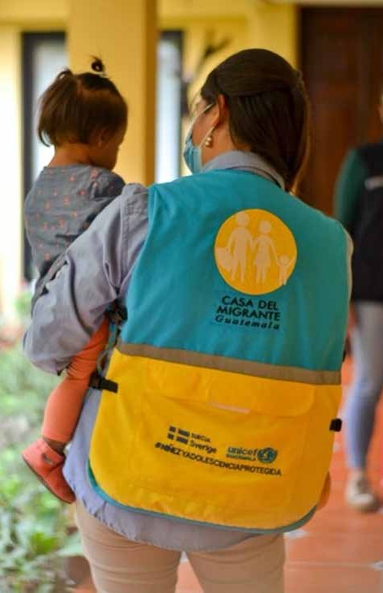
In Guatemala, UNHCR distribute soap, gel in hygiene kits as well as WHO information material to refugee and asylum-seekers families to prevent the spread of COVID-19.
© UNHCR/Alexis Masciarelli

- The model of care for unaccompanied children promoted by the programme was institutionalized by the SBS (the institution in charge of childhood)
- UNHCR, in its role as advisor, supported the identification of people with protection needs among the returnees assisted under this joint programme

GUINEA

Supporting the Ministry of Health to Strengthen Local Capacity for Epidemic Response

End Date: 31 December 2020

Programme Summary
This joint programme partnered with the Ministry of Health to strengthen its capacity for better response to epidemics at the national and local levels. The programme, as implemented by WFP, WHO, and UNICEF, relied on community
engagement to improve vulnerable people’s access to basic social services in the three regions most exposed to COVID-19.

Achievements under Pillar 1 on Health First
This programme focused on supporting the Government of Guinea in identifying vulnerable groups in need of protection and health and nutrition services as a result of
the socio-economic impacts of the pandemic. It also helped strengthen coordination between government agencies, facilitated the training of healthcare service providers, and enabled treatment centers in the regions of Conakry, Boke, and Kankan to improve the efficiency and effectiveness of contact tracing.
The programme:
- Trained 900 staff in the target regions on epidemiological surveillance and case management at treatment unit centers
- Provided treatment centers in Kankan and Boke with resuscitation equipment, bed sheets, and medical supplies
- Provided two intensive care units with intensive care

equipment for patients with severe cases of COVID-19
- Established a coordination committee with partner agencies and relevant ministries to identify beneficiaries that produced data on 50,000 vulnerable households, including 1,186 beneficiaries’ households identified
by the National Statistics Office and transferred into the national single registry database for future use
- Identified 12,115 vulnerable populations to receive PPE as well as food and nutrition assistance, to mitigate the immediate shocks of the pandemic

Innovation and Learning

- Provided, in collaboration with the Ministry of Health, supplementary nutrients for 231 severely
malnourished children under the age of five years old (111 girls and 120 boys)
- Enabled a donation from Colgate International of 850,000 bars of soap for hand washing, which were distributed to beneficiary households
- Provided 360 vulnerable households with locally procured radios to raise awareness and provide targeted communities in Conakry, Boke and Kankan with
information on how to protect themselves from COVID-19 transmission as well as information on the procedures of contact tracing and case management
- Engaged 500 artisans in mask production
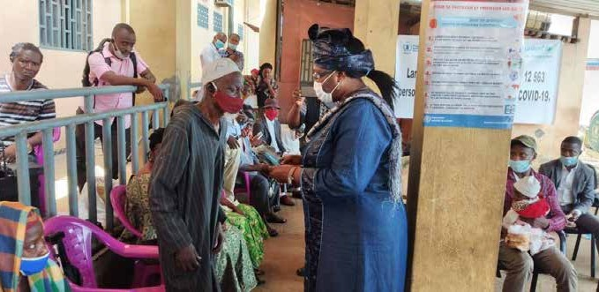
Hadja Mariama Sylla, Ministre de l’Action sociale et des personnes vulnérables en train de remettre des masques à un vieux.
© Saa Momory KOUNDOUNO

Strategic partnerships for identification of and support to beneficiaries nationally and locally
The implementing agencies established a coordination mechanism for partner agencies to collaborate with the Ministry of Social Affairs, National Health Security Agency, and the National Institute of Statistics to help identify the beneficiaries at- risk of being left behind and in urgent need of support in the context of COVID-19. The active involvement of local authorities in the field helped ensure successful project implementation, with Provincial and Regional officials engaged throughout the implementation of activities on the ground, especially during the distribution of goods and services to beneficiaries in remote rural areas.

HONDURAS

Saving Lives in COVID-19 Times

End Date: 31 December 2020

Programme Summary
This programme supported the direct health response to COVID-19 though (1) strengthening of epidemiological surveillance by increasing the capacity of the laboratory network for COVID-19 diagnosis; (2) establishment of and support for
rapid response teams (RRT) and community outreach; and (3) ensuring the continuity of maternal-neonatal and sexual- reproductive health services and assuring that these services were considered essential in the context of the pandemic.

Achievements under Pillar 1 on Health First
The programme gave significant support to the health services of the municipalities prioritized in 11 Departments. The strengthening of analysis and diagnostic capacity of the national health system helped reduce the spread of
COVID-19 and its overall impact on the quality of healthcare. Under this programme:
- Three molecular biology laboratories were equipped for the diagnosis of COVID-19 through PCR-RT technique;
laboratory personnel were trained to execute PCT-RT tests
- Designed an automated system for recording the traceability of laboratory samples, which helped reduce delivery time on test results from four to 14 days to 24 hours
- Trained officials of the central and regional health surveillance units in the management of the online platform of the Health Surveillance System (SVS) for the analysis of COVID-19 indicators as well as to prepare epidemiological bulletins that served as a complementary tool for decision-making related to the pandemic
- 14 Situation Rooms were established, activated, and equipped with technological equipment (computers, printers, digital televisions and UPS) and an operational guide was developed for operation of situation rooms in the context of COVID-19
- As of December 13, 2020, the Ministry of Health conducted an average of 1,137 daily samples to detect COVID-19 cases
- 61 Rapid Response Teams (RRTs) were established, trained, and involved in prioritized health regions
- Through project epidemiologists, the initial diagnosis of the RRT was carried out in 11 health regions
- The establishment of RRTs helped to strengthen a community approach to pandemic control, along with the

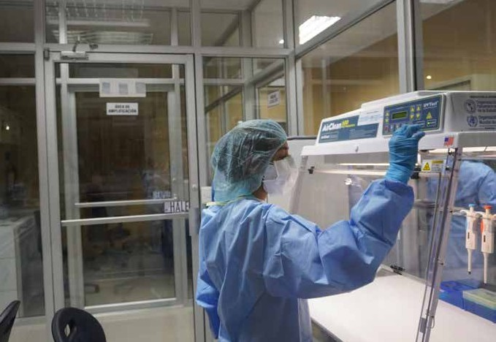
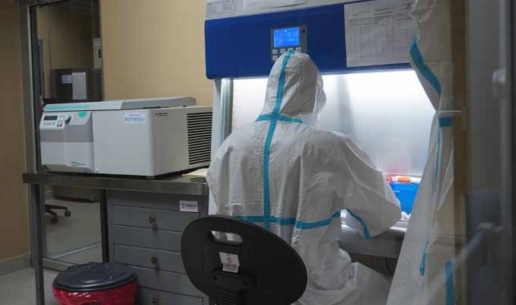

COVID-19 test processing at the Regional Molecular Biology Laboratory of Copán.
© OPS/OMS Honduras Daysi Núñez

training of 95 volunteer community health promoters, who worked actively in 19 prioritized municipalities nationwide. Their work included risk communications, which after hurricanes Eta and Laura, reached approximately 100,000 people

Innovation and Learning
The programme supported the development of a barcode diagnostic test registration and traceability Health Surveillance System (SVS) that was tailored for the Laboratory Network, reporting an average of 1,137 samples per day (only in two labs), reducing the time for issuing laboratory results from over four days to just 24 hours. The system helped with the capturing, analyzing, and presenting of epidemiological information in a timely and accurate manner, and it will feed into the data analysis undertaken by the newly established 21 Situation Rooms for decision making on emergency response.
The key results were maximized through synergies with other projects. To strengthen laboratory capacities for the diagnosis of COVID-19, PAHO made alliances with USAID and SESAL to establish three additional molecular biology laboratories located in strategic geographic areas in the Departments of Atlántida, Cortés, and Copán. USAID built the facilities, PAHO bought all the equipment and supplies with the Fund, and SESAL was responsible for providing human resources and sustainability. This was a huge achievement that quadrupled the country’s laboratory capacity.
Further, though 14 situation rooms where launched through this project, seven additional rooms were established through another PAHO project, amounting to a total of 21 Situation Rooms (one per Health Region and one Central). Overall, the work carried out within the framework of the Saving Lives Programme had a positive impact in the Department of Cortes, especially assuring high quality SRH and maternal care. This allowed for expansion with another project led by the UNFPA and financed with funds from the Government of Canada (DEREJUV) to respond to the humanitarian and health emergency in the area.

JAMAICA

Suppress Transmission of COVID-19 and Save Lives in Jamaica

End Date: 31 January 2021

Programme Summary
This programme responded to needs within the Jamaican health sector. It was designed to ensure equal access to essential health services, while also addressing critical gaps in the response to COVID-19.

Achievements under Pillar 1 on Health First
Towards Infection Prevention and Control (IPC) this programme:
- Ensured all healthcare workers, including sexual and reproductive health workers, had PPE and training on its use. Supplies included: 2,022 disposable gown isolation, 10,000 disposable surgical respirator FFP2/N95-masks, 10,000 disposable surgical masks (type IIR), 17,000 sterile surgical gloves, and 17,000 examination gloves
- Procured supportive equipment for the effective us of 28 ventilators
- Implemented the Go Data© surveillance system, with PAHO donating 25 Android tablets, with the contact tracing application installed
- Provided 16,000 doses of Depo Provera to the National Family Planning Board
- Reached 228,055 people with a national risk communication and community engagement campaign for COVID-19 that used 152 new multimedia-based products
- Deployed mobile units to reach vulnerable groups, including women and the elderly
- Established 21 essential service hotlines for women, men, and the elderly, and trained 80 volunteers to service them

- Implemented a multi-month dispensing policy for ARV and other essential medicines, along with social support measures for people living with HIV (PLHIV)
- Bolstered testing capacity with procurement and hand- over of extraction kits, and built capacity and readiness for large scale testing
- Held trainings on molecular detection of COVID-19 and on IPC for suspected cases
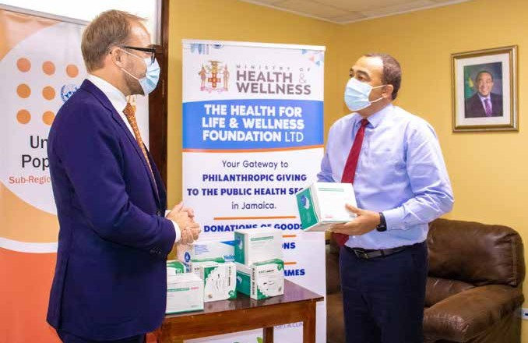
Seth Broekman, Deputy Director, UNFPA Sub-Regional Office for the Caribbean, hands over PPE to The Hon. Christopher Tufton, Minister of Health and Wellness of Jamaica. The PPE went to medical personnel delivering sexual and reproductive health (SRH) services in public health facilities.
© UNFPA

KOSOVO

Support Kosovo Institutions with Swift and Innovative Solutions to Contain the Spread of the COVID-19 Pandemic
End Date: 30 November 2020

Programme Summary
This programme provided integrated and innovative digital solutions necessary to allow Kosovo institutions to operate in a coordinated manner in addressing the pandemic. It also contributed to improved infection prevention and control of
COVID-19 by addressing the needs of institutions and citizens in dealing with the pandemic as well as the needs of front- line workers in conducting their work in a safe environment. The programme thus addressed both the needs of the general population, with a focus on vulnerable groups, and those of institutional workers who could discharge their duties safely and efficiently.

Achievements under Pillar 1 on Health First
- Distributed support packages to 62 volunteers (50% of which were women), engaged to provide 24/7 medical and psychological support through the COVID-19 Call Center and the Helpline for Psychological Support
- Furnished and supplied the working space of the
COVID-19 call center, which received 20,500 calls in the period August-November 2020
- Volunteers from the Helpline for Psychological Support assisted 313 people (59% women/girls), offering them psychological first aid and referrals to relevant institutions
- Provided lifesaving personal protection and other equipment (PPE) to 3,614 frontline workers, both within primary healthcare facilities and from the Institute of Public Health (10% of which worked in Kosovo-Serb majority municipalities)

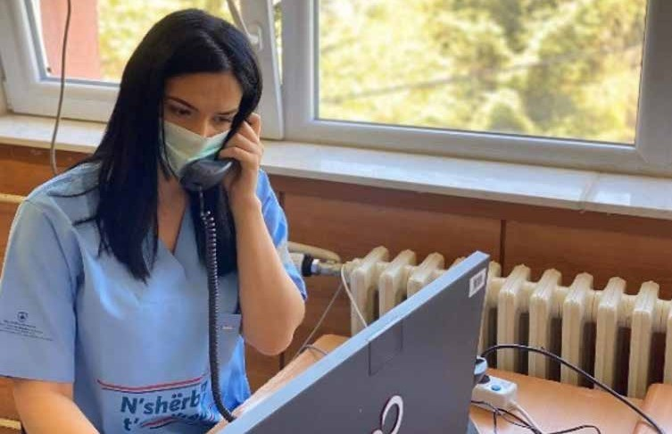
Volunteer serving with COVID-19 Call Center responding to questions from the public.
© UNDP/UNV

Achievements under Pillar 2 on Protecting People

- Strengthened the digital infrastructure of Kosovo’s Parliament through the provision of videoconference systems (Zoom licenses and Cisco Webex) to ensure the continuity, safety and transparency of the Parliament’s work, and a continuative information flow to the population
- Provided IT tools and equipment to the Agency for Information Society, which ensured that vital institutional processes continue to run uninterrupted
- Developed the University of Pristina’s online psychoeducational platform https://shendetimendor. org to support people’s coping mechanisms, help citizens to overcome social isolation, inform on health and safety

Innovation and Learning
guidelines, and provide access to mental and psycho- social support during and after the pandemic
- Supported the development of 10 webinars, 8 video animations, 1 video interview, and 40 Facebook posts - all of which remain functional and available for educational purposes.
- 308 participants attended the webinars, whereas online viewership on social media platforms scored 52,400 views between October and December 2020
- Developed an outreach campaign that reached 503,500 users with 1,617,897 impressions

The programme supported the development and upgrade of the web application platform ‘Kosovo Job Portal,’ which served as an online board linked to the Employment Management Information System. This enabled the provision of all employment services online, thereby limiting the need for physical proximity of job seekers and job providers and reducing potential
COVID-19 exposures.
In support of inclusive crisis management and public awareness raising, the programme developed a social media campaign to amplify public health advisories and respond to mental health issues caused by the pandemic. This extended the UN’s voice, leveraged the respective agencies’ partnerships and communications, and focused on engaging the vulnerable groups.
The gender-responsive approach of the programme took into consideration the disparate impacts of COVID-19 on women and girls, such as entrenched gender discrimination, higher socio-economic vulnerability, exacerbated domestic violence during lockdowns, and frontline roles as caregivers and medical workers. In developing digital content for psychosocial support, a particular focus was put on preventing and addressing gender-based violence due to the increase of reported cases recorded during the pandemic.

KYRGYZSTAN

Safety First: Securing Healthcare Workers and Health Systems in the Response to the Immediate Needs of Vulnerable Populations during COVID-19
End Date: 15 December 2020

Programme Summary
This joint programme implemented by UNDP, UNICEF, UNFPA, and WHO supported the Government of Kyrgyzstan to strengthen overall preparedness and response to the health crisis in the country. Specifically, it strengthened institutional capacity for IPC; trained medical staff; provided protective and medical equipment; and raised IPC awareness in communities. The initiative also assisted the Ministry of Health with policy updates and guidelines to support the national preparedness and response plan.

Achievements under Pillar 1 on Health First
To strengthen institutional capacity for effective COVID-19 preparedness and response, the programme:
- Worked with the Ministry of Health to distribute protective and WASH equipment to health workers
- Supplied essential medicines to support healthcare for patients with non-communicable diseases, especially children
- Equipped 1,910 health care workers in 42 health facilities with PPE (70% female 30 % male)
- Distributed mobile and regular oxygen concentrators to 20 hospitals
- Trained 1,089 health workers and 4,000 nurses (online)
on the correct use of PPE
- Conducted a WASH assessment that led to the procurement of 14,108 IPC items (waste containers,
In July 2020, Kyrgyzstan hit a record high number of COVID-19 infections among medical workers. In total, 1,450 health workers were infected, 21 of whom died fighting the virus. 536 recovered and were discharged from hospitals. In the early stages of the crisis, a shortage of PPE, among other issues, led to the high infection rates. Many healthcare workers and their families in Kyrgyzstan grappled with whether to live safely with or to separate themselves from loved ones to keep everyone safe. The joint programme supported by the COVID-19 MPTF was able to gather PPE and hand them over to the government to facilitate distribution among 20 health facilities in the most affected areas of Kyrgyzstan.
“It is not easy wearing PPE for the entire day, it causes heavy sweating, itching and skin irritation. Yet it saves your life, we should think not only of ourselves but of our family and community, too”- Saltanat Nazaralieva, deputy head physician of the National Maternal and Child Health (MCH)

- Integrated up-to-date protocols and guidelines in line with WHO recommendations via high level policy dialogues at the Ministry of Health
- Developed a national training plan detailing target trainees, facilities, locations and programmes, tailoring WHO guidelines to the national context, addressing essential knowledge and skills needed for healthcare worker IPC
- Provided 6,000 copies of health promotional materials in Russian and Kyrgyz and distributed 1,000 sanitizers to raise community awareness of IPC
- Mapped all service providers and capacities to inform the development of an action plan to strengthen mental health services in line with WHO guidelines and recommendations •Integrated up-to-date protocols and guidelines in line with WHO recommendations via high level policy dialogues at the Ministry of Health

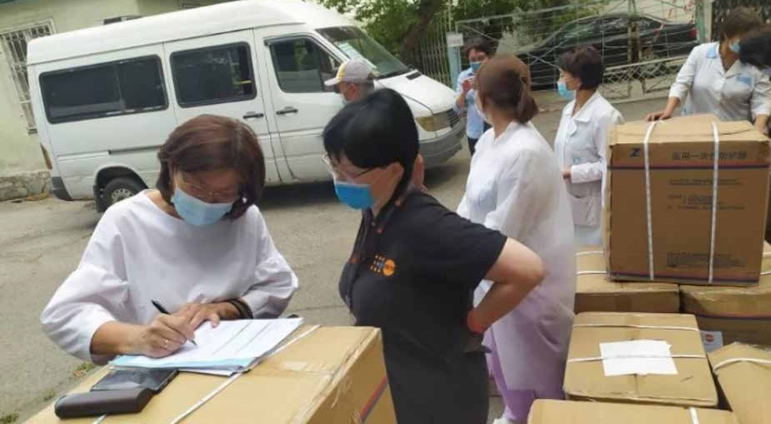
Maternity care staff are accepting boxes with PPE from UNFPA.
© UNFPA

bags for medical waste management, needle destructors, disinfection containers, shower stalls with water heaters and other items) for 49 healthcare facilities across the country

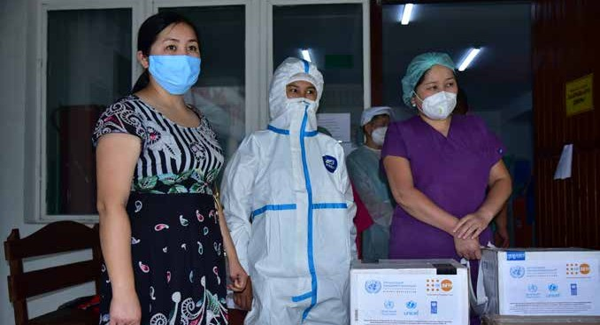
Staff of the maternity unit of the Maternal and Child Health Center at the PPE handover ceremony.
© UNFPA

LAO PDR

Supporting Essential Sexual, Reproductive, Maternal, Newborn, Child and Adolescent Health Services during COVID-19
End Date: 31 March 2021

Programme Summary
In this joint initiative, UNFPA, UNAIDS, and UNICEF collaborated to ensure access to healthcare through increased trainings and the roll-out of telehealth services. In the pandemic context, the programme focused on improving access to antenatal care services and the treatment of people diagnosed with HIV.

Achievements under Pillar 1 on Health First
This programme improved overall access to health services, especially for women and the most vulnerable populations in Lao PDR. The programme:
- Increased access to antenatal care (ANC) services during the implementation period, with the data platform
DHIS2 showing how the proportion of women receiving antenatal care for the first time (ANC 1) increased more than 40%. Women accessing their fourth round of antenatal care (ANC 4) increased 10%. These statistics included access during the mobile outreach, under which 211 mothers received ANC 1 and 127 mothers received ANC 4 (within two days and up to 42 days)
- Provided postnatal care through mobile outreach for 346 mothers
- Increased the use of contraceptive pills, injectables, implants, and IUDs
- Provided 505 women ANC1 by end of December 2020 in Phoukhoun District and 734 women ANC1 in the Phonthong District by end of December 2020
- Programmatic approaches were integrated into the RMNCAH Plan of Action 2021 for other provincial areas to commence implementation, including Savannakhet, Bolikhamxai, Bokeo, Champasack and Oudomxai provinces
- UNAIDS completed the development of a community guideline to provide tele-health services for people living with HIV in 11 antiretroviral therapy (ART) sites
- Approximately 50 (31 female) participants (people living with HIV peers, nurses, and doctors) working in treatment sites received training on use of the guideline to

Innovation and Learning

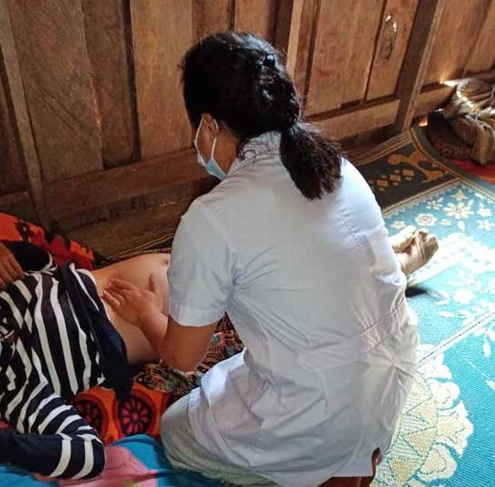
Antenatal care through mobile outreach Nam Luang Health Center, Don village, Phontong district, Luang Phrabang province.
© UNFPA

provide remote (telehealth) support on ARV uptake and adherence, care, and psychosocial support during the COVID-19 pandemic
- Developed and introduced the standard operating procedures (SOP) for community ARV drug dispensing to 80 service providers (doctors, nurses, pharmacists, and people living with HIV) working in 10 ART sites in seven provinces, including providing support for coaching and monitoring at the sites

Many women benefited from the telehealth services this programme helped put in place. It was thus promoted as a formalized part of the current health system to continue after the pandemic, especially during seasonal flooding and in instances where women might become isolated. The innovation proved extremely relevant for Lao PDR where access for mothers and children to essential health services at health facilities remains problematic due to their scattered and remote geography.
Overall, telehealth provided immediate assistance for people who were normally hard to reach through traditional health services and improved early problem detection. It also bettered communication and knowledge exchange between healthcare professionals across the country, especially in remote regions isolated from District Health Offices. Telehealth also improved referral systems and advanced the early detection of issues for at-risk pregnant women and children. For people living with HIV/AIDS, telehealth reduced the cost of travel for services, and therefore, UNAIDS advocated government partners to continue using the guideline after the COVID-19 pandemic.

LAO PDR

Supporting Provincial Health Preparedness and Surge Capacities, including at Points of Entry in Lao PDR
End Date: 30 March 2021

Programme Summary
This joint programme strengthened COVID-19 surveillance and screening at Points of Entry (POE) in Lao PDR. It used a three-pronged approach that focused on training border officials, procuring personal protective equipment, and improving operations and facilities at POE and quarantine centers.

Achievements under Pillar 1 on Health First
To improve the health and safety of migrants and contain the virus, this programme:
- Refurbished and assured the joint inspection of seven quarantine centers to improve the safety and well-being of occupants, including migrants. Improvements included light renovations and the provision of bedding and kitchen materials
- Completed construction of 37 gender sensitive WASH facilities in six quarantine centers that provided gender-separate bathrooms, shower facilities, handwashing stations, water piles and taps, and hygiene suppliesCreated information, education, and
communication (IEC) materials on good WASH practices and safety measures, including in migrants’ native languages, to accompany WASH provision
- Trained 508 border officers (375 male/ 133 female) in COVID-19 IPC at seven international border checkpoints (land and air borders)
- Mapped seven border protocols to understand the challenges/bottlenecks in infrastructure, processes, personnel, and mobility flow in responding to the pandemic
- From this mapping, created tailored trainings and simulations and distributed 21,500 copies of IEC materials to inform inbound and outbound migrants on health, IPC, safe return to Lao PDR from Thailand,

quarantine measures, and job access in the pandemic context
- Trained two national trainers (1M/1F) who then delivered training sessions to 81 (79M/2F) Border Liaison Officers from 20 different border areas
- 83 district and village level authorities received peer-to-peer training from previously trained officials on COVID-19 IPC: Combined with the successful implementation of training sessions for 508 PoE officers, results exceeded programme targets
- Developed Standard Operating Procedures on immigration and transportation at each PoE in line with the Prime Minister Decree 558 on PoE Management, PM Order 06, ASEAN Standard, and other COVID-19 Response Orders
- Provided 500 copies, in both Lao and English, of the SOPs to frontline officials
- Provided 3,000 officers with copies of a pocket guide on COVID-19 IPC and 500 COVID-19 info guides; and provided PPE for officers at 20 Border Office locations
- Ministry of Home Affairs (MoHA), Ministry of Health (MoH) and WHO held a meeting with 321 local government officials in four provinces to share experiences on preparations to prevent, contain, and treat COVID-19 through enhanced public services and community engagement

By cooperating with and relying on feedback from the Ministry of Health, the programme supported the
development of a national quarantine center profile and occupant registry dashboard. The dashboard is owned
by the Ministry of Health - Department of Communicable Diseases, and it facilitates the capturing, logging, and analysis of data related to conditions of quarantine centers and their potential needs. Further, information on occupants at the center may trigger contact tracing.
The programme also supported the critical provision of WASH infrastructure and products, such as new toilets, shower facilities, hand-washing stations, water pipes and taps, and hygiene supplies at quarantine centers. This ensured a safer, healthier, and more comfortable stay for many Lao migrant workers/returnees from Thailand while they quarantined for 14 days. The construction of proper gender-separated bathrooms – three stalls each for men
and women with walls, roofs, and doors – was particularly beneficial as there were only a few basic latrines for the entire quarantine center before the renovation.

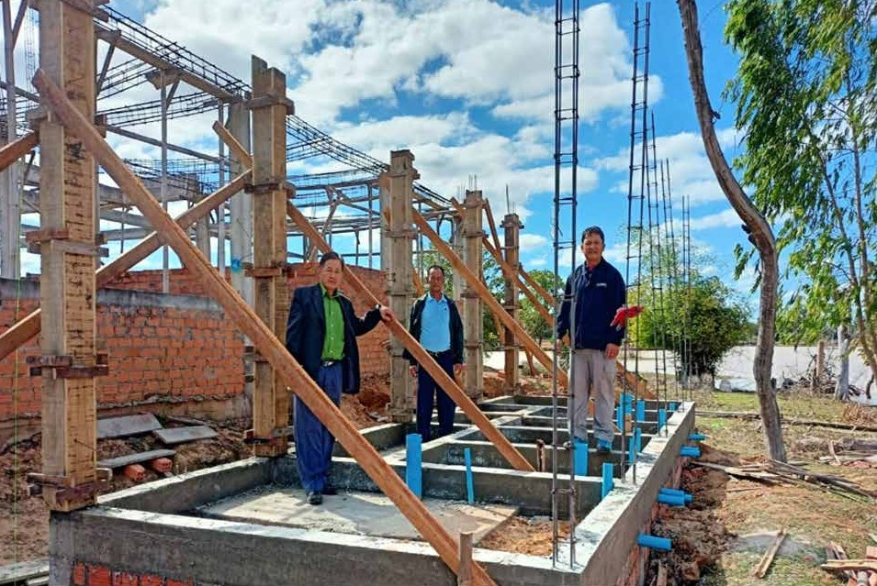
UN Habitat Lao PDR building a gender-separated bathroom at Songkhone District Health Quarantine Centre in Savannakhet Province
© UN-HABITAT

LESOTHO

UN Support to Control Spread and Minimize the Socio-economic Impact of COVID-19 in Lesotho
End Date: 31 December 2020

Programme Summary
This joint programme employed innovative approaches and data and digital technology solutions to: (1) enhance the coordination, planning, and monitoring of the national response; (2) facilitate rapid response for surveillance, investigation, and case management; (3) promote infection prevention and control; and (4) enable continuity and delivery of critical health and non-health services.

Achievements under Pillar 1 on Health First
- With programmatic support, Lesotho successfully reported COVID-19 cases to WHO within 24 hours, and established a referral system for COVID-19 patients to minimize the spread of the virus and increase survival rates in health facilities
- Deployed District Coordination Assistants to enhance reporting and implementation of a decentralized response in the districts
- Created a new digital application, Bophelo-ka- Mosebeletsi, which enabled village health workers (VHW) to undertake community surveillance, monitoring, and quarantining of suspected COVID-19 cases
- Provided VHWs in Quthing and Mokhotlong with 1,081 mobile gadgets and partnered with Econet Telecom Lesotho to enable free internet access to use the application, which significantly increased the number of patients that VHW could observe
- Strengthened capacity at border points to screen incoming travelers via regular epidemiological reporting
- Maintained essential health services at 193 health facilities providing vaccinations, family planning services, and tuberculous and HIV services
- Reached 138,618 people with COVID-19 related messages in six districts

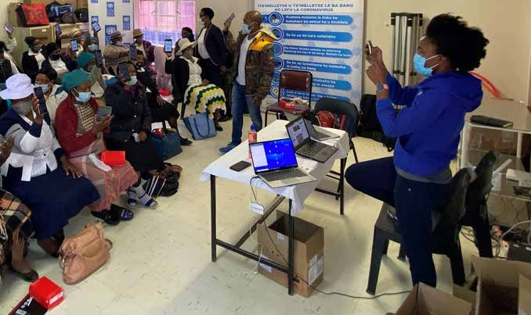
Village health worker training.
© UNDP

- Reached 113,590 people with WASH services at health facilities, isolation/quarantine centers, high-risk communities, and open spaces
- Collaborated with the Maseru City Council to install 48 water stations in all key areas around the Maseru bus- stop areas and market centers
- Engaged RISE International, a social enterprise for youth entrepreneurship development, for the construction and installation of the water stations

Innovation and Learning
In the area of surveillance, the project partnered with one of the two telecommunication service providers in the country to host the new digital application, Bophelo-ka- Mosebeletsi, the mobile application developed for village health workers to use. The application, which supported
monitoring, increased the number of suspected cases health workers could review and reduced costs, as paper reports no longer needed to be provided to local health facilities.

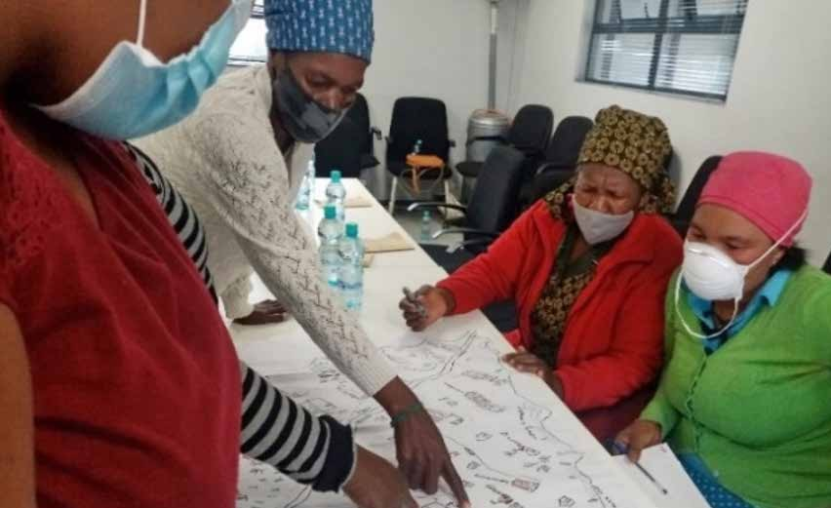
A training session on community risk mapping and planning.
© Lebesa Nkune

MADAGASCAR

Reinforcing Surveillance, Case Management, and Infection Prevention and Control in Support of Madagascar’s COVID-19 National Response Plan
End Date: 31 December 2020

Programme Summary
This programme strengthened mechanisms for COVID-19 case prevention and contract tracing with a special focus on supporting frontline workers and boosting the local economy through PPE production. The programme focused on three clusters of activities: (1) providing PPE and equipment; (2) training healthcare workers; and (3) training and supporting women-led textile companies.

Achievements under Pillar 1 on Health First
The programme strengthened health structures at the central and district levels, equipping them to test and treat COVID-19 cases and instate necessary IPC measures. The programme:
- Raised the investigation rate for COVID-19 from 75.9 % to 84.3 % of cases
- Tested 20,223 or 100 % of suspected cases either with RT PCR or GeneXpert tests
- Treated 17,671 confirmed COVID-19 cases
- Operationalized 22 Rapid Response Teams (RRTs) for COVID-19 testing and training for the regions and trained an additional 19 RRTs
- Trained 408 emergency response team members to support regional and district level activities

- Provided 36 treatment centers with essential equipment and supplies to treat COVID-19 patients; assured targeted hospitals had oxygen at their disposal; and equipped 46 resuscitation/respiratory teams to provide correct and proper care for severe cases
- 100% of patients with severe symptoms received
needed treatments, including oxygen therapy
- Provided 31 intensive care centers with 95,781 m3 of oxygen until the end of December 2020, which covered 9,276 days that patients received specialized care and oxygen therapy
- Trained 874 hygienists in three regions on IPC measures

Achievements under Pillar 3 on Economic Response and Recovery
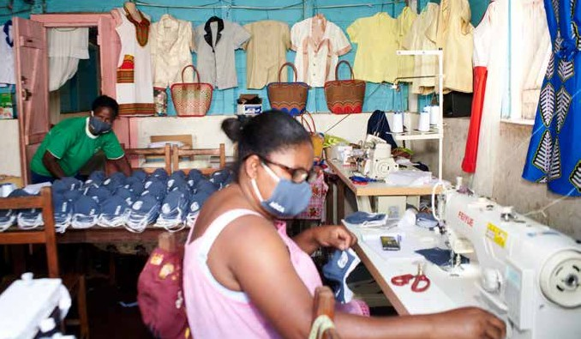
The joint programmed facilitated jobs via local mask production. The programme:
- Supported the production of 400,000 masks in cooperation with 10 local associations and companies, which created 2,565 jobs, of which 1,500 were occupied by women
- Six of the mask production shops were led by women
- Provided the shops with: organized trainings and capacity building sessions on production; garment quality workshops; two fablab laser cutters to improve production capacities; and 75 industrial sewing machines

Innovation and Learning
Female tailor in the east of Madagascar (Fenerive-Est) producing masks with industrial
sewing materials provided by UNIDO through the MPTF.
© UNIDO

In addition to the provision of equipment and basic quality training, the programme boosted the sustainability of the operation by collaborating closely with the government’s Ministry of Industry, Trade and Craft to identify programme beneficiaries. The programme also granted each workshop and/or association a subsidy to support facemask production. This additional funding gave the association and/or cooperative the financial means to assure future projects and the quality production of other items.
The programme also helped establish exceptional procurement procedures to support rapid response interventions - procedures that mirrored other protocols adopted to rapidly respond to COVID-19.

MALAWI

Emergency Response for the Continuity of Maternal and Newborn Health Services

End Date: 31 March 2021

Programme Summary
In the context of COVID-19, this programme expanded the safety, accessibility, and continuity of healthcare to all women of reproductive age. It pursed three central objectives:
- establish protocols and guidelines for the treatment of pregnant women during COVID-19;
- strengthen the continuity of maternal and new-born care services during the pandemic; and (3) support the referral system for pregnant women and newborns.

Achievements under Pillar 1 on Health First
Under this programme:
- 256,282 women utilized maternal and neonatal health services
- 88.9% of pregnant women, including adolescents, attended all of their scheduled ANC visits in the target facilities
- The programme distributed 1,500 copies of guidelines and protocols to health centers nationwide
- The programme trained 50 male champions to support women’s access to health services and to share information on COVID-19
- 39 gatekeepers were trained to discuss gender norms and barriers to women’s healthcare access, as well information on COVID-19
- In 15 communities, distribution agents were trained to provide family planning services at the doorstep, an undertaking that overcame pandemic-related restrictions on mobility and the stigma of visiting healthcare facilities
- 1,443 women were given referrals for sexual and reproductive health rights (SRHR)
- The programme engaged 67 health workers to provide pathways for referral
- 16 radio programmes (six for Mzuzu diocese, three Lilongwe and five for Blantyre) raised awareness on access to SRHR
The programme also met healthcare supply needs.
- It procured and distributed 2,400 buckets with taps for handwashing at 11 COVID-19 treatment centers
- It gave 960 theatre tunics and 250 reusable cloth aprons to healthcare workers

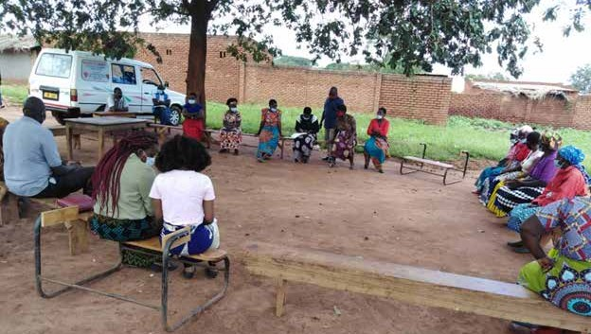
Representatives of womens’ groups and Anamukungwi (traditional birth attendants) from TA Chitukula meeting with the duty bearers from the Lumbazi and Mbang’ombe health centers to discuss the problems women face in accessing sexual reproductive health services during the pandemic.
© Mr Patrick K. Chima, Lilongwe CCJP Head of Programmes

- It distributed, via service delivery points, 3,500 boxes of disposable gloves and 50,000 N95 masks to hospital staff
- Through the programme, UNFPA procured and distributed three ventilators, 10 anesthesia machines, 20 patient monitors, 10 ultrasound machines, 56 doppler fetal heart machines, 10 vacuum extraction machines, 20 infant scales, 30 suction machines and 100 hand- operated infant resuscitators
- These supplies improved access to care in 10 districts countrywide and created more spaces for women
to access Comprehensive Emergency Obstetric and Newborn Care (CEmONC) services
- With regard to infrastructure, the programme built temporary tents for maternal and newborn health services, and it refurbished two operating theatres in Dedza which were 60% complete at the time of
reporting. It also procured 15+ laptops and helped meet technology and connectivity needs.

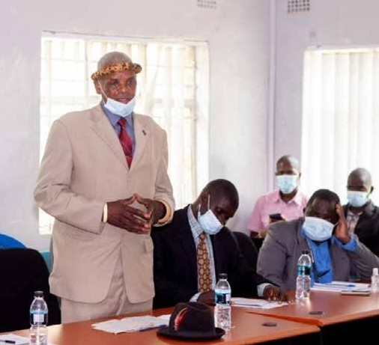

TRADITIONAL LEADERS PROMOTE SRHR IN T/A CHINDI
With the capacity built among chiefs, traditional leaders undertook awareness campaigns that challenged men and boys to use their societal privilege and become agents of change that protect and promote sexual and reproductive health rights for women and girls.
Inkosana Thomas Nkosi (pictured here) who chaired the group of 14 chiefs mandated by the T/A to mobilize men and boys as agents of change said, “Before this project came in, it was difficult for us to realize how much damage we were doing to our women and girls, but the project has been an eye opener to us as chiefs and we felt challenged that we should take this message to
our people sensitizing them on the need to respect women and girls...” The initiative, which reached 635 people (533 men and 102 women) at the time of reporting, aimed to reach 1,000 people by the end of the programme.

Innovation and Learning
Innovative virtual trainings reduced the time service providers spent going to in-person trainings, and it expanded reach. Meanwhile, mobile health services decongested health facilities by offering service at the doorstep and allowed for additional service provision.
On transport, the programme recognized bicycle ambulances as practical in rural settings and recommended reprofiling the budget to include them. In addition, a one-stop-center model created efficiency and facilitated outreach programmes where health personnel could provide SRHR services, report cases, and disseminate information on GBV and COVID-19 all at once. With regarding to training, preparing helpline workers to handle GBV cases proved essential and there was an increase in the number of callers seeking information and guidance on GBV.

MAURITANIA

Improving Epidemiological Monitoring for COVID-19 through an inclusive community level response in Mauritania
End Date: December 31, 2020

Programme Summary
This programme helped operationalize community monitoring strategies and ensured inclusive epidemiological monitoring nationally. It promoted the importance of early identification and rapid isolation of positive cases across the eight regions that share borders with Mali and Senegal. The intervention pursued three priority objectives: strengthening surveillance at the local and national level; strengthening epidemiological research; and improving case management.

Achievements under Pillar 1 on Health First
- The community watch operation mobilized 2,288 volunteers that reached 288,000 households across the country with information on how to prevent COVID-19, to refer COVID-19 cases to the right health institution, monitor potential cases, and prevent further transmission in households with a positive case
- Established a national steering committee to strengthen and coordinate community response mechanisms; it was comprised of the three Ministries of Health, Youth and Social Affairs) as well as UN agencies
- Established an alert and response system including a toll-free number (1155) to strengthen the capacities of intervention teams to investigate and follow-up suspected cases

- Deployed 85 health workers in the Nouakchott region to screen contact cases. This team, called the COVID
-19 intervention brigade, detected the first cases of community contagion
- Deployed 300 health workers in the Nouakchott region for two months to bolster the capacity of hospitals to handle COVID-19 cases
- Trained border agents on screening travelers and border communities; trained regional health authorities to coordinate more effectively
- Equipped border crossings with disinfection equipment and PPE

Innovation and Learning
An innovative payment system (rapid provision of funds through local bank branches) was set up to transfer funds to community volunteers to cover their travel expenses. Relevant authorities across civilian and security domains were brought together, which created significant synergies and allowed the program to be catalytic in its impact as developed capacity cascaded down through several institutions.

MALDIVES

Strengthening Resilience of the Most Vulnerable to Future Shocks in the Maldives

End Date: 31 Dec 2020

Programme Summary
This programme supported the capacity of the mental health system to: help the elderly as well as youth cope with stress; to meet the needs of people with disabilities; to expand government services for those living in quarantine; and to provide specialized care for healthcare and essential workers in a gender and age sensitive manner.

Achievements under Pillar 1 on Health First
- Provided Mental Health and Psychosocial Support Services (MHPSS) training to nearly 7,000 individuals (teachers, MHPSS volunteers), thereby increasing their capacity to deliver community-based psychosocial support (PSS)
- Expanded access to MHPSS support, with 6,995 people across the country directly benefitting from the psycho- social helpline
- UNICEF and its partners (SHE, ARC, MRC, CMH,
Blue Heart) disseminated 132 mental health related messages and posts via social media reaching 1,546,227 people
- Approximately 4,000 people received specialized mental health services from the Centre for Mental Health (CMH). In part, as a result of the increase in service availability and the messaging regarding the universal challenges caused by COVID-19, there was a notable shift in community sentiments towards the acceptability of mental health services
- Expanded critical MHPSS services across the four layers of MHPSS services, covering different kinds of services in the spectrum
- Leveraged UNICEF’s existing partnerships and built new ones to improve access to quality MHPSS services – as

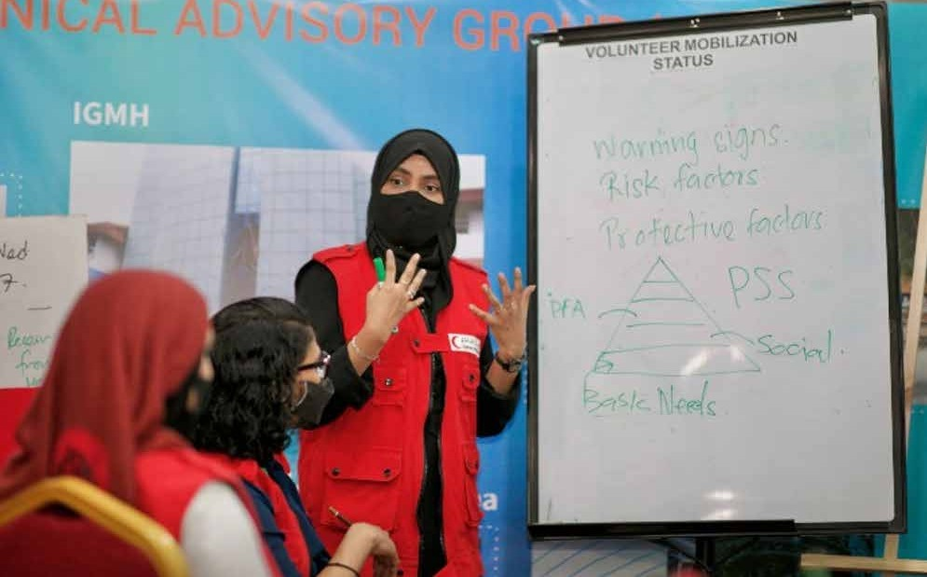
Shita, taking an orientation session with MRC Volunteers in the health emergency Operation Centre.
© UNICEF

the project had four civil society organizations and four government agencies involved
- Strengthened emergency preparedness at the Home for People with Special Needs (HPSN) through the provision and installation of medical equipment for an intensive care unit (ICU) and the provision of drugs and personal hygiene items

MOLDOVA

Safety First: Securing Healthcare Workers and Health Systems in the Response to the Immediate Needs of Vulnerable Populations during COVID-19
End Date: 15 December 2020

Programme Summary
This joint programme, implemented by IOM, UNWOMEN, and UNICEF, contributed to more effective and accessible health services and control of the COVID-19 pandemic. The intervention focused especially on providing urgent support, supplies, equipment, and capacity building to key frontline medical workers, police, border police, and social workers. The UN worked closely with civil society partners to identify and reach vulnerable communities in Moldova such as Roma, women from underrepresented groups, people with disabilities, and other at-risk communities. Finally, the programme improved safety and infrastructure around points of entry (PoE) with improved WASH facilities and waste management.

Achievements under Pillar 1 on Health First
Protective equipment for health facilities and vulnerable populations
- Procured 933,098 units of PPE for frontline workers
- Provided PPE to 58 healthcare facilities, as well as 500 social workers and social assistants from 70 multi- disciplinary teams from six districts (Ocnita, Telenesti, Drochia, Glodeni, Rascani, and Donduseni)
- Provided 7,939 vulnerable and marginalized women, including young girls and their dependents, access to immediate and preventive supplies, such as food and hygiene packages
- Provided protective equipment to vulnerable populations that included Roma people (923), women from the vulnerable Transnistrian region (1,800), women living with HIV (3,145), women with disabilities (108), and survivors of domestic violence (336)
Protection and preventative measures at points of entry
- Trained 200 border guards virtually
- Provided 764,380 individuals with health screenings at PoEs, by early 2021
- Provisioned supplies to 12 PoEs, including: 2,000 gallons of disinfectant solution, eight thermo-scanners, 12 UVC Germicidal lamps, five nebulizers, seven back-pack sprayers, 10 bio-trash bins, 23 automatic/non-contact hand sanitizer dispensers, 30 mini safe step carpets, 35 liters biocidal solution, lysoformin 3,000, 10 table watercoolers and 30 water bottles
- Updated standard operating procedures and guidelines were introduced to enhance PoE emergency response and safety procedures
- Provided updated gender disaggregated data on returned migrants
- Executed a Displacement Tracking Matrix Assessment through comprehensive surveying of returning migrants and their host communities

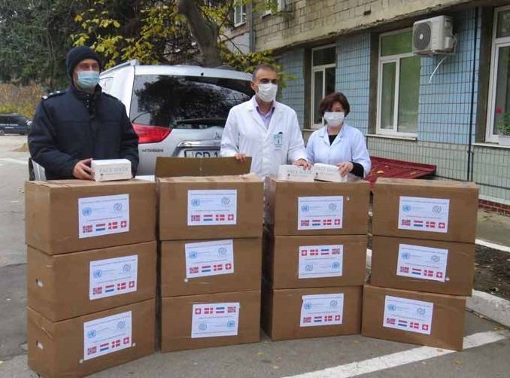
Face masks offered to border police
© IOM

- Drafted a report on the mobility-driven impacts of COVID-19 and profiles of the returning migrants as well
as specific vulnerabilities of groups affected by remittance decreases
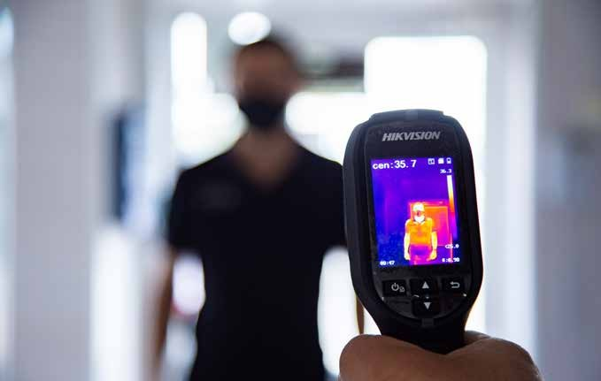
Detection equipment, thermography scanners, donated to border police
© IOM

Innovation and Learning
Learnings on the importance of local procurement and civil society cooperation
Close collaboration with civil society organizations turned out to be a valuable approach for successfully identifying vulnerable populations and distributing supplies to those most at-risk of being left behind. The implementing agencies put a special emphasis on identifying local service providers and vendors for the procurement of supplies for distribution. One of the most important selection criteria for the vendors providing PPE and cleaning and hygienic products, was that they were local manufacturers and retailers. A special emphasis was also given to those vendors that were managed or owned by women. This approach created an additional layer of support for women affected by the economic consequences of the COVID-19 pandemic and proved especially important given the constrained capacity of international vendors to provide PPE, especially at the beginning of the pandemic.

MOROCCO

Ensuring the Continuity of Essential Primary Healthcare and Hospital Services for the Most Vulnerable and Developing Prevention and Hygiene Measures for Essential Non-health Sectors during the COVID-19 Pandemic

End Date: 31 December 2020

Programme Summary
This programme used a two-pronged approach to nationally address health and safety in the context of COVID-19. It ensured the continuation of care of selected health services (reproductive, maternal, and chronic condition care) to vulnerable populations. It also protected frontline workers through improved IPC and communications in and outside of the health sector.

Achievements under Pillar 1 on Health First
To maintain continuity of essential non-health services in the context of the pandemic, the programme:
- Helped three sectors of food, trade, and waste management provide protective measures for 2,000 employees, thus avoiding disruptions of essential services
- Sensitized 2,000 front-line workers (40% women) on communication tools developed by the programme; and sensitized 5,000 employees on COVID-19 prevention
- For 100 enterprises, it produced and disseminated six practical guides to support business recovery and resilience to the pandemic; and developed an online training platform
- Developed a COVID-19 Prevention Charter with information on labor law, circulars, and guidelines
- Reached 5,000 frontline workers in industrial sectors with communication materials
With regard to healthcare, the programme:
- Exceeded its target by two-fold by benefitting 21,473 women via mobile health services across 30 health facilities
- Made available four patient databases in four health facilities (two urban and two rural)
- Procured four mobile health units to ensure in-home palliative care for 400 bedridden cancer patients
- Equipped 30 SRH facilities with computer tools and digital applications
- Created two hospital palliative care units (in the Regional Oncological Center of Agadir and Beni Mellal) to benefit all patients requiring palliative care
- Employed three thermocycler PCR machines to aid COVID-19 diagnostic testing
- Equipped 200 health facilities with medical equipment such as electrocardiograms, oximeters, and blood pressure monitors
- Equipped 30 health facilities with medical equipment to ensure a quality prenatal care through a rapid screening of high-risk pregnancies – which benefited 3,000 women

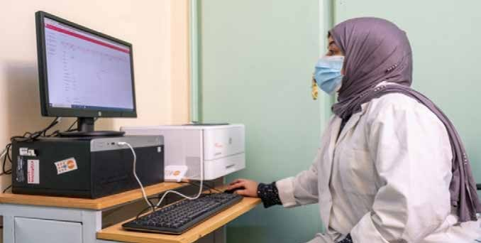
“All women, married or not, who come to this Health Centre and wish to receive a contraceptive method are supported. Thanks to this application, women receive messages in Arabic on their phones reminding them the date of the next consultation. In this way, we ensure the continuity of the service in a safe environment.” - Mrs Salwa, midwife, AMAL Health Center
© ONU-Maroc/HassanChabbi

- Developed a digital dashboard to ensure the continuity of SRH services provided by OPALS (Pan-African Organization to fight against AIDS) and its internal management
- Developed a monitoring and evaluation tool on services provided by Regional Maternity Hospitals
The programme trained various professionals on the use of

digital interventions.
- 15 health professionals of four pilot primary health centers and 20 managers at the Informatics Department of the Ministry of Health trained on digital applications
- 20 Ministry of Health trainers learned digital applications and trained 200 health professionals
- 50 health professionals trained on palliative care and pain treatment
- 72 health professionals operating in prisons trained to use the teleconsultation services
- 400 healthcare professionals received online training for six weeks on essential newborn care
Interventions provided protective materials and equipped facilities for service. The programme:
- Provided 3,200 health workers and 852 centers with PPE

- Equipped 24 prisons with 13,700 inmates with PPE and teleconsultation services
- Equipped 113 health units for women victims of violence in provincial hospitals with informatics tools for women’s health tracking
- Equipped 18 health units for women victims of violence in provincial hospitals with medical and office equipment to ensure women’s privacy and care in line with the essential service packages
To address gender-based violence and support vulnerable populations, the programme:
- Hosted 139 women victims of violence and three migrants in three shelters
- Provided 200 women victims of violence with hygiene and COVID-19 protection kits
- Counselled and gave legal support to 504 women victims of violence in ANARUZ centers
- Integrated 50 women victims of violence into three cooperatives to economically empower them
- 4,500 women victims of violence received emergency contraceptive pills
- Trained 765 healthcare professionals to provide medical care for victims of GBV

Innovation and Learning
Confronted with the restrictive measures, the adoption of health digitalization was a central innovation. It ensured the continuity of health services, both in primary hospital settings and in prisons. With regard to SRH and family planning, the digital system developed for the benefit of 30 Primary Health Facilities was a highly innovative tool
for managing and monitoring consultations of pregnant women and women of childbearing age, as well as for data collection, work organization, and appointments management. Similarly, the implementation of a teleconsultation system in the 24 targeted prisons, as a
pilot initiative in the country, was an effective response that ensured health coverage inside these centers, which did not have a full-time medical team and had a population of over 13,000 inmates.

- Sensitized 3,500 sex workers on COVID-19 protection
- Gave 250 Moroccan and foreign women gynecological and dermatological consultations
- Provided psychological support to approximately 60 people living with HIV
- Benefitted 1,050 migrants with HIV prevention and SRH promotion programmes
- Created a monitoring and evaluation dashboard for the 113 Health Units for women victims of violence in provincial hospitals
The initiative used communications tools to meet its objectives. It:
- Equipped 80 OPALS local development agents with COVID-19 protection kits
- Trained 267 officials and 37 managers of “youth structures” on prevention and communications
- Supported OPALS to produce 1,000 flyers (in English, French, and Arabic) on virus prevention
- Distributed 100 vests and 80 caps to ensure the visibility of the local information agents
- Produced 26 video-clips to raise awareness and support recovery of targeted enterprises
- Produced four video-clips to document project results

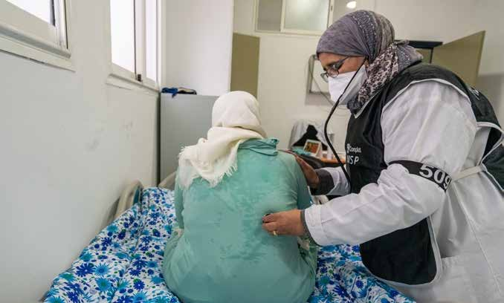
© ONU-Maroc/HassanChabbi

PAPUA NEW GUINEA

Integrating WASH, Nutrition, and Maternal and Newborn Health (MNH) Interventions for COVID-19 Response in Western Province, Papua New Guinea
End Date: 31 March 2021

Programme Summary
This programme improved basic service delivery in four villages of the North Fly District of Western Province, a border area with COVID-19 cases. It supported the provision of WASH services, the reduction of severe malnutrition rates in young children, and the improvement and continuity of maternal care services.

Achievements under Pillar 1 on Health First
Under the maternal and newborn health (MNH) component, the following results were achieved in the seven target communities:
- 829 pregnant and postpartum women received antenatal and postnatal care
- 104 newborns were delivered and provided with neonatal care
- 62 healthcare providers improved their capacities to provide maternity and neonatal care with adequate IPC measures
- 6,610 community members were reached with information on COVID-19, pregnancy complications, delivering in a health facility, newborn care, and family planning

- As a result, the proportion of births delivered in health facilities rose to 64% from 58%
- An emergency transport system for pregnant and postpartum women was established
- 400 clean reproductive health delivery kits, six anti- shock garments and mannequins were procured for six project health facilities and the village health volunteers (VHVs)
- A basket fund was established for emergency transport of mothers and newborns from rural communities/facilities to the Rumginae referral hospital
- Completed renovation of the Matkomnae Sub health center and Rumginae Rural hospital to provide improved maternal care

Achievements under Pillar 2 on Protecting People

The nutrition component was fully achieved and exceeded expected project results for every target.
- 172 children were treated and cured of SAM out of 215 admitted and treated
- 9,469 children under five received vitamin A

supplements
- 3,725 children under five received micronutrient powder

supplementation
- 3,272 caregivers of children under two received feeding

counselling
- 3,993 pregnant and lactating women received nutrition
education

Innovation and Learning
One of the key lessons learnt was in the area of partnership: engaging with CSOs, and mobilizing and using community volunteers was an efficient strategy for delivering emergency response services in hard-to-reach and inaccessible communities.
- 5,915 adolescents were reached with COVID-19 prevention messaging as part of nutrition education
- 7,265 caregivers were counselled on child feeding practices
- 62 village health volunteers and 43 healthcare workers
were trained on treatment of SAM, micronutrient supplementation, and child feeding
Under the WASH component:
- a needs assessment identified 25 target sites (six health centers/posts, 12 schools and seven other sites) in eight villages for WASH infrastructure rehabilitation and upgrade
- The activities, by project end, aimed to benefit 1,203 households, including 7,123 individuals

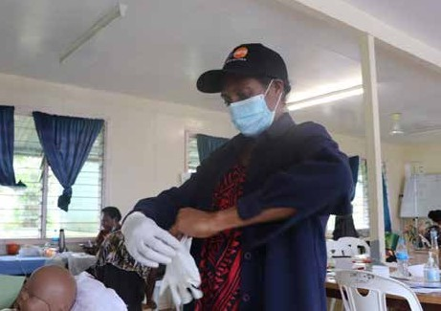
Stella O’Wene demonstrates her antenatal care techniques to trainers from the National Department of Health. The skills rehearsed in this training session
will be passed on to her colleagues at Matkomnai Sub-Health Centre.
© UNFPA / Rachel Donovan

PERU

Saving Lives and Protecting the Rights of Amazonian Indigenous Women in COVID-19 Response
End date: 1 January 2022

Programme Summary
This programme focuses on building back a better, more resilient, and adaptable health system that reaches groups in Peru most at risk of being left behind. By pursing a leave-no-one-behind (LNOB) approach, this intervention will ensure indigenous women’s access to health services, especially sexual and reproductive health (SRH) services, in Condorcanqui. It will also strengthen national coordination and referral systems to prevent and respond to gender-based violence (GBV).

Achievements under Pillar 1 on Health First
The joint programme commenced on 1 November 2020. Thus far it has:
- Progressed with an assessment of current needs and gaps in the Peruvian health system, which will facilitate a mapping of activities to strengthen the competencies of health personnel and access to health services for indigenous women
- The sexual and reproductive healthcare model adapted to COVID-19, successfully implemented in other regions, was reviewed and the points of cultural adaptation to the context of Condorcanqui defined
- Carried out a similar process with the prototype created by UNFPA to strengthen the recording of the variable
of ethnic self-identification in SRH records and the epidemiological surveillance of maternal death
- Held a training workshop on the management of obstetric emergencies for 35 obstetricians belonging to DIRESA Amazonas, thus indirectly benefiting 418 pregnant indigenous women
- Prepared two hospitals to care for obstetric complications of pregnant women referred from Condorcanqui (Bagua Hospital and Virgen de Fátima Hospital)

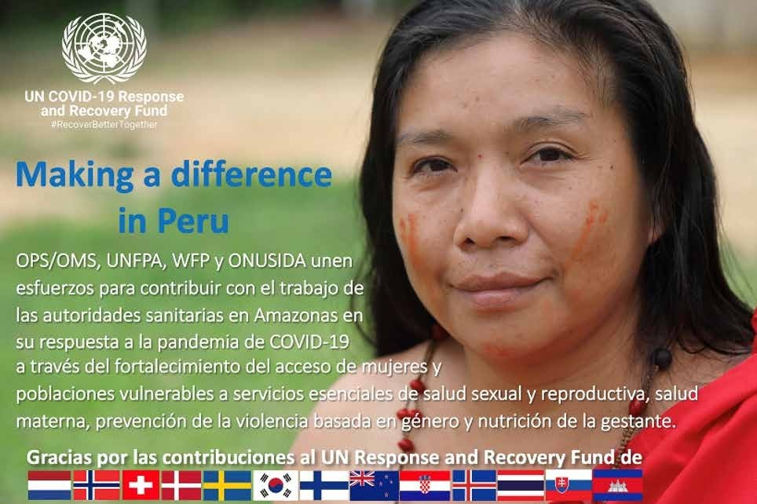
Picture of woman from Condorcanqui from Peru’s national leg of the COVID-19 MPTF Making a Difference - Social Media Campaign

- Designed a cascade training strategy to strengthen the skills of more health workers to reduce maternal morbidity and mortality
- Began research to identify the gaps and needs for strengthening coordination between the institutions that make up the system of protection against GBV

TAJIKISTAN

Strengthening the Health System in Tajikistan to Prepare and Respond to COVID-19

End Date: 31 March 2021

Programme Summary
This programme supported government preparations to provide healthcare services, especially to women of reproductive age, in the context of COVID-19. Specifically, it helped procure and distribute medications and ventilators across hospitals; trained reproductive healthcare service providers in remote consultation; and supported four regions of Tajikistan to acquire the mobile and internet connectivity needed to ensure that reproductive health services could continue to operate.

Achievements under Pillar 1 on Health First
- To support national preparedness amid the coronavirus pandemic, the programme, in consultation with the Ministry of Health and Social Protection of Population (MoHSPP), agreed on a priority list of 13 types of pharmaceutical medication and 12 kinds of equipment to procure and provide for the intensive care units
of 35 hospitals selected to treat patients suffering from COVID-19
- Delivered and installed five ventilators, 20 (10L) units of oxygen concentrator and five analyzers to health facilities. Provided tailored training sessions to ICU staff on the equipment’s use and maintenance
- Procured essential supplies as per the approved MoHSPP’s Distribution Plan for 100 hospitals/primary healthcare facilities, benefitting 13,000 people confirmed positive for COVID-19 and who received treatment through this support
- Established a tele-health system to minimize direct patient contact in non-urgent situations in an attempt to minimize the spread of COVID-19
- Procured, tested, and handed over tele-health equipment to the National and four Regional reproductive health centers of MoHSPP, with 22 sexual and reproductive health (SRH) service providers selected to maintain alternative antenatal care (ANC), family planning (FP) and psychosocial support services
- Provided 22 dedicated phone numbers and stable Internet connection for all reproductive health clinics
- An estimated 19,400 women of reproductive age received remote online consultations on SRH and GBV related services, with the government institutionalizing the mechanism and remote service provision set to continue throughout the pandemic at least until June 2021
- Three temporary protocols on ANC, FP and psychosocial protection were developed by the national experts group of MoHSPP and integrated into reproductive health facilities throughout the country.

More than 13,000 patients with COVID-19 and acute respiratory infections across Tajikistan benefited from a shipment of life-saving equipment and medicine, including patients at the Republican Infectious Diseases Hospital in Dushanbe. UNICEF Tajikistan, in close cooperation with the Ministry of Health and Social Protection of the Population, distributed the equipment and medicine to ensure fast and quality treatment for patients.
© UNICEF Tajikistan/2020/Saidmurod Odinaev

All protocols were developed based on WHO/UNFPA technical guidance notes on maternal care during COVID-19 and tested at the National RH Clinic
- Three cascade trainings on the provision of online SRH services based on temporary counseling protocols were conducted at national and regional levels, covering 91 SRH specialists along with 64 RH service providers trained on psychosocial support services during COVID-19
- Distributed 60,000 leaflets along with 200 posters on SRH and basic hygiene practices throughout the country along with awareness raising campaigns
- Aired a video public service announcement on national and regional TV media 152 times; it reached over two million people, including 200,000 pregnant women and 800,000 women using modern contraceptives

Innovation and Learning
The programme helped establish tele-health technologies for the first-time, introducing alternative ways of SRH service provision in Tajikistan. Different MoHSPP affiliated structures such as the National Reproductive Health Center, the Republican Clinical Family Medicine Center along with experts from the Academy of Health Sciences were engaged in the adaptation and development of temporary counseling protocols on SRH during COVID-19. Adjustments to the standard schedules were tested so that some appointments could be conducted using phone or video chat, and to ensure that there was no disruption in service for women’s maternity care.
With regard to learning, it was necessary to reconsider country-based contingency plans to include epidemiological situations such as the COVID-19 pandemic. With the development of new technologies, Tajikistan should learn and apply alternative ways of providing healthcare services, such as tele-health, in order to provide quality information and safe services for its population at times of emergencies. Tajikistan should also consider developing distance learning opportunities, especially targeting emergency preparedness and response interventions.

TOKELAU

Enabling Quarantine and Isolation Capacity on the Three Atolls, Convertible to Long-term Use Post COVID-19, in line with the Tokelau Preparedness and Response Plan for COVID-19
End date: 31 March 2021

Programme Summary
An isolated pacific island State with a population of just over 1,600 residents living on three atolls, Tokelau had no reported COVID-19 cases at the time of reporting. This programme supported the government to prepare for COVID-19 cases by assuring that each atoll had operational quarantine and hospital isolation centers; building capacity of homes to
accommodate any overflow from hospital isolation centers; and enhancing national capacity to mainstream gender-sensitive protection activities and assure the continuity of essential sexual and reproductive health (SRH) information and services.

Achievements under Pillar 1 on Health First
- Upgraded quarantine centers on all three atolls so that a total of 39 rooms, 64 beds and 11 isolation wards are available
- Procured 21 air conditioning units and installed them at the centers in each atoll (eight on Atafu, seven on Fakaofo, and six on Nukunonu)
- Procured and distributed 1,716 items of PPE
- Reached 1,600 people (which is close to Tokelau’s entire population) with preventive healthcare awareness campaigns on each atoll
- Trained 20 health care workers on COVID-19 case management
- Built the capacity of 14 female and 1 male healthcare workers to integrate SRH and women’s protection into national emergency response
- Built the capacity of 56% of the health workforce in Tokelau on the Minimum Initial Service Package (MISP) for essential SRH services during emergencies, including COVID-19 adaptations to ensure the continuity of SRH services. The training covered 100% of Tokelau’s atolls

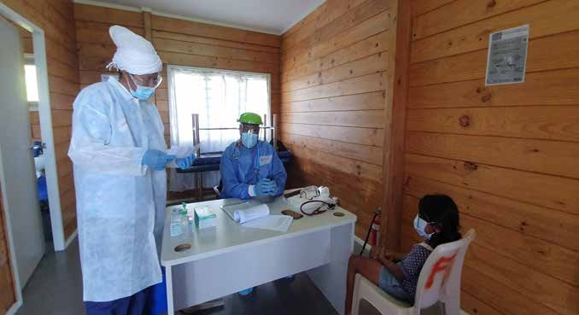
A mock scenario during one of the Advisory Committee M&E’s visit to Fakaofo. Dr Lameka Sale sitting in full PPE and RN Sela Poasa standing in full PPE checking to confirm if the suspect baby girl is confirmed or not.
©National media

and 100% of health facilities, with 14 health workers capacitated
- Conducted a social economic impact survey covering 20% of Tokelau’s population and 30 businesses, with
an assessment report based on the findings under development

Innovation and Learning
Gaps and barriers for sexual reproductive health rights
With regard to learning, the programme revealed gaps and barriers in access to sexual and reproductive health rights. In connection with the impact assessment, 10-34 % of survey respondents refused to answer questions related to difficulty in accessing reproductive health services, while 40-64% responded that they had no need for reproductive health services. Given this data, the programme has enhanced the partnership between the Tokelau Department of Health and UNFPA. Through the emphasis on continuity of essential sexual and reproductive health services, the programme has engendered key lessons to improve and target future UNFPA programmes and engagement towards closing lingering gaps and barriers, like those revealed in the assessment, that prevent universal access to sexual and reproductive health services in the country.

57
The COVID-19 MPTF Global Report

PILLAR 2

Protecting People – Social Protection and Basic Services

ARMENIA

COVID-19 and Resilience in Armenia: Mitigating the Socio-economic Impact on Vulnerable People and Communities
End date: 31 March 2021

Programme Summary
This joint programme supported the Government of Armenia in meeting critical social and economic priorities in the country’s pandemic response. It lent assistance to the country’s most vulnerable through cash transfers to children with disabilities; financial support to MSMEs, and assistance to migrant workers.
Achievements under Pillar 2 on Protecting People
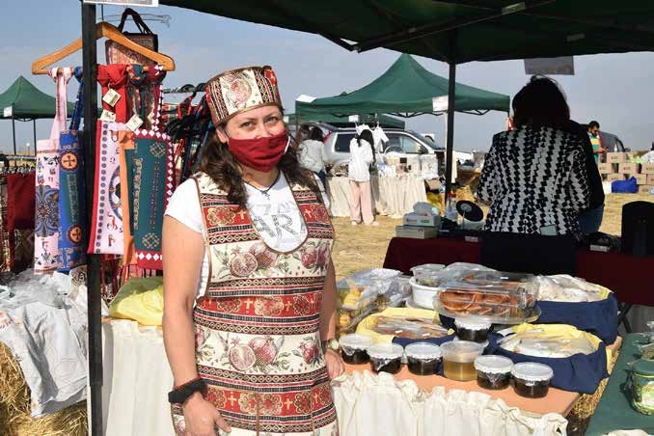
Despite the compounding crises of the pandemic and escalating hostilities in the Nagorno Karabakh region, this joint programme successfully employed a mix of traditional and innovative approaches to target and provide support for some of the most vulnerable groups in Armenia while also enhancing the stability and resilience of micro-, small-, and medium-enterprises (MSMEs).
On social protection, the programme:
- To mitigate poor data availability and lack of needs assessments, which challenged government approved socio-economic programmes, the programme assessed 35,000 persons (8,000 households) affected by
COVID-19 through a rapid assessment undertaken by the Ministry of Labor and Social Affairs

- To supplement these findings, the programme worked with the Ministry of Labor and the World Bank to develop a dedicated online platform for social workers to enter information to assist the future identification and enrolment of beneficiaries into social protection programmes
- Offered direct cash support to 3,647 individuals and 247 households, including 2,932 children with disabilities, households with persons (predominantly Armenian nationals) displaced from Syria, and 715 elderly age 75 and above, and living alone
- A vertical cash top-up of 26,500 AMD per child – aligned with the childcare benefit value and food poverty line – was provided to 2,932 children with disabilities (67% boys, 33% girls) living in 2,797 families receiving family benefits countrywide
A displaced Syrian entrepreneur, supported through “COVID-19 and Resilience in Armenia: Mitigating the Socio-Economic Impact on Vulnerable People and
Communities” project funded by the UN COVID-19 Response and Recovery Fund, wears a facial mask to help combat the spread of COVID-19 at the annual Festival of Rural Life and Traditions held near Yerevan, Armenia.
© Anahit Hayrapetyan/UNHCR

- Purchased two servers for the Ministry of Labor and Social Affairs to enable unified data collection on
domestic violence cases as well as for data development disaggregated by age, sex, vulnerability and location
- Trained 500 social service workforce professionals on mental health and case management in the context of COVID-19

Achievements under Pillar 3 on Economic Response and Recovery

To support MSMEs, the programme
- Supported opportunities for employment and entrepreneurship for disadvantaged people and MSMEs, including through improved access to technical assistance and digital innovation. Interventions included assessing and testing PPE production value chains
- Offered 106 MSMEs various mechanisms of support
- Benefited five industrial companies, with approximately 1,000 employees (95% women), so they could produce medical uniforms and bed linens; assisted 50 women employees with the organization of medical gear production
- Provided 101 MSMEs with funding for entrepreneurial initiatives

Innovation and Learning
Towards mobile healthcare, a Mobile Testing Service was piloted under this joint programme. It included a needs assessment, design of the mobile testing service, development of the management system for the new service, capacity development of nurses, and finally, a roadmap for the new service pilot. Based on the high interest and need for mobile healthcare services in larger municipalities, mobile testing services will be upscaled within the UNDP project ‘Women and Youth for Innovative Local Development’ and will be established in one more large municipality.
The programme also supported the development of an online platform for labor rights protection. The innovative EmployeeProtect.am platform was designed by the initiative of the Health and Labor Inspection Body in partnership with the Armenian Lawyer’s Association. It aimed to strengthen the system of the protection of labor rights in Armenia and offered a response to numerous cases of job losses or labor rights violations during the pandemic. Easy to navigate, the platform allowed for online registration, acceptance, and examination of applications on violations of the rights of employees, which were then processed by the Health and Labor Inspection Body of Armenia. It supported evidence-based implementation of reforms in the labor rights’ protection sector based on the information generated from complaints of labor rights violations of employees. It also provided a space for awareness raising on the rights of employees as well as the latest updates on labor rights’ protection. The platform will be piloted for the next three months and improved based on the user feedback and operational efficiency. In parallel, a replicated model will be applied to mobile apps for IOS and Android systems.
One of the key programmatic learnings came from the decision for the UN to open a dedicated Treasury account under the Ministry of Labor and Social Affairs for the Social Security Service. Though this process caused some initial delays (approximately one and half months), it proved to be a much more efficient, better coordinated, and more direct way of providing cash to beneficiaries.

BHUTAN

Education Continuity in Response to COVID-19 in Bhutan

End Date: 31 December 2020

Programme Summary
This programme supported the delivery of online learning for children through TV and Google Classrooms as well as the distribution of self-instructional materials (SIM) to children living in remote parts of the country. Further, it reinforced the capacity of teachers to use radio, SIM, television, and online learning tools, ensuring the continuity of education services in response to the COVID-19 induced closure of schools and early learning centers. The programme also assisted trained school counsellors in providing online and mobile psychosocial support to vulnerable children.

Achievements under Pillar 2 on Protecting People

- Developed Education in Emergency (EiE) Guidelines as well as an EiE Phase-II COVID-19 response plan including school re-opening protocols and highlighting curriculum adjustment and delivery, safety protocols for when children return to school, and psychosocial support to children
- Supported the government provision of home-based education through TV and Google Classrooms to 170,000 children
- Developed SIM and radio lessons for students living in remote areas who were unable to attend e-lessons due to a lack of access to the Bhutan Broadcasting Service, television or smartphones
- Printed and delivered SIM materials to support the education of 32,135 children
- Provided 171,938 SIM booklets to schools, of which 86,072 SIM booklets were supplied by the Ministry
of Education, 34,805 booklets by the Dzongkhag and Thromdey Education offices, in addition to 51,061 copies printed within the schools
- Developed guidelines to ensure that children could meaningfully engage with their assistive devices for online learning, focusing on online safety, usage, updates, maintenance, and hand-over details
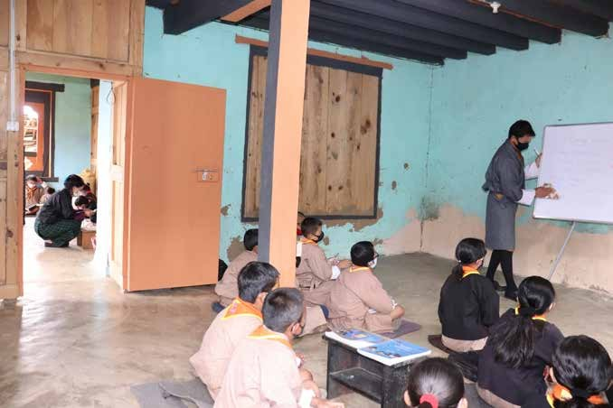
Mobile teaching: A farm house in Laptsakha village, Punakha functioned as a classroom during the closure of schools in 2020.
© UNICEF Bhutan/2020/SPelden

Innovation and Learning
The SIM were an innovative intervention developed to support the continuity of learning for the most vulnerable of children – those who lacked access to online or TV-based lessons during the pandemic. SIM were printed teaching-learning materials that carried the same learning lessons as the adapted curriculum and were structured in such a way that learners
could do most, if not all, their learning based on the materials alone.
A SIM assessment was undertaken as part of the Education in Emergencies Monitoring and Assessment. It will be finalized by the end of February 2021 and capture the experiences and lessoned learned for future use. The preliminary findings of the assessment revealed that 80.8% of the respondents found SIM user-friendly and adequate for learning.

BOSNIA AND HERZEGOVINA

Business Unusual: Reimagining Education for Marginalized Girls and Boys during and post COVID-19 in Bosnia and Herzegovina
End Date: 15 March 2022

Programme Summary
This joint programme will support Bosnia and Herzegovina (BiH) to reimagine education such that it: supports marginalized learners; prevents, mitigates and quickly responds to emergencies; focuses on gender-responsive approaches addressing learning losses and dropouts; offers skills for employability; supports the teaching profession and teachers’ readiness; expands the definition of the right to education to include connectivity and removes barriers to connectivity; strengthens data and monitoring of learning; and strengthens the articulation and flexibility across levels and types of education and training. The initiative’s key activities will help mitigate and overcome educational disparities while building the capacity of and empowering female teachers who constitute close to 70% of the workforce. Additional activities will focus on closing gender data gaps and making long-term investments and education policy changes that promote gender equality in the teaching workforce.
Achievements under Pillar 2 on Protecting People

- The programme’s coordination structure was established, and its induction phase is in the process of finalization
- This joint programme requires the establishment of the complex partnership mechanisms with the selected education authorities in Bosnia and Herzegovina. The
UN has obtained the formal endorsements of the intervention from five education authorities (Ministry of Civil Affairs in BiH; Ministry of Education and Science in Republika Srpska; Ministry of Scientific and Technological Development; Higher Education and Information Society in Republika Srpska; Ministry of Education, Culture,
Science and Sports in West Herzegovina Canton; Ministry of Education, Culture, Science and Sports in Una Sana Canton) and has further identified the
government institutions to be included in the specific areas of intervention (such as pedagogical institutes and universities).
- UNESCO initiated a series of consultations with potential implementing partners (UNESCO Global Education Coalition, Microsoft, academia, local training providers, and CSOs) to explore the possibility of catalyzing additional support, as well as cooperating in the implementation of specific programme activities

CABO VERDE

Safety Nets and Revenue Recovery for the Poorest Households and Women Informal Workers in Cabo Verde
End Date: 31 December 2020

Programme Summary
This programme provided lifesaving and relief assistance at the national level to vulnerable households in the country. It targeted households headed by women and with at least one child under 15 years of age, an elderly person, or a person with a disability. For six municipalities on two islands, the programme also supported women-led informal businesses owners to recover their economic activities, while adapting to the pandemic context.
Achievements under Pillar 2 on Protecting People

All planned programmatic activities were successfully implemented within the budget’s framework and timeline. The programme supported social protection coverage, through the extension of an emergency cash-transfer, and it piloted business recovery solutions for women working in the informal sector.
- 1,000 of the poorest and female-headed households received a 5,500 CVE transfer for three months (beneficiaries were selected trough the Single Social Register (Cadastro Social Único) and those that were not yet registered into the CSU were integrated during the process)

Innovation and Learning
- 150 women from the islands of Fogo and Santo Antão, the country’s poorest and most isolated areas, received an integrated package to promote their recovery and/ or adaptation of their economic activities. This package
included: financial support, two training packages (Get- Ahead and Financial Education), financial and management services and guidance from partners’ NGOs and local consultants, and coaching for business recovery and formalization
- 52% of these businesses transitioned towards formality
- The initiative also allowed for the mobilization of an additional amount of US$10,200 from regular resources for UNICEF and UNDP to the country

Building on the lessons learned from this programme – in particular, its social protection coverage extension and business recovery solutions for the informal sector – a similar intervention called a ‘productive inclusion project’ with a US$10 million budget is being developed by the Ministry of Family and Social Inclusion with support from the World Bank, in 2021. Some of the lessons it may draw on include, inter alia: that a combination of financial and non-financial services was key to supporting the sustainable recovery of businesses and their transition to formality; that beneficiaries’ selection criteria should be clearly defined at the beginning of the process; that local authorities should be strongly involved in the process; and that, despite the challenging context of COVID-19, wide local ownership of the project should be ensured. Synergies with the municipalities were also crucial to implementation success.

DEMOCRATIC REPUBLIC OF THE CONGO

Concerted Action for Forcibly Displaced Women, Girls, and Host Communities against Consequences of the COVID-19 Crisis
End Date: 1 November 2021

Programme Summary
This programme will foster participatory, collective, and inclusive actions at the grassroots level in the Democratic Republic of the Congo’s North Kivu Province. It will involve a diverse array of women and girls, men, and boys, as well as traditional and other opinion leaders, and women’s rights advocates, organizations, and networks. Approximately 3,000 vulnerable women and girls among refugees, internally displaced persons (IDPs) and host communities, and 1,000 male and female- lead households will receive urgent socio-economic and health assistance that has been diverted due to COVID-19 prevention measures. They will gain rapid and improved access to basic supplies, integrated and quality maternal and reproductive health care, protection services to safeguard their rights, cash transfers, as well as kits with food and medical items to be distributed during events that will also sensitize on sexual and gender-based violence (SGBV) and COVID-19.
Communities at large will benefit from improved health services, increased economic activity and social cohesion.
Achievements under Pillar 2 on Protecting People

- The sexual and reproductive health kit procurement plan was developed and implemented, while intervention locations were approved including eight health structures with the collaboration of the Health Zone Manager
- Provided psychosocial support (individual therapy) to 201 cases of GBV, of which 77 were in Masisi
- Provided 122 young, at-risk women with cash transfers
- Supported one civil state office in Masisi Center to register 124 births. The files of 255 children were supported before the Tribunal de Paix of Masisi Center. An ongoing campaign in Masisi territory reached 3,158 IDPs with information on the registration moratorium
- Elaborated action plans and provided initial training to 20 women from five women’s organizations on the axis Masisi Center - Katale: Forum des Femmes, SOFEM, CAFPEDI, Wamama Simameni, and ALW
- Trained 11 officials from the ANR (intelligence), PNC (police), civil affairs office, social affairs office, and territorial administration on the key concepts of GBV and human rights; the legal framework; as well as their role and responsibilities in the prevention and protection of women and girls, displaced persons, returnees, and marginalized people, including with regard to the referral circuit

ESWATINI

Strengthening Crisis Responsiveness of Social Protection Systems during and beyond the COVID-19–induced Food Emergency in Eswatini
End Date: 31 December 2020

Programme Summary
This programme helped to meet immediate needs with regard to food security and agricultural recovery in Eswatini. It leveraged existing programmes to inform the reform of social protection mechanisms to address current and future shock- induced livelihoods and food security challenges. The initiative targeted those at high risk of food insecurity due to loss of employment, high food prices, and declining incomes.
Achievements under Pillar 2 on Protecting People and Pillar 3 on Economic Response and Recovery
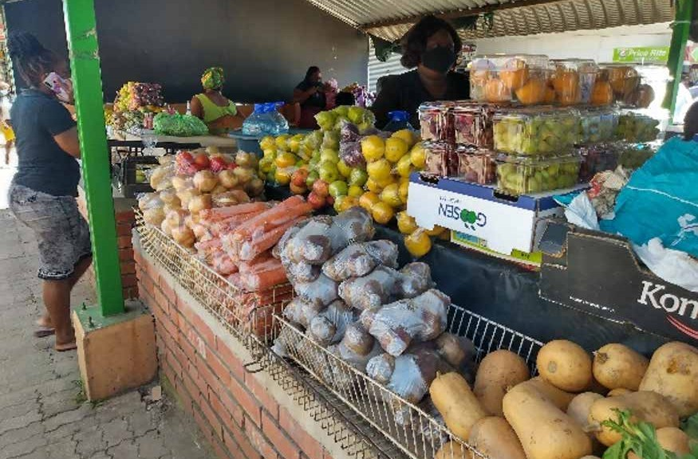
- WFP Provided cash-based transfers to the most vulnerable of populations in four peri-urban constituencies, namely Kwaluseni, Lobamba Lomdzala, Mbabane East, and Mbabane West. This assistance was provided between May and September 2020 to different groups affected by the pandemic including urban poor households affected by COVID-19, small business support (SBS), refugees, and the malnourished HIV/TB Clients (MHTC)
- The total number of beneficiaries reached were 46,591 people (8,993 households) that received cash-based transfers of SZL140.00 per person; 1,179 informal traders which received recovery startup capital SZL3,000.00 per person; 1,205 malnourished people on HIV/TB treatment that received SZL208.8 per person to meet their

respective food and nutrition needs
- FAO supported 15 farmer groups to produce and supply vegetables required by the 200 market vendors in Manzini and Mbabane communities
- Six transporters (three in Mbabane and three in Manzini) were engaged to deliver the produce from the farm gate to the vendor
- 30 (eight farmer groups and 22 individual smallholder farmers) were identified jointly with the National Maize Corporation (NMC) to produce maize (103.60ha)
Part of the market stall in Manzini, President Centre for vendors supported with vegetables to recover from impacts of the pandemic.
© FAO

and 38ha of beans for winter production. Indirect beneficiaries, estimated at 10,000+ individuals, were the family members of the beneficiaries
- As an ongoing initiative on the e-digital platform, all the stakeholders in the project were mobilized to register on a newly established marketing platform; Agricultural Marketing Information System (AMIS) currently managed by NAMBoard to facilitate ease of marketing the produce.

Innovation and Learning
FAO mainly focused on addressing loss of livelihoods and food insecurity challenges caused by disruptions of the agro-food system. This involved the use of appropriate available e-solutions and supply chain platforms to facilitate market linkages for smallholder farmers affected by market disruptions, allowing them to access markets and earn incomes and continue production.
Programme results showed that assisted affected populations improved their food security and reduced their engagement in negative coping strategies. However, to address poor nutritional feeding habits, diets should be improved through education.
A review of the Social Assistance policy will help the Deputy Prime Minister Office - Department of Social Welfare to put in place a robust National Social Assistance System platform to provide efficiency, accountability (audit & reporting) and
sustainable solutions in the management of beneficiary information; and flexible, accessible, and robust payment modalities. This is in pursuance of collective social welfare for broader coverage, transparent targeting, and harmonization of social protection programs for the benefit of the most vulnerable. It is envisaged that the Harmonized Social Assistance Policy will be shock responsive and recommend more efficient models. The review of the social protection policy will also serve as the basis for the development of the vulnerability register. Overall, this will support national goals to reduce poverty, inequality, and vulnerability.

FEDERATED STATES OF MICRONESIA

Support COVID-19 Contingency Plan for Federated States of Micronesia: Improved WASH Access and Services in Health Facilities
End Date: 31 December 2020

Programme Summary
This joint programme supported WASH interventions at health dispensaries and facilities in all four Federated States of Micronesia (FSM) States, as well as community and youth educational interventions meant to prevent COVID-19 transmission.

Achievements under Pillar 2 on Protecting People
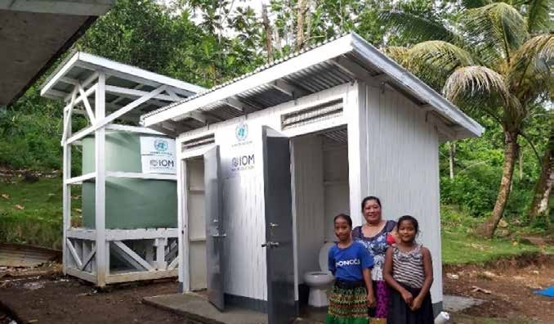
This programme improved IPC in 18 healthcare facilities benefitting 71,755 people. In addition to support for infrastructure and supplies, the technical assistance and advocacy facilitated the declaration of Chuuk State Handwashing Day on 21 October 2020 and Chuuk State Toilet Cleanliness and Sanitation Day on 25 November 2020, by Governor Johnson Elimo.
Specifically, the programme achieved:
- Installation of 35 additional handwashing facilities, 10 toilets, and 12 water tanks in 10 healthcare facilities (HCF) at the facility entrance, points of care, and toilets, as well as patient waiting areas

- Provision of 150 sanitary bins in 18 HCF to support waste management, which benefited 106 HCF staff
- The Department of Health and Social Affairs (DOHSA) finalized four videos on hygiene and IPC for HCF staff training and community awareness; benefitting 249 HCF staff

- Trainings were provided to schools and religious institutions to strengthen the implementation IPC at both institutions:
- Schools: 219 principals, teacher, and staff from 53 schools trained on IPC in school settings
Newly completed toilets and water tank at the Polle Village Dispensary in Chuuk State
© IOM

- Religious organizations: 10 youth leaders (8 female and 2 male) trained on how to implement IPC in religious facilities, which benefitted 200 children attending Sunday school in 10 Churches
- Baseline data on WASH in HFC, schools, and households were collected and utilized for programme planning and implementation

GHANA

Addressing Gaps in Ghana’s Pandemic Response for the Most Vulnerable Populations

End Date: 31 December 2020

Programme Summary
This Joint Programme provided national-level assistance as well as support for direct service provision in the Greater Accra area, which was the epicenter of the pandemic in Ghana and home to large numbers of people living in high density and low income circumstances.

Results under Pillar 1 on Health Services
Targeted beneficiaries included health workers, frontline WASH staff, communities, caregivers, children, and adolescents.
- 2,185 health workers benefitted from capacity building to assure the continuity of essential health services
- 346,931 people (men, women, and adolescents) received health and nutrition messages, and child welfare clinics (CWC) attendance increased from 4,619 boys and 4,591 girls in April 2020 to 31,034 boys and 32,086 girls
- 1,261 caregivers received infant and young child feeding (IYCF) counselling

Results under Pillar 2 on Protecting People
Targeted beneficiaries included extremely poor families and vulnerable people
- 1,435,132 extremely poor families (including 58,242 people living with disabilities) benefited from an emergency double payment with a top-up to support social distancing as a result of a re-setting of the Ghana Productive Safety Net Programme developed in

- 873 children age 6 to 59 months with severe acute malnutrition (SAM) were identified and received treatment
- 14,156 people received hygiene promotion messaging on handwashing in 10 communities. The initiative included risk communications in 101 public spaces and PPE provision for 150 WASH staff
- 1,046 patients and 502 health workers accessed improved WASH facilities in six health centers
- 8,037 children were provided handwashing facilities in 16 schools in the Accra Metropolitan area

agreement with the government and monitored with the support of MPTF funds
- 150,000 additional vulnerable people (orphans, homeless, disabled, alleged witches) benefited from a temporary cash transfer scale-up provided via a new mobile money payment modality

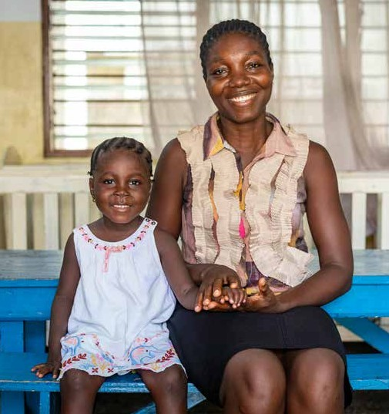
At the time of five-year old Georgina’s admission, the Princess Marie Louise children’s hospital in Accra Central was rationing the few cartons of donated therapeutic foods it had to treat severe acute malnutrition (SAM). Unfortunately, the children who needed this treatment were not getting sufficient rations. Following her admission with a weight of 7.3 kg, Georgina was not recovering as fast as expected. After almost seven weeks of treatment, she had gained just 1.3 kg.
To support the hospital’s provision of essential health and nutrition services in the wake of the pandemic, the UN Multi-Partner Trust Fund (MPTF), through UNICEF, donated 35 cartons of therapeutic food and milk to the facility in November 2020, and it supported the training of staff to provide essential health and nutrition services, infant and young child feeding, treatment of SAM, and immunizations.
Following the donation to the hospital, Georgina was given sufficient rations for her weight, and was discharged on 4 December 2020 at 10.0 kg. Georgina’s mother, a trader, said, “I thought my daughter was going to be in the hospital forever. Before, my child was not gaining weight as required and my business was also going down. I can now smile again. My daughter is well again. I can now concentrate on my business to grow. Thank you to those who supported the hospital with this magic food. God bless you.’’

Five-year-old Georgina Osei with her mother, following adequate treatment of malnutrition.
© UNICEF

Results under Pillar 3 on Economic Response and Recovery

Targeted beneficiaries were women and girls, market leaders, traditional leaders, paralegals, health workers, psychologists, and men between the ages of 12 and 60.
- Direct beneficiaries totaled 2,636 (1,427 Females and 1208 males); Indirect beneficiaries totaled 424,155 (204,250 Males and 219,905 Females)
- 20 women health workers were educated on SGBV and enabled to conduct routine screenings and 21 women and four men were enabled to serve as managers of an SGBV hotline
- 2,500 vulnerable women and girls received dignity kits
- 60 men were engaged as COVID-19 SGBV ambassadors to facilitate community awareness
- 16 women and 58 men from 37 religious institutions and five women’s groups were enabled to support anti- stigma campaigns in their communities
- 3,000 critical social welfare, criminal justice system and civil registration staff were provided with basic PPE

Innovation and Learning
Much learning came from the collaboration and partnership of programmatic actors with the Government of Ghana.
For instance, the programme engaged the government as well as development partners to convey a common strategy on emergency cash transfer. While the usage of this new payment modality proved challenging, it also offered much in the way of initial learning and lessons on which to build and provide improved shock responsiveness of Ghana’s Social Protection system over the long term.
Further, collaboration with the Ministry of Gender and other development partners helped fill critical technical gaps related to the cash transfer system, such as on design and on beneficiary communications, and particularly on monitoring and evaluation (including the use of mass SMS-survey tools). This active collaboration supported dialogue around more sustainable financing for shock responsive social protection and strengthened information management systems for cash transfer delivery in emergencies. The programme also saw strengthened partnership with Ghana Health Service, which ensured an uptake of the health services at the facility level.

INDIA

Protection of Women and Girls from Sexual and Gender-based Violence in the times of COVID-19
End Date: 31 December 2021

Programme Summary
Across 17 States, this joint programme will enhance the protection of women and girls from sexual and gender-based violence (SGBV) in the pandemic context. With a focus on the most vulnerable groups, it will: (1) ensure availability of and accessibility to gender responsive and age sensitive SGBV protections; (2) improve access to gender sensitive justice systems for women and girls at risk and/or survivors of SGBV; (3) raise awareness among women and girls of SGBV risks and harmful practices, and empower and engage them in decision making; and (4) reduce women’s and girls’ economic vulnerability and increase their access to livelihood and income generation programmes.

Early Achievements under Pillar 2 on Protecting People

The programme commenced on 16 November 2020. UN agencies have laid a solid foundation to ensure a successful roll-out of the program in 2021, including:
putting in place relevant coordination mechanisms; securing strategic partnerships; designing and developing resource and campaign materials; and ensuring sufficient human resources for implementation in programmatic locations.
- Ten community consultations reached approximately

200 direct beneficiaries and 600 indirect beneficiaries
- UN agencies continued strategic support to enhance the capacity of frontline workers from all relevant sectors
  - child protection, health, education, law enforcement
  - to ensure the continuity and quality SGBV services
delivered to women and girls during COVID-19
- WHO and partners helped build the capacity of frontline healthcare professionals to provide gender and age sensitive services to women and girl survivors of SGBV
- UNICEF strengthened child protection systems in 17 States with an emphasis on front line respondents
including CHILDLINE and the police to ensure continuity of services. Based on its current model of community- based mental health and psychosocial support (MHPSS),
UNICEF and partners will continue expanding the model across states to better reach women and girls experiencing SGBV
- UN agencies provided technical inputs to the long- term multi-sectoral action plan on MHPSS and will continue supporting its implementation by the Ministry of Health and Family Welfare and the National Disaster Management Authority

Innovation and Learning
To improve access to the justice system for women and girls enduring or at risk of GBV, UNICEF and the National Police Academy reached a breakthrough agreement to set up a National Child Protection Resource center to enhance police training, research, and documentation of child protection and SGBV issues.
To overcome pandemic related restrictions and to expand its outreach, the programme is pursuing innovative methods like virtual platforms and mixed methods of delivery, both in person where feasible, and online. Building on recent experiences, it is also exploring online platform mobilization with non-traditional partners such as technology firms.

INDIA

India’s Response to COVID-19: Inclusive and Scalable Social Protection Systems for Immediate and Sustained Food, Nutrition and Livelihood Security
End Date: 31 December 2020

Programme Summary
This joint programme helped mitigate the devastating socio-economic impacts of COVID-19 in India by reaching those who were most in need with food and livelihood assistance. The initiative also strengthened systems to respond more effectively to future crises and help marginalized communities to build back better.
Early Achievements under Pillar 2 on Protecting People

Supporting the efforts led by the Government of India and State Governments, and working in collaboration with civil society, the private sector, and UN partners, this programme:
- Addressed the immediate needs of approximately 3.3 million vulnerable and unemployed people against a target of 2.5 million
- Helped meet the longer-term needs of another 14 million people through systems strengthening, linking eligible beneficiaries to all three social protection systems
in India, strengthening the capacity of frontline civil society organizations, and providing policy support for long-term impact and sustainability that could eventually benefit up to 100 million people
- Facilitated improved access to nutritious food for 1.6 million marginalized and vulnerable people, including migrant workers, through government food safety schemes

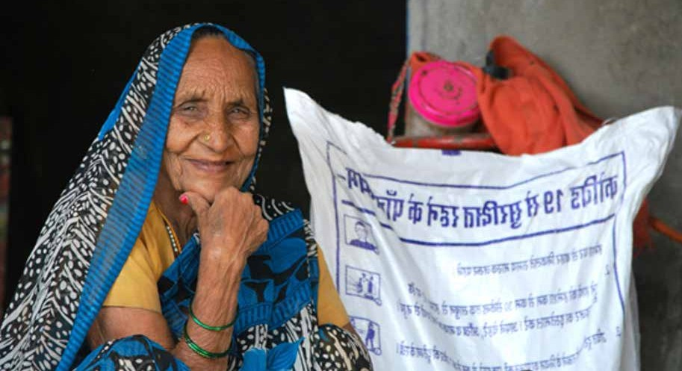
An elderly woman displays her happiness after receiving dry rations of Wheat Flour, Oil, pulses and salt during the COVID lockdown in Lucknow , Uttar Pradesh. As part of COVID -19 response, WFP supported SAMARTH, a frontline civil society organization to distribute food packets to nearly 120,000 marginalised including sex workers, transgender, migrants, and members who are chronically ill or have a disability.
© WFP/Ankit Sood

Innovation and Learning
- Expanded access to fortified nutritious foods in government safety nets by fortifying 2,420 MT of rice for nearly 1.5 million beneficiaries
- Established a production unit in Malwa, Fatehpur to produce nutritious take home rations for 25,300 young children and pregnant and lactating women
- Facilitated access to information on applying for social protection and rural employment guarantee schemes to 1.7 million people: reaching 23,971 marginalized women and youth with information on accessing food- based safety nets and restoring livelihoods through trainings, rural collectives, and enterprises; and enabling 31,500 women and youth to access information on job opportunities in urban areas
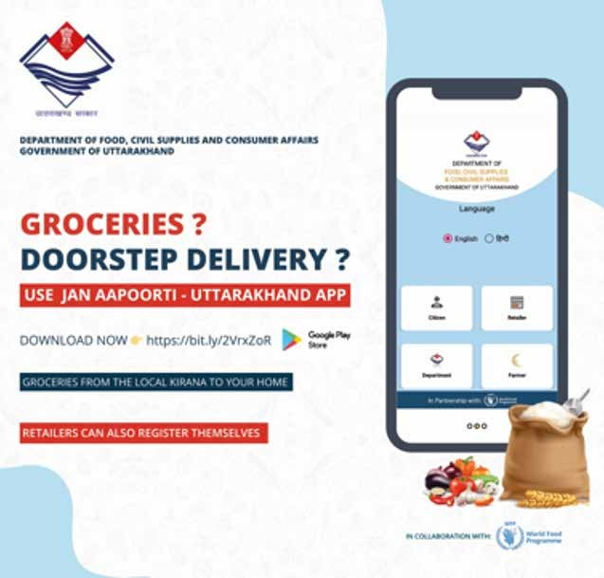
An awareness collateral informing citizens of Uttarakhand to download and use the mobile application “Jan Aapurti Uttarakhand” for ordering essential commodities and getting them home delivered during the COIVD-19 lockdown. The app was
developed by WFP India in collaboration with the Government of Uttarakhand to enable availability of essential commodities in Uttarakhand.
© WFP

Leveraging the power of digital tools and innovations to facilitate activities during lockdowns, the joint programme improved outreach to vulnerable groups and strengthened systems for service delivery. A mobile application called Jan Aapurti (fulfilment of needs of the citizens) developed and launched in Uttarakhand allowed 192,000 vulnerable citizens to order essential commodities for home delivery. Another application launched in Telangana, Aalambana (support), digitally connected more than 10,000 weavers and people from artisan communities, enabling them to create new design ideas for product diversification based on emerging market demand for health and hygiene products.
On learning, mobile phone penetration in India was relatively high and this provided many opportunities for outreach at a time when physical movement was restricted. Therefore, the joint programme made use of mobile apps and short videos that could be shared via WhatsApp and found them extremely useful in reaching target populations across the country. Some 49 videos on online career counselling and guidance were developed and attracted a wide range of experts and young people. The videos were made using simple language and were contextualized to the needs of the target audience. This made the channel and the content both relatable and useful.

INDONESIA

Protecting People: Supporting the Government of Indonesia and Key Stakeholders to Scale Up Inclusive Social Protection Programmes in Response to COVID-19
End Date: 31 March 2021

Programme Summary
This programme supported the Government of Indonesia to roll out social protection that was more effective (reaching the most vulnerable), inclusive (leaving no-one behind), and responsive and adaptive (contributing to long-term recovery and climate resilience).
Achievements under Pillar 2 on Protecting People
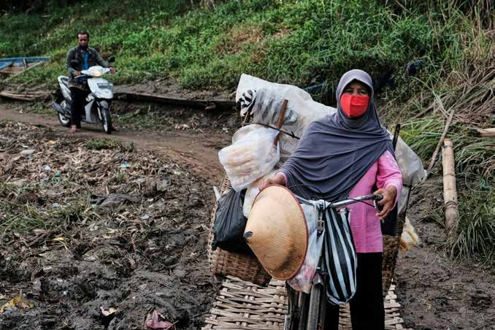
The initiative achieved three main outputs: (1) enhanced government capacity to expand social protection and include marginalized populations, with a focus on women and children; (2) increased capacity of COVID-19 Task Forces, volunteer mechanisms operating under the Ministry of Social Affairs (MoSA), to plan and deliver social protection
responses to the pandemic; and (3) adoption of data analysis as well as financial and digital innovations to better inform gender-responsive social protection.
- The programmatic indirect beneficiaries were the beneficiaries of the current and expanded social protection programme for COVID-19, consisting of 10 million households of unconditional cash transfers (PKH); 20 million households of food assistance programmes (Kartu Sembako); and 11.6 million households of

Village Cash Transfer
- The Programme helped improve social protection in Indonesia by reaching 443,160 individuals.
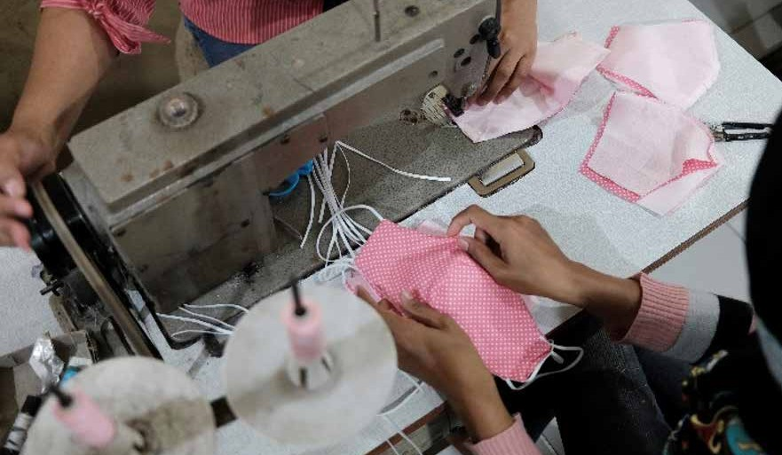
- It mapped 359,818 children vulnerable children in institutional care, identified 171 vulnerable children in West

The program empowered 60 women to produce masks. Otherwise unemployed, they will receive cash for their work. “We are optimistic with the program as it has become a solution of income for these women, and an opportunity for our society to recover from the COVID-19 crisis. The program is also aligned with our own program to increase the capacity of the community,” said Feriana Rahman, village secretary official of Desa Pondok Kaso, Sukabumi.

- Provided trainings on case management, psychosocial support, self-care, and social work for 852 individuals
- Trained 1,985 social workers on social service provision
Kusmiyati, a cracker trader, wears a mask and holds her bicycle while waiting to cross the Bengawan Solo River to trade in Surakarta, Indonesia.
© UNICEF

Nusa Tenggara, and offered gender-responsive cash for work programme to 300 women

- Trained 1,337 parents/caregivers on parenting, budgeting, and violence prevention
- Disseminated Learning Kits for Public Communication (MoSA) to 78,697 individuals

Innovation and Learning
Reaching the Vulnerable
The programme introduced innovative data analysis to improve understanding of the socio-economic impacts of the pandemic, especially for at-risk populations. It strengthened PRISM, a cloud-based platform to monitor and detect the socio-economic impacts of the pandemic. In addition, WFP strengthened the methodology of VAMPIRE, a cloud-based platform, by combining near
real-time evidence to detect and monitor the additional vulnerability incurred by the pandemic as well as for droughts and floods. The programme also helped the government adopt mobile data collection (mVAM) to assess and monitor food security in hard-to-reach areas during pandemics and other crises. Also in this vein, the initiative produced a simple web-based tool to identify vulnerable children, women, and the elderly (dubbed APEM KETAN), realizing that the existing system to identify at-risk individuals was based on poverty alone. The new tool
integrated disability, pregnancy, and female family heads into vulnerability factors.
On Gender
The programme used big data to assess the pandemic’s impacts on women. UN Women leveraged technologies and innovations to capture data, analyze gender, and spotlight the impact of the pandemic on women
and children from marginalized groups, during a time in which in-person data collection at the household level was improbable. This helped inform government policy and strategies to integrate stronger gender dimensions into the national economic recovery programme. The initiative

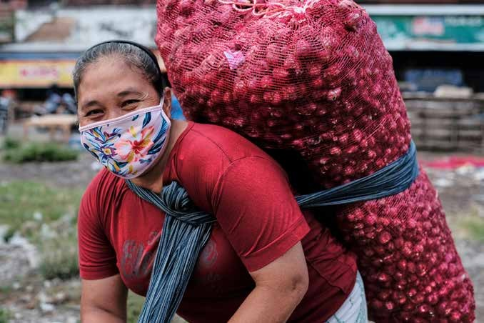
Sutirah carries red onions in Surakarta, Indonesia.
© UNICEF

commenced Interactive Voice Response (IVR) Household Surveys on the Socio-Economic Impacts of COVID-19 with 17,000 respondents, and launched a COVID-19 impact
on gender report through a collaboration with INDOSAT Ooredoo, a telecommunications company. Also on gender, this joint initiative produced policy research titled,
‘Leveraging Digitalization to Cope with COVID-19 Pandemic: Indonesia Case Study on Women-owned Micro and Small Businesses,’ which combined big data analysis with quantitative and qualitative surveys to assess the impact of the pandemic on micro and small businesses from a gender perspective.

JAMAICA

Safeguarding and Protecting the Most Vulnerable: Enhancing Jamaica’s Shock Response Social Protection Mechanisms in Support of Vulnerable Groups, including Children
End Date: 21 February 2021

Programme Summary
This programme helped safeguard the poorest and most vulnerable while assisting them through the socio-economic hardships caused by the COVID-19 pandemic.
Achievements under Pillar 2 on Protecting People
- Extended existing social protection programmes vertically and horizontally to approximately 3,937 households (13,000 people) who received a US$30 increase in PATH benefits, totaling 8,451 payments between August to December 2020
- 757 of the most poor and vulnerable households with pregnant and lactating women and 2,180 of the most poor and vulnerable households with children with disabilities were reached with additional social protection
- 1,000 households with children ages three- to five-years old and experiencing food insecurity because of the impacts of COVID-19 received food care packages
- The programme established the protocol to trigger

immediate humanitarian support and cash transfers in future emergencies and had a Memorandum of Understanding signed
- The programme established a pathway/protocol for an agricultural buy-back programme linked to social protection mechanisms to support female-headed farms and others in extremely vulnerable circumstances during the pandemic recovery phase

Innovation
With two sons suffering from asthma, including one who often requires hospitalization, Nadine and Miguel say the funds have come in handy covering essential items like school uniforms, books, and visits to the wholesale store.
© UNICEF

- 200 farmers participated in this agricultural support / buy-back programme

The Ministry of Agriculture and Fisheries (MOAF) designated locations where farmers and buyers could meet to transact business, and farmers were paid immediately with cash and cheques or by electronic funds transfer the next day. This was a significant improvement from the norm where farmers were paid weeks after a transaction. Digital payments now allow for payment in one to two days.

Learning
The programme realized that many female farmers were involved more in livestock than in crop production. In the future, it will thus be important that the buy-back programme also focus on livestock in addition to crops to assure greater female participation.

KENYA

Improving the Livelihoods and Protection of Young Women and Men in Kenya

End Date: 1 December 2021

Programme Summary
This joint programme builds on existing youth programmes to connect young men and women to better livelihood opportunities while increasing youth engagement in awareness raising initiatives that combat gender-based violence at the community level. The programme will leverage and enhance established digital tools for youth engagement, namely the Youth Marketplace (YOMA) Platform, which connects young people to learning and internship opportunities, and the U-Report survey and information service for community participation.
Achievements under Pillar 2 on Protecting People

This programme commenced in November 2020. The first months of the programmatic cycle focused on governance and integration. Towards this end:
- PUNOs formed a planning committee and organized inter-agency consultations to jointly map and agree on potential partners in the two target counties of Turkana and Kisumu
- A baseline assessment and ecosystem mapping were scheduled for February 2021 to map out gaps and entry points in target counties
- Programmatic funding facilitated a formal engagement with the State Department for Youth Affairs as the Secretariat for U-Report - a partnership that builds on existing youth engagement programs at the Generation Unlimited (GenU) Kenya Secretariat and the National Youth Council by providing a technology platform that enables aggregation and comprehensive feedback to inform policy
responses to the COVID-19 crisis and to make sure relevant information reaches young women and men
- Potential implementing partners participated in
joint planning meetings, which helped harness the voice of key stakeholders, civil society, and community- based organizations
- Formalizing and onboarding partners on U-Report commenced in December 2020 with Kenya Scouts Association and Kenya Girl Guides Association.
- The programme is leveraging on the Agri-Jobs 4 Youth collaboration with GIZ to support youth in the indigenous poultry value chain
- Commenced the contracting of incubation hubs to provide coaching and mentoring
services, financial linkages, and business growth opportunities for scaling pre-identified youth-led innovations

EL SALVADOR

Shock Responsive Social Protection to Reduce the Socioeconomic Impact of the COVID-19 Pandemic on Poor Households, while Ensuring Support for an Early and Sustainable Recovery

End Date: 31 December 2020

Programme Summary
This programme designed and tested a model of Shock Responsive Social Protection - applicable and scalable using national social protection programmes. It was implemented in the municipality of Tacuba as an integrated response including multipurpose cash-based transfer, agricultural inputs, and technical assistance, as well as the provision of support to prevent violence against women, girls, boys, and adolescents.
Achievements under Pillar 2 on Protecting People
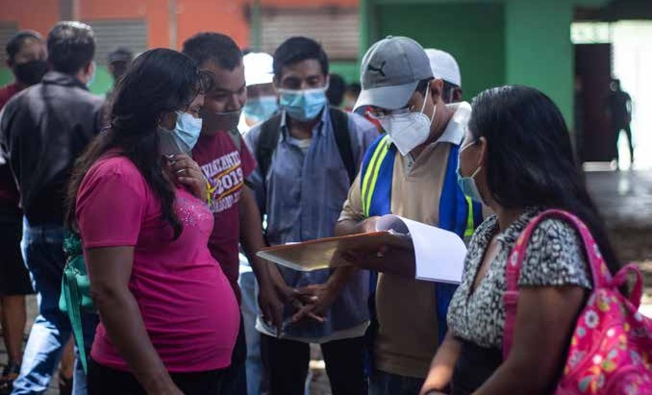
- A scalable Shock Responsive Social Protection (SRSP) model was created. For both its elaboration and the design of its standard operation procedures (SOPs), an inter-institutional work team was formed with the House of the President’s team in charge of social protection programmes
- 2,190 vulnerable families were identified in the municipality of Tacuba and assisted by means of a vertical and horizontal expansion of the SRSP model, jointly with the Central Government and the Municipalities
- WFP tested the model by leveraging funding and assisting identified families for three months under a cash-based transfer modality

- Vulnerable families not previously included in social protection programmes, in particular those headed by women, those with children under seven-years of age, people with disabilities, and indigenous families were incorporated into the social protection system
- 1,000 smallholder farmers’ households (of which 49.7% were female-headed) received agricultural incentives and training on alternative livelihoods as a mitigation measure to the crisis. In close collaboration with the National Centre for Agricultural and Forestry Technology

Innovation and Learning
Delivery of 1,000 post-harvest kits for family storage of basic grains in Tacuba,
Ahuachapán.
© WFP/David Fernández

(CENTA), virtual trainings and technical assistance on bean production were provided in the form of video tutorials and one-off visits to plots
- 2,190 vulnerable families were provided with information, education, and communication materials on the prevention of gender-based violence against girls and women

The programme allowed for the inclusion of CENTA as part of the Ministry of Agriculture in terms of crisis response using the social protection system. This innovative alliance allowed for (1) the integration of agriculture programmes into the functioning of the social protection system; (2) follow up on investments in agriculture promoted by FAO and WFP; and (3) stronger inter-institutional alliances for future interventions using this model.
With regard to learning, the understanding of the Social Protection System in El Salvador by the institutions involved was a priority. The information available in the system made the identification of beneficiaries by gender and age possible, which facilitated gender analysis and an approach that addressed existing gender gaps in the targeting process.

KIRIBATI

Enhancing Food Security, Nutrition and Resilience in Kiribati

End Date: 31 December 2020

Programme Summary
This programme supported small-scale fisheries, aquaculture production, and agriculture production systems to increase the local production and availability of nutritious foods, with a view to improving food security during and after the pandemic. It also provided counselling and interventions to improve nutritional outcomes for pregnant women and children.

Achievements under Pillar 2 on Protecting People
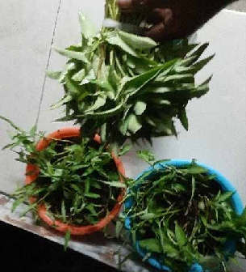
Overall, the programme:
- Provided 19,155 pregnant women and children under 5 years old with essential nutrition services such as vitamin A, iron, and folic acid
- Messaged 50,000 community members on infant and young child feeding practices via a range of media and community-based platforms such as radio talkback, SMS, roadshows, practical cooking demonstrations, and promotion through churches and NGOs
- Trained 423 direct beneficiaries and 2,538 indirect beneficiaries (25% of which were women) via

Promoting Kaengkong to the public on UN Day Kaengkong is a nutritious food that can easily grow in Kiribati soil.
© MELAD/Tianeti Ioane

programmatic agriculture interventions
- Expanded trainings to reach 1,000 direct beneficiaries in South Tarawa and 100% of farmers in the outer islands of Banaba, Teraina, Taburaean, Maki, Marakei, and Kuria
- Up-skilled fisheries harvest trainers to train an additional 120 fishers in South Tarawa, and 12 in Abaiang, Maina, Aruanuka, and Kuria
- Trained 24 women and four men on fish processing; and in the first quarter of 2021, 40 fish processors will be trained to supply novel tuna products to thousands living on outer islands and shopping in urban markets
Other key activities and results included:
- Screening, referral and treatment of children for acute malnutrition: 10,884 children (5,609 boys and 5,275 girls) were screened with 57 cases of moderate acute malnutrition and 28 cases of severe acute malnutrition identified and referred for treatment
- Supplementation of micronutrients: Prepositioned and distributed Vitamin A for children 6-59 months, and iron and folic acid for pregnant women, reaching 1,385 children (6-12 Months) and 10,834 children (13-59 months), with distribution in some communities ongoing

Innovation and Learning
- Capacity building of health workers for continuous delivery of quality nutrition services: 29 medical assistants and 37 public health nurses trained on high impact nutrition interventions
- Social and behavior change and community engagement: At the community level, 11 church denominations and six non-governmental organizations (622 community volunteers) were orientated on nutrition, including how to maintain a healthy diet in the context of COVID-19
- Fisheries and agriculture collaboration for improved soils: Developed systems to turn large volumes of seaweed polluting South Tarawa beaches into compost using locally made water tanks and training local people
- Trainings on local production of traditional vegetables and fruits: Community members trained to improve household gardens
- Improved practices and awareness on agriculture production: Purchased biodegradable nursery plant grow bags (50,000 pcs), pruning shears (100 pcs), seedlings tray (1,000 sets), peat moss pellets (25,000 pcs), peat moss (5,000 L), and polycarbonate corrugated roofing (15 pcs) to improve nurseries resilience and farmer output

The programme enabled safe, small-scale community fish processing and value-added. It established a small-scale community fish processing facility to support the manufacture of novel tuna products for domestic sale in South Tarawa. The programme also developed an innovative portable ‘hand pushed’’ fish hygiene trolley to help roadside fish vendors improve hygiene and food safety in what is an unregulated local industry.
In addition, the programme sought to improve access to and training for nearshore pelagic fishing. It helped secure new fishing gear that was manufactured with locally available, low-cost materials prior to commencing trainings.

KOSOVO

Countering the Deepening of Pre-Existing Inequalities in Kosovo through COVID-19 by Assisting Kosovo’s Non-Majority Communities and Domestic Violence Survivors
End Date: 31 January 2021

Programme Summary
This joint programme assisted those most affected by COVID-19 in Kosovo, in particular the country’s non-majority communities and domestic violence survivors. It facilitated access to urgent social and healthcare services, as well as to information, and it built capacities for economic integration. The programme consisted of five main areas of intervention:
(1) Mental health support and counseling; (2) A referral system to ensure assistance response; (3) Legal aid; (4) Domestic shelters capacities; and (5) Income generation for persons of concern.
Achievements under Pillar 2 on Protecting People
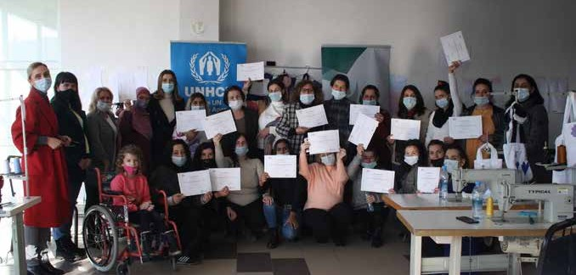
- Overall, this programme assisted 5,377 direct beneficiaries through counselling, legal aid assistance, and income generation support. Of these, at least 1,336 beneficiaries belonged to the Roma, Ashkali or Egyptian communities, and 574 persons to the Kosovo-Serb non-majority group
- 1,022 people were provided with access to free medical examinations, and 453 people received support with their medical bills
- A referral system was established to address community

needs. 3,240 referral cases were identified, relating to the needs of 7,144 vulnerable individuals
- Cumulative campaigns reached at least 621,003 persons through various social media and other platforms, informing the public on: 1) the pandemic and prevention measures; 2) the impact of the pandemic
on women and women’s economies; 3) domestic (DV) and gender-based violence (GBV) through the 16 days of activism campaign; and 4) the Kosovo Police app, which was used to report DV and GBV cases as well as other incidents and crimes
- 464 internally displaced persons (IDPs), returnees, and vulnerable individuals from non-majority communities were provided with legal counselling and assistance, supporting them in accessing their rights
- 25 women from vulnerable communities were empowered through participation in focus group meetings with high profile personalities, and 35 other women became co-authors of a cook-book providing traditional recipes from the non-majority communities
- All nine shelters in Kosovo received tailored guidelines on safety planning during emergency situations
- 10 online trainings trained staff to utilize these guidelines, which introduced practical advice on the

Innovation and Learning
16 participants from Roma, Ashkali, and Albanians communities, from the municipality of Mitrovica, were awarded certificates for completing vocational training.
© UNHCR

treatment of cases during the pandemic, including new techniques such as distance service delivery. In total, 85 members of the Municipal Coordination Mechanism against DV and GB participated
- Working and capacity building tools were distributed to all nine shelters, including beehives, tailoring and hairdressing tools, baking ovens as well as technical equipment, to enable income generation for the shelters, and foster the economic empowerment of their residents
- 104 vulnerable IDPs, returnees and community members participated in UNHCR vocational trainings, with 97 completing the training
- 36 vulnerable community members completed IOM on-the-job training, and were matched with 26 private companies
- Career guidance/mentoring sessions were provided to 56 vulnerable beneficiaries that needed skills to maneuver within the economic labor market during and after the pandemic

Online psycho-social sessions were provided to 689 beneficiaries to help them focus on positivity and move away from excessive fears of contagion or difficulties maintaining social connections. These beneficiaries included 195 women and children in shelters for survivors of DV and GBV. The programme provided 76 individual psychological therapy sessions, seven group therapies with an average eight participants per session, and seven group recreational therapy activities for children.
The programme learned that provision of psycho-social counselling sessions through phone conversations was cost effective without travel expenses, and offered greater privacy. It was also realized that donor coordination proved to be very important to avoid duplications and adapt implementation whilst maintaining the same desired impacts. Further, gender mainstreaming, as integrated in the project document, was identified as a good example at the global level.

MALDIVES

Protecting Women and Children: Digitalizing and Streamlining Social Services, and Creating a Unified Platform for National Care
End Date: 1 November 2021

Programme Summary
This programme will extend shock responsive social protection benefits to women to prevent them from falling into poverty and to help them avoid violent situations arising from prolonged socio-economic and emergency circumstances.
Early Achievements under Pillar 2 on Protecting People

This programme commenced in December 2020, with the Ministry of Gender, Family, and Social Services
(MoGFSS) as the lead on the social protection portfolio. With implementation set to being in early 2021, the programme has:
- Discussed the main results area of the workplan
- Received endorsement from the MoGFSS on additional project implementation partners: National Social Protection Agencies (NSPA), National Bureau of Statistics (NBS), Ministry of Communication, Science and Technology, Indhira Gandhi Memorial Hospital (IGMH), Maldives Police Service, Business Center Corporation (BCC), and Local Government Authority (LGA) to link local councils
- Bilateral meetings with the MoGFSS and NSPA discussed the development of a data platform to register vulnerable populations; with LGA to establish a linkage with local councils that are in an opportune position to collect data on vulnerable populations at a decentralized level
- Conducted initial dialogues with BCC to explore development of economic empowerment opportunities through training and skill building such as vocational trainings targeted at women entrepreneurs and to explore capacity building for micro-, small- and medium- enterprises (MSMEs) in the areas of digital solutions,
e-commerce, and digital marketing

MONGOLIA

Strengthening the National Capacity to Suppress Transmission and Maintain Essential Services in the COVID-19 Pandemic
End Date: 31 March 2021

Programme Summary
This programme supported the efforts of the Government of Mongolia to implement its National COVID-19 Preparedness and Response Plan. It focused on the provision of critical education and health services.

Results under Pillar 1 on Health Services
Programme activities helped Mongolia prepare for its current community outbreak by increasing its testing capacity by tenfold, which helped prevent widespread community transmission in six provinces of Arkhangai, Darkhan-Uul, Orkhon, Selenge, Gobisumber, and Dornogobi.
- Programme interventions increased daily testing capacity by ten-fold from 600 to 6,000 since last midterm progress report
- The programme supported the testing of 559,878 people in Ulaanbaatar and seven provinces. Of this cohort, 1,074 were confirmed COVID-19 positive

Results under Pillar 2 on Protecting People
The programme helped to strengthen e-readiness of the Mongolian Education sector with significant improvements to the online learning platform and development of online educational resources for pre-primary, primary, and secondary education, which launched in November 2020. In addition to core subjects, the interactive e-learning contents focused on health education, including comprehensive sexuality education to prevent young people from entering into early pregnancy and being exposed to sexually transmitted infections, psychological distress, trauma, and gender-based violence (GBV) during lockdowns.
- The online interactive learning contents reached cumulatively 149,161 children, parents and teachers, including ethnic Kazakh and Tuvan minorities and people with disabilities (hearing and visual impairments), providing equal opportunities to those who are normally disadvantaged

Innovation and Learning

- An additional 2,078,369 people in Ulaanbaatar and seven provinces benefited from this programme indirectly by having improved access to lab testing service in their provinces
- The national COVID-19 testing laboratory capacity was increased by 11 labs, and the number of laboratories of the National Influenza Network increased from five to 16
- The programme purchased kits and PCR reagents needed for 40,000 tests
- PPEs were provided for 500 frontline responders

- The programme strengthened the e-learning capacity of 172 teachers and government counterpart methodologists
- The programme strengthened the institutional capacity to develop and deliver e-contents by establishing a laboratory Health Education Cabinet at the Institute of Teachers Professional Development (ITPD)
- Approximately 40 government officials and 10 government institutions were consulted in the ICT policy review process
- 25 teachers and education officials from the ITPD and Ministry of Education and Science were trained, enhancing their on-line learning and distance teaching skills
- Prepared a list of best practices in ICT in education for the Ministry of Education and Science to use for e-learning and policy development

Overall, the programme supported an unprecedented undertaking that brought together at least 15 different organizations under one umbrella to work towards a common goal. The programme established a solid project implementation, coordination, and monitoring mechanism to ensure the sustainability of future ICT initiatives in the education sector. It strengthened UN agencies’ existing partnership with government, particularly with the Ministry of Education and Science (MoES), while also engaging private sector participation, in particular, Mongol Content LLC, which was the core company working on the multimedia aspect of content development. Mongol Content LLC collaborated closely with other NGOs that engaged with people with disabilities, for instance, to execute the project. In addition to strengthening and harmonizing UN agency efforts to address COVID-19, the programme served as a best practice and is expected to open doors to new and broader interventions.
The initiative was also pioneering and innovative in that it addressed online learning, which was a relatively new area for Mongolia, particularly for the pre-primary and general education sectors. Towards this end, it contributed significantly to laying a foundation for a digital transformation in the education sector.

Based on the findings that TV lessons were not meeting needs of learners, the joint programme helped develop interactive content to support the existing TV lessons. It created a stimulating learner-centered approach that transformed traditional learning objectives into a 2D cartoon animations with interactive modules. As part of this initiative, 104 interactive lessons developed in Mongolian, ethnic minority languages of Kazakh and Tuvan, as well as sign language, and they were released to the public on 25 November 2020. The approach proved highly effective. According to a rapid assessment result done by the MoES, more than 94% of 268 teachers surveyed said that the interactive lessons were age-appropriate and interesting, supported creativity, and met the learning needs of children
With regard to gender, the programme helped mainstream gender transformative and gender sensitive language in national ICT policy and ICT master plan. It helped ensure that Mongolian youth had access to quality e-information on sexual and reproductive health and rights, and it supported the production of video education programmes for young people that have been highly regarded by UN agencies globally.

NICARAGUA

Strengthening of the Educational System to Address Challenges Derived from the Emergency before and after COVID-19 that Promote Educational Care with a Gender Perspective

End Date: 31 December 2020

Programme Summary
This programme strengthened the education system in Nicaragua so that it could address COVID-19-related challenges from a gender perspective and provide a safe learning environment for children. The initiative aimed to (1) provide effective curricular adaptation; (2) strengthen psycho-emotional care for children, in particular girls; (3) offer digital solutions to accelerate administrative and educational processes in departmental and municipal education offices and enhance educational management, coordination, and communication; and (4) improve access to drinking water, food, and hygiene and WASH facilities in schools.

Achievements under Pillar 2 on Protecting People

Despite encountering challenges related to unfavorable conditions for infrastructure construction to improve WASH facilities in selected sites and delays in the procurement of technological equipment and hygiene kits, the programme achieved the following results:
- Developed a set of guidelines for the psychosocial support of children and adaption of school curricula with the aim of mitigating the negative impacts of the pandemic on school children
- The guidelines, which contain practical exercises on coping with emotions during crisis or emergency situations, will be disseminated to nearly 60,000 teachers at pre-school, primary, and secondary schools; exceeding the programme target of 5,500 teachers
- Assured no one was left behind by producing various indigenous and Afro-Caribbean versions of the guidelines in Creole, Miskito, Mayangna, Panamaka and Tuak, thus promoting the inclusion of indigenous
and Afro-Caribbean populations from the Caribbean Coast of Nicaragua
- With the Ministry of Education, the programme provided access to a digital WebEx-cisco platform, which connected 221 municipal education offices
- This platform provided offered 180 virtual rooms.
It enabled municipal and departmental education offices to carry out on-line administrative and educational processes and was used to train teachers on integrated sexual education, socio-emotional support in crisis situations, and provide related recommendations to parents of children in early learning situations and/or children with disabilities
- 1,000+ participants attended training sessions in 2020, and approximately 50,000 teachers and school principals benefitted indirectly, as training sessions were replicated at local levels

SENEGAL

Ensuring Continuity of Learning for the Most Vulnerable Children and Youth in Senegal

End Date: 31 March 2021

Programme Summary
This joint programme supported the deployment of distance learning solutions and helped restore the continuity of learning for vulnerable learners, including refugees. It operated in collaboration with the Ministry of Education and within the framework of the national initiative, ‘Learn at Home;’ and with the Ministry of Employment, Vocational Training, Learning and Integration and within the framework of the distance learning platform, ‘Ejang.’

Achievements under Pillar 2 on Protecting People
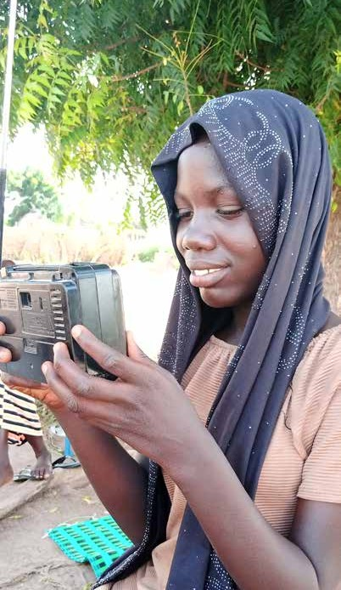
- Strengthened Senegal’s education system by boosting its resilience and service delivery capacities through new distance learning solutions, which were deployed
to the benefit of marginalized children and youth in primary and secondary education, particularly in rural areas, in a context of national school closures triggered by the COVID-19 pandemic. The programme had a particular focus on digital learning solutions and radio programming
- Reached approximately 653,960 learners by 31 December 2020
- Provided 360 disabled children (visually and hearing impaired) with adapted assistance and learning devices
- Provided 1,000 refugee learners from 50 middle and high schools with course materials, school supplies, and tablets with course materials in the form of videos and files
- Trained 200 teachers in techno-pedagogy
- Equipped three virtual laboratories with simulation software

A learner in last grade of primary school, in Kaffrine region/ Senegal, prepares for national examinations through the radio- based learning programme, which was developed by the Ministry of Education with UNICEF’s support as a response to national school closures due to the COVID-19 pandemic.
© UNICEF Senegal/MEN 2020/ Pape Malick Niang

Innovation and Learning
The programme reached 652,960 learners through the roll-out of a national radio learning programme focused on fundamental skills in literacy (72 lessons) and numeracy (72 lessons). It was delivered in partnership with national radios and a network of 120 community radios operating across the country, which, initially, raised some coordination challenges. Local committees were therefore set up with representatives of decentralized entities of the Ministry of Education and community radios to ensure a harmonious and successful broadcast of the radio programme.

TIMOR LESTE

Leaving No One Behind in Timor-Leste’s COVID-19 Response - Technical and Financial Support for the Implementation and Monitoring of the Cash Transfer Scheme for Low- Income Households

End Date: 31 March 2021

Programme Summary
This programme helped the Government of Timor-Leste run and monitor an expansive and inclusive cash transfer scheme to support low-income households. The Joint Programme: (1) contributed to the operational costs of the cash-transfer programme developed by the Government of Timor-Leste to mitigate the socio-economic impact of COVID-19; and (2) increased the engagement of civil society organizations representing vulnerable groups, such as women, domestic workers, the disabled, and lesbian, bisexual women, and transgender persons (LBT) likely to encounter barriers to accessing social safety nets. It was the first time in the country’s history the government sought to implement a nationwide cash transfer scheme.

Achievements under Pillar 2 Protecting People
- The joint programme covered 68% of the operational costs of the first stage of the cash transfer scheme and significantly contributed to its efficient implementation
- With Fund support, the government’s COVID-19 social cash transfer scheme for low-income households reached 313,398 households1 – 98% of all eligible households

in the country, 20% of which were female-headed
- In the first stage of the cash transfer, 298,816 households were reached, 19% of which were female- headed households. In the second stage of the cash transfer, for complaints only, 14,582 households were reached, 36% of which were female-headed

Cash transfers sought to ensure economic and geographic access to basic needs, including food. One key adverse effects of the COVID-19-induced State of Emergency (SoE) according to the Joint UN Socio-Economic Impact Assessment 2020, was that households lacked access to markets to buy and sell food (32%). One 32-year-old women said, “We used to have fish because my father and brothers normally go fishing. I love fish. But during that time [SoE] we didn’t eat fish because my family wanted to go fishing but the police had forbidden them to do so. Instead we ate moringa, corn and papaya
and only meat sometimes, like chicken.” Approximately 95% of households (Uma Kain Subsidy Report by the Ministry of Social Solidarity and Inclusion, 2020) reported that they planned to use the cash to purchase food, which would mean that the cash transfers increased economic access to food. The Market Resilience Survey (2020) reflected an improvement in access to food; between May and July 2020, foods including grains, eggs, meat and fish, and agriculture products became less scarce.

- The joint programme enabled civil society to monitor the government scheme, which strengthened the capacities of 14 women’s organizations coordinated by the umbrella network Rede Feto to support evidence- based advocacy and conduct qualitative research that
directly engaged 1,594 people across 12 municipalities and the Special Administrative Region of Oecusse- Ambeno
- Women’s organizations’ research findings were presented in two workshops and via a television programme to reach a wider audience2
- The work of the CSOs resulted in a set of recommendations that can inform future government COVID-19 response and recovery programmes and assure no one is left behind
- The Minister of Social Solidarity and Inclusion recognized the programme as catalytic and an enabler of good collaboration and coordination amongst the development partners and civil society organizations in support of the Ministry

- Note that these numbers are subject to very minor changes as the data reconciliation for the complaint payment process is being finalized.
- To access the policy brief produced by Rede Feto, see: https://bit.ly/3kho1S8

Innovation and Learning
The programme shed light on the value of using digital methods, such as tablets, to gather real-time data, even in contexts where such technology had not yet been widely adopted. The programme also reinforced the need for the development of a banking system that takes into account people’s wellbeing, not only access to financial services, but also public health, including in the pandemic context.
The inclusion of different levels of government (central, municipal, local) and working across sectors in deploying programmes that required a local physical presence - even when some of the entities were not traditionally involved
in the deployment of social protection programmes – was an important element of success. It was also reinforced that key vulnerable groups such as isolated populations, single mothers, LGBTI persons or people with disabilities) should be involved in response design and monitoring of programmes, as many of these marginalized groups have struggled to access support.

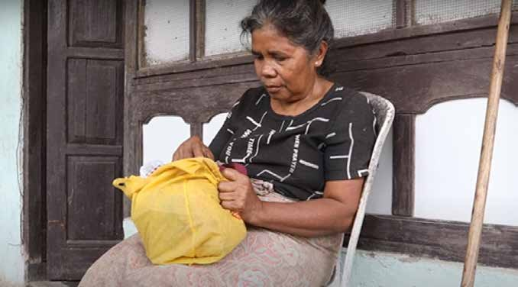
A woman with a physical disability in Timor-Leste shared her challenges accessing benefits because she was unable to apply for a family card. Her story can be found here: https://www.youtube.com/watch?app=desktop&v=cynZFPLahbU&feature=youtu. be
© Bernardino Soares

TUNISIA

Strengthening Social Protection and Economic Relief Systems for Vulnerable and Marginalized Segments of the Population as a Response to COVID-19
End Date: 31 March 2021

Programme Summary
This programme supported the Government of Tunisia to ensure that vulnerable communities were included in the national response to COVID-19 through the provision of tools that enabled authorities to target such communities. In parallel, the programme provided emergency support, including financial, psychological, shelter, to those communities that were not yet covered by the national response. It also offered income generating opportunities to marginalized women and supported small and micro businesses, promoting their inclusion in the digital economy.
Achievements under Pillar 2 on Protecting People

- Helped the government scale-up actions to strengthen women-headed micro-enterprises’ resilience to the COVID-19 pandemic
- Conducted a mapping of the most vulnerable women micro-entrepreneurs in the Southern governorates of Tunisia to better target beneficiaries and assess their financial needs; created a database
- Identified 740 vulnerable women micro-entrepreneurs and integrated them into the database as target beneficiaries for capacity strengthening activities
- Involved approximately 46 public servants from different ministries and from the National Institute of Statistics in gender responsive budgeting training sessions
- In response to rising rates of violence against women in the pandemic context, trained six operators working the telephone hotline 1899, in addition to five members from the National Observatory of fighting violence against women, on Law n°2017-58
- Assisted the Orientation and Social Support Centers in charge of hosting homeless people and their SAMU Social in Tunis, Sousse and Sfax to provide the homeless with shelters, access to basic hygiene facilities, and socio- psychological support

Innovation and Learning
- Produced six knowledge products mainly dealing with the pandemic’s impact on women’s socio-economic conditions and access to health services. These included four policy briefs, a national methodology on preventing violence against women and a legal report. One last report on socio-economic, taxation, spending and SDG policies during the COVID-19 pandemic in Tunisia was in the final drafting stage
- Translated information on COVID-19, sexual and reproductive health, and gender-based violence into sign language
- UNFPA Tunisia and the Arab Institute for Human Rights launched a campaign as well as a programme of action to provide social aid including treatments, medical equipment, hygiene kits and dignity kits to 637 young people with disabilities in coordination with national structures and dedicated organizations
- Initiated a light renovation of the women’s living unit in the Homeless Center of Tunis to improve the conditions of reception of women into the center and catalyze similar interventions financed by other donors

Support was provided to the Ministry of Social Affairs and Ministry of Education to improve the targeting of vulnerable groups and the governance of programmes by identifying said groups and digitizing and modernizing the social protection system. The OOESCO/Ministry of Education database was set up and connected to the Ministry of Social Affairs database to include the 73% of households with children benefiting from school meals as safety nets which are currently excluded.
The first hotline for psychological support to adolescents and youth was launched in Tunisia in November 2020. It was managed by psychologists, with the contribution of a network of psychiatrists and child psychiatrists across the country who were available to provide psychological support confidentially and for free.
With regard to learning, urgent cash assistance was provided to hard-hit urban refugees and asylum seekers registered with UNHCR Tunisia, with some 1,000 extremely vulnerable beneficiaries countrywide receiving a one-time 250 TND (90USD) cash grant delivered in partnership with the Tunisian Post Office. The distributions of grants allowed UN agencies to gain access and support vulnerable groups in regions where they did not previously have a presence, and provided the opportunity to collaborate, for the first time, with new local municipalities and civil society organizations that could be included in future programming.

TUVALU

Enhancing Food Security and Building Socio-economic Resilience to COVID-19 in Tuvalu

End date: 31 March 2021

Programme Summary
Though Tuvalu had no confirmed COVID-19 cases at the time of reporting, the pandemic slowed economic growth and trade, as well as tourism. In response, this joint programme implemented by FAO, IOM, and ILO, aimed to improve food security and nutrition for fishing-dependent households and mitigate the pandemic’s impacts on the labor market and remittances. The initiative focused on providing technical support to increase fishing opportunities for nearshore pelagic species; improving data collection and analysis to inform policy development and the planned National Housing Census in 2022; and providing recommendations on potential interventions to the Government of Tuvalu to assess the impact of COVID-19 on the labor market and on remittances as a source of livelihoods.

Achievements under Pillar 2 on Protecting People
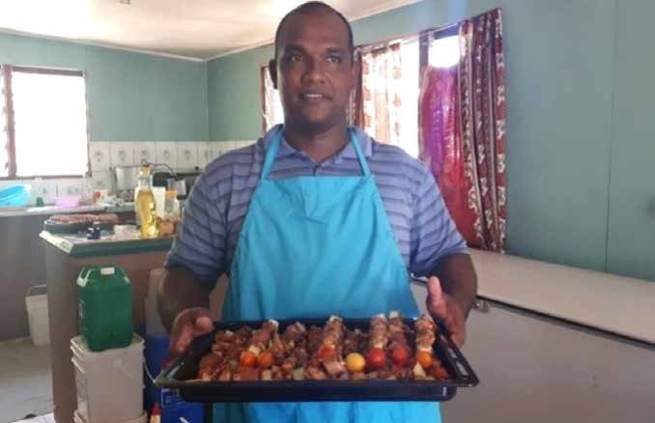
Several programme activities were delayed due to supply chain disruptions, travel restrictions, which caused staff shortages, and other pandemic-related challenges.
- Procured materials for boat building and trained assistant builders; the intervention is on track to complete its fisheries-related activities
- Provided technical support to the national statistics office to analyze agriculture data from the 2017 Population and Housing Census and formulate recommendations for an agriculture module in the 2022 census
- Conducted a national survey to assess the impacts of COVID-19 on 32 enterprises; 189 workers; 23 laid-off employees and 87 households on the main island of

Funafuti
- Established a tripartite taskforce to ensure multi- stakeholder strategic inputs for the planned surveys and to help provide data and statistics on the impact of COVID-19 on Tuvalu’s economy
Under the project, a national assessment in Tuvalu captured the stories of individuals, businesses, and households affected by COVID-19, and their strategies to remain resilient and cope.
© IOM 2020 / Seluselu VAGUNA

Innovation and Learning
The establishment of taskforces with representatives from Tuvalu’s Ministry of Labor, the Department of Statistics, and the Tuvalu Overseas Seafarers Union, as well as with various fisheries stakeholders in country helped ensure stakeholder ownership of the project. This proved crucial for the delivery of the planned surveys and will be equality important for the
up-take of recommendations. Further, the financial support was important to procuring tools for these implementing partners to ensure data collection and evidence-based programming to respond to COVID-19.
Finally, it was learned that there was a great need to improve Disaster Risk Reduction Strategies and Plans (DRR) as well as the accompanying training and integration of DRR into national legislative frameworks. This would help mitigate the threats posed by future pandemics and natural disasters.

URUGUAY

Strengthening a Gendered and Generational Socio-economic Response through Evidence- based Policy Advocacy and Analyses
End Date: 1 April 2022

Programme Summary
This programme will generate integrated information systems and analytical reports on vulnerability to improve resource mobilization and allocation to all households living in poverty and extreme poverty, as well as for those that subsist barely above the poverty line and/or share other critical welfare deficits with regard to housing and basic infrastructure. The programme will also generate a pilot employment and childcare program for vulnerable women and guarantee the educational continuity of secondary school students from vulnerable sectors.
Achievements under Pillar 2 on Protecting People
Programmatic beneficiaries, based on the 2019 household survey and using the official poverty line, will be 34.2% of the population of Uruguay, which comprises 330,000 households and 1,200,000 people. Through UNDP’s Accelerator Lab, an innovation platform will be activated that connects data, information systems, and community experiences to create transformative solutions for the future delivery of social protection programs.
Thus far, the programme:
- Commenced implementation in October 2020
- Engaged with government actors and formed four working groups on databases, employability, education, and territory
- Installed a Programme Management Committee that had its first meeting in early December 2020 and will hold bi-monthly meetings to follow up on implementation

Country | Total Direct Beneficiaries | Men | Women | Youth | Differently Abled | Rural | Urban | People Trained
Uruguay | 1.2 million | 47.8% | 52.2% | -- | -- | 14.8% | 85.2% | --

UZBEKISTAN

Support to Early Recovery and Inclusive Service Delivery for Vulnerable Groups Heavily Affected by the COVID-19 Crisis in Uzbekistan
End Date: 31 December 2020

Programme Summary
This joint programme implemented by UNDP, UNICEF, IOM, and UNFPA targeted the most vulnerable populations in Uzbekistan to help them cope with the impacts of the pandemic. Towards this end, the programme helped strengthen the capacity of the Ministry of Mahalla and Family Support of Uzbekistan (the Ministry), as well as associated CSOs and NGO networks supporting service delivery, to better identify and respond to the needs of selected target groups, adjust policies, and deliver basic socio-economic protection and services.
Achievements under Pillar 2 on Protecting People

On Gender-based Violence (GBV), the UN collaborated with the Ministry, Gender Equality Commission under the Senate of Uzbekistan, Republican Rehabilitation Center for Gender- based Violence (GBV) Survivors, and ‘Opa Singillar’ (NGO
for women with disabilities) to strengthen referral systems, coordination, and capacity at the national and local levels
to provide legal, psychological, and direct support for GBV survivors and their children, and disabled women and girls. The programme:
- Procured supplies for 12 regional Republican Rehab Centre (RRC) branches
- Helped 301 women and children to be hosted by shelters between August and December 2020
- Improved access to services by facilitating the ‘No to Violence’ Telegram channel, Instagram, and Facebook pages, which gained 5,000 subscribers. The channel broadcasted GBV statistics from shelters along with the contact details of service providers
- 150 women with disabilities and mothers of children with disabilities who received sim cards joined the Telegram group created by the head NGO ‘Opa Singillar,’ and thus gained access to vital information on GBV and how to connect with relevant authorities
- 154 families of women with disabilities and mothers of children with disabilities received food packages. The cost of utilities was covered for 27 families most affected by the lockdown
- Re-launched the national GBV hotline and sponsored six moderators and one IT specialist. The hotline received 5,623 calls from women and girls, including 970 cases related to family conflicts, violence and/or harassment in the workplace
- Connected 50 rehabilitation center staff members of 14 regional offices to mobile operators and internet, which enabled them to field calls from and help GBV survivors

Achievements under Pillar 3 on Economic Response and Recovery

To support women and youth who were unemployed or employed in the informal sector, the programme:
- Developed special programmes to provide business and entrepreneurial skills trainings that helped nearly 400 women and youth in the mahallas (communities) most affected by lockdowns and related unemployment in Karakalpakstan, Kashkadarya, Ferghana, and Syrdarya regions
- The UN, with the Ministry, identified 100 women mardikors (casual workers) who had been hit hard by the pandemic and offered them trainings on business and family entrepreneurship
- 100 women from more than 80 mahallas were identified and selected in collaboration with the NGO network to effectively manage credits and bank loans for their businesses. These women attended trainings on, inter alia, business digital skills, financial literacy, and logistics
The UN partnered with NGOs to facilitate community outreach to returned and repatriated migrants and their families, covering remote areas and districts in Uzbekistan.
- Reintegration assistance was provided to 60 beneficiaries (12 in each region, including 35 men and 25 women). Each migrant received, on average, $2,568 and received assistance to purchase equipment, raw materials, and other components for start-up businesses
- 356 children (including 210 girls) who left closed institutions during the programme implementation phase received reintegration services and psycho-social support services
- 580 (274 men and 306 women) migrants and their families received various types of counseling (psychological, legal, and business)
- NGOs and the Ministry surveyed 508 (284 men and 224 women) returned migrants in five regions to generate data on their vulnerabilities and needs for support
- 100 children (51% girls) repatriated from conflict zones and their families were provided with medical and
educational services as well as support for improving their living conditions

Innovation and Learning
The project revealed policy gaps and barriers that prevented rehabilitation centers from effectively supporting survivors of GBV. Based on the programmatic findings, the Ministry developed cost estimations for shelters to be upgraded to meet standards required for housing GVB survivors and additional policy regulations to be endorsed by the Cabinet of Ministers.
With regard to innovation, the programme supported the online ‘Job Café’ platform, which was a digital tool for connecting day laborers with work opportunities, helping maximize employment rates during the pandemic. This private online platform covered job searches for the informally employed. By 31 December 2020, user numbers reached 9,478.

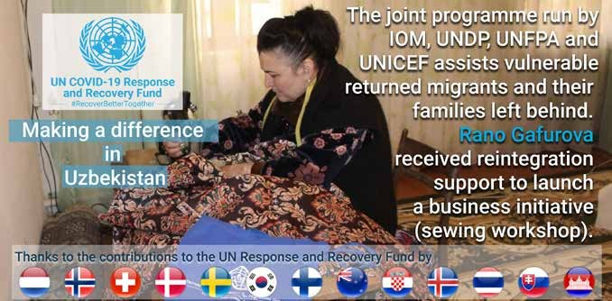
Uzbekistan appropriated the COVID-19 MPTF campaign format for a national level Twitter campaign.
© UN Uzbekistan

VIET NAM

Mitigating the Socio-economic Impact of COVID-19 in Viet Nam on the Most Vulnerable Groups and Supporting More Resilient Policies and Systems
End Date: 31 December 2020

Programme Summary
This programme mitigated the socio-economic impacts of COVID-19 by helping assure that vulnerable people, like pregnant women, children, drug users and the incarcerated, were able to access health, WASH, and other critical services. Specifically, the initiative helped continue the provision of essential health and nutrition services in 132 difficult-to-reach and disadvantaged communes in the four provinces of Dien Bien, Gia Lai, Kon Tum and Ninh Thuan. It also supported cash for food security and livelihoods in ethnic minority households in Ha Giang and Lao Cai province.
Achievements under Pillar 2 on Protecting People

Maternal, Newborn, and Child Healthcare
- 300 front-line health workers trained to provide integrated health and nutrition interventions
- 12 fetus monitors provided to the 12 most vulnerable district hospitals
- 12,600 pregnant women accessed quality antenatal services, and 1,500 newborns and their mothers received a postnatal home visit
- 1,000 lactating women attended community-based sessions to improve breastfeeding knowledge
- 4,500 children under two received micro-nutrient supplementations to prevent anemia
- 8,700 parents/caregivers of children under five received communications on prevention of infection and transmission of COVID-19
- A package of behavior change communication (BCC) materials on continuing provision and utilization of sexual and reproductive health services amid the COVID-19 pandemic was developed and distributed to
all 63 provinces for dissemination at health facilities and communities
SRH and Support for Vulnerable Populations
- A smart phone application was developed and used to schedule 210,400 SRH visits, of which approximately 12,600 were for maternal health services
- Project-trained providers attended 210,000 SRH visits
- 1,506 PLHIV and other key populations benefited from emergency health service support packages, daily necessities packages, cash transfers and social support
- 60,514 HIV key populations received some combination of support in the form of information, cash transfers, and/ or support packages
- Beginning in 2021, the programme will pilot take-home dose methadone to the benefit of 2,000 drug users in three pilot provinces
WASH and Support for At-Risk Populations
- WASH kits and upgrades provided to 53 schools and 41 bio-sand filtration models demonstrated in three communes to support behavior change. 86 participants of commune officials, commune health workers, and village leaders attended the training on point of use water treatment and safe storage. Overall, these WASH activities benefitted 21,300 children and 11,300 villagers
- UNDP provided direct unconditional transfers of 2.2 million VND (approx. US$100) each as well as PPE to 600 household businesses (554 ethnic minority women and 46 ethnic minority male-led)
- 600 ethnic minority women from 600 poor households received cash grants of US$100, benefiting approximately 2,520 people
- 800 ethnic minorities received information on violence against women
- 1,200 ethnic minority households in Ha Giang and Lao Cai province were supported with cash for food security and alternative livelihood investment

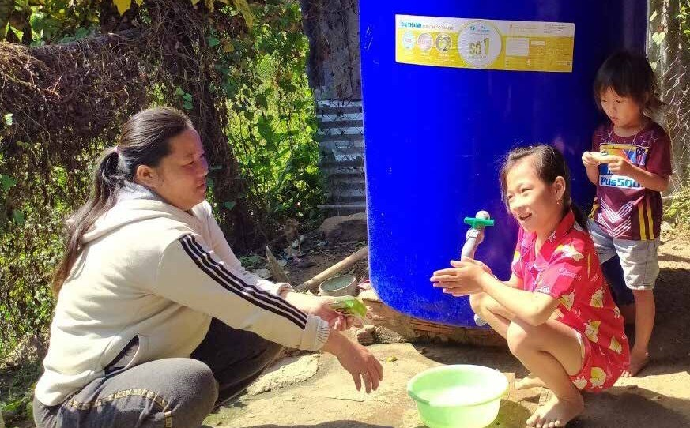
My washing her hadns with soap at home in Whi Ha communie in Ninh Thuan province.
© UNICEF Viet Nam\Natsuko Hatano

Innovation and Learning
With regard to learning, UNDP’s initial discussions with provincial agencies and provincial Women’s Union (an implementation partner) revealed that they lacked
confidence in applying digital tools for direct transfers to beneficiaries due to unfamiliarity with the proposed approach and concerns over beneficiary capacity and digital access.
UNDP arranged a briefing for provincial partners on digital options, visited a sample of beneficiary households, and provided online training to provincial, district, and commune personnel. As a result, with support from commune personnel all 600 beneficiaries applied the online digital registration tool to receive the direct transfer. This
digital registration tool and approach were incorporated into ongoing support to the government through the Joint SDG Fund programme on Accelerating Vietnam’s Transition Toward Inclusive and Integrated Social Protection.
The programmed proved innovative. First, UNICEF developed and conducted virtual trainings for essential workers in the health and education sectors. All courses achieved ratings
of over 8.5/10 (from participant satisfaction surveys) and showed significant increases in knowledge between pre- and post-tests. Not only was the training appreciated, but it also enabled a broader, more inclusive and cost-effective way to reach more frontline workers. The online training
demonstrated great potential for further replication in routine programming.
In addition, UNFPA developed and piloted a smart phone Application (MH247- “Me con vui khóe” (Healthy and Happy Mother and Baby) to facilitate tele-SRH services so as to avoid disruptions amid the pandemic. The Application has been available in both Android and IOS format for

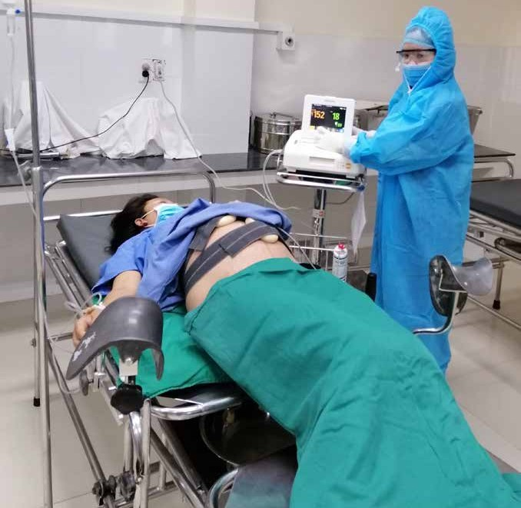
Maternal service provision in Bac Tra My District of Quang Nam province.
© UNFPA

free download since November 2020. At this stage, the MH247 was piloted in Bac Ninh and Hoa Binh provinces for five months. It created a platform for users to arrange appointments and attend online consultations with health providers if they were not able to visit health facilities because of COVID-19 or humanitarian crisis situations. The
official launch of the MH247 for upscale is planned for June 2021.

91
The COVID-19 MPTF Global Report

PILLAR 3
Economic Response and Recovery – Protecting jobs, small and medium-sized enterprises, and vulnerable workers in the formal economy

ARGENTINA

Socio-economic Recovery from the COVID-19 Crisis from a Gender Perspective

End Date: 1 December 2021

Programme Summary
This programme will work to improve access to social benefits for vulnerable populations and address the gender gaps in women’s financial inclusion in Argentina. The programme aims to improve the conditions for caregivers servicing those
most vulnerable to the impacts of the COVID-19 crisis, including the elderly and people with disabilities. It will also support more equal and gender-balanced approaches to caregiving and unpaid domestic work.

Early Achievements under Pillar 3 on Economic Response and Recovery

The joint programme was initiated on 15 October 2020. Initial implementation focused on establishing appropriate governance structures, including hiring programme staff, setting up mechanisms for inter-agency coordination, and identifying synergies and opportunities to harmonize with other important programmes and policy initiatives. Thus far, the programme has:
- Held an online launch with government counterparts on 18 November 2020. UN Women hosted the event,

which was attended by 20 representatives from various ministries
- Rolled out a Terms of Reference (ToR) for an assessment of the psycho-social impacts of the pandemic on the elderly
- Gathered data for implementation, including initiation of a collaboration with the Central Bank to conduct an analysis of their current debtors base as well as with the
National Social Security Administration to examine current levels of debt by households receiving social protection
- Agreed, with programme partners, a ToR with the Ministry of Labor to study the need to revise and update policies and guidelines related to the labor conditions for family care work and workers in collective agreements
- Carrying out a ToR to provide technical assistance to the National Ministry of Women, Gender and Diversity for a draft law to create a National Comprehensive System of Care
- Engaged with the Ministry of Finance to discuss the development of trainings to increase women’s financial literacy and labor market inclusion in Argentina

ARMENIA

Accelerating Women’s Empowerment for Economic Resilience and Renewal: The post COVID-19 Reboot in Armenia
End Date: 31 December 2021

Programme Summary
This joint programme will invest in women’s economic empowerment and contribution to national efforts to build back better. It will focus on (1) Providing vulnerable groups of women with access to STEM skills to access/adapt to a changing market; (2) Creating livelihood opportunities for vulnerable women and girls; (3) Ensuring that women at risk and survivors of gender-based violence can access relevant evidence-based information and benefit from protection support adapted to the COVID-19 context. The programme will also facilitate the adoption of a unified Gender-Based Violence Information and Management System (GBVIMS) to improve data collection, processing, and gender-based violence services. The GBVIMS will be linked with online and mobile app supported tools for gender-based violence prevention response and service delivery.

Early Achievements under Pillar 3 on Economic Response and Recovery

- The programme commenced in 2021 with a detailed outline of agency workplans. These were then merged into a project tracker developed by the Resident Coordinator’s Office to enhance UN Country Team coordination and collaboration with the broader development community and to facilitate continuous government engagement.
- The conflict in and around Nagorno Karabakh has put added pressure on the socio-economic situation in Armenia, making times even more challenging for the government in the country. The implications of conflict
escalation coupled with the short reporting period means no outcome level results could be reported, apart from the successful programme planning.
- During its implementation, the programme is projected to reach 100,850 beneficiaries. Targeted groups include minorities, migrant women, rural women, older persons, people living with disability, gender-based violence survivors, expectant and nursing mothers, and female single-headed households.

BHUTAN

Protecting Livelihoods and Reinforcing the Tourism and Agriculture Sectors in Bhutan

End Date: 31 March 2021

Programme Summary
This joint programme addressed the direct impacts of the COVID-19 pandemic on livelihoods by mitigating food insecurity, creating jobs, and strengthening Bhutan’s tourism and agricultural sectors to “build back better.” The programme provided cash-for-work incentives to vulnerable groups as well as reskilling and upskilling activities, with a particular focus on women. The agricultural component primarily targeted smallholder farmers and helped them enhance local vegetable production.
Achievements under Pillar 3 on Economic Response and Recovery
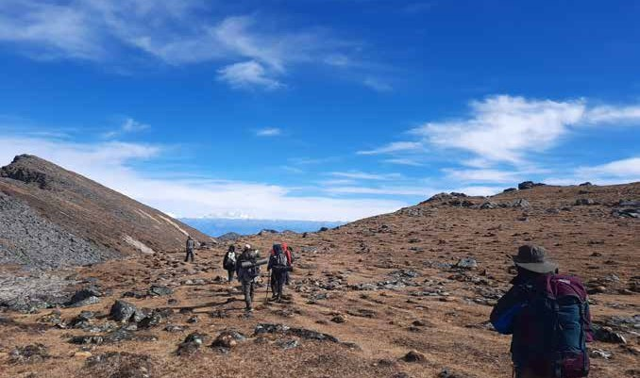
- 100 (82 male and 18 female) licensed national cultural tour guides (national certificate level II) who were laid off completed an upskilling programme that trained
them as trekking guides (national certificate level III). (The average age of the direct beneficiaries was 27 years)
- Developed and enhanced four facilities in the tourism sector through a cash-for-work scheme
- One of the popular trekking routes in Bhutan was under rehabilitation (80% complete) in partnership with the Guides Association of Bhutan, which engaged 30 laid off individuals from the tourism sector

- Surveyed the ‘Snowman Trek’ for digitization in partnership with the National Land Commission
- In partnership with the Ministry of Agriculture and Forests and the local government, the programme supported
the local production and sale of vegetables in the two vulnerable districts of Zhemgang and Samtse; the intervention also helped link farmers to markets
- Provided 668 smallholder farmers, of which 70% were women, (and their household members or approximately 3,340 individuals in total) with high-
quality vegetable seeds, tools and implements, as well as green technologies such as drip kits, sprinklers, flexible pipes, mulching plastic, low-cost poly-houses, water storage tanks, water harvesting materials, and electric fencing materials
- Increased production by at least 20% compared to previous years, with over 44MT of local vegetables produced by the targeted beneficiaries; 35MT of vegetables sold for US$ 28,000

Trekking guide trainees walking past the Pankha area along the famous Dagala Pass Trek.
© Tourism Council of Bhutan
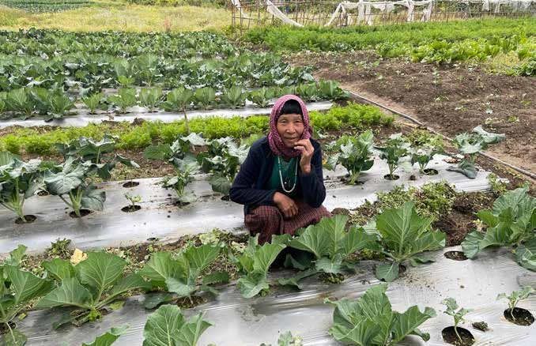
A woman farmer, Aum Wangmo, in her agriculture field in the village of Zhemgang.
© WFP

Innovation and Learning
The programme supported the Tourism Council of Bhutan to institute the Bhutan Tourism Dialogue series, which aimed to rethink and reinforce tourism in the country. It shared knowledge and best practices, and it helped develop the travel sector in Bhutan through dialogue.
Through this programme, UNDP embarked on another initiative with the Tourism Council of Bhutan to devise a blueprint on the ‘Digitalization of the tourism sector in Bhutan,’ which will guide Bhutan’s tourism sector in partnership with national stakeholders and the UN World Tourism Organization.
With regard to learning, through the joint action of the Economic Contingency Plan and other programmes, the production of agriculture commodities showed remarkable progress. To avoid market glut and price drops due to excess produce supply, it was realized that the district and technical agencies should advise farmers on properly planning and staggering production, as well as on post-harvest handling and storage solutions.

BOLIVIA

Mitigating the Socio-economic Impact of COVID-19 on Employment and Income of Women Working in the Informal Economy
End date: 31 October 2021

Programme Summary
This joint programme intends to reduce the socio-economic impacts of COVID-19 on women working in the informal economy by preventing them from falling into poverty and promoting gender equality through their economic empowerment. The programme will: establish social protection mechanisms; improve access to decent work; offer capacity building and trainings; and provide access to financing.

Achievements under Pillar 3 on Economic Response and Recovery

The joint programme commenced activities shortly after national elections were held in October 2020. With the second wave of the COVID-19 pandemic expected to peak in early February 2021, the programme has engaged its counterparts virtually. It has:
- Commenced its first study to inform on women in the target group, in accordance with the concept note and its outcomes. The study will: generate knowledge to aid the development of public policy, help with approaches
to potential partners (particularly public institutions), and harness interests in the programme, thus enhancing its durability and scalability potential
- Generated a conceptual framework to support the measurement of the target population, given the lack of nationally recognized definitions of the formal and informal Bolivian economy. This will be done by utilizing employment and socioeconomic variables from the surveys undertaken by the National Institute of Statistics and the informality guidelines provided by the ILO
- Developed an Impact Monitoring System, with the Productive Development Bank. This intends to measure the impacts of credits to medium- and small- micro enterprises (MSMEs) meant to mitigate the impacts of COVID-19. This system has defined gender indicators, which seek to incentivize the development of adequate financial products for self-employed women

COSTA RICA

Integrated Support for Health and Socio-Economic Recovery Focused on Local Women, Migrants and Vulnerable Asylum-Seekers
End Date: 15 October 2021

Programme Summary
This intervention supports Costa Rica’s national response to COVID-19 on the health, social, and economic fronts. The programme will strengthen border management procedures to fast-track migrants’, refugees’, and asylum seekers’ access to labor markets. It will also contribute to the inclusion of at-risk women (nationals, migrants, and asylum seekers) in local productive sectors through entrepreneurial actions. With the establishment of a community-based health surveillance mechanism that encourages women’s participation, the programme will promote safe practices and behavioral changes that prevent and reduce COVID-19 transmission, sexual and gender-based violence, xenophobia, and discrimination.
Achievements under Pillar 3 on Economic Response and Recovery

- Designed a training process for work centers to support the dissemination of knowledge on basic aspects of occupational safety and health, as well as the measures and tools applicable in the workplace for the preparation of COVID-19 plans
- Held a pilot workshop jointly with the Chamber of Commerce of Pococí (Hüetar Caribe Region), the Ministry of Health and the Occupational Health Council
- Together with government authorities and private sector representatives from Costa Rica, the programme promoted a dialogue process with the Government of Nicaragua for the limited reopening of land borders to
ensure the temporary and regulated entry of Nicaraguan seasonal agricultural workers; The outcome was the Costa Rica-Nicaragua binational agreement signed in November 2020, allowing the regulated hiring of temporary Nicaraguan workers in Costa Rica
- Supported the Costa Rican Government with 1) the development and implementation of the Migratory
Labor Traceability System (SITLAM), designed to register and locate seasonal agricultural migrants during their stay in Costa Rica with a focus on preventing and mitigating the spread of COVID-19 among migrants and host communities; and 2) the development of SIMLA: Labor Migration System, which allows electronic file transactions among Ministry of Labor (MTSS) and DGME for the approval of work permits
- Provided technical support to the Occupational Health Council in the development and implementation of
the Work Center Portal (https://pct.go.cr/) and in the implementation of a toolbox; a self-evaluation form based on the protocols of the Ministry of Health; and a seal of work center protected/warned against COVID-19
- Initiated actions to identify and contact implementing partners for the management of the women’s entrepreneurship programme

DJIBOUTI

Climate Resilient, Women-Centric Economic Empowerment for Inclusive and Greener Post- COVID-19 Recovery
End Date: 15 October 2021

Programme Summary
This programme focuses on empowering women by providing them with enhanced entrepreneurship and leadership skills gained through support to and the promotion of micro-, small-, and medium-scale enterprises (MSMEs) that prop up local production and accelerates women’s contributions to the national economy, the blue and green economies, and climate resilient enterprises.

Achievements under Pillar 3 on Economic Response and Recovery

This programme made important initial progress since its inception on 4 November 2020. The official programme launch is planned for February 2021.
- Priority was given to the identification of beneficiaries
and to the development of a coordination platform
for organizations working in the arena of agriculture and women’s empowerment – all to be further developed with national authorities
- The beneficiary identification process benefitted from existing or budding women-led MSMEs and MSMEs contributing to greening the economy. The programme initiated:
  - the mapping of existing grantees of the Small Grants Programme of the Global Environment Facility
  - the mapping of budding women entrepreneurs incubated by ongoing entrepreneurship and leadership initiatives
  - identification of three women agro-entrepreneurs in the three different regions of Ali Sabieh, Djibouti, and Dikhil
- A preliminary assessment of agri-business operators found that enhanced irrigation, improved seeds, faster and higher value crops and micro-finance to purchase modern equipment were needed. It also found that new entrepreneurs and smallholder farmers will need holistic support
- UNDP, on behalf of the programme, developed a comprehensive matrix to map initiatives undertaken by key partners working in the agro-business and agro-sector promotion. It will support coordination of efforts and, more importantly, promote collaboration among partners and avoid duplications to maximize the impact of interventions for greener and stronger post COVID-19 socio-economic recovery. The mapping was shared initially with the Ministry of Economy, Finance and Industries (MEFI), the World Bank, and FAO for trial purposes

FIJI

Inclusive Economic Recovery through Sustainable Enterprises in the Informal Economies of Fiji, Palau, Tonga and Vanuatu
End Date: 1 November 2021

Programme Summary
This programme targets the sub-sectors of informal economies, creative industries, and agriculture sectors in Fiji, Palau, Tonga, and Vanuatu. It will mobilize stakeholders in the labor market to address unemployment, underemployment, and business deficits, as well as fundamental flaws in the informal economy to improve resilience, employment, production, and income for recovery from the impacts of COVID-19.

Achievements under Pillar 3 on Economic Response and Recovery

- Foundational processes were put in place to allow for an effective collaboration between participating agencies, as well as an inclusive and consultative approach to tailor the programme to the needs and priorities of each country. As the project is in its third month, beneficiaries were yet to be reached
- National inception meetings provided the opportunity for interdisciplinary discussions and enabled interaction and exchanges between sectors that traditionally do not work together. They brought together partners and stakeholders on a national level, creating a link between government partners working in the field of trade with those working in the cultural sector as well as with trade unions, farmer organizations and cultural brokers
- During these meetings, the agriculture and creative industry sectors shared good practices and ways to resolve common challenges. Discussions led to the
establishment of synergies and possible partnerships that can help capitalize on the comparative advantages of each sector, such as using agricultural by-products for crafts or bolstering the cultivation of materials that are in demand for the creative sector
- The ILO is in the process of formalizing its partnership with the Australian-funded Market Development Facility (MDF) to identify and develop innovative and high- impact regional business accelerator and incubator facilities (physical and virtual) that creative-preneurs and agri-preneurs in the informal sector can access
- UNDP developed partnerships with financial institutions to provide training on basic business management and financial literacy to micro-entrepreneurs in the informal sector to strengthen their capacity to run their business as well as better plan and manage their finances for the attainment of their sustainable development aspirations

MYANMAR

Accelerating COVID-19 Socio-Economic Recovery in Myanmar through Resilient and Gender Transformative Enterprises
End Date: 4 January 2022

Programme Summary
This programme helps assure that COVID-19 financial stimulus packages reach women-owned and led businesses that were disproportionally affected by the crisis. It will enhance women’s livelihood opportunities and economic empowerment by contributing to long-term improvements in the operating environment for women to start, adapt, and operate resilient businesses that attract investments, including through digital transformation; and in doing so address the underlying structural bottlenecks and socio-cultural boundaries limiting women operating in the business space.

Achievements under Pillar 3 on Economic Response and Recovery

This programme commenced on 28 October 2020 and intends to target 100 women-led micro-, small-, and medium- enterprises (MSME) and their employees.
To strengthen the Government of Myanmar’s capacity to include gender and women-owned enterprises in its socio- economic response to COVID-19 in the short and medium- terms, the programme:
- Drafted and finalized the Terms of Reference (ToR) for project governance structure (Project Advisory Committee-PAC) and Technical Advisory Group with proposed membership
- Held initial discussions with the proposed Government Co-Chair of the PAC (Director General, Department
of Industrial Supervision and Inspection, Ministry of Planning, Finance and Industry)
To assure that the entrepreneurship ecosystem of Myanmar, including in its accelerators, has strengthened capacity to effectively support women impacted by the COVID-19 crisis in an integrated way, the programme:
- Contracted an implementing partner, BoPInc, to be responsible for undertaking the capacity building of ecosystem players, including accelerators, incubators, and investors
- Drafted a ToR for a dedicated Accelerator Programme for select women-led MSMEs
To strengthen access to finance for capacitated women MSMEs, the programme:
- Compiled a database/pipeline of potential investors and financial institutions that could offer support to the programme
- Initiated collection of secondary data on various funding activities and programmes that support women-led institutions from different angles (i.e. banks/ FSPs, governments, DFIs, etc.) – to understand supply- side gaps and recommendations to further support lending to women-led/owned MSMEs

NEPAL

Immediate UN Response for Coherent Safeguarding the Livelihoods of People Made Most Vulnerable by COVID-19
End Date: 1 November 2021

Programme Summary
This programme supported traditionally at-risk groups whose vulnerabilities were further compounded by COVID-19 containment measures. It targeted migrants at-risk of exclusion from existing support programmes and young women in need of specific training and reskilling opportunities. To promote jobs and sustainable tourism in the long-term,
the programme supported community efforts to preserve the environment along road sites; and to improve waste management, signage, drainage, and landslide clearing along 600km of popular trekking trails.
Achievements under Pillar 3 on Economic Response and Recovery

The programme exceeded it anticipated targets. It:
- Reached 2,812 beneficiaries, of which 1,411 (50.2%) were women and 1,799 (64%) were from marginalized groups, including 1,000 Janajati (indigenous ethnic groups) (35.6%) and 786 (26%) Dalits
- Provided immediate cash assistance and recovery support of approximately US$ 115 (NPR 13,500) to 250 vulnerable returnee migrants (72.4% women; 79.2% disadvantaged groups; 37.6% youth) through different NGOs shelters in Kathmandu Valley, Bagmati Province
- Of the total number of returnee migrants supported, 35% were undocumented, 23% irregular, and 42% were in a stranded condition. The cash supported their further travels to home districts, as well as immediate food, accommodation, and personal hygiene needs
- Created short-term employment on rural road maintenance for vulnerable wage workers and supported entrepreneurship development and job creation for the most vulnerable groups, as well as short-term employment in the hard-hit tourism sector
- Through the Council for Technical Education and Vocational Training (CTEVT), the programme provided vocational and skills trainings to 244 direct project beneficiaries
- The employment rate two months after training completion was estimated at 58% as of 31 December 2020, compared to the original target of 50%
- Implemented complementary initiatives on information and awareness-raising that addressed the high prevalence of misinformation on COVID-19
- Made use of existing public sector systems for more rapid implementation and future scalability

Learning and Innovation
Programme implementation during the pandemic encountered multiple logistical and health-related challenges related to restrictions on travel and large gatherings. However, with an increased number of virtual meetings with implementing partners and key stakeholders; an increased number of training opportunities, each with fewer participants; and strict health and safety protocols in place, the participating UN agencies successfully and timely completed all project components. The strong partnerships between UN agencies and government agencies at all levels and with civil society organizations significantly contributed to the programme’s success.

SAO TOME AND PRINCIPE

Women Economic Empowerment Window (WEEW)

End Date: 2 November 2021

Programme Summary
As a direct response to the structural issues identified in the consecutive National Strategies for the Promotion of Gender Equality and Equity (ENIEGs) and the impacts of COVID-19 pandemic on them, this programme will support the realization of the national gender strategy with a focus on the economic empowerment of São Tomean women. It will develop: (1) the entrepreneurial capacities of specific women’s groups, in particular those for women in vulnerable situations; (2) an alternative mechanism for financing their economic activities; and (3) new business associative initiatives that can create synergies between women led micro-, small-, and medium enterprises (MSMEs) and enhance market linkages. The programme will also, with regard to childcare and education access, enhance resiliency by creating alternative safety nets for women-led households.

Achievements under Pillar 3 on Economic Response and Recovery

- Commenced building and scaling up existing of UNDP, UNICEF and ILO programmes in São Tomé and Principe to create an intervention that organically connects and addresses a number of economic and social gender discriminatory factors and makes vulnerable female- headed households more resilient in the face of the COVID-19 pandemic
- This project’s services will translate into more structured MSME businesses to be implemented through the entrepreneurship platform programme. The WEEW will identify successful businesses implemented by women entrepreneurs in the country in order to invest
for scale up, improve the quality of services and products offered, open markets and strengthen management capacity, including connecting them to financing facilities offered by the local commercial bank
- The women targeted by the WEEW will also benefit from UNICEF’s Back to School programme in terms of the
direct support provided to their children to be able to attend school, but also as potential suppliers of the goods and services required by this programme
- The WEEW will propose additional and innovative support measures to ensure the continuity of services, secure workplaces, and support the workforce. Towards that end, training and capacity-building tools for MSMEs will be developed and made available to them to enable them to better cope with the risks associated with COVID-19
- Networking between large companies and MSMEs will also be established within the dialogue framework that will be put in place to identify the types of alternative jobs that can be created within a partnership framework between the public employment service, large companies, and MSMEs, especially in a crisis context such as COVID-19

SAO TOME AND PRINCIPE

Ensuring the Access of Most Vulnerable Families to Food and Working Conditions Facilities during the COVID-19 Pandemic
End Date: 2 February 2021

Programme Summary
This programme assisted rural and vulnerable families at risk of food and other insecurities heightened by the pandemic. The programme provided trainings to families engaged in agriculture to support their hygiene, health, and safety in the agricultural workplace. It also supported school gardens to the benefit of children as well as others engaged in learning environments.
Achievements under Pillar 3 on Economic Response and Recovery
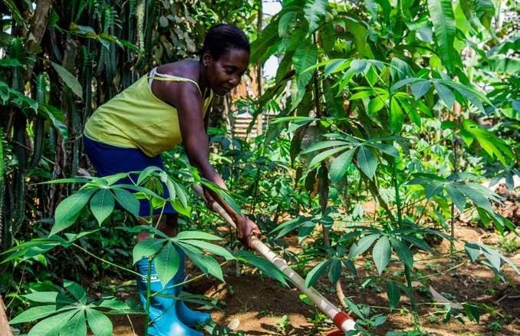
In the context of an unprecedent humanitarian and health crisis that negatively impacted the food security of
thousands of Santomeans in 2020, this programme achieved results that reenforced sustainable agricultural production techniques (including food storage and processing techniques) and conditions, ensuring the operationalization of government warehouses and school gardens. The programme:
- Identified 600 poor households, including children, women, and small-scale producers, considered at the highest risk of food insecurity
- Reached 3,000 beneficiaries (600 family groups of which

92.77% were headed by women)

- Provided training sessions to these 600 households/ family groups
- Re-activated and organized school gardens from 32 national entities to the benefit of approximately 3,500 school children attending kindergarten and primary schools, along with a plethora of education (teachers and school directors) and school feeding (kitchen helpers and gardeners) actors working in this sector
- Conducted a pre-gender analysis in close collaboration with the National Institute for Gender Equality and Parity and relevant national stakeholders to explore the main

Woman from a household in Sao Tome and Principe re-applying the knowledge she gained through training activities on sustainable agricultural techniques. She is also using working kits and rapid reproduction seeds to grow food for her family during the pandemic.
© Ody MPOUO/FAO

assumption that women’s empowerment needs to be mainstreamed into programmatic activities along with a gender lens to differentiate the specific needs of women and girls highly exposed to the impacts of COVID-19

SOLOMON ISLANDS

Supporting Solomon Islands Marketplaces to Respond to Twin Crises of COVID-19 and Tropical Cyclone Harold
End date: 28 February 2021

Programme Summary
This programme addressed the compounded socio-economic impacts of the COVID-19 crisis and tropical cyclone (TC) Harold on the livelihoods of market vendors (especially women vendors) and farmers in Solomon Islands. The initiative had a four-pronged approach that focused on (1) improving WASH supplies and safety measures at marketplaces; (2) supporting livelihoods and food security through procurement and distribution of seeds, seedlings, tools, and other agricultural
inputs; (3) developing a digital market space; and (4) a rapid diagnostic on the impact of COVID-19 on the labor market and economy to inform decision-making on socio-economic responses to the pandemic.
Achievements under Pillar 3 on Economic Response and Recovery
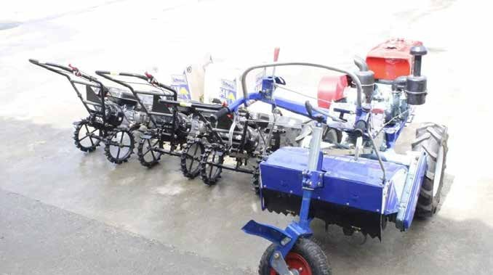
The project enabled women market vendors to operate safely in the pandemic and post cyclone context. It amplified the Markets for Change (M4C) response to the pandemic and the cyclone. M4C project brings
together governments, market vendors and Market Vendors Association (MVAs), civil society and UN agencies to promote gender equality through economic empowerment of women vendors in Fiji, Solomon Islands and Vanuatu. It is implemented by UN Women and UNDP with support from the Governments of Australia, Canada, and New Zealand.
This programme:
- Undertook a needs assessment to determine specific

WASH needs in relation to COVID-19 risks in the targeted market spaces
- Delivered and installed water tanks in Auki market
- Procured WASH supplies for all three targeted markets: 150 x 5-liter containers, of hospital grade disinfectant, 150 x 5 liter containers of liquid hand soap, 50 deck brooms, 60 mops, 70 rolls of cleaning cloths, 300 cartons of facemasks, 70 cartons of gloves, 60 buckets, six hoses, and five single bowl sinks
- Supplied 400 market vendors with tents and WASH equipment to enable business continuity
- Provided 60 farmer vendors from Honiara Central Market Vendors Association, 87 farmer vendors from Gizo Market Vendors Association and 62 farmer
Agricultural inputs received by the Auki Market Vendors Association (AMVA) in Auki, Malaita Province.
© Joel Reverly/AMVA

vendors of Auki Market vendor association seeds, seedlings, tools, and other agricultural inputs to boost agricultural productivity
- Procured and distributed 108 pieces of agricultural equipment to Market Vendors Associations; Further agricultural inputs will be distributed during February 2021 reaching an estimated 30,000 people
- Indirectly the programme benefited 90,000 people who depend on the markets for fresh produce

SRI LANKA

Healthy Socio-Economic Recovery of the Micro and Small Enterprise Sector of Sri Lanka

End Date: 31 March 2021

Programme Summary
This programme assisted micro and small enterprises (MSE) in Sri Lanka. Supported initiatives focused on the deployment of MSE surveys; COVID-19 specific occupational safety and health (OSH) trainings; the provision of business services addressing issues such as repurposing, continuity planning, entrepreneurship support, manager-worker dialogue, on-line delivery channels; and trainings to enhance sustainability and ensure decent work.
Achievements under Pillar 3 on Economic Response and Recovery

Thus far, this programme has:
- In close coordination with the Ministry of Health, Industrial Safety Division under the Ministry of Labor and the National Institute of Occupational Safety and Health (NIOSH), determined the OSH requirements for selected 232 MSEs in Gampaha and Kaluthara
- Undertook the entire sourcing, evaluation, quality control, procurement, transportation, and physical distribution of PPE Kits for 995 micro and small enterprises in both districts
- Engaged with local-level actors including the District Secretariat, District Chamber of Commerce, MOL, NIOSH and MOH officers to provide tailored psycho-social support to employers and employees of MSEs in both districts
- Rolled out a multidimensional communication campaign to reach MSEs and the general public on both the physical health and safety aspects of return to work, and the psychosocial particularities caused by financial stress and anxiety facing workers and entrepreneurs in struggling MSEs
- Reached 966 MSEs (468 women-led and 498 male- led) out of a project target of 1100 MSEs to enhance their access to finance to help them resume and continue business operations
- Reached (indirectly) nearly five million people (or 25% of the country’s population) through a nationwide communication and mass media campaign on OSH and MSE’s access to finance
- Reached 93 MSEs through four large companies in the coir (coconut husk) sector such that these 93 MSEs will receive LKR 22.18 million (app. USD 120,000) as working capital loans from these four companies. So far, 15 MSEs (small suppliers to the large companies) received LKR 4.15 million and others are in the queue. Though these small-scale businesses are mainly owned by males, more than 50% of the workers are female
- Together with the Women’s Chamber of Commerce, provided a specialized training and services to 50 female owned MSEs on how to improve their business, OSH, and productivity, thus making the enterprises more resilient to disasters and exogenous shocks

Learning and Innovation
One of the key lessons learned from the programme operationalization at the ground level was that potential dedicated government officers were attached to the divisional level on behalf of the Micro and Small Enterprise sector. The capacity building of these officers in ground-level data collection in a systematic way was vital for empowering the MSE sector.

VANUATU

Supporting Marketplaces to Respond to the Dual Crises of COVID-19 and Tropical Cyclone Harold in Vanuatu
End date: 31 December 2021

Programme Summary
This programme supported the health, hygiene, stability, and needs of market vendors that service large segments of the population in Vanuatu. The programme also assisted in the procurement and distribution of seeds, seedlings, and other agricultural inputs to boost agricultural productivity and supply, allowing 3,000 vendors to help meet local demand at the Luganville market, which serves a population of approximately 10,000 people
Achievements under Pillar 3 on Economic Response and Recovery
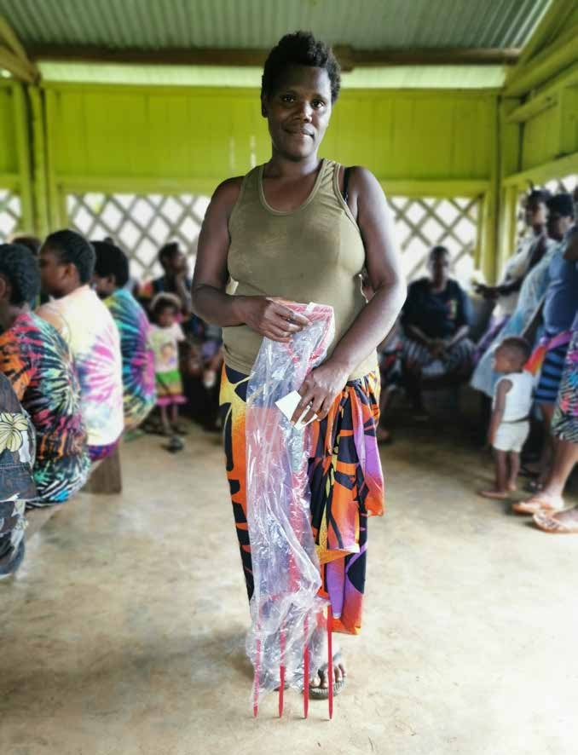
There were over 4,500 direct beneficiaries of this programme, 90% of whom were women. The programme undertook the following emergency actions:
- Procured WASH and PPE supplies for market vendors to ensure their safety; items included: signage, washable and reusable face masks, stainless-steel sinks, water blusters and trailers for markets, and communications materials such as PA systems and screens to support public health announcements
- Benefited 1,000 vendors in Port Vila Market with the delivery of WASH supplies and COVID-19 prevention interventions; indirect beneficiaries were 40,000 people living in the market catchment area
- Directly benefitted 3,000 vendors in Luganville Market and indirectly benefitted a market catchment population of approximately 10,000 people; 100 vendors in Marobe market were also direct beneficiaries
- Department of Agriculture and Rural Development (DARD), in collaboration with partners, organized vendors to meet at a central location to receive agricultural inputs (seeds, tools, etc..) and built capacity on the use of provisioned materials
- 692 vendors received agricultural inputs (679 women, 13 men, and 28 people with disabilities)
- 2,892 vendors will have been provided agricultural inputs, surpassing the proposed target, once additional

gardening tools procured are distributed in February 2021
- DARD extension officers helped the Northern Islands Market Vendors Association (NIMVA) members run their satellite nurseries
Anna Rose Andikar posing with her garden fork during distribution in August at Nambauk village.
© UNDP/Vasemaca Takau

ZIMBABWE

Empowering Women through Safe, Resilient, Gender Responsive Food Markets and Systems in Response to COVID-19
End date: 30 April 2022

Programme Summary
This programme will promote gender equality and the social and economic empowerment of women, youth, and other marginalized groups, while also enhancing their safety and security. It will achieve these objectives through (1) Safe Markets: infrastructure that is sensitive to community and women’s needs, complies with COVID-19 and occupational health and safety regulations (OSH), and is accompanied by mechanisms and structures to prevent and address gender- based violence and harassment; (2) Financial Security: improved economic security of women marketers (3) Influence and Decision-making: increased voice and agency of women in community and market-oriented leadership structures;
(4) Institutional Capacity: enabling a gender responsive policy framework and capacitated institutions responsible for administration, regulation, and the monitoring food supply systems; and (5) Inclusivity: inclusive e-solutions for safe markets.
Early Achievements under Pillar 3 on Economic Response and Recovery

The COVID-19 outbreak necessitated the need to scale up and broaden “safe markets” that protect against sexual and gender-based violence, comply with COVID-19 and OSH management systems, and prevent disease transmission
– measures that will help ensure women do not lose their income during public health emergencies and can operate in public spaces free from violence.
This programme, designed to help meet these needs, commenced in mid-November 2020, focusing on two key outputs that will create a strong basis for implementation:
(1) a project document defining the key parameters of engagement and expected results and (2) a detailed annual work plan. The programme also:
- Held interagency coordination meetings
- Mapped key stakeholders and strategized engagement
with the Government of Zimbabwe
- Prepared a comprehensive baseline from which to expand and deepen activities, which included reviewing of existing activities and conducting a lessons learnt session to identify gaps and land key recommendations from stakeholders; and reviewing untapped opportunities to be utilized to refurbish and build the new markets, capacitate women-led businesses, and strengthen regulations

107
The COVID-19 MPTF Global Report

PILLAR 4

Macroeconomic Response and Multilateral Collaboration

CAMBODIA

Unlocking Cambodian Women’s Potential through Fiscal Space Creation

End Date: 30 December 2021

Programme Summary
This programme will support the Government of Cambodia in rolling out, for the first-time ever, a $200 million credit guarantee scheme to provide low-cost and reliable financing to micro-, small-, and medium-sized enterprises (M/SME) and boost growth in this sector. With a view to reducing poverty and increasing employment, the scheme will maximize the participation of and benefits to women-owned M/SMEs operating in the informal sector as well as labor intensive businesses and businesses requiring low skilled labor, in particular, migrants.
Early Achievements under Pillar 4 on Macroeconomic Responses and Multilateral Collaboration

This programme commenced on 1/1/2021. The key result delivered to date was the legal establishment of the Credit Guarantee Corporation of Cambodia (CGCC), the formal government approval of the CGCC policy framework, and critical partnership development between the government, neighboring countries credit guarantee organizations, and the private sector. Towards these outcomes, the programme:
- Organized and implemented an international dialogue on credit guarantees to support the formulation process of the policy and legal framework for the establishment of the CGCC
- Supported finalization of the CGCC legal framework
and policy
- Supported the CGCC to develop the operationalization road map to enable credit guarantees to be issued in the second quarter of 2021
- Developed partnerships (Moody’s and CGCC) and introduced risk management unit and policy and procurement of international credit missions

Endnotes
The COVID-19 MPTF Global Report

- Worldometers.info and World Health Organization (2021). WHO Coronavirus Disease (COVID-19) Dashboard. Obtenido de World Health Organization. Accessible at: https://covid19.who.int/
- World Economic Outlook, International Monetary Fund, October 2020, Table A.8
- International Monetary Fund (2020). How COVID-19 Will Increase Inequality in Emerging Markets and Developing Economies. Accessible at: https://blogs.imf.org/2020/10/29/how-covid-19-will-increase-inequality-in-emerging-markets-and-developing-economies
- United Nations Development Programme (2020). Impact of COVID-19 on the Sustainable Development Goals. Accessible at: https://bit. ly/2Qvvd2g
- International Monetary Fund (2020). Fiscal Monitor: Policies for the Recovery. Accessible at: https://www.imf.org/en/Publications/FM/ Issues/2020/09/30/october-2020-fiscal-monitor
- World Food Programme (2020). Risk of famine in four countries, warns UN agencies’ report. Accessible at: https://www.wfp.org/stories/risk- famine-four-countries-warns-un-agencies-report
- International Labour Organization (2020). ILO Monitor: COVID-19 and the world of work. Sixth edition. Accessible at: https://www.ilo.org/global/ topics/coronavirus/impacts-and-responses/WCMS_755910/lang--en/index.htm; and Delaney, N (2020). Helping informal workers weather
the pandemic. Accessible at: https://www.hks.harvard.edu/faculty-research/policy-topics/poverty-inequality-opportunity/helping-domestic- workers-home-based?utm_medium=socialmedia&utm_source=hksfacebook
- International Labour Organization (2018). More than 60 percent of the world’s employed population are in the informal economy. Accessible at: https://www.ilo.org/global/about-the-ilo/newsroom/news/WCMS_627189/lang--en/index.htm
- Delaney, N. (2020). Helping informal workers weather the pandemic. Accessible at: https://www.hks.harvard.edu/faculty-research/policy-topics/ poverty-inequality-opportunity/helping-domestic-workers-home-based?utm_medium=socialmedia&utm_source=hksfacebook
- World Bank (2020). COVID-19 to Add as Many as 150 Million Extreme Poor by 2021. Source: COVID-19 to Add as Many as 150 Million Extreme Poor by 2021. Accessible at: https://bit.ly/3vjh1bx; and 2020 Year in Review: The impact of COVID-19 in 12 charts. Accessible at: https://blogs. worldbank.org/voices/2020-year-review-impact-covid-19-12-charts
- World Health Organization (2020). In WHO global pulse survey, 90% of countries report disruptions to essential health services since the
COVID-19 pandemic. Accessible at: https://www.who.int/news/item/31-08-2020-in-who-global-pulse-survey-90-of-countries-report-disruptions- to-essential-health-services-since-covid-19-pandemic
- Ibid
- United Nations Office on Drugs and Crime (2020). How COVID-19 restrictions and the economic consequences are likely to impact migrant smuggling and cross-border trafficking in persons to Europe and North America. Accessible at: https://reliefweb.int/report/world/how-covid-19- restrictions-and-economic-consequences-are-likely-impact-migrant-smuggling
- International Organization for Migrants (2020). COVID-19 Analytical Snapshot #18: Migrants & global food supply. Accessible at: https://www. iom.int/migration-research/covid-19-analytical-snapshot
- World Bank (2020). COVID-19 to Add as Many as 150 Million Extreme Poor by 2021. Source: COVID-19 to Add as Many as 150 Million Extreme Poor by 2021. Accessible at: https://bit.ly/2QTpZ0d; and (2020b). 2020 Year in Review: The impact of COVID-19 in 12 charts. Source: https://blogs. worldbank.org/voices/2020-year-review-impact-covid-19-12-charts
- Jang, Y., & Yum, M. (2020). Aggregate and intergenerational implications of school closures: A quantitative assessment. Covid Economics, p.46- 93
- Organization for Economic Co-operation and Development 2020. Hanushek, E. A., & Woessmann, L. The Economic Impacts of Learning Losses. Accessible at: https://www.oecd.org/education/The-economic-impacts-of-coronavirus-covid-19-learning-losses.pdf
- World Health Organization (2020). Attacks on health care in the context of COVID-19. Accessible at: https://www.who.int/news-room/feature- stories/detail/attacks-on-health-care-in-the-context-of-covid-19; and World Health Organization (2020). COVID-19 disrupting mental health services in most countries, WHO survey. Accessible at: https://www.who.int/news/item/05-10-2020-covid-19-disrupting-mental-health-services- in-most-countries-who-survey
- United Nations Conference on Trade and Development (2020). COVID-19’s economic fallout will long outlive the health crisis, report warns. Accessible at: https://bit.ly/3vkpScV
- United Nations (2020). COVID-19 and Higher Education: Education and Science as a Vaccine for the Pandemic. Accessible at: https://www. un.org/en/academic-impact/covid-19-and-higher-education-education-and-science-vaccine-pandemic
- Ibid
- 22 United Nations Conference on Trade and Development (2020). COVID-19’s economic fallout will long outlive the health crisis, report warns. Accessible at: https://bit.ly/2QUqs2e;

UN Multi-Partner Trust Fund Office
© 2020 UN MPTF Office. All rights reserved.

Author: COVID-19 Response and Recovery Fund Secretariat Copy Editor: Lauren Anderson
Graphic Designer: Edgar Mwakaba Production: Graphics Service Bureau, Digital
109

