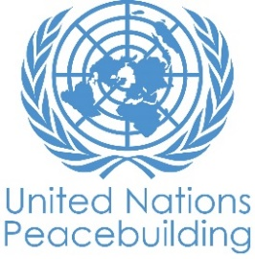
PBF PROJECT progress report
COUNTRY: SIERRA LEONE
TYPE OF REPORT: semi-annual, annual OR FINAL: ANNUAL
YEAR of report: 2021

Project Title: Mitigating localized resource-based conflicts and increasing community resilience in Pujehun and Moyamba districts of Sierra Leone
Project Number from MPTF-O Gateway: PRF 00117938
If funding is disbursed into a national or regional trust fund:  Country Trust Fund  Regional Trust Fund  Name of Recipient Fund: | Type and name of recipient organizations:  RUNO WFP (Convening Agency)  RUNO UNDP
Date of first transfer: 01 October 2019
Project end date: 31 March 2022
Is the current project end date within 6 months? Yes

Check if the project falls under one or more PBF priority windows:
Gender promotion initiative
Youth promotion initiative
Transition from UN or regional peacekeeping or special political missions
Cross-border or regional project

Total PBF approved project budget (by recipient organization): WFP
Recipient Organization Amount
WFP $ 1,664,000
UNDP $ 1,336,000
Total: $ 3,000,000
Approximate implementation rate as percentage of total project budget: 85 percent
*ATTACH PROJECT EXCEL BUDGET SHOWING CURRENT APPROXIMATE EXPENDITURE*

Gender-responsive Budgeting:

Indicate dollar amount from the project document to be allocated to activities focused on gender equality or women’s empowerment: $ 1,839,268
Amount expended to date on activities focused on gender equality or women’s empowerment:

Project Gender Marker: GM2
Project Risk Marker: Medium
Project PBF focus area: 2.3 Conflict Prevention/Management
Report preparation:
Project report prepared by William Hopkins, PBF Project Manager (WFP) & Catherine Waliaula,
Project report approved by: Yvonne Forsen, Deputy Country Director (WFP)
Did PBF Secretariat review the report: No

NOTES FOR COMPLETING THE REPORT:
- Avoid acronyms and UN jargon, use general /common language.
- Report on what has been achieved in the reporting period, not what the project aims to do.
- Be as concrete as possible. Avoid theoretical, vague or conceptual discourse.
- Ensure the analysis and project progress assessment is gender and age sensitive.
- Please include any COVID-19 related considerations, adjustments and results and respond to section IV.

PART 1: OVERALL PROJECT PROGRESS

Briefly outline the status of the project in terms of implementation cycle, including whether preliminary/preparatory activities have been completed (i.e. contracting of partners, staff recruitment, etc.) (1500 character limit):

The establishment of the Grievance Redress Committees (GRCs) and district-level Multi-Stakeholders Platforms (MSPs) in the targeted Chiefdoms and district have been highly acclaimed for mitigating conflicts between community people and the communities and companies and promoting peace and businesses (companies’ businesses). Discussions are presently on-going for the transformation of these committees/structures into permanent local structures. It is reported and confirmed by chiefs that the GRCs are resolving many conflicts in their chiefdoms (Annex 3). Because of the good work of these committees which were established at Chiefdom level, GRCs have been established at Sectional levels in the targeted Chiefdoms. With the formation of these Sectional Committees, issues raised within the Sections of the chiefdom, are resolved at Sectional level, if not resolved, they are referred to the Chiefdom level Committees for action and resolution, otherwise, for bigger issues/problems that are beyond the scope of the GRCs, they are referred to the Multi-stakeholder Platforms for action and or resolution.

A comprehensive register of issues handled by the Grievance Redress Committee (GRC), including land conflicts and other community-based conflicts was established and updated. The findings were also discussed at the project Technical Committee meeting held in October 2021. With the approval of a six-month No-Cost Extension (NCE), the two UN Agencies are working with the Office of the Vice President (OVP), Ministry of Local Government and Rural Development, Local Councils and Chiefdom authorities to finalize and activate an inclusive Exit and Sustainability Plan.

All four Community Actions Plans planned under the project have been formulated through inclusive processes that championed the participation of women and youth. Social tensions were reduced by strengthening the agricultural livelihoods of 4,065 farmers working together under 60 Farmer Based Organisations (FBOs). Support provided included a one-month Cash Transfer of US$58 to 3,658 farmer participants (high risk youth [2,357] and vulnerable women [1,301]). To optimise land use and reduce land-related conflicts, quality, short-duration seed rice and fertilizer was provided to farmers to increase yields. To strengthen food security, lead farmers and Community Youth Contractors were trained in nutrition-sensitive agriculture and improved Post-Harvest Management practices. Six poultry houses were constructed to support diversified and synergistic livelihoods. Lead farmers were also trained in improved

Please indicate any significant project-related events anticipated in the next six months, i.e. national dialogues, youth congresses, film screenings, etc. (1000 character limit):

Activities to be done till the end of project in March 2022:
- A study tour to be conducted by the OVP on the Management of SLEITI and VGGT in Senegal (South-South Cooperation)
- A lesson learned workshop on the innovative approach used in the project will be conducted to inform future project design
- Validation of the Land Degradation Project following an assessment conducted by the Project in 2020. The validation will be led by the OVP.
- Provision of vegetable gardening tools, improved vegetable and legume seeds and training in nutrition-sensitive agriculture to representatives of all FBOs.
- Stocking of poultry houses with 1,200 layers, equipment and starter feed, and training of women in poultry management and chicken feed production.
- Purchase of surplus rice and vegetables from supported FBOs for distribution under a Home Grown School Feeding pilot project.
- Building market linkages between supported FBOs and private-sector companies.
- Finalization and activation of an Exit and Sustainability Plan.

FOR PROJECTS WITHIN SIX MONTHS OF COMPLETION: summarize the main structural, institutional or societal level change the project has contributed to. This is not anecdotal evidence or a list of individual outputs, but a description of progress made toward the main purpose of the project. (1500-character limit):

The establishment of Grievance Redress Committees (GRCs) and District level Multi-Stakeholders Platforms (MSPs) have been highly acclaimed for mitigating conflicts between community members, and between communities and companies. Discussions are presently on-going for the transformation of these committees into permanent local structures. Based on the effectiveness of GRCs at Chiefdom level, these have been replicated at Sectional level. If a conflict cannot be resolved at the Sectional level, the issue is escalated to the Chiefdom-level GRC and finally to the MSP.

Agricultural livelihood support has greatly strengthened social cohesion in targeted areas, with the emergence of 60 formalized FBOs – new groups collectively engaged in group farmers - that are registered with the Ministry of Agriculture and Forestry (MAF) and their respective District Councils demonstrating increased cohesion at the community-level. Furthermore, livelihood support has galvanized cohesion between communities – reflected by 17 FBOs in Lower and Upper Banta chiefdoms, Moyamba district; and 14 FBOs in Malen and Makpele chiefdoms, collectively aggregating, processing, and selling their rice to WFP. Furthermore, two agricultural cooperatives – the Lower Banta Farmers’ Cooperative and the Malen Farmers’ Associations – have been created to facilitate long-term collective action between farmers in targeted districts. Community Youth Contractors (CYCs) – high performing young agriculturalists technically backstopping their communities - have established networks to discuss challenges and share ideas to sustain support after the project.

In a few sentences, explain whether the project has had a positive human impact. May include anecdotal stories about the project’s positive effect on the people’s lives. Include direct quotes where possible or weblinks to strategic communications pieces. (2000-character limit):

Members of the GRC have been trained in conflict resolution and with the acquired skills and capacity, the members of these Committees can now confidently intervene and resolve conflicts in the communities. The Paramount Chief of Upper Banta Chiefdom confirmed the relevance of the GRC in his Chiefdom and stated that the CDC would consider supporting the activities of the Committee at the end of project.

Women of Lower Banta lead the way in agricultural production

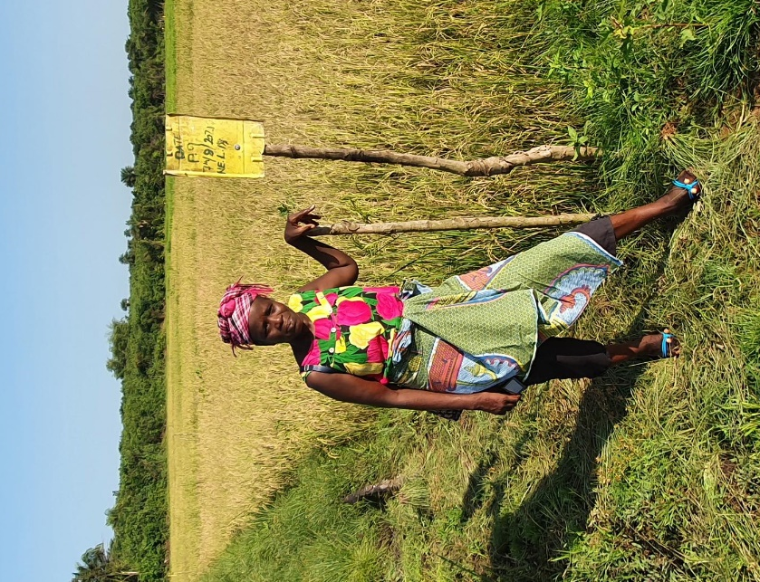
The Matagelema Women Farmer’s Association from Lower Banta chiefdom, Moyamba district, is a Farmer Based Organisation (FBO) comprised of over 100 members that was formed in March 2021. The group was formed after receiving support from WFP and MAF under the PBF project to develop irrigation systems in two unused and overgrown Inland Valley Swamps (IVS). One of the IVS is an abandoned mining site that was rehabilitated by Sierra Rutile. Located just three miles from the bustling mining centre of Moriba Town, the women and youth of Matagelema had been significantly affected by rutile mining conducted by Sierra Rutile. With most of their agricultural land affected by mining activities, PBF support to women and youth has enabled them to intensively develop and cultivate unutilized land, significantly strengthening social cohesion and increasing food security.
Figure 1: Mammy Action and Matagelema's rice,
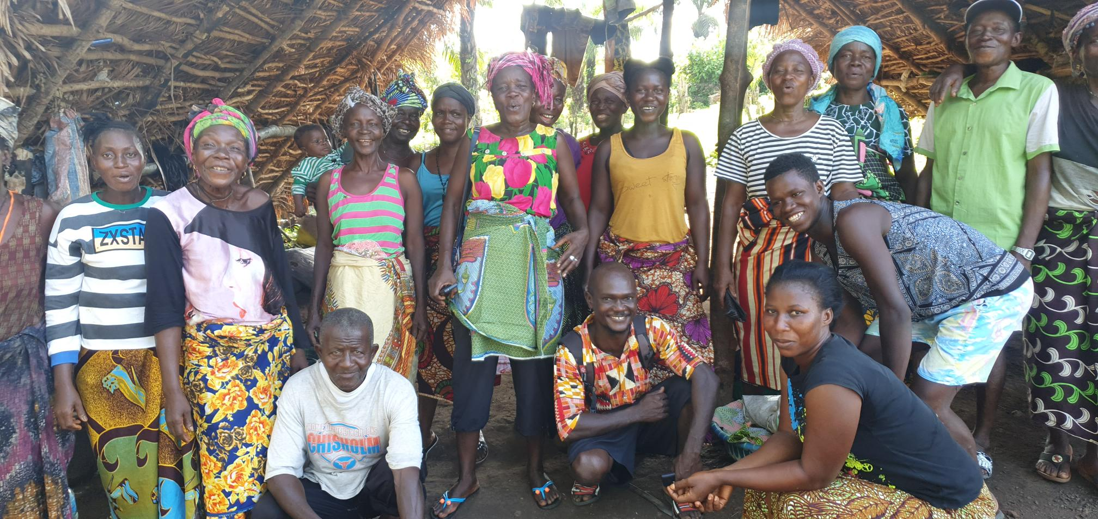
Led by the inspirational “Mammy Action”, in 2021 the Matagelema Women Farmer’s Association removed the thick bush from the IVS, developed irrigation canals and fully cultivated 25 acres with rice using improved production methods taught under the PBF project. “With most members of our group women, people thought that we would not succeed with this project”, explained Mammy Action. “Because our community is located so close to Moriba Town, many men in the village are supporting mining activities, meaning us women had to rise to the occasion”. Although land clearing and irrigation system construction are activities culturally undertaken by men, the women of Matagelema joined together and fully completed the development in time to plant with rice in June before the onset of the heavy rains. By following the improved agronomic practices championed by MAF and WFP, they are now anticipated to achieve one of the highest rice yields of any FBO supported under the project.
Figure 2: Members of Matagelema Women's Association

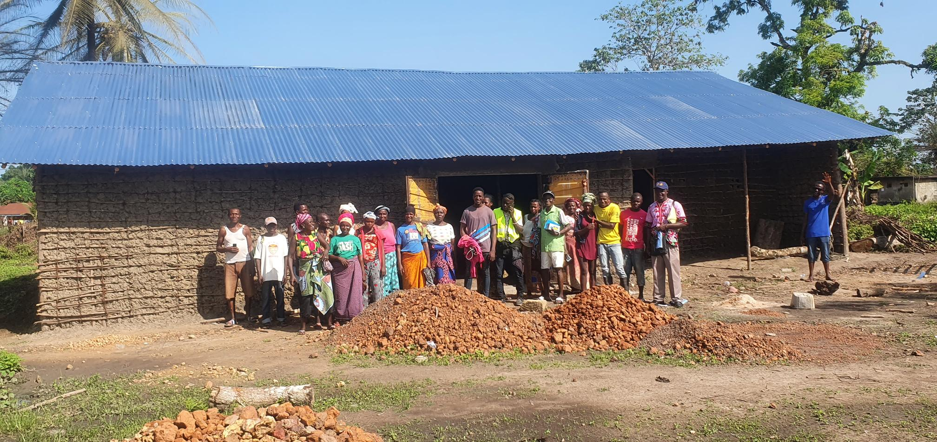
The Matagelema Women’s Association have come together to construct a large store to accommodate their harvest, which they hope will be used by other groups in their vicinity to store their produce. In recognition of their strong performance, cohesion, and self-reliance - and to put in place a mechanism for long-term sustainability of the project - WFP plans to donate a rice mill and threshing machine to the Association, in addition to supporting them to construct a drying floor. In November 2021, through the PBF project the Matagelema Women’s Association will receive vegetable and legume seeds and gardening tools to cultivate during the dry season. Given their proximity to Moriba Town, Mammy Action and her group intend to supply its neighbour Sierra Rutile with locally produced rice, fresh vegetables, and beans.
Figure 3: Matagelema Women Association's store under construction

PART II: RESULT PROGRESS BY PROJECT OUTCOME

Describe overall progress under each Outcome made during the reporting period (for June reports: January-June; for November reports: January-November; for final reports: full project duration). Do not list individual activities. If the project is starting to make/has made a difference at the outcome level, provide specific evidence for the progress (quantitative and qualitative) and explain how it impacts the broader political and peacebuilding context.

- “On track” refers to the timely completion of outputs as indicated in the workplan.
- “On track with peacebuilding results” refers to higher-level changes in the conflict or peace factors that the project is meant to contribute to. These effects are more likely in mature projects than in newer ones.

If your project has more than four outcomes, contact PBSO for template modification.

Outcome 1: Communities in Pujehun and Moyamba districts benefit from more accountable institutions and mechanisms that promote peaceful relations between communities and private companies.

Rate the current status of the outcome progress: on track

Progress summary: (3000-character limit)

The VPO is consulting with relevant stakeholders to prepare for the validation of the SLEITI annual report. The findings of the report will inform government policy and guidelines relating to the operations of the extractive industries for improved relations with host communities. SLEITI held two meetings, and VGGT held one meeting during the reporting period as the project remained proactive in highlighting emerging issues in the extractive industries. Also, communities in the target districts were educated on land rights, land acquisition and the existing land regulatory frameworks. To ensure effective transfer of knowledge and skills to the community members on land acquisition and use, various educational tools, community sensitisation and awareness raising activities including Town Hall meetings, Radio Panel Discussions, use of Information, Education and Communication (IEC) materials and stakeholders’ engagements (advocacy) were completed. Community members have reported using the knowledge gained in conducting land transactions and resolving land conflicts.

Monthly GRCs meetings were held, and a comprehensive register of issues handled was developed. To date the GRCs have handled 78 cases, out of which 26 (including land and leadership disputes) have been successfully resolved. Because of the significance and successes of the GRCs in resolving conflicts, promoting peace and companies’ businesses, they have now been cascaded and established at Sectional level. With minimal support from the facilitating partner – Fambul Tok International - GRCs are held at Sectional level to resolve emerging issues/conflicts in the respective sections, those that cannot be resolved are referred to the monthly Chiefdom level GRCs and to the District level Multi-stakeholders’ Platforms (MSP). This innovative mediation and dialogue infrastructure/mechanism, that is from GRC to MSP, has gained the admiration of government (specifically the Ministry of Planning and Economic Development - MoPED) and discussions are on-going for the transformation into District Dialogue Committees. These structures are inclusive with the participation of women and youth. To foster their participation, women and youths have been empowered through leadership trainings and livelihood activities. The project has ensured the inclusion and participation of women and youth in Chiefdom Development Committees (CDCs), GRCs and MSPs.

To increase police accountability and strengthen existing community and police partnerships, the project is supporting the training of the Local Police Partnership Boards (LPPBs), from mid-Nov. 2021, in the four target chiefdoms. The LPPBs comprise security officials, local authorities, community stakeholders and members (including women and youth) and reinforce the work of the GRCs and MSPs in identifying and addressing conflicts and emerging issues. Also, to further improve the relationships between communities and companies, human rights and business training was conducted between 23rd August and 2nd September 2021 for a total of 80 (61 male and 19 female) community members and company staff. Participants were trained on doing business with human rights considerations, the significance of business investment in promoting community development and National growth, and partnership in monitoring conflict and conflict mitigation in business related communities.

Indicate any additional analysis on how Gender Equality and Women’s Empowerment and/or Youth Inclusion and Responsiveness has been ensured under this Outcome: (1000-character limit)

GRCs/MSP/CDCs/LPPBs are all structures supported by the project to address conflicts and issues arising in communities. The Implementing Partners ensured that women and youth are significantly represented in these structures. Through awareness raising and empowerment, women’s participation, and responsiveness in addressing conflicts and issues emerging within the communities and between the companies and the communities has been heightened. As a result of their inclusion in these structures and committees, conflicts affecting women and youth gained prominence and were addressed effectively.

Outcome 2: Social tensions reduced by enhancing sustainable livelihoods and food security

Rate the current status of the outcome progress: on track with significant peacebuilding results

Progress summary: (3000-character limit)
Sustainable livelihoods were enhanced through supporting 3,658 high risk youth (2,357) and vulnerable women (1,301) working in 60 groups with Cash Based Transfers (CBTs) to develop and rehabilitate irrigation systems in Inland Valley Swamps (IVS). IVS were targeted as high potential areas for agricultural production, particularly important in target communities given limited arable land, which can serve as a trigger for resource based conflicts.

With catalytic funding, 29 groups (1,848 farmers [1,179 youth; 669 women] received 20 days CBT (US$58 per month, total amount US$110,896] to clear virgin IVS and develop irrigation systems, whilst 31 groups (1,810 farmers [1,178 youth; 632 women) received 20 days CBT (US$58 per month, total amount US$108,692) from PBF funds to rehabilitate irrigation systems that had been developed in 2020. Support to rehabilitation work was provided given COVID-19 related shocks that had impacted farming households. All groups formed FBOs to continue group working, demonstrating the positive impact of livelihood support on social cohesion.

Irrigation system construction was completed in June 2021, at which time WFP provided farmers with short-duration seed rice and fertilizer, the inputs farmers require to practically apply the Technical Package for Rice Production (T-PRP) that 122 lead youth and women farmers and 34 CYCs received 2-days training in during June 2021, implemented by MAF. By enabling farmers to increase agricultural productivity using limited available arable land, this support is key to increasing food security and mitigating resource-based conflicts.

In September 2021, WFP, OVP, other Ministries, Departments and Agencies (MDAs), Fambul Tok and development partners facilitated the two remaining Community Based Participatory Planning (CBPPs) sessions – an inclusive process used to formulate Community Action Plans (CAPs). CAPS provide a roadmap to sustaining peace and propelling local development. Unfortunately, neither Sierra Rutile nor Vimetco sent a representative to these events. Nonetheless, CAPs will be shared with private-sector company management and CDCs to support resourcing of priority initiatives.

With catalytic funding, WFP constructed six poultry houses in six communities across the four targeted chiefdoms to support Mother Support Groups (MSGs) to establish poultry enterprises. Groups will each be supplied with 200 fully grown layers, starter feed and equipment, in addition to training in poultry management. This initiative seeks to improve nutrition and provide a sustainable livelihood option for women. MSGs will be taken on a study visit to learn about poultry rearing and feed production, whilst neighbouring FBOs will be supplied with improved corn to market as a constituent for chicken feed.

To diversify incomes and improve nutrition and health, WFP with MAF and nutritionists from the Ministry of Health and Sanitation implemented a pilot training in nutrition-sensitive agriculture, targeting 50 lead farmers. The training imparted knowledge on optimum nutrition and improved agronomic practices to produce nutritious vegetables, legumes, and tubers. Training will be rolled-out to all other assisted FBOs in the next quarter, to be followed by tool and seed support for operationalization. Vegetable production will provide an important income generating activity for women, reducing their vulnerability, whilst mixed cropping will enhance soil fertility and contribute toward long-term sustainability and peace consolidation.

To reduce post-harvest losses, empower farmers to add value to their crops and galvanize collective action to market their produce, in November 2021 WFP implemented four trainings in improved Post-Harvest Management, training 122 women and youth lead farmers. Farmers were trained in improved handling practices and guided on how to thresh, dry, mill and parboil their rice, whilst FBOs were tasked with developing a collective aggregation and marketing plan to collectively sell their surpluses, fostering both long-term sustainability of FBOs whilst increasing social cohesion. WFP will provide equipment to enabled farmers to put skills learned into practice, whilst the best performing FBOs in 2021 will receive rice processing machinery. Encouragingly, given the significant harvests that supported groups anticipate achieving, many FBOs in Moyamba district have constructed their own stores, which WFP plans to upgrade through the construction and rehabilitation of drying floors during the next quarter. Under a complementary Home Grown School Feeding (HGSF) pilot initiative in partnership with the Japanese International Cooperation Agency (JICA), WFP plans to procure rice surpluses from all FBOs supported under the PBF project during the first quarter of 2022. Based on their strong performance, WFP selected six schools and FBOs assisted by the PBF project in Malen and Makpele chiefdoms, Pujehun district to be targeted by the one-year HGSF pilot, providing a sustainable market for assisted farmers to sell fresh vegetables under the National School Feeding Programme.

Indicate any additional analysis on how Gender Equality and Women’s Empowerment and/or Youth Inclusion and Responsiveness has been ensured under this Outcome: (1000-character limit)
As the core recipients of livelihood support - activities implemented under outcome 2 made an important contribution to both Gender Equality and Women Empowerment and Youth Inclusion and Responsiveness.
By imparting training on improved agricultural practices and enabling the application of skills learned through the provision of equipment, the project advanced the economic equality of women and youth in targeted areas through strengthened livelihoods. Through the network of CYCs established under the project, the perception of young people in targeted areas has been transformed, away from youth being perceived as the instigators of social unrest, but instead being seen as the catalysers of agricultural and rural development. The inclusion of women and youth in CBPPs also increased inclusion in community decision making. Encouraging, a high proportion of FBOs formed under the project have women and youth in leadership positions.

Outcome 3:

Rate the current status of the outcome progress:

Progress summary: (3000-character limit)

Indicate any additional analysis on how Gender Equality and Women’s Empowerment and/or Youth Inclusion and Responsiveness has been ensured under this Outcome: (1000-character limit)

Outcome 4:

Rate the current status of the outcome progress:

Progress summary: (3000-character limit)

Indicate any additional analysis on how Gender Equality and Women’s Empowerment and/or Youth Inclusion and Responsiveness has been ensured under this Outcome: (1000-character limit)

PART III: CROSS-CUTTING ISSUES

Monitoring:  The project has continued to be monitored by WFP, UNDP, VPO and the Implementing Partners. In 2021, UNDP conducted two monitoring visits (in September and November 2021) during the reporting period to monitor the progress made in project implementation.  In one of the monitoring visits, UNDP found that, in addition to the companies captured in the project documents, at least two new companies were either mining or doing mining prospects in Moyamba District. These companies, though their mining operations were affecting the communities, were not effectively involved in project activities like the others. In response to this issue, UNDP has proposed a log template for GRCs to take note of conflicts in their communities and the status of conflict resolution.  During another monitoring visit, the UNDP team noted that while GRCs were doing much in addressing conflicts in their communities, there was need for improved documentation of meetings and the updating of registers to track the resolution of issues.  WFP undertakes monthly monitoring of livelihood activities in collaboration with its partner MAF and CYCs. WFP systematically debriefs MAF on its findings and then monitors the implementation of remedial measures. MAF Block Extension Supervisors monitor agricultural activities on a weekly basis, whilst CYCs provide daily oversight at the community level. WhatsApp groups have been established both by WFP and MAF and by the CYCs to discuss project progress, share experiences and to troubleshoot. WFP operates a toll-free Beneficiary Feedback Mechanism throughout the project, with beneficiaries able to report any challenges faced directly to WFP, with all issues thoroughly investigated.  The livelihood component has attracted keen interest from district and local stakeholders, including Ward Councilors and customary leaders. Ward Councilors in Malen and Lower Banta have taken it upon themselves to actively monitor the project and report challenges to WFP and MAF.  In May 2021, the United Nations Resident Coordinator and members of the Resident Coordinator’s Office visited two livelihood sites in Moyamba district – Ngiguabehun and Ngiehun in Lower Banta chiefdoms. This visit enabled them to gain first-hand knowledge about livelihood support from women and youth farmers. | Do outcome indicators have baselines? yes  Outcome and Output indicators have Baseline figures as established by the Project Baseline Survey that was conducted in 2020.  Has the project launched perception surveys or other community-based data collection? yes  Perception surveys as part of the project evaluation will be launched at the end of the project implementation. Though no data collection has been done in the project, some community-based data collection has been instituted. For instance, the GRCs have been collecting data/information on the number of conflicts in the communities and their status (resolved, pending or referred for further action).
Evaluation: Has an evaluation been conducted during the reporting period?  No formal evaluation was conducted but internal results-oriented assessment was undertaken in September 2021, using OECD evaluation criteria. | Evaluation budget (response required):  If project will end in next six months, describe the evaluation preparations (1500-character limit):
Catalytic effects (financial): Indicate name of funding agent and amount of additional non-PBF funding support that has been leveraged by the project. (please only report on NEW funding since last reporting cycle) | Name of funder: Amount:  WFP (SRAC) US$1m
Other: Are there any other issues concerning project implementation that you want to share, including any capacity needs of the recipient organizations? (1500-character limit) | A Land Degradation Assessment was conducted in December 2020. However, the validation of the Assessment Report to be led by the OVP and initially scheduled for Q1 2021, remains pending. The findings of the report will inform the potential review of land agreements with the companies The project continues to follow-up to have the report validated during Q4 2021.

PART IV: COVID-19
Please respond to these questions if the project underwent any monetary or non-monetary adjustments due to the COVID-19 pandemic. (please only report on NEW expenditure since last reporting cycle)

- Monetary adjustments: Please indicate the total amount in USD of adjustments due to COVID-19:

$

- Non-monetary adjustments: Please indicate any adjustments to the project which did not have any financial implications:

- Please select all categories which describe the adjustments made to the project (and include details in general sections of this report):

☐ Reinforce crisis management capacities and communications
☐ Ensure inclusive and equitable response and recovery
☐ Strengthen inter-community social cohesion and border management
☐ Counter hate speech and stigmatization and address trauma

☐ Support the SG’s call for a global ceasefire
☐ Other (please describe):

If relevant, please share a COVID-19 success story of this project (i.e. how adjustments of this project made a difference and contributed to a positive response to the pandemic/prevented tensions or violence related to the pandemic etc.)

PART V: INDICATOR BASED PERFORMANCE ASSESSMENT

Using the Project Results Framework as per the approved project document or any amendments- provide an update on the achievement of key indicators at both the outcome and output level in the table below (if your project has more indicators than provided in the table, select the most relevant ones with most relevant progress to highlight). Where it has not been possible to collect data on indicators, state this and provide any explanation. Provide gender and age disaggregated data. (300 characters max per entry)

 | Performance Indicators | Indicator Baseline | End of project Indicator Target | Indicator Milestone | Current indicator progress | Reasons for Variance/ Delay  (if any)
Outcome 1  Communities in Pujehun and Moyamba districts benefit from more accountable institutions and mechanisms that promote peaceful relations between communities and private companies. | Indicator 1.1  Outcome Indicator 1 (a): Level of perceptions in all chiefdoms that believe that companies in their area respond (always or sometimes) to the needs of communities. | 45 per cent of baseline survey respondents in all chiefdoms believe that companies in their area always (4 per cent) or sometimes (41 per cent) respond to the needs of communities. | 55 percent in all chiefdoms. |  | Indicator to be measured at the end of the project. However, discussions with project beneficiaries during recent monitoring visits indicate that the all the resident companies respond to corporate responsibilities, even though with some delays at times.
 | Indicator 1.2  Outcome Indicator 1 (b): Level of trust between communities and Community Development Committees. | 30.3 per cent of survey respondents said that trust between people in their area and the Community Development Committee is either very high (5 per cent) or somewhat high (25.3 per cent) | 45 percent of survey respondents |  | Indicator to be measured at the end of the project. Discussions with project beneficiaries indicate that the level of trust is not very encouraging. There are issues of mismanagement and dishonesty of the communities.
 | Indicator 1.3  1 (c): Level of trust between communities and Grievance Committees | 11.9 per cent of survey respondents said that trust between people in their area and the Grievance Committee is either very high (0.6 per cent) or somewhat high (11.3 per cent). | 30 percent of survey respondents. |  | Indicator to be measured at the end of the project. Discussions with stakeholders and beneficiaries indicate that trust between people and the GRCs is high.
Output 1.1  Land acquisition and land use processes are more inclusive and aligned with policy frameworks. | Indicator 1.1.1  Land conflict and degradation analyses for 4 targeted chiefdoms completed to identify common ground for dialogue | Land conflict analysis in the four chiefdoms of the two districts | 4 conflict and land degradation analyses completed |  | Land degradation Assessment concluded, and report finalized. Presentation made to the OVP and other high-level stakeholders. Validation scheduled before end of 2021.
 | Indicator 1.1.2  Number of community stakeholders (disaggregated by gender and age) trained on existing regulatory framework on land acquisition. | 0 (no records of recent trainings on regulatory frameworks in the four target chiefdoms) | 200 community stakeholders (50 per chiefdom) |  | Stakeholder education the National Land initiated in the two project districts.
 | 1.1.3: Developing a simplified checklist to guide land acquisitions | Output Indicator 1.1.3a: Simplified checklist developed  Baseline: 0  Target: 2 simplified checklists developed and operationalized  Output Indicator 1.1.3b: Number of community members trained on use of simplified checklist (disaggregated by gender)  Baseline: 0  Target: 200 community members trained | Simplified checklist produced.  Checklist validated for adoption  Plans for implementation of training finalized | Revised checklists validated and adopted  At least 100 community members trained | Checklist to be validated for use.  --- Community members (--- make & --- females) have been trained on existing regulation on land issues
 | 1.1.4: Promoting Lesson Learned from this Innovative approach of Community and Private sector Partnership | Output Indicator 1.1.4: # of policy initiatives for SLEITI and VGGT adopted based on international best practices  Baseline: 0  Target: 2 policy initiatives | Reports produced from VGGT and SLEITI platforms  Finalization of reports ongoing | Lessons learnt incorporated in government policy | Collection and collation of information and data ongoing.
Output 1.2  Infrastructure for mediation and dialogue strengthened to manage conflicts within and between communities and companies. | Indicator 1.2.1  Percentage of community members that had a conflict in the last two years felt that it was resolved very fairly | 33.1 per cent per cent of survey respondents who had been in a land dispute in the last two years believed that was the resolution to the dispute was very fair. | 40 percent of survey respondents |  | Data to be collected at the end of the project.
 | 1.2.2: Strengthening mechanisms to increase transparency and accountability of community development funds | Output Indicator 1.2.2: Percentage of local platforms (CDCs, Grievance Committees, and MSPs) with inclusive membership (minimum of 30 per cent women)  Baseline: variable across CDCs, Grievance Committees, and MSPs  Target: 30 per cent of CDCs, Grievance Committees, and MSPs have membership of 30 per cent women | Baseline and endline surveys | Re-composition of committees to include women. | Review of the composition of the committees ongoing to ensure inclusion of women.
 | Indicator 1.2.3  # of district-level MSPs meetings held on quarterly basis | 0 | 2 MSP meetings quarterly |  | Three MSP meetings held
Output 1.3  Strengthen the capacity of government, security sector, local leaders, and companies to be more accountable to communities | Indicator 1.3.1  Percentage of Local Police Partnership Board (LPPBs) meetings held on a monthly basis | 0 (no record of recent LPPBs meetings held in the 4 target locations) | 40 percent of LPPBs. |  | 100 LPPB and Sierra Leone Police (SLP) members from Lower and Upper Banta Chiefdoms capacitated in Human Rights, Sexual and Gender-Based Violence (SGBV) and conflict resolution
 | Indicator 1.3.2  Number of company staff from respective company community relations units trained in conflict mediation (disaggregated by gender). | 0 (no record of company staff trained in conflict mediation) | 20 company staff trained in conflict mediation and human rights. |  | 166 participants drawn from private companies in project areas (16) and communities (20) have increased capacities in Business and Human Rights facilitated by the Human Rights Commission Sierra Leone
Output 1.3.1: Strengthen the capacity of SLEITI and VGGT | Indicator 1.3.1: Number of SLEITI and VGGT coordination meetings held | Baseline: 0  Target: 6 SLEITI and VGGT meetings. |  |  | 6 meetings held  Guidelines incorporated in government processes
Outcome 2  Social tensions reduced by enhancing sustainable livelihoods and food security | Indicator 2.1  Level of perception of the reduction of resource-based disputes | 57.8 per cent of survey respondents reported that they believe that the level of resource conflicts in their communities is either very high (26.7 per cent) or somewhat high (31.1 per cent). | Indicator to be measured at the end of the project. |  | To be measured in February 2022 endline assessment.
 | Indicator 2.2  Food Consumption Score, disaggregated by sex of household head | Measures of the FCS captured by the baseline survey were 12.6 per cent with poor FCS and 65.8 per cent with borderline FCS in Moyamba district (78.4 percent total) and 57.2 per cent with poor FCS and 37.8 per cent with borderline FCS in Pujehun district (95 percent total) | Reduction of both poor and borderline FCS in both districts by 80 per cent. | Indicator to be measured in June 2020 | Moyamba, 7.5 percent with poor FCS and 44 percent with borderline (total = 51.5 percent); Pujehun, 4 percent poor FCS and 63 percent borderline (total = 67 percent). Moyamba =65 percent reduction; Pujehun = 70 percent reduction.
Output 2.1  Promote climate-smart agriculture practices, agricultural value chain strengthening and livelihood opportunities | Indicator 2.1.1  Percentage of community action plans developed with participation of women |  | 100% community action plans developed with minimum of 50 per cent female representation |  | 4 out of 4 CAPs developed with minimum 50 percent women
 | Indicator 2.1.2  Number of farmers trained in climate-smart agriculture practices (disaggregated by gender) |  | 800 farmers trained in climate-smart agriculture. | In line with seasonal calendar, farmer training in climate-smart agriculture to commence in June 2020. | 547 farmers (247 women) trained in climate-smart practices
2.1.3: Support communities to diversify and increase their livelihood opportunities | Indicator 2.1.3: Percentage of targeted community members reporting non-agricultural livelihoods as their primary source of income | Baseline: 60.3 per cent of survey respondents indicated that their households relied on non-agricultural livelihoods as their primary source of income | Target: 80 per cent |  | Not yet available.

Supporting document: Annex 3.
Supporting document: Annex 4.
Supporting document: Annex 5.
Supporting document can be found in Annex 6.
Annex 3.
UNDP is supporting these trainings through facilitators within the security sector. Supporting document is provided as Annex 7.
Supporting document of this training is attached under Annex 8.
UNDP mission reports are included as Annexes 1 and 2.
Log is attached as supporting document (Annex 3).
Supporting document is attached as Annex 1.
Evaluation Criteria - OECD

