Joint Police Programme
Quarterly Report: Q3 Jul-Sep,2021

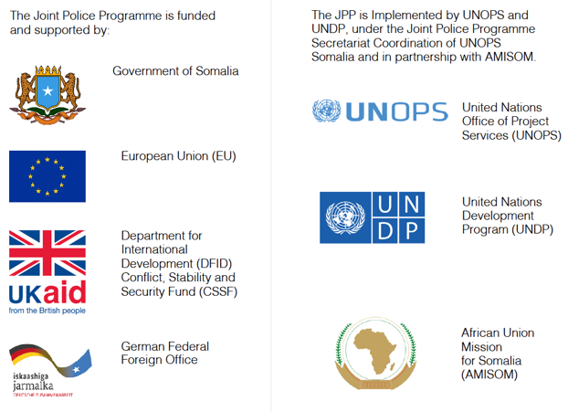

xxxxxxxxxxxxx

Table of contents

Table of contents 3
1. Background 4
2. JPP Theory of Change 5
3. Strategic Activities of the Secretariat 6
4. Major Risks / Mitigation Strategies 7
5. Lessons Learned & Good Practice 8
6. Value for Money 9
7. Programme Status – FGS / Banadir. 10
8. Programme Status – Galmudug 13
9. Programme Status – Hirshabelle 15
10. Programme Status – Jubaland 18
11. Programme Status – Puntland 19
12. Programme Status – South West State 22
13. JPP Executive Board Decisions (September 6th, 2021) 24

Background
Name of Lead Organization | UNOPS
Programme Title | Joint Police Programme (JPP)
Programme Budget ($US) | USD $56,233,341
Key partner organization(s) | UNDP, AMISOM, UNSOM Police
Targeted locations | Banadir, Jubaland, South West State, HirShabelle, Galmudug, Puntland
Key Outputs | - Output 1: Procurement of non-lethal support equipment to Federal and State police forces  - Output 2: Provision of infrastructure support through rehabilitation and construction of police facilities  - Output 3: Provision of financial support to State and Federal Police forces  - Output 4: Provision of training [basic and specialized] , assisting and advising  - Output 5: Provision of support to legal framework and police development for Somali Police Services  - Output 6: Support to effective oversight and governance of policing  - Output 7: Institutional coordination addresses police development and reform in Somalia  - Output 8: Support to Federal and State Daraawish branches aligned with NPM and the Transition Plan
Project start & end dates | Start:  11th June 2018 |  | End:  31st December 2022
Reporting period | From:  1st July, 2021 |  | To:  30th September, 2021
Project Year / Quarter | Year 3 / Quarter 3
Date report produced | 18th January, 2022
Name/position of primary person who compiled this report | Name:  Kailash Balendran |  | Position:  Monitoring & Evaluation (M&E) Specialist
Name/position of primary person who approved this report | Name:  Eleanor Lenawarungu |  | Position:  Head of JPP
Name/position of contact point for correspondence relating to this report | Name:  Kailash Balendran |  | Position:  M&E Specialist
 | Email: | kailashb@unops.org

JPP Theory of Change

The Joint Police Programme (JPP) aims to improve the security and access to justice for civilian populations in the major population centres and their supply routes. It focuses on creating nascent Federal Member State (FMS) police services capable of delivering basic policing services and supporting progress towards the transition of the Somali Police Force (SPF) into the Somali Federal Police (SFP).
The programme arose as a response to the need for a ‘centre of gravity’ for bilateral donors (UK, EU and Germany) to streamline their funding and to provide more comprehensive, strategically aligned and coordinated support to policing in Somalia. The JPP provides a convening platform that incentivises both Federal and FMS authorities to collectively negotiate, discuss and agree on the approach to delivering against a New Policing Model (NPM) in line with the National Security Architecture. The JPP is Somali-led and guided by four principles to ensure that the policing services are ultimately affordable, acceptable, able and accountable.

Figure 1: JPP Theory of Change (ToC) 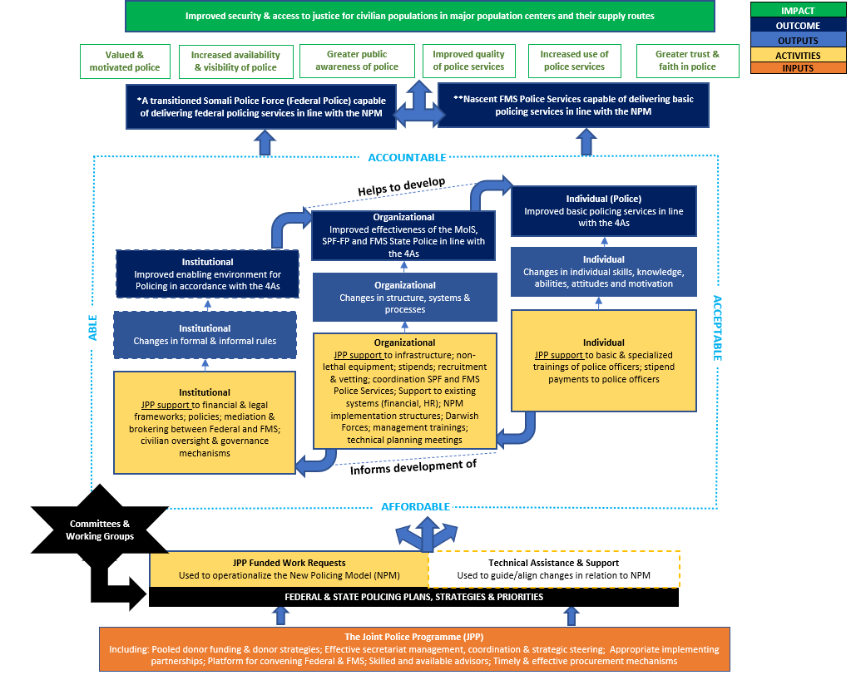
*For further information around the JPP ToC, please refer to the full JPP ToC narrative and visual

Strategic Activities of the Secretariat

Socio-Political/Relationship Management
The Secretariat remained committed to developing direct relations with Federal/regional State Ministers, police commissioners and key political influencers whose opinions impact the JPP activities. The Secretariat has continued to engage and directly consult with stakeholders to get a better understanding of the impact of wider politics, changes in the political environment and its effects on the future planning and prioritisation of both federal government and federal member states. Focus has been on developing deeper understanding of the implication of ongoing delayed elections and developing strategic measures to avoid negative impact on ongoing and planned JPP activities. As the worries of the election continue to dominate the political environment the secretariat continues developing relationships with new appointed ministers and will continue to monitor the situation to plan and minimise the risk of election instability.
In this final quarter JPP secretariat will conclude the state consultation meetings and will finalise a comprehensive report highlighting the needs and strategic priorities of the state focusing on joint accountability, improved communication, and development of mechanisms to enhance better coordination between partners and government counterparts.

Programme Advisory
The JPP Coordination Group continues to provide an effective forum through which to engage implementing partners and partner agencies in order to review progress of delivery of approved work requests, identify opportunities for collaborative support as well as discuss how to ensure timely and effective support to Somali counterparts. During this quarter, the forum has carried out detailed analysis and review of UNDP implementation of activities in Puntland, Hirshabelle and support to Federal Police. The Secretariat has also engaged extensively with the International and National Consultants leading on the development of the National Training Strategy. Compliance and advocacy on international humanitarian law, human rights and child protection continues to feature throughout all of our work. Through regular engagement with UNHRPG and attendance at the UN Country Task Force on Monitoring and Reporting, JPP is strengthening its position to raise awareness of violations, identifying mitigation measures when developing work requests and promoting compliance amongst Somali counterparts. At the request of donors we are developing mechanisms by which to ensure closer monitoring of violations reported through Third Party Monitors ‘flash reports’ and other sources.
In preparation for the final quarter of this year, the Secretariat is preparing to engage with the Federal and Member State police to review delivery against all work request activities, utilisation of budget and preparations for final year of programme delivery. These presentations and discussions will be hosted through the JPP Strategic Planning meetings.

Monitoring & Evaluation
The Secretariat has continued to develop the Management Response to the Mid Term Review (MTR), identifying twenty priority actions and defining a series of activities to ensure delivery within the next six months. In order to monitor progress against these prioritized actions, the Secretariat has developed a Monday.com board with these key actions and sub-actions, this will be shared with broader JPP stakeholders. The Secretariat has also gone through an extensive consultation exercise with Federal and FMS stakeholders around the JPP M&E Rubric. As a result of this process, the Rubric has now been formally endorsed by Puntland, Jubaland, SWS and Galmudug, with formal endorsements pending for HirShabelle and FGS. The Rubric assessment will be initiated in 2022 with a pilot in one FMS and thereafter rolled out across the remaining FMS and Federal level. Responding to recommendations from the JPP MTR and evolving programme needs, the Secretariat has developed an updated approach to JPP Third Party Monitoring (TPM). This approach places a greater focus on the contextual understanding (especially conflict dynamics), more systematic monitoring of implementing partner activities and emphasis on results monitoring. These changes are anticipated to take effect from January 2022.
In the final quarter of 2021, the Secretariat will initiate implementation of the JPP MTR prioritized actions. The Secretariat will work with the TPM provider to plan and design the pilot assessment for the Rubric, and simultaneously work with the TPM to adapt the approach for 2022.

Finance & Budgeting
Total funds received: US$ 41,347,506 which includes interest earned (US$ 65,476) and a running cash balance of US$11,684,692. Current commitments US$3,947,418. It is expected after the moratorium placed under the FGS is lifted, JPP activity implementation will accelerate. Over 86% of the funds contributed by donors are used for implementation of JPP outputs and the TPM. The remaining 14% budgeted for personnel, operations and indirect cost. The overall burn rate as at Q3-2021 was 52.63%, and Activity Implementation (i.e JPP outputs) at approximately 51%. Given the Programme is at 71% expired time, the JPP needs to fast track activity implementation to the level of time expired. The programme total budget is $56,233,341. In October 2021 an extra US$ 206,688 was received from UKFCDO to be included in Q4-2021 reporting. GFFO has also expressed interest to increase the fund with Euro 2,000,000 and an anticipated budget revision is expected in Q4-2021. Please refer to the Q3 Financial Progress and Narrative Report for further details.

Major Risks / Mitigation Strategies
Table 1: Q3 Major Risks and Mitigation Strategies
Risk | Impact | Response
Infrastructure
Security situation in Somalia and Federal Member States of Somalia restricts movement of JPP infra team and contractors. | High | Project team to monitor security situation and work closely with FSA, UNDSS, CTG security
COVID19 impacts movement of the project team may get restricted, and the implementation of the JPP infrastructure projects and site assessment may get delayed. | Medium to High | JPP infra team will monitor closely COVID 19 situation in Somalia, update work project plans and request the extension of time for the project implementation, if such need arises.
On hold projects by JPP EB and DNP Period. These on hold projects may have no, or shorter DNP after substantial completion, as the JPP end date is 31 Dec 2022, and the delay will have financial implications for personnel and operation. | High | Inform JPP secretariat and seek their support to start implementation of the on hold projects.
Intent of the Somali authorities to extend their influence in the procurement processes causing delay in project implementation | Medium to High | UNOPS procurement and JPP team to work with Somali counterparts and explain the rules and regulations of the UNOPS procurement processes
Stipends
As Amal bank closed our beneficiaries’ bank accounts without prior notice or justification, this may cause further delays in getting alternate bank account details from Jowhar . | Medium to High | Regular follow up with the office of the police commissioner and get the support from the JPP secretariat to escalate the matter.
The inability of third party service provider Bank to perform the bank transfers due to further COVID-19. | Medium to High | Continuous communication with the money transfer bank and also tracking the performance of the bank.
Breakdown in banking system due to COVID19 impact. | Medium to High | Continued monitoring of the performance of the money transfer bank and discussions on contingency planning, i.e. telephone banking
UNDP
Continued instability in Galmudug and Hirshabelle | High | Delays to activities may be necessary until situation has stabilised
Upcoming elections draw focus of ministries and police leadership | Medium | Close coordination and communication with implementing partners is required to ensure that activities remain a priority during the election period

Lessons Learned & Good Practice

Infrastructure
- For organizing timely visits for undertaking site assessments of the police facilities, the requester (MOIS and the FMS’s MOIS’s) should submit their work requests before pre-EB meetings, to give sufficient time to organize site visits and prepare site assessment reports.
- To expedite the costing for the infrastructure activities and preparation of new WR’s, beneficiaries should have clear a Statement of Requirements for their initiated infrastructure requests.
- To avoid any misunderstanding and variation of the designs after completion of the detail designs, the concept designs for the infrastructure activities should be endorsed by focal points of the MOIS’s.
UNDP
- Leveraging the influence of other related joint programmes, for example in the security sector, has proven beneficial in engaging with local partners.

Value for Money

UNDP – Capacity building, training & community engagement activities
- Relevance: All capacity building/training/community engagement activities remain extremely relevant for improving the capabilities and professionalism of police services in Somalia, and for developing greater engagement and trust between the police and the local communities which they serve. In particular, CWR002:2020: Election Security Trainings is highly relevant to creating a secure environment for the upcoming general elections in Somalia
- Effectiveness: The capacity building workshops conducted for CWR002:2020 and SPF004:2019 achieved their respective intended results. Similarly, PUN005:2019 – Activity 2b was effective in producing updated recruitment guidelines for Puntland police.
- Efficiency: Use of resources to maximise results was achieved through proper planning, including. extensive consultations with partners, regular monitoring of activities, adjusting activities if necessary.
- Economy: Procurement done under UNDP supported activities is mostly around procuring venues for workshops and travel. For this, UNDP works closely with partners to ensure that procurement processes are followed correctly. UNDP also provides financial and operational management training to its partners. UNDP does not process payments without receiving documentation that proper procurement processes were undertaken by the partners.

UNOPS – Infrastructure activities
- Relevance: The outcome/purpose of the completed infrastructure activities during Q3 2021, Conducting Site. Assessments of the six Police Facilities in Puntland FMS, WR ID: PUN001-2021 remain relevant.
- Effectiveness: Soon after JPP EB approved the work request JPP infrastructure has made all required arrangements and has organized site visits to six (6) proposed police facilities.
- Efficiency: In a noticeably brief period of time JPP infrastructure has assigned an assessment engineer to conduct site visits and undertake assessments of the six (6) proposed police training facilities.
- Economy: The most efficient and financially reasonable option, using road transportation, for travelling of the assessment engineer to the six (6) proposed police facilities was applied.

UNOPS – NLS
- Relevance: The WR relevance stayed the same and will still support the outcomes as expected in the relevant Strategic Police Plans of the FGS and FMS’s.
- Effectiveness: Results achieved by UNOPS as anticipated in the approved WRs.
- Efficiency: The NLS team does not measure the utilization of the provided NLS, only ensure the efficiency of the procurement and delivery process in support of the Development Plans.
- Economy: UNOPS Procurement Rules and Regulations are strictly implemented on a fully transparent and competitive process to ensure value for money.

Programme Status – FGS / Banadir.
FGS/Banadir - Key achievements
During the quarter, the following achievements were registered for the FGS/Banadir. These are achievements within approved JPP work-requests, specifically at the activity level. These achievements contribute towards broader outputs, which in turn contribute to broader outcomes within JPP’s overarching Theory of Change (ToC).
ToC Organizational Level: OUTPUT: Changes in structure, systems, & processes OUTCOME: Improved effectiveness of the MoIS, SPF-FP and FMS State Police in line with the 4As
ICT equipment to support implementation of the Asset Management Policy: CWR001:2020 (Activity 2) The remaining ICT Equipment including* servers and printers have been delivered to all locations. The SPF and the five FMS Police Services are committed to strengthening their respective asset management systems to ensure accountability within their policing institutions, to their line-ministries and to the people of Somalia. In January 2020, the Somalia Technical Working Group (STWG) endorsed the asset management policy identifying a basic equipment list to implement the asset policy. As such, this IT equipment will serve to support the implementation of the asset management police with emphasis on the asset register.
*The following IT equipment was provided to the SPF, five FMS Police Services and AMISOM; Servers with windows server 2016 (8), Desktop computer installed with windows 10 pro (8), Antivirus/firewall (8), Storage devices (8), Inscribers (8), Pattress box (40), Keystone Jack (80), CAT 6 cables (8), RJ45 Ends (200 pieces/package - 8), Patch Panel 16 port (8), Face Plate (40), Wireless Routers (8), Switches (8), System Rack (8), Uninterruptible Power Supply (8), Printer (8), Cartridge/Toner (8), Laptop Computer (1).

ToC Individual Level: OUTPUT: Changes in individual skills, knowledge, abilities, attitudes and motivation OUTCOME: Improved basic policing services in line with the 4As
Improving election security management (Training of Trainers): CWR002:2020 (Activity 7) - The Training of Trainers (ToT) election security workshops, facilitated by AMISOM police trainers enabled the training of police officers to act as in-house trainers for their respective forces on the policing challenges related to elections. In total, 71 police officers (15 female) across the FMS and FGS participated in the workshop from 3rd to 31st August. The course provided an explanation of the need for free and fair elections and offered comprehensive guidance on election security management, including police responsibilities, threat assessments, gender-specific security considerations, and human rights principles. The training provided the participants with the knowledge and tools to build the capacity of their fellow officers in election security through further in-house training

Improving election security management (Station Commanders): CWR002:2020 (Activity 6) - The series of workshops for Station Commanders; facilitated by AMISOM police trainers, provided the regional police leadership with training to further develop their capacity to manage the security environment during elections. During the quarter, these trainings were conducted in Puntland, South West State and Jubaland, with a total of 24 participants (0 female). Training in Galmudug was delayed due to insecurity, whilst the training in HirShabelle and the FGS is planned for Q4. The course included specific training on improving communication, team building and community interaction, as well as the responsibilities and ethical standards required of police commanders. The training contributed to building the capacity of the participants to provide management of the policing role during elections.

Enhancing management of election-related protests and civil disorder (Police Officers): CWR002:2020 (Activity 4) - The series of Public Order Management workshops, facilitated by AMISOM police trainers provided capacity building training to state police officers on operating during civil disorder. During the quarter, these trainings were conducted in Puntland, HirShabelle, South West State and Jubaland, with a total of 224 officers (30 female) participating. Training in Galmudug was delayed due to insecurity, whilst the training for the FGS is planned for Q4. The courses focused on principles and techniques for handling protests and disorder, including crowd control, maintaining human rights standards and COVID-19 precautions. The capacity of the state police forces to handle election-related protests and civil disorder has been enhanced through these training courses.

Enhancing police leadership: SPF004:2019 ( Activity 4a) – The ToT leadership package workshop was for 25 police officers from the Somalia Police Force: who will eventually form the core staff of a Police Leadership and Management Training Centre. The ToT workshop provided leadership and management capacity building training for the participants, encompassing topics including police accountability, communication, HR management, community policing, financial management and legal frameworks for policing. In total, 25 participants (1 female) were trained as planned. The training enabled the development of a group of officers capable of conducting future trainings and providing knowledge transfer to their colleagues. This included participants developing individual plans to identify areas where they could immediately begin to implement leadership and management practices in their respective teams/departments.

FGS/Banadir - Delivery challenges and issues
Infrastructure
- SPF001:2021 (Activity 1) - Armo Police Training Academy (Refurb). The activity is currently on hold pending the publication of the National Training Strategy (UNDP Activity) Mitigation Actions: Monitor progress in publication of the strategy and remain on standby to commence work.
- COMMON: Considering that the JPP will end in December 2022, the programme may not have 12 months of Defect Notification Period (DNP) for select infrastructure projects. Mitigation Action. A letter with proposed options for managing the DNP has been shared with donors, however, a preferred option has not been decided. JPP secretariat to seek donors approval for one of the proposed options for managing DNP. UNOPS will accelerate the design and design review process to avoid any further delays.
- SPF-008-2020 (Activity 1) – Construction of CID facilities. The JPP EB has not yet given go ahead with the project implementation for the construction of the CID facilities. The estimated duration for the completion is about 18 months, including: design, design review and the procurement in addition to 12 months for physical construction. If commencement of implementation is further delayed, the project may not be completed by the end of the programme .Mitigation Action. JPP Secretariat to seek clarification from JPP EB for the way forward.
UNDP
- CWR002:2020 (Activity 4 and 6) - Public Order Management Course Station Commanders Course on Election Security. Serious and ongoing instability has resulted in the postponement of training in Galmudug. Mitigation Action: Due to the security risks, it is necessary to postpone Galmudug-specific training, including the election security training and the continuing work towards the Human Rights training Continue to assess security situation to determine if resumption of implementation is possible.
NLS
- SPF002:2020 (Activity 3) - Repairing the existing digital communications equipment: This work request does not include maintenance costs nor the costs of transporting the equipment to the new NTAC. No further movement due to the high cost of the procurement and installation. Matter has been referred back to the SPF for clarity with no resolve to date. Mitigation Action: Further communications with SPF to obtain their direction on the way forward.

FGS/Banadir - Prioritised actions for the next quarter

Infrastructure
- SPF001:2021 (Activity 1) - Armo Police Training Academy (Refurb).The activity is currently on hold pending the publication of the National Training Strategy (UNDP Activity). Once published complete design and the design review for the refurbishment.
- SPF-008-2020 (Activity 1)- Construction of CID facilities. If JPP EB lifts moratorium on Federal WR's then complete design and design review.
UNDP
- CWR002:2020 (Activity 7) - ToT Election Security. Completion of outstanding election security trainings. Continue to assess the security situation to determine if resumption of implementation is possible.
- SPF002:2021 - Recruit two consultants to draft the Somali Police Training Strategy. The international consultants onboarding has been completed and the national consultant is awaiting security clearance from NISA. The consultants will be able to commence with the development of the Somali police training strategy in Q3.
NLS
- SPF002:2020 (Activity 3) - Repairing the existing digital communications equipment. Further communications with the SPF.
- SPF001-2019(activity 2a)- SPF Workshop equipment. UNOPS is following up with the supplier to receive the final shipment of the SPF workshop equipment in Mogadishu. This shipment will reach Mogadishu seaport on 30 October 2021.
- SPF002:2020 (Activity 2a) - SPF workshop maintenance contract. UNOPS will arrange a meeting with SPF to discuss the details of the maintenance required so that a TOR could be developed.
- SPF001:2019(Activity 1) - SPF workshop recovery truck. UNOPS has completed the specifications for the recovery truck and procurement process has been initiated.

FGS/Banadir - Budget summary

Table 2: Q3 FGS/Banadir Budget Summary
Budget Summary by Location
Output | Total Approved WR Budget (USD) | Total disbursed + Committed | Budget balance against approved WRs | Burn rate against Approved WRs
Infrastructure | 4,166,738 | 1,247,067 | 2,919,671 | 29.93%
Non-Lethal | 2,896,669 | 1,339,648 | 1,557,021 | 46.25%
Stipends | 0 | 0 | 0 | 0.00%
UNDP | 619,401 | 365,445 | 253,956 | 59.00%
Totals | 7,682,808 | 2,952,160 | 4,730,648 | 38.43%

Programme Status – Galmudug

Galmudug - Key achievements
During the quarter, the following achievements were registered in Galmudug. These are achievements within approved JPP work-requests, specifically at the activity level. These achievements contribute towards broader outputs, which in turn contribute to broader outcomes within JPP’s overarching Theory of Change (ToC).
ToC Individual Level: OUTPUT: Changes in individual skills, knowledge, abilities, attitudes and motivation OUTCOME: Improved basic policing services in line with the 4As
Continued stipend payments to ensure basic compensation of police officers in Galkayo (GAK001:2018, Activity 1a): On average 164 (10: F) Police Officers from Batch 1,2 received USD$100 for each of the three months in quarter 3, 2021. This amounted to $49,200 in stipend payments.
A first round of verification in all locations was also completed in early August and the second round of verification is in progress . The project team paid special attention to the officers not verified and found the deserted officers and removed them from the stipend payment list in consultation with the respective police commissioners.

Galmudug - Delivery challenges and issues
Infrastructure
- GAL001/2018 (Activity 6)-Construction of two police stations. Late approval of amended WR’s for construction of Afmadow and Galkayo Central PS, as a result the facilities may not go through a full cycle of DNP, certain defects might be identified after the substantial project completion which will not be rectified by the contractor. Mitigation Action: Seek donors’ approval for the extension of time for the full 12 months DNP.
UNDP
- GAL001:2018 - all UNDP WR activities. Serious and ongoing instability has resulted in the postponement of activities. Mitigation action; Due to the security risks, it is necessary to postpone activities, including the election security training and the continuing work towards the Human Rights training.
NLS
- GAL001:2020 (Activity 1)- Procurement of six patrol vehicles. Galmudug vehicles security clearance required by CID Dubai at Jebel Ali seaport. CID Dubai stopped releasing the six Land Cruiser 79 series vehicles procured for Galmudug. They require security clearance of these vehicles to ensure they will not be used for military purposes. Mitigation Action: A meeting will be held with UNWEBBUY to discuss the issue and obtain justifications for this unexpected additional cost. The issuance of tax exemption certificate for these 6 vehicles has taken very long that is beyond UNOPS’s control. UNOPS has followed up with Puntland for issuance of the tax exemption certificate with no result yet. The vehicles arrived at Bosaso seaport on 15 July 2021.

Galmudug - Prioritised actions for the next quarter
Infrastructure
- GAL001/2018 (Activity 6)-Construction of two police stations. Monitor construction process.
Stipends
- GAK001:2018 (Activity 1a) – Galkayo stipends. Continue to do the physical biometric verifications and establish the status of all officers not verified. Continue to work hand in hand with respective police commissioners and establish the status of all officers not verified.
UNDP
- GAL001:2018 all UNDP WR activities. Continue to assess the security situation to determine if resumption of implementation is possible.
NLS
- GAL001:2020 (Activity 1)- Procurement of six patrol vehicles. Meeting will be held with UNWEBBUY to discuss the issue and obtain justifications for this unexpected additional cost.

Galmudug - Budget summary
Table 3: Q3 Galmudug Budget Summary
Budget Summary by Location
Output | Total Approved WR Budget | Total disbursed + Committed | Budget balance against approved WRs | Burn rate against Approved WRs
Infrastructure | 682,819 | 665,340 | 17,479 | 97.44%
Non-Lethal | 1,570,434 | 564,273 | 1,006,161 | 35.93%
Stipends | 476,856 | 393,658 | 83,198 | 82.55%
UNDP | 1,312,875 | 470,994 | 841,881 | 35.88%
Totals | 4,042,984 | 2,094,265 | 1,948,719 | 51.80%

Programme Status – Hirshabelle

HirShabelle - Key achievements
During the quarter, the following achievements were registered in HirShabelle. These are achievements within approved JPP work-requests, specifically at the activity level. These achievements contribute towards broader outputs, which in turn contribute to broader outcomes within JPP’s overarching Theory of Change (ToC).
ToC Organizational Level: OUTPUT: Changes in structure, systems, & processes OUTCOME: Improved effectiveness of the MoIS, SPF-FP and FMS State Police in line with the 4As
Community-based assessments to improve understanding of community policing situation and needs (HIR001:2020, Activity 2b): UNDP JPP team conducted a mission to Hirshabelle to carry out community-based assessments in Jowhar and Beletweyne: These assessments provided an overview of the security, crime and police status in the two towns, progress since the completion of community policing workshops, challenges faced by the community policing committees and recommendations for next steps. The assessments provide insights and expand our understanding of the policing situation in Hirshabelle and so will help to guide ongoing and future programming in the state.
ICT equipment to support establishment & functioning of key departments (HIR001:2020, Activity 1): The ICT Equipment* including servers and printers have been delivered to Beletweyne for 7 departments and the LAN installation has been completed. This IT equipment will enable Hirshabelle State to establish main police HQ branches including Human Resource Management, Discipline, Administration, Finance, Training, Transport, Communication, Estate & Projects and Medical. The IT equipment will help establish proper functioning administrative and operational police structure across the State and ultimately support improvement of policing services.
*The following equipment were provided and their quantities; server (4), printer (9), desktop computer (4), laptop computer (9), antivirus/firewall (13), storage devices (5), inscribers (4), electric extension card (20), keystone jack (40), CAT 6 cables (2 boxes), RJ45 ends (1 Package (200PCS), Patch Panel (4), Face Plate (20), Wireless Routers (9), Switches (4), System Rack (4), Uninterruptible power Supply (4).
Delivery of two trucks to Jowhar (HIR002:2019, Activity 3): Delivery of two trucks to Jowhar: The two MAN trucks were handed over to Hirshabelle Minister of Security on 4th August 2021.
ToC Individual Level: OUTPUT: Changes in individual skills, knowledge, abilities, attitudes and motivation OUTCOME: Improved basic policing services in line with the 4As
Continued stipend payments to ensure basic compensation of police officers (HIR002:2018, Activity 2): In July, 553 officers (F=38) received USD$100, this amounted to USD$110,600 in disbursements. The August & September stipends process is ongoing through alternate bank accounts, the number of officers will be confirmed once the payment process is completed.

HirShabelle - Delivery challenges and issues
Infrastructure
- HIR004:2019, Activity 1 - Jowhar Police Training Facility (Upgrade).The project scope is partially completed: The remaining not completed project scope from phase 1 is combined with the scope of the second phase and a consolidated design package was completed. The JPP EB has not approved the amended WR for the consolidated design package. Mitigation Action: JPP Secretariat to seek clarification from JPP EB for the way forward, to cancel the WR or to approve the amended WR.
- HIR002:2019, Activity 1 - Upgrading the Jowhar Police Training Facility. Funding sources come from two sources (EU Bilateral Project & JPP). Contract could not be awarded due to the EU Bilateral Project not being able to confirm approval of the funds, therefore the WR was amended, requesting additional funds for the project implementation, and it was presented to the JPP EB for review and approval. JPP EB has not approved the amended WR. Mitigation Action: JPP Secretariat to seek clarification from JPP EB for the way forward, to cancel the WR or to approve the amended WR.
- HIR002:2019, Activity 2 - Construction of Police Station in Bulle Burte. Due to recent worsening Security situation in Bulle Burte region, contractor was not able to deliver to the site some required finishing materials, and therefore the project completion is delayed. Mitigation Action: Update the execution work plan and extend duration for the project completion. Do analyses for possible financial implication and request contractor to provide an updated work plan for project completion.
UNDP
- HIR001:2020, Activity 2a - Four Community Police Dialogue and Cooperation forums: Difficulties communicating with ministry, partly due to prioritising focus on the deteriorating security situation. Mitigation Action: Continuing to foster closer communication, both through the UNDP JPP and also through leveraging influence of other programmes and agencies.
NLS
- HIR004:2019, Activity 4 - Communication equipment: sets one VHF Radio and, Walk talk (200 pcs) for Hirshabelle State Police. Hand-held radios only work with line of sight, meaning they normally need a network of repeater towers to function. UNOPS has not had sufficient time to schedule a site visit for a communications provider to assess the repeater requirements, and therefore, cannot provide a costing. Discussions were held with the FGS Police, Col Kaafi, and no solution could be reached on proceeding with the procurement as the items to be procured needs to be supported by an elaborate radio communications network at different locations at a considerable cost. The FGS needs to provide further guidance on their perceived outcomes for this work request. Mitigation Action: FGS to decide on the way forward, whether an additional work request will be submitted to support the requested hand radios.
- HIR001:2020, Activity 1- Establish main police HQ branches. Delays were experienced in the procurement of the ICT items due to challenges in the technical specifications as provided by AMISOM. Further delays on delivery were experienced for Jowhar due to flooding in the area. Mitigation Action: Technical specifications for the procurement were amended to fit local circumstances. Direct communications with the FGS Police to resolve delivery challenges.
Hirshabelle - Prioritised actions for the next quarter

Infrastructure
- HIR001:2020 (Activity 2a): Four Community Police Dialogue and Cooperation forums - Proceed with contract award, if JPP EB approves amended WR.
- HIR-002-2019 V001 (Activity 2):Construction of Police Station in Bulle Burte - Contractor to deliver needed finishing materials, complete and handover the completed project to the beneficiary.
- HIR002:2019 (Activity 1): Upgrading the Jowhar Police Training Facility for the commencement of the second batch of two hundred (200) police recruits training - Proceed with contract award, if JPP EB approves amended WR.
Stipends
- HIR002:2018 (Activity 2): Stipend Payments - Continue to do the physical biometric verifications and establish the status of all officers not verified. Continue to work hand in hand with respective police commissioners and establish the status of all officers not verified.
UNDP
- HIR001:2020 (Activity 2a): Four Community Police Dialogue and Cooperation forums - In coordination with the MOS and police leadership, resolve the location of the remaining community workshop(s) and conduct.
NLS
- HIR004:2019 (Activity 4): Communication equipment, sets one VHF Radio and, Walk talk (200 pcs) for Hirshabelle State Police - Further discussions with the FGS.

Hirshabelle - Budget summary
Table 4: Q3 Hirshabelle Budget Summary
Budget Summary by Location
Output | Total Approved WR Budget | Total disbursed + Committed | Budget balance against approved WRs | Burn rate against Approved WRs
Infrastructure | 1,117,298 | 585,222 | 532,076 | 52.38%
Non-Lethal | 1,967,421 | 1,751,342 | 216,079 | 89.02%
Stipends | 2,038,796 | 825,318 | 1,213,478 | 40.48%
UNDP | 165,902 | 85,890 | 80,012 | 51.77%
Totals | 5,289,417 | 3,247,772 | 2,041,645 | 61.40%

Programme Status – Jubaland

Jubaland - Key achievements
During the quarter, the following achievements were registered in Jubaland. These are achievements within approved JPP work-requests, specifically at the activity level. These achievements contribute towards broader outputs, which in turn contribute to broader outcomes within JPP’s overarching Theory of Change (ToC).
ToC Organizational Level: OUTPUT: Changes in structure, systems, & processes --> OUTCOME: Improved effectiveness of the MoIS, SPF-FP and FMS State Police in line with the 4As
Continued stipend payments to ensure basic compensation of police officers (JUB005:2018, Activity 2): On average 513* (F = 49) police officers from Batches 1,2,3 received USD$80 for each of the three months in Q2, 2021. This amounted to USD$123,120 in stipend payments. Jubaland also made their 50% contribution to salary payments for April, May and June.

Jubaland - Delivery challenges and issues
Infrastructure
- JUB005:2018 (Activity 6) - Kismayo Central PS & Gedo (Luuq) PS Construction of PS in Afmadow. Eventually JPP EB has approved an amended work request to redirect remaining unspent approved funds and approved additional funds for construction of PS in Afmadow. However, an option for managing the Defect Notification Period (DNP), after substantial completion is not defined. Without a defined option for managing the DNP, UNOPS cannot move forward with the procurement process. Mitigation Action: A letter with proposed options for managing the DNP has been shared with donors. However, a preferred option has yet to be decided by donors. JPP secretariat to seek donors approval for one of the proposed options for managing DNP. Accelerate the design and design review process to avoid any further delays.
Stipends
- JUB005:2018 (Activity 2) - Harmonized monthly stipend payments of 80 USD after the FMS paid salaries of 50 USD. Salary payments are not always up to date which delays the stipend payments. Mitigation Action. Regular communications with the FMS.
- JUB005:2018 (Activity 3) - Continued stipend payment of the existing police officers for one year: As Amal bank closed our beneficiaries’ bank accounts without prior notice or justification caused delays in paying the stipends in time. Mitigation Action. Collect alternate bank account details of beneficiaries.

Jubaland - Prioritised actions for the next quarter
Infrastructure
- JUB005:2018 (Activity 6) - Kismayo Central PS & Gedo (Luuq) PS Construction of PS in Afmadow. Complete design and design review process for construction of the Afmadow PS.
Stipends
- JUB005:2018 (Activity 2, 3) On a monthly basis communicate with the FMS ensuring salary payments are taking place on time. Maintain a comprehensive database of beneficiaries with primary and secondary bank account details and mobile phone numbers. Continue to do the physical biometric verifications and establish the status of all officers not verified. Continue to work hand in hand with respective police commissioners and establish the status of all officers not verified.
NLS
- JUB005:2018 (Activity 1b) Jubaland Training of 600 Recruits The amended work request for training of 600 police officers in Kismayo, Jubaland was approved by JPP Executive Board on 06 September 2021. The procurement of all items including vetting material (medicine) , catering services, bedding material, stationery, toiletries, transportation etc. have been initiated and will be continued in Q4.

Jubaland - Budget summary
Table 5: Q3 Jubaland Budget Summary
Budget Summary by Location
Output | Total Approved WR Budget | Total disbursed + Committed | Budget balance against approved WRs | Burn rate against Approved WRs
Infrastructure | 1,330,974 | 969,794 | 361,181 | 72.86%
Non-Lethal | 2,394,073 | 840,668 | 1,553,405 | 35.11%
Stipends | 2,861,895 | 2,034,836 | 827,059 | 71.10%
UNDP | 91,024 | 24,875 | 66,149 | 27.33%
Totals | 6,677,966 | 3,870,172 | 2,807,794 | 57.95%

Programme Status – Puntland

Puntland - Key achievements
During the quarter, the following achievements were registered in Puntland. These are achievements within approved JPP work-requests, specifically, at the activity level. These achievements contribute towards broader outputs, which in turn contribute to broader outcomes within JPP’s overarching Theory of Change (ToC).
ToC Organizational Level: OUTPUT: Changes in structure, systems, & processes OUTCOME: Improved effectiveness of the MoIS, SPF-FP and FMS State Police in line with the 4As
Strengthening recruitment procedures & processes PUN005:2019 (Activity 2b): Recruitment guidelines for Puntland police developed, reviewed and endorsed. The new recruitment guidelines will replace the previous outdated guidelines, providing updated guidance for the standardisation of selection criteria, medical vetting and recruitment procedure of police officers in Puntland. This guidance includes provisions for non-discrimination based on race, clan, gender or location, and for the time and cost efficiency of the process. The update guidelines will support the effectiveness and equality of police recruitment, thereby contributing to enhanced professionalism of the Puntland police.
Developing police identification systems PUN009:2018 (Activity 1): This includes the hardware, software, and training of Puntland police officers to perform these functions (biometric registration and issuance of ID cards). The ID card printer was airlifted to Puntland on 08 August 2021. The State is still busy obtaining the tax exemption certificate that has not materialized yet. After the customs clearance of the ID card printer is finalized, UNOPS will install the printer.
ToC Individual Level: OUTPUT: Changes in individual skills, knowledge, abilities, attitudes and motivation OUTCOME: Improved basic policing services in line with the 4As
Continued stipend payments to ensure basic compensation of police officers in Galkayo (GAK001:2018, Activity 1a): On average 164 (10: F) Police Officers from Batch 1,2 received USD$100 for each of the three months in quarter 3, 2021. This amounted to $49,200 in stipend payments.
A first round of verification in all locations was also completed in early August and the second round of verification is in progress . The project team paid special attention to the officers not verified and found the deserted officers and removed them from the stipend payment list in consultation with the respective police commissioners.

Puntland - Delivery challenges and issues
Infrastructure
- PUN005:2019 (Activity 1) - Construction of four (4) new police stations and renovation of one (1) old police stations. Puntland MOIS submitted land ownership documents for the allocated sites with delay. The Puntland MOIS requested additional evaluation criteria to be added to the tender some of the proposed criteria were not in conjunction with the UNOPS procurement manual. The Puntland MOIS did not want refurbishment of the existing PS’s on Galkayo, instead they requested construction of new PS be built. JPP EB has approved amended WR on 6 Sept 2021 for construction of Central PS in Galkayo with UNOPS as implementing partner. Option for managing the Defect Notification Period (DNP), after substantial completion of the Galkayo Central Police Station is not defined, without a defined option for managing the DNP UNOPS cannot move forward to the procurement process. Mitigation Action. A letter with proposed options for managing the DNP has been shared with donors. However, a preferred option has not been provided by the donors. JPP secretariat to seek donors approval for one of the proposed options for managing DNP of the Galkayo Central PS. Accelerate the design and design review process of the Galkayo Central PS.
- PUN001-2021(Activity 1)- Conducting Site Assessments for New Police Station: Puntland MOIS still yet to define Statement of Requirements (SoRs) for the construction of new PSs in the assessed sites. Mitigation Action: Request Puntland MOIS to expedite the finalization of the statement of the requirements for the new police stations in 6 assessed locations.
UNDP
- PUN005:2019 - all UNDP WR activities: Lack of required financial documentation from implementing partners has delayed payments. Mitigation Action: Deepening coordination to facilitate timely preparation of required documentation Confirmation of realistic dates for key activities, including trainings at Armo.

Puntland - Prioritised actions for the next quarter
Infrastructure
- PUN005:2019 (Activity 1) - Construction of four (4) new police stations and renovation of one (1) old police stations. Monitor construction process for construction of 4 P'Ss. Complete design, design review and procurement process for construction of Galkayo Central PS.
- PUN001-2021(Activity 1) - Conducting Site Assessments for New Police Station. Finalize assessment reports, scope of the work, associated construction costs estimates and the concept designs for the proposed new PS’s.
Stipends
- GAK001:2018 (Activity 1a) – Galkayo stipends. Continue to do the physical biometric verifications and establish the status of all officers not verified. Continue to work hand in hand with respective police commissioners and establish the status of all officers not verified.
UNDP
- PUN005:2019 - all UNDP WR activities - Confirmation of realistic dates for key activities, including training at Armo.
NLS
- PUN009:2018 (Activity 1)- Provision of Internet for asset management. UNOPS will process the procurement of the internet of Puntland as Hurmuud does not have a presence in Puntland. The procurement of this service is under process.

Puntland - Budget summary
Table 6: Q3 Puntland Budget Summary
Budget Summary by Location
Output | Total Approved WR Budget | Total disbursed + Committed | Budget balance against approved WRs | Burn rate against Approved WRs
Infrastructure | 2,099,019 | 1,267,636 | 831,383 | 60.39%
Non-Lethal | 908,407 | 958,934 | -50,527 | 105.56%
Stipends | 476,856 | 393,658 | 83,198 | 82.55%
UNDP | 1,666,691 | 444,165 | 1,222,526 | 26.65%
Totals | 5,150,973 | 3,064,393 | 2,086,580 | 59.49%

Programme Status – South West State

South West State - Key achievements
During the quarter, the following achievements were registered for the FGS. These are achievements within approved JPP work-requests, specifically, activity level achievements. These achievements contribute towards broader outputs, which in turn contribute to broader outcomes within JPP’s overarching Theory of Change (ToC).
ToC Individual Level: OUTPUT: Changes in individual skills, knowledge, abilities, attitudes and motivation OUTCOME: Improved basic policing services in line with the 4As
Continued stipend payments to ensure basic compensation of police officers (SWS003:2018, SWS001:2019): On average 718 (F = 61) police officers from Batches 1,2,3 and 4 received USD$100 for each of the three months in Q3, 2021. This amounted to USD$215,500 in stipend payments.
A first round of verification in all locations completed in early August and the second round of verification is in progress. The project team paid special attention to the officers not verified and found the deserted officers and removed them from the stipend payment list in consultation with the respective police commissioners.

South West State - Delivery challenges and issues
NLS
- SWS001:2019 (Activity 1b) - Recruits will be issued with 2 sets of uniform. Training cost include catering, training material, and toiletries. Uniforms can only be procured and delivered after the completion of the Basic Police recruit Training. There is a delay in JPP EB approval for any further training until the Somali Government can provide assurances that newly trained officers will be issued with firearms and deployed. Discussions on the delivery, sizes, timelines, storage and responsibility after delivery were held with the FMS, with no resolve to date. Mitigation Action. Further discussions on the matter with the FMS to get their resolve of challenges posed.

South West State - Prioritised actions for the next quarter
Stipends
- SWS003:2018 (Activity 2) – Stipend Payments SWS001:2019 (Activity 2) – Stipend Payments to Lower Shabelle recruits: Continue to do the physical biometric verifications and establish the status of all officers not verified. Continue to work hand in hand with respective police commissioners and establish the status of all officers not verified.
NLS
- SWS001:2019 (Activity 1b) - Recruits will be issued with 2 sets of uniform. Further discussions on the matter with the FMS to get their resolve of challenges posed.

South West State - Budget summary
Table 7: Q3 South West State Budget Summary
Budget Summary by Location
Output | Total Approved WR Budget | Total disbursed + Committed | Budget balance against approved WRs | Burn rate against Approved WRs
Infrastructure | 516,818 | 517,708 | -890 | 100.17%
Non-Lethal | 2,127,768 | 1,809,147 | 318,621 | 85.03%
Stipends | 5,023,915 | 3,260,542 | 1,763,373 | 64.90%
UNDP | 91,024 | 24,845 | 66,179 | 27.29%
Totals | 7,759,525 | 5,612,243 | 2,147,282 | 72.33%

JPP Executive Board Decisions (September 6th, 2021)
Table 7, below, highlights the key decisions from the Q3 Executive Board held on September 6th, 2021.
Table 7: JPP Executive Board Decisions (September, 2021)
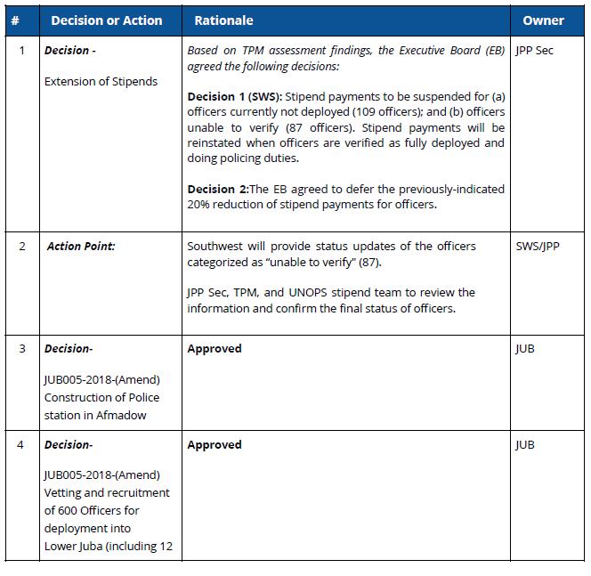

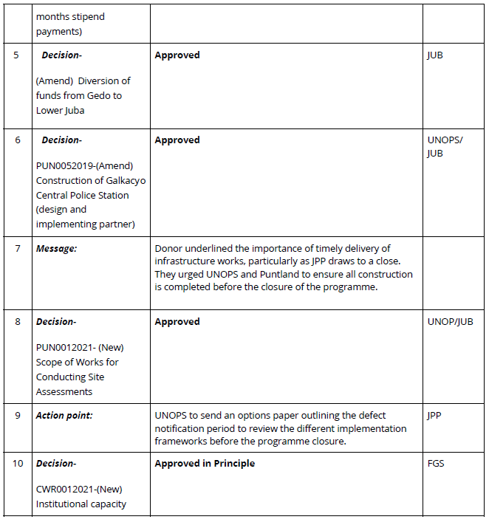

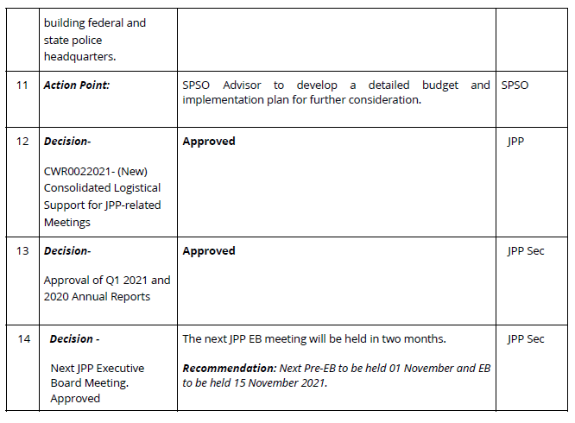

Planned 200 – the reduced number of individuals receiving stipends according to plan are due to desertion, death, individuals on leave, at training, sick or wounded.
Planned 570 – the reduced number of individuals receiving stipends according to plan are due to desertion, death, individuals on leave, at training, sick or wounded.
Planned 200 – the reduced number of individuals receiving stipends according to plan are due to desertion, death, individuals on leave, at training, sick or wounded.
Planned 880 – the reduced number of individuals receiving stipends according to plan are due to desertion, death, individuals on leave, at training, sick or wounded.

