Joint Police Programme
Quarterly Report: Q4 Oct-Dec, 2021

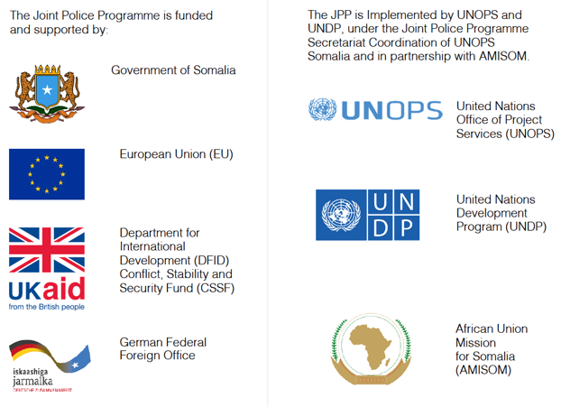

xxxxxxxxxxxxx

Table of contents

Table of contents 3
1. Background 4
2. JPP Theory of Change 5
3. Strategic Activities of the Secretariat 6
4. Major Risks / Mitigation Strategies 7
5. Lessons Learned & Good Practice 9
6. Value for Money 9
7. Programme Status – Consolidated Work Requests (CWR) 10
8. Programme Status – FGS / Banadir 12
9. Programme Status – Galmudug 13
10. Programme Status – HirShabelle 15
11. Programme Status – Jubaland 17
12. Programme Status – Puntland 18
13. Programme Status – South West State 21
14. JPP Executive Board Decisions 23

Background
Name of Lead Organization | UNOPS
Programme Title | Joint Police Programme (JPP)
Programme Budget ($US) | USD $56,233,341
Key partner organization(s) | UNDP, AMISOM, UNSOM Police
Targeted locations | Banadir, Jubaland, South West State, HirShabelle, Galmudug, Puntland
Key Outputs | - Output 1: Procurement of non-lethal support equipment to Federal and State police forces  - Output 2: Provision of infrastructure support through rehabilitation and construction of police facilities  - Output 3: Provision of financial support to State and Federal Police forces  - Output 4: Provision of training [basic and specialized] , assisting and advising  - Output 5: Provision of support to legal framework and police development for Somali Police Services  - Output 6: Support to effective oversight and governance of policing  - Output 7: Institutional coordination addresses police development and reform in Somalia  - Output 8: Support to Federal and State Daraawish branches aligned with NPM and the Transition Plan
Project start & end dates | Start:  11th June 2018 |  | End:  31st December 2022
Reporting period | From:  1st October, 2021 |  | To:  31st December, 2021
Project Year / Quarter | Year 3 / Quarter 3
Date report produced | XXX
Name/position of primary person who compiled this report | Name:  Kailash Balendran |  | Position:  Monitoring & Evaluation (M&E) Specialist
Name/position of primary person who approved this report | Name:  Katrina Aitken-Laird |  | Position:  Director of Security & Justice
Name/position of contact point for correspondence relating to this report | Name:  Kailash Balendran |  | Position:  M&E Specialist
 | Email: | kailashb@unops.org

JPP Theory of Change

The Joint Police Programme (JPP) aims to improve the security and access to justice for civilian populations in the major population centres and their supply routes. It focuses on creating nascent Federal Member State (FMS) police services capable of delivering basic policing services and supporting progress towards the transition of the Somali Police Force (SPF) into the Somali Federal Police (SFP).
The programme arose as a response to the need for a ‘centre of gravity’ for bilateral donors (UK, EU and Germany) to streamline their funding and to provide more comprehensive, strategically aligned and coordinated support to policing in Somalia. The JPP provides a convening platform that incentivises both Federal and FMS authorities to collectively negotiate, discuss and agree on the approach to delivering against a New Policing Model (NPM) in line with the National Security Architecture. The JPP is Somali-led and guided by four principles to ensure that the policing services are ultimately affordable, acceptable, able and accountable.

Figure 1: JPP Theory of Change (ToC) 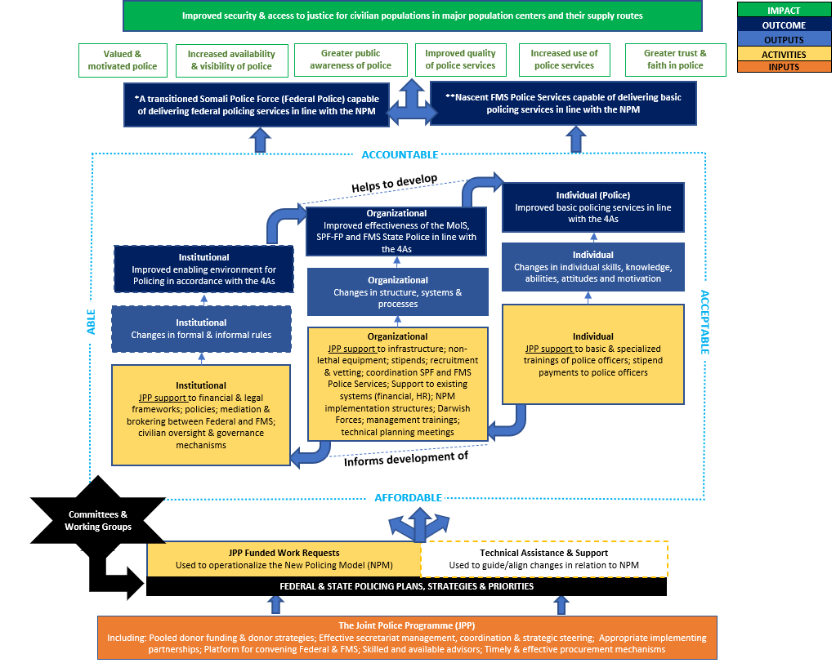
*For further information around the JPP ToC, please refer to the full JPP ToC narrative and visual

Strategic Activities of the Secretariat

Socio-Political/Relationship Management
The JPP Secretariat invested heavily in this quarter to strengthen the programme’s strategic engagement with senior leadership across all the Federal Member States (FMSs) and the Federal Government. This is particularly important given the need to ensure continued relevance and ownership of the JPP in this final year of programming, and for a potential follow-on. The JPP Secretariat completed regional visits to each of the FMS. During the quarter met with President Madowe from Jubaland and Minister of Security, Police Commissioner and Director General, to improve relations, discuss JPP and agree on modalities to improve communication. Similarly, met with the HirShabelle Minister of Security (in Mogadishu) who welcomed and commended the efforts of the JPP. In Galmudug, the JPP Secretariat met with President Qoorqor and Minister of State, to discuss the training of 700 officers and priorities for security in the state going forward.
Programme Advisory
Q4 was both a particularly challenging period given election and security issues across the country, as well as a critical one for the JPP as it approaches the final year of implementation. Whilst there continues to be interest and willingness to advance activities throughout the final year of the programme, the JPP Secretariat recognises the increasing importance ensuring delivery and completion against all previously approved activities. To this end, the JPP Secretariat introduced new business intelligence tools that enable more detailed understanding and analysis of budgets allocated at the level of activities, rather than Work Requests. The ability to produce this deeper level of analysis will provide a greater understanding of the relationship between funding expenditure and delivery against objectives. Additionally, a positive development has been the increased number of FMSs that have scrutinised implementing partner budgets to ensure value for money.

Monitoring & Evaluation
As part of the JPP Secretariats efforts to ensure a more robust approach to monitoring and evaluating the results of the JPP, the Rubric (results) Framework was developed. In Q4, the JPP Secretariat and Third Party Monitor (TPM) continued planning and design efforts to operationalize the Rubric Framework. This included working closely with the JPP the TPM to elaborate and further define indicators, develop sampling strategies and data collection tools. Jubaland has been selected as the pilot location to initiate the assessment (planned for February 2022). The assessment will be rolled out to other locations thereafter.

The JPP Mid-Term Review was finalised in June 2021 with a set of 33 discrete recommendations around the strategic direction of the programme, conceptual design and operational management. The JPP agreed or partially agreed to 32 of the 33 recommendations. In Q4 the JPP Secretariat and Donors worked on developing actions in relation to the recommendations, 20 key actions were prioritized and an operational plan for these actions were developed. During the quarter progress had been made across 8 of the 20 prioritized actions, with a continuation of implementation in 2022.

Finance & Budgeting
To be completed

Major Risks / Mitigation Strategies
Table 1: Q4 Major Risks and Mitigation Strategies
Risk | Impact | Response
Infrastructure
Security situation in Somalia and FMS of Somalia. Restriction of the movement of the JPP infra project team and the contractors’ team. | High | Project team to monitor security situation and work closely with FSA, UNDSS, CTG security
The “Omicron” COVID 19 variant may spread rapidly in Somalia, resulting in restricted movement of the project team and delayed implementation of JPP infrastructure projects and site assessment. | High | JPP infra team will closely monitor the COVID 19 situation in Somalia, update work project plans and request extension of the project implementation period, if such need arises.
Security situation and recent tensions in Bossaso has forced the contractor to suspend all work activities on site. This will delay completion of Police Station (PS) in Bossaso. | High | Project team to monitor security situation and work closely with FSA, UNDSS, CTG security. Conduct analyses for possible financial implication and request contractor to provide an updated work plan for project completion. Project team to monitor carefully completion timeline and risk of this extending past JPP programme end date.
Late approved amended WR’s for construction of Afmadow and Galkayo Central PS. The approved 8 month no-cost extension to cover the Defect Notification Period (DNP) required for all infrastructure works has not been yet formalized into an Amendment to the current legal agreement. This may delay approval of the award by HQCPC. | High | Inform JPP secretariat and request them to expedite the formalization of the extension.
Decision of the EB to put certain infrastructure projects on hold may mean that completion of these projects would exceed the timeline of the current programme. | High | Inform JPP secretariat and EB of risk to delivery of key infrastructure projects. Issue to be raised at first 2022 EB for decision.
Intent of the Somali authorities to extend their influence in the procurement processes. | Medium | UNOPS procurement and JPP team to work with Somali counterparts and explain the rules and regulations of the UNOPS procurement processes
UNDP
Continued instability in Galmudug | High | Delays to activities may be necessary until situation has stabilised
Upcoming elections draw focus of ministries and police leadership | Medium | Close coordination and communication with implementing partners is required to ensure that activities remain a priority during the election period
Stipends
Lack of support from some Police Commissioners (eg: Jowhar) will significantly reduce the effectiveness of stipend payments. For example, there has been slow responses from the Police Commissioners office in HirShabelle in providing alternate bank account details of officers – despite multiple attempts by the project team. This may cause delays in project implementation, and reduce ownership which may in turn have a negative impact upon sustainability. | Low | Continue follow-up with Police Commissioners office. There will be considerable emphasis placed on sensitizing government stakeholders at the subnational level.
Deteriorating security situation in Somalia will considerably reduce the field presence of project team. This may cause delays in undertaking field verifications and field level stakeholders meetings. | Low | Increase the number of virtual meetings and plan the verification exercises in conjunction with security officials.

Lessons Learned & Good Practice

Infrastructure
- The legal agreements for the implementation of the infrastructure projects should include 12 months of time for managing the DNP, so as to avoid the approval processes for other options for managing the 12-month of DNP.
UNDP
- The UNDP/UNSOM Police joint visit to Armo Academy, accompanied by the new Police Commissioner, was an example of good practice in fostering closer relations through joint initiatives and ensuring that the training needs of the police are better understood and responded to.
NLS
The stipend project team initiated a process of opening alternate bank accounts to be used to transfer the stipend payments. During the upgrading of the UNHRS19 an additional field in each stipend beneficiaries’ profile will be created for a secondary (alternative) bank account number.

Value for Money

UNOPS – Infrastructure activities
- Relevance: The outcome/purpose of the completed infrastructure activities during Q4 2021, Construction of PS in Bulle Burte District, Hirshabelle State, HIR-001-2019-02 and PS in Galkayo, Puntland State, PUN-005-2019-01 remain relevant.
- Effectiveness: UNOPS engineers on respective sites confirmed that the construction activities have been completed in full compliance with the project scope, according to the design and at the high-quality standards. During the operation/usage of completed facilities, M&E team should confirm whether the completed activities have achieved their intended results.
- Efficiency: Due to security constrains in Bulle Burte region, the completion of the construction of Bulle Burte PS was delayed for about two months comparing with the initial timeline for completion. The construction of the PS in Galkayo is completed ahead of planned time for completion. The implementation of the completed infrastructure activities are managed with the minimum number of the personnel.
- Economy: The contractors for construction of the above mentioned construction activities were hired through Emergency Procurement Processes (EPPs). UNOPS offered fair and equal opportunities to all companies/suppliers, which meets bid criteria. The bid evaluation panels consisted of internal and external members. A representative of MoIS of the Federal Government, and representatives of the respective FMS’s were part of the bid evaluation panel. The respective contracts were awarded to most technical compliant and lowest bidders.

UNDP – Capacity building, training & community engagement activities
- Relevance: All capacity building/training/community engagement activities remain extremely relevant for improving the capabilities and professionalism of police services in Somalia, and for developing greater engagement and trust between the police and the local communities which they serve. In particular, CWR002:2020: Election Security Trainings continues to be highly relevant to creating a secure environment for the upcoming general elections in Somalia.
- Effectiveness: The capacity building workshops conducted under PUN005:2019 have contributed to increasing the level of knowledge and skills necessary for effective administration and service delivery, along with developing the structure of oversight and complaints mechanisms.
- Efficiency: Use of resources to maximise results was achieved through proper planning, including extensive consultations with partners, regular monitoring of activities, adjusting activities if necessary.
- Economy: Procurement done under UNDP supported activities is mostly around procuring venues for workshops and travel. For this, UNDP works closely with partners to ensure that procurement processes are followed correctly. UNDP also provides financial and operational management training to its partners. UNDP does not process payments without receiving documentation that proper procurement processes were undertaken by the partners.

UNOPS – NLS
- Relevance: The Work request relevance stayed the same and will still support the outcomes as expected in the relevant Development Plans of the FGS and FMS’s.
- Effectiveness: UNOPS NLS focuses on processing the procurement of NLS items, ensuring transparency and value for money to provide requested items to the end user as stipulated in the work request. As such, how these items have been used to support outcomes of the Development Plans are not considered at this stage.
- Efficiency: The NLS team does not measure the utilization of the provided NLS. It does, however, ensure efficiency of the procurement process by ensuring a transparent and competitive process is followed.
- Economy: UNOPS Procurement Rules and Regulations are strictly implemented on a fully transparent and competitive process to ensure value for money.

Programme Status – Consolidated Work Requests (CWR)
CWR - Key achievements
During the quarter, the following achievements were registered across the Federal and FMSs. These are achievements within approved JPP Common Work Requests, specifically at the activity level. These achievements contribute towards broader outputs, which in turn contribute to broader outcomes within JPP’s overarching Theory of Change (ToC).
ToC Institutional Level: OUTPUT: Changes in formal & informal rules OUTCOME: improved enabling environment for policing in accordance with the 4As
Supporting development of the draft FMS Police Act and Regulations: CWR008:2019 (Activity 2) - JPP supported preparation, consultation and Cabinet-level approval of the Hirshabelle State Police Act during Q4 2021. A Terms of Reference (ToR) was advertised and a consultant recruited in late October to support the development of the Hirshabelle State Police Act. The consultant produced a draft State Police Act, which underwent initial consultations during a two-day conference. Held on 11-12th December in Jowhar, the first consultation conference on the State Police Act brought together stakeholders from CSOs, Women’s Associations and government officials. The 60 participants (F:10, M:50) reviewed and provided feedback for refining the draft Act. The State Police Act was subsequently submitted to the Hirshabelle cabinet and passed on 27th December. Several additional consultations outside of Jowhar are planned for Q1 2022 before the act is brought before the Hirshabelle Parliament for final approval.
ToC Organizational Level: OUTPUT: Changes in structure, systems, & processes OUTCOME: Improved effectiveness of the MoIS, SPF-FP and FMS State Police in line with the 4As
Provision of internet to support implementation of the Asset Management Policy: CWR001:2020 (Activity 2) - UNOPS has finalized the procurement process of internet for all locations through Hormuud, apart from Garowe (Hurmuud does not have a presence in Garowe). UNOPS has also finalized the contract with the internet provision company.
ToC Individual Level: OUTPUT: Changes in individual skills, knowledge, abilities, attitudes and motivation OUTCOME: Improved basic policing services in line with the 4As
Improving election security management CWR002:2020 (Activity 4&6) - Completion of election security training workshops by the MOIS for SPF officers in Banadir: Election security training conducted 3-5th October for 15 station commanders (F:0, M:15); Public order management training conducted 3-7th October for 77 SPF officers (F:5, M:72). These workshops, a continuation of the election security training course conducted across the FMS and FGS police, improved the capacity of the police forces to provide security during the upcoming elections, tailored to the knowledge and skills required for the particular security concerns that can result from election-related unrest and violence.

CWR - Delivery challenges and issues
UNDP
- CWR008:2019 (Activity 2) - FMS consultations to develop a generic draft FMS Police Act and Regulations. Due to budget constraints, the proposed representatives from Beledwayne region were not able to attend the initial consultation meeting on the draft State Police Act in Hirshabelle. Mitigation Action: Further planned consultation meetings will prioritise stakeholders outside of Jowhar, in order to have equal ownership of the act across the different regions.

CWR - Prioritised actions for the next quarter

UNDP
- CWR008:2019 (Activity 2) - FMS consultations to develop a generic draft FMS Police Act and Regulations. Conduct additional consultation workshop in Beledwayne for improved representation. Completion of consultations on the draft Hirshabelle police act to enable it to be brought before the Parliament for final approval.
- CWR002:2020 (Activity 3) – Station Commanders Course on Election Security - Completion of 3 outstanding election security trainings – 2 in Galmudug, 1 in Hirshabelle.

Programme Status – FGS / Banadir
FGS/Banadir - Key achievements
During the quarter, no achievements were registered for the FGS/Banadir.
FGS/Banadir - Delivery challenges and issues
Infrastructure
- SPF001:2021 (Activity 1) - Armo Police Training Academy (Refurb). JPP EB has not given the go ahead with the project implementation. Considering that the programme will end in Dec 2022, this project may not have the 12 months of DNP. Mitigation Action: JPP Secretariat to seek donors final decision on whether to proceed with implementation or to cancel this activity.
- SPF-008-2020 (Activity 1) - Construction of CID facilities. The remaining time to the end of the JPP will not be sufficient for the substantial completion of the CID. The estimated duration for the substantial completion is about 18 months, including design, design review, procurement and 12 months for physical construction. Mitigation Action: JPP Secretariat to inform the donors for the estimated timeline for the implementation, and to seek donors advice for the way forward.
NLS
- SPF002:2020 (Activity 3) - Repairing the existing digital communications equipment. This work request does not include maintenance costs nor the costs of transporting the equipment to the new NTAC. No further movement due to the high cost of the procurement and installation. Matter has been referred to the SPF for clarity with no resolve to date. Mitigation Action: Further communications with SPF to obtain their direction on the way forward.

FGS/Banadir - Prioritised actions for the next quarter

Infrastructure
- SPF-008-2020 (Activity 1) - Construction of CID facilities. Initiate completion of the detail design, if JPP EB agrees with the proposed implementation timeline.
NLS
- SPF002:2020 (Activity 3) - Repairing the existing digital communications equipment. This work request does not include maintenance costs nor the costs of transporting the equipment to the new NTAC. Further communications with the SPF.
- SPF-001-2019-2a - SPF Workshop equipment. The handover of the last shipment (1 container) will be completed during 1st week of January 2022.
- SPF002:2020 (Activity 2a) - SPF workshop maintenance contract. UNOPS will arrange a meeting with SPF to discuss the details of the maintenance required so that a TOR could be developed.
- SPF001:2019 (Activity 1) - SPF workshop recovery truck. UNOPS has completed the specifications for the recovery truck and procurement process has been initiated - finalize the procurement of the recovery truck.
- SPF003: 2021 (Activity 1E, Activity 2, Activity 3) Furniture, 10 Land Cruisers and Two trucks. Enhance Mogadishu Security work request has been approved. Initiate the procurement of all items under the approved work request during Q-1 2022. The vehicles also be ordered.
- SPF001:2020 (Amendment 1, Activity 1) – Darwish, provide equipment to 225 Federal SSPF officers. The Darwish work request has been approved, the project team will initiate the procurement processes as soon as the approved work request is received.

FGS/Banadir - Budget summary

Table 2: Q4 FGS/Banadir Budget Summary
Budget Summary by Location
Output | Total Approved WR Budget (USD) | Total disbursed + Committed | Budget balance against approved WRs | Burn rate against Approved WRs
Infrastructure
Non-Lethal
Stipends
UNDP
Totals

Programme Status – Galmudug

Galmudug - Key achievements
During the quarter, the following achievements were registered in Galmudug. These are achievements within approved JPP work-requests, specifically at the activity level. These achievements contribute towards broader outputs, which in turn contribute to broader outcomes within JPP’s overarching Theory of Change (ToC).

ToC Individual Level: OUTPUT: Changes in individual skills, knowledge, abilities, attitudes and motivation OUTCOME: Improved basic policing services in line with the 4As
Continued stipend payments to ensure basic compensation of police officers (GAK001:2018): On average 165* (F = 10) police officers from Batches 1,2 received USD$100 for each of the three months in Q4, 2021 for Galkayo officers. This amounted to USD$49,600 in stipend payments during the quarter.

Galmudug - Delivery challenges and issues
UNDP
- GAL001:2018 all UNDP WR Activities - Serious and ongoing instability has resulted in the postponement of activities. Mitigation Action: Due to the security risks, it is necessary to postpone activities, including the election security trainings and the continuing work towards the Human Rights training
- GAL001/2018 (Activity 6) Construction of two police stations, Hobyo and Addado. Change of the construction site by the Addado district and supported by the Galmudug MOIS at the beginning of the construction process has delayed the completion of the project. Mitigation Action: None, construction activities are ongoing and both police stations are in the finishing stage.

Galmudug - Prioritised actions for the next quarter
Infrastructure
- GAL001/2018 (Activity 6) Construction of two police stations, Hobyo and Addado - Complete construction of both police stations and hand them over to Galmudug MOIS.
UNDP
- GAL001:2018 (All activities) - Continue to assess security situation to determine if resumption of implementation is possible
Stipends
- GAK001:2018 (Activity 1a) Stipends for the Galkayo Joint Police Patrol Unit (JPPU) -Continue to pay the stipend for eligible beneficiaries of all JPP project locations through alternate bank accounts. Undertake a biometric verification of JPP project stipend beneficiaries of all JPP project locations (includes 6 locations in SWS, 5 in Jubaland, 7 in Galkayo and 5 in Jowhar).

Galmudug - Budget summary
Table 3: Q4 Galmudug Budget Summary
Budget Summary by Location
Output | Total Approved WR Budget (USD) | Total disbursed + Committed | Budget balance against approved WRs | Burn rate against Approved WRs
Infrastructure
Non-Lethal
Stipends
UNDP
Totals

Programme Status – HirShabelle

HirShabelle - Key achievements
During the quarter, the following achievements were registered in HirShabelle. These are achievements within approved JPP work-requests, specifically at the activity level. These achievements contribute towards broader outputs, which in turn contribute to broader outcomes within JPP’s overarching Theory of Change (ToC).

ToC Organizational Level: OUTPUT: Changes in structure, systems, & processes OUTCOME: Improved effectiveness of the MoIS, SPF-FP and FMS State Police in line with the 4As
Developing police infrastructure - construction of the District Police Station in Bulo Burte (HIR006: 2019) - Completed construction of the Police Station in Bulle Burte District and handed over to the HirShabelle MOIS on 25 November 2021.
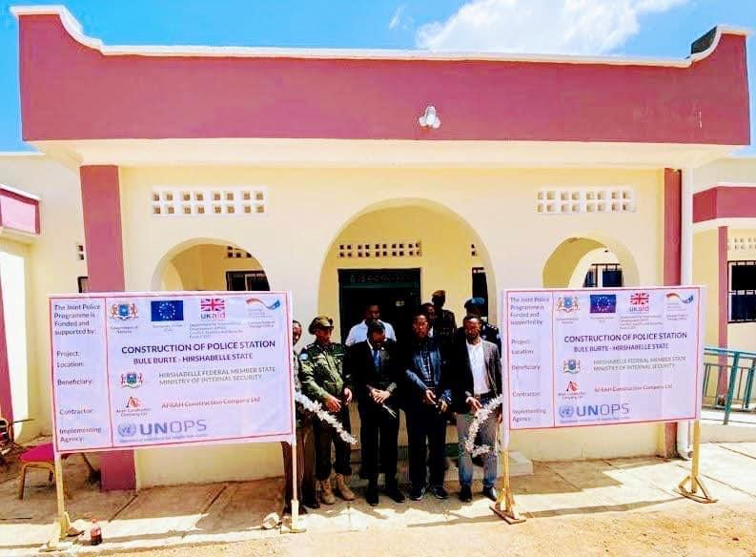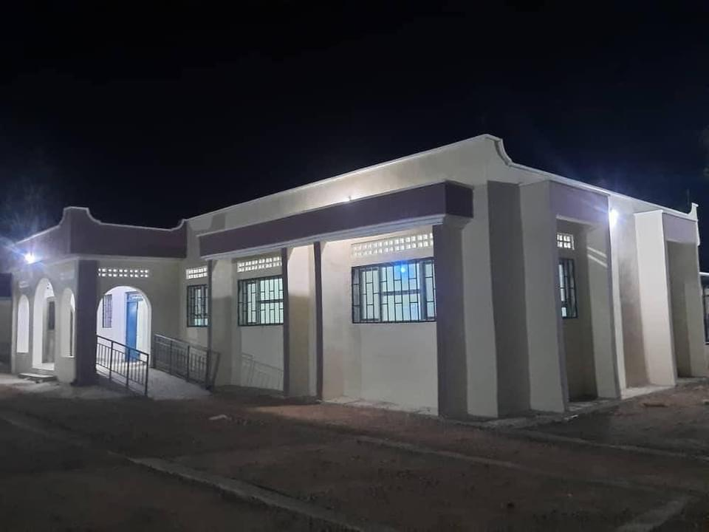
ToC Individual Level: OUTPUT: Changes in individual skills, knowledge, abilities, attitudes and motivation OUTCOME: Improved basic policing services in line with the 4As
Continued stipend payments to ensure basic compensation of police officers (HIR002:2018): On average 518* (F = 38) police officers from Batches 1,2 received USD$100 for each of the three months in Q4, 2021. This amounted to USD$162,300 in stipend payments during the quarter.
*Reduction in the number of officers receiving stipends compared to previous quarter due to desertion of officers and non availability of alternate bank accounts

HirShabelle - Delivery challenges and issues
Infrastructure
- HIR004:2019 (Activity 1) - Jowhar Police Training Facility (Upgrade). The project scope is partially completed. The remaining not completed project scope from phase 1 is combined with the scope of the second phase and a consolidated design package was completed. The JPP EB has not approved the amended WR for the consolidated design package. Mitigation Action: JPP Secretariat to seek clarification from JPP EB for the way forward, to cancel the WR or to approve the amended WR.
- HIR002:2019 (Activity 1) - Upgrading the Jowhar Police Training Facility. Funding sources come from two sources (EU Bilateral Project & JPP). Contract could not be awarded due to the EU Bilateral Project not being able to confirm approval of the funds, therefore the WR was amended, requesting additional funds for the project implementation, and it was presented to the JPP EB for review and approval. JPP EB has not approved the amended WR. Mitigation Action: JPP Secretariat to seek clarification from JPP EB for the way forward, to cancel the WR or to approve the amended WR.
Stipends
- HIR002:2018 (Activity 2) – Stipends payments. Continue to experience challenges in getting the alternate bank account details of the remaining officers of Jowhar. Mitigation Action: Escalate the matter to the JPP secretariat and the next level of the government mechanism.
NLS
- HIR004:2019 (Activity 4) - Communication equipment. UNOPS has not had sufficient time to schedule a site visit for a communications provider to assess the repeater requirements, and therefore, cannot provide a costing. Discussions were held with the FMS Police, Col Kaafi, and no resolution could be reached on proceeding with the procurement as the items to be procured needs to be supported by an elaborate radio communications network at different locations at a huge cost. The FMS needs to provide further guidance on their perceived outcomes for this work request. Mitigation Action: FMS to decide on the way forward, whether an additional work request will be submitted to support the requested hand radios.

Hirshabelle - Prioritised actions for the next quarter

Infrastructure
- HIR004:2019 (Activity 1) - Jowhar Police Training Facility (Upgrade). Considering that the current JPP ends in Dec 2022, suggest that the implementation of this activity to be considered for the possible second phase of JPP.
- HIR002:2019 (Activity 1) - Upgrading the Jowhar Police Training Facility. Considering that the current JPP ends in Dec 2022, suggest that the implementation of this activity to be considered for the possible second phase of JPP.
- HIR-002-2019 V001 (Activity 2) Construction of Police Station in Bulle Burte. Project is completed and handed over, monitor the DNP.
Stipends
- HIR002:2018 Stipend Payments - Continue to pay the stipend for eligible beneficiaries of all JPP project locations through alternate bank accounts. Undertake a biometric verification of JPP project stipend beneficiaries of all JPP project locations (which includes 5 locations in Jowhar). Pay special attention to the officers not providing their alternate bank account details and get the support of TPM to get a better understanding on the ground reality.
NLS
- HIR004:2019 (Activity 4) - Communication equipment. Undertake further discussions with the FGS.

Hirshabelle - Budget summary
Table 4: Q4 HirShabelle Budget Summary
Budget Summary by Location
Output | Total Approved WR Budget (USD) | Total disbursed + Committed | Budget balance against approved WRs | Burn rate against Approved WRs
Infrastructure
Non-Lethal
Stipends
UNDP
Totals

Programme Status – Jubaland

Jubaland - Key achievements
During the quarter, the following achievements were registered in Jubaland. These are achievements within approved JPP work-requests, specifically at the activity level. These achievements contribute towards broader outputs, which in turn contribute to broader outcomes within JPP’s overarching Theory of Change (ToC).
ToC Individual Level: OUTPUT: Changes in individual skills, knowledge, abilities, attitudes and motivation OUTCOME: Improved basic policing services in line with the 4As
Continued stipend payments to ensure basic compensation of police officers (JUB005:2018): On average 521 (F = 49) police officers from Batches 1,2,3 received USD$80 for each of the three months in Q4, 2021. This amounted to USD$125,040 in stipend payments during the quarter. Jubaland also made their 50% contribution to salary payments for October, November and December.

Jubaland - Delivery challenges and issues
Infrastructure
- JUB005:2018 (Activity 6) - Construction of PS in Afmadow. The JPP EB has approved 8 months no cost extension for managing 12 months DNP. However, the approved extension has not yet been formalized into the amendment to the legal agreement, therefore HQCPC has conditionally approved the award. Mitigation Action: JPP secretariat to expedite formalization of the approved 8 months no-cost extension into amendment of the current legal agreement.

Jubaland - Prioritised actions for the next quarter
Infrastructure
- JUB005:2018 (Activity 6) - Construction of PS in Afmadow. Award the contract and start the physical construction on site.
Stipends
- JUB005:2018 (Activity 3) – Stipends payments. Continue to pay the stipend for eligible beneficiaries of all JPP project locations through alternate bank accounts. Undertake a biometric verification of JPP project stipend beneficiaries which includes 5 locations in Jubaland.
NLS
- JUB005: 2018 (Activity 1b) – Uniforms for new recruits training materials. Jubaland Training of 600 Recruits. Finalize procurement of all items including vetting material (medicine), catering services, bedding material, stationery, toiletries, transportation etc. ensure delivered to the UNPOL facility in Kismayo during Q1 2022.

Jubaland - Budget summary
Table 5: Q4 Jubaland Budget Summary
Budget Summary by Location
Output | Total Approved WR Budget (USD) | Total disbursed + Committed | Budget balance against approved WRs | Burn rate against Approved WRs
Infrastructure
Non-Lethal
Stipends
UNDP
Totals

Programme Status – Puntland

Puntland – Key achievements
During the quarter, the following achievements were registered in Puntland. These are achievements within approved JPP work-requests, specifically, at the activity level. These achievements contribute towards broader outputs, which in turn contribute to broader outcomes within JPP’s overarching Theory of Change (ToC).

ToC Institutional Level: OUTPUT: Changes in formal & informal rules OUTCOME: improved enabling environment for policing in accordance with the 4As
Establishing Community Policing Forums to improve cooperation between the community & the police (PUN005:2019:3a): Community policing forum workshop was conducted in Garowe on 18-22nd November with 41 participants (F:17, M:24) from 4 districts (Galdogob, Rako, Xarfo and Armo) and from ministries, CSOs, the human rights defender office and the police in Garowe. The participants received training on the concept and key elements of successful community policing schemes. The workshop resulted in the establishment of Community policing forums in the 4 districts and agreement on SOPs. Once operational, the forums will serve to improve the cooperation between the community and the police, support the enhance reporting and resolution of crimes, and address the specific concerns of the communities.
Support to reactivate the Internal Police Complaints Department (PUN005:2019:4b): A workshop was held on 25-27th November to bring together stakeholders to discuss the re-establishment of the Internal Police Complaints Unit. The 48 participants (F:17, M:31), including representatives from parliament, MOS&DDR, MOJ, MOWFA, Office of Puntland Human Rights Defender ((OPHRD) and Attorney General’s Office (AGO), conducted an assessment of the existing complaints unit and agreed on a roadmap for the necessary steps for improvement, including gender-equitable membership and administrative procedures.
Supporting establishment of the Police External Oversight Board (PUN005:2019:4e): The requirements for the Puntland Police External Oversight Board were established in a workshop on 20-22nd November. 40 participants (F:17, M:23) from the police, various ministries, AGO, OPHRD and Puntland Non-State Actors Association (PUNSAA) discussed membership requirements, reviewed basic principles and mandate, developed a ToT and endorsed the formation of the oversight committee. The purpose of the oversight committee is to uphold standards of professionalism and a level of effective service in Puntland. The next steps in the establishment of the committee is approval by Parliament, and awareness raising of the committee’s purpose, both for the public and for Puntland state police.
ToC Organizational Level: OUTPUT: Changes in structure, systems, & processes OUTCOME: Improved effectiveness of the MoIS, SPF-FP and FMS State Police in line with the 4As
Improving administrative capabilities of the Puntland Police Force (PUN005:2019:5a): From 23-27th November, 40 police officers (F:10, M:30) from police stations in 4 districts (Galdogob, Rako, Xarfo and Armo) received comprehensive capacity building and practical training on the use of crime register books, case files, and information reports. This training contributed towards improved administrative capabilities of the Puntland police force, and concluded with the distribution of the previously-procured Books, Crime registers, files and different forms to the participants to enable them to put their training to immediate use.
Construction of the Galkayo Police Station (PUN-005-2019-01): Completed construction of the Police Station in Galkayo, currently waiting for a response from Puntland MOIS for the date and time of handing over ceremony.
ToC Individual Level: OUTPUT: Changes in individual skills, knowledge, abilities, attitudes and motivation OUTCOME: Improved basic policing services in line with the 4As
Strengthening capacity of the Police Personnel Department (PUN005:2019:5b): A training workshop for the Puntland Police Personnel Department was held on 29th November – 1st December with 40 participants (F:8, M:32). The workshop provided training on recruitment processes, registration of personnel, performance and leave monitoring, and file management. The workshop supported the ongoing capacity building of the personnel department to provide more efficient and professional services, in line with established guidelines and codes of conduct.
Continued stipend payments to ensure basic compensation of police officers (GAK001:2018): On average 165* (F = 10) police officers from Batches 1,2 received USD$100 for each of the three months in Q4, 2021. This amounted to USD$49,600 in stipend payments during the quarter.
*Also included under Puntland

Puntland - Delivery challenges and issues
Infrastructure
- PUN005:2019 (Activity 1) - Construction of four new police stations and renovation of one (1) old police stations. Due to the security tensions in Bosaso in third week of December, the PS construction activities were suspended for a week. The suspension of works will delay completion of the PS in Bossaso. The materialization of the approved 8 months extension for managing the DNP still needs to be sorted out. Mitigation Action: The security situation in Bossaso to be monitored closely, the government officials are encouraged reporting any damage/violations. JPP secretariat to expedite formalization of the approved 8 months no-cost extension into amendment of the current legal agreement.
- PUN001-2021 - Conducting Site Assessments. The remaining JPP funds for Puntland state are not sufficient to cover construction of 6 PSs. Puntland MOIS yet to reduce the number of PS's that can fit into the remaining available JPP budget allocated to Puntland state. Due to the delay of the decision to proceed with the implementation, the 8 months approved extension may not be sufficient to manage 12 months DNP. Mitigation Action: Request Puntland MOIS to expedite the prioritization of the locations and the number of the PSs and to inform the JPP secretariat for the final decision on the number of the police stations and the locations. JPP infra to be informed as soon as possible for the final decision, to enable initiations of the further implementation steps.

Puntland - Prioritised actions for the next quarter
Infrastructure
- PUN005:2019 (Activity 1) - Construction of four (4) new police stations and renovation of one (1) old police stations. Complete and handing over to the Puntland MOIS PSs in Galkayo, Garwe, Bossaso and Qradho and hand them over. JPP secretariat to formalize the approved 8 months no-cost extension into amendment of the current legal agreement. Completing procurement process and awarding the contract for construction of Galkayo Central PS.
- PUN001-2021 Conducting Site Assessments. Initiate required implementation processes as soon as decision for the number of the police stations and the locations is made.
Stipends
- GAK001:2018 Stipend Payments: Continue to pay the stipend for eligible beneficiaries of all JPP project locations through alternate bank accounts. Undertake a biometric verification of JPP project stipend beneficiaries of all JPP project locations (which includes 7 locations in Galkayo).

Puntland - Budget summary
Table 6: Q4 Puntland Budget Summary
Budget Summary by Location
Output | Total Approved WR Budget (USD) | Total disbursed + Committed | Budget balance against approved WRs | Burn rate against Approved WRs
Infrastructure
Non-Lethal
Stipends
UNDP
Totals

Programme Status – South West State

South West State - Key achievements
During the quarter, the following achievements were registered for the FGS. These are achievements within approved JPP work-requests, specifically, activity level achievements. These achievements contribute towards broader outputs, which in turn contribute to broader outcomes within JPP’s overarching Theory of Change (ToC).
ToC Individual Level: OUTPUT: Changes in individual skills, knowledge, abilities, attitudes and motivation OUTCOME: Improved basic policing services in line with the 4As
Continued stipend payments to ensure basic compensation of police officers (SWS003:2018/ SWS001:2019): On average 588* (F = 61) police officers from Batches 1,2,3,4 received USD$100 for each of the three months in Q4, 2021. This amounted to USD$176,500 in stipend payments during the quarter.
*109 Officers payment suspended as per the September 2021 EB decision.

South West State - Delivery challenges and issues
NLS
- SWS001:2019 (Activity 1b) - Recruits will be issued with 2 sets of uniform. Training cost include catering, training material, and toiletries. Uniforms can only be procured and delivered after the completion of the Basic Police recruit Training (dependency). There is a delay in JPP EB approval for any further training until the Somali Government can provide assurances that newly trained officers will be issued with firearms and deployed. Discussions on the delivery, sizes, timelines, storage and responsibility after delivery were held with the FMS, with no resolve to date. Mitigation Action: Further discussions on the matter with the FMS to get their resolve of challenges posed.

South West State - Prioritised actions for the next quarter
Stipends
- SWS003:2018 and SWS001:2019 – Stipend Payments. Continue to pay the stipend for eligible beneficiaries of all JPP project locations through alternate bank accounts. Undertake a biometric verification of JPP project stipend beneficiaries of all JPP project locations which includes 6 locations in SWS

NLS
- SWS001:2019 (Activity 1b) - Recruits will be issued with 2 sets of uniform. Undertake further discussions on the activity with the FMS to get their resolve of challenges posed (described above).

South West State - Budget summary
Table 7: Q4 South West State Budget Summary
Budget Summary by Location
Output | Total Approved WR Budget (USD) | Total disbursed + Committed | Budget balance against approved WRs | Burn rate against Approved WRs
Infrastructure
Non-Lethal
Stipends
UNDP
Totals

JPP Executive Board Decisions
Table 7, below, highlights the key decisions from the Q4 Executive Board held on 1st December, 2021.
Table 7: JPP Executive Board Decisions (1st December, 2020)
