Somalia Joint Corrections Service Support Programme (JCP)

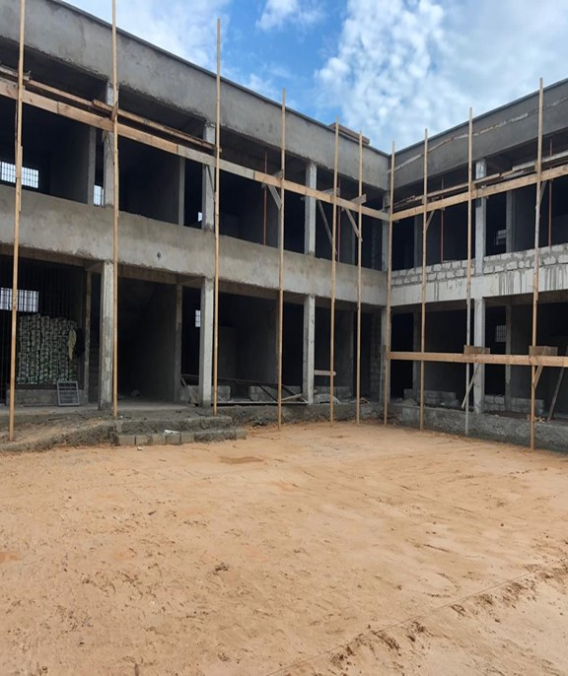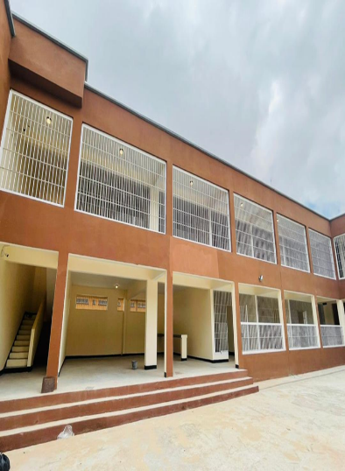 | « Efforts implemented under the Joint Corrections Programme, have led to a rampant growth in Somalia’s justice and corrections systems. For example, prisons in Somalia that were previously marred by infrastructural and managerial challenges have now been developed in line with international standards »
Image by Mohamed Abukar: Before and after photos of the additional block at Mogadishu Prison Court Complex (MPCC)

Key achievements during the reporting period

- The complete construction and reconstruction of prison facilities such as MPCC, Kismayo, and Bossaso prisons to address the previous weak conditions of Somali prisons that had poor infrastructure, sanitation and hygiene, inadequate food and water, and limited access to health care.
- For the first time ever, students attended their exams while serving their sentence in prison. This presents a bright hope for 39 student prisoners regarding their current circumstances and future prospects.
- Prison staff were trained on treatment of prisoners to ensure that prison management adheres to international standards.
- To decrease vulnerability among inmates and increase resilience against violent extremism, prisoners benefited from vocational training courses and educational programmes such as electricity, plumbing, welding, religious studies, literacy and numeracy skills.

Project data

MPTF Gateway ID | 00115384
Geographical coverage | Federal Republic of Somalia
Project duration | 53 months, from August 2018 to December 2022
Total approved budget | US$6,617,660
Programme funding level

Estimated delivery rate

Participating UN entities | UNODC Global Maritime Crime Programme (lead), UNSOM Joint Justice and Corrections Section, UNIDO, UNOPS
Implementing partners | Ministry of Justice Somalia
Project beneficiaries | Prisoners, local population
NDP pillar | 2.4.2. Strategies for Improving the Corrections System
UNCF Strategic Priority | 2. Supporting institutions to improve peace, security, justice, the rule of law & safety of Somalis.
SDG
Gender Marker | Per activity (see below)
Related UN projects  within/outside the SJF portfolio | UNDP Joint Police Programme; Joint Justice Programme; UNSOM Security Sector Governance; Human Rights Joint Programme; Preventing and Countering Violent Extremism/Comprehensive Approach to Security (S4)
Focal person | Abdirizak Jama, UNODC, mohamedjama.abdirizak@un.org, +252 90 794 656

Report submitted by:

 | PUNO | Report approved by: | Position/Title | Signature
1 | UNIDO
2 | UNSOM
3 | UNODC
4 | UNOPS

Section 1: Executive summary

Brief introduction to the project

As a result of the prolonged period of conflict and instability in Somalia, various systems in the country, including the justice and corrections services, lacked the systematic development to address the needs of the Somali people. Several challenges confronted the justice and correctional systems, including a shortage of qualified, trained, and equipped personnel, inadequate infrastructure and working conditions, weak accountability and oversight mechanisms, and some political intervention in the justice system. The impact of these challenges extends to Somali prisons, leading to insecurity in each facility and an increased likelihood of recruitment into extremist groups.

The goal of the Joint Corrections Programme (JCP) is to address the above challenges that are present in the Justice and Corrections services in Somalia and within the prison systems by supporting the construction of adequate prison facilities, capacity building of prison staff, rehabilitation and successful reintegration of prisoners, with the aim of creating a more secure prison environment that complies with international rules and standards and ensuring equitable access to justice by the general community.

Situation update / Context of the reporting period

The impact of the COVID -19 pandemic, which devastated the entire world, was also felt in the Federal Republic of Somalia within the year 2021. The pandemic disrupted affairs in the state to the extent that some implementation plans in the Joint Corrections Programme progressed at a slower pace, leading to the incompletion of some activities outside of their designated time frame.

At the political level, an election held at the beginning of the year led to the appointment of a new Director General for the Ministry of Justice. The appointment also slowed down implementation plans as the DG requested UNODC as the lead agency to provide a signed Letter of Agreement before proceeding further with activities.

Additionally, some security tensions that were present in Somalia within the last year as a result of elections. Al-Shabab attacks contributed to some changes in the implementation plan of the JCP. Lack of funding also severely obstructed program implementation and monitoring efforts, which further explains the gaps and slow developments that were witnessed in 2021.

Although the JCP made significant progress during the year, public health, financial, political, and security issues such as the ones mentioned above delayed the implementation of some programme activities. To address this delay, the JCP was extended until 2022 in collaboration with donors, UN partners, and the FGS, allowing for the completion of activities in the JCP work plan.
Highlights of the project during the reporting period

- Increased management of the prison system in line with international standards.
- The prison environment is now more conducive and secure for all prisoners and staff.
- Decreased vulnerability among prisoners through rehabilitation programmes.
- Enhanced conditions for inmates’ employment after release through reintegration programmes.
- Increased knowledge and participation among community members about the prison and rehabilitation and reintegration of inmates.

Summary of key achievements during the reporting period

Prison systems in Somalia were previously marred by various challenges such as overcrowding, ill treatment of prisoners, lack of infrastructure and relevant technology to ensure proper prison management and inadequate structures to support prisoners who are released after serving their term. Thanks to the interventions from the Joint Corrections Programme, prisoners in Somalia now have a more secure and conducive environment to serve their sentences. This was achieved with the construction and reconstruction of prison facilities across Somalia that allowed for some prisoners to be taken to new cell blocks and reduced overcrowding. An example of such a facility is the additional block that was constructed at MPCC.

Within the year, the JCP also implemented activities on rehabilitation programmes that benefitted a significant number of prisoners through vocational training in skills such as electricity, welding, and plumbing. The prisoners also benefitted from religious and basic education training such as literacy and numeracy skills.

JCP supported the FGS to draft new laws and policies that will further increase adequate prison administration and proper treatment of prisoners in line with international prison management standards.

To further its community engagement initiatives, the JCP implemented activities under its rehabilitation programmes in Garowe that informed the broader community about the prison system and the JCP’s rehabilitation and reintegration efforts. The implementation of this activity aims to increase community active participation and support for prisoners within the prison and upon their release. This will ensure that prisoners are not outcast in their communities and are able successfully re-join society, limiting recidivism.

Section 2: Progress Report Results Matrix

OUTCOME STATEMENT 1
Somali Custodial Corps are increasingly providing fair and human services to the Somali people
SUB-OUTCOME 1.1 STATEMENT
Somali Custodial Corps are delivering correctional services under a unified legal framework
Output 1.1.1: Transcription and development of the corrections model into the current prison law draft legislation
INDICATOR | TARGET | PROGRESS ON OUTPUT INDICATOR
 |  | REPORTING PERIOD (2021) | CUMULATIVE
FGS/FMS political agreement around the content of the current prison law draft legislation | 1 | 0 | 1
Output 1.1.2: Adoption of a new legislation applicable in all regions
Number of new legislations adopted by Parliament on corrections | 1 | 0 | 1
SUB-OUTCOME 1.2 STATEMENT
Somali Custodial Corps are operating at least one correctional facility in compliance with international standards in all regions
Output 1.2.1: Somali regions are all operating with at least one equipped correctional facility in line with infrastructural prison standards
Number of regions equipped with at least one correctional facility in line with infrastructural prison standards | 6 | 1 | 3
Output 1.2.2: Somali Custodial Corps staff are trained to operate correctional facilities in respect of applicable international standards
Number of custodial corps staff trained to operate correctional facilities in respect of applicable international standards | 1200 | 140
Output 1.2.3: Correctional facilities are operating under strengthened and adapted Standard Operating Procedures (SoPs)
Number of SoPs established and implemented in correctional facilities | Unidentifiable | 0 | 0
Output 1.2.4: Somali Custodial Corps own a federal and state Corrections Plan. Gender Marker: Implementation plan must include the above-mentioned gender markers for each activity.
Number of implementations plan per region | 7 | 0 | 0
SUB-OUTCOME 1.3 STATEMENT
Prisoners are benefiting from rehabilitation programs
Output 1.3.1: Prisoners in all regions are benefiting from tailored rehabilitation program
Overall number of prisoners benefiting from tailored rehabilitation programs | 40 per region, 300 overall | 80
SUB-OUTCOME 1.4 STATEMENT
Somali authorities are provided with oversight and accountability mechanisms over all correctional facilities
Output 1.4.1: The capacity of the Attorney General’s Offices is strengthened in monitoring and overseeing of correctional facilities
Number of inspections conducted by the Attorney General's office per region per year | 6 | 0
Output 1.4.2: The capacity of the Somali Custodial Corps to monitor and oversee its correctional facilities is strengthened
Number of inspections conducted by the Federal Commissioner's office per region per year | 6 | 0
OUTCOME STATEMENT 2
Community actors are participating to the improvement of prisoner welfare and community reintegration
Output 2.1: Community actors are involved in oversight mechanisms over correctional facilities
Number of prisons visited by oversight civil committee per region per year. | 6 | 0
Output 2.2: Community actors are supporting prisoners in reintegrating society through tailored community-based reintegration program
Overall number of prisoners and relevant community members benefiting from tailored reintegration programs | 100 overall | 20

<Insert all outcomes and outputs>

Section 3: Narrative reporting on results

Progress towards outcomes

OUTCOME STATEMENT 1
Somali Custodial Corps are increasingly providing fair and human services to the Somali people

SUB-OUTCOME 1.1 STATEMENT
Somali Custodial Corps are delivering correctional services under a unified legal framework
UNSOM:
- Complete draft of Somalia prison law
- Validation and Adoption of a Standard Operating Procedures (SOPs).

In Somalia, the complete development of a unified legal framework for the delivery of correctional services is underway A prison law draft was produced in 2021, which will be further developed into a final draft by the FGS policy and the Legal Drafting Unit. UNSOM also supported the validation and adoption of Standard Operating Procedures for the administration of prisons by training Somali Custodial Corps (SCC) personnel.

These activities so far implemented by UNSOM to address Sub-Outcome 1.1 of the JCP workplan will ensure that a unified legal framework in the form of a prison law and prison management standards are developed in line with international standards that will in turn greatly benefit the prison population and the community at large. The development of a unified legal framework will ensure that prison staff all over Somalia benefit from various trainings on prison management and the humane treatment of prisoners. It will also inform the general public of the rights of detainees and prisoners so as to prevent abuse of power by the prison authorities.

SUB-OUTCOME 1.2 STATEMENT
Somali Custodial Corps are operating at least one correctional facility in compliance with international standards in all regions
UNOPS:
- Full construction of additional block at MPCC
- Construction of Kismayo prison in Jubaland.
- Implementation of a staff database and ID creation for all the correctional facilities.

UNIDO:
- Complete rehabilitation of three prison cell block rooms in Beledweyne prison.
- Complete rehabilitation of a boundary wall in Beledweyne
- Complete construction and establishment of one containerized training workshop

Activities by UNOPS and UNIDO under Sub-Outcome 1.2 has gone a long way to ensure that correctional facilities are constructed and managed in line with international standards. The construction of more prison facilities and additional block has reduced overcrowding in MPCC, for example, thereby creating a more humane living condition for the prisoners, in those facilities. Prison rooms constructed in Beledweyne are now up-to standard for secure and better hygiene for prisoners and the boundary wall improved the security situation in the prison.

SUB-OUTCOME 1.3 STATEMENT
Prisoners are benefiting from rehabilitation programs
UNODC:
- 82 prisoners benefitted from education programme and 39 prisoners graduated from the vocational training activities.
- Counselling activities for prisoners in Garowe
UNIDO
- 15 prisoners benefitted from a practical training that focused on construction and welding works in Beledweyne prison.

SUB-OUTCOME 1.4 STATEMENT
Somali authorities are provided with oversight and accountability mechanisms over all correctional facilities
UNSOM:
- Capacity building training for
UNODC:
- Mentoring on post training for prison officers.
- Development of the Basic Training of Prison Officers (BTPO)

OUTCOME STATEMENT 2
Community actors are participating to the improvement of prisoner welfare and community reintegration
UNODC:
- Complete delivery of a community acceptance forum.

Number of beneficiaries and feedback from beneficiaries

Beneficiaries under JCP are split into 3 groups- prisoners, prison staffs and the community.
- 82 Garowe prisoners graduated from the educational programme.
- 39 Garowe prisoners graduated from the vocational training programme.
- 15 Beledweyne prisoners benefitted from vocational training programmes in construction and welding.
- 54 Custodial Corps personnel benefitted from capacity-building training across prisons in Somalia.

Section 4: Project implementation

COVID 19 Response

To ensure that activities under JCP were implemented in due time despite the restrictions imposed as a result of the COVID-19 pandemic, alternative modalities of implementation were applied. For example, alternative work arrangements for staff made, such as working from home countries or bases within the region. Funds were also channelled within the programme to provide necessary IT equipment, and the training and transport thereof, to ensure capacity building training sessions could still be delivered on a web-based platform as opposed to in-person facilitation.

JCP also continued to provide COVID-19 relief items to target facilities, as well as welfare items including wash buckets, clothing, mattresses and personal cleanliness items.

Key constraints and challenges and associated corrective actions

The JCP experienced certain setbacks in 2021 that caused difficulties and several delays regarding implementation. The COVID-19 pandemic is still very much present in the country and as such, some activities under the JCP had to be postponed due to restrictions on travel, limited movement of staff, and health concerns of beneficiaries. Political tensions within the country also slowed down activities to a maximum as staffs were restricted from traveling into the country for security reasons. For example, an essential visit by the International Monitoring Committee was postponed on several accounts as a result of the impact which was posed by both the COVID-19 pandemic and political tension in Somalia.

Additionally, a new Director General for the Ministry of Justice was appointed, and the new DG required that a signed Letter of Agreement be provided by the lead implementing agency before implementation of activities under JCP can resume.

Risk management

Type of risk | Description of risk | Mitigating measures
Health | imposed by the outbreak of infectious diseases such as the Covid-19 pandemic | Implementation of prevention guidelines outlined by the WHO and the Government of Somalia
Environmental | Flooding as a result of heavy rainfall affected the target region of Beledweyne and although the prison facility was not affected, the impact of the flood within the community itself contributed to the delay in activities | Develop structures to guide against flooding of prisons
Political | Lack of cooperation from national counterparts delayed activities to an extent | Build rapport and good communications with the counterparts

Learning impact

A major shortcoming with implementation under JCP has been the delays associated with programme planning and execution that have led to the programme being extended overtime, even though some of these delays were inevitable. JCP has learned over the years to increase coordination, communication, and cooperation among the various stakeholders for the purposes of clearly mapping out different roles and to be on the same page to guarantee successful execution.

In addition, it was noted that communicating with beneficiaries about their wants, needs and expectations was essential while implementing activities. JCP seeks to maintain such communications in the implementation of other future activities under the programme.

Coordination with other UN entities including UNSOM/UNSOS within and outside the SJF portfolio

UNSOM is one of the implementing partners of JCP therefore actively engaged in the programme. Regular meetings have been conducted to share updates on the activities and to discuss issues relating to the programme.

Engagement with UNSOS has also been active during the period especially regarding the provision of security, camp and medical services for personnel traveling on mission to Somalia.

Role of the UN Somalia Joint Fund

JCP relates to the overall portfolio of programmes of the UN Somalia Joint Fund as it greatly contributes to strengthening the strategic support to enhance the capacity of the Federal Government of Somalia.

However, communication between SJF and the JCP should be strengthened to guarantee necessary oversight and information to the management.

Synergies with other funds (UN and non-UN) working on similar issues

The JCP is interlinked and has worked to collaboratively assist and be assisted by other similar programmes in achieving objectives. Some of these other programmes include:
- The Joint Police Programme (JPP) increases police presence in Somalia to guarantee safety and security in communities and arrest or detain offenders. JCP’s relevance to this programme will ensure that detainee numbers do not exceed prison operational capacities.
- The JJP is linked with JCP since Justice and Corrections Model is part of an integral plan for the overall development of the criminal justice chain. JJP also provides legal assistance to prison detainees.
- Security Sector Governance supports MOIs to strengthen Somali police capacity to engage with the community. This is also similar to JCP strategic priority to ensure that all Somalis benefit from peace, Security & Rule of Law, including Justice, and ensure effective and accountable institutions that respond to the needs and rights of all Somalis.
- The Human Rights Joint Programme and JCP work to promote accountability and oversight, along with protecting and upholding the human rights of detainees.
- Preventing and Countering Violent Extremism/Comprehensive Approach to Security (S4) provides forums that are utilized by JCP to exchange knowledge and experiences on programme results to disengage combatants and effectively prevent violent extremism.

Partnerships

Other partners involved in JCP include:
- The Swedish Prison and Probation Service (SPPS), which has provided its expertise to improve Somalia prison system through the deployment of Swedish prison experts into the field.
- The United Nations Children’s Emergency Fund (UNICEF) has supported FGS/FMS and other actors in Somalia in ensuring the protection of children’s rights. UNICEF actively ensures that juvenile justice is implemented in prisons according to national and international standards. In 2021, UNICEF was involved in the release of children prisoners who were placed in the death penalty.
- The International Committee of the Red Cross supports prison sanitation, prisoner hygiene, and basic medical service supplies in Baidoa and Kismayo.
- Finn Church Aid (FCA) and the Centre for Research and Dialogue supports the High-Risk Prisoner Rehabilitation Program in Baidoa and engage the community in the reintegration process of former Al-Shabaab prisoners.

To further achieve outcomes under the JCP, it is important that the clear roles of external partners are mapped out to avoid duplicity, which often happens. And in the case of duplicity, coordination and cooperation is paramount among external actors to reach an agreement and achieve shared goals.

Monitoring and oversight activities

Monitoring activity | Date | Description | Comments  & Recommendations
Field monitoring visit
DIM audit
Independent evaluation
Engineering site visit
Stakeholder review consultation

Communication activities

JCP share communications about all activities concerning launched, ongoing or completed interventions, along with pictures and descriptions on Twitter. The Twitter handles of relevant donors to the project, such as the European Union and Denmark, the Netherlands, and Sweden governments are often mentioned in the tweets. Updates of the UNODC projects under JCP is included in its fortnightly updates (FNU) twice a month. This FNU is distributed to all counterparts, donor member states, and interested parties on the mailing list. When communicating through the FNU’s and Tweets, it is required that pictures of the prisoner’s faces must be blurred to the extent that they are unrecognizable. Furthermore, any pictures or writeups that may share information about the security of a facility, or an individual are reviewed before publishing.

Section 5: Project management

Number of project board meetings held | 2
Number of UN staff (international/national) funded by the project

Number of government personnel funded by the project.  What are their functions and where do they work? | 0
How has the project ensured the visibility of SJF donors during the reporting period?

Projected funding needs for next year | Around 3 million US dollars

Section 6: Cross-cutting issues

Gender equality and women empowerment

UNODC:
- Inclusion of female prisoners in educational programmes and vocational training activities
- Provision of essential needs unique to women such as sanitary pads, adequate clothing, sanitation soaps and creams for female inmates
- Separation of female prisons from male prisons to assure equality of treatment in the prison between genders.
UNSOM:
- Inclusion of female representatives in SOPs development process.
UNOPS:
- Recruitment of female prisoners to manage the prisoner’s databases

Proportion of gender specific outputs in the project | Total number of project outputs | Total number of gender specific outputs
 | 10 | 10
Proportion of project staff with responsibility for gender issues | Total number of staff | Total number of staff with responsibility for gender issues
 | 3 | 3

Human-rights based approach

UNSOM:
The validation and adoption of SoPs specifically targets human rights and the protection of vulnerable groups in the prisons, including women, youths, and violent extremist prisoners in the corrections sector of Somalia.

UNODC:
The Basic Training of Prison Officers (BTPO) to be implemented by UNODC entails human rights content that seeks to inform prison staff on how to treat prisoners with dignity and respect in line with international human rights standards. Specific learning outcomes for the BTPO include How human rights are relevant and apply to the work of a prison officer; when the use of force against a prisoner might be justified, including the importance of proportionality in deciding whether and how to use force; and the importance of identifying the needs of vulnerable groups.

UNOPS:
Consequently, due to the inhumane state of Somalia prisons which are often over-crowded, unhygienic and insecure for the prisoners, UNOPS completed the construction of the additional block at the MPCC as a development to the target facility that will provide convicted prisoners with a fair and humane environment to serve their sentence.

All the efforts undertaken by the implementing agencies towards promoting human rights and protection of vulnerable groups have strengthened the capacity of the Somali Custodial Corps in dealing with prisoners in compliance with human rights standards.

Has the programme included a protection risk assessment in its context analysis, including on gender issues, and taken measures to mitigate these risks to ensure they are not exacerbated, or new risks created? | Result
 | Yes
Number of programme outputs specifically designed to address specific protection concerns | Result
 | 4
Number pf programme outputs designed to build capacity of duty bearers to fulfil their human rights obligations towards rights holders. | Result
 | 9

Leave no one behind

JCP leave no one behind strategy identifies inequality and discrimination on two main basis- gender and age.

Women:
The issue of inequality and discrimination of women within the prison system in Somalia applies to both female prisoners and female prison staff. Interventions for female prisoners under JCP have recognized the unique issues faced by the prisoners, such as little or no participation in rehabilitation programmes when compared to their male counterparts, as well as other issues related to female sanitation and hygiene. JCP has helped to provide female prisoners with access to sanitary welfare, access to gynaecology, special spaces for pregnant and nursing mothers, and much more. For rehabilitation programmes, JCP has encouraged the participation of female prisoners in vocational training and education programmes to the extent that the number of female prisoners who benefitted from rehabilitation programmes in this reporting year was substantially higher than in previous years. And JCP seeks to aim even higher.

With regards female prison officers, it has been identified that when compared to their male counterparts, the female officers are not included in trainings, promotions, and salary benefits. JCP sought to close this gap by implementing activities that specifically targets female prisoners for training and encourage female officers’ participation in other trainings.

Juveniles:
Juveniles are a special group in need of special attention within the prison system. They are at the risk of being exposed to violence and abuse by prison staff and prisoners alike. To address this challenge, JCP advocates for the separation of juveniles from adult offenders and works hard to implement juvenile justice.

Social contract and legitimacy

When it comes to the corrections and justice system in Somalia, the government lacked the capacity and resources to develop the system to reasonable standards. Hence, the Somali people suffered the consequences. People were arrested and detained without access to a fair trial, detainees were kept in poor conditions and treated without respect for human rights, prison staffs lacked the basic training for proper prison management and much more.

JCP stepped in to restore the social contract in Somalia by working hand-in-hand with the national authorities to address these many issues. JCP interventions in Somalia prison system have strengthened the corrections and Justice system. As an ultimate goal, JCP aims to guarantee transfer and ownership of the programme to the Somalia national authorities, this will further restore the people’s faith back in their government.

Humanitarian-development-peace nexus

Considering the level of insecurity that continues to rare its head from time to time in Somalia, the vulnerable groups in need of humanitarian assistance that have been exposed to such violence also extends into the Somalia prison system. JCP has worked to reconcile the humanitarian-development-peace nexus (HDPN) by providing direct medical, psychological and protection assistance to vulnerable prisoners especially women and juvenile prisoners. Humanitarian activities effected under the programme in 2021 included the delivery of covid 19 relief items, sanitary welfare items for female prisoners, counselling sessions for the prisoners, engagement in rehabilitation and reintegration programmes and protecting juvenile prisoners from the death penalty among others. JCP development strategy has led to the reinforcement of existing structures to build the capacity in prisons and provide improved infrastructure and management within the system. In relation to peace, JCP promoted dialogue and cooperation between government entities and other relevant stakeholders to identify and address various issues which are present in Somalia prisons system and how those issues can affect peace, security and justice if not addressed.

In achieving the Humanitarian-development-peace nexus, the JCP relies heavily on goal 16 of the Sustainable Development Goals. The goal 16 guides every activity that are implemented in the programme.

Environment and climate security

N/A

Prevention of corruption

N/A

Project sustainability

Various measures have been undertaken to ensure the sustainability of impact and results beyond JCP’s investment timeframe. A technical committee was setup by stakeholders to periodically discuss among stakeholders and ensure successful delivery and transfer of ownership of the programme to Somalia national authorities.

Additionally, the programme has engaged the broader community in nearly all sectors. In Garowe, a community acceptance forum was held within the year comprising of religious scholars, members from civil society such as traditional elders or ‘Nabadoono’, members from youth organizations, development organizations, the Garowe business community, lawyer associations and other public figures. The forum sought to create a long-lasting knowledge and participation by the community on prisons work and to discuss how they can assist inmates in their rehabilitation and reintegration. At the end of the forum, some members of the community, along with the prison authority, government authorities and other relevant stakeholders agreed to create a committee responsible for assisting the prison authorities in their needs with regards service provision for prison inmates. This act alone will guarantee project sustainability far beyond the implementation period.

# | Target group |  | Dates | Number of participants |  |  | Title  of the training | Location of the training | Training provider
 | Ministry, District  or UN staff | Others |  | M | F | Total
1 | Somali Custodial Corps (SCC) | FGS & FMS | 21-25 Nov 2021 | 11 | 3 | 14 | Workshop on Validation and Adoption of Standard Operating Procedures (SOPs) for the Administration of Prisons. | Mogadishu, Somalia | UNSOM
2 | Puntland Custodial Corps | Puntland State University (PSU) | July 2021 | 8 | 4 | 12 | Social Work Practical Training | Garowe prison | UNODC
3 | Beledweyne |  | 27 July-31 August 2021 | 44 | 1 | 45 | Containerized Training Workshop | Beledweyne Central Prison | UNIDO
4 | Custodial Corps Beledweyne |  | 31 August 2021 | 10 | N/A | 10 | Capacity Building and Mentoring Support Training | Beledweyne Central Prison | UNIDO
5 | Puntland | Custodial Corps | 9 November 2021 | 4 | 1 | 5 | Refresher Training on Prison Admission Process | Garowe Prison | UNODC
6 | Puntland | Custodial Corps | October 2021 | N/A | 13 | 13 | Refresher Training on Security Measures | Garowe Prison | UNODC
7 | Puntland | Prisoners | July 2021 |  |  | 82 | Education Programme | Garowe Prison | UNODC
8 | Puntland | Prisoners | July 2021 |  |  | 39 | Vocational Training | Garowe Prison | UNODC
9
10
Total Number of participants (students) |  |  |  |  |  | 121
Total number of participants (from Custodial Corp) |  |  |  | 77 | 22 | 99

Section 7: Looking ahead: Focus on the future

Looking ahead in 2022, JCP implementation plans entails full completion of all the activities enlisted in the original and extended workplan of JCP. The impact of the activities which will be implemented will create a unified legal framework for Somali Custodial Corps to deliver correctional services; develop correctional facilities to comply with international standards; maximize capacity building trainings for staffs involved in prison management, increase the number of prisoners benefitting from rehabilitation programs, ensure community participation in increasing prisoners welfare and reintegration and most importantly to encourage national participation and ownership of all the activities for sustainability of the impacts.

Having conducted multiple infrastructural projects, capacity building trainings and specialized pilot projects, newly identified issues and unprecedented challenges have arisen. The participating UN organizations under JCP are planning to engage with donors and national counterparts to further take on projects to address the multifaceted issues posed by violent extremist across Somalia. Some foreseen impacts of programme in the near future will include strengthened institutional capacities to ensure proper management of violent extremist in prisons; strengthened security and management of high risks prisoners through infrastructural development and enhancement of PVE programmes that target high-risk prisoners.

Section 8: Human interest story: Voices from the field

Ahmed Kismayo’s Story
The path to reintegration
Ahmed’s life changed forever one fateful night in Garowe outside his place of business. A discharge of his firearm, he shoots in the air would ricochet and hit a young man who he alleged was part of a gang committing strings of robbery in the area. His shot would kill the young man and he would end up in Garowe prison. Having been in prison for more than 3 years, Ahmed is awaiting the completion of a traditional justice settlement. Ahmed struggled to cope with his new situation as he was a businessman and had no prior offences. “I had no frame of reference; it was very hard for me to adjust to prison life. At first, I was feeling scared, I expected the worst conditions and even worse people both the inmates and the correctional officers. But that wasn’t the case, there are normal people in prison and there is a culture of helping each other out whether its from the officers or inmates, there is a brotherhood here.”
Ahmed was housed in A Block which is the housing unit for serious offenders but adjusting to his new home and new neighbours was not the most difficult part. “My biggest issue was the inadequate of recreational activities in the prison, I had access to books and other vocational training activities but was not sufficient. So, it was hard to adjust to doing little.” That would change however when in August of 2021 he was selected to take part in a 6-week prison counselling program under JCP. Ahmed and 59 other inmates took part in a pilot reintegration program that was facilitated by students from the Puntland State University (PSU) Faculty of Social Studies under the JCP program. “We were 6 groups of 10 inmates each, most of my group were from my block. We didn’t know what to expect from the counselling sessions, but we were very pleased.”
Ahmed relished in the fact that he was selected to be a part of something that would result in him, interacting and leaving his cell. “You know we were just happy to leave the cell, but what we would receive was in fact greater than our expectations. We had interesting conversations on topics of family, prison life, reading story books, interests, future plans, family and friendship and our reintegration expectations. We received advice and support in the form of books from the counselling sessions.” Ahmed spoke of how he and the other inmates were disappointed that the program did not last. “The counselling session was something to look forward to, every week. Most of us were interesting to continue the counselling sessions and looking forward to bringing back it. We still hold on to the things we learned from the counselling sessions and the books we received. But I think it’s very important that the counselling sessions be renewed, because it allowed for us to learn, engage and analyse our life while building connections amongst each other and with you all.”

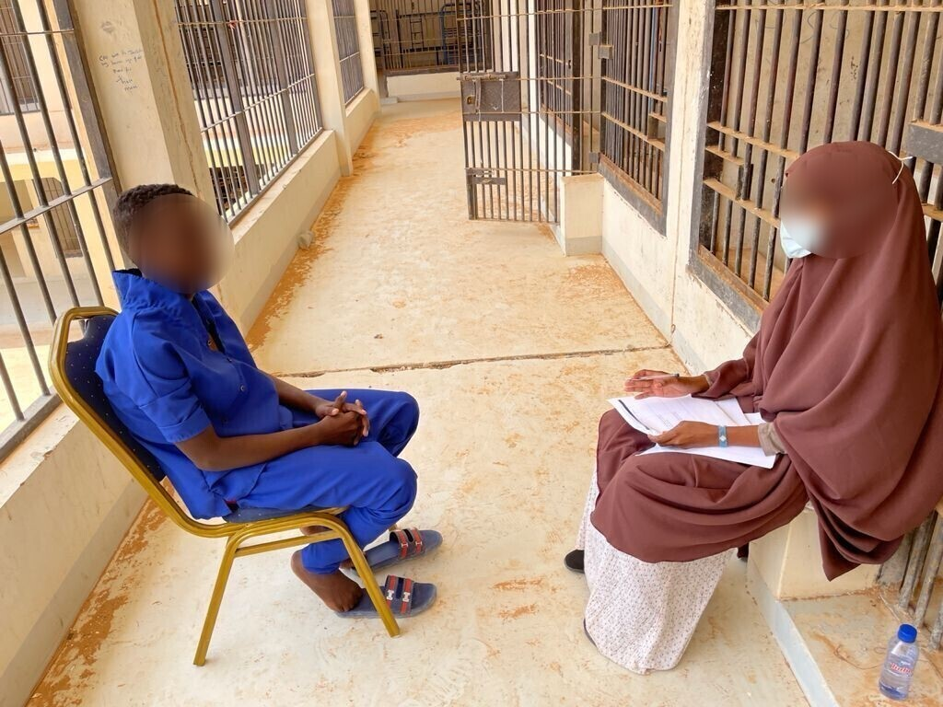
Photo by Abdirizak Jama: A female social work student counselling a prisoner

