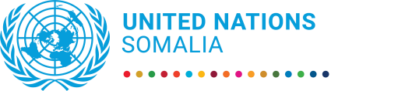
UN Somalia Joint Fund
Progress report

1 January to 31 December 2021

Combatting Poverty and Vulnerability in Somalia through Social Protection, Phase II
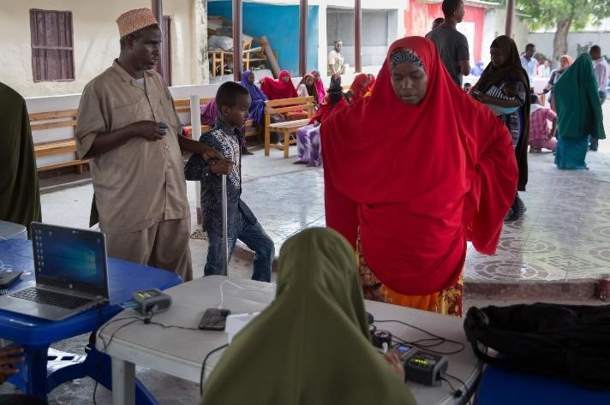

“We are proud to be in the continuously service of the vulnerable communities in our region” - BRA Durable Solution Coordinator Faduma Mohamed

Photo: WFP Kevin Ouma

Key achievements during the reporting period
- Thanks to the MPTF funded urban safety nets implemented by Banadir Regional Administration (BRA), 6000 people have consistently received cash transfers for six quarters since 2020.
- The BRA administration has developed the technical competence and know how to deliver cash transfers directly to its most vulnerable citizens through the UN supported project.
- Government staff in charge of Social protection in South West State now enjoy better working conditions, namely a renovated office more functional and friendly.
- Somaliland social protection policy has been drafted through a consultative process. The policy shares Somaliland vision for gradually setting up a social protection system by 2030.

Project data

MPTF Gateway ID | JP Social Protection #106901
Geographical coverage | All regions, Banadir, Somaliland, South West State
Project duration | 30 months, from September 2019 to March 2022
Total approved budget | US$ 2,220,000
Programme funding level | WFP: US$1,665,000  UNICEF: US$555,000  Total: US$2,220,000
Estimated delivery rate | 85%
Participating UN entities | UNICEF, WFP
Implementing partners | Ministry of Labour and Social Affairs; Banadir Regional Administration  Somaliland Ministry of Employment, Social Affairs and Family (MESAF) South West State Ministry of Labour, Employment and Social Affairs (MoLSA -SWS)
Project beneficiaries | Displacement affected populations, Government staff in MoLSA, MESAF and MoLSA-SWS, future social workers (currently university students),
NDP pillar | Pillar 4: Social development – strategies and interventions that improve access by Somali citizens to health, education and other essential services, including social protection systems in times of extreme need (drivers include information from HDI data on health, living standards and education).
UNCF Strategic Priority | Strategic priority 4: Social development  Outcome 4.1: By 2025, more people in Somalia, especially the most vulnerable and marginalized, benefit from equitable and affordable access to government-led and -regulated quality basic social services at different state levels
SDG | 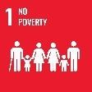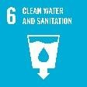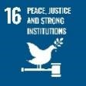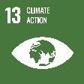
Gender Marker | 2a
Related UN projects  within/outside the SJF portfolio | Toward a Somali-led Transition to National Social Protection Systems  Shock-responsive Safety Nets for Human Capital Project (SNHCP)  Shock-responsive Safety Nets for Locust Response Project (SNLRP)
Focal person | Delphine Dechaux, WFP: delphine.dechaux@wfp.org  Chrystelle Tsafack Temah, UNICEF: ctsafack@unicef.org

Report submitted by:

 | PUNO | Report approved by: | Position/Title | Signature
1 | UNICEF | Angela Kearney | Representative | 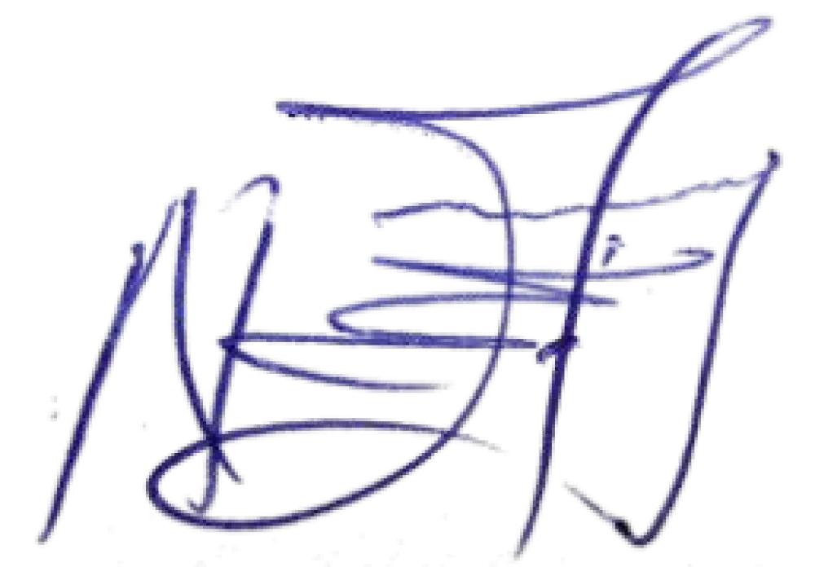 | Nejmudin k Bilal  OIC Representative
2 | WFP | El-Khidir Daloum | Representative and Country Director | 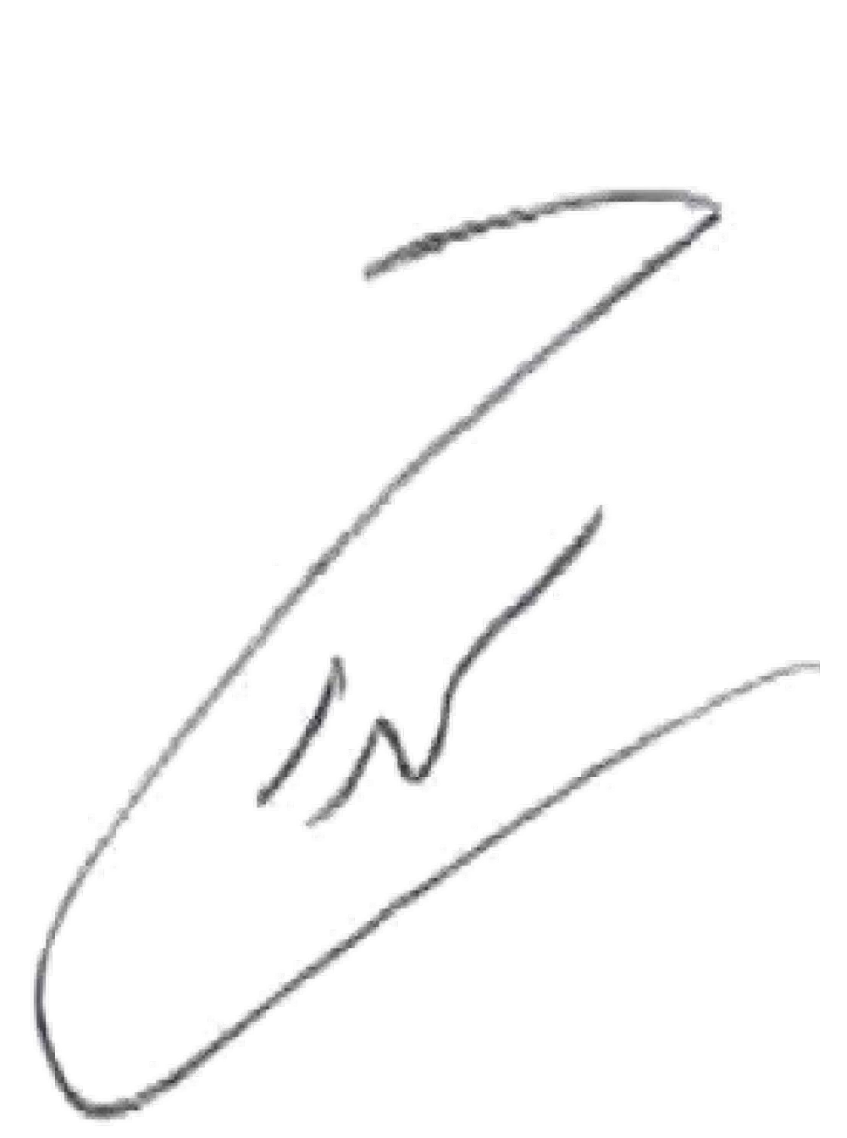  16.02.2022

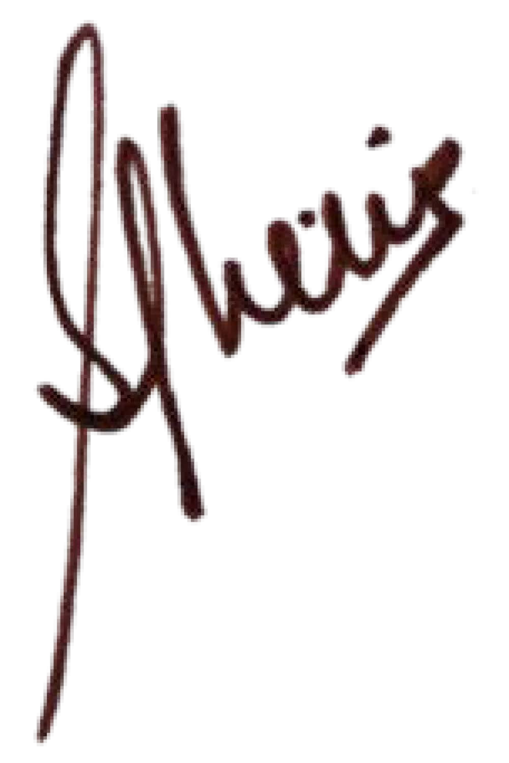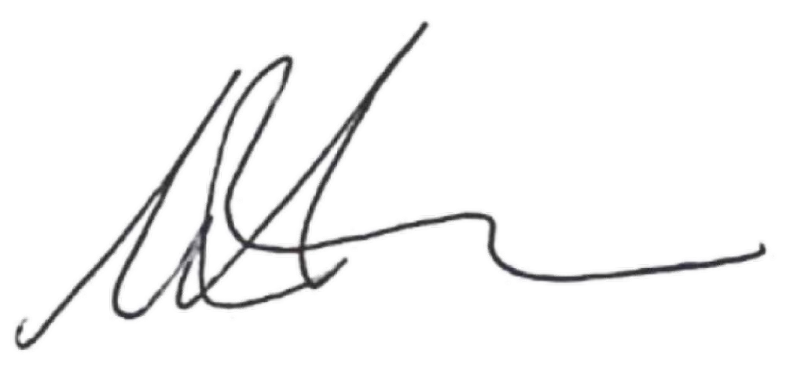

Section 1: Executive summary

Brief introduction to the project

The Joint Programme on Combatting Poverty and Vulnerability in Somalia through Social Protection was designed collaboratively between the Ministry and Labour and Social Affairs, (MoLSA)WFP and UNICEF. The main objective of the programme is to strengthen the federal and regional member states to build the foundational components of social protection system, to address the root causes of poverty and vulnerability and with a view to be shock responsive.
Phase 2 of the JP was drafted in 2018, at a time when humanitarian interventions still dominated the landscape of assistance to vulnerable populations in Somalia. Social protection interventions per se were still embryonic, with MoLSA at very initial stages of institutional foundations for social protection. Since then (and partly as a result of Phase 1), MoLSA has become the institutional lead in social protection sector. As a result, Phase 2 was reviewed and amended to fit the new reality of social protection in Somalia, with three outcomes: (i) Capacity of federal and regional institutions to implement the social protection policy and programming strengthened; (ii) Evidence on vulnerability to support the development of a national social protection system strengthened, and (iii) Usability of the Port of Kismayo augmented to enhance sustainable food systems.

Situation update / Context of the reporting period

At the political level, following a two-year political impasse over the proposed ‘one person, one vote’ model, the Lower
House of Parliament extended the mandate of the current Federal Government for another two years on 12 April 2021. However, the mandate extension has created political opposition from elites resulting to clashes of armed forces affiliated to the opposing political parties.

In addition, there was a reshuffle of the leadership of MoLSA at both the Ministerial and Director-General level. This change in leadership impacted the negotiation and consultation process for the rolling work-plan between UNICEF and MoLSA, resulting in some implementation delays.

Furthermore, Somalia is currently experiencing drought due to the cumulative effects of three consecutive belowaverage rainy seasons, severe water shortages and rising food prices. As of February 2022, about 4.3 million people now estimated to be affected (up from 3.2 million a month ago Additional funding for priority sectors is urgently required to save lives and livelihoods, including substantive and early funding for the 2022 Somalia Humanitarian Response Plan.
The MPTF fund has contributed to building MoLSA’s capacity by supporting key staff in the ministry. MoLSA has taken a strategic leadership role in the social protection sector by developing and establishing a government social protection working group, operationalized in 2021. The ministry continues to lead and coordinate Baxnaano, which covers 200,000 households (1.2 million individuals) in 21 districts. WFP currently implements cash transfers under component 1. Through additional financing, Baxnaano will extend assistance to current beneficiaries until 2023.
MoLSA, as the lead ministry, is preparing to gradually take over the implementation of the cash transfer component. The ministry has established a skeletal structure at the state level with two focal staff with social protection oversight roles. During the final year for MPTF II, MoLSA will receive additional support to undertake a technical review of the federal and state institutional capacity to gradually take over the national cash transfer. The social protection module to be included in the training curriculum of social workers will be finalized, with the aim of equipping this cadre of social workers with the relevant skills.

Highlights of the project during the reporting period

- With support from MPTF funds, the Banadir Regional Administration (BRA) has successfully gained the technical know-how in implementing cash transfers since April 2020, completing six cycles of transfers of US$35 per month each to 6,000 participants.
- The MPTF Fund allowed UNICEF to support the Somaliland Ministry of Employment, Social Affairs and Family
(MESAF) to develop its social protection policy through extensive consultation with all stakeholders. The
purpose of the Somaliland Social Protection Policy is to outline how Somaliland will incrementally build a National Social Protection System by 2030.
▪ The Joint programme is supporting and facilitating the development of the social protection module curriculum. The objective of this assignment is to develop the curriculum for the social protection module to be incorporated to the wider social work academic curriculum. This aims to equip social workers with the professional skills to implement social protection interventions.

Summary of key achievements during the reporting period

In 2021, cash transfers to selected households have been delivered by technically trained government staff of the BRA, using the WFP SCOPE system. BRA has successfully completed four cycles of quarterly transfers of US$35 per month to approximately 6,000 individual participants. Owing to the multiple shocks that the urban poor are currently experiencing with the COVID 19 impact on the local economy, increase prices of basic commodities and the evolving situation with the drought in Somalia, the target households have expressed that the continuous support received through the MPTF funds has stabilized food consumption and protected these households’ income generation as well as human assets. Importantly, the fund has also contributed towards strengthening the institutional capacity of the administrative authorities (BRA) to deliver cash transfers. This has strengthened the confidence of the civil servant’s capacity and has built the image of government as an active agent in the social development arena.
In collaboration with Save the Children, UNICEF supported the Somaliland Ministry of Employment, Social Affairs and Family (MESAF) to develop its social protection policy with technical assistance from Development Pathwayswith the purpose. The policy outlines how Somaliland will incrementally build a National Social Protection System by 2030. This document will form an integral part of the National Development Plan 2022-2030 (NDP III). The draft policy provides a pathway towards (1) targeting social protection interventions, throughout the life cycle approach, (2) identifying arrangements for effective implementation, (3) outlining the way forward for the effective monitoring and evaluation of future investments in social protection; and (4) making recommendations to build capacity on social protection within the Government of Somaliland. The draft policy was validated in a consultative forum on 22 December 2021.

Waayeel Consulting was commissioned to develop a social protection module curriculum, that will be incorporated to the wider social work academic curriculum for bachelor and diploma programmes. So far, the inception report was finalized.

The JP contributed to create a conducive working environment for staff to deliver social protection and other services to the general public, by supporting the rehabilitation of Ministry of Labour and Social Affairs South West State Office.

Section 2: Progress Report Results Matrix

OUTCOME STATEMENT
Outcome 1. Strengthening the capacity of federal and regional institutions to implement the social protection policy and programming
SUB-OUTCOME 1 STATEMENT
Strengthen the capacity of the Federal Government of Somalia, through the Ministry of Labour and Social Affairs
(MOLSA) and Regional Governments, to better understand vulnerability and to develop systems to manage data.
Output 1.1: JP Output 1.1. Strengthen the capacity of the Federal Government of Somalia, through the Ministry of Labour and Social Affairs (MOLSA) and the regional Governments to better understand vulnerability and to develop systems to manage data
INDICATOR | TARGET | PROGRESS ON OUTPUT INDICATOR
 |  | REPORTING PERIOD (YEAR) | CUMULATIVE
MoLSA staffing and operational capacity support provided. | 5 staff  2 staff | Jan to July 2021 Jan to Dec 2021 | 5
‘Transition readiness’ study support provided to MoLSA to take over direct cash management from WFP. | 1 study  commissioned by MoLSA | Oct 2021 to Jan 2022 | 1 study
Output 1.2 : Strengthen the capacity of the Banadir Regional Administration (BRA) to administer safety nets
Staff and equipment for cash transfers | 7 staff and  SCOPE | Jan – Dec 2021 | 7
$35 per month per household, paid every quarter | 1000 households | 4 quarter transfers | 4 quarter transfers
SUB-OUTCOME 2 STATEMENT
Support provided to Institutionalization of social protection
Output 2.2: Support is provided to the development of Somaliland Social Protection Policy
At least one meeting of the Social Protection  Working Group (SPWG) held | At least one meeting of the SPWG held | Convened Quarterly  SPWG meeting | Four SPWG meetings were organized.
Somaliland Social Protection Policy drafted | Somaliland SP policy drafted | Somaliland social protection policy drafted. | Somaliland SP policy  has been formulated in consultation with all stakeholders. The draft policy was validated with concerned stakeholders.
Output 2.3: Capacity to design and implement social protection schemes is strengthened
Social protection module developed for the professional training of social workers | Social  Protection Module developed | Preliminary  consultation meetings on the development of the social protection module curriculum were organized. The meeting identified the first year and semester 1 or 2 as relevant timings for the social protection module. Preparations for the outsourcing of a consultancy firm to undertake the assignment is under process. | Preliminary consultation meetings on the development of social protection module curricular organized. The meeting identified the first year and semester 1 or 2 as relevant timing for the social protection module. Preparations for the outsourcing of a consultancy firm to undertake the assignment is under process.

Section 3: Narrative reporting on results

Progress towards outcomes

OUTCOME STATEMENT
Strengthen the capacity of federal and regional institutions to implement the social protection policy and programming

OUTCOME 1: Strengthen the capacity of the Federal Government of Somalia, through the Ministry of Labour and Social Affairs (MOLSA) and Regional Governments, to better understand vulnerability and to develop systems to manage data (by WFP)

Output 1.1. Strengthen the capacity of the Federal Government of Somalia, through the Ministry of Labour and Social Affairs (MOLSA) and Regional Governments, to better understand vulnerability and to develop systems to manage data
Output 1.2. Strengthen the capacity of the Banadir Regional Administration (BRA) to administer safety nets

The MPTF funding strengthened the capacity of the Federal Government, through the Ministry of Labour and Social Affairs (MoLSA) over the funding period. The initial support by the fund enabled the Social Protection policy to be developed and disseminated through a well staffed institution. After the bombing of the MoLSA offices, the fund helped the government to refurbish and establish their offices. At the subnational level the fund has played an innovative role of building the capacity of the Banadir Regional Administration (BRA) to implement the cash transfer in the urban context for 1000 households.

OUTCOME 2: Support provided to Institutionalization of social protection (by UNICEF)

Output 2.1. The National Social Protection Policy is disseminated at FMS level
Output 2.2. Support is provided to the development of Somaliland Social Protection Policy
Output 2.3. Capacity to design and implement social protection schemes is strengthened
Output 2.4. Working conditions for FMS staff in charge of social protection are improved.

In collaboration with Save the Children, UNICEF supported the Somaliland Ministry of Employment, Social Affairs and Family (MESAF) to draft the social protection Policy. The purpose of the Policy is to outline how Somaliland will incrementally build a National Social Protection System by 2030. This document will form an integral part of the Third National Development Plan (NDP III) 2022-2030. Furthermore, UNICEF supported MESAF to convene a quarterly social protection technical working group meeting. The working group provides a useful platform for MESAF to take strategic leadership, coordination and oversight role for all interventions ongoing and to provide strategic guidance and inputs into social protection policy formulation.
A qualified social workforce is a critical element of a well-functioning social protection system. However, the social work training curriculum in its current form does not equip students with social protection knowledge and skills. In 2021, UNICEF commissioned Waayeel Consulting to develop a social protection module curriculum to address this challenge. Indeed, etc. The inception phase of the assignment is completed. Field data collection and data analysis is ongoing, and the process is expected to be completed before mid-March 2022.

Furthermore, as part of strengthening social protection capacities at sub-national level, the MPFT funds supported rehabilitation of Ministry of Labour and Social Affairs South West State Office.

Section 4: Project implementation

COVID 19 Response

COVID-19 pandemic significantly impacted the progress of the project initially. Project interventions experienced some delays introducing measures to mitigate the spread of the infection and safely carry out the activities. WFP supported and guided BRA staff to ensure hygienic practices and social distancing were immediately introduced in the project's

roll-out. In addition, SCOPE equipment usage and managing public gathering protocols were introduced. One of the key lessons learned is that all government officials were able to adapt to the online meeting option as a new normal. Government staff and United Nations agencies could engage in meetings and conduct online training to ensure that field activities can continue adhering to social distancing and prevention protocols. Furthermore, as COVID-19 risk mitigation measure, the work from home protocol continued, and all meetings were held online.

Key constraints and challenges and associated corrective actions
The key challenge during the reporting period has been in relation to the COVID 19 pandemic and more recently with the drought situation, Banadir is receiving an increasing number of IDPs. The project is unable to scale up response to meet the need owing to lack or resources.

Risk management
Type of risk | Description of risk | Mitigating measures
COVID 19 prevention | Ensure all prevention protocol is followed during registration and follow up | Equipment and information provided to BRA staff
Limited direct supervision | Unable to take field visits and monitoring | Use of remote monitoring during peak of COVID 19; resume through local staff once restrictions are eased.

Learning impact
The Post distribution monitoring reports (PDM) reports have been internalized and discussed with BRA on the key learnings from the project. The Urban Safety Nets model is being documented and fund raising undertaken to scale up implementation. The institutional arrangements were successful and will be tested to scale up withing Banadir and other urban centers. With additional resources, studies are being commissioned to understand the experience of participants in the cash transfer, building pathways toward digital financial inclusion. The next phase of cash transfers will also include design features to prepare eligible households towards ‘Transition readiness’ from cash transfers.

Coordination with other UN entities including UNSOM/UNSOS within and outside the SJF portfolio

Implementation of the joint programme happened concomitantly with two other major social protection programmes in Somalia, namely the Shock-Responsive Safety Nets Projects (SNHCP) and the Joint Programme: Toward Somali-led Transition to Social Protection Systems. Since UNICEF and WFP are implementing agencies for the three programmes, they made sure that this JP is not redundant with the two others. There were regular updates from the two agencies to their partner co-implementing the two other programmes, precisely to avoid duplication and redundancy.

Role of the UN Somalia Joint Fund
MPTF supported initiatives were the first of its kind in the country which helped the setting up of an initial social safety net unit and development of the Social Protection policy which contributed towards UNSJF portfolio. MPTF continues to support the building of the national safety nets as well as regional safety net initiatives. This role has greatly cemented the Government’s capacity to engage with much larger players such as the World Bank to take the safety net initiatives to scale. In addition, supporting BRA implement an urban safety net is contributing towards implementation capacity of government.

Synergies with other funds (UN and non-UN) working on similar issues

This programme complements the national safety nets intervention with technical inputs, which has seveal key players such as the World Bank, other key ministries and donors investing in the core cost of implementing safety nets. In the Banadir regional administration, MPTF funded urban safety nets was complemented by ECHO funding to respond to shock through a vertical top-up to target 1000 beneficiaries This urban safety net model is being tested at a small scale and has potential for scale-up in Mogadishu and other cities with a similar context.
In addition, WFP, in partnership with Gates Foundation, is supporting the national and regional cash transfers to explore and expand financial inclusion, with special emphasis on women’s economic empowerment. Furthermore, UNICEF under Baxnaano Programme is supporting establishment of key building blocks of a social protection delivery system that supports policy development, strengthens institutional capacity, and forms the foundation for a more comprehensive social protection system in Somalia.

Institutional capacity strengthening of Social protection in Somaliland benefited from the implementation of the Joint Programme Toward Somali-led Transition to National Social protection Systems, whereby MESAF staff systematically participated in trainings, exposure visits and study tours organized within the framework of that programme.

Partnerships
The urban safety net project was implemented by the Government- Ministry of Labour and Social Affairs, Banadir Regional Administration under the supervision of MoLSA. The cash transfers were made possible through a private sector cash payment service provider– Hormmud; In addition, through the Bill and Melinda Gates foundation two pieces of research are being currently undertaken on Digital financial Inclusion and women’s economic empowerment, ICRISAT on research related to ‘Transition readiness’. As the government lacks the fiscal space to fund safety nets the operational learning will provide the ability for the government to scale up safety net intervention if funding permits.

Monitoring and oversight activities
Monitoring activity | Date | Description | Comments  & Recommendations
Field monitoring visit of urban safety net | May 2021 | Post distribution monitoring PDM of Urban safety nets. 37 BRA households were also monitored with other urban safety net interventions. | Most of the households (67 percent) recorded acceptable food consumption score in the first quarter of 2021 owing to cash transfers. However due to multiple shocks the target households continue to show negative coping, by engaging in emergency strategies that deplete assets, decrease production and reduce human capital sustained  at 38 percent of all households monitored under the PDM.
DIM audit
Independent evaluation
Engineering site visit
Stakeholder review consultation

Communication activities

Section 5: Project management

Number of project board meetings held | None.
Number of UN staff (international/national) funded by the project | None.
Number of government personnel funded by the project? What are their functions and where do they work? | MoLSA 2 staff (Jan-Dec), and 5 staff & 3 interns from (Jan- June); BRA- 7 staff (Jan-Mar); 2 staff (Jan – Dec)
How has the project ensured the visibility of SJF donors during the reporting period? | Nothing significant to report.
Projected funding needs for next year | N/A. The project is coming to an end in April 2022.

Section 6: Cross-cutting issues

Gender equality and women empowerment

The MPTF fund has supported the cash transfers to households but through additional funding from the Gates foundation, BRA is being supported to improve the digital financial inclusion and women’s economic empowerment. Specific studies on Women’s User Journey analysis and Gender analysis of digital financial inclusion will help further improve on cash transfers being an entry pathway to diverse financial services.

Proportion of gender specific outputs in the project  <Outputs designed to directly and explicitly contribute to the promotion of gender equality and women empowerment> | Total number of project outputs | Total number of  gender specific outputs
 | None | None
Proportion of project staff with responsibility for gender issues <All Staff members contracted to undertaken work for the Joint Programme who have gender  related activities included in their terms of reference> | Total number of staff | Total number of staff with responsibility for gender issues
 | 4 staff | 2 staff with cross cutting responsibility of gender issues.

Human-rights based approach
 | Has the programme included a protection risk assessment in its context analysis, including on gender issues, and taken measures to mitigate these risks to ensure they are not exacerbated, or new risks created? | Result
 |  | No
 | Number of programme outputs specifically designed to address specific protection concerns | Result
 |  | No
 | Number pf programme outputs designed to build capacity of duty bearers to fulfil their human rights obligations towards rights holders. | Result
Output 2.3. Capacity to design and implement social protection schemes is strengthened

The two activities under this output precisely aim at building the capacity of duty bearers (government staff
and social workers) to fulfil their human right obligations towards right holders, who are Somali citizens that should enjoy their right to social protection.

Leave no one behind
Addressing the basic principles of LNOB the project incorporated these aspects into the operationalization of the project. Support to households under the urban safety nets ensured that an objective targeting approach was used to identify and select households. This provided a document with clear targeting criteria for government to follow giving an objective tool to select the most vulnerable households and reduce exclusion from services. It is documented that IDPs form one of the poorest and discriminated groups in Somalia and hence were targeted. The geographical selection of the districts for the intervention through urban safety nets were purposefully selected based on the high numbers of IDPs residing in Hodan and Garasbaley, who were not receiving other assistance. BRA was also supported in 2020/21 with shock response intervention through vertical top up of the registered households by seeking additional financing from other sources.

Social contract and legitimacy
Support to the BRA government has helped improve the social contract with citizens where government is actively seen as a service provider. Each step of the safety net- from identification to verification and follow up has been implemented by the government. This has given government the visibility as a service delivery agent. As a service provider BRA has actively sought and addressed complaints received from households as well as has been at the forefront of resolving issues related to the IDPs in the camps.
Rehabilitation of the South West State Ministry in charge of social protection allowed government staff to enjoy better working conditions. At the same time, it restored government’s image and positioned the Ministry as an institution which is able to provide its staff members and user citizens with decent premises, thereby contributing to its legitimacy.
Humanitarian-development-peace nexus
In the triples nexus through this project is addressing the aspect of strengthening government institutional structures in one of the largest and fastest growing cities that receives a large influx of displaced populations. This capacity will help the municipal authority to provide a safe haven through their interactive and ground presence. Secondly, the investment through cash transfers will enable the municipal government to establish cash transfer systems that can be scaled up in times of need, resources allowing.

Environment and climate security
N/A

Prevention of corruption
Cash transfer participants are enrolled into the programme through an open and consultative manner. The local authorities through the Mayor and DCs are involved to ensure there is oversight to the enrollment of participants. Camp elders and local committees are engaged to ensure that the most needy are identified and selected into the programme. Cash transfers are made directly from WFP via Hormud mobile money service provider to the participants SIM card. WFP undertakes regular monitoring to ensure that information is verified by contacting the participant directly.
Project sustainability
The Project systems and structures are supported through external resources. The Banadir Municipal authorities lack the fiscal space to implement programmes or pay staff. Hence the project is unable to sustain itself beyond the life of the project. However, the cash transfer model implemented through BRA is an example that can be scaled and replicated across other municipalities. The transition to government funded programmes will require macro level economic structuring which is beyond the scope of this project.
# | Target group |  | Dates | Number of participants |  |  | Title of the training | Location of the training | Training provider
 | Ministry, District or UN staff | Others |  | M | F | Total
1 | NA | NA
2
3
4
5
6
7
8
9
10
Total number of participants

Section 7: Looking ahead: Focus on the future

Somalia is currently experiencing a worsening drought situation resulting in 2.6 million people – close to 22 per cent of the population in 66 out of 74 districts across the country, affected by drought and nearly 113,000 people displaced across the country. The situation has evolved following three consecutive failed rainy seasons and is at risk of a fourth consecutive underperforming rainy season in 2021. As most displaced families move to urban centers, Banadir is no exception with the influx of new IDPs reported to be arriving in need of basic services. Given that BRA is a key partner in the Durable Solutions Strategy and implementation of the unconditional cash transfer, the project will not only strengthen the role of government in undertaking social assistance projects but also establish a multisectoral initiative for other urban municipal authorities to adopt. BRA has the capacity to scale up the urban safety net model, to diversify from unconditional cash transfers to supporting livelihoods of displaced as well as the very poor host communities. As the funding has come to an end, BRA and WFP are jointly seeking additional resources to scale the project as well as diversify the government institutional capability to undertake safety nets.

The development of a curriculum for the Social Protection module that is currently underway will allow the improve the training curriculum of social workers in Somalia which is currently being implemented in six universities across Somalia and Somaliland. Filling this knowledge gap is very important since a qualified social workforce is a critical element of a well-functioning social protection system. Going forward, the social protection module will be rolled out in the six universities where the social workers training is already available and should enroll more students to build up a qualified social work workforce in Somalia.

Section 8: Human interest story: Voices from the field

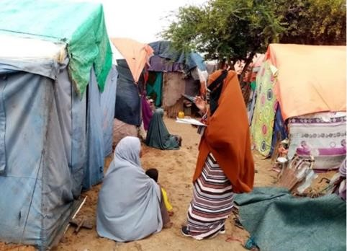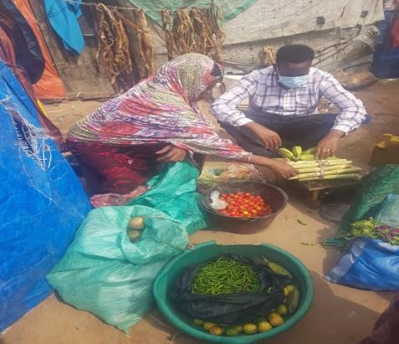
In April 2019, BRA signed a letter of understanding with WFP to assist BRA in developing its capacity to oversee
relief and development programs in Mogadishu, including WFP
-
supported programs of relief, nutrition,
livelihood
s, and safety nets and this pilot project aimed to support displacement affect community. BRA during
their survey of IDP camps enrolled Muumino
a

mother of 13 children. Mumino fled from also Janaale district,
Lower Shabelle region, from relentless heavy fi
ghting between government forces and Al
-
shabab groups. She told
me during the time of the interview that everything she had was destroyed in the ongoing war, which has lasted
almost a year in our district. After I was registered by BRA under
the USN projec
t I started a small vegetable vending business with
dollars with the first instalment
25
.

N
ow
the business has
grown
where

I manage to produce
an
income

to support my

family.

BRA staff during data collection. Photo: BRA Alas Ibrahim

-

https://reliefweb.int/report/somalia/somalia-drought-situation-report-no1-23-november-2021

