TITLE: WOMEN AND YOUTH IN GOVERNANCE, AND LEADERSHIP: factors inhibiting them and workable strategies.

SUMMARY
The Gambia is a multi-party democracy which conducts three main elections every five years: Presidential, Parliamentary and Local Government. The 1997 Constitution of The Gambia guarantees Gambian citizens Universal Adult Suffrage (i.e. the right to vote and be voted for). Women and young people constitute the majority of The Gambia’s population standing at 52% and 65% respectively. Unfortunately, this does not commensurate their level of participation, representation, and leadership in the country’s governance especially in terms of holding public office. In terms of political participation, women and youth tend to vote more than they contest for office. This inhibits their ability to assert their quest for their transformative change and development.

INTRODUCTION
Women and youth still continue to linger on the fringes of leadership particular in political, and public offices at both regional and national level. This pose concerns and questions on their empowerment; thus, deserving urgent attention so as to create the conducive environment for transformative change and development.
More women and youth vote in presidential elections (74.8%) than parliamentary and local government. The least voting happens under Local Government elections (44.1%). The reasons behind this disparity, as revealed during the focus group discussions and stakeholders’ consultations, are that the Presidential elections are more popularised. This suggests that there is low level of awareness/knowledge among women and youth on the existence (schedules) of parliamentary and local government elections. Other reasons are women and youth attach less importance to parliamentary and local government elections are that they do not feel truly represented by their representatives to address their development challenges. In fact, the findings showed that even though women and youth feel poorly represented by their elected representatives, they equally have limited knowledge on the mandates of parliamentarians an local government representatives. This is engendering their lack of interest in these elections. Transportation challenges on voting days, and women’s inability to reconcile their traditional marital roles/household chores equally prevent them from reaching polling centers prior to close of voting.
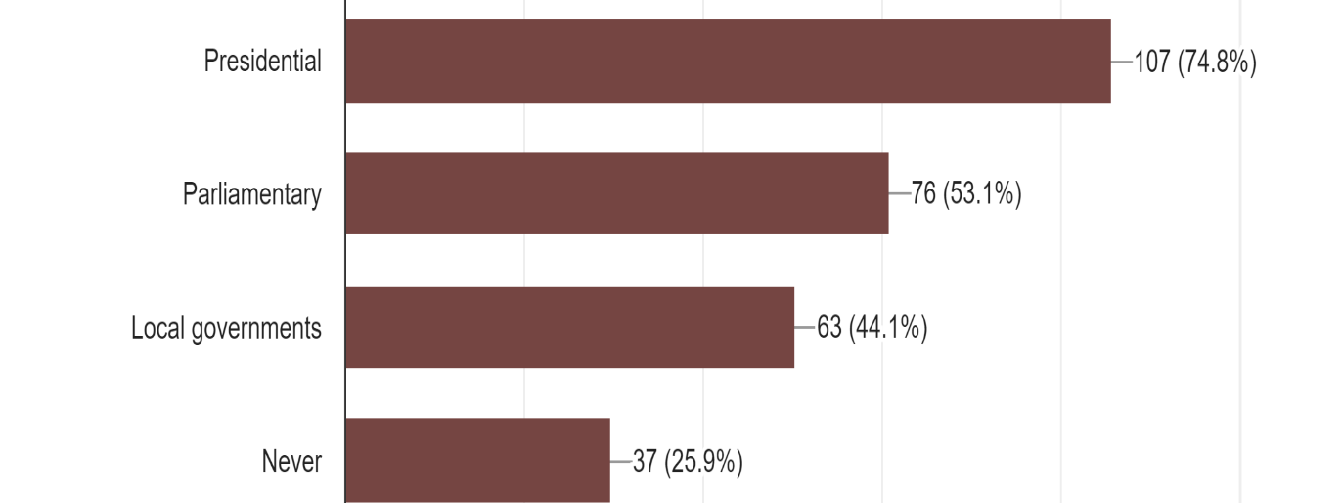
Voting level of women and youth.

The study also looked into the level of women and youth contesting for political office. It was astounding that 97.8% of the respondents reported that they have never contested in any of the three elections. And 32.6% of the respondents who reported that they have never contested in these elections are male while 67.3% are female. And of these total number of respondents, 65% are below 35 years while 34.9% are above 35 years. Although there is low level of women and youth participation in this regard, in terms of gender, women still represent the lowest. By age, the youth are still found at the lowest end of the ladder. The study explored the reasons behind these and found out women and youth are mostly barred from contesting for political offices due to lack of finance to fund their political activities, socio-cultural, and deformed religious norms and beliefs; and stereotypical ascriptions that these group of people do not make good leaders by virtue of age and gender weakness. The study further revealed considerable evidence that women are particularly disinterested in contesting for elections because of the patriarchal nature of most communities, their lack of self-belief, aspersions of harassment, and other forms of gender discriminations they are beset with.

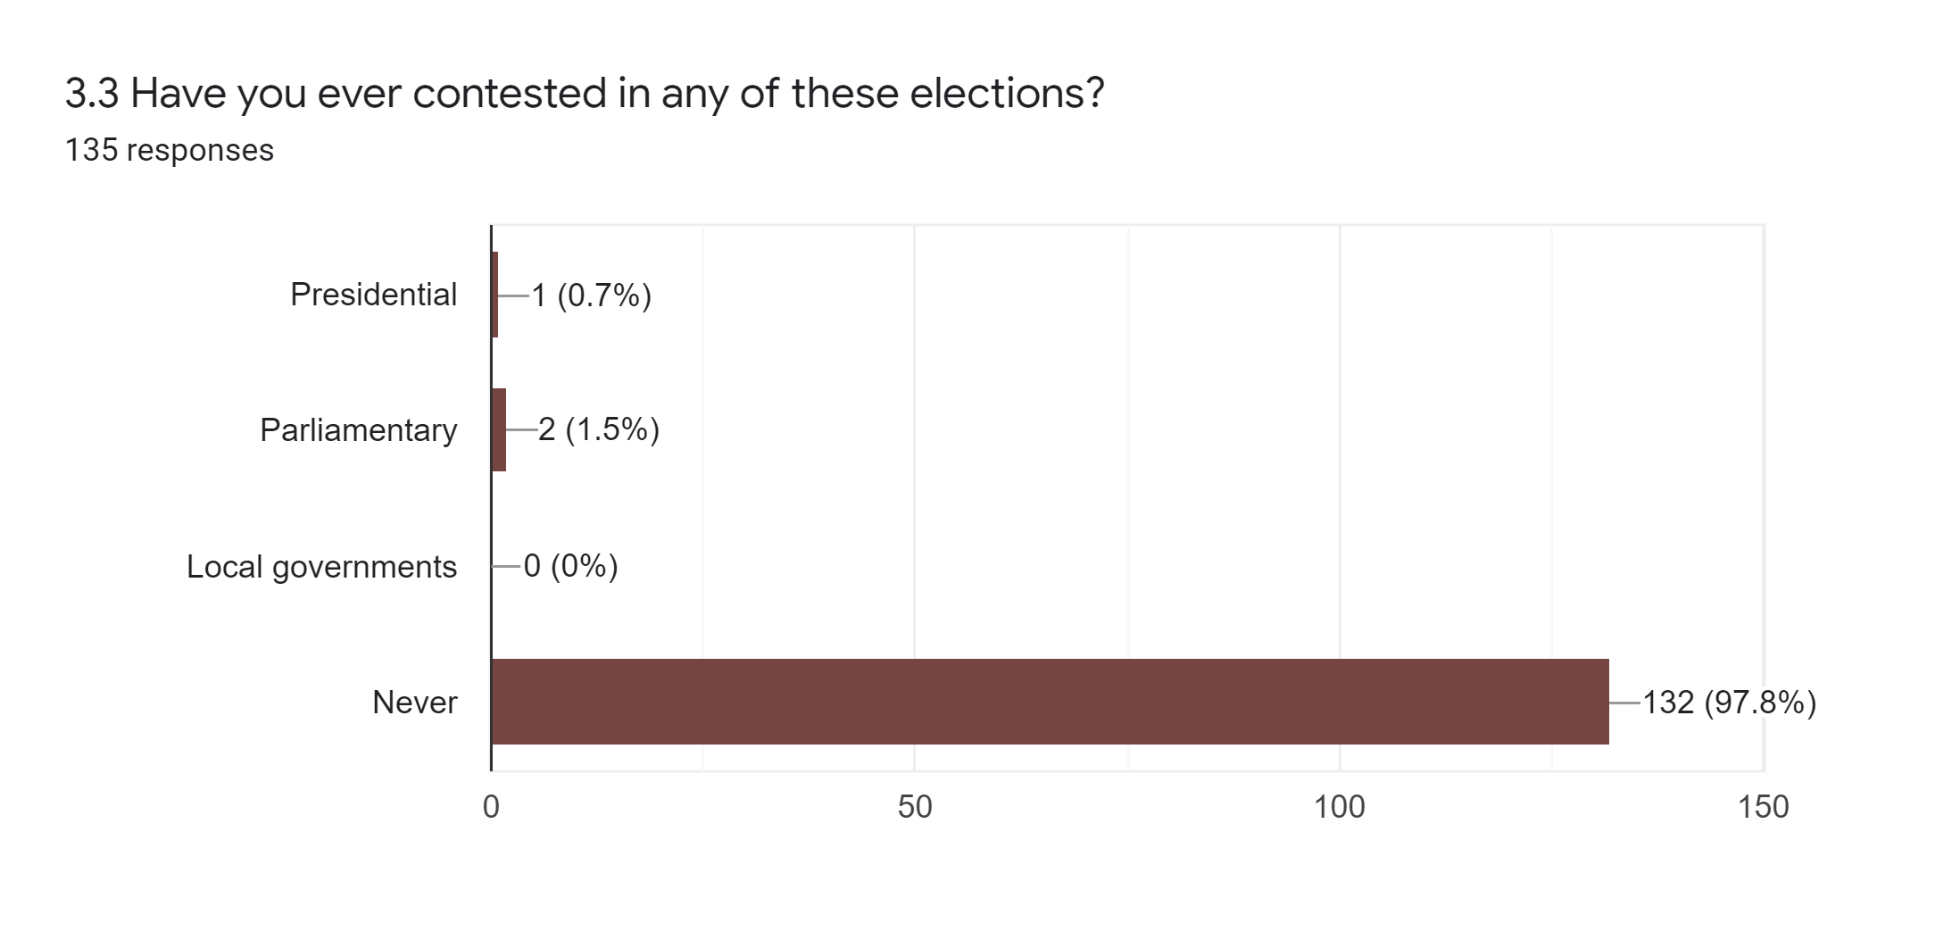

Level of women and youth contesting for political offices

Leadership & Decision-making

Women and youth leadership and decision-making powers are largely limited in the following institutions in their regions: Village Development Committees (VDCs), Civil Society Organisations (CSOs), Ward development Committees, State Owned Enterprises (SOEs), Political Parties, and Regional Youth Committees. The study revealed that 45.5% and 36.4% of the respondents have held or are holding leadership positions in their VDCs and CSOs respectively. And just 9.1% have held or are holding leadership positions in political parties. The reasons for this are generally similar to the ones stated in contest for political office. Women are mostly seen through the misconstrued view of lacking assertiveness and decision-making ability as opposed their male counterparts. Because leadership roles require these traits, which women are viewed to be lacking, they are usually not trusted to lead. Another prominent reason behind the limited women leadership in the said institutions is that they are mostly weigh down by their traditional reproductive role of child-bearing coupled with gender norms such as household/home-keeping duties.
Under RYCs, only youths were interviewed for this section. And only 9.1% of the youths reported that they have held or are holding leadership position in their RYCs. Although the RYCs are purely youth-led, during our FGDs, the major reported reasons why the youth do not have the opportunity to be part of the leadership of their RYCs are because they are not members of registered youth groups in their regions, and also do not attach much interest to attending the RYC Congresses during which the leadership of RYCs are elected.

RECOMMENDATIONS
- There is need for more civic engagements championed by civil society organisations and the National Council for Civic Education to increase civic education and awareness (especially in provincial Gambia) on the significance of parliamentary and local government elections, and the mandates of representatives in these offices.
- The Local Government Act should be popularised, and its contents made known to women and youth so as to enable know the processes involved in becoming a member of their VDCs and WDCs.

- SOEs should adopt, mainstream, and operationalise more gender sensitive policies that encourage affirmative actions.

- The length of work experience required to occupy a leadership position in SOEs are usually high and should be reduced by hiring institutions to allow youth in particular the opportunity to serve in such capacities.

- Civil society and advocacy groups should re-focus their strategies targeting to deconstruct certain socio-cultural/traditional reductionist beliefs against women and youth as unable to make good leaders. This should be complemented by intensive advocacy to encourage youth and women participation in politics and decision-making processes especially in their communities and regions.
- Increase training and mentorship programmes for women, adolescent girls, and youth on leadership.
- The government, through the ministries of education, to mainstream gender education as a subject area especially at the lower tiers of the country’s education system. This will facilitate transformative change of certain concept and beliefs against women.

- Political parties should promote more internal party democracy and create quota systems allowing women and youth to have the opportunity to take up higher leadership positions in political parties. This should be bolstered with the introduction of legislative frameworks requiring parties to practice such a systems.

