DRT-F Reporting template

DRT-F 2017 Annual report
Part A. Integrated UNCT report for 2017

- This report is to be prepared by RCO (or through other UNCT coordination mechanism for DRT-F) on the basis of information collected from lead persons for all DRT-F policy initiatives implemented in 2017.
  - It should be prepared after finalization of the individual reports in the format presented in Part B.
- Both final reports (A & Bs) should be submitted by DRT-F contact person to UN DOCO at the same time.

This report should include ONLY the update for 2017

Country | Ethiopia
Date of the report | September 2017
DRT-F contact person | Malambo Moonga, mmoonga@iom.int

1. Overview of DRT-F policy initiatives – only those implemented in 2017
Instruction: Complete one table per each policy initiative. Delivery rate refers to unaudited delivery rate by end of September 2016.

Policy initiative title |  | Counter Trafficking and Migration Policy and Practice in Ethiopia Joint Policy Initiative
Short title
UN Agencies involved |  | IOM, ILO, UNHCR and UNODC
Main national partners |  | Government of Ethiopia
Implementation period | 1 January 2017 to 30 September 2017 | Funding cycle |  | Total budget | USD 500,000.00 | Delivery rate

2. DRT-F Outcome Indicators – only for 1 Jan – 30 Sept 2017
Instruction: Complete for all policy initiatives in the same table (integrated for UNCT). Include only those outputs that were substantively funded by DRT-F.

2.1 Government plans / policies developed with UN policy support
Instruction for the column “Status: A. Implemented; B. Adopted; C. Submitted for adoption; D. Drafted; E. Ongoing drafting/consultations

In 2017
Short title of policy initiative | Title of the document | Brief description | Status

2.2 National legislation reflects greater compliance with international norms and standards linked to UN policy support

In 2017
Short title of policy initiative | Int’l norm / standard | Related national legislation | Brief, evidence-based, description of what was done

2.3 National policy informed through improved joint data collection and analysis done with UN policy support

In 2017
Short title of policy initiative | National policy | Brief, evidence-based, description of what was done
Counter Trafficking and Migration Policy and Practice in Ethiopia | Migration Profile for Ethiopia, key document to inform a future National Migration Policy (final draft finalized and validated at the technical level, currently awaiting validation at the political level) | Since the launch of the initiative to develop a Migration Profile by IOM in collaboration with the Government of Ethiopia (GoE), the initiative has benefitted from support by the UN Delivering Results Together Fund and contributed to sensitizing the key GoE offices on the concept of migration profiles and the three-phased approach, establishing a government-spearheaded Technical Working Group on the Migration Profile of which the members are drawn from a wide range of stakeholders with migration management mandates; and developing the first-ever Migration Profile Report for Ethiopia. The contents of this report were validated by the Technical Working Group on 30 May 2017 (Annex ).  At the validation meeting, the Technical Working Group for the Migration Profile decided that the document should be reviewed and endorsed at the political level as it would be helpful going forward into 2018 for the scheduled advocacy initiatives on the development of a National Migration Policy for Ethiopia.

4. DRT-F Qualitative Output Indicators – update for 1 Jan – 30 Sept 2017, only if new insights emerged
Instruction: Provide succinct description, indicating evidence (3-5 paragraphs for each question). For the final question – complete the table.
- The responses should refer to all DRT-F policy (integrated for the whole UNCT).

4.1 DRT-F contribution to strengthened UN focus on integrated policy support and capacity development of national partners

The DRT-F has allowed partner UN agencies to enhance their coordination, not only on the present initiative but also on other projects. We believe that having the UN speak with one voice has also increased the visibility of the UNCT. This experience has led the partner agencies to think about additional future joint interventions so that they can improve their coordination further.

4.2 DRT-F contribution to strengthened UN cohesion (coordination and collaboration within UNCT)

The implementation of the DRT-F funded project has led participating agencies to realize the extent of their coordination needs. Hence, they decided in July 2016 to establish a UN Migration Working Group that meets monthly and aims at discussing the implementation of joint projects and to share information relevant to all agencies working in the area of migration management. Membership of the Working Group was extended to all UN agencies having reported activities in migration management. This group will outlive the DRT-F implementation period. Hence, the DRT-F contributed to the establishment of a sustainable coordination platforms on migration issues among UN agencies.

4.3 Main challenges and lessons learned regarding DRT-F implementation

- Coordination to deliver results among multiple UN agencies is time intensive. This has led to delays in implementation of activities but, in the end, better coordination with UN partners has led to an increased impact.
- DRT-F funding is limited, joint resource mobilization could be improved. UN agencies, fund and programmes rely heavily on individual resource mobilization. There is also a number of non-UN actors working in the same areas. Coordination and cooperation is limited.

5. DRT-F Quantitative Output Indicators – update for 1 Jan – 30 Sept 2017
Instruction: Each table should include all policy initiatives (integrated for the whole UNCT).

Indicator | Total No. in 2017
Number of joint analytical studies, with recommendations for national policy and international norms and standards | 1
Number of legal drafts finalized and submitted for approval | 0

Annexes – only in 2017

A. Studies, reviews, and assessments supported by DRT-F
Short title of the policy initiative | Title of the document | Purpose of the document | Date finalized
Counter Trafficking and Migration Policy and Practice in Ethiopia | Migration Profile for Ethiopia | This document draws a picture of the state of play of migration in Ethiopia, including migration trends, impact and governance. It also includes recommendations for the GoE and its partners to effectively tackle migration related challenges, the first of which would be the development of a National Migration Policy. | 30 May 2017 (validated at the technical level)

B. Legal drafts supported by DRT-F
Short title of the policy initiative | Title of the legal act | Purpose of the document | Date finalized

C. Joint advocacy and dialogue initiatives supported by DRT-F

Short title of the policy initiative | Title of the initiative | Purpose of the initiative | Period

OPTIONAL annexes:
- Factsheet / Infographic
- Article on success story or innovation
- Blog entry on “bringing down the silos” (to be published in e.g. Silos Fighters)
- YouTube video on “success story” or “innovation”

DRT-F 2017 Annual report
Part B. Report on individual DRT-F Policy Initiatives in 2017

This report is to be prepared for each DRT-F policy initiative separate – by lead / contact person, in collaboration with the whole team (preferably at a reporting workshop)

This report should include ONLY the update for 2017

Country | Ethiopia
Date of the report | 30 September 2017
Title of the policy initiative | Counter Trafficking and Migration Policy and Practice in Ethiopia Joint Policy Initiative
Short title
Lead Agency & Contact person’s name | IOM: Mr. Malambo Moonga, mmoonga@iom.int  ILO: Mrs. Aida Awel, aida@ilo.org  UNODC: Maria Temesvari, maria.temesvari@unodc.org  UNHCR: Richelle Haines, haines@unhcr.org

1. Overview

Summary of Key Results Accomplished in 2017
IOM working in collaboration with the Government of Ethiopia, particularly the Technical Working Group for the Migration Profile established under this project, finalized and presented the Migration Profile Report for validation to the Technical Working Group. Upon its release, the report will be the main tool for advocacy for a National Migration Policy to be developed in 2018.
UNODC together with the Government of Ethiopia (Federal Attorney General’s office) promoted the development of a Witness Protection Programme in Ethiopia through a regional meeting in Eastern and Horn of Africa
In collaboration with the Ministry of Labour and Social Affairs, ILO deployed the Ethiopian Migrants Data Management System at federal level

2. Key Results in 2017
Instruction: Complete the table – one table for each key result.
- Use thematic policy focus from 2.1.
- Put the Number of SDG Targets only.
Explanations:
- RESULT: What happened?
- EXPLANATION: How did it happen?
- EVIDENCE: How do you know? (provide source)
- RELEVANCE: Why is it important?
- NEEDS/GAPS: What remains to be done?

Key Result No.1 | Development and validation of the first-ever Migration Profile Report for Ethiopia
Thematic policy focus | Migration governance |  | Related SDG targets | 10
Explanation | This initiative contributed to the GoE’s improvement of its migration governance framework, namely through the development of a migration profile for Ethiopia, which compiles important and comprehensive information on migrant trends, the impact of migration and on migration governance gaps in the country. Upon its release, the report will be the main tool for advocacy for a National Migration Policy to be developed in 2018.
Evidence | Relevance | Needs/Gaps
Final report validated at the technical level. | The document will serve as a foundation stone for the development of a National Migration Policy for Ethiopia. | - Need for support in building the GoE’s migration data management infrastructure including human resources;  - Need for support in implementing the recommendations contained in the MPR.

Key Result No.2 | Promoted the development of a Witness Protection programme in Ethiopia
Thematic policy focus | Human Rights, Governance, Migration |  | Related SDG targets | 16.6
Explanation | UNODC together with the Government of Ethiopia hosted a 2-day regional meeting from 25-26 September 2017 with the goal of promoting the development of a witness protection programme in Ethiopia.  Previously in 2010, Ethiopia enacted Witness Protection legislation which has not been implemented. With the assistance of UNODC, the Federal Attorney General of Ethiopia has been working on developing a framework for the implementation of the legislation and is creating a structure or agency.  In order to assist Federal Attorney General in operationalising the existing legislation on witness protection, UNODC brought together experts from the South African Office of Witness Protection, the Rwanda Witness Protection Unit and the Central Protection Service of Italy as well as representatives from Sudan, Djibouti and Somalia. The meeting aimed to strengthen cooperation and partnership between the Ethiopian Attorney General and its counterparts to exchange knowledge, best practices, and lessons learnt.  The meeting brought together extensive expertise in Ethiopia and forms part of an ongoing process by UNODC to guidance and inform the process of creating a functional witness protection programme in Ethiopia.
Evidence | Relevance | Needs/Gaps
Based on the lessons learnt during the workshop, Federal Attorney General’s Witness Protection Taskforce has drafted a proposal to set up a Witness Protection Programme in Ethiopia. The proposal will be presented to the Council for its approval. | Transnational organized and serious crime as well as trafficking in persons continues to pose serious threats to Eastern Africa. As such, effective criminal justice responses to these complex crimes often depend on the testimony of witnesses. In these kinds of cases, without reliable testimony provided by witnesses who are protected and kept safe, the chances of successful investigations and prosecutions are extremely low and often result in impunity.  There is also the need for regional and international cooperation – including through the protection of witness involving multiple jurisdictions – to effectively counter and disrupt transnational organized crime groups. | Need to further build and strengthen the capacity of officials in accordance with international standards, including the UNODC Good Practices in the Protection of Witnesses in Criminal Proceedings Involving Organized Crime, once the implementation of witness protection programme starts in Ethiopia.  This will require reviewing and strengthening legislative and institutional frameworks for witness protection, developing national policies with respect to witness protection, and strengthening capacities on early identification of vulnerable and intimidated witnesses through to management of witnesses which may involve permanent relocation and re-identification.

Key Result No.2 | Promoted the development of a Witness Protection programme in Ethiopia
Thematic policy focus | Human Rights, Governance, Migration |  | Related SDG targets | 16.6
Explanation | UNODC together with the Government of Ethiopia hosted a 2-day regional meeting from 25-26 September 2017 with the goal of promoting the development of a witness protection programme in Ethiopia.  Previously in 2010, Ethiopia enacted Witness Protection legislation which has not been implemented. With the assistance of UNODC, the Federal Attorney General of Ethiopia has been working on developing a framework for the implementation of the legislation and is creating a structure or agency.  In order to assist Federal Attorney General in operationalising the existing legislation on witness protection, UNODC brought together experts from the South African Office of Witness Protection, the Rwanda Witness Protection Unit and the Central Protection Service of Italy as well as representatives from Sudan, Djibouti and Somalia. The meeting aimed to strengthen cooperation and partnership between the Ethiopian Attorney General and its counterparts to exchange knowledge, best practices, and lessons learnt.  The meeting brought together extensive expertise in Ethiopia and forms part of an ongoing process by UNODC to guidance and inform the process of creating a functional witness protection programme in Ethiopia.
Evidence | Relevance | Needs/Gaps
Based on the lessons learnt during the workshop, Federal Attorney General’s Witness Protection Taskforce has drafted a proposal to set up a Witness Protection Programme in Ethiopia. The proposal will be presented to the Council for its approval. | Transnational organized and serious crime as well as trafficking in persons continues to pose serious threats to Eastern Africa. As such, effective criminal justice responses to these complex crimes often depend on the testimony of witnesses. In these kinds of cases, without reliable testimony provided by witnesses who are protected and kept safe, the chances of successful investigations and prosecutions are extremely low and often result in impunity.  There is also the need for regional and international cooperation – including through the protection of witness involving multiple jurisdictions – to effectively counter and disrupt transnational organized crime groups. | Need to further build and strengthen the capacity of officials in accordance with international standards, including the UNODC Good Practices in the Protection of Witnesses in Criminal Proceedings Involving Organized Crime, once the implementation of witness protection programme starts in Ethiopia.  This will require reviewing and strengthening legislative and institutional frameworks for witness protection, developing national policies with respect to witness protection, and strengthening capacities on early identification of vulnerable and intimidated witnesses through to management of witnesses which may involve permanent relocation and re-identification.

Key Result No.3 | In collaboration with the Ministry of Labour and Social Affairs, deployed the Ethiopian Migrants Data Management System (EMDMS) at federal level
Thematic policy focus | Migration |  | Related SDG targets
Explanation | Improved migrant data management system in Ethiopia. The project contributed to the development of the EMDMS in collaboration with ILO- EU funded project. In this regard, the ILO in collaboration with the MoLSA recruited LBS Solutions Cooperation’s’, a Philippines based system developers company, to develop a new, comprehensive, user-friendly, efficient and effective database system titled “Ethiopian Migrants Data Management System (EMDMS)” which is a decentralized migrant’s electronic registration software system that will record the end-to-end migration process of all Ethiopian migrants. The existing database system was critically reviewed so as to identify gaps and thereby design an improved and decentralized electronic migrant’s registration software system that will record the whole migration process of Ethiopian labour migrants.  The system was developed and benchmarked against existing systems with best experiences of labour sending countries such as the Philippines and India and following a thorough consultation on the needs, requirements and functionality of the system with MoLSA and BoLSA relevant staffs. In this regard, the project organized a briefing workshop to enable the developer carry out an in-depth requirement assessment so that it can design a user-friendly web based database system that functions seamlessly and efficiently at all levels. Furthermore, the project assisted the deployment of the system at federal level, ensured an accurate testing by the different departments in MoLSA namely the complaints department, the overseas employment contract approval department and the agency licensing department and organized a ToT training from 18-22 September 2017 for 32 IT experts and end users from MoLSA and BoLSA’s from the 4 Regional States (Amhara, Oromia, Tigray and SNNP regions) and the 2 City Administration (Dire Dawa and Addis Ababa).  The first three days of the training were dedicated for end users. Participants were provided hands on training on the use of the different control panel namely the main/MoLSA and Regional control panel, the licensed and unlicensed control panels, the migrants, embassy, immigration and stakeholder control panels. Whereas, the last two days were more technical trainings, where LBS provided a hands-on training to the IT focal on the process flow and the technical aspect of the system. During this training, participants found the database user-friendly and easy to adapt with the country context. In addition, these five days training helped to facilitate knowledge transfer and IT focal in MoLSA and the BoLSAs’ were able to grasp the development of the system.
Evidence | Relevance | Needs/Gaps
EMDMS is up and running at the Federal level | The system will provide the government better administrative records on the number of migrant workers leaving the country and returning, and will provide specific data on migrants’ gender, age, place of origin, country of destination, employers name and address, occupation, skill level, educational level etc. This system will contribute to the improvement of data on labour migration, better coordination among pertinent stakeholders as well as better protection of MDWs. | The system has been deployed at federal level, there is a need to also decentralize the system at regional level to enhance the coordination and follow up between the different regional BOLSAs and MoLSA.

3. Outputs and Activities in 2017
Instruction: Complete the tables – one table for each output.

3.1 Legislative changes

Output |  | Period
National partners
UN Agencies involved
Brief description of activities
Documents produced
Main events
Methods/Tools used
Comments

3.2 Advocacy and dialogue

Output | 4.2. Government officials and the private employment agencies have improved knowledge and understanding on labour migration management and irregular migration needs. | Period | 2017
National partners | Ministry of Labour and Social Affairs
UN Agencies involved | ILO
Brief description of activities | Relevant stakeholders sensitized on the National Employment Policy and Strategy (NEPS) in Ethiopia. The policy address one of the critical preventive measure for migration, which is Employment. The NEPS was developed to ensure that all citizens in the country have equal opportunity for productive and decent employment. The project supported MoLSA in the sensitization of the National Employment Policy & Strategy. The NEPS was endorsed by the Council of Ministers of the Federal Democratic Republic of Ethiopia, in its 12th ordinary meeting held on April 28, 2016.  This policy and strategy document promotes the creation of productive and equitable employment opportunities in the country by considering the interlinkage between human resource development and employment related policies and strategies, improves labour market related information and services, by improving industrial peace, and upholds the conduction of periodical labour market and employment related assessments. Furthermore, it also addresses issue of protection to labour migrants and proposes decent work and employment as a preventive measure for irregular migration.
Documents produced | National Employment Policy and Strategy in Ethiopia
Main events
Methods/Tools used | Sensitization
Comments

3.3 Reporting on international normative standards / conventions

Output |  | Period
National partners
UN Agencies involved
Brief description of activities
Documents produced
Main events
Methods/Tools used
Comments

3.4 Assessments and studies

Output | 1.2. Produce a Migration Profile for Ethiopia | Period | 1 January to 30 September 2017
National partners | Technical Working Group for the Migration Profile
UN Agencies involved | IOM (lead), ILO, UNHCR, UNODC
Brief description of activities | Various consultations were held to discuss the challenges posed by unmanaged migration from and into the country and the way forward as well as to follow up on the progress of the migration profile initiative. This gave the opportunity for IOM to advocate for a Migration Policy to be developed by GoE.
Documents produced | Migration Profile Report for Ethiopia
Main events | Validation Workshop for the Migration Profile for Ethiopia
Methods/Tools used | Validation workshop
Comments

Output | 3.1. Conduct labour market and livelihoods assessments report produced for both refugee and Ethiopian communities to inform targeted livelihoods reintegration support | Period | 2017
National partners | Ministry of Labour and Social Affairs and Bureau of Labour and Social Affairs in the 3 National Regional States (Tigray, Amhara, Oromia)
UN Agencies involved | ILO
Brief description of activities | Enhanced understanding of sectors with potential to absorb returnees and other potential migrants. The project published a Rapid Market assessment for six sectors in 3 National Regional States namely Tigray, Amhara and Oromia. The report identified value chains with the highest potential to provide employment and income generating activity for returnees and potential migrants, indicated key constraints and suggested ways forward for future programming.
Documents produced | Rapid market assessment on 6 sectors: Agro-processing, Construction Materials, Livestock Fattening, Poultry, Textiles and Garments and Urban Agriculture
Main events | Published and disseminated in August 2017
Methods/Tools used | A detailed research proposal was developed for a better understanding of the assessment goals and needs. Following the proposal a sector setting selection criteria was developed around 3 clusters (relevance to the target group, opportunities to create inclusive growth and feasibility to intervene). Furthermore, a scoping and sector long listing was considered following document reviews of secondary data. Finally sector shortlisting was undertaken.  A participatory and consultative approach was employed in conducting the assessment. Key stakeholders were identified and consulted at federal and local government levels.
Comments

3.5. Campaigns and promotional activities (including brochures/booklets)

Output | 3.1. Conduct labour market and livelihoods assessments report produced for both refugee and Ethiopian communities to inform targeted livelihoods reintegration support | Period | 24-28 April 2017
National partners
UN Agencies involved | ILO
Brief description of activities | Enhance knowledge through publicizing and disseminating research and assessment conducted. The project in collaboration with other ILO LM projects publicized and disseminated the market assessment and other publication on labour migration in Regional Forum. The different reports conducted with this project as well as other ILO Migration projects were exhibited during the second session of the specialized technical committee on Social Development, Labour and Employment (STC-SDLE-2) organized by African Union Commission, Social Affairs Department, in Algiers, Algeria from 24-28 April 2017. With a theme on “Investment in Employment and Social Security for Harnessing the Demographic Dividend” and a side event on Labour Migration. Tripartite participants from various countries in Africa attended the forum and the projects was able to showcase its achievements and provide accurate and up to date information on the dynamics of migration in Ethiopia.
Documents produced | Published and disseminated the following:  - Pre-departure training manual,  - Information guide for domestic migrant workers,  - Comprehensive analysis of the Ethiopian Overseas Employment Proclamation No. 923-2016,  - Analysis of implications of work related vulnerabilities of Migrant Domestic Workers working in Lebanon,  - Migration, forced labour and trafficking of workers from selected regions of Ethiopia
Main events | Second session of the specialized technical committee on Social Development, Labour and Employment (STC-SDLE-2)
Methods/Tools used | All materials developed were exhibited
Comments

3.6 Capacity development (training, organizational change, other)

Output | 2.2. Provide capacity-building to government and other service providers for the provision of protection services to particularly vulnerable migrants and refugees | Period | April-June 2017  were conducted under output 2.2.
National partners | GoE, civil society
UN Agencies involved | IOM
Brief description of activities | IOM trained a total of 31 participants on provision of protection services to particularly vulnerable migrants and refugees, the impact of these trainings will be assessed and reported on in the final report. With regards to the trainings, the first session was conducted in Axum, Tigray Regional State, from April 10-12, 2017 (Image 1). The training covered topics such as assistance to victims of sexual and gender based violence (SGBV), victims of trafficking (VoTs), child protection. 17 participants (1 female and 16 male) attended the training. The participants were drawn from the following government offices: the Administration for Refugee and Returnee Affairs (ARRA), Office of Justice, local court, law enforcement, Office of Youth and Sports, Office of Women and Children Affairs, and various woreda administrations (Tselemt, Tehatay Adyabo (Shiraro), Shire, A/Tsmbla).  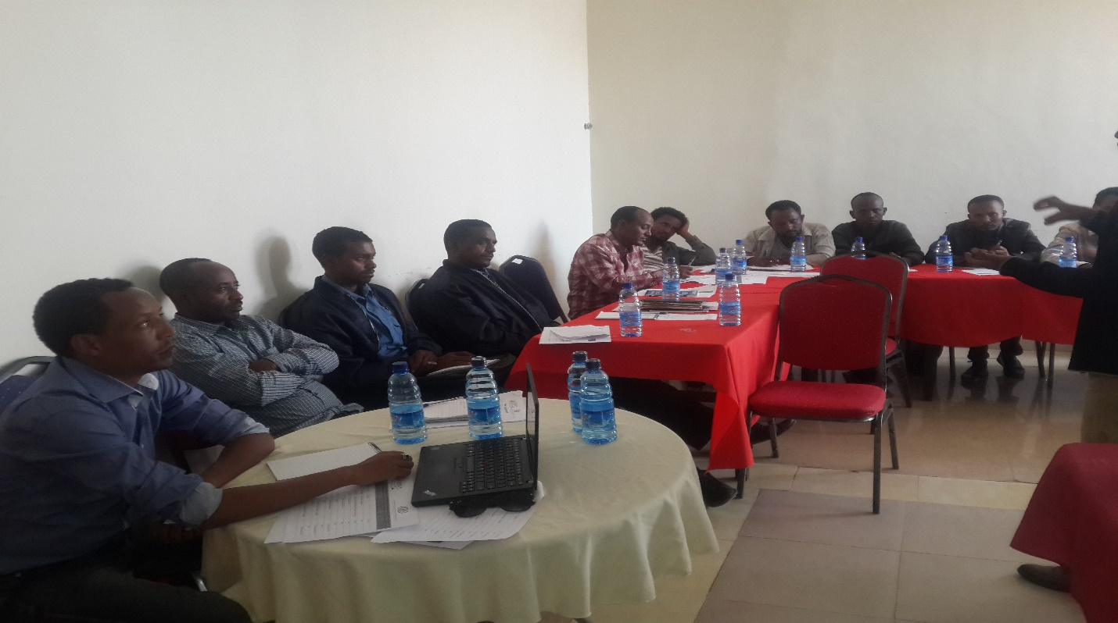  Image 1: Participants attending training session in Axum, April 10th, 2017, Axum, (IOM)  The second training session under this output was conducted in Gambela town, Gambela Regional State, from June 13-15, 2017 and 14 participants (9 male and 5 female) attended the training (Image 2). The training covered topics such as child protection, collaboration and coordination among stakeholders, including through referral mechanisms, introduction to the Proclamation on the Prevention and Suppression of Trafficking in Persons (TiP) and Smuggling of Migrants (SoM) (No. 909/2015). Participants mainly originated from woreda Disaster Risk Management bureau, Bureau of Youth and Sports, Bureau of Women and Children Affairs, local courts and law enforcement.  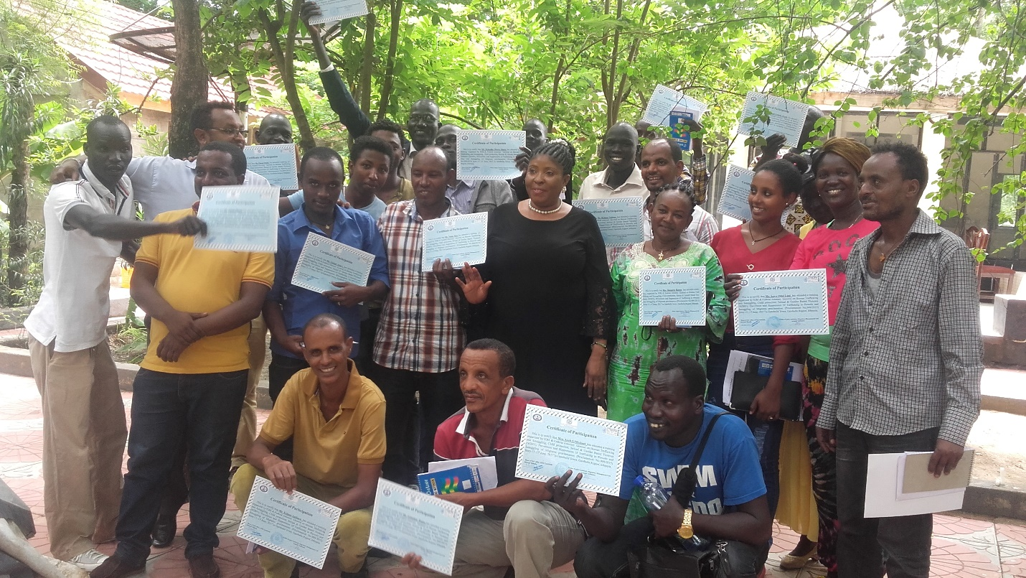  Image 2: Training participants holding their certificates, June 15th, 2017, Gambela town (IOM)
Documents produced | N/A
Main events | Two training sessions on provision of protective services to particularly vulnerable migrants and refugees
Methods/Tools used | Training workshop
Comments

Output | 2.3. Provide technical assistance on implementation of trafficking laws/relevant legal provisions | Period | 2017
National partners | GoE/ARRA
UN Agencies involved | UNHCR
Brief description of activities | In June of 2017, UNHCR Shire, jointly with ARRA staff undertook detention monitoring visits within Tigray Regional State. During the monitoring, it was noted that would-be asylum seekers were being charged with immigration-related offences upon seeking entry into asylum territory. Therefore, advocacy on the principles of international protection, together with an understanding of mixed migration, is required to sensitize law enforcement on the plight of asylum seekers including those returning for a second time from their country of origin.  In November of 2017, UNHCR will host two trainings for government officials, including the Federal Police Commission and other relevant stakeholders in the selected locations of Tigray Regional State, and Somali Regional State, (Mekele and Jijigga, respectively) identified as high-risk areas for irregular migration, trafficking and smuggling, with high numbers of refugees in both locations.
Documents produced | Mission report, event report, attendance sheet, training materials.
Main events | See above
Methods/Tools used | Training
Comments | N/A

Output | 2.4. Provide training to criminal justice and law enforcement authorities as well as to immigration officers, border guards and airport staff for enhanced identification, investigation and prosecution of TiP and SoM cases | Period | May-August 2017
National partners | GoE (mentioned below)
UN Agencies involved | IOM
Brief description of activities | In May and August 2017, IOM trained a total of 77 through a series of trainings on victim-centred investigation techniques and prosecution of TiP cases to law enforcement authorities and criminal justice agencies. The impact of these trainings will be analysed and reported on in the final report. The first session was help in Adama town, Oromia Regional State from May 8th to 12th, 2017. 28 participants (1 female and 27 male) drawn from Justice Bureaus, Immigration Departments, the judiciary including the supreme court and the federal first instance court, law enforcement, police university colleges, Office of the Federal Attorney General and the media (ENN, EBS). These participants were drawn from the federal and regional levels and represented five Regional States namely: Afar, Amhara, Oromia, Southern Nations, Nationalities and Peoples’ (SNNP) and Tigray as well as 2 City Administrations namely Addis Ababa and Dire Dawa. In addition, participants from the Federal Ethiopian Police University College and from Amhara, Oromia, Tigray and SNNPR Regional Police Colleges (investigation and prosecution instructors) attended the training.  The second training session under this output was conducted in Adama town, Oromia Regional State from August 29th to 31st, 2017. 49 participants (47 male and 2 female) drawn from the judiciary, law enforcement, Prime Minister Office, Office of the Federal Attorney General and media (ENN TV, EBC) attended this session.  The topics covered under both these sessions included: background and introductory information on migration, TiP and SoM, introduction on the main components of Proclamation 909/2015 on the Prevention and Suppression of TiP and SoM, principles of intelligence gathering, SOPs on profiling and screening of VoTs and investigation of TiP-related crimes, witness and victim protection standards, identification and interviews of suspected/potential VoTs, assistance to VoTs፡ shelter, medical, legal, psychosocial support/counselling, vocational education, life skills, etc.
Documents produced | N/A
Main events | Two training sessions
Methods/Tools used | Training workshop
Comments

Output | 3.4. Conduct trainings of service providers and implementing partners | Period | September 28th and 29th, 2017
National partners | Technical Vocational Education and Training institutions, Micro and Small Enterprises (MSE) offices, Bureaus of Labour and Social Affairs, Ministry of Labour and Social Affairs (MoLSA) as well as Non-Governmental Organizations running shelters and providing rehabilitation support to VoTs.
UN Agencies involved | IOM
Brief description of activities | A two-day training was provided by IOM to 28 representatives (21 male, 7 female) from victim assistance service providers and implementing partners including Technical Vocational Education and Training institutions, Micro and Small Enterprises (MSE) offices, Bureaus of Labour and Social Affairs, Ministry of Labour and Social Affairs (MoLSA) as well as Non-Governmental Organizations running shelters and providing rehabilitation support to VoTs. The training session aimed at introducing them to standardized forms of VoT screening and identification and to referral procedures and standards in place. The training covered basic concepts related to TiP, security and personal safety issues, how to screen and identify VoTs, referral mechanisms and provision of reintegration assistance. The training further addressed shelter guidelines and health and TiP issues. In order to ensure sustainability of services and given their relevance to participants’ day-to-day activities, materials relevant to the training were shared with the trainees at the end of the training session. The knowledge gained is expected to contribute to enhancing the quality of service delivery to the beneficiaries, by allowing for standard procedures to be followed during identification and screening of returned migrants and for quality standards to be aligned on clear guidelines. Also, a case management system check list was developed by the participants to ensure standardization of the services offered by their respective organizations and to strengthen their documentation while providing assistance to VoTs and other vulnerable migrants.
Documents produced | Case Management System Checklist
Main events | Training workshop
Methods/Tools used | IOM VoT Screening forms and guidelines
Comments

Output | 4.1. National capacity to jointly respond to migration and security challenges, such as transnational organized crime is strengthened and upholds the human rights of migrants and refugees |  | September 2017
National partners | GoE, Main Department for Immigration and Nationality Affairs
UN Agencies involved | IOM
Brief description of activities | Under this output, IOM had initially planned to conduct training and capacity assessment in Togochale (Somali Regional State), one of the major border exit points for irregular migrants from Ethiopia (Eastern migratory route). Due to challenges linked with the deterioration of the security situation in this area, only the training part of this activity was conducted. The assessment part of this activity will be supported under other IOM projects. The training was conducted in Adama, Oromia Regional State from September 26th to 27th, 2017. The 15 participants (14 male, 1 female) were from the offices of justice and immigration bureaus (at head and expert level) of six major border entre/exit points for irregular migration of Ethiopians, namely Galafi (Afar Regional State), Togochale, Teferi Ber (Somali Regional State), Moyale (Oromia and Somali regional states), Metema (Amhara Regional State), and Humera (Tigray Regional State) (Image 3). The participants were introduced to the concepts of TiP and SoM as well as screening and identification of VoTs and other vulnerable migrants, action plan development. A representative from the Office of the Federal Attorney General introduced Ethiopia’s Immigration law. Moreover, the participants were sensitized on the instrumentality of border capacity assessments in building border management capacity for better managed migration. The key points which emerged from the discussion were the following:  - Necessity of cooperation with neighbouring countries in immigration and border management matters; this cooperation needs to be formalized through MoUs/SoPs;  - Absence of shelters dedicated to VoTs and other vulnerable migrants in border areas which leads to migrants being detained with suspected criminals; this can aggravate VoTs and other vulnerable migrants’ initial trauma and mental state.  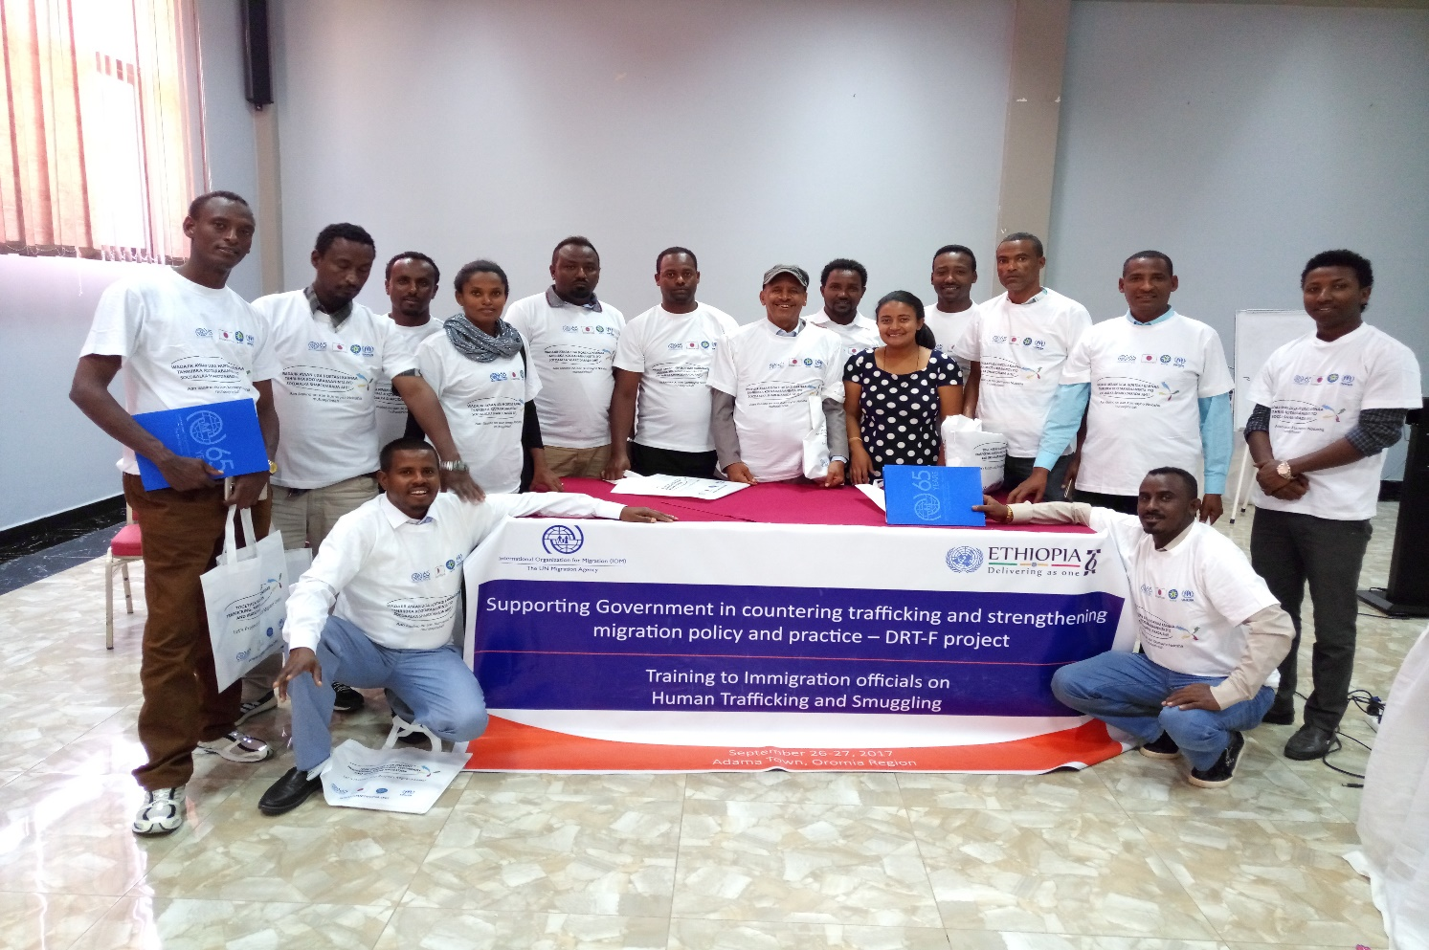  Image 3: Immigration Training Participants, September 27th, 2017, Adama (IOM
Documents produced
Main events | Training Workshop
Methods/Tools used
Comments | The number of migrants assisted at the EMRCs increased after training/sensitization session was provided to Immigration focal points in Adama under this project. This is due to the previous inexistence of a coordination mechanism and lack of awareness of Immigration about EMRC services.

Output | 4.1. National capacity to jointly respond to migration and security challenges, such as transnational organised crime is strengthened and upholds the human rights of migrants and refugees | Period | September 2017
National partners | Federal Attorney General of Ethiopia
UN Agencies involved | UNODC
Brief description of activities | (see above the Key Result no.1)
Documents produced | UNODC web story, attendance sheets, workshop presentations from various countries
Main events | High-level Regional Meeting on Witness Protection (25-26 Sep 2017)
Methods/Tools used | Workshop
Comments

Output | 4.2. Government officials and the private employment agencies have improved knowledge and understanding on labour migration management and irregular migration needs. | Period | 18-22 September 2017
National partners | Private employment agencies association and Overseas Employment Directorate from the Ministry of Labour and Social Affairs
UN Agencies involved | ILO
Brief description of activities | Enhanced capacity of Private employment agencies association and Ministry of Labour and Social Affairs on establishing fair recruitment process in Ethiopia. The project supported the participation of key officials from MoLSA and PEA association, namely the Director General for the Overseas Employment, the Director for Manpower Research and Employment Promotion and the Director for Overseas Employment Agencies’ Licensing, Inspection and Controlling Directorate and the President and the Director General of the Association to attend the “Establishing Fair Recruitment Processes” training held in ITC Turin from 18-22 September 2017. This training fostered the sharing of promising national and international recruitment practices that meet internationally recognized human rights and labour standards, enhance understanding among key actors of how to strengthen regulatory and enforcement mechanisms designed to address abusive and fraudulent recruitment practices and promote the dissemination of fair business standards and practices and of mechanisms for the empowerment and protection of workers. It covered a wide range of fair recruitment cross-cutting themes, such as international binding and non-binding instruments, impact of fair recruitment on the global supply chain and costs of labour migration. This training provided a very useful and practical exposure to fair recruitment and approaches to improving fair recruitment practices in Ethiopia.  Such capacity building is key to avoid abusive and fraudulent recruitment practices affecting migrant workers it helps to prevent human trafficking and forced labour, protect the rights of migrant workers and also it benefits stakeholders to reduce the cost of labour migration and enhance development outcomes for migrant workers and their families, in the destination as well as country of origin.
Documents produced
Main events | Establishing Fair Recruitment Processes training in Turin
Methods/Tools used | Participatory approach
Comments

Other relevant outputs

Output | 2.5. Strengthen cooperation between law enforcement, criminal justice authorities and victim assistance agencies. | Period | April-June 2017
National partners | GoE and civil society, see details below
UN Agencies involved | IOM
Brief description of activities | IOM, in collaboration with the Organization for Prevention, Rehabilitation and Integration of Female Street Children (OPFRIS) and Good Samaritan Association (GSA), local NGOs providing assistance to VoTs and other victimized migrants, conducted a series of training workshops aimed at strengthening cooperation between law enforcement, criminal justice authorities and victim assistance agencies and the impact of these trainings will be reported on in the final report.  The first session took place in Wereta town, Amhara Regional State, from April 25th to 27th, 2017 (Image 4 and 5). The participants were drawn from the justice and education sectors including high schools, Office of Youth and Sports, Office of Women and Children Affairs, supreme court, Ministry and Regional Bureau of Labour and Social Affairs, law enforcement, Office of the Attorney General and the Forum on Sustainable Child Empowerment (FSCE), a local NGO.  The second session was conducted from June 20th to 22nd, 2017 in Wereta town, Amhara Regional State. 40 participants attended the training (28 male and 12 female) and originated from the Amhara Bureau of Labour and Social Affairs, government and private universities (Bahir Dar and Rift Valley), GSA (local NGO), high schools, office of the federal attorney general, regional communications office, returnees, technical and vocational training institutions, the judiciary and the local youth federation.  Both these sessions aimed at fostering dialogue among law enforcement, criminal justice authorities and victim assistance agencies in order to harmonize approaches and assistance to VoTs and other vulnerable migrants. Representatives from the aforementioned agencies discussed the best practices and challenges observed in their daily work pertaining to assistance to VoTs and other vulnerable migrants and devised ways to improve the current situation (Image 5).  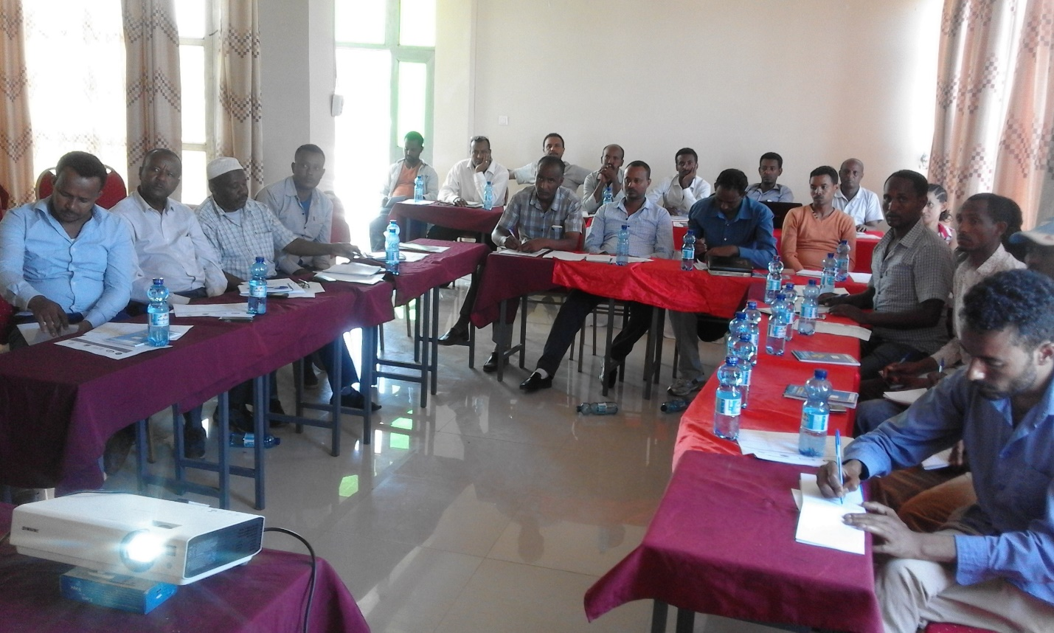  Image 4: Participants attending training session in Wereta, April 25th, 2017, Wereta (IOM)  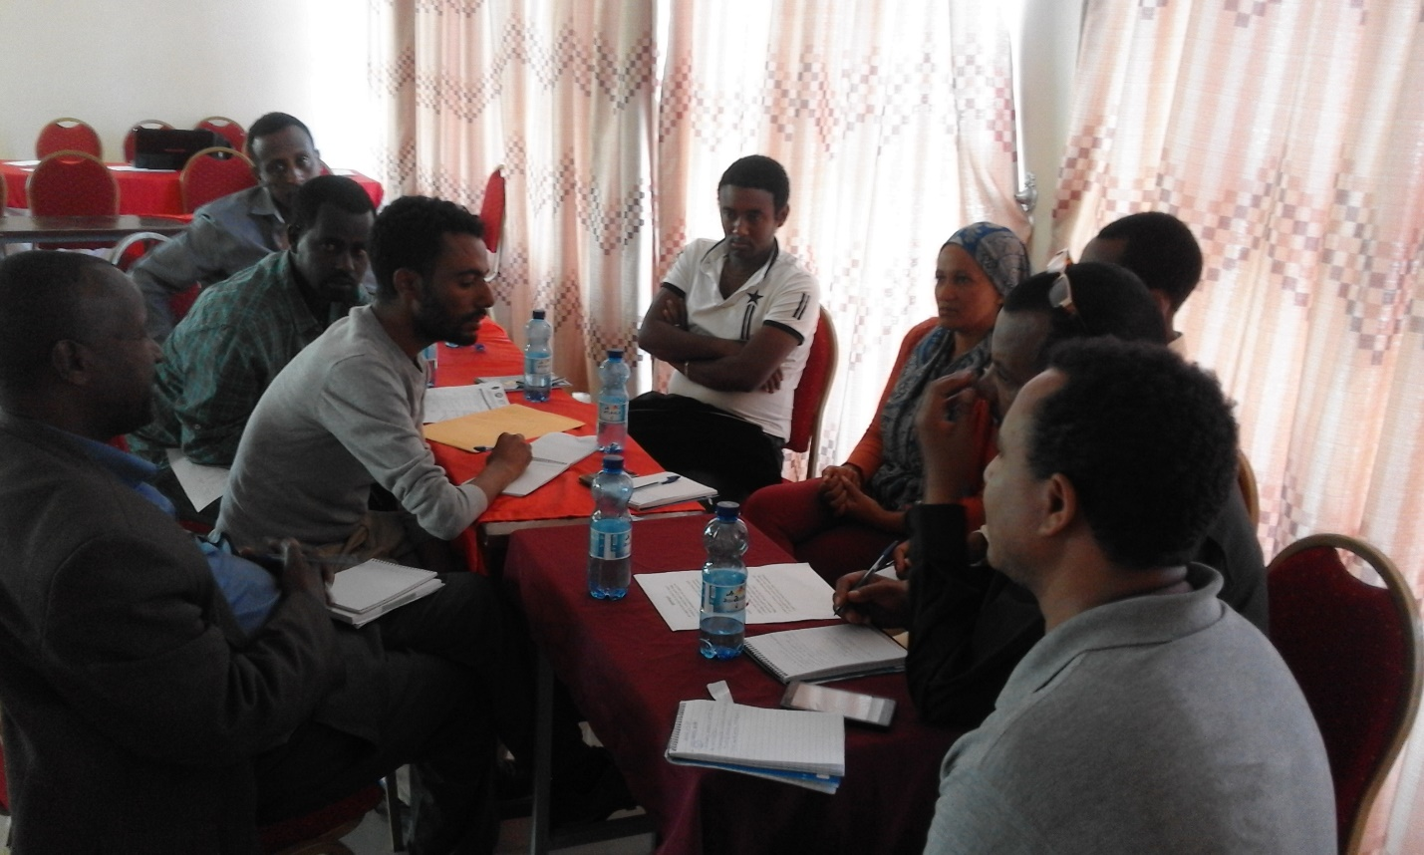  Image 5: Training participants in group discussions, Wereta, April 25th, 2017, Wereta (IOM)
Documents produced
Main events | Training workshop
Methods/Tools used
Comments | There have been improvements in stakeholder coordination in provision of victim assistance services. For instance, as a result of this meeting, law enforcement started to refer girl victims of trafficking to OPRIFS shelter in Bahir Dar.

Output | 4.4. Platforms and mechanisms are established/strengthened for internal and external information-sharing, dialogue, and cooperation between key countries along the migratory route, to protect migrants and refugees' rights, address irregular migration, trafficking, smuggling and promote regular migration | Period | July 2017
National partners | GoE, IOs and civil society, see below
UN Agencies involved | IOM
Brief description of activities | This project supported the National Anti-TiP and SoM Taskforce (NTF) and its regional branches in reviewing its 2016/17 implementation of the National Anti-Trafficking and Smuggling Plan of Action (2015-2020) and in planning its interventions for the year 2017/18. This was done by organizing a national workshop from 28 to 29 July 2017 which brought together 64 (55 male, 9 female) participants in Adama, Oromia Regional State. Participants mainly originated from both national and regional anti-trafficking and smuggling taskforces of the Afar, Amhara, Oromia, SNNP, Somali and Tigray Regional States as well as Addis Ababa and Dire Dawa City Administrations. Other participants were drawn from the following agencies: Ministry of Labour and Social Affairs (MoLSA), Ministry of Women and Children Affairs (MoWCA), Ministry of Youth and Sport (MoY&S), Ministry of Foreign Affairs (MoFA), Office of the Federal Attorney General (OFAG), Administration for Refugee and Returnee Affairs (ARRA), Main Department for Immigration and Nationality Affairs (MDINA), Federal Small Medium Manufacturing Industry Development Agency (FSMMIDA), Ministry of Education (MoE), Ministry of Culture and Tourism (MoCT), Ethiopia News Agency and House of Peoples’ Representatives (HPR). International organization participants came from BMM/GTZ, UNICEF, ILO and Expertise France, as well as non-governmental organizations, including the Consortium of Christian Relief & Development Associations (CCRDA), Ethiopian Youth Federation, Confederation of Ethiopia Trade Union (CETU), Ethiopian Inter-Religious Council (EIRC), Agar Ethiopian Charitable Society, Union of Ethiopian Women Charitable Associations (UEWCA), Forum on Sustainable Child Empowerment (FSCE), Ethiopian Orthodox Church Development and Inter-Church Aid Commission (EOC-DICAC), Good Samaritan, Association for Forced Migration, Geneva Global, Organization for Prevention, Rehabilitation and Integration of Female Street Children (OPRIFS), Ethiopian Catholic Church and Mekaneyesus Church.  The workshop was opened and chaired by Deputy Federal Attorney General, W/ro Mehububa Adem. The NTF coordinator presented on the major accomplishments and challenges for 2016/17. Even though considerable efforts were made to raise public awareness on safe migration through different channels, concerns were raised on the modalities and format of information campaigns in the country. In addition, it was stated that the impact of these interventions was difficult to measure. Participants recommended the focus to be shifted from mere awareness raising to effective behavioural chance communication complemented with creation of livelihood options and legal migration opportunities.  The meeting allowed for the NTF to give clear instructions to its regional branches and other partners by presenting on its 2017/18 plan which focuses on prevention, protection, prosecution and partnership and coordination mechanisms. Each regional taskforce was also required to develop and finalize its own 2017/18 plan before 30 September 2017. The major focus area highlighted by the NTF were, among others, the following:  - Need for strengthening of coordination mechanisms in major source regions (Tigray, Oromia, Amhara, SNNP and Addis Ababa) and for revitalization of regional, zonal and local level anti-trafficking and smuggling taskforces;  - Need to establish coordination mechanisms among migrant source and transit regions as an integrated approach to assisting returnees from border areas (through MoUs);  - Need to allocate material, financial and human resources for the functioning of the NTF;  - Need to take strong measures against government personal/officials engaged in trafficking and smuggling crimes;  - Need to establish a witness accommodation centre in collaboration with stakeholders;  - Need to implement standardized reintegration support packages for returnees to prevent remigration;  - Need to establish a trafficking victim support fund as per Proclamation No. 909/2015;  - Need to establish an Emergency Migration Response Centres (EMRC) on the Ethio-Somali border.
Documents produced
Main events | Coordination meeting
Methods/Tools used
Comments | This activity was in majority funded under this project. The remaining amount was co-funded by a project supported by the US Department of State (BPRM) and entitled “Horn/Gulf of Aden/Yemen: Improving Protection of Migrants, Phase VII.’’  This meeting was instrumental for the NTF in coordinating and cascading its directives down to the regional level. This will ensure a high level of coordination across the country for increased efficiency in counter-trafficking initiatives in the country.

Output | 4.4. Platforms and mechanisms are established/strengthened for internal and external information-sharing, dialogue, and cooperation between key countries along the migratory route, to protect migrants and refugees' rights, address irregular migration, trafficking, smuggling and promote regular migration | Period | September 2017
National partners | GoE, see below
UN Agencies involved | IOM
Brief description of activities | This activity was initially planned to support the Government to attend the 7th yearly Regional Committee on Mixed Migration meeting. However, this activity was already fully covered under another IOM project. In order to complement this activity through the DRT-F funded project, IOM supported the Government of Ethiopia in conducting a review meeting in Adama, Oromia Regional State from September 18th to 19th, 2017 to discuss the issues raised and recommendations formulated at the 7th RCMM meeting which was held in September 2017 in Djibouti. 15 participants (12 male and 3 female) from the Semera and Metema EMRCs, both EMRCs’ management committee members, Bureaus of Labour and Social Affairs, local health centres, the judiciary, Bureaus of Women and Children Affairs and Bureaus of Finance and Economic Development attended the meeting.
Documents produced
Main events | Meeting for the review of 7th Regional Mixed Migration Meeting outcomes
Methods/Tools used | Participatory Approach
Comments

4. Lessons learned and innovation – only new ones in 2017 (if any)
Instruction: List 2-3 under each and briefly explain.

UN coherence, coordination and joint funding
- The DRT-F has allowed partner UN agencies to enhance their coordination, not only on the present initiative but also on other projects. We believe that having the UN speak with one voice has also increased the visibility of the UNCT. This experience has led the partner agencies to think about additional future joint interventions so that they can improve their coordination further.
- The implementation of the migration initiative under the DRT-F had led to the formation of the “UN Migration Working Group,” a permanent UN platform which aims at facilitating information sharing and coordination among UN agencies with migration-related mandates. The working group will outlive the programme implementation period to ensure a higher degree of coordination among UN in Ethiopia on questions related to migration in the future.

Integrated policy, multi-sectoral approach and “whole-of-government”

Capacity development and leadership of national partners
- The UN DRT-F has allowed for the development and validation of a key document for migration governance in Ethiopia: the Migration Profile Report. Its recommendations all go in line with the need for Ethiopia to develop a National Migration Policy to effectively address the challenges posed by migration but especially harness its developmental potential. This document will serve as a basis in advocacy for the development of a National Migration Policy, which will represent a significant change in the Ethiopian migration governance system.

Systemic impact and leverage for transformative change
- See above.

Since it has not been validated and endorsed by the Government of Ethiopia at the political level, kindly consider this document for internal use.

