INTEGRATED APPROACH TO BUILDING PEACE IN NIGERIA’S FARMER-HERDER CRISIS

FINAL EVALUATION REPORT
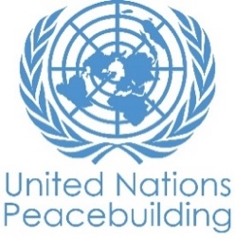
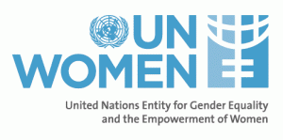
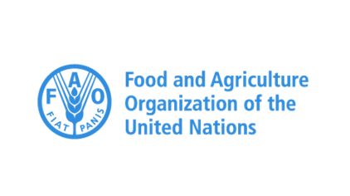
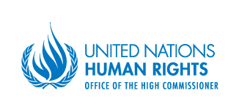
MARCH 2022
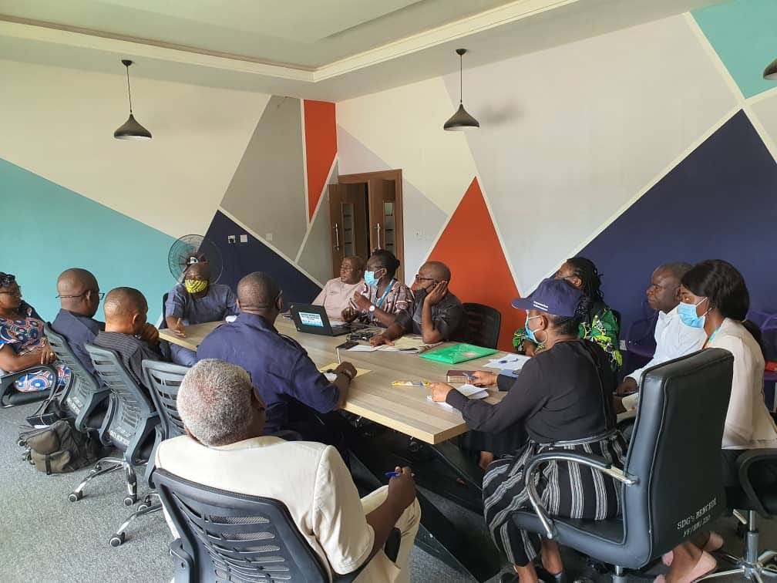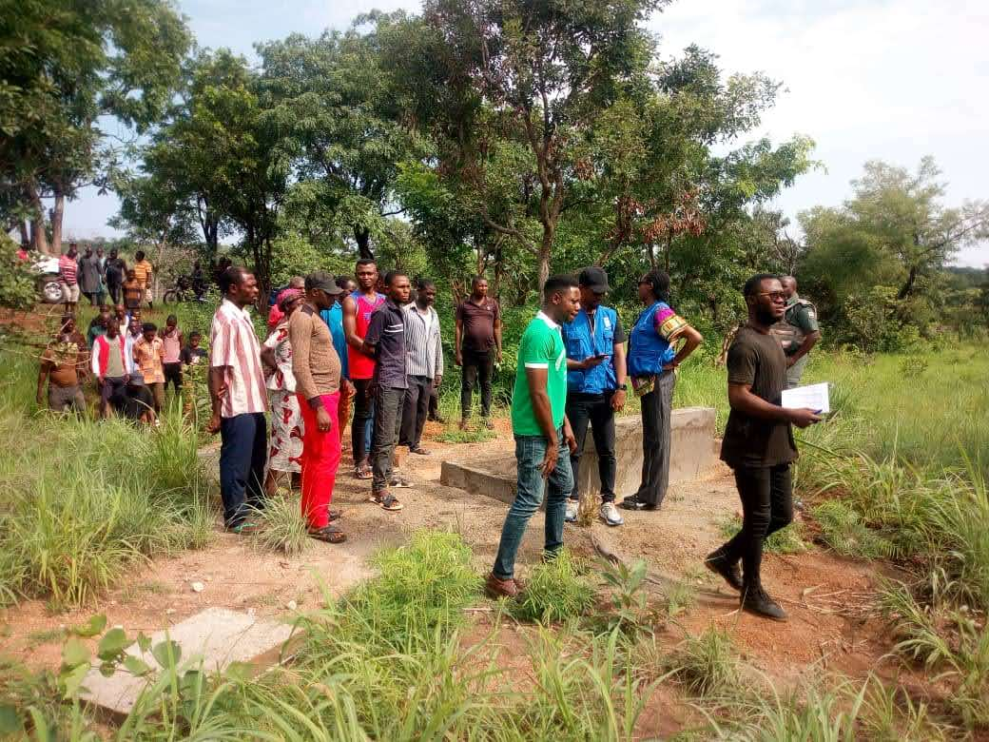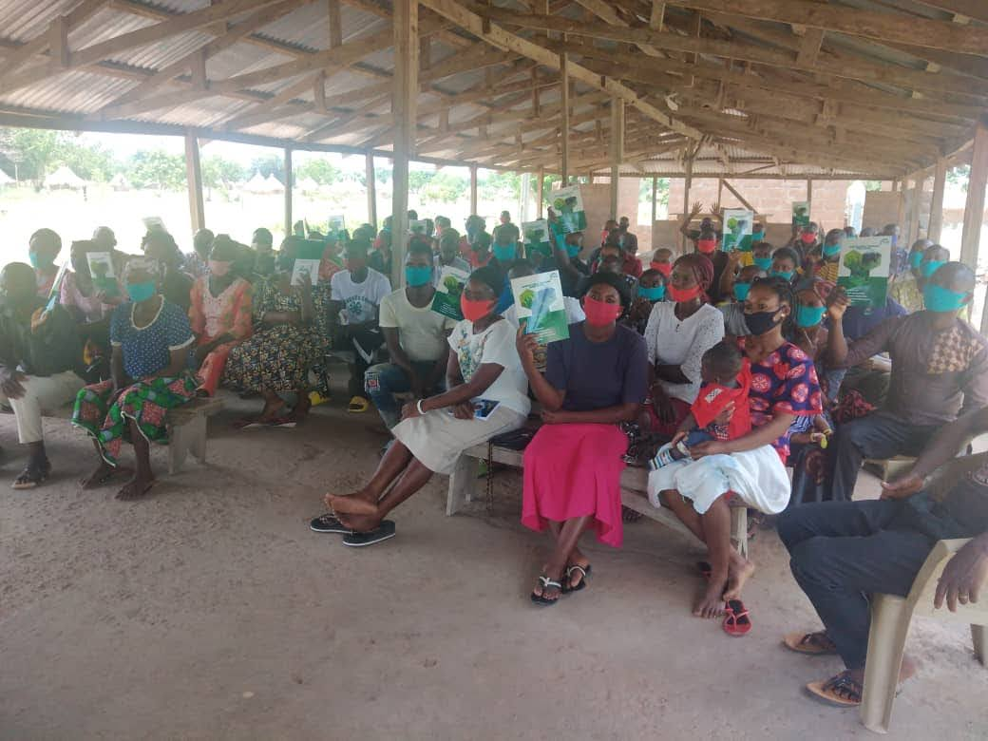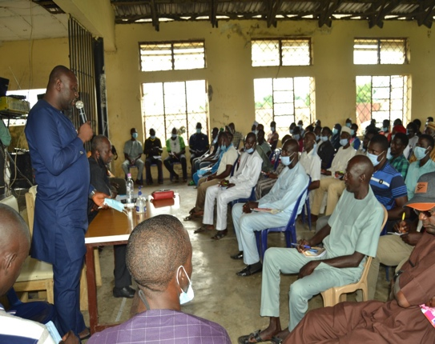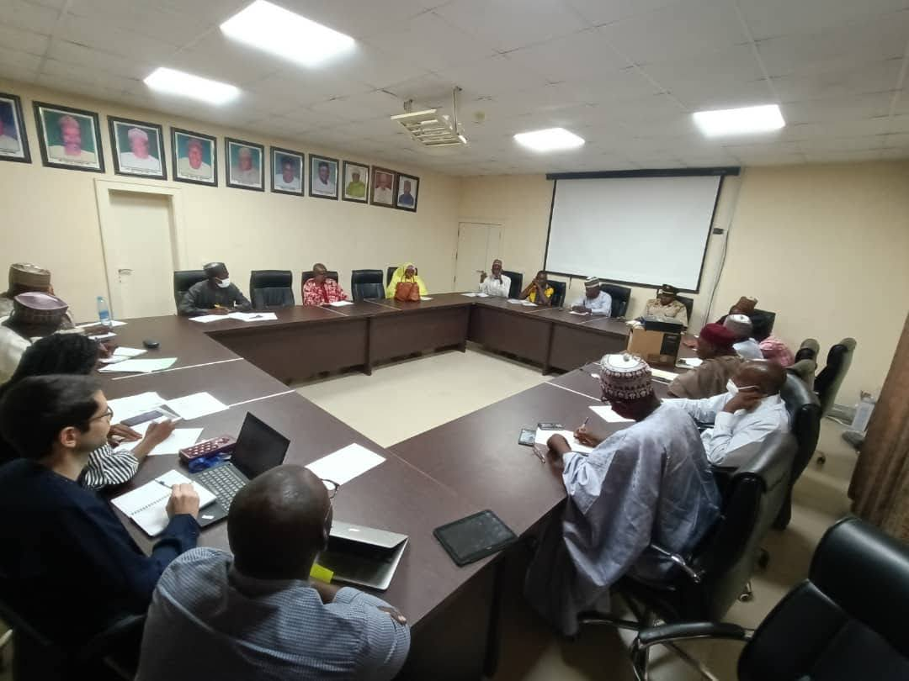

PREPARED BY
WIZ SUPPORT SERVICES
TEAM LEAD (DR. NWIZUGBE EZENWA)
31ST DECEMBER 2021

WAIVER:
The opinions and conclusions represent the views of the evaluation team leader who bears the sole responsibility for this evaluation report.

PROJECT INFORMATION

COUNTRY Nigeria
NATURE OF PRODUCT Final Evaluation

PROJECT TITLE “Integrated Approach to Building Peace in Nigeria’s Farmer-Herder Crisis”

PROJECT NUMBER 00113473

FUNDER UN Secretary General’s Peacebuilding Fund

BUDGET $3,000,000

IMPLEMENTING ORGANIZATIONS UNDP: $1, 683, 283, 41
UN WOMEN: $321,058.85
FAO: $692,890.54
OHCHR: $302, 767, 20

EXPECTED PROJECT COMMENCEMENT DATE: 1st January, 2019
PROJECT DURATION IN MONTHS: 18 Months + 6 Months
PROJECT RISK SCORE: 2 High Risks in Achieving Outcomes
GENDER MARKER SCORE: (30% of the Total Budget Going to GEWE)

CONTENTS
Map of Nigeria |  | 6
1.0 EXECUTIVE SUMMARY |  | 7
1.1 Background |  | 11
1.2 Context of Implementation |  | 13
1.3 The PBF Project Description |  | 13
1.4 Objective of Evaluation |  | 13
1.5 Theory of Change |  | 14
1.6 Key Stakeholders |  | 15
2.0 PURPOSE, SCOPE AND METHODOLOGY |  | 15
2.1 Purpose |  | 15
2.2 Reviewed Objectives |  | 15
2.4 Scope of Work |  | 18
2.5 Why the Choice of the Project States |  | 18
2.6 Evaluation Criteria and Questions |  | 20
2.7 Methodological Approach |  | 22
2.8 Quality Control |  | 23
2.9 Study Limitations and Mitigation Strategies |  | 23
3 EVALUATION FINDINGS |  | 23
3.1 Findings |  | 23
3.2 Achievements |  | 26
3.3 Review of Performance |  | 28
3.4 Review of project outcomes |  | 28
3.5 Relevance |  | 32
3.6 Efficiency |  | 32
3.7 Effectiveness |  | 32
3.8 Value for Money |  | 33
3.9 Sustainability and Ownership |  | 33
3.9.1 Coherence |  | 33
3.9.2 Conflict Sensitivity |  | 33
3.9.3 Catalytic |  | 34
3.9.4 Time Sensitivity |  | 34
3.9.5. Risk-Tolerance and Innovation |  | 34
3.9.6 Current Security Situation |  | 34
4 EVALUATION ENGAGEMENTS |  | 34
4.1 Target Respondents |  | 34
4.2 Sample Selection Techniques |  | 37
4.3 Success Stories |  | 37
5.0 CONCLUSIONS AND RECOMMENDATIONS |  | 39
5.1 Lessons Learnt |  | 39
5.2 Challenges |  | 40
5.3 Recommendations |  | 41
5.4 Conclusion |  | 42
GLOSSARY |  | 43
REFERENCES |  | 44
ANNEXURES |  | 45

PROJECT LOCATIONS
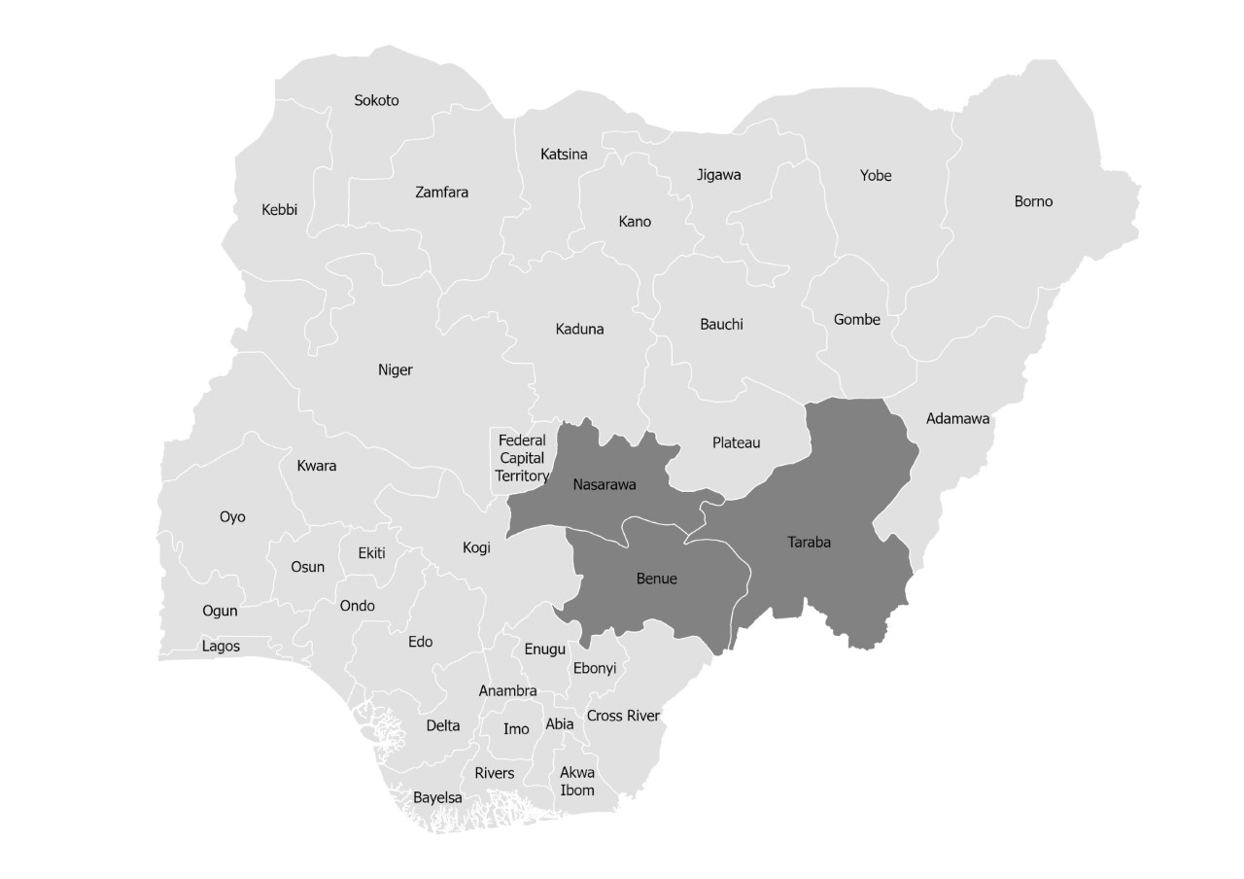

GLOSSARY

ACRONYMS LIST
CRI  EWER | Critical Rescue Item  Early Warning and Early Response for peacebuilding
FAO | Food and Agricultural Organization
FFS | Farmers Field School
GED | Geo-referenced Event Data-set
HD  HSTF | Centre for Humanitarian Dialogue  Human Security Trust Fund
IDP | Internally Displaced Persons
IPCR | Institute for Peace and Conflict Resolution
MDAS  NFI | Ministries, Departments and Agencies  Non Food Item
NHRC | National Human Right Commission
NLTP | National Livestock Transformation Plan
NUNO  OPAPP | Non-United Nation Organizations  Office of the Presidential Adviser on the Peace Process
PSEA | Peace Security and Emergency Assistance State Activation Plan
RUNO | Recipients United Nations Organizations.
SAP | State Activation Plan
SGBV | Sexual Gender Based Violence
UCPD | Upper Conflict Data Program
UN | United Nations
UNDP | United Nations Development Programme
OHCHR  UNRCO | Office of the High Commission for Human Rights  United Nations Resident Coordinators office
WANEP | West African Network for Peace Building
WPS | Women Peace and Security

EXECUTIVE SUMMARY
The Joint UN The Integrated Approach to Building Peace in Nigeria’s Farmer-Herder Crisis project was implemented by four United Nations agencies – United Nations Development Programmes (UNDP), United Nations Entity for Gender Equality and the Empowerment of Women (UN Women), the Food and Agricultural Organization of the United Nations (FAO), and the Office of the High Commissioner for Human Rights (OHCHR). The initial implementation had an end date of 9 June 2020 but was subsequently extended by 6 months with no added cost. UNDP served as the lead UN agency for its implementation. This project evaluation sets out to assess the level of project objectives, peacebuilding impact and sustainability. The evaluation was carried out from 18th November 2021 to 31st December, 2021.
As its key objectives, the project sought to:
- establish effective and gender-sensitive infrastructure for peace at the
State level to support conflict prevention.
- strengthen economic interdependence between farmers and herders.
- enhance accountability and capacity of responders to promote increased effectiveness of response to the crisis;
iv) ensure information management and analysis of the crisis to promote evidence-based advocacy, targeted investments, and innovative solutions.

In assessing these objectives, the evaluators used mixed methods, reviewing documentation and conducting interviews, and focus group discussions, as well as general best practices of evaluation to gather data that focus on the purposes of the evaluation and answer all of the evaluation questions.
Key Conclusions
The existence and implementation of the PBSO-funded project was recognized by the state governments, other development partners, and by civil society as central to some of the progress made in peacebuilding in the middle belt. The project’s work was recognized as particularly important due to the increasingly challenging terrain and counterproductive national discourse over farmer herder issues. PBSO support in the region was seen as even more important due to the dearth of similar peacebuilding endeavors in the region. The project focused on four areas – with progress and achievements recorded in each of the key areas over the course of the project.
The UN’s work in strengthening relationships and trust between the farmers and herders to support the de escalation of the conflict, and engendering a culture of economic interdependence between the different groups was critical to the progress made in the region on this front in the period of the project. The table below encapsulates the main findings in this regard:
Observation | Description | Opportunities and Recommendation Moving Forward
It was observed that climate induced resource competition continued to drive the farmer – herder crisis in Benue, Nasarawa and Taraba. Herders in search of grazing fields and surface water for their herds on one part and farmers who were alleged to have to have expanded their farmland, encroached on usual walkways of the cattle, thus forcing the cattle to stray into cultivated areas for grazing. | Project supported the Taraba state government to operationalize the re-demarcations and beaconing of 53,000 Hectares in Mayo-Kam grazing reserve earmarked for NLTP, more grazing reserves should be identified and delineated to reduce encroachment by either party in the project states.  - Note: While the land was acquired through a complimentary project supported through the Human Security Trust Fund, improving, and preparing the land for livelihoods activities was funded through PBF project.  The installation of two solar powered borehole wells and two drip irrigation systems on 3 hectares of Land in the Mayo Kam grazing reserves in Taraba State for adequate water supply for both herders and farmers, has proven to be productive and efficient sources of not only water that has in the past been a source of communal disputes. | Greater investment and increased capacities ought to be built on alternative feed and fodder resources to minimize the inherent competition over natural resources, a precursor to the recurring farmer/herder crisis.  There is growing concern regarding shrinking natural resources especially water – due to climate change and population growth. Increase in availability of basic resources - more water spots should be built for farmers for irrigation and for herders for animal drinking.
Through strong advocacy, and stakeholders’ engagement the UN PBF project enjoyed functional government partnership and support in the project states. | High level Government involvement and political buy-win was critical for project implementation. The Governors of the three states ensured strategic positioning of the project by assigning State level focal persons who not only ensured a whole-of-government approach to the project, while ensuring the much-needed leadership. | The UN team should consolidate on the gains they have made so far, sustaining the high level goodwill at the State Level and build on the leadership demonstrated by the States in key areas especially the operationalization of the Conflict EWER systems  Full testing and operationalization of the Conflict Early Warning Systems in the three States will be critical if the full gains of the investments are to be realized. In this regard, the UN should consider an additional 5-month investment to accompany the States in testing the EWER systems; setting in place data collection mechanisms and equipping the State level analysts with the much needed skills.
Women and children were disproportionately affected by the conflict. | 4a 50:50 women to men ratio in the selection of livelihood beneficiaries was strictly adhered to in the project.  4b Also the project ensured beneficiaries were drawn from both sides affected by the crisis- The farmer and herder groups  4c. In the same line, 104 youths and media practitioners from Nasarawa, Benue and Taraba states were trained on conflict risk communication, peace building and linking these with COVID19 risk communication | 4. The UN team should maintain its targeted approach to supporting communities, shifting from beneficiaries to implementers, aimed at building stronger sustainability base. For instance, giving out farmlands and seed-crops, building irrigation/water spots and urging farmers to be supplying ranches (where they exist) with fodders. In this way strengthening economic base and relationship between farmers and herders.
It was found that the Joint PBF project contributed to pockets of reduced tensions, increased mutual tolerance, peaceful co-existence and inter-dependence between farmers and the herders in their communities through system strengthening. | 5. The project trained farmers on how to produce improved farm yields, grow fodders and educated them on ways to create a market for their produce. The herders were also trained on how to rear fatter cattle and collect richer milk. Government agents were also trained on how to identify good fodder for the farmers. All these resulted to a commercial and economic interdependence between the farmers and herders, improved the livelihoods of persons in the project communities and led to a peaceful cohabitation of the farmers and the herders. | 5. More people should be empowered as poverty is still very high in the communities. Youths should be empowered and the widows also supported with cash for petit trading and for welfare.  5b more opportunities for dialogue should be created so as to sustain peaceful co-existence  5c In light of understandable pandemic-induced delays, Thrive Agric should fast track all outstanding farm inputs supply for sustained empowerment. Further engagement of the youth would pre-occupy the youth as diversionary therapy from any potential crisis, as they too would become active agents for EWER to protect their business interest
The ability and opportunity for women to join decision making platforms were strengthened and participation widened. | 6. Through the efforts of UN Women in collaboration with UNDP field-based staff, Ministry of Social Welfare and Ministry of Women Affairs, the community women were empowered into becoming political aspirants, peacebuilding negotiators, ambassadors, and EWER monitors. | 6. Through the women network, more women should be encouraged to join political parties, contribute to political enlightenment, and gain places in government. Girl child education should be encouraged, and early girl child marriage discouraged.
The project effectively contributed to the strategic vision of the project. | 9. Effectiveness: The project effectively contributed to the strategic vision by working to prevent further conflicts, helping parties in conflicts make peace, deploying peace keepers such as police and establishing conditions to allow peace to hold and flourish” (Female IDI Nasarawa). | 9. More citizens should be co-opted into the regional peace forum and into the EWER system.
The participating states’ government and officials were lead actors in the implementation of key field activities, thereby enhancing their capacity for sustainability. | 12. The participating states’ government and officials were lead actors in the implementation of key field activities, thereby enhancing their capacity for sustainability. State governments demonstrated strong commitment to PBF project sustainability during and after the end of the project duration, especially with the EWER system and alternative feed/fodder development, training government employees as experts in quality fodder identification and processing. Exit strategies were defined and well communicated. | 12 The UN leveraging its convening power and as a trusted partner should sustain advocacy on the need for positioning traditional institutions and mechanisms to strength social cohesion between the farmers and herders within their communities.  Implementable policies should be made to support traditional leaders.
Government media houses were also used to broadcast peace building initiatives for engagements to the public. | 13 Government media houses were also used to broadcast peace building initiatives fora and engagements to the public. | 13. The use of mass media should be sustained to support the role of traditional rulers in peace process. Tunes and jingles should be produced for informing and educating the communities with accurate and researched information. Peacebuilding jingles should be prepared for public use and awareness.
All the UN agency and partners worked under excellent coordination led by UNDP while delivering their services to their beneficiaries | All the UN agency and partners worked under excellent coordination led by UNDP while delivering their services to their beneficiaries.

1.1 Background
The Farmer-Herder conflict poses a grave threat to peace, security and development in Nigeria especially in the North Central Region. The resulting violence from this crisis has left a devastating impact on the developmental and socio-economic aspects of human life as evidenced in the loss of thousands of human lives, destruction of property, and communities left in total disarray with countless Internally Displaced Persons (IDPs) all over the region. The protracted conflict has also frayed many human connectors, especially inter-ethnic and inter-religious ones at the local level. It has also had a negative effect on the food basket of the country.
Indeed, estimates indicate that the farmer-herder conflict claimed more lives in 2016 alone than the Boko Haram insurgency. The international Crisis Group suggested that the recent escalation of the crisis from early 2018 has claimed six times the number of lives than were lost to the Boko Haram insurgency within the same period. Thus, it is not surprising that a 2016 strategic conflict assessment of Nigeria undertaken by the Institute for Peace and Conflict Resolution (IPCR) identified the conflict between farmers and herders in Nigeria as the most widely spread peace and security threat in Nigeria. The 2016 IPCR report also noted that the highest number of conflicts of this nature occurred in the “Middle Belt” and surrounding states.
It was in the light of this debilitating situation that the United Nations initiated the Integrated Approach to Building Peace in Nigeria’s Farmer-Herder Crisis” project. Funded by the Peacebuilding Fund, the project was specifically designed to support the North Central states of Benue, Nasarawa and Taraba in addressing the farmer-herder crisis in the region. To this end, the project set out to promote peace dialogues, proactive engagements, and an enabling environment that would lead to mutually beneficial economic relationships between farmers and herders. Besides seeking to improve the effectiveness of security responses through strengthened Human Rights monitoring and accountability, it also sought to provide an impartial and evidence-based narrative to defuse the already politicized debate. The overall goal was to create broad-based mobilization and participation.
The final evaluation report for the project was commissioned by the project consortium led by the United Nations Development Programmes (UNDP), in collaboration with UN Women, the Food and Agricultural Organization of the United Nations (FAO), and the Office of the High Commissioner for Human Rights (OHCHR).
The project commenced in January 2019 and was initially due to end in June 2020 (18 months). It was eventually extended by 6 months. This extension was necessitated by the onset of the Covid-19 pandemic in March, 2020 which saw a total lockdown of the country from March 2020 to January 2021 by the Federal Government of Nigeria. Accordingly, it is the successes, challenges and key lessons learnt during the project implementation (which can be incorporated in future programming) that are the subject of this evaluation report.
The PBF project focused on these four major outcomes:
- Establishment of effective and gender-sensitive infrastructure for peace at the State level to support conflict prevention.
- Strengthened economic interdependence between farmers and herders.
- Enhanced accountability and capacity of responders to promote increased effectiveness of response to the crisis.
- Ensure information management and analysis of the crisis to promote evidence-based advocacy, targeted investments and innovative solutions.

This evaluation was carried out over a period of 45 days starting from 18 November to 31st December 2021 and encompasses an introduction that shows why the project was conducted, the context of the implementation of the PBF Project, an explanation of its organisation and the purpose of the evaluation. The methodology adopted in this report included the OECD-DAC standard evaluation criteria of inquiry from which questions answered by the respondents interviewed, the study limitation and how they were mitigated are reported as well. It also explains the findings of the evaluation report, recommendations, lessons learnt and conclusions. Finally, the evaluation report contains an executive summary for ease of perusal.

1.2 Context of Implementation
The conflicts over farmlands and/or pasture and the narratives over same have increasingly taken religious undertones (Muslims v Christians) with some religious leaders publicly exchanging accusations. Ethnic connotations (indigenes v settlers) and stereotypes have also been read into the crisis resulting in heightened tensions. This development has further polarised communities and complicated the efforts of those mitigating the violence. The conflicts were already highly politicised and intensified by groups who claimed the Southward movement of the pastoralist was a deliberate political attempt to Islamize Nigeria.
The multi-dimensional effects of the crisis have overwhelmed the state and federal authorities as the authorities were perceived as not doing enough to address the crisis. The lack of an effective early response by security agencies as well as perceived injustices, partiality and ineffectiveness was eroding public trust in the state’s ability to protect its citizens. With the states lacking effective tools to address the crisis, many state governments had turned to the federal government in search of support, requesting for a strengthened security response. The lack of such strengthened security response gave way to tensions between the federal and state levels.
The United Nations, with the technical lead of the UNDP, scaled up its efforts to complement the efforts of the government in peacebuilding, conflict prevention, resolution and management. Essentially, this support came in form of two catalytic projects that targeted the states of Benue, Nasarawa and Taraba; both designed to address the farmer-herder conflict through the establishment of mechanisms for coordinated peace building, promotion of dialogue and proactive engagements.
1.3 The PBF Project Description
The “Integrated Approach to Building Peace in Nigeria’s Herder-Farmer Crisis” supported Benue, Nasarawa and Taraba States in addressing the conflict through the enhancement of their preventive capacities, by promoting dialogue and proactive engagement; building mutually beneficial economic relationships between farmers and herders; improving the effectiveness of the security response through strengthened Human Rights monitoring and accountability and by providing an impartial and evidence-based narrative to defuse the politicised debate and help mobilise a broader response.
Each project state had designated state focal points, mostly special advisors to the Governor, to constantly engage with the Project Team. Other partnerships with state institutions include the National Human Rights Commission (NHRC), Legal Aid Council, Nigerian Institute for Advanced Legal Studies, and the National Livestock Transformation Plan (NLTP) Secretariat. The Project Team also established a Peace Collaborative, an NGO consortium constituted of West Africa Network for Peacebuilding (WANEP), Mercy Corps, Centre for Humanitarian Dialogue (HD) and the private sector firm ThriveAgric.

1.4 Objective of Evaluation
The evaluation, as per the TOR, sought to assess the relevance and appropriateness of the project in terms of:
- Addressing the key drivers of the farmer-herder conflict and the most
relevant peace building issues.
- Determining if the project implementation is in line with the National Peace building policy and priorities of Nigeria.
- Establishing whether the project capitalised on UN’s added value in Nigeria.
- Examining the degree to which the project addressed cross-cutting issues such as conflict and gender- sensitivity in Nigeria.
- Assessing the extent to which the PBF project made a concrete contribution to reducing the farmer-herder conflict in Nigeria.

1.5 Theory of Change

The Project Design document summarized the project’s theory of change thus:

If states have increased capacities in proactively addressing the crisis through dialogue; a mutually economic beneficial relationship between farmers and herders can be established; security agencies respond more effectively and accountably to the crisis; and the polarized narratives in this crisis are effectively countered through verified and validated information; then the crisis will be transformed, and peaceful coexistence will be possible.

1.7 Key Stakeholders
Through strong advocacy, the PBF project built and enjoyed a strong professional relationship with the government which yielded state partnership and support in the project states. The project states focal persons took the lead and mobilized participants in large numbers for the regional dialogue held in Nasarawa State. They also participated in the Early Warning and Early Response System (EWERS) mobilization and sensitization campaign with varying degrees of participation. Government media houses were also used to disseminate Peace Building Initiatives fora and engagements to the public. Apart from the State governments, the project also engaged and enjoyed the support of local CSOs, the media, other organisations, security agencies, youth and women groups as well as the communities where the project was implemented.
2.0 PURPOSE SCOPE AND METHODLOGY
2.1 Purpose
The overall purpose of the project evaluation is to present an opportunity to assess the achievements and impacts of the project by examining the causes or the consequences of the conflicts or both as well as determine whether the overall added value was in line with the project outcomes, peace building and the sustainability of the farmer herder practices in the middle –belt region of Nigeria.
2.3 Review of Objectives
The objective of the PBF project was reviewed side by side with the project implementation as follows:
Objective 1: Addressing Key drivers of the farmer- herder conflict in Benue, Taraba, and Nasarawa states.

The evaluation found that the farmer-herder crisis in the project states was partly driven by herders in search of grazing fields for their herds. This was due to the adverse climate conditions which affected the availability of surface water and grazing lands. On the other part farmers were alleged to have encroached on the walkways of the cattle, in an attempt to expand their farmlands. Thus, forcing the cattle to stray into cultivated areas for grazing. Broadly, Nigeria has witnessed population growth, growth in consumption and urbanization, hence, there might have been encroachment on traditional grazing roots either by development or farming or both, and perhaps exacerbated by climate change.
Similarly, we found that the struggle for political power, resources control, and the struggle for community land boundary also caused conflict. This perhaps informed the PBF project planning to be a two-way strategy; state level structures and grass-root based structures.
The project took off with a focus on setting up mechanisms for conflict prevention and peacebuilding at state levels (Benue, Nasarawa and Taraba), engaging the youth and women in peace building processes, and developing a Protocol on Gender Sensitive Dialogue and Mediation. UN Women supported the development of The State Action Plan (SAP) on Women Peace and Security to localize UNSCR1325 in Nasarawa and Benue states, and started the engagement in Taraba state but could not complete as at Dec 2020. The SAP is critical to driving gender sensitive peacebuilding agenda in the states. UN Women also set up Network of Women in Peace building in the three states with membership of over 150 women groups and organizations from states to community levels. The Networks were managed by the Ministry of Women Affairs.
The project employed 2 National Human Rights Officers (OHCHR/UNV) and 15 National Human Rights Monitors (CSOs). The 15 National Human Rights Monitors were deployed to Benue State to carry out periodic monitoring and reporting of rights violations, as well as strengthen referral pathways in 15 LGAs in the States.
Also, efforts towards the setting up of mechanisms for conflict prevention and peacebuilding at state levels were scaled through drafting enabling legislation and developing prototypes for ICT-based early warning systems. The project established the early warning and early response (EWER) system across the project states with each State governments donating office spaces to support the EWER system and seconding 40 security personnel each who were trained to operationalize the EWERs Control Room.
This system allows citizens, civil society and other stakeholders to report in real time on behaviour or actions that they consider as potential indicators of conflict. 105 representatives of women's groups and organizations were trained by UN Women to support the ICT based EWER system. The trained women in Keana -Nasarawa, Wukari- Taraba and Logo in Benue, set up structures to locally monitor and respond to threats to peace using the EWER systems developed in the training. The consultant found that there were new motor-bikes and some ICT equipment parked inside the house to operationalize the EWER system. These were donated by the Government of Japan as a catalytic result of the project.
Objective 2: Determine if project implementation is in alignment with National peacebuilding policy and priorities of Nigeria.
The evaluation found that the project aligned with the National peacebuilding policy and priorities of Nigeria. Some of these policies and priorities are The National Action Plan on Women, Peace and Security (the revised UNSCR1325NAP) developed by Nigeria in partnership with Ministries of Women Affairs to develop State Action Plans (SAPs) for localizing the UNSCR1325 with the objective of mainstreaming and driving a gender sensitive implementation of peace and security processes.) which some states (like Nasarawa and Benue) with support from the UN Women adopted, the revised report of CEDAW (July 2017) on Women, Peace and Security as well as the 1999 Constitution of the Federal Republic of Nigeria (Section 42) which promotes gender equality. Also, the modernization of the 11,500 hectares of grazing reserve for the development of pasture in Taraba and the landscape hydrological assessment and crop identification in Nasarawa and Taraba States aligned with the National Livestock Transformation Plan (NLTP).
Objective 3: Whether the project capitalized on the UN’s added value in Nigeria.
The UN-inter-agency project team discharged their duties without biases or discrimination. The project implementation was done in a neutral, fair and timely manner. (Core UN values). Besides the complementarities of the agencies as outlined below, the joint UN project – being the first in Nigeria to attempt a whole of system approach demonstrated the collective value of addressing complex development issues through multiple lenses. This approach is increasingly becoming the desired mode of engagement by Government and development partners alike.
At agency specific level, the UNDP coordinated and supported the implementation of the project in an impartial manner and took into account youth and women inclusiveness. The agency also leveraged its key mandate areas around governance, peace and security, while also linking to inclusive growth and macro-economic policy.
FAO ensured that there was livelihood recovery in agriculture as a way to defeat the hunger that emanated from the conflict in an unbiased manner. In this way they strengthened the economic base in the state through the impacts the project had on beneficiaries while ensuring they retained their self-dignity.
The OHCHR supervised and ensured that the project implementation was in line with the UN’s Human rights initiatives. The agency made sure that human rights of all were protected during and after the project came to an end.
As a team the multi-UN agency team used multi-stakeholder engagements and forum to get a robust feedback which were embraced and used to enable prompt bilateral and multilateral communications.
Objective 4: The degree to which the project addressed cross-cutting issues such as conflict and gender-sensitivity.
The evaluation found that the PBF project doused the tensions, increased mutual tolerance, peaceful co-existence and interdependence between farmers-herders in their communities while ensuring that implementation was so conflict sensitive that it in no way triggered or escalated more conflict in the area. The project was also gender sensitive and ensured that all interventions were gender conscious during project implementation.
The methodology for data collection applied a 50:50 women to men ratio in the selection of livelihood beneficiaries. Furthermore, sixteen (16) organizations/groups members of the Network of Women in Peacebuilding, (89 women and girls) representing women across social strata and conflict divide were trained to produce hydro alcoholic gel in three states. Also the project ensured beneficiaries were drawn from both sides affected by the crisis- The farmer and herder groups.
Objective 5: To what extent did the PBF project make a concrete contribution to reducing the farmer-herder crisis in Nigeria.
The evaluation gathered through interviews and focus group discussions that the PBF project succeeded in dousing the tension between farmers and herders by building economic relationships to bridge the gap- farmers were trained on how to achieve more yields and the herders on how to rear fatter cattle and collect richer milk to foster a commercial interdependence between the farmers and herders. It also ensured sustainable peace dialogues with both parties through the Farmer-Herder Peace-forum set up in each state and contributed to the EWERS systems while training security personnel in order to mitigate the potential for crises to escalate.
2.4 Scope of Work
The evaluation examined the projects implementation process and peace building results, drawing upon the projects results framework and other monitoring data collected on the project outputs as the context of the project.
Evaluation questions were based on the OECD-DAC Evaluation Criteria as well as the PBF specific evaluation Criteria, which has been adapted to the context. The evaluators ensure that the evaluation of the peace building result was the main line of enquiry.
2.5 Why the Choice of the Project States
Although the recent escalation of the farmer-herder crisis highlighted the volatile security environment, research suggested that Nasarawa, Benue and Taraba had long faced these problems according to the Upper Conflict Data Programs (UCDP)and Geo-referenced Event Dataset (GED) 28%. The deaths in attacks between the farmers and herders from 2014 to 2017 in Benue State occurred in Guma and Logo Local Government Areas. In the same period, the farmer-herder attacks in Taraba state claimed 49% of it casualties in Wukari Local government.
These striking death tolls around Nasarawa, Taraba and Benue nexus indicated that targeting these areas could provide crucial peacebuilding dividends for the affected communities. In these states. The project in-depth work with the communities targeted the following local government areas; Ibi and Wukari Local Governments (Taraba), Awe and Keana Local Governments (Nasarawa), Logo and Guma Local Governments. The target beneficiaries are outlined below.

Figure 2.
Source: (Project document-Peace Project-2 PBF funded p15] referenced https:/ww.citypopulation:de/php/Nigeria-admin.php)

Fig 3 Population distribution by male, female and youth in crisis affected LGAs

Source: (Project document-Peace Project-2 PBF funded p15] referenced https:/ww.citypopulation:de/php/Nigeria-admin.php)

2.6 Evaluation Criteria and Questions
This evaluation was done according to the OECD-DAC standard evaluation criteria of enquiry which includes the relevance, efficiency, effectiveness, sustainability, coherence, coordination, conflict sensitivity and risk tolerance of the project
Questions
Evaluation Criteria | Evaluation Questions
Relevance. | Was the initial design of the project adequate to properly address the issues envisaged in formulation of the project and provide the best possible support to the state governments? Was the project relevant in addressing conflict drivers and factors for peace identified in the conflict analysis? Was the project appropriate and strategic to the main peacebuilding goals and challenges in the country at the time of the PBF project’s design? Did relevance continue throughout implementation? Was the project relevant to the UN’s peacebuilding mandate and the SDGs, in particular SDG 16? Was the project relevant to the needs and priorities of the target groups/beneficiaries? Were they consulted during design and implementation of the project? Was the project responsible for any unintended negative impacts? Did the project’s theory of change clearly articulate assumptions about why the project approach is expected to produce the desired change? Was the theory of change grounded in evidence?
Efficiency | : Have project funds and activities been delivered in a timely manner? How efficiently did the project use the project board? How well did the project collect and use data to monitor results? How well did the project team communicate with implementing partners, stakeholders and project beneficiaries on its progress? Overall, did the PBF project provide value for money? Did the monitoring and evaluation systems that UNDP had in place help ensure that the project was managed efficiently and effectively? To what extent did the PBF project ensure synergies within different programs of UN agencies and other implementing organizations and donor with the same portfolio?
Effectiveness | To what extent did the PBF project achieve its intended objectives and contribute to the project’s strategic vision? To what extent did the PBF project substantively mainstream a gender and support gender-responsive peacebuilding? How appropriate and clear was the PBF project’s targeting strategy in terms of geographic and beneficiary targeting? Was the project monitoring system adequately capturing data on peacebuilding results at an appropriate outcome level?
Sustainability & Ownership | To what extent did the PBF project contributes to the broader strategic outcomes identified in nationally owned strategic plans, legislative agendas and policies? Did the intervention design include an appropriate sustainability and exit strategy to support positive changes in peacebuilding after the end of the project? How strong is the commitment of the Government and other stakeholders to sustaining the results of PBF support and continuing initiatives, especially women’s participation in decision making processes? Has the intervention developed the necessary State capacities (both human and institutional) for sustainability? Will the outputs delivered through the  project be sustained and why?
Coherence | To what extent did the PBF project complement work among different entities, especially with other UN actors? To what extent and nature were stakeholders involved in the project’s design and implementation?
Conflict-sensitivity | Did the PBF project have an explicit approach to conflict-sensitivity? Were RUNOs and NUNOs’ internal capacities adequate for ensuring an on-going conflict-sensitive approach? Was the project responsible for any unintended negative impacts? Was an on-going process of context monitoring and a monitoring system that allows for monitoring of unintended impacts established?
Catalytic | Was the project financially and/or programmatically catalytic? Has PBF funding been used to scale-up other peacebuilding work and/or has it helped to create broader platforms for peacebuilding?
Time Sensitivity | Was the project well-timed to address a conflict factor or capitalize on a specific window of opportunity? Was PBF funding used to leverage political windows of opportunity for engagement?
Risk Tolerance and Innovation | If the project was characterized as “high risk”, were risks adequately monitored and mitigated? How novel or innovative was the project approach? Can lessons be drawn to inform similar approaches elsewhere?

2.7 Methodological Approach
The evaluation used a mix of both quantitative and qualitative methodologies to gather data and information. While the qualitative methodology used focus group discussions (FGD) and In-depth interviews (IDI) to collect data from key informants, the quantitative data was collected from secondary sources, such as the project’s final report and M&E data matrix. In all, 11 FGDs and 30 IDIs were conducted. Data collection commenced immediately after validation session with the core project team (and subsequent approval), of the inception report which indicated understanding of the terms of reference, action plan for field work and various developed tools for data collection. A combination of both virtual approach and in -person interviews was adopted. The approach was chosen to ensure adherence to Covid-19 protocols.
2.8 Quality control
The evaluation team conducted a proper training on the evaluation tools. The tools were pretested to ensure completeness, comprehension and accuracy of questions. Questions were asked in local languages (where necessary).
Respondents were assured of the confidentiality of their information. They were educated to understand that they had the right to opt-out at will without any repercussion. All tools were safely stored after the exercise. In view of the prevalence of COVID-19, caution was taken by the minimization of one-on-one interviews and Telephone discussions, Skype calls and Zoom meeting were mostly used.

2.9 Study limitations and mitigation strategy

During fieldwork, personal contact with respondents was to a great extent restricted due to the continuous prevalence of COVID-19 new variant. Most of the interviews were taken online. Only limited one-on-one contact was made. Though fears were high that security risk was still very challenging especially in the crisis affected villages, the consultant visited to conduct on the ground assessment. This was done with the assistance of some vigilante volunteers. The prevailing bad economic situation in Nigeria had its toll on this study, as almost every participant invited for discussion had great expectation for big financial reward; not just a token but real priced pay back, because cost of transport was expressed to be very expensive. The monitoring and evaluation result matrix was not updated. As such, it was not possible to cross-check the program narrative against the M&E results framework.

3.2 Key Achievements/ Impacts

- PBF Project catalysed strategic partnerships at State level with key civil society organizations (CSOs), Women and Youth Organisations to advance the peace agenda, which was in alignment with the national peacebuilding policy. These platforms contribute towards the growing need for mechanisms and platforms for prevention as well as expanding opportunities for citizens to contribute to peacebuilding efforts moving forward.
- With key investments from the Joint UN PBF Project, key pieces of legislation were drafted and adopted by the Project States for the establishment of State level peace agencies. Once operationalized, these agencies will form a critical architecture for coordinating peace processes in the states. Complimenting these are ICT-based Early Warning and Early Response Systems (EWER) that have been developed and installed to support future prevention efforts.
- Platforms for enhancing meaningful participation of women in peace processes have been established which are currently engaged in nurturing mediation, dialogue facilitation capacities among women. These are anchored in the State Action Plan on Women Peace and Security established in Nasarawa, Benue and Taraba States respectively. In addition, the Women Peace and Security Agenda was integrated into a One–Year Action Plan for 2021/2022 developed by The Women Network Technical Working Group with representatives from Ministries, Agencies and Department (MDAs) of project focal state Governments.
- The project prototyped a model for fostering economic interdependence between farmers and herders as a peacebuilding strategy which has been adopted by key state agencies. With support from the Japan Government, Benue state is scaling up this model – which seeks to ensure collaboration between farmers and livestock keep communities across the agro-value chain.
- The community level empowerment of conflict affected people led to increased reporting on SGBV cases within IDP camps and local communities through instituted reporting and referral pathways. The project also conducted targeted activities including SGBV protection trainings for women and girls and community resilience and conflict resolution sessions for traditional and religious leaders, village chiefs, heads of women and youth groups, and members of community watch teams. A total of 104,734 persons comprising of 21,842 boys (20.85%), 23,789 girls (22.71%), 27,878 men (26.61%) and 31,225 (29.81%) women were reached through these sessions. (PBF Project Progress Report, p4 2020)

3.3 Review of performance
This project evaluation will focus on four outcome pillars that inter-link and provide a robust response to peacebuilding, capacities for conflict prevention and particularly peacebuilding in Benue, Nasarawa and Taraba states. These pillars are grouped into four Outcome areas as below.
Outcome1 Effective and gender sensitive infrastructure for peace in place at the state level to support conflict prevention
Outcome2. Strengthen economic interdependence between farmers and herders..
Outcome3. Enhanced accountability promotes increased effectiveness of response to the farmer-herder crisis.
Outcome4. Improved understanding of the crisis encourages evidence-based advocacy, targeted investments and innovative solutions.

3.4 Review Project Outcomes

Conceptual Outline of Project Outcomes
of Project Outcomes and Corresponding Root Causes Being Addressed in Farmer-Herder Crises in Benue, Conceptual Outline Nasarawa and Taraba states.

Source: [Project Document-Peace Project-2 PBSO funded p20]

M&E Outcome Results
Outcome | Indicators | Baseline value | Target | Achieved | Variance
Outcome 1 Effective and gender sensitive infrastructure for peace in place at the state level to support | 1.1 % of desired peacebuilding infrastructures established per state | 0 | 3 = (100%) | 3
 | 1.1B % of women / youth participating in gender sensitive infrastructure | 0 | 35% women /youth gender sensitive participation | ?
 | 1.2 % of women and youth surveyed who perceive that peace infrastructure adequately reflects and addresses their concerns | 0 | 50% women/youth | ?
Output 1.1. Establishment of state level agency /commission/structure to drive gender-sensitive peacebuilding agenda | 1.1 Number of agreement with state Governors office supporting the establishment of agency/ commission/ structures | 0 | 3 agreements | 3
Output 1.2. State peacebuilding agency/commission/structure supported to drive gender-sensitive peacebuilding agenda. | 1.2.1 Number of institution supported to drive gender sensitive response | 0 | 15 (at least 5 per state) | 15
 | 1.2.2  Number of mediation/ dialogues led by peacebuilding structure | 0 | 5 | 5
Output 1.3. Gender sensitive early warning and early response capacity developed, supported and improved. | 1.3 Number of functional EWERS established | 0 | 3 (1 per state) | ??
Output 1.4. Constructive dialogue promoted through inter-ethnic and inter-religious exchanges | 1.4 Number of verifiable peacebuilding activities achieved | 0 | 30 Projected | 4  Movement restriction due to COVID-19
 | Number of Community Human Rights outreach carried out | 0 | 3,116 | 3,116
 | Number of LGAs where interfaith dialogues were held | 0 | 15 (Benue) | 15
 | Number of persons reached with messages of peacebuilding | 0 | 104,734 people | 104,734 people
Outcome 2. Strengthen economic independence between farmers and herders. | 2.0 Number of new cooperative initiatives between farmers and herders demonstrating mutually beneficial economic interdependence | 0 | 3 instances of new cooperation | 3
 | Number of persons economically empowered within the conflict affected persons. | 0 | 2,686 | 2,686
 | Number of persons trained and engaged through a participatory consultative process to identify the impact of the Open Grazing Prohibition and Ranches Establishment Law | 0 | 80 | 80
Output 2.1 Improved land, fodder/feedstock and water management to reduce competition over natural resources | 2.1.1 Survey reports provided to relevant state institutions and validated | 0 | 1 | 1
 | 2.1.2 Number of farmers and herders informed about alternative fodder/feedstock opportunities | 0 | 1,800 | 2,686 (m:1450, f:1236)
Output 2.2. Alternative fodder and feedstock promoted to reduce encroachments impacts and incentivize farmer-herder cooperation | Number of Agric Extension Agents trained within Government employees to ensure sustainability | 0 | 60 | 60
 | 2.2.3 Number of men/women/youths supported by vocational training | 0 | 125 | 2,686 (m:1450, f:1236)
 | 2.2.4 Number. of people benefiting from new market opportunities in project areas | 0 | 485 direct beneficiaries and at least 50,000 indirect beneficiaries | 2,686 (m:1450, f:1236)  Implementation limited by movement restriction due to CIVID-19
 | Number of Hectares of grazing reserves for the development of pastures. | 0 | 5,000 Hectares | 5,000 Hectares
Outcome 3. Enhanced accountability promotes increased effectiveness of response to the farmer-herder crisis. | 3.1 Number of states with systematic monitoring of HR abuses | 0 | 1 | 1
 | 3.2. % increase in awareness of SEA and SGBV in project areas | Low | 50% of surveyed population stated being aware of SEA/SGBV | 30% | 20% Implementation limited by movement restriction due to CIVID-19
 | 3.3. Degree of improvement in HR responsiveness of military and security apparatus | Zero | 30% improvement | 60%
Output 3.1 Capacity of monitoring, investigation, of follow up on human rights abuses enhanced | 3.1.2 % of reported HR abuses and violations that were investigated | Low | 50% | 70%
 | Number of Human Right Officers trained and deployed for PBF project | 0 | 2 | 2
 | Number of Human Right Monitors trained and deployed for PBF project | 0 | 15 | 15
Output 3.2 Increased civil-military/security agencies’ cooperation and dialogue | 3.2.1 Number of workers and dialogue platforms supporting behavioral changes | 0 | 3 | 3
Outcome 4. Improved understanding of the crisis encourages evidence-based advocacy, targeted investments and innovative solutions
Output 4.1 Information Management and Analysis Unit provide reliable and credible information on farmers-herders crisis. | 4.1.1. Number of references in national and state media to project generated information and analysis on farmers-herders crisis | 0 | 12 projected. | 2  Implementation limited by movement restriction due to CIVID-19
Output 4.2. Objective and verified information on the crisis is made publicly available. | 4.2.1 Number of reports, briefs and info graphic that launch a wide audience | 0 | 100,000 reaches, 100 likes, 100 shares/rewets
Output 4.3. Total value of additional funds leveraged to farmer-herder conflict | Funds-Japan Govt  Funds- Mercy Corps. | 0 | $5 million (at least $1 million target women/youth) | $191940.00 $10342.00  ($202,282.00) | The narrative indicated that the fund support from the Japanese government was used to purchase motor-cycles for EWER project.

Source: Result Framework in Source: (Project document-Peace Project-2 PBSO funded p pp36-44

3.5 Relevance
It was found that the project was conceived at the peak of the crisis after a needs assessment was done by the UN joint project team, who worked side by side with the State team and made useful consultations with key stakeholders. The project addressed some of the root causes of the conflict mostly driven by environmental degradation, lack of water and pasture, poor management of land, water, forest resources, poor maintenance and demarcation of grazing routes, population explosion, urbanization and infrastructure development, lack of consultation in land tenure (as prescribed by the Land Use Act), and sales of communal land. The project mandate aligned with the mandate of SDG 16, that is; promoting peace, security and development in crisis affected areas. The project was therefore relevant to resolving the conflict situation between the farmers and the herders in the project states

3.6 Efficiency
Considering the level of success made by PBF project, it was found that the overall staffing, planning and coordination within the project were efficient. However the PBF project did not have substantive staff but instead hired UN Volunteers to work with the Project Manager. This was considered to be technically inadequate There were no obvious deficiencies in the project fund releases and the project’s implementation approach, including procurement. The number of implementing partners and other activities were efficient and stakeholders were intimated with the project’s outcome results from time to time.

Activity monitoring was also efficient, continuous and consistent all through the life of the project. The Technical Working Groups (TWG) in the project states and the UN team conducted efficient monitoring of PBF project performance. Irrespective of the restrictions posed by COVID-19, remote monitoring was done.
All the PBF project actors; the stakeholders, the TWG and the UN partners worked close to ensure synergy within the different programs of UN agencies and other implementing organizations and donor.

3.7 Effectiveness
The PBF project achieved its objectives and contributed to the project’s strategic vision. This was effectively done through engagements and partnerships with key stakeholders to prevent further conflict and help parties in conflicts make peace. The deployment of peace-keepers, such as the police and establishment of conditions to regulate the peacebuilding process added in ensuring that the rebuilt relationship between the farmers and the herders flourished.

3.8 Value for Money
We found that the PBF project provided efficient value for the money spent considering the way it positively touched many lives. The project beneficiaries 4 communities were found to be highly satisfied and results from activities achieved.

3.9 Sustainability & Ownership

The project aligned with the National Livestock Transformation Plan, which serves as the Federal Government’s approach to addressing the farmer-herder crisis. It addressed several elements of a broader framework and incorporated support to the states in domesticating and operationalizing the plan at the state-level, establishing peacebuilding structures which enhanced the States capacity to engage proactively in the crisis while it promoted dialogue around the crisis, and helped states link to local capacities for conflict prevention.
The participating states government and officials owned the process as lead actors in the implementation of key field activities, this built the capacities of government personnel in peace dialogue, agricultural extension work, identifying and developing alternative fodders, delineating boundaries between farmers and herders and donating land to support the farmers and herders. In this way government showed ownership of the project process and readiness for sustainability. Exit strategies were also well defined and communicated.
As a result of the project’s strategic engagements in Taraba, a budget line and budget allocation, was approved for the first time by the state government for the 2020 budget year of the State Ministry of Women Affairs. The allocated budget was put in place to support the implementation of the women, peace and security (WPS) agenda in the state. This affirmed the project states were committed to sustaining the project impacts even after the project had ended. (PBF Project Progress Report, 2020)
3.9.1 Coherence
It was found that there was good understanding among the different projects’ implementing agencies in the communities and there was synergy in their operation and unity of purpose.

3.9.2 Conflict-Sensitivity
The project was not responsible for any unintended negative impacts or triggers as they had a good understanding of the conflict enough to avoid any unintended negative impacts. The project team was also conflict sensitive in all their dealings with every stakeholder it engaged.

3.9.3 Catalytic
The project was found to be catalytic as it was able to mobilze an additional fund of $191,940 which was used to procure 51 motor bikes and ICT equipment’s for the operationalization of the EWERS control room in the three states.

3.9.4 Time-Sensitivity
It was found that the PBF project was well-timed in addressing the conflict and the PBF funding was used to leverage political windows of opportunity for political engagement, especially for the women. Regarding the timeline for the project, implementation was slowed downed by the COVID-19 pandemic restrictions and protocols put in place by the federal government. This affected the release of the second tranche of funds for the project as well.

3.9.5 Risk-Tolerance and Innovation
We found that the risk log was closely monitored, and mitigation measures were implemented quickly when needed. This enhanced the achievement of project objectives. For instance, before any travel was undertaken by the UN team, security checks were conducted and certified right. During the course of implementation, new risks were also not identified, except for the unexpected COVID-19 pandemic that befell the world. Mitigation measures included restrictions on one-on-one contacts with others (put in place by government to avoid infection). This was fully adhered to during implementation.

3.9.6 Current Security Situation
Tensions have been doused by the PBF Project. Community members now go about their daily activities without any fear of attack. EWERS has also been put in place and the youth and women groups trained to act as monitors. There now exists interdependence between the conflict parties as the PBF Project succeeded in de-escalating the crisis.

4.0 EVALUATION ENGAGEMENT
4.1 Target Respondents
The fieldwork was conducted as planned in all the 3 States (Benue, Nasarawa and Taraba) among the project stakeholders. In all 12 FGDs and 30 IDIs were conducted among the farmer-herder stakeholders and randomly selected and 30 IDIs key informants who were purposively selected thus:

IDI: Each eligible respondent was identified within its cluster in the project state and community, and purposively selected for discussion. With the assistance of the project implementing partners and M&E Specialist, a list of eligible respondents was generated for the consultant. From this list, all the eligible respondents were selected. This is described as sampling frame.

FGD: Each eligible subject was selected from within its cluster through a simple random method in its cluster, bearing in mind similarity in age group, gender and socio-economic status. This was done to ensure that every participant felt free to contribute to the group discussion without any hindrance. Each discussion group was within a manageable size of 6-8 persons.

Secondary data and information collection: The project annual progress reports and monitoring and evaluation service statistics were all sources for additional data and information collected. The project document did not only provide data to justify why the project states and LGAs were selected for implementation, the baseline data also justified implementation and made comparison for activities performed which were also collected from the document. The project final progress report was the source of data for the outcomes and outputs performance.

Evaluation Research Questions: Evaluation Questions within specific OECD-DAC were undertaken by the UN team with the technical stakeholders involved in the design and monitoring of the project like WANEP, Cousant Limited, Thrive Agric and BENGONET.

Table 3.
Interviews conducted | BENUE |  | NASARAWA |  | TARABA
 | IDI | FGD | IDI | FGD | IDI | FGD | IDI TOTAL | FGD TOTAL
1. Country PBF team (male/female) UNDP, UNW, FAO, OHCHR | Closing Interview (zoom) |  |  |  |  |  | 3 | 1
2. WANEP, Cousant Limited, Thrive Agric and BENGONET |  |  |  |  |  |  | 3 | 0
3. Bureaucrats: Officials from key ministries: MWA, SDG, MOA, Budget & National Planning, etc. (male/female) | 2 | 1 | 2 | 1 | 2 | 1 | 6 | 3
4. The government: Security agencies, SEMA (male/female) | 2 | 0 | 2 | 0 | 2 | 0 | 6 | 0
5. Representatives of CSO / CBO (male/female) | 2 | 1 | 2 | 1 | 1 | 2 | 6 | 3
6. Community leaders (male) | 1 | 0 | 1 | 0 | 1 | 0 | 3 | 0
7. Community Women | 0 | 1 | 0 | 0 | 0 | 1 | 0 | 2
8. Religious leader (Islam) | 1 | 0 | 1 | 0 | 1 | 0 | 3 | 0
9. Religious leader (Christian) | 1 | 0 | 1 | 0 | 1 | 0 | 3 | 0
10. Youth leaders (male/female). | 0 | 1 | 0 | 0 | 0 | 1 | 0 | 2
Total | 10 | 4 | 10 | 3 | 10 | 4 | 33 pers. | 11X7= 77pers.

List of TWG partners contacted
Non-State Implementing Partners
Benue State
S/N | Name |  | Email | Phone
 | West Africa Network for Peacebuilding (WANEP) | Mrs. Bridget Osakwe, National Network Coordinator, WANEP-Nigeria. | bosakwe@wanep.org, | 8033243345
 |  | Osariemen Amas-Edobor, | newsmanager-nigeria @wanep.org, | 7081902755
 |  | News Manager- Nigeria | amasedobor@yahoo.com,
 | Thrive Agric | Obaka Ikani | obaka@thriveagric.com, | 8036506142
 | Cousant Limited | Tolu Adelowo CEO | Tolu.adelowo@cousant.com | 7039439875
Nasarawa State
 | West Africa Network for Peacebuilding (WANEP) | Mrs. Bridget Osakwe, National Network Coordinator, WANEP-Nigeria. | bosakwe@wanep.org, | 8033243345
 |  | Osariemen Amas-Edobor, | newsmanager-nigeria @wanep.org, | 7081902755
 |  |  | amasedobor@yahoo.com,
 |  | News Manager- Nigeria
 | Thrive Agric | Obaka Ikani | obaka@thriveagric.com, | 8036506142
 | Cousant Limited | Tolu Adelowo | Tolu.adelowo@cousant.com | 7039439875
 |  | CEO
Taraba State
 | West Africa Network for Peacebuilding (WANEP) | Mrs. Bridget Osakwe, National Network Coordinator, WANEP-Nigeria. | bosakwe@wanep.org, | 8033243345
 |  | Osariemen Amas-Edobor, | amasedobor@yahoo.com, | 7081902755
 |  | News Manager- Nigeria
 | Thrive Agric | Obaka Ikani | obaka@thriveagric.com, | 8036506142
 | Cousant Limited | Tolu Adelowo | Tolu.adelowo@cousant.com | 7039439875
 |  | CEO
 | Supervising organization
 | Office of the Secretary to the State Government | Mr. Koku Agbu Koku (Asst. Director, Admin) | kokubaba@gmail.com | 8030768807

4.2 Simple Selection Techniques
All the proposed respondents were clustered according to their relevance in the project implementation profile; as shown in the sample distribution Table above.
Note: Deliberate attempt was made to ensure fair gender mix in all the sessions, while not undermining age spread.

Success Stories

Several success stories were reported. Prominent among them were;

- “During the crisis there were two polarized parallel markets; one for the Jukun (farmers) and the other for the Fulani (herders). The conflicting groups tried never to meet each other either along the way or in the market-place. However, Since the coming of the PBF project, peace has returned and the markets are now functioning with the farmers and herders meeting one another as friends and co-community members. The market split along ethnic line does not exist anymore.”

- “Our youths now go to clubs even at night without fear and traders now go to market without security escorts. This was not possible before the coming of the UN team. Peace has returned”. (Traditional leaders Benue, Nasarawa and Taraba).

- Inter-religious marriages between Christian and Muslim have come to stay. Before the coming of the PBF project, Christians and Muslims saw themselves as enemies. We never intermarried. But the UN Project came and preached to us that we should see ourselves as one people who live together and go to the same market. “They made us to realize that whether you are a Christian or Muslim, we worship one God and therefore should love one another. Now we intermarry irrespective of your religion”. (Traditional leader, Wukari).

- We now have a Jukun man as our Imam. The crisis made us to realize that our son can act the role of an Imam and indeed acted as such. Now that the crisis is over, he is still our Imam. We achieved this through a peaceful negotiation approach, which UN people taught us how to do. (Traditional leader, Wukari).

- Bridget Audu, who lives in Guma IDP Camp in Benue stated that she went to IDP camp without clothes, no money and no food, but today; “I am comfortable. I learnt to be a tailor, was given a sewing machine by UN multi-agency team and today, I train others to sew”. Many others also received items from the UN team that transformed their lives.

- Bala Tsokwa, a 42-year-old crop and poultry farmer from Wukari, was displaced due to the farmer-herder conflicts. The predicaments of isolation from families, loss of social and economic opportunities, and depression became evident in his everyday life. “It was like a dream as the protracted crisis destroyed our sources of livelihood and left us disconnected and hopeless. These supports have restored our human dignity, re-united us and given us hope. We remain grateful to our partners”.

- The Women Peace and Security Agenda was integrated into the developed One–Year Action Plan for 2021/2022. This was made possible by the Women Network technical working session with representatives of government's Ministries, Agencies and Department (MDAs) in the project states. Also, the Security Agenda EWER has a place in the 2021 Action Plan of state government in Taraba state as the state donated a block of 2-room building to EWER.
- Through the efforts of UN Women in collaboration with UNDP field office staff, and with Ministry of Women Affairs, the community women in Benue, Nasarawa and Taraba were spurred into becoming Political Activists, Peacebuilding Negotiators and EWER army.

- Government of project states as lead actors have positioned themselves for the project sustainability. The training of 50 Government employed Agric Extension Workers in identifying and processing of alternative fodders/feeds for cattle, was to prepare the ground for PBF project sustainability, and for mutual economic co-existence between the farmers and herders. “Indeed, social life has returned back to our communities. We can now visit one another, conduct ceremonies, go to market and go to Churches and Mosques without fear”.

- The herders’ wives and daughters among us now hawk their milk (NUNU) around without molestation. This was not so in the past. During the crisis period, if a Fulani crosses over to the Jukun area, he may never return, and if the Jukun crosses over to the Fulani area, he may not return back home. All these have now stopped. We now realize that we depend on one another for better life. This PBF project made all these possible”. (IDI Traditional leader, Taraba).

5.0 CONCLUSIONS AND RECOMMENDATION
5.1 Lessons Learnt

- It was learnt that government ownership and leadership is critical in carrying out an impactful peacebuilding project. Government played the role of providing the enabling environment upon which all engagements with relevant stakeholders became possible and fruitful. They also provided the required personnel and security support for the peacebuilding actors to engage with community stakeholders including farmers and herders.
- Partnerships with Traditional leaders aided the peacebuilding process carried out by the PBF project. Traditionally the role of community leaders as agents of peacebuilding between conflicting groups has always been recognized, and their decision respected. This role needs to be strengthened for social cohesion through enabling legislations by state government.
- Programming with community structures (CSOs) enhanced the peacebuilding project. Working through some CSOs with track record of promoting dialogue, fostering inter-ethnic and inter-religious coexistence, particularly in the context of crisis and peacebuilding worked as a good entry point in the respective states.
- Combination of humanitarian protection items – Non-Food Items (NFIs) and Critical Rescue Items’ (CRIs) distribution with stakeholders’ mobilization, sensitization and advocacy aided the project. In as much as the vulnerable stakeholders needed peace to return fast to their communities, they listened more to organizations that guaranteed their immediate shelter, food, water, medication and psychosocial support. These provisions worked as entry points for mobilizing conflicting groups for negotiation and peacebuilding.
- Strengthening the capacity of the female gender to support peacebuilding project was a good strategy. Women and children are most negatively affected in a crisis. Involving them both as vulnerable group and as stakeholders brought faster restoration and healing from crisis.
- Networking with gender sensitive organizations in peacebuilding project is paramount. Working with the state Ministry of Women Affairs, Youths and Children as entry points to mobilizing, sensitizing and making advocacy visits to the community stakeholders worked in favor of the peacebuilding project.
- The mobilization, sensitization and empowerment of the youth was seen to have catalyzed the process as they became agents of peace as against escalating the conflict.
- Introducing the EWER systems created a consciousness among the entire population of stakeholders of the need to report very early any suspected danger signal worked for early intervention and conflict resolution.
- The multi-partner and multi-dimensional approach to project implementation was an excellent strategy for the project. Since the expectation of the conflict affecting population was varied and urgent, having multiple organizations with specialized packages attend to the needs of the vulnerable persons worked so well. Hence the combination of UNDP, UN Women, FAO, OHCHR, state government (lead actor) and relevant CSOs became a plus in the de-escalation in the farmers’-herders’ crisis.
- The establishment of networks of socio-economic relationships between the conflicting parties stabilized the project communities and promoted a peaceful co-existence in those communities.

5.2 Challenges

- Delays in recruitment of the Joint PBF project Staff – including the manager had a bearing on timely implementation. The Project Manager came on board 10 months after the roll out of the project. While the objective to minimize overheads to the project were commendable, the overreliance on UNVs to provide substantive support within the states was noted by counterparts as a limiting factor. UNVs play a key role as Peace and development advocates, but there is need to beef up their capacity – an area that the UN is looking at in subsequent work. It is important to note that there was no field office or UN staff based in Nasarawa State within the duration of the PBF project. This was a challenge to project coordination.
- COVID-19 pandemic in 2020 undermined effective implementation of key project activities especially those linked to agro-based and community recovery efforts. Some of the gaps were raised by beneficiaries to livelihoods activities who could not access inputs and key skills. As a result, key planting seasons for the agriculture season was missed.
- Federal government’s order restricting movement nationwide due to COVID-19 was a setback to the smooth operation of the PBF project activities, especially the Farmer/Herder Peace Forum meetings which failed to hold monthly as stated in the project document.
- The movement restriction order also made the Project team to rely on zoom meetings. A major challenge with the virtual meetings was poor attendance as most participants had issues connecting to the meeting due to complaint of poor network connectivity, operational technology and cost of data.
- The entire project implementation suffered delays as mentioned above (effects of COVID-19), and this affected the overall deliverables of the project as planned in the project document.
- Bringing the parties to the conflict together to initiate peaceful dialogues was very challenging, especially with respect to getting the herders to the dialogue table. Although getting the herders to dialogue was initially very challenging, through persistent sensitization, consultation and advocacy with the herders’ leadership, their cooperation was positive.
- The PBF monitoring and evaluation data capturing system was faulty and incomplete. The monitoring and evaluation results’ matrix was not completely filled to enable users of program report verify claims in the report with the data captured through the M&E system.

5.3 Recommendations

- The UN in Nigeria jointly with partners should consolidate the gains made so far, by ensuring that the infrastructures for peace, conflict EWER system are operationalized and a key Government entitized play a key role in sustaining them.
- The UN should continue with targeted support to communities using beneficiaries as implementers, aimed at building stronger sustainability base; for instance, giving out farmlands and seed-crops, building irrigation systems and supporting ranches. In this way economic base and relationship between farmers and herders will be strengthened
- The women are most vulnerable in this crisis therefore, the UN should ensure that safety measures – including unconditional cash transfer systems is put in place to empower the women to engage in petty trade for livelihood.
- While some youths benefited from the programme, there is need for the UN to re-think investments that allow young people to meaningfully participate in peace process–- similar to the initiative that is currently being rolled out that seeks to foster participation of youth in agro-business ventures that addresses the economic incentives of conflict.
- The use of mass media should be sustained to support the government and traditional leaders by broadcasting informing, educative, accurate and researched information to the masses. Peacebuilding jingles should be created for public use.
- Government should continue to engage more with the respective stakeholders in the crisis; like the farmers and herders’ leadership, before resettling the locals (now in IDP Camps) to their respective communities.
- UN team should conduct community needs assessments for different communities, as needs at this time are peculiar. The local people should be fully involved through indirect implementation.
- Lessons from this joint UN project provide an opportunity for catalysing responses that address the root causes with a focus on natural resource governance, climate security and strengthening capacities for peace.

  - Conclusions

The existence and implementation of PBF project was recognized by government of Nigeria, UN, development partners and civil society organizations as central to the progress that has been made in peacebuilding in the northcentral region. The PBF project was recognized as particularly important because of the challenging issues that remain in implementing and moving forward peacebuilding, especially the farmer-herder crisis in Nigeria. PBF support was also seen as very important because there almost was no other willing instrument to facilitate addressing many of the key issues of peacebuilding in Nigeria. However, credit must go to HSTF project that was on ground before the PBF project, and thus served as an entry point for the PBF project to leverage its successes.
The PBF project implementation succeeded in achieving all the four key outcomes expected from it. The project almost achieved all the four outcome areas with tremendous success. There is therefore need for continuity to further sustain the gains made by the project.

The management strategies, operational system and structures agglomerated towards addressing the crisis were also effective and efficient. The peacebuilding intervention model came timely from UNDP when there seemed to be no other viable option for Nigeria. The coordination mechanism by UNDP was in tandem with the SDG 16 framework. The project was a success.

References

- International Crisis Group; Herders against Farmers, Nigeria’s Expanding Deadly Conflict. African Report No 252. 10th Sept 2017.
- SBM International (2017), A look at Nigeria’s Security Situation. http:/sbmintel.com/wp/content /uploads/2016/03/20171/security-report/pdf
- International Crisis Group (2018), Stopping Nigeria’s Spiraling Farmers-Herders Violence. Africa Report No 262, 26 July 2018.
- Ajibefun. M.B. Journal of Educational and Social Research, Vol No 2, May 2018
- Women Peace and Security Architecture in Northern Nigeria: A Review of Peace and Security Architecture in Adamawa, Gombe and Plateau state: A Report Prepared for UN Women project on Promoting Women’s Engagement in Peace and Security in Northern Nigeria by Hussaini Abdu.
- Project Document-Peace Project 2-PBSO Funded-1(1).pdf
- Final Report PBSO Project (002)(1)
- Sahabu Mahmud (2021), “Eviction Threat”: Miyetti Allah vows to fish out criminal cattle herders in Taraba” in Premium Times, August 3, 2021).
- Talcott Parsons (1902-1979) Functionalism Theory https://www.google.com/search? client
- Ajibefun. M.B. Journal of Educational and Social Research, Vol No 2, May 2018
- Final Report PBSO Project (002) (1)
- International Crisis Group; Herders against Farmers, Nigeria’s Expanding Deadly Conflict. African Report No 252. 10th Sept 2017.
- International Crisis Group (2018), Stopping Nigeria’s Spiraling Farmers-Herders Violence. Africa Report No 262, 26 July 2018.
- Project Document-Peace Project 2-PBSO Funded-1(1).pdf
- Sahabu Mahmud (2021), “Eviction Threat”: Miyetti Allah vows to fish out criminal cattle herders in Taraba” in Premium Times, August 3, 2021).
- Talcott Parsons (1902-1979) Functionalism Theory https://www.google.com/search? client
- Women Peace and Security Architecture in Northern Nigeria: A Review of Peace and Security Architecture in Adamawa, Gombe and Plateau state: A Report Prepared for UN Women project on Promoting Women’s Engagement in Peace and Security in Northern Nigeria by Hussaini Abdu.
- The Constitution of the Federal Republic of Nigeria (1999)
- The CEDAW Report (July 2017)
- The National Action on Women Peace and Security
- The National Livestock Transformation Plan

Annexures

ANNEX 1 (TOOL 2 FINAL).
MODERATOR’S GUIDE FOR UN AND TECHNICAL PLANNING AND MONITORING TEAM.
PART 2 | Evaluation Questions within specific OECD-DAC criteria | State Date
 | Community. State Date
 | Respondent category.
 | IDI/FGD.
 | Name. Gender.
 | Highest Education Age. Tel
Question Tags | Response
RELEVANCE  1 | Was the initial design of the project adequate to properly address the issues envisaged in formulation of the project and provide the best possible support to the state governments? Why?
2 | Was the project relevant in addressing conflict drivers and factors for peace identified in the conflict analysis? Why?
3 | Was the project relevant to the UN’s peacebuilding mandate and the SDGs, in particular SDG 16? Explain.
4 | Was the project relevant to the needs and priorities of the target groups/beneficiaries?  Explain.
5 | Were the target beneficiaries consulted during design and implementation of the project? Why?
6 | Did the project’s theory of change clearly articulate assumptions about why the project approach is expected to produce the desired change? Was the theory of change grounded in evidence? Explain.
7 | To what extent did the PBF project respond to peacebuilding gaps? Give examples.
EFFICIENCY  8 | How efficient was the overall staffing, planning and coordination within the project (including between the two implementing agencies and with stakeholders)? Why?
9 | Have project funds and activities been delivered in a timely manner? Explain.
10 | How efficient and successful was the project’s implementation approach, including procurement, number of implementing partners and other activities? Explain.
11 | How efficiently did the project use the project board? Explain.
12 | .How well did the project collect and use data to monitor results?  Explain.
13 | How effectively was updated data used to manage the project? Explain.
14 | How well did the project team communicate with implementing partners, stakeholders and project beneficiaries on its progress? Explain.
15 | Overall, did the PBF project provide value for money? Why?
16 | Have resources been used efficiently? How?
Coordination: 17 | Did the monitoring and evaluation systems that UNDP had in place help ensure that the project was managed efficiently and effectively? Explain.
18 | To what extent did the PBF project ensure synergies within different programs of UN agencies and other implementing organizations and donor with the same portfolio?  Explain.
EFFECTIVENE  19 | To what extent did the PBF project achieve its intended objectives and contribute to the project’s strategic vision? Explain.
20 | To what extent did the PBF project substantively mainstream a gender and support gender-responsive peacebuilding? Explain.
21 | .Was the project monitoring system adequately capturing data on peacebuilding results at an appropriate outcome level?  Why?
SUSTAINABILITY & OWNERSHIP 22 | Did the intervention design include an appropriate sustainability and exit strategy (including promoting national/local ownership, use of national capacity etc.) to support positive changes in peacebuilding after the end of the project? Explain.
23 | How strong is the commitment of the Government and other stakeholders to sustaining the results of PBF support and continuing initiatives, especially women’s participation in decision making processes, supported under PBF Project? Explain.
24 | Has the intervention developed the necessary State capacities (both human and institutional) for sustainability? How? Explain.
25 | Will the outputs delivered through the project be sustained by State capacities after the end of the project duration? If not, why?
COHERENCE:  26 | To what extent did the PBF project complement work among different entities, especially with other UN actors?
27 | To what extent and nature were stakeholders involved in the project’s design and implementation?
CONFLICT-SENSITIVITY 5  28 | Were RUNOs and NUNOs’ internal capacities adequate for ensuring an on-going conflict-sensitive approach? Explain.
29 | Was the project responsible for any unintended negative impacts? How?
CATALYTIC:  30 | Was the project financially and/or programmatically catalytic/ enabling? Explain.
31 | Has PBF funding been used to scale-up other peacebuilding work and/or has it helped to create broader platforms for peacebuilding? Explain.
TIME-SENSITIVITY 32 | Was the project well-timed to address a conflict factor or capitalize on a specific window of opportunity? Explain.
33 | Was PBF funding used to leverage political windows of opportunity for engagement?  Explain.
RISK-TOLERANCE AND INNOVATION: 34 | If the project was characterized as “high risk”, were risks adequately monitored and mitigated?  How?
35 | Can lessons be drawn to inform similar approaches elsewhere?  Give examples.
GENDER WOMEN’S EQUALITY AND EMPOWERMENT 36 | How did the PBF project mainstream gender and support gender sensitive project implementation and outcomes?
37 | To what extend did the project enhance and contribute to gender equality in the target states peacebuilding approaches and interventions?
38 | To what extend did the project contribute to women’s empowerment in the target communities and states?
Send all observations to wizsupportservices@gmail.com Tel 08034251562.

Annex 2. Community Tool.
PART 1 | Community. State Date
 | Respondent category.
 | IDI/FGD.
 | Name. Gender.
 | Tel. Highest Education Age
Question Tags | Research Questions | Response
ASK ALL: | Assess the relevance and appropriateness of the project in terms of the following:
1  Key drivers of the farmer-herders conflict | What are the key drivers of the farmer-herders conflict in your area?
2 | What are the most relevant peacebuilding issues which you know?
3  Alignment of most relevant peacebuilding issues with the National Peacebuilding Policy | What are the alignment of these most relevant peacebuilding issues which you have identified, with the National Peacebuilding Policy and national priorities of Nigeria?
4  The UN’s added value in Nigeria | In your opinion, did the project capitalize on the UN’s added value in Nigeria? Explain.
5  Conflict and gender-sensitivity | To what degree has the project addressed cross-cutting issues such as conflict and gender-sensitivity in Nigeria?
6  Value of PBF project to reducing conflict | .To what extent has the PBF project made a concrete contribution to reducing the farmer-herders conflict in Nigeria?
7  Value of PBF to achieving SDG 16 | In your opinion, did the PBF contribution help to advance achievement of the SDGs, and in particular SDG 16?  Explain.
8  Efficiency of PBF project implementation | In your opinion, would you consider the implementation of the project in your area as efficient?  Why?
9  Rate the project’s implementation strategy | How would you rate the project’s implementation strategy in your area? Very Bad, Bad, Good, Very good, Excellent. Why?
10  PBF project’s institutional arrangements | How would you rate the project’s institutional arrangements in your area? Very Bad, Bad, Good, Very good, Excellent. Why?
11  PBF project’s management and operational systems | How would you rate the project’s management and operational systems in your area? Very Bad, Bad, Good, Very good, Excellent. Why?
12  PBF project’s value for money | How would you rate the project’s value for money in your area? Very Bad, Bad, Good, Very good, Excellent. Why?
13  PBF project & the Women Peace and Security agenda | In your opinion, would you agree or disagree that the support provided by the PBF has promoted the Women Peace and Security agenda (WPS), in your area? Why?
14  PBF project & focus on women’s participation in peacebuilding processes | Would you agree or disagree that the support provided by the PBF has allowed a specific focus on women’s participation in peacebuilding processes? Why?
15  PBF project &  gender equality | Would you agree or disagree that the support provided by the PBF paved way for gender equality? Why?
16 | In your opinion, was this project implemented through a conflict-sensitive approach? Explain.
17 | Since the implementation of this project in your community, what has changed for better?  List them.
18 | What opportunities are now available in your community that were not there before the project?  List them.
19 | What is the current security situation in your community which you can attribute to this project?  Explain
20  Good practices, innovations and lessons emerging from the PBF project implementation | What would you consider to be the good practices, innovations and lessons emerging from the project implementation in your area?  Explain

Project document –Peace Project-2 PBSO funded p4

