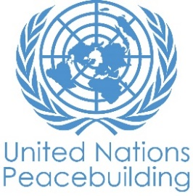
PBF PROJECT progress report
COUNTRY: SOUTH SUDAN
TYPE OF REPORT: aNNUAL REPORT
YEAR of report: 2021

Project Title: YOUTH ACTION FOR REDUCED VIOLENCE AND ENHANCED SOCIAL COHESION IN WAU, SOUTH SUDAN
Project Number from MPTF-O Gateway: 118940
If funding is disbursed into a national or regional trust fund:  Country Trust Fund  Regional Trust Fund  Name of Recipient Fund: | Type and name of recipient organizations:  IOM (Convening Agency)  UNESCO
Date of first transfer: 2nd December 2019
Project end date: 30th December 2022
Is the current project end date within 6 months? Yes

Check if the project falls under one or more PBF priority windows:
Gender promotion initiative
Youth promotion initiative
Transition from UN or regional peacekeeping or special political missions
Cross-border or regional project

Total PBF approved project budget (by recipient organization):
Recipient Organization Amount

IOM $ 1,922,095.00
UNESCO $ 865,650.00

Total: $ 2,787,745.00
Approximate implementation rate as percentage of total project budget: 50%
*ATTACH PROJECT EXCEL BUDGET SHOWING CURRENT APPROXIMATE EXPENDITURE*

Gender-responsive Budgeting:

Indicate dollar amount from the project document to be allocated to activities focussed on gender equality or women’s empowerment: USD1,605,737.44
Amount expended to date on activities focussed on gender equality or women’s empowerment: USD 807,359.2

Project Gender Marker: GM2
Project Risk Marker: Medium
Project PBF focus area: 2.3 Conflict Prevention/Management
Report preparation:
Project report prepared by: Benjamin Moore, Coordinator, Transition and Recovery, IOM
Project report approved by:
Did PBF Secretariat review the report:

NOTES FOR COMPLETING THE REPORT:
- Avoid acronyms and UN jargon, use general /common language.
- Report on what has been achieved in the reporting period, not what the project aims to do.
- Be as concrete as possible. Avoid theoretical, vague or conceptual discourse.
- Ensure the analysis and project progress assessment is gender and age sensitive.

PART 1: OVERALL PROJECT PROGRESS

Briefly outline the status of the project in terms of implementation cycle, including whether preliminary/preparatory activities have been completed (i.e. contracting of partners, staff recruitment, etc.) (1500 character limit):

During the reporting period, the interventions implemented led to a reduction of youth gang violence and impacted how youths articulate their perceptions and understanding of themselves and their situations, as well as their ways of coping with conflict, and violence and dealing with everyday life challenges, including dealing with anger, frustration, grief, confusion, and hopelessness. In general, there have been some indications where youths have started to gain their sense of agency. The youth have demonstrated resorting to non-violent ways of managing conflicts, for instance, by organizing a peace party by themselves. Other improvements include increased cohesion among groups that were initially involved in gang violence, increased positive self-image, and better communication with parents and other family. Substantial achievements have been noted in the area of restored family relationships (such as improved interactions, and fostering mutual appreciation and respect), which have been instrumental in bringing back the youths to live with their parents and for them to experience being part of family activities. The project has also successfully engaged youth from different gender and ethnic groups who are at risk of criminalization, resulting in a shift in perceptions of gender roles and conflict dynamics.. This shift was achieved by developing a robust and contextualised approach that has helped to address social and gender-based attitudes and norms that underpin violent behaviours. The gender dialogues have created a core group of “youth influencers” who are motivated to continue this work among their peers to leave a lasting positive impact.

By receiving support from counsellors, peers, families, and communities, youths have also changed their self-perception, re-learned life skills and self-care, started to build trust, and were able to create positive social relations and networks. The youths have started to productively engage themselves in activities to further improve family relationships and their roles in promoting change in their respective communities, especially in the areas of education, health, peace and security, and economic stability.

The project has transformed the youth from being perceived as delinquent to being recognized as productive members of their communities. The skills they acquired from the project’s vocational skills and business development trainings enabled them to engage productively in the local economy, thereby reducing their economic vulnerability and deincentivizing involvement in negative coping activities that previously characterized their lives as members of youth gang groups. These skills have also enabled them to contribute positively to the community, especially as people battle the spread of COVID-19. For example, the youth produced and distributed face masks and soap, repaired water points (boreholes), and sensitized community members on the spread of COVID-19, preventive measures, and control protocols. For the girls, being able to depend on themselves and contribute to the welfare of their families is critical in reducing their chances of being forced into early marriage, in order to raise resources for their households in the form of a bride price. For the boys, being now able to provide for themselves and their families in the face of the hard economic situation and food insecurity helped them to regain their identity and avoid acts of violence and crime, which used to be their primary strategy to express their authority and control in society.

Interventions aimed at improving youths’ relationships and perceptions with local communities and governmental authorities,including radio talk shows,inter-generational dialogues and forums with decision makers , yielded positive results during the reporting period. Youth continued to engage and collaborate with local authorities to jointly undertake several public good project initiatives, including conducting basic repairs of local feeder roads, helping repair sports facilities, and organizing sport activities to promote social cohesion. As previously mentioned, the positive transformation of the youth captured the attention of local authorities, including the State Governor and the security agencies. As a result, the State Governor ordered the establishment of a Partners Forum, under the Ministry of Youth, to scale up youth-centric interventions similar to those implemented under this project. On their part, the local leaders initiated a campaign to encourage inter-generational interactions to further strengthen the positive relationship and mutual understanding between youth and the members of the community.

Please indicate any significant project-related events anticipated in the next six months, i.e. national dialogues, youth congresses, film screenings, etc. (1000 character limit):

The Ministry of Youth, in collaboration with and with the support of partners supporting youth-centric interventions in South Sudan, has initiated the process of developing the National Youth Strategy at the national level. The strategy will help define the government’s vision towards youth engagement, identifying key areas in which action is required to enable youth development and providing a framework for action for all stakeholders.

The Youth Strategy development process has been designed to be consultative and participatory and will include youth consultations and engagementat the local state levels. This approach will ensure that the youth’s diverse and unique concerns are heard and taken into consideration while developing the strategy. The youth in Western Bahr el Ghazal, including the youth-at-risk, will be supported throughout the process to genuinely engage their inputs into the strategy’s design.

FOR PROJECTS WITHIN SIX MONTHS OF COMPLETION: summarize the main structural, institutional or societal level change the project has contributed to. This is not anecdotal evidence or a list of individual outputs, but a description of progress made toward the main purpose of the project. (1500 character limit):
N/A

In a few sentences, explain whether the project has had a positive human impact. May include anecdotal stories about the project’s positive effect on the people’s lives. Include direct quotes where possible or weblinks to strategic communications pieces. (2000 character limit):

This project has generated direct positive human impacts, particularly as a result of implementing the gender transformative curriculum. For example, before the project, youth gangs/groups from the eastern bank of Wau were always involved in violent conflict with groups from the western side of Wau town. Following the implementation of gender transformative sessions, groups from the two sides are now reporting that they are living in harmony with a reported reduction in violence. In July 2021, nine groups of young men and women from various corners of Wau organised a peace party on their own to show that they can live together in peace and that they are now working in cohesion. During the event, the groups:
- Formed a joint committee that would coordinate all groups to show their unity in promoting peace and refraining from violence
- Agreed to cease all hostilities so that members of all groups can move freely without obstruction and resulting violence
- Agreed to transform their groups from violent to non-violent groups
- Agreed to work collectively to positively contribute to their communities and positively transform their image in the communities where they live

This peace party is an illustration of the project’s impact in reducing youth gang-related violence, especially because the engagements happened organically without the involvement of project partners. The youth facilitated the activities on their initiative, which shows that when given the knowledge and skills, youth engagement can act as a catalyst for peace and security.

PART II: RESULT PROGRESS BY PROJECT OUTCOME

Describe overall progress under each Outcome made during the reporting period (for June reports: January-June; for November reports: January-November; for final reports: full project duration). Do not list individual activities. If the project is starting to make/has made a difference at the outcome level, provide specific evidence for the progress (quantitative and qualitative) and explain how it impacts the broader political and peacebuilding context.

- “On track” refers to the timely completion of outputs as indicated in the workplan.
- “On track with peacebuilding results” refers to higher-level changes in the conflict or peace factors that the project is meant to contribute to. These effects are more likely in mature projects than in newer ones.

If your project has more than four outcomes, contact PBSO for template modification.

Outcome 1: Emotional distress and use of violence among youth at risk are reduced through positive coping strategies at individual, family and community levels

Rate the current status of the outcome progress:

Progress summary: (3000 character limit)
To reduce emotional distress, the psychosocial mobile team (PMT) in Wau engaged marginalized youths actively involved in gangs or at risk of joining youth gangs. IOM’s mental health and psychosocial support (MHPSS) team assisted the youths and their families to cope with distressful situations brought about by complex factors such as conflict, poverty, limited opportunities and the onset of COVID-19. Due to this assistance, 219 (90 M, 129 F) displacement affected youths (returnees and host communities) saw notable improvements in self-perception and roles in their families and communities through a WHO-5 tool for measuring wellbeing of individuals, beneficiriary satisfaction form, observation and self-reporting by the youth and family members. 120 families (parents and guardians) who received support reported improvements in factors affecting family relationships. Out of the 219 youth, 129 youths (73M, 56F) also received focused, non-specialized support.

In addition, every month, at least six support group meetings took place, attended by 310 youths (191 M, 119 F). Topics related to their rights, such as security, peace, freedom from poverty, and economic empowerment, were the main themes during these discussions. Problem-centered discussions included suicide, alcohol and substance abuse, gender-based violence (GBV), delinquency and being in situations of violence and armed conflict. These peer support group discussions allowed the youths to regain confidence in dealing with challenges and to be part of the “healing” process within their respective families.

34 youth participated in the inter-generational dialogue, 15 youth attended the Identity, Belonging, and Diversity workshop, while 22 youth graduated from vocational training and participated in the business development training to start individual/group income-generating endeavors. As an outcome, 87 youth (23F, 64 M) have returned to their homes following intergenerational daloges between youth and parents/guardians and 43 (18F, 25M) returned to school while 12 (8F, 4M) are operating small business enterprises. Youths from Bazia Jedid have become good role models for young people by initiating volunteer work constructing houses or gathering shelter materials to support the most vulnerable in their communities, such as the abandoned and neglected elderly, as well as persons with disabilities.

To change gender attitudes and norms that underpin violence, a gender transformative approach for engaging young men and women at-risk, aged between 16 and 35, in individual behaviour change focusing on the gendered dimensions of violence was developed. Using this approach, 18 participants (9M and 9F) drawn from national implementing partners were trained from which, trainees were selected to roll out the pilot approach with 44 selected youth (22M and 22F). These youth participated in the conflict and gender transformative curriculum for eight weekly dialogue sessions of three to four hours. As tension between gangs often falls on ethnic lines, the mixed ethnic grouping of participants helped to diffuse tensions and promote coexistence among the youth gangs.

Upon completion of the pilot session, the youth conducted four community awareness sessions on harmful gender norms, which underpin violence, community insecurity, and conflict between gangs and ethnic groups, reaching 845 (560 female and 285 male) people. IOM also trained 39 young women aged between 18-32 in leadership to ensure that they effectively engage in issues that affect them and have the tools to spearhead initiatives that focus on curbing these issues’ negative impact. Community leaders and parents highlighted they are seeing huge improvements in non-violence among the youth that were engaged in the pilot dialogues and leadership training. By October 2021, the youth groups were still active and implementing violence prevention interventions on their own.

Indicate any additional analysis on how Gender Equality and Women’s Empowerment and/or Youth Inclusion and Responsiveness has been ensured under this Outcome: (1000 character limit)

The gender and violence prevention transformative dialogues were inclusive of the needs and experiences of both young men and women, which were determined through participatory action research with the participants themselves. The dialogue approach was adapted into two different curricula to address these specific experiences and social expectations and to engage on issues especially relevant to young men and women. In addition, the training of 39 young women in leadership has enabled them to become effective advocates for engaging decision-makers and processes on issues that affect them such as being excluded from decision making processes.

Outcome 2: Youth increase their positive social and economic engagement in their communities
Rate the current status of the outcome progress:

Progress summary: (3000 character limit)

Interventions supporting youth-at-risk for positive socioeconomic involvement in their communities demonstrated great success during the reporting period. A significant number of youth (210, with 50% girls) who received vocational skills training were absorbed in the local market and some established their own small enterprises. For example, a group of eight female youth, who completed a tailoring course, indicated to project partners that they established their own tailoring shops and won a tender to supply uniforms to several schools in Wau town. Additionally, two leading hotels in Wau town have reached out to project partners indicating their willingness to give industrial attachment opportunities to youth trained on culinary skills. The hotels could not previously provide these opportunities as most establishments had temporarily closed operations due to COVID-19 restrictions. Five out of twenty seven o youth who acquired basic computer skills have been absorbed in growing local cyber operation businesses, which involve small shops offering internet surfing, typing, printing and photocopy services. The skills acquired and the start-up kits provided under the project helped these young men and women to detach themselves from their old social groupings where they were often in conflict with the law and perceived as delinquent. In addition, examples of the youth’s work attest to their positive contribution to society. Key contributions with a positive impact in the community, for instance, include the production and distribution of face masks and soap to help fight COVID-19 in the community and the repair of community water points (boreholes).
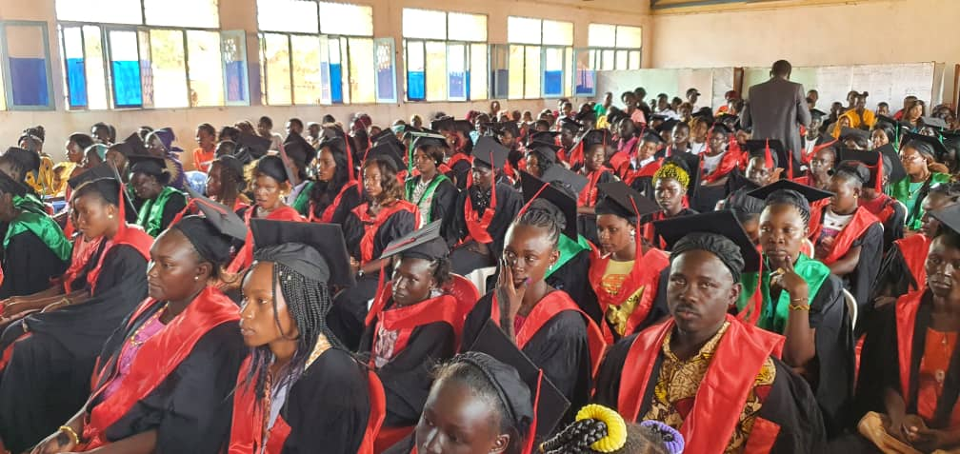Photo 1. Graduation ceremony of vocational skills trainees attended by State officials from Ministry of Education, Ministry of Gender, Ministry of Physical Infrastructure, Ministry of Health and Ministry of Youth and Sports.

Beneficiary testimonies suggest that the skills they acquired give them hope that they can contribute to both improving their own lives and that of others. In a video documentary to be released in the coming months, beneficiaries recounted the change the project brought to the lives of these once economically and socially vulnerable young people whose past was characterized by negative coping mechanisms, which often brought them into conflict with the law. Being able to make a living and support others has many other associated benefits. For the young men, it provides a sense of security and identity and a reason not to rejoin gang groupings associated with crimes such as theft of property, vandalism, and drug abuse. For girls, it lessens the chances of being forced into early marriage in order to fetch bride wealth, because their familial support now alleviates the dire economic situation and food insecurity their households face. The State Government in Western Bahr el Ghazal has applauded technical and vocational education and training (TVET) as the best approach because of its potential to rapidly transform and empower the youth with tools to engage in productive activities that will significantly contribute to the local economy.

Indicate any additional analysis on how Gender Equality and Women’s Empowerment and/or Youth Inclusion and Responsiveness has been ensured under this Outcome: (1000 character limit)

The project team ensured that the project kicked off with a mapping exercise to collect individual and household disaggregated data, including sex, age, education level, marital status, residential status (whether internally displaced or not), sources of livelihood, social group membership and special needs (such as form of disability). The exercise covered eight youth hotspots, 36 youth gangs, and a population of 3,497 individuals, of which 1,394 (39.9%) were female and 2,103 (60.1%) male. This exercise helped to ensure that the project includes and responds to needs of the most at-risk youth, both male and female. The average age of male youth targeted by the project was 20.6 years old and the average age was 20 for the girls targeted. Of the youth who engaged in the vocational skills training, 50% (105) were female youth.

Outcome 3: Community perceptions of youth are transformed, breaking stigmatization and enabling young men and women to participate in decision-making processes.
Rate the current status of the outcome progress:

Progress summary: (3000 character limit)

The project’s impact under this outcome has continued to be felt and witnessed in the community. Over 400 youth previously engaged in gang-like activities have demonstrated a strong commitment to abandoning delinquent behaviours and embracing positive, constructive, and lawful lifestyles. Seven former gang groups transformed themselves into formal and legally registered groups and started their own positive enterprises, including small businesses and artistic groups in the community. Several other youth groups have continued to do basic road repairs in their communities on a voluntary basis. In August 2021, 10 former gang groups initiated a campaign to advocate for the rehabilitation of Algezira Stadium in one of the Wau town localities. The youth organized themselves to provide free labour and lobbied the State Government and the town’s business community to provide materials, including cement, sand and bricks, for the stadium construction. Consequently, the relationship between the youth and the local authorities and broader community has greatly improved. The State Government has embraced the project’s objective of youth transformation and has established a Partners’ Forum to discuss a strategy to scale up youth-centric interventions similar to those being implemented under this project. In addition, as a result of project intervention, the local leaders, including the Chiefs and Block Administrators, initiated conversations at the community level to encourage parents, especially father figures, to reach out and open up spaces to listen to and interact with their children. Furthermore, members of different gang groups forged a strong friendship and now freely visit each other in their streets of residence, which were previously no-go zones for members of different gangs.

Feedback gathered from various sources, such as the inter-generational dialogues and radio talk shows, indicate that the livelihood support provided under the project has contributed to making the youth productive in society. For example, 46 (36 male, 10 female) youth who chose to be trained in art and handicraft reported that the proceeds from the products they produced somewhat enhanced their self-reliance. The group trained in embroidery (mostly teenage girls) now earn a living from making and selling bed sheets, towels, pillowcases, baskets, bracelets, clothes, socks and caps. Four of them, however, opted to continue with their education and managed to sit for the national grade 12 examinations.

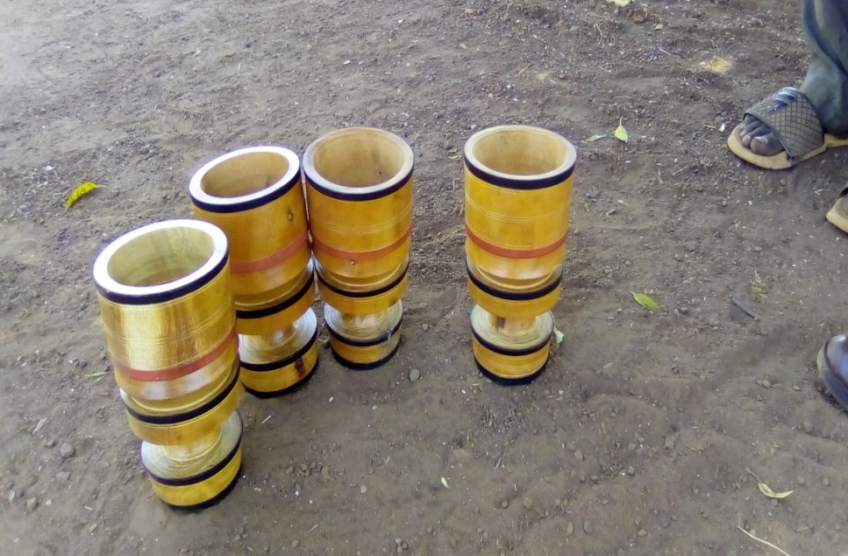
The young people trained in art and handicraft work continue to engage in the production of variety of objects such as statues of prominent personalities and other objects. These youth have transformed themselves into a working group and as such, they have no more time and motivation to rejoin gang groups. They have also established a mini gallery containing portraits of historical figures and fictional characters. This group has developed a strong sense of identity through their artwork while receiving support and recognition from their community at large.
Photo 2. Sample of artwork by the youth
A group of four youth who received training in drawing have trained 10 other youth who were once members of a youth gang in Jebel el Kheir suburb of Wau Town. This group now sees no more value in belonging to a gang group, as their skills are being appreciated by the community members who have requested commissioned artwork. Members of the Jebel el Kheir community reported that gang membership has drastically reduced in the area, with relative reduction in violence, theft, vandalism, and criminality in general.

Indicate any additional analysis on how Gender Equality and Women’s Empowerment and/or Youth Inclusion and Responsiveness has been ensured under this Outcome: (1000 character limit)

As described under outcome 2, the project made a concerted effort to target the most at-risk youth. This approach was made possible by the mapping exercised, which rooted the project intervention in qualitative and quantitative indicators disaggregated by age and sex, as well as other socioeconomic markers of vulnerability. During the inter-generational dialogues, radio drama series, and radio talk shows, gender issues such as gender stereotyping, gender-based violence, and early and teenage marriage and pregnancy were treated as acts that undermine the rights and dignity of women and therefore accounting to a form of violence. The youth themselves, having been trained in conflict transformation, leadership, civic engagement, and gender, were positioned as agent of change, encouraging community members to refrain from committing such acts.

PART III: CROSS-CUTTING ISSUES

Monitoring: Please list monitoring activities undertaken in the reporting period (1000 character limit)  At least three visits were undertaken during the reporting period to monitor activities’ implementation. In the last monitoring visit in April 2021, the IOM Coordinator for Transition and Recovery Programmes interacted with beneficiaries and also with newly appointed State Ministers for Youth and for Peacebuilding. The Government officials expressed great interest in taking the youth activities forward but requested that the project to extend for at least some period to allow the new government settle in and plan how to take over youth engagement once the project ends. The monitoring visit also revealed a gap with juvenile and delinquent youth, as they lack an integration mechanism within the community once released from juvenile centres. | Do outcome indicators have baselines?  Has the project launched perception surveys or other community-based data collection?
Evaluation: Has an evaluation been conducted during the reporting period? | Evaluation budget (response required):$147,445  If project will end in next six months, describe the evaluation preparations (1500 character limit):
Catalytic effects (financial): Indicate name of funding agent and amount of additional non-PBF funding support that has been leveraged by the project. | Though no additional catalytic funding has been sourced due to this specific project, IOM recently submitted a proposal based on the success of this project, which will focused on leveraging youth action for reduced violence in Juba. This proposal was submitted to the Embassy of Japan with a project value of 1,500,000 USD in South Sudan and builds on this existing intervention to address the issue of youth gang violence in the country’s capital.  Name of funder: N/A Amount: N/A
Other: Are there any other issues concerning project implementation that you want to share, including any capacity needs of the recipient organizations? (1500 character limit) | None

PART IV: INDICATOR BASED PERFORMANCE ASSESSMENT

Using the Project Results Framework as per the approved project document or any amendments- provide an update on the achievement of key indicators at both the outcome and output level in the table below (if your project has more indicators than provided in the table, select the most relevant ones with most relevant progress to highlight). Where it has not been possible to collect data on indicators, state this and provide any explanation. Provide gender and age disaggregated data. (300 characters max per entry)

 | Performance Indicators | Indicator Baseline | End of project Indicator Target | Indicator Milestone | Current indicator progress | Reasons for Variance/ Delay  (if any)
Outcome 1:  Emotional distress and use of violence among youth at risk are reduced through positive coping strategies at individual, family and community levels. | Indicator 1.1  % of improvement in well-being of people who participate in supportive activities and report on reduced emotional distress levels | Overall 64%; Males 68%; Females 48% | BL+10% | 10% average improvement rate on a (compiled scores and towards the end of the project). While 50% of the target participants reported positive changes by end of 2020.
 | Indicator 1.2  % of youth who believe the use of violence is never justified to resolve conflict | Overall 88%; Males 86%; Females 92% | BL+10% | Attitude changes at completion of 18 weeks dialogues. Behaviour changes after follow-up activities.
Output 1.1  Psychosocial Support is provided for female and male at-risk youth and youth gang members, affected families and their respective communities | Indicator 1.1.1  Number of female and male youth, and respective family members provided with focused mental health and psychosocial support services (individual and group) | 0 | 200 youth (direct beneficiaries) and 400 community members | 100% by end of project | 171 youths (82 male, 89 female); 135 community members | Beneficiary numbers are lower than planned due to COVID-19 restrictions on gatherings
Output 1.2  Youth and community leaders are engaged in a series of dialogues on communications, relationships and masculinity, including the use of violence at community level and against women | Indicator 1.2.1  # youth and community leaders attend dialogue  sessions on communication, relationships and  positive masculinity | 0 | 200 |  | 44 youth (22 men and 22 women) engaged in a series of gender dialogues.  32 community leaders (14 men, 18 women) engaged through awareness campaigns, e.g., drama by participating youth. A total of 76 individuals reached (36 men, 40 women). | It was not possible to reach more youth and community leaders due to COVID-19 restrictions, which made it difficult to have large gatherings and created project delays
Output 1.3  Young women are engaged  through leadership and  confidence building activities | Indicator 1.3.1  % Increase in young women’s empowerment | 54% completely confident  12% fairly confident  10% somewhat confident  15.5% slightly confident  8.5% not confident at al | 65% | Changes in confidence  after completion of  empowerment  sessions. Final  empowerment targets  to be achieved with  engagement in  economic  empowerment activities  and dialogue sessions. | 39 young women trained in leadership to build their confidence.
Outcome 2:  Youth increase their positive social and economic engagement in their communities | Indicator 2a  % adults who agree that youth contribute to  productive societies through the livelihood  assistance provided | 51% | BL+20%
 | Indicator 2b  % of youth who report increased self-esteem  and enhanced self-reliance outside of crime  activities | Self-esteem 52%; Self-reliance 57% | BL+20%
Output 2.1  Male and female youth receive  vocational training, small  business trainings, and start up  kits combined with soft skills  development and socio-emotional  competencies | Indicator 2.1.1  # of youth provided with business skills and  start-up kits (disaggregated by age and sex) | 0 | 200 |  | 447  (275M; 172F)
 | Indicator 2.1.2  # of youth participating in TVET provided | 0 | 100 |  | 283  (204M; 79F)
 | Indicator 2.13  # of youth linked with job and internship  opportunities | 0 | 50 |  | 0 | Due to COVID-19 restrictions, activity implementation was delayed and also the country’s economy was slowed. Activity currently under implementation.
Output 2.2  Youth capacity built in life skills,  organizational management and  socio-emotional competencies  needed to create a sustainable  livelihood project | Indicator 2.2.1  # of youth provided with soft skills | 0 | 200 |  | 250 (with 50% women were provided soft skills and small business competencies and interview and job skills)
Output 2.3  Male and female youth receive  basic, technical and/or alternative  education | Indicator 2.3.1  Mapping of out of school children (OOSC) | 0 | 1 |  | 1 (Mapping of out of school conducted) | Data collection was mainly dependent on secondary sources for the OOSC. For the youth mapping, survey questionnaires were developed, and a team of 30 enumerators was used to fill them. A desk review methodology was used to collect the secondary data
 | Indicator 2.3.2  Number of back to school campaigns | 0 | 5 |  | 5 (at least 5,000 direct beneficiaries reached on back to learning campaigns through community meetings and local community radios)
 | Indicator 2.3.3  Mapping of youth gang at Boma and Payam  level | 0 | 1 |  | 1 (20 men, 26 women) youth gangs’ members are mapped at Wau County in five blocks, Boma and Payams)
 | Indicator 2.3.4  Number of youth facilitated to enroll in school | 0 | 200 |  |  | Due to the extended closure of schools as a national COVID-19 strategy, this activity was delayed. Schools have just reopened recently
 | Indicator 2.3.5  Number of adult/functional literacy classes provided | 0 | 25 (500 students with 50% girls) |  | 10 (250 learners with 50% female were provided 10 different FAL training sessions).
 | Indicator 2.3.6  Number of youth participating in TVET | 0 | 100 |  | 210 (105 men, 105 women) youth participated in TVET
Outcome 3:  Community perceptions of youth are transformed, breaking stigmatization and enabling young men and women to participate in decision-making processes. | Indicator 3a  % of youth who believe they have  improved relationships and increased influence  within their communities | 0% | BL+10%
 | Indicator 3b  % of community members who believe  that youth positively contribute to their  communities | 78% | BL+10%
Output 3.1  Community awareness raised on  youth contributions to  peacebuilding | Indicator 3.1.1  # of radio and theatre projects produced  and community sensitization events led by the  youth participants | 0 | 12 (6 major community events + 6 radio  drama series) |  | 11 Radio talk shows and 5 small scale community events | As a result of COVID-19 restrictions, the project adapted to the use of radio talk shows and held scaled-down community events with parameters allowed by health authorities
 | Indicator 3.1.2  # of participants (direct and indirect  participants) in the community awareness  events | 0 | 15,000 (direct and indirect)  participants) |  | 15,000
Output 3.2  Platforms are provided for the  voices of young people to  be heard by decision-makers to  promote understanding | Indicator 3.2.1  # of forums held between youth and  community/political leadership | 0 | 5 |  | 3 | Delays in the formation of the State Government affected the planning and execution of the activity. Additional forums currently being implemented
 | Indicator 3.2.2  # of Intergenerational dialogues between youth and community elders/ leaders | 0 | 10 |  | 7
 | Indicator 3.2.3  # youth trained on conflict transformation and leadership | 0 | 200 |  | 236 (125 men and 111 women benefited from the five conflict transformation and leadership trainings)
 | Output indicator 3.2.4  # of people participating in capacity  building events | 0 | 120 |  | 32 people participated in the capacity-building events organized
 | Output Indicator 3.2.5  Number of civic education sessions held for in and out of school youth | 0 | 5 |  | 5 civic educationssessions were conducted for in and out of school youth, and the event was covered by radio Voice of Hope (HOP) and was aired for the general public's consumption.
Output 3.3  Youth are empowered to engage  in a consultation process with  community to define priority  projects to be supported | Indicator 3.3.1  # of youth action plans developed | 0 | 5 |  | 5
 | Indicator 3.3.2  Youth participating in community labour | 0 | 200 |  | 0 | Phase for community labour still ahead.
 | Output Indicator 3.3.3  Prioritized Infrastructure/community project | 0 | 1 |  | 1

