PROGRAMME SEMI-ANNUAL PROGRESS REPORT
Period: January to June 2021

Project Name | Joint Programme for Sustainable Charcoal Reduction and Alternative Livelihoods (PROSCAL)
Gateway ID | 00100442
Start date | 01 April 2016
Planned end date  (as per last approval) | 31 March 2022
Focal Person | (Name): Abdul Qadir Rafiq
Focal Person | (Email): Abdul.qadir@undp.org
Focal Person | (Tel): +254 714 056483
Participating UN entities | FAO, UNDP, and UNEP
NDP Pillar | 4- Economic Foundations; 9 – Resilience
UNCF Strategic Priority | 4: Strengthening the resilience of Somali institutions, society, and population.  5: Supporting socio-economic opportunities for Somalis
Location(s) | National
Gender Marker | 2

Total Budget as per ProDoc | USD 9,469,218.50
MPTF: | USD 9,192,352.00
Non-MPTF sources: | PBF: Not Applicable
Non-MPTF sources: | Trac: USD 229,950.00
Non-MPTF sources: | Other: Not Applicable

 | PUNO | Report approved by: | Position/Title | Signature
1. | UNDP | Joselyn Mason | Resident Representative
2. | FAO | Etienne Peterschmitt | FAO Representative
3. | UNEP | Ms. Juliette Biao Koudenoukpo | UNEP Representative

Total MPTF Funds Received |  |  |  | Total non-MPTF Funds Received
PUNO | Semi Annual 2021 (1) | Cumulative | Annual 2020 | Semi Annual 2021 (1) | Cumulative | Annual 2020
 | 1 January - 31 June 2021 | From prog. start date | 1 Jan – 31 Dec 2020 | 1 January - 31 June 2021 | From prog. start date | 1 Jan – 31 Dec 2020
UNDP | - | 5,301,387.00 | 972,043.00 | 312,000.00 | 523,563.00 | 113,979.00
FAO | - | 3,120,858.28 | 648,028.62 | - | - | -
UNEP | - | 551,138.79 | - | - | - | -
Total | - | 8,973,384.07 | 1,620,071.62 | 312,000.00 | 523,563.00 | 113,979.00
JP Expenditure of MPTF Funds |  |  |  | JP Expenditure of non-MPTF Funds
PUNO | Semi Annual 2021 (1) | Cumulative | Annual 2020 | Semi Annual 2021 (1) | Cumulative | Annual 2020
 | 1 January - 31 June 2021 | From prog. start date | 1 Jan – 31 Dec 2020 | 1 January - 31 June 2021 | From prog. start date | 1 Jan – 31 Dec 2020
UNDP | 78,900.00 | 4,197,843.00 | 656,128.00 | 66,405.00 | 278,485.00 | 113,979.00
FAO | 101 442.49 | 2 187 037.75 | 270 370.13 | - | - | -
UNEP | 54,181.25 | 271,372.99 | 59,938.14 | - | - | -
Total | 234,523.74 | 6,656,253.74 | 986,436.27 | 66,405.00 | 278,485.00 | 113,979.00

ANNUAL HIGHLIGHTS
< To be completed by Lead Agency (designated by PUNOs), maximum of 5 bullet points each of one sentence. Explain/describe achievements of the Joint Programme during the reporting period with a focus on results/impact rather than process. Do not include as highlights the organization of workshops, meetings, missions, etc., but what was the programmes’ strategic contribution to peaceful development in Somalia?>
- DoECC led five (5) meetings in Q1 and Q2. Engagement with the national and sub-national environment ministries and institutions for alternative energy solutions to charcoal use resulted in strong national and local ownership with capacity development of key institutions. A total of 104 including 28 women representing environment ministries at federal and state levels, the Participating UN Organizations (PUNOs), and Donors.
- The first draft of National Forestry and Strategy has been completed in Q1. The federal government of Somalia intends to promote its strategic priorities for forestry through regional and national planning to enhance the role of forests as carbon sinks and to adapt forestry to climate change.
- Approval of the 2021 Annual Work Plan with a committed budget and two strategic meetings for the key stakeholders and counterparts held in Q2.
- In Q2, UNEP partnered with the Green Watch Trust on the World Environment week to promote public awareness and action around environmental degradation and loss of biodiversity. Integrated initiatives including TV and radio campaigns, Eco-Arts competitions for High school students, and sensitisation films benefiting more than 2,008,038 people ( 42% women). Powerful messages such as “Be a Part of the Solution, Care Clime Change by Being not part of the Environmental degradation and Oceanic Pollution’’ were highlighted in both Somali and Mai dialect on the World Environment day as a collective wake call to enhance the meaningful participation of local people on Environment and Climate Actions.
- Initiation of the Next Generation Charcoal Programme. A donor round table meeting was held in Q2 to mobilize additional resources for the Next Generation charcoal Programme. The government of Norway is in the process of signing a 3 years agreement with the MPTF to provide funding to the current phase and the next generation project while a concept note is presented to the Qatar Foundation to support alternative energy solutions to charcoal use.
- One tree nursery was established by FAO in Jubaland while twenty-three (23) members of the community committees including seven women mobilized to manage the tree nurseries. More than 6950 assorted seedlings are available for distribution to restore degraded rangelands. The nurseries serve as a source of tree seedlings for the neighbouring Internally Displaced Person camps and do generate income for the community groups by selling seedlings to the local and business community.
HIGHLIGHTS OF KEY ACHIEVEMENTS
< To be completed by Lead Agency (designated by PUNOs), In narrative form, outline/describe achievements of the Joint Programme during the reporting period with a focus on results/impact rather than process. Please refer to 1-page Joint Programme summaries in previous consolidated MPTF reports for types of inputs expected.>
350 words MAX!!!
The Programme has demonstrated integrated actions for reducing unsustainable charcoal production at the local level. These includes:
In Q1 and Q2, the Directorate of Environment and Climate Change (DoECC), Federal Government of Somalia led Five coordination and high-level technical meetings including two (2) technical meetings, one (1), a pre Programme Steering Committee Meeting and a donor round table discussions. Engagement with the national and sub-national environment ministries and institutions for alternative energy solutions to charcoal use resulted in strong national and local ownership with capacity development of key institutions. A total of 104 including 28 women representing environment ministries at federal and state levels, the Participating UN Organizations (PUNOs), and Donors.
The finalization of the first draft of the National Forestry and Strategy in Q1 of 2021. The Directorate of Environment and Climate at the office of the Prime minister concluded a peer review by the relevant stakeholders at the federal and federal member states. This strategy will help the federal government of Somalia to accelerate its ambition around sustainable forest management to regulate carbon sinks and to adapt effectively to climate change through regional and national partnership planning and partnership.
The partnership of UNEP with Green Watch trust on the World Environment week to promote public awareness and action around environmental degradation and loss of biodiversity. Integrated initiatives including TV and radio campaigns, Arts competitions for High school students, and sesitisation films were used as means of creating environmental awareness among the locals attracting. 2,008,038 people ( 42% women) . Powerful messages such as “Be a Part of the Solution, Care Clime Change by Being not part of the Environmental degradation and Oceanic Pollution’’ were highlighted in both Somali and Mai dialect on the World Environment day as a collective wake call to enhance the meaningful participation of local people on Environment and Climate Actions. These actions have contributed to building partnerships on addressing the illegal export of charcoal by bringing together national environmental champions and experts, raising awareness at national and subnational levels attracting more than Also, the media has a big role to play in making people aware of environmental issues and taking actions to protect the environment.
A donor round table meeting was held in Q2 in Nairobi, Kenya, to mobilize additional resources for the Next Generation charcoal Programme. The government of Norway is in the process of signing a 3 years agreement with the MPTF to provide funding to the current phase and the next generation project while a concept note is available with the Qatar Foundation to support alternative energy solutions to charcoal use. Also, the Denmark embassy has a new strategy that focuses on the environment, climate change, and conflict in the context of Somalia.
The establishment of one tree nursery by FAO in Jubaland. To support functionality, a water tank with drip kit installation is in place while twenty-three (23) members of the community committee including seven women of three sites (Gobweyn, Yontoy, and Kismayo) were mobilized to manage the tree nurseries. More than 6950 assorted seedlings are available for distribution to restore the degraded lands. Also, the nurseries serve as a source of tree seedlings for the neighbouring Internally Displaced Person camps and do generate income for the community groups by selling seedlings to the local and business community.
SITUATION UPDATE
< To be completed by Lead Agency (designated by PUNOs), not to exceed ½ page. Explain/describe any changes in the context since the last reporting period, e.g. changes in the AWP; changes in outputs/outcomes; changes of national counterparts; withdrawal of staff from intervention areas; etc. >
The Joint Programme for Sustainable Charcoal Reduction and Alternative Livelihoods faced multiple encounters since Q1 and Q2 of 2021. The first and foremost is the COVID19 pandemic and associated restrictions on movements, social distancing, and organizing in-person meetings. COVID19 also impacted senior officials in the counterpart institutions with illnesses and few unfortunate casualties. Virtual conferences and meetings were adopted to the extent possible and coordinate with national counterparts. This helped in making good progress for streamlining the Institutional mandates on the implementation of PROSCAL and its engagement of the relevant line ministries at federal and federal member states level. The execution of the 2021 planned activities was on hold due to three unanticipated factors: (a) the Covid-19 global health pandemic that disrupted continuity of activities that required broader stakeholders engagement due to the COVID-19 preventive measures (lockdowns, social distancing) (b) the outstanding and fragile operations at the level of both Federal Government and the Federal Member States, and (c) disruption of the national election process over the first six months. The political leadership of the country remained focused on negotiations to build consensus around the election process. After the initial political impasse, consensus on the elections process was reached on 27 May 2021 and the elections calendar was released recently. This has improved the political and security situation for wider engagement of stakeholders will help in catching up on implementation delays in the second half of 2021. It is also important to note here that COVID19 has impacted the national economy, with already vulnerable communities falling further behind in terms of their access to social services and secure livelihoods. The project recognizes this as a challenge and opportunity for rapid implementation that contributes to the recovery efforts with a climate lens making the outcomes sustainable on a medium to long-term timescale. It is therefore anticipated that the delivery of the PROSCAL will accelerate and the Country Office will be able to achieve the chunk of the delivery target. Furthermore, fast-tracking tools and strategies are in place and committed by all stakeholders including the Government counterparts, PUNOS, and MPTF donors (EU, Sweden, & Italy).

SEMI-ANNUAL PROGRESS REPORT RESULTS MATRIX
OUTCOME STATEMENT

Economic governance institutions are strengthened, and an enabling environment established for inclusive,
sustainable and broad-based economic growth driven by the emerging small and medium enterprise (SME) sector.
SUB-OUTCOME 1 STATEMENT

Promote the sustainable development and management of natural resources by developing legal and regulatory frameworks and building capacity in key Natural Resources Management (NRM) institutions.
Output 1.1: Regional Charcoal Policy Framework and Legally Binding Instrument, within the concept of international policy on charcoal National Promulgation and Rules of Business for Reducing Charcoal Production.
INDICATOR |  | TARGET | PROGRESS ON OUTPUT INDICATOR
 |  | TARGET | REPORING PERIOD (2021) |  | CUMULATIVE
Comprehensive policies and laws by the government governing charcoal production adopted |  | Target 2020/2021: Enactment and enforcement of charcoal policy/laws by the government; no charcoal export from Somalia; and policy for private sector investment developed and adopted | Final National Charcoal Policy and its translation pending for FGS Endorsement |  | Final Validated/translated National Charcoal Policy pending for endorsement by Federal Government of Somalia endorsements
Awareness material disseminated |  | Yes | Yes (across Somalia, awareness around alternative energy solutions to charcoal use including the use of energy-efficient cook-stoves and Liquified Petroleum Gas (LPG) were demonstrated on world environment day.  69 T-shirts branded with alternative energy solutions to charcoal use were distributed to 60 government officials (23F) engaged in the coordination’s |  | Yes (60 T-shirts and twenty-three banners were demonstrated across Somalia to encourage the use of alternative energy solutions to charcoal use.  two-pager awareness materials/pamphlets developed and shared with UNEP, UNDP, FAO, and Ambassadors in the April 2019 meeting in Nairobi)
UNDP ONLY: sources of evidence (as per current QPR) Progress Report; workshop agenda and report, Policy Document and Acts.
Output 1.2: Monitoring Systems of Charcoal Production, Reporting, and Movement in Somalia
Increasing Vegetation Index reports |  | Baseline data on tree densities and charcoal was established. | Yes (achieved in 2020) |  | 3 400 to 6 000 trees per km2  295 000 charcoal sites identified  558 000 tons of charcoal production estimated  20 663 000 charcoal bags estimated
 |  | Vegetation Index maps on an annual basis | Yes (achieved in 2020) |  | 8 vegetation index maps Web platform developed (https://proscal.faoswalim.org/)
Baseline socio-economic survey conducted in Badhaadhe, Kismayo, and Afmadow |  | Baseline socio-economic survey report | Yes (achieved in 2020) |  | Baseline socio-economic survey report covering Afmadow, Badhaadhe, and Kismayo districts available with the Ministry of Environment and Tourism, Jubaland State, Somalia
Field surveys on charcoal production in selected villages in Jubaland |  | Report on charcoal production in Jubaland | Yes (achieved in 2020) |  | Completed field survey and collected data on charcoal production in Afmadow, Badhaadhe, and Kismayo districts. Report on charcoal production available with the Ministry of Environment and Tourism, Jubaland State, Somalia
UNDP ONLY: sources of evidence (as per current QPR): Progress reports; Change assessment maps; Tabular data on charcoal production sites
Output 1.3. Support to the development of enabling policies on Energy, Forestry and Natural Resources Management
National policies on natural resources management adopted. |  | Solid policy framework on natural resources management established and specific policies implemented | Yes (the first draft of National Forestry and Strategy has been completed in Q1 of 2021. |  | 7 (4 approved: National Climate Change Policy, National Environment Policy, National Water Policy & National Environmental management bill/acts; validated National Charcoal Policy and draft Energy Policy and National Forestry and Strategy)
UNDP ONLY: sources of evidence (as per current QPR): Progress Report; workshop agenda and report, Policy Document and Acts.
Output 1.4. Establishment of regional Partnerships with Gulf States to Strengthen cooperation and to address the Demand side of Charcoal Trade - UN well placed to support FGS with this.
The number of countries revised rules of charcoal trade and banned its import. |  | Significant reduction in the charcoal trade | 0 (planned in Q4) |  | 0
Number of private sector companies from Gulf countries establishing businesses in Somalia. |  | GCC / OIC investment in Somalia increased in energy, and livelihoods enterprises in Somalia; | 0 (planned in Q4) |  | 0
Amount of funds mobilized from Arab countries and OIC for energy and livelihood projects in Somalia. |  | Arab countries financial support for PROSCAL achieved | a concept note was presented to Qatar Foundation by UNEP in Q1 of 2021 to support alternative energy solutions to charcoal use. |  | A concept note has been submitted to Qatar Foundation to support energy and livelihood projects in Somalia.
Number of persons who attended international/regional summits. |  | 0 | 0 (planned in Q4) |  | 2018 (350 national and international counterparts (25% women) were engaged in the  International summit on Building Partnerships to Curb Illegal Charcoal trade, Unsustainable Production, and trade). The event proved a tremendous success in stepping up the efforts to curb the illegal trade of charcoal with an increase in support for promoting alternative sources of energy and livelihoods.
UNDP ONLY: sources of evidence (as per current QPR): Agenda and minutes of the meeting, Investment plans, and signed grants commitments on energy and alternative livelihoods
Output 1.5: Improved awareness about environmental degradation and loss of livelihoods in Somalia due to charcoal trade
Number of sensitization workshops/seminars and special events organized |  | Awareness and advocacy campaigns improved.  International and Local stakeholders and media engaged to promote Sustainable Charcoal Reduction and Alternative Livelihood Options | 1 |  | 22
Number of persons reached through sensitization workshops and regional conference |  |  | 104 (28 women) sensitization/coordination workshops  2,008,038 people ( 42% women) |  | 1,160 persons (women 354) engaged in the Sensitisation Workshops  5,208,038 million people (52% women).  (500,000: SNTV/Radios: 900,000: SLNTV/Horn cable; 1,500,000:PL Golis Telcom alerts; and 350,000: PL TV, Universal TV 1,154,887, Dalsan Tv 280,886 viewers, Mustaqbal Media 242,215, Shabelle Radio 80,000 and Radio Deegaan 250,000)
Number of hits on charcoal sensitization website |  |  | 48+ awareness hits on the world environment day and special events including radios, TVs and, Eco-Arts competitions and one sensitisation video documentary (sensitisation dialogue, Eco- (13: Dalsan TV, 17: Universal TV and 7: DoECC website, 10: UNEP website) |  | 157 (7 video documentaries, and 89 media hits (12 internationals, including 6 on BBC media, 15 African regions, 8+ in Somalia; 16: MoLFR website; 23:SL MoERD website;19: PL MoEACC website, 13: Dalsan TV, 17: Universal TV and 7: DoECC website and 14 UN Environment)
UNDP ONLY: Sources of evidence (as per current APR): Communications and awareness-raising document; Workshops/ Seminars reports;
Output 1.6: Capacity building of federal (MOLFR), state-level Env. Ministries and Communities to coordinate and actions for Reducing Charcoal Production, Trade, and Use
Number of governments ministries supported and fully functional to full-scale PROSCAL activities |  | 7 adequately resourced gov’t institutions coordinating & implementing charcoal issues | 0 (planned in Q3) |  | 7 (Directorate of Environment and Climate Change-OPM, Galmudug Ministry of Environment and Forestry, HirShabelle Ministry of Environment and Rural Development, South West Ministry of Environment and Forest, Jubaland Ministry of Environment and Tourism, Puntland Ministry of Environment and Climate Change, and Somaliland Ministry of Environment and Rural Development)
Number of technical staff hired and seconded to the government ministries |  | At least 12 Staffs hired and supporting the implementation of the full-scale charcoal program at federal and federal member states Environment Ministries | 19 Staffs (6 interns) (5: DoECC:2: SL, and 2:PL, 2 GL, 2 HR, 2 SW and 2 JL) including |  | 22 Staffs (Directorate of Environment and Climate Change:7; Galmudug:2; HirShabelle:2; South West:2; Jubaland:2; Puntland:3; and Somaliland:4) including 9 Women
Number of coordination meetings held |  | At least four coordination meetings held  community activists and government staff at federal and federal member states trained on outreach sensitisation and alternative energy solutions and livelihoods options to charcoal use | 5( 1 pre PSC: 1 coordination, 2: Technical meetings & one donor round table) engaging 35 stakeholders (women) representing (26:FGS, 4: Donors-Sweden, Denmark, Norway, and PUNOS (5) |  | 23
UNDP ONLY: sources of evidence (as per current QPR): Progress Reports, LOAs, and meeting minutes
SUB-OUTCOME 2 STATEMENT
Promote sustainable alternative sources of energy to reduce local charcoal consumption through piloting energy efficient and renewable energy technologies
Output 2.1. Accelerated diffusion of efficient cook-stoves for reducing charcoal consumption
Number of businesses established and functional |  | Eight new businesses were established for the production and sale of efficient cook-stoves | 0 (planned in Q4) |  | 346 retailers (95% women-owned).
Number and share of households using efficient cook-stoves |  | Higher levels of efficient cook-stove adoption (15,000 in total), | 0 (Planned in Q4) |  | 27,280 households (95% women-headed)
Reduction in the consumption of charcoal |  | significant reduction in levels of charcoal use | Yes |  | Yes (Energy-efficient cookstoves burn 50% less combine with traditional cookstoves). innovate home-grown solutions were also piloted (green charcoal from invasive tree species, and production of biomass briquettes from compressed biomass material including farm waste) to support meaningful domestic demand shift.
Number of people employed in the efficient cook-stoves sector |  | connect women and youth engaged in cook-stove production and sales to production facilities | 0 (Planned in Q4) |  | 307 (123 women retailers)
Number and share of persons previously active in charcoal chain employed in improved cook-stove sector |  | Women and youths engaged | 0 (Planned in Q4) |  | 372 (Y:33 and W:339)
UNDP ONLY: sources of evidence (as per current QPR): Project reports; Fact sheets on the businesses established; third party monitoring reports
Output 2.2. Sustainable and efficient production of charcoal for local consumption
Reduction in the share of live trees used for charcoal production |  | Charcoal production in an organized and high-efficiency manner demonstrated at one location | 0 (Planned in Q4) |  | 11 green charcoal facilities/Kiln established (Somaliland:6; Puntland:5).
The viable business model established for the production of green charcoal |  | Charcoal production in an organized and high-efficiency manner demonstrated at one location | 0 (Planned in Q4) |  | 2 youth innovate home-grown solutions piloted (green charcoal from invasive tree species, and production of biomass briquettes from compressed biomass material including farm waste
Number and share of persons [gender disaggregated] previously active in charcoal chain employed in the green charcoal facility |  | engage youth in the efficient production of charcoal through innovation challenges and provision of innovation prizes/grants | 0 (Planned in Q4) |  | 374 (Y:328; W:46)
UNDP ONLY: sources of evidence (as per current QPR): Project reports; Fact sheets on the businesses established; third party monitoring reports; reports on alternative livelihoods
Output 2.4. Development of the LPG market and its accelerated diffusion to reduce local charcoal consumption
Number of LPG businesses established |  | Higher levels of LPG availability, adoption, and a robust supply chain | 0 (Planned in Q4) |  | 57 business/retailers including 28 women-owned) (15 Mogadishu Hodan districts; 30 in Somaliland; and 12 in Puntland)
Number of LPG connections provided |  | 20,000 new LPG connections; and significant reduction in levels of charcoal use | 0 (Planned in Q4) |  | 9,100 sets of LPGs (Somaliland: 4100 Puntland:2000; Mogadishu:600; Galmudug; 600; HirShabelle:600; south West:600; and Jubaland:600)
Number of persons [gender disaggregated] employed |  | women and youth employed in the LPG sector | 0 (Planned in Q4) |  | 57 (W:40; Y:17)
UNDP ONLY: sources of evidence (as per current QPR): Project reports; Feasibility studies for public-private partnerships for LPG supply and marketing Employment statistics reports
Output 2.5. Development of solar energy market and accelerated diffusion of solar energy equipment to reduce local charcoal consumption
Number of institutions/businesses using Solar/solar water heating systems as alternative energy options to charcoal use |  | Demonstrate the use of SWHS and LPG in 8 public institutions to reduce charcoal consumption | 0 (Planned in Q4) |  | 14 ( 6 public teashops, and 6 hospitals, one orphanage center, and a prison camp)
Number of youths trained on the installation and maintenance of solar systems |  | At least 15 youths trained on Solar systems installations and maintenance | 0 (Planned in Q4) |  | 10 youth trained in Somaliland on solar applications and maintenance
The response of beneficiaries about solar technologies |  | Satisfactory response and solar cooking demonstrated at 30 sites; increase in demand of solar systems | Yes |  | Yes (more solar training for the women and youths proposed by government counterparts at federal and federal member states to support sustainable transitioning)
UNDP ONLY: sources of evidence (as per current QPR): Project reports. Feasibility studies for public-private partnerships for solar systems and marketing, and Employment statistics reports
SUB-OUTCOME 3 STATEMENT
Promote Sustainable Alternative Livelihoods for Charcoal Value Chain Beneficiaries
Output 3.2: Diversification of income and asset building for vulnerable households to facilitate the transition to more resilient and sustainable livelihoods
INDICATOR | TARGET |  |  | PROGRESS ON OUTPUT INDICATOR
INDICATOR |  |  |  | REPORING PERIOD (2021) |  | CUMULATIVE
the Number of farmers engaged in new micro-enterprises in livestock, agriculture, forestry, and fisheries with value products | 20 lead farmers trained in the agriculture value chain; 20 lead farmers trained in the livestock value chain; 20 lead farmers trained in forestry products value chain |  |  | 0 (panned in Q4) |  | 2019. 4 000 beneficiaries were reached.
Number of farmers who have diversified from charcoal to other micro-enterprises | 20 lead fishmongers trained in the fisheries value chain |  |  | 0 (planned in Q3) |  | 950 Jubaland
Number of farmers engaged disaggregated by (fodder; honey milk) | 2 cooperatives on fodder production formed;2 cooperatives on honey production formed; 2 cooperatives for milk production |  |  | 0 (planed in Q4) |  | Fodder seeds:  500 beneficiaries; Beehives and other beekeeping equipment distributed to  450 beneficiaries
UNDP ONLY: sources of evidence (as per current QPR)
Output 3.3. Reforestation and rehabilitation of degraded ecosystems for environmental conservation and sustainable production of food, fuel, and fodder
Number of plant nurseries established | 4 tree nurseries were established one in each region |  |  | 1 tree nurseries established and operationalized at Yontoy and Gobweyn in Jubaland  6950 seedlings available and planned for distribution in Q3 |  | 7 tree nurseries established and operationalized (Mogadishu:1; Dhusamareeb:1; Jowhar:1; and Jubaland:2)  13000 seedlings (FAO:  10,000 at Gobweyn and Yontoy, & Puntland environmental activists:3000)
UNDP ONLY: sources of evidence (as per current QPR)

NARRATIVE
<Summary of key results achieved and how these results contribute to higher-level impact/change and to achieving programme outcomes. Do not just list activities, number of workshops held, people trained. Maximum half page per output for each PUNO >
The Programme implementation is managed by UNDP in consultation with the Directorate of the Environment and Climate Change, the Federal Government of Somalia, UNEP, and FAO. The first and second quarter activities focused on resource mobilization, coordination, and high-level meetings, providing intuitional support to the directorate on behalf of the Federal Government of Somalia and federal member states including (Galmudug, HirShabelle, South West, and Jubaland) in undertaking the procurement processes to hire technical staffs to support the coordination and sensitizations around alternative energy solutions to charcoal use. Also, letters of agreement were signed with the Somaliland Ministry of Environment and Rural Development, and the Puntland Ministry of Environment, Agriculture and Climate Change (MoEACC) to implement similar activities around alternative energy solutions through demonstrative actions. The first pre Programme Steering Committee was also prepared during the reporting period. The Consolidated Annual Workplans and Letters of Agreements were also revised and approved to scope out activities with available funding. Progress to date against the annual output target provides the level of current achievements as detailed below.
Output 1.1: Regional Charcoal Policy Framework and Legally Binding Instrument, within the concept of international policy on charcoal National Promulgation and Rules of Business for Reducing Charcoal Production.
The Directorate of Environment and Climate Change, the federal government of Somalia has been leading the endorsement of the Validated National Charcoal Policy which is yet to be endorsed by the cabinet due to multiple factors including the disputes on the national election and the implications of the Covid-19 Pandemic. The full endorsement of the policy is anticipated in Q4 of 2021. With endorsement and resources, the Charcoal policy will serve as a legal Instrument to curb illegal charcoal export from Somalia; and promote conservation of the country’s remaining forests through better management of domestic consumption of charcoal in a sustainable manner. Also, the existing policies including the (National Climate Change Policy, National Environment Policy, National Water Policy & National Environmental management bill/acts; validated National Charcoal Policy and draft Energy Policy and National Forestry and Strategy) supplements complementarities and will help Somalia accelerate its ambition around sustainable natural resource management and climate adaptation.
Sixty (69 ) T-shirts branded with alternative energy solutions to charcoal use were given to sixty government officials (60) government officials (23F) who were engaged in the coordination meeting to streamline the mandates of the government institutions and ministries at the federal and federal member states. This is part of the integration of the awareness-raising campaign with the demonstration actions, by establishing champions (e.g., promotion of alternative technologies in government institutions, schools, and hospitals) and intensifying the spread of the materials on alternative energy sources and efficient charcoal production; and collaboration with other initiatives should be sought to disseminate lessons learned across a broader public perception and action.
Output 1.2: Monitoring Systems Established and Strengthened to record Charcoal Production and Movement
All activities under this Output were completed and reported on in the 2020 annual report.
Output 1.3. Support to the development of enabling policies on Energy, Forestry and Natural Resources Management
On 24 January 2021, a Senior Environmental Consultant was engaged for the Development of National Forest Policy/Strategy, (PROSCAL) in Somalia. The inception report has been approved by UNEP senior management. The first draft of the National Forestry Policy and Strategy is available with the Directorate of Environment and Climate Change, the federal government of Somalia while consultations with federal member states line ministries are ongoing. This strategy will help the federal government of Somalia to accelerate its ambition around sustainable forest management to regulate carbon sinks and to adapt effectively to climate change through regional and national partnership planning and partnership. Furthermore, the draft energy policy available with the federal ministry of Energy and Water Resources will support regulatory frameworks in the energy sector and forging partnerships with the private sector in demonstrating the viability of reliable and affordable clean energy. Likewise, the approved Water Policy and the National Water Resource Management Strategy will enhance water Governance and equitable access to clean and affordable water. The National Climate Change policy and the National Environment Policy supports climate change adaptation and sustainable Natural Resources Management.
Output 1.4. Establishment of regional Partnerships with Gulf States to Strengthen cooperation and to address the Demand side of Charcoal Trade - UN well placed to support FGS with this.
The Promotion of international Media Campaigns, to highlight the illegal nature and detrimental consequences of importing Charcoal from Somalia to the Gulf States and to seek financial support has been initiated. The UN Agencies support this by working with key UN partners on the ground in the Gulf States, as well as the Federal Government of Somalia.
On 28 April 2021, UNEP held a meeting with the Qatar Foundation and discussed how to collaborate beyond PROSCAL. A concept note focusing on alternative energy to charcoal and rehabilitation of degraded ecosystems has been presented to the Qatar Foundation for funding.
Output 1.5: Improved awareness about environmental degradation and loss of livelihoods in Somalia due to charcoal trade
On the 5th June 2021, UNEP engaged the Green Watch Trust, on the World Environment week to promote public awareness and action around environmental degradation and loss of biodiversity. Integrated initiatives including TV and radio campaigns, Eco-Arts competitions for High school students, and sensitization films were used as means of creating environmental awareness among the common people. The top ten students (6 girls) from Ten (10) local schools were engaged in the Eco-Arts competition and the three (3) best winners (1girl) were awarded to advance the role of young people as positive agents of change in the environment and climate change. Also, 40 students (20 Women) from the local universities including SiMad University, Mogadishu University, Somalia National University, Somali University, and Benadir University, were engaged in a TV dialogue to enlighten the local people on issues about environmental degradation, loss of biodiversity, and marine pollution. Powerful messages such as “Be a Part of the Solution, Care Clime Change by Being not part of the Environmental degradation and Oceanic Pollution’’ were highlighted in Somali dialect on the World Environment day as a wake call to enhance the meaningful participation of local people on Environment and Climate Actions. Likewise, local radios such as Mustaqbal, Shabelle, and Degagan were similarly engaged to broadcast an interactive programme on environmental conservation, the value of nature featuring experts working on the ground environmental experts, local communities, and Islamic scholars reaching out to more than 572,215 listeners (40% women. A short film for world environmental day captured the desertification and climate change effect on the pastoralist. A powerful short film featuring the effect of charcoal production was shot in the rural areas as well as in big towns to mainstream the situation of climate vulnerability in the country context. Furthermore, major Somalia television networks such as Universal and Dalsan TV were engaged to broadcast awareness on environmental conservation and promotion of alternative energy solutions to charcoal use reaching out to more than 1,435,773 viewers. The influential public figures, environmental experts, community activists, religious leaders, private sectors, and local media have a big role to play in making people aware of environmental issues and taking actions to protect the environment attracting 48+ awareness hits on world environment day and special events including radios, TVs and, Eco-Arts competitions and one sensitisation video documentary (sensitization dialogue, Eco- (13: Dalsan TV, 17: Universal TV and 7: DoECC website, 10: UNEP website). This has raised the profile of the community awareness to sustainable natural resource management and displayed alternative energy solutions to charcoal use.
Output 1.6: Capacity building of federal (MOLFR), state-level Env. Ministries and Communities to coordinate and actions for Reducing Charcoal Production, Trade, and Use
The Directorate of Environment and Climate Change (DoECC), the federal government of Somalia, has been leading the coordination for reducing charcoal production. DoECC led five (5) meetings which included a pre Project Steering Committee meeting and one (1) coordination meeting held in Mogadishu attended by more than 69 (23F) government officials representing the federal and federal member states line ministries, two (2) technical meetings, one (1) donor round table engaging the federal government of Somalia, PUNOS (FAO, UNDP, & UNEP) and Donors. The first technical meeting with the EU was virtually held on 10 March 2021 while the second meeting was held on 29 June 2021 via remote. The coordination meeting served as a podium to streamline better the Institutional mandates at federal and federal member states, deliberate equally the relevant roles and functionals in the implementation of the PROSCAL which led to the consensus of the DOECC leading the execution of PROSCAL on behalf of the federal government and federal member states after numerous negotiations. The first and second technical meetings with EU and Sweden facilitated strategic guidance as PRO SAL is at a critical stage with a bulk of pending activities under a strict timeline of six months compounded by many factors including the fragile operating context of the Country, derailed national election process and restrictions of movements due to the requirements of the Covid-19 social distancing. Also, these strategic meetings were instrumental to the elaboration of the 2021 annual Workplan and its endorsement by all stakeholders on the Participating UN Organizations (PUNOs) and Donors (Sweden, Denmark). Furthermore, active engagement of the Federal Government of Somalia, DoECC in particular with the decision-makers and key stakeholders in member states has helped in raising the profile of the programme, mobilizing additional resources, and building ownership of the federal member states. As such, the donor round table discussed overall environmental and climate issues in Somalia leading to the Initiation of the Next Generation Charcoal Programme. The government of Norway is in the process of signing a 3 years agreement with the MPTF to provide funding to the current phase and the next generation project Also, the Denmark embassy plans a new strategy that focuses on the environment, climate change, and conflict in the context of Somalia.
Through the project operational support, 19 staffs (6 interns) are on board including eight Females) to support the implementation of the full-scale programme activities at federal and federal member states. Seven for the DoECC-FGS, two in Somaliland, two Puntland, two in Galmudug, two in Hirshabelle, two in south West and two in Jubaland.
Output 2.1. Accelerated diffusion of efficient cook-stoves for reducing charcoal consumption:
Not achieved. Planned in the Q4 of 2021:
Output 2.2. Sustainable and efficient production of charcoal for local consumption:
Not achieved. Planned in the Q4 of 2021:
Output 2.4. Development of the LPG market and its accelerated diffusion to reduce local charcoal consumption
Not achieved. Planned in the Q4 of 2021:
Output 2.5. Development of solar energy market and accelerated diffusion of solar energy equipment to reduce local charcoal consumption:
Not achieved. Planned in the Q4 of 2021:
Output 3.2: Diversification of income and asset building for vulnerable households to facilitate the transition to more resilient and sustainable livelihoods:
Not achieved. Planned in the Q4 of 2021:

Output 3.3. Reforestation and rehabilitation of degraded ecosystems for environmental conservation and sustainable production of food, fuel, and fodder:
FAO’s implementing partner, Himilo Organization for Development (HoD), remobilized previously trained community tree nursery committees in Gobweyne and Yontoy villages, Kismayo district while observing strict COVID-19 mitigating measures. Twenty committee members were mobilized to manage the tree nurseries: ten from each village, 7 women and 13 men.
In addition, FAO employed local staff to support project activities on the ground. The staff member and implementing partner supervised the water tank stand construction in Yontoy, drip kit installations, and water connections from nearby water sources at the Yontoy and Gobweyne tree nurseries.
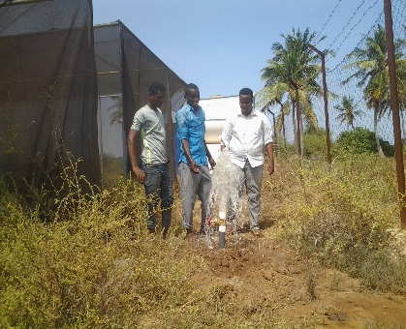
Yontoy tree nursery water connection (24 February 2021)

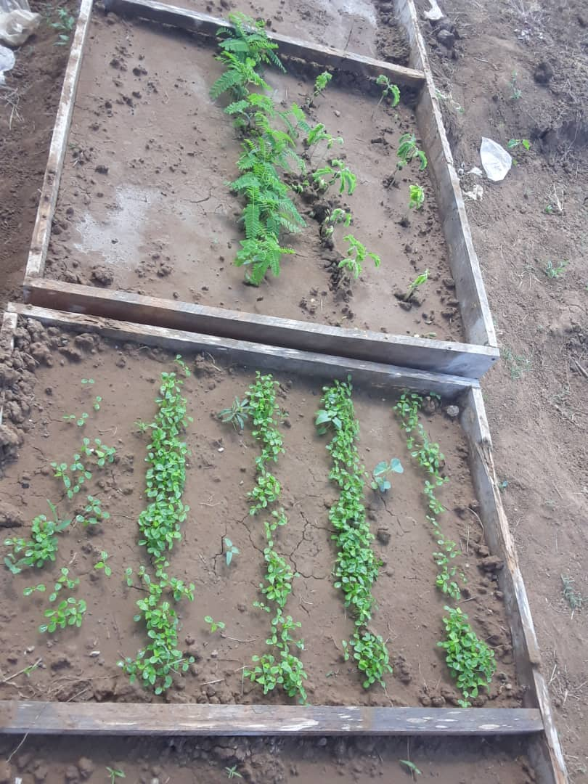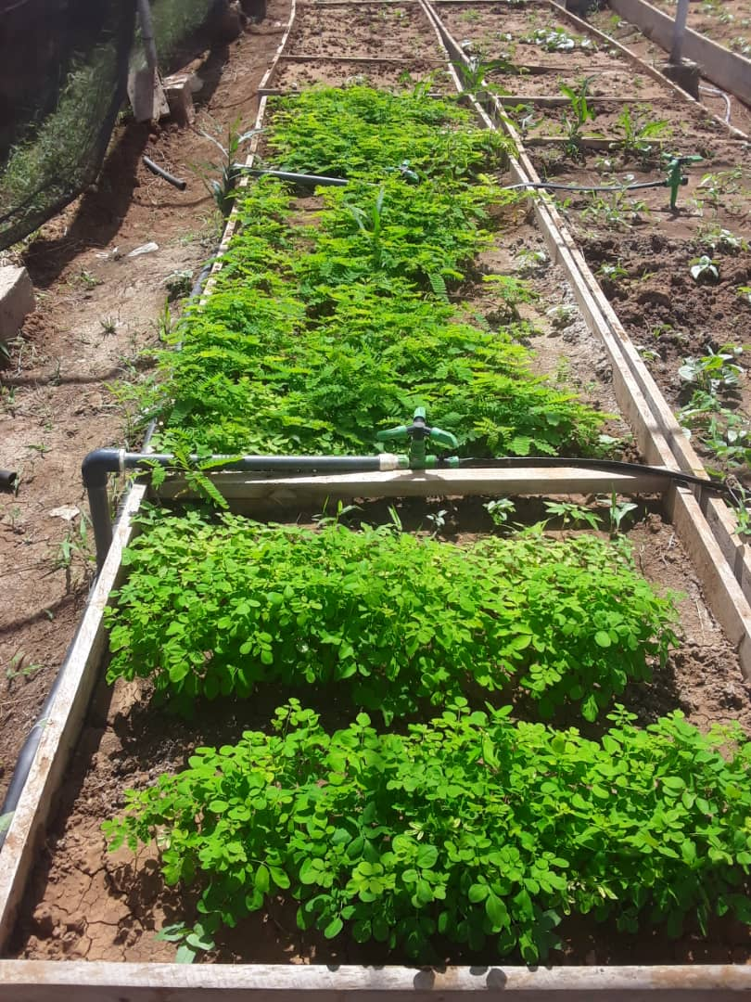
Yontoy tree nursery seedbed (25 June 2021) Yontoy tree nursery seed with sprinkle system (25 June 2021)
Both tree nurseries have a variety of tree seedlings growing at different stages. The Yontoy tree nursery has an estimated 4 100 tree seedlings growing: Tamarindus, papaya, moringa, guava, palms, acacia tortillas, Terminalia prunioides, Acacia nilotica, and Azadirachta. The Gobweyne tree nursery has an estimated 2 850 tree seedlings growing: Tamarindus, Azadirachta, date palm, acacia tortillas, Acacia nilotica, moringa, mahogany, coconut, and Ziziphus Mauritania.
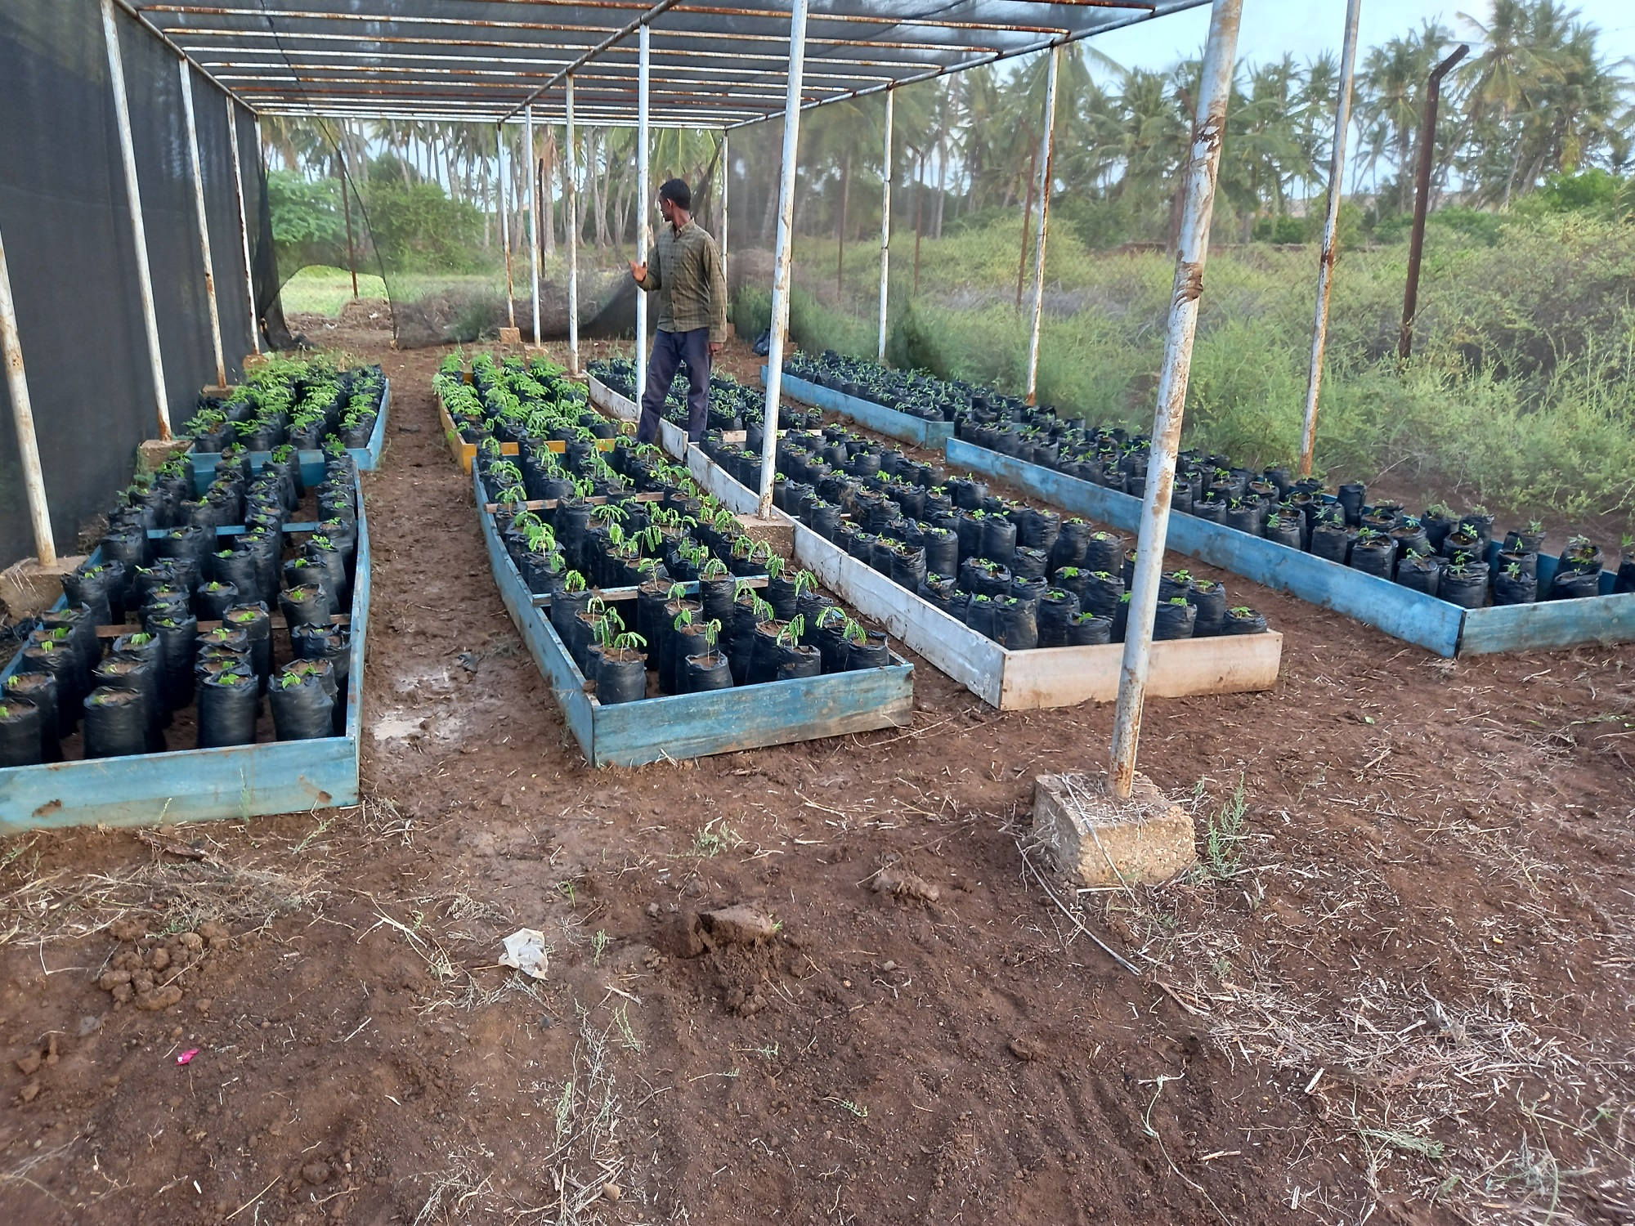 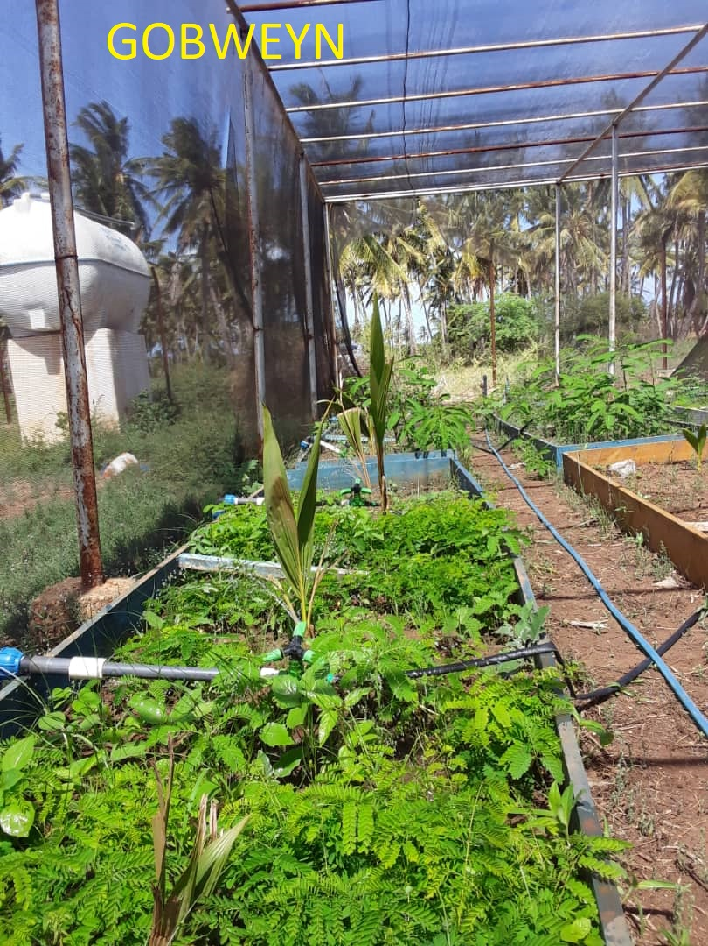 Gobweyne tree nursery (19 June 2021) Gobweyne tree nursery (25 June 2021)
The handover of the tree nursery sites to the community is set for the end of June 2021 and preparations are currently underway. All of the tree seedlings will be handed over – 2 850 from the Gobweyne tree nursery and 4 100 from the Yontoy nursery. Additional items to be handed over are 20 watering cans, 6 wheelbarrows, 30 shovels, 30 forks, 20 Pangas, 16 hoes, 20 gloves, 2 drip systems, 2 water tanks and stands, and 2 generator pumps. FAO plans to support two tree nursery attendants per tree nursery for six months to ensure that the tree nurseries are maintained and can generate income for the community group by selling seedlings to the local and business community. The nurseries are also expected to be the source of tree seedlings for the proposed Luglow IDP settlement in the Kismayo District.
Other Key Achievements <bullet points on additional achievements arising out of your interventions; maximum 2 bullet points per PUNO>
- The initiation of the second generation charcoal Programme. Advance resource mobilization is a timely step to build strategic partnerships and opportunities to present the success of the first cycle and integrating best practices and lessons learned for meaningful interventions and long-term sustainability. The government of Norway is in the process of signing a 3 years agreement with the MPTF to provide funding to the current phase and the next generation project. Also, the Denmark embassy plans a new strategy that focuses on the environment, climate change, and conflict in the context of Somalia. Somalia as a country can utilize these opportunities in realigning its strategic visions around climate and sustainable natural resource management
Number of beneficiaries – quantify the number of beneficiaries the programme engaged with during the reporting period. Specify, where possible, the number engaged through virtual platforms.
More than 2,008,165 (40% women participation) representing (2,008,050 via electronic media, 92 face-to-face while observing Covid-19 protocols, 23: via remote)
COVID-19 response <Describe how the programme has adapted to the COVID-19 pandemic, including specific Covid-focused activities - do not include impacts of the pandemic on Joint Programme, this should be included in the next section (150 words max) >
The Participating UN Organizations (PUNOs) applied stringent measures to curb the spread of COVID-19 at all project stages. The following measures were enforced:
- Social distancing – 1.5 meters were observed at all times.
- Handwashing facilities were erected in all places where social gatherings took place; and
- Awareness was raised through posters that included symptoms of COVID-19 and behavioural changes during the pandemic period
Challenges (incl: COVID-19, Delays or Deviations) and Lessons Learnt: <if any, briefly describe the delays or changes in focus, approach, or targets, and provide a short justification for the change (1-2 paragraphs)>
- Reconvening the project steering committee did not materialize as planned in Q1 due to covid, fragile context, and disruption due to the national election process. Virtual conferences and meetings were adopted to the extent possible and coordinate with national counterparts and Donors led to the approval of the 2021 annual plan at end of June 2021. After the initial political impasse, consensus on the elections process was reached on 27 May 2021 and the elections calendar was released recently. This has improved the political and security situation for wider engagement of stakeholders will help in catching up on implementation delays in the second half of 2021
- PROSCAL is at a critical stage, the first two quarters spent on negotiations around mainstreaming institutional mandates and approval of the 2021 Annual Workplan. With no possibilities for extension under fragile context, executing all pending activities by December 2021 and undertaking the final programme evaluation in the first quarter of 2022 which falls in a federal and federal member states transition phase, is quite challenging. Technical level meetings were held to expedite the execution of pending activities, and fast-tracking strategies, and enhanced coordination, and a bi-monthly meeting engaging all stakeholders were agreed to provide timely guidance and course correction
- The increased pressure and a shift of focus to delivery to accommodate the execution of all pending workload may jeopardize the programme quality and compromise the expectations of the and strategic objectives and intended results. Robust implementation road map strengthened capacity on the ground, and observer effects are possible channels to inform the results
Gender
(For ALL Programmes) Narrative on activities undertaken during the reporting period in which the programme directly contributed to promoting Gender Equality & Women’s Empowerment. One paragraph per PUNO.

Notable Gender mainstreaming results include:

Output 3.1: Directly contributed to promoting Gender Equality & Women’s Empowerment. The natural resource management training for the establishment of tree nurseries ensured that the committees in Gobweyne and Yontoy villages had gender representation and women made up 30% of the committees.

In Q1 and Q2, a total of 104 including 28 women representing environment ministries at federal and state levels, the Participating UN Organizations (PUNOs), and Donors were engaged in coordination and high-level technical meetings. Engagement with the national and sub-national environment ministries and institutions for alternative energy solutions to charcoal use resulted in strong national and local ownership with capacity development of key institutions.

Integrated initiatives including TV and radio campaigns, Arts competitions for High school students, and sensitization films were used as means of creating environmental awareness reached out to more than 2,008,038 people ( 42% women). These actions have contributed to building partnerships on addressing the illegal export of charcoal by bringing together national environmental champions and experts, raising awareness at national and subnational levels attracting more than Also, the media has a big role to play in making people aware of environmental issues and taking actions to protect the environment.

In Q4 of 2021, UNEP & Green Watch Trust engaged the Top ten students (6 girls) from Ten (10) local schools in the Eco-Arts competition, and the three (3) best winners (1girl) were awarded to advance the role of young people as positive agents of change of environment and climate change.

Also, 40 students (20 Women) from the local universities including SiMad University, Mogadishu University, Somalia National University, Somali University, and Benadir University, were involved in a TV dialogue to enlighten the local people on issues about environmental degradation, loss of biodiversity, and marine pollution. Powerful messages such as “Be a Part of the Solution, Care Clime Change by Being not part of the Environmental degradation and Oceanic Pollution’’ were highlighted in Somali dialect on the World Environment day as awake to enhance the meaningful participation of local people in the Environment and Climate Actions.

Furthermore, Sixty (69 ) T-shirts branded with alternative energy solutions to charcoal use were given to sixty government officials (60) government officials (23F) who were engaged in the coordination meeting to streamline the mandates of the government institutions and ministries at the federal and federal member states. This is part of the integration of the awareness-raising campaign with the demonstration actions, by establishing champions at the government institutions to pioneer environmental and climate action innovations.
The proportion of gender-specific outputs in Programme | Total no. of Programme Outputs | Total no. of gender-specific Outputs
The proportion of gender-specific outputs in Programme | 17 | 1
The proportion of Programme staff with responsibility for gender issues | Total no. of Staff | Total no. of staff with responsibility for gender issues
 | 21 | 9
Human Rights
(For ALL Programmes) Narrative on activities undertaken during the reporting period in which the Joint Programme directly contributed to promoting Human Rights and Protection of vulnerable groups. One paragraph per PUNO.
Has the Programme included a protection risk assessment in its context analysis, including on gender issues, and taken measures to mitigate these risks to ensure they are not exacerbated or new risks created? |  |  | Result (Yes/No)
 |  |  | Yes
No. of Programme outputs specifically designed to address specific protection concerns. |  |  | Result (Number)
 |  |  | 10
No. of Programme outputs designed to build the capacity of duty-bearers to fulfill their human rights obligations towards rights holders. |  |  | Result (Number)
 |  |  | 0
Other
Do the Programmes have a national cost-sharing component (i.e. funds and/or other resources provided by the FGS and/or FMS (including in-kind contributions)? (if ‘Yes’, describe below). |  |  | Results (Yes/No)
 |  |  | No
Have FMS(s) been engaged in one or more of the following: design, planning, implementation, coordination, and/or monitoring of the Joint Programme? |  |  | Results (Yes/No)
 |  |  | Yes
Describe nature of cost sharing:
Engagement with UNSOM/UNSOS – how, if at all, did the programme work with UNSOM/UNSOS in the implementation?
- The DOECC at the OPM FGS is working with UNSOS on reforestation using seed balls from drones.

Partnerships – what partnerships have the programme benefitted from? With the IFIs, NGOs, civil society, academia, private sector, etc.
The project has actively engaged with key multi-sectoral groups of stakeholders in the various stages of consultations, awareness around environmental protection, alternative solutions to charcoal use, World Environment Day, resource mobilisation, and operationalization of tree nurseries. Specific details include:
- Engagement of the local communities and government agencies who are the implementing partner of this project including the Directorate of Environment and Climate Change-FGS, Ministry of Environment, Agriculture and Climate Change, Puntland State, Somalia (MoEACC), Ministry of Environment and Rural Development, (MoERD) Somaliland, Ministry of Environment and Forestry, Galmudug, Ministry of Environment and Rural Development (MoERD), Hirshabelle, Ministry of Environment and Tourism (MoET), Jubaland, and Ministry of Environment and Forestry (MoEF), South West.
- Sensitization targeting diversified local communities, authorities, civil societies, private sectors, academia, religious groups, activities and experts, vulnerable groups, etc.
- FAO engagement with the implementing partner Himilo Organization for Development (HoD) in the tree nursery activities.
- UNEP partnership with Green Watch trust to launch an awareness campaign that was aimed at public sensitization during world environment week. This has raised the profile of the community awareness to sustainable natural resource management and displayed alternative energy solutions to charcoal use.
- Inter-UN Agencies coordination with key UN partners on the ground in the Gulf States, as well as the Federal Government of Somalia in Promoting an international Media Campaign, to highlight the illegal nature and detrimental consequences of importing Charcoal from Somalia to the Gulf States and to seek financial support.
- FAO engaged the implementing partner Himilo Organization for Development (HoD) in the tree nursery activities. This has a wider impact on sustainability and can generate income for the community group by selling seedlings to the local and business community. The nurseries are also expected to be the source of tree seedlings for the proposed Luglow IDP settlement in Kismayo District
- Engagement of UNEP with key public high schools and universities in promoting environmental education, biodiversity, and ocean conservation
- Collaboration and coordination of UNEP with the Qatar Foundation on alternative energy to charcoal and rehabilitation of degraded ecosystems
- Engagement of the local media, environmental, experts, religious leaders
Role of the MPTF – describe how the programme relates to the overall portfolio of Programmes of the MPTF, what role the MPTF has played in supporting the achievements of strategic results of the programme, and what the MPTF should do better to increase its relevance as a platform for UN integration and joint programming
The UN joint program joint program on charcoal falls under the economic development portfolio of the MPTF. The program funding comes through the MPTF which is a flexible arrangement interms of joint work planning and single reporting. The MPTF secretariat has supported the program in the fund mobilization initiative for both the current phase of the program and the next generation program whose discussions have commenced recently.
The MPTF can further support greater coordination with other joint programs and linking the program to the other funds (WB and AFDB).
Communications & Visibility – Highlight communication activities/products (press releases/conferences, media missions, pictures/videos, social media, website, brochures/newsletters, banners) and donor visibility (in addition to any visibility measures on the mentioned communication activities/products, visibility on training curricula, equipment, and office facilities). If applicable, provide an additional explanation on limitations to communication and visibility measures, e.g. security risks or no opportunities for communication and visibility.
During the reporting period, the following activities were undertaken to promote and enhance the communication and visibility of the Joint Programme on Charcoal and Alternative Livelihoods in Somalia:
- What does it mean a world environment day in Somalia?
https://www.facebook.com/watch/?v=315881463482278.
- World environment day Radio program (daily program – 5-12 June)
https://www.facebook.com/radioshabelle/videos/319966056282654/
- Climate Crisis in Somalia Documentary (Special clip)
https://fb.watch/5Y6tIpsq5Z/
- Eco Arts Competition for the youth
https://twitter.com/GreenwatchTrust/status/1401201031065788419?s=20
- Trees are complaining not to cut (Environmental song)
(20+) Facebook
- vegetation index maps Web platform developed
(https://proscal.faoswalim.org
https://www.facebook.com/JLTVOFFICIAL/videos/160972875751045/
- Handing over ceremony of ceremony in Galmudug
Shabelle TV: https://www.facebook.com/shabelletv/videos/3924587807598148/
Somalia National TV: https://www.youtube.com/watch?v=qHaK6pRPMZg
Looking ahead <maximum one paragraph for each PUNO highlighting major and significant events foreseen/planned for the next 6 months and an additional paragraph for upcoming communication and visibility opportunities with indicated activities/products planned>
- Activity 1.1.1: Drafting National Charcoal Act with Action Plan by UNEP in Q4 of 2021
- Holding dialogue workshop for mandated institutions to implement strategy and action plan of the National charcoal policy and acts by UNEP in Q4 of 2021
- Supporting the development of enabling policies on Energy, Forestry and Natural Resources Management by UNEP in Q4 of 2021
- Drafting National Forestry Policy & Strategy aligned with IGAD Forestry Policy & Strategy by UNEP in Q4 of 2021
- Drafting National Rangeland Management with Action Plan by UNEP in Q4 of 2021
- Developing one standardized communication and awareness-raising strategy and action plan for Somalia by UNEP in Q3 of 2021
- Production and dissemination of translated policies, short videos, satellite pictures in English/ Arabic through the Mainstream international and Arab media, including sensitization of the public. (Twice a Year) by UNEP
- Establish strategic Arab/ international media network to promote fact-based information on the negative impact of illegal charcoal production and export by UNEP in Q3 of 2021
- Development of Awareness and advocacy material (Print, electronic in Somali and English and its dissemination) on the negative impact of unsustainable charcoal production and promoting alternative sources of energy by UNEP in Q3 of 2021
- Organizing a high-level meeting between the FGS, SRSG, DSRSG, and representative of Gulf Countries / OIC, creating awareness platform, targeting a wide audience of Arab speaking nations in the Gulf countries about the detrimental effect of illegal charcoal export to those countries by UNEP in Q4 of 2021
- Organizing six Monthly Partnership cooperation dialogue workshops with Gulf Countries embassies in Nairobi with FGS Embassy reviewing the status of illegal charcoal export and mobilization of funding for land restoration and possible investment in renewable energy sector/ agriculture etc. in Somalia by UNEP in Q3 and Q4 of 2021
- Promoting an international Media Campaign, to highlight the illegal nature and detrimental consequences of importing Charcoal from Somalia to the Gulf States and to seek financial support. UN Agencies to support this by working with key UN partners on the ground in the Gulf States, as well as FGS by UNEP in Q3 of 2021
- Monitoring of Vegetation Index, Acacia busses tree densities, and charcoal burning sites through RS/GIS by FAO in Q3 and Q4 of 2021
- Capacity Development for Targeted Value chains for Enhanced Marketing of Livestock Products (fodder, dairy, beekeeping, poultry) in Kismayo District, Lower Juba Region by FAO in Q3 and Q4 of 2021
- Facilitate formation of micro-enterprise schemes that can encourage livelihood diversification by stimulating employment opportunities and skills/knowledge enhancement (milk processing and marketing, honey and fodder) by FAO in Q3 and Q4 of 2021
- Activity 3.3.2. Supporting existing tree nurseries inform of rehabilitation and IFES, and capacity building to tree nursery committees by FAO in Q3 and Q4 of 2021
- Activity 3.3.5--Planting of appropriate species for simple IFES and environmental protection by FAO in Q3 and Q4 of 2021
- Conduct training and capacity-building exercises with the committees on how to manage tree nurseries as a business venture. They will also learn how to market their tree nursery products. Additional support will be provided in the form of tools and tree seeds by FAO in Q4 of 2021
- The training on beekeeping, fodder production, and milk marketing value chains on commercialization and value-addition will be conducted from July to August 2021 in Kismayo District by FAO in Q4 of 2021
- Market studies on the level of use, quality, price differential, and efficiency of conversion
and availability of efficient cook-stoves in the market by UNDP in Q4 of 2021
- Establishment of cooperatives / CBOs and small businesses engaged in manufacturing and selling of efficient cook-stoves with start-up grants of up to 50% by UNDP in Q4 of 2021
- Establishment of a Green Charcoal" Production Facilities in 5 locations by UNDP in Q4 of 2021
- Youth-focused Innovation camp for efficient charcoal – ‘Green Charcoal Production Facility' and alternative energy sources by UNDP in Q4 of 2021
- Development and implementation of franchise model concept for retailing LPG in major cities by UNDP in Q4 of 2021
- Assessment of the experience and knowledge sharing on Green Charcoal’ and development of plans for scaling up the pilot efforts to cover the requirements of major urban areas by UNDP in Q4 of 2021
- Development of solar energy market and accelerated diffusion of solar energy equipment to reduce local charcoal consumption by UNDP in Q4 of 2021
- Feasibility study for the establishment of a pilot biogas plant in potential site for demonstration by UNDP in Q4 of 2021
- Preparations for the Final programme Evaluation & deliverable-based Terms of Reference in Q4 of 2021
Human interest story – What impact has the programme had on individuals and local communities? Any perspectives from the field from especially national programmes staff? Include a short human interest story (with photos).

ANNEX 1. RISK MANAGEMENT
This section can be used to update or use the risk logs developed during the project development stage and provide any mitigation measures being undertaken by the project. (State whether the risk is from the ProDoc or is new, whether the Joint Programme was exposed during the reporting period and what specific mitigation measures were applied.

Type of Risk | Description of Risk | Mitigating Measures
Operational | The low delivery | The low delivery was due to three unanticipated factors: (a) the Covid-19 global health pandemic that disrupted continuity of activities that required broader stakeholders engagement due to the COVID-19 preventive measures (lockdowns, social distancing) (b) the outstanding and fragile operations at the level of both Federal Government and the Federal Member States, and (c) disruption of the national election process over the first six months. The national election process and political standoff between the Federal Government of Somalia and Federal member states delayed the planning and implementation of the Multi-year project activities including the reconvening of the 5th Programme meeting and the approval of the 2021 annual workplan. Virtual conferences and meetings were adopted to the extent possible and coordinate with national counterparts. This helped in making good progress for the coordination of hosting technical meetings via remote that led to the approval of the 2021 annual plan in late June 2021. community-level engagement suffered most due to limited access to delayed approval of the work plan. COVID19 also impacted senior officials in the counterpart institutions with illnesses and few unfortunate casualties. Towards the first quarter of 2021, the political leadership of the country remained focused on negotiations to build consensus around the election process. After the initial political impasse, consensus on the elections process was reached on 27 May 2021 and the elections calendar was released recently. This has improved the political and security situation for wider engagement of stakeholders will help in catching up on implementation delays in the first six months of 2021. It is also important to note here that COVID19 has impacted the national economy, with already vulnerable communities falling further behind in terms of their access to social services and secure livelihoods. The project recognizes this as a challenge and opportunity for rapid implementation that contributes to the recovery efforts with natural management and a climate lens making the outcomes sustainable on a medium to long-term timescale. It is therefore anticipated that the delivery of the PROSCAL will accelerate and the Country Office will be able to achieve the chunk of the delivery target. Furthermore, fast-tracking tools and strategies are in place and committed by all stakeholders including the Government counterparts, PUNOS, and MPTF donors (EU, Sweden, & Italy)
Environmental |  | The nationwide lockdown and requirements of the Physical distancing due to the Covid-19 Global health pandemic has significantly impacted the implementation of key planned activities including the approval of the 2021 annual Workplan , Institutional capacity development, workshops, feasibility studies, alternative energy solutions to charcoal use, and alternative livelihood components of the Charcoal Value Chain Beneficiaries (CVCBs). Relevant adopted mitigation measures include:  - Virtual conference meetings and digital platforms were adopted to support the continuity of planned activities and constantly guide government counterparts on the implementation and course correction which led to the successful meeting including the coordination, technical meetings, and donor round table meetings as well as the approval of the 2021 Annual Workplan  - Standard Operating Procedures, including social distancing – 1.5 meters were observed at all times, hand washing facilities were erected in all places where social gatherings took place, and awareness was raised through posters that included symptoms of COVID-19 and behavioural changes during the pandemic period. This led to the successful completion of the tree nurseries in Jubaland by FAO and the UNEP and Green Watch Trust partnership that hosted numerous sensitization components across Somalia especially on the World Environment Week. It was also possible to engage the key influential public figures, youth champions, civil societies, private sectors, academia, experts, and religious groups on Environmental education, public awareness, biodiversity, and collective actions oceanic pollution  - Increased letters of agreements with government counterparts at federal and federal member states to decentralized implementation, ownership, and boost delivery.  - Regular reality checks inform of virtual coordination and bilateral meetings among the federal and federal member states, PUNOS, and MPTF donors
Political | Delayed implementation and access to project sites | Planned Q4 of 2021 activities may be impacted should the outcome of the ongoing national election be disputed and contenders by the presidential candidates at federal and federal member states. Reality checks, risk mitigation plans of the committed Letter of Agreements with the Government counterparts are in place for decision making and minimizing high and moderate risks  Insecurity, the transitional period for the Federal Government and federal member states can significantly delay the continuity of the remaining activities including the final project evaluation. The PUNOS and donors will closely work with the Directorate of Environment and Climate which is the lead institution to coordinate the evaluation process with the federal and federal member states ministries and Institutions

ANNEX 2. MONITORING AND OVERSIGHT ACTIVITIES <list here the monitoring and oversight activities undertaken during the reporting period. Precise and specific, the table should not exceed one page>

Monitoring Activity | Date | Description & Comments | Key Findings / Recommendations
[I.e. Programme oversight field monitoring visit] |  | [Monitoring of project undertaken by CO Programme oversight unit; POPP mandates that these must take place for each project minimally once a year.]
[I.e. Project Board Meeting] |  | [Should take place quarterly.]
[I.e. DIM Audit] |  | [Should take place annually above certain financial thresholds; organized by CO.]
[I.e. Independent Evaluation] |  | [Should take place as per project document.]
[I.e. Engineering site visit.]

[I.e. Stakeholder Review Consultation] | 10 January 2021 | Inter-Ministerial Coordination Workshop | More than 60 government officials (23F) representing the line ministries of the federal and federal member states were engaged and received Sixty (69) T-shirts branded with alternative energy solutions to charcoal use as part of events promotion at public and community-level institutions  . Key action points include:  - Reconvening the coordination meeting Bi-monthly  - The strategic vision of the coordination be harmonized information sharing, equal representation at federal and federal member states level  - Stakeholders engagement plan revised to include the lead institution representing the federal government of Somalia as the Directorate of Environment and Climate Change in consultation with all the relevant institutions/ministries at the federal and state level  - Institutional mandates and roles, and functions agreed  - Action points of the coordination meetings are part of the agreed actions of the Project Steering Committee meeting
 | 10 March 2021 | The first technical meeting with the EU was held virtually | 11 (one female) officials representing the PUNOS, donors, and the Federal government of Somalia attended.  Key action point includes:  - Regular technical meetings to be held on monthly basis  - Enhance intra governmental coordination suggested  - Next generation program discussions initiated
 | 29 June 2021 | The second technical meeting with program donors | 12 all men representing the PUNOS, donors, and the Federal government of Somalia joined.  Key action point includes:  - Each agency needs to provide financial narratives and any additional information on each activity/component by 4 July  - Implement the remaining objectives of the programme  - Frequent meeting to be decided (Monthly or every two months)  - Provide a budget summary of each activity under each component for the three agencies  - The AWP is not providing categorization /classification of carried forward budget from 2020 and the current year allocation budget hence we need to have separate Financial narratives.  - Fast-track the implementation of the work plan for all three agencies to ensure the achievement of maximum delivery for the remaining 6 months.  - Directorate Environment office to enhance joint communication and coordination mechanisms among the government counterparties and the UN agencies and to resolve any partner's concerns promptly.

ANNEX 3. TRAINING DATA <list here details of training activities undertaken during the reporting period; should not exceed one page>
# | Target Group |  | Dates | # of participants |  |  | Title of the training | Location of training | Training provider
# | Ministry. District or UN staff | Others
 |  |  |  | M | F | Total | Title of the training | Location of training | Training provider
Totals:

Uncertified expenditures. Certified annual expenditures can be found in the Annual Financial Report of MPTF Office (http://mptf.undp.org/factsheet/fund/4SO00 )
Fill in only the numbers or yes/no; no explanations to be given here.
Fill in only the numbers or yes/no; no explanations to be given here.
Gender Specific Outputs are those that are specifically designed to directly and explicitly contribute to the promotion of Gender Equality and Women’s Empowerment.
Staff members are those contracted to undertaken work for the Joint Programme including full time staff, consultants, advisors, interns, etc. Staff members with responsibility for gender issues are those who have gender related activities included in their Terms of Reference.
Environmental; Financial; Operational; Organizational; Political; Regulatory; Security; Strategic; Other.

