2021 Annual Progress report
1 January to 31 December 2021
UN Joint Rule of Law Programme for Somaliland 2020-2021

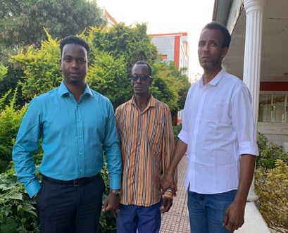 | “I appreciate the professional legal services provided by the Amoud University Legal Clinic. I could never have afforded private lawyers who charge exorbitant legal fees. I appeal for a fair judgement for my case and medical assistance to get my vision and my life back.”  Hussain Abbas (centre)
Key achievements during the reporting period

- 423 SGBV survivors (F:391, M:32) received medical and legal services through SGBV Baahikoop centres in Hargeisa, Borama and Burco. The Attorney General’s Office handled 188 cases involving a total of 213 SGBV survivors (F:201, M:12), with 71 cases resulting in a conviction.
- Through the support of the programme, 5,267 individuals (F:2,946, M:2,321) were provided with access to justice through legal aid and mobile courts.
- Capacity building trainings, consultation workshops and awareness raising campaigns reached a total of 2,794 (F:716, M:2078), including custodial corps, police officers, legal professionals, ministerial staff, health providers, and local students.

Project data

MPTF Gateway ID | 00123121
Geographical coverage | Somaliland
Project duration | From 01 January 2020 to 31 December 2021, extended to 30 June 2022
Total approved budget | 7,780,979
Programme funding level | 5,363,486 (MPTF)
Estimated delivery rate | 42%
Participating UN entities | UNDP, UN Women and UNODC. UNSOM acts as the non-executing Agency.
Implementing partners | Somaliland MoJ, MoI, MoD, Attorney General’s Office, Supreme Court, University of Hargesia, University of Amoud, University of Burao, Baahikoop Centres, Somaliland Lawyers’ Association, Somaliland Women Lawyers’ Association, NAGAAD network
NDP pillar | Somaliland’s National Development Plan II 2017-2021 (NDP-II) Pillar 3 titled ‘Good Governance’, and sub sectors of ‘rule of law and security’ is designed in line with the SDGs 16 (the achievement of ‘peaceful and inclusive societies for sustainable development, provide access to justice for all and building effective, accountable institutions at all levels.’)  Somaliland aspires to build a state where all citizens are equal before the law, and where the rights of every citizen is protected by the law and the law enforcement agencies, without discrimination based on ethnicity, clan, colour, religion, gender, age, political affiliation or belief.
UNCF Strategic Priority | SP2 - Supporting Institutions to improve peace, security, justice, the rule of law, human rights and safety of people in Somaliland.  Contributing Outcome (UNCFSP2)  UN Sustainable Development Cooperation Framework for Somalia (UNSDCF) (2021-2025). Strategic Priority 2: Security and Rule of Law
SDG | 5, 16
Gender Marker | 2
Related UN projects  within/outside the SJF portfolio | N/A
Focal person | Doel Mukerjee, doel.mukerjee@undp.org

Report submitted by:

 | PUNO | Report approved by: | Position/Title | Signature
1. | UNODC | Sylvie Bertrand | Regional Representative | 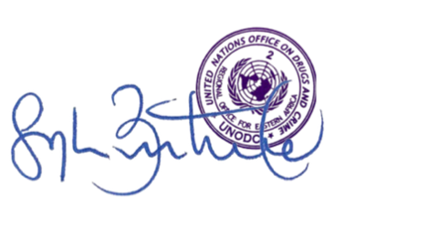
2. | UNDP | Jocelyn Mason | Resident Representative | 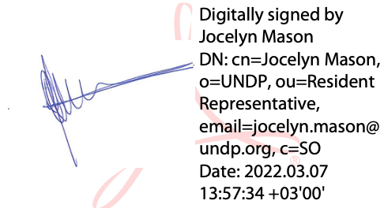
3. | UN Women | Sadiq Syed | Country Programme Manager | 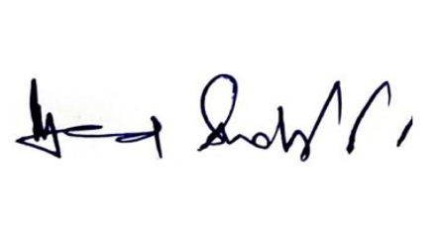
4. | UNSOM | Jeff Sims | OIC ROLSIG, UNSOM | 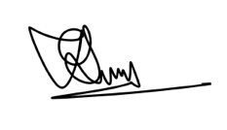

Section 1: Executive summary

Brief introduction to the project

The Joint Rule of Law Programme (JROLP) for Somaliland involves implementation of a series of activities supporting improved justice, security, policing, gender equality and human rights, with the ultimate objective of ensuring Somaliland is more secure, peaceful, and stable. Building on lessons from the Phase I Joint Rule of Law Programme (2015-2018), the programme seeks to extend the focus to the ‘difficult to reach’ rural areas as well as to promote access to justice and enhance the rights of specific, vulnerable, and disadvantaged groups. At the same time, the programme uses these and related initiatives incrementally to support the Government of Somaliland to develop and pilot new national models for the delivery of basic, rights-respecting and accountable rule of law and security services from one that provides justice only for the few in the urban areas to one that ensures and delivers tangible and measurable improvements in justice for hard to reach population in the regions which can be sustained across the whole of the jurisdiction. This new approach will put people at the centre of justice and security systems that serves their needs and is close to them, seek much closer working between formal and traditional justice and policing services and it will expand civil society space, engage local communities and civil society actors in levering up accountability through participation and social audits, responsiveness, and respect for basic rights at all levels.

Situation update / Context of the reporting period

Somaliland remained relatively peaceful and stable during the reporting period, particularly in comparison to the insecurity and political disputes experienced in regions of Somalia. Parliamentary and local government elections, held on 31 May 2021, were concluded peacefully. These elections were the first parliamentary elections since 2005, and the first local government elections since 2012, and excited widespread interest in Somaliland, with 65% of the registered electorate voting.

Somaliland was faced with the ongoing COVID-19 pandemic, which has had some impact on the implementation of the programme. Disruption to humanitarian and development assistance because of COVID-19 has exacerbated acute and chronic needs of particularly vulnerable persons, whilst movement restrictions such as stay-at-home orders, curfews, and school closures imposed in response to COVID-19 have also heightened the risk of SGBV, domestic violence and female genital mutilation.

Highlights of the project during the reporting period

- Through the support of the programme, 5,267 individuals (F:2,946, M:2,321) were provided with access to justice through legal aid and mobile courts.
- 423 SGBV survivors (F:391, M:32) received medical and legal services through SGBV Baahikoop centres in Hargeisa, Borama and Burco. The Attorney General’s Office handled 188 cases involving a total of 213 SGBV survivors (F:201, M:12), with 71 cases resulting in a conviction.
- Election security training was cascaded to 1,490 police officers through training of trainers, providing the officers with increased capacity for mitigation of election security threats and protecting the rights of women and vulnerable groups during elections.
- The capacity of institutions and key staff to deliver services were enhanced through a range of trainings, including custodial corps, lawyers, prosecutors, and parliament stakeholders. An awareness raising campaign on SGBV issues was conducted in local schools.
- The Somaliland Threat Assessment (SLTA) Drafting Process was launched with inter-Ministerial meetings of the SLTA Core Group Task force in late 2021.

Summary of key achievements during the reporting period

The provision of legal aid and mobile court services enabled 5,267 individuals (F:2,946, M:2,321) to access justice. Legal aid was provided through partnerships with legal aid clinics in the Somaliland Women Lawyers’ Association and the Universities of Hargeisa, Amoud, and Burao. Three SGBV centres in Hargeisa, Borama and Burao supported 423 SGBV survivors (F:391, M:32) with one-stop access to counselling, medical and legal services.

The programme invested in women's access to justice to advance gender equality and their empowerment and representation, establishing women's associations in Borama and Burco to ensure their inclusion in the programme interventions and access to basic services. Providing legal empowerment training, legal aid services, and public dissemination enabled Somaliland's women and girls to gain knowledge about justice services.

In Q4 2021 the Somaliland Threat Assessment (SLTA) drafting process was launched through successive inter-Ministerial Drafting Conferences and three research contractors were hired to support the process.

A series of trainings were provided to a range of justice and security partners to develop capacity. Training needs assessments and subsequently specialised trainings were delivered to lawyers across the regions to strengthen the professionalism, integrity, and ethics of the legal profession. Police officers received training on mitigation of election security threats and protecting the rights of women and vulnerable groups during elections.

The capacity of the prison service Custodial Corps was enhanced through a month-long Developing Managers Programme, held with 14 prison officers. The training course developed the management skills of junior officers to become middle managers, and the graduates from the training were able to return to their respective prisons and assume an operational role.

Section 2: Progress Report Results Matrix

ANNUAL PROGRESS RESULTS RESOURCES FRAMEWORK
IMPACT STATEMENT
Somaliland is more secure, peaceful and stable
INDICATOR |  | TARGET 2021 | PROGRESS ON IMPACT INDICATOR
- % of victims of SGBV are satisfied by police and prosecutors in SGBV cases (16.1.3) |  | 60% increase | SGBV victim survey with Baahikoop centres in planning stage
- % of public sampled who consider they are receiving better policing and court services and feel safe in the piloted areas (16.1.4) |  | 60% increase | - 47% of public sampled rated policing services as somewhat or very good.  - 49% of public sampled rated ease of access to court services as somewhat or very good.  - 81% of public sampled indicated that they felt somewhat or very safe walking in their local area.
- % of unsentenced detainees and undertrials decreases in the prisons (16.3.2) |  | 60% decrease | - 13.2% of total prison population is unsentenced or undertrial (356 prisoners of total 2,691)
OUTCOME STATEMENT
Sustainable models developed for the effective delivery of rights-based, inclusive, accountable rule of law and security, being implemented across regions in Somaliland.
INDICATOR | TARGET 2021 |  | PROGRESS ON OUTCOME INDICATOR
 |  |  | REPORTING PERIOD | CUMULATIVE
- # of people directly benefiting from legal aid interventions supported by the EU (EU Results FW, level 2 #27) | 2500 (30% women, 50 %IDPs, 10% prisoners) |  | 4,004 (F:2,476, M:1,528) | Cumulative total 5,986 (F:3,305, M:2,681)
- # of cases from TDR and ADR decisions dealt with by the formal courts ensuring human rights and fair trial standards | 200 |  | Zero | 67 cases
- # of reported SGBV cases that are dealt with by specialised benches (SDG 16.3) | 50 per quarter |  | Zero – specialized benches have not been implemented due to security concerns | Zero
- Change in number of un-sentenced detainees in the prisons (SDG 16.3.2) | 200 fewer |  | 356 unsentenced detainees in prisons as of Nov 2021 | 356 unsentenced detainees in prisons as of Nov 2021
- Percentage change in the number of arbitrary administrative detentions and human rights violations of journalists (SDG 16.10.1) | Reduced by 50% |  | 21 journalists arbitrarily detained | Arbitrary detention of journalists reduced from 31 in 2019 to 21 in 2021 – 32% decrease.
- % of women in the regions who have access to justice (SDG 16.3) | 30% |  | Total 3,337 women received A2J in reporting period.  470 women received mobile court services, 391 women received SGBV centre services, and 2,476 women received legal aid services | Cumulative total of 4,785 women received A2J.
- # of police referrals to victim protection and support services in targeted locations. | 200 |  | 423 SGBV victims (F:391, M:32) referred to Baahikoop centres | Cumulative total 695 (F:642, M:53)
- # of parole prisoners engaged in community rehabilitation programmes, disaggregated by sex | 150 |  | Zero – parole programme not implemented during reporting period | Zero – parole programme not yet implemented
OUTPUT 1:
Institutional capacity in developing inclusive and rights based RoL policies and consequent legal drafting process is developed.
INDICATOR | TARGET 2021 |  | PROGRESS ON OUTCOME INDICATOR
 |  |  | REPORTING PERIOD | CUMULATIVE
1.1) Status of development and implementation of regulation on drafting and (b) accompanying SOP on the drafting process | - One (1) drafting regulation developed and adopted across the government.  - SOP approved by the Council of Minsters |  | Workshop conducted, draft needs assessment and guideline developed. | 3 workshops conducted, draft needs assessment and guideline developed.
1.2) # of legal officers trained in rights respecting legislative drafting techniques with the support of the project, disaggregated by sex. | 50 |  | Zero | Zero
1.3) Number of (a) policies and (b) pieces of legislations developed with support of the project | - 3 policies including National Disability Policy  - 4 pieces of legislation including Disability Law |  | - National Disability policy, Media policy and legal aid policy developed.  - Disability law, Media law, legal aid law and maritime legislation developed and awaiting approval. | - National Disability policy, Media policy and legal aid policy developed. TDR policy in progress.  - Disability law, Media law, legal aid law and maritime legislation developed and awaiting approval.
OUTPUT 2:
Customary dispute resolution is better understood, harmonised, and linked with the formal court system informed by human rights and gender equality principles

2.1) Status of (a)  National TDR/formal  justice policy and (b) guidelines on collaboration between the traditional and formal justice system | two consultations organised in Burao and Borama. One policy developed and approved by the Council of Ministers One (1) guideline developed and agreed by the stakeholders i.e. judiciary / MOJ, AGO and lawyers’ associations is implemented in the regions. |  | Consultations on TDR conducted in Burao and Borama. Development of national TDR policy in progress. | Consultations on TDR conducted in Burao and Borama. Development of national TDR policy in progress.
OUTPUT 3:
The provision of legal aid, especially to vulnerable groups especially women, children and minority groups in regions is expanded

3.1) Number of districts and regions in which mobile courts are operational | 8 Districts as in year 2020 |  | 45 Districts in six regions of Somaliland. | 45 Districts in six regions of Somaliland.
3.2) Number of districts in which mobile justice system specialized for SGBV cases is available | 3 |  | Zero – specialized mobile justice system for SGBV has not been implemented due to security concerns | Zero – specialized mobile justice system for SGBV has not been implemented due to security concerns
3.3) Number of regions where manual case management is functional | 6 regions as in 2020 |  | All Six Regions (District, Regional and appeal Courts) | 6 regions
3.4) Status of judicial inspection and disciplinary system | one (1) complaint mechanism developed and implemented.  Judicial complaint mechanism is being regularly monitored and reported upon. |  | Judicial complaint mechanism in place | Judicial complaint mechanism in place
3.5) Status of construction of Burao Regional Court | Construction undertaken and made operational |  | Court design, Bill of Quantities, and tender documents completed | Court design, Bill of Quantities, and tender documents completed
3.6) Status of legal aid law | Legal Aid Law finalised and approved by the Council of Ministers |  | Legal Aid Bill finalized and awaiting Parliamentary approval | Legal Aid Bill finalized and awaiting Parliamentary approval
3.7) Status of legal aid model and guidelines in of Burao, Borama, Berbera and Sheikh. | Legal aid model implemented by all relevant stakeholders in regions |  | National Legal Aid Policy and implementation guidelines are under review. | National Legal Aid Policy and implementation guidelines are under review.
3.8) Status of monitoring and inspection of prisons for human rights compliance and ensuring appropriate legal aid services. | Ten (10) prisons monitored using inspection tool |  | Total 37 visits to police stations and 30 visits to prisons in 2021.  The AGO visited 14 police stations and 11 prisons for monitoring. The MoJ visited 12 police stations and 14 prisons for monitoring. The NHCR visited 11 police stations and 5 prisons for monitoring. | Total 37 visits to police stations and 30 visits to prisons in 2021.  Draft Standard Tools for Prison Inspection and Monitoring was completed and is planned for validation in 2022.
OUTPUT 4:
The capacity to handle SGBV cases is strengthened
4.1) Status of 3 SGBV centres | SGBV cases data in centres documented and coordinated and discussed with follow up actions |  | Three SGBV Centres functional in Hargeisa, Borama and Burco Hospitals. Data documents and coordinated by Hargesia Baahikoop centre. | 3 BHK Centres functional
4.2) Number of SGBV centre staff trained on collection of evidence in medico-legal cases, and investigation of SGBV supported, with medico-legal examination training modules in SGBV cases, disaggregated by sex and centre. | 20 |  | No trainings in 2021 | 39 Trained staff (F:17, M:22) on data collection of evidence in medico-legal cases and investigation of SGBV cases
4.3) Number of investigators and prosecutors trained on juvenile and gender needs, principles of fair trial, medico legal, SGBV | 75 |  | Training for Specialized Prosecutors on SGBV in Burao held on 13-14 October 2021. Participants were 15 prosecutors from east regional office of Attorney General. Training for Specialized Prosecutors on SGBV in Boorama held on 12 and 13 December 2021. Participants were 15 prosecutors from west regional office of Attorney General. | 72 trained in 2020, 30 trained in 2021.
4.4) Number of juvenile and women’s units established | 6 |  | 6 Women & Children Units functional under the six regional prosecution offices of Somaliland. | 6 Women & Children Units established and functional under the six regional prosecution offices of Somaliland.
OUTPUT 5:
Female legal professionals’ capacities enhanced
5.1) Number of women’s association functioning | One (1) in Burao |  | Two women’s associations were established in Borama and Burao, each consisting of 15 members. | Two women’s associations established.
5.2) Percentage change in number of women joining justice institutions and legal profession (SDG16.7.1) | 20% increase |  | No data | No data
5.3) Number of female paralegals trained to enhance referral pathway on SGBV and legal aid services (disaggregated by region) | 6 in Burao and Borama and one in WAAPO. |  | 7 female Community-based SGBV referral paralegals | 7 female Community-based SGBV referral paralegals
OUTPUT 6:
Capacities of judges and lawyers are enhanced
6.1) Number of internships at Bar Association (disaggregated by sex) | 5 (of which at least 2 women) |  | 5 Interns (3 female and 2 male) interns working under SWLA | 5 interns (F:3, M:2)
6.2) Status of graduate law curriculum | Curriculum introduced in Hargeisa University |  | No progress | No progress
6.3) Number of scholarships awarded disaggregated by sex | 10 (5 women) |  | 10 LLM students (5: females, 5 male) from Justice Institutions, MOJ, Judiciary, Prosecutors, Solicitor Generals, are currently sponsored in Hargeisa University | Total 10 (F:5, M:5)
6.4) Number of judicial trainers trained, disaggregated by sex. | 10 |  | No trainings in 2021 | 44 (Male:35, Female: 9) Judges, HJC and court staff trained in Nov 2020.
6.5) Number of manuals for judges’ training developed | 4 |  | Training material developed | Training material developed
6.7) Number of trainings held for judges, prosecutors and lawyers | 3 in the regions |  | 3 Training Needs Assessments held for 93 legal professionals (F:15, M:78) in Hargeisa, Burao and Borama in October. 3 three-day workshops on professional ethical standards training for 86 legal professionals (F:27, M:59) in Hargeisa, Burao and Borama in November/December. | 3 Training Needs Assessments held for 93 legal professionals (F:15, M:78. 3 three-day workshops on professional ethical standards training for 86 legal professionals (F:27, M:59).
6.8) Status of inclusion of sentencing guidelines in the judges’ inspection scheme and code of conduct. | 50 judges, prosecutors and lawyers trained on the sentencing guidelines  Monitoring of Sentencing guidelines included in inspection missions’ functions |  | No progress | No progress
OUTPUT 7:
Rights-respecting and accountable basic policing services increased are enhanced
7.1) Number of police stations in which a community policing initiative is implemented | 6 |  | Two Community Policing initiatives established in Burao and Borama respectively | Four Community Policing initiatives established – 2 in Hargesia, 1 in Burao and 1 in Borama
7.2) Number of police stations constructed and equipped in targeted locations | 4 |  | Design and Bill of Quantities completed for construction 6 police stations – construction planned for 2022 | Design and Bill of Quantities completed for construction 6 police stations – construction planned for 2022
7.3) Number of police officer and community members of regional community police stations educated and trained on community policing (disaggregated by sex and region) | 70 |  | Trainings conducted in Burao and Borama in December for police and district security committees with total 60 participants (F:13, M:47). | Trainings conducted in Hargesia, Burao and Borama for establishment of community policing initatives, with total 97 trained (F:28, M:69)
7.4) Number of training modules developed on rights-based community partnership policing, human rights, due process, child sensitive and gender responsive policing | 4 trainings delivered |  | 2 trainings delivered | 2 trainings delivered
7.5) Number of police officers trained in human rights, SGBV and child rights | 75 |  | No specific policing trainings on human rights, SGBV and child rights in 2021, but community policing and election security courses included training on the rights of women and vulnerable groups | Cumulative total 35 trained
7.5) Status of the Police Complaints mechanism | a) Internal complaints system is implemented.  7.5b) Accompanying regulations drafted  7.5c) Regulations are approved by MOI |  | No progress | Consultative workshop on internal complaints attended by all the stakeholders conducted in 2020.
7.6) Number of Special Protection Unit personnel trained in their functions | 50 |  | N/A - implemented under elections programme | N/A - implemented under elections programme
OUTPUT 8:
Parole and probation services are strengthened
8.1) Status of parole policies and programme | Parole and probation policy approved by the Minister for Justice  a) Parole regulation developed and approved by the Minister and parole manual developed.  b) Parole Board/supervisory office set up  c) Parole programme piloted in Hargeisa and women Prison Gabiley |  | Parole and probation policy yet to be agreed | Parole and probation policy yet to be agreed
8.2) Number of staff of the Parole Unit and custodial corps trained on new parole and probation disaggregated by sex | 50 |  | Parole and probation policy yet to be agreed | Parole and probation policy yet to be agreed
8.3) Percentage parole board monitors trained on the new parole system | 100% |  | Parole and probation policy yet to be agreed | Parole and probation policy yet to be agreed
8.4) Number of human rights monitors trained on the new parole system. disaggregated by sex | 50 |  | Parole and probation policy yet to be agreed | Parole and probation policy yet to be agreed
8.5) Number of probation officers trained on new parole regulations and manual, disaggregated by sex | 50 |  | Parole and probation policy yet to be agreed | Parole and probation policy yet to be agreed
8.6) Status of feasibility study on PVE in prison | One PVE feasibility study delivered |  | Feasibility study completed and validated by MoJ | Feasibility study completed and validated by MoJ
8.7) Number of (a) senior and (b) junior managers trained on rehabilitative approaches disaggregated by sex | a) 25  b) 25 |  | a) no training yet conducted  b) 14 (F:2, M:12) custodial corps officers trained through Developing Managers Programme | a) no training yet conducted  b) 14 (F:2, M:12) custodial corps officers trained through Developing Managers Programme
OUTPUT 9:
Security Sector Governance enhanced.
9.1) Number of people trained for the security and human rights committees of the parliament to improve capacity for civilian oversight of the security institutions | (2) trainings for members and staff of the Human Rights and Security Committees of the parliament on issues of the security and human delivered to increase capacity in civilian oversight of the security institutions. |  | Cooperation with Government Counterparts largely frozen in Q1-Q2 2021 due to COVID and Electoral priorities of the Somaliland Government. Subsequent to this planning and coordination with Somaliland counterparts has accelerated. | Preparatory work and strategic level discussions ongoing to identify the implementation approach and modalities. Planned for Q1-Q2 2022
9.2) Number of members of the Armed Forces Courts trained in case management, fair trail, gender perspective | 15 |  | Planned for Q1-Q2 2022. | Preparatory work and strategic level discussions ongoing to identify the implementation approach and modalities. Planned for Q1-Q2 2022.
9.3) Status of Armed Forces Courts legislation review and reform plan | Legislation review and reform plan developed |  | Cooperation with Government Counterparts largely frozen in Q1-Q2 2021 due to COVID and Electoral priorities of the Somaliland Government. Subsequent to this planning and coordination with Somaliland counterparts has accelerated. | Preparatory work and strategic level discussions ongoing to identify the implementation approach and modalities. Planned for Q1-Q2 2022.
9.4) Status of Human Security ‘Somaliland Threat Assessment (SLTA) and Security Policy | Policy developed and approved the Minister. |  | Launch of SLTA Drafting process in two consecutive inter-Ministerial Drafting Conferences. Three Contract researchers were hired to support the process in December 2021. | Preparatory work and strategic level discussions ongoing to identify the implementation approach and modalities. Two SLTA inter-Ministerial Drafting Conferences conduced. Planned to conclude in Q1-Q2 2022.
9.5) Status of security forces reform: gratuity and pension law | Removed |  | Removed due to reduction of funds and overlap with separate UK engagements with MOD | Removed due to reduction of funds and overlap with separate UK engagements with MOD
OUTPUT 10:
Sub working groups under NDP II are coordinated and supported
10.1) Number of sub working groups meetings held related to:  a) Rule of law and Human Rights,  b) Security,  c) Juvenile justice  with participation of 80% of sub-group members | a) 4  b) 4  c) 4 |  | 2 Rule of law and Human Rights sub-working group meeting in June and December respectively. 1 juvenile justice sub-working group meeting held on 28 December. | Total 9 sub-working group meetings held, (4 Rule of law and Human Rights; 2 Security; and 3 Juvenile justice.
10.2) Status of integrated Rule of Law & Security Sector programme aligned to NDPII and the Government Prioritisation Plan on rule of law, human rights and security | New Rule of Law and Security Sector Programme document developed & approved |  | Planned for 2022 | Planned for 2022

Section 3: Narrative reporting on results

Progress towards outcomes & outputs

OUTCOME STATEMENT: Sustainable models developed for the effective delivery of rights-based, inclusive, accountable rule of law and security, being implemented across regions in Somaliland.

OUTPUT 1: Institutional capacity in developing inclusive and rights based RoL policies and consequent legal drafting process is developed.

The roadmap for mapping of opportunities for justice systems collaboration in the legislative drafting process was facilitated by the MOJ and validated by 34 stakeholders representing the AGO, MOPCA etc. to establish a clear protocol for legislative development through the UNJRoL programme and identify the processes, mechanisms and partnerships with the various government.

The National Disability Policy and law have been developed and are awaiting submission to cabinet. Traditional Dispute Resolution Policy is in progress and maritime legislation is under review by EUCAP Somaliland. The Legal aid policy guidelines and the Bill are ready for parliamentary approval.

The Media law has been drafted following consultations and is awaiting submission to the cabinet. Advocacy workshops were held in October between media stakeholders and the new Parliamentary Sub-Committee of Justice, Judiciary and Human Rights to discuss the freedom of press in Somaliland and legal gaps.

OUTPUT 2: Customary dispute resolution is better understood, harmonised, and linked with the formal court system informed by human rights and gender equality principles

Limited progress has been made as roles and responsibility for linking Traditional dispute resolution to the formal justice system is still under discussion between Ministry of Justice, Ministry of Interior and Supreme Court.

The draft national policy on TDR in is progress. Two TDR consultations were conducted by the Ministry of Justice in December in Burao and Borama, bringing together relevant local TDR stakeholders, such as elders, traditional leaders, CSOs and legal professionals, to provide feedback on the draft TDR policy framework and discuss how TDR can be linked to the formal justice system in Somaliland.

OUTPUT 3: The provision of legal aid, especially to vulnerable groups especially women, children and minority groups in regions is expanded

In June 2021, the Regional legal aid coordination meeting was held in Burco for the first time, to discuss means of data sharing of SGBV cases with the AGO, CID and the judiciary. The coordination meeting ensures capacity building of MOJ regional officers to effectively coordinate legal aid and justice services in the respective regions and strengthen legal aid services by monitoring legal aid providers. A further coordination meeting was held in December 2021.

A total of 4,004 beneficiaries (F:2,476, M:1,528) received free legal aid provided by the legal aid clinics run by SWLA and the Universities of Hargeisa (UoH), Amoud (AULC), and Burao.

The Somaliland NHRC conducted inspection visits to prisons in Mandhera and Berbera, and 2 police stations in Berbera to review prisoners’ living conditions. A report was developed and shared at a workshop in Hargesia, attended by detention centre stakeholders, to present the situation in the visited prisons and the priorities for improvement.

The expansion of mobile courts to 45 districts in all the 6 regions has resulted in an outreach to vulnerable population living in areas with no Judiciary. It has further resulted in the introduction of the people to access the formal justice system and a gradual trust by the litigants in the formal justice institutions. During 2021, 1,263 individuals (F:470, M:793) accessed mobile court services, including 433 children and 357 IDPs.

OUTPUT 4: The capacity to handle SGBV cases is strengthened

The three Baahikoob Centres (BKC) provided a range of medical and legal services to a total of 423 SGBV survivors (F:391, M:32) during the reporting period, including 292 children. BCK’s awareness raising campaigns, disseminated through various women led associations, media channels and schools, have informed stakeholders and public about the nature of SGBV offences and the impact of GBV during Covid 19. The various medical, psycho-social and legal services available to SGBV survivors were explained, including the provision of care packages to survivors.

The AGO has been supported to enhance SGBV coordination in the justice sector and the capacity of specialized SGBV prosecutors to prosecute cases. An SGBV coordination meeting for the socialization and awareness raising on SGBV Offences law of relevant justice institutions was hosted by the AGO for 25 participants. A SGBV-Coordination Group was formed to ensure effective, integrated case management and coordination between the medical, law enforcement and social workers. The AGO conducted 2 trainings in Burao and Borama for total 30 specialized SGBV prosecutors, which aimed to enhance the capacity of the prosecutors to utilize international instruments for the protection of SGBV survivors and increase the knowledge of Somaliland laws relating to SGBV crimes. A consultation workshop was held on training manuals developed on the investigation and prosecution of SGBV crimes and juvenile justice.

Six Regional Units specialising in juvenile and women’s SGBV related cases have been established and functional under the six regional prosecution offices of Somaliland. Juvenile and SGBV Department of AGO coordinates and develops data on SGBV cases across the country, providing necessary technical and legal expertise, on-the-job training and mentoring to the specialized prosecutorial units in investigating and prosecution of SGBV and Juvenile cases, including interviewing of the victim, preparation and presentation of the case.

The NRHC undertook a series of awareness-raising workshops with local schools, engaging students and teachers in civic education on gender equality, human rights, and gender-based violence. In particular, the workshops sought to increase understanding of the impact of SGBV, how to prevent it and the support available for those affected by it.

OUTPUT 5: Female legal professionals’ capacities enhanced

SWLA trained 70 women, representing community paralegals, women led CSOs, AGO regional officers, MoJ, university students, and minorities, on constitutional and Islamic rights, international human standards and procedures. The participants committed to help each other and disseminate messages to their communities on protective measures from SGBV, domestic and intimate partner violence during Covid 19. Information on referral platforms and GBV response services for survivors were shared. SWLA developed messages and materials for awareness campaigns on women legal empowerments, access to justice and reporting procedures of the SGBV related cases to further enhance the knowledge and share the information with the community at large particular, most vulnerable women and WIDPs in Hargiesa, Burco, Gebiley and Borama.

7 female Community based paralegals were recruited by SWLA to support referral pathways on SGBV and legal aid services. The paralegals received training on Mediation, Counselling and administrative skills in October.

In response to the Rape, Fornication, and other Related Offenses bill, the NAGAAD Network were supported to engage and train 20 social media influencers (M:4 and F:16) to contribute to amending the bill and strengthen public dialogues and debates through engaging lawyers and activists. 20 members of the House of Elders were also engaged in a workshop to highlight and discuss the issues and loopholes in the Rape, Fornication, and other Related Offenses bill.

SWLA conducted orientations for the IDP settlements in Burco and Gebiley to inform them of SWLA’s project activities relating to EVAW and girls with special reference to the rise of SGBV cases during the pandemic. The orientation targeted women leaders/households, youth, elders, religious leaders and people with disabilities, enhancing their knowledge on A2J and protection for women and girls.

OUTPUT 6: Capacities of judges and lawyers are enhanced

A workshop (May 26- 27) on Election Laws, procedures, disputes and offenses, SOPs on election security management, civil and political rights etc. was conducted by the Higher Judicial Commission for 30 participants including regional courts presidents and senior judges and prosecutors in the Maroodjeex Region. The training materials were developed by the local consultant prior to the workshop.

The Judiciary Inspection and Monitoring team conducted community awareness programs in the West Regional Court in Gabiley, Regional and Appeal Courts in Dilla, District court of Borama and District Court of Tog Wajaal. Written brochures and leaflets were shared, informing the community of their right to access to justice, court procedures and the Inspection and monitoring schemes. Following such public awareness campaigns, the JSC has received complaints through phones calls from some communities in the six regions and the villages visited.

The Somaliland Lawyers Association (SOLLA) conducted three Training Needs Assessment workshops in October 2021, bringing together a total of 93 lawyers (F:15, M:78) to determine current capacity levels and the trainings required to strengthen the professionalism, integrity and ethics of the legal profession in Somaliland. These needs assessments informed the design and content of three capacity building workshops on professional ethical standards for lawyers, held in Hargeisa, Burao and Borama with a total of 86 participants (F:27, M:59).

OUTPUT 7: Rights-respecting and accountable basic policing services increased are enhanced

A ToT curricula Manual was developed for TOT and Election Security Trainings on right based policing partnership developed. UNSOM and UNDP technical experts provided quality assurance and reviewed the materials to ensure compliance on due process, rule of law and human rights standards and that the documents are in harmony with the international standards and protocols.

A 5-day training was held from 2-5 May for 50 Police officers (M35:W15) from 23 electoral districts, focusing on the role of security forces during the electoral cycle; broader political context of elections; distinction between key security threats and possible prevention and mitigation options during the various phases of the electoral period; protecting the rights of the women and vulnerable groups and coordination and operation of security forces. The training was conducted by UNSOM’s Police adviser and Human Rights Officer together with EU-CAP and British Police Advisory officers from FCDO. The Police ToT officers then provided training to 240 Police officers from 6 regions, which ultimately benefitted an estimated 1,200 Police officers across 23 electoral districts and election polling stations.

Community policing initiatives were established in Burao and Borama. Workshops in December brought together the police and the district security committees in the respective regions, providing an introduction to community policing concepts and supporting the initial establishment of community policing units in each area.

OUTPUT 8: Parole and probation services are strengthened

The MOJ, AGO and the NHRC held consultations with all related stakeholders including UNSOM in order to discuss finalize the draft of the ‘Standard Tools for SL Prison Inspection and Monitoring’. The draft was completed and is planned for validation in 2022. A total of 37 monitoring visits to police stations and 30 monitoring visits to prisons were conducted by MOJ, AGO and NHRC during the reporting period, in order to verify prisoner numbers, review detainment conditions and ensure compliance with basic standards of service. The NHRC prioritized sensitizing custodial officials on the requirement to adhere to the international human rights standards applicable to prisoners and detainees.

The Developing Manager Programme targeted junior officers to be equipped with theoretical and practical knowledge and skills to become middle managers in prisons in Somaliland. A four-week (Jan 17- Feb 10) classroom-based prison management and leadership training for 14 participants (F:2, M:12) focused on gender-sensitive correctional policies, anti-corruption measures, financial and human resources, alternatives to imprisonment and communication skills as main topics. It strengthened the capacity of participants focussing on a human rights-based approach of leadership including equality and fair decision making. One of the participants working at the Custodial Corps Headquarter, shared her experience: “I read something from my study material almost every day, I carry it with me to work. It is good to know that many of the answers that I seek is in the material.” She emphasized that “When I was invited to another training after I received the DMP, I was the only person in the classroom who heard about Nelson Mandela Rules before, so it felt good to share and contribute to the discussions.”

The second part of the DMP training (March 28- Ap 1) comprised of guest lectures and participant presentations on the practical application of skills learnt during part 1. The practical exercises in a prison enabled the participants to use the new skills that they learnt throughout the theoretical part. The post-training survey expressed that the participants improved their skills on teamwork and communication, prisoner admission and database, safety and security aspects of prison management. As a follow up, UNODC prison mentors have begun training the participants on the ground reaching out by phone to those in the regions. UNODC Prison Mentors thereafter compiled a reflection report, capturing the lessons learnt from the training and recommendations for the forthcoming Senior Management Programme (SMP). The graduates of this programme are now stationed in Hargeisa, Burao, Mandhera, Barbera and Gabiley.

The Hargeisa Central Prison Feasibility Study was conducted and validated by the Ministry of Justice. A consultation was convened with key government stakeholders and the Swedish Prison and Probation Service (SPPS) on the prison feasibility study to present its findings and recommendations. The study drew on qualitative data, particularly from semi-structured interviews and focus groups, to detail the conditions for the reintegration of prisoners and preventing violent extremism. The attending Director General proposed that the prison feasibility study could serve as a baseline for future cooperation and programming. Among the several areas/themes discussed, medical checks and the provision of health care appeared to emerge as a key topic for future interventions.

OUTPUT 9: Security Sector Governance enhanced

Activities under output 9 were postponed during the reporting period due to the Somaliland government’s prioritization of COVID relief measures and electoral preparations. In particular, the parliamentary training initiative could not move ahead until elections were concluded. Since June 2021 planning and preparations with Government counterparts has accelerated and the UNSOM I-SSR team visited Hargeisa in September, October and December 2021. Preparations for the Maritime legislative review have also accelerated since the conclusion of elections in June 2021 and following visits to Hargeisa by the I-SSR team. The review is expected to take place in 2022.

The decision was taken by the PSC to cease preparations on Rightsizing of the Uniformed Services due to comparable efforts by the UK and therefore a serious risk of program redundancy/overlap. In October the Somaliland Threat Assessment (SLTA) drafting process was launched, supported through successive inter-Ministerial Drafting Conferences in October and December, and three research contractors were hired to support the process. All JROLP Security Sector Reform initiatives are on track to successfully conclude by or before June 2022.

OUTPUT 10: Sub working groups under NDP II are coordinated and supported

3 sub-working group meetings took place in 2021 through programme support - 2 Rule of law and Human Rights sub-working group meeting in June and December respectively, and 1 juvenile justice sub-working group meeting on 28 December.

Number of beneficiaries and feedback from beneficiaries

- 423 SGBV survivors (F:391, M:32) received medical and legal services through SGBV Baahikoop centres in Hargeisa, Borama and Burao.
- 1,263 individuals (F:470, M:793) utilized mobile court services organized by the Supreme Court, including 433 children and 357 IDPs.
- 4,004 beneficiaries (F:2,476, M:1,528) received free legal aid provided by the legal aid clinics run by SWLA and the Universities of Hargeisa (UoH), Amoud (AULC), and Burao.
- A total of 2,794 participants (F:716, M:2078) attended trainings, workshops and consultations provided through programme support.

Section 4: Project implementation

COVID 19 Response

- Since the outbreak of Covid-19 and particularly during the lockdown period, there has been intensified cases of various types of VAW and girls such as intimate partner violence, sexual harassment, child marriage, female genital mutilation (FGM), domestic and sexual abuse of women and girls etc. GBV Information Management System (IMS) 2020 data reported an increase of over 61% in GBV cases during COVID-19. The pandemic has negatively impacted the socio-economic welfare and livelihoods, particularly for women and girls. UNJRoL program in order to strengthen the RoL and A2J to women, engaged with women civil society organizations to address the heightened incidents of GBV and provided a multi-sectoral response.
- In the spirit of the Nelson Mandela Rules, according to which prisoners are entitled to treatment and care for infectious diseases, in February 2021, UNODC delivered over 1,300 COVID-19 relief items to the Hargeisa Central Prison, including thermometers, and cleaning supplies, benefitting more than 400 prison staff and prisoners to prevent and minimize virus transmission.
- Recognizing that equipment and resources alone may not be enough to prevent infections, UNODC produced guidelines and an educational video for prison officers and leaders to cope with infectious diseases in places of detention.
Key constraints and challenges and associated corrective actions

- The Covid-19 pandemic affected Somaliland throughout the reporting period and resulted in some constraints to the implementation of activities, largely through the need to maintain social distancing and constraints on travel or large gatherings. However, as all project partners have adjusted to the pandemic, the impact on implementation was relatively minor outside of some delays.
- Delays in adopting the AWP in early 2021 resulted in delays to partners’ receipt of funding, pushing back some programme activities to Q2 onwards.
- There is ongoing discussion on between the Ministry of Justice, Ministry of Interior and Supreme Court on roles and responsibilities for the linkage of TDR to the formal justice system. The lack of resolution of this issue has caused significant delays to this activity and will be discussed during a PSC in early 2022.
- The submission of regular reporting and data has been inconsistent across some partners, with different formats and definitions used, reports delayed or lacking information, or inaccurate or missing beneficiary data. To address these problems, UNDP’s M&E team visited Somaliland in December to conduct meetings with implementing partners to address some of the issues, including agreeing on improved data collection formats, more consistent beneficiary definitions. The partners all committed to the improved system starting from January 2022.
- Somaliland House of Representatives in 2020 approved the ‘Rape, Fornication and Other Related Offences Bill’, paving the way for its submission to the Upper House of Parliament for debate. If approved by the Upper House, the Bill will be sent for Presidential assent and signature as a Law. The donors, UN and the civil society have strong reservations on this Bill due to its non-compliance of human rights standards and discriminatory provisions. Analysis and recommendations from three CSOs have been consolidated under the leadership of the SLNHRC. NAGAAD jointly with SLNHRC is forging together all stakeholders to strategize their inputs to advocate with the speaker of the Gurti and the relevant Ministers.

Risk management

Type of risk | Description of risk | Mitigating measures
Women’s empowerment interventions | Noncompliance of interventional standards in legislative development | - Enabling the government develop an SOP for consultation and legislative drafting policy that will place more women in policy and decision making position.  - Advocating for SOB draft Bill that complies with international standards.  - Recruiting more ad more women in the justice and security sector.
Legal aid access in prisons in Somaliland | Access of legal aid lawyers and paralegals to the prisons and detention centres | The UNJRoL programme is working with MOJ, police, with custodial corps and the SLNHRC is ensuring that legal aid lawyers and paralegals have access to the prions and police stations particularly in the Regions.
Security | Deterioration of security situation in some targeted areas imperils pilots | - Careful pre-selection assessment of sites and monitoring  - Coordinate with Security and UNDSS on the updated security assessment  - Maximise use of national coordination mechanisms  - Identify alternative target sites for use if necessary  - Revise work programme  Ensure that security budget is materialized in the document at the designing stage
Security | Key security and justice actors are unwilling to support/block reforms | - Enhance political underpinning of reforms  - Engage with Justice and Security actors at early stage hence they own sectoral reforms  Careful development of broad supportive coalitions and use of public awareness-raising and training programmes. Identification of high-level local champions and opportunities to negotiate consent.
Political | Political leadership/ownership insufficient to progress activities. | - Promote early wins from the programme (and political adoption) to help cement relationships. Foster ownership and coalitions of interested stakeholders through Output 5 mechanisms and ensure programme does not drop from view.  - Encourage parties at the technical and governance levels to take decisions and actions to progress the activities. Some of the activities affected may need to be re-prioritised.
Financial | Funding shortfalls and delays | - A resource mobilization strategy will be developed and close consultations and engagement with the donor community will be conducted to ensure sufficient funding for the programme.  - Early and regular engagement with traditional and non-traditional donors to weigh donors’ interest in support the programme.  - Remain flexible to prioritize and adjust programme intervention in alignment with the funds availability
Finance management | Risk of corruption, badly drawn up contracts, unanticipated costs, substandard assets | Challenges related to cash requirements and/or banking arrangements, particularly for remote areas are expected to be challenging. In Q3 and Q4 2021 detailed analysis through spot checks are expected to be undertaken
Operational | Lack of coordination among different stakeholders | - Use of the coordinating machinery developed under Programme Output 5  - Weekly visits to the IPs
Operational | Limited monitoring and evaluating tools available for programme implementation. | - Complementary use of the monitoring tools of the M&E programme of Goal 16 for Somaliland.  - Possible use of third-party monitoring  - Monitoring activities to be undertaken by programme team and government counterparts.
COVID response | Remote working arrangements and absence of opportunities for face-to-face meetings and workshops/trainings | Increased use of virtual communication, provision of virtual platforms (e.g. Zoom) to government partners and piloting trainings online, thereby gradually strengthening the technological capacity of all JJP partners to continue programme implementation.  In 2021 use of technical capacity has increased and a number of trainings have been provided using zoom.

Learning impact

The use of quarterly advance payments has created difficulties in the monitoring of the performance of programme-funded advisors, as it can be three months before performance reporting is submitted, meaning that a lack of achievements or activities cannot be corrected quickly. Noting this, the programme changed to monthly direct payments and monthly reporting to improve tracking and monitoring of activities and enable more timely identification of issues.

Coordination with other UN entities including UNSOM/UNSOS within and outside the SJF portfolio

The Participating UN Organisations (PUNOs) have coordinated closely during implementation to maximise their comparative advantages and relative areas of expertise.

Synergies with other funds (UN and non-UN) working on similar issues

Limited synergies with funds focusing on Somaliland specifically, but the JROLP and its activities are closely connected to programmes focusing broadly on Somalia, such as the joint programmes on justice, police, and security sector governance. The lessons learnt and knowledge derived from this programming has helped to inform the JROLP in Somaliland, as the implementation of some activities are very similar.

Partnerships

- The Joint RoL programme of Somaliland 2020-2021 represents a strong partnership between the UN, the Executive and Judicial branches of the Somaliland government and the international community.
- The Swedish Prison and Probation Service (SPPS) in partnership with UNODC, seconded two Prison Mentors to be based in Hargeisa to inter alia support the Hargeisa Central Prison, in reducing the risks associated with the Covid 19- Pandemic.
- Partnership with the EUCAP for the SAFE training of Police officers
- Partnership with FCDO in election risk assessment, training for SPU for protection of international election monitors.
Monitoring and oversight activities

Monitoring activity | Date | Description | Comments  & Recommendations
UNDP Portfolio Manager Visit to Hargeisa and Burao |  | Meeting with implementing partners and the civil society | Expansion of justice services in the Eastern Regions, capacity building of SGBV.
Project Steering Committee meeting | March 11, 2021 | Programme Steering Committee (PSC) Virtual Meeting. | Annual Work Plan 2021 and the Election Security Management Plan Approved by the PSC Members
Portfolio Manager ROL& Security – Monitoring Mission to Somaliland Joint ROL Program | 02 – 06 May 2021 | - Meeting and discussion with instructions with ROL Team  - Meeting with Head of UNSOM office | - Rolling out of the annual workplan and identify implementation issues.  - Discussed and agreed the Results Framework which has been provided to the EU for reporting.  - Discussed and agreed action points on EU mid term report to ensure that substantive inputs can be provided with the TPM to measure mid term progress.
Monitoring visits by RoL Team in Somaliland | weekly | - RoL team based in Hargeisa regularly monitors the progress of the programme activities  - Provides advisory and technical support to the institutions | The IP and advisors need continuous technical support to deliver the activities in line with the Programme Outcomes  Proactive monitoring and visits to IPs is critical for timely and quality outputs and outcomes
Technical Level Meeting with the Donors and PUNOS | June 28, 2021 | - Review and update of progress since the meeting of PSC on March 11, 2021 | - This technical level meeting is extremely useful and should be organized regularly.  - The RoL programme is recommended to focus on capacity building of the national institutions relating to the judiciary, justice, human rights, corrections and security.  - It was observed that great progress has been made in terms of programme activities. It is important to map out the means of articulating this progress in terms of results. There is a need for more stringent collection of evidence to indicate the programme results, Capacity changes and the impact on the beneficiaries.  - The programme could identify, highlight and focus on synergies between different elements and with other similar projects in Somaliland. How can one activity lead to and contribute towards another activity? The linkages and sequencing of enhanced results and impacts.
Somaliland Joint ROL Field staff Monitoring Mission to Project activities Tog-dheer region /Burao by Abdisalam and Mohamed Abdi | 20 - 25 June 2021 | - Monitoring the ROL Partners in Burao MOJ, AGO, Baahikoob, Mobile courts, Burao University and legal provision in the region | The Justice and legal aid coordination meeting (held quarterly) in Burco is seen as an important forum for information sharing and building cooperation between key and potential justice actors in the region.  MOJ and UNDP are requested to assist Legal aid lawyers Access to monitor the detainees in the Police stations in Burco.  Institutional capacity building and development of managing manuals and Policies and TORs for the Burco Legal aid Clinic under faculty of Law and sharia of Burao University.  Observed the site for the Constriction of Burao regional Court.  Continuous Monitoring and mentoring visits to the regions and next Mission to Boroma.
PSC Meeting | 10 August 2021 | Programme Steering Committee meeting | Approval of Terms of reference for the mid-term evaluation through an independent international consultant, No Cost Extension and civil construction work.
UNODC Field monitoring visit | 29 Aug 2021 | Broma Prison Visit | Follow up with the DMP participants
UNODC Field monitoring visit | 13 Sep 2021 | Gabiley Prison Visit | Follow up with the DMP participants
UN Women Field monitoring visit | 21-30 September 2021 | Participation of Donor Mission and Launch of the Project with NAGAAD Network- Hargiesa, Somaliland | 1)UN Women to support the office space and training of Women pressure group that was established in Borama through SWLA.  2)UN Women and Donor representative to advocate and support to mobilize funds for the vocational training of the women in Gabiley prison
UNDP M&E team field visit & monitoring training | 05-11 December 2021 | Conduct meetings with implementing partners to address monitoring and reporting challenges | Agreement on improved data collection formats and more consistent beneficiary definitions. The partners all committed to the improved system starting from January 2022.

Communication activities

The programme has regularly highlighted achievements and activities through a range of communication channels, including press releases, social media platforms, videos, and website publications. See below for examples:

- UNODC’s Developing Managers’ Programme (DMP) (Phase one), held from 17 January to 10 February 2021.
  - https://www.unodc.org/easternafrica/en/Stories/strengthening-prison-leaders-capacity-in-somaliland.html
- UN Women’s partnership with the Somaliland Women Lawyers Association (SWLA) to improve women’s access to the local justice system and enhance their legal empowerment.
  - https://reliefweb.int/report/somalia/un-women-partners-somaliland-legal-group-empowerment-women
- Handover Ceremony of Assets 13 vehicles for Rule of Law Sector/ Joint Rule of Law Programme in Somaliland.
  - https://www.so.undp.org/content/somalia/en/home/presscenter/pressreleases/new-cars-for-somaliland-justice-institutions.html
- Election Laws and offenses for judges and prosecutions. organized by the HJC, supported by UNDP at Maansoor Hotel In Hargeisa, Somaliland.
  - https://www.facebook.com/wasaaradagudaha/photos/pcb.1461486417537820/1461486357537826
- Handing of Communication equipment Training for Somaliland Police in Hargeisa, Police academy on
  - https://www.youtube.com/watch?v=-UFyGm2H4tU

Additionally, the NAGAAD Network engaged and trained 20 social media influencers (M:4 and F:16) to contribute to amending the Rape, Fornication, and other Related Offenses bill and strengthen public dialogues and debates through engaging lawyers and activists.
Section 5: Project management

Number of project board meetings held | 3
Number of UN staff (international/national) funded by the project | 4
How has the project ensured the visibility of SJF donors during the reporting period? | The contribution of SJF donors has been highlighted in each workshop, report, and communication activity

Section 6: Cross-cutting issues

Gender equality and women empowerment

In order to promote gender equality within the security and justice sector in Somaliland, the programme strengthens legal reform; enhances the capacity of formal security and justice institutions and actors; grants university scholarships to female students; trains female paralegals and interns; improves community access to justice through paralegals, mobile clinics and legal aid; strengthens women’s advocacy and awareness-raising groups and networks; supports SGBV prevention and response services, and works with local traditional authorities. The program promotes women representation and participation in all activities and advocates for human rights compliance of Somaliland laws and policies.

Proportion of gender specific outputs in the project | Total number of project outputs | Total number of gender specific outputs
 | 10 | 2
Proportion of project staff with responsibility for gender issues | Total number of staff | Total number of staff with responsibility for gender issues
 | 4 | 1

Human-rights based approach

- The Police and Prison monitoring undertaken by the AGO and SLNHRC, and trainings on Prison management, have enhanced compliance with human rights of prisoners and detainees including juveniles, women, marginalized groups, prisoners serving life sentences and civil liability cases and other long-term detainees. The prions inspections reports are shared with the Ministry and legal aid providers.
- The training of various officials on compliance with international human rights standards applicable to prisoners, detainees, children, women, and vulnerable groups including the disabled. Public awareness has increased on the rights of women, children, and the vulnerable groups.

Has the programme included a protection risk assessment in its context analysis, including on gender issues, and taken measures to mitigate these risks to ensure they are not exacerbated, or new risks created? | Result
 | No
Number of programme outputs specifically designed to address specific protection concerns | Result
 | 4
Number pf programme outputs designed to build capacity of duty bearers to fulfil their human rights obligations towards rights holders. | Result
 | 8

Leave no one behind

Increasing the ability of the Somaliland people, and in particular marginalized groups, to access justice services has contributed to the reduction of exclusion. The provision of free legal aid via partner legal clinics provides access to legal advice and representation to those who would otherwise not be able to afford it, whilst the mobile court missions have expanded the reach of the formal justice system into rural areas, enabling access for those who would otherwise have to devote time and money, and potential risk, to travel to a formal court.

Social contract and legitimacy

The engagement of women and youth through the programme, including through the establishment of women’s associations and awareness raising of justice services, human rights and SGBV issues, has contributed towards a greater capacity of marginalized groups to hold institutions accountable. The capacity of institutions to deliver effective services for vulnerable groups has been enhanced, for example in the justice sector through gender-specific capacity building training for prosecutors under the AGO.

Humanitarian-development-peace nexus

N/A

Environment and climate security

N/A

Prevention of corruption

The ongoing strengthening of the government institutions in Somaliland through programmatic support and capacity building has contributed to the prevention of corruption.

Project sustainability

Start Date | End Date | Main Target Group | Female | Male | Total | Institution Providing Training | Title of Training/Workshop | Location of Training/Workshop
17 January 2021 | 10 February 2021 | MOJ and Custodial Corps | 2 | 12 | 14 | UNODC | Developing Managers Programme | Ambassador Hotel
28 March 2021 | 01 April 2021 | MOJ and Custodial Corps | 2 | 12 | 14 | UNODC | Developing Managers’ Programme (Final Part) | Prison Headquarters
02 May 2021 | 06 May 2021 | Somaliland Police | 10 | 40 | 50 | UNDP /UNSOM’s Police adviser and Human Rights Officer together with the EU CAP and British Police Advisory officers from FCO | Election Security Management Training of Trainers (TOT) on maintaining public order and safety during the election campaign as well as other public events. | Somaliland Police Academy in Hargeisa
09 May 2021 | 12 May 2021 | Somaliland Police | 40 | 200 | 240 | MOI / Somaliland Police/UNDP | This training was rolled out to 6 regions benefiting 240 Police officers. Training was done by the Police TOT Officers on civil and political rights, election process, human rights, election security management (1 day training workshop in each 6 regions) | In the 6 regions (Hargeisa, Burao, Borama, Barbera, Lasanod, Erigavo.)
15 May 2021 | 20 May 2021 | Somaliland Police | 250 | 950 | 1200 | MOI / Somaliland Police/UNDP | Training delivered on civil and political rights, election process, election laws, procedure and SOPs, election security management and prosecution of election crimes in the 6 Regions and rolled out to the 23 Electoral Districts – (One day training in each district) | In All the 23 Electoral Districts of Somaliland
24 May 2021 | 25 May 2021 | Somaliland Police | 6 | 38 | 44 | UNDP, UNSOM and EU CAP. | Election Security Training for the SPU | Police Academy Hargeisa.
26 May 2021 | 27 May 2021 | High Judiciary Commission (HJC) | 2 | 28 | 30 | HJC/UNDP | Training workshop on Election Laws and election related offenses for judges and prosecutions from the regions of Somaliland. | Maansoor Hotel, Hargeisa,
01 June 2021 | 01 June 2021 | MoJ Prison Officers | 0 | 7 | 7 | UNODC | Refresher training on gate procedures | Hargeisa Central Prison
06 June 2021 | 10 June 2021 | 13 Partners with ROL Somaliland | 20 | 19 | 39 | UNDP/ROL team | Financial management and procurement training for partners (13 Partners with Somaliland ROL Program) | Online Zoom Training
12 June 2021 | 12 June 2021 | Somaliland Police | 2 | 20 | 22 | MOI / UNDP | Training workshop on Equipment communication | Police HQ, Hargeisa
15 June 2021 | 17 June 2021 | SWLA | 40 | 0 | 40 | UN Women | Training for women, girls and persons with disabilities for their legal rights and reporting procedures and provision of legal materials | Green Plaza Conference Hall, Hargeisa
28 June 2021 | 28 June 2021 | Attorney General’s Office – (AGO) | 6 | 19 | 25 | AGO/UNDP | Support capacity building training of AGO and SGBV coordination meeting of relevant justice institutions socialization and awareness raising on SGBV Offences law - One day SGBV coordination meeting organized in Hargeisa | Fish and Steak Hotel, Hargeisa
02 July 2021 | 07 July 2021 | UNDP ROL Staff | 5 | 14 | 19 | UNDP Consultant | Non-Violent Communication (NVC) training for UNDP ROL staff | Online Zoom Training
08 August 2021 | 12 August 2021 | MoJ Prison Officers | 10 | 0 | 10 | UNODC | Security and Gate Procedures | Hargeisa Central Prison
18 September 2021 | 20 September 2021 | community paralegals, women led CSOs, AGO regional officers, MoJ, university students and minorities | 30 | 0 | 30 | SWLA | Constitutional and Islamic rights, international human standards and procedures | Borama
03 October 2021 | 04 October 2021 | Intern paralegals | 3 | 2 | 5 | UNWomen/SWLA | Legal aid service delivery
03 October 2021 | 05 October 2021 | House of Elders | 0 | 20 | 20 | UNWomen/ NAGAAD Network | Workshop on loopholes of the Rape Fornication, and Related Offenses Bill in Somaliland | Hargeisa
06 October 2021 | 06 October 2021 | Ministerial technical personnel | 3 | 20 | 23 | UNSOM | Somaliland Threat Assessment drafting conference | Hargeisa
06 October 2021 | 07 October 2021 | Community based SGBV referral paralegals | 7 | 0 | 7 | SWLA | Mediation, Counselling and administrative skills | Hargeisa
10 October 2021 | 27 October 2021 | Somaliland Legal Professionals | 15 | 78 | 93 | Somaliland Lawyers Association (SOLLA) | 3 one-day Training Needs Assessment workshops | Hargesia, Burao and Borama
17 October 2021 | 17 October 2021 | parliamentary sub- committee of justice, judiciary and human rights, Media stakeholders | 7 | 23 | 30 | NHRC | Advocacy workshop on media law | Hargesia
17 October 2021 | 17 October 2021 | prosecutors, Police, Judges, Health  Providers (Baahikoob), MOLSA, MOJ, SHRC, SWLA, CLDC, UNCIF, UNFA and UNDP. | 10 | 30 | 40 | AGO | Consultation workshop on training manuals developed on investigation and prosecution of SGBV crimes and juvenile justice
21 October 2021 | 22 October 2021 | parliamentary sub- committee of justice, judiciary and human rights, Media stakeholders | 5 | 30 | 35 | NHRC | Advocacy workshop and legal analysis on media law | Burao
24 October 2021 | 24 October 2021 | Detention Centre stateholders incl. police, custodial corps, MoJ, MoI, CSOs | 4 | 28 | 32 | NHRC and UNDP | Consultation workshop on monitoring of detention centers priorities | Hargesia
04 November 2021 | 05 November 2021 | Social media influencers | 4 | 16 | 20 | UNWomen/ NAGAAD Network | Engagement on contributing to public dialogue on the Rape, Fornication, and other Related Offenses bill | Hargeisa
09 November 2021 | 09 November 2021 | Sheikh Ibrahim secondary school students | 40 | 40 | 80 | NHRC | Awareness raising on human rights and gender-based violence | Sheikh Ibrahim secondary school, Hargesia
09 November 2021 | 10 November 2021 | CSOs | 17 | 13 | 30 | UNWomen/ NAGAAD Network | Advocacy strategy with messages for the implementation of SOL in Somaliland | Hargeisa
23 November 2021 | 02 December 2021 | Somaliland Legal Professionals | 27 | 59 | 86 | Somaliland Lawyers Association (SOLLA) | 3 three-day workshops on professional ethical standards training for lawyers | Hargesia, Burao and Borama
27 November 2021 | 27 November 2021 | Secondary School teachers | 3 | 27 | 30 | NHRC and UNDP | civic education and human rights | Hargeisa
04 December 2021 | 04 December 2021 | Students from Farax Omar school | 100 | 150 | 250 | NHRC | Awareness raising on human rights and gender-based violence | Hargeisa
09 December 2021 | 09 December 2021 | AGO prosecutors and administration staff | 6 | 18 | 24 | AGO | Workshop on SGBV Database Maintaining and Sharing Tools and Mechanism | Hargeisa
12 December 2021 | 13 December 2021 | SGBV Specialized Prosecutors | 4 | 11 | 15 | AGO | Training for Specialized Prosecutors on SGBV | Borama
15 December 2021 | 15 December 2021 | Ministerial technical personnel and CSO observers | 1 | 13 | 14 | UNSOM | Somaliland Threat Assessment drafting conference | Hargeisa
26 December 2021 | 27 December 2021 | Traditional elders, traditional leaders, CSOs, lawyers | 7 | 29 | 36 | MoJ and UNDP | Consultative meeting on the Draft Collaborative Framework for Traditional Dispute Resolution (TDR) | Borama
28 December 2021 | 28 December 2021 | secondary school children and teachers | 5 | 35 | 40 | NHRC | Awareness raising on human rights and gender-based violence
28 December 2021 | 30 December 2021 | participants from CSOs, police, parliament, media houses, journalists and attorney general’s office | 10 | 30 | 40 | NHRC | two awareness and training workshops on media law in Hargeisa on 28 December and in Borama on 30 December | Hargesia & Borama
30 December 2021 | 30 December 2021 | Police and the district security committees | 7 | 23 | 30 | Ministry of Interior - police reform office | Consultative Workshop on Establishment of Community Policing Units and Committees in Borama | Borama
31 December 2021 | 31 December 2021 | Police and the district security committees | 6 | 24 | 30 | Ministry of Interior - police reform office | Consultative Workshop on Establishment of Community Policing Units and Committees in Burao | Burao
Total |  |  | 716 | 2,078 | 2,794

Section 7: Looking ahead: Focus on the future

The JROL programme in Somaliland has been extended until 30 June 2022 to provide additional time for implementation of outstanding activities and initiatives. Consequently, the focus of the extension period will include: progressing the planned construction of police stations and judiciary buildings; continuation of support for access to justice; completion of the Somaliland Threat Assessment process; continuation of capacity building trainings for key stakeholders; progressing the TDR linkage to formal justice system; and development of a parole system.

A priority will also be the conceptualization and development of a new phase of the JROLP in Somaliland, incorporating lessons learnt from the current programme to inform the design and scope of an improved programme to continue the progress made by the current programme.

Section 8: Human interest story: Voices from the field

Hussain Abbas, a farmer employed by an Egyptian-owned agricultural farm, lost 75% of his eyesight in an accident in October 2020 when a gas pipe leaked during the process of applying chemicals and pesticides. His employer refused to acknowledge his accident and with no family or supporting persons around, he was unable to fend for himself and could not afford his medical bills.

Hussain said: “I’m confined in an IDP camp in Hahaddi village, in the Western part of Boroma, Awdal region. After my relatives communicated my matter to the AULC lawyer during one of their awareness raising visits to the Camp, I met Mr. Makahil my lawyer face to face for the first time in April 2021. I appreciate the professional legal services provided by the AULC. I could never have afforded private lawyers who charge exorbitant legal fees. I appeal for a fair judgement for my case and medical assistance to get my vision and my life back”.

The Amoud University Legal Clinic (AULC), which provides legal aid with support from JROLP Somaliland, filed a case seeking damages in the District court of Borama, which adjudicates under a mixed legal system of Islamic and traditional as well as the civil and common law legal systems. As per the Islamic law, compensation for Hussein’s case is computed as 50 camels’ worth for the complete loss of sight in his left eye and 30 camels for the partial loss of his right eye amounting to 40,000 Ethiopian Bir. Additional medical fees incurred while undergoing treatment at the Borama and Hargeisa hospitals amounts to 500 US$. The defendants filed their preliminary objections and the case is currently pending in the District Court.

Hussain Abbas and his legal counsel from AULC

Support from Community Legal Paralegals

Guryo Samo, a 30-year-old mother of 9 children, has been married to a soldier for the past 15 years. Due to severe economic challenges, she lives in an IDP settlement where her elder children attend school. She is not working and had sought separation from her husband a year ago seeking maintenance for her children, some of whom are facing malnutrition. He refused to provide any support and although he briefly left their marital home, he has returned several times to verbally and physically attack Guryo, causing her numerous injuries. In September 2021, she underwent an eye operation following an attack.

Guryo met with Najma, a community paralegal attached to the Somaliland Women Lawyers Association (SWLA) office in Burco, which receives support from the JROLP in Somaliland for provision of legal aid. Najma described her work with Guryo: “She informed me of her problems in an abusive marriage and because of the threat to her physical safety and mental well-being, I referred her to our lawyer Ahmed. Guryo had no knowledge on the legal process, and sonwe helped her to lodge a police statement and file a divorce and maintenance case. SWLA’s paralegals gives her constant encouragement to tell her story before the District Courts of Burco. The court sent a bailiff to bring her husband to courts and granted her divorce”. Although Guryo’s husband still visits her home, she feels protected and supported by the SWLA.

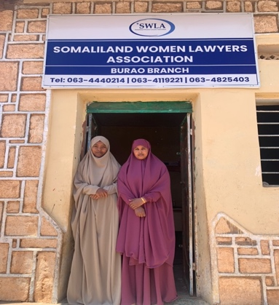
Najma and Najah, SWLA Paralegals in Burco.

ANNEX 1

Third Party Monitoring Report of Rule of Law (RoL) Support to Somaliland Institutions
Legal Aid Clinic at University of Hargeisa

Implemented by:
Judicial Commission
Ministry of Justice
University of Hargeisa, Amoud & Burao Universities

Submitted to: UNDP

Researchcare Africa
P.O Box 100506-0010,
Nairobi, Kenya
consult@researchcareafrica.com

Table of Contents
Table of Contents 2
Acronyms 3
Executive summary 5
INTRODUCTION 8
1.1 Background on the project 8
1.2 Project Objectives & Outcomes 9
METHODOLOGY 10
2.1 Approach 10
2.2 Data collection 10
2.3 Data processing 10
2.4 Data quality 10
2.5 Field challenges 11
FINDINGS 12
3.1 Introduction 12
3.2 Public perception on policing and court services 12
Background of respondents 12
3.2.1 Perception on individual safety 13
3.2.2 Rating of police services 14
3.2.3 Ease of access to the courts 15
3.2.4 Ease of access to mobile courts 16
3.3 Unsentenced detainees and undertrials in Somaliland prisons 17
3.4 Legal aid services 18
3.4.1 Overview 18
3.4.2 Beneficiaries of legal aid services 19
3.5 Mobile courts services 22
3.5.1 Overview 22
3.5.2 Beneficiaries of mobile courts 23
3.5.3 Status of mobile court cases 24
3.6 Public complaints to Somaliland Judicial Commission 26
3.7 Challenges 29
3.8 Recommendations 30
ANNEXES 31
4.1 List of respondents interviewed 31
4.2 Data collection tools 31
4.3 List of project documents 31

Acronyms

AG | Attorney General
GBV | Gender Based Violence
LoA | Letter of Agreement
MOI | Ministry of Interior
MOJ | Ministry of Justice
RoL | Rule of Law
TPM | Third party Monitoring
UN | United Nations
UNDP | United Nations Development Program

Executive summary
The Joint Rule of Law Programme (JROLP) for Somaliland involves implementation of a series of activities supporting improved justice, security, policing, gender equality and human rights, with the ultimate objective of ensuring Somaliland is more secure, peaceful, and stable. This third-party monitoring mission focused on three key outcome-level indicators to assess the effectiveness and impact of the JRoL programme that specifically correspond to SGD16 indicators.

For the purpose of the TPM, the monitoring focused largely of the following areas: perception of the general public on better policing and court services and feel safe in the piloted areas; the percentage of unsentenced detainees and undertrials in prison, beneficiaries receiving legal aid services from the Legal Aid Clinics in Amoud University in Borama, Burao University in Burao and University of Hargeisa in Hargeisa, beneficiaries receiving services through mobile courts in Hargeisa, Borama and Burao and the number of complaints received, registered and processed by the Judicial Commission from Hargeisa, Boroma and Burao.

The public perception survey generally looked into their perception on individual security, their opinion on the police, and ease of access to the mainstream courts as well as the mobile courts. Overall, 40% of the respondents rated ‘how safe they feel walking in their local area’ as somewhat safe, while 41% of the respondent rated it as very safe, which shows that the community feels safe in their localities. Moreover, the survey revealed that only 13% of the respondents rated the police services as very good, with over a third (34%) of the respondents rating it as somewhat good. On the access to the courts, overall, 38% of the respondents rated the ease of access to the court system in their area as somewhat good - this shows that access to the courts is still low in Somaliland, probably due to the dominance of the traditional customary law (Xeer) system.

In terms of the number of unsentenced detainees and undertrials in the Somaliland prisons, the TPM found out that the total inmates in Somaliland prisons are 2691 persons. These include, those in remand, death row inmates, and those who are already convicted.

Regarding beneficiaries of the legal aid services, the TPM collected data from the legal aid clinics across the 3 universities. A total of 399 beneficiaries received legal aid services – 299 beneficiaries from Amoud University Legal Aid Clinic, 60 beneficiaries from Hargeisa University Legal Aid Clinic and 40 beneficiaries from Burao University Legal Aid Clinic. By gender, 62% (n=247) of the beneficiaries were male with three quarter (75%) coming from Amoud University Legal Aid Clinic, 37% from Hargeisa University Legal Aid Clinic and only 3% from Burao University Legal Aid Clinic. On the other hand, 38% (n=152) of the beneficiaries who were supported by the legal services were female with 97% coming from Burao University Legal Aid Clinic, 63% from Hargeisa University Legal Aid Clinic and a quarter (25%) from Amoud University Legal Aid Clinic. For the mobile courts, a total of 435 cases were handled by the Mobile Courts during the monitoring period. Of this number 57% (n=246) were criminal cases while 43% (n=189) were civil cases. Overall, men (27%) were the highest beneficiaries of cases supported as compared to other categories of beneficiaries – 18% for the poor group, 17% for the women, 14% each for children and minority group and 10% for the IDPs/Refugees.

Besides, the TPM sought to collect data on the number of complaints received and handled by MoJ. Overall, cases of complaints received was highest in Hargeisa (24 cases), followed by Burco (22 cases) and 8 at Borama. Majority of the cases were complaints against court judges where most people complained of judges either delaying court hearings or giving them short notices for hearings which causes them to be absent during the judgement day/s or when the courts determine the next hearing dates.

Key among the challenges identified during the TPM is the low budget allocation for the legal aid clinics in Hargeisa, Burao and Amoud universities. The legal aid clinics complained that the current budget is not adequate for their operation as it has affected staffing and their general operations. Additionally, program staff reported low awareness on the availability of the mobile courts as well as the legal aid clinics which limits the uptake of these crucial judicial services across Somaliland. Furthermore, there is reported interference from elders especially in the rural areas who try to oppose the formal justice system and try to convince people to seek justice in the customary law system (Xeer). Therefore, the TPM recommends the following: -
- The need to increase budget and personnel and also conduct capacity building seminars and training for staff at the legal aid clinics and mobile courts across Somaliland.
- UNDP should consider doing awareness raising through MoJ regional offices in Burao, Borama and Hargeisa on the availability of mobile courts and legal aid services to ensure there is increased access to the formal justice system. These offices could also organize outreach missions on awareness raising as well;
- There is need to ensure that an SGBV unit or desk is created at all the three (3) legal aid clinics in Burao, Amoud and Hargeisa universities that would be mandated to handle gender-based violence cases.

INTRODUCTION

1.1 Background on the project
In Somaliland, access to responsive, rights-respecting and confidence inspiring policing, justice and correction services especially for women and in the rural areas remains a significant challenge across the country - state provision of policing and justice services is also very weak outside the urban population centres. Therefore, people mostly rely upon informal, traditional arrangements, resulting mainly from centuries of problem-solving by the elders responsible for the security of their rural villages and pastoral area. Such approaches tend to focus on family and clan relationships rather than the rights and responsibilities of individuals and also tend to vary from region to region. Procedures and outcomes can fall well short of basic standards, especially with regard to the rights of disadvantaged and vulnerable people, notably women and those from minority clans or outside clan groupings.

The NDP II analysis suggests that low official reported crime rates reflect the paucity of formal policing and justice arrangements in many areas. It also points to low levels of public ownership of a formal system long associated with colonial occupation (and, latterly, dictatorship) as well as associated cultural factors such as esteem for clan-based authority systems and religion. The NDP II analysis concludes that further significant reform is required to the formal justice system but suggests that its reputation is improving (albeit from a low base) in response to recent justice reform in general and to the introduction of the mobile courts initiative and legal aid services in particular areas.

The Rule of Law (RoL) programme in Somaliland builds on and learn lessons from the Phase I Joint Rule of Law Programme (2015-2018) that focused mainly on supporting the Government of Somaliland to improve its rule of law services in Hargeisa and select population centres. Combining mobile courts, legal aid, law scholarships, and prisons and courts inspections that programme expanded legal profession, enlarged access to the formal legal system and strengthened public confidence in it, mainly in the urban areas. This programme seeks to extend the focus to the ‘difficult to reach’ rural areas as well as to promote access to justice and enhance the rights of specific, vulnerable and disadvantaged groups. The programme is using these and related initiatives incrementally to support the Government of Somaliland to develop and pilot new national models for the delivery of basic, rights-respecting and accountable rule of law and security services from one that provides justice only for the few in the urban areas to one that ensures and delivers tangible and measurable improvements in justice for hard to reach pullulation in the regions which can be sustained across the whole of the jurisdiction.

1.2 Project Objectives & Outcomes
The Joint Rule of Law Programme (JRoLP) aims at enhancing capacity of Somaliland’s Rule of Law System to cater for the needs of all, and especially vulnerable groups. To achieve this strategic objective, the Programme is structured around five main outputs that seek to support and enable the Somaliland institutions to:
- Improve quality as well as quantity of basic rights respecting justice and policing services (including traditional as well as formal arrangements);
- Enhance public space for partnership and accountability of justice institutions;
- Develop and pilot parole and probation services to help the management of scarce corrections facilities;
- Enhance security sector governance; and
- Adopt an increasingly holistic and coordinated approach to the rule of law and security sectors for sustainable development and achieve a just, tolerant, equitable, open and socially inclusive society.

METHODOLOGY

2.1 Approach
The third-party monitoring was guided by the use of project indicator checklist approved by UNDP. The monitoring targeted a broad range of respondents including the general public through a survey and interviewed key personnel at the various implementing departments/units and institutions. These interviewees were particularly drawn from the Directorate of Planning at Ministry of Justice, Prison authorities, mobile court focal persons, and project focal points for the legal aid clinics at the universities of Burao, Hargeisa and Amoud.

2.2 Data collection
The monitoring adopted the use of pre-designed questionnaires, to gather relevant information related to the project under review. Photos and documentary evidence were also collected where available. The TPM used both survey and KIIs as the main tools for data collection. A public survey using a house-to-house modality was conducted in Burao and Borama, using a sampling determining method of Confidence Level (95%) and Confidence Interval (6%) to derive a sample of 268 respondents which was distributed into 134 respondents in each of the 2 locations – this survey was aimed at gauging the public perception on policing the courts services in Somaliland. Additionally, trained field researchers administered the KII questionnaires to selected key informants during the data collection and summary notes prepared from interviews conducted.

2.3 Data processing
After the data collection phase of the monitoring exercise, the team collated the raw data for analysis. Findings of the qualitative data, collected as transcripts from all interviews with project staffs were analyzed in detail to inform this report. Further, observation notes from the field were also used to complement the information collected.

2.4 Data quality
The data collected was validated and triangulated to ensure quality. The rationale for triangulation was that the use of multiple methods and sources overcomes the weaknesses associated with using single methods and sources. Any inconsistent information, errors were communicated/cross-referenced with the field teams and corrected before finalizing the fieldwork.

2.5 Field challenges
There were no notable limitations encountered during the TPM exercise. However, the TPM team faced some delays in interviewing government officials who were understandably busy and had tight schedules. Nevertheless, the research team managed to secure all planned interviews.

FINDINGS

3.1 Introduction
The Joint Rule of Law Programme (JROLP) for Somaliland involves implementation of a series of activities supporting improved justice, security, community policing, gender justice and equality and human rights, with the ultimate objective of ensuring Somaliland is more secure, peaceful, and stable. This third-party monitoring mission focused on three key outcome-level indicators to assess the effectiveness and impact of the JRoL programme that specifically correspond to SGD16 indicators. These indicators include the following:
- The percentage of public sampled who consider they are receiving better policing and court services and feel safe in the piloted areas; and
- The percentage of unsentenced detainees and undertrials in prison.
- The number of beneficiaries receiving legal aid services from the Legal Aid Clinics in Amoud University in Borama, Burao University in Burao and University of Hargeisa in Hargeisa
- The number of beneficiaries receiving services through mobile courts in Hargeisa, Borama and Burao.
- The number of Complaints received, registered and processed by the Judicial Commission from Hargeisa, Boroma and Burao.
- The number of misconduct investigations and details of thematic outcomes of investigations

3.2 Public perception on policing and court services

Background of respondents
The household survey was conducted among 268 households from two districts – Borama and Burao, with 134 household from each location. Overall, nearly half (49%) of the respondents were between the age group 31 – 50 years, 33% aged 18 – 30 years and 18% were 50+ years.
Table 1: Background of respondents
Age group | Gender |  | District |  | Overall (n=268)
 | Male (n=139) | Female (n=129) | Borama (n=134) | Burao (n=134)
18 - 30 years | 33% | 33% | 25% | 41% | 33%
31 - 50 years | 49% | 50% | 49% | 49% | 49%
50+ years | 18% | 18% | 26% | 10% | 18%
Total | 100% | 100% | 100% | 100% | 100%

3.2.1 Perception on individual safety
The survey sought to enquire about respondents’ perception on how safe they feel walking around in their areas of living. Overall, 40% of the respondents rated ‘how safe they feel walking in their local area’ as somewhat safe, while 41% of the respondent rated it as very safe. By district/location, more (47%) of Borama district residents rated their local areas as very safe to walk as compared to 36% of those in Burao district. In terms of gender, more male (44%) rated ‘how safe they feel walking in the area’ as very safe, compared to their female counter parts (39%). This is indicative of the fact that most locations in Somaliland are safe and secure for the general population, perhaps due to the absence of threat emanating from government forces or other militia.
Table 2: Please rate how safe you feel walking in your area
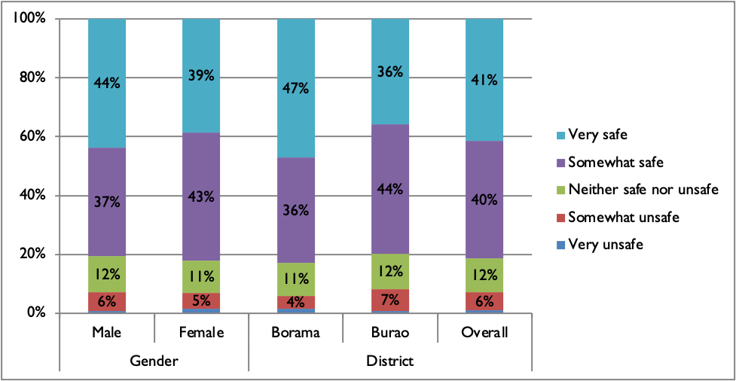

3.2.2 Rating of police services
Over a third (34%) of the respondents rated the police service in their area as somewhat good with only 13% of the respondents rating police service as very good. More (15%) of the residents of Borama district rated the police service as very good as compared to the residents of Burao district (12%). On the other hand, more male (16%) rated the police service in their area as very good as compared to their female counterparts (11%). The survey results on the rating of police services shows to a generally low opinion on the services provided by the police as a notable percentage of 10% and 22% of the respondents rated police services as very bad and somewhat bad respectively.
Table 3: Please rate the police services in your area
Please rate the police services in your area: | Gender |  | District |  | Overall (n=268)
 | Male (n=139) | Female (n=129) | Borama (n=134) | Burao (n=134)
Police services are very bad | 12% | 7% | 8% | 11% | 10%
Police services are somewhat bad | 21% | 23% | 26% | 18% | 22%
Police services are neither bad nor good | 21% | 22% | 21% | 22% | 21%
Police services are somewhat good | 30% | 37% | 30% | 37% | 34%
Police services are very good | 16% | 11% | 15% | 12% | 13%
Total | 100% | 100% | 100% | 100% | 100%

The survey further examined respondents’ opinion on whether they would report to the police if they were a victim of crime. Interestingly, despite their low opinion about the police, nearly a half (48%) of the respondents indicated they were likely to report a crime to the police if they were victims of crime. Similarly, 23% of the respondents would certainly report a crime to the police if they were victims of crime. In terms of district, more (32%) of the residents in Borama would certainly report a crime to the police if they were victims of crime as compared to the residents of Burao district (13%). In terms of gender, more male (26%) would certainly report a crime to the police if they are victims of crime as compared to their female counterparts (19%). This demonstrates that the public have confidence in the formal institutions despite their weaknesses in terms of capacity and professionalism.
Figure 1: If you were the victim of a crime tomorrow, would you report it to the police?
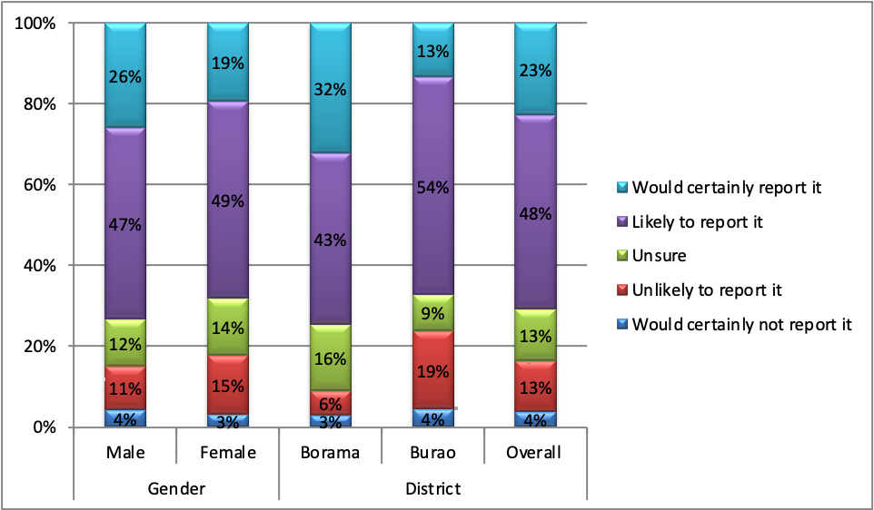
A further investigation on what could be the main issues with the service provision of the police, respondents cited: corruption, delay in response to the emergencies, few female police staffs, insufficient training among the police etc. among other problems. On the same note, the survey enquired for suggestion from the respondents on how the current issues facing the police could be improved -respondents opined that the problems could be improved by creating an emergency unit/desk at police stations, remunerating the police well to avoid corruption, and providing a more professional, sufficient and standards trainings to the Somaliland police etc.

3.2.3 Ease of access to the courts
Overall, 38% of the respondents rated the ease of access to the court system in their area as somewhat good. Similarly, 11% of the respondents rated the ease of access to the court system as very good. In terms of district, more (15%) of the respondents in Borama district rated the ease of access to the court system as very good as compared to the residents of Burao district (7%). In terms of gender, more male (14%) rated the ease of access to court system as very good as compared to female (7%). This again shows that access to the courts is still low in Somaliland as shown by respondents’ perception in the survey. Somalis being a society that has the traditional Xeer system, the perception on low access to the formal courts could be as a result of their preference of the Xeer customary law to the formal courts, and suspicion of corruption and nepotism of the courts by the local population. Nonetheless, there is need to increase outreach activities and enhance awareness on the availability of the formal courts in Somaliland.
Table 4: Please rate the ease of access to the court system in your area
Please rate the ease of access to the court system in your area: | Gender |  | District |  | Overall (n=268)
 | Male (n=139) | Female (n=129) | Borama (n=134) | Burao (n=134)
The court system is very bad | 6% | 5% | 5% | 6% | 6%
The court system is somewhat bad | 28% | 24% | 22% | 31% | 26%
The court system is neither bad nor good | 19% | 21% | 22% | 17% | 20%
The court system is somewhat good | 33% | 43% | 36% | 40% | 38%
The court system is very good | 14% | 7% | 15% | 7% | 11%
Total | 100% | 100% | 100% | 100% | 100%

Upon enquiring what respondents think of the biggest problem with the court system, respondents cited delays in the conclusion of court cases, backlog of cases because of few courts in the area and that most of the judges are male and so women victims feel uncomfortable sharing their cases openly. Respondents suggested that these issues could be solved by increasing the number of judicial service staff particularly female staff to handle sensitive cases involving women victims and increasing the number of courts.

3.2.4 Ease of access to mobile courts
The survey further examined the ease of access to the mobile courts to the respondents. Overall, 16% of the respondents rated the ease of access to the mobile courts as very good. Similarly, a quarter (25%) of the respondents rated the ease of access to the mobile courts as somewhat good. In terms of district, more (28%) of those from Borama district rated the ease of access to the mobile courts as very good as compared to only 5% of residents of Burao district. This shows that despite the efforts of JRoL in providing the mobile courts outreach, local communities seem to having low perception on the effectiveness of these courts. In fact, some of the respondents were unfamiliar with the mobile courts during the survey. Therefore, there is need to extensively create awareness on the existence and importance of the mobile courts.
Table 5: Please rate the ease of access to the mobile courts in your area
Please rate the ease of access to the mobile courts in your area: | Gender |  | District |  | Overall (n=268)
 | Male (n=139) | Female (n=129) | Borama (n=134) | Burao (n=134)
The mobile courts are very bad | 10% | 8% | 4% | 13% | 9%
The mobile courts are somewhat bad | 22% | 26% | 17% | 31% | 24%
The mobile courts are neither bad nor good | 22% | 28% | 23% | 27% | 25%
The mobile courts are somewhat good | 29% | 22% | 28% | 23% | 25%
The mobile courts are very good | 17% | 16% | 28% | 5% | 16%
Total | 100% | 100% | 100% | 100% | 100%

3.3 Unsentenced detainees and undertrials in Somaliland prisons
One of the key aspects that the TPM mission focused on was to investigate the number of unsentenced and undertrial cases in Somaliland prisons. Overall, the TPM found out that the total inmates in Somaliland prisons are 2,691 persons. These include, those in remand, death row inmates, and those who are already convicted. Analysis of the data from the Prisons Department shows that convicted persons are the majority of the people hosted in Somaliland Prisons, which represents 86.7% of the total population of prisoners, the is followed by those in remand which constitute 13.2%, while those waiting for their cases to be determined by the Supreme Court are 8% of the total number of people in the prisons.
Below table shows the disaggregated per location/prison, remanded prisoners, those whose cases at the supreme court, those who are juvenile, those with rape cases, death row inmates and those convicted.
Table 6: Data on Somaliland prisoners
Prison | Remand | Appellate/Supreme Court | Juvenile | Female | Rape | Death Row Inmates | Convicted | Total
Hargeisa | 52 | 95 | 90 | ------ | 84 | 87 | 578 | 630
Gabilay | ---- | 14 | 21 | 72 | 13 | 10 | 285 | 285
Borama | 71 | 28 | 45 | 5 | 5 | 5 | 132 | 177
Baki | 1 | ------ | ----- | ------- | ---- | ------ | 114 | 115
Mandheera | 1 | 85 | 25 | ------ | 50 | 24 | 525 | 526
Berbera | 24 | 2 | 7 | 3 | 12 | 2 | 77 | 101
Burao | 113 | 4 | 84 | 3 | 63 | 13 | 448 | 574
Las Anod | 3 | --- | --- | --- | 3 | 13 | 66 | 69
Gar-adag | 2 | --- | 3 | --- | 1 | 2 | 12 | 14
El-afweyn | 10 | 2 | 1 | ---- | 1 | 1 | 2 | 12
Erigavo | 67 | 20 | 20 | 9 | 10 | 5 | 73 | 140
Balligubadle | 5 | --- | 2 | ---- | ----- | ---- | 10 | 15
Aynaba | 7 | 3 | 4 | ---- | ----- | 3 | 13 | 20
Total | 356 | 227 | 302 | 92 | 242 | 152 | 2,335 | 2,691
 |  |  |  |  |  |  |  | 2,691

3.4 Legal aid services

3.4.1 Overview
Number of beneficiaries disaggregated by gender, age and vulnerability, receiving legal aid services from Amoud University Legal Aid Clinic in Borama, Burao University Legal Aid Centers n Burao and Hargeisa University Legal Aid Clinic in Hargeisa.
The legal aid services component of the JRoL is implemented in partnership with the faculties of law at three (3) leading universities in Somaliland i.e., University of Hargeisa, Burao University and Amoud University in Borama. The legal aid clinics in these three universities provide pro-bono services to mostly economically disadvantaged members of the community especially the IDPs, minority groups, women, children and other vulnerable groups. The legal clinics also provide legal counseling and legal awareness to all persons who visit the centers, through publishing of leaflets and brochures, and during outreach. Respondents at the universities also hailed the programme as it has to the development of the legal education to students in third and fourth years at the faculties of law, and provided them with an opportunity to apply and expand their theoretical concept of the law in a client services context.
In terms of the scope of work of the legal aid clinics, interviews with the focal persons of the legal aid services revealed that most of the cases they handle are around civil, criminal, human rights and women and children rights. Under the civil law; the clinics mainly handle land and property disputes/cases; under the criminal cases, they mainly deal with rape, robbery, theft etc, under women and child rights they mostly deal with domestic violence; and under human rights they deal with freedom of expression, asylum seekers etc.,
The rationale of partnering with the Law Schools of the 3 main universities in Somaliland stems from their strategic locations as they are able to serve community members from all corners of Somaliland. Another important consideration is that the legal aid clinic serves as a practical hub for the law school students who learn a lot about all kinds of cases common in Somaliland society.

3.4.2 Beneficiaries of legal aid services
The TPM collected data on the number of beneficiaries who benefitted from the legal aid clinics across the 3 universities. A total of 399 beneficiaries received legal aid services – 299 beneficiaries from Amoud University Legal Aid Clinic, 60 beneficiaries from Hargeisa University Legal Aid Clinic and 40 beneficiaries from Burao University Legal Aid Clinic.
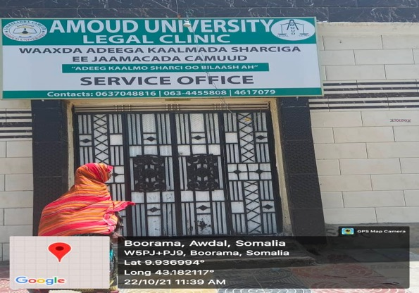
A mother seeking services from the Legal Aid Clinic in Amoud

In terms of gender disaggregation, 62% (n=247) of the beneficiaries who were supported by the legal services in the Legal Aid Clinic were male with three quarter (75%) coming from Amoud University Legal Aid Clinic, 37% from Hargeisa University Legal Aid Clinic and only 3% from Burao University Legal Aid Clinic. On the other hand, 38% (n=152) of the beneficiaries who were supported by the legal services were female with 97% coming from Burao University Legal Aid Clinic, 63% from Hargeisa University Legal Aid Clinic and a quarter (25%) from Amoud University Legal Aid Clinic.
Table 7: Beneficiary profile of legal aid services clinic
Gender | Amoud University Legal Aid Clinic  n=299 | Hargeisa University Legal Aid Clinic  n=60 | Burao University Legal Aid Clinic  n=40 | Overall  n=399
Male | 75% | 37% | 3% | 62%
Female | 25% | 63% | 97% | 38%
Total | 100% | 100% | 100% | 100%

In terms of age disaggregation, 14% (n=57) of the beneficiaries were age < 18 years, 60% (n=240) of the beneficiaries were aged 18 – 29 years and over a quarter (26%) n=102 of the beneficiaries were aged 30 and above years.
Table 8: Age distribution of legal aid clinic beneficiaries
Age group | Amoud University Legal Aid Clinic | Hargeisa University Legal Aid Clinic | Burao University Legal Aid Clinic | Overall
 | n=299 | n=60 | n=40 | n=399
< 18 | 15% | 13% | 13% | 14%
18 - 29 | 62% | 57% | 50% | 60%
30 and above | 23% | 30% | 38% | 26%
Total | 100% | 100% | 100% | 100%

In terms of vulnerability of the legal aid clinic beneficiaries, majority (63%) were persons who were not able to pay court fees. This was followed by IDP/Returnees at 17%, victims of violence such as family violence at 9%, minority group at 6%, persons with disability at 3%, girls at 2% and others at 2%.
Figure 2: Vulnerability profile of the legal aid clinic beneficiaries
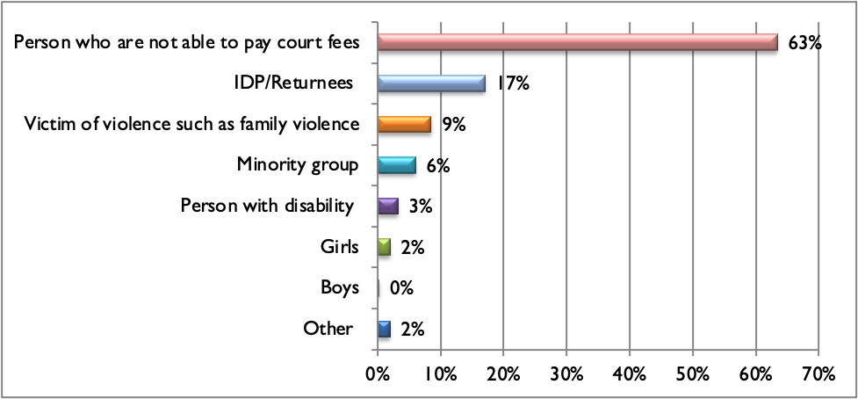
By gender, majority (75%) of persons who were not able to pay court fees were male as compared to the female (44%). More female (20%) were victims of violence such as family violence as compared to the male (2%). Similarly, more female (23%) were IDP/Returnees as compared to their male (13%) counterparts.
Table 9: Gender profile of the legal aid clinic beneficiaries
Vulnerability | Gender |  | Overall
 | Male | Female
Minority group | 7% | 5% | 6%
Person with disability | 2% | 5% | 3%
IDP/Returnees | 13% | 23% | 17%
Person who are not able to pay court fees | 75% | 44% | 63%
Victim of violence such as family violence | 2% | 20% | 9%
Girls | 0% | 5% | 2%
Boys | 0% | 0% | 0%
Other | 2% | 2% | 2%

In terms of vulnerability by age group, the beneficiaries who were aged < 18 years were the majority of person who are not able to pay court fees as compared to those aged 18 – 29 (65%) and 30 and above (57%).
Table 10: Vulnerability of the legal aid clinic beneficiaries by age group
Vulnerability | Age group |  |  | Overall
 | < 18 | 18 - 29 | 30 & above
Minority group | 4% | 4% | 12% | 6%
Person with disability | 4% | 3% | 4% | 3%
IDP/Returnees | 12% | 19% | 15% | 17%
Person who are not able to pay court fees | 68% | 65% | 57% | 63%
Victim of violence such as family violence | 4% | 9% | 10% | 9%
Girls | 7% | 2% | 0% | 2%
Boys | 2% | 0% | 0% | 0%
Other | 0% | 1% | 5% | 2%

3.5 Mobile courts services

3.5.1 Overview
The judiciary with support of the UNDP’s JRoL programme is currently implementing the mobile courts project. The mobile court’s main objective was to expand court services to the remote and uncovered far flung areas in order to support access to judicial services for those who are not fortunate enough to reside in the major centers where the supreme court, regional courts and appeal courts are situated.

3.5.2 Beneficiaries of mobile courts
During the monitoring period, a total of 435 cases were handled by the Mobile Courts. Of this number 57% (n=246) were criminal cases while 43% (n=189) were civil cases.
Figure 3: Types of cases at the mobile courts
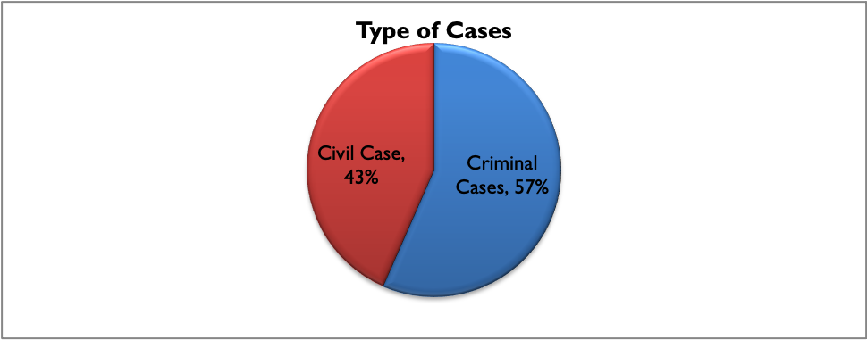
The cases were distributed by region as follows; in Maroodijeex (17%) – 16% criminal cases and 19% civil cases; Saxil region (10%) of cases – 10% criminal cases and another 10% civil cases, while in Togdheer region (13%) cases – 13% criminal cases and 12% civil cases. In Sanaag region (11%) cases – 11% each for criminal and civil cases. In Awdal region (11%) cases – 9% representing criminal cases and 14% representing civil cases. In Gabiley region (11%) cases – 11% criminal cases and 12% civic cases. In Sool region (8%) cases – 7% for criminal cases and 8% for civic cases. And in the Supreme Court, there were 19% of cases – 22% for which were criminal cases and 15% civil cases.
Table 11: Mobile court cases by region
Region | Criminal | Civil | Total
Marodijex | 16% | 19% | 17%
Saxil | 10% | 10% | 10%
Togdheer | 13% | 12% | 13%
Sanaag | 11% | 11% | 11%
Awdal | 9% | 14% | 11%
Gabiley | 11% | 12% | 11%
Sool | 7% | 8% | 8%
S/Court | 22% | 15% | 19%
Total | 100% | 100% | 100%

Overall, men (27%) were the highest beneficiaries of cases supported as compared to other categories of beneficiaries – 18% for the poor group, 17% for the women, 14% each for children and minority group and 10% for the IDPs/Refugees. By region, men were the highest beneficiary group – 30% in Maroodijeex, 35% in Saxil, 23% in Togdheer, 28% in Gabiley and 25% in S/Court. The poor group (26%) was the highest beneficiary in Sanaag region and the minority group (24%) was the highest beneficiary group in Awdal region.
Table 12: Mobile courts beneficiaries by gender and region
Beneficiary | Region |  |  |  |  |  |  | Overall (n=673)
 | Marodijex (n=157) | Saxil (n=88) | Togdheer (n=86) | Sanaag (n=73) | Awdal (n=72) | Gabiley (n=81) | S/Court (n=116)
Women | 15% | 22% | 20% | 19% | 18% | 14% | 14% | 17%
Male | 30% | 35% | 23% | 25% | 22% | 28% | 25% | 27%
Child | 10% | 7% | 13% | 12% | 15% | 17% | 23% | 14%
IDPs/Refugee | 11% | 17% | 7% | 11% | 7% | 10% | 9% | 10%
Minority | 15% | 11% | 21% | 7% | 24% | 6% | 13% | 14%
Poor | 19% | 8% | 16% | 26% | 14% | 25% | 16% | 18%
Total | 100% | 100% | 100% | 100% | 100% | 100% | 100% | 100%

3.5.3 Status of mobile court cases
Out of the 435 cases that were handled with the mobile courts, 80% (n=348) of the cases had been disposed during the monitoring period while 20% (n=87) of the cases were still pending.
Figure 4: Status of mobile court cases
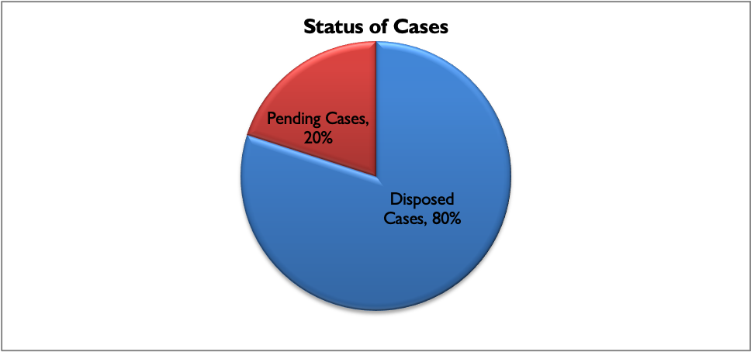
In terms of the status of cases by region, Maroodijeex region has disposed 18% of cases and has 16% of pending cases. Saxil region had disposed 10% of cases and had 11% pending cases. In Togdheer region, the courts have disposed 11% of cases and with 18% pending cases. In Sanaag region, the courts have disposed 11% of the cases and have 10% pending cases. In Awdal region, the court has disposed 11% of cases and has 9% pending cases. In Gabiley region, the court has disposed 11% of the cases and had also 11% pending cases. In Sool region, the court has disposed 7% of the cases and has 9% pending cases. And in S/Court, the court has disposed 20% of the cases and has 14% pending cases.
Table 13: Status of mobile court cases by region
Region | Disposed Cases (n=348) | Pending Cases (n=87) | Total Cases (n=435)
Maroodijeex | 18% | 16% | 17%
Saxil | 10% | 11% | 10%
Togdheer | 11% | 18% | 13%
Sanaag | 11% | 10% | 11%
Awdal | 11% | 9% | 11%
Gabiley | 11% | 11% | 11%
Sool | 7% | 9% | 8%
S/Court | 20% | 14% | 19%
Total | 100% | 100% | 100%

3.6 Public complaints to Somaliland Judicial Commission
According to the ministry of justice (MoJ) staff concerned with registration of complaints from the public, there are main categories of the complaints received at the department. These include the following: -
- Complaints against lawyers’ misconduct;
- Complaints against the courts/judges; and
- Complaints against public notary
The thirds party monitoring examined the number of complaints received, registered and processed by the Judicial Commission from Hargeisa, Borama and Burao and the number of misconduct investigations and details of outcomes of the investigations.
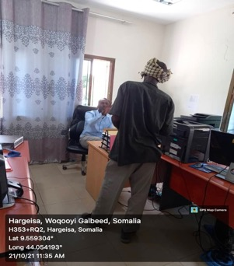 | 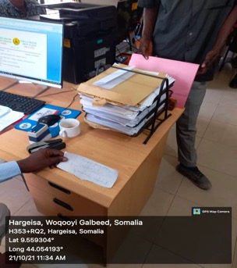
A complainant reporting a case against a lawyer to MoJ official in Hargeisa | The MoJ officials opens a case file and give the complainant a case number for reference

Overall, the number of complaints received at the MoJ offices in Hargeisa was highest in the Capital (Hargeisa) with 24 cases, followed by Burco with 22 cases and 8 at Borama. Majority of the cases were complaints against court judges where most people complained of judges either delaying court hearings or giving them short notices for hearings which causes them to be absent during the judgement day/s or when the courts determine the next hearing dates.
Table 14: Details of complaints received at MoJ in Hargeisa, Borama and Burao
Nature of complaint | Region
 | Hargeisa | Borama | Burao
Complaints against lawyers’ misconduct | 10 | 6 | 1
Complaints against the courts/judges | 5 | 1 | 18
Complaints against public notary | 9 | 1 | 3
Total | 24 | 8 | 22

Regarding the complaints against the lawyers, most people complained of lawyers not respecting and treating clients with dignity. For example, ministry officials noted that some lawyers often refuse meeting clients or do not give them adequate time to discuss their issues. On the complaints against public notary, most complaints were on the transfer of lands without proper documentation or due diligence. They further indicated that these complaints also involved lawyers acting for clients who do not create proper files for land transfers, and processing land/property transfers without witnesses.
In terms of misconduct investigations against lawyers, there was evidence of redress of clients’ grievances conducted by the ministry officials. Ministry officials reported that they first of all review the case before them in accordance with Article 18 (2001) of Somaliland Constitution – Public Notary Law and Article 30 (2004). Upon sufficient evidence of misconduct, the ministry officials withdraw lawyers’ licenses and subsequently suspend them - those where there are no sufficient grounds to suspend, the ministry issues a warning letter. For the first 2 quarters of 2021 (January to June), the Ministry officials indicated that they have issued warning letters to 5 lawyers with the other cases ongoing, hence not yet concluded.
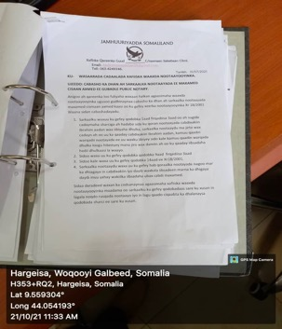 | 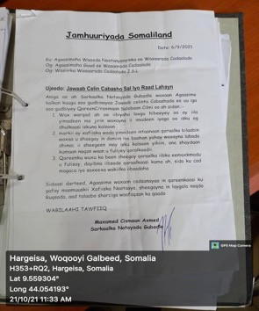
An official complaint addressed to MoJ against a lawyer | A response filed by the lawyer who is complained against
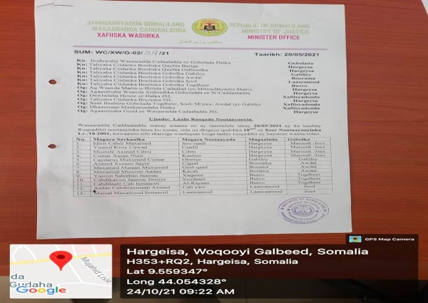
Ministry of Justice letter suspending (practising licenses) lawyers found culpable of misconduct

Besides the open complaints’ mechanism for the public, Ministry of Justice officials indicated that they have inspections and monitoring scheme which aims at investigating any mal-administration, corruption, and other gross misconduct and present cases to the judicial commission to discuss and evaluate the complaint issues.

3.7 Challenges
- Inadequate funding and program budget for the legal aid clinics in Hargeisa, Burao and Amoud universities. The universities reported that they receive a program budget of $36,000 (University of Hargeisa) and $28,800 (Burao and Amoud Universities) which according to them is quite low for the scope of work. They lamented that this low budget coupled with the short-term nature of UNDP LoA has affected staffing at the legal aid clinic, as the most competent and experienced lawyers drop out due to this unpredictable short-term nature of the contracts – program staff noted that currently, there are only 2 lawyers and 2 paralegal staff and a finance assistant to run the whole program, which is not enough.
- Program staff at the legal aid clinic reported that they have a challenge working with the mobile courts as they are reportedly mostly based in the capital Hargeisa, hence with limited outreach and missing on scheduled hearings outside of Hargeisa.
- Program staff reported having problems with handling SGBV cases as victims and/or their families often prefer to keep their cases confidential and hence not to report to relevant authorities. This is largely due to the associated risk of discrimination and stigma.
- There is low awareness of the availability of the mobile courts as well as the legal aid clinics which limits the uptake of these crucial judicial services across Somaliland.
- There is reported interference from elders especially in the rural areas who try to oppose the formal justice system and try to convince people to seek justice in the customary law system (Xeer).
- Program staff at the legal aid clinics lamented that there are cases where the Police does not allow paralegals and lawyers to interview detainees or prisoners.
- Program staff reported that there insufficient number of female court workers especially in the prosecution department which affects support to female victims.

3.8 Recommendations
- There is need to increase personnel and conduct capacity building seminars and training for staff at the legal aid clinics and mobile courts across Somaliland. More female paralegal staff needs to be hired.
- UNDP should consider doing awareness raising through MoJ regional offices in Burao, Borama and Hargeisa on the availability of mobile courts and legal aid services to ensure there is increased access to the formal justice system. These offices could also organize outreach missions on awareness raising as well;
- There is need to ensure that an SGBV unit or desk is created at all the three (3) legal aid clinics in Burao, Amoud and Hargeisa universities that would be mandated to handle gender-based violence cases.
- JRoL program should ensure there is enhanced coordination among stakeholders such as the ministry of justice and other institutions such as Universities and NGOs. This can be done through workshops and regular meetings.
- Increasing the budget for the legal aid clinics at University of Hargeisa, Amoud University and Burao University for better performance and wider reach.
- As paralegal and lawyer of the office stimulated in their monthly report, fast majority of the vulnerable community are in need of mass awareness campaign through seminars training and social platform in the way to overcome the lack of awareness of the existence of free legal and services

ANNEXES

4.1 List of respondents interviewed
Name of Person Interviewed | Position | Date | Contact
Yassin Abdi | Director of Planning, MoJ | 18-10-21 | 0634471239  yasinmoj007@gmail.com
Sharmarke Yussuf | Head of Mobile Courts Department | 23-10-21 | sharmaarkey1@gmail.com
Mohamed Abdillahi | Department of Investigation of Cases | 22-10-21 | deeqcpo@gmail.com
Mohamed Abokor | University of Hargeisa Legal Aid Clinic | 23-10-21 | abokorhaji@gmail.com
Barkhadle Hamud Ibrahim | Amoud University Legal Aid Clinic | 24-10-21 | 0634455808
Mohamed Abdullah Adam | Burao University Legal Aid Clinic | 23-10-21 | 063443578

4.2 Data collection tools

4.3 List of project documents

As per Third-Party Monitoring findings submitted November 2021. Follow-up monitoring planned for 2022 to measure change.
As per Third-Party Monitoring findings submitted November 2021. Follow-up monitoring planned for 2022 to measure change.
Disagreement between partners regarding responsibility for capturing this data has not yet been resolved.
As per Third-Party Monitoring findings submitted November 2021. Follow-up monitoring planned for 2022 to measure change
GBV IMS data August 2020
Project document - Phase 2-UN Joint Rule of Law Programme for Somaliland 2020-2021
The latest available figures, from 2016, imply just 5 cases per 1,000 residents
Project document - Phase 2-UN Joint Rule of Law Programme for Somaliland 2020-2021

