IRAQ UNDAF TRUST FUND
MPTF OFfice GENERIC final programme NARRATIVE report
REPORTING PERIOD: from APRIL 2021 to DECEMBER 2021

Programme Title & Project Number |  |  | Country, Locality(s), Priority Area(s) / Strategic Results
- Programme Title:  Sustainable Solutions of Compost Production from Organic Waste in Iraq - Karbala Governorate  - Programme Number (if applicable)  - MPTF Office Project Reference Number:  00127213 |  |  | Iraq / Karbala Governorate
- UNDAF Priority 3: Environmental management and compliance with ratified international environmental treaties and obligations
- UNDAF Priority Outcome 3.3: Government of Iraq has improved programmes for the prevention and control of pollution.
Participating Organization(s) |  |  | Implementing Partners
- UNDP  - UNEP |  |  | - Ministry of Environment (separated from the former Ministry of Health and Environment)  - Governor Office of Karbala  - Municipality of Karbala  - Directorate of Agriculture, Karbala
Programme/Project Cost (US$) |  |  | Programme Duration
Total approved budget as per project document:  MPTF /JP Contribution:  - UNDP 460,000 USD  - UNEP 140,000 USD |  |  | Overall Duration 9 months  Start Date 28 May 2021
Agency Contribution  - by Agency (if applicable) |  |  | Original End Date 30 September 2021
Government Contribution  (if applicable) |  |  | Actual End date 30 December 2021  Have agency(ies) operationally closed the Programme in its(their) system? | Yes No  X X
Other Contributions (donors)  (if applicable) |  |  | Expected Financial Closure date:  30 December 2022
TOTAL: 600,000 USD
Programme Assessment/Review/Mid-Term Eval. |  |  | Report Submitted By
Evaluation Completed  Yes X No Date: dd.mm.yyyy  Evaluation Report - Attached  Yes X No Date: dd.mm.yyyy |  |  | - Name: Zena Ali Ahmad  - Title: Resident Representative  - Participating Organization (Lead): UNDP Iraq  - Email address:zena.ali-ahmad@undp.org
Acronyms

BoQ Bill of Quantity
EIA Environmental Impact Assessment
DIM Direct Implementation Modality
IGES Institute for Global Environmental Strategies
MoEn Ministry of Environment
MPTF Multi Partner Trust Fund
NDC Nationally Determined Contributions
NSWMP National Solid Waste Management Plan
SOP Standard Operating Procedure
UNEP United Nations Environment Programme
UNDAF United Nations Development Assistance Framework
UNDP United Nations Development Programme
UNSDCF United Nations Sustainable Development Cooperation Framework

EXECUTIVE SUMMARY

The Programme promoted environmentally sound waste management through the following key results:
- A technical capacity was established within the Governorate of Karbala through training of a technical team from Karbala Municipality that was trained locally and abroad on organic waste management including production of compost. This will result in creating green jobs which will support the agricultural sector, phasing out imported chemical fertilizers that has negative impact on both individual/public health and the environment as well as reducing emissions from organic waste that would have been dumped in unregulated landfill sites.
- Attracted private sector engagement throughout the project on the importance and benefits of organic compost including value chain market assessment. In addition, fifty private sector entities were identified and engaged in surveys and assessments and have been selected as collection points for organic waste to be delivered to the pilot composting facility.
- Enhanced knowledge of the local communities on waste management and composting: local communities in Karbala Governorate were influenced through conducting awareness campaigns using locally tailored awareness raising materials to enhance the knowledge of local communities on waste management and composting. The awareness events have resulted in feedback from the community such as will to participate in waste sorting individual level, requests have also been received on more details on how waste management can be support on different levels. As a result, Karbala Municipality is planning a 3 day awareness event were the first day will target decision makers including Iraqi House of Representatives members. The second day will target the private sector and the third day will target schools and community representatives. UNDP has been invited to join the event in March 2022.
- A draft a national strategy “Iraq National Organic Waste Composting Strategy” was developed with the overall aim to ensure organic waste generated is diverted from open dumping (landfill) sites for composting. The strategy has been submitted to the Ministry of Environment (MoEn) as it is the regulatory agency for waste management in Iraq. UNEP will continue to support the MoEn in taking the strategy in its waste management agenda with or without adopting a standalone strategy for composting.
- Developed a business modality of compost production and marketing approaches, and private sector involved in agrochemical businesses was supported through conducting a review of municipal compost production and marketing potential in Iraq and by informing them on the benefits of compost. . All these deliverables have been handed over to Karbala Municipality for their endorsement.
- Capacity of Karbala Governorate was enhanced through developing a technical guideline for the construction and sustainable operation of composting facilities and conducting training programmes. In addition, a guide for awareness raising on source separation of organic was developed.
- A knowledge exchange visit was arranged for relevant staff from Karbala Governorate, Karbala Municipality and Karbala Environmental Department to sustainable and integrated waste management experience in Jordan including composting facilities, recycling factories and Al Ghabawi landfill waste to energy project. The visit resulted in exposing the participants to the successful implementation of integrated waste management throughout the phase of planning, implementing and sustaining the various locations. A connection has been established between Karbala Municipality and Greater Amman Municipality Greater, Irbid Municipality and Mafraq Greater Municipality.

The main factor for success was the cooperation between the project stakeholders, mainly Karbala Governorate and Karbala Municipality as well as the joint implementation of this UN Joint Programme between UNDP and UNEP were each UN agency utilized their resources effectively to achieve quality deliverables. Karbala Governorate headed by the Governor speeded up all necessary decisions and approvals including selection and handover of project site, setting up technical committee and participating in strategic consultation meetings. The technical staff from Karbala Municipality provided the necessary data with no delays and were flexible in participating in events during and outside their day to day work as well as their valuable support during the knowledge exchange visit and building connections with municipalities in Jordan.

Purpose

The main objective of the Programme was to promote environmentally sound waste management in Iraq by creating a value chain for compost for the private sector and encourage efficient management of sustainable production and utilization of compost. In addition, the programme aimed to pilot a best practice on composting benefits in the Karbala Governorate, Iraq. The core technology that was supported was the production of organic compost generated from waste at the household level and at municipal landfills, augmented by decomposition technology at landfills to reduce methane emissions. The Programme aimed to incentivize the use of compost over chemical fertilizers by progressively integrating compost into the existing fertilizer market and demonstrating its proven advantages. The expected outcome of the Programme is “improved economic opportunities for environmental practices in the solid waste management sector for local community in the Karbala Governorate” which also contributes to UNDAF Priority 3: Environmental management and compliance with ratified international environmental treaties and obligations and UNDAF Priority Outcome 3.3: Government of Iraq has improved programmes for the prevention and control of pollution.

Assessment of Programme Results

- Narrative reporting on results:

The outcome of the Programme is improved economic opportunities for environmental practices in the solid waste management sector for local community in the Karbala Governorate and is aligned with the Nationally Determined Contributions (NDC) of Iraq under the overall goal of the waste sector: To support the integrated management of waste and to promote and improve its management and recycling to produce energy from solid waste, preserve the environment, improve the quality of treated water, and reduce energy consumption as part of achieving sustainable development goals. Furthermore the Programme is aligned with the United Nations Sustainable Development Cooperation Framework (UNSDCF) 2020-2024 “Strategic Priority Area 4: Promoting Natural Resource and Disaster Risk Management, and Climate Change Resilience” and supports the National Solid Waste Management Plan (NSWMP). Contributing to the achievement of these strategic results, the Iraq National Organic Waste Composting Strategy was developed and handed over to Karbala Municipality and the MoEn. The strategy as well as the guidelines, SOPs and other documents developed by the Programme will support scaling the Karbala pilot composting facility in other cities in Iraq.

The MoEn with representatives from headquarters and their Environmental Department in Karbala participated in most of the consultation meetings as well as training events in Karbala and Amman. MoEn provided insight on the environmental regulations in the waste sector as well as the commitments of Iraq towards the global community in terms of GHG mitigation and sustainable development goals. This information was valuable in implementing project activities in alignment with the national regulations as well as the national climate change priorities. Furthermore, MoEn provided information on the requirements of the EIA for the pilot composting facility, which was later approved by the Middle Environmental Directorate under the MoEn, the EIA was necessary before the implementation of the pilot composting facility .

Karbala Municipality has established technical teams for operation and management of the pilot composting facility. Furthermore, there are plans for potential scale up of the pilot composting facility as well as establishment of other facilities for recycling of paper and plastic. Contributing to technical knowledge exchanges, linkages have been made between the Municipality of Karbala and four municipalities in Jordan that has successful experience in sustainable solid waste management . The Local Authorities in Karbala allocated a 5000 m² land for composting purposes from organic waste where 2000 m² was used to implement the pilot composting facility through this Programme. In addition, a road was established leading from the main road to the composting facility to facilitate easy access for transporting organic waste to the site as well as transporting organic compost from the site. Green jobs was created to support operating the pilot composting facility with priority of appointment given to the families in the rural areas near Karbala landfill site.

The programme was implemented jointly by UNDP and UNEP under Direct Implementation Modality (DIM) with partnership with the local authorities of Karbala including the Governor’s office and Karbala Municipality.

The Programme focused on achieving four outputs as detailed below:

In order to achieve “Output 1: Enhanced knowledge of the local community on the Solid Waste Management (SWM) sector and potential for livelihood opportunities in the value chain” the project conducted desk reviews and surveys to assess the current situation and identify awareness raising needs. Based on the analysis from the collected data, awareness programmes were developed. The indicator for this output was to identify stakeholders for data collection and awareness activities disaggregated by gender as well as awareness campaigns conducted. The target was achieved through identifying 50 stakeholders in Karbala City with more than 30 % women representation. Awareness programmes were conducted jointly with Karbala Municipality targeting producers of organic wastes, including hotels, restaurants, café, local markets, and a shopping mall all located within Karbala city.

As for “Output 2: Enhanced capacities of local authorities on composting and waste management.” the target was to develop a capacity assessment report and conduct training on compost delivery, organic waste handling and composting techniques. A capacity assessment report was developed based on a desk review and information gather from the stakeholders. Based on the assessment report a training programme was developed and training conducted with participation of 25 staff members (including 7 women) from Karbala Municipality and Karbala Environmental Department.

Output 3 aimed at developing a business modality of compost production and marketing approaches as well as a national strategy for upscaling. The indicators under this output was number of market supply and demand studies completed and national strategy for promoting waste to compost developed as well as number of awareness events on economic benefits for organic compost conducted. All targets were met with the:

- Completion of a study on municipal compost production and marketing potential in Iraq,
- Development of a national organic waste composting strategy
- Implementation of awareness raising activities targeting the private sector involved in the agrochemical business to raise awareness as well as assessment their willingness to promote compost.

Construction of a pilot composting facility was the target of Output 4. The first step of output 4 was to identify potential sites and this was done during the first technical meeting held on the 10th of June 2021, two sites were proposed by Karbala Municipality. The first was site was within Karbala Waste Transfer station which was not suitable since an EIA would not be approved due site location within the city as well as limited area within the already fully utilized transfer station for waste handling. The second site was within the area of the planned Karbala Typical Landfill site, an EIA was prepared for the pilot composting facility and was approved by the Middle Environmental Directorate under the MoEn. Although there is a sufficient area to be utilized for the pilot composting facility as well as scale up potential, Karbala Typical Landfill is in a rural area not served by the city infrastructure including electricity, water and roads. The project identified that a minimum supply of electricity would be needed to operate the pilot composting facility and therefor an electricity supply unit was included in the implementation plan of the facility. The electricity supply unit was chosen to be solar energy powered in order to mitigate GHG emissions as well as to be used as a show case of the potential of renewable energy. The procurement process to contract an eligible company went through a lengthy process of several phases in order to ensure that only qualified companies with a proven track record would be contracted. Upon contracting the most suitable company, a company located in Najaf (60km from Karbala) with experience in construction for both the public and private sector, a site handover meeting was held on site between UNDP, Karbala Municipality and the company. The construction phases (earth works, construction of facilities, road works and fencing of area) were implemented in parallel with several shifts in order to complete the pilot composting facility within 5 weeks. The pilot composting facility was handed over to Karbala Municipality and an opening ceremony was agreed to be held in April 2022. Evaluation templates was handed over to Karbala Municipality for them to input data based on the first two months of production and for the Municipality to use it for their reference. The evaluations were originally planned to be conducted within the project lifetime but was not possible since Karbala Municipality decided to finalize their preparations of the collection and transportation of waste before the opening in April 2022 of the composting facility.

The pilot composting facility is estimated to have an annual input capacity of up 150 tonnes of organic waste and generate it 75 tonnes of compost. The pilot composting facility will directly benefit farmers as well as managing annual organic waste for 100 households (500kg per capita is the average annual organic waste per capita in Iraq) in addition to improving the soil with compost (instead of using fertilizer) which is a more environmentally friendly and sustainable way of maintaining healthy agriculture. Studies shows that compost from organic waste mitigates 50% of CO2- equivalent GHG emissions compared to organic waste being dumped in landfill sites.

The overall achievement of the programme is the establishment of a foundation (which includes capacities, systems, guidelines/standards) to utilize organic in waste in organic compost production in Karbala Governorate, that could then be scaled up across Iraq. Although the pilot composting facility itself is located within Karbala Governorate, key achievements such as the national organic waste composting strategy, the SOPs, awareness materials, data collection questionaries, design and guide for composting facility, can be relied upon across the country. The key partnership under the Programme was with the Karbala Governor Office and Karbala Municipality and they supported quick implementation from their side as the Programme had an original implementation time of 6 months. Other partnerships included the Institute for Global Environmental Strategies (IGES) which is specialized in developing low carbon strategies and supported the programme in developing the business modality and national strategy. Furthermore, UNDP and UNEP’s joint implementation utilized the resources from both agencies effectively in order to achieve the results. Meetings were held between UNDP and UNEP regularly as needed and both agencies secured services from qualified national and international experts to support developing the deliverables and support Karbala Municipality.

In relation to the potential scale up, a project document was developed focusing on a 3 year time-frame with the aim of revising existing legislations and regulations for circular economy and strengthening environment-friendly schemes within the solid waste management context, and conducting knowledge and awareness activities targeting the local community of Karbala. Furthermore, the proposed project will support enhancing the capacities of Karbala Municipality on composting and waste management, develop business modality of compost production and marketing approaches as well as establishing and maintaining of one commercial scale composting facility and one environmentally friendly and cost-efficient sludge management pilot scale co-digestion facility.

Using the Programme Results Framework from the Project Document / AWPs - provide details of the achievement of indicators at both the output and outcome level in the table below. Where it has not been possible to collect data on indicators, clear explanation should be given explaining why.
ii) Indicator Based Performance Assessment:

 | Achieved Indicator Targets | Reasons for Variance with Planned Target (if any) | Source of Verification
Outcome
Improved economic opportunities Environmental Practices in the SWM sector for local community in the Karbala Governorate
Output 1: Enhanced knowledge of the local community on the Solid Waste Management (SWM) sector and potential for livelihood opportunities in the value chain.  Indicator 1.1: Number of key stakeholders that are identified and participate in awareness activities representing local authorities, private sectors and NGOs disaggregated by gender (at least 30% women)  Baseline 1.1: 0  Planned Target 1.1: 50 key stakeholders identified and participate in awareness activities representing local authorities, private sectors and NGOs (disaggregated by gender) | Target was achieved.  50 stakeholders (35% women staff) representing local authorities, private sectors and NGOs. Representatives were from all districts of Karbala, were identified and participated in awareness programmes targeting waste generators such as restaurants and schools. |  | Number of stakeholders identified in survey reports in (Arabic).  Awareness raising materials and report on awareness raising programme  Reduction of Organic Waste through Source Separation:  A Guide for  Raising Awareness
Indicator 1.2 Number of key stakeholders surveyed on willingness to participate in the compostable waste collection process  Baseline 1.2: 0  Planned Target 1.2: 50 stakeholders (i.e. camp operators, NGOs, hotels, and community influencers) surveyed | Target was achieved.  50 entities that have a relatively large generation of organic waste were surveyed on their willingness to participate in the compostable waste collection process. The entities represented restaurants, hotels, tourism facilities where food is served, and factories among others. |  | Number of stakeholders identified in survey reports in (Arabic).
Output 2: Enhanced capacities of local authorities on composting and waste management.  Indicator 2.1: Number of capacity assessment report on collecting and delivering compost to selected site conducted  Baseline 2.1: 0  Planned Target 2.1: One capacity assessment report on collecting and delivering compost to selected site conducted | Target was achieved.  One capacity assessment report prepared on collecting and delivering compost to selected sites. Questionaries were developed on composting and waste management, which were filled in by the Local Authorities.  Karbala Municipality also reported on the number of staff and vehicles engaged in waste collection and transfer. |  | Capacity Assessment Report based on questionaries.
Indicator 2.2: Number of staff working with waste management trained on organic waste handling and composting techniques  Baseline 2.2: 0  Planned Target 2.2: 25 staff working with waste management trained on organic waste handling and composting techniques (gender disaggregated, based on available staff) | Target was achieved.  A SOP for composting techniques in compost facilities was developed, and 25 staff (5 women) from Karbala Municipality working with waste management were trained on the SOP. |  | SOP  Technical guideline  for the construction and sustainable operation of composting facilities in Iraq  Workshop report
Output 3:  Business modality of compost production and marketing approaches, and national strategy are developed.  Indicator 3.1: Number of market supply and demand studies completed  Baseline 3.1: 0  Planned Target 3.1: 1 market supply and demand study completed | Target was achieved.  One report on the review of municipal compost production and marketing potential in Iraq was completed following the collection of relevant data at the national level, organization of a consultation workshop among relevant stakeholders.. |  | Study report - A review of municipal compost production and marketing potential in Iraq
Indicator 3.2: A national strategy for promoting waste to compost developed  Baseline 3.2: 0  Planned Target 3.2: 1 National strategy developed | Target was achieved.  One national organic waste composting strategy was developed. |  | The Iraq national organic waste composting strategy
Indicator 3.3: Number of awareness events on economic benefits for organic compost conducted  Baseline 3.3: 0  Planned Target 3.3: 2 awareness events on economic benefits for organic compost conducted | Target was achieved.  Through consultation and awareness raising activities among the private sector involved in the agrochemical business to raise awareness as well as to assess their willingness to promote compost |  | Report on consultation events with the private sector
Output 4: Construction of a pilot composting facility completed  Indicator 4.1: Progress phase of pilot composting facility is (designed, constructed and operational):  Baseline 4.1: 0  Planned Target 4.1:  Pilot composting plant fully operational and handed over | Target was partially achieved.  The construction of the pilot composting facility was completed and hand over to Karbala Municipality | The age of the project is relatively short compared to the duration of one cycle of compost production facility. The programme practically started in June and therefore the full operation was not possible by December 2021. | Pilot Composting Facility hand over report
Indicator 4.2: Number of technical and economic evaluations completed on composting facility products in M3 and M4  Baseline 4.2: 0  Planned Target 4.2:  2 technical and economic evaluations completed on composting facility products in M3 and M4 | Target was partially achieved.  Evaluation template was handed over to Karbala Municipality for them to input data based on the 1st two months of production and for the Municipality to use it for their reference. | The technical and economic evaluation of the pilot composting facility products was not possible during the implementation time. | Templates for conducting the technical and economic evaluations

iii) Evaluation, Best Practices and Lessons Learned

The programme was originally to be implemented between April-Sep, however, fund transfer was on the 28th of May and was later extended until 30 Dec 2021 due to the delays in fund transfer and COVID-19 implementation restrictions.

Challenges: During the implementation of the programme, COVID-19 impact was clear in terms of the safety regulations for gatherings and movements, Beneficiaries, stakeholders and the project team were also infected by COVID-19 during the spike in cases in 2021. Parliamentary elections were held in Iraq on the 10th of October 2021 and was followed by a tense political and security situation. In addition, the programme faced a delay of 3 months due to final approval of the Programme Document from the Government representatives and therefore delays in fund transfer.

The mitigation actions for the challenges above included proactive preparations of the Programme including meetings with stakeholders, development of Terms of References for consultants and data collection. Several meetings were held virtually and the international experts joined all events virtually to mitigate the spread of COVID-19 from international travel.

Best Practices: A best practice of the programme was relying on UNDP Karbala sub office. The sub-office in the Karbala City has established connections with the Local Authorities of Karbala through having supported a number of projects in the Karbala Governorate in the fields of solid waste management, youth skills development and livelihoods. In person meetings with the decision makers was possibly even on a daily basis when needed and this provided a momentum to speed up the process of decision making ,data collection, conducting the EIA and site hand over of the construction of the pilot composting facility. In addition, the project received international expertise and experience sharing from the IGES Centre Collaborating with UNEP on Environmental Technologies to ensure the international best practices were incorporated in the project implementation.

Lessons Learned: A key lesson learned related to the procurement process for the construction of the pilot composting facility and necessary measuring equipment for composting. The specifications, design and Bills of Quantity (BoQ) was developed by an international composting expert with experience in the middle east region and based on the successful composting experience in Jordan, the neighboring country to Iraq with similarities in the local context and public behavior. The specific equipment needed and limited time for implementation resulted in a limited number of bidders and thus a lengthy process to ensure the qualification of the bidders to implement in a timely and quality manner began. The evaluation of bidders was done in detail to ensure that the bidders had a good track record in related fields as well as the capacity to implement within the limited period and with the best value for money principle. As for the composting equipment, only a limited number of companies can provide the very specific equipment to measure gases that determines the quality of the compost being produced in the pilot composting facility. The first advertisement failed to receive any bids and a second succeeded in receiving only two offers. The lessons learned is the need of developing specifications and criteria that are available in the market following a detailed market assessment. With support from UNDP Iraq’s Senior Management the procurement process was fast tracked and prioritized without jeopardizing the selection of qualified bidders. In the end, the Programme was able to sign contracts with qualified companies and through cooperation with Karbala Municipality in terms of site hand over and clearing the receival process of the equipment, the procurement processes were completed.

The management arrangements with key decisions being taken by Karbala Governor, Head of Karbala Municipality as well as senior management from UNDP Iraq and UNEP supported course correction of the project when bottle necks were faced. The project management teams of UNDP and UNEP met on a weekly basis to ensure progress of the Programme during the first months and then met regularly to follow up implementation of activities.

iv) A Specific Story

On the 10th of June 2021, during the first technical meeting held few days after receiving the project fund, Karbala Municipality had already identified 3 sites that can be used for the planned pilot composting facility as well as establishing technical teams that will be involved with the project. The ambition of Karbala Municipality including the Environmental unit led by Mrs. Alaa Baidi was clear through the plans that was presented during the first meeting. Karbala Municipality had allocated land for a typical landfill site of 2250 hectare that is planned to include several waste treatment facilities such as recycling, waste to energy etc. However, their plans had been postponed due to the political, security and economic situation which Iraq faced during ISIS crisis and oil price significant decline (the main source of income for Iraq).

The project seized the opportunity to plant the first seed in the typical landfill site which had now become the first pilot organic waste to compost facility for municipalities in Iraq. As can be seen in the pictures below, the desert area turned into a pilot composting facility with admin space, water facility, warehouse as well as electricity from a solar PV unit. This five week transformation was possible due to the high level of commitment, engagement and cooperation from all stakeholders including Karbala Governor Office, Karbala Municipality, UNDP, UNEP as well the contractor who constructed the site.

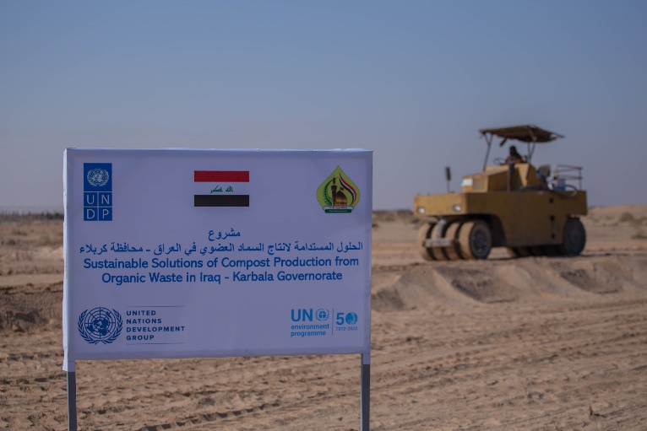 | 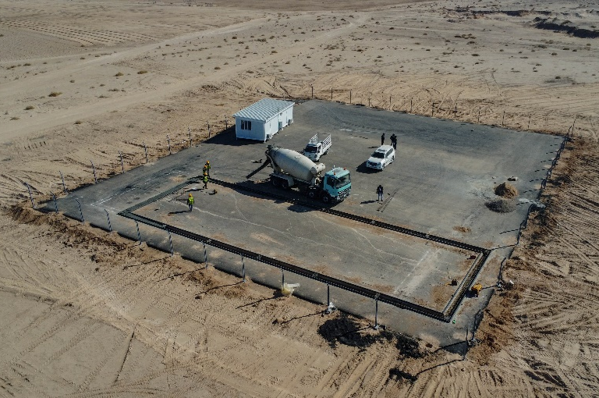
Day 1 – Construction of pilot composting facility | Day 20 – Construction of pilot composting facility
Day 35 – Construction of pilot composting facility

One of the heroes of this achievement was Mrs. Alaa Baidi as well as the technical teams from all stakeholders. Mrs. Alaa under the leadership of the Head of Karbala Municipality supported the project and participated in all events. The project focused on empowering Mrs. Alaa and gave her a leading role in the training and awareness events, the knowledge exchange visit to Jordan and the engagement of the pilot composting facility from design to implementation to operation. Furthermore, the project achieved at least 30 % women participation in all events. Mrs. Alaa highlighted that the composting facility “is the first step of transforming the waste management process into a more environmental friendly and sustainable approach” adding that “the pilot composting facility has created green jobs for the families in the rural area surrounding the typical landfill site. Mrs. Alaa also highlighted “the potential for women to support the environmental sector in Iraq in all fields”. Below few of the events that Mrs. Alaa joined:

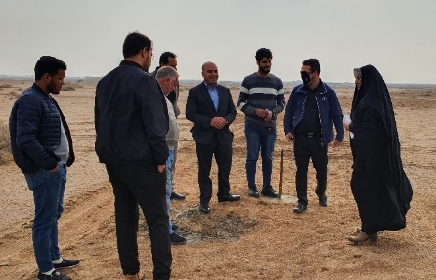 | 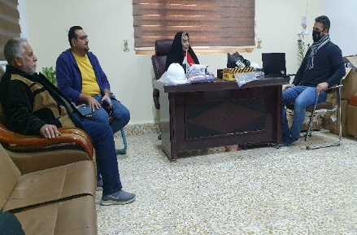
Site handover | Equipment handover meeting
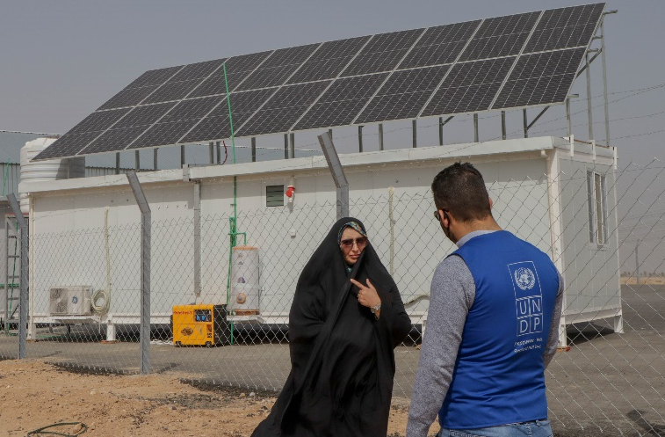 | 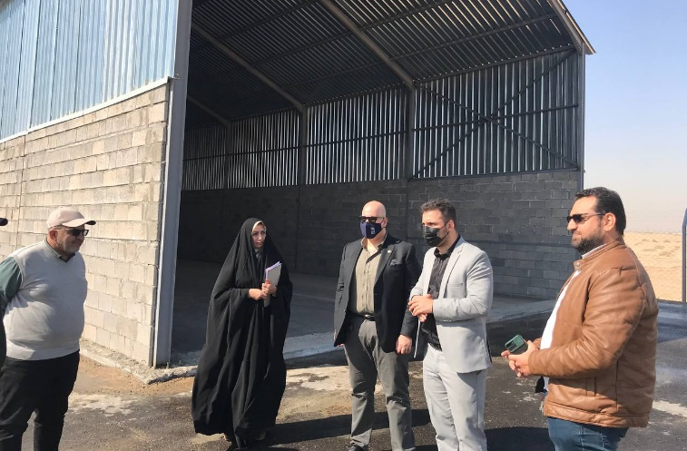
Pilot composting facility handover site visit

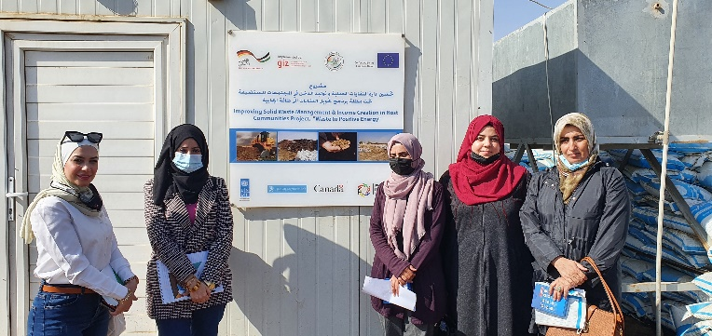 | 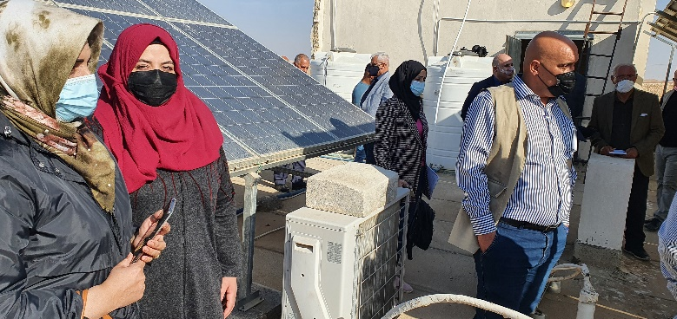
Jordan waste to energy site visit | Jordan composting facility visit

Problem / Challenge faced: Describe the specific problem or challenge faced by the subject of your story (this could be a problem experienced by an individual, community or government).

The programme faced some delay during the selection of a new Head of Karbala Municipality as it was necessary to present the programme to the new key stakeholder and sensitize him on the importance of this project and how it can support Karbala Municipality in their efforts to transport their waste management in a more integrated and sustainable approach.

Programme Interventions: How was the problem or challenged addressed through the Programme interventions?

With support from:
- Karbala Governor’s Office in taking necessary decision and giving project approvals
- UNDP Karbala suboffice day to day meetings and face to face meetings to follow up project, disseminate surveys etc. and collected data
- Programme management team of UNDP and UNEP frequent meetings to follow up projects and finding solutions for delays

the activities could progress again.

Result (if applicable): Describe the observable change that occurred so far as a result of the Programme interventions. For example, how did community lives change or how was the government better able to deal with the initial problem?

The implementation of pilot composting facility including the solar PV off grid unit has raised the curiosity of the rural area population were most of them are farmers that now have an increased knowledge on both compost and solar energy potential. The local government are now better equipped to deal with organic waste in a more sustainable approach through their trained capacities as well as the pilot composting facilities that can be scaled up, scale up designs and guidelines have been developed and handed over to Karbala Municipality. The rural community was engaged in the construction of the pilot composting facility and they will be given priority in the green positions that will be created in order to operate and maintain the facility.

Lessons Learned: What did you (and/or other partners) learn from this situation that has helped inform and/or improve Programme (or other) interventions?

Building connections on all levels with the stakeholders from decision makers to technical team will support overcoming challenges faced with the turnover of officials etc. Studies and assessments on local level and targeted to the main stakeholders will help developing capacity building and awareness events that will solve actual needs. In addition, any technology transfer activities from best case experience in the region or globally will be better tailored to the local context if there is sufficient understanding of the local needs.

The term “programme” is used for programmes, joint programmes and projects.
Strategic Results, as formulated in the Strategic UN Planning Framework (e.g. UNDAF) or project document;
The MPTF Office Project Reference Number is the same number as the one on the Notification message. It is also referred to as “Project ID” on the project’s factsheet page on the MPTF Office GATEWAY.
The MPTF/JP Contribution is the amount transferred to the Participating UN Organizations – see MPTF Office GATEWAY
The start date is the date of the first transfer of the funds from the MPTF Office as Administrative Agent. Transfer date is available on the MPTF Office GATEWAY
As per approval of the original project document by the relevant decision-making body/Steering Committee.
If there has been an extension, then the revised, approved end date should be reflected here. If there has been no extension approved, then the current end date is the same as the original end date. The end date is the same as the operational closure date which is when all activities for which a Participating Organization is responsible under an approved MPTF / JP have been completed. As per the MOU, agencies are to notify the MPTF Office when a programme completes its operational activities. Please see MPTF Office Closure Guidelines.
Financial Closure requires the return of unspent balances and submission of the Certified Final Financial Statement and Report.
Note: Outcomes, outputs, indicators and targets should be as outlines in the Project Document so that you report on your actual achievements against planned targets. Add rows as required for Outcome 2, 3 etc.
https://news.un.org/en/story/2021/11/1106412

