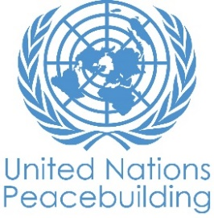
PBF PROJECT progress report
COUNTRY: Liberia
TYPE OF REPORT: semi-annual, annual OR FINAL: SemSemI-ANNUAL
YEAR of report: 2022
Project Title: “Sustainable and inclusive peace in Liberia through promoting women leadership and participation in civic and political life and their strengthened role in conflict resolution”

Project Number from MPTF-O Gateway: 00125953
If funding is disbursed into a national or regional trust fund:  Country Trust Fund  Regional Trust Fund  Name of Recipient Fund: | Type and name of recipient organizations:  NUNO ZOA (Convening Agency)
Date of first transfer: 22 February 2021
Project end date: 21 August 2022
Is the current project end date within 6 months?

Check if the project falls under one or more PBF priority windows:
Gender promotion initiative
Youth promotion initiative
Transition from UN or regional peacekeeping or special political missions
Cross-border or regional project

Total PBF approved project budget (by recipient organization):
- Please enter the total amounts in US dollars allocated to each recipient organization
- Please enter the original budget amount, amount transferred to date and estimated expenditure by recipient.
- For cross-border projects, group the amounts by agency, even where transfers are made to different country offices. You can provide the detail in the attached budget.

Recipient organisation | Budget Allocated ($) | Amount Transferred to date ($) | Amount spent to date ($)
Stichting ZOA (ZOA) | $ 1,289,614.83 | $ 902,730.38  Tranche 1 (35%) and Tranche 2 (35%) | $ 554,313.88
TOTAL | $ 1,289,614.83 | $ 902,730.38

Approximate implementation rate as percentage of total project budget: 46%

*ATTACH PROJECT EXCEL BUDGET SHOWING CURRENT APPROXIMATE EXPENDITURE*

The budget templates are available here

Gender-responsive Budgeting:

Indicate what percentage (%) of the budget contributes gender equality or women's empowerment (GEWE)? 100%

Indicate dollar amount from the project document to contribute to gender equality or women’s empowerment: 1289614.83USD

Amount expended to date on efforts contributing to gender equality or women’s empowerment: 554,313.88 USD

Project Gender Marker: GM3
Project Risk Marker:
Project PBF focus area: Conflict prevention/ management.
Report preparation:
Project report prepared by: ZOA and ABIC
Project report approved by: Jaap van Kranenburg, Country Director ZOA Liberia
Did PBF Secretariat review the report:

NOTES FOR COMPLETING THE REPORT:
- Avoid acronyms and UN jargon, use general /common language.
- Report on what has been achieved in the reporting period, not what the project aims to do.
- Be as concrete as possible. Avoid theoretical, vague or conceptual discourse.
- Ensure the analysis and project progress assessment is gender and age sensitive.
- Please include any COVID-19 related considerations, adjustments and results and respond to section IV.

PART 1: OVERALL PROJECT PROGRESS

Briefly outline the status of the project in terms of implementation cycle, including whether preliminary/preparatory activities have been completed (i.e. contracting of partners, staff recruitment, etc.) (1500-character limit):

The project was officially launched on 28 May 2021. It created awareness and a sense of responsiveness among stakeholders at all levels ranging from Eminent Women, political leaders, local authorities, government institutions, media and CSOs.

Staff recruitment processes for both ABIC and ZOA were done with all preliminary activities done in the early phase of the project before jumpstarting the project.

Under outcome 1, the following was done: by-election in Jorquelleh #2 was monitored, 4 meetings held with political actors, 20 intercommunity unity games, 20 engagements on advocacy, 20 monitoring of violent cases and interventions, 3 women’s peace marches held, 50 airplay of peace messages, 2 WSR hour on ECOWAS radio, 5 women’s mediation dialogues with interventions by chiefs in communities.

For outcome 2, 172 appreciative inquiry meetings were held with 20 women’s groups in Bong and Montserrado Counties. 80 meetings have also been held with actors to date (44 enablers and 36 blockers), totalling 252 meetings. ZOA Team also provided capacity building for CSOs in financial management procedure and accountability. A feedback session was conducted with women’s groups and CSOs to hear from both women and the few men on the appreciative inquiry, and how it has impacted their lives in different ways. The feedback was also meant to identify gaps and find amicable ways to address them. The process also provided information to communities on the pending learning and experience sharing workshop expected to be held in June.

The Liberia Peacebuilding Office (PBO) has led monitoring trips to the two project counties and continue to provide recommendations to ABIC and ZOA.

FOR PROJECTS WITHIN SIX MONTHS OF COMPLETION: summarize the main structural, institutional or societal level change the project has contributed to. This is not anecdotal evidence or a list of individual outputs, but a description of progress made toward the main purpose of the project. (1500-character limit):

Grassroots women and youth know their rights under the law when it comes to elections. They have gained skills in conflict resolution and demonstrated it by doing interventions at community level. Women’s attitude towards being visible and creating their space at the decision-making table has been realised. Women have become confident to go on radio and discuss issues of peace and violence in their communities. Women and youth leaders from political parties have pledged commitment to do descent campaign before, during and after 2023 elections. Women, youth and chiefs have committed to campaign against the proliferation of drugs which has become the number indicator of violence. Chiefs have become bold to address the politicisation of customs to cause violence in elections. Chiefs and women leaders are able to do village to village interventions through fund support.

Since the intervention of the appreciative inquiry meetings in the project communities, most men perceptions have changed. They see power sharing with the women as a new paradigm shift for them but are positive about it. The AI engagements were able to make men discover the importance of an inclusive community. They termed it as releasing stress from them, thereby prolonging their lifespan. The impact of this change is not only evident by their commitment to accept that an inclusive life is important but are ready to support and appoint women to key leadership positions in their communities.

The engagements have also improved women’s confidence about stepping out for power sharing with the men. Calm and civility have been restored to some communities because everyone is now beginning to have a sense of responsibility to their community for its peace and development.

PART II: RESULT PROGRESS BY PROJECT OUTCOME

Describe overall progress under each Outcome made during the reporting period (for June reports: January-June; for November reports: January-November; for final reports: full project duration). Do not list individual activities. If the project is starting to make/have made a difference at the outcome level, provide specific evidence for the progress (quantitative and qualitative) and explain how it impacts the broader political and peacebuilding context.

- “On track” refers to the timely completion of outputs as indicated in the workplan.
- “On track with peacebuilding results” refers to higher-level changes in the conflict or peace factors that the project is meant to contribute to. These effects are more likely in mature projects than in newer ones.

If your project has more than four outcomes, contact PBSO for template modification.

Outcome 1: Women promote co-existence and peaceful conflict resolution among political actors in the aftermath of the mid-term Senatorial Elections using the Women’s Situation Room (WSR) mechanism

Rate the current status of the outcome progress:

Progress summary: (3000-character limit)

Women and youth have reported an increase in sense of agency and civic responsibility to initiate mediation and conflict resolution mechanism at the community level owing to the association with, and training in the WSR methodology as a conflict resolution tool. These women and youth in the 20 project communities are led by the chairladies and youth leaders respectively. Prior to the commencement of the project, an enlightenment of their active roles in the local peace building agenda through education was lacking. The women have initiated an agenda not only to demand their seats at the decision-making table but to create their seats and be visible at the decision-making table.

Actors within the local government structure in concerted efforts have acknowledged the key roles of women in mediation and conflict resolution. This has been more pronounced in the communities within the structure of the chiefs by referencing the change in attitude of women chiefs and chairladies to resolving disputes and mitigating violent cases since the WSR was commenced. In the current phase of the project, the women chiefs and chairladies have assumed confidence to speak on radio and record peace messages for airplay across community radio stations.

The neutrality of the WSR mechanism has enabled it to bring political and non-political actors on the same platform to dialogue reoccurring issues of violence related to elections, especially as targeted at women and perpetrated by youth. The difference these mediation dialogues made as compared to others in the past was the lack of accusatory statements among the actors, but rather there was an echoing of self-accountability and responsibility for the ills of elections and the commitment to change the narrative going in the 2023 elections. The acknowledgement of self-blame for contributions to electoral violence has been the first step in the right direction to properly finding lasting solutions to the issues. The remaining months of the project will be committed to this agenda.

The relationship and network building with women in the political parties has encouraged women to see the relevance of their roles beyond the fallow activities of the women’s wing, which was primarily anchored on restrictive cultural norms whose value of women is relegated in domesticity. Women leaders from 19 political parties engaged in mediation dialogues have declared their intention to contest for executive roles in their parties while 3 party chairladies have decided to contest for the candidacy of their parties in order to run on their tickets during the 2023 elections.

Women in active political spheres have committed to encourage the motivation of women as the premier constituency of political actors, which is women supporting women in a manner that eradicate divisiveness and solidifies their political gains in each respective party. The youth in political parties have also committed to work to ensure the youth narrative in elections is flipped away from perpetrators of violence to reflect that of peace initiators.

Indicate any additional analysis on how Gender Equality and Women’s Empowerment and/or Youth Inclusion and Responsiveness has been ensured under this Outcome: (1000-character limit)

The Women Situation Room is an all-inclusive mechanism, from the staff composition to beneficiaries of activities. Women and youth empowerment are at the core of the mechanism. The below tables provide an overview of the gender and age categories of project team members and beneficiaries.

Project Team Members

S/N | County | Sex | Age disaggregation
 |  |  | 18 - 35 | 35+ | Total
1 | Bong | Female | 2 | 0 | 2
 |  | Male | 5 | 0 | 5
2 | Montserrado | Female | 6 | 3 | 9
 |  | Male | 3 | 8 | 11
Total |  |  | 16 | 11 | 27

Project Beneficiaries registered in the database

S/N | County | Gender disaggregation
 |  | Women | PWDs | Youth | PWDs
1 | Bong | 980 | 20 | 965 | 35
2 | Montserrado | 995 | 5 | 985 | 15
Total |  | 1,975 | 25 | 1,950 | 50
 |  | 2,000 |  | 2,000

Chiefs implementing the WSR Mediation Mobile Clinic

S/N | County | Women | Men
 | Bong | 28 | 22
 | Montserrado | 15 | 35
Total |  | 43 | 57
 |  | 100

Outcome 2: Local authorities and traditional leaders have improved perceptions on and increased commitment to women participation and leadership at local and county level

Rate the current status of the outcome progress:

Progress summary: (3000-character limit)

As the project is approaching its concluding phase, the appreciative inquiry has shown to have made a significant change in the project communities. Most male traditional, and local leaders along with some men in the communities are very positive about women’s leadership and have become champions for inclusive participation in the decision-making of their communities.

The perceptions of most actors earmarked as blockers under the project have changed meaningfully and they are leading the appointment of women to different leadership positions in their communities. Currently, women are being appointed to town chief, assistant town chief, quarter chief, assistant quarter chief, block leaders, elder council member, development chair, and community police officer positions. In Blameyea, a community where tradition was a major hinderance to women’s leadership, a woman has now been appointed to serve as town chief with three others appointed to serve as assistant quarter chiefs. Similarly, in SKT, where the town chief was identified as a blocker under the project, has changed his perception about power sharing and has appointed a female as assistant town chief. Project enablers have played a significant role in achieving this.

The improved perceptions of key actors have outshined the cultural walls that stopped women’s inclusion and participation in the decision-making processes of their communities; proven by the decrease in the volume of bullying women faced at the inception of the project. The tolerance male leaders are demonstrating to accommodate women to execute particular civic and traditional roles say how laudable it is, and how optimistic they are about change towards inclusivity.

It is also good to note that women are being aware that been in leadership is the gateway for women to have a voice at the decision-making table, which they think promotes an equitable society. Women’s groups and individual members have also started feeling a sense of responsibility to their communities and have started taking initiatives that support the welfare of their communities. A lady in the Goba-chop Group feels very enthusiastic and strong about her responsibility to her community as she commits to cleaning dirt from her immediate neighbourhood as a way of contributing and giving back to her community.

Women who were very shy and afraid from the early stage of the project, are now sharing their stories about how the project has improved their confidence and can now represent their own interest at major community meetings.

The appreciative inquiry meetings beyond seeking for changed perception towards inclusiveness in decision making and leadership, it has also strengthened cohesion among group members. Most groups have taken on communal initiatives that are beneficial to their communities. Some communities have jointly started constructing public toilets, town halls and women’s centres, while others are undertaking community farm projects.

The appreciative inquiry engagements are making local communities leadership realize that a community is more peaceful and productive towards growth and development when the decision-making processes are inclusive and participatory.

The process has been getting away from traditional deficit-based change to a positive, strength-based approach which is helping people and communities appreciate and value themselves and begin to think through possibilities that can define for them a future that is participatory, productive and sustainable.

Indicate any additional analysis on how Gender Equality and Women’s Empowerment and/or Youth Inclusion and Responsiveness has been ensured under this Outcome: (1000-character limit)

At the start of the project, the power analysis was conducted to gain understanding on the way in which power influences women’s leadership and participation. The CSOs training and women’s group selection ensured the inclusion of both men and women in the promotion of inclusive civic and political life. It also guaranteed the involvement of youthful men and women as well as Middle Ages. The CSOs training which was intended to ensure that the appropriate skills are acquired to implement the appreciative inquiry method under outcome 2, trained a total number of 43 persons. The first table reflects the CSO staff who have been trained on the AI disaggregated participation by gender and age. The second table shows the number of CSO staff who are carrying out the AI activities in the communities. Of the 43 CSOs trained, 22 of them are implementing the appreciative inquiry. Of the 22 persons, 17 are females and 5 males.

County | Sex | Age disaggregation
 |  | 18 -35 | 35+ | Total
Bong County | Female | 8 | 7 | 15
 | Male | 1 | 2 | 3
Montserrado | Female | 5 | 16 | 21
 | Male | 2 | 2 | 4
Total |  | 16 | 27 | 43

County | Sex | Age disaggregation
 |  | 18 -35 | 35+ | Total
Bong | Female |  | 7 | 7
 | Male | 1 | 2 | 3
Montserrado | Female | 3 | 6 | 9
 | Male | 1 | 2 | 3
 |  | 5 | 17 | 22

The inclusion of women and men ranging from key actors, male champions, and women’s groups are seen in the table below. The project recruited in total 20 key actors, however out of the 20 actors only 17 have been active in the project. Additionally, the CSOs are meeting with the county superintendents in the two counties, who are both females.

No | Stakeholder | Number per category | Youth participant | Adult participant
1 | Women’s group | 400 | 180 (45%) | 220 (55%)
2 | Male champions | 100 | 40 (40%) | 60 (60%)
3 | Male actors | 10 | 2 (20%) | 8 (80%)
4 | Female actors | 7 | 0% | 7 (100%)

 | Performance Indicators | Indicator Baseline | End of project Indicator Target | Indicator Milestone | Current indicator progress | Reasons for Variance/ Delay  (if any)
Outcome 1: Women promote co-existence and peaceful conflict resolution among political actors in the aftermath of the mid-term Senatorial Elections using the Women’s Situation Room (WSR) mechanism  This outcome contributes to SDG targets: 5.5 and 10.2  (Any Universal Periodic Review of Human Rights (UPR) recommendation that this Outcome helps to implement and if so, year of UPR) | Outcome Indicator 1a: % of participating women and youth who report an increase in sense of agency and civic responsibility to initiate and own mediation and conflict prevention/mitigation processes in their communities through the WSR mechanism | Sense of agency: 74%  Civic Responsibility: 81% | Target: Between 60% and 80% of participating women (all ages) and youth (between 18 – 35, male and female) | 40% of participating women and youth after the first 9 months of the project | 40% of citizens  Women  - 820 out of 1,975 (20.5%)  - 7 out of 25 PWDs (0.2%)  Youth  - 200 out of 850 girls (5%)  - 550 out of 1,100 boys (13.8%)  - 27 out of 50 PWD (0.7%) | More women and young girls have participated in the various activities. Their interests were in the sports activities and peace marches. We encountered the challenge of people migration as some of the original recruits representing the variance have moved to other non-communities. For the youth, the variance accounts for those who have ran off to the bush to join the ‘society’. For example, in Belefanai, our last engagement saw only 15 youth out of 100.
 | Outcome Indicator 1b: % of political actors, citizens and other relevant stakeholders who acknowledge the key role of women in conflict resolution and peaceful co-existence | Conflict Resolution: 89%  Peaceful Coexistence: 81% | Target: Between 60 and 80% of political actors, citizens and other relevant stakeholders (including local authorities, traditional leaders, youth) (male and female, all ages) | 40% of political actors, citizens and other relevant actors after the first 9 months of the project | 40% of citizens  Women  - 820 out of 1,975 (20.5%)  - 7 out of 25 PWDs (0.2%)  Youth  - 200 out of 850 girls (5%)  - 550 out of 1,100 boys (13.8%)  - 27 out of 50 PWD (0.7%) | More women and young girls have participated in the various activities. Their interests were in the sports activities and peace marches. We encountered the challenge of people migration as some of the original recruits representing the variance have moved to other non-communities. For the youth, the variance accounts for those who have ran off to the bush to join the ‘society’. For example in Belefanai, our last engagement saw only 15 youth out of 100.
 | Outcome Indicator 1c: % of citizens in target communities who report co-existence and peaceful conflict resolution in the aftermath of the elections | Peaceful Aftermath: 89% | Target: Between 60 and 80% of citizens in target communities (male, female, youth, elderly, diverse religious, ethnic and socio-economic backgrounds) | 40% of citizens in target communities after the first 9 months of the project | 40% of citizens  Women  - 820 out of 1,975 (20.5%)  - 7 out of 25 PWDs (0.2%)  Youth  - 200 out of 850 girls (5%)  - 550 out of 1,100 boys (13.8%)  - 27 out of | More women and young girls have participated in the various activities. Their interests were in the sports activities and peace marches. We encountered the challenge of people migration as some of the original recruits representing the variance have moved to other non-communities. For the youth, the variance accounts for those who have ran off to the bush to join the ‘society’. For example in Belefanai, our last engagement saw only 15 youth out of 100.
Output 1.1  Output 1.1 Selected women have knowledge on the WSR mechanism, methodology in delivering Track II mediation and have the skills to convene mediation dialogues to manage post elections expectations between conflicting political actors | Output Indicator 1.1.1: # of women from local civil society groups and communities who complete the training and are certificated on the WSR mechanism and Track II methodologies. | 0 | Target: 30 women from local civil society groups and communities are certified as Women Mediators (eminent women – above 40 years old) | 30 women are certified after the first 9 months of the project | 0 achieved | Training preparations have commenced and currently ongoing. The final figures will be communicated in the final report
 | Output Indicator 1.1.2: % of Women Mediators who demonstrate acquired skills and knowledge of the WSR mechanism and methodologies of Track II mediation by convening mediation dialogues. | 0 | Target: Between 60 and 80 % of Women Mediators (above 40 years) | 40% of women mediators the first 9 months of the project | 40% of women mediators | The women mediators are awaiting the refresher training in mediation and corresponding certification
 | Output Indicator 1.1.3: # of mediation dialogues with conflicting political actors convened by Women Mediators to mediate issues among conflicting political actors | 0 | Target: 20 (10 per county) | 10 mediation dialogues implemented after the first 9 months of the project | 6 mediation dialogues convened
 | Output indicator 1.1.4: % of women-led mediation dialogues among conflicting political actors which result in peaceful conflict resolution and co-existence | 0 | Target: Between 60 and 80% of mediation dialogues | 40% successful women-led mediation dialogues the first 9 months of the project | 60% of successful women-led mediation dialogues convened with 343 national stakeholders
Output 1.2  Output 1.2: Local women’s groups are capable of advocating for citizens’ rights and responsibilities and promote peace in their communities | Output Indicator 1.2.1: # of women participating in peace marches organized by women’s groups in their communities | 0 | Target: 2,000 women (all ages) | 1,000 women have participated in peace marches after the first 9 months of the project | 1,651 women peace activists from project beneficiaries marched to create their seats at the decision-making table. 443 non project beneficiaries marched along with the women from beginning to end | .
 | Output Indicator 1.2.2: # of peace statements delivered by political actors and women | 0 | Target: 120 | 40 peace statements after the first 9 months of the project | 120 peace messages have been recorded. 96 messages are being played on air | The remaining 24 messages are being edited for airplay
 | Output Indicator 1.2.3: % of participating women who report to have the capacity to advocate for citizen’s rights and responsibilities | 0 | Target: Between 60 and 80% of participating women (all ages) | 40% of participants after the first 9 months of the project | 70.5% of women (this is cumulative since project inception)  Women  - 1,398 out of 1,975 (69.9%)  - 12 out of 25 PWDs (0.6%)
Output 1.3  Output 1.3: Youth groups (male, female) have the knowledge and skills to advocate nonviolence in their communities and support women’s groups in conflict resolution and mediation | Output Indicator 1.3.1: # of youth trained in the WSR mechanism and conflict resolution | 0 | Target: 400 (200 females; 200 males) and 10 peace monitors (5 female, 5 male) (between 18 and 35) | 400 youth trained after the first 9 months of the project | 400 youth and 10 peace monitors have been trained in the WSR mechanism as a conflict resolution tool
 | Output Indicator 1.3.2: # of peer to peer peace dialogues conducted by peace monitors and # of participants | 0 | Target: 40 (20 per county) with around 2,000 youth participants (male and female) | 20 peer to peer peace dialogues after the first 9 months of the project | 30 workshops (peer to peer peace dialogues) with 1,214 youth and 10 peace monitors
 | Output Indicator 1.3.3: % of trained youth who report nonviolence and peaceful conflict resolution in their communities in the aftermath of the senatorial elections | 0 | Target: Between 60% and 80% of youth beneficiaries (male and female) | 40% of participants after the first 9 months of the project | 54% of citizens (this is cumulative since project inception)  Youth  - 350 out of 850 girls (17.5%)  - 700 out of 1,100 boys (35%)  - 27 out of 50 PWD (1.35%)
Outcome 2: Local authorities and traditional leaders have improved perceptions on and increased commitment to women participation and leadership at local and county level  This outcome contributes to SDG targets:  5.5 to ensure women’s full and effective participation and equal opportunities for leadership at all levels of decision-making in political, economic and public life.  10.2 to empower and promote the social, economic and political inclusion of all, irrespective of age, sex, disability, race, ethnicity, origin, religion or economic or other status 16.7 committed to ensure responsive, inclusive and representative decision-making  (Any Universal Periodic Review of Human Rights (UPR) recommendation that this Outcome helps to implement and if so, year of UPR) | Outcome Indicator 2a: % of participating local authorities / traditional leaders who accept there is a problem of under representation of women in political and civic life | Women Underrepresented in: Leadership: 66%  Civic Life: 57%  Politics: 55% | Target: between 60 and 80% of participating local authorities / traditional leaders (male and female, all ages) | 40% of participants after the first 9 months of the project | Final results to be reported during end evaluation, however monitoring shows that 11 out of 20 actors (55%) accept there is a problem of women underrepresentation.
 | Outcome Indicator 2b: % of participating local authorities and traditional leaders who report improved perceptions and increased commitment to women participation and leadership | 35% | Target: between 60 and 80% of participating local authorities and traditional leaders (male and female) | 40% of participants after the first 9 months of the project | Final results to be reported during end evaluation, however monitoring shows that 40% of local authorities and traditional leaders report improved perceptions and increased commitment toward women participation and leadership. (see Annex for actors who perception changed during the AI meetings)
 | Outcome Indicator 2c: # of locally led solutions which are agreed upon by women’s groups and actors, gain written commitment and are implemented | 0 | Target: At least 4 ideas (2 per county) gain written commitments, becoming tangible outcomes for local institutions. It is hoped that more will gain informal consent and action. | 0 locally led solutions after the first 9 months of the project | Montserrado (2)  Bong County (4)  39 women in leadership positions  (See annex for locally led solutions)
Output 2.1: Local authorities and traditional leaders reflect on and understand the barrier’s women face to participate in decision-making | Output Indicator 2.1.1: # of appreciative inquiry visits with local authorities and traditional leaders | 0 | Target: 120 visits – 72 with driving actors and 48 with blocking actors | 60 appreciative inquiry visits conducted after the first 9 months of the project | 80 visits; Driving actors - 44 (61%) and Blocking actors – 36 (75%) | .
 | Output Indicator 2.1.2: % of participating local authorities and traditional leaders who can mention and elaborate on the key structural barriers for women participation in their community / area | Education & Skills: 58%  No barriers: 47%  Self-Confidence: 41%  Finances: 36% | Target: between 60 and 80% of participating local authorities / traditional leaders (male and female, all ages) | 40% of participants after the first 9 months of the project | Final results to be reported during end evaluation, however monitoring shows that 11 actors out of 20 actors (55%) have an increased understanding on barriers women face.
Output 2.2: Local women’s groups have the confidence, knowledge and skills to represent women’s issues, demands and aspirations at local and county level decision-making processes | Output Indicator 2.2.1: # of appreciative inquiry visits with women’s groups | 0 | Target: 200 visits (100 per county, 10 per women’s group) with between 300 and 400 participants (female of all ages) | 100 appreciative inquiry visits conducted after the first 9 months of the project | 172 (86%) visits with 400 women, 200 per county.
 | Output Indicator 2.2.2: % of participants in the appreciative inquiry visits who report increased confidence, knowledge and skills to represent women’s issues, demands and aspirations | 0 | Target: Between 60% and 80% of participants (female of all ages) | 40% of participants after the first 9 months of the project | The % will be determined during the end line evaluation. However, during monitoring visits improvements in confidence, knowledge and skills of women have been observed.
 | Output Indicator 2.2.3: # of participating women who takes a leadership position at local or county level withing the project period | 0 | Target: 20 women who take a leadership position | 5 | 39 women; 36 appointed and 3 elected.
Output 2.3: Inclusive dialogue with key public actors and representatives of women’s groups to discuss contextualized solutions for women’s civic and political participation | Output Indicator 2.3.1: # of participants at solution sharing workshops held between women and local authorities and traditional leaders (1 per county) | 0 | Target: 60 representatives of women’s groups (30 per county) (female all ages) and 20 local authorities and/or traditional leaders (at least four female) | 0 inclusive dialogues held after the first 9 months of the project | Pending
 | Output indicator 2.3.1: # of contextualized solutions which are considered feasible by representatives of women’s groups and key public authorities | 0 | Target: at least four solutions (2 per county) | 0 solutions developed after the first 9 months of the project | Pending

PART III: CROSS-CUTTING ISSUES

Please indicate any significant project-related events anticipated in the next six months, i.e. national dialogues, youth congresses, film screenings, etc. (1000-character limit):

From June to August 2022, Outcome 1 will be completing training and certification activities, the last series of mediation dialogues, continue networking and relationship building with political parties and other politically exposed actors and follow up activities on new tools of the WSR which include the mediation mobile clinic with the chiefs and women leaders.

Several activities are anticipated to take place between June to August under outcome 2, which include training of CSOs on the Appreciative Inquiry training tool kit, conducting training on data collection and reporting, conducting experience sharing and learning workshop, workshops with key public actors and representatives to agree on locally led solutions and follow-up activities. Additionally, a booklet will be developed to showcase stories of change from project participants.

In a few sentences, explain whether the project has had a positive human impact. May include anecdotal stories about the project’s positive effect on the people’s lives. Include direct quotes where possible or weblinks to strategic communications pieces. (2000-character limit):

The longevity of Outcome 1 has sustained the commitment of women, youth, men, chiefs and other local leaders in peaceful co-existence in the communities. Women leaders have assumed their mediation roles by engaging in interventions at community level through the WSR Mediation Mobile Clinic. Political actors have for the first time publicly shamed the use of traditions and norms to intimidate and terrorise women candidates in elections. This has stirred conversations on the clash between statutory laws and cultural norms and the need to prevent it from happening in 2023.

‘This is the first time we the chiefs have been called to talk about this bad habit in my community. When you belong to your ‘society’ that na your business, don’t bring it to the rest of us. We don’t even know who control the country devil. The minister of internal affairs and the leader of the traditional council, chief Zazakawa need to appear before us and tell us the truth. We tired of all this, it gives we the chiefs bad name in front of our people - paramount chief’.

‘I woman town chief thanks to God. Because of this project, I now able to talk in chiefs meeting even if the men threaten to bring out the country devil’.

The appreciative inquiry meetings are yielding achievements across communities. The project underscores inclusion as a key element of unity for families, communities and within the groups. Men have started to understand that women are an important and should be given their place in different decision-making procedures. Cohesion is being restored to communities, women’s confidence is being built and many women now embrace public positions.

A participant from Goba-Chop said “I used to be very shy and saw decision making as the man’s thing. Since ZOA and YWCA came to Goba-chop here, the teaching opened my eyes. The teaching got me brave to talk among people. When they said who all ley women in ley group here that able to be leader, I put my hand up. Da how ley chairman appointed me as zonal head for zone #2 in my community. I wa not satisfy o. I went to Nimba County to my own hometown, and I lobby to be part of the local leadership in the entire district where there is no woman. I never got tired self because I wa brave na from ley teaching ZOA give us. Me and my group lee talking until they appointed me as general town chief in Tweh Town, Tapeta District. I am so happy for this training”

You can also upload up to 3 ﬁles in various formats (picture ﬁles, PowerPoint, pdf, video, etc..) to illustrate the human impact of the project and 3 links to online resources

OPTIONAL

Monitoring: Please list monitoring activities undertaken in the reporting period (1000-character limit)  In the past six months of the project, the focus of monitoring shifted more from activity monitoring to monitoring of progress towards outcomes. The team conducted a performance review was across the project communities to identify potential course corrections and to contribute to learning. The aim of the progress monitoring was to ascertain the level of perceptions change of women group members and key public actors on the inclusion of women in decision-making and to follow up on women appointed / elected into leadership positions. Annex I provides an overview of findings and results. Additionally, the Liberia Peacebuilding Office (PBO) continued to carry out the quarterly monitoring visits to the project locations, UNPBF colleagues from New York joined on a monitoring visit and ZOA staff conducted a joint monitoring visit to compare the appreciative inquiry as part of the UNPBF funded project to the appreciative inquiry as part of an Irish Aid funded project. The report is yet to be finalized. | Do outcome indicators have baselines?  Has the project launched perception surveys or other community-based data collection?  MEAL staff continuously monitors perceptions of key project stakeholders as the project specifically aims to promote more positive perceptions towards women participation and leadership. Additionally, the team piloted and used the most-significant change (MSC) approach as a source of inspiration to identify and collect stories of change among project participants. Stories coming from various communities will be published in a booklet developed by a consultant (to be completed in August).
Evaluation: Has an evaluation been conducted during the reporting period? | Evaluation budget (response required): 10000.00USD  If project will end in next six months, describe the evaluation preparations (1500-character limit):  The Terms of Reference (TOR) for the end evaluation has been drafted by the ABIC and ZOA and shared with UNPBF for their input. We aim to have a consultant recruited in July so that the end evaluation can start in July / early August.
Catalytic effects (financial): Indicate name of funding agent and amount of additional non-PBF funding support that has been leveraged by the project.  N/A | Name of funder: Amount:
Catalytic Eﬀect (non-ﬁnancial): Has the project enabled or created a larger or longer‐term peacebuilding change to occur?  Please select  No catalytic eﬀect  Some catalytic eﬀect  Signiﬁcant catalytic eﬀect  Very Signiﬁcant catalytic eﬀect  Don't Know  Too early to tell | If relevant, please describe how the project has had a (non-ﬁnancial) catalytic eﬀect  Please limit your response to 3000 characters including spaces.  N/A
Other: Are there any other issues concerning project implementation that you want to share, including any capacity needs of the recipient organizations? (1500-character limit) | At the current stage not yet. ZOA and ABIC appreciate the supportive attitude and involvement of the PBF Secretariat.

PART IV: COVID-19
Please respond to these questions if the project underwent any monetary or non-monetary adjustments due to the COVID-19 pandemic.
PLEASE NOTE THAT THIS SECTION IS OPTIONAL

- Monetary adjustments: Please indicate the total amount in USD of adjustments due to COVID-19:

$0

- Non-monetary adjustments: Please indicate any adjustments to the project which did not have any financial implications:

N/A

- Please select all categories which describe the adjustments made to the project (and include details in general sections of this report):

☐ Reinforce crisis management capacities and communications
☐ Ensure inclusive and equitable response and recovery
☐ Strengthen inter-community social cohesion and border management
☐ Counter hate speech and stigmatization and address trauma

☐ Support the SG’s call for a global ceasefire
☐ Other (please describe):

If relevant, please share a COVID-19 success story of this project (i.e. how adjustments of this project made a difference and contributed to a positive response to the pandemic/prevented tensions or violence related to the pandemic etc.)

N/A

Pictures from project activities:

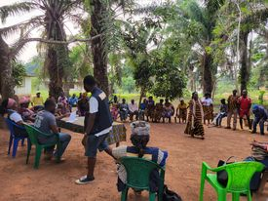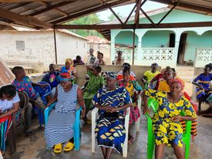
AI meeting in Chief Compound AI meeting in some our communities
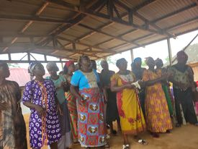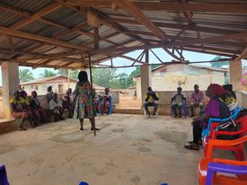
Women’s group doing traditional welcoming Feedback meeting in Blagmeyea
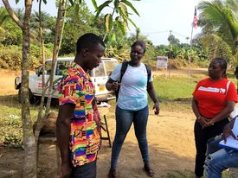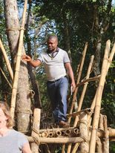
CSO engaging project actor MEAL staff making way to hard to reach com.
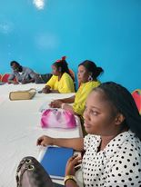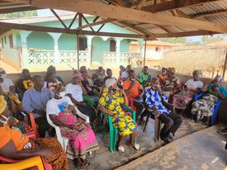

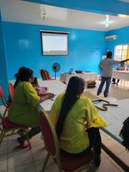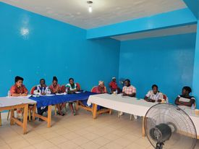
Capacity building training with CSOs Capacity building training with CSOs
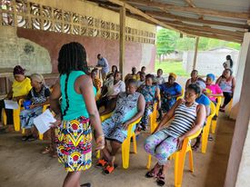
AI Meeting in Duta Feedback meeting in Careyburg Westpoint
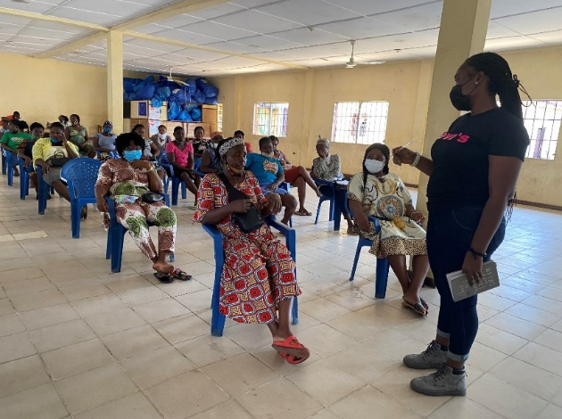
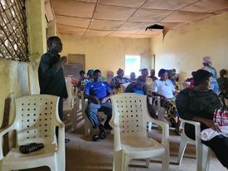
Feedback meeting with women’s Meeting with women in New Kru Town
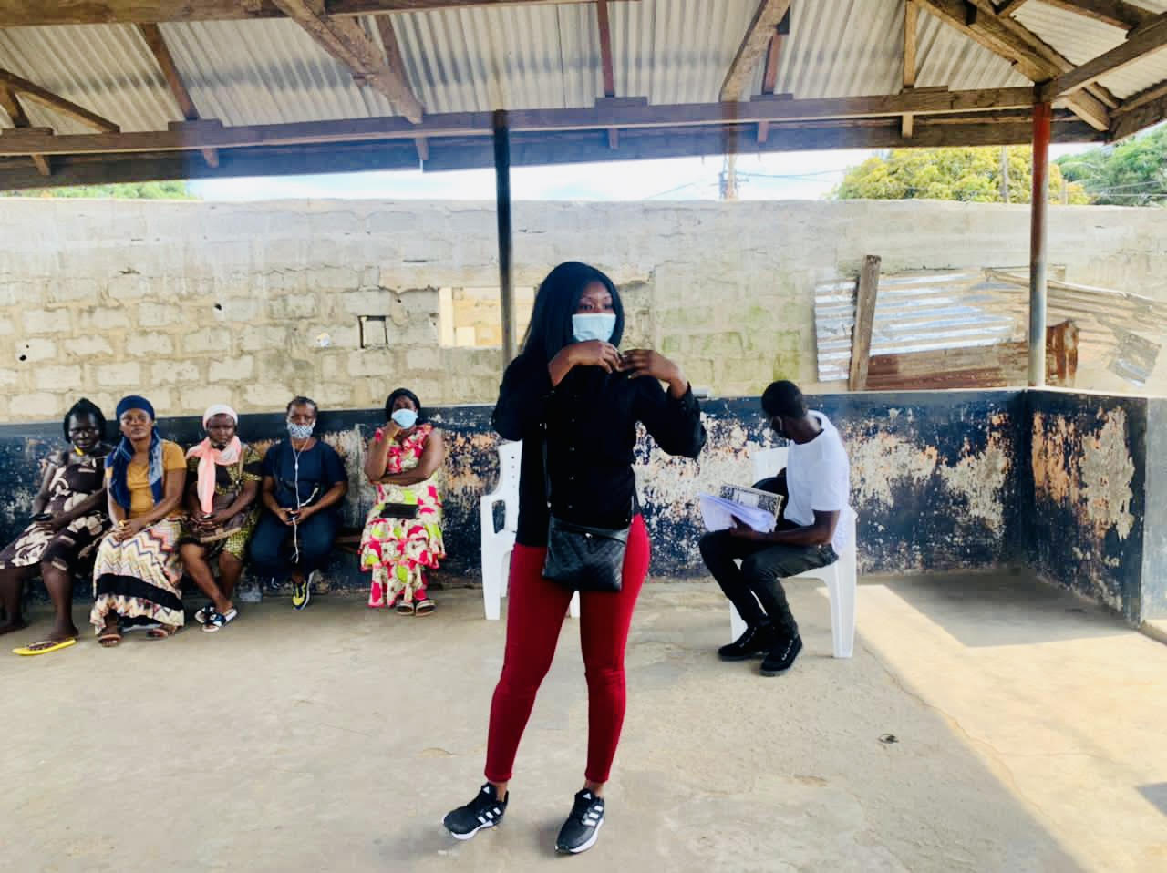
group in Bentol
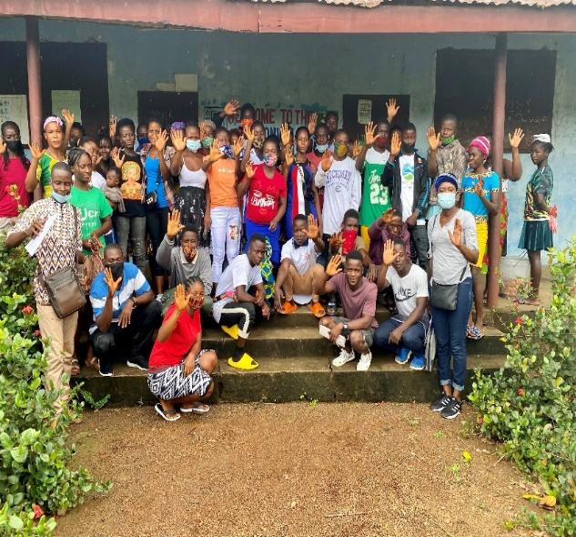

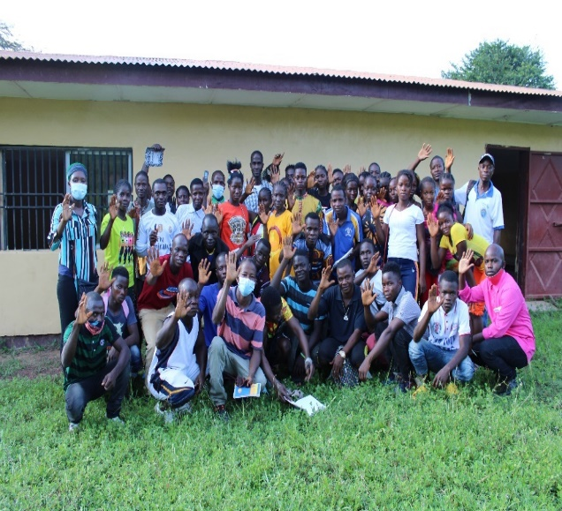
Meeting with women in District #8 Youth engagement in Bentol City
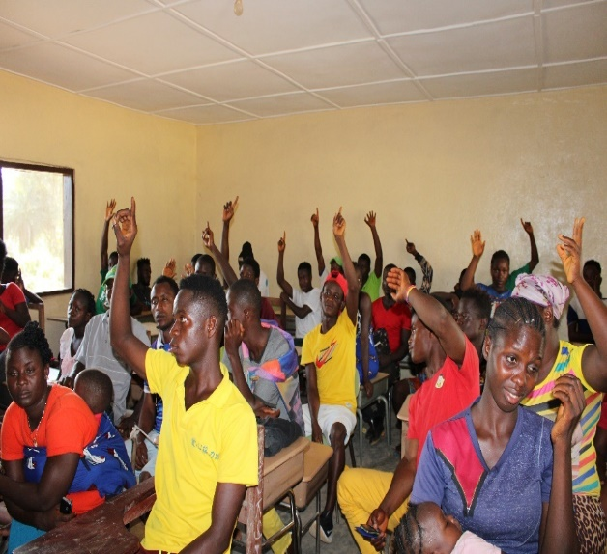

Peer to Peer dialogue in Belefanai Peer to peer dialogue in Samayta, Folobia

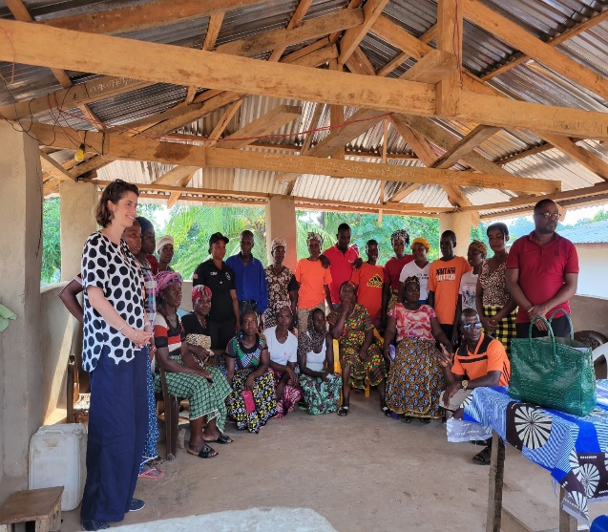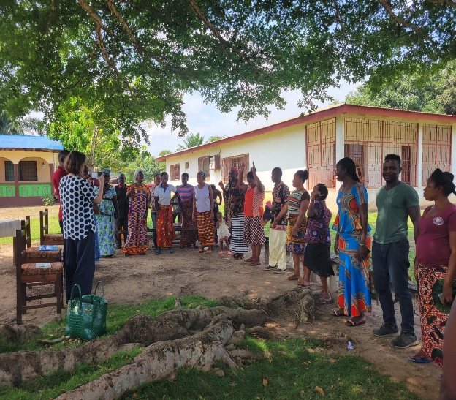
UNPBF staff visit to the Jenepleta Same visit to Millionaire Quarter

The multiplicity of women ranges from chiefs, women leaders from the political party wings, members of elders council in the communities, chairladies, women leaders, market women, fishmongers and other ordinary women
Superintendent, 100 chiefs, commissioners, mayors and mayoress
Vice President of the Republic of Liberia, incumbent senators, incumbent representatives, political parties, women groups, youth groups, chiefs, concerned voters, media, superintendent, mayors, mayoress and civil society members
Finalising the gender disaggregation of the data
In addition to the baseline survey, ABIC collected additional data and the report has been attached this report. The values as reported based on the baseline study are relatively high and do not necessarily reflect experiences on the ground. We anticipate the high figures are due to the way in which the questions were asked or the general positive perception of respondents, which is farfetched. Initial locations which were assessed during the baseline study changed as well. The additional has complemented the values as presented in the baseline report and provide a better picture of the actual experiences in the communities.
Out of 4,000 beneficiaries, 50 are PWDs. 27 represent respondents in this reporting period
Same as above footnote,
Same as above footnote.
The women mediators have gained skills in the WSR methodology as a conflict resolution tool. They convened the 5 days women mediation dialogue with national stakeholders from Bong and Montserrado counties.
The last 5 mediation dialogues for Bong and Montserrado were jointly organised by bringing stakeholders from each county to Monrovia to dialogue the issues ranging from the politicisation of traditions to cause electoral violence to the issue of youth, drug and violence in the communities. The last 4 dialogues have scheduled for June and July.
When the baseline study was conducted, local authorities / traditional leaders were not selected yet. Data collection took place within potential communities to establish baseline values. As such current values might not reflect the actuals. ZOA decided to conduct additional data from the actual enablers and blockers after their selection to gain a more in-depth and representative understanding of their perceptions. Data analysis is ongoing and the baseline values will updated accordingly.
Same as footnote above.
Same as footnote above.

