Photos of the activities for the EFR Project during July –December 2007

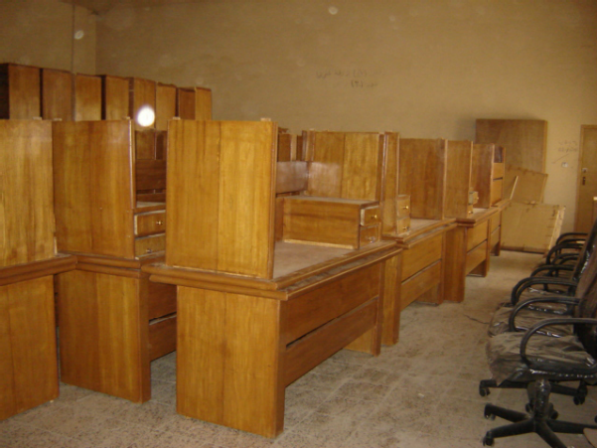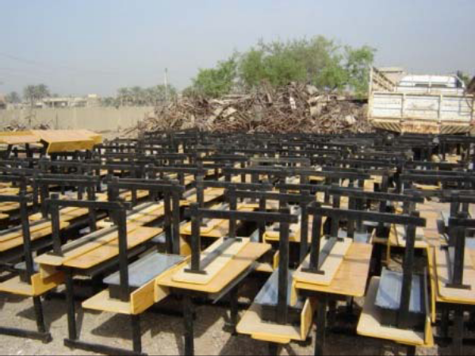
Supply of Furniture to 14 Kindergartens & 11 Schools in Baghdad

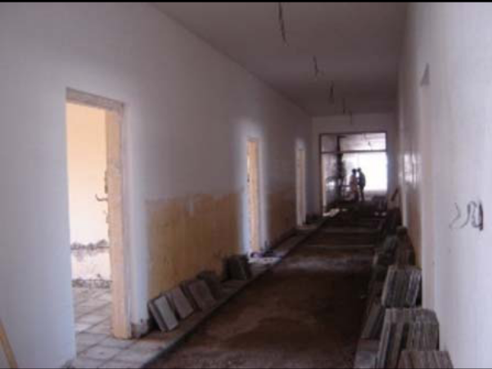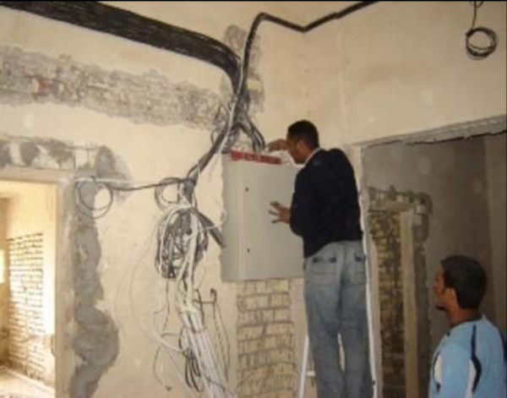

Rehabilitation of Electrical Department & Sewerage Network in Zafaraniyah Institute of Technology in Baghdad

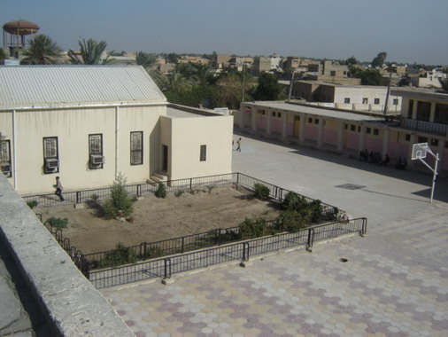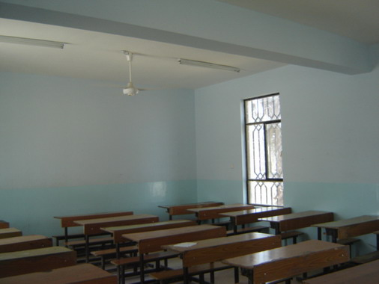

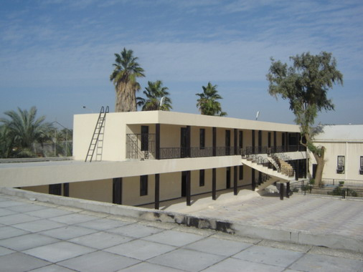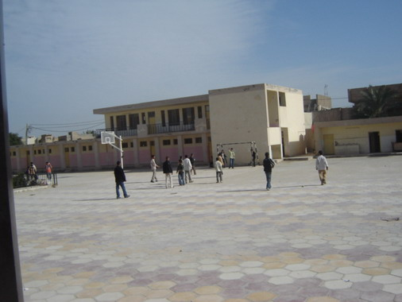

Al-Muthana Secondary School for Boys after rehabilitation (Samawa)

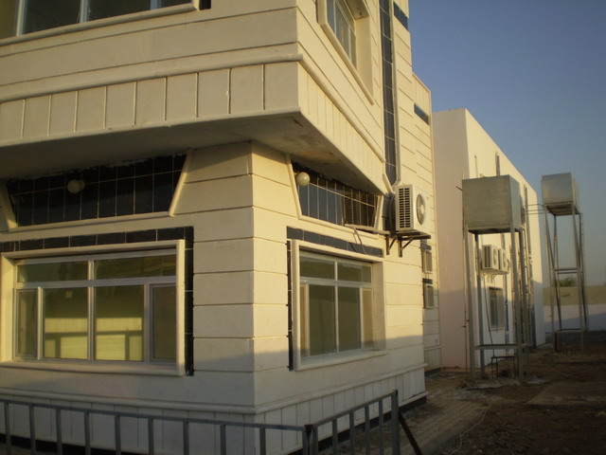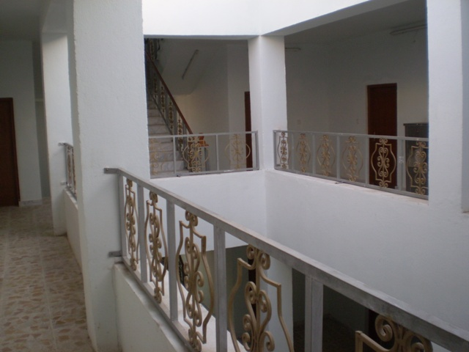

Deaf & Mute Institute in Nassiriyah after rehabilitation

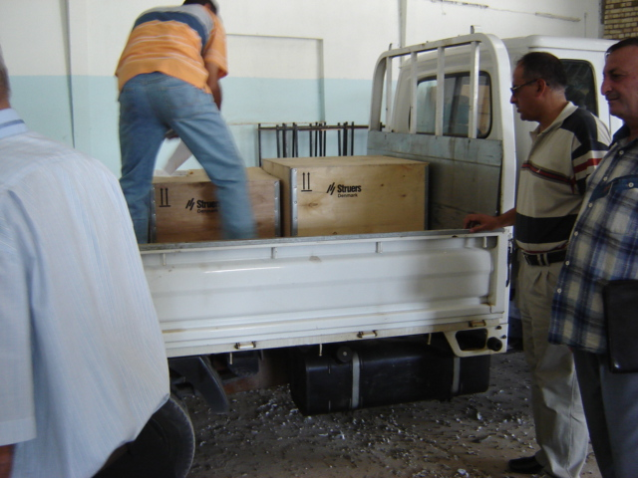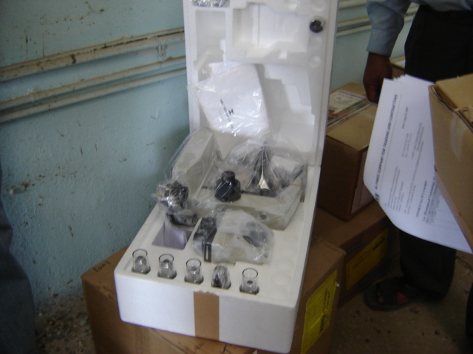

Delivery of the second shipment of tools & equipment for Zafaraniyah Institute of Technology in Baghdad

