JOINT PROGRAMME
ON ENVIRONMENTAL MAINSTREAMING AND
ADAPTATION TO CLIMATE CHANGE IN MOZAMBIQUE
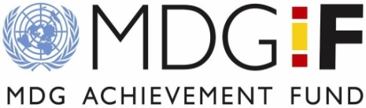

CLIMATE CHANGE IMPACTS AND COPING STRATEGIES IN CHICUALACUALA DISTRICT,
GAZA PROVINCE, MOZAMBIQUE

Final Report Draft 1



Author: Ataide Sacramento

Maputo, 8th November 2009
Table of contents
List of Tables iii
List of Figures iv
List of Annexes iv
Acronyms v
Acronyms v
Executive summary vi
1. Introduction 8
2. Background of the research area 9
2.1 Geographic information 9
2.2 Livelihoods 9
2.3 Coping Mechanisms base line Information 10
3. Methodology 12
4. General Climate information 15
4.1 Scientific observations of Climate variability and change in Mozambique 18
4.1.1 Temperature 18
4.1.2 Precipitation 19
4.2 GCM Projections of Future Climate for Mozambique 21
4.2.1 Temperature 21
4.2.2 Precipitation 22
5 Current climate change vulnerability in Chicualacuala 23
5.1 Exposure to climate Hazards 23
5.1.1 Local perception of the climate variability 23
5.2 Sensitivity to climate hazards 25
5.2.1 Current Impacts on livelihood resources in Chicualacuala district 28
5.3 Implications of projected climate change for rural livelihoods in Chicualacuala district 31
5.3.1 Natural Resources 31
5.3.2 Agriculture (Livestock rearing and crop production) 32
5.3.3 People 33
5.4 Adaptive capacity 34
5.4.1 Coping strategy in similar areas (arid and semi-arid) 34
5.4.2 Cross- impacts analyses and underlying drivers of vulnerability in Chicualacuala 35
5.4.3 Current coping strategies 37
5.4.4 Suggested adaptation activities for current and future climate change impacts 39
5.4.5 Enabling conditions and constraints to implementing suggested Strategies 41
6 Conclusions and Recommendation 44
6.1 Conclusions 44
6.2 Recommendations 45
7 References 45

List of Tables
Table 1Climate Change Vulnerability Framework 13
Table 2 Summary Descriptions of Tools used in the Field Work 15
Table 3 Main climate hazards mentioned by the communities that are affecting their livelihoods 24
Table 4 Main livelihood resources used by communities in Chicualacuala district 27
Table 5 Current Strategies to Cope with the Main Hazards 37
Table 6 Alternative coping strategies 38
Table 7 Enabling conditions and constraints to implement strategies in Chicualacuala district 42

List of Figures
Figure 1 Example of rain water harvest systems 11
Figure 2 Consultations with communities groups (left), and part of the team analyzing collected data in a borrowed room by communitarian radio at Eduardo Mondlane Village (right). 14
Figure 3 Number of stations in Mozambique, left - 1975 and right – 2008 (Source: INAM) 17
Figure 4: Not working meteorological station in Eduardo Mondlane Village 17
Figure 5 Annual mean maximum and minimum temperature (1951-2006) in south region of Mozambique 19
Figure 6: Annual temperature deviation in the South of Mozambique 19
Figure 7 Seasonal variation of monthly mean rainfall in Mozambique (left), annual observed rainfall in the southern region (right) 20
Figure 8 Updated rainfall deviations (1960-2008) in the southern region of Mozambique 21
Figure 9: Seasonal Calendar 23
Figure 10 Water scarcity is a major problem in Chicualacuala district 23
Figure 11 Dry river Nuanetzi 24
Figure 12 Example of crops cultivated in Chicualacuala district (Ndombe community) 26
Figure 13 Example of livestock available in Chicualacuala district 26
Figure 14 Example of coping strategies: small business and selling of charcoal 30

List of Annexes
Annex 1 Seasonal Calendar Field Guide 47
Annex 2 Vulnerability Matrix Field Guide 47

Acronyms
CRiSTAL – Community-based Risk Screening Tool – Adaptation and Livelihoods
CVCA – Climate Vulnerability and Capacity Analysis
FAO – Food and Agriculture Organization
GCM – General Circulation Model
INAM – National Institute of Meteorology
INGC – National Institute of Disaster Management
MICOA – Ministry for Coordination of Environmental Affairs
MINAG –Ministry of Agriculture
NGO – Non Governmental Organization
NRM – Natural Resources Management
RWH - Rain Water Harvesting
UNEP – United Nations Environmental Program
UNHABITAT – United Nations Human Settlement
UNIDO – United Nation Industry and Development Organization
UNJP – United Nations Joint program
WFP – World food Program

Executive summary

Located on the east coast of Africa, Mozambique is situated in an area with a natural propensity to extreme weather events. The country is faced by a number of climate-related hazards, predominantly droughts, floods and cyclones, with more frequency and intensive in the recent past (Oxfam, 2008). The impacts and losses caused by these events are high because the high poverty rate, lack of meteorological services to provide weather forecast, weak institutions with capacity to prepare, respond and recover from these natural occurrences, among others reasons that making the populations in Mozambique very vulnerable to the climate-related events.

This study intend to document climate-related hazards, impacts on small scale farmers, livelihood systems and identify adaptation options and/or coping strategies undergoing in Chicualacuala District essentially in communities of Administrative Post of Eduardo Mondlane (Dingue and Mahatlane) and Administrative Post of Mapai (Madulo, Ndombe and Muzamane/Chissapa).
Evidence suggests that the negative impacts of climate change are greater and is expected to grow more rapidly in the developing countries like Mozambique. The impact of climate change in Chicualacuala district is a reality, in terms of observed reductions and uneven rainfall temporal and spatial distribution, increasing frequency and intensity of droughts, occasional flooding, increasing temperatures, desertification and strong winds causing soil erosion and high evaporation. This is already impacting on the viability of community livelihoods strategies in the district through reduced water availability for crop production which is mainly rain-fed, for livestock watering, as well as for domestic use. Other impacts include reduced availability and quality of pasture for livestock and a general increase in ecosystem degradation leading to reduced forest products and other ecosystem goods and services.
In general climate-related impact is having increasingly adverse effects on all sectors of activities in Chicualacuala district, including crop production, livestock keeping, food security, access to clean and safe water, availability of forest products, education and on health. This coupled with underlying causes of vulnerability (such as a combination of social, economic and environmental factors, inadequate resources, technology and infrastructure, as well as weak representation of government institutions and civil society in Chicualacuala. However the communities in the district recognize and understand the importance of changing and adapting their livelihoods to changing environmental conditions and has been doing so for centuries through technologies embedded into traditional social structures and resource management systems.

Their ability to adapt is constrained by many factors, including increasing scarcity in key resources, limited access to information (weather forecast, climate change, market, pest and disease outbreak information); limited education, skills and access to financial resources and markets required to diversify their livelihood activities; and social and gender inequalities and marginalization, which reduce the voice and adaptive capacity of the most vulnerable. To enhance the adaptive capacity of these communities will require community-based and community-led interventions, but will also require tailored support from all stakeholders. To effectively do this, the district must integrate climate change issues into mainstream development planning (the UNJP is doing this through support in the elaboration of the PEDD).

Introduction
The Joint Programme on Environmental Mainstreaming and Adaptation to Climate Change in Mozambique (UNJP) aims to support the Government of Mozambique’s efforts towards sustainable development through the implementation of two components: Environmental Mainstreaming and Adaptation to Climate Change.

The Environmental Mainstreaming component composes of activities aiming at the sensitization and empowerment of government, civil society, communities and other stakeholders on environmental and climate change issues, strengthening government capacity to implement environmental policies, and mainstreaming climate proofing methodology into government development plans at national, provincial and district levels.

The second component, dealing with Adaptation to Climate Change, focuses on the building of resilience to climate change in selected communities in Chicualacuala district. This is done through the enhancement of community climate change coping mechanisms (in the areas of conservation agriculture, agro-forestry, forest resource management and water resources management) and the diversification of community livelihood options.

The implementation of the Joint Programme involves six UN Agencies, namely FAO, UNEP, UNHABITAT, UNIDO, UNDP, and WFP. The main government partners are: the Ministry for Coordination of Environmental Affairs (MICOA), Ministry of Agriculture (MINAG), National Disaster Management Institute (INGC), National Meteorology Institute (INAM), and the Governments of the Gaza Province and Chicualacuala District.

The purpose of this assessment is to apply the CRISTAL methodology in the Joint Programme’s project site (Chicualacuala District) in order to identify vulnerabilities of the visited communities (Dingue, Mahatlane, Madulo, Ndombe and Muzamane/Chissapa) to impacts of climate change and to understand their current coping strategies, the resources important to coping and the constraints to coping. The results of this exercise will contribute to strengthening the Government’s capacity to mainstream adequate responses to the impacts of climate change in their development plans. Policy recommendations derived from the appraisal will directly contribute to second component of the Joint Programme in the elaboration of district development plans. For the purpose of this appraisal, community-level vulnerability is understood as a function of exposure to (climate and non-climate) hazards, sensitivity to hazards, and adaptive capacity. Information on vulnerability is disaggregated according to location and gender for a better understanding of who exactly in these communities is vulnerable to what, and get a sense of how livelihood stresses are being observed and experienced by different social groups. A special focus is given to the underlying drivers of vulnerability. The implications of future climate change on the three pillars of subsistence farmer livelihoods (agriculture, natural resources and people) is also assessed.

Background of the research area

Geographic information
Chicualacuala district is located in the north part of Gaza province, south of Mozambique. The district borders in the south Mabalane and Massingire districts, in the east the district of Chigubo, in the north the district of Massangena and in the west the Republic of Zimbabwe and South Africa. The district covers an area of 18.243 km², about 24% of the total province area; it has a population of 39.358 inhabitants (55.7% are women), accounting for 3% of the total population of the province. The rural population is dispersed (2.1 inhabitants per km²) and lives in nine localities spread over the three main Administrative Posts, namely Eduardo Mondlane, Mapai and Pafúri (UNJP, 2008)

Chicualacuala lies in an agro-ecological region characterized by poor to moderate soil fertility and tropical arid and semi-arid climate conditions. Annual rainfall is less than 500 mm, and comes erratically between November and February. The relative air moistness is 60-65%. The potential evapotranspiration of reference normally is superior to 1500 mm and the annual average temperatures are superior to 24ºC. This aggravates the situation of great irregularity of the precipitation throughout the rainy station and increases the occurrence of frequent dry periods during the growth of crops (Ministério da Administração Estatal, 2005).

The main hydrological resources are the Limpopo basin and the rivers Nuanetzi, Chefu, Munene and Singuedzi (Ministério da Administração Estatal, 2005).

Livelihoods
The climatic dry conditions makes that Chicualacuala district is considered as one of the poorest in the south of Mozambique, with about 90 % of its population living in poverty, and not being able to meet their basic food and non-food needs. The majority of the population in the district relies on natural resources for their subsistence (Ministério da Administração Estatal, 2005).

The district is the geographical entry point of the Limpopo Basin into Mozambique. The Limpopo River has 4 effluents: the Munene, Nuanetzi, Chefu and Singuedzi rivers. The flow rates vary considerably during the year and the basin area experiences increasingly frequent and severe climate related disasters in the form of droughts and occasional floods, which have serious negative consequences on the livelihoods of the people living there.

The main crops in the district are maize, beans (cow peas, jugo and manteiga), millet, sorghum, sweet potato, groundnuts, melons and cassava, tomato, kale, onions, garlic, chilli, peppers and cucumber. The agro-ecological conditions of the region indicate several constraints for agriculture, with most of the area classified for pasture and forest, and small patches for agriculture with low productivity. The suitable areas for agriculture are situated at the eastern boundaries, which may receive some rains during the winter. Along the river there are 300ha of potentially suitable land for irrigated crop production, yet to be properly exploited rainwater harvesting techniques and investments in efficient irrigation systems will be required.

Livestock keepers hold small to medium herds of cattle, about 5 to 300 herds per family. The total number of cattle in the district is about 28,006 bovines from the 2008 census. Traditional practices encourage keeping large herds of livestock as a sign of wealth and power. Other livestock include pigs and goats though in smaller numbers than cattle. Traditional practices encourage keeping large herds of livestock as a sign of wealth and power. About 20% of the families consider selling few goats and 17% of those that are considered to be richer because of the number of heads they own and the use of animal traction, but they will consider selling cattle as well.

The rain-fed food crop productions are very low, unpredictable and subjected to the variation of the weather. Firewood and charcoal are the main non-agricultural income generating activity, during the critical period the communities rely on a range of indigenous plants and tree fruits (e.g. roots and fruits of Boscia albitrunca - Chikutso, fruits of Strychnos sp. – massala, macuacua, etc.) as supplementary food sources.

Coping Mechanisms base line Information

Adaptive capacity of livelihood systems in Africa particularly in Mozambique is low due the low economic resources and technology, and vulnerability is high as a result of heavy reliance on rain-fed agriculture, frequent droughts and floods, and poverty.

According to base line studies done by the UNJP (FAO, 2009; PMA, 2009), 94% of the interviewed households were affected by drought or irregularity of the rainfall and others affirmed that they suffered through the increase in food prices . However, to minimize the effects, during the hungry times rural families drink/eat and/or sell, often processed, a wide range of products from non-cultivated plants including native tree products, small business and they part time jobs - work for food. Charcoal production has increased sharply in the last few years as a result of drier than usual conditions.

FAO base line studies indicate that there is no commercialization of products from agriculture as the yields are not sufficient to feed the households for more than 4 months after the harvesting. Millet and sorghum were more widely grown than maize before 1980 while in recent years this pattern has changed; despite the fact that farms know maize is not drought tolerant. Cow peas, groundnuts and cassava have always been among the most important crops for Ndombe farmers.

A further complicating factor is the lack of transport system from communities to the nearest villages which makes the market access very difficult. However, as an example of coping strategies under drought conditions, “fuma” from the surrounding communities is sold in relatively large quantities in Eduardo Mondlane market, mainly on Thursdays, market day, which is the day that the passenger train from Maputo and Zimbabwe arrives. Sale of this product helps households pay their children’s school fees and others expenses.

According to information given in the FAO base line study, the community members have an intricate knowledge of forest resources and exploit the forests as an integral part of a coping strategy against drought and hunger; were identified 22 forest species used for many purposes, where they say that men explore more than women, such as men cut grass for house thatching, poles and ropes for construction, where some of these materials are used in their own houses and others are sold. Simultaneously with exploitation of products from forest, other important component of coping strategies under drought conditions in the rural communities in Chicualacuala district is livestock keeping. Sale of animals has increased greatly as part of household coping strategies since 2000 (do you have proof of this?).
The UNJP base line study on rain water harvesing, mentioned that the local people possess a profound knowledge on how to cope with drought by applying traditional Rain Water Harvesting (RWH) strategies (Figure1).

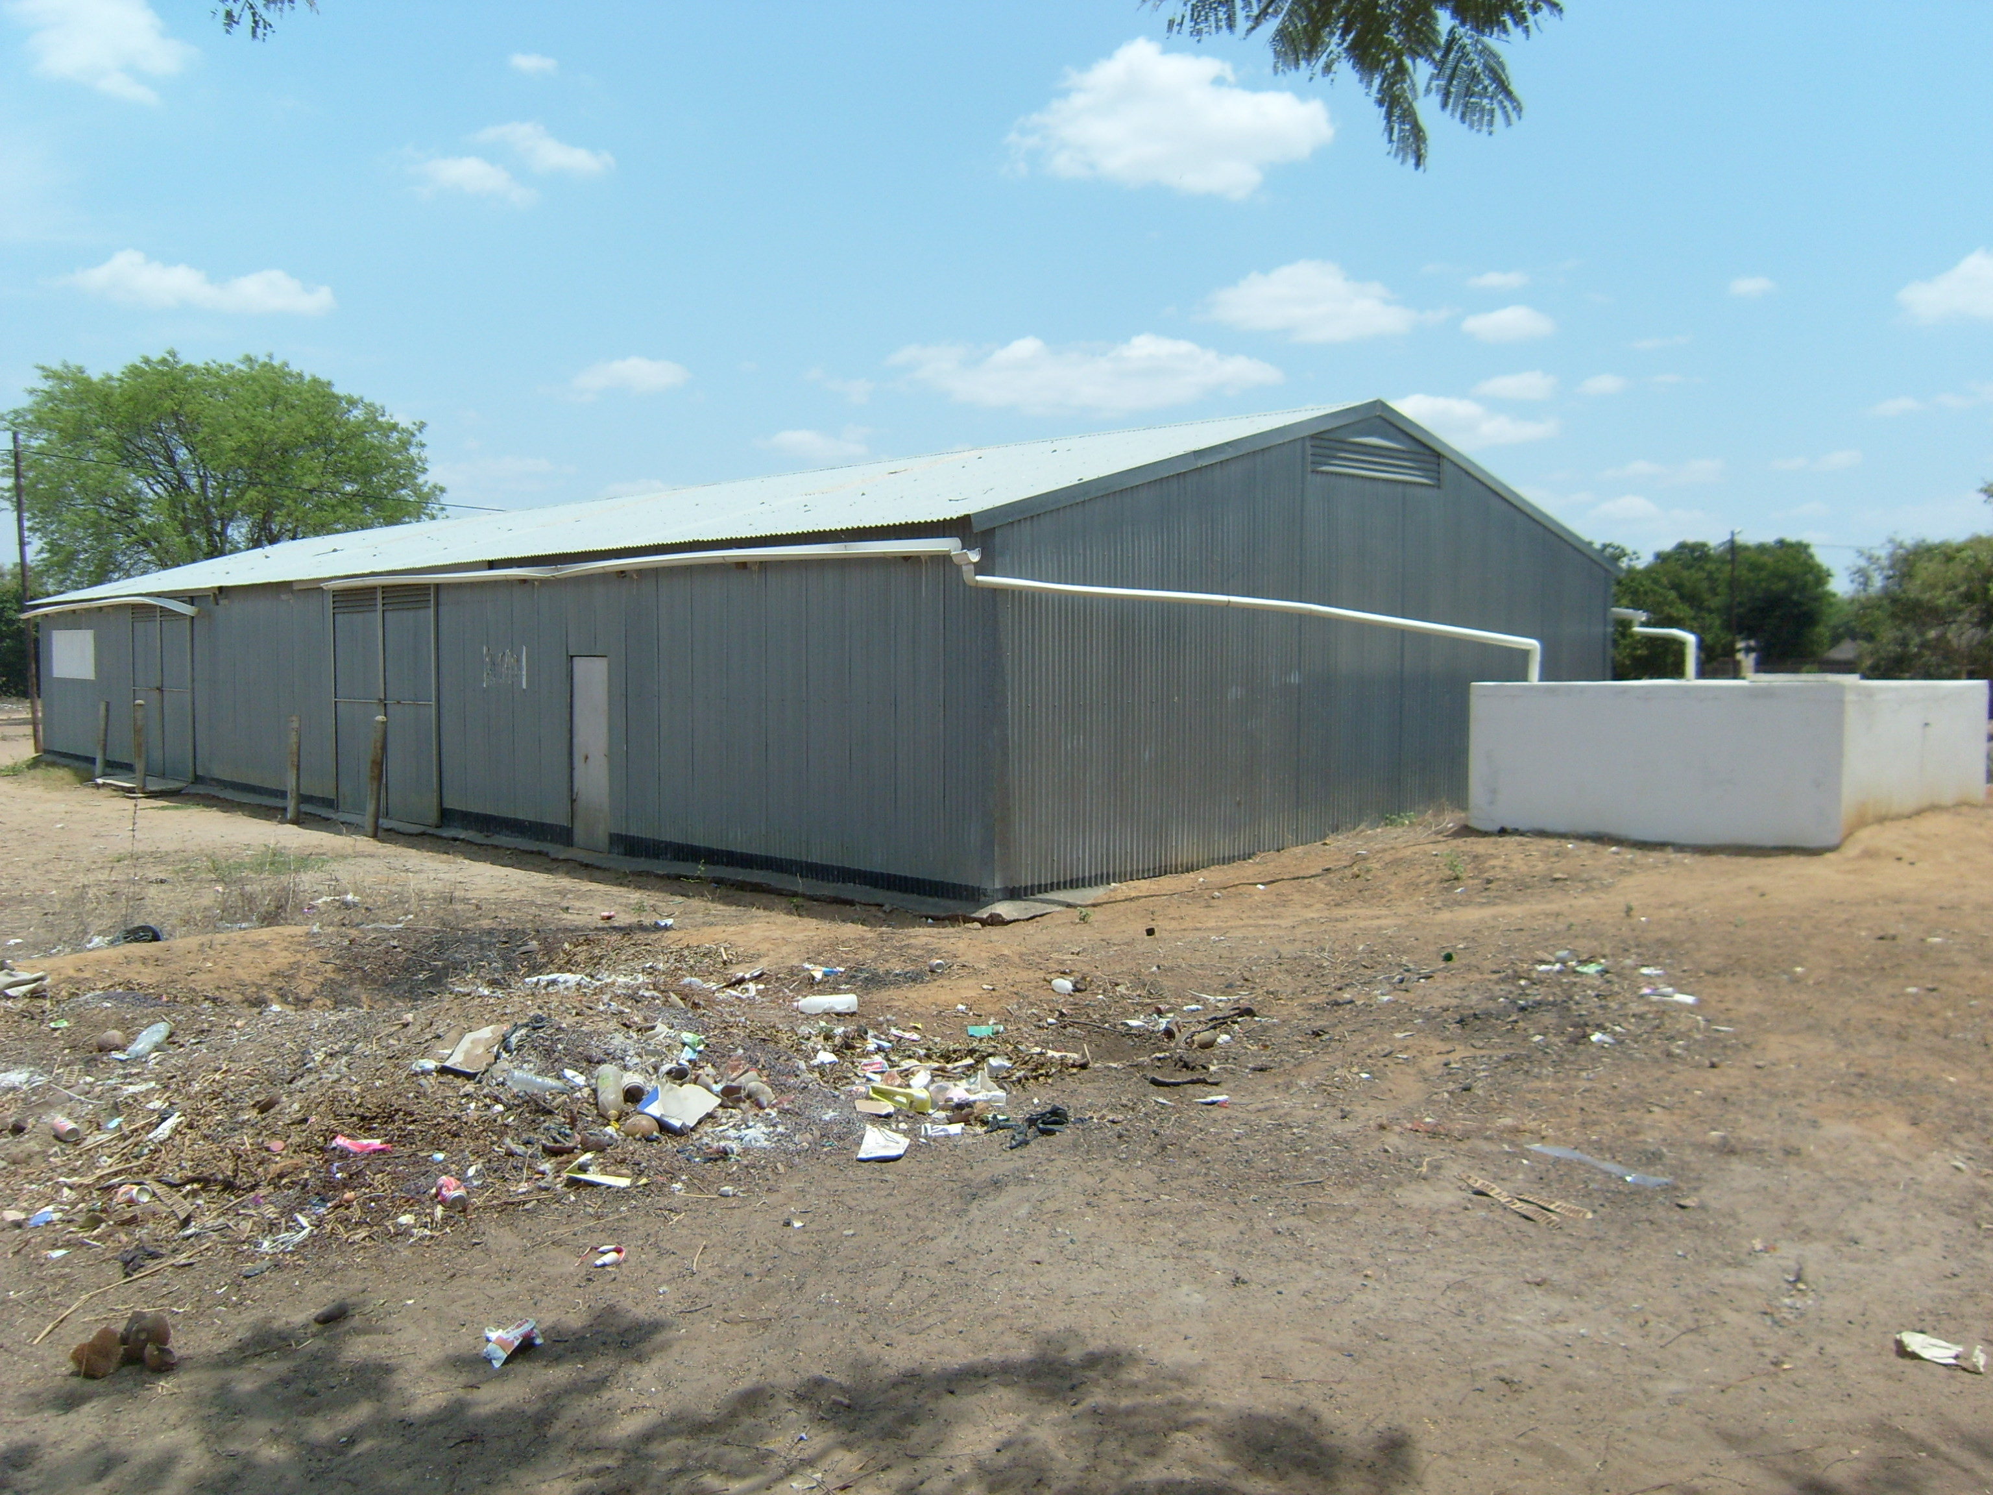
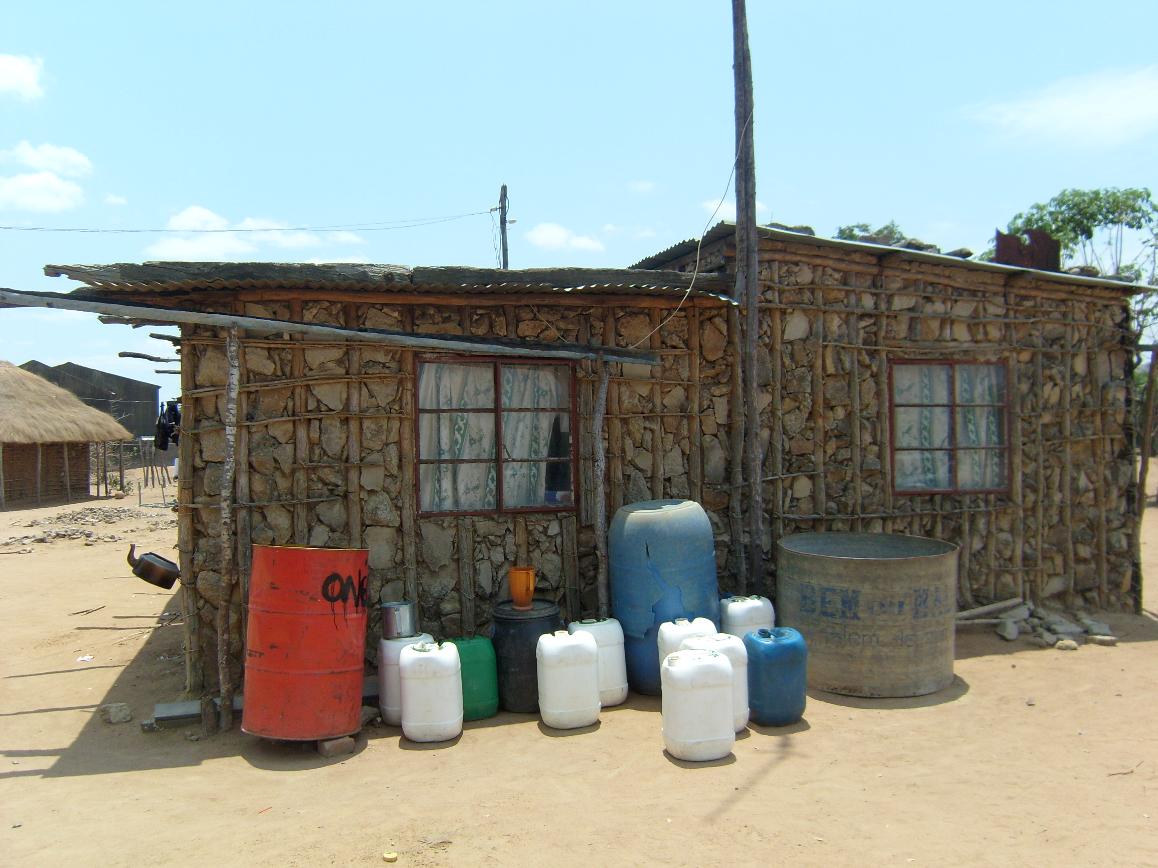

Figure 1 Example of rain water harvest systems

However, considering to the significant decrease of rainfall actually registered (timescale??) these strategies are less and less applicable. In the specific zones (which?) the natural lagoons in low areas filled with water after the rains are mentioned as a longer term source of naturally stored water to be used for human consumption, agricultural purposes and for livestock.

The present study will provide a more detailed inventory of coping mechanisms to complement those that have already been identified in the base line studies mentioned above.

Methodology

Methods used in the present study are the same as used in the previous pilot study done in Mapai by UNDP where a UNEP national consultant formed part of the work team.

Climate-related vulnerability is assessed in terms of climate change exposure, sensitivity, and adaptive capacity. Exposure is defined by the magnitude, character and rate of climate change in the research area. Sensitivity to climate change is the degree to which a community is adversely or beneficially affected by climate-related stimuli. It largely depends on the main livelihood activities of the community (including its dependence on livestock and rain-fed agriculture), its key livelihood resources, and the impacts of climate hazards on these key resources. The adaptive capacity of a community is its ability to adjust to climate change, to moderate or cope with the impacts, and to take advantages of the opportunities. Key questions to assess climate-related vulnerability from the community are indicated in the framework presented in following Table 1.

Table 1Climate Change Vulnerability Framework
Exposure | Sensitivity | Adaptive Capacity
- Which climate-related hazards affect livelihoods?  - Changes in timing, frequency, and intensity of climate hazards?  - How do non-climate hazards interact with climate-related hazards?  3. What is the ‘science’ saying about recent climate trends? Projections?  - How does it compare to community observations? | 1. How sensitive are livelihood activities to climate change? Indicators of sensitivity include:  - Dependence on livestock  - Livestock type (are they resilient species?)  - Dependence on rain-fed agriculture  - Crop mix/types (are they resilient species?)  - Environmental conditions (type, level, rate of degradation)  2. Which livelihood resources are most affected by climate hazards? | 1. Experiences with risk management and coping  - What activities are currently undertaken to cope with climate hazards?  - Are these strategies effective and sustainable with future climate change?  2. Reactions to scenarios?  - Which activities could be undertaken to prepare for anticipated climate change impacts?  - Which resources are key?  3. Enabling conditions and barriers to adapting  - CVCA questions at local, district and zonal levels  - Determinants of adaptive capacity include: economic wealth, literacy rate, access to information, markets, technology, services, and formal and informal assistance, and institutional capacity
Disaggregated by gender
Reference

Methods used for data collection include a combination of:
• Consultations with community groups disaggregated by gender in mixed ages; as well as with key informants - governmental and nongovernmental organizations working in the district (Figure 2);
• Gathering of primary ‘indicator’ data (related to population, livelihoods, location, infrastructures and well-being);
• Review of observed climate data and national predictions; and
• Review of climate and livelihoods related documents including the baseline studies under the UNJP.

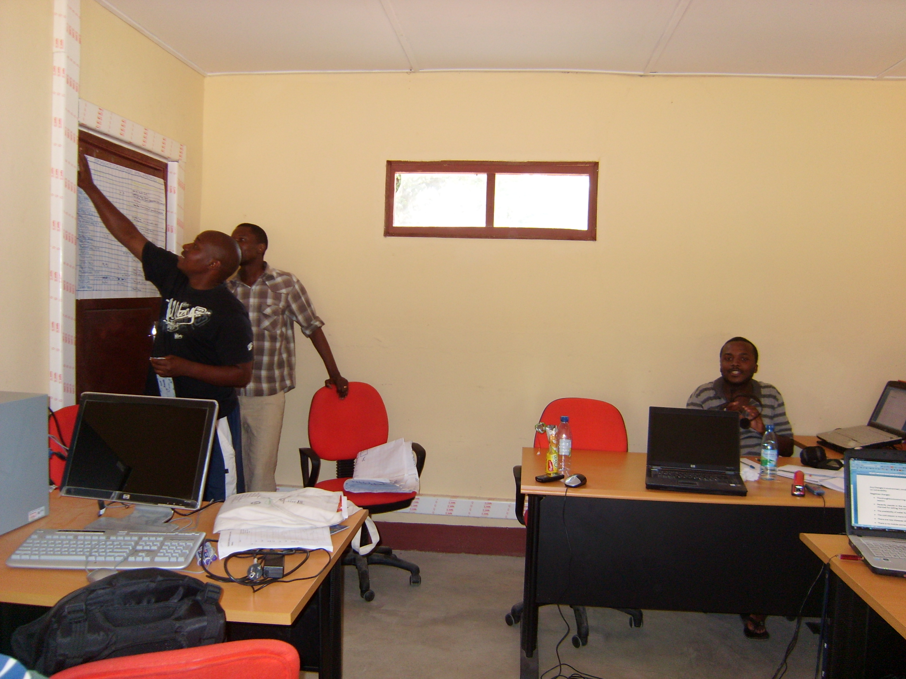
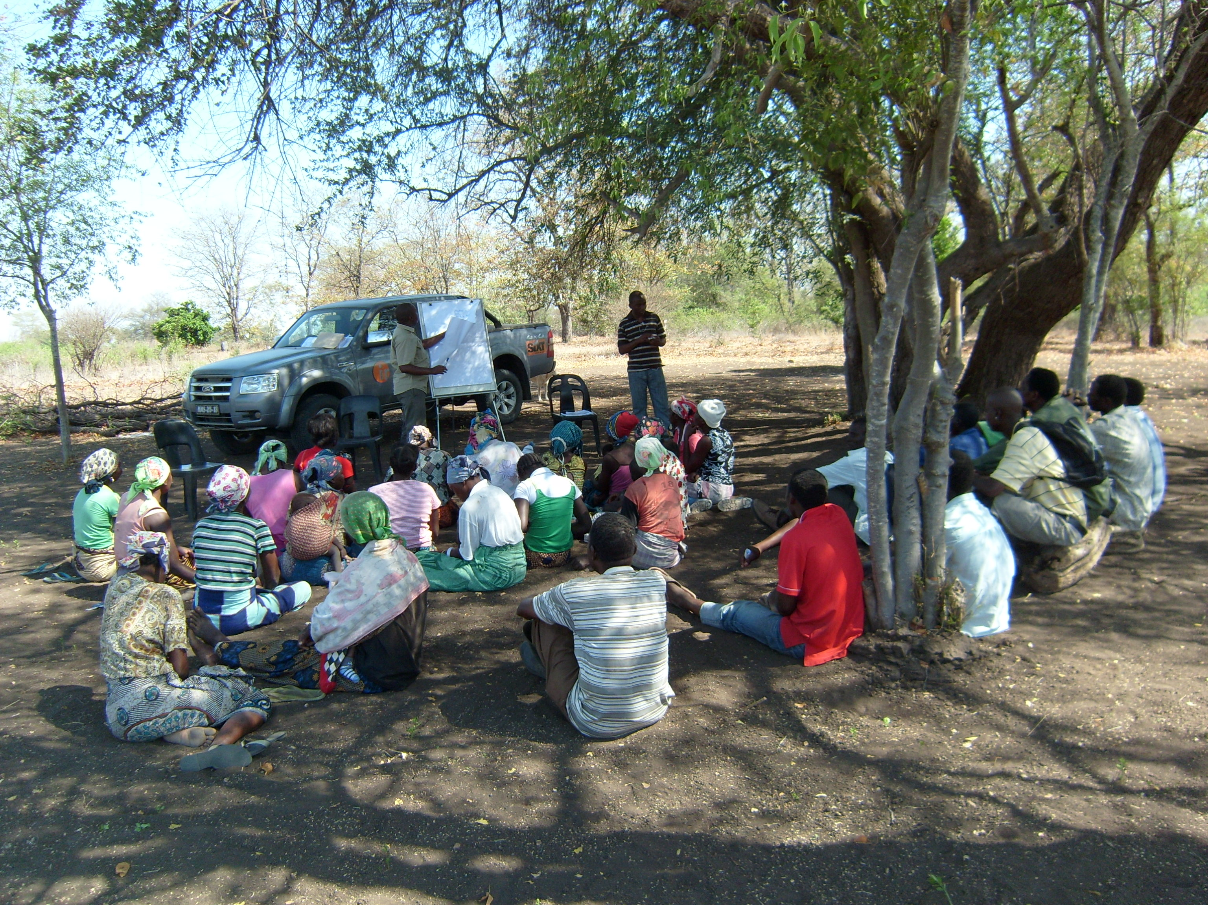

Figure 2 Consultations with communities groups (left), and part of the team analyzing collected data in a borrowed room by communitarian radio at Eduardo Mondlane Village (right).

As this study is the second part of the previous pilot study conducted in Mapai (16 de Junho community), the research involved the following stages:

a). 15 days of field work in Chicualacuala district (Eduardo Mondlane and Mapai administrative posts) for community consultations (from 09th to 24th October 2009). Research areas included two groups, one of women and other of men in mixed ages where discussed agriculture (crops and livestock production) as the main livelihood system. The tools used during the field work included: seasonal calendars, vulnerability matrices, and CRiSTAL Tool. Summary descriptions of these tools are provided in the annex. The field research team included staff from Chicualacuala District, FAO project, and UNEP national consultants. The reporting template used by research teams to enter the information collected during community consultations is included in the Annexes (Annex 1 and 2).

b). Analysis of collected data and writing of the assessment report and policy brief (2 weeks from October 26, 2009).
Tools used during the field work and analysis of collected data includes: Seasonal Calendar, vulnerability matrices, CRiSTAL, as well as the CVCA. The seasonal calendar and vulnerability matrix are community-based participatory tools, which were used with two community groups (men and women in a mixed age) in Eduardo Mondlane and Mapai. CRiSTAL is a computer-based tool, which was used by the research team to analyze the data collected from community consultations. The CVCA (including its guiding questions at household/individual, community/local government and national levels, as well as its field guides on community-based participatory tools) were used to develop the field methodology and consultation questions, and to analyze the collected field data. Descriptions of the tools used during the field work are provided in Table 2 below.

Table 2 Summary Descriptions of Tools used in the Field Work

Tool | Objectives | For more information
Seasonal Calendar | - To understand what is “normal” rainfall/temperature from the perspective of community members  - To examine trends in rainfall/temperature  - To brainstorm on future rainfall / temperature scenarios and potential responses  - To evaluate use of climate information for planning | See Annex 1
Vulnerability Matrix | - To determine the hazards that have the most serious impact on important livelihoods resources  - To determine which livelihoods resources are most vulnerable  - To discuss who has control over and access to livelihoods resources  - To identify coping strategies currently used to address the hazards identified, and explore new potential strategies | See Annex 2
CRiSTAL (Community Based Risk Screening Tool – Adaptation and Livelihoods) | - To better understand linkages between livelihoods, climate and project / proposed activities  - To identify which livelihood resources are most vulnerable to climate hazards, and which resources are important for adaptation  - To assist project planners and managers in making project / programme adjustments to improve its impact on community resilience to climate change | www.cristaltool.org
CVCA (Climate Vulnerability and Capacity Analysis) | - To analyze vulnerability to climate change and adaptive capacity at the community level, based on a framework of ‘enabling factors’ for community-based adaptation  - To combine community knowledge and scientific data to yield greater understanding about local impacts of climate change | http://www.careclimatechange.org/cvca
Ref

General Climate information

Mozambique lies on the southeast coast of Africa between 10°S and 27°S. It has a long coastline which faces the tropical and sub-tropical Indian Ocean and which experiences a predominantly maritime climate. The climate of this coastal region is largely determined by the offshore warm waters of the Agulhas current and the close proximity of tropical cyclones which pass mostly from the north to the south of the country. The mountainous region towards the northwest of the country, bordering Malawi, moderate the high temperatures usually found at these latitudes, whereas the deep wide valleys of the Zambezi and Limpopo rivers are regions of lower topography. The coastal regions are in the path of highly destructive tropical depressions and cyclones that occur during the wet season, and which are often associated with heavy rainfall events that may contribute a significant proportion of annual rainfall in a very short period (INGC, 2009).

Generally temperatures are warmer near the coast (and the warm offshore ocean current) and cooler inland at higher altitudes. The climate ranges from subtropical in the South to tropical in the North, but is mostly tropical, characterized by two seasons; a cool and dry season from May to September and a hot and humid season between October and April.

The rainfall distribution in the country follows an east-west gradient, with more abundant rainfall along the coast, where the annual average varies between 800 and 2000mm, reaching as high as 1500mm on the coastal areas of Beira and Quelimane. The inland high altitude areas in the north and central regions receive approximately 1000 mm, whereas the inland central and south areas receive about 600mm of rainfall. The south part of the Mozambique is generally drier, more so inland than towards the coast, with an average rainfall lower than 800mm, decreasing to as low as 300mm in Pafuri District, Gaza province (INGC, 2009).

In Mozambique there are serious problems regarding the number of climatologic stations and the regularity in data collection. INGC (2009) notes that the approximate station density is 1 station to 29, 000km², which is low density if we have to compare with South Africa (is approximately 1 station every 1,000 km²). Before 1975, National Institute of Meteorology (INAM) had sufficient number of stations, which could cover almost all districts in Mozambique, but after independence the civil war, animals and natural disasters (cyclones, floods) destroyed most of the stations (Figure 3). INAM is working to improve the number of stations, to cover all country, at least one station per district.

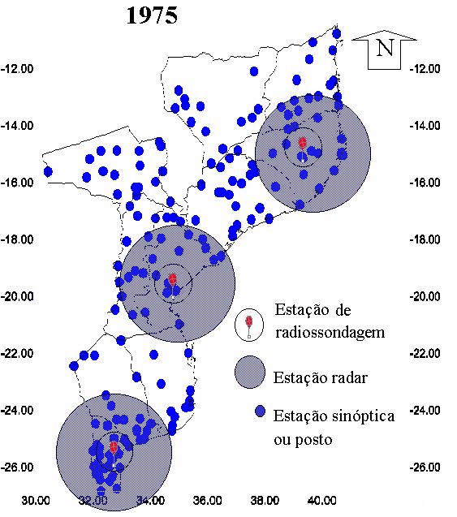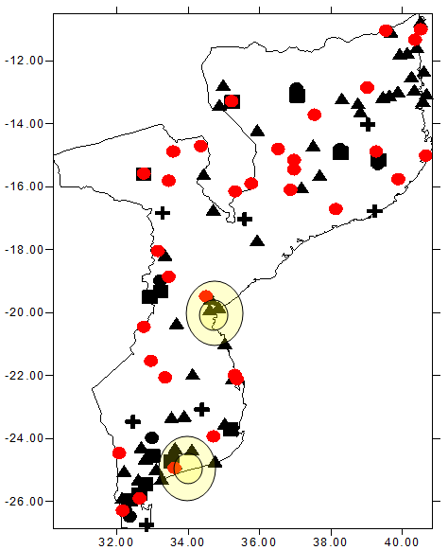
2008
Figure 3 Number of stations in Mozambique, left - 1975 and right – 2008 (Source: INAM)

LEGEND FOR 2008 TABLE

In Chicualacuala district there are Class 2 stations (Figure 4) not operational (Eduardo Mondlane, Mapai and Pafúri), the Eduardo Mondlane station was operational for 15 years, from September 1961 to December 1976 and is located at 22º05´ S and 31º41´, with altitude of 452 m, according with INAM the station will be reactivated under the UNJP. The stations in Mapai and Pafúri were operational from 1956-1976 (20 years) and 1951-1976 (25 years) respectively, and still in negotiation between INAM and UNJP the possibility to reactivate.

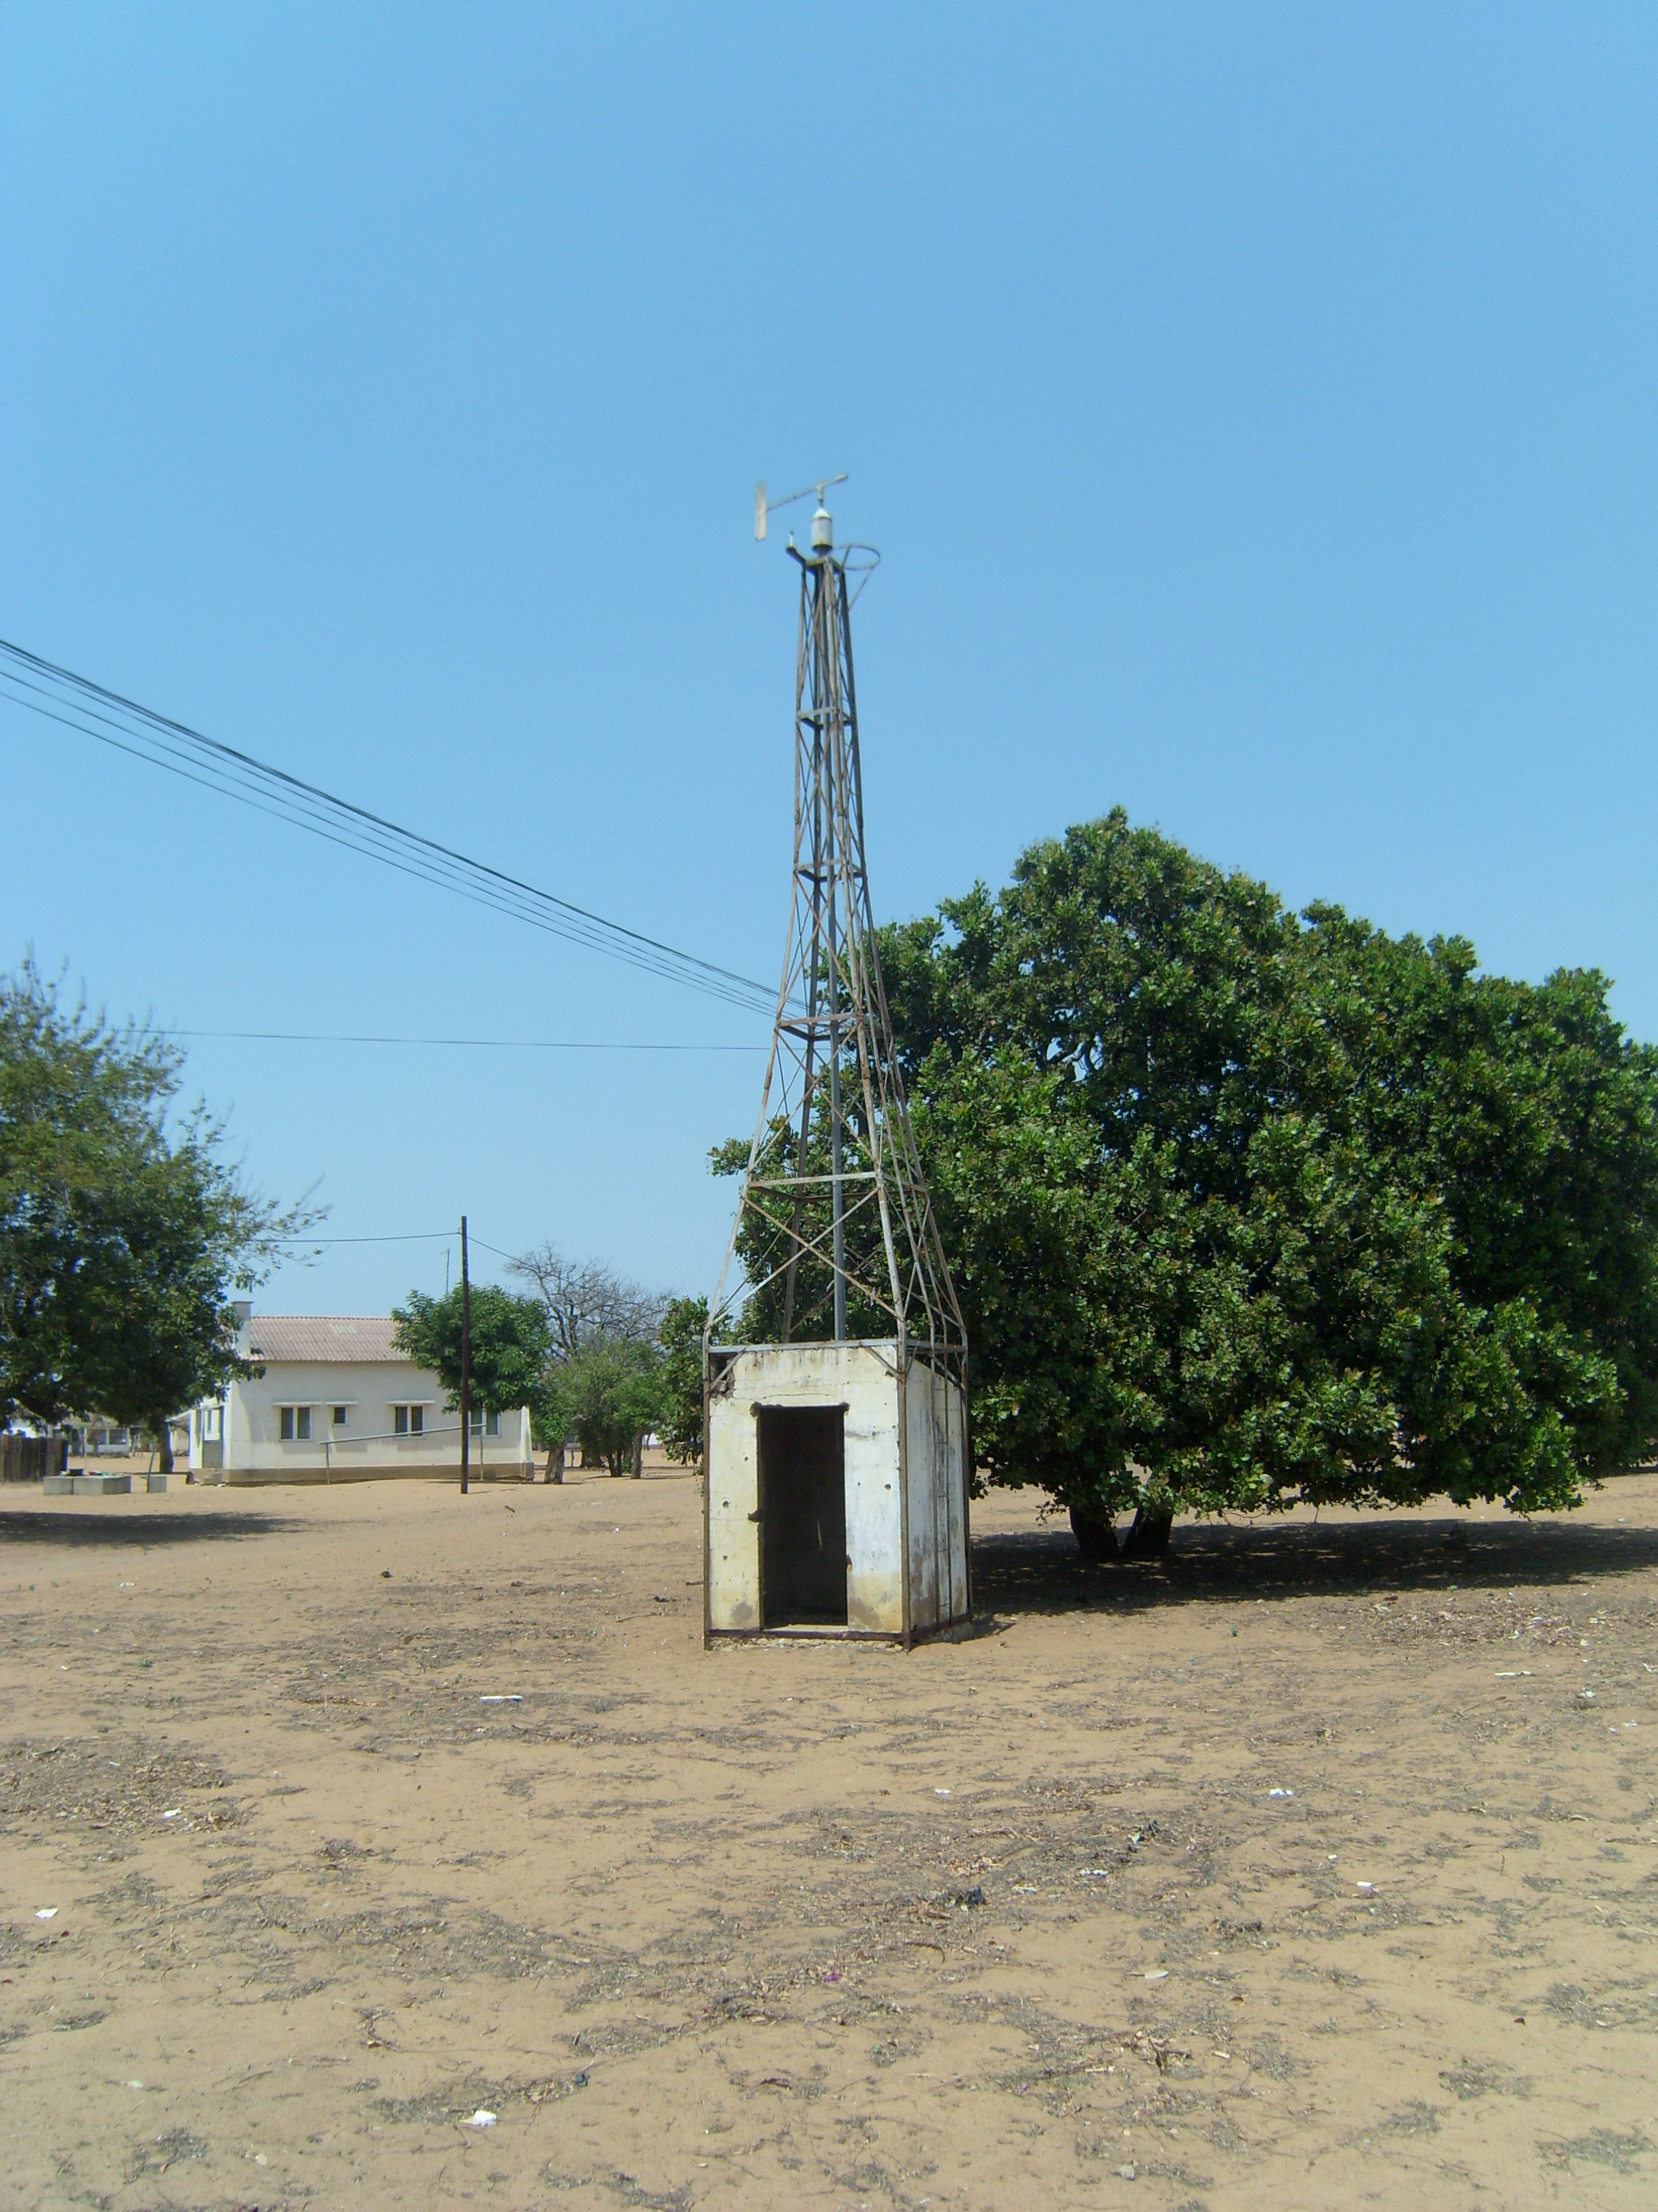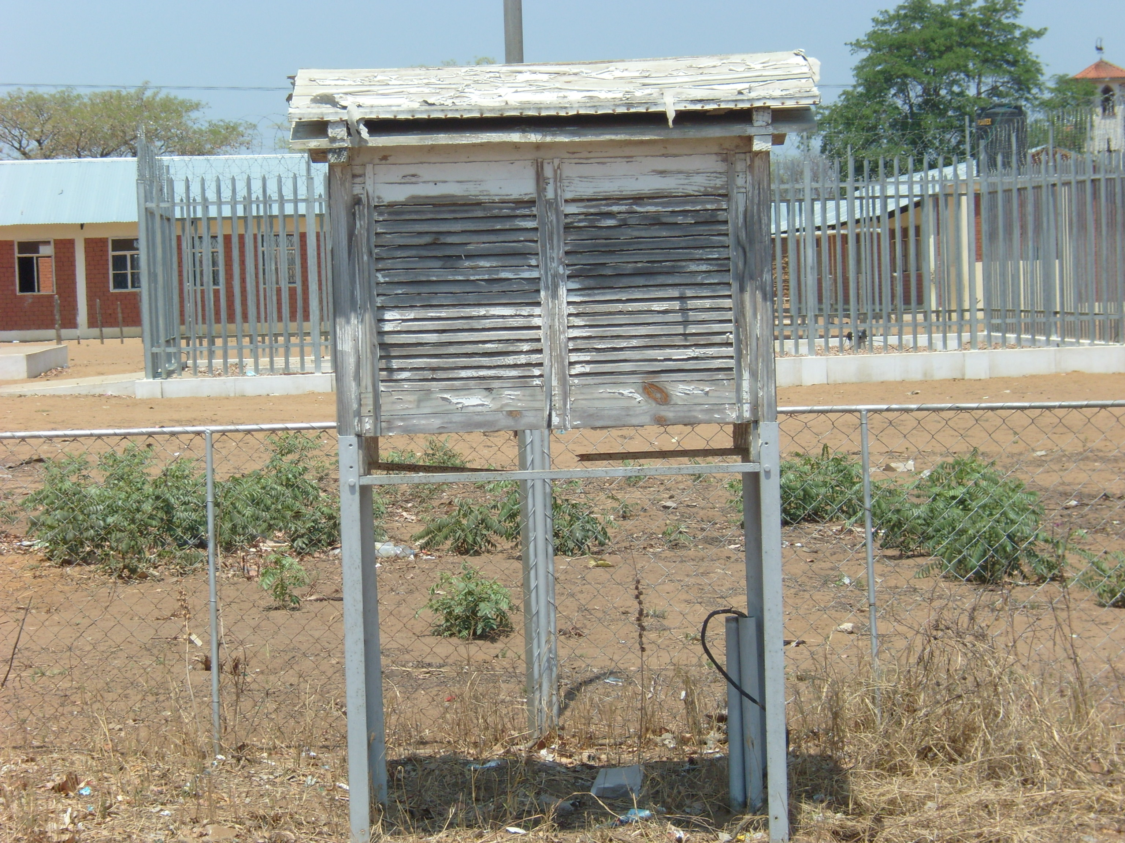
Figure 4: Not working meteorological station in Eduardo Mondlane Village

Scientific observations of Climate variability and change in Mozambique
Mozambique has historically been exposed to droughts and floods but recent decades have seen the frequency and severity of these climatic hazards increase. In addition there are changes in climate trends. Some areas are experiencing increased or decreased average precipitation; others a shift in rainfall patterns, with the rainy season starting later than it used to in places and changes in the extent of dry spells in others; and many places are experiencing increasing average and maximum temperatures. In addition, there are many places where we do not yet understand if and how the current climate is different from the past climate because there is limited weather station data (both spatially and temporally) and/or limited human capacity means that scientists have not yet analysed the data (Oxfam GB, 2008).

The climatic change leads to the increase of the frequency and intensity of the extreme events as tropical cyclone, La Niña phenomenon and floods, and on the other side El Niño phenomenon and droughts. As example, Mozambique was witness the occurrence of a sequence of floods (1977-1978, 1985, 1988, 1999-2000, 2001, 2006-2007, and 2007-2008) and droughts (1981-1984, 1991-1992, 1994-1995, 2002-2003 and 2005-2006).

Temperature
An analysis of temperatures in Mozambique indicate that annual means of both minimum and maximum temperatures from 1960 to 2006 shows significant changes in all regions, particularly from the early 1990’s. In the North the annual maximum average temperatures where often below 30°C before the 90’s and constantly above 30 °C after 1990. The Centre has recorded average temperatures around 31°C before 90’s; with sharp increase after this year. The south region has typical annual maximum average temperatures around 31°C with a slight increase over the period 1960-2006 (INGC, 2009).

The temperature is evaluated in terms of seasonal and inter-annual variability, the lower temperatures (winter) are observed between May-September and high temperatures (summer) is between October-April. In general country wide monthly minimum average temperatures range between 18 - 22°C in summer and 14-18°C in winter. Monthly maximum average temperatures are typically between 28-32 °C in summer and 24-28°C in winter; the highest maximum temperatures are registered in central and coastal areas, and annual mean minimum temperatures show noticeable increase in the northern and southern regions (INGC, 2009).

The increase in minimum temperature will lead to decrease on cold days. On his study McSweeney et al (2008) describe that the frequency of cold days and nights have decreased significantly since 1960 in all seasons except September, October and November (SON). The average number of ‘cold ‘days per year has decreased by 14 days (3.9%) between 1960 and 2003 and the average number of ‘cold’ nights per year has decreased by 27 days (7.4%).

Annual means of both minimum and maximum temperatures from 1960 to 2006 shows significant changes in all regions, particularly from the early 1990’s. The south region has typical annual maximum average temperatures around 31°C with a significant increase from early 80’s, and for typical annual minimum average temperatures is around 18,6°C with a significant decrease from early 70’s (Figure 5).

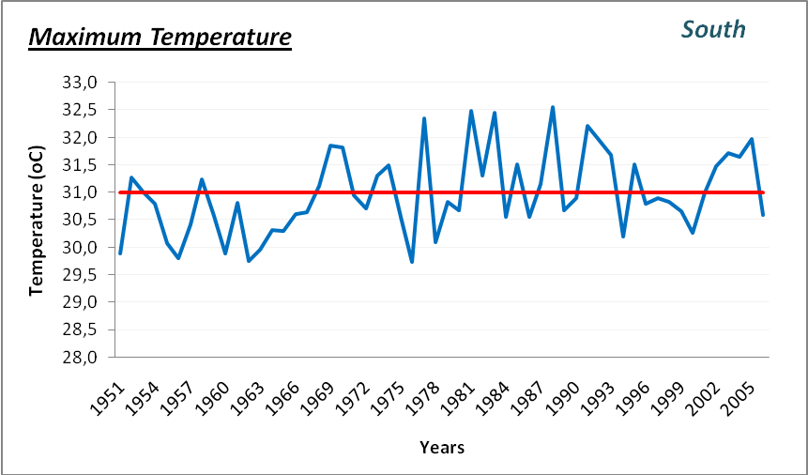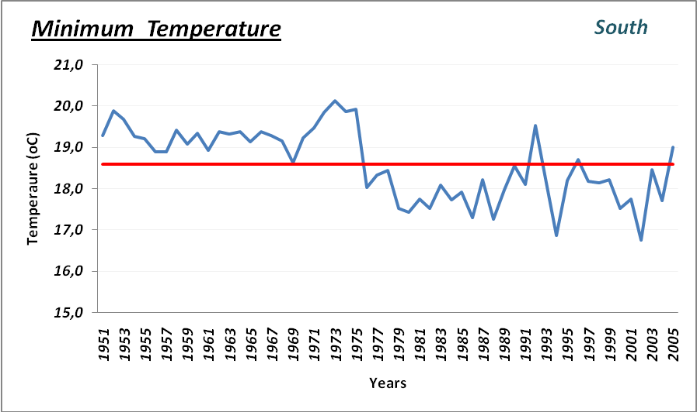
Figure 5 Annual mean maximum and minimum temperature (1951-2006) in south region of Mozambique
REF FOR FIG 5

The deviation of annual mean temperature in south region of Mozambique from 1961 to 2006 gives a strike indicator of change on climate on this region. The graphic in the Figure 6 shows the trend of increasing in the annual mean temperature from about 1985 which means that the frequency of the years with temperatures above the normal is increasing.

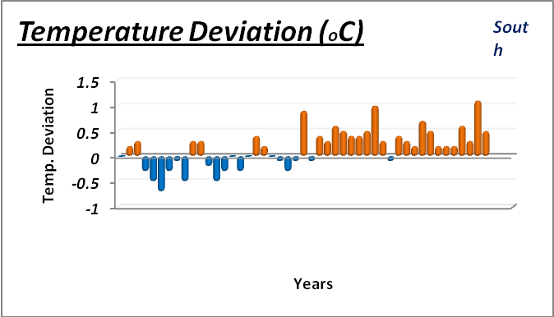
Figure 6: Annual temperature deviation in the South of Mozambique
Ref for fig 6

Precipitation

Most of the rainfall in Mozambique occur during the Southern Hemisphere summer, from October to April. Two seasons are usually distinguished early summer (October to December) and late summer season (January to March) (INGC, 2009). During the rainy season the highest values in amount of rainfall (Figure 7) occur in January, February and March, corresponding 46% of the total annual rainfall.

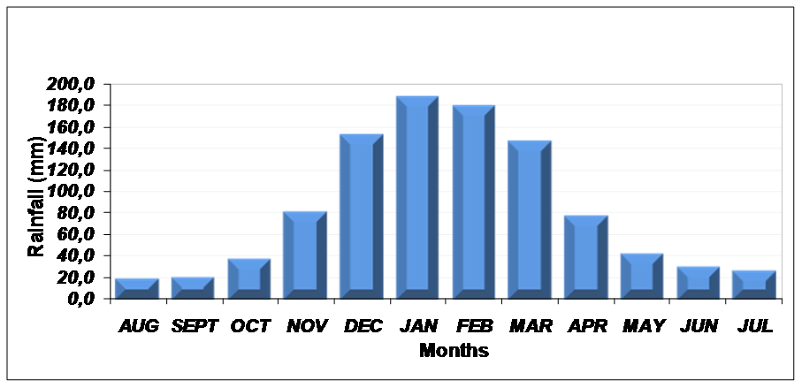
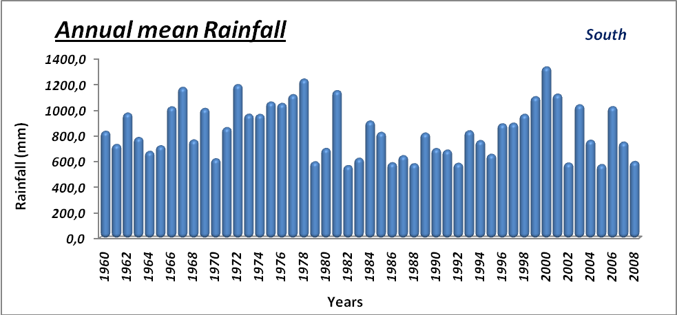
Mozambique

Figure 7 Seasonal variation of monthly mean rainfall in Mozambique (left), annual observed rainfall in the southern region (right)
Ref for fig 7

In north region typical values of monthly average rainfall are 20–200 mm in wet season and 5–30 mm in dry season. The central has approximately 30–200 mm for wet period and 20–40 mm in dry period. The south has the lowest recorded values of about 40–130 mm in wet season and 20–40 mm in the dry season. It is important to note that the dry season has relatively high rainfall values compared to the previous two regions due to the influence of active cold fronts in winter, which contribute to the rainfall in this region. The coastal region has significant rainfall of about 40–200 mm in wet season and 20–60 mm in dry season (INGC, 2009).

In the south region, an average rainfall of approximately 800mm and it is characterized by high inter-annual variability, with annual means of 400 mm (e.g. 1970) and well above 1000 mm (e.g. 1962, 1967, 1978, 1999, 2000, 2001) being recorded in this region (Figure 7). Gaza province has the highest spatial variability in south, receiving in average 800–1200mm of annual rainfall as recorded in Xai-Xai station, whereas the middle inland station of Chókwé receive about 400–800mm per year (INGC, 2009). The mean annual rainfall value for region of Pafuri in Chicualacuala district is below 400mm per year and has only two months of rain (Benessene, 2002).

Observed rainfall deviations from the climatologically average between 1960 and 2008 in the south region (Figure 8) indicates weather extreme events, such as floods and droughts. The graph shows a high frequency of droughts with extensive drought periods during the early 80’s and 90’s, while the high magnitude floods are observed around 2000.

In northern region the magnitude of floods and droughts is small compared with central, south and coastal regions. The central region is characterized by high frequency of floods, Coastal rainfall deviations characterized by the similar signature of the south region, may be due to high data density in the South compared with the Centre and North.

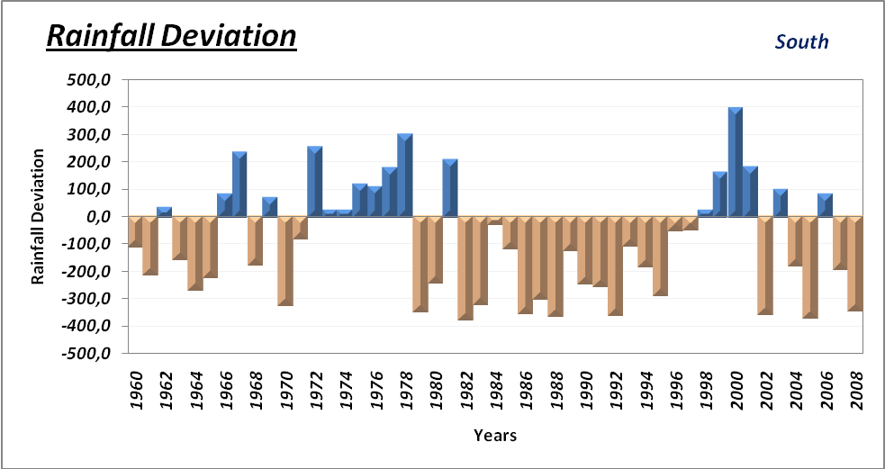
Figure 8 Updated rainfall deviations (1960-2008) in the southern region of Mozambique
Ref for fig 8

GCM Projections of Future Climate for Mozambique

Temperature
According to McSweeney et al (2008), the mean annual temperature is projected to increase by 1.0 to 2.8°C by the 2060s, and 1.4 to 4.6°C by the 2090s. Under a single emissions scenario (explain what you mean by this in a footnote) , the projected changes from different models span a range of up to 1.8°C. The projected rate of warming is more rapid in the interior regions of Mozambique than those areas closer to the coast and all projections indicate substantial increases in the frequency of days and nights that are considered ‘hot’ in current climate. All projections indicate decreases in the frequency of days and nights that are considered ‘cold’ in current climate.

Annual, projections indicate that ‘hot’ days will occur on 17-35% of days by the 2060s, and 20-53% of days by the 2090s. Days considered ‘hot’ by current climate standards are projected to occur in 26-76% of days by the 2090s. Nights that are considered ‘hot’ for the annual climate of 1970-99 are projected to increase more quickly that hot days, occurring on 25-45% of nights by the 2060s and 29-69% of nights by the 2090s. Nights that are considered hot for each season by 1970-99 standards are projected to increase most rapidly in DJF, occurring on 47-97% of nights in every season by the 2090s.

All projections indicate decreases in the frequency of days and nights that are considered ‘cold’ in current climate. These events are expected to become exceedingly rare, and do not occur at all under the highest emissions scenario (A2) by the 2090s (McSweeney et al, 2008).

Precipitation
Projections of mean rainfall do not indicate substantial changes in annual rainfall. The range of projections from different models is large and straddles both negative and positive changes (-15 to +20mm per month, or -15% to +34%). Seasonally, the projections show a more coherent picture, with the projections tending towards decreases in dry season rainfall occurring during September to November, offset partially by increases in wet season rainfall occurring in December, January and February.

Projected rainfall changes in the months of June to August range from -54 to +19% with ensemble median changes of -11 to -24% and during September to November, -48 to +26% with ensemble median values -10 to -12%. Projected changes in the December to February rainfall range from -9 to +25% with ensemble median values of +1 to +8%. The increases in December to February rainfall are largest in the north of Mozambique (McSweeney et al, 2008).

In overall, the models consistently project increases in the proportion of rainfall that falls in heavy events in the annual average under the higher emissions scenarios, of up to 15% by the 2090s. The proportion of total rainfall that falls in heavy events is projected to increase in during December to February in projections from all models and all scenarios, by up to 18%. Models are also broadly consistent in indicating increases in March to May rainfall, but decreases in June to August rainfall and September to November rainfall. The models consistently project increases in 1- and 5-day rainfall maxima by the 2090s under the higher emissions scenarios of up to 20mm in 1-day events, and 34mm in 5-day events. These also generally increase in the December to February rainfall and March to May rainfall, but decrease in June to August rainfall and September to November (McSweeney et al, 2008).

The models consistently project increases in 1 and 5 day rainfall maxima by the 2090s under the higher emissions scenarios of up to 20mm in 1 day events, and 34mm in 5 day events. These also generally increase in the December to February rainfall and March to May rainfall, but decrease in June to August rainfall and September to November (McSweeney et al, 2008).

Current climate change vulnerability in Chicualacuala

Exposure to climate Hazards

Climate change exposure is defined by the magnitude, character and rate of climate change in a certain geographic area. Due to the lack of meteorological services, long-term and continuous meteorological data records in most of the developing countries and due to the lack of scientific climate change projections at the local level (projections are usually only available at the regional or national scale and there are often very high uncertainties when downscaling projections at smaller scales), scientific information is often insufficient to analyze exposure of local communities to the climate hazards and change. This scientific information needs to be complemented by an analysis of local-level climate perceptions, through community consultations and other local actors who are dealing direct and/or indirectly with climate change issues. (okay you have defined what you mean bu climate change hazard/exposure but what have you got to say about climate hazards in Chivcualacuala?).

Local perception of the climate variability
Communities and key informants from government in Chicualacuala District have been observed changes on climate scenarios, such as a reduction in rainfall and shortening of the rainy seasons during the last years. In long times ago, rains usually initiated October have been observed that now started later in November and tend to end earlier than before in February as can be seen in the seasonal calendar (Figure 9) to be added below. In addition, rain frequency, distribution and predictability seem to have decreased in the area as well. This is leading to slower pasture growth, increased water scarcity (Figure 10) and depletion of resources. According to the community, the droughts are occurring more frequentl reducing the availability of water for livestock and agriculture, as well as for domestic use.
Figure 9: Seasonal Calendar
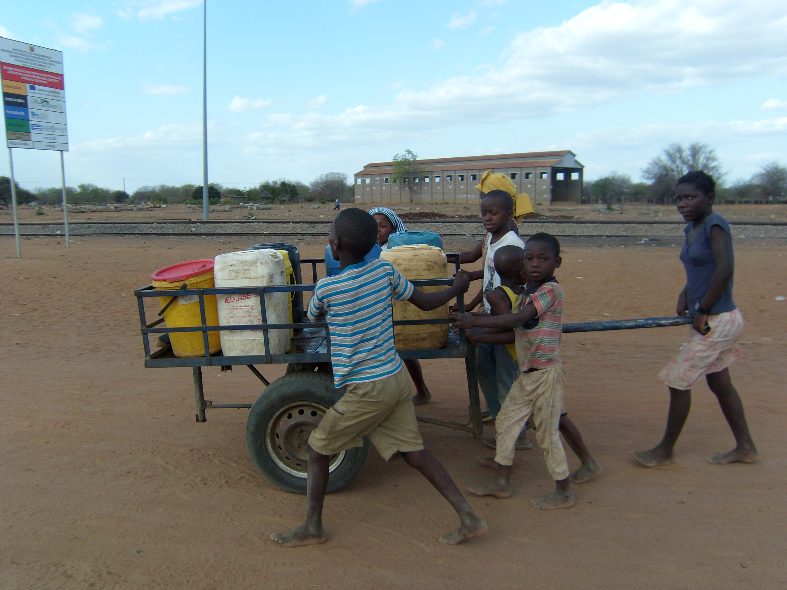
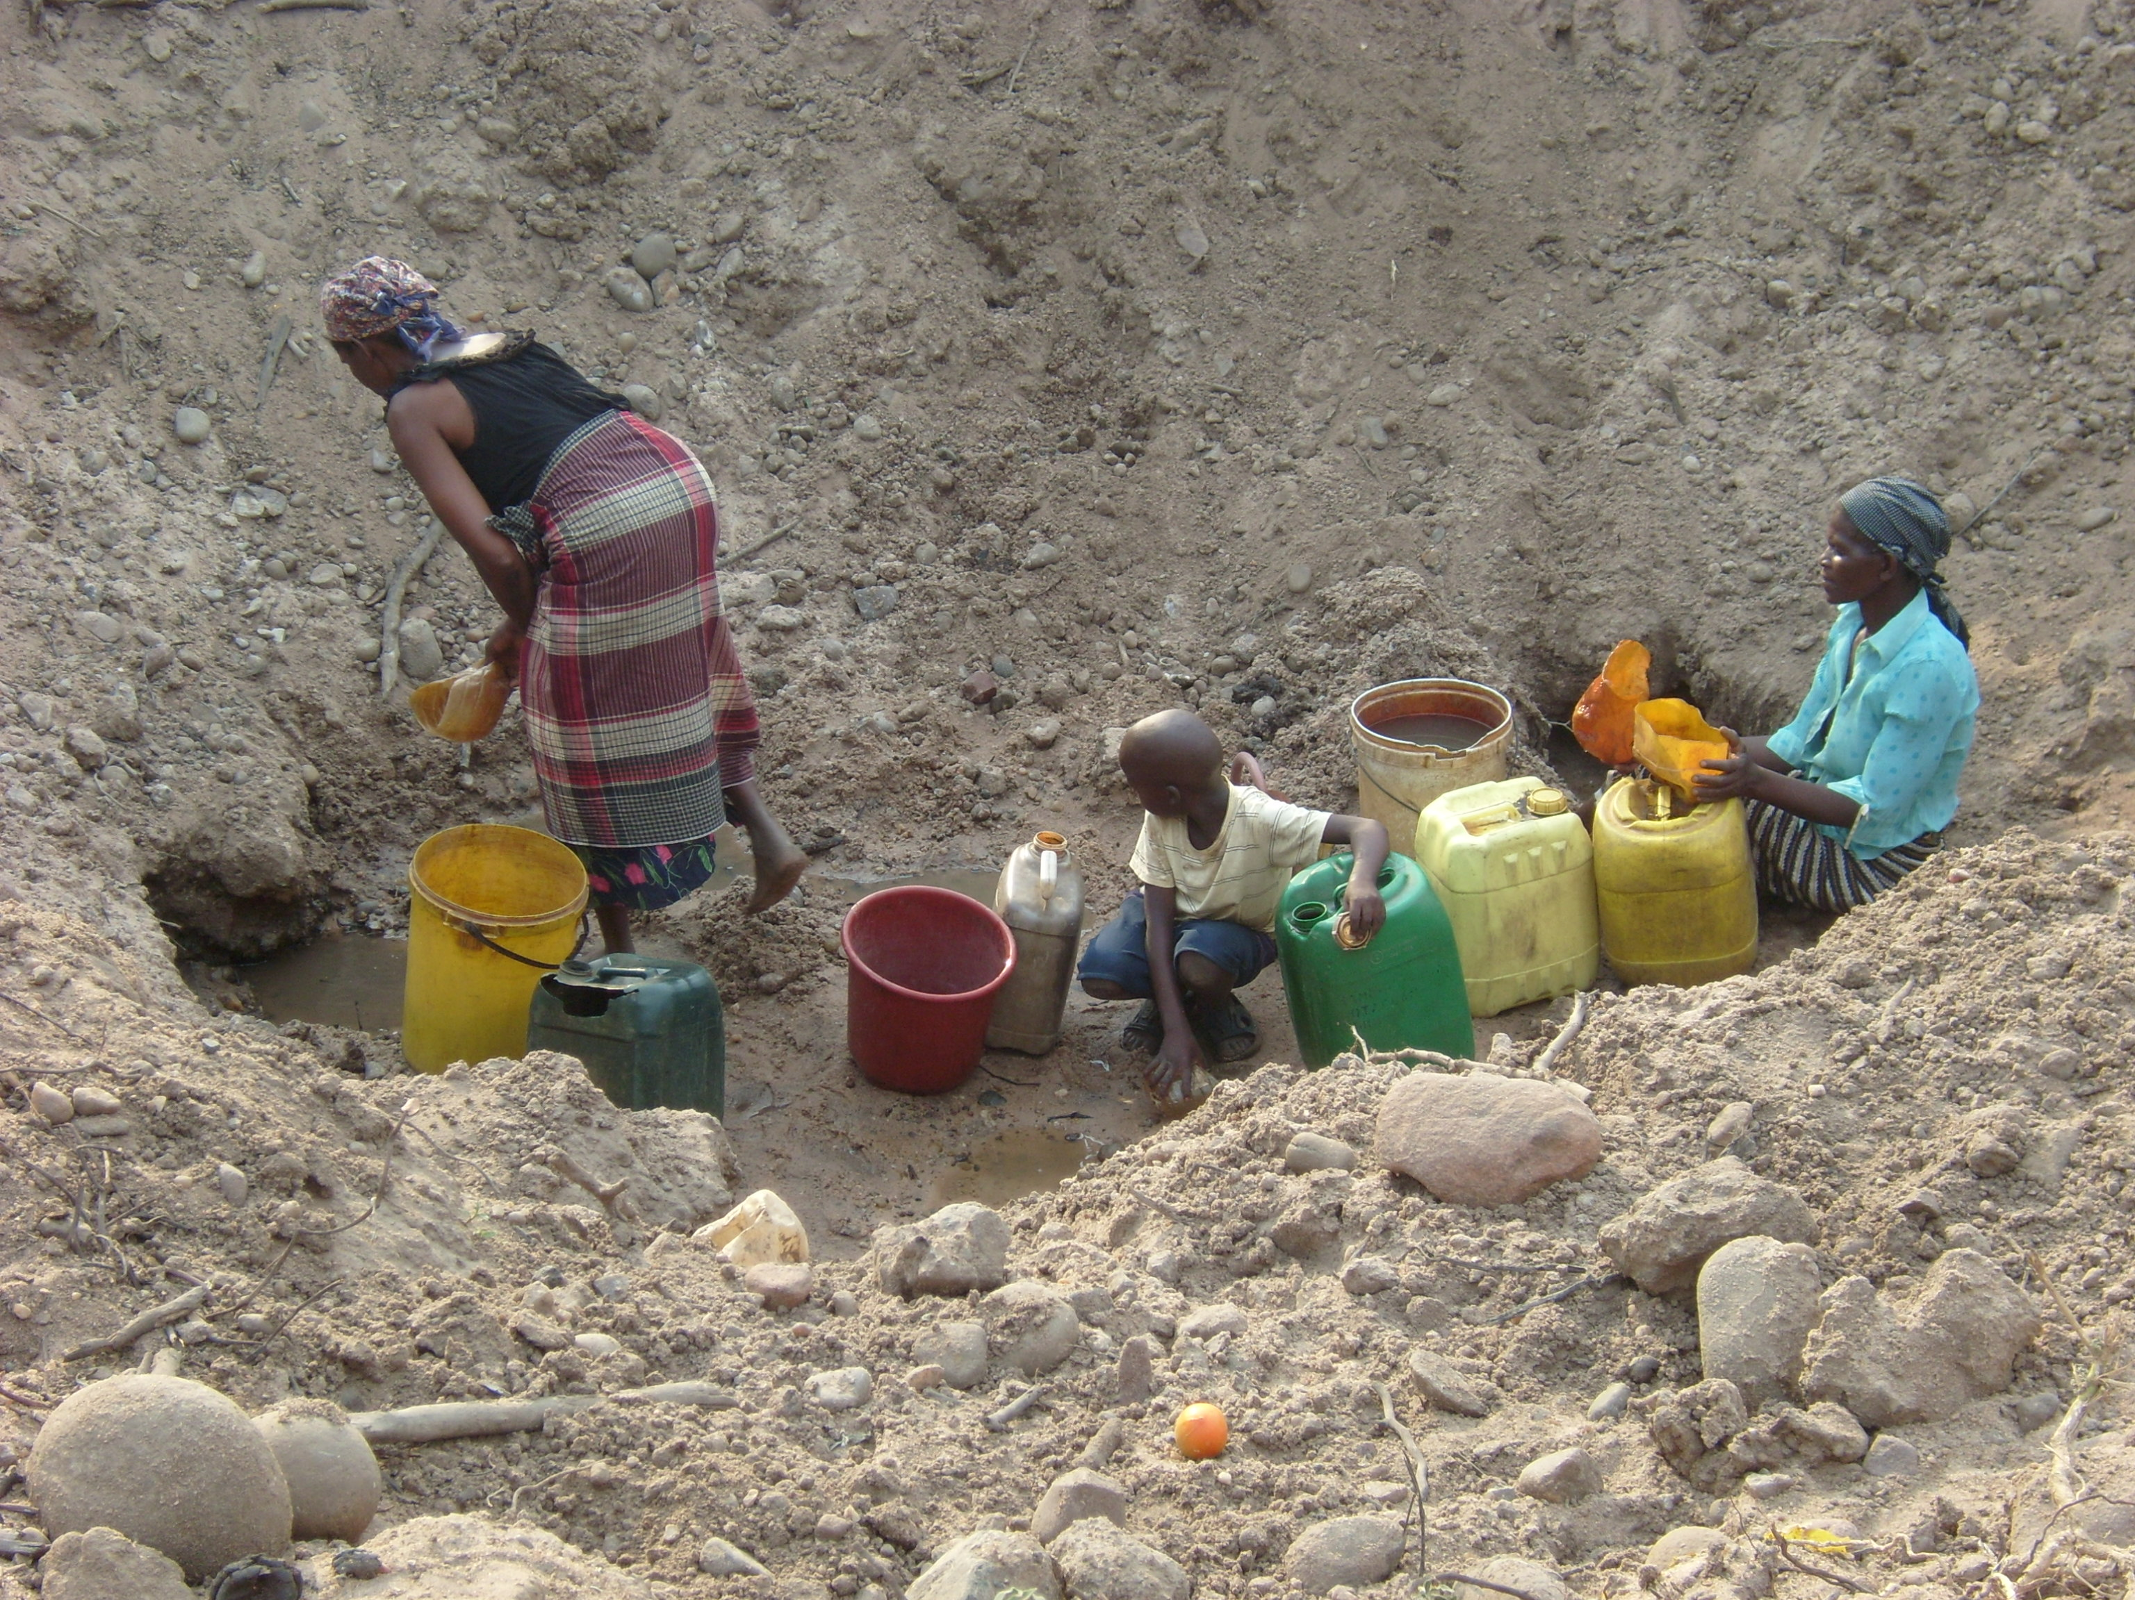

Figure 10 Water scarcity is a major problem in Chicualacuala district
The main climate hazard that is affecting all interviewed communities in Chicualacuala district is drought. When asked them to rank the main climate hazards affecting their livelihoods, all five community groups mentioned drought as the main hazard, extreme heat was ranked as the second hazard and third one was strong wind for tree communities (Dingue, Mahatlane & Madulo) and disease for two communities (Ndombe & Muzamane/Chissapa) as shown in Table 3. The other hazard mentioned by three communities out of five was floods, essentially the 2000 floods. You should state that only those communities close to the river suffer from floods, the majority of the district does not have this problem.

Table 3 Main climate hazards mentioned by the communities that are affecting their livelihoods
Location | Hazard 1 | Hazard 2 | Hazard 3
Dingue | Drought | Extreme heat | Strong Wind
Mahatlane | Drought | Extreme heat | Strong Wind
Madulo | Drought | Extreme heat | Strong Wind
Ndombe | Drought | Extreme heat | Diseases
Muzamane/Chissapa | Drought | Diseases | Extreme heat
Mapai | Drought | Desertification | Strong Wing
Droughts, the main hazard ranked by the community have hit Chicualacuala district regularly in the recent past, being verified an increase since 2005 with most years having less rainfall. According to the communities droughts have become more frequent and more severe (you said this above, reduce the repetiton throughout the document) as evidenced in the last years in the district. As a result sources of water such as from rivers are becoming scarcer in Chicualacuala district (Figure 11).

Add figure 11

Figure 11 Dry river Nuanetzi
In addition, according to local observations in Chicualacuala district, temperatures have increased significantly, therefore four of the consulted communities rated extreme heat as the second major climatic hazard after droughts. According to the communities both day and night temperatures have increased over the years. According to them, daily hotness used to occur mainly in the early afternoon, but now begins much earlier in mid-mornings while night temperatures are also warmer than before. It was also noted that the hottest months are also the months when the area receives rainfall, a challenge to crop and pasture growth due to high evaporation and evapotranspiration leading to rapid loss of soil moisture soon after it rains, as well as the high temperatures leads to reduce them labor hours (this is a rehash of what has already been said in various sections above, reduce repetition.
In the communities, the combination of drought and high temperatures, pressure on natural resources due to increasing population and other factors have led to land degradation and desertification. Strong winds also occur and cause damage to infrastructure, crops and trees as well as an increase others diseases in human.
The combination of the two main climate hazards (drought and high temperatures), bring pressure on the access of natural resources due to increasing population and other factors have led to land degradation, deforestation and desertification in the district. Strong winds have also identified by the communities in Mahatlane, Dingue, Madulo and in Mapai in the earlier study, as an increasing hazard leading to damage in infrastructure, crops and trees as well as an increase in human diseases such as respiratory and eye diseases.

When looking at the mentioned hazards by the communities and their perceptions of the climate variability we observe that they are in line with the projections for the country. For instance community observations of increasing temperatures are consistent with scientific observations and projections for Mozambique as whole and the increasing frequency of drought are consistent with climate change projections for southern Mozambique. Due to the lack of climatic data information at local level it becomes impossible to downscale predictions to the district level.

Sensitivity to climate hazards

How communities are adversely or beneficially affected by climate-related stimuli is called by sensitivity. It mostly depends on the main livelihood activities of the communities (livestock keeping, rain-fed agriculture, etc), its key livelihood resources and the impact of climate hazards on these resources.

The visited communities in Eduardo Mondlane and Mapai administrative posts are mainly subsistence farmers growing crops and keeping livestock. The consulted groups mentioned that the main crops grown includes maize, sorghum, millet, beans, ground nuts, cashew nut, water melon, pumpkin and cassava and where there is water availability to include tomato, kale, carrots, onions, eggplant, garlic, chilli and peppers (Figure 12).

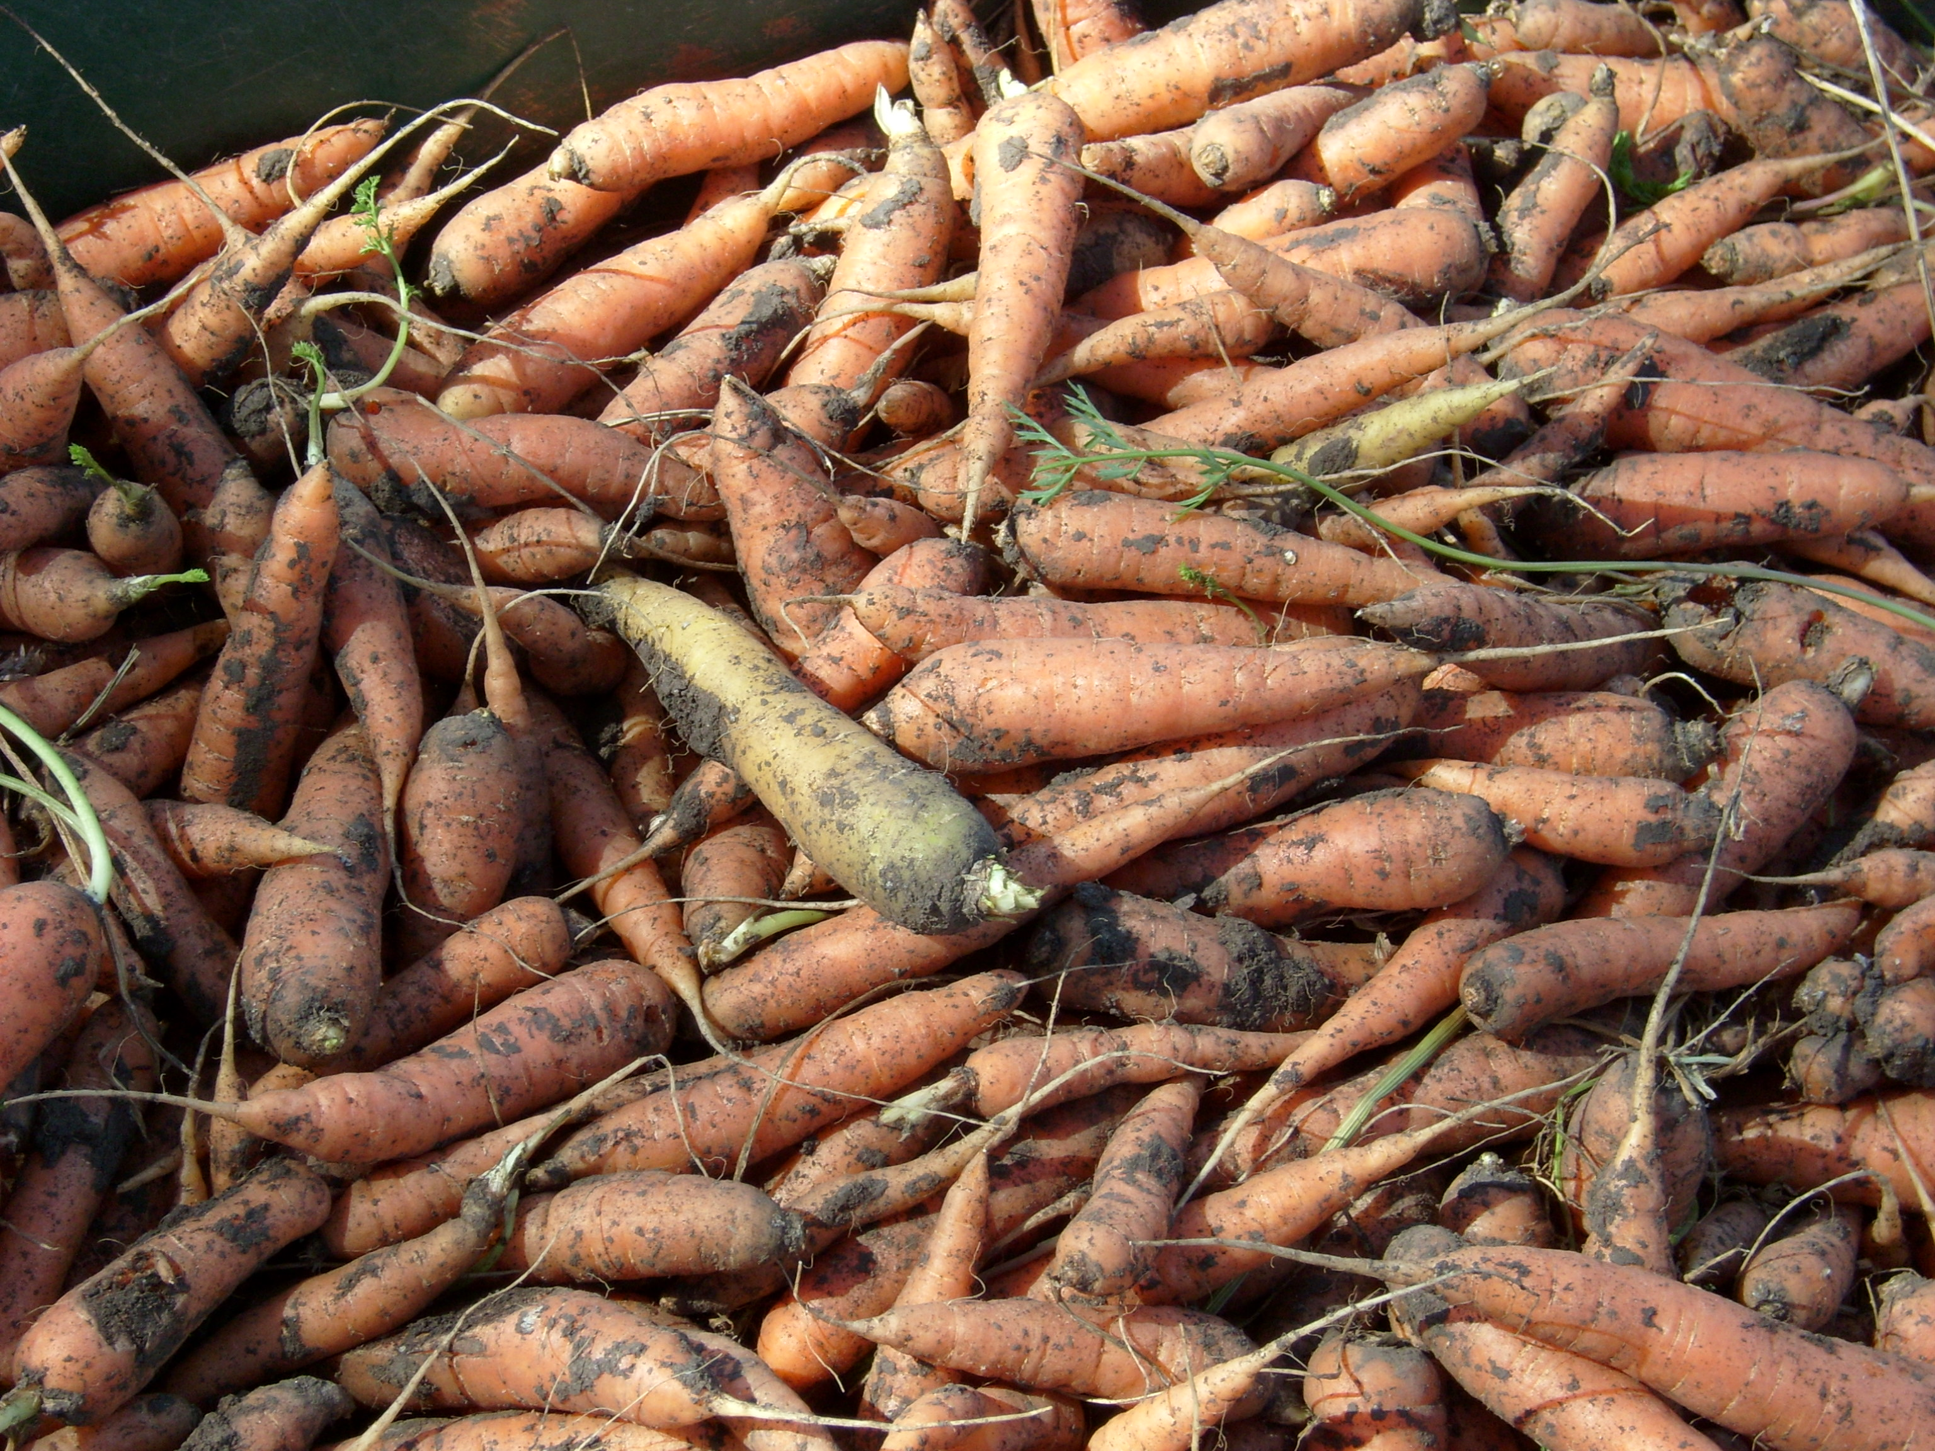
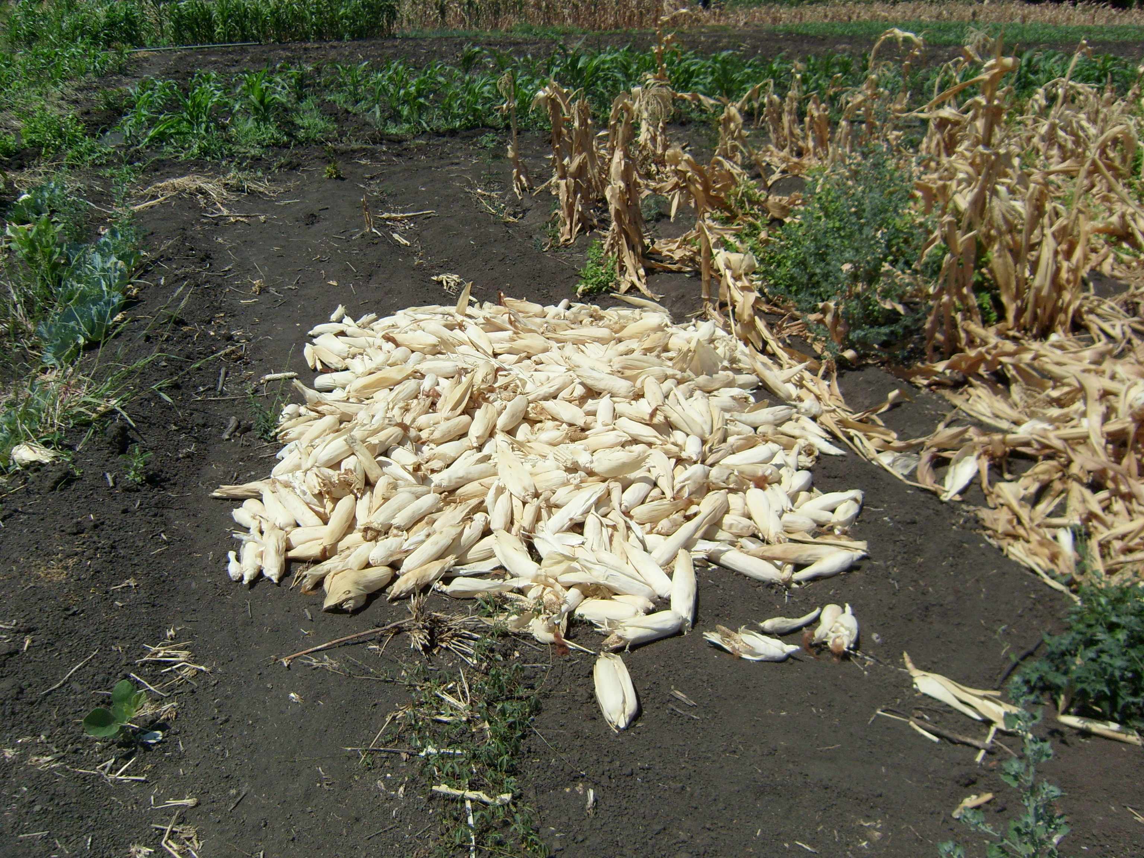

Figure 12 Example of crops cultivated in Chicualacuala district (Ndombe community)

They mentioned as the common livestock cattle, goat, pigs, sheep, donkey, chicken and ducks (Figure13).

Figure 13 Example of livestock available in Chicualacuala district

Add fig 13

Both crop production and livestock are considered to be highly climate-sensitive as they are impacted by changes in rainfall patterns, water availability, strong winds, floods, and extreme heat, ecology of pests and diseases, and carbon dioxide concentrations (I do not believe this in the middle of a huge forest!). The climate change vulnerability of local communities varies with time, geographic location, economic condition, social, and environmental conditions. In Chicualacuala district, farming activities have been negatively affected by frequent droughts and less reliable rainfall to the extent that some members of the community do not consider farming as a viable livelihood activity. Particularly the men’s group indicated that their main livelihood activity had since changed to collecting and selling products from the forest such as fruits, charcoal and roots.

The impact of frequent droughts have also affected livestock due to reduced pastures and water availability as most of the traditional livestock management practices in Chicualacuala depend on communal grazing areas with minimal or no supplementary feeding. These resources for livestock have become scarce leading to poor condition of livestock and an increase in livestock diseases increasing their vulnerability (this is very seasonal and there is no evidence of widespread overstocking In fact, given the importance of livestock in coping strategies, increasing livestock numbers is one of the obvious options. The district could support many more animals if water resources were better developed/distribute)

Rain-fed crop farming and traditional livestock keeping, the two key livelihood activities for the community in Chicualacuala district are highly sensitive to the climate hazards being experienced and as such climate change is posing a serious challenge to the community wellbeing. A more detailed sensitivity review of the community to climate hazards is demonstrated through an analysis of the impact of the hazards on key livelihood resources for the community. The main livelihood resources identified by consulted communities are shown in the Table 4 bellow.

Table 4 Main livelihood resources used by communities in Chicualacuala district
Type of resource | Important resources
Natural | Water  Pastures  Farmland  Forests
Physical | Water infrastructure  Roads  Rail way  Farming implements  Bicycles  Animal traction
Financial | Livestock  Crops  Forest (e.g. Firewood and charcoal, wild fruits)  Access to markets  Credit  Local investment Fund
Human | Farming skills  Livestock keeping skills  Veterinary skills  Irrigation skills/capabilities  Gardening skills/capabilities  Tree planting skills/capabilities  Business skills/capabilities  Charcoal making skills/capabilities  Health skills  Educational skills  Extension services (agrarian and vet)
Social | Traditional leaders  Traditional healers  Associations  NGOs  Church  Government social services  Agricultural associations/cooperatives  Customary institutions (Elders and Headmen)

Ref

Current Impacts on livelihood resources in Chicualacuala district
Natural resources
Farmland, forest and water are the most important natural resources in Chicualacuala district. Communities are observing significant negative impacts of drought and extreme heat events on natural resources such as water sources, farmland and trees. Communities and government officials in Chicualacuala and Gaza province have all mentioned the increase in land degradation and declining availability, productivity and quality of pastures, forest, crop land and water resources localized perhaps but general no. The decline in quantity and quality is due to changing environmental conditions (more frequent droughts, shorter rainy seasons, occasionally heavy precipitation events, uncontrolled bushfires, overgrazing, clearing for crop production, charcoal production and changing climatic conditions). The above factors lead to reduction in crop production and decrease in grazing potential of the land.
Deforestation is a serious problem in Chicualacuala and is all at once a contributor, an amplifier, and a consequence of changing weather patterns. Indeed, local deforestation can alter local climatic conditions and amplify the impacts of global climate change. In addition, drought decreases tree growth as well as pod and leaf production. Also, coping strategies undertaken by communities in times of drought (such as firewood and charcoal selling) lead to increased deforestation rates. Although small initiatives exist to incentive planting trees in schools, tree planting (or reforestation) does not seem to be a common activity in Chicualacuala, and very few community groups consulted identified it as a potential adaptation strategy in the face of future climate change.

Physical resources
The main physical resources for the communities in Chicualacuala district are roads, railway, animal traction and farming implements. The district is serviced by a gravel road and the Limpopo corridor railway line from Maputo to the border with Zimbabwe. These are important for the access to markets for the community as cattle is slaughtered and meat and other forest products sold to business people who come by train to the district. One important physical resource for the communities which is affected by main climatic hazards is animal traction. It is also noted that in some areas a number of wells have become less effective due to less water resulting from prolonged and persistent drought combined with extreme heat. Explain what you mean and provide eveidence with examples

Financial resources
The main financial resources on which the communities in Chicualacuala district depend on are, limited sale of crops, sale of livestock (cattle, pigs, goats, sheep and chickens) and sale of forest products including charcoal fruits, firewood etc. Few people on the communities visited depend on the Local Initiative Fund provided by government but, theoretically this is available to them and the UNJP should help them to access these funds through training in project proposal development etc. It is noted that the main financial resources are negatively influenced by drought because most of them are directly dependent on climate-sensitive natural resources, such as pasture land, water, farmland and forests.
As mentioned above if it has been mentioned above do not mention it again here, drought leads to decreased pasture and water availability, access and quality, which in turn leads to livestock emaciation and death, decreased livestock productivity (in terms of milk and meat), decreased livestock disease resistance. Amongst livestock species in Chicualacuala, cattle are especially vulnerable to climate change this is not true because cattle browse trees as well as eat grass while goats and donkeys are more drought resistant and are less affected by pasture degradation. These will become more important as pasture and water become scarce with future climate change.
Maize is the cereal crop of preference even though the communities knows it is not drought resistant and does not produce good yields under the current climatic conditions and soils in Chicualacuala. Millet and sorghum are also widely grown cereal crops and the farmers know they are more drought resistant than maize. However, they prefer maize because millet and sorghum are more prone to bird attack and, in the case of millet, more difficult to process for eating. The other drought tolerant crops grown widely are cow peas, water melons this is an important food and cash crop and an important part of coping strategies in the hungry months (Feb-Apr) before harvest and groundnuts. The drought resistant crops and varieties will become important for coping to future climate conditions they already are, for ex. millet, sorghum, cow pea. It should also be noted that farmers do not usually sell their food crops as there is rarely a marketable excess due to poor yields as a result of frequent droughts and lack of adaptive farming methods. However in Ndombe the farmers produce enough but due to lack of transport they fail to put the entire product in the market.
All communities visited seemed to agree that diversification of financial resources and income generating activities is the key to adapting to changing conditions, whether this means engaging in small business, charcoal selling (Figure14) and labor provision.

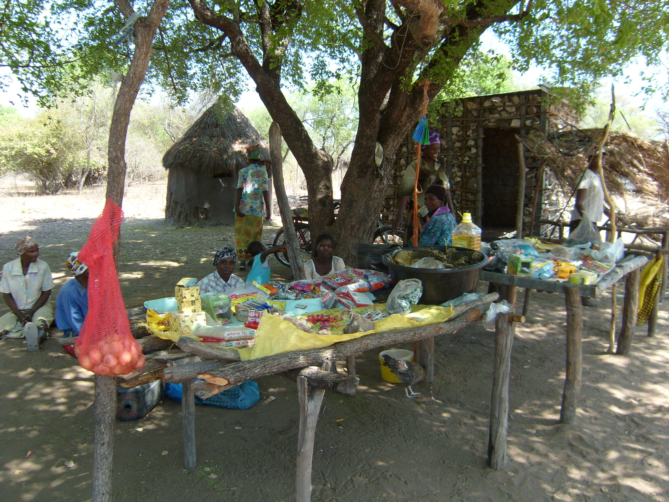
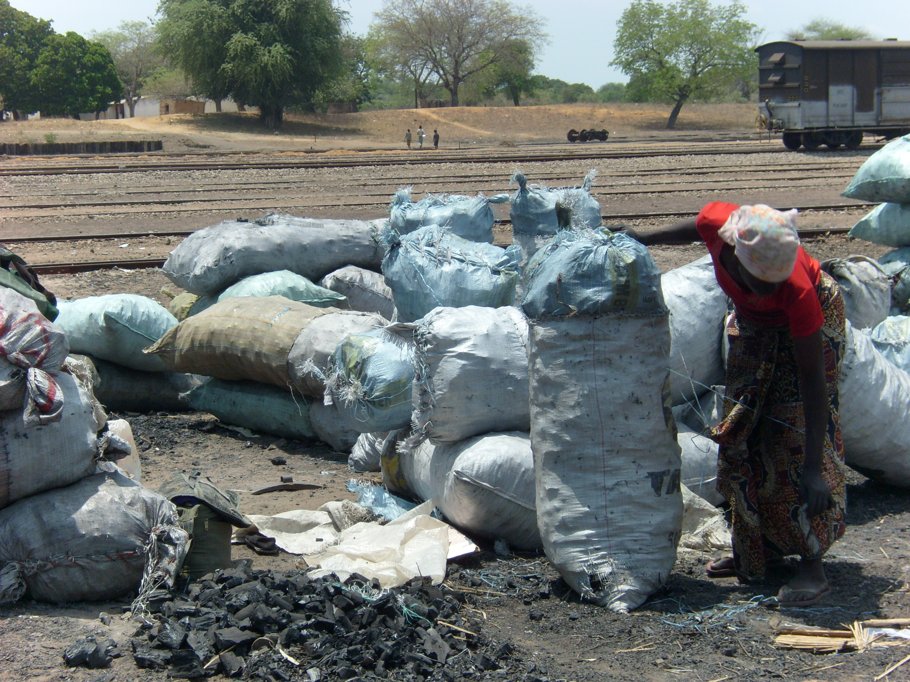

Figure 14 Example of coping strategies: small business and selling of charcoal

Human resources
The main human resources mentioned by the communities as important for their livelihoods are farming skills, health, education and extension services (farm and veterinary). Drought is affecting human resources which are important for people’s livelihoods, increasing their vulnerability. The decrease in food in times of drought affects human health reduces human disease resistance, human labor productivity, and human capability to undertake different activities such as farming. With increasing hazards such as droughts and extreme heat, improved farming and livestock management skills including small scale irrigation, health and extension services (farming and veterinary) will become more important for adapting to climate change impacts. For instance the majority of the communities visited have only a first aid officer, who cannot respond to a number of diseases faced by the communities.

Social resources
The main social resources in the community are farmers associations, churches and NGOs. NGOs assist the community in the provision of social services though there are very few NGOs and Civil Society Organizations operating in the areas of agriculture, livestock management and water supply in Chicualacuala, with the exception of the UN agencies under the UNJP .
The traditional resource management systems are important as most of the natural resources are communal with head of household and the community leaders having control on the use of the resources for the benefit of all. These will require capacity building as the scarcity of water and forest resources may soon lead to conflicts between suitable harvesting and food security or survival with increased drought frequency.
From the communities visited it is noticed that men are usually responsible for livestock selling and women for crop and forest products selling. It is important to consider those specifications when introducing activities impacting in the communities livelihoods.

Implications of projected climate change for rural livelihoods in Chicualacuala district
From the consultation with the communities in Chicualacuala district it was observed that they are already experiencing decreasing rainfall and increasing temperatures in the last years. This is in line with the future climate change scenarios predicted for the district. Taking in consideration the communities livelihoods, the following main sectors will be affected by the projected climate change scenarios: natural resources, agriculture and people.

Natural Resources
Natural resources occupy a predominant place in the lives of the community in the district. The success of their main livelihood activities (livestock rearing and agriculture) and their survival depend directly on the availability, quality, access and control over natural resources such as water, pastures, arable land, and forests/trees.
The lack of water is the most limiting factor in promoting livelihood diversification in Chicualacuala district and will be one of the most negatively affected resources to climate variability and change. The projected increase in temperatures will likely lead to enhanced water evaporation rates, as temperatures are already very high, thereby leading to decreased water availability. To face that constrain people will search for less secure water sources with implications on their health.
Increasing temperatures and more frequent hot days and nights, projected in Chicualacuala will likely affect pasture growth, availability and quality, as well as crop yields this has already been said in various section above. During the consult the communities already mentioned high temperatures as a main hazard, leading to decreased pasture availability (subsequently leading to pasture shortage, overgrazing, and land degradation), crops wilting and decreased crop yields. this has already been said in various section above.
High temperatures and changing rainfall patterns and are likely to affect tree growth and availability. Communities noted that fruit trees important for their livelihoods such as massala (Strychnos spinosa) and macuacua (Strychnos madagascarienses) get dry due to extreme heat. Forests and trees are in threat not only by direct impacts of climate hazards by also due to the communities Other threat affecting forests and trees are the coping strategies put in place by case of charcoal burning to sell. The activity provides households with an alternative income source when livestock and crop production fail due to droughts or other hazards. The strategy is only effective on the short-run, if sustainable measures are not taken in account. With increasing drought frequency the pressure on the forest resources will increase leading to massive deforestation and forest degradation. Repetition.
Deforestation and forest degradation is also influencing the micro climate (by influencing rain patterns, air and soil moisture content, and temperature variations) and can thereby amplify the impacts of global climate change at the local level. Deforestation and forest degradation can also reduce the future adaptive capacity and livelihood options of local communities.

Agriculture (Livestock rearing and crop production)
There are strong linkages between climate change and agricultural productivity especially in poor rural communities who depend solely on rain-fed agriculture. This makes rural livelihoods extremely vulnerable in terms of food security as rainfall variability increase and the growing seasons shrink. Pasture and water for livestock are also impacted as these resources become scarce.

In view of the climate projections for the district, together with other prevailing conditions such as increasing environmental degradation, livestock populations may decrease in the long term the trend is to increase and I think it will (and should) continue that way.. Some breeds of livestock may not cope well with extreme heat events true but those breeds do not exist in Chicualcuala and could suffer high mortality due to increased incidences of weather-related diseases. Inadequate access to veterinary services could also contribute to an exacerbation of mortality. Further, a reduction in livestock numbers could also occur due to increased incidences, duration and severity of droughts in the area. The livestock quality may decline due to disease resistance leading to a decrease in body mass, reproductive capacity (in terms of the survival of young ones) and milk production. This is very theoretical, read up on complementary growth of livestock in arid zones
According to the IPCC projections for Africa, agricultural production, including access to food, is projected to be severely compromised by climate variability and change; there is an expected decrease in the area suitable for agriculture, length of growing seasons and yield potential, particularly along margins of semi-arid and arid areas; and in some countries, yields from rain-fed agriculture could be decreased by up to 50% by 2020 (IPCC, 2007).

The anticipated changes in agro-ecological conditions and increases in extreme events (such as extreme heat, droughts and occasional floods) will likely increase food assistance needs in Chicualacuala district. Unless communities switch to drought resistant crops but they already grow drought resistant crops!, food security will become a serious challenge in the district. Food insecurity might be aggravated because crop selling is one of the main financial resources for the communities but in earlier sections you have said, quite correctly, that there is very limited sale of crops. The failure crop production will never fail completely, farmers are very resilient and have very sophisticated coping strategies to guard against this in crop production will hinder the purchase of other goods including food increased malnutrition especially among children and infants.
In addition, other factors that drive vulnerability such as inappropriate policies, land use changes, population pressure, and environmental degradation may combine with climate change impacts to produce negative outcomes.

People
People and social structures in rural communities are likely to be strongly affected by future climate change, mainly as a result of climate change impacts on key natural resources, crops and livestock. Significant impacts can be expected on human health and nutrition, social structures and interactions, and markets and prices.
Human Health
Increased human health problems are already being experienced due to high temperatures, increased dust due to stronger winds over land left bare as a result of land degradation there is no visible evidence of this, land is leaft bare where it has already been cultivated and is waiting to be cultivated againa when the rains come, poor sanitation as clean drinking water gets scarcer.
Given the predictions that it will get hotter and dryer in Chicualacuala district, sanitary and vector-transmitted diseases could change in distribution, range, prevalence, incidence and seasonality. Similarly, higher temperatures and increased rainfall intensity that may lead to flash floods might result in more water-borne diseases during the rainy season very doubtful. However, there remain high uncertainties regarding the impacts of future climate change on diseases. Then I would leave this paragraph out.
With anticipated higher temperatures and increased rainfall unpredictability, combined with increasing land degradation, food security and nutritional challenges might increase in the future. Increased food insecurity and malnutrition is likely to decrease human disease resistance and human labour productivity and increase human death, unless health services which are currently poor in Chicualacuala district are improved in the near future. Repetition
The already mentioned then do not mention it again negative impacts of climate variability and change on crop yields likely decrease the availability of crops on the market and lead to a substantial increase in crop prices. On the other hand, decreased pasture availability and livestock quality in times of drought leads to increased livestock brought to the market and reduced livestock prices. These market conditions in times of drought (i.e. increased grain prices and decreased livestock prices) reduce terms of trade for the rural poor, leading to reduced household income and increased poverty.
Poor road infrastructure into the interior might also reduce market access for communities living away from the main transport line (road and railway), thereby limiting their capacity to rapidly sell their livestock when a drought starts or buy food when their livestock or crop production fails. This is case of Ndombe and Mahatlane communities whereby the distance to the next village with market access is about 60km (2hrs driving or 6hrs on foot in average tenta la, pago te uma cerveja se conseguires).

Adaptive capacity
The adaptive capacity of a community is defined as the ability to adjust to climate change, to moderate or cope with the impacts, and to take advantages of the opportunities. Adaptive capacity is often a function of economic wealth, literacy rate, access to information, markets, technology, services and assistance, institutional capacity, and the underlying causes of vulnerability e depois??? Se nao tiver nada a dizer sobre adaptive capacity in Chic, apague.

Coping strategy in similar areas (arid and semi-arid)
Populations have developed a number of coping mechanisms in order to live with climate variations and uncertainty, such as diversification of crops and sources of income, migration, collection of wild fruits, switching to non-farming activities, selling assets and in extreme cases reliance on remittances these are very important and they are not extreme casas and social networks (Orindi et al, 2006). Most individuals and households employ a combination of responses to the impacts of climate on their livelihoods (Thomas et al, 2005). This suggests that actions constantly changes with different situations. For instance in Nwadjahane, Manjacaze district, Gaza province, in a household the following coping strategies are used in different situations:
When crops are damaged by drought, they move to other locations where food is available, sell liquid assets, buy limited food, use remittances and eat wild fruits (Thomas et al, 2005).

In Chigubo and Guijá districts (arid and semi-arid zones), Gaza province, to cope with climate variability and the erratic rains the farmers plant whenever the rain comes (even if is not normal time for planting) and grow different crops with the hope that one of the cultures will survive to the weather conditions and succeed until time of harvesting. When there is crop failure or to compensate low harvesting the following strategies are used:
- Sell livestock,
- Collect and eat wild fruits,
- Exchange of labor,
- Engage in small business,
- Engage in fishing,
- Sell firewood and charcoal; and
- Migration to other areas looking for employment

This also happens in Chic.

Cross- impacts analyses and underlying drivers of vulnerability in Chicualacuala

The population of Chicualacuala district depends largely on the natural resources (farmland, water and forest resources), and sale of livestock including animal traction to implement their coping strategies to face the impacts of climatic changes. These resources are largely affected by the climatic hazard (drought, extreme temperatures and strong winds) increasing the community vulnerability to the impacts of the climatic changes. Repetition.

Drought has a negative impact on farmland, water and forest resources which are the key natural resources important for crop production, livestock keeping and water supply for home consumption. Drought has particularly decreased water availability for the community in Chicualacuala district with negative impacts on all livelihood activities and financial resources. Repatition

Extreme heat affects most natural resources, having a negative impact on the livelihoods system. For instance it affects the livestock which is one of the main resources for household subsistence as animal traction and for selling, and then it will enhance the community vulnerability. Repetition

Strong winds affect negatively the livelihoods, since the communities use the forest products for income diversification, as well as for their consumption (e.g. fruit trees such as massala and macuacua). Repetition

Underlying drivers of vulnerability
The vulnerability to climate change in Chicualacuala is not only caused by climate variability and change but through a combination of social, economic and other environmental factors that interact with climate variability and change. It is the interaction of all these multiple stressors that make the district vulnerable to climate change. These vulnerabilities include environmental degradation, population pressure, general poverty, limited alternative livelihood activities, poor infrastructure, weak institutions and lack of technical capacities.
Below are described some of the underlying causes of vulnerability in the district based on the consultations with the communities.

- Environmental degradation: Increasing deforestation rates, pasture and farmland degradation and desertification are important drivers of vulnerability in Chicualacuala. Recurrent drought increased felling of trees for firewood, charcoal production and overstocking which leads to overgrazing, agricultural expansion and inappropriate agricultural practices have led to increased soil erosion, lower quality of pasture and farmland and reduced carrying capacity for livestock and humans per unit area. Some of the coping strategies employed by communities, such as cutting trees to produce charcoal and firewood for sale further contribute to environmental degradation, and reduces their resilience to climate change as resources become scarcer. Repetition
- Population pressures: Although the population density of Chicualacuala district is low, there is an imbalance with the availability of natural resources. In some areas it is observed increasing human populations attributable to various factors close to river limpopo, including immigration and settlement along the major road and railway line leading to high population density pockets in that areas. The demand on natural resources is not only caused by population growth, but also because of the selling of charcoal and firewood which increased with the existence of a functional train and railway but do not forget that the railway is the lifeline of the district.
- Inadequate off-farm employment opportunities and skills: The community in Chicualacuala has limited education, skills, and opportunities to engage in alternative and sustainable off-farm income generating activities. Many young men are working outside the district in Maputo, RSA etc and send money to their families.
- Poor access to infrastructure and services: While Chicualacuala is served by the main gravel road and railway line, the communities in the interior (example Ndombe, Mahatlane) have very poor access to main services making them more vulnerable. Therefore, many people have very limited access to markets, financial resources, and information, technology, education and health services. With few resources at their disposal and limited access to quality social services, most of the community tends to be very vulnerable when hazards occur.
- Inadequate capacity for improved Natural Resources management at local level: One of the major contributors to the vulnerability of the community in Chicualacuala district is the inadequate capacity to deal with sustainable natural resources management and creation of alternative livelihoods for the rural community. This is mainly a result of scarce water resources This leaves the community very vulnerable to climatic risks.

Current coping strategies
Communities in Chicualacuala district are already undertaking activities to cope with climate-related hazards. An assessment of current local coping strategies, as well as their effectiveness and sustainability, can give us an insight on local adaptive capacity. Current coping strategies are presented in Table 5 below.

Table 5 Current Strategies to Cope with the Main Hazards
Hazard | Coping Strategies
Drought | Consumption of wild tubers and fruits  Selling of firewood and charcoal  Selling of wild fruits and vegetables  Sale of livestock  Small business  Digging deeper wells and walking long distances to fetch water  Travelling long distances in search of pasture and water for livestock  Purchasing water for animals and humans  Practice of agriculture using irrigation systems (Madulo, Ndombe and Muzamane)  Selling traditional alcoholic drink from the forest  Open borehole for livestock (Madulo)
Extreme heat | Designating new grazing areas  Digging deeper wells  Opening new fields  Grazing livestock in the morning and evening  Planting shed trees  Working early in the mornings (Ndombe and 16 de Junho)  Move the livestock to places with shadow trees (Madulo)  Feed the animals close to the river and/or lagoon (Ndombe, Muzamane and Chissapa)  Sensitize and awareness the community to reduce firewood  Firebreak  Health post
Desertification | Use of animal manure to improve soil fertility this is not a widespread practice  Small business  Migrating to towns for employment  Digging deeper wells  Cultivating along the river  Selling of fire wood and charcoal
Strong winds | Building strong structures  Rebuilding the structures damaged  Planting wind breaks  Protective measures

It is important to note that not all current local strategies to cope with hazards are efficient or appropriate for long term adaptation. Some strategies, based on short-term considerations, survival needs, lack of information or imperfect foresight, can worsen environmental degradation and thereby diminish future adaptive capacity and livelihood options (Eriksen, 2001). The sustainability of different coping strategies also depends on the intensity, duration and frequency of the hazard.
The non sustainable traditional coping strategies in the face of current climate change are already visible, and have been mentioned by community members who fear for worse conditions particularly from cutting of forests for firewood and charcoal sales.

Alternative Coping Strategies
If future climate change scenarios for Chicualacuala (i.e. decreasing rainfall and increasing temperatures) were to occur next year, community groups suggested the following alternative coping strategies (Table 6).
Table 6 Alternative coping strategies
Hazard | Coping Strategies
Drought | - Construction of water supply system for irrigation  - Increase the number of motor pump along the Limpopo river and Ndombe lagoon  - Construction of dam  - Construct water supply systems for livestock close to the grazing areas  - Plant the fast growing fruit (mango, papaya, cashew nut and bananas)  - Plant drought resistant crops (cassava and sweet potatoes  - Supplementary of fodder during dry season  - Small business
Extreme Heat | - Construction of water supply system for irrigation  - Plant heat resistant crop  - Intensify the irrigated agriculture along the Limpopo river and Ndombe lagoon
Strong Winds | - Wind resistant infrastructure  - Reforestation  - Plant windbreak along the infrastructure (as well as for the farms)
Diseases | - Acquisition of material for pulverization  - Promote the selling of pesticides locally  - Building the Hospital

The major weakness is the lack of financial resources to utilize the coping strategies effectively as the major sources of income (crop and livestock sales) are being adversely impacted by climate change.
The opportunities available for effective use of these coping strategies depends on the introduction of new technologies and support from agencies that may start to work in the area given that the local institutions and service provision is weak.

The major threat to most of the coping strategies is their lack of sustainability in the face of current and projected climate change impacts which will lead to ecosystem degradation and loss of goods and services from the natural resources on which this community depends on.

With the increase in the frequency and intensity of droughts and high temperatures anticipated, it is likely that the adaptive capacity of the Chicualacuala community will progressively be weakened. The resources they draw upon to build their resilience will be eroded and the impacts of climate change may be progressively damaging in the near future.

Suggested adaptation activities for current and future climate change impacts
Starting with coping strategies being undertaken by the community, a number of adaptation options were formulated using the CRiSTAL Tool which takes into account sustainability in view of projected climate change impacts. This was done by analyzing all the coping strategies in terms of sustainable development and climate change. The strategies suggested are believed not to deplete economic assets, not to have potential to degrade the environment but improve it while enhancing livelihoods of women, men and children. These are elaborated below:

Modification of farming practices: In farming, the following adaptation options are suggested:
a) Provision of farmers with short-term and long-term weather forecast data from the National Meteorological Services.
Personalized climatic information made for farmers such as 7-10 day forecasts for improved management decision making that reduce climatic uncertainties in their daily farming operations such as choice of on crop varieties, timing of farming activities and general planning. This will help farmers to adjusting to the seasonal changes in the onset and cessation of rainfall by changing their planting dates to, for example coincide with the new rainfall regime;
.
b) Improved provision of extension services for improved farming practices through maturing cereal and legume crops such as sorghum, millet, cassava, groundnuts, beans etc. It is recommended that agricultural practices that improve soil fertility such as agroforestry be promoted, given the declining productivity of the soil.

c) Use of minimum and reduced tillage technologies in combination with planting of cover crops and green manure crops inappropriate because of lack of rain should be encouraged as these help in reversing soil erosion and nutrient loss due to climate change.

Catchment rehabilitation, maintenance, rehabilitation and construction of water infrastructure for improved water availability

Water scarcity is one of the major impacts of drought in Chicualacuala. It is recommended that investments be made by government and NGOs in water supply infrastructure for the community in the district. This should include where ecologically sound, construction of sand dams and rehabilitation of defective boreholes, drilling new ones, increase the motor pump along the Limpopo River or Ndombe lagoon and training communities on improved maintenance of the facilities. Water supply needs to be improved for domestic use, livestock watering and small scale irrigation to help the communities cope with the impacts of climate change.
This should be coupled with catchment rehabilitation by promoting planting of appropriate trees to encourage ground water recharge. Water harvesting though not widely practiced should be promoted hand in hand with soil and water conservation measures.

Planting of multi-purpose trees, restoration of wetlands, and gulley reclamation should be promoted for reversing land degradation as one of the factors that contribute to the changing climate in Chicualacuala is deforestation. This is critical for the restoration of ecosystems services which include improving water availability.

Improved livestock management practices
Livestock is one of the most important livelihood activities in Chicualacuala. However, given that livestock management is still mainly traditional with a stronger emphasis on numbers rather than on quality, it is important to sensitize the community on the need for matching livestock numbers with the carrying capacity the district is understocked as the pastures and water resources for livestock are getting scarce due to climate change impacts.
Destocking neither practical nor desirable, accompanied by improved provision of veterinary services and rangeland management extension should be prioritized in the coming years. There is also need for livestock diversity this already exists and adjustments in herd composition towards less grazers (cattle and sheep) and more browsers and drought-tolerant species such as goats not practical nore desirable. This shift will be important as droughts become more frequent and temperatures get higher. In addition communities should be sensitized on the importance of veterinary services for improved livestock management and support should be given to the training and functioning of Community Animal Health Workers for provision of basic veterinary interventions.

Diversification of livelihood activities for communities
Given the high dependence of the population on agriculture, alternative livelihood options outside agriculture are limited for the great majority of the people of Chicualacuala. Therefore, it is important to promote and facilitate micro-financing support for the community for income diversification in some non-agricultural off-farm activities Local Inititiave Fund??. Activities such as improved harvesting, processing and marketing of forest products need to be promoted while growing of fruit trees and vegetables through irrigation from improved water supply are the other suggested options. It is important for communities to get engaged in different kinds of income generating activities such as Small business, labor work, and other forest based entrepreneur activities. This will help reduce the community’s risks to climate change.

Community-based participatory management of Natural Resources
The dependence of the Chicualacuala district community on natural resources which are currently over exploited requires that an effective system of natural resource management is put in place to promote sustainable management of the resources as more pressure is exerted by the increasing population dependent on the forest products. Support to community forest management by establishing Joint Forest Management Systems for conservation and controlled harvesting and marketing of indigenous fruits and vegetables from the forest for income diversification is suggested as priority adaptation option.

Public health and sanitation
Support the campaigns by the Ministry of health on improved hygiene and protection from diseases which have become more prevalent as a result of droughts and high temperatures and strong winds what types of disease and where is the proof?. Malaria prevention activities such as mosquito breeding areas spraying and management of stagnant water from intermittent flush floods should be mainstreamed into general hygiene and sanitation. Planting of multi-purpose trees around the fields and homesteads will in addition to reducing the impacts of strong winds also help to improve the homesteads and provide other benefits to the households. Additional the community mentioned need on constructor of Hospital accompanied by health professional.

Raising community awareness on climate change issues, projections and potential adaptation strategies, so that they can prepare as much as possible for the coming impacts. Adapting to climate change impacts requires a mindset shift by all stakeholders and this can best be achieved by putting place awareness raising activities for all stakeholders.

Enabling conditions and constraints to implementing suggested Strategies
Consultations with communities in Chicualacuala district allowed the identification of enabling conditions and barriers to adaptation at local and district levels. The following enabling conditions and constraints to the adoption of the suggested adaptation options at the local level were identified.

Resources identified by the Chicualacuala communities as being important for implementing coping and adaptation strategies are presented below (Table 7).

Table 7 Enabling conditions and constraints to implement strategies in Chicualacuala district
Strategy | Enabling conditions | Constraints
Improved livestock management practices | - Market access for livestock (train to Maputo)  - Livestock keeping is a cultural aspect of the community  - Communities have observed the decline in pasture availability and quality this is a constraint if it is true  - The presence of trained para-vets that are capable of providing basic services if supported with drug kits | - Cultural resistance to destocking  - Poor animal health services in the community with no pharmacies or drug stores  - Shortage of extension staff in the area to facilitate destocking  - Lack of training in improved management techniques such as supplementary feeding  - Lack of knowledge on the types of animals that are better adapted to the new and projected climatic conditions  - Traditionally, holding a large number of livestock was a source of prestige and was a way to spread risks (instead of diversifying in other activities). Attitudes will therefore need to be changed.  - Reducing livestock numbers would require increasing the productivity of animals or promoting other income generating activities to avoid a decrease in income levels
Diversification of livelihood activities | - Community members have the willingness to undertake other livelihood activities  - Drought times are favorable for broker activities (undertaken by young men) as there are many livestock to sell during those times | - Limited market access and limited up-to-date market information  - Limited financial support and credit access to engage in different kinds of business activities  - Limited skills to engage in new income generating activities  - Limited water resources available for farming and irrigation in many areas  - Firewood and charcoal selling is leading to depletion of forest resources, and since many people are doing this, prices are very low  - Low or no demand for casual labor in many areas
Catchment rehabilitation and improved land management | - The existence of the UNJP which is be promoting multi-purpose trees for agro-forestry in the area,  - The existing Action Plan for prevention and reduction of uncontrolled fires | - Limited alternative livelihoods  - Lack of tree nurseries in the area to provide trees for planting  - Lack of financial resources and knowledge on catchment rehabilitation
Modification of farming practices | - The possibility that the Met. station in Chicualacuala will be re-established soon  - Presence of Mozambique Agrarian Investigation Institute in Chókwè that may have relevant results for Chicualacuala  - Presence of a Polytechnic Institute in Chókwè for undertaking adaptation studies in crops and livestock  - The people of Chicualacuala are traditionally farmers  - The existing National Green Revolution Strategy which focus on agricultural intensification | - The lack of local weather station to provide forecasts for farmers  - Lack of an efficient extension service in the area,  - Lack of inputs such as improved seed of drought resistant crops and varieties  - New varieties may be susceptible to pests and diseases  - Possible resistance to new crops and varieties  - Shortage of oxen and seeds during the planting time  - Lack of knowledge on the management of drought resistance crop species  - Limited knowledge/skills to adapt practices to the new conditions
Maintenance, rehabilitation construction of water infrastructure and increase motor pump | - The 2007 National Strategy for water resources in Mozambique which is promoting drilling of boreholes and construction of dams and river basin management for sustainable development  - Availability of local materials for building  - Many community are willing to maintain and rehabilitate existing water infrastructure and participate in the construction of new infrastructure | - Low water table for groundwater harvesting  - Mostly salty borehole water in the area  - Rainfall scarcity in the area  - There are maintenance issues regarding current water infrastructures  - Some Water infrastructures may lead to ecological problems (overgrazing, erosion, etc.)
More effective, efficient Community –based participatory management of available natural resources by community groups | - The existence of some groups  - The existence of some Natural Resources Management Committees  - The willingness by the community to address the impacts of climate change on the livelihood resources | - Lack of experience in community-based NRM in the area  - Time constraints for community members to meet to discuss NRM given the more pressing issues of seeking food during drought times  - Limited number of NGOs dealing with NRM
Improved public health and sanitation | - Existence of NGOs in the district (Uronga, Samaritanos, JAM LIFE) that promote public health | - Possible resistance by the community to adopt hygienic practices  - Limited numbers of environmental health workers  - Lack of public health pamphlets in local languages
Raising community awareness on climate change | - There is a willingness amongst community members (including the youth) to learn more about climate change in order to better prepare themselves | - Most local organizations and communities have no access to seasonal forecasts and other climate information  - Lack of information in local language

Conclusions and Recommendation

Conclusions
- Drought is a common hazard in Chicualacuala district and both men and women of all age groups are affected negatively by this phenomenon.
- The lack of local weather predictions for Chicualacuala district is a great challenge
to find better adaptation strategies for this region.
- Finish this section

Recommendations
- Introduction of short-cycle varieties
- Introduction of drought resistant varieties
Finish this section

References
Benessene, 2002
Eriksen, 2001
FAO. 2009. Draft Report from FAO as a contribution to the baseline study. UN Joint Programme on Environmental Mainstreaming and Adaptation to Climate Change in Gaza. UNJP/MOZ/085/SPA
INGC. 2009. Main report: INGC Climate Change Report: Study on the Impact of Climate Change on Disaster Risk in Mozambique. [Asante, K., Brundrit, G., Epstein, P., Fernandes, A., Marques, M.R., Mavume, A, Metzger, M., Patt, A., Queface, A., Sanchez del Valle, R., Tadross, M., Brito, R. (eds.)]. INGC, Mozambique.
IPCC. 2007. Africa. Climate Change 2007: Impacts, Adaptation and Vulnerability. Contribution of Working Group II to the Fourth Assessment Report of the Intergovernmental Panel on Climate Change, M.L. Parry, O.F. Canziani, J.P. Palutikof, P.J. van der Linden and C.E. Hanson, Eds., Cambridge University Press, Cambridge UK, 433-467.

McSweeney, C.; New, M.; and Lizcano, G. 2008. UNDP Climate Change Country Profiles. Mozambique in http://country-profiles.geog.ox.ac.uk, (Accessed December, 2008)
Ministério da Administração Estatal. 2005. Perfil do Distrito de Chicualacuala, Província de Gaza
Orindi, V.; Kibona, E.; and Moindi, D. 2006. Addressing climate change in the developing process in Tanzania. Ecopolicy 18.Acts Press
Oxfam GB, 2008
PMA. 2009. Estudo de base. Programa conjunto das Nações Unidas em Valorização Ambiental e Adaptação à Mudanças Climáticas
Thomas, D.; Osbahr, H.; Twyman, C.; Adger, N. and Hewitson, B. 2005. ADAPTIVE: Adaptations to climate change amongst natural resource-dependant societies in the developing world: across the Southern Africa climate gradient. Tyndall Centre for Climate Change Research. Technical Report 35
UNJP, 2008
- Annexes
Annex 1 Seasonal Calendar Field Guide
Annex 2 Vulnerability Matrix Field Guide

Dried, milled preparation of smoke cured seeds from macuacua (wild fruit)

