Completion report for project:

Summary
Participating UN Organisation: |  | Cluster:
UNICEF |  | INFRASTRUCTURE REHABILITATION

Project No. and Project Title: |  | Project Location/Region/Province:
E3-01: Rehabilitation and medium-term Interventions in Water & Sanitation in the Southern Governorates of Iraq. |  | 8 Southern Governorates of Iraq: Basrah, Muthanna, Najaf, Qadissiya, Thiqar, Missan, Wasit and Babil

Reporting Period: |  | Report Number:
30th June 2004 to 31st June 2007 |  | 6

Counterpart organisations / implementing partners: |  | Project cost:
Ministry of Municipalities and Public Works (MMPW), the Directorates of Water and Sanitation, UN agencies and NGOs |  | US$ 21,500,000

Abbreviations and acronyms: |  | Project Duration:
 |  | Start date: 30/06/2004  Original End date: 30/12/2005  Extension-1: 30/06/2006  Extension-2: 31/12/2006
  UNICEF: | United Nations Children’s Fund
  UNDG: | United Nations Development Group
  UNDP: | United Nations Development Programme
  UN-HABITAT: | United Nations Human  Settlements Programme
  UNIDO: | United Nations Industrial  Development Organisation
  UNOPS: | United Nations Office for  Project Services
  WHO: | World Health Organisation

I. Purpose

Main objectives and outcomes expected as per approved Project/Programme/project document:
Main objectives
The goal of this project is to ensure sustainable access to safe water and sanitation services by restoring the sector to pre-war conditions, enabling strategic medium-term development of appropriate technologies and management approaches. The ultimate goal is to arrest further decline in Iraq’s child mortality and morbidity through the rehabilitation and sustainable mid-term development of the water and sanitation sector

Specific Objectives
Rehabilitation/Reactivation of the Water and Sanitation (Water and sanitation) Sector
- To rehabilitate badly damaged networks in the 8 southern governorates;
- To rehabilitate the worst hit sewage pumping stations and sewage networks;
- To build capacity of technicians and operators of water and sewage facilities.

Medium-Term Interventions in the Water and Sanitation Sector
- Contribute to the 10 percent reduction in water losses, as a means of raising water production in urban areas;
- Support the revision of production of potable water from brackish/saline sources;
- Contribute to the 20 per cent increase in rural water supplies through development and adoption of appropriate technology;
- Promote alternative methods of treatment of domestic sewage using land treatment systems:
- Promote development of alternative solid waste management strategies;
- Improve rural sanitation via accelerated provision of latrines and hygiene education;
- Support school sanitation and hygiene;
- Develop and maintain a national Management Information System;
- Catalyse Sector Reforms.
Outcomes expected
Rehabilitation/Reactivation of the Water and Sanitation Sector
- Enhanced availability of water through rehabilitation of water treatment plants and water distribution networks;
- Sewage-related pollution is reduced in major cities in the 8 southern governorates;
- Solid waste collection is resumed in urban cities in the 8 governorates;
- 200 plant operators are properly trained to run water and sanitation facilities;
- The water and sanitation sector has improved capacity for future planning and water quality is better monitored.

Medium-Term Interventions in the Water and Sanitation Sector
- The per capita daily water supply is increased in the 8 governorates;
- New strategies for treating saline water are developed and piloted in Basrah governorate;
- Rural water production is increased in rural areas of the 8 governorates;
- Alternate methods of treating domestic sewage are adopted and a pilot plant is installed;
- New methods of solid waste management practices are introduced and at least 1 pilot plant is installed;
- Rural sanitation is improved in 8 governorates;
- School sanitation and hygiene education are promoted in primary schools in 8 governorates;
- A national Information Management System of the sector is developed and functional;
- Sector reforms are supported.

Reference to how the programme/project related to the UN Assistance Strategy to Iraq and how it aimed to support Iraq national development goals and the Millennium Development Goals:
The project focuses on rehabilitation and medium term interventions in water and sanitation in eight southern governorates of Iraq. The project contributes towards achieving universal access to safe water and sanitation as articulated in the Iraqi National development goals. The proposed interventions are further in line with the UN cluster overall objectives of reducing the percentage of people without access to safe drinking water and proper sanitation, and in so doing, to contribute to addressing the national Infant Mortality Rate (IMR) and to improving nutrition.

Specifically the project relates to the following cluster matrix outcome from the Joint UN-Iraq Assistance strategy document:
Cluster | Matrix outcomes
Cluster-E (Infrastructure Rehabilitation) | Availability of stable and safe drinking water and improved sanitation

Project Management arrangements
Implementing Partners
Line Ministry
UNICEF closely interacts with the Ministry of Municipalities and Public Works (MMPW), who has overall responsibility for water and sewage infrastructure in the 15 governorates. In addition to its central offices and institutions in Baghdad, the MMPW has Directorates of Water and Sewerage in each of the 15 Governorates of Iraq except the three northern governorates, which is separately managed by the Ministry of Municipalities-KRG. Local Authorities in all the eight southern governorates have been consulted from the onset of the project and continue to participate fully at every stage of the project ensuring that their capacities are strengthened by the end of the project implementation. They also collaborated closely during the implementation, monitoring and subsequent taking-over of the above-mentioned projects.

Collaboration with UN Agencies
UNICEF actively collaborates with the following UN agencies to benefit from their technical expertise, area of specialization and comparative advantage and, so as to ensure the best possible synergy of actions on ground:
- WHO: Water Quality surveillance
- UNDP/UNOPS: Water network rehabilitation
- UN-HABITAT: Development of healthy and sustainable cities
- UNEP: Development of appropriate water and sanitation solutions in the marshlands of lower south

For this particular project UNICEF has collaborated with UNOPS in the rehabilitation of water distribution networks in 6 locations using Polyethylene pipes.

NGOs
Given the security situation in Iraq, UNICEF developed key partnerships with several International NGOs to implement its projects within Iraq. These included Norwegian Church Aid, HELP, ACTED, LIFE/ANERA, and IMC.

Private Sector and Specialized Institutions
UNICEF made use of its in-house pre-qualified list of local contractors and engaged them on a competitive basis to assist with the completion of various project activities in the Southern Governorates of Iraq. Assistance from Specialized Agencies/ Institutions such as CEHA/WHO, NALCO, CHEMONIX, IHE-Delft Netherlands, ENGICON etc. were sought through competitive bidding in advancing the skills/capacity of local authority staff for improved planning/ design, operation & maintenance of water and sanitation facilities, in integrated water resource management, water and wastewater quality sampling & analysis, public-private-partnerships and solid waste management.

Co-ordination
UNICEF’s lead Agency role in the water and sanitation sector is based on its knowledge of the sector in Iraq stemming from its presence in the country since 1983, its global institutional experience in emergency water and sanitation interventions, and strong linkages with other UN agencies and NGO partners involved in emergency water and sanitation activities. As co-ordinator of Infrastructure Rehabilitation Cluster, UNICEF assumes a dual function of implementing its own planned activities, and facilitating and co-ordinating effective response by all concerned humanitarian actors. UNICEF closely coordinates its activities with other sectors within UNICEF to facilitate a wider integrated approach to its interventions.

Implementation and Monitoring Mechanism

Iraq is still under security Phase-IV, with some areas in Phase-V. Given the volatile security situation within the country, the UNICEF Iraq Support Centre established in Amman in October 2003, continues to support and manage day-to-day operations inside Iraq.

In Iraq, UNICEF has national offices in Erbil and Basrah; operations inside Iraq are being carried out by well-experienced national staff, through a network of engineers and monitors, who are employed through a corporate contract. In addition, UNICEF has full fledged operations, supply / logistics & finance support units in Erbil and Basrah offices which support water & sanitation programmes as well as other sectoral programmes. With the evacuation of UNICEF international staff to Amman, the senior international water and sanitation officer [head of section], and two international Project Officers are now located in Amman. Similarly, the senior and highly experienced international operations, supply / logistics and finance officers and staff are now temporarily located in Amman and support the programme implementation there from. There is a Supply Unit especially established for Iraq within the UNICEF Supply Division in Copenhagen to facilitate international procurement of supplies and equipment.

UNICEF thus continues to run operations via its national staff, in close consultation with the international staff in Amman. Iraqi staff travel to Amman on a regular basis to ensure proper flow of information between offices in Amman and Baghdad. A strengthened logistics line has been established between Amman and Baghdad, while procurement of major supplies continues to be undertaken through the UNICEF Supply Division in Copenhagen, with the distribution of supplies being monitored by contracted monitors. In addition, UNICEF made use of its already pre-qualified local contractors to undertake rehabilitation works in the selected project sites

Quality control at the project sites and monitoring of the activities is undertaken by a team of monitors and engineers. The monitors and engineers - some of them previously UNICEF/UN staff – provide a critical monitoring/supervisory input to the implementation of the project. They track the arrival of supplies/ equipment; supervise the civil works and installation of equipment in various governorates, while reporting to the UNICEF staff in Amman for technical guidance and adherence to implementation schedule. This allows UNICEF to minimize the exposure of its national staff to risks involved in travelling to project sites, while still being able to monitor programme implementation process and results. Security situation permitting, UNICEF national staff make random visits to several project sites. The local authority staff are involved in every step/process, starting with the handing over of sites to contractors, monitoring during implementation and taking over after the warranty period, further ensuring that the deliverables are in accordance with quality standards.

Further UNICEF has a very elaborate and stringent programme monitoring system through the use of its global software tool - ProMS (Programme Management System). ProMS enables daily monitoring of the physical and financial progress of any project. Periodic accounting audits are also conducted to ensure transparency and proper utilisation of funds.

II. Resources

Total approved budget and summary of resources used for the programme/project from the UNDG Iraq Trust Fund (and non-Trust Fund resources where applicable):
UNICEF received a sum of US $ 21,500,000 from the UNDG Trust Fund for the implementation of this project. All the funds available to the project have already been committed. The disbursement as of end July 2007 is approximately 97.5% of the total funds. The remaining funds are expected to be disbursed shortly with the final handing over of the 4 contracts that are under the warranty period.

During the implementation of the project course corrections were made duly recognising the urgent needs on the ground while keeping in mind the overall objectives of the project. Some of the resources allocated to developmental aspects of the project were therefore diverted to fund rehabilitation and capacity development activities in line with the Local Authorities’ planning needs. See section-III for more information.

The project was managed by an international programme manager and supported by two national officers. Resources provided under the project fully funded the mentioned staff in the first year of implementation, but subsequently other resources were increasingly used for staff support. In addition, as mentioned in the previous section, in-country assessment, monitoring and supervision support was provided by a team of external Engineers/ Monitors recruited through a corporate contract.

III. Results

An assessment of the extent to which the programme/project component / programme /project has achieved the outcomes and outputs expected
Rehabilitation of water and sanitation projects have been completed at all the planned locations except at two locations that were cancelled. Over 2.1 million people have gained improved access to water/ sanitation as a result. More than 400 water and sanitation authority staff benefitted from the various capacity developmental activities that were simultaneously undertaken on the field as well outside Iraq. Trained staff are expected to contribute towards the long-term sustainability of the water and sanitation sector.

Continuing insecurity on the ground meant that the resources were more directed towards rehabilitation projects limiting close engagement with the community on pilot based projects and also prevented from engaging with the Government on long-term policy issues.

The following table summarizes the extent to which the outcomes have been realized under the project. All the funds allocated to the project have already been committed ($ 21,500,000 US).

Outputs - Immediate Interventions:  - Badly damaged water networks are repaired in the 8 governorates  - Worst hit pumping stations & sewer networks are repaired  - Solid waste collection is resumed in urban cities in the 8 governorates;  - 200 plant operators are properly trained to run WatSan facilities | Fully Achieved (numbers in parenthesis relate to the outputs)  - 39 water and sanitation contracts have been completed benefiting over 1.8 million people in the 8 southern (1-2) governorates;  - Rehabilitation of a water treatment plant and three booster stations in Babil. (1)  - Construction of approximately 4.5 kms of storm water drains in Samawa and Nassriya cities; (2)  - 9 sewage flooded neighbourhood sites have been transformed into play areas for children in Samawa and Nassriya cities; (2)  - 62 government staff have been trained on “public private partnership in solid waste management” and “design of sanitary landfills”; (3)  - 5000 families in the marshlands were provided with 10 litre bins to facilitate management of household wastes (3)  - 140 public waste receptacles were provided to enable proper collection and disposal of solid waste in Samawa and Nassriya; (3)  - 232 Engineers/ Operators have been trained on the proper Operation & maintenance of Water treatment plants/ Compact units, RO units, Sewers & Sewage pumping station and Unaccounted for water control; (4)  - 31 Government Engineers have been trained on planning/ design of water and sewer networks and in management of water distribution system and another 7 exposed to integrated water resources management; (4)  - 10 Government staff have been exposed to current thinking and best practices in the sector through their participation in conference/ exchange program; (4)  - 48 government staff have been trained on water quality sampling and testing methods and another 13 staff trained on wastewater water analysis and sampling; (4)  - Emergency WatSan kit to cater to 75,000 families have been procured (1-2)
Outcome-1 : “Rehabilitation/ Reactivation of the Water and Sanitation Sector “  - Sewage-related pollution is reduced in major cities in the 8 southern governorates.  - Solid waste collection is resumed in urban cities in the 8 governorates.  - 200 plant operators are properly trained to run water and sanitation facilities.  - The water and sanitation sector has improved capacity for future planning and water quality is better monitored. | All the outcomes except that of resumption of solid waste collection have been met. These included reduction in sewage related pollution, training of more than 200 operatorsª in the proper operation of water and sanitation facilities and enhanced capacity of water and sanitation authorities for future planning and improved quality monitoring ^{b}.  Security situation did not permit piloting community based solid waste management projects and construction of sanitary landfills for the proper disposal of solid wastes. However UNICEF organized training programs on “public private partnership in solid waste management” and “design of sanitary landfills” to enhance the technical skills of 62 government staff in the solid waste management sector.  (a – 232 Operators have been trained; b – 109 Government staff have been trained in different areas related to planning and water quality)
Outputs - Medium Term Interventions:  - The per capita daily water supply is increased in the 8 governorates.  - New strategies for treating saline water are developed and piloted in Basra governorate.  - Rural water production is increased in rural areas of the 8 governorates.  - Alternate methods of treating domestic sewage are adopted and a pilot plant is installed.  - New methods of solid waste management practices are introduced and at least 1 pilot plant is installed.  - Rural sanitation is improved in 8 governorates.  - School sanitation and hygiene education are promoted in primary schools in 8 governorates.  - A national Information Management System of the sector is developed and functional. | Fully Achieved  - Over 2.1^{c} million people have benefited from all the rehabilitated WatSan facilities including those implemented by NGOs under the project ;  - Two Reverse Osmosis (RO) units have been installed in Al Talimi hospital, Basrah; (1, 2)  - Refurbishment of 1000 m3/hr RO plant in Basra being implemented in collaboration with DFID is completed; (2)  - 20 Engineers have been trained on proper operation & maintenance of RO units; (2)  - 22 compact treatment units have been rehabilitated in the rural areas of Wassit and Missan governorates; (1,3)  - 3300 families in the marshland areas have been provided with two 10-litre jerry cans and a 50 litre storage tank each to encourage safe storage of water; (3)  - 7 government staff have been trained on integrated water resources management; (cross-cutting topic)  - 375 family latrines have been constructed benefiting approximately 2400 people in the marshland areas; (6)  - School sanitation and hygiene education programs have been implemented in 5 primary schools in Missan governorate. 52 teachers from Missan were trained on health/hygiene awareness and community awareness programs were conducted in 10 villages in Wassit governorate; (7)  - Capacity building of infrastructure through provision of survey equipment to the Water and Sewerage authorities in the 8 governorates; water quality laboratory equipment/ supplies to the 8 central governorate laboratories; two sets of leak detection equipment to Wassit governorate and 1 set of Leak Noise Correlator each to the Water Directorates in Babil and Muthanna; (8, cross-cutting)  (c – includes 140,000 people served by the RO refurbishment project in Basrah)
Outcome-2 : “Medium-Term Interventions in the Water and Sanitation Sector “  - The per capita daily water supply is increased in the 8 governorates.  - New strategies for treating saline water are developed and piloted in Basra governorate.  - Rural water production is increased in rural areas of the 8 governorates.  - Alternate methods of treating domestic sewage are adopted and a pilot plant is installed.  - New methods of solid waste management practices are introduced and at least 1 pilot plant is installed.  - Rural sanitation is improved in 8 governorates.  - School sanitation and hygiene education are promoted in primary schools in 8 governorates.  - A national Information Management System of the sector is developed and functional.  - Sector reforms are strengthened. | The outcomes related to increase in per capita availability of water have been met in the communities where rehabilitation of water supply facilities was carried out. One of the major Reverse Osmosis Plant in Basrah was refurbished in collaboration with DFID benefiting approximately 140,000 Basra inhabitants.  Rural sanitation has been improved in select rural areas in the marshlands of Thiqar governorate. School sanitation and hygiene education programs have been implemented in five primary schools in Qalaat Saleh district, Missan. Community awareness campaigns on proper hygiene practices have been conducted in select areas in Wassit, and Missan governorates.  Pilot projects need the support of Government, a secure environment and close involvement of the community necessitating the presence of UNICEF staff or experienced NGOs to ensure its success. The precarious security situation did not allow the presence of UNICEF staff on the ground. It also severely restricted the presence of experienced NGOs on the ground thereby severely affecting the initiation of any pilot initiatives on the ground (nos. 4 & 5). The need of the hour being the improvement of services, sector reforms could not be achieved. Similarly there has been limited progress in the establishment of Water and Sanitation database. Efforts are currently underway to build this system using other resources.  UNICEF did however take the opportunity to include a number of capacity building initiatives aimed at strengthening the capacity of local authorities through training programs for improved planning/ design, operation & maintenance, quality monitoring and emerging issues.
Note: Also see Log Frame
Basic Service Delivery
Of the Forty one contracts that were issued to private contractors for the implementation of rehabilitation works in different locations, thirty nine have been completed, while 2 contracts were terminated@. These include 6 contracts that have been successfully completed by UNOPS. In addition Project Co-operation agreements (PCA) with three INGOs have been successfully completed. In terms of the magnitude of work completed:-
- 35 compact units/ water treatment plants were rehabilitated;
- Nearly 176 kms of water network were extended/ rehabilitated;
- More than 35 kms of sewer network and 6 sewage pumping stations have been rehabilitated;
- 9 sewage flooded neighbourhood sites have been transformed into play areas for children;
Some funds were also used to cover part of the costs involved in the installation of three ECHO Compact units in Thiqar, Wassit and Basrah.
@ Savings from the contracts have been reprogrammed for capacity development activities.

Employment generation
Rehabilitation of water and sanitation projects provided the greatest opportunity for employment during project implementation, with pipe-laying works contributing significantly to the employment of unskilled labourers. Private contractors as well as NGOs enjoy a symbiotic relationship with the community by providing employment to a large number of workers from within the community while the safety of their materials/equipment and of their staff is guaranteed by the community. It is estimated that nearly 450,000 person-days of employment opportunities with contractors as well as NGOs were generated by the project.

Capacity Development
A wide range of activities contributing to enhanced capacities for effective planning, monitoring, operation and management of the water and environmental sanitation sector have been completed thus far. More than 400 Government staff have been trained on various thematic issues related to the sector – Planning/ Design of Water and Sewer Networks; Water and Wastewater Quality Monitoring; Operation & Maintenance of Water and Sewerage facilities; Unaccounted for Water; Public Private Partnerships in Solid Waste Sector; Landfill Design and Integrated Water Resources Management. These courses took place both inside (mainly through partner NGOs) as well as outside Iraq, making use of internationally renowned training institutions. In addition, senior officials were exposed to new and different approaches in international conferences and best practices through exchange programs. Capacities of the governorates in the eight southern governorates were also strengthened through the provision of survey equipment and laboratory equipment, while leak detection equipment was provided to Wassit, Babil and Muthanna governorates. The series of training events are expected to contribute considerably to the attainment of project objectives and outcomes related to improved planning, operation and maintenance, water quality monitoring and solid waste management.

Policy Dialogue
As mentioned in the previous progress reports, Policy level discussions on choice of appropriate technology in water, wastewater treatment and solid waste management; public-private-partnerships in solid waste management have been limited and largely confined to training programs and participation in international conferences and forums.

Main activities undertaken and achievements/ impacts:
The following section highlights the main activities undertaken and their achievements under three sub-headings- Rehabilitation of Water and sanitation Infrastructure; Capacity Building & Emergency Response:

- Rehabilitation of Water and sanitation Infrastructure
Implementation through INGOs
- Rehabilitation of Compact Units in Wassit (Implementing Partner: HELP)
All the works under the project have been completed serving the needs of approximately 55,000 inhabitants in the project areas.

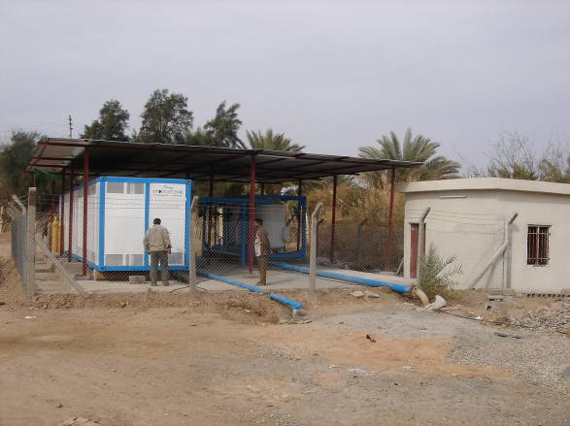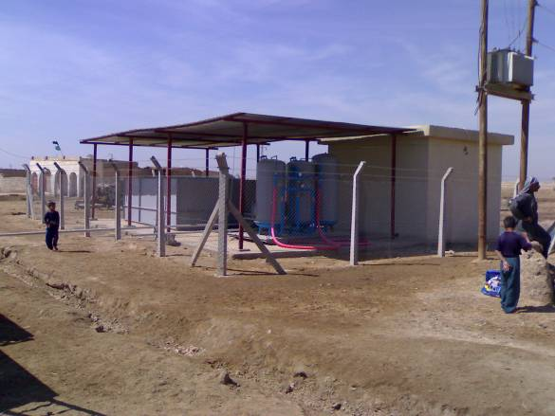
Rehabilitated Compact Unit in Al Mansya, Wassit governorate | View of another rehabilitated Compact Unit in Al Gasaba, Wassit governorate
- Approximately 55,000 people in ten villages in Wassit governorate have improved access to safe water as a result of the ten compact water treatment units that were rehabilitated.
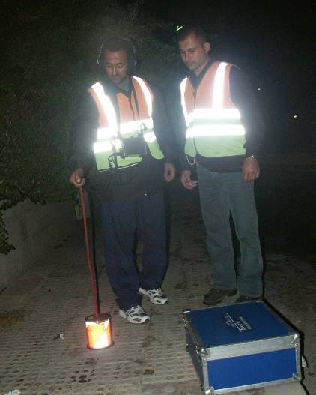
- In addition to infrastructure rehabilitation, an “Awareness campaign for water users”, was launched. In this context, a workshop was organised in Amman from 22-27 September 2005 to train selected people from the communities to become master communicators. Following the training, the master communicators began raising awareness in the project areas through numerous contacts, interviews and campaigns. Three different posters presenting messages for the communities have been designed and produced for display at public places and public buildings. As congregations were severely restricted during the month of December 2005 in view of the elections, public campaigns targeting the resident populations could not be done at local level (schools, health centres and assembly premises of the local governments), to disseminate the awareness messages. These campaigns were completed in January 2006.
Training of trainers on the use of Leak detection equipment in Amman
- Two sets of leak detection equipment were procured and two master trainers were trained on its use in Amman. These trainers subsequently trained the water authority staff in the field.

- Participatory Water Rehabilitation and School Sanitation & Hygiene Project in Qalaat Saleh district, Missan Governorate (Implementing Partner: LIFE/ANERA)
All the works under the project have been completed enhancing access to safe water to 92,500 people in the project areas.
- Three compact units have been rehabilitated/ upgraded in Al-Hurya benefiting approximately 25,000 people. In addition, another two compact units in Al-Sadr Hospital and Al-Adala have been rehabilitated serving the needs of approximately 67,500 inhabitants.

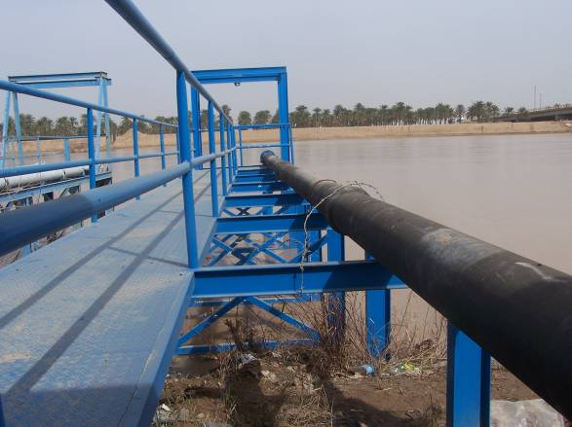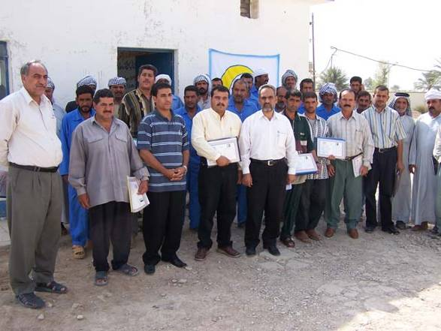
Newly constructed Intake structure – Al Sadr Compact Unit, Missan | Participants of the Training Program displaying their Certificates

- A health and hygiene awareness training workshop for 52 Teachers from 5 primary schools in Qalaat Saleh, Missan Governorate was conducted. The workshop promoted sanitation and hygiene issues through lectures, demonstrations, group sessions and discussions over a 3-day period.
- Technical on-the-job training was completed benefiting 67 participants, mainly operators of water treatment plant sites in Missan Governorate including some engineers. The workshops were conducted at three different project sites in coordination with Missan Water Directorate to ensure a wider participation of operators from the Governorate. The workshop comprised development of skills and updated information on the operation of water treatment facilities, enhanced knowledge in dealing with machinery/ equipment at the site and enhanced awareness on the importance of the proper treatment of water/ water conservation for the wellbeing of the community that depends on it.

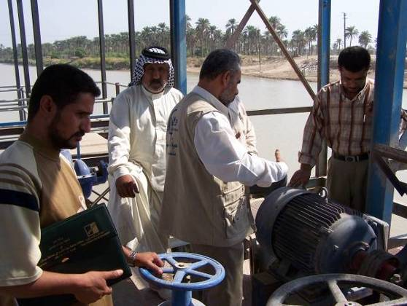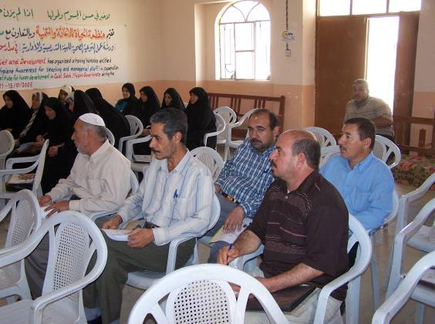
Training of Operators/ Engineers on Operation & Maintenance of Water Treatment Plant in Missan | Health & Hygiene Awareness workshop in Missan

- Community based water and sanitation interventions in select urban, rural and marshland areas of Muthanna, Thiqar and Missan Governorates (Implementing Partner: ACTED)
With the conclusion of the project, over 150,000 Iraqi citizens have enhanced access to safe water/ sanitation.
- Rehabilitation/ construction of 7 water treatment units and rehabilitation/ replacement of water distribution networks in marshland areas of Missan Governorate have been completed serving the potable water needs of approximately 27,000 residents;
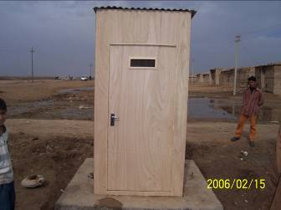
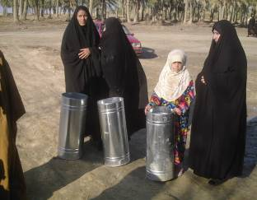
- 3300 families in marshland areas have been provided with 50 litre water storage tanks and 2 jerry cans per family;
Women from the marshland villages in Thiqar governorate receiving 50 litre water storage tanks

One of the latrines constructed in Missan governorate

- Sewage-flooded neighbourhood sites at six locations in Samawa and Rumeitha districts in Muthanna governorate and three locations in Nassriya city were transformed into recreational sites/ play areas for children, benefiting 22,000 people in the targeted areas. In addition, 10 litre plastic bins have been provided to 2500 families each in Muthanna and Thiqar governorates for garbage storage and another 70 public waste receptacles installed each in Muthanna and Thiqar governorates. These combined interventions would ensure that the play areas remain clean and child-friendly in the future.
- Drainage channels and allied works were laid in Al Hussain/ Al Sharqi and Al Hussain/ Al Gherbi quarters in Rumeitha district, Muthanna governorate and Al Salhiyah in Nassriya city in Thiqar governorate.
- 375 household latrines were constructed in the marshland areas of Thiqar (115) and Missan (260) governorates improving access to sanitation to 375 families residing there.
- 35 Operators from Missan and Thiqar governorates were trained on the proper Operation and Maintenance of compact treatment units.
- Hygiene promotion campaigns through media broadcasts reached approximately 1.8 million people in the project areas.
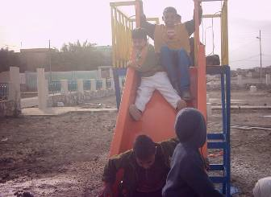
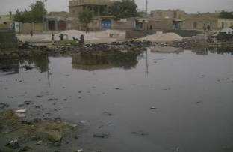

Pre-implementation: Sewage Ponded Neighbourhood | Post Implementation: Transformed Recreational site in Nissan quarter, Muthanna
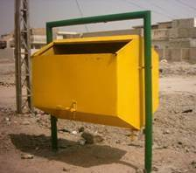
Public waste receptacle Installed in one of the neighbourhoods in Samawa, Muthanna

- Implementation in collaboration with UNOPS

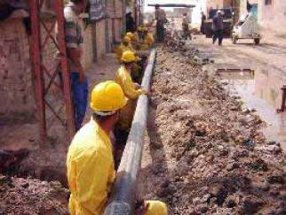
The rehabilitation of water distribution networks in Al Jzair and Al Iskan residential complex in Qadissiyah governorate marked the introduction of polyethylene pipes (PE), the pipe material in vogue, the world over for its durability, ease of laying & jointing, and better operational characteristics. Necessary guidance through prior class room trainings in Amman and on-the-job training were provided to staff to ensure best practices were followed during implementation. Subsequently PE pipes were laid in Al Bani in Muthanna governorate and Al Hora and Al Jamiya in Wassit governorates. Nearly 225,000 inhabitants have benefited from the improved access and enhanced availability of safe water as a result. For Capacity development activities refer see 2.2.3 and 2.4.6.
Manual laying of Polyethylene pipes – Al Iskan Water network rehabilitation project, Qadissiya Governorate - UNICEF

Project location | Diwaniya | Al-Jzair | Al-Bani | Al-Iskan | Al-Hora | Al-Jamiya
Governorate | Qadissiya | Qadissiya | Muthana | Qadissiya | Wasit | Wasit
Beneficiaries | 85,000 | 14,000 | 10,000 | 20,000 | 80,000 | 16,000

- Collaboration with DFID

In collaboration with DFID the physical works related to the refurbishment of the Reverse Osmosis Plant at the Basrah Petrochemical factory has been completed by a private contractor. The project is refurbished to a capacity of 1000 m³/h, 50% (500 m³/h) of which is available for public consumption and would meet the potable water needs of 100,000 to 140,000 people in Basrah.
Newly installed RO Skid

- Implementation through Private Contractors

- Completed contracts

The following tables summarises and consolidates the rehabilitation/ extension works undertaken to improve the water supply and sewerage services in different governorates under the project:

S/N | Type of Intervention | Governorate | Sector | Beneficiaries | Water Network (m) | WTP/ CU - (#)
1 | Rehabilitation/ Extension of water network | Babil | Water | 23,500 | 52,475
2 | Civil works for installation of Reverse Osmosis Units in Al-Sader Hospital & Plumbing works | Basrah | Water | 15,000
3 | Rehabilitation of Compact Treatment Units (CUs) | Missan | Water | 78,000 |  | 2
4 | Rehabilitation/ Extension of water network | Muthanna | Water | 12,000 | 12,500
5 | Rehabilitation of Water Treatment Plant (WTP) and water network | Najaf | Water | 811,000 | 31,560 | 2
6 | Rehabilitation of WTP/ CU and water network | Thiqar | Water | 181,000 | 18,100 | 3
7 | Rehabilitation of WTP & CU | Wasit | Water | 120,000 | 3,500 | 6
 | SUB-TOTAL |  |  | 1,240,500 | 118,135 | 13
NOTE: | Does not include projects implemented by NGOs and UNOPS. They are covered separately.
S/N | Type of Intervention | Governorate | Sector | Beneficiaries | Sewer Network (m) | SPS (#)
1 | Rehabilitation/ Extension of sewer network | Babil | Sewage | 20,000 | 1,200
2 | Rehabilitation/ Extension of sewer network and Sewage Pumping Stations (SPS) | Basrah | Sewage | 135,000 | 20,300 | 3
3 | Rehabilitation/ Extension of sewer network | Missan | Sewage | 12,000 | 6,000
4 | Rehabilitation/ Extension of sewer network and SPS | Najaf | Sewage | 30,000 | 1,180 | 1
5 | Rehabilitation and provision of submersible pumps | Qadissiyah | Sewage | 50,000
6 | Rehabilitation/ Extension of sewer network and SPS | Thiqar | Sewage | 137,000 | 4,412 | 1
7 | Rehabilitation/ Extension of sewer network and SPS | Wasit | Sewage | 32,000 | 2,150 | 1
 | SUB-TOTAL |  |  | 416,000 | 35,242 | 6
NOTE: | Does not include projects implemented by NGOs. They are covered separately.

- Contracts awaiting final hand-over

The following table lists the contracts that have already been completed and are currently awaiting final handover formalities with the Government.
List of Contracts | Governorate | Remarks
Rehabilitation of Al-Musayab sewer line | Babil | Final taking over has been issued by Babil Sewerage Directorate but awaits approval of the same from the General Directorate of Sewerage in Baghdad.
Rehabilitation of Al-Musayab, Al-Shuyoukh ,Al-Thawra, Al-Jumhuryah and Al-Mu’alimeen water supply networks | Babil | Under Warranty period.
Rehabilitation of Al-Gharbi and Al-Najmi water network | Muthana | Under Warranty period.
Rehabilitation of Suq Al-Sheouk sewer network and SPS | Thiqar | The final taking over was completed on 14/6/2007 and the related documents were sent to GDS from Thiqar Sewerage Directorate for approval on 1/7/2007 to the General Directorate of Sewerage, Baghdad.
The RO refurbishment project done in collaboration with DFID is also awaiting final handover.

- Capacity Building

- Capacity Building for improved operation & maintenance of water and sanitation systems

- Training on unaccounted for water control & management
Recognizing the differential capacity development needs two types of training programs - one for engineers and another for operators on “Unaccounted for Water (UFW)” were conducted in Amman in November 2005. The training was facilitated by a private institute in Amman, with trainers from Jordan and an international expert (for the engineers). It provided the 20 participants with a broader understanding of UFW issues, the technical and technological aspects and the related operational & maintenance concerns. It included several practical sessions and site visits, to complement the theoretical sessions with hands-on experience.

- Training on operation & maintenance of water treatment plants
A similar training programme was conducted on proper “Operation & Maintenance of Water Treatment Plants” in Amman in November/ December 2005 facilitated by experienced staff from the private institute. Nineteen engineers and supervisory technical staff were trained on treatment process fundamentals, design criteria, technical and technological aspects and related operational & maintenance concerns with some practical experience, while 15 operators benefited from more hands-on training sessions, including some theoretical sessions.

Training on operation & maintenance of Compact Units
Through Project Cooperation Agreements (PCA) with two NGOs, operating in Wassit and Missan, training programmes aiming at enhanced operation and maintenance of compact units were organised for operators of the compact units rehabilitated under these PCAs. Together these trainings reached out to about 75 operators.

- Training on operation & maintenance of Sewers and Sewage Pumping Stations
Two training programs - one for Engineers/ Technical Supervisory Staff and the other for Operators/ Technicians were conducted in November/ December 2006 in Amman and Cairo respectively. The topics mainly covered wastewater characteristics and flow estimation; types of collection and conveyance systems including their advantages and drawbacks; types of appurtenances; design criteria; suitability of materials for sewers and Sewage Pumping Stations (SPS); preventive maintenance and repairs; standard sewer inspection and cleaning procedures; standard operating procedures for SPS, trouble shooting and power supply break downs; types of equipment, tools & plants used for routine maintenance; staffing needs; development of O&M plan; health & safety issues and importance of public awareness. Although meant for 30 Government staff, only 19 could participate due to travel restrictions imposed by the prevailing security environment. Among them, 10 participants belonged to the southern governorates (Babil, Basrah, Qadissiya, Najaf, Wassit and Muthanna).
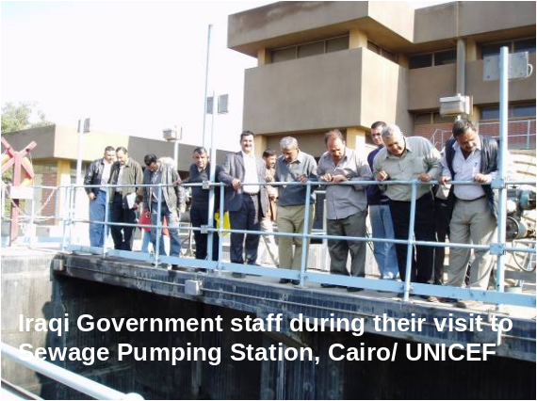

- Capacity Building for improved Planning

  - International Conferences and Training
A limited number of senior officials and Technical staff participated in select international events related to the water and sanitation sector:
    - Annual World Water Week in Sweden;
    - Symposium on “Learning Alliances for scaling up innovative approaches in the water and sanitation sector” in the Netherlands;
    - International Solid Waste Conference (Towards Integrated Urban Solid Waste Management) in Argentina;
    - 7th Gulf Water Conference, Towards an Integrated Water Resources Management in Kuwait;
    - Training on international water and environmental laws and institutions;
    - Participation of 5 Government staff in the 32nd WEDC Conference on “Sustainable Development of Water Resources, Water Supply and Environmental Sanitation” in Colombo in November 2006;
    - Participation of 5 Government staff in the Learning exchange program on “accelerating rural sanitation” and “wise water management” organized by UNICEF India in November 2006.
As policy level and sectoral know-how encompasses the whole nation including the project area (8 southern governorates) and cannot be effective in isolation from the central level ministry, support of the central level Ministry to the training programs is vital to its success. Hence some costs from the project have been charged to these events.

  - Training on Planning/ Design of Water Distribution and Sewer Networks
With significant investments going into the rehabilitation and extension of water distribution and sewer networks all over the country there is all the more an urgent need to enhance the skills of the Government staff in better planning and design of WatSan systems to ensure optimal use of resources as well as ensuring their effective functioning during their design life and their sustainability in the long-term. Towards that end procurement of design software to aid Government staff in the planning and design of water and sewer networks along with their training was envisaged (also see 2.4.2). Five Engineers representing several governorates participated in the three day training on planning and design of water distribution network in Amman using latest computer application - WaterCAD. Similarly another six Engineers were trained in the planning and design of sewer networks using SewerCAD. One participant could not attend the training program due to travel difficulties associated with insecurity.

  - Training on Management of Water Distribution System
UNOPS organized a week long water management training of 20 MMPW engineers representing the water directorates in the 8 governorates in Amman from 14th to the 20th of July 2007. The training exposed the participants to the Design and Regulatory Requirements in the water sector, tendering & contracting procedures, polyethylene pipe laying and jointing, pump maintenance, surveying & mapping of water distribution system, leak detection equipment, preparing budget estimates and was supplemented by field visits.

  - Training on Public-Private-Partnerships (PPP) for the solid waste sector
In November UNICEF entered into an agreement with a training institute for the facilitation of four training on PPP for the solid waste sector. All the four courses have been completed; the first training took place in December, while the other three courses were completed in February and March 2006. The 10-day programmes include the following topics: solid waste management and planning, PPP strategies, informal agents in the solid waste sector, PPP feasibility analysis, public awareness campaigns, site visits in Cairo, study tour in Alexandria etc. 38 Government staff comprising Engineers, finance and legal staff have benefited from the training program.

  - Training on Planning and Design of Sanitary Landfills
10 representatives from the southern governorates participated in the training programme in Cairo from 11-21 February. The training comprised strengthening the skills of Municipal engineers in the planning, design and implementation of an engineered landfill. Intensive classroom sessions were supplemented with field trips to sample project sites in Alexandria.

  - Hygiene Promotion
Two partner NGOs were supported to implement hygiene promotion activities in their project area. One NGO, working in Missan, reached out to schools and trained more than 50 school teachers on hygiene, sanitation etc. The other NGO, active in selected areas of Thiqar, Missan and Muthana, focussed more on the community at large and also addresses solid waste issues, in addition to hygiene concerns. UNICEF translated some of the hygiene promotion materials in to Arabic to facilitate use by partner NGOs and others in Iraq.

  - Exposure visits and training on Integrated Water Resources Management (IWRM)
In collaboration with the Jordan Valley Authority exposure visits and training on IWRM was organised in November. The 21 participants visited several sites all over Jordan including dams, water treatment plants, sewage facilities, control chambers etc, to see how the authorities are managing Jordan’s scarce water resources. Seven participants were from the Southern Iraq.

- Capacity Building for Improved Quality Monitoring

- Training courses on Water Quality Monitoring
Through an agreement with CEHA (WHO’s Centre for Environmental Health Activities in Amman) a series of seven training courses was conducted focusing on standards for drinking water quality, procedures for water sampling and examination, and quality assurance & quality control. Over the period 4 September to 5 December, 123 Government staff were trained, including samplers, water quality analysts, laboratory technicians, bacteriologists, chemical engineers, senior laboratory staff etc. Although the emphasis was on the south of Iraq, not all trainees came from the 8 governorates under this project and for that reason costs were shared with a non-ITF source. About 2/3 of the training programme (or about 82 trained people) directly contributes to improved water quality monitoring in the 8 southern districts.

- Training courses on Waste Water Quality Assessment and Monitoring
Two training programs aimed at enhancing the sampling and analysis capability of laboratory staff were organised in Amman during December 2006 over a period of 8-10 days. Course-1 on “Microbiological and Biological examination for Wastewater Treatment Plant Operation” covered all the required tests for wastewater examination in addition to how to set up the monitoring program for effluent and sludge and the required operational examinations for the wastewater treatment processes. The training programs also included visits to sewage treatment plants with a view to enable the participants to familiarise with the routine testing done at the field level. Course-2 on “Quality Assurance & Quality Control for Laboratory Procedures” covered topics related to quality control and quality assurance in addition to hands-on training. With the knowledge gained through this training, the 26 trainees (of which 13 were from Babil, Basrah, Qadissiya, Missan, Najaf and Thiqar) are expected to meaningfully contribute to the laboratory work. Four trainees could not attend the training program due to travel restrictions imposed by the security situation in Iraq.

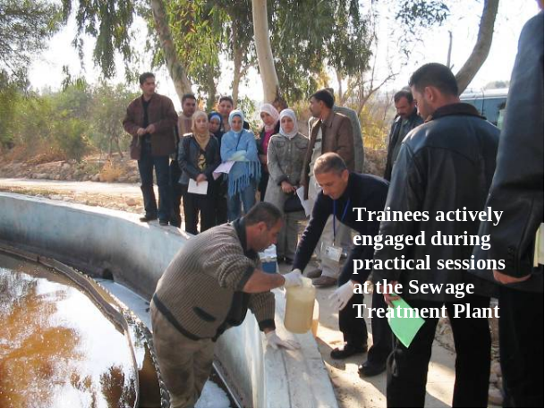

- Capacity Building of Infrastructural Facilities

  - Procurement of Water Quality Laboratory Equipment
The laboratory equipment and needed supplies meant for refurbishing the Governorates’ Central Water Quality Laboratories in the eight southern governorates have been provided.

  - Provision of WaterCAD and SewerCAD software
Two sets of WaterCAD and SewerCAD software were procured to aid in the planning and design of water and sewer networks respectively at the Central level and in Basrah governorate (Also refer 2.2.2 above).

  - Procurement of Survey Equipment
Towards strengthening the capacity of the Planning/ implementation units within the department of water and sewerage in the eight southern governorates, UNICEF has provided 32 numbers of 5” theodolites, 32 automatic levels and 48 numbers of 50 metre measuring tapes.

  - Procurement of Leak Detection Equipment
As part of a Project Co-operation Agreement with NGO-HELP, two acoustic leak detectors were procured for Wassit Governorate. The NGO undertook the training on the use of the equipment, which started with a practical training-of-trainers in Amman, followed by on the job training in Wassit. In addition UNICEF also provided two sets of Digital Leak detection equipment (Leak Noise Correlator) for use in Babil and Muthanna governorates and trained two master trainers on its use.

  - Procurement of GPS equipment
UNICEF supported the GIS unit of MMPW with 20 hand-held GPS devices. This is part of UNICEF’s ongoing efforts to assist MMPW in establishing an effective GIS that will help planning/ management of the sector.

  - Provision of Electro Fusion Welding Machines
As part of the collaboration with UNICEF, UNOPS provided a set of Electro Fusion Welding Machine with Pipe Cutter & Peeler, and electro fusion fittings suitable for 100 mm diameter Polyethylene pipe (about 100 items including couplers, T connections, Double T connections, 45 and 90 deg. Elbows) to the water directorates in Wassit, Qadissiyah, Muthanna and Missan. The provision of above device along with spare fittings will enable the water authority in the said governorates to undertake necessary repair and maintenance activities on the newly installed Polyethylene pipe network. Engineers in the mentioned governorates have already been trained on-the-job on its use.

- Emergency Response:
The following items have been procured and delivered to the UNICEF warehouse in Baghdad to enable timely response to emergencies, particularly in the eight southern governorates:

Water container 10 L | 150,000 nos.
Bucket, HDPE, with lid, 14 L | 75,000 nos.
Soap toilet 110 g | 375,000 nos.
33 gm water purification tablets | 750,000 nos.

Implementation constraints, lessons learned from addressing these and knowledge gained from assessments, evaluations and studies that have taken place during the project:
Following lists the major implementation constraints, many of which emanate from the lack of adequate security:

Pre-Implementation
- Security situation delayed the joint-assessment of water and sanitation rehabilitation projects for the southern Governorates from General Directorate of Water (GDW) and General Directorate of Sewerage (GDS) and the subsequent list of prioritized rehabilitation projects by UNICEF. This affected the schedule of preparation of final Bills of Quantities (BoQ), bidding and implementation;
- Lack of adequate co-ordination between the central Government and the Directorates in some cases led to changes in project locations as some water treatment plants had already been rehabilitated;
- Frequent changes in Government staff resulted in working with new officials unfamiliar with UNICEF rules and regulations therefore affecting the progress of works;
- Sporadic rise/ Fluctuations in prices of raw materials, fuel, oil and other basic commodities raised the value of contracts unfavourably and contributed to several re-bidding exercises adding to the delay in award of contracts and subsequent implementation;
- Contractors’ refusal to sign the contract after being awarded the work in Babil Governorate on the basis of security concerns;
- Delay in nomination of participants by the local authorities and subsequent visa processing affected the schedule of training programs.
- Progress on all the rehabilitation works have been affected due to the elections in December 2005 and the subsequent festivals;
- Protracted negotiations with contractors and local authorities to execute the projects within the available budgets delayed awarding of contracts by over 6 weeks in case of UNOPS.
- Delay in the commencement of some projects due to belated handing over of sites by the Local Authorities to the contractor; This has also been due to the long mobilization period taken by the contractor to commence works;

During Implementation
- Delays in implementation schedule of NGOs as a result of frequent ad-hoc work interruptions and consequent shifting of project operational staff and equipment from one site to another;
- Despite the joint assessment exercises undertaken, there have been occasional cases of inadequate/ incorrect information available during the preparation of contract documents that led to modifications during implementation and subsequent postponement of completion date;
- Local authorities have at times taken long time to give their decisions – for instance while changing pipe line routes; taking long time to conduct tests on materials used in the project (pipes, etc.) and give their consent to use etc. resulting in severe time loss;
- Preliminary handing over of projects includes the setting up of a committee, their visit to the project sites followed by recommendation from their end. Security situation often prevents timely getting together of committee members to enable preliminary handing over. As a result the warranty period is un-necessarily prolonged. Similar delays in final handing over of projects have led to delayed financial settlements to the contractor;
- Occasionally access to the sites was restricted due to closure of roads by the military;
- National events such as the referendum in October 2005 and election in December 2005 had a significant adverse impact on the implementation schedule.
- Security issues particularly in the southern part of Iraq, not withstanding major religious festivals, continued to cause significant delays to the programme implementation including procurement of pipes and fittings.
- Travel restrictions imposed by curfew and insecurity across governorates prevented many staff from attending the training programs and few of those who attended were delayed by a day or more in some instances.

Other
- Continuously deteriorating security situation coupled with the steady exodus of international NGOs out of Iraq prevented UNICEF from getting involved in pilot development initiatives;
- Lack of enough competent contractors in the southern Governorates;

The following indicates the major lessons learned during the course of implementation along with corrective actions taken in some instances:
- Importance to contract most of the services in order to reduce dependency on UNICEF staff presence/ mobility; Services of engineers/monitors (employed through a corporate contract) for project supervision and monitoring are key to successful implementation;
- Delegation of responsibilities to line Ministries and building of their capacities to manage the project to the largest extent possible is required;
- More close co-ordination with relevant Water and Sanitation Authorities on-the-ground is needed to ensure emerging problems are resolved at the site itself thereby saving time. Currently this is being achieved through regular meetings between the UNICEF Engineers and the relevant authorities.
- Findings from the UNICEF sponsored - LIFE conducted Water Quality testing and needs assessment of all the water project sites in Missan Governorate highlighted the fact that the performance of many of the treatment plants could significantly improve with enhanced operation & maintenance skills alone (particularly in filter backwashing, chemical dosing and general maintenance of M&E works). Training programs geared towards enhancing the skills of local authority staff in the operation & maintenance of water and sanitation facilities thus continued to be a major focus area for UNICEF interventions;
- The above study further noted the deteriorated state of one-fourth of the water treatment plants surveyed and the need for repairs to the sedimentation & filtration systems and chemical dosing systems in one third of the water treatment plants surveyed. Rehabilitation of water treatment plants therefore constituted a major intervention;
- The above study also highlighted that despite the fact that water treatment plants/ compact units are well operated; the dilapidated state of the water distribution network prevents the availability of clean water to far-away houses. This suggested the need for rehabilitation of water treatment plants to go hand-in-hand with the rehabilitation of distribution network to achieve full benefit from the interventions;
- Need to expand the UNICEF database of competent contractors: An expanded database of competent contractors in collaboration with UN-Habitat and UNOPS has enabled better and wide selection of contractors for rehabilitation works;
- UNICEF is also conducting a comprehensive market survey which is updated periodically. This has helped in making more realistic estimates of the rehabilitation projects and consequently reduced re-bidding exercises.
For Future
- Conduct joint assessment exercises well in advance – at the project proposal preparation time to avoid delays in preparation of BoQ resulting from insecurity;
- Co-ordination between the central Government and the Directorates continues to be a challenge. Establishment of a sector working group at Baghdad level is expected to alleviate many of the problems with co-ordination;
- Planning of Training programs well ahead – at least three months in advance will minimize the problems associated with delays in nomination. However this would not be possible for conferences that are organised with short notices;
- Reasonable reduction in warranty periods of rehabilitation contracts to minimise un-necessary prolongation of physically completed contracts and the difficulties in processing payment to the contractors.

Key partnerships and inter-agency collaboration, impact on results:
UNICEF is co-ordinator of the Infrastructure Rehabilitation cluster and chairs meetings in Amman. UNICEF conducts monthly water and sanitation sector co-ordination meetings in Amman. As such, UNICEF co-ordinates all activities in the sector implemented by either UN Agencies or NGOs. This has helped ensure good prioritization of water and sanitation projects funded through the UN Trust Fund and avoided duplication.

Highlights and cross cutting issues pertinent to the results e.g. Gender disaggregation, policy engagement and participation of the public:
Were the needs of particularly vulnerable or marginalised groups addressed?
The proposed project addresses the marginalized and vulnerable groups in highly un-served/under served locations in the 8 southern governorates where the water distribution network and sewer lines were either absent or damaged and required intensive rehabilitation. All disadvantaged families living in these areas were deprived of sufficient safe drinking water and proper sanitation which are basic human rights. The proposed locations were also areas prioritised by MMPW for WatSan interventions and further corroborated by UNICEF hired engineers/monitors.

How did the beneficiaries of the programme/project participate in its development and delivery?
The prevailing insecurity did not allow close collaboration with the community in the project. However the local water and sewage authorities representing these communities were closely involved in all phases of the project - assessment, implementation & subsequent monitoring & evaluation processes and selection of participants for the training programs.

How did men and women benefit from the programme/project? How was gender inequalities handled?
The project benefitted the disadvantaged families in the selected communities irrespective of gender. Women and girls most affected by the health and security risks associated with the lack of private sanitation facilities and who carry the burden of hauling 10 to 20 kilograms of water walking several kilometres, especially those in the marshland areas of Thiqar and Missan are the greatest beneficiaries of the project. Time thus saved is expected to help them in attending school and devote more time to studies, other useful/developmental activities including income generating activities and childcare. Continuous advocacy with the Government on including gender considerations has resulted in noticeable improvement at least in terms of participation of women candidates in training programs. For instance in 2006, women candidates represented approximately 30% of all participants.

Were environmental concerns addressed including environmental impact/risk assessment where relevant?
Adequate precautions were taken to dispose of the surplus excavated material/debris remaining after water/ sewer pipe laying and subsequent back filling to suitable sites without causing any environmental harm. Rehabilitated sewer lines in many of the sewage-logged areas have brought about a marked improvement in the environment, including reduction in groundwater contamination and a potential decline in water-related diseases. Improved sewerage system has also eliminated the existence of sewage filled ponds (open areas) in the neighbourhood where sewers were rehabilitated thereby providing a healthy and safer environment for the children, who usually play at these sites. The project is thus having a positive impact on the environment.

Were there any specific issues in relation to the security situation?
See section on “Implementation and Monitoring Mechanism”.

How did the project contribute to capacity building in ministries and elsewhere?
At the central level, UNICEF worked actively with MMPW in planning, identification and project formulation in addition to providing policy and technical advisory support. At the governorate level, the water and sewerage directorates were jointly involved and consulted right from the onset of the project, and continued to participate fully at every stage of the project, including the assessment, implementation and the subsequent monitoring & evaluation processes. Capacities at the directorate level, in assessment, preparing bills of quantities, tendering, implementation, supervision and monitoring have been strengthened as a result of on-the-job experience.

In addition, UNICEF organized a number of intensive trainings for the government staff at the central and governorate level to enhance their capacities in planning, design, management and operation & maintenance of WatSan facilities. (For more information see section on “Results”).

IV. Follow up actions and sustainability

Priority actions that should be supported/implemented following completion of project to build on achievements and partnerships rectify shortcomings encountered and use the lessons learned during the project with strong emphasis on achieving sustainability of the outcomes:
The priority is to get the two rehabilitation projects in Babil and Muthanna that are currently under warranty period successfully completed and handed over to the Government. Many of the lessons that have been learnt during the implementation of the project will be put to use in future projects. Also see the section on lessons learned for future.

Indication of major adjustments in the strategies, targets or key outcomes and outputs:
During the course of implementation changes have been made to some of the project components that were more of long-term nature and involved close involvement of the community in their design and implementation. The resulting savings were programmed to enhance access to safe water and sanitation in line with the urgent needs and government priorities.

As reiterated in previous progress reports, Policy level discussions on choice of appropriate technology in water, wastewater treatment and solid waste management; public-private-partnerships in solid waste management have been limited and largely confined to training programs. Recurrent budget continues to be a major concern and an impediment to the proper operation of the water and sanitation facilities.

Refer outputs and outcomes achieved under section- III, “Results”.

Estimated Budget required:
Budget required for any necessary follow up action
The needs of the WatSan sector are enormous. UNICEF’s estimated funding requirement for the implementation of its water and sanitation programme in Iraq for the year 2007 is approximately US$ 34.75 M. So far only 13.74 M has been received reflecting a shortfall of over US$ 20 M.

Annex 1 Key Performance Indicators – Log Frame Matrix

Objectives | Measurable indicators | Means of verification | Outcomes
Development Objective  The goal of this project is to ensure sustainable access to safe water and sanitation services (especially in the 8 southern governorates) by restoring the sector to pre-war conditions, enabling strategic medium-term development of appropriate technologies and management approaches. | No. of people with increased access to safe water;  No. of people with access to improved sanitation;  Improved planning and management of WatSan facilities/ sector. | UNICEF Engineer’s Field Monitoring Reports;  Government Records;  UNICEF Records (Programme/ Financial).  Other Surveys. | - More than 1.7 Million people (rural/ urban) have increased access to safe water;  - Nearly 440,000 people (rural/ urban) have access to improved sanitation;  - More than 400 government staff have strengthened capacities in planning/ design/ management & operation of WatSan facilities.
Immediate Objectives:  - To rehabilitate badly damaged networks in the 8 southern governorates;  - To rehabilitate the worst hit sewage pumping stations (SPS) and sewerage networks;  - To build capacity of technicians and operators of water and sewage facilities;  Medium-Term  - Contribute to increase in rural & urban water supplies;  - Support production of potable water from saline sources;  - Promote alternative methods of sewage treatment;  - Promote development of alternative waste management strategies;  - Improve rural sanitation;  - Support school sanitation and hygiene;  - Develop & maintain a national management information system;  - Catalyse sector reforms. | Kms of water network rehabilitated/ extended;  Kms of sewer network rehabilitated/ extended;  No. of Sewage pumping stations rehabilitated;  No. of Operators trained in various aspects of the water and sanitation sector;  No. of WTP/ CUs rehabilitated; | UNICEF Engineer’s Field Monitoring Reports;  Government Records (Letters confirming final taking over of projects; records with the directorates confirming training of Government staff)  UNICEF Records (Programme/ Financial). | Immediate Objectives:  - Achieved – Badly damaged water networks in Babil, Muthanna, Najaf, Thiqar, Wassit and Missan governorates were rehabilitated & functional;  - Achieved – Badly damaged networks in the 8 governorates and 6 damaged SPS were rehabilitated & functional;  - Achieved – 232 Operators from the 8 governorates have strengthened capacities to operate WatSan facilities;  Medium-Term  - Increase quantities of water supplies are available to nearly 1.6 million rural &urban inhabitants;  - An additional 140,000 people have access to safe water post refurbishment of the major Reverse Osmosis plant in Basrah;  - Could not be achieved;  - Could not be achieved, however technical capacities of 62 municipal officials in solid waste sector were strengthened;  - 2,400 marshland inhabitants in Thiqar and Missan have access to improved sanitation;  - Children in 5 primary schools and 52 teachers are aware of hygiene practices;  - Could not be achieved;  - Could not be achieved.
Outputs :  - Badly damaged water networks are repaired in the 8 governorates  - Worst hit pumping stations & sewer networks are repaired  - Solid waste collection is resumed in urban cities in the 8 governorates;  - 200 plant operators are properly trained to run WatSan facilities  Medium-Term  - The per capita daily water supply is increased in the 8 governorates.  - New strategies for treating saline water are developed and piloted in Basra governorate.  - Rural water production is increased in rural areas of the 8 governorates.  - Alternate methods of treating domestic sewage are adopted and a pilot plant is installed.  - New methods of solid waste management practices are introduced and at least 1 pilot plant is installed.  - Rural sanitation is improved in 8 governorates.  - School sanitation and hygiene education are promoted in primary schools in 8 governorates.  - A national Information Management System of the sector is developed and functional. | Kms of water network rehabilitated/ extended;  Kms of sewer network rehabilitated/ extended;  No. of Sewage pumping stations rehabilitated;  No. of locations where solid waste management services are functional;  No. of Operators trained in various aspects of the water and sanitation sector;  No. of WTP/ CUs rehabilitated;  No. of pilot projects for treating saline water, sewage using alternative processes and on solid waste management installed ;  No. of latrines constructed;  No. of teachers trained on hygiene awareness programs;  No. of primary schools where school sanitation and hygiene education were promoted;  National Information management system of the sector in place and functional. | UNICEF Engineer’s Field Monitoring Reports;  Government Records (Letters confirming completion and primary taking over of projects)  Records at the Water treatment plants/ Compact units;  UNICEF Financial Records;  Contracts with Private Contractors/ Institutes/ NGOs for implementing projects;  School records;  Photos during implementation; | - Nearly 176 kms of water network have been rehabilitated/ extended;  - More than 35 kms of sewer network and 6 sewage pumping stations have been rehabilitated;  - Solid waste collection could be facilitated in Muthanna and Thiqar governorates through the provision of 10 litre plastic bin to each of the 5,000 families and the installation of 70 public waste receptacles.  - 232 Operators have been trained in the proper operation and maintenance of WatSan facilities. In addition another 109 Government staff have been trained in the areas of planning, design, management and water/ wastewater quality monitoring.  Medium-Term  - 35 WTP/ CUs have been rehabilitated benefiting over 1.3 Million rural and urban inhabitants;  - Major Reverse Osmosis Plant in Basrah refurbished improving access to nearly 140,000 residents.  - 22 CUs have been rehabilitated in rural areas of Missan, Muthanna, Thiqar and Wassit governorates serving nearly 175,000 people.  - Could not be done.  - Could not be done. However, 62 Municipal Officials were trained on the “design of sanitary landfills” and “public-private-partnerships in solid waste management”.  - 375 latrines were constructed in the marshland areas of Missan & Thiqar serving 2,400 inhabitants.  - School sanitation and hygiene education were promoted in 5 primary schools and 52 teachers were trained in hygiene promotion.  - Could not be done.
NOTE: Please also refer Section-III on Results for more details.

Annex 2 PROJECT COSTS

CATEGORY | UNDG ITF approved budget ,US$ | Actual COST | Percentage of Approved | Budget Revision approved (22/06/06) | Percentage  of revision
1. Personnel  - including staff and consultants | 1,161,000 | Certified financial statement showing the actual cost will be separately provided as soon as it is made available by the UNICEF Head Quarter.  As of 31/07/07  Commitment = 21,500,000 US$  Disbursement is over 21,000,000 US$ |  | 1,161,000
2. Contracts  - including companies, professional services, grants | 12,890,507 |  |  | 13,250,000
3. Training | 840,569 |  |  | 931,076
4. Transport | 0 |  |  | 0
5. Supplies and commodities | 1,025,000 |  |  | 1,025,000
6. Equipment | 2,600,000 |  |  | 2,150,000
7. Travel | 65,000 |  |  | 65,000
8. Security | 303,000 |  |  | 303,000
9. Miscellaneous | 409,196 |  |  | 409,196
10. Agency Management Support | 2,205,728 |  |  | 2,205,728
Total Expenditure | 21,500,000 |  |  | 21,500,000

Annex 3: List of contract awards by procurement method
Following are the projects implemented through private contractors in various parts of Iraq.
S/N | Name of Project/ Contract | Governorate | Sector | Beneficiaries
1 | Rehab. Of WNW in Musayab, Al-Shuyuk, Al-Thawra, Al-Jumhuriyah & Al-Mualimin districts/ Babil govern. | Babil | Water | 11000
2 | Renewal of water network in Hay Al-Mashta & Al-Thania in Babil Governorate | Babil | Water | 2500
3 | Rehabilitation/ renewal of water network in Hay Al-Husain, Hay Al-Ameer and Hay 7-Nissan in Al-Madhatya district | Babil | Water | 10,000
4 | Rehabilitation/ Extension of sewer in Al-Musayab | Babil | Sewage | 20,000
5 | Rehab. Of Hay Al-Jumhuryah SPS and Sewer Network/Basrah | Basrah | Sewage | 60,000
6 | Rehab. Of Al-Mishraq Al-Jadeed SPS and Sewer Network/Basrah | Basrah | Sewage | 60,000
7 | Civil works for installation of RO Units in Al-Sader Hospital | Basrah | Water | 15,000
8 | Plumbing works for the RO unit in Al Sader Hospital | Basrah | Water | 15,000
9 | Rehabilitation of Station No. 17 SPS in Al-Imarat Al-Sakaniyah in Al-Ismaee | Basrah | Sewage | 15,000
10 | Rehablitation Al-Wihda Al-Arabiya and Al-Muqatil CUs | Missan | Water | 78,000
11 | Rehabilitation of Al-Iskan sewerage network in Al-Amara | Missan | Sewage | 12,000
12 | Rehab. Of Al-Gharby & Al-Najmi Garage WNW in Rumaitha/Muthanna | Muthanna | Water | 10000
13 | Rehab. of Al-Thahera WNW in Al-Muthanna governorate | Muthanna | Water | 2,000
14 | Rehab. of Al-Hera SNW & P.S. in Hera / Najaf governorate | Najaf | Sewage | NA
15 | Rehab. of old and new Kufa WTP | Najaf | Water | 250,000
16 | Rehab. of Nasser-Bar WNW in Najaf governorate | Najaf | Water | 45,000
17 | Renewal of Trunk line from Booster station to old Najaf city | Najaf | Water | 200,000
18 | Renewal of Trunk line in Al Urooba and neighbouring quarters | Najaf | Water | 60,000
19 | Rehabailitation/ renewal of water network in Al-Mahdi Quarter | Najaf | Water | 6,000
20 | Rehabilitation of Old Al-Kufa WTP | Najaf | Water | 250,000
21 | Renewal of sewerage network and SPS in Al-Qadissiya district | Najaf | Sewage | 30,000
22 | Rehabilitation and provision of submersible pumps | Qadissyah | Sewage | 50,000
23 | Rehabilitation of Al-Iskan collapsed sewerage network in Diwaniyah city | Qadissyah | Sewage | NA
24 | Rehab. of Al-Salhiyah WNW in Nassiriyah city/Thi-Qar govern. | Thiqar | Water | 35,000
25 | Rehab of Al-Salhiyah SNW in Nassiriyah city / Thi-Qar governorate | Thiqar | Sewage | 30,000
26 | Suq Al-Sheouk SNW & SPS / Thi-Qar governorate | Thiqar | Sewage | 45,000
27 | Rehabilitation of Fuhood WTP & Al Hammar CU | Thiqar | Water | 80,000
28 | Rehabilitation of Al Fuhood WTP | Thiqar | Water | 66,000
29 | Rehabilitation of Hay Al-Sader network in Nassriyah city | Thiqar | Sewage | 22,000
30 | Renewal of Somer sewer Network | Thiqar | Sewage | 40,000
31 | Rehab. Of Al-Mouafaqyah WTP | Wasit | Water | 40,000
32 | Rehab. Of Al-Jamaheer SPS and Sewer Network | Wasit | Sewage | 25,000
33 | Rehabilitation of Kilo 51 WTP, Zubidiya WTP and CU & Al-Kardhiyah WTP | Wasit | Water | 70,000
34 | Rehabilitation of Al-Tanmiya CU | Wasit | Water | 10,000
35 | Renewal of Al-Sharqiyah sewerage network in Al-Kut | Wasit | Sewage | 7,000
36 | Rehabilitation of trunk main in Diwaniya | Qadissiyah | Water | 85,000
37 | Rehabilitation of Al Jazir WNW | Qadissiyah | Water | 14,000
38 | Rehabilitation of Iskan Reservoir complex | Qadissiyah | Water | 20,000
39 | Rehabilitation of Al Hora WNW | Wasit | Water | 80,000
40 | Rehabilitation of Al Jamiya WNW | Wasit | Water | 16,000
41 | Rehab. Of Al Bani WNW | Muthanna | Water | 10,000

CANCELLED CONTRACT
Projects Implemented by UNOPS
NOTE: The above list does not include the projects that were implemented by NGOs as part of the Project Co-operation Agreement with UNICEF.

UNICEF’s office in Baghdad was closed in 2006.

