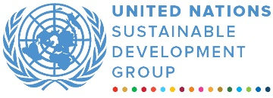

Sri Lanka UN SDG MPTF
MPTF OFfice GENERIC finalprogramme NARRATIVE report
REPORTING PERIOD: from 29 September 2020 - 1 April 2021
Programme Title & Project Number |  |  | Country, Locality(s), Priority Area(s) / Strategic Results
- Programme Title: COVID-19 Emergency Response  - Programme Number (if applicable)  - MPTF Office Project Reference Number: 00123974 |  |  | Country/Region: Sri Lanka/National
 |  |  | Priority area/ strategic results: Resilience
Participating Organization(s) |  |  | Implementing Partners
- UNICEF |  |  | - Ministry of Education  - State Ministry of Women and Child Development  - Provincial Departments of Education (PDEs)
Programme/Project Cost (US$) |  |  | Programme Duration
Total approved budget as per project document: $83,333  MPTF /JP Contribution: $83,333  - by Agency (if applicable) |  |  | Overall Duration (months)  Start Date 29.09.2020
Agency Contribution  - by Agency (if applicable) |  |  | Original End Date 01.04.2022
Government Contribution  (if applicable) |  |  | Actual End date01.04.2022  Have agency(ies) operationally closed the Programme in its(their) system? | Yes No  x
Other Contributions (donors)  (if applicable) |  |  | Expected Financial Closure date: 30.04.2023
TOTAL: $83,333
Programme Assessment/Review/Mid-Term Eval. |  |  | Report Submitted By
Evaluation Completed  Yes No Date: dd.mm.yyyy  Evaluation Report - Attached  Yes No Date: dd.mm.yyyy |  |  | - Name:  - Title:  - Participating Organization (Lead): RCO  - Email address:

NARRATIVE REPORT FORMAT

EXECUTIVE SUMMARY

From the onset of the COVID-19 crisis in 2020, the Education sector was severely impacted, with prolonged school closures (since March 2020) and inequitable distribution of distance learning opportunities. As the Education Sector co-lead, UNICEF has played a major role in supporting the Ministry of Education (MoE) to coordinate partners and guide the development and implementation of the education sector response and recovery strategy to the COVID-19 pandemic, which helped prioritize and streamline efforts. UNICEF was also instrumental in linking the COVID-19 response to ongoing education reforms, as part of its Building Back Better (BBB) efforts, by demonstrating effective models and generating evidence to inform a system strengthening approach to safe school reopening, learning continuity and recovery, and child wellbeing.

With the valuable funding from the Australian Department of Foreign Affairs and Trade (DFAT), UNICEF developed, in coordination with the MoE and Ministry of Health (MoH), a child-friendly, age-appropriate cartoon book with Infection, Prevention and Control (IPC) messages particularly aimed at primary students, which was printed both in Sinhala and Tamil languages. This cartoon book was distributed to all primary schools in the nine (9) provinces, which will benefit more than 1.67 million children nation-wide; of which, the contribution from DFAT directly reached an estimated 33 per cent of all primary schools reaching around 560,000 primary students in 3,300 primary schools.

Although phased school reopening came into effect by the government in October 2021, concerns around significant learning loss and widening gaps in learning and skills development remain, especially among the most marginalized. Therefore, continuous learning for all children remains a top and immediate priority. To this end, UNICEF has been working with the MoE to develop and implement a strategy on learning continuity and learning recovery which applies various forms - both online/offline - based on the local conditions. In-line with this strategy, UNICEF used the valuable funding from DFAT to systematically support the MoE and Provincial Departments of Education to help ensure continuous learning for primary children.

Purpose

The purpose is to support safe-school operations, learning recovery and continuous learning, based on tried and tested models implemented by provincial education authorities in Uva and Central provinces. Specifically, UNICEF will work with the MoE at national and provincial levels to develop a national strategy on continuous learning/learning recovery, which gives flexible options both in situations of continuous school closure, as well as if schools are reopened. The strategy will present a streamlined technical framework but allow flexibility for adaption at the provincial level based on local realities. Once the national strategy/framework is developed, UNICEF will support its implementation, with a focus on the educationally disadvantaged provinces, namely Uva, Central, Eastern and Northern.

Results

- Narrative reporting on results:

To support the ongoing efforts for safe school reopening and operations, at the request of the MoE, UNICEF supported the national ‘Back-to-School’ communication campaign, which included different communication materials, such as video and audio clips, posters, panels etc., with Infection, Prevention and Control (IPC) messages. As part of these risk communication efforts, the valuable funding from Australia DFAT enabled UNICEF to develop, in coordination with the MoE and MoH, a child-friendly, age-appropriate cartoon book with IPC messages particularly aimed at primary students, which was printed both in Sinhala and Tamil languages (see the photos below). This cartoon book was distributed to all primary schools in the nine (9) provinces, which has benefited more than 1.67 million children nation-wide. Of the total benefitted, the contribution from DFAT will directly reach an estimated 33 per cent of all primary schools, covering around 560,000 primary students in 3,300 primary schools. The cartoon book helped primary-aged children better understand key hygiene messages and build their confidence in continuously practicing these positive hygiene behaviors both in school and at home.

The cartoon book, developed in line with national IPC guidelines (which UNICEF helped draft), included the following set of key messages:
- Maintain at least one-meter distance from each other both inside and outside the school.
- Regularly wash your hands with soap and water for at least 20 seconds or use an alcohol-based hand-rub before and after engaging in any activities including play and sports.
- Cover your nose and mouth with a face mask during and after school.
- Sneeze or cough into your bent elbow or use a tissue and ensure that you dispose of the used tissue into a bin with lid immediately and wash your hands with soap thereafter.
- If experiencing cough, cold or fever symptoms, stay at home and consult a doctor.
- School, classrooms and all surfaces should be cleaned and sanitized regularly.
- Do not discriminate against anyone because of the Coronavirus. Let’s be kind…and support each other…to STAY SAFE.’

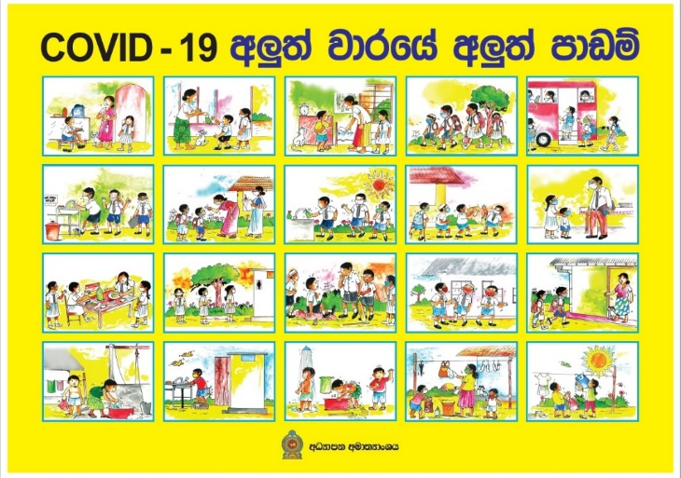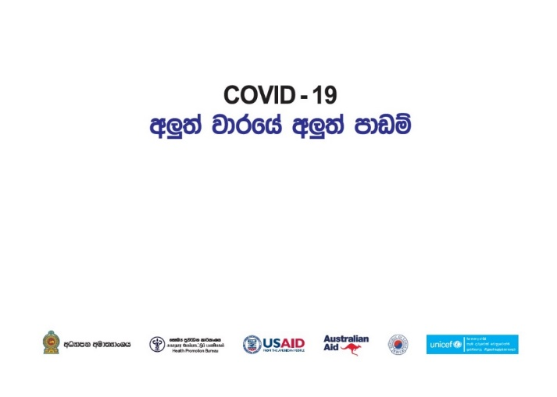
©️UNICEF/Sri Lanka /2020

Cartoon book on COVID-19 awareness for Primary students (front cover and back cover)

UNICEF also used the valuable funding to support continuous learning and mitigate learning losses for primary graders, especially vulnerable and underserved children, which - considering the prevailing situation - was a top and immediate priority. To this end, UNICEF worked with the MoE to develop and implement a strategy on learning continuity and learning recovery which applies various forms - both online/offline - based on the local conditions. Since access to online learning for primary grades were quite limited, especially among those in rural and disadvantaged communities and households, this support was critical and timely.

Through the work with the MoE and the Provincial Education Departments (PDEs) in Central, Uva and Eastern Provinces, UNICEF supported the demonstration and documentation of good models, applying blended approaches to continuous learning and learning recovery for primary grades, which particularly helped disadvantaged children and mitigated widening learning gaps. UNICEF supported the MoE and Central PDE to conduct a workshop in January 2021, engaging Uva and Eastern PDEs, to take stock of these provincial experiences and consolidate and document a draft strategy for learning recovery. The aim is to scale up this remediation strategy to minimize learning losses and mainstream it as an evidence-driven national strategy for nation-wide implementation. The draft strategy was reviewed by high-level MoE leadership, based on which, a national workshop was held in April 2021 by the MoE, with UNICEF’s support, engaging provincial authorities and other key government institutions in all nine provinces. The national workshop presented an opportunity for all key stakeholders at national and provincial level to discuss the strategy, share practical experiences and agree on the next steps for implementation and monitoring.

Subsequent to this, UNICEF supported the implementation of the strategy nation-wide. The valuable funding from DFAT enabled UNICEF to systematically support the MoE and PDEs to implement the continuous learning / learning recovery strategy in Uva, Central, Eastern and Northern provinces (other provinces were financed by other funding sources). For this, homebased learning packages were developed for primary grade students on mathematics and first language (Sinhala/Tamil) with technical and financial inputs from UNICEF. The printed version of the home-based activity packages has been delivered to each household with the support of divisional directors and school principals. Simultaneously, a digital version has also been shared with students through available social media networks. Approximately 395,300 primary students have benefited, with the breakdown by province as below:
- Uva - 71,484 (Grade 1-3)
- Central – 136,699 (Grade 1-3)
- Eastern - 154,118 (Grade 1-5)
- North - 33,000 students (Grade 1-2)

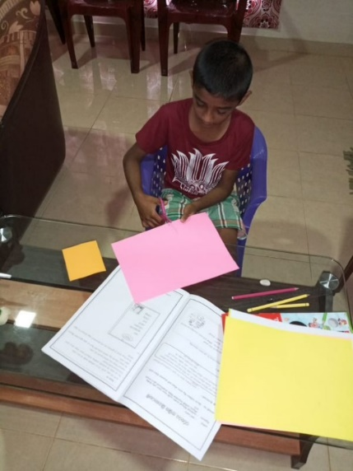
These home-based learning packages consist of several simple activities in-line with the expected competencies of each grade as per the national curriculum. Children did these activities at home with the guidance of their parents. A simple assessment system was also included in the package. After the child has completed each set of activities, the parent /guardian completed the assessment report and shared it during the bi-weekly meeting with the respective class teacher. Divisional Directors of Education and In-Service Advisers frequently collected feedback from parents and students over the phone. Parents were requested to share photos or video clips of their children doing these activities at home whenever possible. The feedback received by the divisional education office report that most students are enthusiastically involved in the home-based activities with the support of their parents. In some families, elder and younger siblings are also engaged in the activities. As a result of these concerted efforts by government authorities, the school administration, teachers, parents and targeted primary students have been engaged in the learning process during this critical period.
Children learning at home using the home-based learning study packs

©️UNICEF/Sri Lanka /2021

Challenges, lessons learned & best practices:

In developing all risk communication materials, including the cartoon book with IPC messages, inter-ministerial coordination between the MoE and MoH was facilitated. While the MoH provided technical guidance on the health and hygiene standards for the content of the IPC messages and visuals, the MoE ensured that the cartoon book was effective in terms of age-appropriateness, local and cultural relevance, etc. Particular attention was also paid to ensure that the story book adequately reflected issues of inclusiveness and gender, as well as promoted social cohesion and diversity, including representation of children from different language and religious groups. The book was also drafted in both national languages – Sinhala and Tamil.

For the home-based learning packages, which were also produced in Sinhala and Tamil, UNICEF’s support demonstrated a good example of an evidence-based, systemic approach to continuous learning and learning recovery at scale. UNICEF provided technical guidance, based on global evidence, in developing the strategy and practical tools. The pilot in Uva and Central provinces was systematically documented and used as a basis for nation-wide scaling up. In terms of the delivery modalities, a blended approach was promoted, including use of printed materials and low-tech methods, such as smartphone text messages and calls, which enabled disadvantaged children to continuously learn under challenging conditions. Key findings from the national survey on continuity of learning (primary grades), undertaken by MoE and UNICEF (funded by other sources), indicated that such a combination of online (high-tech/low-tech) and off-line (such as printed materials, textbooks) methods was useful, and that the capacity of and continuous support from teachers and parents in the learning process at home during school closure are key determinants.

The significant impact of COVID-19 on the education sector and long-term adverse effects on children’s well-being, including issues around their environment, protection and social cohesion, has shed light on the pressing need for a more risk-informed and resilient education sector to ensure quality, continuous learning, and a safe and protective learning environment for all children and adolescents in all settings and occasions.

Going forward, UNICEF will continue to focus on resilience building of the education sector in a comprehensive manner, by integrating and strengthening key components of sector strategies and plans, addressing data gaps and improving monitoring, advocating for data-driven resource allocation and building capacity of the education system. This will include issues around climate change and adaptation, hygiene behaviour promotion, social cohesion and violence mitigation. UNICEF will also continue its focused efforts for systemic promotion of blended learning, including a sustainable strategy, finances and capacity building for expanded digital solutions that can be applied in both development and emergency contexts.

ii) Indicator Based Performance Assessment:

 | Achieved Indicator Targets | Reasons for Variance with Planned Target (if any) | Source of Verification
Outcome 1
Indicator:
Baseline:
Planned Target:

Output 1.1: Increased understanding amongst primary-aged children on key hygiene messages that they need to practice both in school and at home  Indicator 1.1.1: # of children reached with IPC messages  Baseline: 0  Planned Target: 560,000 primary students | UNICEF developed, in coordination with the MoE and MoH, a child-friendly, age-appropriate cartoon book with IPC messages particularly aimed at primary students, which was printed both in Sinhala and Tamil languages. This cartoon book was distributed to all primary schools in the nine (9) provinces, which will benefit more than 1.67 million children nation-wide. The contribution from DFAT will directly reach an estimated 33 per cent of all primary schools, covering around 560,000 primary students (285,600 girls and 274,400 boys) in 3,300 primary schools. | N/A | MoE records
Output 1.2: Improved efforts by key stakeholders to ensure continued learning and minimize learning losses  Indicator 1.2.1: Availability of a strategy on learning continuity and learning recovery  Baseline: Strategy is not available  Planned Target: Evidence-driven national strategy on learning continuity and learning recovery is mainstreamed for nation-wide implementation. | UNICEF supported the MoE and PDE to consolidate and document a draft strategy for continuous learning/learning recovery.  The draft strategy was finalized and UNICEF supported the implementation of the strategy nation-wide, including in four provinces funded by DFAT (Uva, Central, East, North). | N/A | Strategy document

iii) A Specific Story (Optional)

III. Other Assessments or Evaluations (if applicable)
Not applicable.

IV. Programmatic Revisions (if applicable)
No programmatic revisions.

V. Resources (Optional)
Not applicable.

The term “programme” is used for programmes, joint programmes and projects.
Strategic Results, as formulated in the Strategic UN Planning Framework (e.g. UNDAF) or project document;
The MPTF Office Project Reference Number is the same number as the one on the Notification message. It is also referred to as “Project ID” on the project’s factsheet page on the MPTF Office GATEWAY.
The MPTF/JP Contribution is the amount transferred to the Participating UN Organizations – see MPTF Office GATEWAY
The start date is the date of the first transfer of the funds from the MPTF Office as Administrative Agent. Transfer date is available on the MPTF Office GATEWAY
As per approval of the original project document by the relevant decision-making body/Steering Committee.
If there has been an extension, then the revised, approved end date should be reflected here. If there has been no extension approved, then the current end date is the same as the original end date. The end date is the same as the operational closure date which is when all activities for which a Participating Organization is responsible under an approved MPTF / JP have been completed. As per the MOU, agencies are to notify the MPTF Office when a programme completes its operational activities. Please see MPTF Office Closure Guidelines.
Financial Closure requires the return of unspent balances and submission of the Certified Final Financial Statement and Report.
Note: Outcomes, outputs, indicators and targets should be as outlines in the Project Document so that you report on your actual achievements against planned targets. Add rows as required for Outcome 2, 3 etc.

