--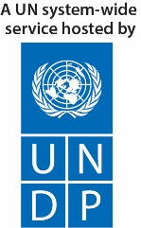 | 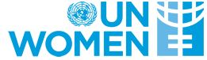  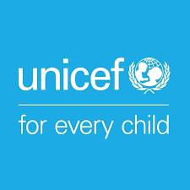 | 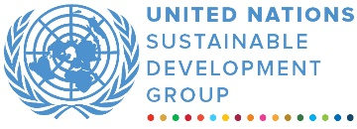
Joint Programme On Youth
MPTF Office generic annual programme narrative progress report
reporting period: 1 January – 31 December 2022

Programme Title & Project Number |  |  | Country, Locality(s), Priority Area(s) / Strategic Results
- Programme Title: Joint Youth Programme  - Programme Number (if applicable)  - MPTF Office Project Reference Number: 00120076 |  |  | Country/Region RWANDA
Priority area/ strategic results
- UNSDCF Outcome 1, 3,6

Participating Organization(s) |  |  | Implementing Partners
- Organizations that have received direct funding from the MPTF Office under this programme  UNDP-UNFPA-UNICEF-UNWOMEN |  |  | Ministry of Youth and Culture, Ministry of Health, Ministry of Gender and Family Promotion, the Imbuto Foundation, FAWE
Programme/Project Cost (US$) |  |  | Programme Duration
Total approved budget as per project document:  MPTF /JP Contribution:  - by Agency  Agency Contribution  - by Agency (if applicable) | $7,278,541  230,997.15 (UNFPA 4th tranche)  150,000.09 (UNICEF 4th tranche)  107,000 (UNDP 4th tranche)  117,282 (UNWOMEN 5th tranche)  3,271,314 USD (Outcome 1)  311,766 (Outcome 2)  1,657,139 (Outcome 3) |  | Overall Duration (months) Original End Date (dd.mm.yyyy)  Current End date(dd.mm.yyyy) | 54  June 2023  June 2024
Government Contribution  (if applicable) | 1,100,000 USD (In kind)
Other Contributions (donors)
(if applicable)
TOTAL: | 5,845,501
Programme Assessment/Review/Mid-Term Eval. |  |  | Report Submitted By
Assessment/Review - if applicable please attach  Yes No Date: dd.mm.yyyy  Mid-Term Evaluation Report – if applicable please attach  Yes No Date: January .2023 |  |  | - Name: Nicolas Schmids  - Title: Programme Analyst  - Participating Organization (Lead): UNDP  - Email address: Nicolas.schmids@undp.org

List of Acronyms

AFCTA: African Continental Free Trade Are
ASRH: Access to Sexual and Reproductive Health
BDF: Business Development Fund
DOT: Digital Opportunity Trust
FAWE: Forum for African Women Educationalists
GenU: Generation Unlimited
HIV: Human Immunodeficiency Virus
ICT: Information and Communication Technology
LODA: Local Administrative Entities Development Agency
MIGEPROF: Ministry of Gender and Family Promotion
MINAGRI: Ministry of Agriculture and Animal Resources
MINEDUC: Ministry of Education
MINICT: Ministry of ICT and Innovation
MININFRA: Ministry of Infrastructure
MYCULTURE: Ministry of Youth and Culture
MoU: Memorandum of Understanding
NCDA: National Child Development Agency
NGO: Non-governmental Organization
PSF: Private Sector Federation
RBC: Rwanda Biomedical Center
RDB: Rwanda Development Board
RMF: Road Maintenance Fund
RTDA: Rwanda Transport Development Agency
TVET: Technical Vocational Education Training
UHC: Universal Health Coverage
UNDP United Nations Development Programme
UNFPA: United Nations Population Fund
UNICEF: United Nations Children's Fund
UNWOMEN: United Nations Entity for Gender Equality and the Empowerment of Women
UNSDCF United Nations Sustainability Development Cooperation Framework
VSLA: Village Savings and Loan Association
WASH: Water Sanitation and Hygiene
WEM-TECH: Women Empowerment through Technology

EXECUTIVE SUMMARY
The Joint Youth Programme (JYP) contributed to the economic empowerment of young men and women with a particular attention to the most vulnerable. In 2022, it contributed to the creation of 8,899 (5,753 men; 3,146 women) jobs for young men and women. The JYP also increased the capacity of 1,535 (549 Men and 986 Women) young entrepreneurs through different competitions and trainings including the support to Young women and girls (135), the YouthConnekt Boot Camp/Awards for young entrepreneurs at national and province levels (180), the Bootcamp for refugees (217), the support to vulnerable youth (840), Art-Rwanda initiative bootcamp (147) and the TVET Youth Challenge (36). Their capacity was built in development of business plans, access to finance, marketing, pitching and leadership, and contributed to improving the profitability and sustainability of their businesses as well as to supporting the scaling-up of their projects. In October, the 5th annual YouthConnekt Africa (YCA) Summit engaged 10,000 young people across Africa and beyond, with the objective of advancing solutions to issues crucial to the future of youth worldwide. The Summit was held in collaboration of all UN agencies involved in the JYP. It resulted in the production of a manifesto of African Youth on climate change which was presented at the United Nations Conference on climate change (UNFCCC, COP27) as well as in the commitment of most of the 22 Ministers of Youth from across the continent present in Kigali to increase their investment in their youths. In the field of Health, particular attention was given to providing access to information on Sexual Reproductive Health (SRH) among the youth. Community-based radios, social media and interpersonal communication were used to reach 60,000 adolescents and young people in and out-of-school with information on HIV and sexual and reproductive health rights (SRHR) and 23,000 adolescents and young people received HIV testing services. Through the i-accelerator initiative, 991 youth-led solutions were received to address the challenges related to SRH, sexuality education, family planning, maternal health and other population development issues (phase 4 and phase 5) out of which 43 were supported through seed funding, training, and skills development. Support was also provided to review, adapt, and develop guidelines and training tools for ensuring quality SRH information and services for adolescents and young people. Finally, the capacity of Health care providers’ and teachers has also been built (60 trained) through supportive supervision and mentorship as well as eLearning platforms on the continuity of essential health services, including SRH.

Purpose

The JYP contributes to the achievements of the Outcomes 1,3,4,6 of the UN Sustainable Development Cooperation Framework (UNSDCF 2018-2024):
- Outcome 1: “By 2024 people in Rwanda benefit from more inclusive, competitive and sustainable economic growth that generates decent work and promotes quality livelihoods for all” and its indicator 1.1. “Number of new decent jobs created”.
- Outcome 3: ‘’By 2024 people in Rwanda, particularly the most vulnerable, enjoy increased and equitable access to quality education, health, nutrition and WASH services’’.
- Outcome 4: “By 2024, people in Rwanda, particularly the most vulnerable, have increased resilience to both natural and man-made shocks for a life free from all forms of violence and discrimination”.
- Outcome 6: “By 2023, people in Rwanda participate more actively in democratic and development processes and benefit from transparent and accountable public and private sector institutions that develop evidence-based policies and deliver quality services.”

The Joint Youth Programme has mainly 3 key objectives (JYP Outcomes):
(1) increased youth (girls and boys) access to decent jobs in Rwanda;
(2) empowerment of youth to fully engage in policy-making and civic engagement;
(3) increased youth use of health services and adoption of healthy lifestyle practices.

These JYP objectives are also aligned with the UN’s renewed Youth Strategy, contributing to the advancement in Rwanda of each of the Strategy’s three pillars: peace and security, human rights, sustainable development. It is also aligned with the African Union’s Vision 2063 and the SDGs. The JYP’s strategy to promote skills development and job creation aligns with the Rwandan Government’s Agenda 2020, the National Strategy for Transformation and the National Youth Policy. JYP Outputs contributing to the achievement of these objectives include increased employability and skills development for youth; the establishment of youth-friendly policies, informed by youth engagement with policy-makers; increased youth demand for employability skills; robust programme management support and data collection on program impacts; youth skills development to participate in civic engagement and policy dialogue; increased capacity of youth-focused organizations to support youth engagement in policy dialogue; increased youth access to health services by training more teachers and health centers to offer youth-friendly services; and increased youth awareness of health services and healthy life choices. Cutting across these outputs, the Programme focuses on strong partnerships, in particular with the Ministry of Youth and Culture (MYCULTURE), the Imbuto Foundation, the Ministry of Health, the Ministry of Gender and Family promotion, the National Youth Councils, CSOs and the Private sector.

Results

Outcome 1: Young people in Rwanda (boys and girls) have increased access to decent jobs.
Output 1.1: Youth have increased employability/job-related skills and entrepreneurship knowledge

Support to Rwanda Career Women’s Centre
In 2022, with the support of UNWOMEN through the JYP, technical and financial support was provided to the newly set up Rwanda Career Women Centre to enhance young women’s digital literacy, entrepreneurship, and coaching skills to effectively engage and benefit from a digitized world. Specifically, 30 women were supported to increase their skills in Clarity 4D to help improve teamwork, communication and productivity. 30 young girls increased their knowledge on business development, employability skills, entrepreneurship as well as transformational leadership skills. 15 out of the 30 women and girls secured jobs as they started their own business. In addition, the 30 women increased their skills in coaching and mentorship in various sectors, including leadership and entrepreneurship. The coaches are now linked with graduates and as a result, 25 women have developed their business plans which were submitted to the Business Development Fund (BDF) to access loans. So far, the business plans have been accepted and awaiting final disbursement from BDF.

Empowerment of young Women and Girls in STEM, digital literacy and leadership
In 2022, with the support of UNWOMEN, 60 young women and girls increased their skills in the field of computer programs, leadership, and entrepreneurship through a 16-week intensive training. Among them, 10 young women who completed the program with outstanding performance in programming was awarded full- time jobs as junior software developers. In addition, 10 students with outstanding performance from low-income families were awarded with laptops to support their learning and enhance their employability.
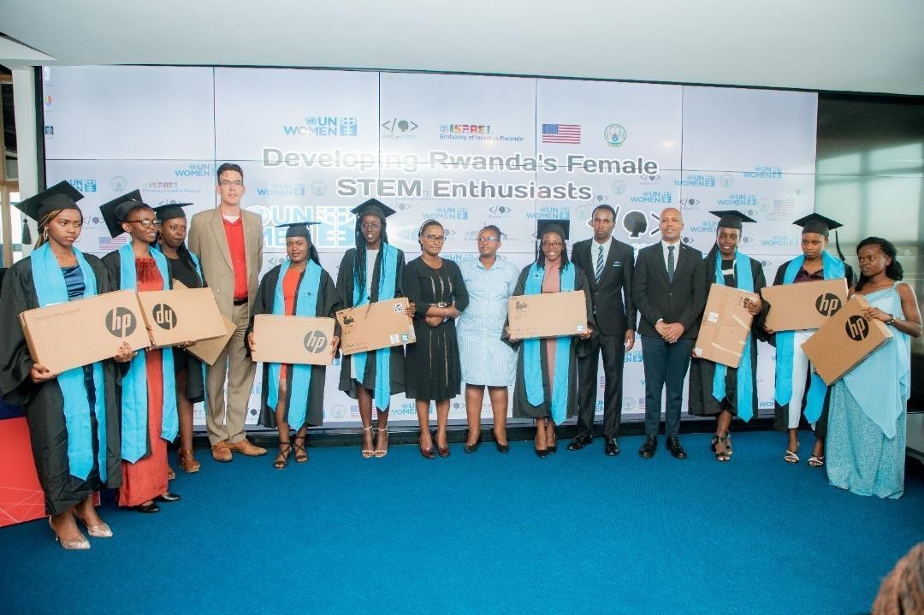

10 students awarded with computers to support their learning and job creation.

Training of young women entrepreneurs for career development and business management
With the support of UNWOMEN, 25 young women and girls from the Catholic University of Rwanda were provided with Entrepreneurship and Communication skills as a result of a training on access to business opportunities as well as job creation. Specifically, the trained young women and girls improved their skills in the following: Development and management of businesses; Development of good business idea in the field of ICT and Development of business activities action plan. The selected young women and girls enhanced their skills and created publisher documents; business cards (invitation cards); installed windows 7 using VMware; installed windows 10 using Physical machine; repaired operating system, etc.

Support of Vulnerable young entrepreneurs
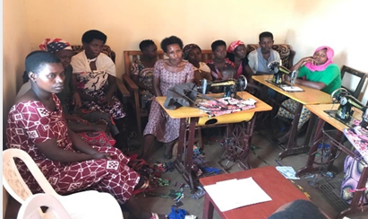
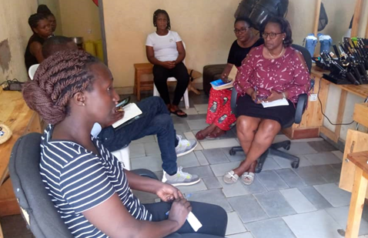
In 2022, with the support of UNDP, 840 young vulnerable entrepreneurs (665 women, 175 men) grouped in 41 cooperatives from 7 districts (Kirehe, Ngoma, Nyamagabe, Karongi, Ngororero, Rwamagana and Ruhango) were provided with working capital (including financial support to rent their workshops), training and start-up toolkits to set-up their business and generate income in the field of tailoring, shoe making, hair dressing as well as other fields as per the needs of some specific areas. These beneficiaries include 388 teen mothers, 144 youth with disability (80 women and 64 men) and 308 (197 women, 111 men) other vulnerable youth trained in youth centres. Since the initiation of this activity in 2020, a total of 3,267 vulnerable youth (2,891 women; 376 men) have been supported.

Vulnerable Groups Supported in Hair Dressing (Left) and Shoes Making ( Right)

YouthConnekt bootcamp/awards (national bootcamp, bootcamp for refugees, TVET Youth Challenges)
With the support of UNDP, a total number of 580 (374 Men and 206 Women) youth were trained, awarded/supported in different YouthConnekt bootcamps/awards including the YouthConnekt Boot Camp/Awards for young entrepreneurs at national and province levels (180), the Bootcamp for refugees (217), Art-Rwanda initiative bootcamp (147) and the TVET Youth Challenge (36). Through the bootcamps and with the support of national partners from the civil society and private sector (RDB, Imkomoko, BDF, DOT Rwanda, etc.), the young entrepreneurs gained entrepreneurship skills, scalable project development and management skills, as well as toolkits and cash prizes to boost their businesses. Their capacity was built in development of business plans, access to finance, marketing, pitching and leadership, etc. Those contributed to improving the profitability and sustainability of their businesses as well as to supporting the scaling-up of their projects. Out of those 580 young entrepreneurs trained, 236 youth were awarded with seed funding capital to support the scaling-up of their businesses.
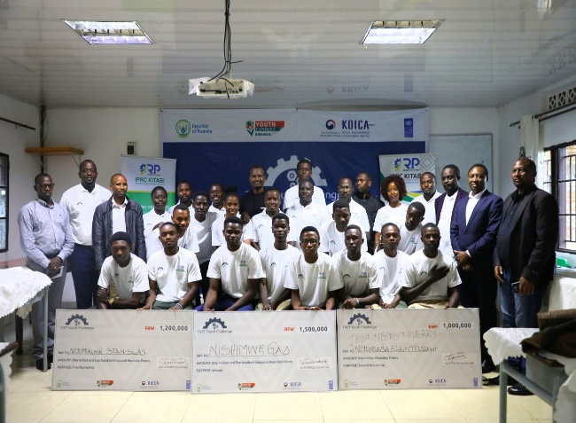
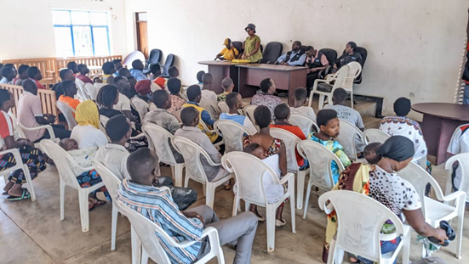

Training of young entrepreneurs’ refugees, 15-16 November 2022 (left); Winners of TVET Youth Challenge, IPRC Kitabi (right)
YouthConnekt Ecobrigade
With the support of UNDP in 2022, the Eco-brigade initiative continued with the routine work of environmental conservation activities on ground in three districts namely Karongi, Muhanga and Ngororero. 299 jobs (153 women, 146 men) were created through different rehabilitation of ecosystem and environmental protection activities like terracing, forest restoration, and reforestation. The activities also contributed to sustaining and covering the set areas from previous years.
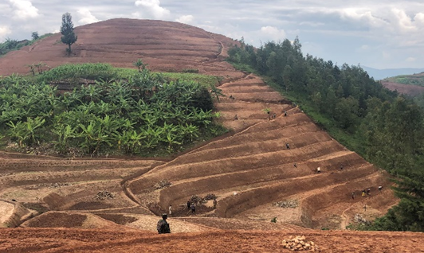
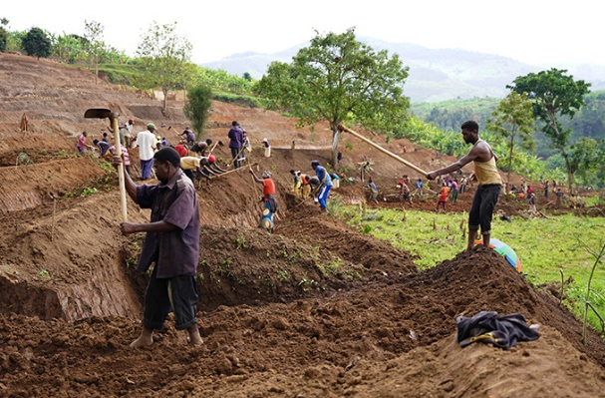

Terracing work by Eco-brigade beneficiaries,2022
The youth cultivated terraces 912 ha (512ha radical and 400ha progressive) of land, 332km of riverbanks were planted with bamboo. The activities of these youth cooperatives were monitored by 24 Ecobrigade volunteers who were employed for this purpose. Cumulatively 11,889 (6,685 women and 5,204 men) jobs were created since the inception of the program in 2019. In addition to the efforts of ensuring sustainability of established businesses from their respective savings, 20 cooperatives have been selected to receive seed funding considering their best performance on saving that will boost their projects and create more impact for communities.
YouthConnekt mentorship training program
The YouthConnekt mentorship with the support of UNDP seeks to provide additional mentorship services to support the youth-led SMEs at a more advanced stage. It provides skills to support their growth, sustainability, and regional competitiveness as well as seed funding to past YouthConnekt beneficiaries. In 2022, the programme provided both joint training to address needs and challenges faced by the entrepreneurs. 420 (296 Men and 124 Women) Young entrepreneurs were provided with customised mentorship sessions with experienced business personalities (role models) from their similar areas of commerce to tackle individual needs as well as have timely guidance to ensure proper growth of youth led businesses. This forum was held at IRPC MUSANZE (Musanze District, Northern Province) from 1st to 6th December 2022.
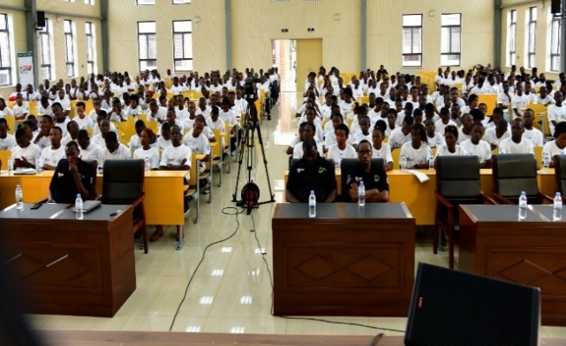
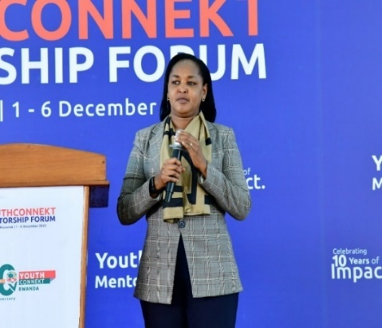

Honorable Minister addressing young entrepreneurs (left); training of young entrepreneurs, Musanze, December 2022
More than 10 facilitators from various partners including (PSF, RRA, SINA Gerard Urwibutso Enterprise, Volcano, MIFOTRA, RMF, RSB, RTDA, RCA, BDF, LODA and MINICOM), all settled to provide skills, knowledge and facilitate the exchanges for stronger collaborations between attended young entrepreneurs.
Support to scaling-up of YouthConnekt across Africa
In 2022, with the joint support of all UN agencies involved in the JYP, the 5th edition of the YouthConnekt Africa Summit was successfully organized in Kigali from 13th -15th October. Inspired by the African Union's theme of the year, this year's summit focused on building the resilience of young people on the African continent to accelerate human capital and socioeconomic development. 10,000 African youth, 22 Ministers of Youth and 5 heads of states attended this year’s Summit to discuss and chart a way forward on how to involve the youth in Africa’s trade, health, climate resilience and financing, technology, skilling for the future and other topics that are critical for a sustainable future.“YouthConnekt has become a powerhouse, bringing together thousands of young people each year, to contribute to solutions and to learn from each other.” H.E. Paul Kagame, President of the Republic of Rwanda.
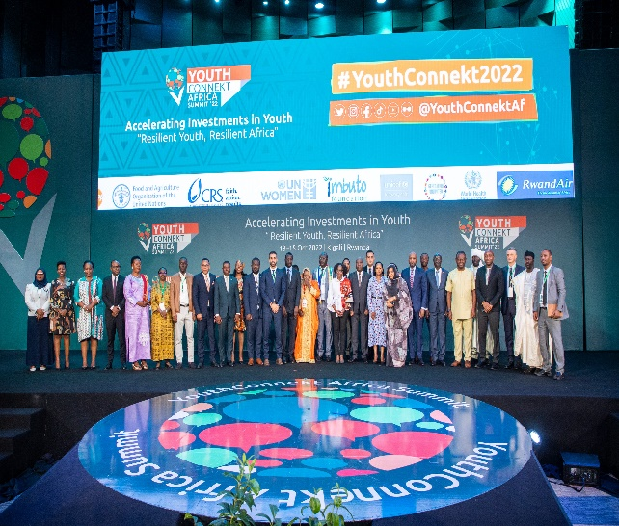
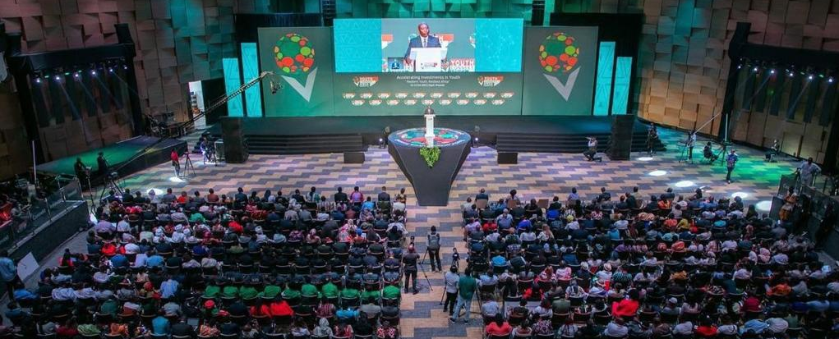

High level participants attending the closing ceremony of 2022 YouthConnekt Africa Summit
Output 1.3: Increased youth demand for employability skills
YouthConnekt monthly hangout sessions/ TV show
The Hangout is an efficient virtual engagement for a good number of young people in different remote areas, organized in the form of a panel discussion including debates and opportunity sharing sessions, the virtual interactions provide an open space for the young people mainly from universities to be informed on available opportunities and emerging issues. Youth were able to engage with specialists on those different societal and economic issues. Interactions are made through Google Hangout, where young people communicate with their peers, leaders, and role models remotely. In 2022, with the support of UNDP. 7 Hangouts sessions took place.

In 2022, with the financial support of UNDP in partnership with MYCULTURE and the Rwanda Broadcasting Agency (RBA), 52 episodes of Inspire me-Isaha y’Urubyiruko were aired at Rwanda Television (RTV). This weekly show has been designed to motivate youth to embrace entrepreneurship as one major way to tackle unemployment. It shares the stories of young entrepreneurs allowing them visibility as well as sharing their testimonies, journey, lessons learnt, and common challenges shaped in a format to influence and guide others. The TV shows aired in 2022 covered a variety of topics including: Saving for investment; Creative industry and job creation; Cross border trade opportunities for youth between Rwanda and DRC; Youth and job creation; YouthConnekt Africa Summit; Opportunities for youth from Commonwealth family; Youth mental health; AfCFTA opportunities for youth; Creative industry, etc.

Outcome 2: Young people in Rwanda are empowered to fully participate in policy making and civic engagement in Rwanda

Output 2.1: Young people are equipped with knowledge and skills for increased participation in civic engagement and policy dialogue

YouthConnekt Month and Holiday programme
The YouthConnekt Month and Holiday programme has been a platform for the young people to demonstrate their potential to contribute to the development of the country. Within that framework, the Road Maintenance program was initiated in 2020 aims to contribute to better livelihood and development of local communities. The programme aims to identify and select young engineers for the day-to-day maintenance of unpaved roads across the country. In 2022, with the support of UNDP, the 153 recruited companies composed of 459 young engineers maintained 2,060 km of unpaved roads countywide. In total, the programme has created 7,760 jobs (5,432 men; 2,328 women). The Ugandan Minister of Youth has visited the road maintenance site during CHOGM 2022 and acknowledged the impact the programme on local infrastructural development.
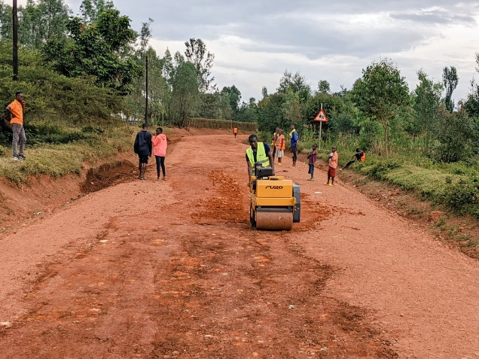

Youth engaged in road maintenance activities,2022.
Strengthen youth participation in budgeting and planning.
With the support of UNICEF, more than 14,827 children and young people were reached and engaged in decision making processes in 2022, mostly on planning and budgeting and in community dialogues. In addition, more than 12,000 children in secondary school were sensitized about ‘Vision 2050: The Rwanda We Want’. Children/Young adolescents’ representatives from 3 districts (Kirehe, Kicukiro and Gasabo) took part in the budget hearing and budget consultations with parliamentarians. Children (Young adolescent from 13 districts were provided with knowledge and capacities in leadership, communication, planning and advocacy. In addition, 404 youth from different universities in Rwanda were exposed to infographics and socioeconomic statistics which improved their knowledge and ability for meaningful participation. 100 youth (50% female, 50% male) from various youth organizations were trained on the Youth Advocacy guide (YAG) with the purpose to increase their advocacy skills to advance their respective missions.

Outcome 3: Youth in Rwanda have increased utilization of health services and adopt healthy and safe attitudes and behaviours, including in humanitarian settings.

Output 3.1: Youth have increased access to health information and services.

Support review Adolescent Sexual and Reproductive Health (ASRH)/Family Planning Strategic Plan
With the support of WHO, the mid-term review of Adolescent Sexual and Reproductive Health (ASRH)/Family Planning Strategic Plan was imitated in 2022 as well as the situation analysis on Adolescent health to ensure that the new information which became available to support the implementation of the fourth Health Sector Strategic Plan. This will inform the development of a Comprehensive Adolescent Health Strategy to provide a positive environment to address major adolescent health conditions and risks factors that go beyond ASRH and provide guidance on the implementation of evidence-based interventions and human rights-based approaches highlighted by AA-HA! flagship. In addition, support was also provided to conduct an operational research on factors affecting access to ASRH information and services to feed into the development of this strategy.

Support development, validation and dissemination of SRH guidelines
With the support of WHO, the JYP contributed to the development, validation and dissemination of a number of SRH guidelines, including: 1) Family planning guideline and standards; 2) Medical eligibility criteria for contraception; 3) National protocol for comprehensive abortion care services; 4) Standard Treatment Guideline (STG); and 5) Essential Medicine List (EML). These guidelines ensure the provision of quality SRH services to achieve UHC especially for adolescents and youth. Further, an Adolescent Reproductive Health Training manual was developed and is being used to improve the capacity of health care providers to provide quality Adolescent friendly health services. It is based on WHO SRH competency-based framework in pre-service training and will capacitate health care providers with the knowledge and skills to mainstream SRHR in UHC.

Support capacity building of health practitioners on SRH
With the support of WHO, 60 trainers were trained in 2022 (including health care providers from district hospitals and health centres) on comprehensive abortion care and post abortion care to improve the quality of abortion care provided to women and girls. In line with this, mentorship to health care providers on ASRH was conducted in 50 health centers of Kirehe, Kayonza and Burera Districts with the aim to further build their capacity in providing quality SRH care centered around adolescent health needs. WHO also worked closely with the Medical Students Association of Rwanda (MEDSAR) on the organization of the SCOPH Africa Summer School 2022 held from 18th to 25th September under the theme “Digital Health towards health system strengthening in post pandemic era”. The summer school hosted a total of 85 medical students from medical students from Burundi, Cameroon, Ethiopia, Germany, Rwanda, Sierra Leone, Sudan, and Zimbabwe to participate in the course. Discussions focused on SRHR, communicable and non-communicable diseases and included outreach services for screening of communities on SRHR, communicable and non-communicable diseases. Medical students have also been trained on training of trainers on TNT and a Public Health Leadership Training. WHO also supported MEDSAR in their 25th anniversary where medical students discussed the role of youth in UHC, including SRHR. The Medical students were enlightened on their role in attainment of Universal health Coverage. Moreover, to support youth-led organizations leading ASRH activities, WHO collaborated with the Health Promotion Organization (HPO), in collaboration with University of Rwanda Public Health Students Association (URPHSA), to hold a 2-day training of trainers on the Ishema Ryanjye Card Game from 5th to 6th November 2022 in Kigali. The training capacitated trainees to implement the Ishema Ryanjye Card Game and equipped 20 trainees with knowledge and skills on SRHR.

Increase access to HIV Self Testing among hard-to-reach vulnerable adolescents and young people
With the support of UNICEF, Community-based radios, social media (9,349 SMS, calls and Facebook comments) and interpersonal communication were used in Huye and Kirehe Districts to reach a wider targeted audience with information on HIV and sexual and reproductive health rights (SRHR) (response and prevention), reaching 60,000 adolescents and young people in and out-of-school had been reached by peers through interpersonal communication, home visits, group sessions and in schools, and 23,000 adolescents
and young people had received HIV testing services. In Kirehe district, 240 Youth volunteers / peer educators including 144 females (representing 60%) were selected from 12 sectors (20 per sector) and their database was set up before the training sessions. The 240 selected youth volunteers / peer educators were trained on SRH, HIV and STIs prevention, GBV and life skills in all 12 sectors. During the reporting period, UNICEF and HIV implementing partners in Huye reached a total of 987 (510 female and 477 male), adolescents and young people received individual HIV risk assessment, among them 366 living in hard-to-reach areas (females and males) tested for HIV with 2 testing positive. Furthermore, 1,824 (450 female and 1374 male) adolescents and young people received condoms distributed in Huye district. The existing pool of community-based youth volunteers’ databases were updated and currently there are 138 trained youth volunteers. In Huye District, 366 youth in hard-to-reach areas received HIV self-testing kits and two individuals tested positive.

Build the capacity of community adolescent peer volunteers to deliver combined HIV prevention interventions and support services for adolescents living with HIV
With UNICEF Technical and financial support, 240 volunteers including 144 females (representing 60%) were trained on SRH, HIV-STIs prevention and life skills. This included the provision of job aids and communication materials and providing equipment for the District Youth / Yego Centre. With technical support of UNICEF and in collaboration with Rwanda Biomedical Center, training sessions were offered to 12 health care providers and 22 peer educators to integrate individual HIV risk assessment in routine HIV testing services and share HIV self-testing and provide HIV risk assessment and HIV self-testing services at health centers in the district.

Output 3.2: Youth have increased awareness of available health services and are equipped with knowledge and skills to make informed decisions on their health

I-Accelerator
The Innovation Accelerator (iAccelerator) is a mentorship driven acceleration programme, supporting young entrepreneurs with seed funding, training, and skills development to generate innovative solutions in response to challenges related to sexual and reproductive health, sexuality education, family planning, maternal health and other population development issues. In 2022, with the support of UNFPA, a total of 43 youth gained pitching skills , as part of the selection process of the 490 youth-led innovative solutions received on the iAccelerator phase 4 and 501 in phase 5. Two innovation challenges were the focus on in phase 4, namely; Mental Health and ASRH whereas iAccelerator phase 5 focused on promotion of family (parent-children and adolescent) dialogue on SRH and innovative approaches aiming at reducing mental health and enhancing access to information and services. A 6-day bootcamp was organized for the top 10 projects where Digital Opportunity Rwanda equiped the young innovators with business skills to further develop their projects. Training was providing in writing a business plan, conducting group research, and pitching a business idea. A 6-month mentoring programme for iAccelerator phase 4 was also conducted covering the topics of business management, accounting and finance skills, procurement skills and taxation. As the winning innovators work towards growing their projects into impactful and lucrative start-up organizations, they benefited from extra guidance in business and management training. Similar training was provided to iAccelerator phase 5. The 23 young innovators in phase 5 completed the training session of six days of boot camp supported by DOT Rwanda coaches. The participants were also offered informative sessions on ASRH and Mental Health to help them use evidence-based knowledge while fine-tuning their projects. Thanks to the boot camp, business plans of the participants were drafted, and their pitch presentations were made more soundly and confidently.
Engaging Youth on issues affecting them through Youth Forum Series
Prior to the final pitching and award ceremony, Imbuto Foundation in partnership with UNFPA and MYCULTURE organised a Youth Forum to discuss issues pertaining to the theme “Addressing Socio-Cultural Barriers Affecting Mental Health and Sexual & Reproductive Health.” The Forum served as a platform to generate ideas and sharing of good practice/success stories in place to prevent and manage mental health issues and addressing prevailing social barriers to accessing sexual and reproductive services from young people’s lenses. The youth forums helped young innovators to improve their projects after gaining insight from their peers, Imbuto Foundation and UNFPA. Upon completion of the bootcamp, young innovators from the top 10 winning projects were given the opportunity to showcase their refined innovations. The following 4 solutions emerged top best from the competition and were awarded US$ 10,000 each: Bohoka App; JoCare ; Tele-Mental Health application and URUNGANO Best Friend Book.

Empower adolescents to understand and prevent protection related issues (including VAC, GBV and rights of child with disability)
Community outreach was promoted with the support of UNICEF in collaboration with youth volunteers and health centers (37 outreach events were organized at cell level) and 3,400 adolescents. The aim was to further sensitize communities and increase awareness of the importance of continued access to health services including HIV services. Outreach also promoted prevention of HIV and reinforced the importance of addressing health challenges among adolescents and young people. Through partnership with local NGO CLADHO, UNICEF supported the National Child Development Agency (NCDA) to train 252 adolescent peer facilitators (143 girls, 109 boys including some living with disabilities) to understand and participate in the prevention, identification and reporting of VAC and GBV. Training significantly raised levels of knowledge on VAC/GBV. A rapid endline survey conducted in four districts showed that all trained children (100%) are now able to identify at least three child protection violations, and correctly list reporting channels. Post-training, all children knew where to get help should they experience or witness abuse, violence, or neglect, compared to 17% of girls and 23% of boys pre-training. Through a cascading model delivered through peer facilitators, 1,580 additional adolescents (905 girls, 675 boys) were reached. Trained adolescents developed action plans including activities such as advocating for other children’s rights, setting up and facilitating clubs, and contributing to the identification and reporting of VAC cases through existing reporting channels. In addition, 2,075 adolescents (1,576 girls and 499 boys) participated in adolescent-led community dialogues to raise awareness of their rights including VAC/SGBV and linking them with service providers.

Child Protection service providers are able to deliver quality of adolescent friendly protection services, including referrals to other services at all levels.
With the support of UNICEF, a total of 67 children and young people with disabilities (45 female and 22 male) were placed in family care. The NCDA continued to identify and support families that are at risk of new or renewed separation through linking them with various services including birth registration, social protection, education and health referrals. In two districts under pilot for inclusive care reform, parents of 6,689 children with disabilities received training, and have been enrolled in 146 peer support groups. All 6,689 children with disabilities being identified in the two districts were referred for services. In addition, a total of 211 long-term foster parents (55 males and 156 females) were identified and 81 received pre-service training to orient them on their roles and responsibilities as foster parents. The districts will keep providing training to the foster parents.

Output 3.3: Girls and boys including vulnerable children have improved gender equitable opportunity in education.

Increase awareness to address negative social norms towards girls' education.
With the support of UNICEF, a comprehensive approach to communication and digital engagement, using popular social media channels (including Facebook, Instagram, YouTube and WhatsApp) was used in 2022 to communicate and engage with target groups identified for this partnership, to challenge existing social norms. In partnership with URUNANA Development Communication (DC), UNICEF produced and aired 60 episodes on education with 40 specific themes on girls’ education and girls in science, technology and maths (STEM) subjects. The purpose was to generate demand for education services and inclusive education, remove barriers to girls’ education and promote school readiness.

Establish model remedial education programme
With the support of UNICEF, targeted schools were able to deliver remedial learning sessions during normal days and at weekends. The programme follows structured teacher mentors’ resource documents and the holiday programme guide, developed by the REB with support from the Imbuto Foundation, UNICEF and Inspire, Educate and Empower (IEE). In total, 24,261 learners (16,423 girls) accessed remedial education to improve their foundational skills, a cornerstone for future learning. Remedial education was supported by 201 educators trained on formative assessments, remedial education, and gender-responsive pedagogies. Some 402 community education workers were engaged to track and support retention of children, especially adolescent girls identified to be at risk of irregular school attendance or dropping out.

Support school to work transition.
UNICEF in partnership with the Rwanda Basic Education Board (REB) the Career Pathways guide was developed, validated, and approved. A total of 2000 copies were printed and distribution to schools has started. The guide provides students with information on career guidance and pathways, giving adolescent girls the information, they need to make informed choices for their future. To support MINEDUC/REB to provide appropriate career guidance and counselling, 51 REB staff and 1,489 teachers and directors of studies were trained to raise awareness among young learners of the influence of social factors, behavior and personal attitudes on their futures.

ii) Indicator Based Performance Assessment: Using the Programme Results Framework from the Project Document / AWP - provide an update on the achievement of indicators at both the output and outcome level in the table below. Where it has not been possible to collect data on indicators, clear explanation should be given explaining why, as well as plans on how and when this data will be collected.

 | Achieved Indicator Targets | Reasons for Variance with Planned Target (if any) | Source of Verification
Outcome 1 Young people in Rwanda (boys and girls) have increased access to decent jobs.  Indicator: # of youth in new employment  Baseline:8,309  Planned Target: 24,209 (cumulative)  Indicator: # of youth owned business supported  Baseline: 580  Planned Target: 1,500 (cumulative) or 920 | Indicator: # of youth in new employment  In 2022: 8,899 (5,753 men; 3,146 women  Cumulative 34,298 (18,589 Men; 15,709 Women) |  | MYCULTURE 2022 Annual report
Output 1.1 Youth have increased employability/job-related skills and entrepreneurship knowledge  Indicator 1.1.1 # of young men and women equipped with entrepreneurial and soft skills  Baseline: 580  Planned Target: 3,600 (cumulative) | In 2022: 1,875 (1,291 women, 584 men)  Cumulative: 5,631  (3,901 women, 1,730 men) | NA | MYCULTURE 2022 Annual report, UNWOMEN report 2022
Output 1.2 Youth-friendly policies are in place to support youth’s access to decent jobs  Indicator 1.2.1 # of young men and women who participated in policy dialogue  Baseline: 23,398  Planned Target (cumulative): 30,000 | Achievement 2022: 0  Cumulative achievement: 23,919 |  | MYCULTURE 2022 Annual report
Output 1.3 Increased youth demand for employability skills  Indicator 1.3.1 # # of young men and women provided with internship/apprenticeship opportunities  Baseline: 0  Planned Target: 200 | In 2022: 299  Cumulative: 11,889 (6,685 women and 5,204 men) |  | MYCULTURE 2022 Annual report
Outcome 2 Young people in Rwanda are empowered to fully participate in policy making and civic engagement in Rwanda  Indicator # of M and F involved in policy making and civic engagement activities  Baseline: 2,024,067  Planned Target (cumulative):2,000,000 | In 2022: 7,760  Cumulative: 2,033,342 |  | MYCULTURE 2022 Annual report
Output 2.1 Young people, youth-led organizations and networks are equipped with knowledge and skills for increased participation in civic engagement and policy dialogue and advocacy  Indicator 2.1.1 # of young men and women involved in civic engagement activities/volunteerism within their communities  Baseline: 2,024,067  Planned Target:1,000,000 | In 2022: 7,760  Cumulative: 2,033,342 |  | MYCULTURE 2022 Annual report
Outcome 3 Youth in Rwanda have increased utilization of health services and adopt healthy and safe attitudes and behaviours, including in humanitarian settings.  Indicator: Teenage pregnancy rate (15-19 years)  Baseline: 7,3  Planned Target:6 | 5,2 | NA | (DHS 2019/2020)
Output 3.1 Youth have increased access to health information and services  Indicator 3.1.1 # of start-ups who completed acceleration programme  Baseline: 4  Planned Target: 11 | In 2022: 102  Cumulative: 155 | NA | UNFPA, 2022
Output 3.2 Youth have increased awareness of available health services and are equipped with knowledge and skills to make informed decisions on their health  Indicator 3.2.1 # of youth (girls and boys) reached with health and life skills messages.  Baseline: 284,000  Planned Target: 1,000,000 | Achievement 2022: 60,000  Cumulative achievement: 522,934 | NA | UNFPA, UNICEF 2022

iii) A Specific Story (Optional)
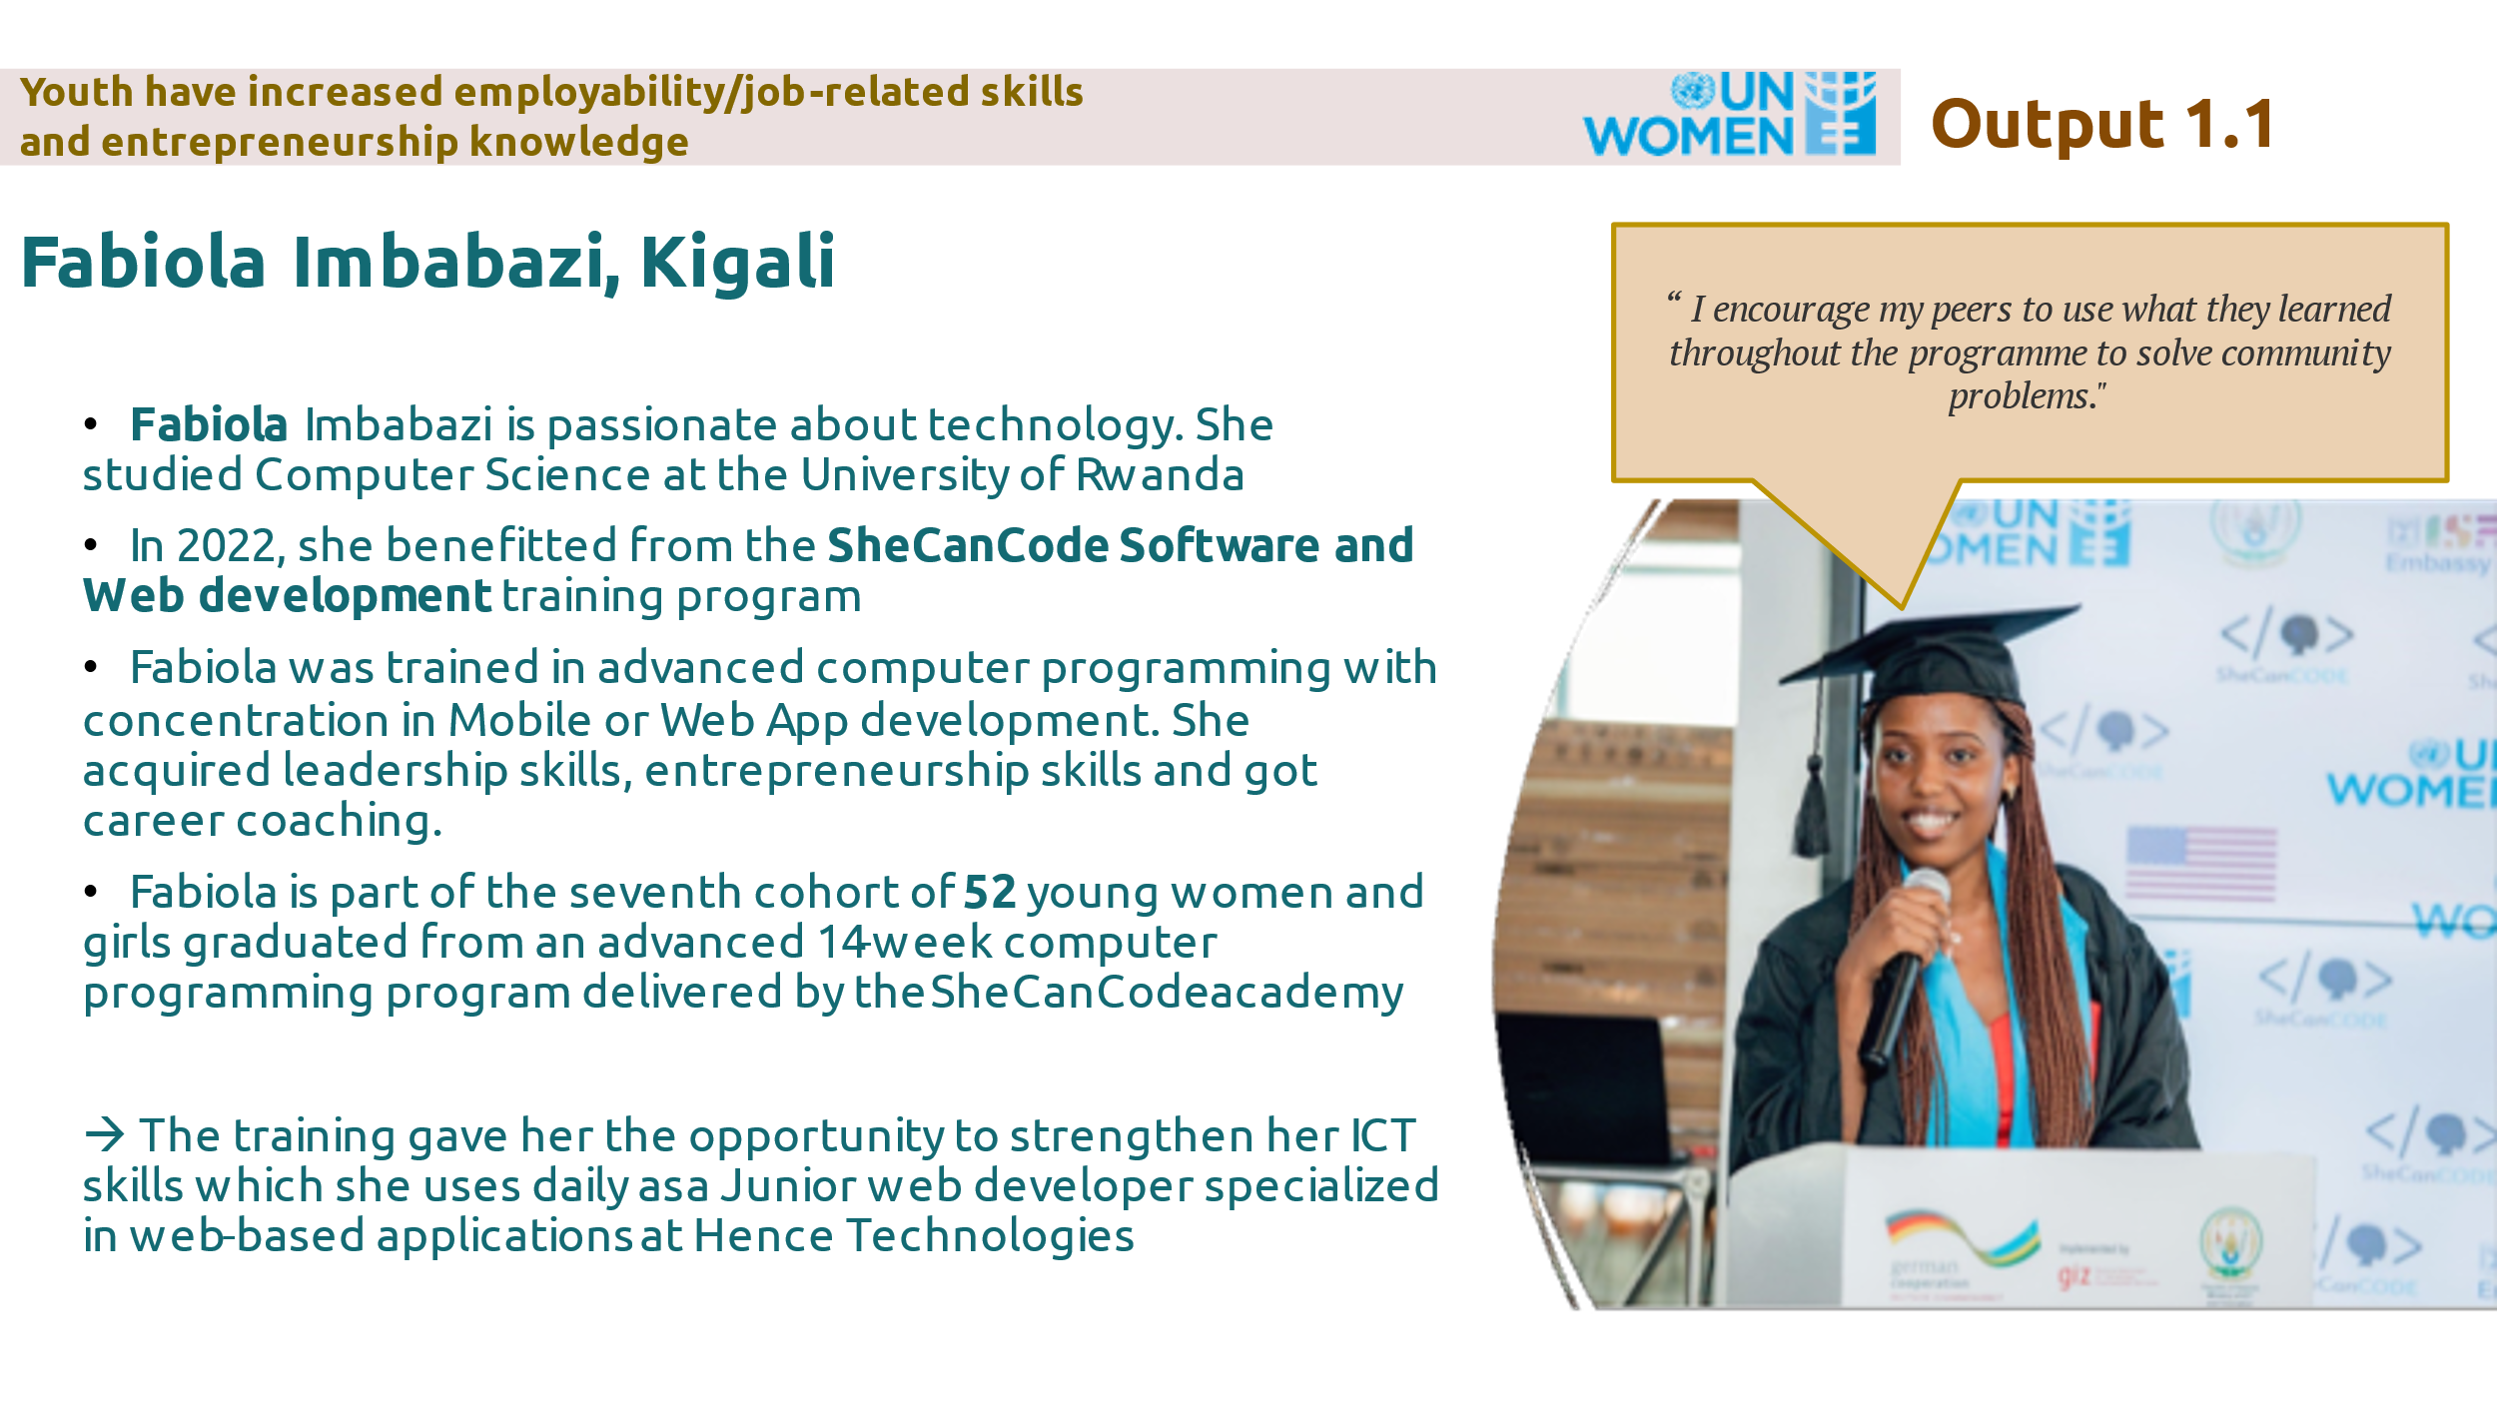

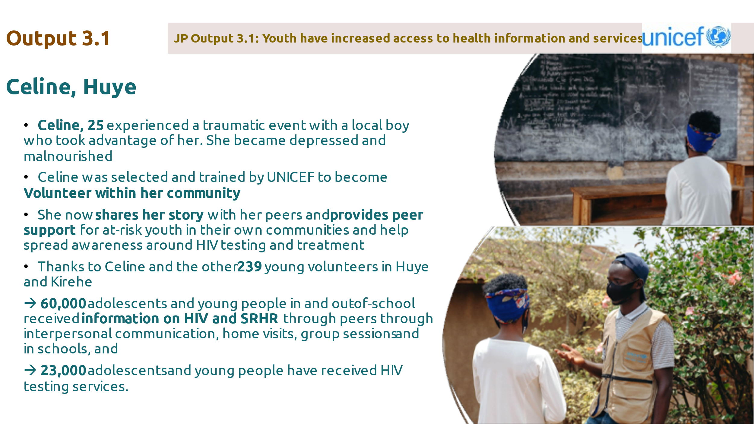

Problem / Challenge faced:

A common challenge faced by all partners of the Joint Youth Programme is to measure the impact of our intervention on the youth, especially the several trainings and competitions organized. There is a need to go beyond the number of youth trained in order to assess the transformative impact of the trainings, technical and financial support provided on the young men and women.

Programme Interventions: How was the problem or challenged addressed through the Programme interventions?

In 2022, The Joint Youth Programme technical team decided to replicate UNICEF’s best practice of using pre and post training knowledge tests to assess the impact of training on the youth.

Lessons Learned:
The successful collaboration and synergies between all UN agencies of the Joint Youth Programme contributed to a successful organization of the 5th edition of the YouthConnekt Africa Summit, the biggest Youth gathering at the continent engaged 10,000 young people across Africa and beyond, advancing solutions to issues crucial to the future of youth worldwide, to peace, and to the health of people and planet. All UN agencies mobilized their technical and financial support contributing to this success.

III. Other Assessments or Evaluations (if applicable)

A mid-term evaluation of the Joint Youth Programme was conducted in 2022 and aimed to : Assess the Programme’s implementation strategy ; Assess the relevance, efficiency, effectiveness, sustainability, and impact of the interventions; Assess the Programme’s processes, including budgetary efficiency; Assess the extent to which planned activities and outputs are being achieved; Identify the main achievements and impacts of the programme’s activities including the most successful initiatives to be scaled-up; Identify the underlying causes and issues of non-achievement of some targets; Document lessons learnt of effective approaches; Make recommendations for the next project cycle and make recommendations for strengthening the synergies among UN agencies and implementing partners. The final mid-term evaluation can be found in Annex 1.

The term “programme” is used for programmes, joint programmes and projects.
Strategic Results, as formulated in the Strategic UN Planning Framework (e.g. UNDAF) or project document;
The MPTF Office Project Reference Number is the same number as the one on the Notification message. It is also referred to as “Project ID” on the project’s factsheet page the MPTF Office GATEWAY
The MPTF or JP Contribution, refers to the amount transferred to the Participating UN Organizations, which is available on the MPTF Office GATEWAY
As per approval of the original project document by the relevant decision-making body/Steering Committee.
If there has been an extension, then the revised, approved end date should be reflected here. If there has been no extension approved, then the current end date is the same as the original end date. The end date is the same as the operational closure date which is when all activities for which a Participating Organization is responsible under an approved MPTF / JP have been completed. As per the MOU, agencies are to notify the MPTF Office when a programme completes its operational activities.
The discussions covered topics such as: YouthConnekt Hangout: Instilling heroism values amidst youth; YouthConnekt Africa Stakeholders Meeting; KWIBUKA28: Remembering former MIJEUMA employees perished during Genocide against Tutsi; KWIBUKA28: Youth Forum: A promise of a generation; YouthConnekt Awards and TVET Youth; Challenge Awarding Ceremony
Web/Mobile Application aimed at providing mental health (MH) services.
Friendly, educational Web & App platform that will allow young people, to discuss sexual reproductive health information through friendly, educational, online, and offline innovative tools
Mental health innovation that will integrate into the universal health coverage system in Rwanda; giving every citizen access to affordable MH education and services they need.
A storyboard book that provides reliable information on SRH & rights.
Note: Outcomes, outputs, indicators and targets should be as outlined in the Project Document so that you report on your actual achievements against planned targets. Add rows as required for Outcome 2, 3 etc.

