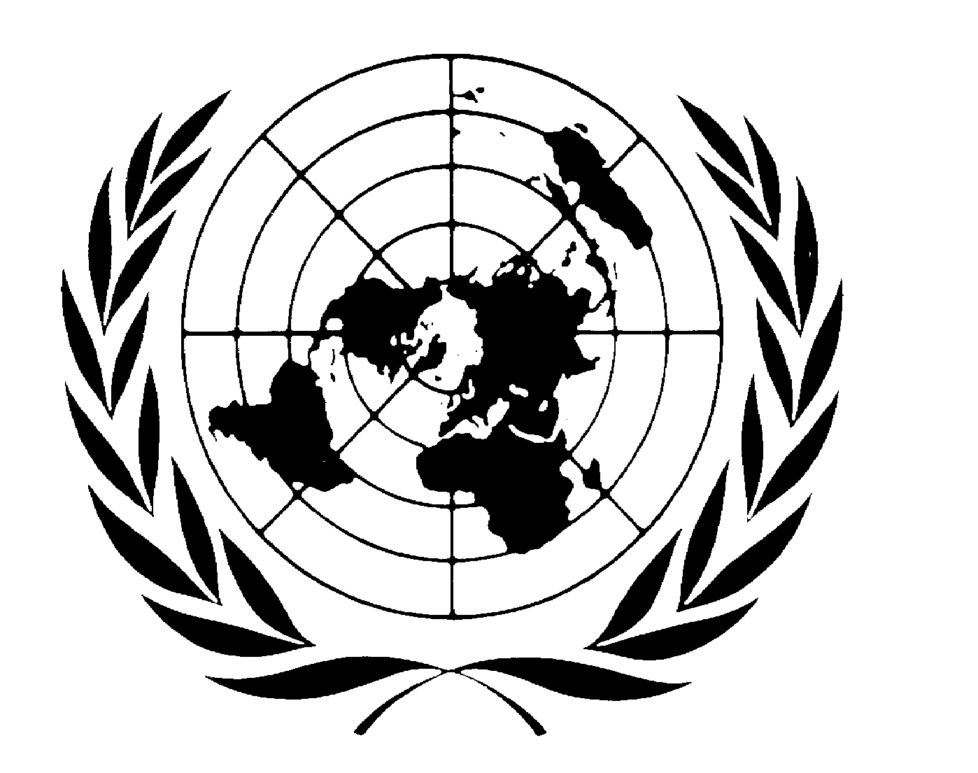

Peace building fund
Final PROGRAMME Narrative report

Programme Title & Number |  | Country, Locality(s), Thematic Area(s)
- Programme Title: Support to the Implementation of the Sierra Leone Reparations Programme as Part of the Recommendations of the Truth and Reconciliation Commission  - Programme Number: PBF/SLE/A-4  - MDTF Office Atlas Number: |  | Sierra Leone, Democracy and Good Governance

Participating Organization(s) |  | Implementing Partners
International Organization for Migration |  | National Commission for Social Action (NaCSA)

Programme/Project Cost (US$) |  |  | Programme Duration (months)
MDTF Fund Contribution:  - by Agency (if applicable) | 3,000,000 |  | Overall Duration | 15 months
Agency Contribution  - by Agency (if applicable) | - |  | Start Date | October 2008
 | - |  | Original end date | September 2009
Government Contribution  (if applicable) | 246,000 |  | Revised End Date,  (if applicable) | December 2009
Other Contribution (donor)  (if applicable) |  |  | Operational Closure Date | February 2010
TOTAL: | 3,246,000 |  | Expected Financial Closure Date | April 2011

Final Programme/ Project Evaluation |  | Submitted By
Evaluation Completed  Yes No Date: __________________  Evaluation Report - Attached  Yes No |  | - Name:  - Title:  - Participating Organization (Lead):  - Contact information:

FINAL PROGRAMME REPORT

- PURPOSE

The signing of the Lomé Peace Agreement in 1999 in principle heralded the end of the 10 year conflict in Sierra Leone. In a bid to translate the Peace Agreement into law and make peace more permanent, the Sierra Leone Parliament in 1999 ratified the Peace Agreement (The Lomé Peace Agreement Act No, Act 3 1999). Lome Peace Agreement - Article VI paragraph 2 (ix) provided for the establishment of the Truth and Reconciliation Commission (TRC) to address the causes and victims of the war. The TRC Act (Act No 4, 2000) passed by Parliament in 2000, expressly mandated the Commission to inter alia respond to the needs of the victims. Consequent upon this mandate, the TRC report recommended the establishment of a Reparations Program to be implemented by NaCSA. This project to a very large extent, kick-start the process of addressing the needs of the victims irrespective of the type of harm they suffered and meet the obligations of the Government, as specified in the Lomé Peace Accord and recommended in TRC Report

The main outputs of this project are:
- A special Unit for Reparations is established at NaCSA
- Staff and technical consultant recruited
- The reparations unit provided with logistics capacity to implement the programme
- Capacity of staff build on how to manage reparations
- Five year strategic plan developed
- Data base on the profile of war victims established
- Government, civil society and donors sensitized for continued support to the reparations programme
- War victims trust Fund established
- Reparation benefit delivery sub project were implemented.

The main outcomes are:
- Contributed to an enhanced capacity of the Reparations Unit to implement the Sierra Leone Reparations Programme
- Contributed to enhanced recognition and improved human dignity for victims of the civil conflict

This project is linked to the strategic planning framework for the consolidation of peace in Sierra leone. The signing of the Lomé Peace Agreement in 1999 in principle heralded the end of the 10 year conflict in Sierra Leone. In a bid to translate the Peace Agreement into law and make peace more permanent, the Sierra Leone Parliament in 1999 ratified the Peace Agreement (The Lomé Peace Agreement Act No, Act 3 1999). The TRC Act (Act No 4, 2000) passed by Parliament in 2000, expressly mandated the Commission to inter alia respond to the needs of the victims. Consequent upon this mandate, the TRC report recommended the establishment of a Reparations Program to be implemented by NaCSA.

In furtherance to this recommendation, the Government of Sierra Leone officially designated NaCSA as the Government’s lead agency to implement the said program and approved of the setting up of a
Reparation Taskforce comprising NaCSA (as Chair), UNIOSIL, Representatives from Civil Society,
Victims, the TRC and the Office of the Vice President to advice on the establishment of a Special Fund for War Victims and the implementation of a Reparations Program in the country.
The war witnessed massive suffering and devastation on the lives of many. In the execution of its
mandate, the TRC identified five categories of persons as victims of the conflict with respect to
Reparations to wit; amputees, war wounded, war widows, victims of sexual abuse and children.
The Reparations Taskforce with technical assistance from consultants (REDRESS, a London based
NGO with long experience in managing reparations and IOM from Geneva) has developed plans and
strategies to implement the Reparations Program including the setting up of the Reparations Unit,
establishing and operationalzing of the Special Fund for War Victims, identifying and development of a database on beneficiaries and identifying the policy and legal framework required to enhance the
effective implementation of the reparations for war victims. The final report prepared by the Task Force has been approved by Government and made public to major stakeholders. The implementation of this project has, to a very large extent, kick-start the process of addressing the needs of the victims irrespective of the type of harm they suffered and meet the obligations of the Government, as specified in the Lomé Peace Accord and recommended in TRC Report.

The main implementing partner for this project is the National Commission for Social Action (NaCSA) and the main beneficiaries are over 32,000 registered war victims. Key stakeholders include victims groups, the international community, civil society, the government and families of the war victims.
- ASSESSMENT OF PROGRAMME/ PROJECT RESULTS

The project objective of contributing to increased justice, security and peace building and all
project outcomes and outputs were all fully achieved during implementation of the project. In
2009, through this project, the Reparations Programme was successfully kick-started. A
reparations unit was set up in NaCSA and its capacity in implementing; coordinating and
mobilizing support for the programme was built through training and experience. NaCSA was
capacitated with skills, logistics, structures, policies and a framework that enabled it to provide
social services to the five categories of victims. Thousands of victims received initial installment
of micro-grants, education support, medical examination and treatment and psycho-social
support in an effort to respond to their needs, to restore their dignity and to create relief.

The successful completion of this project, especially with the delivery of initial concrete benefits
to war victims as a way of acknowledging abuse suffered during the war, has started to cement
the peace process that was started after the end of the decade long conflict in Sierra Leone. The
reparations activities such as symbolic reparations and psychosocial counseling sessions gave
people the opportunity to express their feelings concerning the loss of loved ones and helped
restore dignity. The activities, which were well attended, promoted tolerance for victims and
their families, helped communities find common ground, created social cohesion and thus paved
the way for peaceful coexistence. Other forms of reparations like micro-grants, education support
and medical assistance helped in concretely acknowledging and addressing human right abuses
suffered by victims during the war.

All the project outputs were fully achieved. The number of war victims was higher than the
estimated caseload of 16,000 as anticipated by the project proposal.

The intensive and successful outreach that was organised by the reparations programme ensured
that more victims, especially those who suffered sexual violence, came out to register than
expected. There are some more war victims that remained unregistered, and NaCSA is reviewing
the cases on an individual basis when they come for registration.

Gains made as a result of the fall in the value of the Leone against the dollar allowed the
reparation programme to pay the first installment of micro grant and educational support as well
as the delivery of other forms of assistance to more victims than originally planned for this
project.

Payments were outsourced and conducted by the Sierra Leone Commercial Bank for security and
credibility reasons.
Instead of recruiting two international technical consultants, one national technical consultant
was hired to design the war victims’ database. This was due to financial reasons, and the
availability of such a consultant in the country. However the consultant did not have the
technical capacity required to develop a national data base. The database was finally developed
and made operational with the expertise rendered by the IOM’s Technical Assistance Project
funded by the German Government.

According to the project document 11 staff would be recruited for the reparations for 6-12
months as appropriate. Nine local staff (including two drivers) were hired plus approx. 63 staff in
the field who were given short contracts ranging from 3 to 6 months to register, validate, and
enter war victims applications into the data base and to supervise payments.

This project has two strategic outcomes: a) to contribute to an improved capacity of the Reparations Directorate of National Commission for Social Action (NaCSA) for the implementation of the Reparations Program; b) contribute to improved human dignity of the victims of the conflict through a reparations program. These outcomes were realized through specific project outputs shown in the table below.
The table below shows the relationship between planned outputs, activities and their achievement.
Project Outputs | Planned Activities |  |  | Achievements |  | % achieved
A Special Unit for  Reparations is  established, office spaces  acquired and furnished | Revision of the NaCSA Act  to incorporate the  Reparations mandate.  Expand the Board and extend  NaCSA’s mandate beyond  2008.  • Establish a Reparations  Directorate within NaCSA  provide office spaces,  procure office furniture and  equipments.  • Establish a policy making  body to provide relevant  guidance to the management  of the reparations  programme.) |  |  | The NaCSA Act revised to  incorporate the Reparations  mandate. The NaCSA mandate  was expanded till 2018.  • A Reparations Directorate was  established within NaCSA.  Office equipment was procured  and the office space was  furnished.  • A National Steering Committee  composed of members from  government, civil society,  victims groups, religious bodies  and UN agencies was  established. This committee  serves as the policy making and  guidance body to oversee  implementation of the project.. |  | 100%
Technical  consultants recruited.  National Staff  recruited. | Recruitment of two international  technical consultants.  Recruit 11 national staff for  the reparations directorate  for 6-12 months as  appropriate. |  |  | One (local) technical consultant  was hired by NaCSA to design a  war victim’s database. The  consultant made the initial  assessment regarding the IT  requirements related to the  reparation database that was  later developed by IOM  international staff in Geneva and Georgia. The national consultant  did not have sufficient technical  capacity to perform the task  Nine permanent staff were  recruited for the reparations  programme. These included a  programme Director,  Programme manager, outreach  officer, M&E officer, database  Officer, Field supervisor, office  assistant and two drivers.  Approx. 63 temporary staffs  were also recruited to assist in  registration, validating, entering  applications from war victims  into the database, and  supervising payments |  | 100%
NaCSA  Management Unit  provided with logistic  capacity. | Provide reparations  directorate with logistics  capacity (two 4x4 vehicles  and 1 motor bike). |  |  | Two 4x4 vehicles and one motor  bike were procured to enhance  the logistic capacity of the  reparation programme  Directorate |  | 100%
Capacity of  Relevant Staff Built in  managing reparations | Organize for and outsource  capacity building trainings  for project staff and other  relevant partners on  implementing successful and  sustainable reparations  programmes. |  |  | The Director of the Reparations  unit attended a one-week  symposium on reparations in  Morocco. Trainings were  organized for (registration/  validation/ payment) project  staff at the NaCSA headquarters  and in all regions |  | 100%
A five year  strategic plan for  continued support for  reparations developed  and operationalised. | Plan for and develop a five  year strategic plan for the  sustainability of the  Reparations programme  beyond the current project  funding |  |  | A five year strategic plan on  sustaining the reparations  programme was developed and  is been put to operation |  | 100%
A database on  profile of war victims  established |  | Registration, review and  validation of five categories  of war victims’ applications  (a projected figure of 16,000  victims).  • Develop and install a  database. | Approx. 29,700 Applications  from war victims were received  and reviewed, and a total of  20,107 applications were  validated.  • A war victims database was  designed by IOM and installed.2  However due to time constraints  (end of project) the data base  could not be tested and NaCSA  staff only partially trained to its  management. |  | 100%
Government,  victims, Civil Society,  donors and other  stakeholders sensitized  on the reparations  programme |  | - Establish an outreach system nationwide to sensitize war victims for registration.  • Continuation engagement  with Government, victims  and key stakeholders for the  sustainability of the  reparations. Develop  communication/ outreach  strategies for sensitization  and dissemination of  reparation messages through  print and electronic media. | Key stakeholders were  sensitized about the reparations  programme and victims were  widely encouraged to apply for  the reparations programme. A  two-day stakeholder  sensitization/ consultation  meeting was organized at  Parliament.  • NaCSA engaged with the  government, donors and victims  in regular meetings as well as  the general public through radio  programmes and publications to  raise awareness and sustain the  reparations programme |  | 100%
A Special Fund for  War Victims established  and operationalised. |  | Opening a bank account and  set up a Special Fund for War Victims and mobilizing stakeholder to make contributions | A Special Fund for War Victims  was launched on 5th December  2009. The fund currently has  seven Trustees to manage the  Fund and operates two accounts  at the Rokel Commercial Bank.  Cash donations and pledges were made of approximately 200 million Leones. |  | 100%
Reparations subprojects  for War Victims  implemented |  | Identify partners, projects and  provide inputs for the delivery of  multi-sectoral social services for  victims:  • Outsource the organization  of community symbolic  reparations activities in 40  communities.  Facilitate screening and  provide medical support  including fistula surgery to  200 Victims of sexual  Violence  Provide free medical support  to severely war wounded  victims.  Outsource the provision of  psychosocial support to war  victims in 4 communities  Deliver first installment of  micro grant and educational  support to 16,000 victims. | - Community symbolic  reparations activities designed to  promote communal healing and  reconciliation were held in 40  chiefdoms. Five NGOs  specialized in undertaking the  community based activates were  recruited to implement the  symbolic reparations.  - 235 victims of sexual violence  were screened and provided  with financial assistance to treat  various types of sexually  transmitted infections. Five  received fistula surgeries  undertaken by the medical  charity Mercy Ships at the  Aberdeen West Africa Fistula  Center. Others were treated at  Marie Stopes clinics.  49 War victims received support  for emergency surgery for  injuries and other life  threatening conditions sustained  during the war (e.g. surgery to  remove bullets).  Community psychosocial  support activities were  completed in four communities  in the country (north, south, east  and west). Four NGOs with  extensive experience in  community work, trauma  healing and counseling were  recruited to implement the  psychosocial support activities.  13,123 and 6,984 Victims  received the first installments of  micro grants and educational  support respectively. The Sierra  Leone Commercial Bank was  contracted to perform the  payment of the grants to  beneficiaries. |  | 100%
This project was implemented by NaCSA, which was able to achieve the desired results by establishing successful partnership with key organizations. The table below shows they list of key partners and how they impacted the results.

.
Partners / Agencies |  | Impact on Results
International Organization for Migration | Provided technical support to planning and  implementation of the project as well as ensuring proper monitoring and fudiciary management-
West Africa Network for Peace  Building (WANEP-SL | Conducted symbolic reparations in six chiefdoms in Moyamba and Kono Districts as well group psychosocial activities in the Southern province
Child Fund Sierra Leone | Conducted symbolic reparations in four chiefdoms in Kenema District as well group psychosocial activities Kambia District in the Northern province  .
Graceland Counseling Services | Conducted group psychosocial activities for war victims in the Western Urban and Rural Districts
P.R.O.T.E.C.T. Sierra Leone | Conducted symbolic reparations in seven chiefdoms in the Bombali and Koinadugu Districts  .
Work By Faith Development Association (WOFDA) | Conducted symbolic reparations in seven chiefdoms in Port Loko and kambia districts
Kailahun District Development  Association (KADDF) | Conducted group psychosocial activities for war  victims in the Kailahun, Kenema and Kono Districts in the Eastern province
Hope Sierra Leone | Conducted symbolic reparations in seventeen chiefdoms across the country
Sierra Leone Commercial Bank (SLCB | Paid micro-grants and educational support to 20,107 beneficiaries across the country
Mercy Ships | Conducted medical screenings and performed fistula surgeries to victims of sexual violence
Connaught Hospital | Performed surgeries to 49 war victims to remove bullets and cure other war related infections

III. EVALUATION & LESSONS LEARNED

The successful completions of the Reparations project in 2009, has created hope and expectation among thousands of war victims who are eager to receive fully reparations as recommended by the TRC. However experience and lessons learned during the implementation of the project suggest that the reparations programme requires long term commitment and more funding. The government at the
present circumstance cannot provide the financial commitment needed to sustain this important process that has began to fulfill the recommendations of the Sierra Leone Truth and Reconciliation Commission to address the abuses faced by war victims. It is therefore imperative that donors should continue to provide funding for the reparations programme so that the capacity that has been developed by the project in 2009 would not be lost.

The Sierra Leone Reparation program 2010 needs a projected budget of $ US 8,000,000 to start sustaining the achievements of 2009, streamline benefits into existing government programs (i.e. health care, education), develop a benefit delivery policy and exit strategy and continue the implementation of reparations sub-projects reaching out affected communities and war victims.
IV. INDICATOR BASED PERFORMANCE ASSESSMENT

Not applicable

The term “programme’ is used for programmes, joint programmes and projects.
Priority Area for the Peacebuilding Fund; Sector for the UNDG ITF.
The start date is the date of the first transfer of the funds from the MDTF Office as Administrative Agent. Transfer date is available on the MDTF Office GATEWAY (http://mdtf.undp.org).
All activities for which a Participating Organization is responsible under an approved MDTF programme have been completed. Agencies to advise the MDTF Office.
In addition, staff of the unit and a member from the steering committee participated in two workshops organised by IOM in Geneva on managing reparations programmes, as well as in other trainings organised in Freetown on the same theme. However, these activities were not funded with PBF funding. The German government paid for the Geneva workshops as well as the trainings in Freetown in order to support the PBF funded programme.

