Final Report on PBF-LBR-A7
UNICEF LIBERIA

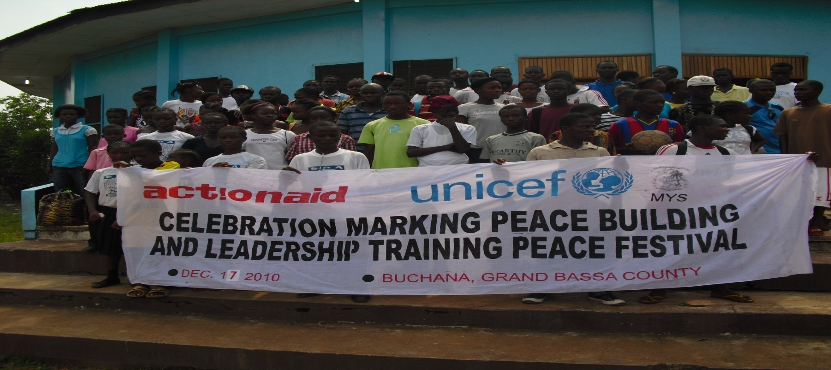
Photo: Actionaid

- Contribution Summary

Country/Region | Liberia
Programme Name | Youth Empowerment Services for Peacebuilding and Stability
PBA Reference | SM/2009/0288
Total Contribution | US$1,000,000.00
Total Programmable Amount | US$934,600.00
Total Funds used to date* | US$928,013.92
Unspent Balance* | US$6,586.08
Project Period | April 2009 – December 2010
Report Due Date | 30 April 2011
Report prepared on | 27 April 2011
Project Objectives | - Enhanced capacity of targeted youth population to assume leadership, participate in local and national policy networks and decision making processes and to contribute to peace and development  - Targeted youth are empowered to use their capacities, skills, opportunities and energies constructively to enhance non-violence, peaceful co-existence and assume civil responsibilities on all levels of society.  - Improved understanding and knowledge about youth issues leads to “youth sensitized” local and national policy making structures.
Target Population | Youth between the ages of 12-35 are eligible, but the target group was between 14-28 year olds
Geographic Focus area | Grand Bassa and Grand Cape Mount counties
Project Partners | Ministry of Youth and Sport (MoYS), Action Aid Liberia (AAL), Federation of Liberian Youth (FLY)
UNICEF Contact(s) | Isabel Crowley  UNICEF Liberia  E-mail: icrowley@unicef.org  Tel: +2316702281
* This is only an indicative amount. The final certified financial report will be made upon expiry of the contribution by UNICEF NYHQs.

- Executive Summary

The problem analysis of the Poverty Reduction Strategy (PRS) confirms that the failure to invest adequately in young people’s education, health, welfare and livelihoods as a predictor of social dissatisfaction may lead to unrest and even conflict, where other factors are also present. Conflict practitioners believe that the huge participation of young people in the Liberia civil war was due to lack of a concrete agenda for youth development and activities, lack of basic opportunities to enhance positive growth, and exclusion from participation in national decision making and governance. When young people become marginalised, feel resentment towards the society that excludes them, and have nothing to lose but their isolation, they are highly vulnerable to exploitation and prone to engage in conflict and violence. The process of desocialisation applies to those who have already been involved with fighting forces as well as to those who have not, meaning that a successful approach to deepening the peace must deal with all young people.

It is the overall strategy of the Government of Liberia and its partners to strengthen the capacity of the youth to become agents for change and transformation to ensure peace and stability in Liberia. To that effect, a PBF-L pilot project to facilitate the integration of young people into their communities and society was developed. The major goal of the “Youth Empowerment Services for Peacebuilding and Stability (YES Peace)” project was to increase the involvement of youth in decision making processes at all levels of society in order to prevent exclusion and dissatisfaction that could lead into violent action by youth and easy manipulation of youth by various political and economic interest groups. The project was embedded in the Joint Programme on Youth Empowerment and Employment (JPYEE), ended December 31, 2010. The JPYEE applies multiple strategic approaches that enable young people to gain skills and opportunities in the areas of employment, health, volunteering, youth information services, peacebuilding and leadership. The link between the various components is designed to achieve comprehensive and sustainable Youth Empowerment.

PBF-L funds provided to this project were utilized for the construction of three Youth Centers and to educate and train approximately 5,200 community youth in over 30 communities in conflict management and mediation, gender equity, human rights, civic rights and responsibilities, and leadership in Cape Mount and Grand Bassa Counties. Due to the methodology of the training there were approximately 15-25% additional indirect beneficiaries (depending on the community) as community elders and others would monitor the education and training modules. In both counties 15 core communities were selected over four districts, and over the course of the three training cycles different satellite villages (close to the core community) were selected. There are both educational and training components to the modules on Peacebuilding and Leadership, with each cycle lasting 22 days over a period of approximately 3 months (twice weekly at four hours a day). Modules teach about the concept of peace, understanding yourself and others, appreciating difference (non-discrimination), understanding conflict, why conflict occurs and the types of conflict that occur. The training focuses on strategies to manage and mediate conflict, how to identify and address the root causes of conflict, and how to respond to the different kinds of conflict that usually occur in Liberia. A primary component here is to focus on gender equity and equality, given the high instances of Gender Based Violence (GBV) in Liberia. Training focuses on negotiation and communication techniques and how to manage emotions in stressful and conflict situations – or anger management. There are also ‘rule of law’ educational modules on human rights, legal rights of Liberians, and citizenship and political processes. The Leadership component focuses on self-esteem, building and maintaining relationships, and learning to accept differences and not discriminate. Then there are modules on team building, trust building, and communication – which are realized through getting civically and politically engaged in the community and working with others. Also, and importantly for political engagement, there is learning the traits of good leadership and identifying different leadership styles. The modules therefore combine education with skills training and then practice, so that once youth are equipped with the knowledge and skills they begin engaging in both conflict mediation and political engagement at the community level.

The primary goal of the education and training modules was to equip youth with the skills to manage conflict non-violently and to participate in decision making structures at the community and county level. As a result, community leaders and beneficiaries report multi-level reconciliation including: Inter-generational reconciliation, inter-household reconciliation, inter-ethnic reconciliation, and intra and inter-communal reconciliation. It was reported that there was a tremendous reduction in GBV (wife and girlfriend beating) and many young women have risen in stature in the community. Furthermore, many youth are now directly involved in community decision making structures, development and livelihood initiatives, and ‘peace committees’ that manage conflict non-violently when it arises. Again, females are reported to be playing a large role, often times in leadership positions. Although institutional data is not available to corroborate, it is reported by the vast majority of the communities that violence (especially against women) has been drastically reduced and minor disputes are settled by communities themselves through ‘Alternative Dispute Resolution (ADR)’ structures. This preventative work eases the strains on the over-burdened formal justice system (prisons and courts), such that far fewer disputes are brought to the police.

- Issue

As highlighted in the National Youth Policy for Liberia, current levels of youth poverty, unemployment, and marginalisation and exclusion from decision making and development processes stem from the protracted armed conflict the country experienced. Though other disparities were present long before that, the multiplier effects of these phenomena are exemplified by poverty-intensifying dynamics such as an increasingly frustrated and militarised youth population becoming engaged in “negative employment” - quasi-professional entrepreneurship of violence and other criminal activities. The gender dimension of “negative employment” is also evident in the increasing recourse to prostitution by young girls as an economic activity/occupation, with the attendant consequences of unwanted pregnancies and HIV/AIDS. The high level of sexual and gender-based violence (SGBV) that continues to be perpetuated against children, youth and women is a continuing aspect of the culture of impunity and unasserted state authority that needs to be urgently addressed. The personal safety of girls has emerged as a key security concern during the children and youth county consultations of the PRS development process made it clear that girls need spaces where they can acquire skills, gain experience, and enjoy personal growth and development in safety. Youth and child-friendly spaces, or Youth Centers, can provide the atmosphere required for this to be achieved.

Recognising that young people need to feel cared for and supported as part of mainstream society, Liberia has made huge strides in re-establishing its social services. Access to education and health has increased and many young people have had the chance to go to school that they had missed for 15 years; half of all out-of-school children live in conflict-affected areas. Nevertheless, young people are disproportionately affected in morbidity and mortality; HIV prevalence is higher in 15 to 24 year olds than in other age groups, with a sharp increase in the 20-24 year old group; 15-19 year old adolescent girls have a maternal mortality rate of 1, 134 (compared with 994 for all females of reproductive age). Primary school NER is only 33 per cent and secondary NER is under 16 per cent, meaning that the vast majority of children and young people have had little or no education (60 per cent of rural women have never been to school). Access to livelihood is similarly restricted. The 2007 labour survey found that over 80 per cent of the country’s youth are engaged in vulnerable employment or are under-employed, serving as unpaid family workers, or employed in hazardous/exploitative jobs. Furthermore, evaluations of the reintegration programme for children associated with the fighting forces identified inadequate education, dearth of employment opportunities and lack of psycho-social support as the main barriers to full reintegration, indicating that investment specifically in young people was not adequate despite recognition of the need to assimilate young people into mainstream society effectively.

But investing in young people immediately after post-conflict is not easy. One of the characteristics is that they are not a homogeneous group and after years of conflict, they are disassociated, scattered, disconnected from social institutions and often from their families. Moreover, the institutions usually given the responsibility of dealing with young people can have mandates that are fairly narrow or segmented into other institutions; for example many countries bundle youth issues in Ministries of Youth and Sports, which are often the least resourced. When they exist, youth organisations may be weak and/or vulnerable to manipulation. International assistance to countries rarely take a comprehensive approach to youth, instead limited approaches (mostly sectoral) are taken that corresponds to their mandates. A comprehensive and adequately resourced approach is therefore essential.

Young people are a nation’s greatest development asset; it is through them that nations can change – the wave of social revolution sweeping the Middle East and North Africa is indicative of this. Youth learn to do things quickly and are often ready to adjust more swiftly than older generations. Thus they can provide a solid basis for democratic governance and be key participants in a strategy for transforming socio-political systems and building a sustainable democratic society. Key elements of such a strategy are: support to achieving universal education and health access; efforts to bolster and strengthen community-based initiatives that promote peaceful conflict resolution, support to acquire skills for civic engagement, expanded livelihood opportunities specifically for young people, especially those out-of-school, and the establishment of centres managed by young people with support from community members and local authorities to provide safe spaces and facilitate the provision of other skills and services. When young people are seen as part of the process of change, they can be critical agents for constructive community recovery and reconciliation, peace building, and development.

Because the youth constitute a large percentage of the human resource of Liberia, the country cannot experience lasting peace without the popular support and full participation of its youth population, nor can the human and economic conditions improved without the full and effective contribution, creativity and popular enthusiasm of the vast majority of the young people. After all, it is to the youth that the benefits of development must accrue. Therefore, at the heart of Liberia’s peacebuilding process and objectives must lay the ultimate and overriding goal of a youth-centred approach.

Realizing the multidimensional nature of post-war peacebuilding, practitioners have recognized the need for comprehensive and integrated approaches that not only ensure the restoration of basic services, post-war reconstruction, and development but put in place a long-term strategic framework to ensure that countries emerging from civil wars do not slip back into violence. Such a strategic peacebuilding framework not only entails securing stability, recreating or strengthening the basic functions of state administration, revitalizing the economy, and rebuilding infrastructure, but it also requires rebuilding relationships, reducing ethnic tensions, and ensuring that the population co-exist again after years of hatred and violence against each other.

The framework must include and take into serious consideration Liberia’s traumatized and psychologically challenged youth. It is clear that without a clear agenda and environment to properly engage the youth population, they pose the most threats to the country’s fragile peace. Thus the need to provide the enabling environment for peace building, conflict and anger management, sustainable life skills and dialogue among youth to enhance peaceful co-existence can never be over-emphasized.

Before the project it was recognized that there were not adequate structures that provide the civic and political space for youth to positively and substantially participate in mainstream decision-making and related activities in the political, economic and social spheres. The objective of the project was therefore to create that space through the development of youth friendly spaces. The youth friendly spaces are to be used as a vehicle to engage Liberia’s youth and empower them and expand their capacities and opportunities to initiate and participate in selected community and local development initiatives.

The core element of the project was to reduce the alienation faced by youth and increase their civic engagement. Helping youth meet, provide support to one another and engage with governance mechanisms in a structured way will help alleviate some of the feelings of alienation currently felt by youth. The project logic assumed that by reaching youth with key social services that deal with some of their existing needs (such as reproductive health services) will address key priorities for youth as regards services. Importantly, the assumption is also that by organising better response to the key needs of Youth at the community level, the project will help youth feel more a part of the development processes ongoing in their communities and that in turn will help better integrate the youth into their communities.

Interventions that were to be undertaken in the project included ensuring that youth have the relevant information and skills to utilise information positively within their social, economic or political domains. The project also addresses these issues by empowering young women and men to give them a sense of belonging and usefulness in society. The areas of intervention directly address the issues raised in the National Youth Policy and Draft National Youth Action Plan regarding youth as a conflict factor. They recognise the importance of youth friendly spaces as a means to deliver social services as well as employment related skills and enhance youth participation in national dialogue and governance.

The project delivers benefits both at the individual, community and government levels. All levels will benefit from the training opportunities that the youth will received regarding management, facilitation and life skills. The individual benefits are obvious for those who will benefit from training opportunities. At the community level, community members will be able to tap into the increased capacity of youth, particularly those of facilitation and as peer educators. There will also be continued benefits at both individual and community levels in linking youth with key providers of social services through youth officers and representatives of youth centres. The youth centre structure facilitates provision of social services to youth at community level. At the government level, the project will help the implementation of the National Youth Action Plan. Key personnel of the Ministry are selected for training and their role is to support the role of the National Youth Action Plan at the county, district and community levels. Also the project helps to link young people to governance structures both at the community and national level. The project for instance helps decide how best they can be represented at the County Development Steering Committees and the National Youth Action Plan steering committee.

This was an 18-month pilot project and is part of the larger Youth Employment and Empowerment Programme. The full programme is planned for the duration of three years. Grand Bassa and Grand Cape Mount Counties have been selected as locations for this initial period since Grand Bassa has a youth centre already established whereas Cape Mount does not, but it does have child protection resource centres. Another reason for selection was the high concentration of young people in these areas.

- Action

Project Objectives

1: Leadership skills and political participation

Outcome: Enhanced capacity of targeted youth population to assume leadership, participate in local and national policy networks and decision making processes and to contribute to peace and development.

Participation is a vehicle as well as an indicator for social and political integration. The youth have a strong potential and a desire to look at situations from a different angle and to develop new ways of dealing with problems. As a result of the trainings they are now able to express their views and to be heard by the adult community, as well as the respective political and social bodies in the public sphere at the community, district, and county levels. This potential is being used in a constructive manner and helping to prevent the youth from falling into destructive behaviours. Youth are taking initiative in their communities for development and public works, conflict mediation when conflict arises, and awareness/sensitization campaigns.

The development of leadership skills, creating awareness about Liberia’s peace and development processes, identifying potential and upcoming opportunities and the exercising the ability to make informed decisions within the current socio-political context are generating self-confidence and community peace and development initiatives. The youth reached will not be easily mobilised for political ends and the abuse of power, instead they have been empowered to get civically involved in a peaceful and constructive fashion. It is important that the process of building self-confidence and a positive identity is accompanied by growing job opportunities that have by themselves an integrative impact. The linkages to livelihoods and skills development have unfortunately not been moving as quickly as anticipated.

Leadership skills are essential for the guidance and continuity of youth groups. These skills have empowered them to expand their capacities and opportunities to initiate and participate in selected community and local development initiatives, as well as linking up with other groups such as County Peace Committees. In all the communities where trainings were conducted it is reported that Youth are engaged in conflict resolution, development, and sporting activities. This corresponds with a core element of the project that was to focus on redirecting youth toward civic responsibility and promoting peace and reconciliation as cornerstones for positive, non-violent change in Liberia.

The intervention as capacity enhancement was carried out by implementing the training modules in 3 cycles from 2009-2010, with follow up activities currently underway (as of April, 2011) to continue on the efforts of the PBF-L project by building Peace (and Development) Networks at the decentralized (District) level and in the short term preparing for the 2011 elections and other key activities. This will be done by increasing conflict management capacities and training in early warning systems. The Ministry of Youth and Sports (MoYS)/ Action Aid partners have issued certificates for the completion for the Peacebuilding and Leadership course, while planning is underway for follow up activities related to strengthening capacity of Peace Committees in partnership with the Liberia Peacebuilding Office and UNMIL (additional to on-going partnerships with MoYS/AAL/FLY) The training focused on the following skills: team building, trust building, communication, strategic participation in community decision making processes, as well as problem respectively opportunity analysis. Key examples to highlight impact in 2011 regarding leadership and political engagement were youth group mobilization for voter registration and Peace Club/Committee led community sensitization campaigns about preventing pre/post election violence through drama performances.

2: Peacebuilding and conflict resolution

Outcome: Targeted youth are empowered to use their capacities, skills, opportunities and energies constructively to enhance non-violence, peaceful co-existence and assume civil responsibilities on all levels of society.

Youth have the strong ability to connect easily amongst themselves and they have become peacebuilders in the communities, often times as part of inclusive Peace Committees that reflect democratic representation at the community level (in partnership with elders and women’s groups) but also for their own activities. This has lead to inclusion and exchange between youth groups from different origin, religion, sex, language and ethnic backgrounds – particularly during the Peace Festivals and other events that bring communities together. It has been reported that conflict and violence have been drastically reduced and peaceful co-existence is the norm, particularly between community youth but also between youth and elders where inter-generational tensions were reported as very high before the project.

This component has achieved the fostering of non-violent communication skills such as peaceful conflict resolution methods and mediation. Important elements of the activities under this component were self-awareness, self-respect and anger management. It has enhanced the understanding and application of values such as equality, tolerance and respect. The core element of this intervention entails redirecting youth toward civic responsibility to enable them to promoting peace and reconciliation as cornerstones for positive, non-violent change in Liberia. Now that conflict has been reduced and reconciliation achieved, youth within communities are taking the lead in local development and public works activities, such as road-side brushing and communal farming (assisting one and other on family plots).

In addition to the provision of centre-based services that is now underway, the project has facilitated community-level dialogue, bringing together youth and community leaders to promote interaction. The project has strengthened the capacity of the youth, initially through the peer leadership programme and consequently through the outreach education/training activities that targeted the most vulnerable peers within the peer leaders’ respective communities. This component entailed a variety of activities such as trainings, community meetings, peace festivals, radio programs and dramas. A communication strategy is currently being implemented (January-July) to capture the success and impact of the project at both the community and national level to highlight the level of change the project accomplished. This includes community drama groups and national radio shows that focus on the peacebuilding and conflict resolution capacities that have been strengthened as a result of the UNICEF PBF-L project

This component of the intervention has improved knowledge and skills that have had a strong impact on the behavior of youth in their political and social contexts, primarily through reducing conflict and violence and in becoming agents for positive peace and development in their communities, districts, and counties. As of April 2011, community peace committees are organizing by district and making linkages to County level peace committees in the formation of Peace Networks in the pilot counties.

3: Provision of Youth Friendly Spaces and Information Resource Services

The creation of Youth-Friendly Spaces will harness the creativity and potential of young people in productive and socially cohesive ways and support the foundation for social cohesion and change. Three Youth friendly spaces, or Youth Centers, will be constructed and equipped in Robertsport, Sinje, and Gorblee (Compound #3) to provide services. The existing Youth Center in Buchanan will receive equipments and resources.
The goal of these services is to support the other activity areas (1-2 mentioned above) effectively with information and materials on a wider scope.
Regarding the reports on youth issues in the communities the following outcome comes under this component:
Improved understanding and knowledge about youth issues leads to “youth-sensitised” local and national policy making-structures.

Both the Poverty Reduction Strategy and youth policy consultations recognise the importance of Youth Centres as a means to deliver social services, employment related skills training and as a structure through which to encourage youth participation in national dialogue and governance. The YES PEACE programme is aligned with PRS Strategic Objective 4: To provide safe public spaces for children and youth. A core element of the project is the growing awareness of youth about their own situation, challenges and opportunities.

While there were significant delays in construction activities, all three Centers are now built and equipped, with only Sinje requiring formal dedication. Buchanan Youth Center received equipments and some renovation. The delay in construction has led to a delay in the development of information resource service provision with regards to employment. However, Peacebuilding and Leadership manuals have been distributed to some of the centers and computers are being utilized by Action Aid, Federation of Liberia Youth, and Population Services International for their various activities as implementing partners with the MoYS. Activities, events, trainings, and other functions are held at the Youth Centers now open. Furthermore, the sexual and reproductive health corners (operated by Joint Programme partners UNFPA and their implementing partners) are now operational in the Youth Centers.

The Centres are in different levels of development depending on location, but by June 2011 all will be providing information services in the political, social and health spheres such as:
- Reports on the situation of youth in the community and district
- Activities of the Youth Centre
- Basic civic education on political functions and structures
- Human Rights
- Decision making structures in the community and how to access them
- Reproductive health and risky behaviours
- Education
- Volunteerism
- Other active groups in the area to network with
- Information Technology (internet services)

The information is also useful indirectly for all members of the community, although the services’ priority is the youth.
4: Project monitoring, evaluation and supportive supervision

Under this project component a monitoring and evaluation framework was established in order to inform implementing partners and all political levels on the challenges and opportunities the youth are facing. It connects the community level with the higher political levels and has an impact on the development of national governmental policies for youth, primarily through the establishment of monthly County level coordination meetings among partners and stakeholders that are now being led by the MoYS County Coordinators.

During the designing of the project due consideration of the importance of results based management was given the deserving priority and therefore a clear logical framework was incorporated in the programme. In addition clear risks and assumptions were spelt out. These ensured room for flexibility in the implementation. To ensure that the required systematic data collection and documentation was achieved during implementation time, positions for M&E were created. Implementing Partners AAL recruited two county based M&E Officers in both Cape Mount and Grand Bassa, who participated in all UNICEF led and Joint monitoring visits. Monitoring visits occurred in both counties at least once monthly and usually over a two-three day period. Travel/logistics were difficult as roads are very poor and the communities spread out. Capacity was built particularly in qualitative data collection and testimonials based on the Most Significant Change methodology.

Strategies and Activities implemented, including strategic/coordination partners

1: Timeline and Selected Key Activities
- May and June 2009: two field visits were made to all the project sites in Grand Bassa (Buchanan and District No. 3) and in Grand cape Mount (Robertsport, Sinje and Tieni) to introduce the project. Key results achieved include:
  - mapping of the implementation timetables in the two counties by project participants and key stakeholders;
  - identified three sites for the construction of youth multi-purpose centres and recreation facilities that were handed over to the Ministry of Youth and Sports by county officials and traditional authorities;
  - Four youth organisations have been identified by the Federation of Liberia Youth that will form the core of the management structure for the implementation of the project;
  - A project management structure outlined and implementing partner Action Aid selected, to commence October;
  - A functional technical working group on youth employment and empowerment as part of the joint programme has been established.
- July 2009: Joint Steering Committee approves annual Work Plan. Coordination mechanisms at all levels of the project have been established with the participation of key stakeholders. Delay in the establishment of the JSC causes project implementation delays, with anticipated new completion date of December 2010. Procedural arrangements required of UNICEF to start construction of Youth Centers will also cause delays. A re-allocation of US$90,000.00 requested for the implementation period of the project until December 2010 to account for technical support and other costs.

- August-October 2009: Curriculum development and training experts in youth leadership skills/peacebuilding skills to develop a leadership and peacebuilding training skills resource pack respectively, and train youth leaders as peer trainers in the use of the resource pack recruited, work underway. The community identification process for the outreach areas has concluded in Cape Mount County, with all 5 districts represented. The identification process undertaken in collaboration of UNICEF, Action Aid, MYS, FLY and local youth organisations. Some communities in Grand Bassa around Buchanan identified. Management structure for the project implementation has been provided in the budget for the AAL. It includes 1 program coordinator, 2 County supervisors, 4 M&E Officers, 4 youth center managers. Recruitment process of a National Coordinator concluded. All logistical equipments and supplies for the YES Peace project have been procured by UNICEF. The relevant stakeholders in the county administration and government departments in both counties have been fully enrolled into the programme. M&E framework completed and distributed.

- November 2009-January 2010: Curriculum development and training expert in youth leadership skills held consultation workshops with key stakeholders, such as representatives of local youth organisations and local government in Grand Bassa and Grand Cape Mount counties. In Monrovia one consultation workshop with members of MoYS, FLY and Action Aid provided input for the drafting of the leadership skills training manual. Two curriculum development and training experts in youth peacebuilding have held various consultative meetings and focus group discussions with a wide range of key stakeholders in the field and in Monrovia. They assessed the capacity and needs in peacebuilding training for youth. The consulted agencies were MoYS, MoE, FLY, UNESCO, UNMIL Human Rights and UNHCR. With the support of the Young Women Christian Association it a separate focus group discussion with female youth held. Female youth have different experiences, needs and capacities regarding conflict and peace building. The ToT trainings for 60 peer educators completed in Grand Bassa and Cape Mount Counties, with draft manuals adjusted by experts based on ToT experience and consultations.
- February-April 2010: A validation workshop for the Leadership and Peacebuilding skills training manuals held with key stakeholders in Monrovia. Representatives of MYS, MoE/PEHCED, MOGD, FLY, YWCA, National Youth Volunteers youth organizations, UNESCO, UNFPA and Action Aid contributed their final input to the training resource packs. The training resource packs were copied and distributed by Action Aid to the local peer educators in Cape Mount and Grand Bassa counties. The trainings of youth in the selected 30 outreach areas implemented under the first cycle, with a total number of 1523 youth trained. To increase the number of females, preparations to select and train 30 additional female peer educators from the 30 communities initiated. Radio talkshows in Grand Bassa and Cape Mount held to sensitize the general public about the project. Project monitoring and meetings with partners and stakeholders on-going and regular in both counties.

- May-July 2010: Registration for the second training cycle from July-September held, in order to get more female participants the peer educators and trained community youth undertake house-to-house sensitization. Due to the lower education level of females, the selection criteria changed. All young females between 15-24 years who are active in their communities and are ready to take more responsibilities in their immediate environment are selected regardless their level of formal education. Thirty Additional female Peer Educators trained and certified since there was low numbers in original ToT. A baseline study report conducted in 19 communities in 8 districts on the involvement of youth in leadership and peacebuilding completed by AAL and discussed with stakeholders of the project in a validation workshop in Monrovia. The construction has started in mid-May on the Youth Centers in Robertsport, Sinje and Compound #3, with three contractors selected by the MoYS. Technical Working Group meetings are regular and MTR of PBF-L recommendations followed up on, matrix developed and submitted.

- September-October 2010: A new international project manager is recruited from the Liberia Peacebuilding Office and takes over management responsibilities. 1000 Peacebuilding and 1000 Leadership training resource packs produced and delivered to UNICEF for distribution to Youth Centers upon their opening. The second training cycle of 1,800 youth in the selected 30 outreach areas completed. In Cape Mount there were 555 females and 345 males trained, and in Grand Bassa there were 640 females and 260 males trained. Registration for the third training cycle from October-December held and training begins. Second cycle training was majority female, which offsets the first cycle that was majority male. Peer Educator Refresher trainings held in both counties (Sinje and Robertsport), with two groups of 30 selected, and challenging module materials were addressed. Communication strategy developed with DANIDA funding involving MoYS, FLY, AAL that will involve the participation of beneficiaries from the project involving multiple activities, including the creation of a newsletter on Youth Peacebuilding to sensitize youth in their communities, the county authorities, and central level on youth leadership and peacebuilding and to highlight the ongoing community trainings and disseminate information on youth activities. Collaboration between UN agencies (UNFPA, UNDP) and UNMIL increases for improving M&E, Joint Monitoring, and Communication strategy. MOYS, FLY, AAL, and JPYEE participate in monitoring trips as well, with a focus on qualitative/impact data collection. The construction progress delayed at Youth Centers based on release of second tranche of funding.

- November-December 21010: The third cycle training concluded with 950 beneficiaries in Grand Bassa, with 448 males and 502 females, and 950 in Cape Mount, with 422 males and 528 females, for a total of 1900. The total number of beneficiaries trained across the project cycles was 5, 223. Communities integrating youth in their existing decision making structures and/or created new community based bodies for peacebuilding and conflict resolution. An independent consultant was hired by Action Aid to conduct an endline survey that highlights this particular impact. Youth are taking on strong leadership roles in the community and contributing to community work projects, considerably easing previous tensions between Youth and Elders. Compound #3 (Gorblee) Youth Center dedicated by the President of Liberia and opened. Robertsport Youth Center completed, but was dedicated in January 2011 by UNICEF Representative, D/SRSG and MoYS. Sinje experienced longest construction delays but is completed in March 2011. To be dedicated in April 2011.

2: Leadership Skills and Political Participation, Peacebuilding and Conflict Resolution
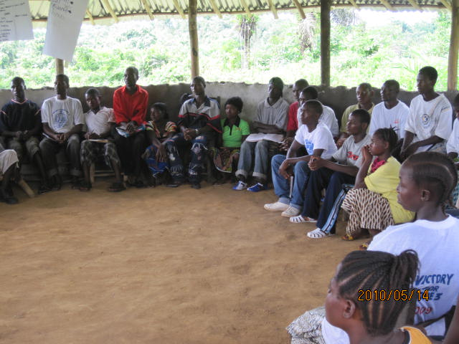

Young People in Peacebuilding and leadership training

  - The Education and Trainings
The selection of clusters of 30 outreach areas in Grand Bassa and Cape Mount was undertaken by local youth organisations in close consultation with the county authorities and the communities based on the number of youth in the area. In these areas no similar training program has been conducted before. The selected communities were able to take ownership of the program due to a high level of involvement. Prior to the trainings a Memorandum of Understanding (MoU) was signed between the communities, AAL and the peer educators. The communities selected the peer educators, provided the training venue and a caterer for the trainings. They established training committees in order to manage the little funding which was given for the catering. In all of the communities monitored, community leaders were observing the training sessions.

The community trainings were conducted in the local vernaculars. This enables the participants to understand the lessons well and it helps also to reduce the “fear-factor”, particularly of young women whose education and literacy level is lower than the one of their male colleagues. The first training cycle from April to June 2010 was well attended. The participants and community members selected the training times, usually twice a week for about three hours. This ensured participation of in-school and out-of-school youth as well as young mothers. The 22 training day (11 days for each, peacebuilding and leadership) allowed the participants to get to know each other better over three months, in order to create a level of trust and group spirit which was necessary to consolidate the lessons learned and to follow up activities of the same group.

  - Female participation
The involvement of young women into the peer educator’s training was challenging. In the first round of TOT trainings, four out of the 60 trained peer educators were women. The communities were requested to select one male and female for the trainings. It was reported that the limited participation of young women (15-24 years) was because they had not reached senior high school level; they also mentioned that the selected peer educators need to have a certain standing in the communities in order to be taken seriously by participants. AAL and UNICEF re-visited the communities one-by-one and re-emphasised the importance of capacity building for young women for the communities. After a challenging recruitment process, a second TOT training cycle was held in May 2010 for an additional number of 30 young women in both counties. This allowed them to share their personal experiences particularly in the field of Sexual Gender Based Violence freely. It was very important for these women to have this safe space in order to gain confidence in them.
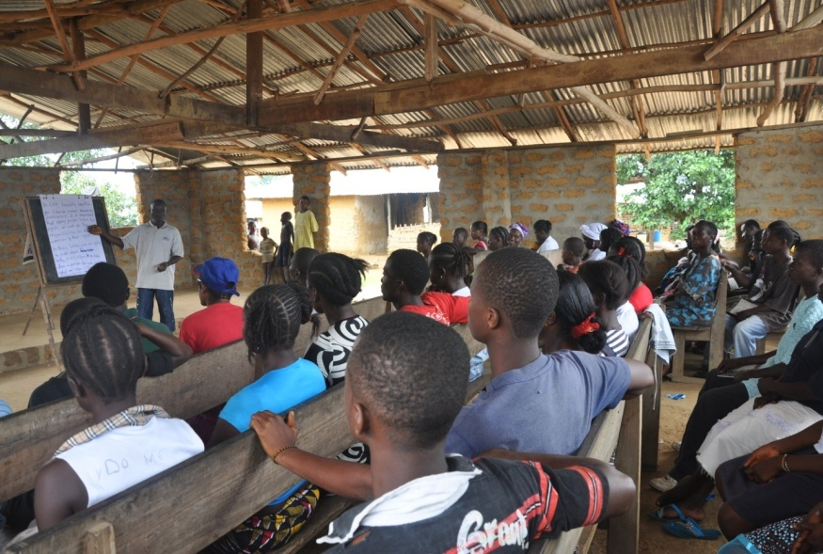
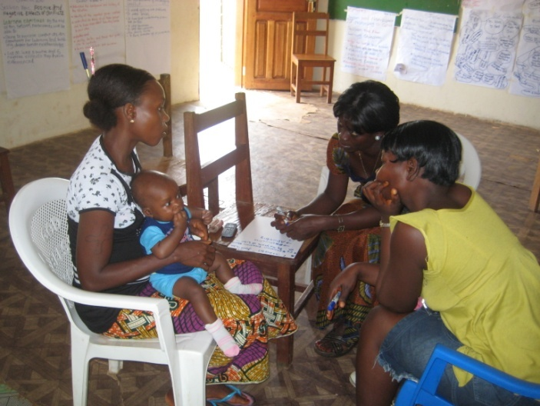

During the TOT training that was held for young women, the participants were able to share a lot of their experiences and concerns freely.

Addressing the issue:
Two major obstacles for the limited female participation were established;:

- The “fear factor”: Young women are not confident enough to participate. In order to address this, it was suggested to the peer educators to conduct separate trainings for young women.
- Education level: Most of the young women in rural areas do not reach senior high school level and have a low level of literacy.
The issue was tackled by dropping the education level for community trainings during the 2nd and 3rd training cycles. With further sensitization in the communities and the new criterion that all young women who wanted to be engaged in their communities would be admitted to the trainings, the number of female participants increased dramatically. In fact, they were in the majority of the 2nd and 3rd training cycles. The participant numbers, disaggregated by gender, are found in the table below:

Table 1: Number of young people trained per training circle
Circle | Grand Bassa |  |  | Grand Cape Mount |  |  | Total
 | M | F | Total | M | F | Total
First | 373 | 380 | 753 | 345 | 425 | 770 | 1,523
Second | 260 | 640 | 900 | 345 | 555 | 900 | 1,800
Third | 448 | 502 | 950 | 422 | 528 | 950 | 1,900
Total | 1,081 | 1,522 | 2,603 | 1,112 | 1,508 | 2,620 | 5,223
Source: AAL field records

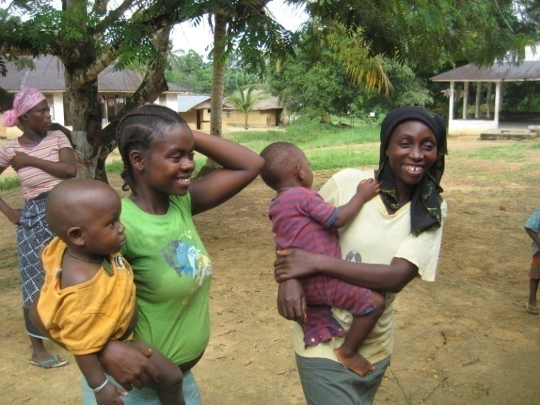

Two young women from Kangar Town, Cape Mount County, who were encouraged by their friends to register for the next training cycle.

  - Peer educators become peace-makers
In most instances, peer educators have gained a lot of respect from the community members. Town chiefs started to send ‘cases’ to the trainings to be solved by the peer educators and the participants. The town chief in Mando community, Cape Mount County, confirmed that the number of conflicts in which he was asked to mediate have reduced significantly after the training started. He observes the training regularly to build his knowledge on conflict resolution. Most of the communities are willing to establish the peer educators as “peace-makers” and have formed ‘peace committee’s’. In some cases the peer educators have been selected to serve in higher positions in the community leadership despite their young age. It became evident that there was a growing understanding in the communities that young people are able to support peace and stability in the community once they are sensitised and trained. In turn, the trainings gave the youth a platform where they could perform and apply their newly acquired skills and knowledge, with the community able to directly observe the benefits.

  - The nature of conflicts
The highest number of conflicts mentioned by training participants and community members were domestic problems and Sexual Gender Based Violence resulting from conflicts over family resources and child support which spill over to the community level. Besides of that, discrimination between tribes in the communities was also mentioned.

As expected, stories from the war and conflict lines that have divided communities are most of the time kept under the surface. Participants and community members rarely talk about them in order not to open old wounds and to be able to re-establish a level of normalcy in their lives. Nevertheless, the old scars play a role in current conflicts that on first sight have nothing to do with these broken relationships. During the training sessions, most of the participants reported burdensome stories they witnessed during the war. This fact had to be kept in mind throughout the training sessions and handled carefully. In some instances the participants need further counselling and space to go deeper and the training sessions were not always the right forum for that.

In both counties the generation gap creates a negative perception which seriously affects the relationship between the different age groups in communities. In most instances the older generation felt that the youth were not willing to engage in voluntary work for the community. At the end of the project, one of the most frequently reported impacts was that the youth are now working alongside the rest of the community members for community development. In fact, in many instances they are taking the initiative on their own to do community work such as roadside ‘brushing’ and organizing development initiatives such as the cultivation of a cassava farm or the construction of a clinic.

Conflicts over resources
Conflicts over resources prevailed in both Counties. Depending on the geographic areas the conflicts slightly change.

The major conflicts affecting participants of the training in Grand Bassa County:

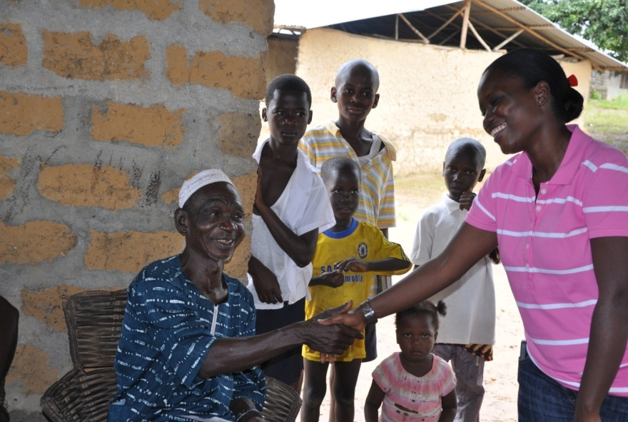
- Conflicts over rubber at Compound number 3 in Grand Bassa County were mentioned. Some youth are involved in illegal rubber tapping which leads to conflicts with security staff from concession areas such as the Liberian Agricultural Company. Furthermore, youth are also involved in rubber production on a private level and sometimes get into conflict over the produced rubber. In one community, two participants were involved in such a conflict. The community reported it during the peacebuilding training; these two participants saw the need for a peaceful settlement and came to an agreement on the income from the produced rubber.
Participants role-play conflict management situations.Ascott/UNICEF
- The local youth feel deprived of job opportunities and education. For instance two companies Mittal Steel and Buchanan Renewables created job opportunities. The companies usually select and transfer more qualified staff from Monrovia and foreigners to Grand Bassa. The local youth feel disadvantaged and left out since they do not have the opportunity to get the adequate education and training to apply for open positions.
- There is a constant dispute between Ghanaian fisherman and the local youth along the beaches. Local youth who have smaller fishing boats with a lower cruising range feel hindered by the Ghanians. Such conflicts were brought to the attention of the peacebuilding training session in Dorr community and solved.

The major conflicts affecting participants of the training in Cape Mount County:

- Land conflicts around Bendu community between different towns. This conflict was brought to the attention of the ongoing training and also to the UN Volunteer for Peace in the area. So far the conflict is still being negotiated because the senior leadership of the communities has to come to an agreement. Nevertheless, the youth have played a constructive role throughout the process.
- Conflict over the sale of gold in mining areas in Gornelor and along the Sierra Leonean border. Some mining chairmen complained that the gold has not been sold to them as it is the normal procedures but to other people. There is no control over the sale of gold. Furthermore, the fact that many of the miners are from Sierra Leone and there is a vibrant illegal trade between the borders creates polarisation in the communities. A similar conflict has been observed in diamond mining areas around Kongo Mano River where so far no trainings have been held. Whether the peacebuilding training can have an impact in these instances remains a question. It is critical that future interventions focus on these ‘hot-spot’ areas and recruit more young miners into the trainings.

  - The establishment of peace committees at community level
Discussion of community members in Pujun, Cape Mount County, on the establishment of a peacebuilding committee

In Bampala, Cape Mount County, one participant explained that he never attended community meetings before the training although he was invited. Encouraged by the leadership training he decided to attend and understood the practical meaning and importance of participation in overcoming exclusion and marginalisation only through the leadership training. Similar effect was also reported by participants from other areas.

Most of the community participants also noticed that besides the community meetings there was no peace committee which they can trustfully refer to when there are conflicts. UNICEF and AAL strongly encouraged these communities to set up peace committees which include elders, community leaders, women and youth groups as well as a few committed participants of the peacebuilding trainings. It is of utmost importance that the momentum gained is harnessed now that the project has ended. Usually the community leaders and members mention that there are traditional structures at community level, but that they are not transparent and inclusive enough in order to be used as peacebuilding structures.

It should be noted that in many communities the participants started activities which go beyond the duration of the training such as waste collection, sport and recreational activities as well as spontaneous gatherings to exchange experiences and to meet for informal peer counselling in order to share experiences and to learn from each other’s approaches to deal with these situations. These initiatives are rather “un-political” in the communities and can be undertaken by the youth at any time.

Follow up assessments since the end of the project show that many of these activities and youth clubs are on-going, therefore establishing that there has been a lasting short-term impact.

2: Provision of Youth Friendly Spaces and Information Resource Services

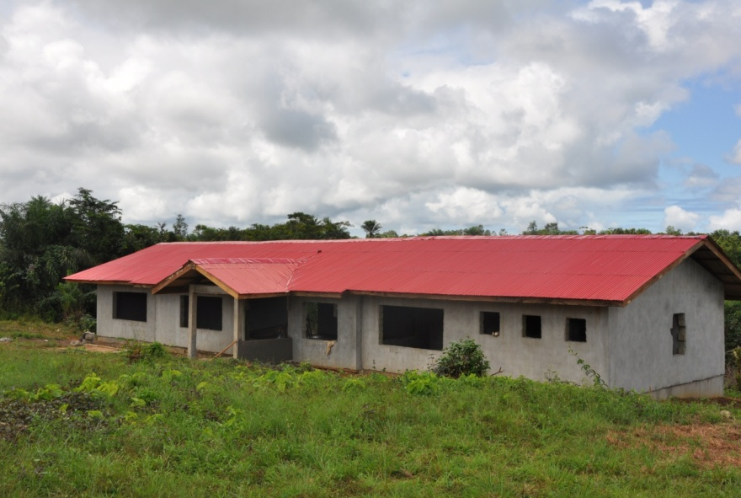
The construction of the three Youth Centers has been completed in Robertsport and Sinje (Grand Cape Mount) and Gorblee (Compound #3, Grand Bassa). The Gorblee Youth Center was opened and dedicated by President Ellen Johnson Sirleaf in November2010. The Robertsport Youth Center was dedicated by the GoL and UNICEF, with local youth performing drama and other events in January 2011. All the Youth Centers have been provisioned with computers, a printer, furniture, a generator, fuel, and other supplies, including Buchanan Youth Center (also located in Grand Bassa). The Swiss Development Corporation (SDC) provided many of the equipments for these Youth Centers. As part of the JPYEE, UNFPA and its local partners moved their Sexual and Reproductive Health (SRH) corners inside of the Youth Centers (accessible through separate entrances) and are now providing services there.
Three Youth Centers were completed in Grand Cape Mount and Grand Bassa Counties, Ascott/UNICEF

A capacity needs assessment on leadership and peacebuilding skills of youth between 15 to 24 years was conducted with key stakeholders in Monrovia and local youth organizations in Grand Cape Mount and Grand Bassa Counties. The peacebuilding and leadership training resource packs were developed by three consultants in consultation with key stakeholders in Monrovia, Cape Mount and Grand Bassa Counties. Representatives of Ministry of Youth and Sports (MYS), MoE/PEHCED, MOGD, FLY, YWCA, National Youth Volunteers, local youth organizations, UNESCO, UNFPA and Action Aid contributed to the training resource packs. The consultations were done to ensure context-relatedness of the training resource packs.
The modules were then tested during ToT training of 60 peer educators from local youth organizations in Cape Mount and Grand Bassa Counties. The peacebuilding and leadership skills training manuals were then finalized and validated by key stakeholders such as MYS, MOE, MoGD, FLY and local youth organizations. The training manuals were then finalized and 1000 of each (2000 in total) were printed. They included trust building exercises, communication and participation in community decision making, conflict management and mediation, understanding self and other (self-respect), anger management, and sections on human rights and civic education. Consultation processes occurred throughout, bringing together youth leaders and community leaders in order to give input in the design of the training resource pack and the roll out of the program. The training manuals are being distributed to the Youth Centers and High school Peace Clubs as primary resources.

3: Project monitoring, evaluation and supportive supervision

A baseline survey was conducted to determine the conflict vulnerability in these two counties before the roll out of the project. During the implementation regular joint monitoring by the Government, Action Aid, UNICEF and JPYEE were sought and lessons learnt were well documented through field monitoring reports, photographs and video clips. Observations and challenges were shared with the implementing team on the ground at the end of each monitoring field visit. This was to ensure that the project implementation was carried out as envisioned at the project inception. Specific areas of monitoring included regular attendance by the participants, quality of training offered, gender disaggregation, and ages of the participants. Each county had two Monitoring and Evaluation (M&E) officers hired by Action Aid who would make frequent monitoring visits to the youth groups. Other team members, including the MoYS County Coordinator and the Centre Manager, also participated in project monitoring. Methods of M&E used included checklist, observation and oral interviews. At the end of the project an end line survey was contacted by an external evaluator.

The biggest gain was in developing qualitative M&E techniques, with extensive field trips and interviews to gather testimonials and stories of impact from beneficiaries and community representatives utilizing the ‘Most Significant Change’ methodology. This was incredibly important given the qualitative nature of Peacebuilding programming, where the objective is to change behaviour and empower youth. Capturing this as an impact goes beyond quantitative figures. Capturing impact is still challenging, because the objective is long-term change geared towards sustainable peace and development that goes well beyond the project cycle itself.

Despite the fact that the field teams did not have access to computers, the M&E officer from Action Aid came to Monrovia and typed up qualitative interviews for the database and files. It was this extensive qualitative data collection that revealed the consistency of community Reconciliation and project wide impact.

4.3 Implementation constraints, lessons learned from addressing the constraints and knowledge gained during the implementation period.

- Implementation constraints
- Limited technical and management capacity to implement peacebuilding programmes by government and CSO counterparts in specific areas, primarily finance -- but also in Resource Management and M&E. There is a need to continue to support the Government and CSO implementing partners, particularly in finance. The liquidation of funds was a challenging process that often caused delays because the UN has a number of formal procedures that have to be completed in order to liquidate and release new funds, which often caused project delays. Greater efforts should be taken by UN agencies to build capacity in implementing partner finance departments. This is as much the responsibility of the UN as it is the Government and NGOs. There were systemic issues (difficulty in understanding the UN liquidation and finance system and requirements) but also human resource issues with AAL, who had turnover of finance staff at critical periods and therefore difficulty liquidating in a timely fashion. The Government also has limited human resources and technical knowledge in this regard. Both encountered delays of up to one month when it came to releasing more funds, which froze up implementation and caused delays.

The Buchanan Youth Center was pre-established and has a good management system, however the same is not yet true of the newly built centers. It will most likely take some time after hand-over to the Government partners and continued support before they are operating smoothly and at full capacity to deliver the services anticipated in the project document – particularly as regards employment opportunities because they are limited. The computers donated and stored at the Youth Centers were supposed to facilitate M&E and reporting by field based partners, but only became operational at the end of the project.

- Construction costs and delays. Construction costs seemed high and there were delays. At the Gorblee Compound #3 Youth Center funds were spent to hand dig a well and no water was found, therefore additional funds needed to be sourced for a borehole. Also, at the same Youth Center a generator house was not built, so further funds will need to be secured to ensure that the generator can be safely stored outside and deliver current to the Youth Center. A consultancy firm was hired and this seemed to alleviate some of the delays and issues.

- Project cycles should focus on long term visioning beyond funding cycles, with a focus on sustainability. Exit strategies were not clearly articulated, but that is understandable given the pilot nature of the project. However, it is very important that issues of sustainability are addressed at the outset, so impact can be sustained. Also, 18 month project cycles for peacebuilding activities might be too short given the nature of the work and delays that occur in conflict to peace transition environments. Nearly all of the PBF-L projects required no-cost extensions. This lesson learned has been applied to Peacebuilding Commission (PBC) engagement in Liberia, where planning is now to cover three years. However, the focus of PBC engagement has shifted away from ‘preventative’ interventions such as was the nature of this project.

- Lessons learned and knowledge gained
- The Methodology utilized under the PBF-L project by UNICEF and Action Aid Liberia for the implementation of training was successful and is showing impressive (short term) impact and results. There is a concern that short workshops and training sessions as outputs have limited outcome or impact. Preliminary reports on another PBF-L project were suggesting that the eight day training cycle on Community Empowerment might have individual level impact, but not community or socio-political level impact, which informed the design of the prolonged training schedule. The idea was to create peacebuilding and leadership education as well as training in conflict management and mediation techniques. Therefore, the modules were designed to be conducted in 22 days over a period of three months.

This type of engagement was more involved and sustained ensuring that the material was utilized by the beneficiaries. Also, youth were able to build sustained relationships as they met regularly over a three month period. Furthermore, while youth were targeted for official enrolment, community elders and others were encouraged to participate and monitor. Therefore, the number of beneficiaries increased and community elders felt a part of the trainings and came to understand the importance of the material. This focus on sustained engagement and holistic community participation has, preliminarily, produced some impressive results.

While some beneficiaries speak about how the trainings changed them personally (for example, I used to beat my wife or cause trouble in my community and now I do not), others emphasize how the entire community has changed and how youth are now participating in decision making structures and community initiatives. The elders, chiefs, and community leaders overwhelmingly have the same narrative across the project communities, despite their diverse locations. They all report that before the project intervention the youth caused problems and would not assist in the community. Now they are involved and taking initiative for community development and participating in decision making. There is overwhelming reports of reconciliation at the community level. Discrimination by gender, ethnicity, and age has been drastically reduced. ‘Jungle Justice’ or mob violence has been reduced, as has the frequency of police involvement in the community to settle disputes and the number of cases brought to the formal court system.

- Impact

5.1 Results: Impact on the target population (in line with the proposal)

This pilot project aimed to integrate youth into local and national economic, social, and political systems: In so doing it reduces the propensity for alienated youth to be drawn into destructive and violent structures and actions.

The project’s main assumption was that there was a need to invest into civil, political, and social asset development for youth. The objective was to build their resilience – or assets – for reducing the risks of marginalization and exclusion, and therefore the potential for sliding back into conflict and negative behaviour. The youth needed to be linked to the main social institutions in their communities, but also to the county authorities, with a “mediating institution” (in this case the youth centres) between the marginalised youth and established socio-political institutions. The project intervened by education and skills training to increase the participation of youth in governance structures, peacebuilding and conflict management, and development processes of their communities, districts, and counties. The integrated approach of the education and trainings in both peacebuilding and leadership were mutually reinforcing.
Parade during youth festival in Buchanan. Photo/ Actionaid

The achievements and impact of the project were manifold based on qualitative data collected throughout the duration of the project based on interviews with community members, community elders, and from the beneficiaries themselves. Reconciliation was perhaps not specifically identified as the primary goal of the project but became the biggest accomplishment, along with a substantial gains in achieving gender equality in project communities. Reconciliation was widespread and across multiple levels: Inter-generational, inter-household, and intra and inter-communal. The impact on young women was especially strong, with a huge reduction reported of GBV (wife and girlfriend beating), as well as female inclusion into decision making structures and processes. Youth, especially young women, now play an important and constructive role in decision making processes and conflict mediation in the community, and are also taking initiative for community development works and advocacy on important issues. There are slow but steady linkages being made between the communities to the district and county levels, with youth who were trained in urban areas reported to be highly involved in civic and political engagement. This is also true when it comes to rural/mining areas, where youth have played a pro-active and engaged role in advocating for their community needs with regard to the Social Development Funds (Eg/ Mittal Steel in Cape Mount).
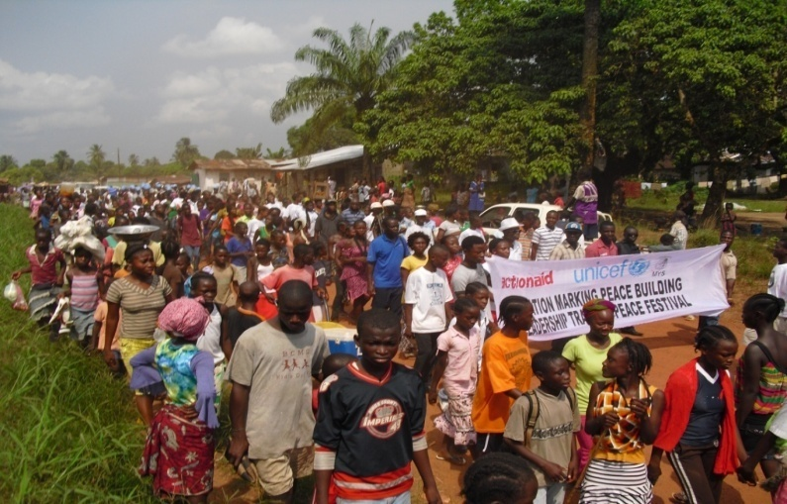

Qualitative data collection was used to measure impact using the ‘Most Significant Change’ methodology, which conducted comprehensive and systematic participatory interviews of town and community leaders/elders, community members, and beneficiaries to identify the impact of the Peacebuilding intervention. Below is a selection of those interview findings:

- The town commissioner of Harmonsville (Grand Bassa) communicated that the project had brought some significant changes in the community. Particularly, more women were now involved in community decision making processes and people were taught how to deal with conflict. Previously, there were conflicts around family (household) matters and also conflicts with other townships in the area. He said that before the project ‘things were out of hand’ and now it has become ‘more peaceful and quiet’. After the training there are recognized individuals who do conflict mediation and intervention whenever there are problems in the community.

- It was expressed by the beneficiaries in Tubmanville (Grand Bassa) that the trainings brought ‘togetherness’ and taught people how to resolve conflict, also that there are efforts now to achieve gender equality in the community. One key impact from the project was the resolution of ethnic tensions that have existed since the end of the war. This was caused because a certain ‘town son’ who returned was causing tensions by discriminating against another ethnic group who had settled there. The man was saying that the new comers were ‘strangers’ and ‘did not belong’. Since the training there has been an intervention with the man who was counselled by beneficiaries and community leaders about the importance of not discriminating against people based on tribe or origin and the tension has been resolved. Women are now participating in decision making processes and a female was appointed as a ‘tribal chief’ who specializes in conflict resolution. A peace committee was also set up comprising of the town chief, women, youth and elder representatives. Instead of going to the police or government, issues are addressed and resolved within the community.

- The community leader and beneficiaries in ‘On Your Own’ community (Grand Bassa) expressed that before the project came there were serious problems in the community, particularly with youth fighting and people ‘taking the law into their own hands’ or what is referred to as ‘jungle justice’ (mob violence). Since the project this no longer happens and ‘people have learned how to handle conflicts peacefully’. Also, women have become more involved in decision making processes.

- At a focus group meeting with Peer educators, beneficiaries, and the town chief in Bampala (Cape Mount) it was communicated that the project had ‘brought people in the community together’, particularly in the household but also when it came to community work. Before the project men and women were not communicating (men would tell women what to do and then leave), but now daily activities are discussed and decisions made jointly in the household. A similar dynamic existed with regard to community work, where the town chief would ‘give orders’ and the youth would ignore them, causing communal tension. Now, the town chief will ‘call a meeting and invite the youth and females to discuss and plan communal activities’, decisions are made together and everyone is participating in both decision making and communal activities. It was expressed that before the project, the people ‘did not have the tools or the mindset to deal with conflict’ appropriately and exclusion in decision making caused many problems. Education and training have resolved these issues, with many beneficiaries expressing that the project has taught them ‘the importance of self initiative’ and controlling your temper.

- The town chief in Farlie (Kanga satellite community, Cape Mount) reported that before the project there was an on-going conflict between Farlie and Kanga over the location of a school that was built, with town youths often clashing based on this initial disagreement. The project had resolved this conflict, with the ‘two towns communicating and no more fighting’ reported. A female beneficiary described how before the project men would ‘discriminate against women’, but now they have learned that this is damaging to relations and have ‘changed their behaviour’. Also, she has learned about ‘how the government works and her responsibility to vote and participate’ in decision making processes. One key thing she has learned is that ‘tribe and religion do not matter’, but rather how one ‘serves the people as a representative of the community’. An elder explained that the trainings had brought ‘knowledge’ to the community and that they had set up a conflict resolution committee called the ‘Farrie Peacebuilding Ambassadors’. He said that before the people in the community did not know how to respond to conflict but that the trainings had given them the skills to manage conflict peacefully.

- It was reported that Sinje and Gohazodua (Cape Mount), two communities located close to each other, have had many conflicts and problems since the war because during the 1990’s citizens of Gohazodua killed many people in Sinje. The project trainings created awareness about the importance of living together in peace and Sinje was chosen as the location of one of the Youth Centers to address this underlying conflict factor and history. Currently, there have been no incidences of violence reported between the two communities and the youth are meeting together for sporting and activities that promote peace and development.

- In SOS Joah (Grand Bassa) there was a huge conflict between the youth population and the elders surrounding issues of witchcraft accusations. The youth believed that the community was not developing or prospering because the elders had invited demons into the town. As a result the youth consulted a medicine man to cleanse the town of the evil spirits, which caused a conflict with the elders that degenerated into threats and counter-threats. During the trainings, the modules seized upon this on-going issue and applied the techniques to hold consultations and resolve the conflict. This is a key example of how inter-generational tensions are intertwined with cultural perceptions and development. Now that the youth and elders are working together, development initiatives are underway and the perception is that the town is beginning to prosper
The key expected outcomes were:

- Enhanced capacity of targeted youth population to assume leadership, participate in local and national policy networks and decision making processes and to contribute to peace and development.
- Targeted youth are empowered to use their capacities, skills, opportunities and energies constructively to enhance non-violence, peaceful co-existence and assume civil responsibilities on all levels of society.
- Targeted youth are empowered to make informed choices and decisions about their lives. Enhanced ability of targeted youth to take responsibility contributes to stabilisation and inclusion of society.
- Improved understanding and knowledge about youth issues leads to “youth-sensitised” local and national policy making-structures.

The key outcomes of the project were achieved: development and strengthening young people’s skills and capacity to make better decisions in their life and participate in the decisions being made in their community; increased civic engagement and the formation of conflict management structures; and reduced violence (especially GBV) in the communities. While the project proposal emphasized youth inclusion in both local and national ‘policy networks and decision making processes’, the emphasis has primarily been at the decentralized (local) level. Currently efforts are underway to strengthen linkages between the community, the district, the county, and the national level. Also, while Youth are in some instances very involved in county economic decisions (such as in Grand Bassa under the Social Development Funds), others in rural areas are more focused on improving their livelihoods. More efforts need to be made to link remote rural communities to those in urban centers, however this is logistically challenging.

Youth are very involved in Grand Bassa political and national policy making structures and making gains despite challenges related to political party deadlock in the county. Youth are changing the political landscape by advocating for social development funds, for the improvement of educational facilities, and they are taking leadership roles related to conflict management and addressing the potential for election related violence. Youth who benefited from the trainings are advancing themselves as candidates for local and national representative positions levels in Cape Mount, primarily through the Federation of Liberian Youth structure (where the current president will be competing for the House of Representatives). With regard to Conflict Management structures, there are currently Peace Committee representatives for District #1, #2, #3, and #4 in Grand Bassa and in Commonwealth, Garwula, Golakonneh, Porkpa, and Tewor (all counties) in Cape Mount. On-going efforts are working to harmonize and further capacitate Peace Committees at the District level and link them to the County Peace Committees in order to build County Peace Networks. Peace Committees often become vehicles for development initiatives and advocacy campaigns as well, however capacity building must continue to ensure sustained impact.

The project has accomplished (in the pilot counties) the integration of young people –especially young women – into local decision making processes and given them the skills to manage conflict in a peaceful manner. It has increased their participation and leadership in peacebuilding and development initiatives at the community level, which is working upstream to the County levels through a variety of initiatives.

- Financial Implementation

UNICEF Liberia received a total of USD 1,000,000.00 from the Peacebuilding Fund Liberia. All of the contribution has been fully utilized as summarized in the table below. Please note that this financial summary is an indicative report. The amount reflects the figures available at the field office level and should be considered as indicative. Actual expenditures are reflected in the Statement of Accounts prepared by the Division of Financial Management, New York.

Activity | (USD)
1. Leadership Skills and political participation and Peace building and Conflict resolution | 391,236.70
- First, second and third instalments to Action Aid for “Integration of Young People for sustainable Peace in Grand Bassa and Cape Mount Counties” | 334,731.50
- Consultancy to develop four modules and resource packs on leadership training skills and train 40 peer educators in the leadership training skills. | 20,000.00
- Consultancy to review and develop a youth Peace building education & skills modules/ resource packs for and train 50 peer educators in the use of peace education and peace building skills | 30,000.00
- Production of Peace Building Training modules and leadership skills training manuals on behalf of the JPYEE | 2,220.20
- Technical support for the training of trainers (T.o.T ) on Peace Education and the leadership training manuals | 4,285.00
- Provision of Youth Friendly Spaces and Information Resource Services | 224,172.14
- Payment to Consultancy firm for reproduction of three sets of working drawing for the youth Center | 229.23
- Service charges-pre-Construction services for the facilities of the youth centers | 12,572.00
- Consultancy fees and payment for the Construction works of two Youth Centres and renovation of one Youth center in two counties | 211,370.91
- Project Monitoring and Evaluation and supportive supervision | 2,829.00
- 16 Regular technical and supervision visits | 2,829.00
- Vehicles and Equipment MoYS | 124,804.68
Vehicles for the ministry of Youth and Sports | 56,155.28
Equipment to Ministry of Youth and Sports Peace building project | 68,649.40
- Staff and travel Cost | 184,971.40
Staff Cost | 158,292.00
Travel cost | 26,679.40
Total Cost | 928,013.92
Recovery cost (7%) | 64,961
Total | US992,974.92
Unpent Balance | US$6,586.08
GRAND TOTAL

- Future Work Plan

There are on-going activities explicitly linked to the PBF-L project that receive continued funding from Danida and UNICEF core funds. These include a communication strategy to highlight the impact and gains of the YES Peace project, follow up activities to link Youth organizations and community Peace Committees to County Peace Committees to form strong Peace Networks and to build further capacity in their activities, small grants to communities that have demonstrated initiative in livelihoods or development projects in order to establish activities that can sustain Peace and Development work, training to focal points for information resource services management at the Youth Centers, and continued support to the MoYS to adequately monitor and coordinate Youth programmes and activities (M&E, data collection and reporting).

Given the success and impact of the pilot project, plans are being made, and funds sought, to scale up the education and training modules to ‘hot-spot’ counties (from two to five by 2012) and to target ‘at-risk’ youth and conflict prone communities. Preliminary assessments and consultations with partners have been identified in Nimba, Grand Gedeh, Montserrado, and Maryland counties for future activities and project implementation. Specific communities in many of these counties have also already been identified based on conflict mapping reports and other data collected. These were selected based on the criteria of where the majority of conflicts are concentrated and in light of the political crisis and on-going violence in Coite d’Ivoire. Border counties will be incredibly important areas for peacebuilding work given the alarming trend of arm elements crossing the border from Coite d’Ivoire (many of whom are reported to be Liberian former fighters).

Human Interest Story, Project Photos, etc

On the way to reconciliation

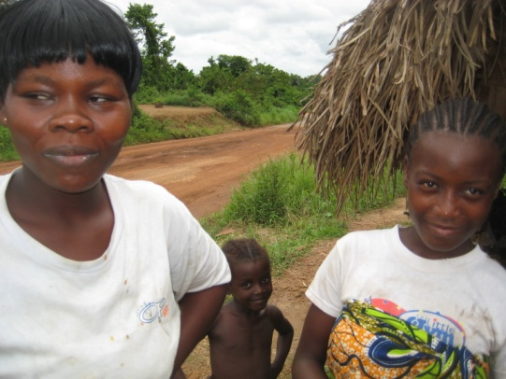

Korto completed the TOT training in peacebuilding and leadership skills. She is 21 years old and a single mother of one child. She attends school and is selling products on the market in order to support herself and her mother.

During the selection of the young women for the TOT trainings, we came across Nekreen town in Grand Bassa County where community members found it challenging to select a female for the trainings. Korto, which had the adequate education level was called a “trouble maker” and therefore did not get on the short-list of the community. After AAL and UNICEF encouraged the community, she was sent to the training despite all reservations.

During the training Korto gained confidence in the other participants and the peer educators and she narrated her story: Her father was killed during the war by one of her neighbours. She knows exactly who did it but the perpetrator never came to her and her family to apologize. She refuses to talk to him because she still feels hunted by the pictures every time she sees him and she is reminded of her father’s death and her powerlessness at the time. She was able to describe her feelings and her anger as well as how she is trying on her own to manage her life. During the training she was conscientised on the role of reconciliation and how it can help in her life. She was also encouraged by other participants and she found out that she is able to relate to others, to make friends, to learn something and to play a responsible role in her community. She expressed the desire to meet the person who killed her father and to reconcile before she starts delivering the community trainings. Therefore she approached the community leaders. AAL accompanied her and the community leaders agreed to organise the meeting between her and the perpetrator.

Korto was able to restore her dignity in the community and to tell her side of the story which explains some of her previous unfriendly behaviour. As she performed reconciliation by example, the community accepted her as one of the peer educators for peacebuilding and leadership.
  - Three stories from participants

Together against SGBV

In Dorr community, Grand Bassa County, the bi-weekly trainings are usually started with the “community news” which are brought in by the participants. Community news contain conflict issues of community members, news from local youth organisations and other issues of concern. The conflict issues will be used as case studies during the training.

One couple had a serious problem in their relationship. She was spreading bad rumours in the town about her husband because he usually beat her and went out with girlfriends. It was disturbing the peace in the community and their private affair become the story of everyone. Both of them happen to be participants in the peacebuilding and leadership training. The community members decided to bring it up in the community news and to make it a topic for the training. During one training session she told the group that he frequently used violence against her. He was able to explain his bad feelings against her. After a group of participants talked to them separately after the trainings both of them were able to understand how they created a vicious cycle of verbal and physical violence. The group helped them to analyse the causes and to find solutions. The peer educators and the participants brought them together after the separate talks and asked them to apologize to each other. They did it and as they were telling us, they have been peaceful together since then.

Also, other couples in other communities in both counties have experienced similar conflicts and have solved them during the trainings by improving their communication. Community members were able to understand how they influence the lives of couples by sometimes contributing to the conflict in taking sides.

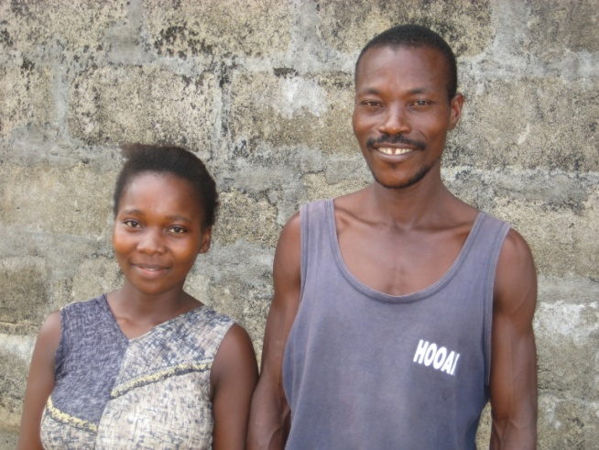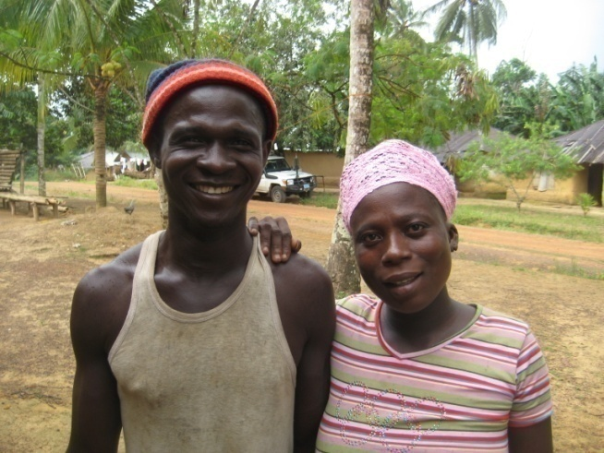
Two couples in Cape Mount and Grand Bassa who were able to resolve their conflicts through
the peacebuilding training.

Children in Pujun Community, Cape Mount County.
Behavioural change for a better future

In Wahrzon Town, Grand Bassa County, the participants were particularly impressed with the session on identity and “knowing yourself”. They reported that their new awareness how much their own behaviour can influence the behaviour of other people and evoke sometimes violent reactions made them much more careful how they go about things. One father of two children said that he was occasionally drinking and that he sees some “bad” behaviour in his children already. He has severely beaten his children in these instances. During the training he started to understand the link between his own behaviour against his wife and children and other community members and the one of his children. He learned that his behaviour has a direct impact on his children since they usually learn by copying.

Therefore, according to him, he changed his behaviour and focuses on being a responsible father who pays attention to his wife and children and provides them with the necessary care. The other participants of the trainings confirmed a change in his behaviour and were also committed to remind him when he is falling back into his old attitudes. A lot of male participants in both counties report that particularly the leadership training helps them to stop beating and neglecting their children.
In a few communities, members and participants also realised that they engaged their children in very hard physical work which is harmful to the development of their children. Some parents said that they are trying to change this and to give their children lighter tasks which are more appropriate for their age.

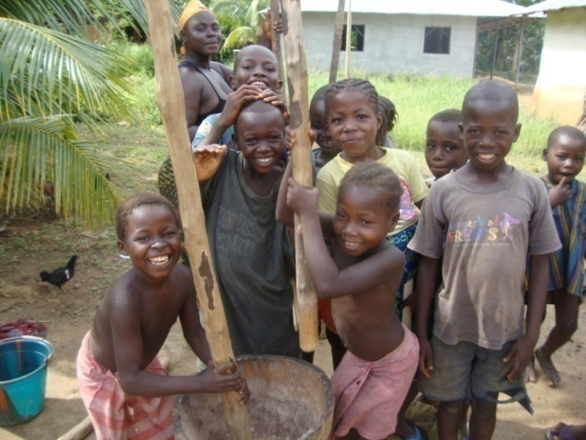

Oslo Conference
that the majority of Liberia’s youth were never integrated in the mainstream of society (Medecins du Monde, Children in the Fighting Forces)
A National Youth Policy for Liberia: A framework for setting priorities and executive actions, December 2005, p.6.
Children’s PRS Consultations Report, 2008
Dupuy, Education in conflict and post-conflict settings
2008 School census, MoE
UNICEF Liberia, 2007, Evaluation of the Disarmament and Demobilization Programmer for Children Associated with the Fighting forces in Liberia.
For example, in Kenya during the post-election violence in early 2008
Work is currently underway to strengthen the linkages from the community to the county level by administrative district organizing, based on decentralization policies. County to National level linkages are still weak.
Reference is made to some of the core principles and values underpinning the National Youth Policy, p.7.
Reference is made to some of the core principles and values underpinning the National Youth Policy, p.7.
Action 1&2 are combined because Peacebuilding and Leadership training were conducted together as part of the comprehensive 22 day education and training sessions.
Names are changed.

