Liberia Peace Building Fund

ANNUAL programme NARRATIVE progress report

REPORTING PERIOD: 1 january – 31 December 2010

Programme Title & Number |  | Country, Locality(s), Thematic Area(s)
- Programme Title: Strengthening Prosecution services at the Ministry of Justice  - Programme Number (00070485)  - MDTF Office Atlas Number: PBF/LBR/E-3 (PP/R3/A3/09) |  | Liberia, Nationwide, Access to Justice

Participating Organization(s) |  | Implementing Partners
Carter center-Liberia  PAE  UNMIL/JLSSD  ABA, LNBA |  | Ministry of Justice, RL  Name: Cllr. M. Wilkins Wright  Address: Ashmun Street, Monrovia, Liberia  Telephone: +231.651.8103  - E-mail:

Programme/Project Cost (US$) |  |  | Programme Duration (months)
MDTF Fund Contribution: 1,082,000 USD |  |  | 18 months
Agency Contribution in kind  (in kind Staff contribution) |  |  | Start Date  April 2009
Government Contribution in kind  (in kind staff support) |  |  | End Date or Revised End Date,  December 2010
Operational Closure Date
March 31, 2011
TOTAL: | 1,082,000 USD |  | Expected Financial Closure  April 30 2011

Programme Assessments/Mid-Term Evaluation |  | Submitted By
Assessment Completed - if applicable please attach  Yes No Date: __________________  Mid-Evaluation Report – if applicable please attach  Yes No Date: __________________ |  | - Name: Cleophas Torori/James Verdier  - Title: Programme Manager  - Participating Organization (Lead):UNDP  - Email address: james.verdier@undp.org

Table of contents

- Project information ……………………………………………………………………………………………………………….1-2

- Table of contents ………………………………………………………………………………….. ………………………………..3

- Acronyms…………………………………………..............................................................................................................................4

- Purpose …………………………………………………………………………………………………………………………........5-6

- Resources…………………………………………………......................................................................................................................7

- Monitoring & Evaluation……………………………………………………………………………………………………………..7-8

- Results ………….......... ………………………………………………………………………………………… …………………..8-15

- Future work plan…………….………………………………………………..………………………………………………………..15

Acronyms

CPAP-Country Programme Action Plan

CSOs-Civil Society Organizations

GOL- Government of Liberia

LNBA- Liberia National Bar Association

LNP-Liberia National Police

MOJ-Ministry of Justice

NGO-Non Governmental Organizations

ROL-Rule of Law

UNDP—United Nations Development Programme

UNMIL-United Nations Mission in Liberia

SGBV-Sexual and Gender Based Violence

CO- Country Office

OTD- Office of Director of Training and Development

SG- Solicitor General
ABA- American Bar Association
UNDAF- United Nations Development Assistant Framework

I Purpose

The Government of Liberia and the UN have identified weak justice systems as one of the challenges facing Liberia today. The challenges identified include an acute shortage of qualified personnel and general capacity as well as an undue delay or no prosecution of matters. Following a period of brutal and destructive civil war that commenced in 1989, a Comprehensive Peace Agreement (CPA) was reached between the warring factions on 18 August 2003. The conflict was characterized by brutal and widespread atrocities fueled by inter-ethnic tensions and a complete collapse of the rule of law and accountability of the police and the military. With the subsequent departure of then-President Charles Taylor and the UN Security Council Resolution 1509, Liberia had a new chance for peace and stability. The establishment of the National Transitional Government of Liberia (NTGL) and the implementation of the Results Focused Transitional Framework (RFTF) facilitated the subsequent holding of landmark national elections culminating in Mrs. Ellen Johnson Sirleaf’s accession to the Presidency of Liberia in January 2006—the first democratically elected female president in Africa.

As mentioned above, the conflict resulted in a complete breakdown of the rule of law. Liberia faces several institutional challenges with regard to its justice system:

- The justice system suffers from chronic capacity constraints in terms of basic infrastructure and material resources as well as acute shortages in human and financial resources, all of which severely hamper the administration and delivery of justice. There is an acute shortage of trained prosecutors and public defense counsel to staff the courts, and magisterial and specialized courts continue to be staffed by unqualified personnel.
- There are major case management constraints between the various parts of the criminal justice system, severe shortcomings in evidence gathering and preservation, and serious problems regarding the length of pre-trial detentions and the long delays for trials. For example, the majority of prisoners are pretrial detainees who have been waiting for long periods for their cases to be heard in court, due to a lack of prosecutors and public defenders to facilitate their cases.
- There are significant shortcomings in the protection and promotion of human rights, a lack of equal access to the justice system, and limited public understanding of citizens’ rights under the law. Specifically, access to justice is limited for women and those in rural areas, and is further hampered by the inefficient administration of justice.

To that end, the PBF set forth its Priority 3.3: Strengthening State Capacity for Peace Consolidation, and proposed support to Strengthening and Expanding State Authority – security sector reform, justice strategies with restructured security architecture, including decentralized security to support the rule of law; extension of legal services, public lawyers in rural areas, with sensitivity for issues affecting women, youth and underrepresented groups; construction/rehabilitation of protection and rule of law infrastructure.

This project aimed to strengthen the prosecution arm of the Ministry of Justice so that it can expand its reach into rural areas and address issues relevant to those communities, including issues relating to women and youth. This project also built the capacity of the Ministry of Justice to better manageand train its personnel, and builds a long-term plan to develop its prosecution services. The result of this capacity development will be qualified and well-trained personnel in all counties in Liberia, operating under a set of standard operating procedures, with ongoing training, as well as linkages with other justice players, namely the public defenders and the police. Furthermore, emphasis was placed on community outreach to ensure that public perception and faith in the justice system is increased, through ensuring timely and fair disposition of cases.

The project was broken down into four components to address the various capacity gaps, with realistic and detailed activities set forth that reflect the timeline available.

The first component was the development of a strategic plan for improving prosecution services at the Ministry of Justice with consultant support from UNDP. Two consultants undertook a series of workshops and drafted the strategic plan, which has not been approved by the Minister as yet due to the change of administration at the Ministry of Justice. The plan remains to be fully implemented and taken ownership by the Ministry.

The second component was the establishment of an Office of Training and Development (OTD) within the Ministry of Justice to design a comprehensive training program such as training courses and materials in identified substantive areas, including juvenile justice, to periodic refreshers training for county attorneys and city solicitors, and coordinating donor training activity. The MOJ identified office space and this project equipped the space, assisted the MOJ in recruiting a Head of Office who was paid by this Project for the period of one year. This OTD undertakes the identification of prosecutorial training needs and gaps, and the development of a comprehensive training programme for prosecutors. The comprehensive training programme was approved by the Minister. OTD developed an annual work plan that included initial training covering standards, policies and procedures, and reporting requirements. Other target areas are trainings on Liberian criminal law and procedure, the initial charging process and the rules of evidence, and topics dealing with vulnerable populations, specifically juveniles and victims of SGBV.

The third component of the project was building the capacity for operational management and the development of standards and policies for prosecutors of the MOJ, specifically the Office of the Deputy Minister of Justice for Administration and Public Safety (DMA) and the Office of the Solicitor General (SG). These offices were equipped with operational materials. Staff of these offices also benefited from comprehensive training package designed and implemented by the OTD (pls see component 2). A total of 388 personnel of the Ministry of Justice benefited from the training package. They included; Liberia national Police, Immigration officers, Prison Officers, County attorneys, City solicitors, District Attorneys, among others

The fourth component of the project involved the development of mechanisms for community outreach to promote joint police-prosecutor efforts, increase public investment in rule of law and justice, and to enhance public dialogue.
This component built on the efforts already made by the community policing forums and established linkages with them to further enhance their service delivery. Two community police forums were conducted in two counties (Monsterrado and Grand Cape Mount) jointly by the Ministry of Justice/Liberia National Police on one hand, and the Community Security and Rule of Law Programmes of UNDP on the other hand using several selection criteria, including population and crime rate.

II Resources

Financial Resources
The Peace Building Fund provided by DPKO in the amount of 1,082,000 USD was the only source of funding for the project “Strengthening Public Prosecution services at the Ministry of Justice. There was three months no cost extension of the project due four months delay (January- April) in the transfer of the funds by the PBO.

Human Resources
The prosecution Project is one of the Rule of Law Portfolios. The entire portfolio had six staff. A Rule of Law Project Manager (National), two (2) Programme Associates (National), and two Internationals-- Chief Technical Advisor and Programme Specialist. These are professionals from diverse backgrounds including Law, Communications, and Management.

III Monitoring & Evaluation

Project monitoring and evaluation (M&E) was conducted in line with CPAP and UNDAF plans. UNDP was responsible for setting up the necessary M&E mechanisms in order to ensure continuous tracking of the project’s results, as well as to ensure efficient resource utilization, accountability, transparency and integrity. Regular communication with stakeholders, i.e. MOJ, ensured critical inputs.

Strategies employed included tracking the achievements of planned results for each activity within the annual work plan and reporting progress to the project board and giving feedbacks to implementing partners through quarterly board meetings. The Project Manager, in collaboration with the Project Board selected implementing partners and developed a results-based monitoring plan. The plan had SMART indicators which facilitated effective monitoring. The project Manager provided monthly reports to the project board.

The specific mechanisms used to monitor the achievement of results included:

- Monthly and quarterly progress and financial reports, prepared by the Project Manager for review by the Project Board; a standard reporting format was produced by the Peace Building Office and used for reporting.
- Annual progress report, technical and financial report prepared by the annual work plan implementing agency and/or the ERP Atlas system at the end of the year; and
- Quarterly meetings of the Project Board convened to review progress reports and reports on monitoring visits in order to take necessary actions to ensure the project results were achieved and where possible, recommended a change in implementation strategy. A mid–term review with partners was conducted.

1V results
Target/outputs Achievements
1. Strategic plan for improving prosecution services developed by the Ministry of Justice (MOJ) | Strategic plan was been developed and consultants have consolidated final version for approval by Authority at the Ministry of Justice. Implementation plan is on going through series of regional trainings and consultations
2. The Office of Training and Development (OTD) established within the Ministry of Justice to design and implement a comprehensive training programme, provide training courses and materials in identified substantive areas, including juvenile justice, to county attorneys and city solicitors, and coordinate donor training activity | Office of Training and Development has been established under the office of the DMA; Director hired. Several regional training activities for County Attorneys, City solicitors were carried out throughout the entire country.
3. The Office of the Deputy Minister of Justice for Administration and Public Safety (DMA) capacity for operational management enhanced, and the development of standards and policies for prosecutors, including a code of conduct/ethics, supported | Operational capacity management of the DMA has been enhanced, OTD office established, series of trainings for prosecutors on – going; legal texts and office supplies given for operations. Standards and polices, procedure are being discussed and generated through the series of on-going regional consultations with stakeholders
4.  Mechanisms for community outreach developed to promote joint police-prosecutor efforts, increase public investment in rule of law and justice, and to enhance public dialogue. | Mechanisms to promote Joint police- prosecutor efforts in place. There is an ongoing, combined regional police- prosecutor training, preparation under to reinforce community police forums which will buy into the public interest.

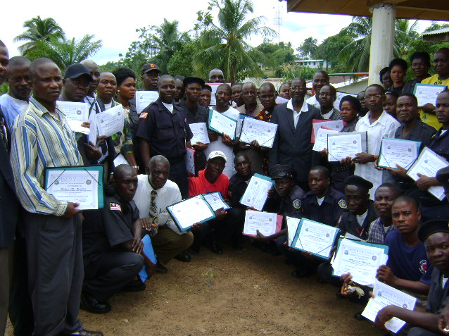

V. future work plan
This project’s sustainability lies in the fact that its components meet gaps identified in Liberia’s Poverty Reduction Strategy and are designed to bolster that strategy at a critical time in order to engender long-term development of the judicial sector. Strategic Objective 3 of the PRS is “to strengthen and enhance the effectiveness and integrity of legal and judicial institutions.” Specific priority interventions include identifying critical staffing and skills gaps and developing a prioritized strategy for remedying those gaps, in particular, focusing on recruitment standards, in-service training, salaries and incentives, appropriateness of pre-employment legal education, among others.

For example, the Office of Training and Development will develop a long-term comprehensive training programme. The project includes salaries for these staff for the duration of the project, after which the MOJ is expected to absorb these staff members onto its payroll, thus assuring complete national ownership of this Office and its products. Furthermore, the database to be built under the Deputy Minister for Administration and Public Safety (DMA) will serve as a tool for tracking prosecutors nationwide, and can be replicated internally for use by other Departments or Agencies, i.e. Finance, etc. In addition, the standards, policies and procedures that are being developed are going to be the foundation for an overall administrative structure that governs all operational and training aspects of prosecutors in Liberia.

Finally, UNDP is undertaking a 2 year project on Strengthening the Rule of Law and Administration of Justice in Liberia. The project presented herein will be implemented in parallel with this 2 year project, and will be implemented by the same Project Management Unit. Furthermore, the activities herein will lead into the activities to be funded by the 2 years project, and will in essence act as building blocks for future support. This will ensure complementarities between the two projects, a lack of duplication of activities, and a sustainable impact on the institutions being supported.
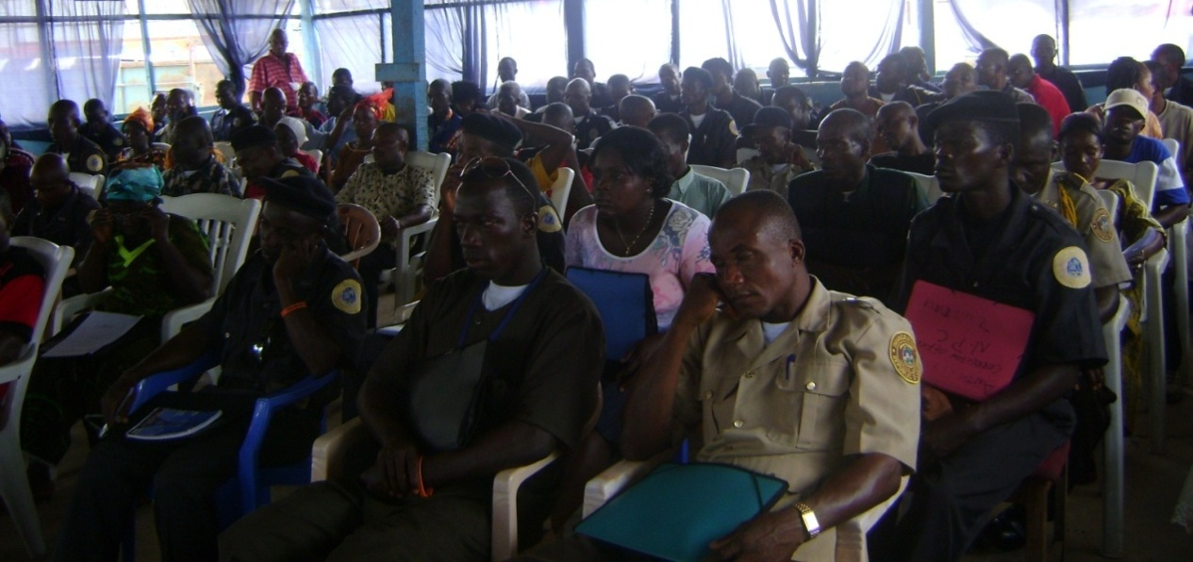

Liberia national Police and immigration officers in training

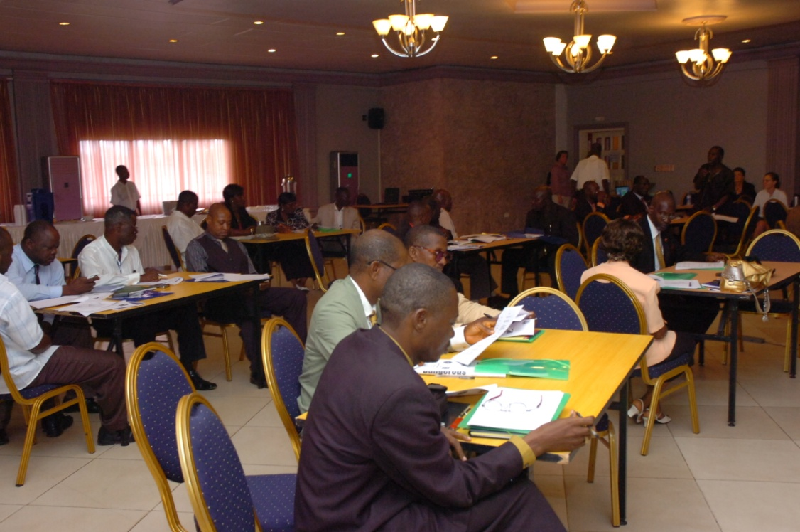

Prosecutors in session during the development of “Strategic Plan” in Monrovia

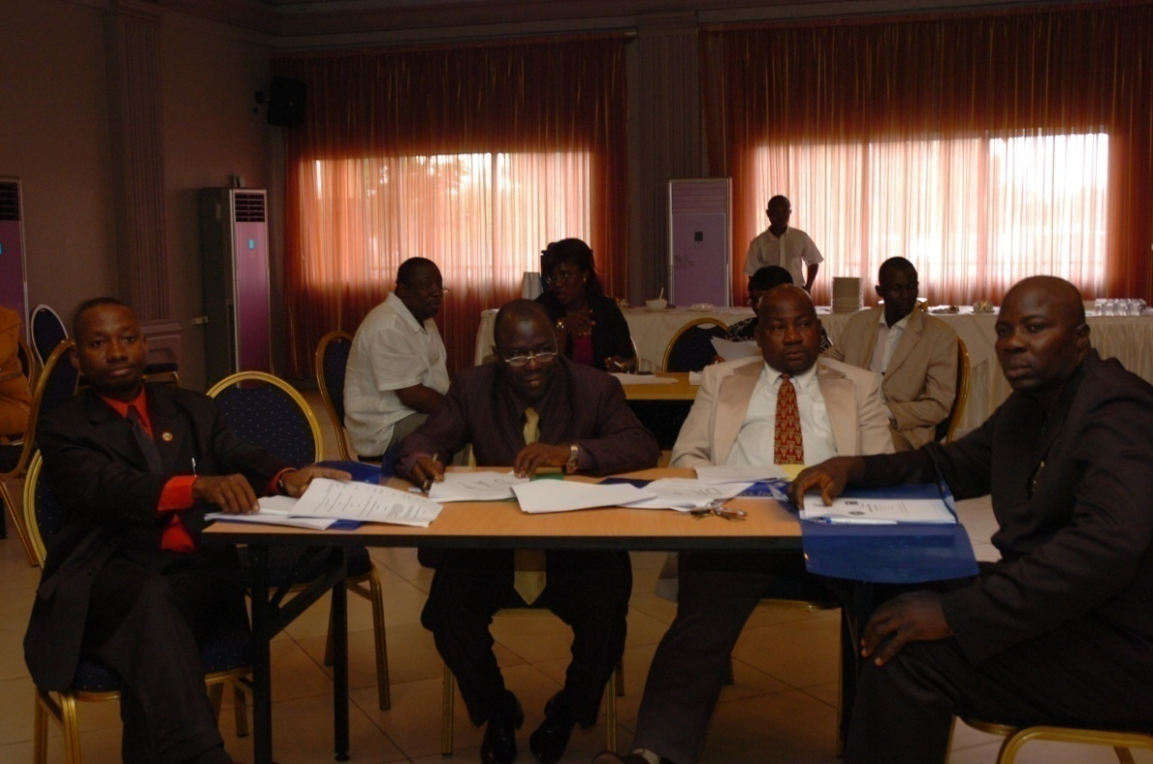

Prosecutors during validation of a “Strategic Plan” for Prosecutors of the Ministry of Justice

For more information on this project activities please visit undp intranet
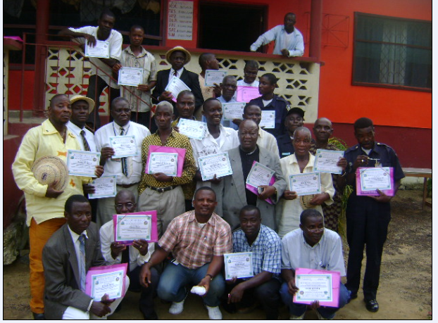

The term “programme” is used for programmes, joint programmes and projects.
Priority Area for the Peace building Fund; Sector for the UNDG ITF.
The start date is the date of the first transfer of the funds from the MDTF Office as Administrative Agent. Transfer date is available on the MDTF Office GATEWAY (http://mdtf.undp.org).
All activities for which a Participating Organization is responsible under an approved MDTF programme have been completed. Agencies to advise the MDTF Office.

