Liberia Peace Building Fund

QUARTERLY STATUS REPORT AS of October - December 2010
Recipient UN Organization: | UNDP |  | PBF Priority Area: |  | 3.1, 3.2
Implementing Partner(s): | The Judiciary, Republic of Liberia
Project Number: | PBF//R3/A3/09 (PBF/LBR/E-4_ID 00073631)
Project Title: | “Strengthening Public Defence”
Total Approved Project Budget | $750,066 USD
Project Objective and Scope | Long term war and insecurity has led to the disintegration of the Liberian legal system. Efforts to rebuild the trust of the Liberian people are ongoing by ensuring the rights of suspects, detainees and accused can be respected and provided access and opportunity for free and fair trials. One key area however, has not been adequately addressed: the rights of prisoners and defendants in the legal system. Pre-trial detainees are languishing in jail as a result of poor case management procedures, lack of transportation, and lack of legal representation. It is the responsibility of the Public Defenders’ Office to represent indigents, yet the office is poorly equipped to do so. The Public Defenders’ Office lacks both the logistical support and proper capacity to provide services so desperately needed by unrepresented indigents. While much emphasis has been placed on prosecution of the accused, the defence has not been given similar consideration. A fully functioning and just legal system should place equal emphasis on prosecution and defence and upholding the right to due process. This project duration is 12 months.
Funds Committed: | $750,066 USD |  | Percentage of Approved: |  | 100%
Funds Disbursed: | U$ 744,186 |  | Percentage of Approved: |  | 99%
SC Approval Date: | January 22, 2009
Expected Project Duration: | 12 Months | Forecast Final Date: |  | April 2010 |  | Delay (Months): | 4 Months

Outputs: | Progress: | Percentage of planned:
1. Identify and recruit a Public Defense Training Coordinator to be assigned with the Judicial Training Institute (JTI) to coordinate the development of a curriculum for training.  2. A comprehensive training manual and program established to train public defender through the Judicial Institute (JI) | - Public Defense coordinator has been recruited and the post of curriculum developer advertised.  - Short listing already done, interviews scheduled.  - Two local consultants recruited for the development of the training manual | - 100%  - 50%
3.Office space for 8 public defenders is identified/refurbished | Continues maintenance of 14 vehicles procured under the Public Defenders project, salaries, accommodation and scratch card provided to the Judiciary to enhance the effectiveness of Public defenders. | 100%
4.Public defenders are available and dedicated to represent and protect the legal interest of individuals declared indigents  5. Public Defence monitor recruited to provide oversight monitoring of public defenders alongside the Training Coordinator on a roving basis. | Public defenders have been identified and recruited by the Judiciary and deployed into counties.  The Public Defender coordinator continues to play the role of monitor ensuring that they are making the required representation. | 100%  0%

Outcomes: | Progress:  {In terms of Indicators} | Comments/Remarks:
outcomes:  Peace building Impact: An effective and accessible public defence system that underprivileged and economically challenged individuals, though accused of crimes, can rely and trust for adequate legal representation and protecting the right to due process.  Key Outcomes: Citizens will have increasing confidence in public defence system and will begin to seek and rely on trained and equipped public defender to have their day in court. | As a result of this projects’ intervention/support to the Public, there has been an increased confidence in their work due to the number of representation made on behalf of indigents.  Citizens are now having access to public defenders due to their availability. This is evident by the number of cases defended by the public Defenders in the underprivileged Counties like Lofa, Bong, Grand Gedeh, Grand Kru, River Gee, Maryland and other counties. There are total of 21 public Defenders assigned in the 15 Counties | N/A
Number of prolong pre-trial detentions in withholding centres and at the Central Prison will decrease. Citizens rights to due process protected with greater appreciation of the cliché – “an accused is deemed innocent until proven guilty | Visitation to courts and prisons have increased in the respective assigned areas of the Public Defenders with the aim of providing legal services for indigent where required.
”. A functional, trained and equipped criminal justice system comprising both strong and effective prosecution and public defence system. Citizens develop confidence in the fairness of the criminal justice system and its capacity to respect basic human rights. | Pursuant to building a strong and competent justice system, ongoing training for Public Defenders continued with the last session held from September 2nd -3rd 2010 covering the following topics, cross examination, expert witness, and preservation of evidence.

Qualitative achievements against expected results:
Key Achievements:
The last training conducted for public Defenders was held in Kakata, Margibi county. The training was held from October 26-27, 2010. It brought together judges, Magistrates and other legal practitioners. The training was as a result of recommendations coming out of the various trainings conducted for the Public Defenders. It focuses on the role of judges in dispensing justice and the role of public defenders. Some of the key topics were grounds for dismissal, when to except, and making the court records. The quarter ended with ongoing support for the provision of salaries for the eight Public Defenders under the project, accommodation, and scratch cards. Additional provision of maintenance/ repairs and fuel for vehicles. The below data represents the number of representation made by public defenders per county.

Next Steps:
The final step of the project is the development of the training curriculum for public Defenders underway.

Challenges{If Necessary}:
- Logistics (inadequate logistical support for the public defenders0
- Bad road conditions thus imparting on the number of cases handled by public Defenders.
- Inadequate funding to meet the demands of the project.

Annex 1 (Additional elements such as photos, list of workshop participants etc

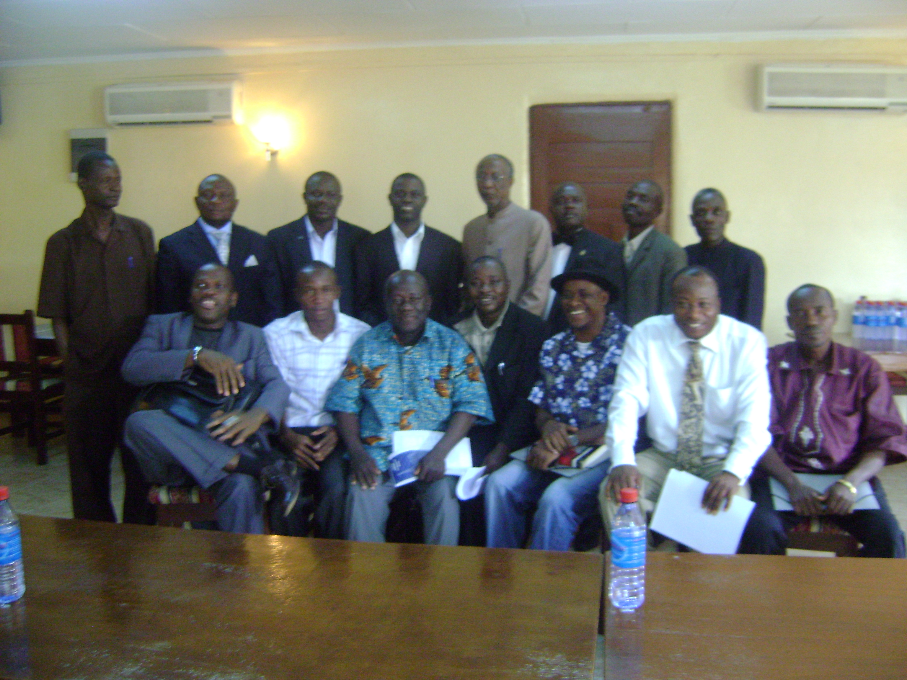

Public Defenders after the training session.

