

LEBANON RECOVERY FUND

ANNUAL project NARRATIVE progress report

REPORT COVER PAGE

Participating UN Organization: |  | Report Number:
UNDP |  | 5

LRF Project No:  New Atlas Project No: (as per enclosed list)  65549  65557 |  | LRF Project Title:
 |  | Flood Risks Management, Water Harvesting and Soil Conservation in Baalback-Hermel. Phases I & II

Reporting Period: |  | Project Budget:
1 January to 31 December 2011 |  | LRF-funding:  Flood I: $ 2,843,881  Flood II: $ 3,800,000  Other funding: $ -

List of Implementing Partners: |  | Project Coverage/Scope:
- Arab Center for the Studies in Arid Zones and Drylands (ACSAD)  - German Society for International Cooperation (GIZ)  - Ministry of Agriculture  - Ministry of Water & Energy/Bekaa  - Municipalities of Aarsal, Fakeha and Ras Baalback |  | Baalback-El Hermel region  Flood I: Aarsal and Fakeha villages  Flood II: Ras Baalback village

Abbreviations and acronyms: |  | Project Duration/Closed Project:
ACSAD: Arab Center for Studies in Arid Zones and Drylands  ARDA: Aarsal Rural Development Association.  CO: Country Office  DIM: Direct Implementation Modality  GIZ: German Society for International Cooperation.  LRF: Lebanon Recovery Fund  MoA: Ministry of Agriculture  MoE: Ministry of the Environment  MoEW: Ministry of Energy and Water  MoU: Memorandum of Understanding  PMU: Project Management Unit |  | Start Date:  - Flood I:  Original start date :07 Nov. 2007  Actual start date: 01 Feb. 2008  - Flood II:  Original start date :26 Sept. 2008  Actual start date: 20 Feb. 2009  End date:  - Flood I:  Original end date : Sept. 2009  Revised end date: May 2011  - Flood II:  Original end date : Feb. 2011  Revised end date: Mar. 2013

NARRATIVE REPORT FORMAT

Purpose
The project aims at assisting the Government of Lebanon in its recovery efforts in the conflict-affected Baalback–El Hermel area which is being threatened by desertification through better land management practices, namely: flood risks reduction, restoration of vegetation cover and improved availability of irrigation water needed to increase crop productivity and improve the standards of living. This will be achieved through the construction of stone walls, check dams and water collection reservoirs to prevent runoff water from reaching villages and farms and through the restoration of land cover to reduce soil erosion. The objectives related to water management will be achieved through construction of membrane-lined reservoirs to collect unused water from springs, rainfall and snow melts and through installation of water-use efficient irrigation networks and systems that will be used by local farmers to improve their crop diversity and productivity.
The project objectives will be met through the following outputs:

- Coordination and linkage with on-going projects established and strengthened;
- Risks and damages caused by floods in target area managed and reduced;
- Water for irrigation harvested, managed and made available to farmers;
- Land cover in risk areas increased and soil erosion reduced;
- Sustainability, capacity building and public awareness.
The expected outcomes from the current projects particularly those related to water harvesting, increased vegetation cover and higher productivity will serve very well the national efforts and plans aiming at combating desertification and alleviating poverty in North Bekaa. They will also serve the recovery efforts made by the Lebanese government in normalizing the living conditions of rural communities and in restoring the basic needs and infrastructure for practicing sound and profitable agriculture in the affected area.
The Ministry of Agriculture is the main national project partner responsible for the supervision and execution of the project through the National Action Programme to Combat Desertification project already established at the Ministry; while the Ministry of Energy and Water is the key facilitator in the execution of the excavation works. The local municipalities and communities in the region are the project stakeholders and will be involved in the project activities. GIZ and ACSAD had a high technical backstopping role through sharing information and coordinating activities during the first phase of the project. For the second phase of the project, the consulting firm Earth Link and Advanced Resources Development (ELARD) was engaged to provide the necessary technical support for the effective data collection, design and supervision of execution of the flood management structures.
- Resources

All the project’s fund were provided by the Lebanon Recovery Fund, a Lebanese Government led programme established on the occasion of the Stockholm Conference, and is in line with the UNDP’s development goal of alleviating poverty in rural drylands of the conflict-affected Baalback - El Hermel area.
The MoA is hosting the project, it is providing the offices and other associated services but without any in cash contribution.

No budget revisions or financial changes were undertaken but it should be noted that a re-deployment between budget lines (especially for personnel, supplies and commodities, and miscellaneous) was done to cover additional expenses incurred after the extension of the project second phase.

Human Resources:

National Project Staff:
- 1 Project Manager who resigned at the end of the year 2011. UNDP management has assigned a new project manager to start at the beginning of year 2012 to ensure that there is no gap in project management.
- 3 full time Technical Assistants (technical, field and project assistant)
- 3 part time Technical Assistants (in GIS, communication and graphic design)
- 1 driver

A long term agreement with a local Consultant for topographic survey and mapping services was signed on the 24th of November 2011 and will expire on March 2013. The contractor will check and validate the accuracy and adequacy of topographic data and maps submitted by the Contractors, will locate boundaries of the reservoirs, and notify of any discrepancies or problems discovered in work and suggest solutions for improvement.
Implementation and Monitoring Arrangements
The Project is executed under the UNDP Direct Implementation Modality (DIM), whereby UNDP acts both as the implementing and the executing agency. For the day-to-day management of the project, the UNDP CO has set-up a Project Management Unit (PMU). The PMU works under the direct supervision of the UNDP CO, and in close collaboration with the donor, the Lebanese Government, the local direct and indirect beneficiaries, as well as with the international team of experts and the local contractors recruited for this project. The PMU is led by a full time national Project Manager and is supported by the required national professional and administrative staff as well as national and international consultants.

The UNDP CO is responsible for monitoring the progress towards intended results, and for ensuring high-quality managerial and financial implementation of the project, including the responsibility for ensuring proper use of administrated funds to assigned activities, timely reporting of progress (quarterly progress reports), as well as undertaking of mandatory and non-mandatory evaluations. The UNDP CO follows up with the PMU on a semi-weekly basis on project implementation issues and undertakes annual tripartite review meetings. Furthermore, the procurement of goods and services and the recruitment of personnel are effected in accordance with UNDP standard guidelines, procedures and regulations.

Further to a decision by the LRF steering committee on April 4, 2011 major expenditures in the project were frozen pending the results of an external evaluation. The evaluation was requested by the LRF further to an extension request filed by UNDP for the phase II of the Flood Project. The purpose of the evaluation was to assess the need for the project in terms of objectives, approaches, feasibility and socio-economic impact as well as the capacity of UNDP to implement the project and its sustainability strategies. The extension was requested because there was a delay in the project implementation and the project objectives could not be delivered on schedule. These delays resulted from:
- Meteorological data non-existent in region;
- Difficulty on the ground in the excavation of 2 million cubic meters for13 reservoirs;
- Additional time to conduct training sessions on maintenance of ponds and reforestation.

- Results

The actual start date of the project’s activities was on 01 February 2008 following the signature of the project document by the national counterparts. With the approval of the Lebanon Recovery Fund of the Phase II of the Flood Project that targets the watershed of upper Aarsal and Ras-Baalback covering an area of approximately 250 Km², a new UNDP Project Document was developed encompassing both phases of the project. The two watersheds targeted by the projects are shown in Figure 1 below. Both phases of the Flood project comprise a larger programme on Flood Management in the Bekaa region. Accordingly, this report will include progress on both projects.

The total budget for both phases I and II amounts to $6,643,881 covering originally a 4 year timeframe in total (2008 – 2011) extended to March 2013.

During the current reporting period, the activities of Phase I are complete and the project was operationally closed in May 2011. A final evaluation for Flood I was conducted by an international consultant. For phase II, an assessment requested by the LRF completed and the extension was granted until March 2013. Bureau Hamid Kayrouz was selected to undertake all the excavation works for the reservoirs and the implementation activities of the designed flood management structures; works on site for the excavation of the reservoirs was initiated. A UNDP surveyor was selected to verify on the successful completion of excavation works executed by the contractor and to validate on site all requested data submitted by the municipality and the technical consultant ELARD. Also, a MoU was signed with the Municipality of Ras Baalback for the maintenance of the reservoirs, walls and the reforested area. TORs for reforestation were reviewed and related procurement activity is ongoing.

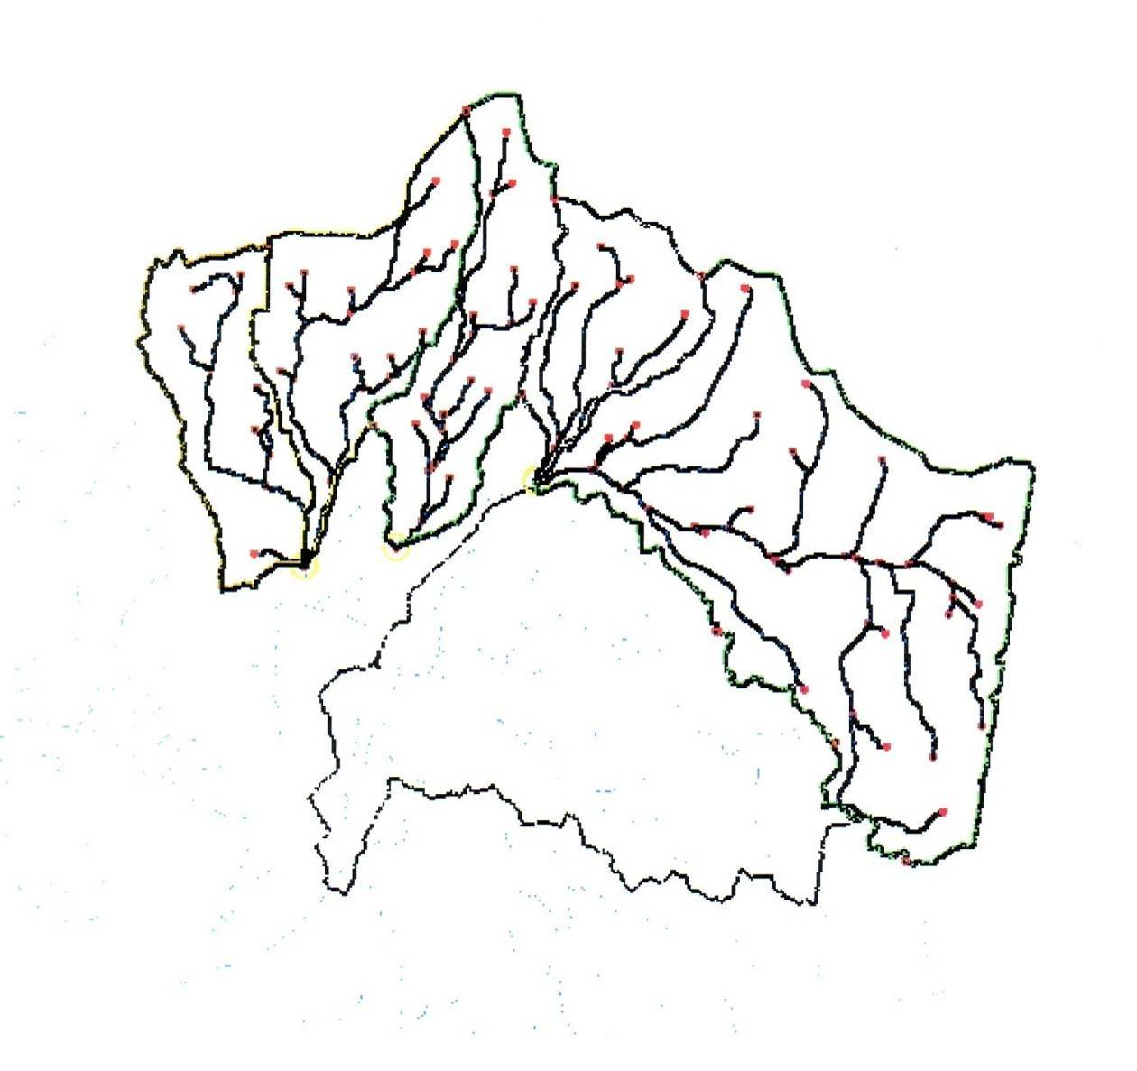
Figure 1: The Two Project Watersheds in North Bekaa Region

Progress on outputs

- Project Management and Coordination

- The contract awarded to Earth Link and Advanced Resources Development-ELARD for the modeling of the watershed and supervision in phase II, was extended till January 2013.
- The Flood Project team held meetings with the Disaster Risk Reduction (DRR) staff in order to plan the common activities. As a result, the flood team provided technical assistance in the following issues: 1) available data and information related to flood events in Lebanon (dates, affected regions, and damages) transferred to the DRR team. This information has been integrated into the DESINVINTAR software; 2) terms of References (ToRs) for expert on flash flood hazard mapping prepared and posted on the UNDP website; 3) CVs and technical skills of applicants evaluated and three potential candidates selected; 4) a presentation on flash flood hazards presented during a meeting held in the Grand Serail on October 28, 2011. The members of the National Committee for the preparation of Disaster Risk Reduction Strategy attended the meeting; 5) final draft of the Disaster Risk Reduction Strategy reviewed and comments submitted to the DRR team.
- Two evaluations were carried out
  - One evaluation to assess activities of both phases of the project (feasibility, impact, available resources, revised workplan). The project assisted the LRF assigned evaluator in compiling data about the project, responding to technical queries and coordinating for site visits to the project sites. Assessment completed and the extension was granted by the LRF until March 2013.
  - The second evaluation was assigned to an international Consultant to assess the activities of the first phase and to prepare case studies and project proposals. The evaluation mission and the finalization of the first draft report are completed.
- Two internships assisted the project team in preparing studies on “the impact of flood on public health”, and “green job opportunities in the agriculture sector”.
- A project board meeting was held in the premises of the Ministry of Agriculture in the presence of the project partners in January 2011 to discuss the project activities and the plans for the coming year.
- The project ensured that the all the designs of the water retention ponds and flood management structures were shared and approved by the Ministry of Energy and Water given that the mandates overlap in this sector. Coordination meetings were held with experts from MoEW and the project team.
- Furthermore, all required approvals by the MoEW for the excavation of reservoirs were secured by the project. Approval was received from the MoEW to use the public lands (river ways) for the construction of reservoirs and a permit from the MoE was granted to mobilize a stone crusher to the site. As well, drawings of the reservoirs were finalized with the MoEW.
- A visit to the Deir El Ahmar reservoir was organized for the steering committee members of the Dryland Desertification Centre (DDC). The latter expressed their interest to support this component through extending the irrigated area covered by the Deir El Ahmar reservoir through the installation of the needed infrastructure for efficient irrigation. This option will be further explored in the beginning of 2012.
- The Project Manager, Charbel Rizk, submitted his resignation at the end of the year 2011.

- Flood Risks Management and Reduction
Phase I activities

- Successful completion of phase I;
- Project operationally closed at the end of May 2011.
Phase II activities
- The design of reservoirs and walls for Phase II was finalized. 13 potential sites identified and specifications developed. Given the issue related to land ownership, all the reservoirs selected were located in the public domain such that there is no need for compensatory payments for expropriation of land. The large reservoirs were subdivided into smaller basins. This design will reduce the maintenance costs and improve the efficiency of the system. The first basin will act as a stilling basin and will take most of the sediment load without spreading it to the rest of the reservoirs. The water flowing out of the first basin will have lower solids content and will accordingly cause less blockage of the soil in the subsequent basins, thus will not reduce water infiltration.
- A new design for wall structures was developed in order to encourage the growth of grass and improve grazing.
- Assessment of the impact of the May 2011 flood in Ras Baalback and review of designs of walls and reservoirs further to the inspection of the site damages. The field investigation showed that there was damage variability along the wadi and that in some locations, a very important soil erosion and sediment transport were observed. The check dams and gabions established by GIZ were highly damaged and spillways of some retention ponds were collapsed; nevertheless, the six retention ponds (also established by GIZ) played an important role in retaining a significant part of the run-off water, thus protecting the downstream urban settlements of Ras Baalback from flood damages. Preliminary field measures undertaken by the team revealed that the maximum discharge was around 12m³/s which means that the event is a 10-year flood. The number may be off by some margin of error; however it represents the best estimate in the existing context. As a recommendation, it appears that reservoirs and micro dams may reduce the destructive energy of floods and protect downstream localities but there is a need for additional non-structural measures like regulations and codes organizing land use, protecting flood plains. Reforestation of denuded and steep slopes contributes effectively in limiting flood intensity.
- A report on the flood of September 2011 was prepared by the project further to site inspections Site visits were organized to the areas affected by the flood of September 2011 including areas not targeted by the project. The results showed that the reservoirs in Aarsal collected around 30,000m³ and the walls collected water behind them leading to reduced soil erosion and overland flow. Measurements of flood stream width, water depth and extent of damage were taken. Meetings with locals were also organized and their verbal feedbacks noted. The flood was estimated to be a 10-year flood. The direct cost of a flood event in the region of Baalback – El Hermel amounts to approximately 2.5M USD. The project will contribute to at least 50% cost reduction for the Lebanese Government currently covered in damage costs by the Higher Relief Council
- A tractor and a wheel loader were purchased and offered to the municipality of Ras Baalback. A handover ceremony will be organized in the presence of the Minister of Agriculture, the Ambassador of Spain and concerned stakeholders. The expected event date may be associated with the World Day to Combat Desertification and Land Degradation, on June 17, 2012. Please provide tentative date
- A MoU was signed with the Municipality of Ras Baalback for the maintenance of the reservoirs, walls and reforested area.
- The phase II of the flood project is at the implementation stage of 13 reservoirs ranging in volume from 50,000 m³ to 400,000m³ with the contractor Bureau Hamid Kairouz being selected and planning to start at the beginning of December 2011.
- Bids for the construction of walls component evaluated and contractor selected, waiting for Contract finalization and signature.

- Water Harvesting for Extending Irrigation Periods (Only Phase I)

- Successful completion of the artificial lake in Deir El Ahmar with a capacity of 33,000m³. More than 300 farmers will benefit from the reservoir in Deir El Ahmar. The land irrigated by the reservoir will be planted mainly with vines for wine making. Vines require irrigation for the first two years of planting. The current stored volume of water can irrigate around 40 ha for the first two years, and another 40 ha every two years to finally cover all the available land area estimated at 200 ha.
- The DDC/Finland expressed their interest to support this component through extending the irrigated area covered by the reservoir through the installation of the needed infrastructure for efficient irrigation. The activity is defined by laying 1,000m of irrigation pipes to draw water from the artificial lake for cultivation. The irrigated land surface will be increased to around 50 hectares. The sustainability of the lake and water distribution will be ensured by the Cooperative of Deir El Ahmar together with the Municipality.
- Supported local farmers to secure piping to upgrade the usage of an existing pond executed in 2003 and funded from the Sub Regional Action Programme (SRAP) to Combat Desertification. To improve its efficiency, 300m of main pipes (5”) were established to feed the lake over the year with Yammouneh water. This support helped to cultivate a one hectare with apple trees.
- To ensure the sustainability of the planting operation, a grant agreement between Aarsal municipality and UNDP was signed for the maintenance of seedlings by collecting endemic seeds and replanting of dead seedlings, using seeds at a rate of 3 seeds to replace one dead seedling, and installing an irrigation system to take care of the irrigation schedule. This activity is still ongoing and supervised by the project team till the end of project’s phase II duration.
- Training on water use and irrigation efficiency was undertaken by the project. The training covered the construction of the reservoir and its maintenance and efficient irrigation techniques. Around 20 farmers, owners of land that will benefit from the irrigation water, attended the meeting.
- Upon a request for a second training covering irrigation and pest management for wine making from the coop, another workshop was held on 09 November 2011. Around 50 farmers attended and the workshop was considered successful and responding to farmers’ needs.
- Project operationally closed at the end of May 2011.

- Land Cover Increase and Soil Erosion Reduction

Phase I:
- Successful completion of phase I;
- Project operationally closed at the end of May 2011.
Phase II:
- Around 20,000 seeds of different kinds of forest trees and 75Kg of mixed forage seeds were collected from Aarsal surrounding villages and stored in freezers. These seeds will be planted in Ras Baalback in order to increase and restore the vegetation cover, reduce soil erosion while keeping the natural ecosystem of the area. Please clarify objectives and activities
- A bid for reforestation was launched twice and cancelled further to the receipt of only one and technically non-compliant bid. The reforestation component is in the implementation phase for execution in-house by the SLM team. The area to be planted with seedlings and seeds is located in Ras Baalback village (plot No. 3385). The total surface area of the plot is approximately 5.7ha. The seedlings to be planted are estimated at 3,000 and the seeds are up to 1,800 including trees and lower strata. The plot will be divided into subplots to show the difference in survival growth using “normal irrigation and different types of solid water”. It is expected to be completed by end of March 2012.
- Strong collaboration with MoE reforestation project is on going to test the new different types of solid water indicated in the previous paragraph.
- A grant agreement with the Municipality of Ras Baalback was signed to purchase a water cistern and irrigation/spraying pump in order to maintain and protect the seedlings that will be planted by the project team. The “Flood “project has funded the planting of 3,500 seedlings in the village of Ras Baalback. The planting will be done by the project and the irrigation and maintenance will be undertaken by the municipality. In order to be able to perform the irrigation and maintenance works, the municipality of Ras Baalback will be provided with funding to build a 4,000 liters water cistern and purchase an irrigation and spraying pump. This equipment will be trailed by a tractor that is already provided by the project to the municipality of Ras Baalback.
- Improving green cover is one of the tools used in reducing flood risks and consequent damages. Increasing the green cover is strongly hindered by overgrazing. Accordingly, there is a need to address the issues related to grazing prior to reforestation. Consequently, the PMU has initiated grazing related work on several fronts. It has started collaboration with the Development Studies Association (DSA) and specifically through their GEF Small Grants Fund project on promoting the concept of inter-cropping for herdsmen. A presentation to the MoA staff was done by experts from the DSA. Further to the presentation, work was initiated between UNDP and MoA on grazing. A joint field visit was undertaken to Ras Baalback and Aarsal in order to assess the area for a joint project on sustainable grazing. The flood project has selected an area of land for a grazing demonstration plot in cooperation with the MoA. The MoA will provide seeds and the rest of the work will be undertaken by UNDP who will be in charge of planting and maintaining the seeds in collaboration with the municipality and the cooperative.

- Capacity Building and Awareness Raising

- A training session, introducing the works of the flood project (II), was organized on December 23rd 2011 in Ras Baalback in collaboration with the municipality. Approximately 30 local farmers participated; the objective was to explain the role of the community of Ras Baalback (municipality and residents) in preventing or mitigating the effects of flash flood hazards and how to respond properly by using their own capacities.
- A documentary film on the SLM program including flood was produced. The film shows the impact of the flood and the damages incurred in the case flood risks were not mitigated.
- Participated in the LRF donors meeting. This helped in awareness raising and building the capacity of the project team in all matters related to LRF and donors.

Implementation Constraints

Land ownership: Land ownership is a serious problem in North Bekaa region. Selection of land areas for planting trees was strongly affected by land ownership. The project faced the issue of identifying the land owners and getting their approval for the use of the land to construct reservoirs for flood mitigation. The process of identification of owners is very tedious since these are almost abandoned and un-delimited lands and ownership has been passed from generation to generation without clear documentation. The process of approval has also taken its toll on time. The concept of flood mitigation is new in the area. Accordingly it took a certain length of time to explain to owners the objectives of the project in order to acquire the acceptance of some of them.

Overgrazing: The selection of planting sites has been strongly influenced by the capacity of the municipality of Aarsal to protect the planted areas from grazing herds. Aarsal has the largest herd of sheep and goats in Lebanon. Overgrazing is a major problem. Plots were selected close to Ras Baalback with a possibility to be viewed from the village. Far areas could not be planted because the municipality did not have enough capacity to guard the planted trees.

Availability of Data: the design of flood risks management structure depends on the availability of weather data. The lack of weather stations in the regions of Ras Baalback and Aarsal resulted in the need to use statistical modelling to develop the data needed in flood modelling.

Capacity of Contractors: The design of the water harvesting pond in Deir El Ahmar is almost unique in Lebanon and does not follow the usual design criteria used commonly for ponds in Lebanon. The design most commonly used is a dug area of land covered with a lining membrane. The design of Deir el Ahmar is unique in the fact that the pond is located on a slope and not on flat lands and this is to ensure gravity feed for irrigation and, the specifications include drainage layers on slopes made of porous concrete and gravel. These drainage layers serve to protect the membrane and increase the time that the water is retained in the pond in case of membrane failure. The design also includes a 13m by 170m dam structure. The uniqueness of the design and the fact that it has not been done before by contractors had a major impact on the execution schedule and the need for very close supervision by the PMU and coordination between the contractor and the design Consultant.

Photos of Project Activities

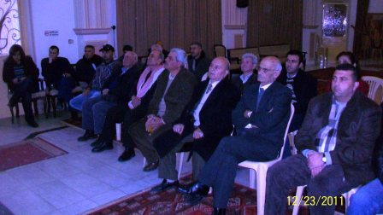 | 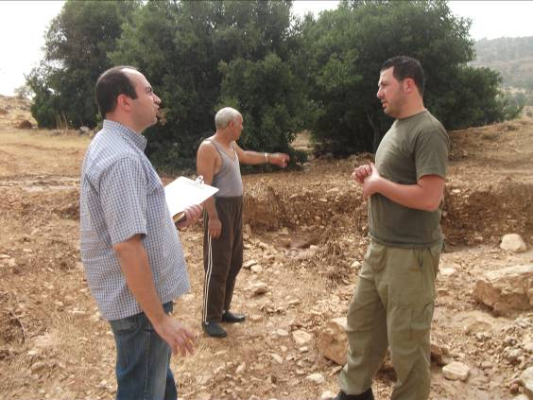
Training Wkshp in Ras Baalback-23 Dec 2011 | Flood Event Assessment-Sept 2011
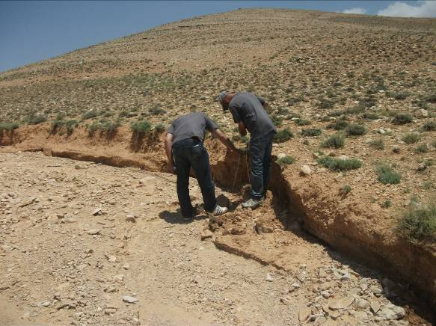 | 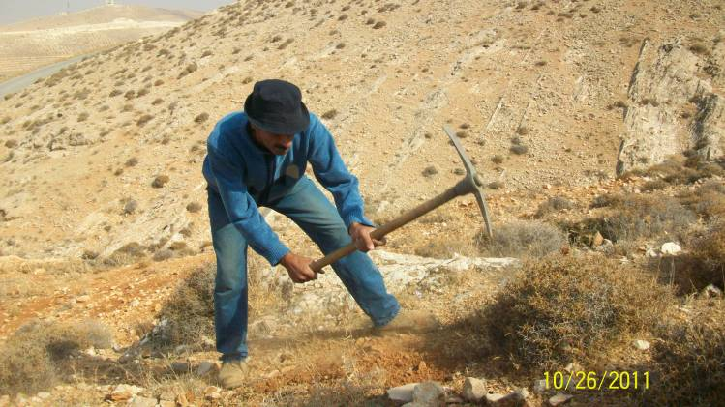
Flood Event Assessment-June 2011 | Soil Sampling for Analysis-Ras Baalback Reforestation
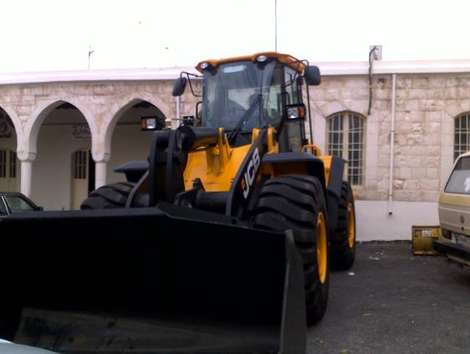 | 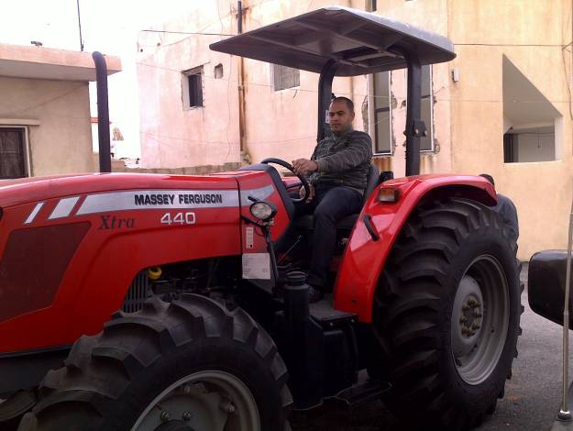
Wheel loader Grant to Ras Baalback Municipality | Tractor Grant to Ras Baalback Municipality
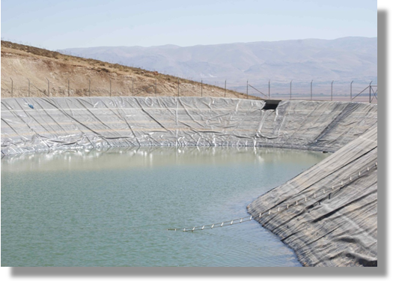 | 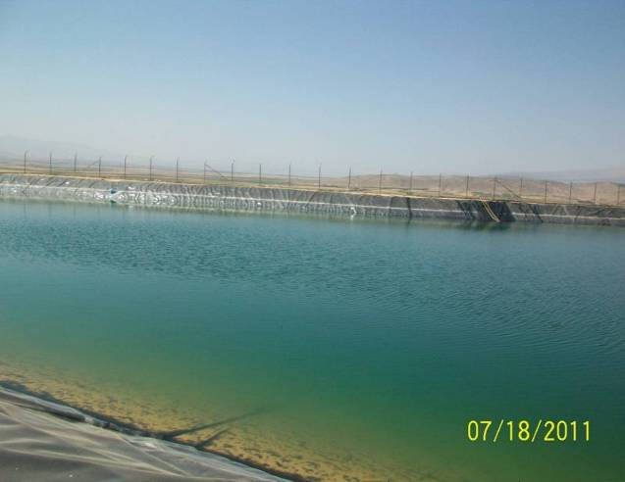
Water 30,000 m³ sealed reservoir in Deir El Ahmar

Partnerships and Collaborations

Phase I: A good partnership was established between UNDP, MoA, ACSAD and GIZ and the Municipality of Aarsal. The project’s working group met whenever needed to discuss all major implementation steps and ensure lessons learnt from the initial pilot project implemented by GIZ, ACSAD and MoA in Al-Qaa are transferred.
Phase II: Cooperation was initiated with the municipality of Ras Baalback and the decision making process involves the Mayor and the municipal council. Stronger partnerships were developed with the disaster risk management project and the MoEW. The previous partnerships are still kept strong.
The project is working closely with the technical team of the Reforestation project at the Ministry of Environment to test some of the techniques being proposed by the project, particularly related to irrigation and planting methods. This is a win-win situation for both projects and has strengthened the linkages between the Ministry of Agriculture and the Ministry of Environment.

- Future Work Plan

The projected activities and expenditures for the following reporting period (1 January-31 December 2012) are in the order of 1,400,000.00 USD divided as follows:

Activities | Timeframe |  |  |  | Allocated Budget (USD)
Activities | Q1 | Q2 | Q3 | Q4 | Allocated Budget (USD)
Walls and check dam constructions | X | X | X | X | 141,691.00
Reservoirs excavation (Hamid Kairouz) | X | X | X | X | 815,410.00
Surveyor | X | X | X | X | 18,000.00
Supervision of flood risk management structures by ELARD | X | X | X | X | 36,250.00
Maintenance of seedlings (Ras Baalback Grant)/Purchase of 1 cistern for irrigation purposes | X | X |  |  | 4,961.00
Reforestation | X | X |  |  | 45,000.00
Environmental play | X | X | X |  | 21,060.00
Evaluation |  |  |  | X | 25,000.00
Salaries of staff & Consultants | X | X | X | X | 180,000.00
Others (F&A, auditing, fuel consumption, misc.) |  | X | X | X | 132,920.00
TOTAL |  |  |  |  | 1,420,292.00

There will be no major changes in the strategy, targets or outputs.

Revised Budget as per extension approved:



