PROGRESS REPORT

Reporting UN Organization | : | United Nations Development Programme (UNDP)
Country | : | Lebanon
Award ID | : | 00047251
Award Title | : | CEDRO III – “Country energy efficiency and renewable energy demonstration project for the recovery of Lebanon”
Award Timeframe | : | Oct 2009 – June 2014
Award Components | : | CEDRO 3 – 00071261
Reporting Period | : | 01st April 2013 – 30th June 2013

List of Acronyms

BDL Banque du Liban
CDR Council for Development and Reconstruction
CO Country Office
GDP Gross Domestic Product
EDL Electricty of Lebanon
EE Energy Efficiency
GSHP Ground Source Heat Pump
ITB Invitation to Bid
LCEC Lebanese Centre for Energy Conservation
LED Light Emitting Diodes
LRF Lebanon Recovery Fund
MoET Ministry of Economy and Trade
MoEW Ministry of Energy and Water
MoF Ministry of Finance
MoU Memorandum of Understanding
PV Photovoltaic
RE Renewable energy
SHW Solar hot water
SPNL Society for the Protection of Nature in Lebanon
UNDP United Nations Development Programme
WWTP Waste Water Treatment Plants

I. PURPOSE

Project Summary:

The aim of the CEDRO project is to support Lebanon’s recovery, reconstruction and reform activities and to complement the national power sector reform strategy through the implementation of end-use energy efficiency and renewable energy projects and through the removal of barriers for the promotion of sustainable energy applications in Lebanon. To achieve this, the project will work on three levels: the first involves the establishment of a demonstrative model addressing public sector building and facilities, the second involves the activation of the replication process, and the third involves the triggering of a national sustainable energy strategy and action plan. The CEDRO project is financed through the Lebanon Recovery Fund, and is in-line with Lebanon’s ongoing efforts to improve national patterns of energy consumption and cost.

Project Phases and Outputs:

CEDRO 3  3,772,827 USD | - Implementation of end-use energy efficiency and renewable energy applications for public sector buildings and facilities (app. 60 sites across Lebanon)  - Technology transfer to enable the conversion of other public sector buildings and facilities into energy efficient modalities  - Research and development to enable the formulation of a national sustainable energy strategy and action plan
Project Linkages to National Priorities and Reconstruction Goals:

Lebanon imports around 97% of its energy needs in the form of fossil fuel. In 2004, the national energy bill amounted to around 1.6 billion USD (around 20% of the annual public expenditure and around 7.8% of the national GDP), and in 2005 it reached 2.1 billion USD (around 26% of the annual public expenditure and around 10% of the national GDP).

The government of Lebanon has placed the reform of the power sector among its highest national priorities, as outlined in the recovery, reconstruction and reform paper submitted to the Paris 3 conference after the 2006 conflict. However, given the enormity of the challenges faced by the power sector, the power sector reform strategy has concentrated on addressing the energy supply side, without extending the scope to the demand side of energy management.

Knowing that reform on the supply side needs to be accompanied by reform on the demand side, the proposed CEDRO program has sought to complement the national power sector reform strategy by targeting end-use energy conservation and renewable energy demonstrations which will assist in the above categories of demand-supply imbalance, security of supply, diversification of energy sources, economic cost and the environment.

Moreover, the current Lebanese government has set itself a goal of achieving 12% of its total energy needs from renewable energy sources. CEDRO is seeking to assist in achieving this goal through its demonstration projects of various zero carbon to low carbon technologies and its analysis of renewable energy resources.

This project is an initiative by the Government of Spain to assist the Government of Lebanon in its recovery and reconstruction efforts with a clear focus on promoting sustainable energy services and concentrating on public sector buildings and facilities.

This project is in inline with Lebanon’s recovery, reconstruction and reform objectives, and falls within the Ministry of Energy and Water’s main priority to meet national demand for electricity.

Project Implementation Partners:

The CEDRO partners and their respective roles are indicated to in the Table below:

Institution | Role
Spanish Agency for International Cooperation | Funded the CEDRO project through the LRF. The agency simply observes the work of the CEDRO project and sends representations to any event or occasion that CEDRO launches.
Ministry of Energy and Water (MoEW)  and Lebanese Center for Energy Conservation Project (LCEC) | CEDRO’s works closely with the Ministry and the LCEC as they are the main players in the energy sector. CEDRO’s work augments that of the Ministry and the LCEC, particularly in terms of knowledge-sharing through research activities for the energy sector.
Ministry of Finance | Part of the established Steering Committee for CEDRO.
Ministry of Economy and Trade | Part of the established Steering Committee for CEDRO.
Council for Development and Reconstruction | Part of the established Steering Committee for CEDRO, and monitors the works and finances of CEDRO.

International Partners: - Spanish Agency for International Cooperation
National Partners: - Ministry of Energy and Water (MoEW)
and Lebanese Center for Energy Conservation Project (LCEC)
- Ministry of Finance
- Ministry of Economy and Trade
- Council for Development and Reconstruction

- Project Management

- Coordination and follow-up on a regular basis with the Technical Backstopping Agency, TTA, on all technical assessments for the selection of new sites, installation designs, supervision and monitoring of works;
- Preparation of regular progress reports and financial management of expenditures;
- Organization of stakeholder meetings (regular meetings with the Ministry of Energy and Water (MoEW) and with EDL) – leading to and following up on several projects to be implemented on pico-hydro, energy from wastewater treatment plants, Batroun centralized PV lighting port, among others;
- Daily follow-up with site engineers and project staff;
- Providing technical and policy advice to decision-makers (MoEW) and UNDP CO on renewable energy issues;
- The CEDRO project is providing the MoEW and the LCEC in writing up and publishing the National Renewable Energy Strategy from 2014-2020 and beyond. This study will include the techno-economic assessment of renewable energy sources in Lebanon and will also look at the supporting environment needed to support Lebanon in meeting the renewable energy target of 12% by 2020;
- Assess future requirements for renewable market enhancement in Lebanon.

- Implementation of end-use energy efficiency and renewable energy demonstration projects for public sector buildings and facilities

Several ongoing projects are listed below:

- The Batroun Port Renewable Energy Street Lighting contract is on-going. Some modification to the original design followed taking into account fishermen’s feedback. Expected completion date is Aug. 2013.
- The pico-hydro project was transferred from Roumin to Ramlieh in Mount Lebanon due to technical constraints related to water supply and availability. Given this change, solar street lighting will be implanted in the village of Roumin instead. Details of the PV systems will be provided in the next quarterly report.
- Green Roof at the Central Bank: work is on-going in a timely manner. The first version of the design of the roof space was discussed with the Central Bank and the contractor is currently amending it in line with UNDP and the Central Bank team’s comments. The co-financing amount of $100,000 was received by UNDP from the Central Bank.
- The implementation of the hybrid PV-microwind contract for four sites has been completed with the exception of 1 site, the Aarsel army post. Due to the current security situation, the Contractor is unable to reach the site in order to install the system. Accordingly, the contract has been extended until December 2013 to allow time for the situation to improve.
- The solar street lighting and energy efficiency application (energy saving light-bulbs to be distributed) project that is being implemented in Qobeiyeet (North Lebanon), under the Madinati Khadra project, will be completed by end of July 2013.

The expected timeframes of the above project is shown in the Table below:

ID | Type | ITB/RFQ delivered to bidders | Project commences | Project completion
1 | Fayadiyi SHW | Done | June 2012 | Completed
2 | Large PV sites | Done | July 2012 | Completed
3 | Microwind | Done | June 2012 | Completed
4 | Hybrid PV/U-wind | July 2012 | Aug 2012 | 3 sites done, one site till December 2013
5 | Green Roof | July 2012 | Jan 2013 | October 2013
8 | Batroun Port | July 2012 | Feb 2013 | August 2013
9 | Ramliyeh Pico Hydro | July 2012 | Feb 2013 | September 2013
10 | Roumin Street Lighting | July 2013 | Sep 2013 | March 2014

In partnership with the Italian Cooperation Agency, the CEDRO project delivered large hot water tanks and heat exchangers for the solar hot water system in Chahhar public hospital. All other parts and works, including installation, were undertaken by the Italian Cooperation. The project has now been commissioned.

- Setting an enabling environment for the conversion of public sector buildings and facilities into energy efficient modalities

- The CEDRO website (www.cedro-undp.org) is being updated. The project is currently in process to amend the website;
- CEDRO Exchange issue 5 and 6 were sent to CEDRO stakeholders/contact list. Please find a copy of the cover page of both issues in Annex 1 (The full exchange for both issues can be found on CEDRO’s website);
- CEDRO organized a workshop on the 8th of April 2013 on wind energy development and conversation of migratory soaring in coordination with the Ministry of Energy and Water, Ministry of Environment, the Lebanese Center for Energy Conservation, Birdlife International, and the Society for the Protection of Nature in Lebanon (SPNL) with the attendance of 45 people. This workshop focused on soaring birds, where mitigation technologies for wind farms where discussed, particularly radar technology that identifies migratory birds passing over a wind farm and signals wind turbines to shut down. The invitation card and the agenda can be found in Annex 2;

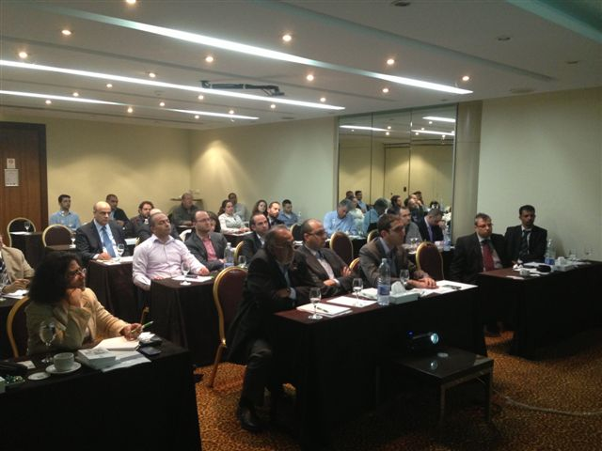
Picture 1- Workshop on wind energy development and conservation of migratory soaring birds (April 08, 2013)
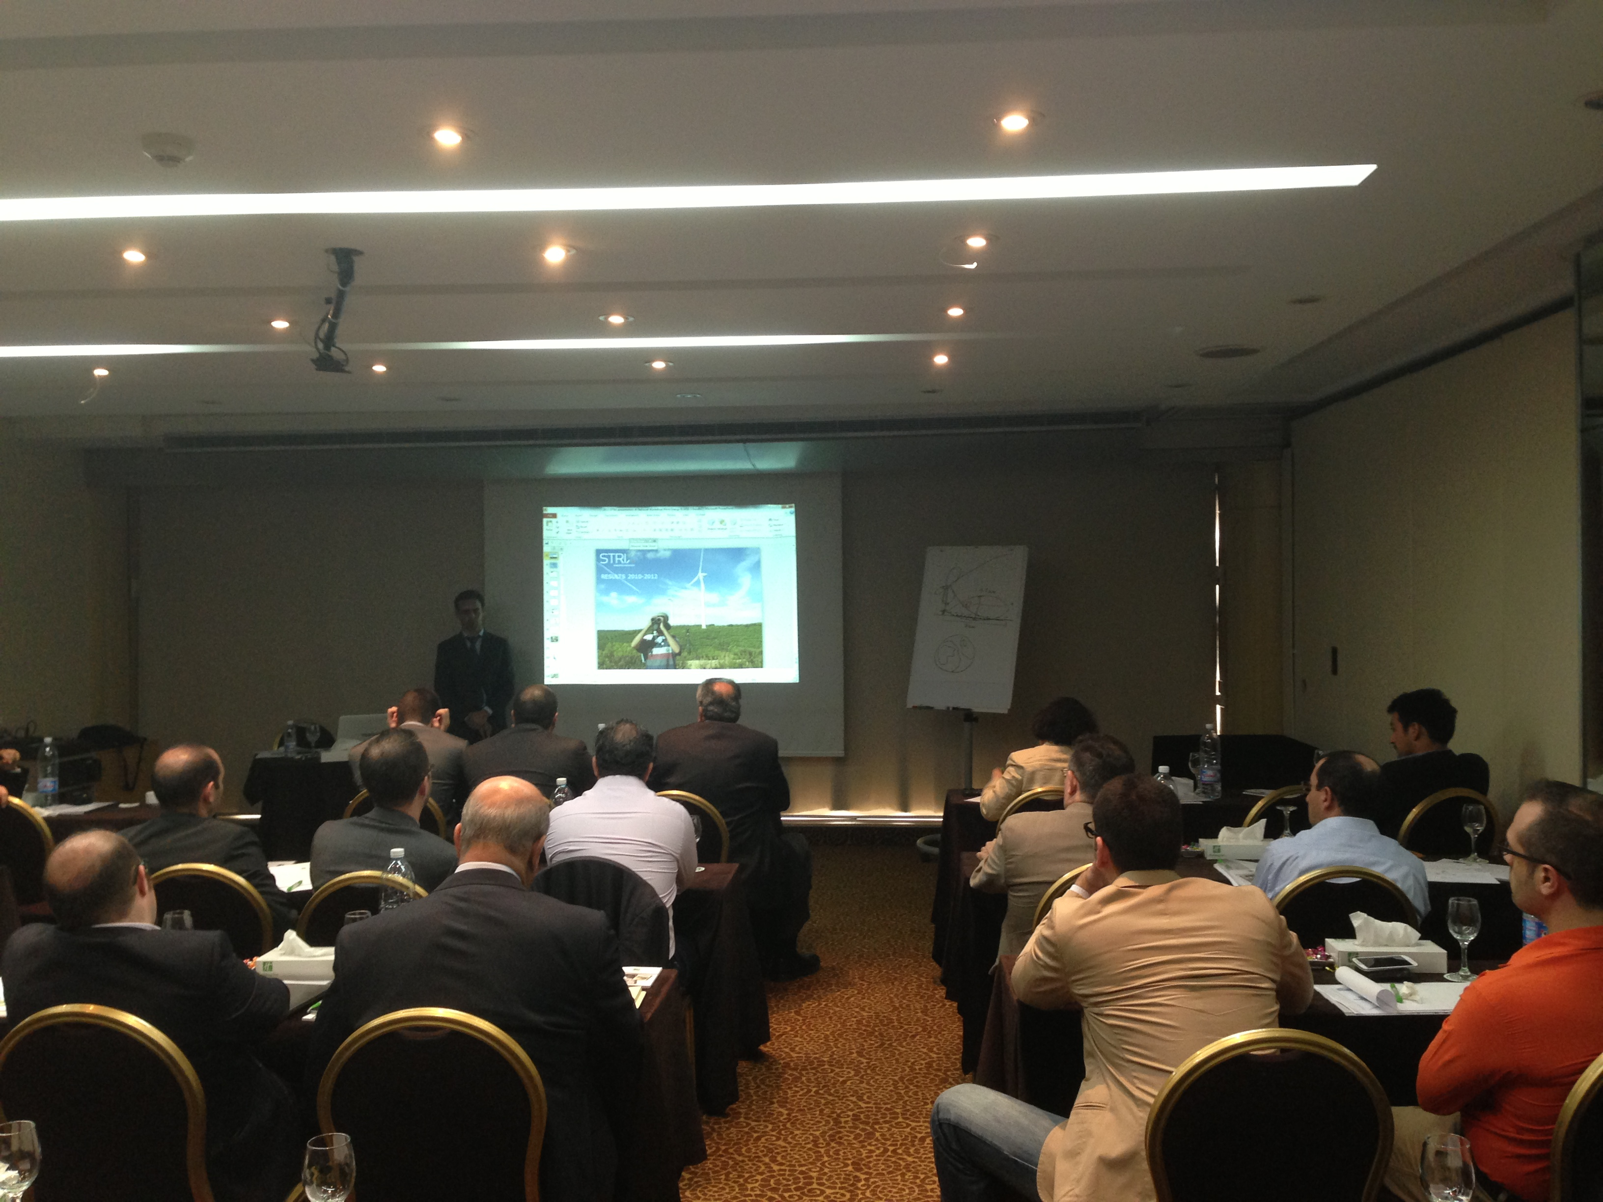
Picture 2- Workshop on wind energy development and conservation of migratory soaring (April 08, 2013)

- Assisting the establishment of a sustainable Energy Strategy for Lebanon

- CEDRO and Geowatt, the consultants for the geothermal assessment, have decided to investigate the temperature of deep boreholes (min. 1000 meters) that exist in Lebanon. Seven such boreholes exist, however only two of the most prominent boreholes (due to accessibility, security...) where selected. A contractor is currently onsite to undertake this mission. The results of these temperature readings will further increase the accuracy of the analysis; however it required a cost and time-extension to the contract. A report is expected by the end of Q3 of 2013;
- The study on hydropower from non-river sources has been released (see picture below). It has been distributed to over 200 people in the field;
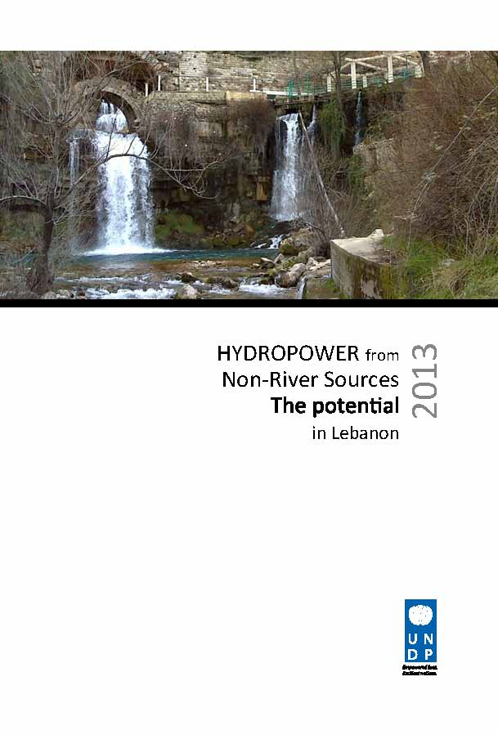

- A project to undergo a nation-wide survey to assess the willingness to pay (WTP) for small-scale and utility renewable energy systems in Lebanon for both the residential sector and the commercial sector have been launched by CEDRO. The contract with Statistics Lebanon, the winning consultancy, was signed and results should be out by Q3 of 2013;
- A new study for the assessment of the industrial potential, job creation, and local capacity for renewable energy systems in Lebanon has been decided to be undergone in Lebanon. The Terms of Reference for this study have been drafted and will be posted online for competitive bidding in Q3 of 2013. The study will be completed by Q2 of 2014.

All in all, CEDRO aims to assist the government in Lebanon in deciding which energy source to utilize to reach its objective of 12% of its energy mix to come from renewable energy sources by 2020 – an objective approved by the Council of Ministers and asserted in the Copenhagen Summit.

II. RESOURCES

 |  | CEDRO 3
Total budget approved | : | USD 3,772,827.00
Total disbursements as for 30 June 2013 | : | USD 2,453,798.48
Available Balance | : | USD 1,319,028.52
Commitments for next quarter | : | USD 200,000.00

Budget and Expenditure Breakdown per LRF Category:

 | CEDRO3
CATEGORY | Total Budget  (USD) | Total Exp. to date (USD)
1. Personnel* (Incl. staff and consultants) | 252,000 | 504,373.97
2. Contracts  (Incl. companies, professional services) | 599,050 | 874,441.81
3. Training (incl. AV printing / production) | 41,000 | 28,064.95
4. Transport (local) | 11,000 | 33,272.18
5. Supplies and commodities**  (Incl. IT equip and rental & maintenance) | 55,000 | 72,961.82
6. Equipment (including installation) | 2,505,000 | 640,888.64
7. Travel | 15,000 | 47,555.06
8. Miscellaneous | 31,539 | 79,589.92
9. Agency Management Support (7%) | 263,238 | 172,650.13
TOTAL | 3,772,827 | 2,453,798.48

*Total expenditure for staff and consultants exceeds the total allocated budget because most of the technical design and supervision of works is being implemented by project personnel and not sub-contracted to third-party companies as originally planned. A budget revision is therefore being requested should this be necessary.
** Given the difference in budget line description between UNDP and the LRF accounts, the expenditures being reported under this budget account “supplies and commodities” during Q2 is less than Q1 because Batroun Port Renewable Energy Street Lighting contract should be considered under the budget account “contracts” not “supplies and commodities”

CEDRO Project | CEDRO 3  USD 3,772,827
Activity Results
1 - Implementation of end-use energy efficiency and renewable energy demonstration projects for public sector buildings and facilities | - Identification and Implementation of 60-80 EE/RE demonstration projects across Lebanon
2 – Outreach and technology transfer to enable the conversion of other public sector buildings and facilities into energy efficient modalities | - Development and implementation of technical workshops and awareness tools  - Development of GIS energy data base and EE/RE procurement specs  - Validation of project results and development of replication schemes
3 – Research and development to enable the formulation of a national sustainable energy strategy and action plan | - Assessment of national renewable energy resources  - Assessment of national energy efficiency potential  - Development of national EE/RE strategy & action plan

Progress in Project Implementation:

Activity Results | Activity Actions | Targets for 2013 | Status for 2013
1 – Project Management | - Technical Management;  - Financial Management;  - Operational Management. | - Organization of 2 conferences and/or events, including end of year project closing meeting  - Opening of Pico-hydro site  - Opening of Army Solar Hot Water site | - 1 conference already undertaken, related to energy from wastewater treatment plants.
1 – Project Management |  | - Apply the issues raised in the report on the status and results of the CEDRO I pilot projects published in Q4 of 2012 | - Recommendations of CEDRO 1 Evaluation Report have been completed
1 – Project Management |  | - Provide advisory support services on EE/RE policies and legislations | - Advisory role and participatory role in the upcoming Lebanese Renewable Energy Strategy is to be undertaken this year with the LCEC and the MEW.
1 – Project Management |  | - Attendance of capacity building workshops for CEDRO team | - 3 CEDRO engineers participated in the RENAC (http://www.renac.de/), which is 75% funded by RENAC (only).
1 – Project Management |  | - Preparation of regular progress reports | - Q1 progress report prepared  - Q2 progress report prepared
Activity Results | Activity Actions | Targets for 2013 | Status for 2013
2 - Implementation of end-use energy efficiency and renewable energy demonstration projects for public sector buildings and facilities | 2.1 Undertake targeted assessment and identification of project beneficiary sites;  2.2 Develop tender documents and undertake bidding & procurement of goods/services;  2.3 Undertake commissioning of works and supervision and monitoring of sites;  2.4 Undertake testing of performance & data collection. | - Following-up on projects under implementation  - Batroun Port  - Qabayeet street lighting initiative  - Roumin Pico-hydro system  - Launch three sites of Madinati Khadra competition  - 8 larger PV sites  - 4 hybrid PV/microwind sites  - Green Roof initiative at the Central Bank  - Chahhar public hospital  - Complete work on Bejji Municipality (GSHP)  - Complete work on Roumieh Prison | - Works on-going for all projects  - Roumin changed to Ramliyeh  - Hybrid sites completed with the exception of 1 project.  - Chahhar hospital completed.
 |  | - Regular maintenance of all sites  - Data collection | - Maintenance checks regularly followed by 3 CEDRO engineers  - Data being collected from many sites across the country
Activity Results | Activity Actions | Targets for 2013 | Status for 2013
3 – Outreach and technology transfer to enable the conversion of other public sector buildings and facilities into energy efficient modalities | - Develop and implement technical workshops and awareness activities;  - Develop GIS energy data base and EE/RE procurement specs;  - Validate project results and enable replication schemes. | - Development and implementation of 1 technical workshops | Status
 |  | - Continuation and expansion of CEDRO outreach and visibility  - 1 newsletter to be produced in 2013  - Complete revamping of CEDRO website to be implemented  - Final CEDRO Project documantary (if budget allows) | - Updating project website: www.cedro-undp.org (En/Ar);  - Full press coverage for the Energy from Wastewater Event at the MEW ; All the TVs aired a report during their news, and most daily newspapers mentioned the event
 |  | - Interactive Map for CEDRO sites to be installed on new webstie | - Interactive Map being set up
4 – Research and development to enable the formulation of a national sustainable energy strategy and action plan | - Asses national renewable energy resources;  - Assess national energy efficiency potential;  - Develop national EE/RE strategy & action plan. | - Publish energy from waste water treatment plants (WWTP) study  - Publish study on hydropower resources from non-river sources  - Launch and implement the national geothermal power assessment for the country.  - Undergo Renewable Energy Strategy Study with the Ministry of Energy and Water and the LCEC  - Undergo study on the willingness to pay (WTP) for renewable energy for the commercial and residential sectors in Lebanon  - Undergo a study for the assessment of the industrial potential, job creation, and local capacity for renewable energy systems in Lebanon | - Energy from WWTP has been published and disseminated  - Hydropower resources from non-river sources has been published and disseminated  - Study on WTP ongoing.
* EE/RE = Energy Efficiency and Renewable Energy
Implementation Constraints and Lessons Learned during this quarter:

- The security situation in Lebanon is not allowing the CEDRO project to properly visit and monitor the sites that are already implemented, esp. on the border with Syria. Some other sites, like Aarsel, are under security review.

IV. FUTURE WORK PLAN

 | 2013
Outputs and Activities | Q3 | Q4
1. Implementation of end-use EE/RE demonstration projects  - Identification of beneficiary sites  - Development of tender documents  - Procurement of goods / services  - Site Supervision and hand-over  - Monitoring of system performance | Monitor implementation of works  Prepare Operation and maintenance plan post-CEDRO  Record all data collected from sites | Project extended to June 2014  Finish BDL Green Roof  Finish Pico-hydro site  Finish hybrid PV-microwind sites  Supervise all sites
2. Outreach and Technology transfer for the activation of EE/RE applications  - Establishment of energy saving data base for public sector facilities  - Development & Implementation of capacity building & awareness programs  - Development of relevant EE/RE policies and procedures  - Validation of project results | Closing event for CEDRO project (even though CEDRO has obtained an extension, closing ceremony will be held in Q3)  Dissemination of PV Farm study
3. Research and development for the formulation of a national EE/RE strategy and action plan  - Assessment of national RE potential  - Assessment of national EE potential  - Identification of viable EE/RE actions  - Identification of Implementation tools and funding mechanisms | Put together all CEDRO’s work on RE and EE in one document; a national document for RE and EE  Launch study for RE and industry (from new extension of funds) | Geothermal power assessment result dissemination

 | 2014
Outputs and Activities | Q1 | Q2
1. Implementation of end-use EE/RE demonstration projects  - Identification of beneficiary sites  - Development of tender documents  - Procurement of goods / services  - Site Supervision and hand-over  - Monitoring of system performance | Monitor implementation of works  Record all data collected from sites  Monitor all installations  Prepare Operation and maintenance plan post-CEDRO | Terminate project  Publish Operation and maintenance plan post-CEDRO
2. Outreach and Technology transfer for the activation of EE/RE applications  - Establishment of energy saving data base for public sector facilities  - Development & Implementation of capacity building & awareness programs  - Development of relevant EE/RE policies and procedures  - Validation of project results | Awareness activity to be determined | Dissemination of results of the RE and Industry study
3. Research and development for the formulation of a national EE/RE strategy and action plan  - Assessment of national RE potential  - Assessment of national EE potential  - Identification of viable EE/RE actions  - Identification of Implementation tools and funding mechanisms | Put together all CEDRO’s work on RE and EE in one document; a national document for RE and EE | Put together all CEDRO’s work on RE and EE in one document; a national document for RE and EE

CEDRO 3
- Implementation of end-use energy efficiency and renewable energy applications for public sector buildings and facilities (60-80 sites across Lebanon)

- Technology transfer to enable the conversion of other public sector buildings and facilities into energy efficient modalities

- Research and development to enable the formulation of a national sustainable energy strategy and action plan

Annex 1 – CEDRO Exchanges

CEDRO Exchange Issue#5

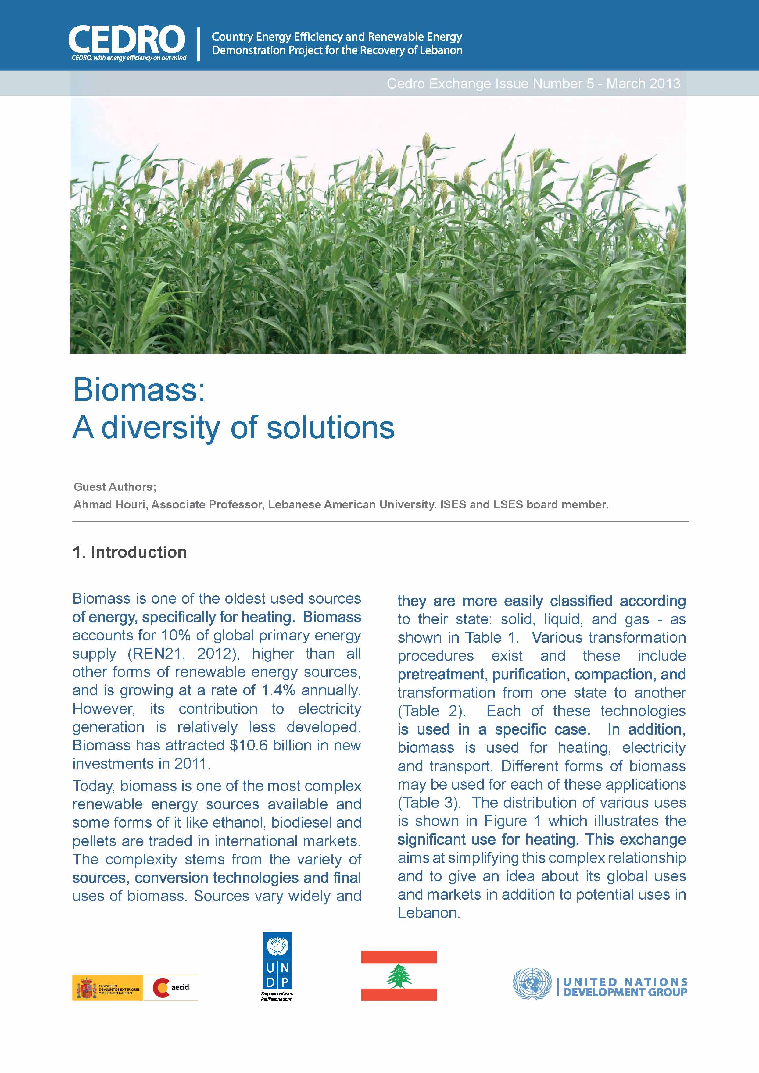

CEDRO Exchange Issue#6

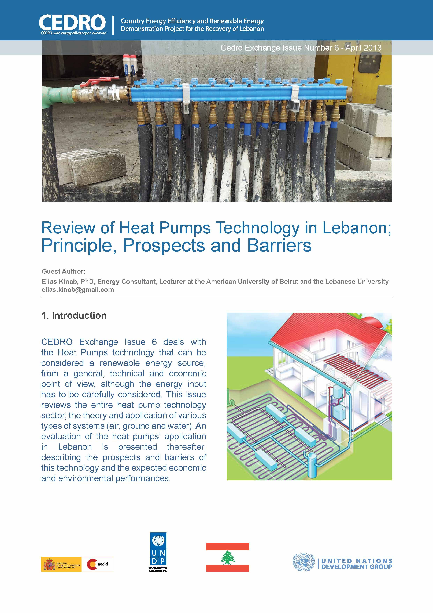

Annex 2 – Workshop Invitation Card and Agenda

