 |  | 

INTERIM PROGRESS REPORT

Reporting UN Organization | : | United Nations Development Programme
Country | : | Lebanon
Project No. | : | 00069789
Project Title | : | Flood Risk Management and Water Harvesting for Livelihood Recovery in Baalback-El Hermel, Phase II
RF Signature date | : | 10 October 2007
Project Start date | : | Phase II: 20 February 2009
Project Timeframe | : | Phase II: 31 March 2013
Reporting Period | : | April – June2012

I. PURPOSE

Project Summary & Objectives
The project aims at assisting the Government of Lebanon in its recovery and reform efforts in the conflict-affected and high-poverty region of Baalback-El Hermel through better land management practices, namely flood risk reduction and improved access to irrigation water and networks to achieve crop diversification and improve productivity. This will be achieved through the construction of stone walls, check dams and water collection reservoirs to prevent runoff water from reaching villages and farms and through the restoration of land cover to reduce soil erosion. The objectives related to water management will be achieved through installation of water-use efficient irrigation networks and systems that will be used by local farmers to improve their crop diversity and productivity. The project is financed by the Government of Spain through the Lebanon Recovery Fund, a Lebanese Government led programme, established on the occasion of the Stockholm Conference, and is in line with the UNDP’s development goal of alleviating poverty in rural dry lands of the conflict-affected Baalback - El Hermel area.

Project Phases and Expected Outputs

FRM II  3.8 million USD | - Establishment and implementation of a flood risk management plan over an area of 250 km² in upper Aarsal and Ras Baalback.  - Improved land cover in Ras Baalback and upper Aarsal mountains.  - Improved soil conservation in Ras Baalback and Aarsal.  - Improved public awareness on flood risks management and training of the target municipality on maintenance of flood management structures.

Project Linkages to National Priorities and Recovery
The National Action Programme to Combat Desertification (NAP), which was developed in 2003 by the Ministry of Agriculture and in collaboration with UNDP and German Society for International Cooperation (GIZ), classified the project’s target area (Baalback-El Hermel) as one of the areas prone to high risks of desertification. This is mainly due to lack of proper land and water management practices, bad rainfall distribution, overgrazing, steep mountains with shallow soil and poor vegetative cover. Moreover, summer droughts and uneven rain distribution are the main reasons for poor agricultural productivity in that area.

The effect of the July 2006 conflict on North Bekaa, particularly Baalback-El Hermel area was not to be underestimated. Large scale destructions in infrastructure, biodiversity and agriculture were reported. These led to harder living conditions, more poverty and increased soil erosion threats.

The expected outcomes from the current project particularly those related to water harvesting, increased vegetation cover and higher productivity will serve very well the national efforts and plans aiming at combating desertification and alleviating poverty in North Bekaa. They will also serve the recovery efforts made by the Lebanese government in normalizing the living conditions of rural communities and in restoring the basic needs and infrastructure for practicing sound and profitable agriculture in the affected area.

Project Implementation Partners
Type of partner | Partner | Role
International Partners | Spanish Agency for International Cooperation | Provision of funds to project through the LRF
International Partners | German Society for International Cooperation (GIZ) | The GIZ had executed a pilot project on Flood over a pilot area of 18 km². GIZ is the intellectual partner of UNDP for phase one. UNDP benefitted from the same experts and lessons learned from the GIZ project
National Partners | Ministry of Agriculture | Current host of the project. Provides support and follow-up on project activities
National Partners | Ministry of Water & Energy, Bekaa | Provides ad hoc support when needed and is a link to MoEW
National Partners | Local municipalities and communities | They are the direct beneficiaries of the project. They provide advice, follow-up, local contacts, facilitation, administrative papers, etc.

Based on the result of the evaluation requested by the LRF, the phase II of the project has been extended till the end of February 2013

II. RESOURCES

 | Amount (USD)
 | Phase II
Total budget approved | $3,800,000.00
Total disbursements as for June 2012 | $1,819,722.00
Commitments for next quarter | $830,000.00
Available Balance | $1,980,278.00

Budget and Expenditure Breakdown per LRF Category:

CATEGORY | Total Budget (USD) | Exp. to date (USD)
1. Personnel (Incl. staff and consultants) | 600,000.00 | 535,741.00
2. Contracts  (Incl. companies, professional services) | 350,000.00 | 268,137.00
3. Training (incl. AV printing / production) | 50,000.00 | 1,975.00
4. Transport (local) | 30,000.00 | 26,743.45
5. Supplies and commodities  (Incl. IT equipment and rental & maintenance) | 340,000.00 | 285,186.67
6. Equipment (including installation) | 2,091,402.00 | 554,332.28
7. Travel | 40,000.00 | 3,351.00
8. Miscellaneous | 50,000.00 | 25,209.00
9. Agency Management Support (7%) | 248,598.00 | 119,047.28
TOTAL | 3,800,000.00 | 1,819,722.68

It should be noted that a re-deployment between budget lines (especially for Personnel, Contracts, supplies and commodities, and Miscellaneous) was done to cover additional expenses incurred after the extension of the project.

III. Results: Progress per activities

Project Outputs | Activities | Progress to date | Targets for 2012
1.Project management | - Technical, financial and operational Management.  - Promote synergies with relevant on-going projects in target area.  - Exchange of information and coordination meetings | - Ongoing meetings with stakeholders, the municipalities of Ras Baalback and Aarsal, line ministries and contractors.  One meeting held on the 9th of April with the Disaster Risk Management project at the office of the Prime Minister, in order to prepare the “National Flood Hazard Map”. The project team helped in providing the necessary resources and materials and participated in the discussion of the outputs concerning disaster mapping. The map will serve in the development and updating of land use strategy. Available data and information related to flood events in Lebanon (dates, affected regions, and damages) transferred to the DRR team. This information has been integrated into the DESINVINTAR software; Terms of References (ToRs) for expert on flash flood hazard mapping prepared and posted on the UNDP website; Final draft of the Disaster Risk Reduction Strategy reviewed and comments submitted to the DRR team  - Improved coordination with the Ministry of Energy and Water and the Ministry of Environment in the coordination of the flood risks activities and its execution. The MoEW authorized the use of flood plains for the construction of the detention reservoirs.  - A cash contribution from UNDP/DDC (Dryland Desertification Centre) was granted to extend the irrigation network of the water reservoir in Deir El Ahmar. A total amount of US$26,840 was transferred to the Flood II project (00069789) for the completion of this activity within the project’s overall objective. The irrigation network was purchased and installed linking the reservoir outlet to the farmers’ fields. | - Strengthened coordination with project stakeholders
1.Project management |  |  | - Coordination with Municipality of Ras Baalback for phase II implementation
1.Project management |  |  | - Design of flood risk management structures
1.Project management |  |  | - Procurement of sub-contractors for the implementation of Phase II
1.Project management |  |  | - Submission of quarterly progress reports
2. Flood Risk Management and Reduction | 2.1 Data collection and identification of target area.  2.2 Modeling of target area and generation of maps.  2.3 Construction for flood control and prevention.  2.4 Monitoring, evaluation and impacts assessment. | - Meetings held with the Contractor in the presence of the Consultant to follow up on the execution progress of the work and to discuss the procedure of work for each reservoir, the communication strategy among the different partners.  - The excavation of reservoir RR14 and the section between RR12 and RR14 are almost complete. Contractor finalizing the excavation work for RR11 and the section between RR11 and RR12.  - The Contractor submitted shop drawings, method statements and workplan for reservoirs RR7, RR10 and RR11.  - Initiation of excavation works in the RR6, RR7 and RR8 reservoirs.  - The 114 work sites have all been delivered to the contractor to continue with the construction. Until present, 49 walls were constructed. | - Initiation of excavations of flood water collection reservoirs  - Initiation of construction of FRM structures
2. Flood Risk Management and Reduction |  |  | - Development of a flood management plan for Ras Baalback
2. Flood Risk Management and Reduction |  |  | - Determine the number and locations of stone walls
2. Flood Risk Management and Reduction |  |  | - Construct walls
3. Land Cover Improvement | 3.1 Identification of erosion-sensitive areas  3.2 Establishment of nurseries for seedling production  3.3 Crop diversification and increased productivity  3.4 Forestation cultivation | - The reforestation component has been executed in-house by the SLM team.  - The site to be reforested was selected by the Municipality (Plot 3385); its surface area is around 5.7 hectares.  - A water cistern and irrigation/spraying pump were granted to the Municipality of Ras Baalback in order to maintain and protect the seedlings that will be planted by the SLM team.  - Design of the irrigation network and fences were identified and described by the team.  - The installation of fences and irrigation system are completed.  - Irrigation of the seedlings is carried out every fifteen days (12 liters for each seedling and 6 liters for the sewed seeds).  - 3000 seedlings and 1,800 seeds of wild trees and lower strata purchased and granted for the reforestation activity.  - Reforestation activities launched in close coordination with the Coop of Ras Baalback and the municipality on the 25th of March 2012 within the framework of awareness campaign where school children and local actors participated. During the event, caps, flyers, shovels, hand tools were distributed. The Coop of Ras Baalback prepared the site before the forestation awareness campaign by digging 1,800 holes of 35cm width and 40cm depth and irrigation was carried by the local during the event.  - Extension of the irrigation system in the artificial lake of Deir El Ahmar. An additional irrigation network was connected to the main pipes already existing in the lake of Deir El Ahmar in order to supply irrigation water to around 200ha of the agricultural surface area, benefiting up to 500 vineyard growers. | - Forestation in Ras Baalback with forest trees
3. Land Cover Improvement |  |  | - Development of plan to increase green cover in Ras Baalback. The aim of the green cover plan is to recreate the forest ecosystem with not just trees but also lower strata in order to reduce the soil erosion and flood hazards. Planting was done using seedlings and seeds, which in turn will serve as a seed production unit used for future expansion of the green cover by the municipality when protecting from grazing is ensured. Within this activity, two types of solid water were used to be able to assess the difference between plants irrigated through solid water and the traditional irrigation. The project team prepared the ToRs, selected the contractors and supervised the execution of the activities. The municipality received from the project a water cistern to facilitate the maintenance, irrigation and protection of the forested site.
3. Land Cover Improvement |  |  | - Development of the irrigation plan in Deir El Ahmar to cover 200ha and highest number of beneficiaries.
4. Sustainability, capacity building and awareness raising | 4.1 Empowerment of target beneficiaries.  4.2 Awareness-raising on flood and water management.  4.3 Capacity building through training.  4.4 Alternative livelihoods | - Awareness on environmental issues (i.e. energy/water conservation, sustainable management, and reforestation) was held by “Bee Event” through theatric plays addressed to young students aging between 6 and 12 years old; Till now, 52 theatrical presentations were performed mainly in the South of Lebanon (Nabih Berri Compound, Sultanieh School, Moussa Sadr School, etc.), Saida, Beirut and UNESCO palace.  - Training sessions for the vineyard growers in Deir El Ahmar completed: One session on “best pruning practices” followed by a second one, in reply to farmers’ request, on “modern irrigation techniques of vineyards”. The first training session was held on the 22nd of March 2012 and details of the training highlighted in the previous report; the second training was held on the 15th of May 2012 during which brochures on types of pruning have been distributed. | - Building the capacity of Ras Baalback Municipality in flood management and train vineyard growers of Deir El Ahmar on Viticulture & Irrigation management.

Overall Project Impact

The project will contribute to the reduction of risks and damages, direct and indirect, of floods in the region of Baalback El Hermel. It will also improve livelihoods through increased availability of water for multiple uses through direct harvesting such as through the water collection reservoir of Deir El Ahmar or through infiltration of the water collected in the flood reservoirs to the water table further to a flood event. The project will also contribute to the increase in green cover in both Aarsal and Ras Baalback. Currently, the Higher Relief Council incurs 2.5M USD as damage compensation further to a flood event; “Flood” will contribute to the reduction of these compensation payments. Finally the project will contribute to the creation of a national flood risk map and of knowledge and expertise in flood risk management.

- Project Management

Project management took place on a full time basis by the Project Management Unit (PMU). This involved project administration, field visits with the potential bidders for the walls to Ras Baalback, and meetings between subcontractors and stakeholders. During this quarter, five meetings took place with the project’s team, ELARD and the contractor-Bureau Hamid Kayrouz (BHK) to review the shop drawings and discuss method statements.

Moreover, the PMU met with the Ministry of Energy and Water (MoEW) and the Ministry of Environment (MoE) to cooperate and coordinate related flood risks and management activities.

In the context of partnership established with the Disaster Risk Reduction (DRR) Project, the Flood Project team held meetings with the DRR staff plan common activities. In order to prepare the “National Flood Hazard Map”, the project team helped in providing the necessary resources and materials and participated in the discussion of the outputs concerning disaster mapping.

Further to a visit organized last year for the steering committee members of the Dryland Desertification Centre (DDC) to Deir El Ahmar reservoir, the latter expressed its interest to support this component through a contribution made available from DDC and the Government of Turkey. The fund was used to compliment the works already done in Deir El Ahmar by extending the irrigation system and reach a higher number of beneficiaries. (See Annex I for details)

- Flood Risks Management

A consultant for topographic survey was hired on a retainer basis to support the excavation works component on needs basis. Six site visits were carried out to Ras Baalback to check the boundaries of public lands identified for the establishment of the reservoirs and one visit to Deir El Ahmar pond to assess the stability of the dam. The topographic surveyor is receiving the sites from the contractor after the excavation works were completed and checking levels according to the design and as-built drawings.

The Contractor, Bureau Hamid Kayrouz (BHK), completed the excavation of reservoirs RR12, RR14 and the section between RR12 and RR14. The reservoirs RR11, the section between RR11 and RR12, and RR7 are almost complete. Shop drawings were submitted and works initiated for reservoirs RR6 and RR8.

The location, number and the design of the stone walls were prepared by the project team. A total number of 114 work sites were delivered to the contractor, Bureau Hamid Kayrouz, to initiate construction activities. 49 walls were completed during the current reporting period. Photos of works on the ground can be found in Annex III.

- Land Cover Improvement

The technical specifications for the reforestation management, irrigation and fences were prepared by the team and offers were collected. The contract of the management and supervision of reforestation activities was awarded to “Ras Baalback Cooperative for Sustainable Agricultural Development”. Upon the signature of the reforestation activities contract, and within the framework of awareness campaign, the Coop launched reforestation in the presence of local communities and school children on the 25th of March 2012. A number of 3,000 seedlings and 1,800 seeds were purchased and planted. Fences are installed and the irrigation operations and maintenance of the reforested site are on-going. The Coop of Ras Baalback prepared the site before the forestation awareness campaign by digging 1,800 holes of 35cm width and 40cm depth and irrigation was carried out by the locals during the event (the minimum quantity per tree: 12 liters and per seed: 6 liters). During the event, caps, flyers, shovels, hand tools were distributed. The maintenance of the new forested site is handled by the municipality of Ras Baalback in partnership with the Coop of Ras Baalback.

- Sustainability, Capacity Building, and Awareness Raising

A workshop on “Modern Irrigation Techniques” was carried out on the 15th of May 2012 in Deir El Ahmar with the participation of 24 local farmers. The objective was to increase the wine yard productivity by using the appropriate irrigation techniques that fit best to the existing grape varieties, method of calculation for crop water demand and a valid irrigation programme based on the meteorological and soil data collected from the area. During the event, illustrated brochures including sketches showing the different pruning techniques and irrigation schedule were distributed to farmers. Details and photos are found in Annex II. The cooperative in Deir el Ahmar is not able to do this task, as information differs from one cultivated crop variety to another, soil texture, precipitation, irrigation techniques, pest infection, etc. If there is any opportunity to provide assistance in other villages, the project is always ready to participate.

- Implementation Constraints

Political and Security Situation in the Project Area: Due to the escalation in the security situation along the Lebanese-Syrian border especially in the project area, some of the project activities were adversely affected: certain reservoirs as well as wall structures are very close to the border and visible in a way to form an easy military target; thus, the project, while carrying on with the reservoirs excavation and walls construction works in the non-exposed border locations, is studying other alternative. These changes will be implemented before the project deadline allowing enough time to complete the excavation works in other identified locations away from the danger zone, and which will maintain the efficiency of the flood risk reduction system as a whole. In the case of the wall structures, the relocation is much easier and the works are much less time consuming than the excavation works. Plan B is not a complete change in approach in the project design or timeframe. The changes according to the security situation are already done. Mainly this related to the relocation of some of the flood walls to downstream areas which does not reduce the efficiency of the flood mitigation measures. The reservoir designs are still the same although the security situation resulted in some delays in execution but which will not affect the overall time frame of the works.

- Key Partnerships & Collaboration

A good partnership is established between UNDP, MoA, and the Municipalities of Ras Baalback. The project’s working group is meeting whenever needed to discuss all major implementation steps and ensure lessons learnt from the initial pilot project implemented by UNDP and MoA in Aarsal are transferred. The municipalities have become fully involved in the flood works. In Aarsal, the staffs of the municipality undertake routine checks on the reservoirs and perform needed maintenance works. The municipality is undertaking the maintenance of the seedlings planted by ARDA. In Ras Baalback the municipality has supported the project in land selection for the location of the reservoirs, the land for reforestation and all matters related to logistics with the consulting firm doing the design of the flood structures and the contractors bidding for the excavation. As regards the MoA, the ministry has extended all the support required by the project in terms of logistics, administration and technical support.

Strong partnerships were developed with the Ministry of Energy and Water and the Ministry of Environment. The MoEW personnel are currently aware of all the activities undertaken by the project and have been providing all the required support and advice needed for its execution.

A strong partnership has been created with the UNDP disaster risk management project where the flood project will work on the development of a flood risk map for Lebanon. The project has been involved in the development of the Standard Operating Procedures for the early response by the army, civil defence and the Red Cross teams in case of a flood event. Finally the project will be involved in developing the national flood risk map for Lebanon.

IV. Work plan per activity for the 3rd quarter in 2012 (Jul – Sept 2012)

Key Milestones  Wks | July |  |  |  | August |  |  |  | September
Key Milestones  Wks | 1 | 2 | 3 | 4 | 1 | 2 | 3 | 4 | 1 | 2 | 3 | 4
1. Project Management and Coordination
1.1 Technical, Financial and operational mgt.
1.2 Promotion of synergies with other projects
1.3 Information exchange and coordination.
2. Flood Risks Management and Reduction
2.1 Finalization of excavation works for RR6, RR7 and RR8
2.2 Walls Construction
2.3 Monitoring, evaluation & impact assessment.
3. Land Cover Improvement
4.1 Maintenance and irrigation operations
4.2 Irrigation system in Deir El Ahmar (DDC component)
4.Sustainability, Capacity Building & Awareness Raising
  - Empowerment of target beneficiaries. Topic: Role of local authorities in Flood management
  - Awareness raising on flood and water mgt.
  - Capacity building through training. PMP training cycle for SLM programme and Ministry staff
5.4 Alternative livelihoods Increase agricultural activities especially vineyards

ANNEX I

Deir El Ahmar Irrigation Network – DDC fund
Municipality of Deir El Ahmar
Cooperative of Deir El Ahmar

- Overview of Works Implemented

Within the context of the project “Flood Risk Management and Water Harvesting for Livelihood Recovery in Baalback-Hermel” executed by the United Nations Development Program (UNDP), in partnership with the Ministry of Agriculture, the project has finalized the execution of water harvesting reservoir with full capacity of 30,000m³ of water for irrigation use.

With additional funding provided by the Dryland Desertification Centre (DDC), an additional irrigation system was connected to the main pipeline from the reservoir to provide irrigation water to cover up to 200ha of agricultural land in Deir el Ahmar. This new network serves up to up to 500 beneficiaries (land parcels) in the area and has increased the capacity of the old irrigation system by up to 4 times. The agricultural land is used mainly to cultivate vineyards for wine production.

The additional irrigation network which was installed by the project consists of 1,075m of polyethylene irrigation pipes (5 inch), 1,100m of PE irrigation pipes (4 inch) and 1,800m of PE irrigation pipes (3 inch) with 8 manholes and 24 gate valves. The network is designed in such a way as to draw water from the lake by gravity; without the use of electric pumps and at no cost to the beneficiaries. This design reduces the cost of irrigation while potentially increasing crop yield.

To date, part of the installed network is already put in use, while the network consisting of larger pipes has been installed but still needs the valve connections to be housed in protective concrete boxes. This task should be completed by the end of June 2012.

- Partnership and Brief Financial Overview

The installation of additional irrigation pipes has been undertaken in collaboration with three partners:
- UNDP: provision of the irrigation pipes with a total budget of USD 26,000.
- Deir El Ahmar Municipality: in-kind contribution in the excavation and backfilling works with a total budget of USD 12,000.
- Deir el Ahmar Cooperative: contribution through the installation of the irrigation network according to the project instructions and guidance.

Pictures showing different steps of works in Deir El Ahmar irrigation network

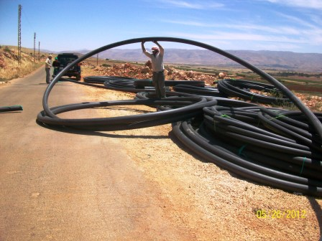 | 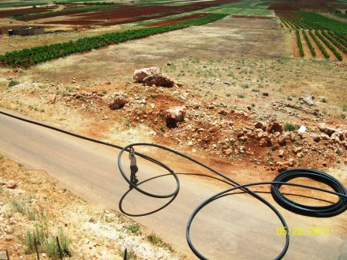
Pre-Installation of the PE pipes (5 inches) | Pre-Installation of the PE pipes (4 inches)
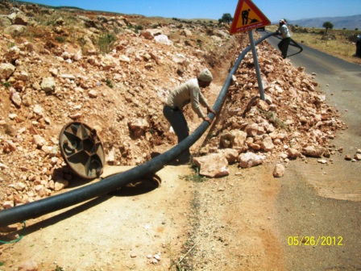 | 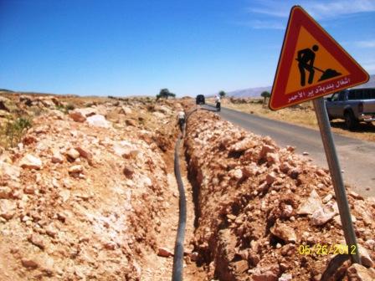
Junction point between the old (6 inches) and the new irrigation network (5 inches). | Installation of the PE pipes (5 inches).
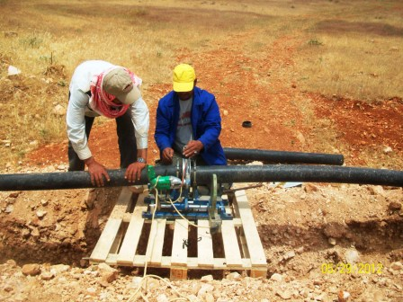 | 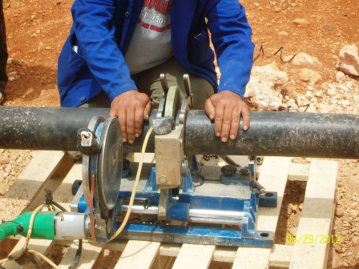
Step 1: Welding of the irrigation network. | Step 2: Sealing of the irrigation network
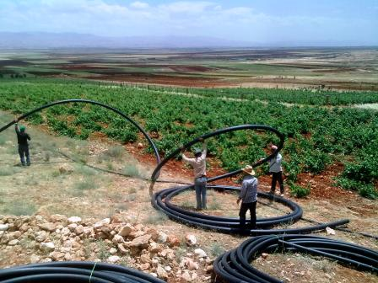 | 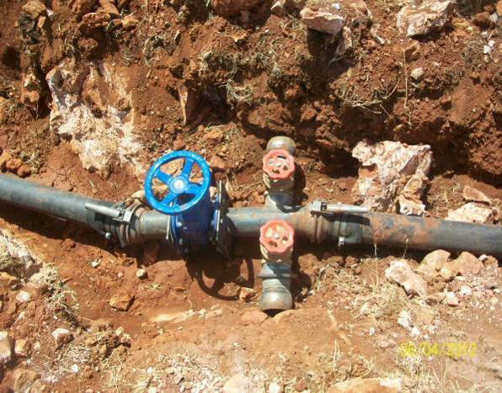
Pre-installation of PE pipes (4 inches) | Gate valves (5 inches & 3 inches).
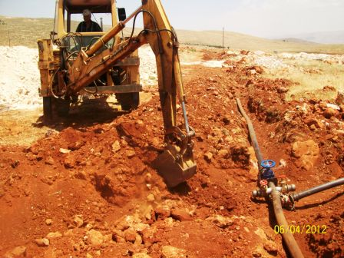 | 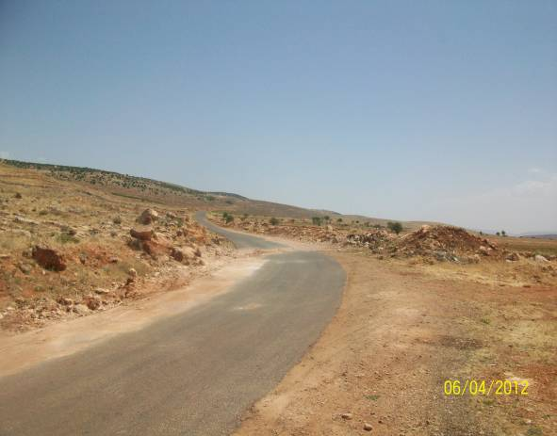
Excavation works in manholes locations. | Backfilling of the irrigation network (5 inches).

ANNEX II

Second Training on “Modern Irrigation Techniques for Vineyards
(Supplementary Irrigation for Viticulture)

Objective: Enhancing wine yard productivity through integration of supplementary irrigation

Date: May 15, 2012

Place: Deir el Ahmar - North Bekaa

Enhancing agriculture productivity is one of the planned outputs of the project “Flood Risk Management and Soil Conservation”.

Farmers of Deir el Ahmar consider viticulture for wine production as a promised cultivation with high economic value. They believe this agro business may ameliorate the livelihoods of farmers and address the socio-economic situation.

However, important challenges hinder the evolution of this cultivation such as shortage on water and improper irrigation practices. These reduce the productivity and may disturb the sustainability of this cultivation.

In order to assist wine growers to overcome these challenges, the project team in collaboration with Mr. Charbel Hobeika, expert on vineyards management, organized a training session on “Importance of Supplementary Irrigation for Viticulture”. The training session took place on May 15, 2102 at the center of Women Association of Deir el Ahmar.

Mr. Antonio Youssef (UNDP team) opened the session briefing on the different activities undertaken by the project in the field of water harvesting and irrigation techniques. He outlined the purposes of the training session. Then, Mr. Hobeika delivered a presentation explaining the process followed in the collection of different data and the software (Cropwatt) used for the calculation of annual evapo-transpiration of vineyards in Deir el Ahmar. He advised the farmers to conduct three interventions during the berry growth period (beginning of June till end of July). An additional irrigation after harvesting can be very useful for the productivity of the next year. 30-40m³ must be supplied for a dunum (1,000m²) per irrigation. Irrigation must be avoided before the flowering and during maturity phases as it may badly harm the productivity. Mr. Hobeika stressed on the importance of the use of tensiometer to define the proper moment for irrigation.

Finally, two exercises (two different scenarios) were done to demonstrate the calculation process of quantity of water and the necessary duration to irrigate one dunum of land, followed by a general open discussion.

During the workshop, technical bulletins were distributed to participants.

List of participants

Name | Phone/mobile number
Joseph Ishak | 08/320375
Ghassan Jreige | 03/420636
Mounir El Hadchiti | 71/735475
Michel Aamad | 71/245517
Maurice Aamad | 08/320141
Pierre Aamad | 08/320139
Sami Habchi | 03/294601
Diab Aamad | 70/122030
Maroun Habchi | 03/085400
Toni Bkaakafri | 03/859715
Houssein Ahmad | -
Nakhoul el Hadchiti | 70/227496
Tarek Habchi | 08/320670
Moukhail Aamad | 03/878502
Georges Fhakhry | 03/651570
Anwar el Kozah | 03/842453
Habib Keyrouz
Samir Habchi | 70/147420
Sami Keyrouz
Barakat Keyrouz

Pictures from the Deir El Ahmar workshop

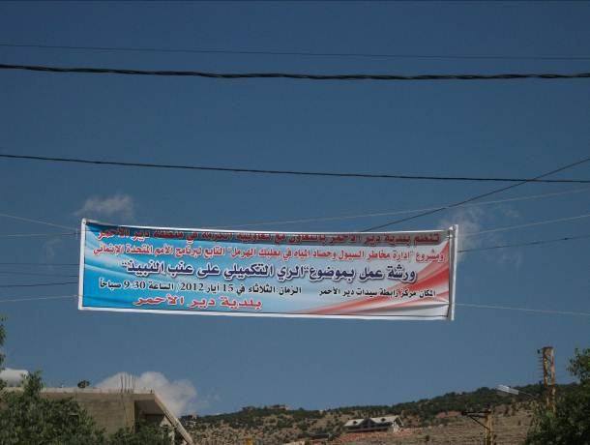 | 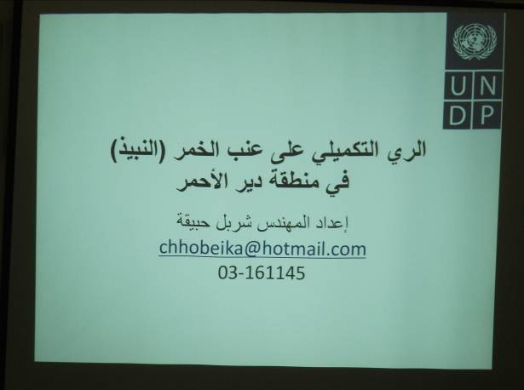
Sign for workshop at the village entrance | Presentation by Expert Charbel Hobeika
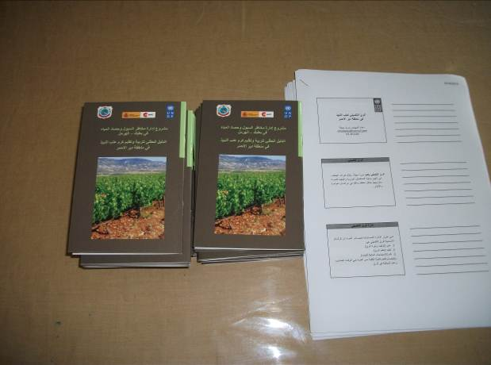 | 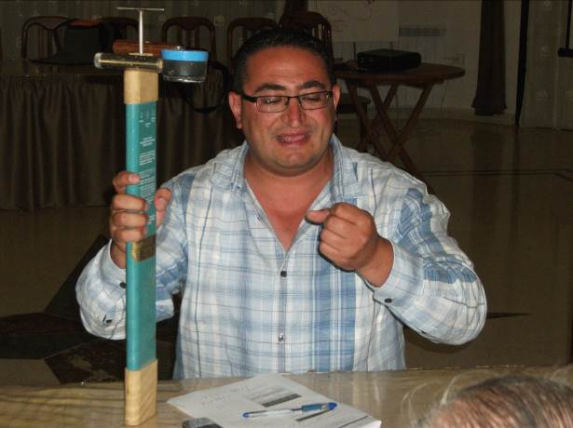
Handy technical Bulletin | Use of tensiometer

ANNEX III

PHOTOS OF PROJECT ACTIVITIES

FLOOD RISKS MANAGEMENT
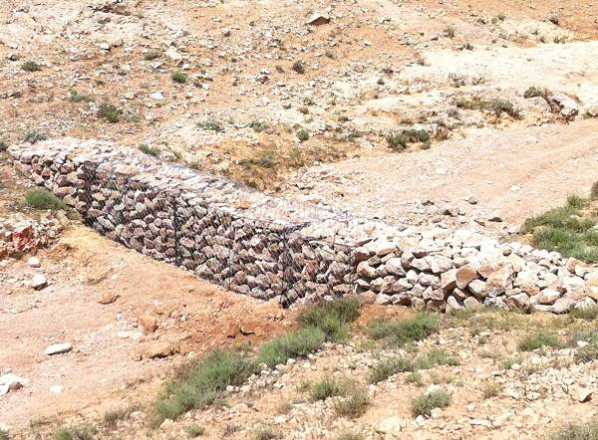 | 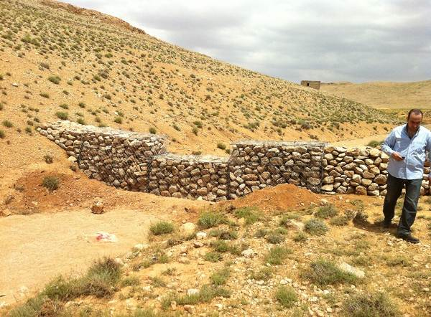
Wall Structure (Gabion) | Wall Structure (Gabion)
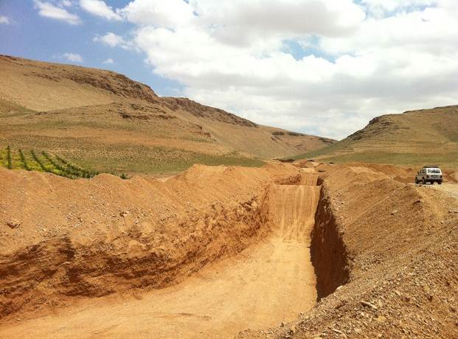 | 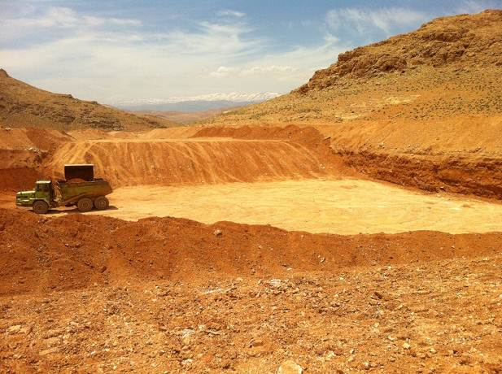
Excavation of reservoir RR12 | Excavation of reservoir RR14
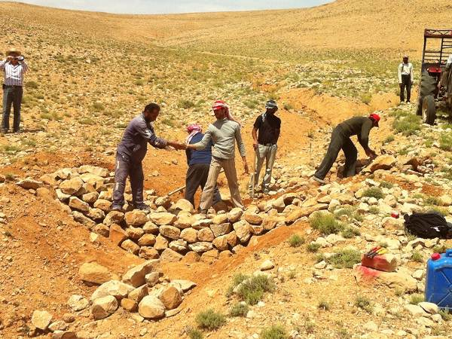 | 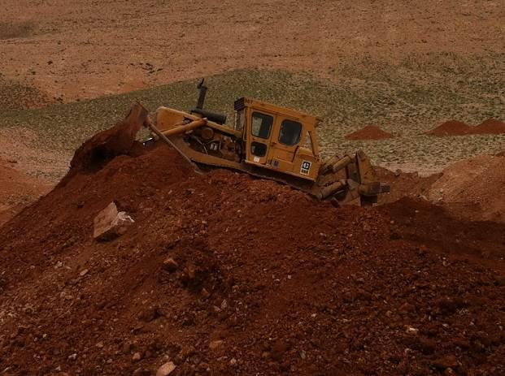
Wall under Construction | Earth moving D9 in RR14

REFORESTATION ACTIVITY
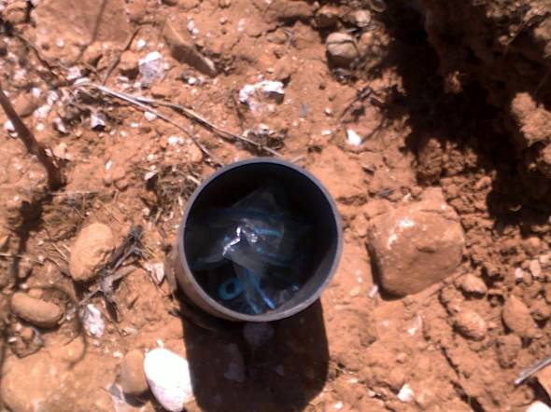 | 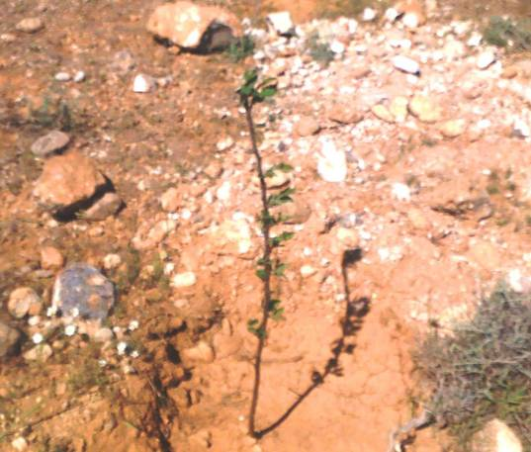
Second refill with rechargeable solid water | Successful growth of the seedlings planted 3 months ago (in March)
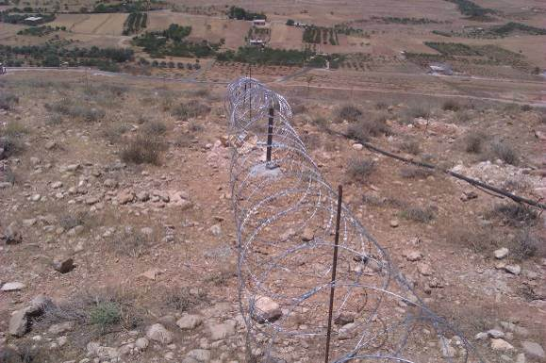 | 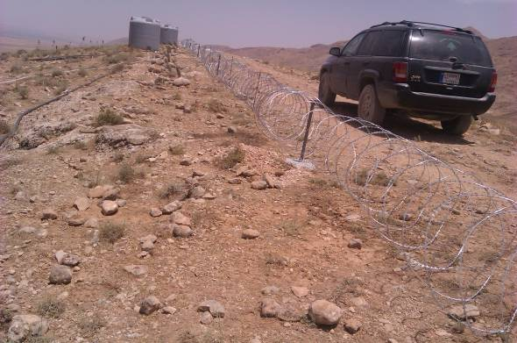
Fencing the reforested site with Concertina type | Concertina fence and irrigation system for the maintenance of the reforested site

