Strategic Grain Reserve in South Sudan Project ID 00079635

NARRATIVE progress report

REPORTING PERIOD: January 1, 2012 – June 30, 2012
Programme Title & Project Number |  | Country, Locality(s), Thematic/Priority Area(s)
- Programme Title: Strategic Grain Reserve in South Sudan  - Programme Number (if applicable)  - MPTF Office Project Reference Number:  Project ID 00079635 |  | (if applicable)Country/Region Republic of South Sudan
Thematic/Priority
Build a National Strategic Grain Reserve in South Sudan to effectively prepare and respond to emergency; to support safety net programs for the poor and early revitalization of the economy specifically the agriculture sector.

Priority Areas 3 and 4

Participating Organization(s) |  | Implementing Partners
- United Nations-World Food Programme South Sudan |  | - Government of South Sudan  - International Food Policy Research Institute (IFPRI)  - Food and Agriculture Organization (FAO)  - National Bureau of Statistics (NBS)  - Famine Early Warning System Network (FEWS NET)  - Private Sector Contractors

Programme/Project Cost (US$) |  |  | Programme Duration
MPTF/JP Contribution:  - US$1,990,200 |  |  | Overall Duration (months) 36 months
Agency Contribution  - Not available |  |  | Start Date | 27 July 2011
Government Contribution  (if applicable) |  |  | End Date (or Revised End Date)
Other Contributions  Government of Norway US$2.5 million |  |  | Operational Closure Date 26 July 2014
TOTAL: $99,624,552 |  |  | Expected Financial Closure Date 26 January 2015

Programme Assessment/Review/Mid-Term Eval. |  | Report Submitted By
Assessment/Review - if applicable please attach  X  Yes No Date: dd.mm.yyyy  Mid-Term Evaluation Report – if applicable please attach  X  Yes No Date: dd.mm.yyyy |  | - Name: Mr. Chris Nikoi  - Title: Country Director  - Participating Organization (Lead): WFP  - Email address: Chris.Nikoi@wfp.org

- PURPOSE

The project aims to establish a Strategic National Food Reserve (NSFR) for the Republic of South Sudan to enable the government to:

1. Effectively and timely respond to emergencies
2. Run nationally owned safety net programs for the poor
3. Stimulate agricultural production.

More than a year after the birth of South Sudan—the world’s newest independent country—the nation continues to face a series of humanitarian emergencies while major development challenges still remain.

The new state’s first year of independence was characterized by a continued lack of agreement on key CPA issues such as border demarcation, oil transit fees, and the fate of the contested area of Abyei. The new republic also continued to face other major challenges as it sought to improve internal security, build state capacity and enable the shift from emergency relief to recovery. Inter-communal clashes and rebel militia activity continued to destabilise communities, disrupt agricultural production, livelihoods and education and increasing vulnerability. Resultantly, the humanitarian situation in South Sudan also deteriorated sharply due to the combination of political-economic shocks, increased conflict and displacement, and worsening food insecurity.

Faced with a multiplicity of needs that are enormous both in scale and complexity, the new government is impelled to show immediate progress in political and security sector reform, addressing underlying grievances that led to the conflict, and supporting the needs of conflict-affected populations including returnees, displaced populations and resident communities. However, the legacy of protracted civil war has left South Sudan with one of the biggest capacity gaps in Africa. Public infrastructure remains severely under-developed; rule of law weak and government capacity to provide basic services low. The Government has taken important steps to strengthen state capacity over the past year, however, it will take years before it can begin direct provision of frontline services.

Developing and stimulating economic diversification and agricultural growth are key development objectives to step out from oil dependency guaranteeing longer-term sustainable development for the country. The Government and experts agree that the key to solving oil dependence and reducing food insecurity in South Sudan, is to develop a robust and vibrant agricultural sector. A project such as National Strategic Food Security without doubt plays significant role to address food insecurity.

To support the government in achieving these objectives, in May 2011, WFP launched a three-year Special Operation (SO 200267) for the establishment of a Strategic Grain Reserve to be handed over to the Government of South Sudan in the final year of implementation. The project, with an overall budget of US$97 million, includes building five warehouses with a total capacity of 100,000 MT as well as developing the administration and logistics capacity of the Government of South Sudan to operate the reserve.

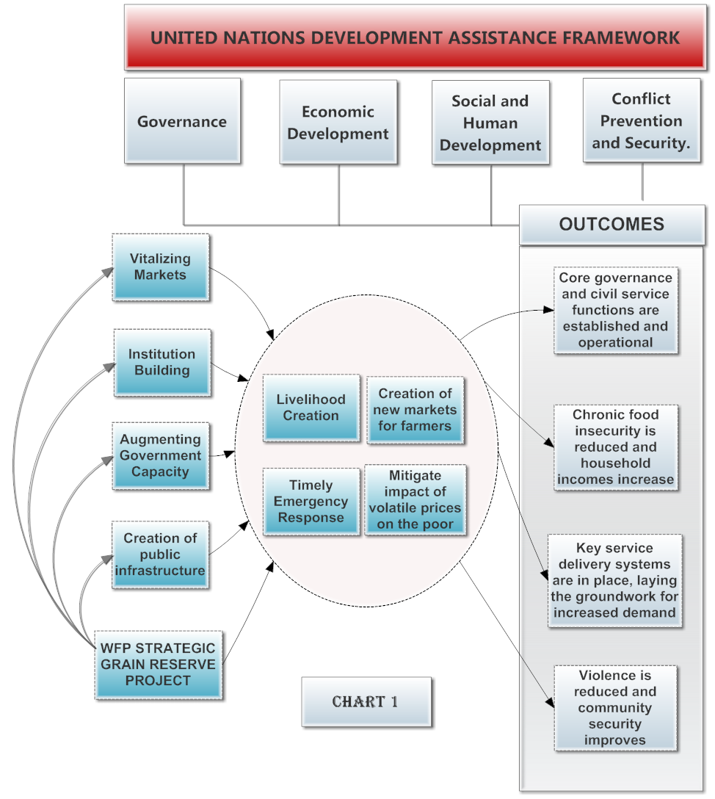
Chart 1 draws out the linkages between the objectives of the Strategic Grain Reserve and their relationship to the pillars and objectives of the United Nations Development Assistance Framework for South Sudan. There is also cross cutting alignment with the South Sudan development framework 2012-2013. In South Sudan, humanitarian agencies and commercial actors have to rely on congested ports to import food and are usually faced with a lack of transport capacity thereby increasing the lead time of bringing much needed food supplies. In a humanitarian emergency, these delays can be life threatening. The Strategic Grain Reserve can help to provide the needed food commodities to the Government and humanitarian partners in a timely and cost effective manner.

While the strategic grain reserve is envisaged as a safety net institution for ensuring timely and effectively response to food emergencies, it can also play a role in post conflict recovering stimulating agriculture development, promoting small-holders, creating employment opportunities and shared peace dividends consolidate government authority building the condition for broad based economic growth.

RESOURCES

This three-year Special Operation (SO 200267) for the establishment of a Strategic Grain Reserve was budgeted for US$97 million. To date the project has received US$ 4.5 million, consisting of US$ 2 million from the Peace Building Fund and US$ 2.5 million from the Government of Norway.

With the support from the Peace Building Fund and the Government of Norway’s contribution, WFP has started the implementation of the newly determined first phase of the project. The Peace Building fund contribution is being used to establish the necessary conditions to establish a sustainable SGR. During the first year the project aims to:

- Develop the GOSS institutional policy framework that will officially legalize the SGR establishment through a resolution from the Council of Ministries.
- Conduct a baseline survey and design the M&E system
- Clear land for reserve locations
- Recruit WFP specialized management team for project supervision

WFP is currently revising the overall requirements of the project in line with its new strategic project implementation approach. The overall cost is expected to reduce with the new increased focus on capacity building rather than construction of the physical infrastructure associated with a grain reserve. The new strategy which entails more contributions and investment by the Government of South Sudan is already bearing fruit with Hon. Dr Betty Achan, Minister of Agriculture, Forestry, Cooperatives and Rural development (MAFCRD), the Minister of Humanitarian Affairs and Disaster Management (MHADM) and other senior officials from the government committing the Strategic Grain Reserve as one of the top priorities of the Government of South Sudan.

The Government of South Sudan has also offered the use of existing government warehouses during the pilot phase of the project, which will enable WFP to reduce the project budget significantly. WFP and MAFCRD have developed a joint resource mobilization strategy and are engaged in bilateral meetings with other donors.

Other Development Partners have also shown a positive interest in the project. During a consultative meeting on 28 June 2012, the World Bank and the Japan International Cooperation Agency expressed their interest in working with or complementing the efforts of the grain reserve and negotiations are also well underway with FAO and FEWSNET to help develop the early warning system capabilities of the Government of South Sudan in support of the reserve. The International Food Policy Research Institute (IFPRI) is already engaged with their expertise on economic analysis to support the project.

The WFP South Sudan Country Office finance division, in accordance with its Financial and Procurement Rules and Regulations, continues to manage the financial resources of the project.

- IMPLEMENTATION AND MONITORING ARRANGEMENTS
To ensure sustainability and achieve the capacity building and indirectly the peace building objectives, the project aimed to promote individual, organizational, institutional, and cultural change in the highly complex and dynamic environment of South Sudan, where the stakeholders and their positions are in continuous flux. Following best practices for the implementation of such projects where regular investigation and monitoring of the applicability of programmatic assumptions hold true in such a dynamic context, WFP conducted numerous formal and informal consultations with key stakeholders. Through these consultations it became evident that if the ultimate goal was sustainable change at the national level, the success of the project in achieving its food security and peace building objectives would depend on the willingness of national actors to buy‐into and to sustain the proposed change. It became evident that national capacity building, partnership, and ownership were critical for the success of this project.

This was contrary to the original project strategy, where the emphasis was on building the infrastructure required for the reserve as the first step and then subsequently moves towards operationalizing the reserve, followed by a hand over to the Government. WFP and partners, including IFPRI and FAO came to the realization that the project ought to be implemented in three distinct phases as outlined below.

Phase I: Build conducive policy environment; strengthen the Government capacity on food security information management system and form the necessary organizational structures
Phase II: Operationalizing the NSFR through a small-scale pilot jointly managed by WFP and Government of South Sudan.
Phase III: Implementing the project at scale, including construction of additional warehouses, and finalizing the handover
World Food program with support from IFPRI will develop rigorous monitoring and evaluation systems. Preparation is underway to develop the instruments that will be used to collect outputs, outcomes and goals that will feed into the evaluation system. This will be followed by focus group discussions and eventually a baseline survey, which will provide data against which the performance of the project will be measured.

Three levels of M&E have been identified.
- Monitoring and evaluating the special operation implementation progress.
- Monitoring and evaluating the objectives set in the logical framework and implementation strategy
- Monitoring and evaluating the operational procedures and book keeping during the execution of the project.

Results

Progress to-date:

1. Consultative meeting with relevant government ministries was held on March 27th, 2012, to reach a common understanding on the role of the NSFR in addressing food insecurity as well as develop a road map to establish SGR in the country.

2. An inter-ministerial Technical Working Group (TWG) was established on April 20th, 2012. The TWG is responsible for designing the NSFR framework, policy and procedure for its operations.

3. The Council of Ministers passed a resolution to establish the NSFR in South Sudan on May 25th 2012.

4. High-level meeting, “NSFR concept to action", with the government, donors and development partners was held on June 28th, 2012.

GRSS commitment to support the NSFR initiative was re-affirmed by Hon. Dr Betty Achan the Minister of Agriculture, Forestry, Cooperatives and Rural development (MAFCRD) . The MAFCRD Minister stressed that NSFR is one of the GRSS priorities in addressing food security in South Sudan.

The TWG has embarked on identifying the government of South Sudan’s institutional gaps in area of early warning and food security information system and is working on the followings:

  - Help the government to establish a crop forecasting and food security analysis system(s)
  - Develop an early warning system, including improved weather forecasting.
  - Policy setting and guidelines.
  - Comprehensive framework for monitoring and evaluation for both the governing body of the Strategic Grain Reserve and the project
  - Drafting of a capacity augmentation plan to ensure success of the project

Future Work Plan (if applicable)

- Design NSFR policy framework. The policy framework defines protocol, guidelines and procedures to ensure consistent level of understanding among stakeholders on the NSFR purpose and policies. The policy framework formulates strategies to achieve the NSFR’s objectives and defines the organizational structures, decision-making process, institutional linkages with existing support systems and response programmes.

- Develop governance structure and form executive body to manage the NSFR

- Build and manage stock: Identify available storage facility to be used during the pilot stage. Build NSFR stock and a program on stock utilization.

- Coordinate among government ministries to ensure the required resources are budgeted.
One of the central pillars of successful handover of SGR to GRSS will be building national capacity -human and physical capacity- to effectively manage, empirically evaluate and successfully integrate into nationally owned safety net programmes. WFP will carry out a series of training and study tours for GRSS officials in countries with successful Food Reserve and safety net programs. The PBF fund is partly earmarked for this purpose.

- INDICATOR BASED PERFORMANCE ASSESSMENT

The NSFR project implementation has been revised from the initial plan. As a result the performance assessment indicators are under review.

Strategic Results, as formulated in the Performance Management Plan (PMP) for the PBF; Sector for the UNDG ITF.
The MPTF Office Project Reference Number is the same number as the one on the Notification message. It is also referred to “Project ID” on the MPTF Office GATEWAY
The start date is the date of the first transfer of the funds from the MPTF Office as Administrative Agent. Transfer date is available on the MPTF Office GATEWAY
As per approval by the relevant decision-making body/Steering Committee.
All activities for which a Participating Organization is responsible under an approved MPTF programme have been completed. Agencies to advise the MPTF Office.

