**Project Implementation**

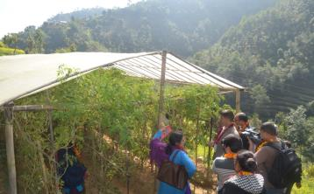

DCC members in Kavre District monitoring the tunnel tomato farming during the monitoring visit in Kusha Devi VDC in Kavre district

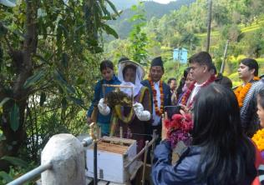

DCC members monitoring the bee keeping done by conflict affected women in Kusha Devi VDC in Kavre district

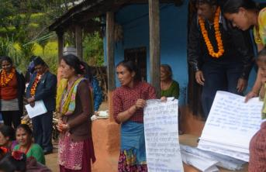

Conflict affected women making presentation on the progress made by the project in the lives of conflict affected women of their VDC to DCC members in Kusha Devi VDC in Kavre district

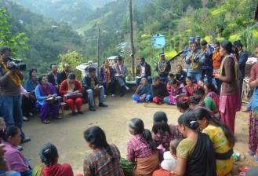

Presentation made by conflict affected women to DCC members in Kusha Devi VDC in Kavre district

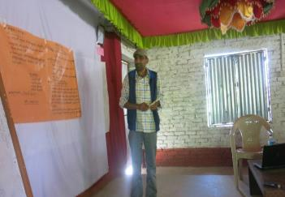

LPC member making presentation on linking the role of LPC with the five pillars of NAP on UNSCRS 1325 and 1820 in Ramechhap district

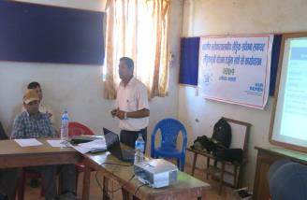

Mr. Gobinda Kattel, representative of District Administration Office in Ramechhap district presenting how the budget planning is done at District Development Committee (DDC)

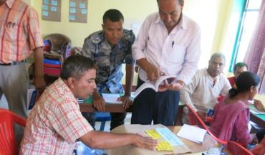

Group work done by the government officials during the workshop on "Gender Sensitization Workshop for government line agencies "held at Ramechhap district

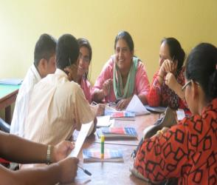

Staff members of Women and Children Office during the group work in Ramechhap district

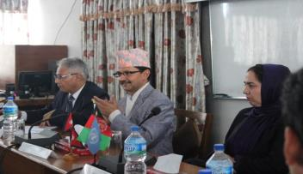

The Study Team of Afghanistan interacting with the Secretary and Joint Secretary of MoPR

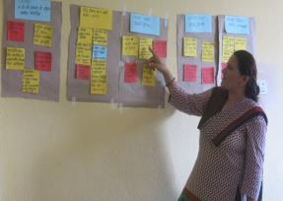

Government stakeholder making presentation during "Gender Sensitization Workshop for government line agencies "held at Ramechhap district

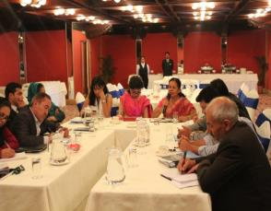

Afghanistan delegates interacting with the representative of Nepali CSOs in Kathmandu

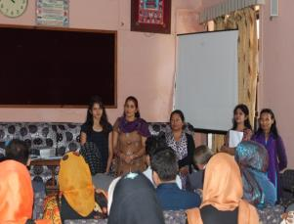

Afghanistan mission delegates interacting with the stakeholders of the GRRSP project in Kavre district

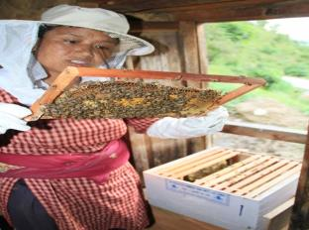

An entrepreneur checking bee hive in Kavre district

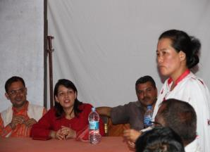

LPC members participating during the mid- term review of the GRRSP project in SIndhuli district

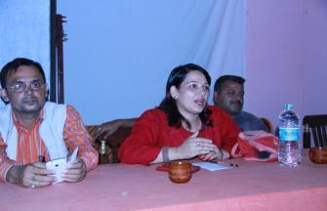

LPC members participating during the mid-term review discussion of the GRRSP project in Sindhuli district

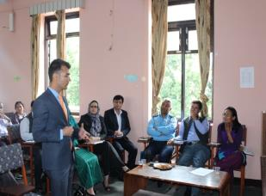

Afghanistan delegates interacting with the DCC members in Kavre district

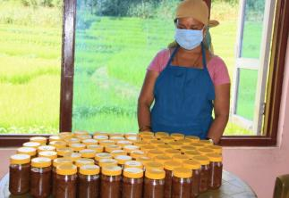

An entrepreneur packaging pickle for market in Kavre district

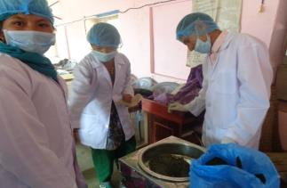

Beneficiaries preparing nettle powder in Ramechhap district

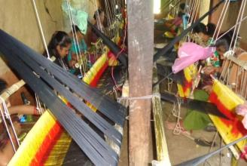

Beneficiaries working on loom for Dhaka weaving in Ramechhap district

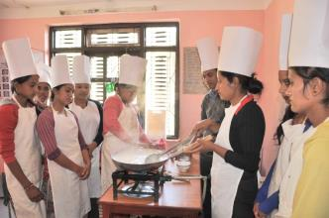

Trainees of sweets and snacks training preparing food items in Kavre district

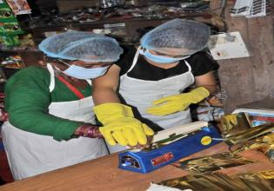

Trainees of turmeric processing and packaging observing packaging technique in Sindhuli district

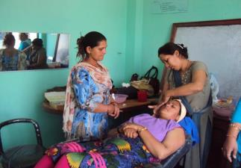

Trainees on practical session of beauty parlor vocational training in Kavre district

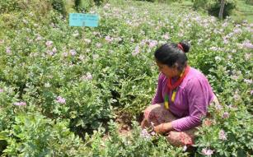

A farmer (conflict affected woman) of *Shanti* Women Farmer’s Group showing potato produced in her land in Doramba VDC in Ramechap district