RUNO Half Yearly Reporting TEMPLATE 4.3
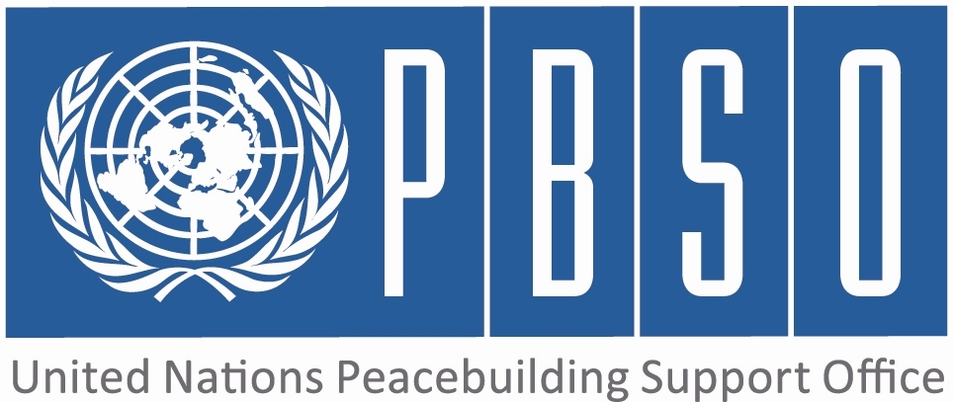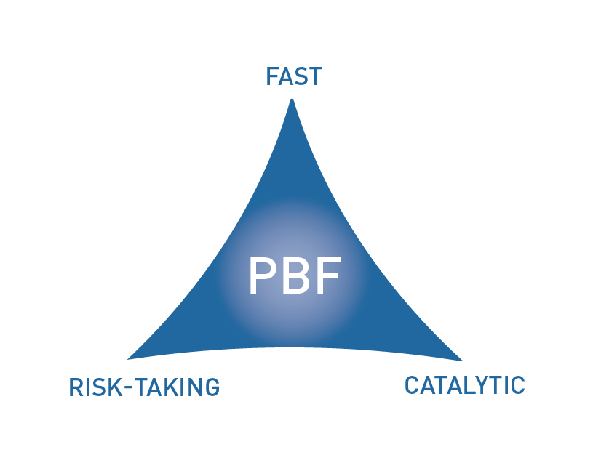
[COUNTRY: Liberia]

PROJECT HALF YEARLY PROGRESS UPDATE

PERIOD COVERED: JANUARY – JUNE 2015

Project No & Title: | PBF/  (0008032) Support to National Reconciliation (Community-based Truth Telling and Atonement Project)
Recipient Organization(s): | UNDP
Implementing Partners (Government, UN agencies, NGOs etc): | Independent National Commission on Human Rights (INCHR)
Total Approved Budget : | 983452
Preliminary data on funds committed : | US$983,452.28 | % of funds committed / total approved budget:
Expenditure: |  | % of expenditure / total budget: (Delivery rate)
Project Approval Date: | 4 October 2013 | Possible delay in operational closure date (Number of months) | Implementation of project was delayed due to Ebola outbreak. Operational closure date was extended into 2015.
Project Start Date: | 1 January 2014
Expected Operational Project Closure Date: | 31 December 2014
Project Outcomes: | Communities are reconciled and live in peaceful coexistence utilizing the Palava Hut system/approach to settle their differences.
PBF Focus Area  (select one of the Focus Areas listed below) | Outcome 1: Communities are reconciled and live in peaceful coexistence utilizing the Palava Hut system/approach to settle their differences.

Qualitative assessment of progress

For each intended outcome, provide evidence of progress during the reporting period.  In addition, for each outcome include the outputs achieved.  (1000 characters max per outcome.) | Outcome 1:  The technical capacity of the PMU has been improved, amounting to improved quality reports; M&E and work plans; development of quality project proposals. Its Project Coordinator has acquired knowledge and skills from external training in Community Organizing for Social Change and Transitional Justice in the USA. Two consultants completed institutional capacity assessment of the INCHR that identified causes of its low performance, put forth mitigating recommendations, and produced institutional, TORs, SOP, Staff Hand book and short-term strategic plan. Some of these recommendations are being implemented. The consultants oriented INCHR Commissioners and staff to human rights concept and application of human rights standards. Two consultants were hired to develop guidelines and methodologies for the Palava Hut hearings.  Outcome 2:  Outcome 3:  Outcome 4:
Do you see evidence that the project is having a positive impact on peacebuilding?  (1000 characters max.) | There is strong enthusiasm among traditional leaders, elders, religious leaders, women and youth leaders and other principle stakeholders across the ethnic and settler divides of the country to converge at the four inpending ethnographic forums to determine the appropriate alternative transitional justice approcahes toward the achievement of the desired goal of the National Palava Hut Program: to heal and reconcile the country for generational peaceful coexistence, security and development. The reinforcement of activities of the Palava Hut process since 2013, through PBF and UNDP support, has caused a notable paradigm shift in pevious public prediction of a potential relapse into conflict for what was deemed government's downplay of the Palava Hut Program. To date, victims, and the public are poised for the palava hut hearings as the major source of hope to address wounds of the war and reconcile the country, which keeps the peace process on a relatively safe path.
Were there catalytic effects from the project in the period reported, including additional funding commitments or unleashing/ unblocking of any peace relevant processes?  (1000 characters max.) | The PBF-funded peacebuilding projects being implemented by various institutions , Peace-Building Office (PBO) and the INCHR have begun collaborating in the area of capacity-building, in order to maximize productivity toward the achievement of the cumulative goal of quality national peace and reconciliation and to ensure strategic use of resourses. In a show of interest of government in fast tracking the Palava Hut, the Minister of Internal Affairs, who oversees the national reconciliation process, requested and received from the INCHR a budgeted activity plan for possible government funding to the Palava Hut and other core activities of the Commission.
If progress has been slow or inadequate, provide main reasons and what is being done to address them.  (1000 characters max.) | The failed recruitment of consultants to conduct the ethnography study at the beginning of the project, the Ebola epidemic which struck Liberia including its neigboring countries delayed approval of the AWP, couple with the slow UNDP procurement processes contributed to the slo prograss. In order to fast track the process, forums will be held instead of a study to be followed by the hearings in four districts. the study tour and the construction of the memorials will be done simultaneously. MIA, PBO and INCHR are collaborating to design a communication strategy to begin a nation wide awareness on the Palava Hut process.
What are the main activities/expected results for the rest of the year?  (1000 characters max.) | Conduct of the Ethnography Forums; comparative study of various transitional justice systems using Rwanda, Sierra Leone and other; conduct Palava Hut Talks and Nationwide outreach on the palava hut talks; drafting of a Palava Hut Bill for legislative enactment and construction of two memorials. Expected Results: Palava Hut methodology and guidelines available and utilized in pilot communities; Lessons learned from the Gacaca and the Fambul Talk transitional justice processes of Rwanda and Sierra Leone which will serve as guidance for palava hut program. Increased local knowledge and understanding of the benefits, safety and process of the palava hut system, thus engendering popular citizens’ participation in and support to the palava hut process. A draft national palava hut bill for legislative enactment produced and national consultations initiated. The dead honored and humanized as part of the community healing process and reduction of stigmatization against Ebola survivors.
Is there any need to adjust project strategies/ duration/budget etc.?  (1000 characters max.) | Project budget needs adjustment to recruit a Psychosocial Counsellor to provide psychosocial support during palava hut hearing. Duration of project needs to be extended to account for time lost to the Ebola crisis.Other adjustments may become appropriate as the project proceeds.

What is the project budget expenditure to date (percentage of allocated project budget expensed by the date of the report) – preliminary figures only?

(1000 characters max.)
Any other information that the project needs to convey to PBSO (and JSC) at this stage?  (1500 characters max.) | The Istitutional Capacity Assessment put the entire INCHR on track. With the identification of key gaps, the basic training for all staff in administrative procedures and reporting, the implementation of the short term strategy and the training of a staff in Trasitional Justice, the INCHR is even more equiped to implement the Palava Hut project. Two staff of the PMU were incorporated into the secretariate of the INCHR with direct supervision of the management of the Project which reflects a savings in the budgetary allocations.This is a step towards incorporating the PMU into the mainstream of the INCHR activities The INCHR is revisiting the staffing of the PMU to determine the staffing needs.

INDICATOR BASED PERFORMANCE ASSESSMENT: Using the Project Results Framework as per the approved project document- provide an update on the achievement of key indicators at both the outcome and output level in the table below. Where it has not been possible to collect data on indicators, state this and provide any explanation in the qualitative text above. (250 characters max per entry)

 | Performance Indicators | Indicator Baseline | End of project Indicator Target | Current indicator progress | Reasons for Variance/ Delay  (if any) | Adjustment of target (if any)
Outcome 1  Communities are reconciled and live in peaceful coexistence utilizing the Palava Hut system/approach to settle their differences | Indicator 1.1  Palava hut methodology and mechanism developed and being utilized in communities | September 2013: No methodological framework for palava hut | Responsive technical capacity by 2015 | Attendees for ethnographic forums being recruited. The forums will also identify war-related violations suitable for the palava hut process.  Design of methodology and guidelines to follow. | Delayed approval of AWP and late arrival of the external consultant due to Ebola, and the criticality of the identification and selection of qualified attendees for the ethnographic forums are the main factors of delay. | Design of the palava hut methodology and guidelines will spill over to the first month of the third quarter.
 | Indicator 1.2  INCHR has capacity to implement project | Limited technical capacity  Leadership vacuum-with no presiding chair | Results-based INCHR by 2015 | New and old staff received separate human rights, M&E, transitional justice and other forms of trainings.
Output 1.1  INCHR capacity strengthened to lead and coordinate the National Palava Hut Program | Indicator 1.1.1  Project Management Unit (PMU) set up and functional in INCHR | No Technical Unit in place | PMU set up by December 2013 | PMU set up in 2014 and functional. Staff currently reduced from 7 to 5.
 | Indicator 1.1.2  # of staff are trained  1.1.3:  #of logistical and technical support is provided  1.1.4: # of reports available  1.1.5: # of staff recruited | 2013: Limited logistics (vehicles etc) in place at INCHR | M&E Plan developed by March 2014  MoV: Project report  Functional Project Management Unit and equipment in place by 2014 | Four staff trained  PBO trained three PMU staff; UNDP provided technical support. Received 2 jeeps, 4 motobikes & logistics. INCHR capacity assessed TORs, SOP, Organogram, Staff Handbook produced.  Five reports available.  One staff recruited
Output 1.2  Studies conducted and Palava Hut methodology and operational guidelines developed | Indicator 1.2.1  # of research findings | Baseline (2013): No report | Studies conducted by 2014 | Ethnographic study in progress. Inception report of stakeholders consultation available. Methodology to be designed after ethnographic study. | Delayed approval of AWP and late arrival of the external consultant due to Ebola, and the criticality of the identification and selection of qualified attendees for the ethnographic forums are the main factors of delay. | Arrangements for the study tour to Sierra Leone and Rwanda were upset by the Ebola outbreak and could not obviously be made concurrently with the ethnographic study and institutional capacity assessment.Tour will take place after the Forums
Indicator 1.2.2

Study report

Output 1.3 | Indicator 1.3.1
Output 1.3 | Indicator 1.3.2
Outcome 2 | Indicator 2.1
Outcome 2 | Indicator 2.2
Output 2.1 | Indicator 2.1.1
Output 2.1 | Indicator 2.1.2
Output 2.2 | Indicator 2.2.1
Output 2.2 | Indicator 2.2.2
Output 2.3 | Indicator 2.3.1
Output 2.3 | Indicator 2.3.2
Outcome 3 | Indicator 3.1
Outcome 3 | Indicator 3.2
Output 3.1 | Indicator 3.1.1
Output 3.1 | Indicator 3.1.2
Output 3.2 | Indicator 3.2.1
Output 3.2 | Indicator 3.2.2
Output 3.3 | Indicator 3.3.1
Output 3.3 | Indicator 3.3.2
Outcome 4 | Indicator 4.1
Outcome 4 | Indicator 4.2
Output 4.1 | Indicator 4.1.1
Output 4.1 | Indicator 4.1.2
Output 4.2 | Indicator 4.2.1
Output 4.2 | Indicator 4.2.2
Output 4.3 | Indicator 4.3.1
Output 4.3 | Indicator 4.3.2

Please note that where there are multiple agencies, only one consolidated project report should be submitted.
Approved budget is the amount transferred to Recipient Organisations.
Funds committed are defined as the commitments made through legal contracts for services and works according to the financial regulations and procedures of the Recipient Organisations. Provide preliminary data only. 4 Actual payments (contracts, services, works) made on commitments. 5 PBF focus areas are: PBF Focus Areas are: 1: Support the implementation of peace agreements and political dialogue (Priority Area 1): (1.1) SSR, (1.2) RoL; (1.3) DDR; (1.4) Political Dialogue; 2: Promote coexistence and peaceful resolution of conflicts (Priority Area 2): (2.1) National reconciliation; (2.2) Democratic Governance; (2.3) Conflict prevention/management; 3:Revitalise the economy and generate immediate peace dividends (Priority Area 3); (3.1) Employment; (3.2) Equitable access to social services 4) (Re)-establish essential administrative services (Priority Area 4) (4.1) Strengthening of essential national state capacity; (4.2) extension of state authority/local administration; (4.3) Governance of peacebuilding resources (including JSC/ PBF Secretariats)

