RUNO ANNUAL PROJECT REPORT TEMPLATE 4.4
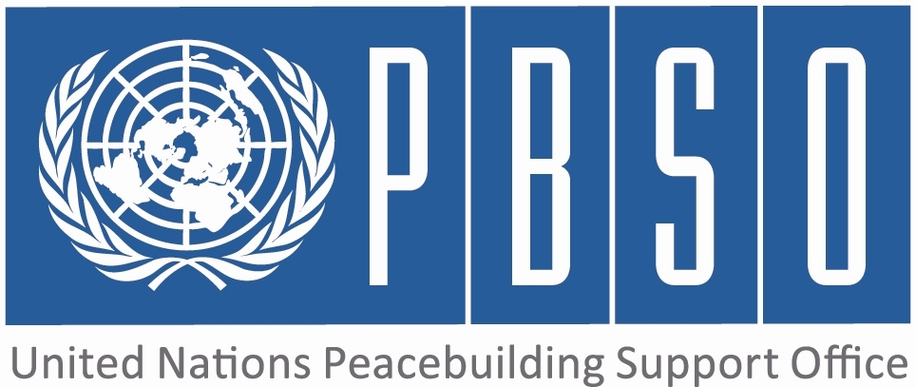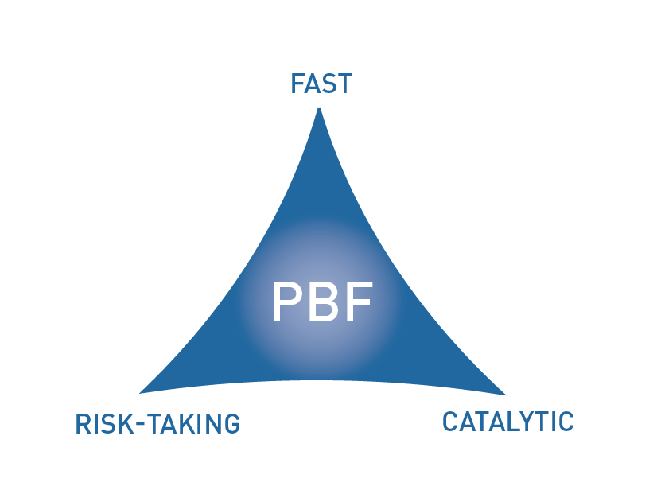

PEACEBUILDING FUND (PBF)
ANNUAL PROJECT progress report
COUNTRY: Liberia
REPORTING PERIOD: 1 january – 31 December

Programme Title & Project Number
Programme Title: Support to National Reconciliation (Community-based Truth Telling and Atonement Project)
Programme Number (if applicable) PBF/LBR/A-11
MPTF Office Project Reference Number: 00088032

Recipient UN Organizations |  |  | Implementing Partners
List the organizations that have received direct funding from the MPTF Office under this programme: UNDP |  |  | List the national counterparts (government, private, NGOs & others) and other International Organizations: INCHR, National Civil Society Organizations, Ministry of Internal Affairs, Ministry of Gender, Children and Social Protection, Liberia Peacebuilding Office, UNDP, UNMIL & UN Women
Programme/Project Budget (US$) |  |  | Programme Duration
PBF contribution (by RUNO) 1,000,000.00 |  |  | Overall Duration (months) 36
PBF contribution (by RUNO) 1,000,000.00 |  |  | Start Date (dd.mm.yyyy) 01/10/2013
Government Contribution  (if applicable)  in kind |  |  | Original End Date (dd.mm.yyyy) | 31/10/2016
Other Contributions (donors)  (if applicable)  308,000.00 |  |  | Current End date(dd.mm.yyyy) 31/10/2016
TOTAL: | 1,308,000.00

Programme Assessment/Review/Mid-Term Eval. |  | Report Submitted By
Assessment/Review - if applicable please attach  Yes No Date:  Mid-Term Evaluation Report – if applicable please attach  Yes No Date: |  | Name: Sunny A. George  Title: Project Manager  Participating Organization (Lead): Independent National Commission on Human Rights (INCHR )  Email address: sunageorge@hotmail.com

PART 1 – RESULTS PROGRESS

  - Assessment of the current project implementation status and results

For PRF projects, please identify Priority Plan outcome and indicators to which this project is contributing:
Priority Plan Outcome to which the project is contributing. Communities in pilot locations have adequate mechanisms for dealing with the past through the Palava Hut process for truth telling, atonement and reconciliation.
Priority Plan Outcome indicator(s) to which project is contributing. 1.1: Proportion of cases taken up by the Palava Hut that are resolved (disaggregrated by cases submitted by men/women)
1.2: Proportion of women in the Palava Hut Committees
1.3: Percentage of citizens in pilot locations who are positive about the national reconciliation process disaggregated by men/women.

For both IRF and PRF projects, please rate this project’s overall achievement of results to date:

For both IRF and PRF projects, outline progress against each project outcome, using the format below. The space in the template allows for up to four project outcomes.

Outcome Statement 1: Communities are reconciled and live in peaceful coexistence utilizing the Palava Hut system/approach to settle their differences.

Rate the current status of the outcome:
Indicator 1:  Proportion of cases taken up by Palava Huts that are resolved (disaggregated by cases submitted by men/women)  Indicator 2:  Palava Hut methodology and mechanisms developed and being utilized in communities.  Indicator 3:  Percentage of citizens in pilot locations who are positive about the national reconciliation process (disaggregated by men/women) | Baseline: Baseline (Sep 2013): 0%  Target: Target (Sep 2015): 50% of cases taken up by Palava Huts are resolved  Progress: The palava hut process has not been established yet. However, the process leading to the commencement of the Palava Hut process has been initiated with the development of context-specific methodology and operational guidelines. The conduct of the 4 ethnographic forums identified similarities, dissimilarities and other useful perspectives of the traditional palava hut systems of the four linguistic groups of Liberia (Kwa, Mande, Mel and Settlers). The forums also identified war related violations to be heard under the Palava Hut. 92 participants (65% male:35% female) attended the forums.  Baseline: September 2014: no methodological framework for Palava Hut  Target: Palava Hut methodology and guidelines developed in 2015.  Progress:Required information for the development of context-specific methodology and operational guidelines for the National Palava Hut has been generated through the conduct of four ethnographic forums that identified similarities, dissimilarities and other useful perspectives of the traditional palava hut systems of the four linguistic groups.of Liberia (Kwa, Mande, Mel and Settlers).The forums also identified war related violations to be heard under the Palava Hut. 92 participants (65% male:35% female) attended the forums.  Baseline: (Sep 2013): Data through the first National Reconciliation Barometer Survey would have established a basedline.  Target: Target (Sep 2015): at least 70%  Progress:No progress!

Output progress

List the key outputs achieved under this Outcome in the reporting period (1000 character limit).Outputs are the immediate deliverables for a project.
INCHR capacity assessed and institutional TORs, SOPs and Administrative Procedures developed and being implemented; 3 PMU staff trained in M & E and result-based reporting; 1 PMU staff trained in Community Organizing for Social Change and Justice in Transition; Stationery, fuel and office equipment received from UNDP; 4 ethnographic forums conducted in 4 linguistic regions; draft forums report whose validation leads to development of Palava Hut methodology and operational guidelines and categorization of war related violations is being finalized; held 1 forum on clarification of INCHR mandate relative to TRC recommendations; 5 assessment visits made to mass gravesite identified for construction of a memorial in Duport Road Community; loop survey conducted by Ministry of Land, Mines & Energy and Land Commission showed that the parcel of land is owned by the Government of Liberia and available for use for memorial. Paynesville City Corporation agreed to partner with INCHR.

Outcome progress

Describe progress made during the reporting period toward the achievement of this outcome. This analysis should reflect the above indicator progress and the output achievement. Is there evidence of the outcome contributing to peacebuilding and to the specific conflict triggers? Is the theory of change that underpins the project design still relevant for this outcome (3000 character limit)?
NCHR has improved institutional capacity and enhanced staff performance to lead the Palava Hut process evidenced by: the development and implementation of administrative and financial procedures and personnel manual; the effective and efficient conduct of four linguistic ethnographic forums across the country with 92 participants of which 65% is male and 35% female, thus achieving the gender marker of PBF projects; acquisition of a parcel of land hosting Duport Road mass grave for construction of a memorial. The memorial is meant to remember the loss, re-educate the next generation never to engage in violence. The 35% of women representation in the ethnographic forums addresses women marginalization and sets the stage for an engendered Palava Hut process. The participation of minority and marginalized groups (Mandingo, Dei, Belle, Settler, youth and persons with disabilities) in the forums creates space for broad based participation in the ownership of the Palava Hut process. The project is contributing to peacebuilding by addressing issues of exclusion and marginalization, which are identified as conflict triggers.

Reasons for low achievement and rectifying measures

If sufficient progress is not being made, what are the key reasons, bottlenecks and challenges? Were these foreseen in the risk matrix? How are they being addressed and what will be the rectifying measures (1500 character limit)?
1. The contingency of implementation of other key project activities on the conduct of the ethnographic forums and delay in getting consultants. As a consequence, the INCHR was constrained to conduct forums under streaneous conditions within limited timeframe

2. Cumbersome procurement process at UNDP oftten delays procurement of materials and services and implementation of planned activities. INCHR will consistently engage UNDP to modify its procurement process.

3. The lack of a dedicated Finance Officer at the PMU since March 2015 delays speedy financial transactions between UNDP and the INCHR, with rippling effects on implementation of project activities. Every financial transaction is being done through the INHCR’s Chief Accountant. The INCHR seeks to recruit a new Finance Officer.

Outcome Statement 2:

Rate the current status of the outcome:
Indicator 1:  Indicator 2:  Indicator 3: | Baseline:  Target:  Progress:  Baseline:  Target:  Progress:  Baseline:  Target:  Progress:

Output progress

List the key outputs achieved under this Outcome in the reporting period (1000 character limit).Outputs are the immediate deliverables for a project.

Outcome progress

Describe progress made during the reporting period toward the achievement of this outcome. This analysis should reflect the above indicator progress and the output achievement. Is there evidence of the outcome contributing to peacebuilding and to the specific conflict triggers? Is the theory of change that underpins the project design still relevant for this outcome (3000 character limit)?

Reasons for low achievement and rectifying measures

If sufficient progress is not being made, what are the key reasons, bottlenecks and challenges? Were these foreseen in the risk matrix? How are they being addressed and what will be the rectifying measures (1500 character limit)?

Outcome Statement 3:

Rate the current status of the outcome:
Indicator 1:  Indicator 2:  Indicator 3: | Baseline:  Target:  Progress:  Baseline:  Target:  Progress:  Baseline:  Target:  Progress:

Output progress

List the key outputs achieved under this Outcome in the reporting period (1000 character limit).Outputs are the immediate deliverables for a project.

Outcome progress

Describe progress made during the reporting period toward the achievement of this outcome. This analysis should reflect the above indicator progress and the output achievement. Is there evidence of the outcome contributing to peacebuilding and to the specific conflict triggers? Is the theory of change that underpins the project design still relevant for this outcome (3000 character limit)?

Reasons for low achievement and rectifying measures

If sufficient progress is not being made, what are the key reasons, bottlenecks and challenges? Were these foreseen in the risk matrix? How are they being addressed and what will be the rectifying measures (1500 character limit)?

Outcome Statement 4:

Rate the current status of the outcome:
Indicator 1:  Indicator 2:  Indicator 3: | Baseline:  Target:  Progress:  Baseline:  Target:  Progress:  Baseline:  Target:  Progress:

Output progress

List the key outputs achieved under this Outcome in the reporting period (1000 character limit).Outputs are the immediate deliverables for a project.

Outcome progress

Describe progress made during the reporting period toward the achievement of this outcome. This analysis should reflect the above indicator progress and the output achievement. Is there evidence of the outcome contributing to peacebuilding and to the specific conflict triggers? Is the theory of change that underpins the project design still relevant for this outcome (3000 character limit)?

Reasons for low achievement and rectifying measures

If sufficient progress is not being made, what are the key reasons, bottlenecks and challenges? Were these foreseen in the risk matrix? How are they being addressed and what will be the rectifying measures (1500 character limit)?

  - Assessment of project evidence base, risk, catalytic effects, gender in the reporting period

Evidence base: What is the evidence base for this report and for project progress? What consultation/validation process has taken place on this report (1000 character limit)? | The PMU successfully produced photos and video documentary, newspaper stories, quarterly reports, press statements and project update report to President Office, INCHR capacity assessment report, institutional TORs, SOPs, Administrative Procedures, Financial and Human Resource Handbook..
Funding gaps: Did the project fill critical funding gaps in peacebuilding in the country? Briefly describe. (1500 character limit) | The PBF project has filled critical funding gaps in peacebuilding in Liberia, especially bringing traditional method of resolving problems to the fore through the concept of Palava Hut Mechanisms. Not much support has been provided by the Government of Liberia to support the palava hut program. For example, for the Fiscal Year 2014/2015, $600,000 was allocated by the Government of Liberia to support the INCHR peacebuilding program, but the institution is yet to receive the money, thus making PBF the only strong donor to the Palava Hut process.
Catalytic effects: Did the project achieve any catalytic effects, either through attracting additional funding commitments or creating immediate conditions to unblock/ accelerate peace relevant processes? Briefly describe. (1500 character limit) | The project, through the ethnographic forums, provided an unprecedented setting ( tradition does not allow women and youths talking issues surrounding the Palava Hut) for traditional leaders, elders, women, youth and persons with disability to sit together for the first time to discuss traditional Palava Hut mechanisms and processes and how they can be incorporated in the National Palava Hut system.
Risk taking/ innovation: Did the project support any innovative or risky activities to achieve peacebuilding results? What were they and what was the result? (1500 character limit) | The assembling of elders, women and youths to discuss traditional Palava Hut practices during the ethnographic forums, especially in public domain as forbidden by culture, constituted a risky undertaking. Meanwhile, the forums were successfully held with participants appreciating one another and agreeing that man, women and youth are given equal opportunity to participate in the National Palava Hut process.
Gender: How have gender considerations been mainstreamed in the project to the extent possible? Is the original gender marker for the project still the right one? Briefly justify. (1500 character limit) | The project has emphasized gender equity by ensuring women and youth participation at all levels of its implementation. For example, 92 participants attended the ethnographic forums with 65% male and 35% female. Women were afforded the opportunities for their voices to be heard during the forums. The issue of gender is also considered in the recruitment of project staff.
Other issues: Are there any other issues concerning project implementation that should be shared with PBSO? This can include any cross-cutting issues or other issues which have not been included in the report so far. (1500 character limit) | The INCHR PMU staff receive the least salaries and benefits, comparatively, among PMUs under PBF funded projects in Liberia. As a result, the INCHR PMU experienced high staff turnover in less than two years.

1.3 INDICATOR BASED PERFORMANCE ASSESSMENT: Using the Project Results Framework as per the approved project document- provide an update on the achievement of key indicators at both the outcome and output level in the table below. Where it has not been possible to collect data on indicators, state this and provide any explanation in the qualitative text above. (250 characters max per entry)

 | Performance Indicators | Indicator Baseline | End of project Indicator Target | Current indicator progress | Reasons for Variance/ Delay  (if any) | Adjustment of target (if any)
Outcome 1  Communities in pilot locations have adequate mechanisms for dealing with the past through the Palava Hut process for truth telling, atonement and reconciliation | Indicator 1.1  Proportion of cases taken up by Palava Huts that are resolved (disaggregated by cases submitted by men/women). | Baseline (Sep 2013): 0% | Sep 2015): 50% of cases taken up by Palava Huts are resolved | The palava hut process is yet to be established.However, process leading to its commencement initiated with the development of context-specific methodology and operational guidelines. | The outbreak of ebola in Liberia. | The end of target was adjusted to 2016 due to the Ebola outbreak.
 | Indicator 1.2  Palava Hut methodology and mechanisms developed and being utilized in communities. | September 2014: No methodological framework for Palava Hut | Palava Hut methodology and guidelines developed in 2015. | Required information for the development of context-specific methodology and operational guidelines for the National Palava Hut generated. War-related violations that may be suitable for Palava Hut identified by forums. | Conduct of forums as precondition for implementing other key project activities and delay in getting consultants. As a result, the INCHR was constrained to conduct forums under streaneous conditions and in limited timefframe.
 | Indicator 1.3  Percentage of citizens in pilot locations who are positive about the national reconciliation process (disaggregated by men/women) | Baseline: (Sep 2013): Data through the first National Reconciliation Barometer Survey would have established a basedline. | Target (Sep 2015): at least 70% | No progress. | Low capacity and ebola outbreak | adjustment was made.
Output 1.1  INCHR capacity strengthened to lead and coordinate the National Palava Hut Programme. | Indicator 1.1.1  # of staff are trained.  # of logistical and technical supports is provided.  # of reports technical reports available.  # of staff recruited | Baseline (Sept 2014) 8 INCHR/  PMU staff trained; 2 jeeps, computers and other logistics available; 7 staff recruited and quarterly, half yealy and annual reports produced. | PMU set up by December 2013;  M&E plan developed by March 2014;  Functional Project Management Unit (PMU);  Equipment in place by 2014 | 1 PM & 1 Project Coordinator recruited; 3 PMU staff skills enhanced in M&E and result-based reporting; 1 staff acquired knowledge in Community Organizing & Transitional Justice; staff capacity also enhanced thru technical support by UNDP & PBO
 | Indicator 1.1.2
Output 1.2  Studies conducted and Palava Hut methodology and operational guidelines developed | Indicator 1.2.1  # of research findings  Study report | (Sept 2013): No report | Target (Sept 2014 ): 3 | 4 ethnographic forums conducted in 4 linguistic regions; War-related violations identified; forums report for design of methodology being finalized; | Difficulty in identifying qualified national consultants; difficulty in getting in Liberia the international consultant eventually hired after six months.
 | Indicator 1.2.2
Output 1.3  Output 5:  At least two Regional Memorials constructed in hard hit war affected communities | Indicator 1.3.1  : # of Memorials constructed | One public memorial was constructed in Bong County by Transitional Justice Working Group with support from OSIWA  2013 | Construction of two memorials to honor the dead by 2015 | Parcel of land hosting Duport Road mass grave identified for construction of first memorial finally secured; Permit for construction obtained by INCHR from local authority. Assessment to identify site for next memorial conductd. | Construction of Duport Road memorial delayed because of prolonged contention between 2 families claiming ownership of land hosting the mass grave. Impasse resolved based on findings of survey by government that declare land public property.
 | Indicator 1.3.2
Outcome 2 | Indicator 2.1
Outcome 2 | Indicator 2.2
Output 2.1 | Indicator 2.1.1
Output 2.1 | Indicator 2.1.2
Output 2.2 | Indicator 2.2.1
Output 2.2 | Indicator 2.2.2
Output 2.3 | Indicator 2.3.1
Output 2.3 | Indicator 2.3.2
Outcome 3 | Indicator 3.1
Outcome 3 | Indicator 3.2
Output 3.1 | Indicator 3.1.1
Output 3.1 | Indicator 3.1.2
Output 3.2 | Indicator 3.2.1
Output 3.2 | Indicator 3.2.2
Output 3.3 | Indicator 3.3.1
Output 3.3 | Indicator 3.3.2
Outcome 4 | Indicator 4.1
Outcome 4 | Indicator 4.2
Output 4.1 | Indicator 4.1.1
Output 4.1 | Indicator 4.1.2
Output 4.2 | Indicator 4.2.1
Output 4.2 | Indicator 4.2.2
Output 4.3 | Indicator 4.3.1
Output 4.3 | Indicator 4.3.2

PART 2: LESSONS LEARNED AND SUCCESS STORY

2.1 Lessons learned

Provide at least three key lessons learned from the implementation of the project. These can include lessons on the themes supported by the project or the project processes and management.

Lesson 1 (1000 character limit) | An invaluable lesson taught by the ethnographic forums is that men have recognized the wisdom, intelligence and smartness of women. But fearing that women could use these God-given potentials and other acquired capacities to neutralize and control men if given equal social recognition and rights, men have always employed cultures and traditions to suppress and marginalize women in order to preserve male dominance and control in society. In the words of a male participant “women are powerful; we consult them for idea at night. But we don't recognize them in public. We use culture to subdue them."
Lesson 2 (1000 character limit) | It was overwhelmingly accepted that the Palava Hut is a useful framework for national reconciliation because:  1. It serves as a cost effective conflict resolution mechanism;  2. The Palava Hut, unlike the legal system, provides for healing of broken relationsship and promotion of social cohesion..
Lesson 3 (1000 character limit)
Lesson 4 (1000 character limit)
Lesson 5 (1000 character limit)

2.2 Success story (OPTIONAL)

Provide one success story from the project implementation which can be shared on the PBSO website and Newsletter as well as the Annual Report on Fund performance. Please include key facts and figures and any citations (3000 character limit).

Rev. William R. Tolbert,III., current Liberian Peace Ambassador and son of President William R. Tolbert who was slain in the April 12, 1980 military coup, participated in the ethnographic forum for the Americo-Liberians/Settlers held at the Town Hall of Brewerville City, Montserrado County, on October 2, 2015. Speaking at the group working session of the male participants, the Peace Ambassador indicated that the "lack of trust can undermine the National Palava Hut." He therefore cautioned his fellow Americo-Liberians to be willing to reach out and talk to other linguistic or ethnic groups of the country in order to build mutual trust, which is one of the key drivers of genuine reconciliation and social cohesion that the National Palava Hut seeks to achieve. He also underscored the need for the religious community to reconcile. Most importantly, the Peace Ambassador said that "the government must play a key role" in bringing about true national healing and reconciliation. He admonished the government to avoid acts with tendencies to erode reconciliation, including "selective justice and marginalization of critical voices" and instead show practical examples promotion of reconciliation and peaceful coexistence.

PART 3 – FINANCIAL PROGRESS AND MANAGEMENT ARRANGEMENTS

  - Comments on the overall state of financial expenditure

Please rate whether project financial expenditures are on track, slightly delayed, or off track:

If expenditure is delayed or off track, please provide a brief explanation (500 characters maximum):

Expenditure on Palava Hut project has been slightly delayed due to the delay on the conduct of the Ethnographic forums which was the precondition to the implementation all other activities. There were difficulties in the following:
1. Identification and hiring of qualified national consultants
2. Readiness and availability of consultants eventually hired
3. Intermitent resignations or promotion of staff especially the Project Managers

Please provide an overview of expensed project budget by outcome and output as per the table below.

Output number | Output name | RUNOs | Approved budget | Expensed budget | Any remarks on expenditure
Outcome 1: Communitieis are reconciliaed and in peaceful co-existance utilizing the Pavala Hut System/approach to settle their differences.
Output 1.1 | Output 1: INCHR capacity strengthened | UNDP | 182,926.80 | 135,420
Output 1.2 | Output 2: Studies conducted | UNDP | 179,500.00 | 14,417
Output 1.3 | Output 3: Nationwide outreach conducted | UNDP | 186,573.20 | 5,789
Outcome 2:
Output 2.1 | Output 4: Palava Hut process | UNDP | 321,000.00 | 52,340
Output 2.2 | Output 5: Atleast 2 regional memorials constructed | UNDP | 130,000.00
Output 2.3
Outcome 3:
Output 3.1
Output 3.2
Output 3.3
Outcome 4:
Output 4.1
Output 4.2
Output 4.3
Total:

  - Comments on management and implementation arrangements

Please comment on the management and implementation arrangements for the project, such as: the effectiveness of the implementation partnerships, coordination/coherence with other projects, any South-South cooperation, the modalities of support, any capacity building aspect, the use of partner country systems if any, the support by the PBF Secretariat and oversight by the Joint Steering Committee (for PRF only). Please also mention if there have been any changes to the project (what kind and when); or whether any changes are envisaged in the near future (2000 character maximum):

The Joint Steering Committee and the UNDP have been very supportive of the Palava Hut Project and its coninuation inspite of challenges faced. Policy decisions have always been encouraging and motivating.

The MPTF Office Project Reference Number is the same number as the one on the Notification message. It is also referred to “Project ID” on the MPTF Office GATEWAY
The start date is the date of the first transfer of the funds from the MPTF Office as Administrative Agent. Transfer date is available on the MPTF Office GATEWAY
As per approval of the original project document by the relevant decision-making body/Steering Committee.
If there has been an extension, then the revised, approved end date should be reflected here. If there has been no extension approved, then the current end date is the same as the original end date. The end date is the same as the operational closure date which is when all activities for which a Participating Organization is responsible under an approved MPTF / JP have been completed.
Please note that financial information is preliminary pending submission of annual financial report to the Administrative Agent.

