|  |  |  |
| --- | --- | --- |
|  | C:\Documents and Settings\amar.bokhari\Local Settings\Temporary Internet Files\Content.Word\UNDG logo solo.jpg |  |

**LEBANON RECOVERY FUND**

**MPTF OFfice GENERIC ANNUAL programme[1] NARRATIVE progress report**

**REPORTING PERIOD: 1 january – 31 December 2013**

|  |  |  |  |  |
| --- | --- | --- | --- | --- |
| Programme Title & Project Number | |  | Country, Locality(s), Priority Area(s) / Strategic Results[2] | |
| * Programme Title: Country energy efficiency and renewable energy demonstration project for the recovery of Lebanon (CEDRO) * Programme Number *(if applicable): LRF 16* * MPTF Office Project Reference Number:[3] *00065556* | | *(if applicable)*  *Country/Region*  Lebanon | |
| *Priority area/ strategic results*  CEDRO 1: South, Bekaa and Aakkar  CEDRO 2: National coverage  CEDRO 3: National coverage | |
| Participating Organization(s) | |  | Implementing Partners | |
| * Organizations that have received direct funding from the MPTF Office under this programme | | * International Partners: Spanish Agency for International cooperation * National Partners: Council for Development and Reconstruction; Ministry of Energy and Water; Ministry of Finance, Ministry of Interior and Municipalities | |
| Programme/Project Cost (US$) | |  | Programme Duration | |
| Total approved budget as per project document:  MPTF /JP Contribution[4]:   * *by Agency (if applicable)* | LRF-funding:  Phase 1: $2.73 million  Phase 2: $3.50 million  Phase 3: $3.50 million + $272,827 extension to June 30 2014 |  | Overall Duration *(months)* | CEDRO 1: 3 yrs 6 months  CEDRO 2: 4 yrs 3 months  CEDRO 3: 4 yrs |
| Agency Contribution   * *by Agency (if applicable)* |  |  | Start Date[5] *(dd.mm.yyyy)* | CEDRO 1: Oct 2007  CEDRO 2: Jan 2009  CEDRO 3: Jan 2010 |
| Government Contribution  *(if applicable)* |  |  | Original End Date*[6]* *(dd.mm.yyyy)* | CEDRO 1: 31-Oct-09  CEDRO 2: 31-Jan-11  CEDRO 3: 31-Oct-12 |
| Other Contributions (donors)  *(if applicable)* |  |  | Current End date[7]*(dd.mm.yyyy)* | CEDRO 1: 31 March 2011  CEDRO 2:31 March 2013  CEDRO 3: 30 June 2014 |
| TOTAL: |  |  |  |  |
| Programme Assessment/Review/Mid-Term Eval. | |  | Report Submitted By | |
| Assessment/Review - if applicable *please attach*  Yes No Date: *dd.mm.yyyy*  Mid-Term Evaluation Report *– if applicable please attach*  Yes No Date: *dd.mm.yyyy* | | * Name: Hassan Harajli * Title: CEDRO Project Manager * Participating Organization (Lead): * Email address: hassan.harajli@undp-lebprojects.org | |

# 

# EXECUTIVE SUMMARY

With the approval of the 3 phases of the CEDRO project (CEDRO 1, CEDRO 2 and CEDRO 3) CEDRO became part of a larger project framework which aims not only at supporting Lebanon’s recovery activities, but also at supporting Lebanon’s recovery, reconstruction and reform activities, namely the power sector recovery, reconstruction and reform plan. CEDRO aims to assist the GoL in moving towards a more sustainable energy system.

As such, the overall CEDRO project (Country Energy Efficiency and Renewable Energy Demonstration Project for the Recovery of Lebanon) now has three objectives:

1) Implementation of end-use energy efficiency and renewable energy projects to reduce national energy consumption and costs;

2) Setting an enabling environment for the conversion of all public sector buildings and facilities into energy efficient modalities;

3) Setting an enabling environment for the development of a national sustainable energy strategy and action plan.

The overall CEDRO programme, when defined as being composed of CEDRO 1 - 3 projects, has a total budget of over 9.7 million USD and a total time frame of over 6 years, with an extension of $245,000 on the 13th of April 2013 under CEDRO 3.

CEDRO 1 has been completed in 2011 and its output was discussed in previous Annual reports.

CEDRO 2 came to an end Q1 of 2013, and only an evaluation report on CEDRO 2 was undertaken in 2013 (and will be discussed herein).

CEDRO 3 was the main project phase under implementation in 2013, and most of this annual report will be focused, therefore, on CEDRO 3, including funding sources received, primarily the Central Bank’s contribution to its’ Green Roof project.

# Purpose

Lebanon imports around 97% of its energy needs in the form of fossil fuel. In 2004, the national energy bill amounted to around 1.6 billion USD (around 20% of the annual public expenditure), and in 2005 it reached 2.1 billion USD (around 26% of the annual public expenditure). Despite major steps taken by the Government of Lebanon since 1990 towards improving the electricity sector, the sector is still facing major challenges including inability to meet increasing national energy demand and large financial subsidies for Electricite du Liban (around 1.0 billion USD in 2006).

As a result of the July 2006 conflict, the situation of the energy sector in Lebanon was further aggravated, resulting in a reduction in electricity supply on a national level and an increase in electricity rationing. This only added to the existing electricity supply challenges faced by Lebanon and further deteriorated the living conditions in the country.

In light of this draining situation, the government of Lebanon has placed the reform of the power sector among its highest national priorities, as outlined in the recovery, reconstruction and reform paper submitted at the Paris 3 conference. However, given the enormity of the challenges faced by the power sector, the reform strategy has concentrated on addressing the energy supply side, without extending the scope to the demand side of energy management. The proposed CEDRO project aims at complementing the national power sector reform strategy by targeting the necessary counterpart and that is end-use energy conservation.

As such, the objective of the CEDRO project is to support recovery, reconstruction and reform activities through the implementation of an energy efficiency and renewable energy program for public sector buildings and facilities. To achieve this, the first phase of the CEDRO project (October 2007 – March 2009) targeted around 30 public sector buildings and facilities in three recovery areas (South, Bekaa and Akkar) highly affected by the July 2006 conflict, while the second phase of the CEDRO project (January 2009 – January 2011) targeted around 10 larger scale public sector buildings and facilities across all Lebanon and approximately 30-40 smaller ones. The third phase of the CEDRO project (January 2010 – June 2014) further supplements the aforementioned two CEDRO objectives (implementation of projects), by a third key objective which is the setting of an enabling environment for the development and implementation of a national sustainable energy strategy and detailed action plan. The third phase of the CEDRO project is the final key component to enable sustainability and a nationwide multi-sectoral scope.

The key outputs of the CEDRO project include: 1) installation of energy efficiency and renewable energy equipments and systems in public sector buildings and facilities; 2) increased public sector awareness and knowledge on energy efficiency and renewable energy applications; 3) availability of validated data on reduced energy consumption and cost; and 4) establishment of relevant policies and procedures to enable the continued implementation of sustainable energy measures in public sector buildings and facilities.

The CEDRO project builds on the objectives of the Ministry of Energy and Water to meet increased national energy demand, and the objectives of the Ministry of Finance to reduce government financial burdens. The project’s main national implementing partners are: the Council for Development and Reconstruction (CDR), the Ministry of Energy and Water (MEW), and the Ministry of Finance, who are parties to the project formulation and approval, as well as parties to strategic decision making and evaluation throughout the project lifetime.

# Results

1. **Narrative reporting on results:**
2. **Project Management**

* Preparation of regular progress reports and financial management of expenditures;
* Organization of field missions and stakeholder meetings (regular meetings with the Ministry of Energy and Water (MEW) and with EDL);
* Daily follow-up with site engineers and project staff;
* Coordination with all national stakeholders and beneficiaries;
* Providing technical and policy advice to decision-makers (MEW) and UNDP CO on renewable energy issues, in particularly CEDRO played an important role in.
* Assess future requirements for renewable market enhancement in Lebanon.

1. **Implementation of end-use energy efficiency and renewable energy demonstration projects for public sector buildings and facilities**

The following five projects have been tendered in 2013 and implemented in 2013 (or at least begun in 2013):

* Roumin Street lighting; the implementation of street lighting in Roumin, South Lebanon, has been completed. Twenty solar PV street lighting fixtures, with LED lighting, PV panels, and battery storage are installed, providing lighting to Roumin at night – enhancing the feeling of security and lowering the risks of accidents.

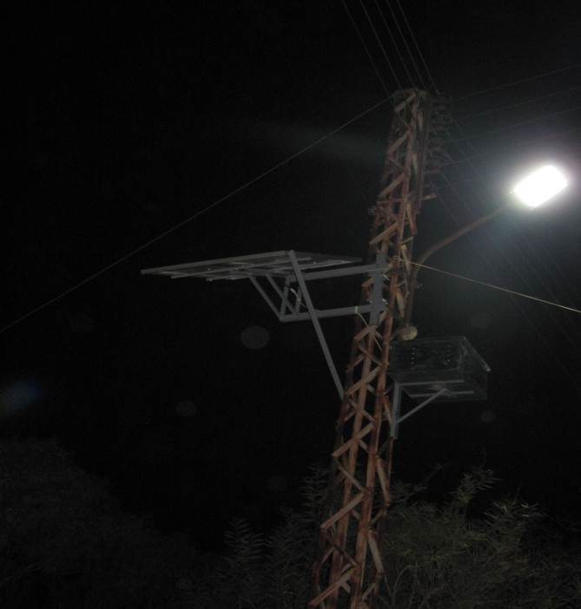

**Sample of Roumin Street Lighting (PV system with LED lighting)**

* Batroun Port; The installation of a 7.5 KWp Photovoltaic system powering the LED lighting in the port was commissioned late 2013. To enhance the beauty of the port, the PV system was centralized in one location. The system comprises 57 PV panels spread over two pergolas. The generated energy is stored in 24 lead-acid batteries. The system powers 62 LED lamps of 30W each installed on poles of 5-meters height, 20 LED lamps of 27W each installed in the canopy of the fishermen working area, in addition to 14 LED floodlights of a 100W each spread over the perimeter of the port.

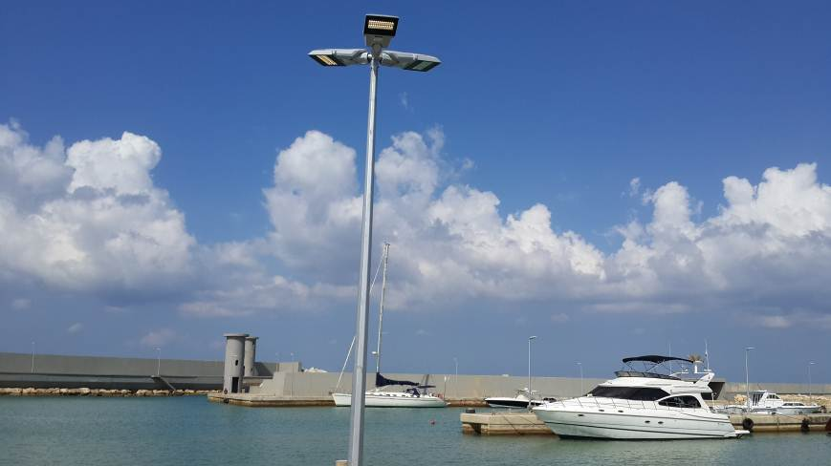

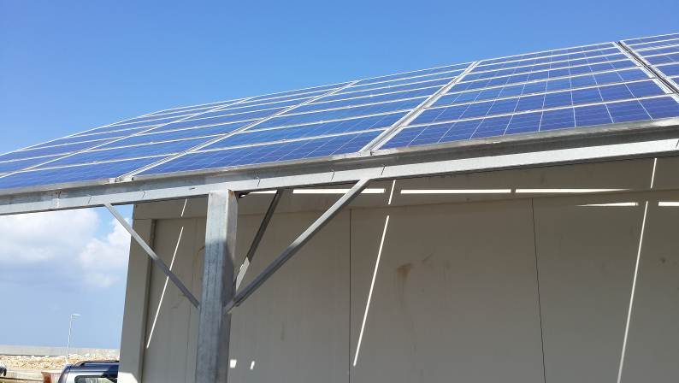

* Central bank green roof application on one of the Central Bank’s main buildings in Hamra was well underway in 2013 and is due to be completed, together with its extended phase 2, in Q1 of 2014. This application will be the first of its kind in Lebanon, and will be monitored for its thermal impacts on the cooling and heating loads of the floor directly beneath the green roof, which is a large auditorium where all banks exchange checks. The Central Bank co-financed this first of its kind project, through a direct fund to CEDRO for the first phase which was completed in December 2013. To enable the connection of the gateway to the roof, phase 2 was added; the Central Bank took the financial and procurement responsibility of all civil works and façade opening related to this phase, whereas CEDRO financed the green roof system application.

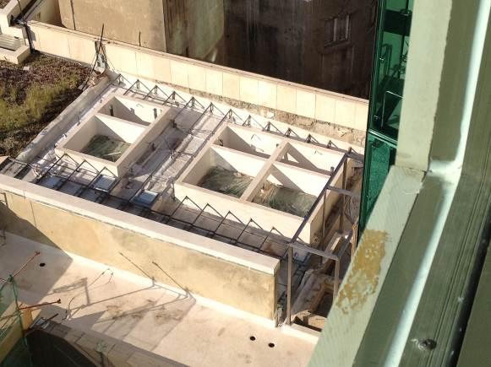

Green Roof – Central Bank

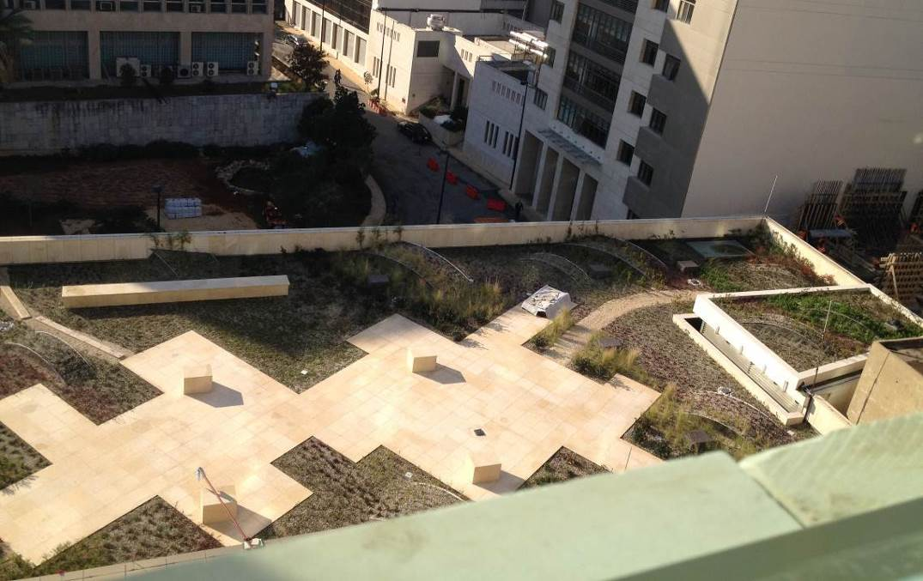

Green Roof – Central Bank

* In partnership with the Italian Cooperation Agency, the CEDRO project delivered a large hot water tanks and heat exchangers for the large solar hot water system in Chahhar public hospital. All other parts and works, including installation, where undertaken by the Italian Cooperation. The system is sized at 4,000 liters and will deliver 60-70% of the hot water needs of the hospital.
* Pico-hydro; The pico-hydro project in Ramlieh in Mount Lebanon has been completed. The project will provide 10 kWp of hydropower from the irrigation channel in Ramliyeh, powering the public school in Ramliyeh and feeding the excess power into the grid through the net metering arrangement. The public school has approximately 120 students, who will all be benefiting from the power that will be generated for lighting, computer use, photocopiers and other electrical requirement the students and staff use.

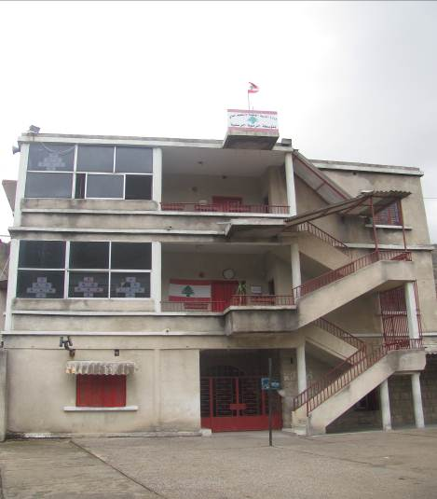

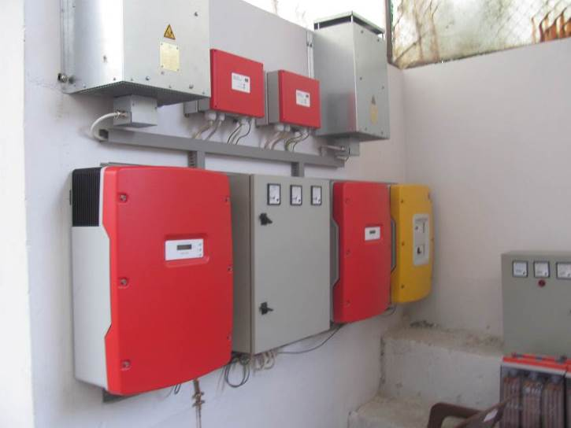 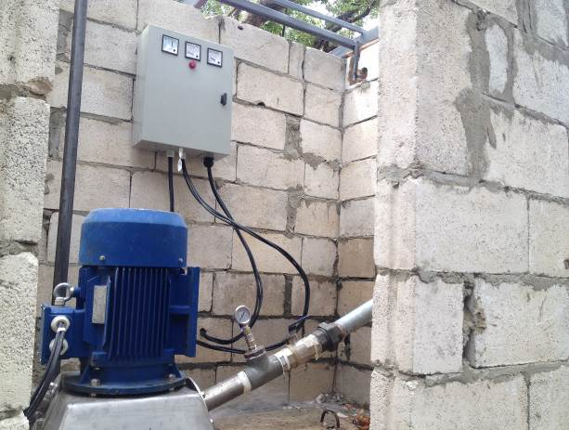

1. **Setting an enabling environment for the conversion of public sector buildings and facilities into energy efficient modalities**

* The CEDRO website ([www.cedro-undp.org](http://www.cedro-undp.org)) is being updated. Future updates and changes are expected.
* CEDRO newsletters Issue 8 and 9 have been prepared and will be sent many stakeholders/contact members in Q1 2014. They address solar hot water solutions for high-rise buildings, concentrated solar power technology and potential for Lebanon, pico-hydro installation, and the Batroun port opening among other stories.
* CEDRO inaugurated the Batroun Port on October 13 2013 with the presence of the Minister of the Energy and Water, the Spanish Ambassador to Lebanon, The head of Batroun Municipality, the Head of the Fisherman Association, and the Assistant Resident Representative of the UNDP.

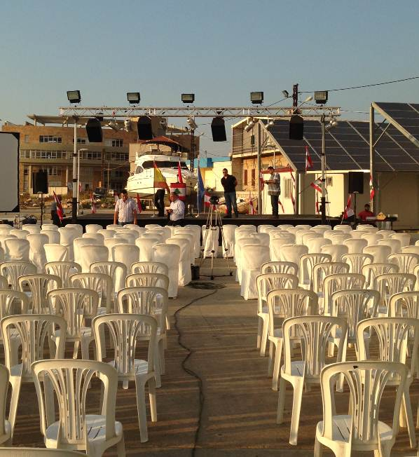

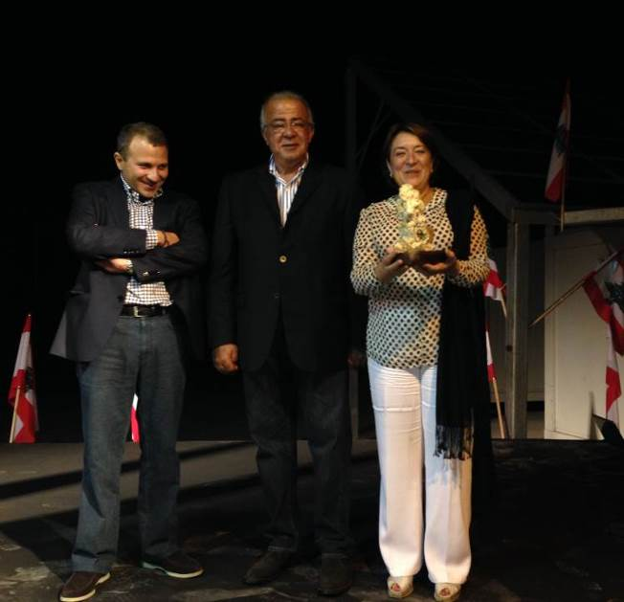 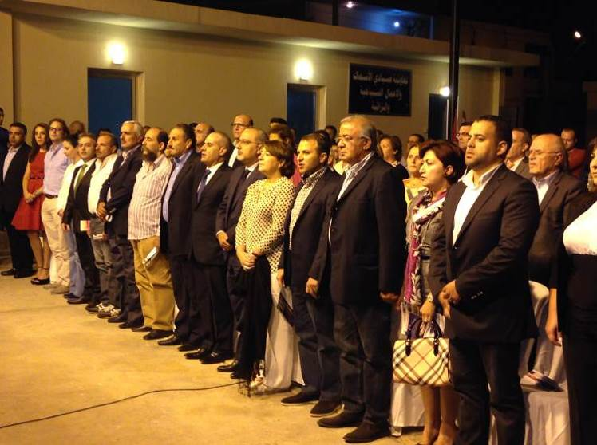

**Batroun Port Inauguration (October 13, 2013)**

* Beirut Energy Forum (BEF) is the largest event in Lebanon related to energy efficiency, renewable energy, and green buildings. The event is distinguished by a 2-day conference sessions with highly selected interventions and presentations from all over the world, including 2 internationally-renowned keynote speakers, as well as a large exhibition area allowing direct interaction among decision makers, commercial companies, and professionals. The BEF 2013 was held on the 26 and 27 September, under the patronage of the Lebanese Minister of Energy and Water H.E. Mr. Gebran Bassil, with the support of the Ministry of Energy and Water, the United Nations Development Programme - Lebanon (UNDP), the League of Arab States (LAS), the European Union (EU) in Lebanon, the Agence Universitaire de la Francophonie, the Central Bank of Lebanon (BDL), the Regional Center for Renewable Energy and Energy Efficiency (RCREEE), and the Order of Engineers and Architects in Beirut (OEA), and in collaboration with ESCWA, the Ashrae Lebanese Chapter, the Lebanese Solar Energy Society (LSES), the Lebanon Green Building Council (LGBC), and the EU-funded projects MED-ENEC and MED-EMIP, with the Lebanese Center for Energy Conservation (LCEC) being the strategic partner of the event. CEDRO participated in Beirut Energy Forum with a stand (photo of the stand shown below) and a presentation that summarized all of CEDRO’s achievements to date.BEF regrouped 730 delegates from 28 countries, and provided a platform for professionals, policymakers, practitioners, donors, academics, and private companies to meet and discuss the latest updates on the Lebanese, Arab, and Euro-Mediterranean initiatives in the renewable energy and energy efficiency sectors.

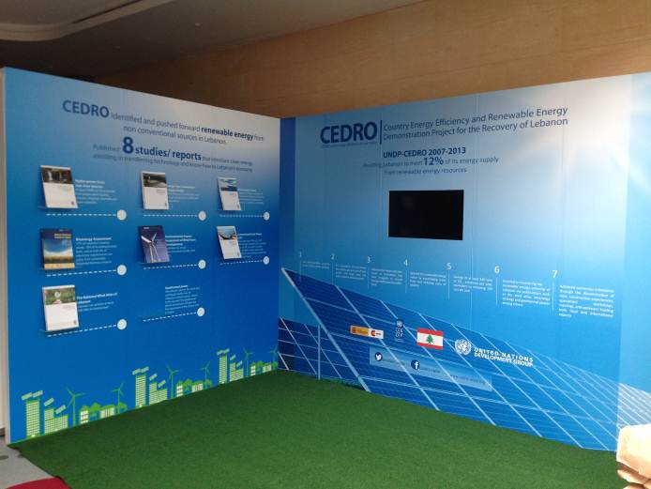

**Beirut Energy Forum, CEDRO Stand (September 24, 2013)**

* CEDRO, in collaboration with the LCEC, published a brochure on PV systems that can be understood by non-engineers and by the Lebanese community at large. 3000 copies where printed and 2700 copies where distributed to selected individuals across the country.

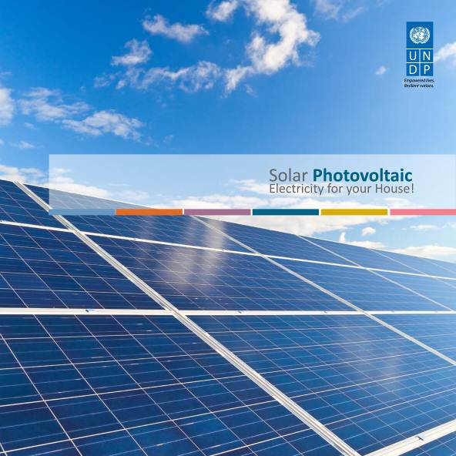

* An artistic video clip has been prepared by CEDRO to summarize all the achievements of the CEDRO project. This video is now online on CEDRO’s website (<http://www.youtube.com/watch?v=nzpNrA6O23w>)!
* CEDRO organized a technical workshop on the 8th of April 2013 on wind energy development and conversation of migratory soaring in coordination with the Ministry of Energy and Water, Ministry of Environment, the Lebanese Center for Energy Conservation, Birdlife International, and the Society for the Protection of Nature in Lebanon (SPNL) with the attendance of 45 people. This workshop focused on soaring birds, where mitigation technologies for wind farms where discussed, particularly radar technology that identifies migratory birds passing over a wind farm and signals wind turbines to shut down.

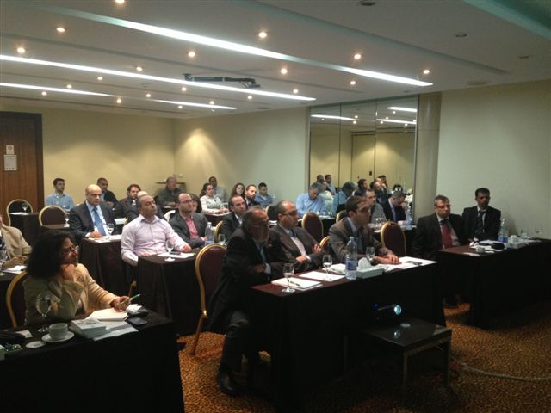

**Workshop on wind energy development and conservation of migratory soaring birds (April 08, 2013)**

* CEDRO and the Minister of Energy and Water inaugurated the study on ‘energy from wastewater treatment plants’ in a conference at the Ministry of Energy and Water on February the 22nd (2013), attended by the Minister himself, the Spanish Ambassador, representatives from the CDR and various stakeholders in the sector.

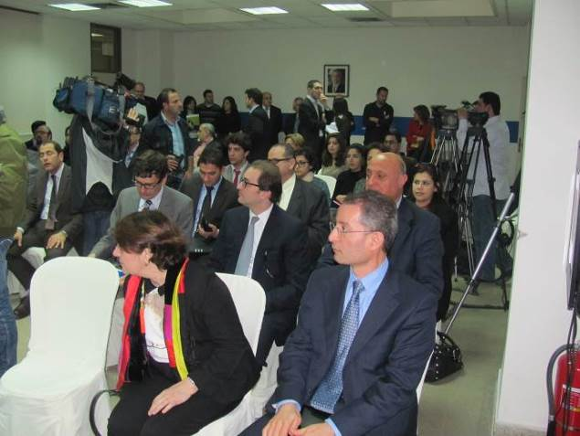 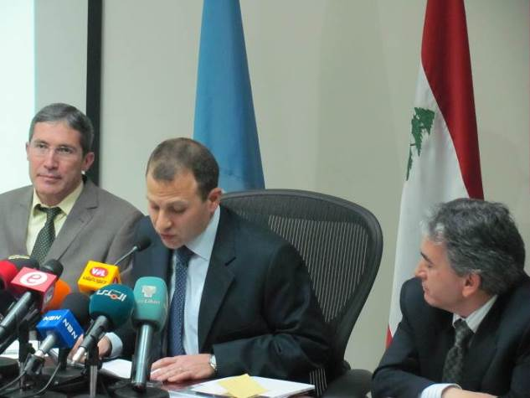

Launching the Energy from Wastewater Treatment Plants report (February 22, 2013)

* 38 participants attended the board meeting that stakeholders was held on the 23rd of July 2013, the meeting was in the presence of Mr. Luca Renda, UNDP Country Director, and the Ministry of Energy & Water Focal Point, Mr. Mahmoud Baroud, as well as the main partners and national stakeholders of CEDRO. The meeting was important to communicate CEDRO’s past, current, and future work, in order to receive feedback and recommendations.



1. **Assisting the establishment of a sustainable Energy Strategy for Lebanon**

* The national geothermal power assessment has been completed. The assessment looks into the potential of deep geothermal power for electricity generation (mainly), and indicates the areas where such potential is most apparent. The study is being designed to be published and will be disseminated in a conference in Q1 of 2014.
* A nation-wide survey to assess the willingness to pay (WTP) for small-scale and utility renewable energy systems in Lebanon for both the residential sector and the commercial sector have been launched by CEDRO. Results are in and CEDRO is in the process of analyzing the data to publish a report. Report cannot be expected before end of Q2 2014.
* A new study for the assessment of the industrial potential, job creation, and local capacity for renewable energy systems in Lebanon has been awarded to a local consultancy and work is ongoing. Results are expected in Q2 of 2014.
* A study for energy from sewage sludge from wastewater treatment plants (WWTP) has been completed and has been published in Q1 of 2013. The study was implemented in cooperation with the Ministry of Energy and Water and the Council for Development and Reconstruction and assessment. This study will push thinking towards synergizing the WWTPs in Lebanon so that they make use of the energy production potential that these plants contain, and even include co-digestion of other wastes to increase or boost energy production.

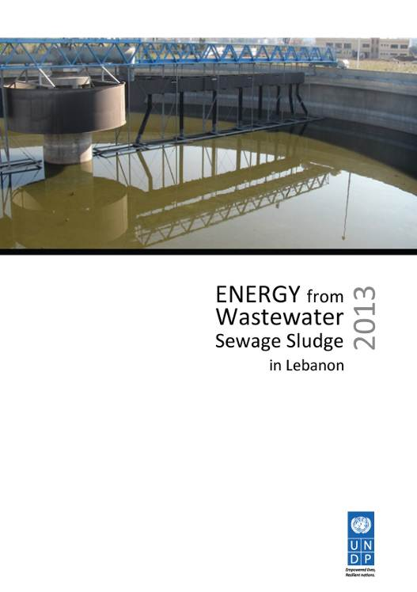

**Energy from Wastewater Sewage Sludge Report**

* Entec, the consultancy responsible for the study to identify the non-river hydropower sources in Lebanon has delivered the final draft at the end of Q4 of 2012. The findings are very encouraging and particularly focused on the main power plants on the shore line of Lebanon, where the cooling system that takes water from the sea and dumps it back, can be used to generate power in the return process. The report has been published in Q1 of 2013.

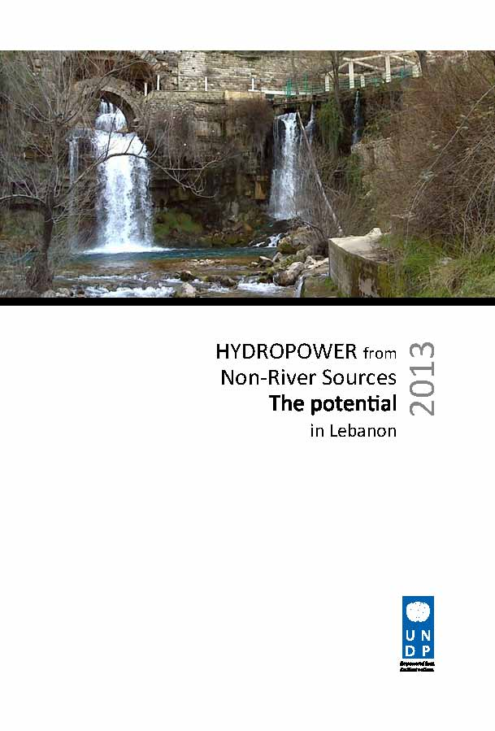

**Hydropower from Non-River Sources Report**

* The PV farm study, undertaken by TTA, has been completed and disseminated in Q3 of 2013. The report outlines photovoltaic farm technology for Lebanon through a technical and economic analysis. A financial model that can be used for pricing PV farms was also included in the results. Results indicate that PV farms are becoming a highly competitive form of power, and should be given more policy focus.

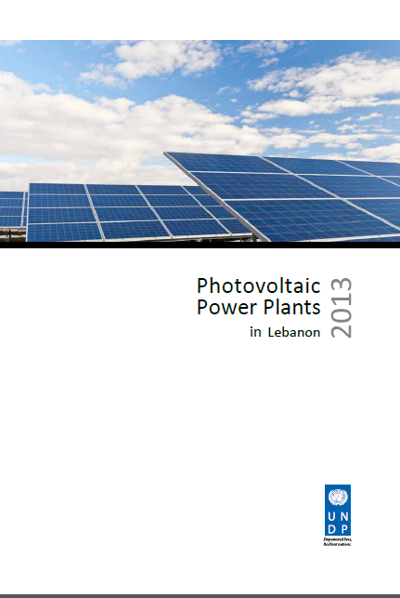

**Photovoltaic Power Plants Report**

* A study to evaluate CEDRO’s greenhouse gas emission impacts has been undertaken, and the report is now published and can be found online; <http://www.cedro-undp.org/documents/mfiles_data/UNDP-Report-CEDRO.pdf>.



* **Delays in implementation, challenges, lessons learned & best practices:**

The major drawback in 2013 was related to the implementation of the Batroun Port project.. The reason for this was due to poor communication between the project partners, mainly in relation to the needs of the Syndicate of Fishermen in the port structure itself. Several poles had to be relocated and a redesign of the port was undertaken.

Furthermore, the location of the PV pergola had to be changed twice due to problems that were not flagged by the beneficiaries to the UNDP project nor to the Ministry of Energy and Water which was coordinating the implementation of this project on the ground.

At the end the project was completed and it was a major success. All parties are currently happy with the new lighting system.

* **Qualitative assessment**

In the last annual report’s qualitative assessment (2012), it was indicated that CEDRO’s achievements and those achievements are relisted in the left column of the below table. The right column indicates the progress in 2013 along similar categories.

|  |  |
| --- | --- |
| **2012 achievements** | **2013 progress** |
| Created the necessary architecture for small-scale RE systems in the country before which most contractors did not know how best to design their systems in a country that is like no other in terms of electricity supply (i.e., characterized by power cuts and brown outs when electricity received is much lower in voltage than what it should be). | Particular focus on centralized solar powered street lighting, through the Batroun Port, has shown an innovative way of street lighting in the country |
| Demonstrated, first-hand, the applications of small-scale renewable energy on the ground | In 2013, the first pico-hydro system has been installed in Ramliyeh. This is a showcase that will be marketed in 2014. |
| Created strong partnerships with the Ministry of Energy and Water, the Lebanese Centre for Energy Conservation, and Electricity of Lebanon (EDL). This partnership has enabled policy-level work to happen, such as the net metering concept that was introduced by CEDRO to the LCEC and the Ministry, and they in turn, together with CEDRO, lobbied EDL for its implementation. | CEDRO is still working closely with the Ministry of Energy and Water, and focus in 2013 and 2014 will be to publish the renewable energy strategy of the country (1), and to strive to obtain a NAMA (nationally appropriate mitigation action), in coordination with the Ministry of Environment’s Climate Change Unit, to assess the electricity grid conditions and its ability to receive variable renewable energy sources. |
| Shed light on the renewable energy potential in Lebanon, showing that Lebanon, although a small country, has significant renewable energy resources that is should harness to lower its dependence on imported fuel. | Several new studies have been published in 2013, like the energy from wastewater, hydropower from non-river sources, and PV farms. A geothermal power assessment has been completed also in 2013 and yet will be published in Q1 of 2014. |
| Spread awareness on renewable energy nationally, and in specific on the younger generation through interactive workshops and plays. | A PV brochure has been published and given out to 2700 people |

**ii) Indicator Based Performance Assessment:**

Using the **Programme Results Framework from the Project Document** **/ AWP** - provide an update on the achievement of indicators at both the output and outcome level in the table below. Where it has not been possible to collect data on indicators, clear explanation should be given explaining why, as well as plans on how and when this data will be collected.

|  |  |  |  |
| --- | --- | --- | --- |
|  | **Achieved Indicator Targets** | **Reasons for Variance with Planned Target (if any)** | **Source of Verification** |
| **Outcome 1[8]:** Enable activation of energy efficiency and renewable energy applications in Lebanon  **Indicator:** (1) Availability of end-use EE/RE demonstration projects; (2) Availability of relevant technical tools for the spread of EE/RE applications; and (3) Availability of national EE/RE strategy and action plan.  **Baseline**: Limited application of EE/RE technologies in Lebanon  **Planned Target:** | Targets (2009)  - Terms of Reference: RE potential  Targets (2010)  - 30 pilot projects  - Draft data base  - Study: RE potential  Targets (2011)  - 30 pilot projects  - Complete data base  - Study: EE potential  Targets (2012)  - 30 pilot projects EE/RE  - EE/RE policies  Targets (2013)  - 4 sites |  |  |
| **Output 1.1** Implementation of end-use EE/RE pilot projects  **Indicator 1.1.1**  Number of beneficiary buildings and facilities  **Baseline:**  **Planned Target:**  - Identification of beneficiary sites  - Development of tender documents  - Procurement of goods / services  - Site Supervision and hand-over  - Monitoring of system performance  **Indicator 1.1.2**  **Baseline:**  **Planned Target:** | 2013 implementation  - 1 Green Roof  - 1 Pico-hydro site  - 2 street lighting  - 1 large SHW site |  | - Survey of beneficiary sites utilising installed equipment;  - Energy bills and energy measuring equipment used to collect data. |
| **Output 1.2** Outreach and technology transfer to enable the conversion of other public sector buildings and facilities into energy efficient modalities  **Indicator 1.2.1:** Number of participating beneficiaries and stakeholders  **Baseline:**  **Planned Target:**  - Establishment of energy saving data base for public sector facilities  - Development & Implementation of capacity building & awareness programs  - Development of relevant EE/RE policies and procedures  - Validation of project results | - Development and implementation of technical workshops and awareness tools  - Development of GIS energy data base and EE/RE procurement specs  - Validation of project results and development of replication schemes |  |  |
| **Output 1.3** Research and development to enable the formulation of a national sustainable energy strategy and action plan  **Indicator 1.3.1**  **Baseline:**  **Planned Target:**  - Assessment of national RE potential  - Assessment of national EE potential  - Identification of viable EE/RE actions  - Identification of Implementation tools and funding mechanisms | - Assessment of national renewable energy resources (Bioenergy finalized, Geothermal energy power finalized, PV Farm study published, Energy from wastewater treatment plant published, Hydro-power from non-river sources study published)  - Renewable energy strategy in cooperation with LCEC  - Development of national EE/RE strategy & action plan |  |  |

**iii) A Specific Story (Optional)**

* This could be a success or human story. It does not have to be a success story – often the most interesting and useful lessons learned are from experiences that have not worked. The point is to highlight a concrete example with a story that has been important to your Programme in the reporting period.
* In ¼ to ½ a page, provide details on a specific achievement or lesson learned of the Programme. Attachment of supporting documents, including photos with captions, news items etc, is strongly encouraged. The MPTF Office will select stories and photos to feature in the Consolidated Annual Report, the GATEWAY and the MPTF Office Newsletter.

|  |
| --- |
| **Problem / Challenge faced:** Describe the specific problem or challenge faced by the subject of your story (this could be a problem experienced by an individual, community or government).  **Programme Interventions:** How was the problem or challenged addressed through the Programme interventions?  **Result (if applicable):** Describe the observable ***change*** that occurred so far as a result of the Programme interventions. For example, how did community lives change or how was the government better able to deal with the initial problem?  **Lessons Learned:** What did you (and/or other partners) learn from this situation that has helped inform and/or improve Programme (or other) interventions? |

**III. Other Assessments or Evaluations (if applicable)**

CEDRO Phase II has been evaluated. The final evaluation report shall be submitted with this Annual report.

**IV. Programmatic Revisions (if applicable)**

*Indicate any major adjustments in strategies, targets or key outcomes and outputs that took place.*

**V. Resources (Optional)**

Human Resources:

* 1. National Project Staff:
* Project Manager
* Project Assistant
* Site Engineers (x3)
* Researcher
* Graphic designer
* Marketing expert
* GIS specialist
* Driver/clerk

International Staff: Trama TechnoAmbiental (TTA - Spain); Technical Backstopping Agency for CEDRO, up to December 2012.

**Expenditures to date (as of December 2013):**

|  |  |  |
| --- | --- | --- |
|  | **CEDRO3** | |
| **CATEGORY** | **Total Budget**  **(USD)** | **Total Exp. to date (USD)** |
| **1. Personnel\*** (Incl. staff and consultants) | 252,000 | 704,511.95 |
| **2. Contracts**  (Incl. companies, professional services) | 599,050 | 1,274,442.82 |
| **3. Training** (incl. AV printing / production) | 41,000 | 33,644.37 |
| **4. Transport** (local) | 11,000 | 45,820.28 |
| **5. Supplies and commodities\*\***  (Incl. IT equip and rental & maintenance) | 55,000 | 79,669.03 |
| **6. Equipment (including installation)** | 2,505,000 | 737,549.42 |
| **7. Travel** | 15,000 | 63,731.18 |
| **8. Miscellaneous** | 31,539 | 100,804.14 |
| **9. Agency Management Support (7%)** | 263,238 | 226,111.33 |
| **TOTAL** | **3,772,827.00** | **3,266,284.52** |

**Abbreviations and acronyms:**

* BDL Banque du Liban
* CDR Council for Development and Reconstruction
* CEDRO Community energy efficiency and renewable energy demonstration project for the recovery of Lebanon
* CO Country Office
* DEX Direct Execution
* EDL Electricite du Liban
* EE Energy Efficiency
* GIS Geographic Information System
* GoL Government of Lebanon
* LCEC Lebanese Center for Energy Conservation
* LED Light Emitting Diodes
* LRF Lebanon Recovery Fund
* MEW Ministry of Energy and Water
* PMU Project Management Unit
* PV Photovoltaic
* RE Renewable Energy
* SHW Solar Hot Water
* TTA Trama TechnoAmbiental
* UNDP United Nations Development Programme
* UNIFIL United Nations Interim Force in Lebanon
* UNV United Nations Volunteers
* WWTP Waste Water Treatment Plants

**Annex 1. Presentation on CEDRO’s achievements given in BEF 2013**

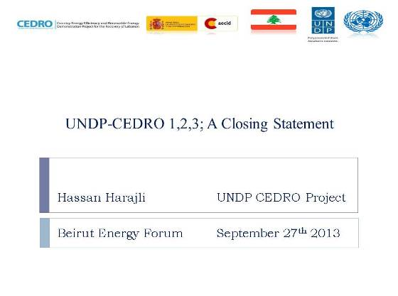 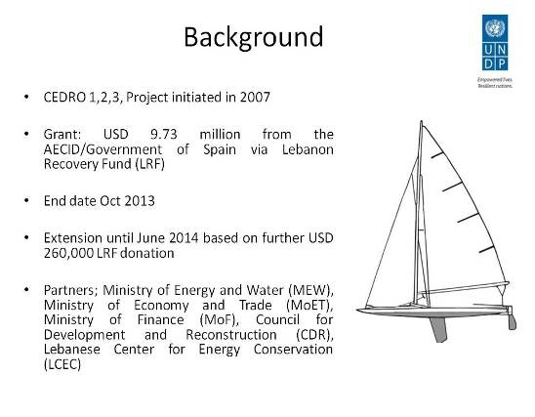

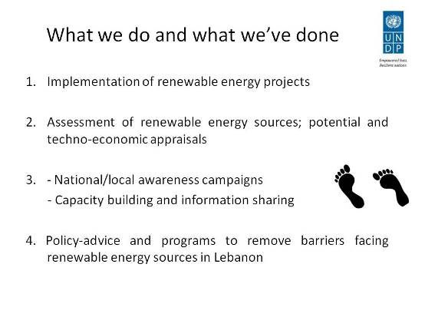 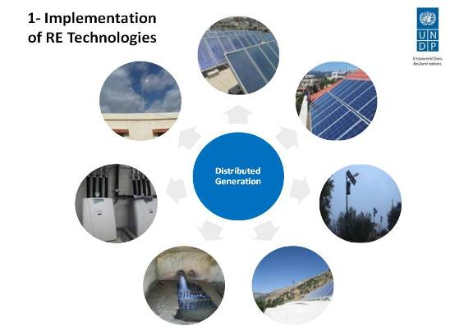

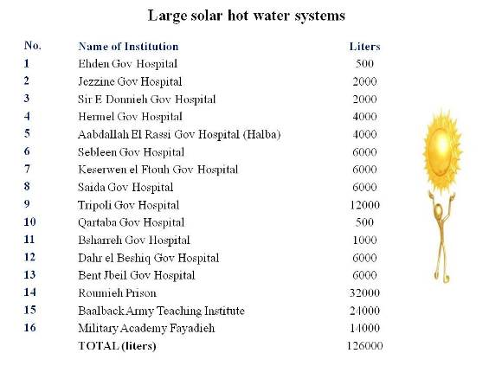 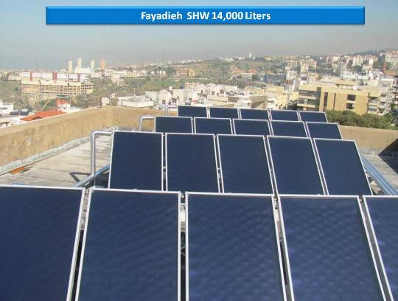

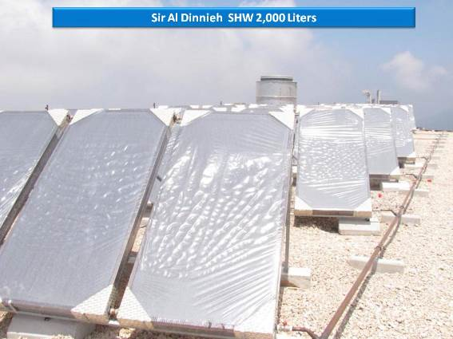 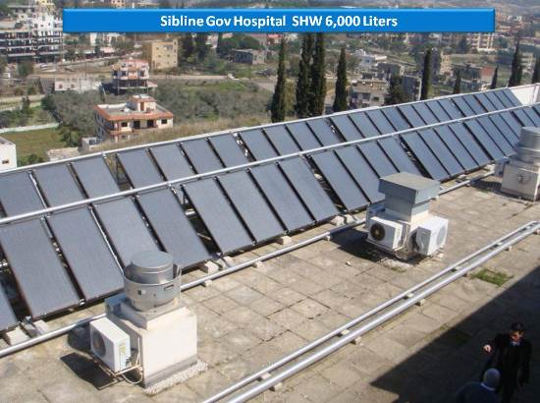

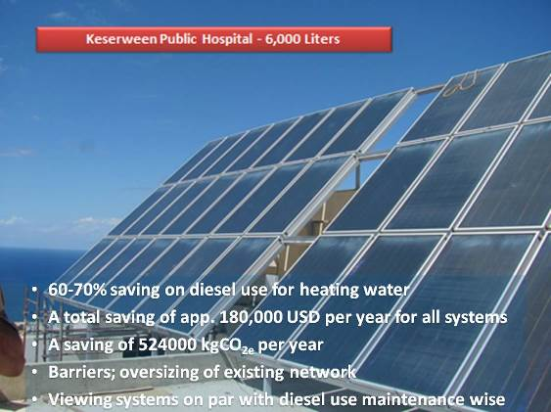 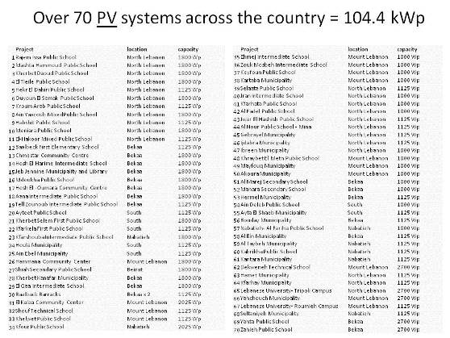

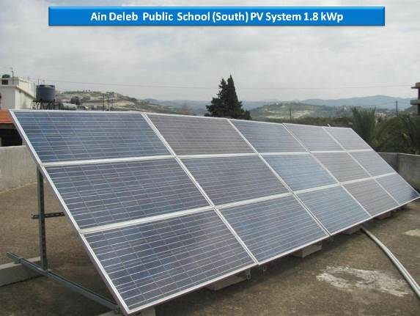 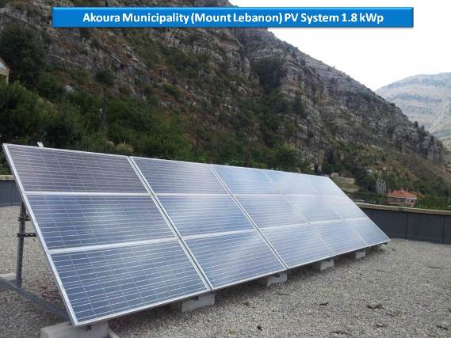

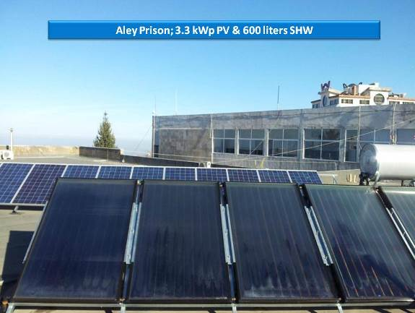 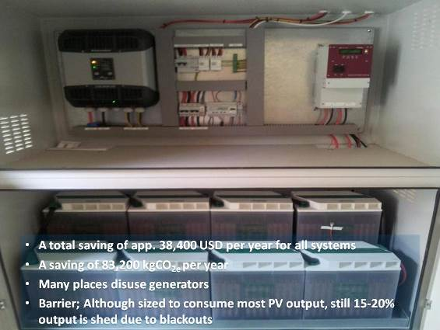

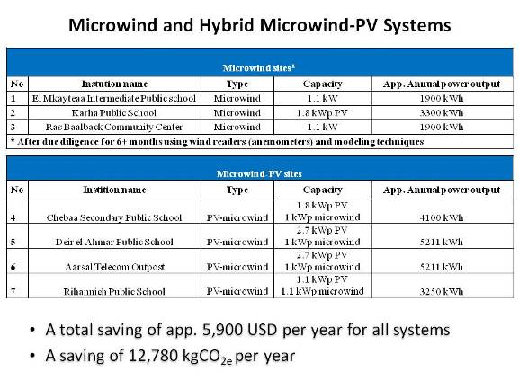 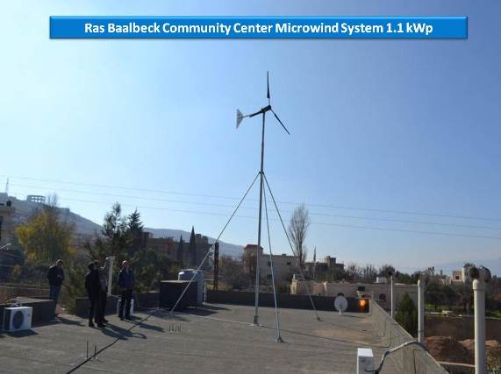

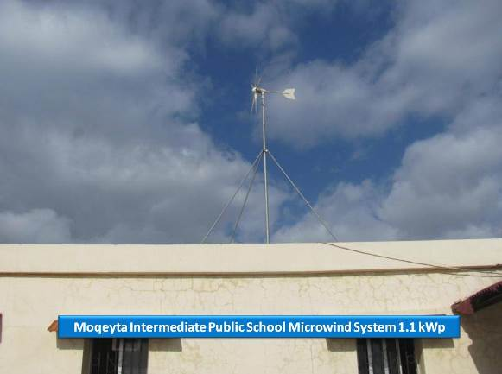 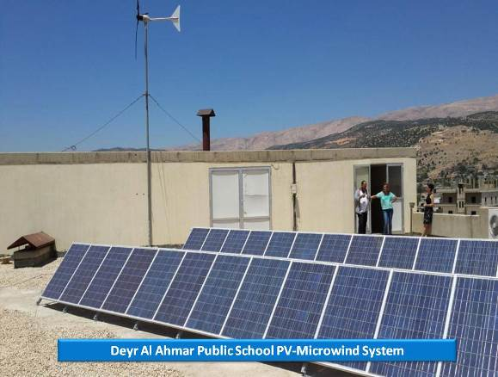

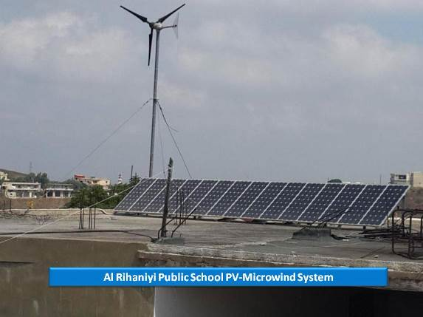 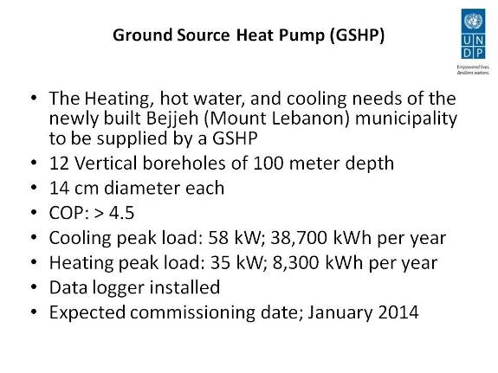

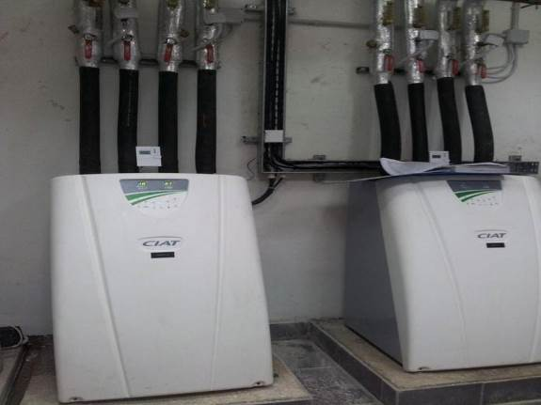 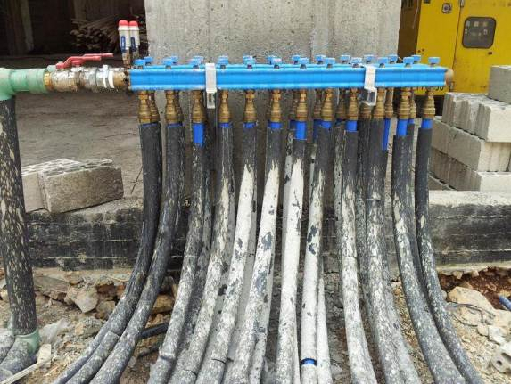

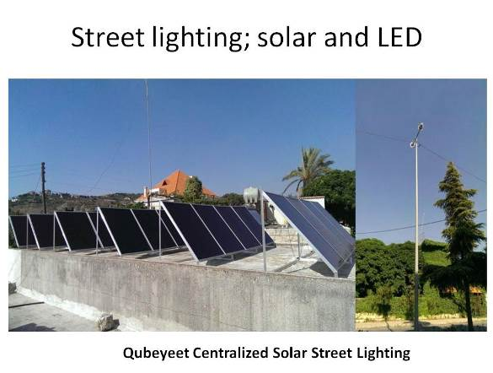 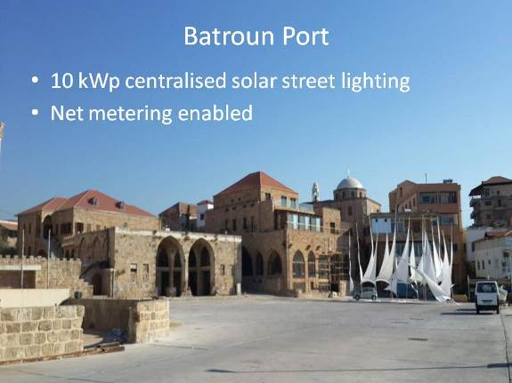

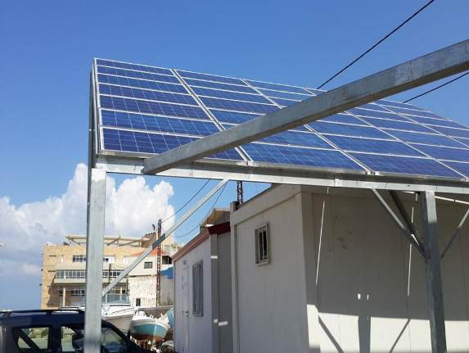 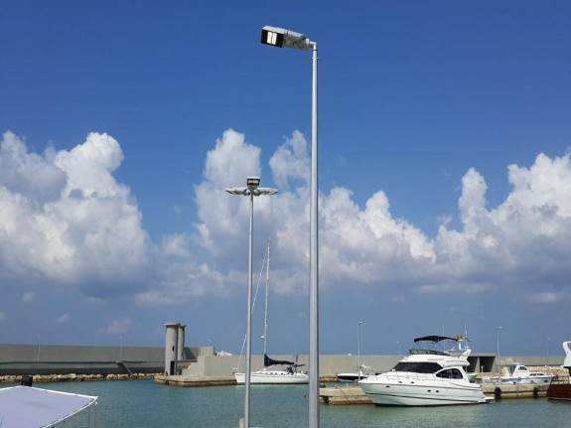

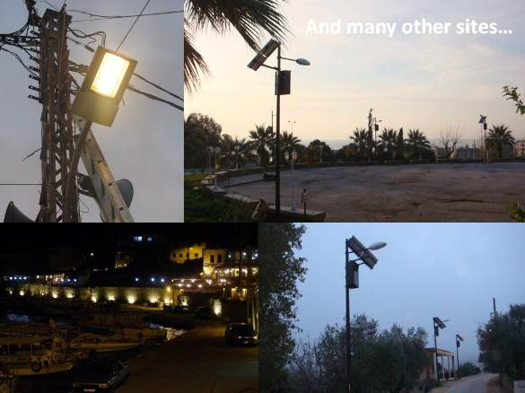 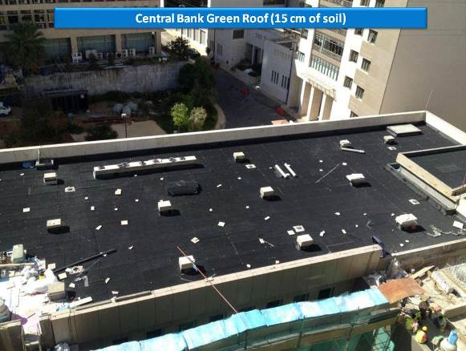

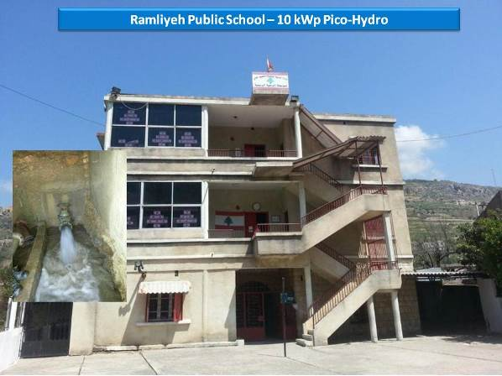 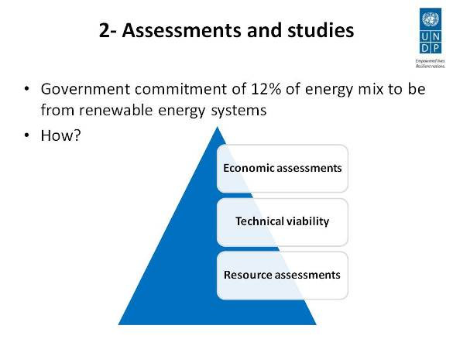

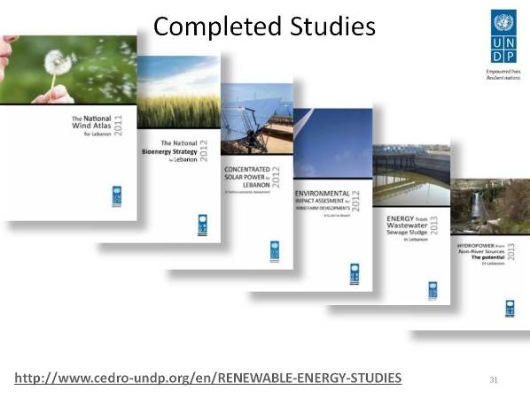 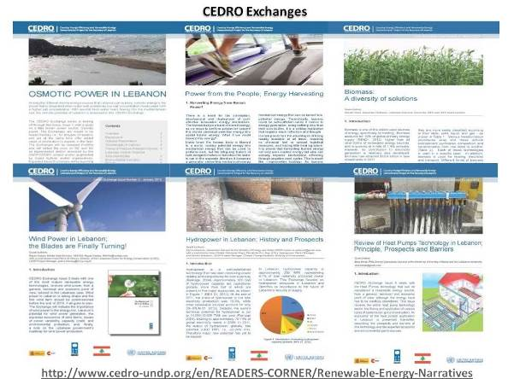

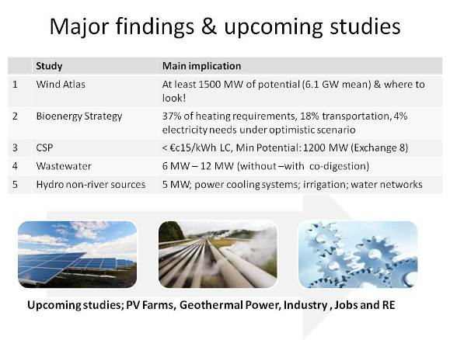 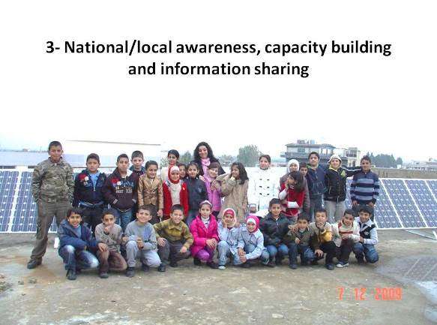

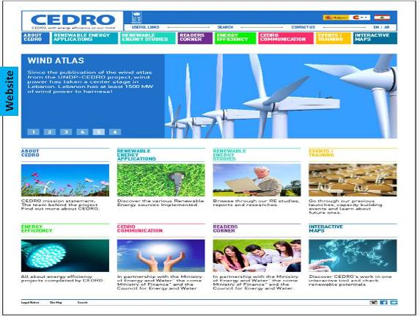 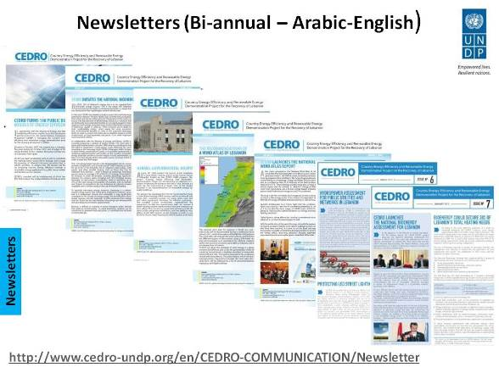

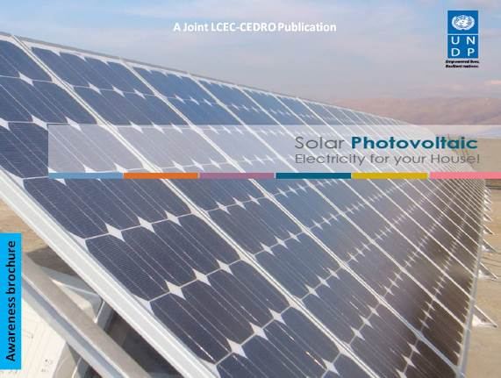 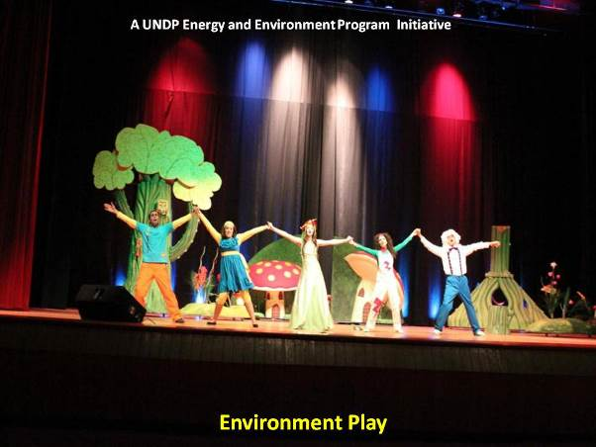

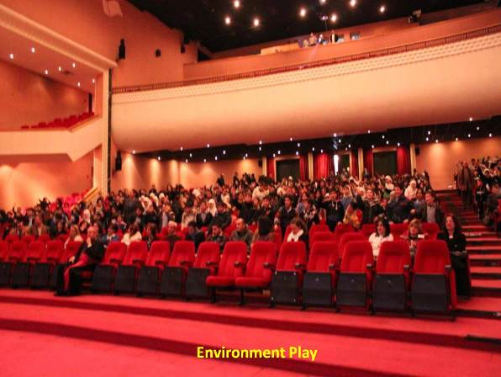 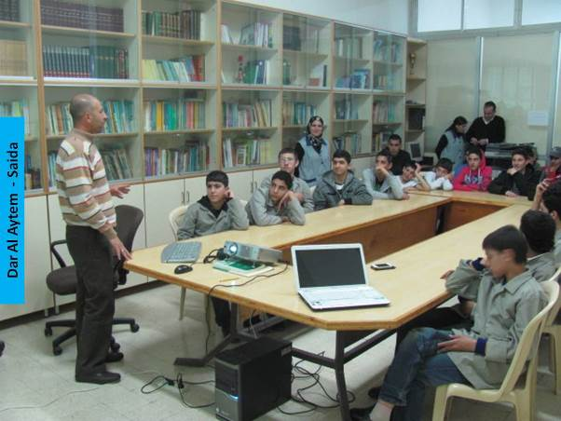

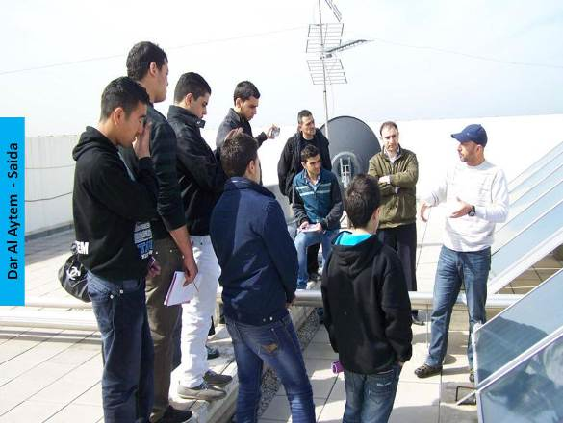 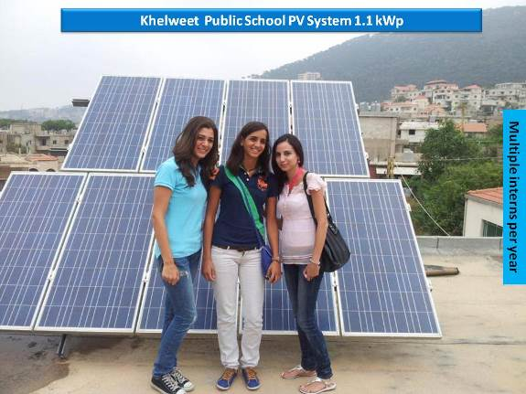

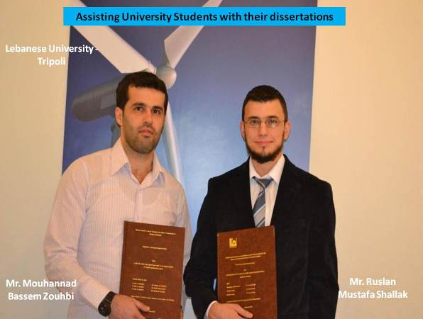 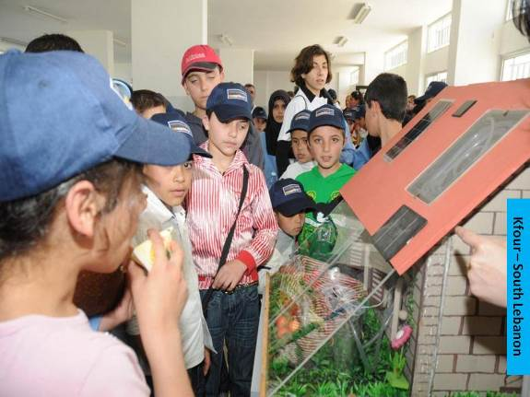

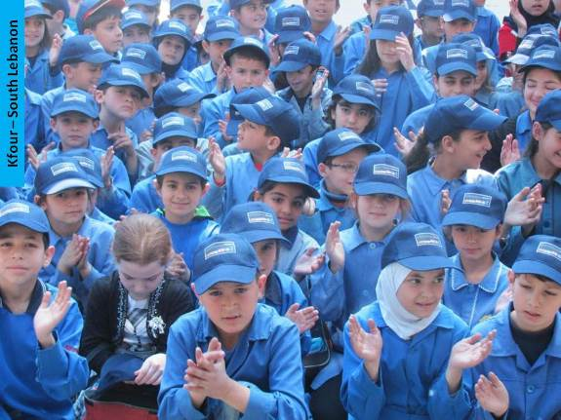 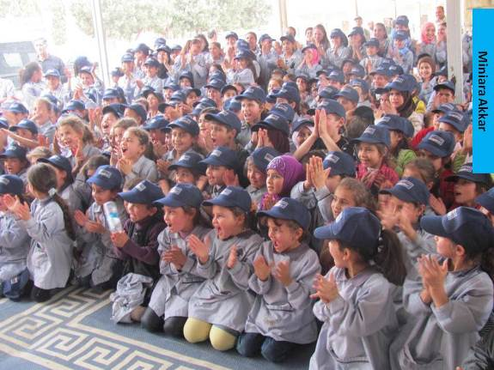

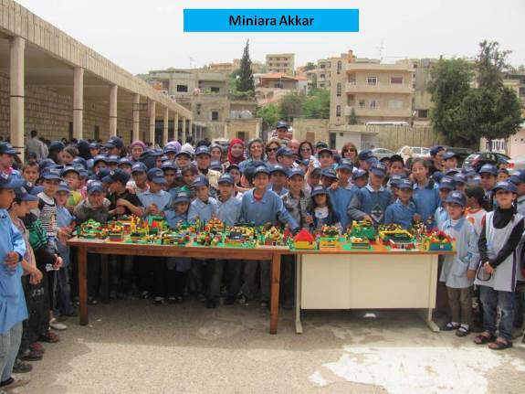 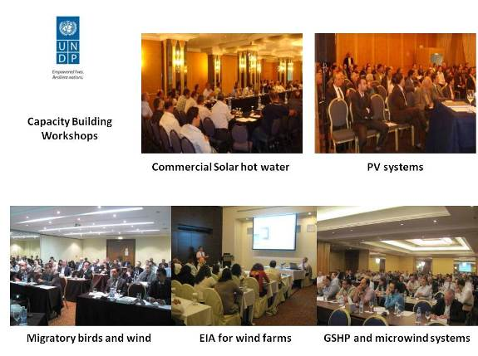

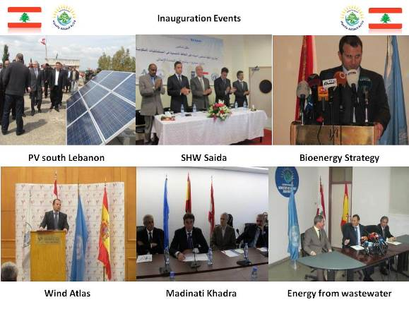 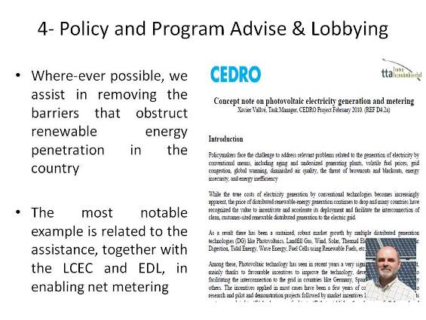

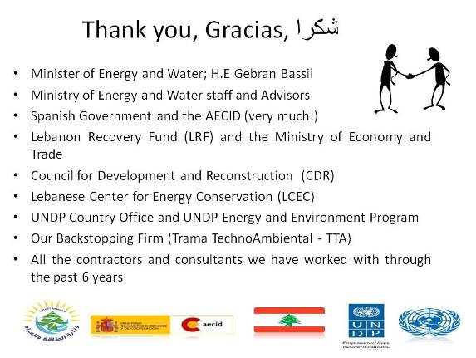 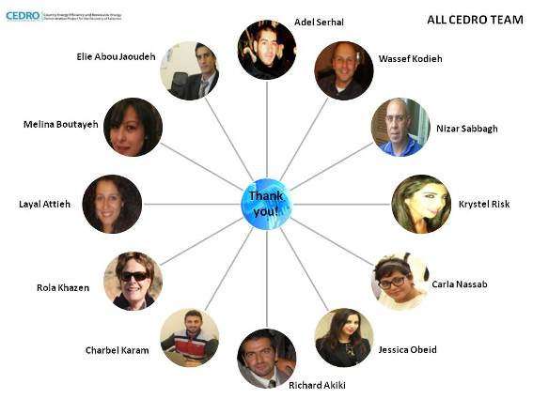

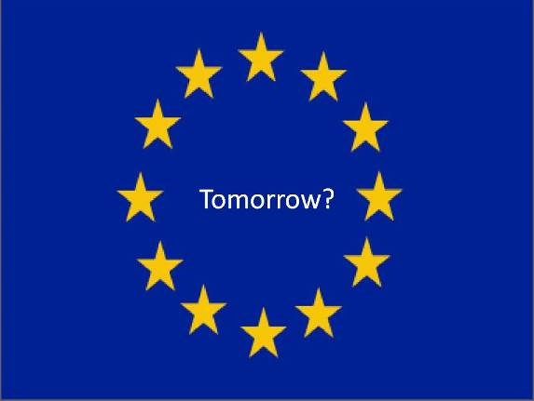 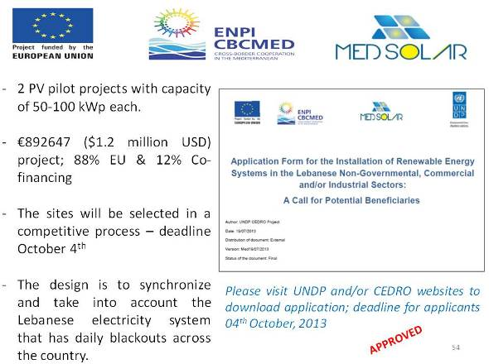

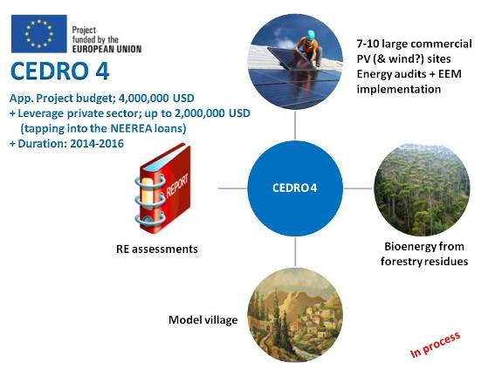 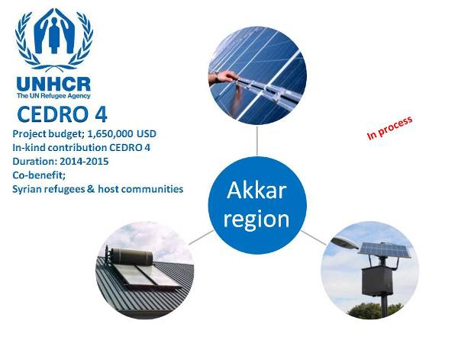

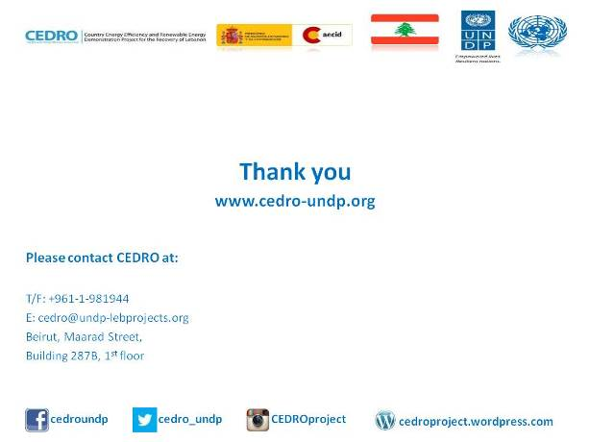

1. The term “programme” is used for programmes, joint programmes and projects.
2. Strategic Results, as formulated in the Strategic UN Planning Framework (e.g. UNDAF) or project document;
3. The MPTF Office Project Reference Number is the same number as the one on the Notification message. It is also referred to as “Project ID” on the project’s factsheet page the [MPTF Office GATEWAY](http://mdtf.undp.org)
4. The MPTF or JP Contribution, refers to the amount transferred to the Participating UN Organizations, which is available on the [MPTF Office GATEWAY](http://mdtf.undp.org)
5. The start date is the date of the first transfer of the funds from the MPTF Office as Administrative Agent. Transfer date is available on the [MPTF Office GATEWAY](http://mdtf.undp.org/)
6. As per approval of the original project document by the relevant decision-making body/Steering Committee.
7. If there has been an extension, then the revised, approved end date should be reflected here. If there has been no extension approved, then the current end date is the same as the original end date. The end date is the same as the operational closure date which is when all activities for which a Participating Organization is responsible under an approved MPTF / JP have been completed. As per the MOU, agencies are to notify the MPTF Office when a programme completes its operational activities.
8. Note: Outcomes, outputs, indicators and targets should be **as outlined in the Project Document** so that you report on your **actual achievements against planned targets**. Add rows as required for Outcome 2, 3 etc.