PROGRESS REPORT

Reporting UN Organization | : | United Nations Development Programme (UNDP)
Country | : | Lebanon
Award ID | : | 00047251
Award Title | : | CEDRO III – “Country energy efficiency and renewable energy demonstration project for the recovery of Lebanon”
Award Timeframe | : | Oct 2009 – June 2014
Award Components | : | CEDRO 3 – 00071261
Reporting Period | : | 01st July 2013 – 30th September 2013

List of Acronyms

BDL Banque du Liban
CDR Council for Development and Reconstruction
CO Country Office
GDP Gross Domestic Product
EDL Electricty of Lebanon
EE Energy Efficiency
GSHP Ground Source Heat Pump
ITB Invitation to Bid
LCEC Lebanese Centre for Energy Conservation
LED Light Emitting Diodes
LRF Lebanon Recovery Fund
MoET Ministry of Economy and Trade
MoEW Ministry of Energy and Water
MoF Ministry of Finance
MoU Memorandum of Understanding
PV Photovoltaic
RE Renewable energy
SHW Solar hot water
SPNL Society for the Protection of Nature in Lebanon
UNDP United Nations Development Programme
WWTP Waste Water Treatment Plants

I. PURPOSE

Project Summary:

The aim of the CEDRO project is to support Lebanon’s recovery, reconstruction and reform activities and to complement the national power sector reform strategy through the implementation of end-use energy efficiency and renewable energy projects and through the removal of barriers for the promotion of sustainable energy applications in Lebanon. To achieve this, the project will work on three levels: the first involves the establishment of a demonstrative model addressing public sector building and facilities, the second involves the activation of the replication process, and the third involves the triggering of a national sustainable energy strategy and action plan. The CEDRO project is financed through the Lebanon Recovery Fund, and is in-line with Lebanon’s ongoing efforts to improve national patterns of energy consumption and cost.

Project Phases and Outputs:

CEDRO 3  3,772,827 USD | - Implementation of end-use energy efficiency and renewable energy applications for public sector buildings and facilities (app. 60 sites across Lebanon)  - Technology transfer to enable the conversion of other public sector buildings and facilities into energy efficient modalities  - Research and development to enable the formulation of a national sustainable energy strategy and action plan
Project Linkages to National Priorities and Reconstruction Goals:

Lebanon imports around 97% of its energy needs in the form of fossil fuel. In 2004, the national energy bill amounted to around 1.6 billion USD (around 20% of the annual public expenditure and around 7.8% of the national GDP), and in 2005 it reached 2.1 billion USD (around 26% of the annual public expenditure and around 10% of the national GDP).

The government of Lebanon has placed the reform of the power sector among its highest national priorities, as outlined in the recovery, reconstruction and reform paper submitted to the Paris 3 conference after the 2006 conflict. However, given the enormity of the challenges faced by the power sector, the power sector reform strategy has concentrated on addressing the energy supply side, without extending the scope to the demand side of energy management.

Knowing that reform on the supply side needs to be accompanied by reform on the demand side, the proposed CEDRO program has sought to complement the national power sector reform strategy by targeting end-use energy conservation and renewable energy demonstrations which will assist in the above categories of demand-supply imbalance, security of supply, diversification of energy sources, economic cost and the environment.

Moreover, the current Lebanese government has set itself a goal of achieving 12% of its total energy needs from renewable energy sources. CEDRO is seeking to assist in achieving this goal through its demonstration projects of various zero carbon to low carbon technologies and its analysis of renewable energy resources.

This project is an initiative by the Government of Spain to assist the Government of Lebanon in its recovery and reconstruction efforts with a clear focus on promoting sustainable energy services and concentrating on public sector buildings and facilities.

This project is in inline with Lebanon’s recovery, reconstruction and reform objectives, and falls within the Ministry of Energy and Water’s main priority to meet national demand for electricity.

Project Implementation Partners:

The CEDRO partners and their respective roles are indicated to in the Table below:

Institution | Role
Spanish Agency for International Cooperation | Funded the CEDRO project through the LRF. The agency simply observes the work of the CEDRO project and sends representations to any event or occasion that CEDRO launches.
Ministry of Energy and Water (MoEW)  and Lebanese Center for Energy Conservation Project (LCEC) | CEDRO’s works closely with the Ministry and the LCEC as they are the main players in the energy sector. CEDRO’s work augments that of the Ministry and the LCEC, particularly in terms of knowledge-sharing through research activities for the energy sector.
Ministry of Finance | Part of the established Steering Committee for CEDRO.
Ministry of Economy and Trade | Part of the established Steering Committee for CEDRO.
Council for Development and Reconstruction | Part of the established Steering Committee for CEDRO, and monitors the works and finances of CEDRO.

International Partners: - Spanish Agency for International Cooperation
National Partners: - Ministry of Energy and Water (MoEW)
and Lebanese Center for Energy Conservation Project (LCEC)
- Ministry of Finance
- Ministry of Economy and Trade
- Council for Development and Reconstruction

- Project Management

- Preparation of regular progress reports and financial management of expenditures;
- Organization of stakeholder meetings (regular meetings with the Ministry of Energy and Water (MoEW) and with EDL) – leading to and following up on several projects to be implemented on pico-hydro, energy from wastewater treatment plants, Batroun centralized PV lighting port, among others;
- Daily follow-up with site engineers and project staff;
- Providing technical and policy advice to decision-makers (MoEW) and UNDP CO on renewable energy issues;
- The CEDRO project is providing the MoEW and the LCEC in writing up and publishing the National Renewable Energy Strategy from 2014-2020 and beyond. This study will include the techno-economic assessment of renewable energy sources in Lebanon and will also look at the supporting environment needed to support Lebanon in meeting the renewable energy target of 12% by 2020;
- Assess future requirements for renewable market enhancement in Lebanon.

- Implementation of end-use energy efficiency and renewable energy demonstration projects for public sector buildings and facilities

Several ongoing projects are listed below:

- The Batroun Port Renewable Energy Street Lighting contract is now completed. Some modification to the original design followed taking into account fishermen’s feedback. The port is used by all the Batroun Fishermen, people from the area for recreational, and tourists. Expected opening event of the port is in mid-October 2013. The port project is a 7.5KWp PV installation with nearly 100 LED lights placed on different sized poles (5 meters and 23 meters). Some of the floodlights of 100W each replaced 1000W incandescent lamps or 250-400W Mercury projectors.
- The pico-hydro project in Ramliyeh in Mount Lebanon is being implemented. All shop drawing and technical specification of the turbine and civil works have been approved. Expected completion is at the end of October. The Ramliyeh site will cater for the Ramliyeh Public school and for the street lighting in the village at night.
- Implementation of street lighting in Roumin, South Lebanon, has been awarded to a contractor. Works should be completed in Q4 2013. The Roumin street lights will benefit all the villagers of Roumin (estimated at around 1,400 residents).
- Green Roof at the Central Bank: work is on-going in a timely manner. A variation order on the project worth 40,000 USD had to be undertaken to expand the area of the green roof to cover the entrance and walkway to the roof. All the insulation and water proofing has been done, and the soil has been placed at the roof (see picture below).
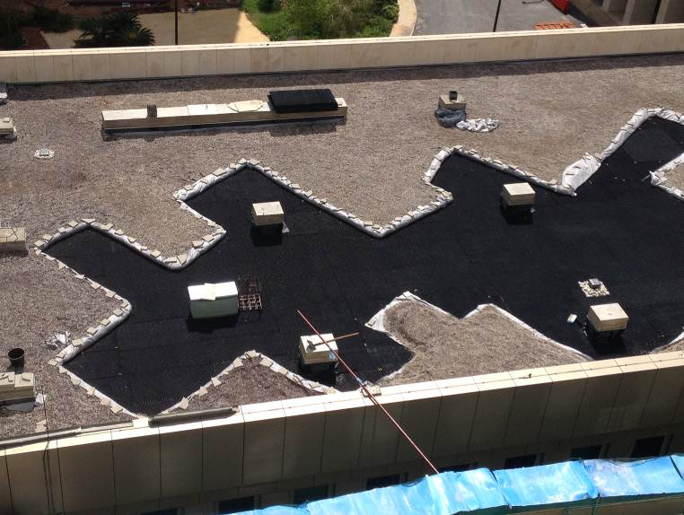

- The implementation of the hybrid PV-microwind (i.e., a system that integrated small wind power and photovoltaic power) contract for four sites. These systems would provide the below mentioned insitutions with power for lighting and running some basic equipment (computer and photocopiers). The Telecom Outpost will be provided with back-up power during electricity outages. The four sites are indicate in the table below;

Institution Name
Rihannieh Public School
Chebaa Secondary Public School
Deir el Ahmar Public School
Aarsal Telecom Outpost

The expected timeframes of the above project is shown in the Table below:

ID | Type | ITB/RFQ delivered to bidders | Project commences | Project completion
1 | Hybrid PV/U-wind | July 2012 | Aug 2012 | Completed, awaiting validation
2 | Green Roof | July 2012 | Jan 2013 | November 2013
3 | Batroun Port | July 2012 | Feb 2013 | Completed
4 | Ramliyeh Pico Hydro | July 2012 | Feb 2013 | November 2013
5 | Roumin Street Lighting | July 2013 | Sep 2013 | January 2014

- Setting an enabling environment for the conversion of public sector buildings and facilities into energy efficient modalities

- The CEDRO website (www.cedro-undp.org) is being updated. Future updates and changes are expected
- CEDRO Exchange Issue 7 and 8 have been prepared and will be sent many stakeholders/contact members in Q4 2013. They address solar hot water solutions for high-rise buildings and concentrated solar power technology and potential for Lebanon.
- Newsletter 7 has been prepared and is in the process of being published and will be distributed in Q4 2013. This may be the last printed version of a newsletter from CEDRO, both due to budget constraints and due to a possible change in communication form to internet based newsletter communication.
- CEDRO participated in Beirut Energy Forum with a stand and a presentation that summarized all of CEDRO’s achievements to date. This event cumulated as CEDRO’s final event, showcasing all of CEDRO’s work from the implementation of renewable energy projects on the ground, to assessments of RE potential in the country, and various other activities such as capacity building and awareness campaigns undergone throughout the past 6 years. Picture of the booth is shown below. Both the booth and the presentation received wide acclaim. Almost all the national stakeholder in the energy sector attended BEF, as well as the Minister of Energy and Water, and the general public. Hundreds of CEDRO publications were distributed in the event.

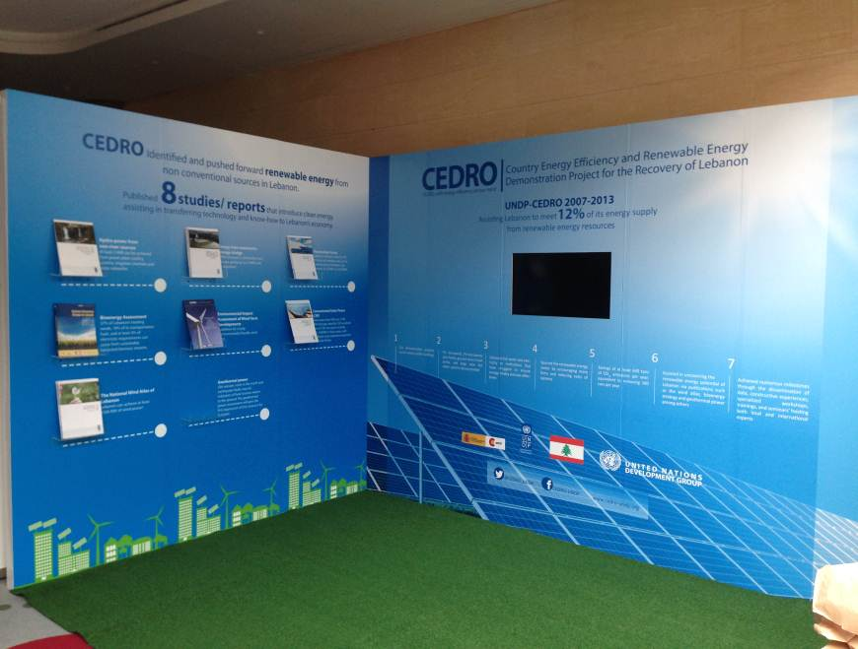

- CEDRO, in collaboration with the LCEC, published a brochure on PV systems targeting potential beneficiaries and the Lebanese community at large. 3000 copies where printed and 2700 copies where distributed to selected individuals across the country.
- An artistic video clip has been prepared by CEDRO to summarize all the achievements of the CEDRO project. The video can be downloaded from the following link; http://www.youtube.com/channel/UCwvTylbL9BqgZuQ5XW1e_hQ

- Assisting the establishment of a sustainable Energy Strategy for Lebanon

- The National Geothermal Power Assessment study is completed and has been delivered to CEDRO for review and comments. It is expected that this study is to be ready for publication by the end of Q4 2013.
- The Study on PV Farms in Lebanon is now completed and published. Hard copies have been distributed in the Beirut Energy Forum.

- A project to undergo a nation-wide survey, with a sample size of 600 for the residential sector and 200 for the commercial sector, to assess the willingness to pay (WTP) for small-scale and utility renewable energy systems in Lebanon for both the residential sector and the commercial sector was completed by CEDRO. Results are in and CEDRO is in the process of analyzing the data to publish a report. Report cannot be expected before end of Q1 2014.
- A new study for the assessment of the industrial potential, job creation, and local capacity for renewable energy systems in Lebanon has been awarded to a local consultancy. The work has already begun. A Steering Committee has been set up including, yet not limited to, the following parties;
Ministry of Finance
Ministry of Energy and Water
Ministry of Industry
Ministry of Environment
Industrial Research Institute
United Nations Industrial Development Organization

All in all, CEDRO aims to assist the government in Lebanon in deciding which energy source to utilize to reach its objective of 12% of its energy mix to come from renewable energy sources by 2020 – an objective approved by the Council of Ministers and asserted in the Copenhagen Summit.

II. RESOURCES

 |  | CEDRO 3
Total budget approved | : | USD 3,772,827.00
Total disbursements as for 30 September 2013 | : | USD 2,692,560.32
Available Balance | : | USD 1,080,266.68
Commitments for next quarter | : | USD 200,000.00

Budget and Expenditure Breakdown per LRF Category:

 | CEDRO3
CATEGORY | Total Budget  (USD) | Total Exp. to date (USD)
1. Personnel* (Incl. staff and consultants) | 252,000 | 606,866.45
2. Contracts  (Incl. companies, professional services) | 599,050 | 939,824.38
3. Training (incl. AV printing / production) | 41,000 | 28,064.95
4. Transport (local) | 11,000 | 42,230.84
5. Supplies and commodities  (Incl. IT equip and rental & maintenance) | 55,000 | 79,013.16
6. Equipment (including installation) | 2,505,000 | 662,408.64
7. Travel | 15,000 | 56,987.83
8. Miscellaneous | 31,539 | 89,129.00
9. Agency Management Support (7%) | 263,238 | 188,035.07
TOTAL | 3,772,827 | 2,692,560.32

*Total expenditure for staff and consultants exceeds the total allocated budget because most of the technical design and supervision of works is being implemented by project personnel and not sub-contracted to third-party companies as originally planned. A budget revision is therefore being requested should this be necessary.

CEDRO Project | CEDRO 3  USD 3,772,827
Activity Results
1 - Implementation of end-use energy efficiency and renewable energy demonstration projects for public sector buildings and facilities | - Identification and Implementation of 60-80 EE/RE demonstration projects across Lebanon
2 – Outreach and technology transfer to enable the conversion of other public sector buildings and facilities into energy efficient modalities | - Development and implementation of technical workshops and awareness tools  - Development of GIS energy data base and EE/RE procurement specs  - Validation of project results and development of replication schemes
3 – Research and development to enable the formulation of a national sustainable energy strategy and action plan | - Assessment of national renewable energy resources  - Assessment of national energy efficiency potential  - Development of national EE/RE strategy & action plan

Progress in Project Implementation:

Activity Results | Activity Actions | Targets for 2013 | Status for 2013
1 – Project Management | - Technical Management;  - Financial Management;  - Operational Management. | - Organization of 2 conferences and/or events, including end of year project closing meeting  - Opening of Pico-hydro site  - Opening of Army Solar Hot Water site | - 1 conference already undertaken, related to energy from wastewater treatment plants.  - CEDRO participated heavily in the 2014 Beirut Energy Forum
1 – Project Management |  | - Apply the issues raised in the report on the status and results of the CEDRO I pilot projects published in Q4 of 2012 | - Recommendations of CEDRO 1 Evaluation Report have been completed
1 – Project Management |  | - Provide advisory support services on EE/RE policies and legislations | - Advisory role and participatory role in the upcoming Lebanese Renewable Energy Strategy is to be undertaken this year with the LCEC and the MEW.
1 – Project Management |  | - Attendance of capacity building workshops for CEDRO team | - 3 CEDRO engineers participated in the RENAC (http://www.renac.de/), which is 75% funded by RENAC (only).
1 – Project Management |  | - Preparation of regular progress reports | - Q1 progress report prepared  - Q2 progress report prepared  - Q3 progress report prepared
Activity Results | Activity Actions | Targets for 2013 | Status for 2013
2 - Implementation of end-use energy efficiency and renewable energy demonstration projects for public sector buildings and facilities | 2.1 Undertake targeted assessment and identification of project beneficiary sites;  2.2 Develop tender documents and undertake bidding & procurement of goods/services;  2.3 Undertake commissioning of works and supervision and monitoring of sites;  2.4 Undertake testing of performance & data collection. | - Following-up on projects under implementation  - Batroun Port  - Qabayeet street lighting initiative  - Roumin Pico-hydro system  - Launch three sites of Madinati Khadra competition  - 8 larger PV sites  - 4 hybrid PV/microwind sites  - Green Roof initiative at the Central Bank  - Chahhar public hospital  - Complete work on Bejji Municipality (GSHP)  - Complete work on Roumieh Prison | - Batroun port is now completed  - Ramliyeh pico-hydro project underway  - Hybrid sites completed and validation is pending  - Chahhar hospital completed.  - All PV sites completed  - Green roof works well underway  - Chahhar hospital has been completed  - Qubeyeet street lighting is now completed.  - Roumieh prison continuation is now transferred to the ISF  - Bejji municipality will be commissioned before end of 2013
 |  | - Regular maintenance of all sites  - Data collection | - Maintenance checks regularly followed by 3 CEDRO engineers  - Data being collected from many sites across the country
Activity Results | Activity Actions | Targets for 2013 | Status for 2013
3 – Outreach and technology transfer to enable the conversion of other public sector buildings and facilities into energy efficient modalities | - Develop and implement technical workshops and awareness activities;  - Develop GIS energy data base and EE/RE procurement specs;  - Validate project results and enable replication schemes. | - Development and implementation of 1 technical workshops | - One technical workshop was undertaken by CEDRO, related to the MEDSOLAR project that CEDRO contrbutes human resouces too. This workshop was on the design element of larger PV systems and occurred on the 24th of September 2013.
 |  | - Continuation and expansion of CEDRO outreach and visibility  - 1 newsletter to be produced in 2013  - Complete revamping of CEDRO website to be implemented  - Final CEDRO Project documantary (if budget allows) | - Updating project website: www.cedro-undp.org (En/Ar);  - Newsletter 7 prepared  - PV brochure prepared and distributed  - Video clip on CEDRO’s achievements produced and posted online on CEDRO website  - Full press coverage for the Energy from Wastewater Event at the MEW ; All the TVs aired a report during their news, and most daily newspapers mentioned the event
 |  | - Interactive Map for CEDRO sites to be installed on new webstie | - Interactive Map being set up, part of which is on the website.
4 – Research and development to enable the formulation of a national sustainable energy strategy and action plan | - Asses national renewable energy resources;  - Assess national energy efficiency potential;  - Develop national EE/RE strategy & action plan. | - Publish energy from waste water treatment plants (WWTP) study  - Publish study on hydropower resources from non-river sources  - Launch and implement the national geothermal power assessment for the country.  - Undergo Renewable Energy Strategy Study with the Ministry of Energy and Water and the LCEC  - Undergo study on the willingness to pay (WTP) for renewable energy for the commercial and residential sectors in Lebanon  - Undergo a study for the assessment of the industrial potential, job creation, and local capacity for renewable energy systems in Lebanon | - Energy from WWTP has been published and disseminated  - Hydropower resources from non-river sources has been published and disseminated  - PV farm study has been published and is being distributed  - Study on WTP ongoing.
* EE/RE = Energy Efficiency and Renewable Energy
Implementation Constraints and Lessons Learned during this quarter:

- Given that the project is coming to a close in its current phase towards the end of October, even if an extension has occurred until the end of June, 2014, it does not cater for the entire CEDRO team. Therefore CEDRO is now in a state of downsizing and actively seeking continuation.

IV. FUTURE WORK PLAN

 | 2013
Outputs and Activities | Q4 2013
1. Implementation of end-use EE/RE demonstration projects  - Identification of beneficiary sites  - Development of tender documents  - Procurement of goods / services  - Site Supervision and hand-over  - Monitoring of system performance | Monitor implementation of works  Prepare Operation and maintenance plan post-CEDRO  Record all data collected from sites  Finish BDL Green Roof  Finish Pico-hydro site  Finish Roumin street lighting  Supervise all sites  Inaugurate Batroun port
2. Outreach and Technology transfer for the activation of EE/RE applications  - Establishment of energy saving data base for public sector facilities  - Development & Implementation of capacity building & awareness programs  - Development of relevant EE/RE policies and procedures  - Validation of project results | Dissemination of PV Farm study
3. Research and development for the formulation of a national EE/RE strategy and action plan  - Assessment of national RE potential  - Assessment of national EE potential  - Identification of viable EE/RE actions  - Identification of Implementation tools and funding mechanisms | Follow study for RE and industry (from new extension of funds)  Follow study on WTP for RE  Complete and inaugurate Geothermal study

 | 2014
Outputs and Activities | Q1 | Q2
1. Implementation of end-use EE/RE demonstration projects  - Identification of beneficiary sites  - Development of tender documents  - Procurement of goods / services  - Site Supervision and hand-over  - Monitoring of system performance | Monitor implementation of works  Record all data collected from sites  Monitor all installations  Prepare Operation and maintenance plan post-CEDRO  Project extended to June 2014  Inaugurate BDL green roof  Inaugurate Pico-hydro  Follow industry and RE study  Complete WTP study | Terminate project  Publish Operation and maintenance plan post-CEDRO
2. Outreach and Technology transfer for the activation of EE/RE applications  - Establishment of energy saving data base for public sector facilities  - Development & Implementation of capacity building & awareness programs  - Development of relevant EE/RE policies and procedures  - Validation of project results | Awareness activity to be determined  Geothermal power assessment result dissemination  Put together all CEDRO’s work on RE and EE in one document; a national document for RE and EE | Dissemination of results of the RE and Industry study
3. Research and development for the formulation of a national EE/RE strategy and action plan  - Assessment of national RE potential  - Assessment of national EE potential  - Identification of viable EE/RE actions  - Identification of Implementation tools and funding mechanisms | Put together all CEDRO’s work on RE and EE in one document; a national document for RE and EE | Put together all CEDRO’s work on RE and EE in one document; a national document for RE and EE

CEDRO 3
- Implementation of end-use energy efficiency and renewable energy applications for public sector buildings and facilities (60-80 sites across Lebanon)

- Technology transfer to enable the conversion of other public sector buildings and facilities into energy efficient modalities

- Research and development to enable the formulation of a national sustainable energy strategy and action plan

