PROGRESS REPORT

Reporting UN Organization | : | United Nations Development Programme (UNDP)
Country | : | Lebanon
Award ID | : | 00047251
Award Title | : | CEDRO III – “Country energy efficiency and renewable energy demonstration project for the recovery of Lebanon”
Award Timeframe | : | Oct 2009 – June 2014
Award Components | : | CEDRO 3 – 00071261
Reporting Period | : | 01st January 2014 – 31st March 2014

List of Acronyms

BDL Banque du Liban
CDR Council for Development and Reconstruction
CO Country Office
GDP Gross Domestic Product
EDL Electricty of Lebanon
EE Energy Efficiency
GSHP Ground Source Heat Pump
ITB Invitation to Bid
LCEC Lebanese Centre for Energy Conservation
LED Light Emitting Diodes
LRF Lebanon Recovery Fund
MoET Ministry of Economy and Trade
MoEW Ministry of Energy and Water
MoF Ministry of Finance
MoU Memorandum of Understanding
NAMA Nationally Appropriate Mitigation Actions
PV Photovoltaic
RE Renewable Energy
SHW Solar Hot Water
UNDP United Nations Development Programme
WWTP Waste Water Treatment Plants

I. PURPOSE

Project Summary:

The aim of the CEDRO project is to support Lebanon’s recovery, reconstruction and reform activities and to complement the national power sector reform strategy through the implementation of end-use energy efficiency and renewable energy projects and through the removal of barriers for the promotion of sustainable energy applications in Lebanon. To achieve this, the project will work on three levels: the first involves the establishment of a demonstrative model addressing public sector building and facilities, the second involves the activation of the replication process, and the third involves the triggering of a national sustainable energy strategy and action plan. The CEDRO project is financed through the Lebanon Recovery Fund, and is in-line with Lebanon’s ongoing efforts to improve national patterns of energy consumption and cost.

Project Phases and Outputs:

CEDRO 3  3,772,827 USD | - Implementation of end-use energy efficiency and renewable energy applications for public sector buildings and facilities (app. 60 sites across Lebanon)  - Technology transfer to enable the conversion of other public sector buildings and facilities into energy efficient modalities  - Research and development to enable the formulation of a national sustainable energy strategy and action plan
Project Linkages to National Priorities and Reconstruction Goals:

Lebanon imports around 97% of its energy needs in the form of fossil fuel. In 2004, the national energy bill amounted to around 1.6 billion USD (around 20% of the annual public expenditure and around 7.8% of the national GDP), and in 2005 it reached 2.1 billion USD (around 26% of the annual public expenditure and around 10% of the national GDP).

The government of Lebanon has placed the reform of the power sector among its highest national priorities, as outlined in the recovery, reconstruction and reform paper submitted to the Paris 3 conference after the 2006 conflict. However, given the enormity of the challenges faced by the power sector, the power sector reform strategy has concentrated on addressing the energy supply side, without extending the scope to the demand side of energy management.

Knowing that reform on the supply side needs to be accompanied by reform on the demand side, the proposed CEDRO program has sought to complement the national power sector reform strategy by targeting end-use energy conservation and renewable energy demonstrations which will assist in the above categories of demand-supply imbalance, security of supply, diversification of energy sources, economic cost and the environment.

Moreover, the current Lebanese government has set itself a goal of achieving 12% of its total energy needs from renewable energy sources. CEDRO is seeking to assist in achieving this goal through its demonstration projects of various zero carbon to low carbon technologies and its analysis of renewable energy resources.

This project is an initiative by the Government of Spain to assist the Government of Lebanon in its recovery and reconstruction efforts with a clear focus on promoting sustainable energy services and concentrating on public sector buildings and facilities.

This project is in inline with Lebanon’s recovery, reconstruction and reform objectives, and falls within the Ministry of Energy and Water’s main priority to meet national demand for electricity.

Project Implementation Partners:

The CEDRO partners and their respective roles are indicated to in the Table below:

Institution | Role
Spanish Agency for International Cooperation | Funded the CEDRO project through the LRF. The agency simply observes the work of the CEDRO project and sends representations to any event or occasion that CEDRO launches.
Ministry of Energy and Water (MoEW)  and Lebanese Center for Energy Conservation Project (LCEC) | CEDRO’s works closely with the Ministry and the LCEC as they are the main players in the energy sector. CEDRO’s work augments that of the Ministry and the LCEC, particularly in terms of knowledge-sharing through research activities for the energy sector.
Ministry of Finance | Part of the established Steering Committee for CEDRO.
Ministry of Economy and Trade | Part of the established Steering Committee for CEDRO.
Council for Development and Reconstruction | Part of the established Steering Committee for CEDRO, and monitors the works and finances of CEDRO.

International Partners: - Spanish Agency for International Cooperation
National Partners: - Ministry of Energy and Water (MoEW)
and Lebanese Center for Energy Conservation Project (LCEC)
- Ministry of Finance
- Ministry of Economy and Trade
- Council for Development and Reconstruction

- Project Management

- Preparation of regular progress reports and financial management of expenditures;
- Daily follow-up with site engineers and project staff;
- Providing technical and policy advice to decision-makers (MoEW) and UNDP CO on renewable energy issues;
- The CEDRO project is providing the MoEW and the LCEC in writing up and publishing the National Renewable Energy Strategy from 2014-2020 and beyond. This study will include the techno-economic assessment of renewable energy sources in Lebanon and will also look at the supporting environment needed to support Lebanon in meeting the renewable energy target of 12% by 2020;
- Assess future requirements for renewable market enhancement in Lebanon.

- Implementation of end-use energy efficiency and renewable energy demonstration projects for public sector buildings and facilities

The completed project in Q1 of 2014 was the green roof application on the Central Bank of Hamra. A 834 m² intensive green roof was esthetically designed using colorful and varied local species, monitored and irrigated with an automated system. CEDRO will be officially launching the green roof during Q2 2014.

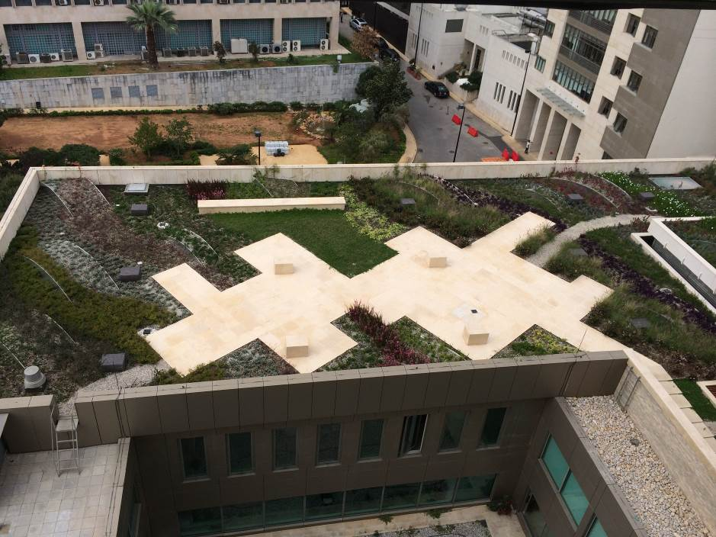
Green Roof, Central Bank (March15, 2014)

The ongoing projects during Q2 of 2014:

- The implementation of solar-powered street lighting systems in Bechtoudar village, North of Lebanon, along with the provision of residential energy efficient lighting The project shall provide 8 solar LED street lighting fixtures, along with their poles, to provide lighting during the nighttime. This would significantly impact Bechtoudar given the excessive blackout hours in the area. Furthermore, 196 energy efficient lighting were distributed in the village, amount to 3 bulbs per home.

- The installation of data logging equipment for three sites in three regions in Lebanon: a micro-wind site in El Mkayteaa- Akkar, a hybrid (wind-photovoltaic) site in Deir El Amhar- Bekaa, and a photovoltaic site in Zahleh- Bekaa, for data collection purposes in order to monitor and improve the energy yield and the performance of these systems. These sites were selected given they are among the top sites at CEDRO that are well operated and maintained, and thereby provide the ideal situation for logging the sites. The new data logger will provide CEDRO with a more comprehensive analysis on the operation of the systems, using real-time data that is connected between the sites and the office. This process will significantly improve on former data logging attempts by CEDRO, where simple loggers where used.

The expected timeframes of the above project is shown in the Table below:

ID | Type | ITB/RFQ delivered to bidders | Project commences | Project completion
1 | Green Roof | July 2012 | Jan 2013 | Completed
2 | Data logging | Feb 2014 | Jun 2014 | Ongoing
3 | Bechtoudar Street Lighting | Feb 2014 | April 2014 | Ongoing

- Setting an enabling environment for the conversion of public sector buildings and facilities into energy efficient modalities

- CEDRO Exchange Issue 10 discussing the Nationally Appropriate Mitigation Actions (NAMA) process in Lebanon was sent to CEDRO stakeholders/contact members. CEDRO Exchange Issue 11 and 12 are being prepared and will be sent in Q2 2014. They address the transportation sector in Lebanon and how to reduce and better manage the sector energy wise. All CEDRO exchanges can be found on CEDRO’s website www.cedro-undp.org).

- E-Newsletter issue 8 and 9 were sent to CEDRO stakeholders/contact list in Q4 2013 and Q1 2014 respectively. The newsletters stated CEDRO’s achievements during the previous 6 months such as the installation of the PV systems at nine new sites with a total installed capacity of 18 kWp; CEDRO helped Tripoli Governmental Hospital to turn up the heat at a lower cost, and provided the Ras Baalbeck Community Center with a 10 Ampere
microwind system; the installation of the Pico-hydro system has been in Ramliyeh Public School, Mount Lebanon and the Batroun port opening among other stories.

- CEDRO held a conference on the 24th of March 2014 to launch the National Geothermal Resource Assessment of Lebanon Report under the auspices of the Minister of Energy and Water, the UNDP Resident Representative represented by the Country Director, and the Spanish Ambassador with the attendance of 65 people; the event was mentioned in several local newspapers. The launched study showed that Lebanon has a potential of 1 x 10^8 GWh of usable geothermal energy, more than the country’s foreseeable demand in 2025. It is with the help of the key stakeholders and the private sector that such technologies will implement and will contribute the national commitment of 12% RE in 2020. The invitation card and the agenda can be found in Annex 1.

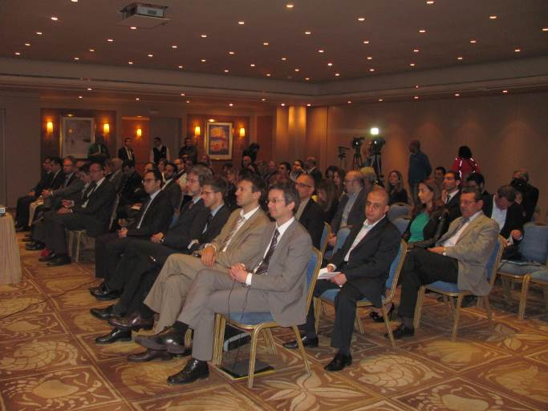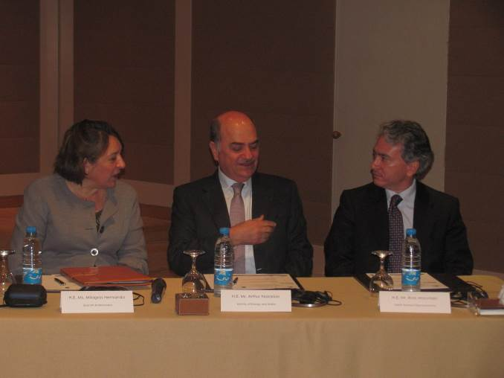

Geothermal Launching Event – March 24, 2014

- Assisting the establishment of a sustainable Energy Strategy for Lebanon

- The National Geothermal Resource Assessment study has been released (see picture below). Hard copies are being distributed distributed to over 200 stakeholders in the field. The objectives of the geothermal atlas are to estimate the current overall potential of geothermal heat and power generation in Lebanon and to estimate the ability of geothermal power to assist in meeting the objective of the Lebanese government in meeting 12% of its total energy needs from renewable energy sources by 2020 and beyond. The study shows that the geothermal potential in Lebanon is low, in comparison to other regions of the world. Nevertheless, two prospective areas seem to be interesting. These prospects could be suitable for the construction of pilot installations for the generation of electricity. The most promising area in the Akkar region in the North, where water is supposed to be found at a temperature of 130°C due to a thermal anomaly. The second area is the Bekaa Valley, where the aquifer is deep enough to reach suitable temperatures. The estimations provided by this study shows temperatures of around 80-90°C. The gross resource is the total energy stored in the underground in Lebanon at a temperature high enough to produce electricity (higher than 100°C) and at a depth that could be reached by present technologies (less than 7,000 meters below ground level). It is in theory of 1.010⁹ GWh, the equivalent of around 70,000 times the yearly energy demand in Lebanon. Unfortunately, only a very small part of this heat could be technically extracted by means the current state of the art techniques (net resource). An optimistic but realistic scenario could consider the implementation of a maximum 1 pilot installation of 1.3 MW_{el} by 2020. In case of success and positives results, 4 additional power plants could be installed until 2025. The total electricity production by 2020 by means of geothermal energy would be around 6 GWh_{el}. By 2025, the total production would be 30 GWh_{el} which corresponds to around 0.2% of the total energy demand at that time.

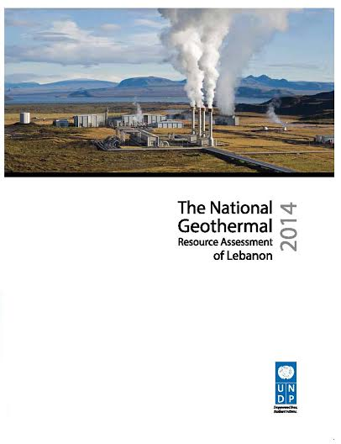

National Geothermal Resource Assessment of Lebanon Cover

- A nation-wide survey to assess the willingness to pay (WTP) for small-scale and utility renewable energy systems in Lebanon for both the residential sector and the commercial sector have been launched by CEDRO. Results are in and CEDRO is in the process of analyzing the data to publish a report. The final report will be published in Q2 2014.

- The assessment of the industrial potential, job creation, and local capacity for renewable energy systems in Lebanon study is being finalized, the report will be published in Q2 2014.

All in all, CEDRO aims to assist the government in Lebanon in deciding which energy source to utilize to reach its objective of 12% of its energy mix to come from renewable energy sources by 2020 – an objective approved by the Council of Ministers and asserted in the Copenhagen Summit.

II. RESOURCES

 |  | CEDRO 3
Total budget approved | : | USD 3,772,827.00
Total disbursements as for March 2014 | : | USD 3,388,437.90
Available Balance | : | USD 384,389.10
Commitments for next quarter | : | USD 384,389.10

Budget and Expenditure Breakdown per LRF Category:

 | CEDRO3
CATEGORY | Total Budget  (USD) | Total Exp. to date (USD)
1. Personnel* (Incl. staff and consultants) | 252,000 | 755,676.75
2. Contracts  (Incl. companies, professional services) | 599,050 | 1,307,759.52
3. Training (incl. AV printing / production) | 41,000 | 37,300.58
4. Transport (local) | 11,000 | 47,864.27
5. Supplies and commodities**  (Incl. IT equip and rental & maintenance) | 55,000 | 85,102.45
6. Equipment (including installation) | 2,505,000 | 738,149.42
7. Travel | 15,000 | 66,144.31
8. Miscellaneous | 31,539 | 110,999.04
9. Agency Management Support (7%) | 263,238 | 238,320.31
TOTAL | 3,772,827 | 3,388,437.90

*Total expenditure for staff and consultants exceeds the total allocated budget because most of the technical design and supervision of works is being implemented by project personnel and not sub-contracted to third-party companies as originally planned. A budget revision is therefore being requested should this be necessary.
** Given the difference in budget line description between UNDP and the LRF accounts, the expenditures being reported under this budget account “supplies and commodities” because Batroun Port Renewable Energy Street Lighting contract should be considered under the budget account “contracts” not “supplies and commodities”

CEDRO Project | CEDRO 3  USD 3,772,827
Activity Results
1 - Implementation of end-use energy efficiency and renewable energy demonstration projects for public sector buildings and facilities | - Identification and Implementation of 60-80 EE/RE demonstration projects across Lebanon
2 – Outreach and technology transfer to enable the conversion of other public sector buildings and facilities into energy efficient modalities | - Development and implementation of technical workshops and awareness tools  - Development of GIS energy data base and EE/RE procurement specs  - Validation of project results and development of replication schemes
3 – Research and development to enable the formulation of a national sustainable energy strategy and action plan | - Assessment of national renewable energy resources  - Assessment of national energy efficiency potential  - Development of national EE/RE strategy & action plan

Progress in Project Implementation:

Activity Results | Activity Actions | Targets for 2014 | Status for 2014
1 – Project Management | - Technical Management;  - Financial Management;  - Operational Management. | - Organization of 2 conferences and/or events  - Monitor implementation of works  - Record all data collected from sites  - Monitor all installations  - Prepare Operation and maintenance plan post-CEDRO  - Follow industry and RE study  - Complete WTP study analysis  - Inaugurate Pico-hydro and Green Roof (BDL) | - 1 conference already undertaken, related to the launching of National Geothermal Resource Assessment study  - Follow up the solar-powered street lighting systems in Bechtoudar villageQ2  - Inaugoration for Pico-hydro on hold given the exceptionally low rainfall this season. The Green roof will be inaugurated in
1 – Project Management |  | - Provide advisory support services on EE/RE policies and legislations | - Advisory role and participatory role in the upcoming Lebanese Renewable Energy Strategy is to be undertaken during this year with the LCEC and the MEW.
1 – Project Management |  | - Attendance of capacity building workshops for CEDRO team | - CEDRO Engineers are part of the RENAC courses/academy – an online learning platform on renewables
1 – Project Management |  | - Preparation of regular progress reports | - Q1 progress report prepared
Activity Results | Activity Actions | Targets for 2014 | Status for 2014
2 - Implementation of end-use energy efficiency and renewable energy demonstration projects for public sector buildings and facilities | 2.1 Undertake targeted assessment and identification of project beneficiary sites;  2.2 Develop tender documents and undertake bidding & procurement of goods/services;  2.3 Undertake commissioning of works and supervision and monitoring of sites;  2.4 Undertake testing of performance & data collection. | - Following-up on projects under implementation  - Green Roof initiative at the Central Bank  - solar-powered street lighting systems in Bechtoudar village  - Complete work on Bejji Municipality (GSHP) | - Green roof is now completed  - Bejji municipality will be commissioned once building is ready and inhabited, CEDRO is assisting the municipality in completing its HVAC system  - Bechtoudar solar-powered street lighting systems project has been awarded and winning contractor has signed the contract to begin work
 |  | - Regular maintenance of all sites  - Data collection | - Maintenance checks regularly followed by 2 CEDRO engineers  - Data being collected from many sites across the country
Activity Results | Activity Actions | Targets for 2014 | Status for 2014
3 – Outreach and technology transfer to enable the conversion of other public sector buildings and facilities into energy efficient modalities | - Develop and implement technical workshops and awareness activities;  - Develop GIS energy data base and EE/RE procurement specs;  - Validate project results and enable replication schemes. | - Continuation and expansion of CEDRO outreach and visibility  - 2 e-newsletters to be produced in 2014  - 3 exchanges to be produced in 2014 | - Newsletter 8 and 9 disseminated in Q1 2014.  - Press coverage of the National Geothermal Resource Assessment of Lebanon Report launching; Most daily newspapers mentioned the event
 |  | - Interactive Map for CEDRO sites to be installed on new webstie | - Interactive Map being set up, part of which is on the website.
4 – Research and development to enable the formulation of a national sustainable energy strategy and action plan | - Asses national renewable energy resources;  - Assess national energy efficiency potential;  - Develop national EE/RE strategy & action plan. | - Publish National Geothermal Resource Assessment of Lebanon study  - Undergo Renewable Energy Strategy Study with the Ministry of Energy and Water and the LCEC  - Dissiminate the data analysis of the study on the willingness to pay (WTP) for renewable energy for the commercial and residential sectors in Lebanon.  - Puvblish the assessment of the industrial potential, job creation, and local capacity for renewable energy systems in Lebanon study | - National Geothermal Resource Assessment has been published and disseminated  - Study on Industry and Renewable Energy Ongoing.  - Data analysis of the WTP study ongoing.
* EE/RE = Energy Efficiency and Renewable Energy
Implementation Constraints and Lessons Learned during this quarter:

None

IV. FUTURE WORK PLAN

 | 2014
Outputs and Activities | Q2
1. Implementation of end-use EE/RE demonstration projects  - Identification of beneficiary sites  - Development of tender documents  - Procurement of goods / services  - Site Supervision and hand-over  - Monitoring of system performance | Terminate project  Publish Operation and maintenance plan post-CEDRO
2. Outreach and Technology transfer for the activation of EE/RE applications  - Establishment of energy saving data base for public sector facilities  - Development & Implementation of capacity building & awareness programs  - Development of relevant EE/RE policies and procedures  - Validation of project results | Dissemination of results of the RE and Industry study  Completion of CEDRO publications from works done and inputs in the Renewable Energy Strategy  Dissimination of the data analysis of the WTP study
3. Research and development for the formulation of a national EE/RE strategy and action plan  - Assessment of national RE potential  - Assessment of national EE potential  - Identification of viable EE/RE actions  - Identification of Implementation tools and funding mechanisms | Put together all CEDRO’s work on RE and EE in one document; a national document for RE and EE; part of National Renewable Energy Strategy

CEDRO 3
- Implementation of end-use energy efficiency and renewable energy applications for public sector buildings and facilities (60-80 sites across Lebanon)

- Technology transfer to enable the conversion of other public sector buildings and facilities into energy efficient modalities

- Research and development to enable the formulation of a national sustainable energy strategy and action plan

Annex 1

