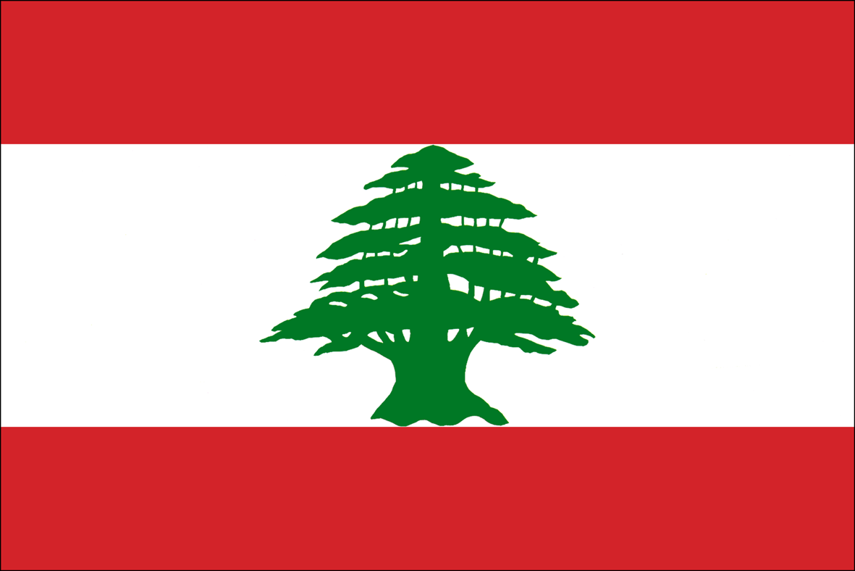
LEBANON RECOVERY FUND
MPTF OFfice GENERIC ANNUAL programme NARRATIVE progress report
REPORTING PERIOD: 1 january – 31 December 2013

Programme Title & Project Number |  |  | Country, Locality(s), Priority Area(s) / Strategic Results
- Programme Title: M&E team for the LRF  - Programme Number LRF 25  - MPTF Office Project Reference Number: 00073340 |  |  | (if applicable)  Country/Region  Lebanon
 |  |  | Priority area/ strategic results
Participating Organization(s) |  |  | Implementing Partners
- Organizations that have received direct funding from the MPTF Office under this programme  UNDP |  |  | - National counterparts (government, private, NGOs & others) and other International Organizations  Ministry of Economy & Trade
Programme/Project Cost (US$) |  |  | Programme Duration
Total approved budget as per project document:  MPTF /JP Contribution: 200,000.00 USD |  |  | Overall Duration (months)  72 months
 |  |  | Start Date 17 Dec 2009
 |  |  | Original End Date 31 Dec 2012
 |  |  | Current End date31 Dec 2015
TOTAL: 200,000.00 USD
Programme Assessment/Review/Mid-Term Eval. |  |  | Report Submitted By
Assessment/Review - if applicable please attach  Yes No  Mid-Term Evaluation Report – if applicable please attach  Yes No |  |  | - Name: Rony Gedeon  - Title: M&E Officer  - Participating Organization (Lead): UNDP  - Email address: rgedeon@economy.gov.lb

LIST OF ACRONYMS

M&E: Monitoring and Evaluation
LRF: Lebanon Recovery Fund
UNRCO: United Nations Resident Coordinator’s Office
FAO: Food and Agriculture Organization
UNIDO: United Nations Industrial Development Organization
UNDP: United Nations Development Programme
UNFPA: United Nations Population Fund
ILO: International Labour Organization
UNESCO: United Nations Educational, Scientific and Cultural Organization
MPTF: Multi-Donor Trust Fund
PAG: Project Approval Group
SC: Steering Committee
HQ: Head Quarters
Q: Quarter
MoM: Minutes of Meeting

NARRATIVE REPORT FORMAT

EXECUTIVE SUMMARY

During 2013, the M&E unit was closely monitoring the ongoing LRF projects whilst providing technical support and advice to the LRF Steering Committee, Project Approval Group and the projects’ teams.

A number of transfers and extensions took place during 2013:
The FAO LRF 26 project Recovery and Rehabilitation of Dairy Sector in Bekaa Valley and Hermel-Akkar Uplands – Phase II” was granted a fund transfer of the remaining funds from LRF 14 project. The Steering Committee previously approved an FAO’s request to transfer the remaining funds from the LRF 14 to the LRF 21 project. However, due to delays in submitting the final financial report of the LRF 14 to the MPTF Office, this transfer couldn’t be executed as the LRF 21 was operationally closed in September 2012.
These additional funds are intended to be used to support an additional number of farmers in Donnyeh area that are not already covered by the LRF 21 or LRF 26 projects.

The LRF 16 “Country Energy Efficiency and Renewable Energy Demonstration Project for the
Development of Lebanon – phase III”, has been granted a time extension of 6 months with an amount of 272,827 USD to conduct additional activities within the scope of the project and priorities of the LRF. The M&E Unit is closely following up with the project on the progress achieved, with regard to listed components, in addition to meeting with the project staff to clarify critical issues pertaining to the implementation of the project’s activities.

The LRF 26, “FAO Recovery and Rehabilitation of Dairy Sector in Bekaa Valley and Hermel-Akkar Uplands (PHASE II)” was also reviewed and granted an extension until December 2014 along with a transfer of a remaining amount of 88,704 USD from the phase I project in order to incorporate new activities aiming to reach a larger number of beneficiaries.

Furthermore, the LRF 25 project “Monitoring and Evaluation Team for the LRF” was granted 24 months extension along with a fund transfer of an amount of 89,985.92 USD as the M&E unit will be monitoring and evaluating the ongoing projects in 2014-2015 and coordinating with the projects’ teams for the closure of the projects within the set time frames.

In addition, a new project was funded under the LRF entitled “Reviving Farmers’ Livelihood in South Lebanon” for a total amount of 700,00 USD that is being implemented by UNDP in collaboration with the Ministry of Agriculture and the municipality of Nabatiyeh in South Lebanon.

Purpose

The M&E unit was designed to enhance the LRF monitoring mechanism by incorporating the below activities into a more coherent and efficient framework and by expanding overall oversight management. The M&E unit aims at enhancing the efficiency, preventing unnecessary expenditures and avoiding project delays. This framework will consist of:

- An increased frequency of field trips and monitoring meetings;
- Closer and more technical follow ups on project implementation and financial activities;
- A continuous evaluation and objective re-assessment of project achievements against pre-set targets;
- A support system to meet timely completion with the objective of raising the effectiveness of projects and ensure cost-efficiency in their implementation, and
- A support system to examine the final evaluation of the projects implemented under the LRF.

Effective oversight management of the LRF projects is time-enhancing and cost-efficient to both donors and beneficiaries. And since the M&E team will oversee all aspects of the project activities, Project Managers are supported in achieving their pre-set deadlines in a timely manner. This will be advantageous to the benefactors since it will prevent the postponement of the project’s activities.
Furthermore, any revisions made in the outstanding projects-such as a no cost time extension, a budget reevaluation or change in scope is effectively assessed and evaluated by the M&E team and hence, improving the cost-efficiency and decision making outcomes of those projects by the PAG team and LRF Steering Committee.

Project Objectives:
The development goal of the M&E Team is to generate a framework whereby the operation and delivery of current and prospective projects approved under the LRF are able to improve efficiency, recognize and prevent unnecessary expenditures and project delays that may arise over the present time frame of each individual project.
The immediate objective of establishing an M&E Team is to strengthen the existing LRF monitoring mechanism by improving the timeliness, cost efficiency and reliability of the current LRF project activities.

Project Outputs:
Main outputs include:
- Support Project Managers in achieving their pre-set deadlines in a timely manner, thus working in favor of the beneficiaries of each project, and

- Revisions made in the outstanding projects - such as a no cost time extension, a budget re-evaluation or change in scope - will be effectively assessed and evaluated by the M&E team. This will improve all decision making outcomes and will ensure compliance with the above revisions.

Results

- Narrative reporting on results:

Monitoring of LRF projects
The M&E unit monitored the progress of the LRF ongoing projects during 2013 in relation to the planned outcomes in the projects’ documents approved by the steering committee. This monitoring entailed a thorough evaluation of progress reports for the four quarters of 2013 for the following projects:
- LRF-16 UNDP Country Energy Efficiency and Renewable Energy Demonstration Project for the Development of Lebanon (CEDRO III)
- LRF-26 FAO Recovery and Rehabilitation of Dairy Sector in Bekaa Valley and Hermel-Akkar Uplands (PHASE II)
- LRF-27 National Action Programme to Mainstream Climate Change in Lebanon's Development Agenda
- LRF-28 Reviving Farmers’ Livelihood in South Lebanon

In collaboration with the concerned UN agencies, the reports were revised in order to highlight on the results and the impact of the LRF initiatives. The final versions of the reports have been uploaded on the MPTF gateway.
In addition, the M&E unit conducted field/office visits to projects’ regions and staff to to better assess the projects’ progress and to obtain feedback of beneficiaries and local stakeholders where possible.
Moreover, the M&E team attended and participated in project events in order to enhance the LRF visibility such as “workshop for the management of flood risk land use” for the Flood Risks Prevention and Management project and the final stakeholder meeting for the Hydro Agricultural Development Project of Marjeyoun.

The LRF-10 UNDP “Country Energy Efficiency and Renewable Energy Demonstration Project for the Development of Lebanon (CEDRO II)” was successfully completed in December 2012. The M&E unit supported the operational closure of the project and uploaded the final narrative report on the MPTF gateway.

In addition, the LRF 23, “Hydro Agriculture Development Project for Marjeyoun area”, and the LRF 17, “Flood Risk Prevention and Management in Baalbeck Phase II”, that were both granted 18 months’ time extension were successfully completed in February 2013.The M&E unit worked closely with the project teams to finalize the operational closure of both projects and uploaded their respective final narrative reports on the MPTF gateway.

Finally, the LRF 24, “Early recovery for Nahr El Bared Surrounding Lebanese Communities Affected by 2006 and 2007 Conflicts”, has been granted a no-cost time extension of 12 months to complete the remaining activities.

Visibility of the LRF
The M&E unit designed and produced two issues of the LRF newsletter sharing success stories and positive outcomes of the different LRF projects. These newsletters have been disseminated to the Heads of the UN agencies in Lebanon, the concerned Ministries and other stakeholders including embassies and consulates in the country.
The M&E will be working, in cooperation with the Information Unit at the RCO, to continuously update the design and contents of the LRF webpage on the Lebanon UN website. Updated information includes statistical data, financial figures, and publications which are available for the public.

Support for the LRF Steering Committee (SC) and Project Approval Group (PAG)

During the implementation of the LRF projects, the M&E unit has organized Steering Committee (SC) and Project Approval Group (PAG) meetings and provided support and advice to the members on projects delays, deviations and critical issues. In addition the M&E unit supported the SC and PAG in resource mobilization planning and coordination with the implementing UN agencies and local stakeholders on project extension and transfer requests.

In addition, the M&E unit facilitated the revision and evaluation process of a new project proposal submitted by UNDP in 2012 and was amended as per the SC request.
The new project entitled “Reviving Farmers’ Livelihood in South Lebanon” was funded under the LRF, for a total amount of 700,00 USD and was started in May 2013 by UNDP in collaboration with the Ministry of Agriculture and the municipality of Nabatiyeh in South Lebanon.

The project aims to expand livelihood opportunities for vegetable farmers in South Lebanon through the establishment of a market place reducing transaction costs and access to extension services to improve post-production stages which are at the heart of sectoral vulnerability.
This initiative will benefit 426,000 Lebanese residents, including over 8,000 fruit and vegetable producers, and serve as a pilot model to be replicated in other rural areas in Lebanon.

In general the project includes two major components:

  - A wholesale fruit and vegetable farmers' market in Nabatieh Mahafazat is established

  - Access to agricultural extension services is improved

ii) Indicator Based Performance Assessment:

Project Outputs | Activities | Indicators
Support Project Managers in achieving their pre-set deadlines in a timely manner, thus working in favor of the beneficiaries of each project | - Monitoring of the projects’ progress conducted on continuous basis. Inquiries, comments and suggestions are shared with the project teams with regard to the obstacles faced and the alternative measures to be adopted to overcome the constraints.  - Close monitoring and evaluation have resulted in pointing out the obstacles facing the projects’ implementation  - Coordination meetings with the projects’ teams to assess the progress made and the obstacles facing the implementation.  - The M&E Unit has been reviewing, editing and amending the quarterly progress reports of 2013; guarantying the timely submission of LRF reports through the MPTF Gateway http://mdtf.undp.org/ and as such:  - Q1, Q2 and Q3 progress reports were reviewed, amended and uploaded on the MPTF gateway.  - Monthly reports reviewed and evaluated  - Annual reports covering 2012 revised and uploaded on MPTF gateway. | Activities completed as per the projects’ set up work plans  Revised projects and updated work plans  Challenges assessed and alternative measures suggested  Minutes of Meetings with the projects’ teams and updated work plans  Reports uploaded to the MPTF website (http://mptf.undp.org/factsheet/fund/LRF00 )
Revisions made in the outstanding projects - such as a no cost time extension, a budget re-evaluation or change in scope - will be effectively assessed and evaluated by the M&E team. This will improve all decision making outcomes and will ensure compliance with the above revisions. | - Periodic site visits to assess the progress achieved.  - Periodic updates to the LRF PAG and SC on the progress achieved and the obstacles faced.  - The M&E is working in collaboration with the information unit at the RC office to continuously update the LRF Webpage  - Production of LRF Quarterly newsletter to disseminate the success achieved by the LRF projects.  - Attendance of the LRF projects’ events | Debriefing meetings  PAG and SC minutes of meeting  www.UN.org.lb  Newsletter produced and disseminated  Events debriefing reports, minutes and press releases

Constraints:

- Administrative procedures in the Ministries and UN agencies resulted in delaying the approval and processing of extension and transfer requests.

- The developing security situation in Lebanon that has resulted in limiting the access of the M&E unit to certain sites.

Lessons Learned:

- To improve the quality of the LRF progress reports, the M&E Unit is conducting individual meetings with the project/program managers to clarify the required info to be included in the progress reports in addition to the focus on the coordination terms between the implementing UN Agencies and the M&E Unit vis-à-vis the visibility of the LRF .
- Monthly reports were requested from the implementing UN Agencies to assess the progress made vis-à-vis the set work plans for projects receiving no-cost time extensions.
- Participation in the LRF projects’ major events.
- Close follow-up with the designated focal points of the MPTF, PAG and SC.
- Meetings with the projects’ teams to assess the progress achieved and consider alternative work plans in light of the developing security situation in the country.

The term “programme” is used for programmes, joint programmes and projects.
Strategic Results, as formulated in the Strategic UN Planning Framework (e.g. UNDAF) or project document;
The MPTF Office Project Reference Number is the same number as the one on the Notification message. It is also referred to as “Project ID” on the project’s factsheet page the MPTF Office GATEWAY
The MPTF or JP Contribution, refers to the amount transferred to the Participating UN Organizations, which is available on the MPTF Office GATEWAY
The start date is the date of the first transfer of the funds from the MPTF Office as Administrative Agent. Transfer date is available on the MPTF Office GATEWAY
As per approval of the original project document by the relevant decision-making body/Steering Committee.
If there has been an extension, then the revised, approved end date should be reflected here. If there has been no extension approved, then the current end date is the same as the original end date. The end date is the same as the operational closure date which is when all activities for which a Participating Organization is responsible under an approved MPTF / JP have been completed. As per the MOU, agencies are to notify the MPTF Office when a programme completes its operational activities.

