|  |  |  |  |  |
| --- | --- | --- | --- | --- |
|  | C:\Documents and Settings\amar.bokhari\Local Settings\Temporary Internet Files\Content.Word\UNDG logo solo.jpg |  |  |  |

**Lebanon Recovery Fund**

**MPTF OFfice GENERIC ANNUAL programme[1] NARRATIVE progress report**

**REPORTING PERIOD: 1 january – 31 December 2013**

|  |  |  |  |  |
| --- | --- | --- | --- | --- |
| Programme Title & Project Number | |  | Country, Locality(s), Priority Area(s) / Strategic Results[2] | |
| * Programme Title: National action programme to mainstream climate change into Lebanon’s development agenda (Climate Change Coordinating Unit – CCCU) * Programme Number *(if applicable): LRF 27* * MPTF Office Project Reference Number:[3] *00085932* | | *(if applicable)*  *Country/Region*  *Lebanon* | |
| *Priority area/ strategic results*  *Governmental institutions/national coverage* | |
| Participating Organization(s) | |  | Implementing Partners | |
| * Organizations that have received direct funding from the MPTF Office under this programme | | * Ministry of Environment * Ministry of Finance * National Council for the Environment | |
| Programme/Project Cost (US$) | |  | Programme Duration | |
| Total approved budget as per project document: USD 500,000  MPTF /JP Contribution[4]:   * *by Agency (if applicable)* |  |  | Overall Duration *(months)* | 24 months |
| Agency Contribution   * *by Agency (if applicable)* |  |  | Start Date[5] *(dd.mm.yyyy)* | 15 March 2013 |
| Government Contribution  *(if applicable)* |  |  | Original End Date*[6]* *(dd.mm.yyyy)* | 15 March 2015 |
| Other Contributions (donors)  *(if applicable)* |  |  | Current End date[7]*(dd.mm.yyyy)* |  |
| TOTAL: |  |  |  |  |
| Programme Assessment/Review/Mid-Term Eval. | |  | Report Submitted By | |
| Assessment/Review - if applicable *please attach*  Yes No Date: *dd.mm.yyyy*  Mid-Term Evaluation Report *– if applicable please attach*  Yes No Date: *dd.mm.yyyy* | | * Name: Vahakn Kabakian * Title: Climate Change Portfolio Manager * Participating Organization (Lead): * Email address: vahakn@moe.gov.lb | |

# NARRATIVE REPORT FORMAT

# Purpose

**Project Summary and linkage to national priorities:**

The project aims at mainstreaming climate change concepts into the different governmental development agenda by climate proofing the relevant plans and actions of the various ministries. The proposed project is in in line with the Government of Lebanon’s plan of action, as mentioned in the first national communication report to the UNFCCC, and reiterated in the Second National Communication report to the UNFCCC. Furthermore, the proposed project builds on the on-going renewable energy and energy efficiency objectives of the Ministry of Energy and Water and the Sustainable Energy Strategy project of the Ministry of Finance as well as Ministry of Agriculture’s adaptation efforts. Overall, this project will work to meet the national priority of achieving the 12% renewable energy mix target by 2020 to move towards a Low Carbon/Emission Economy, as well as provide a directive for national adaptation activities leading to a national low emission climate resilient development strategies.

**Project Outputs:**

* Output 1: Engagement of ministries and governmental and national institutions in continuous planning/decision making on climate change issues
* Output 2: Identify and develop nationally appropriate mitigate actions (NAMAs) and pilot demonstration adaptation projects
* Output 3: Engagement of Lebanon in the international climate change arena and promoting new national and international climate financial mechanisms

**Objectives**

In order to improve climate change governance and meet the challenges that will face Lebanon as a result of climate change, there is a need to mainstream climate change concepts into national and sectoral development plans and to coordinate on-going climate change initiatives that are scattered. To achieve this, the proposed project presents a comprehensive coordination mechanism involving strategic planning, and close and effective communication with national, regional and international partners, as well as the recommendation of financial mechanisms needed at the national level.

With the recent Council of Ministers’ decision during its session dated March 28, 2012, the Decree (8157/2012) establishing the National Council for the Environment (NCE) has been enacted. The NCE is made of 14 members representing 7 ministries (the Ministry of Environment – Head of the NCE; and the ministries of Finance, Interior and Municipalities, Agriculture, Public Works and Transport, Energy and Water, and Industry) and 7 non-public entities (Order of Physicians, Order of Engineers and Architects, The Bar Association, Association of Banks, Association of Insurance Companies, representative of NGOs, representatives of the Academic sector).

Given the above, and knowing that proper climate change governance needs to build on on-going and planned national activities, the proposed project seeks to strategically align all national activities by coordinating and bringing them under the NCE. To achieve this, the proposed project aims to engage ministries and governmental institutions in planning and elaborating effective national adaptation (and pilot demonstration of adaptation technologies) and mitigation action plans (including NAMAs). The project will also address the institutional and legal barriers for the development of the national and international financial mechanisms and will improve the engagement of Lebanon in the international climate change arena.

# Results

1. **Narrative reporting on results:**
2. **Project Management**

* Preparation of regular progress reports and financial management of expenditures;
* Organization of stakeholder meetings (with regular meetings with the Ministry of Finance);
* Daily follow-up with project staff;
* Coordination with all national stakeholders and beneficiaries;
* Providing technical and policy advice to decision-makers on climate change negotiations and other climate related issues (primarily to MoE).
* Coordinate work with CEDRO project and Ministry of Finance and the Lebanese Center for Energy Conservation on clarifying Lebanon’s 12% renewable energy strategy.

**Output 1: Engagement of ministries and governmental and national institutions in continuous planning/decision making on climate change issues**

1. This output involves the establishment of a network of climate change focal points among ministries, embedded in the NCE (as mandated by the NCE Decree 8157/2012) governmental, academic and private institutions to facilitate the interaction and coordination between the different actors involved in climate change issues. This will lead to the establishment of the Government Group (GG) and the Research and Technical Support Group (RTSG).

**Achievements:**

**Focal Points appointment/working group establishment/NCE meeting:**

After internal preparation and reviewing of the terms of references of the “to-be appointed” focal points has been developed, the structure and modality of work with the NCE has also been elaborated with the Ministry of Environment staff.

The first meeting under the National Council for the Environment took place on July 24th, 2013, introducing the programme’s objectives and the workplan as well as the expected achievements and the modality of work to the NCE members. The main discussion points evolved around the role that the project will play under the NCE, including the coordination aspect including the process to be followed with the various NCE members which entails the nomination of technical focal points from the NCE member institutions to follow-up on technical aspects. The NCE was also informed on the close coordination with the Ministry of Finance and the future plans, the outputs of the project (the Agriculture Adaptation Pilots and the Strategic Environmental Assessment of the Renewable Energy Sector) and the process/progress achieved for the preparation of nationally appropriate mitigation actions.

Following the first NCE meeting, the TORs of the focal points was shared with the individuals whose nominations were received officially. The first meeting of the focal points of the Climate Change Coordination Unit (CCCU) was held on December 9th, 2013. The TORs of the focal points were discussed and their comments were noted. The focal points also exchanged current projects and initiatives taking hand at different ministries and institutions. Following the first CCCU focal points meeting, the participants decided to meet on a quarterly basis to discuss potential collaboration, and receive updates on strategies/plans, or the research being done in the area of climate change. It was also agreed that the way forward throughout the next quarter would be to set up thematic working groups to discuss more specific issues. In specific, pressing issues will be discussed with the Middle East Airlines, Order of Engineers and Architects of Beirut, the academic sector and the Association of Banks.

**Coordination under the working groups:**

As part of the coordination of climate change activities undertaken by various national and international actors, the inception workshop of Increasing Farmers’ Resilience through Early Warning and Advisory Climate Service (EWCS), as part of the EU ClimaSouth project, was held at the Ministry of Environment on December 5th and 6th, 2013. The main outcome of the workshop is a detailed table based on the four identified priorities. The work plan is currently being finalized and validated by stakeholders. The main two partners under this coordination stream are the Lebanese Agricultural Research Institute and the Lebanese Meteorological Service, Directorate General of Civil Aviation, Ministry of Public Works and Transport.

1. This output also involves the provision of capacity building and information dissemination to governmental focal points in order to promote public sector capacity and capability to tackle climate change issues in their sectoral plans and policies.

The engagement process will include:

* Focal points designation
* Focal points training
* Inter-ministerial and inter-institutional agreements preparation

**Achievements:**

**Partner Ministry/agency involvements – focal points:**

Nominations from various ministries and agencies were received ( 29 nominations) (List of agencies can be found in annex 1). One agency (Higher Relief Council) declined. Pending nominations for 9 ministries/agencies. Follow-up is ongoing.

**Focal Point Training:**

Hands-on training on the use of GHG Inventory software (NAIIS) prepared by the United Nations Framework Convention on Climate Change Secretariat: training (a newly developed web-based software) for the preparation and reporting of national GHG inventories for developing countries has been secured (free of charge). A total of 7 stakeholders (representing 6 different institutions) from the Ministries of Environment, Agriculture Industry, academia, and environmental consultants, have been trained (see annex 2).

During the first CCCU meeting (mentioned above), the programme requested the stakeholders to identify a series of capacity building they require. These areas, as identified by the focal points, are Cost-benefit Analysis and Cost-Effectiveness Analysis in appraising climate change and environmental projects, Climate change finance, and Meteorological Climate modeling. The programme is currently contacting experts and institutions to conduct trainings for certain groups of focal points in the three proposed areas.

1. Training and capacity building of other ministries in issues related to climate change is also envisaged. Needs for any legislative changes will be reviewed and changes proposed to the NCE (such changes include tariff restructuring (for e.g., RE and EE). It will also serve to undertake the assessment on how to reach the 12% RE national target as an integrated and holistic approach.

**Achievements:**

**Legislative at the fiscal/financial side at Ministry of Finance:**

An agreement was reached between the Ministry of Environment and the Ministry of Finance to share the services of the incumbent joining the project; it was deemed that this will provide further opportunities in strengthening the cooperation of both ministries in financial/fiscal issues related to climate change. The recruitment of the project coordinator (economist) has been finalized. The selected candidate started work on 24th October, 2013.

Based on this cooperation scheme, a workplan has been developed in cooperation with the Ministry of Finance with respect to the tasks to be undertaken by the coordinator (economist). This includes, among other, the follow-up on the execution of a Climate Public Expenditure and Institutional Review (CPEIR). The CPEIR involves the analysis of allocation and management of public expenditures and covers all government expenditure (or alternatively can focus on few priority sectors). The outcome of CPEIR can be used to provide key guidance to strategic planning and budget preparation with the aim to improve the efficiency and effectiveness of resource allocations for climate adaptation and mitigation. By reviewing current climate expenditures from both domestic and external sources of finance and identifying ways in which climate related expenditures can be tracked through time, the CPEIR will be a key building block for developing a comprehensive climate fiscal framework. Funding for conducting the Climate Public Expenditure and Institutional Review (CPEIR) is being secured through the UNDP Arab Climate Resilient Initiative. The required fund for conducting the CPEIR ranges from USD 100,000 to USD 200,000 and might require a period up to 1 year to completion. The project coordinator (economist) also attended a workshop on *Governance Challenges in Climate Change Finance* on December 1st, 2013, and *The Global Forum on Using Country Systems to Manage Climate Change Finance* on December 2nd and 3rd, 2013, in Incheon, South Korea. The Lebanese delegation to the forum understood the general framework to undertake the Climate Public Expenditure and Institutional Review (CPEIR) for Lebanon and made use from the leanings from a number of countries. The team also contacted experts in the area, and in particular, the UNDP Asia Pacific Team showed willingness to support Lebanon.

Other tasks under progress include completing a mapping document for all *Climate Change and Environmental Projects and Initiatives* that the Ministry of Finance is involved in, preparing a document on *General Fiscal Incentives to Reduce GHG Emissions*, and preparing a preliminary assessment of conducting a study on *Fiscal Incentives to Green Vehicles in Lebanon*. Pending tasks for the first quarter of 2014 include preparing a document on *Low Carbon Economy Indicators for Lebanon*, and a *Draft Regulation for Tax Incentives to the Reduction of Industry Pollution*.

**Training on Climate Change negotiations:**

A training to the various national entities on climate negotiations, through a grant funding worth approximately €35,000 from the German Federal Ministry of Foreign Affairs has been secured. The National Workshop on Climate Change Negotiations – Training to Enhance the Skills of the Lebanese Negotiators took place between December 10th and 12th, 2013, in cooperation with the Ecologic Institute. The training worked to enhance the knowledge and negotiating capacity of key Lebanese players with different institutional backgrounds. The sessions thus focused on the history of the international climate regime and its structures and bodies, challenges underlying the climate regime, and insights into the state of play on most relevant issues such as mitigation pledges, adaptation, loss and damage, and finance. The workshop also focused on Lebanon and how its internal structures and processes can strengthen its position in the negotiations. Finally, the workshop involved participants an interactive small-scale simulation of the international climate negotiations. Annex 3 contains the list of participants. In total 15 stakeholders representing 12 different institutions underwent the training.

Work is underway to secure a regional workshop (in collaboration of the Arab Climate Resilient Initiative) in Beirut, under the topic of Climate Public Expenditure and Institutional Review process.

**Output 2: Identify and develop nationally appropriate mitigate actions (NAMAs) and pilot demonstration adaptation projects**

1. This output builds on the assessment of the country’s vulnerability and impacts of climate change and the identification and analysis of the key emitter sectors to consequently propose detailed viable actions (short, medium and long-term) to reduce national emissions, increase resilience, and adapt to climate change.

In this output, various scenarios, opportunities, and approaches will be investigated and viable modalities, policies/regulations and mechanisms will be developed to ultimately facilitate the development of integrated and comprehensive plans for NAMAs. This will be achieved through a systematic coordination process between the public sector (GG) and the academic and private sector (RTSG) with the assistance of the Coordination Unit. Sectoral working groups will be established to allow a focused and continuous interaction between the stakeholders. The developed action plans will be consequently submitted to the CoM for approval following the endorsement of the NCE.

**Achievements:**

**Strategic Environmental Assessment of the National Renewable Energy Strategy:**

Discussions with the Ministry of Finance, Ministry of Energy and Water, and the UNDP CEDRO project lead to redefining the output from the development of NAMAs to the development of an Strategic Environmental Assessment of the Renewable Sector, in which case the latter would provide an opportunity in fulfilling a more crucial gap within the national renewable energy sector. The strategic environmental assessment will provide input to the national renewable energy strategy being currently developed, with the required directives at the strategic level in terms of environmental, social (e.g., job creation) and economic (e.g., energy security) benefits arising from the implementation of the national renewable energy strategy. Most importantly, assessment will identify policy gaps, negative environmental, social and economic impacts that might arise from the implementation of the strategy, and propose actions to be included in the national renewable energy strategy that will reduce or eliminate whenever possible the identified negative impacts.

The terms of reference and procurement process was conducted to select the most competitive consultancy firm to undertaken this task, the contract was awarded, therefore the work under the SEA has started, in collaboration of the Ministry of Energy and Water/Lebanese Center for Energy Conservation. A kick-off meeting was organized on the 7th of November, 2013 with the presence of both the local and foreign consultants.

**Nationally Appropriate Mitigation Actions:**

NAMA development is still envisaged in coordination with the LECB project running in parallel at the Ministry of Environment; work is expected to start Q2/Q3 of 2014.

1. Pilot demonstration adaptation projects are envisaged based on the results obtained from the UNEP/UNDP/MoE Technology Needs Assessment project and other national assessments. The scope and number of pilot projects will be determined once the project is initiated and based on the prioritization set out by the NCE.

**Achievements:**

**Agriculture Demonstration Pilot Project:**

The terms of reference for an agriculture expert to support in the design of the pilot projects has been developed and the expert is recruited, and the three pilot sites for the implementation of the pilot projects on greenhouse rainwater harvesting have been selected. This particular assignment is based on the technology action plan of the Technology Needs Assessment report for the water sector. The specific adaptation technology under consideration is the rainwater harvesting from greenhouse tops (RWHG), which is expected to increase water harvesting and reduce the pressure on pumping from the underground water, therefore increasing water availability during critical months of late summer and early autumn, reducing the risk of salinity in both soil and water, and increase the resileince of crops to prolonged drought and to some fungal outbreaks.

The technical specifications for the procurement of a specialised company to design and implement these pilot projects have been developed and the tendering process was initiated.

**Output 3: Engagement of Lebanon in the international climate change arena and promoting new national and international climate financial mechanisms**

1. This output includes all activities required to reinforcing the role of Lebanon in international climate change negotiations and to enable the country to play a proactive role within the Group of 77 and China, the Cartagena Dialogue as well as the Arab League. This will be achieved through the strengthening, work organization and capacity building, of the official delegation that represents Lebanon in the UNFCCC negotiations.
2. This output will also involve the preparation of national negotiating positions within the Ad Hoc Working Group on the Durban Platform for Enhanced Action (ADP), building blocks and the submission of these positions to the UNFCCC Secretariat.
3. Based on the UNFCCC negotiations and the international climate financing trends, the project will work on setting up an enabling environment in Lebanon that would promote financing mechanisms. This would include NAMA financing mechanisms, available national financing options and official development assistance or credit line programmes that fit into the low emission development strategy. This would bridge the gap in funding of climate change related development and strengthen the national financial institutions in climate issues.

**Climate Change Negotiations:**

Lebanon’s position with the climate negotiations has been prepared and used during the annual Climate Summit that took place in Poland (11-22 Nov, 2013). Analysis of the positions of the various countries under the climate change negotiations has been conducted.

Assistance provided to the Lebanese delegation, i.e., the Directorate of Civil Aviation, to the International Civil Aviation Organization in negotiations of Market Based Mechanisms of the aviation sector under the International Civil Aviation Organization, during the 38th ICAO Assembly which took place from 24 September 2013 to 4 October 2013, in Montreal, Canada has been provided based on a request from the Directorate General of Civil Aviation.

* **Describe any delays in implementation, challenges, lessons learned & best practices:**

Two delays/challenges were experienced during the 10 months project implementation phase:

The first delay/challenge: the recruitment of the project coordinator – economist. The first round of recruitment did not result in any suitable candidate. The TORs were therefore adjusted and a second round of recruitment resulted in the successful recruitment of the incumbent.

The second delay/challenge: The first round of the procurement of the equipments and installation of the agriculture adaptation pilot sites resulted with 2 bids submitted by two companies. The bids did not comply with the specifications requested in the Invitation to Bids. A second round of bidding was launched and in the first quarter of 2014, with installations to finish during the same quarter.

* **Qualitative assessment:**

The project resulted in the creation of momentum on coordination on climate change among the stakeholders. The negotiations training was highly appreciated, as some of the stakeholders are looking forward to closer coordination on that matter. Also, the individual follow-up meetings with some of the stakeholders, i.e., Middle East Airlines, Associations of Lebanese Banks, Ministry of Foreign Affairs, and future activities in collaboration with the three aforementioned partners are under preparation.

The work with the Ministry of Finance on climate change issues has been taken to a new level, whereby close collaboration is underway in studying various fiscal and financial incentives for energy efficient and renewable technologies (including transport vehicles).

While undertaking the strategic environmental assessment, the need arose to provide the Lebanese Center for Energy Conservation, the Ministry of Energy and Water and the Ministry of Finance with the optimum approach in reaching the national 12% renewable energy strategy. The Ministry of Finance has also requested on exploring the cost-benefits of the 12% renewable energy target by 2020, in light of the annual subsidies that are transferred to EDL on a yearly basis.

**ii) Indicator Based Performance Assessment:**

Using the **Programme Results Framework from the Project Document** **/ AWP** - provide an update on the achievement of indicators at both the output and outcome level in the table below. Where it has not been possible to collect data on indicators, clear explanation should be given explaining why, as well as plans on how and when this data will be collected.

|  |  |  |  |
| --- | --- | --- | --- |
|  | **Achieved Indicator Targets** | **Reasons for Variance with Planned Target (if any)** | **Source of Verification** |
| **Outcome 1[8]:** National Coordination on climate change issues  **Indicator:** (1) Engagement of ministries and governmental institutions in continuous planning/decision making on climate change issues; (2) Identification and development national sectoral NAMAs and pilot demonstration adaptation plans; and (3) Engagement of Lebanon in the international climate change arena and promoting new national and international climate finance mechanisms.  **Baseline**: Limited coordination and participation in climate change issues  **Planned Target:**  **See outputs** | Targets (year 1)  - Coordination mechanism established  - Adaptation pilot sites chosen and MoUs signed.  - Training needs for the focal points identified  - Fiscal/financial mechanisms identified in collaboration with the Ministry of Finance  - Climate negotiations training conducted  - Participation in the climate summit (COP 19) |  |  |
| **Output 1** Engagement of ministries and governmental institutions in continuous planning/decision making on climate change issues  **Indicator(s)**  1.1. Assignment of focal points from ministries, governmental institutions, academia, and the private sector to establish GG and RTSG  1.2. Establishment of a cooperation scheme between ministries and governmental institutions for efficient communication and data sharing  1.3. Training of designated focal points for skills and knowledge improvement  **Baseline: weak coordination among ministries on matters related to climate change**  **Planned Target:**  **Coordination scheme established and strengthened (year 1)**  **Training of the focal points (year 1, 2)** | 2013 implementation   1. Focal points’ TORs developed 2. Coordination scheme established 3. Consultation with designated focal points on areas requiring capacity building and training |  | - TORs of Focal Points  - Letter requesting designation of qualified and mandated representatives  - Survey responses from the focal points  - a climate change portal (website) is executed |
| **Output 2** Identification and development of national sectoral NAMAs and pilot demonstration adaptation plans  **Indicator(s):**  **2.1.: Situation analysis and preparation of sector specific NAMAs**  **2.2.: Situation analysis and selection of location of pilot demonstration adaptation projects sites**  **Baseline: availability of few NAMAs and adaptation projects**  **Planned Target:**  **2.1: Situation analysis conducted (year 1, 2)**  **2.2.: NAMAs prepared (year 2)**  **2.3.: Adaptation pilots project underway (year 2)** | 2013 accomplishments   1. Agriculture expert recruited 2. Pilot sites for agriculture adaptation selected 3. SEA for the NRES initiated |  | - Contracts awarded  - stakeholder consultation meetings  - MoUs signed with the pilots sites |
| **Output 3** Engagement of Lebanon in the international climate change arena and promoting new national and international climate area and promoting new national and international climate financial mechanisms  **Indicator(s):**  **3.1.: Strengthening Lebanon’s role in international climate change negotiations and obligations**  **3.2.: Identifying new financing mechanisms for climate change**  **Baseline: Weak role of Lebanon in the UNFCCC negotiations**  **Planned Target:**  **3.1.: Participation in the climate change negotiations (years 1, 2)**  **3.2.: Financial mechanisms promoted (years 1, 2)** | 2013 accomplishments   1. Climate change negotiations training conducted 2. Analysis on the different negotiating positions in the climate change negotiations conducted 3. Participation in the COP 19 4. Fiscal/financial mechanisms identified in collaboration with the Ministry of Finance |  | - Agenda and list of participants of the training session  - Climate negotiations analysis report  - List of participants of the COP 19  - Fiscal/financial analysis report |

**iii) A Specific Story (Optional)**

* This could be a success or human story. It does not have to be a success story – often the most interesting and useful lessons learned are from experiences that have not worked. The point is to highlight a concrete example with a story that has been important to your Programme in the reporting period.
* In ¼ to ½ a page, provide details on a specific achievement or lesson learned of the Programme. Attachment of supporting documents, including photos with captions, news items etc, is strongly encouraged. The MPTF Office will select stories and photos to feature in the Consolidated Annual Report, the GATEWAY and the MPTF Office Newsletter.

|  |
| --- |
| **Problem / Challenge faced:** Describe the specific problem or challenge faced by the subject of your story (this could be a problem experienced by an individual, community or government).  **Programme Interventions:** How was the problem or challenged addressed through the Programme interventions?  **Result (if applicable):** Describe the observable ***change*** that occurred so far as a result of the Programme interventions. For example, how did community lives change or how was the government better able to deal with the initial problem?  **Lessons Learned:** What did you (and/or other partners) learn from this situation that has helped inform and/or improve Programme (or other) interventions? |

**III. Other Assessments or Evaluations (if applicable)**

• Report on any assessments, evaluations or studies undertaken.

**IV. Programmatic Revisions (if applicable)**

• Indicate any major adjustments in strategies, targets or key outcomes and outputs that took place.

**V. Resources (Optional)**

• Provide any information on financial management, procurement and human resources.

• Indicate if the Programme mobilized any additional resources or interventions from other partners.

Mobilized Financial Resources:

€ 35,000 from the Federal Ministry of Foreign Affairs, Germany to conduct the national climate negotiations training.

Human Resources:

* 1. National Project Staff:
* Project Coordinator - economist (x1)

Expenditures to date

USD 73,471

**Abbreviations and acronyms:**

|  |  |
| --- | --- |
| **ADP** | Ad hoc working group on the Durban Platform for enhanced action |
| **CCCU** | Climate Change Coordinating Unit |
| **CEDRO** | Community Energy efficiency and Renewable energy Demonstration |
| **CPEIR** | Climate Public Expenditure and Institutional Review |
| **COP** | Conference of Parties |
| **EDL** | Electricite Du Liban |
| **EE** | Energy Efficiency |
| **EWCS** | Early Warning and advisory Climate Service |
| **GG** | Government Group |
| **GHG** | Greenhouse Gas |
| **ICAO** | International Civil Aviation Organization |
| **LECB** | Low Emission Capacity Building |
| **MoE** | Ministry of Environment |
| **NAIIS** | Non-Annex I Inventory Software |
| **NAMA** | Nationally Appropriate Mitigation Action |
| **NCE** | National Council for the Environment |
| **NGOs** | Non-Governmental Organization |
| **RE** | Renewable Energy |
| **RTSG** | Research and Technical Support Group |
| **SEA** | Strategic Environmental Assessment |
| **UNDP** | United Nations Development Programme |
| **UNFCCC** | United Nations Framework Convention on Climate Change |

Annex 1. List of Focal Points/organizations to the climate change coordinating unit

**Confirmed Nominations**

1. Association of Banks in Lebanon
2. Beirut International Airport
3. Association of Lebanese Industrialists
4. AUB – Issam Fares Institute
5. Balamnd – Institute of Environment
6. Council of Development and Reconstruction
7. Électricité Du Liban
8. Industrial Research Institute
9. IndyAct
10. LARI
11. Middle East Airlines
12. Ministry of Agriculture
13. Ministry of Economy and Trade
14. Ministry of Education
15. Ministry of Finance
16. Ministry of Foreign Affairs
17. Ministry of Industry
18. Ministry of Interior and Municipalities
19. Ministry of Public Health
20. Ministry of Public Works and Transport - التنظيم المدني
21. Ministry of Public Works and Transport - المديرية العامة للنقل البري و البحري
22. Ministry of Tourism
23. Ministry of Energy and Water – Water Resources
24. National Council of Scientific Research
25. Order of Engineers

**Partners**

1. Disaster Risk Management Unit in Lebanon
2. CEDRO
3. Lebanese Center for Energy Conversation (LCEC)
4. Lebanese Center for Water Conservation and Management (LCWCM)

**Pending**

1. Association of Forests, Development and Conservation (AFDC)
2. Ministry of Public Works and Transport – المديرية العامة للطيران المدني
3. Ministry of Energy and Water – مديرية الاستثمار
4. Ministry of Energy and Water – المديرية العامة للطيران المدني
5. Food and Agriculture Organization (FAO)
6. [International Center for Agricultural Research in the Dry Areas](http://www.cgiar.org/cgiar-consortium/research-centers/international-center-for-agricultural-research-in-the-dry-areas-icarda/)  (ICARDA)
7. World Health Organization
8. [United Nations Economic and Social Commission for Western Asia](http://www.escwa.un.org/) (ESCWA)
9. Litani River Authority

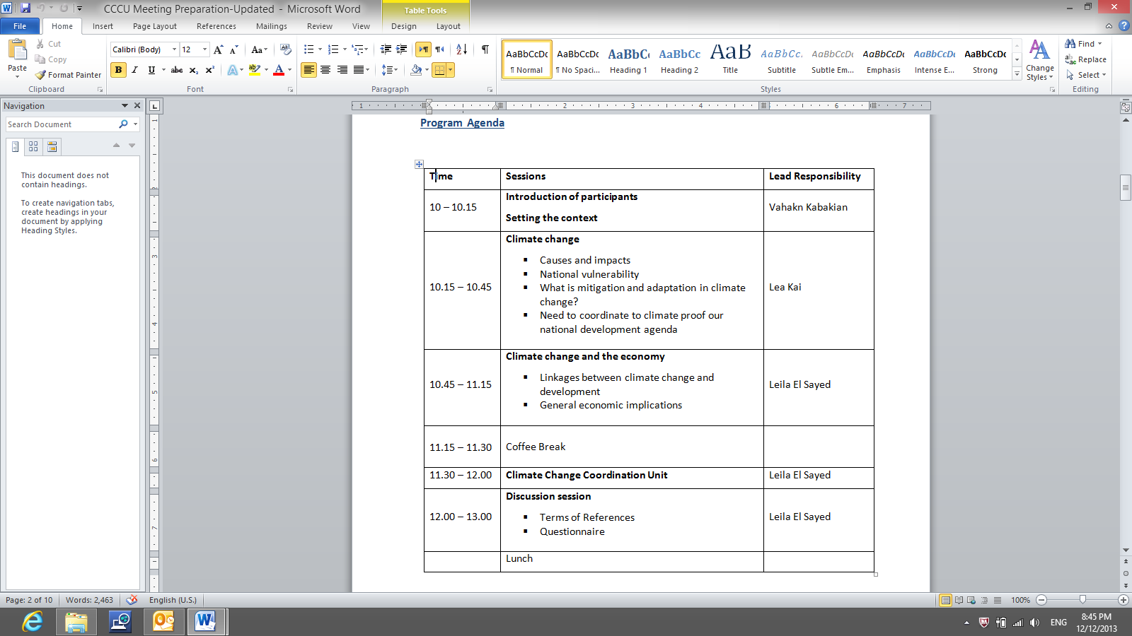

Photos:

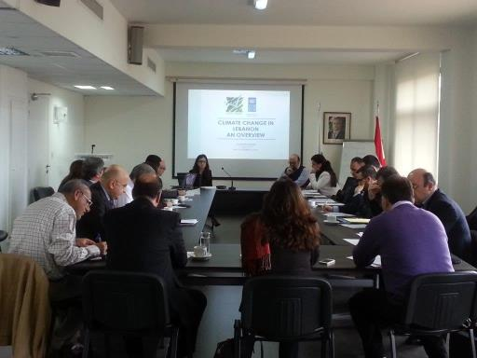

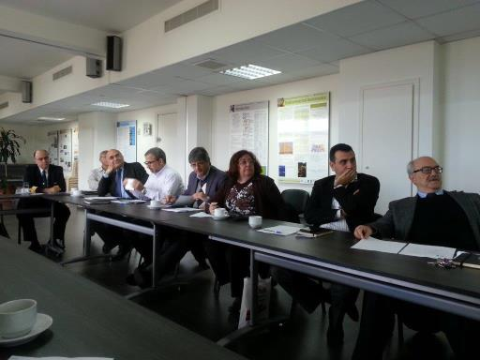

Annex2: List of the members who undertook the NAIIS training

|  |  |  |  |  |  |
| --- | --- | --- | --- | --- | --- |
|  | **Name** | **Title** | **Field of Expertise** | **Organization** | **E-mail** |
| 1 | Ms. Lea Kai | TNC project Manager | General GHG inventory | Ministry of Environment | [l.kai@moe.gov.lb](mailto:l.kai@moe.gov.lb) |
| 2 | Ms. Yara Daou | TNC project assistant | General GHG inventory | Ministry of Environment | [y.daou@moe.gov.lb](mailto:y.daou@moe.gov.lb) |
| 3 | Mr. Jean Stephan | Agriculture engineer | Agriculture sector | Ministry of Agriculture | [jeanstephan@hotmail.com](mailto:jeanstephan@hotmail.com) |
| 4 | Mr. Ramzi Shaha | Head of Department | Chemical Engineer  Industrial sector | Ministry of Industry | [Ramzi_shaha@hotmail.com](mailto:Ramzi_shaha@hotmail.com) |
| 5 | Mr. Charbel Mansour | Assistant professor | Transport and energy sectors | Lebanese American University | [Charbel.mansour@lau.edu.lb](mailto:Charbel.mansour@lau.edu.lb) |
| 6 | Mr. Marwan Rizkallah | Consultant in Environmental engineering and Management | Waste Sector | Freelance Consultant | [Marwan.rizallah@gmail.com](mailto:Marwan.rizallah@gmail.com) |
| 7 | Mr. George Mitri | Director of Biodiversity Programme  Assistant professor | Land use, land use change and forestry sector | University of Balamand | [George.mitri@balamand.edu.lb](mailto:George.mitri@balamand.edu.lb) |

Annex 3. List of members who underwent the climate change negotiations training

|  |  |  |  |
| --- | --- | --- | --- |
|  | **Name** | **Organization** | **E-mail** |
| 1 | Vahakn Kabakian | Ministry of Environment /UNDP | [vahakn@moe.gov.lb](mailto:vahakn@moe.gov.lb) |
| 2 | Lea Kai Aboujaoude | Ministry of Environment /UNDP | [L.kai@moe.gov.lb](mailto:L.kai@moe.gov.lb) |
| 3 | Yara Daou | Ministry of Environment /UNDP | [y.daou@moe.gov.lb](mailto:y.daou@moe.gov.lb) |
| 4 | Leila el Sayed | Ministry of Environment /UNDP | [leila.el-sayed@undp-lebprojects.org](mailto:leila.el-sayed@undp-lebprojects.org) |
| 5 | Rola el Sheikh | Ministry of Environment | [rola.sh@moe.gov.lb](mailto:rola.sh@moe.gov.lb) |
| 6 | Ali Shaar | Civil Aviation | [ali.shaar@hotmail.com](mailto:ali.shaar@hotmail.com) |
| 7 | Marwan Francis | Ministry of Foreign Affairs and Immigrants | [mtfrancis@gmail.com](mailto:mtfrancis@gmail.com) |
| 8 | Mohammad Arayssi | Ministry of Finance | [mohammadar@finance.gov.lb](mailto:mohammadar@finance.gov.lb) |
| 9 | Lama Ghaddar | Indyact | [lama.ghaddar@indyact.org](mailto:lama.ghaddar@indyact.org) |
| 10 | Hanan Abdul Rida | German Embassy in Lebanon | [hanan.abdul-rida@auswaertiges-amt.de](mailto:hanan.abdul-rida@auswaertiges-amt.de) |
| 11 | Wiam Kordab | Civil Aviation | [wiam.kordab@gmail.com](mailto:wiam.kordab@gmail.com) |
| 12 | Karrem Chehayeb | ASI | [chehayeb91@gmail.com](mailto:chehayeb91@gmail.com) |
| 13 | Najah Jaroush | Green Party | [jaroushn@gmail.com](mailto:jaroushn@gmail.com) |
| 14 | Rana El Hajj | American University of Beirut/Issam Fares Institute | [re15@aub.edu.lb](mailto:re15@aub.edu.lb) |
| 15 | George Mitri | Balamand University | [george.mitri@balamand.edu.lb](mailto:george.mitri@balamand.edu.lb) |
| 16 | Wael Hmaidan | Climate Action Network - International | [whmaidan@indyact.org](mailto:whmaidan@indyact.org) |
| 17 | Camilla Baush | Ecologic Institute | [camilla.bausch@ecologic.eu](mailto:camilla.bausch@ecologic.eu) |
| 18 | Lena Donat | Ecologic Institute | [lena.donat@ecologic.eu](mailto:lena.donat@ecologic.eu) |
| 19 | Mattias Duwe | Ecologic Institute | [Matthias.Duwe@ecologic.eu](mailto:Matthias.Duwe@ecologic.eu) |
| 20 | Ralph Boddle | Ecologic Institute | [Ralph.Bodle@ecologic.eu](mailto:Ralph.Bodle@ecologic.eu) |

**Agenda:** 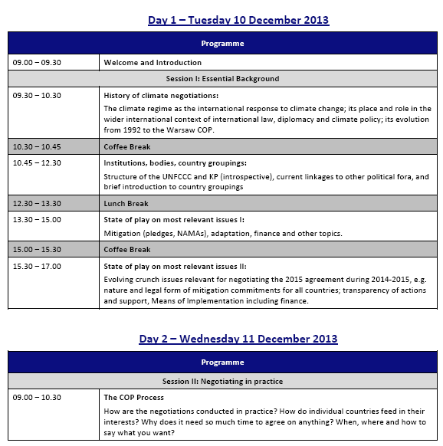****

**Photos:**

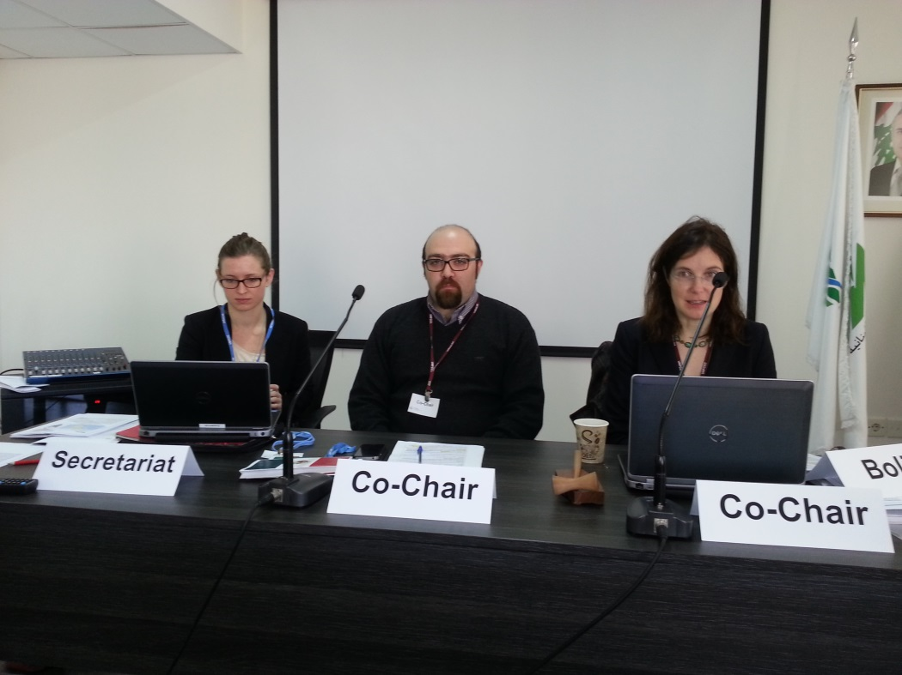

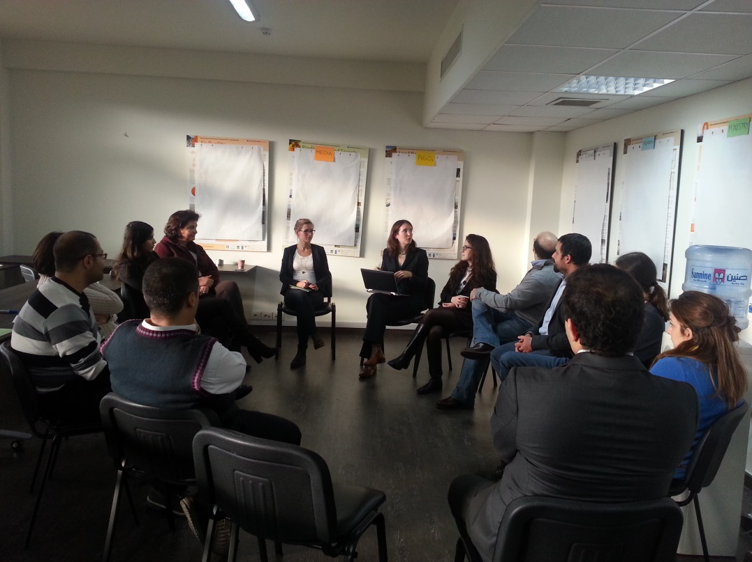

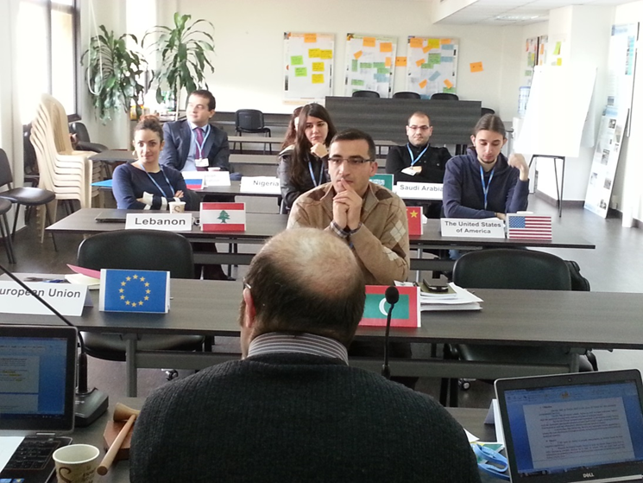

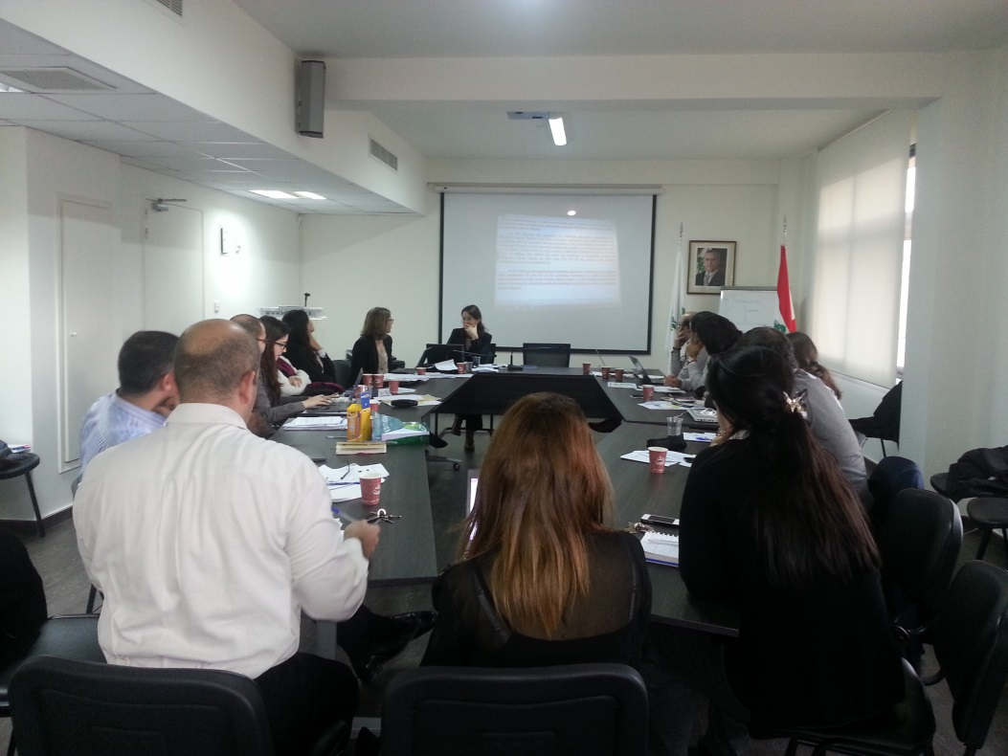

1. The term “programme” is used for programmes, joint programmes and projects.
2. Strategic Results, as formulated in the Strategic UN Planning Framework (e.g. UNDAF) or project document;
3. The MPTF Office Project Reference Number is the same number as the one on the Notification message. It is also referred to as “Project ID” on the project’s factsheet page the [MPTF Office GATEWAY](http://mdtf.undp.org)
4. The MPTF or JP Contribution, refers to the amount transferred to the Participating UN Organizations, which is available on the [MPTF Office GATEWAY](http://mdtf.undp.org)
5. The start date is the date of the first transfer of the funds from the MPTF Office as Administrative Agent. Transfer date is available on the [MPTF Office GATEWAY](http://mdtf.undp.org/)
6. As per approval of the original project document by the relevant decision-making body/Steering Committee.
7. If there has been an extension, then the revised, approved end date should be reflected here. If there has been no extension approved, then the current end date is the same as the original end date. The end date is the same as the operational closure date which is when all activities for which a Participating Organization is responsible under an approved MPTF / JP have been completed. As per the MOU, agencies are to notify the MPTF Office when a programme completes its operational activities.
8. Note: Outcomes, outputs, indicators and targets should be **as outlined in the Project Document** so that you report on your **actual achievements against planned targets**. Add rows as required for Outcome 2, 3 etc.