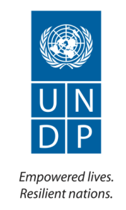

**Peace and Transition Support Project**

**Periodic Progress Report: Second Quarter 2015**

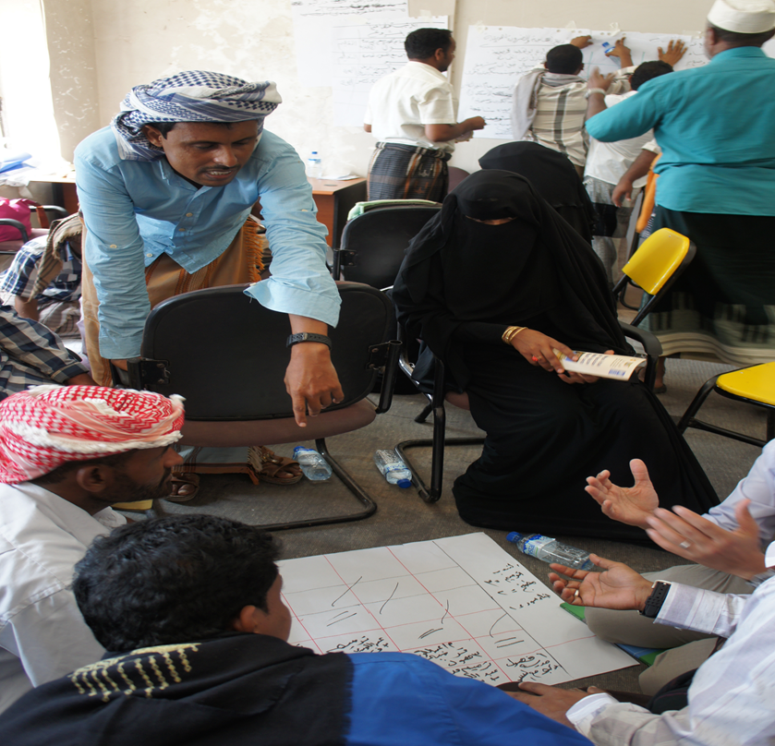

A Training session in Socotra for local authority staff, 2014 ( from Project Archive)

|  |  |
| --- | --- |
| **Implementing Agency:** | United Nations Development Programme |
| **Country/Region or Area:** | Yemen |
| **Project Title and ID:** | Peace and Transition Support Project (Award No. 00079418) |
| **Project Duration:** | May 2014 – October 2016 |
| **Reporting Period:** | April - June 2015 |
| **Contact Person/s:** | Chikako Kodama, Chief Technical Advisor |
| **Funded by:** | European Union, Peacebuilding Fund, UNDP |

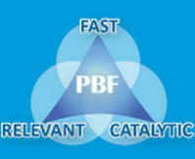**Progress Review**

| **UNDP Country Programme Document outcome:** | | **CPD outcome 26/ UNDAF outcome 7**  By 2016, Government is accountable at central and local levels and decentralization, equitable access to justice, protection and promotion of human rights is strengthened as well as capacity to promote International Humanitarian Law is build. | | |
| --- | --- | --- | --- | --- |
| **UNDP Strategic Plan outcome:** | | **Outcome 3**: Countries have strengthened institutions to progressively deliver universal access to basic services | | |
| **UNDP Strategic Plan Output:** | | **Output 3.2:** Functions, financing and capacity of sub-national level institutions enabled to deliver improved basic services and respond to priorities voiced by the public | | |
| **Project/Programme Outcome:** | | N.A. (project outcome is same with the CPD outcome) | | |
| Indicator | Baseline | | Target | Current Status |
| **CPD outcome indicator:**  Responsive democratic governance (i.e. participation, equity, decision making authority, transparency and accountability) extended at local level | Year: 2011  Status:  1. Law and strategy in place  2. 48 Districts local development plans | | Year: 2016  Value:  1. Revisiting of Governance structure in view of the GCC initiative;  2. 150 Districts local development plans | Year: End of 2014  Value:  1. A option paper produced to provide future government structure  2. Two out of target 12 districts have district plans |
| **Strategic Plan Outcome indicator:** 3.1 Level of public confidence in the delivery of basic services | Year: 2015  Status: To be established. | | Year: 2015  Value: | A perception survey was planned in Q1 but it was cancelled due to the project context change and needs of project change. |
| **Strategic Plan Output Indicator:**  Level of capacity of sub-national governments/administrations for planning, budgeting and monitoring basic services delivery (Scale 1 to 4)[1]   * + - * **3.2.2.A1**: Level of capacity of sub-national governments/administrations for planning delivery of basic services       * **3.2.2.A2**: Level of capacity of sub-national governments/administrations for budgeting delivery of basic services       * **3.2.2.A3:** Level of capacity of sub-national governments/administrations for monitoring delivery of basic services | Year: 2013  Status:  A1: 1  A2: 1  A3: 1 | | Year 2015  Value:  A1: 3  A2: 3  A3: 2 | Year: End of 2014  Value:  A1: 1  A2: 1  A3: 1 |
| **Project Outcome indicators:**  **Indicator 1:** % of people's perception in the target districts on transparency, accountability  **Indicator 2:** % of women and young people (both male and female) in the target districts think that their opinions/needs are reflected in district level planning and budgeting  **Indicator 3:** % of people's satisfaction in the target districts to the government's social service delivery | Year: 2014  Status: To be confirmed. | | Year: 2015  Value:  Indicator 1: 50%  Indicator 2: 50%  Indicator 3: 50% | A perception survey was planned in Q1 but it was cancelled due to the project context change and needs of project change. |

| **Output 1** | | | | | | **Indicators** | | | | **Baseline** | | **Annual target[2]** | **Progress** | | |
| --- | --- | --- | --- | --- | --- | --- | --- | --- | --- | --- | --- | --- | --- | --- | --- |
| JP output 1: District and Governorate Authorities capacitated to deliver peace and development projects. | | | | | | Level of capacity of sub-national governments/administrations for planning delivery of basic services | | | | Year 2013  Value (Score 0-4)[3]: 1 | | Year 2015  Value: 3 | Value: 1  Data verification missions by district authorities were supposed to be implemented in April. Due to intensified conflicts, they were cancelled. | | |
| Level of capacity of sub-national governments/administrations for budgeting delivery of basic services | | | | Year 2013  Value (Score 0-4): 1 | | Year 2015  Value: 3 | Value: 1  Technical support to develop district budgets was postponed | | |
| Level of capacity of sub-national governments/administrations for monitoring delivery of basic services | | | | Year 2014  Value (Score 0-4): 1 | | Year 2015  Value: 2 | Value: 1  A training session for M&E to district authorities was planned in Q2 2015. This did not take place because the conflicts were intensified. | | |
| # of people, disaggregated by sex, benefiting from district plans focused on peace and development | | | | 0 people benefitting from district plans focused on peace and development (2013) | | All target district people benefitting from district plans focused on peace and development (2016) | 0  No development project has been implemented. | | |
| # of local governments with district plan approved, including earmarked budget commitments to sectors that were identified as conflict triggers in an inclusive/participatory planning process | | | | 2 district authorities had district plans submitted to the governorate (2014) | | 12 districts have begun to peace and development plans with earmarked commitments to sectors identified as conflict triggers (2016) | 1 district authority drafted the district plan but has not completed due to the war. | | |
| **Planned activities in the AWP** | **Timeframe (in the AWP)** | | | | | **Level of implementation** | | **Progress and results achieved** | | | | | | **Allocated budget** | **Expenses and % of utilization** |
| **Q1** | | **Q2** | **Q3** | **Q4** |
| Activity Result 1.1 Mobile Team and District Facilitation Teams and Core Team office equipped to fulfil their responsibilities | X | |  |  |  | 80 % | | Procurement of 28 computers and accessories were completed in 2014 and their distribution started (10 districts have confirmed the receipt and 4 districts have not received yet). In June the supplier has been trying to deliver remaining computers to Mukalla and Dawaan as the fighting reduced in the target districts. It will be delivered to Mukalla and Dawaan by the end of July. The computers for Socotra will be delivered when flights resume in August. | | | | | | $ 20,000 |  |
| Activity Result 1.2 Mobile Team, District Facilitation Teams and Core Teams are reactivated and functional in developing participatory district plans and budgets | X | | X | X | X | 23.8% | | The conflict started from the end of March still continues and PTSP could not continue to support district plan and budget development.  A proposal developed together with Taiz DTF, UNFPA and UNDP for engaging citizen using new technology won the award (Annex 1). | | | | | | 814,711.6 | 194,160.58 |
| Activity Result: 1.3 Grants provided to local authorities to respond to local peacebuilding and recovery needs | X | |  |  |  | 0% | | Provision of grants in supporting the 2015 development projects were cancelled due to the following reasons:   * The development budget for 2015 was not transferred to local authorities since there is no approval of the 2015 development budget. * During the airstrikes it does not make sense to support infrastructure development/rehabilitation projects. * The UN Peacebuilding Fund (PBF) has requested to suspend project activities | | | | | | 2,301,000 | 1,416.39 |
| Sub Total | | | | | | | | | | | | | | 3,135,711.64 | 252,111.97 |
| **Outputs Key results** | | | | | | | | | | | | | | | |
| The escalated conflict has changed the overall context of the project and no activity originally planned has taken place. Two of the target areas, Hajja and Taiz as well as Sana’a where the UNDP PTPS project team is based are under continued airstrikes. In Hadramaut, AQAP is active while there is no means of transportation to travel to Socotra. Thus, project activities face challenges with implementation.  While UNDP international staff were temporally relocated to Amman from April to June, PTSP national staff remained in the country. However, three out of five national staff have relocated to outside Sana’a. Regardless of the locations, all staff have no electricity (when there is, only for a few hours/day). Thus, staff do not have any internet access nor most of the time phone access (due to lack of the battery).  In the meantime, some of the initiatives were taken:   * Submission of call for proposal on citizen’s engagement together with Taiz Governorate authority, UNFPA and UNDP. The proposal was awarded. With adjustment based on the given context, a tool for Khadhir district to engage citizens will be developed in Q3 & 4. * A quick assessment of the local authorities’ situation has been conducted in 14 districts targeted by PTSP. Main findings were as follow: * In 14 districts, civil servants are still paid. * Twelve district authorities have received operational costs from the central government between April and June. * No district has received the development budget allocation from the central government for 2015 so no district plan and project has been implemented. * Nine districts responded that they still provide public services although seven out of nine districts said only limited to health, electricity and water. * Due to the context changes, UNDP initiated to develop a new programme framework (a brief of the programme is attached as annex 2). PTSP will be realigned to the new programme framework. * As a part of Humanitarian Response Plan, proposals to support local governance have been submitted to SIDA. | | | | | | | | | | | | | | | |
| **Output 3** | | | | | | **Indicators** | | | **Baseline** | | **Annual target** | | **Progress** | | |
| JP Output 3: Political and Legislative Framework for local governance extension and reform strengthened through the transition process | | | | | | Indicator 1: Participatory conflict-sensitive local development planning institutionalised. | | | Local development planning is delinked from security and peacebuilding processes. | | In 14 district, participatory conflict-sensitive local development planning institutionalised. | | All the policy level discussions were postponed until the end of war and the return of the legitimate national counterparts. | | |
| Indicator 2: # of public and political consultation on local government-unitary decentralization/federalism | | | National Dialogue Conference was convened (2013) | | 12 districts have begun to peace and development plans with earmarked commitments to sectors identified as conflict triggers (2016). | | Due to the lack of the legitimate government and the air strike on Yemen the support was suspended. | | |
| Indicator 3: Assessment of Local Governance recommended actions in National Dialogue Outcomes | | | A federal system was recommended in the NDC outcomes. | | Legal framework review to respond to the new governance system  Capacity assessment of MoLA to prepare for the federal system | | Due to the lack of the legitimate government, the air strike on Yemen the support was suspended. | | |
| **Planned activities in the AWP** | | **Timeframe (in the AWP)** | | | | **Level of implementation** | **Progress and results achieved** | | | | | | | **Allocated budget** | **Expenses and % of utilization** |
| **Q1** | **Q2** | **Q3** | **Q4** |
| Activity Result 3.1 Provision of technical advice and comparative experience in support of design of a new federal and decentralisation systems | | X | X | X | X | 0% | Support to output 3 was postponed due to the political conflict mentioned and the air strike that started on March 26. | | | | | | | $ 262,510.64 | 0 |
| Activity Result 3.2: Review and support of local governance legal framework in selected regions (Max 3 regions covering target 4 governorates) | | X | X | X | X | 0% | $ 92,500 | 0 |
| Activity Result 3.3: Institutional readiness and capacity of MoLA improved | |  | X | X |  | 0% | $ 13.500 | 0 |
| Sub Total | | | | | | | | | | | | | | $ 368,510.64 | 0 |
| **Outputs Key results** | | | | | | | | | | | | | | | |
| This output was planned to provide various technical support to the MoLA at the central government level. Unfortunately the intensified conflict and lack of the counterparts in MoLA (since the MoLA minister’s house arrests, most of the MoLA staff including Deputy Ministers ceased reporting to the office), PTSP could not provide the policy level support. | | | | | | | | | | | | | | | |

Project Risk and Issue Log

| **#** | **Description and date identified** | **Risk or Issue and Type** | **Probability (very likely=5, Likely=4, Moderate=3, unlikely=2, very unlikely=1)**  **Impact on results (critical=5, severe=4, moderate=3, minor=2, negligible=1)** | **Mitigation measure** | **Responsible** | **Deadline** |
| --- | --- | --- | --- | --- | --- | --- |
| **A** | Military operation by Saudi Arabia and its coalition against the Houthies and allied military units, which are loyal to the former President Ali Abdullah Saleh, with the objective of restoring the President Hadi’s Government (26 March). | Security | Escalation of conflicts in all over Yemen: Al Houthis expand their control on the ground and the Saudi-led coalitions continue air strikes.  Escalation of movement for the southern region’s separation  Probability = 5  Impact = 5 | * Identify alternative implementation and monitoring modality (Third party hiring and monitoring to implement and monitoring project) | DCD (operation)  CTA | 31 December |
| **B** | President Hadi left first to Aden after escaping from house arrest and announced his legitimacy as the President while the Houthi has de-facto control over Sana’a (where the Constitution stipulates as a capital).  Then, the President left from Yemen and remains in Saudi Arabia (26 March)  After regain of main areas of Aden and its airport by Saudi-led coalition, some Ministers returned to Aden (end of July) | Political/ Legal | * No legitimate counterpart at the national level. * Further polarization of authorities * No public finance (reduction of or no transfer to local level, No salary payment, No subsidy)   Probability = 5  Impact =5 | * Focus on directly working with local authorities with objective of restoring public service provision * Focus on support to the technical issues | Governance TL  National Coordinator  Chief Technical Advisor (CTA) | 30 September (next review deadline) |
| **C** | Humanitarian crisis intensified (L3 announced on 1 July) and prioritisation of humanitarian activities | Strategic | * UNDP’s projects will not categorized critical level 1. * Limited human and financial resources on the ground   Probability = 5  Impact = 5 | * Empower national colleagues for project implementation * Establish a backstopping mechanism among international staff. | Governance TL  National Coordinator  Chief Technical Advisor (CTA) | 30 September (next review deadline) |
| **D** | Change of focus of projects/programmes (27 March) | Strategic and operational | * Change in needs given the new context during/after airstrikes by the Saudi-led coalition and crashes between the Houthis and the military loyal to the President; the needs would be more life-saving issues, including shelters, water and food.   Probability = 5  Impact =5 | * Review of the project and propose re-programme to the project board. * Plan and manage the transition to the new project | National Coordinator  CTA | 30 September (next review deadline) |
| **E** | Possibility of donors’ reconsideration/suspension of support to projects/programmes in Yemen (10 February)  PBF has suspended the projects (10 April)  No 2nd instalment from EU (End of July) | Financial | * Suspension or cancel the project * Cancel staff contract   Probability = 5  Impact = 5 | * Communications and discussions with donors to allow minimum operations of the project without suspension | Governance TL  CTA | 30 September (next review deadline) |
| **F** | Slow-down of delivery due to lack of resources and escalation of conflicts (April) | Financial | No project implementation  Probability = 5  Impact = 5 | * Communications with counterparts and beneficiaries * Expand resource mobilization efforts | Governance TL  CTA | 30 September (next review deadline) |
| **G** | Inflation of commodities or shortage of staple food supplies and fuel  Cancel subsidy to fuel | Economy | * Implementation of the project will require more resources than the original project document foresaw.   Probability = 5  Impact = 5 | * Plan alternative implementation modality to reduce costs. | Project Coordinator  CTA | 30 September (next review deadline) |

**Financial summary**

**Date: 31 March**

**(Based on Combined Delivery Report until 30 June 2015)**

**By project activity**

|  |  |  |  |  |  |
| --- | --- | --- | --- | --- | --- |
| **Project Output** | **Planned Activities**  **(Activity Results)** | **Budget** | **Total expenses** | **Advance** | **% Utilization** |
| Output 1 | Activity Result 1.1 District Facilitation Teams’ (DFTs) offices equipped to fulfil their responsibilities | $3,135,711.64 | $357,726.09 | $ 0 | 11.41% |
| Activity Result 1.2 Mobile Team (MT), DFT and Core Team (CT) are reactivated and functional |
| Activity Result 1.3: District plan is reviewed in a participatory manner and made public |
| Activity Result 1.4: Peace and Development grants system established |
| Output 3 | Activity Result 3.1 Provision of technical advice and comparative experience in support of design of a new federal and decentralisation systems | $368,510.64 | $0 | $ 0 | 0 |
| Activity Result 3.2 Legal framework for local government reviewed to reflect outcomes of national dialogue and constitutional review |
| Activity result 3.3 Institutional readiness and capacity of MoLA improved to assume its role following outcome of national dialogue and/or constitutional review |
| **DPC+GMS** | | $172,293.39 | $64,487.18[4] | $ 0 | 0 |
| **Total** | | $ 3,676,515.66 | $422,213.27 | $ 0 | 11.48% |

**By Funds and Donors**

|  |  |  |  |  |  |  |  |
| --- | --- | --- | --- | --- | --- | --- | --- |
| **Fund** | **Donor** | **Commitment** | **Received fund up to 2014** | **Expenditure** | | | **Balance (Received-Expenses)** |
| **Year 2014** | **Q1 &2 2015** | **Total expenses** |
| CPR TTF | UNDP (00012) | $150,000 | $150,000.00 | $38,257.99 | $1,818.81 | $40,076.8 | $109,923.2 |
| CPR TTF | Germany (00117) | $150,000 | $150,000.00 | $0 | $0 | $0 | $150,000 |
| Cost Sharing | PBF (11723) | $1,000,000 | $1,000,000 | $19,300.92 | $221,942.41 | $241,243.33 | $758,756.67 |
| EU | EU (10159) | $1,500,000 | $797,419.31 | $556,146.1 | $198,452.05 | $754,598.15 | $42,821.16 |
| Cost Sharing | FRA  (00112) |  | $137,644.35 | $0 | $0 | $0 | $137,644.35 |
| TOTAL |  | $2,800,000 | $2,235,063.66 | $613,705.01 | $422,213.27 | $1,035,918.28 | $1,199,145.38 |

**Updated quarterly work plan[5] for the following period: Third Quarter**

| **Planned activities in the AWP** | **Timeframe (in the AWP)** | | | | **Description/ Comments** | **Allocated budget** | **Budgetary level of execution** |
| --- | --- | --- | --- | --- | --- | --- | --- |
| **Q1** | **Q2** | **Q3** | **Q4** |
| Output 1: District and Governorate Authorities capacitated to deliver peace and development projects | | | | | | | |
| Activity Result 1.1 Mobile Team and District Facilitation Teams and Core Team office equipped to fulfil their responsibilities |  |  | x |  | Follow up the delivery of PCs and a vehicle. | $20.000 | 56,535 |
| Sub Total | | | | | | $ 3,135,711.64 | 252,111.9 |
| DPC+GMS | | | | | | $172,293.39 |  |
| Total | | | | | | $3,676,515.66 |  |

**Other works to be implemented in Q3 are as follow:**

* Local governance survey in Aden, Hajjah, Taiz and Sa’ada Governorates. Two to three districts will be covered in each governorate. The results will be available in early September.
* Quick damage assessment of social and economic infrastructure in Taiz and Hajjah.
* Development of Mushaaraknaa[6] together with Khadir district authority and Taiz Governorate authority. The tool will complete in the end of 2015.

**Annexes:**

**Annex 1: Monitoring Plan for the following quarter**

|  |  |  |
| --- | --- | --- |
| Activity | Responsible | Deadline |
| Local governance survey | Planning and Grants Officer, CTA | 31 August |

1. 1 = No capacity; 2 = very partial capacity; 3= partial capacity; 4= capacity largely in place
2. Annual target has to be reviewed
3. 1 = No capacity; 2 = very partial capacity; 3= partial capacity; 4= capacity largely in place
4. The GMS includes Q3 and Q4 for 2014.
5. OtherDue to the lack of resources in PTSP project, only follow up of activity result 1.1 will be done.
6. Mushaaraknaa means “our participation” and it’s a tool to ensure citizen engagement (please refer to a proposal, annex 2).