RUNO ANNUAL PROJECT REPORT TEMPLATE 4.4
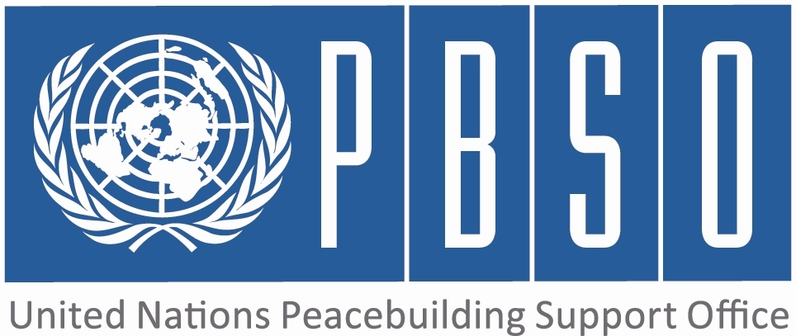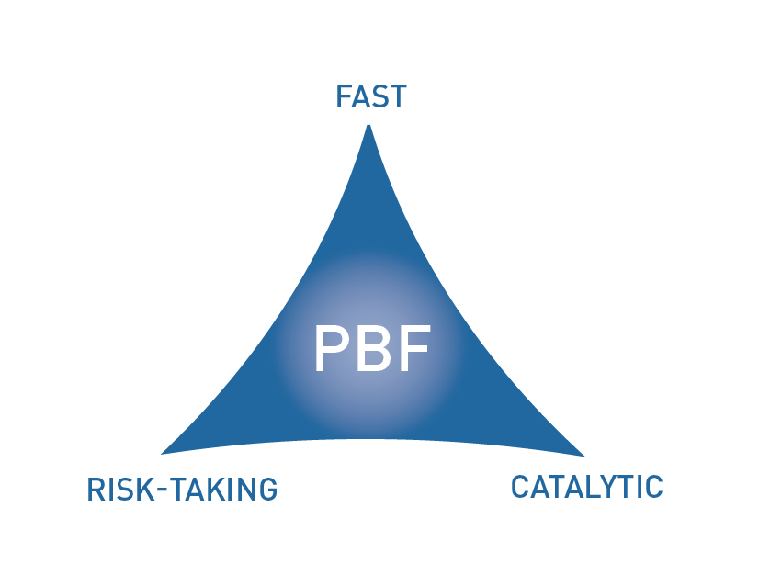

PEACEBUILDING FUND (PBF)
ANNUAL PROJECT progress report
COUNTRY: Kyrgyzstan
REPORTING PERIOD: 1 january – 31 December

Programme Title & Project Number
Programme Title: PBF/KGZ/B1 Building Trust and Confidence Among People, Communities and Authorities (Part 1 - PPP Outcome 1)

Programme Number (if applicable)
MPTF Office Project Reference Number: 00088477

Recipient UN Organizations |  |  | Implementing Partners
List the organizations that have received direct funding from the MPTF Office under this programme: UNHCR |  |  | List the national counterparts (government, private, NGOs & others) and other International Organizations: Government: Ombudsman's Office, Department of Local Self-Government and Interethnic Relations  NGOs: PU Abad, PU Law Center, FTI
Programme/Project Budget (US$) |  |  | Programme Duration
PBF contribution (by RUNO) 350,959 |  |  | Overall Duration (months) 24
PBF contribution (by RUNO) 350,959 |  |  | Start Date (dd.mm.yyyy) 01/01/2014
Government Contribution  (if applicable) |  |  | Original End Date (dd.mm.yyyy) | 31/12/2015
Other Contributions (donors)  (if applicable) |  |  | Current End date(dd.mm.yyyy) 31/12/2015
TOTAL: | 350,959

Programme Assessment/Review/Mid-Term Eval. |  | Report Submitted By
Assessment/Review - if applicable please attach  Yes No Date:  Mid-Term Evaluation Report – if applicable please attach  Yes No Date: |  | Name: Christian Langehenke  Title: Associate Protection Officer  Participating Organization (Lead): UNHCR  Email address: langehen@unhcr.org

PART 1 – RESULTS PROGRESS

  - Assessment of the current project implementation status and results

For PRF projects, please identify Priority Plan outcome and indicators to which this project is contributing:
Priority Plan Outcome to which the project is contributing. 1 and 2
Priority Plan Outcome indicator(s) to which project is contributing. 1.1;2.1;2.2

For both IRF and PRF projects, please rate this project’s overall achievement of results to date:

For both IRF and PRF projects, outline progress against each project outcome, using the format below. The space in the template allows for up to four project outcomes.

Outcome Statement 1: The target population and communities are enabled to solve crucial incidents/grievances/conflicts through or together with authorities, thus increasing dialogues among people, communities and authorities, building up good examples of confidence and trust

Rate the current status of the outcome:
Indicator 1:  % increase of people’s trust/satisfaction with the work of local government and police  Indicator 2:  % decrease of fear among minorities to face humiliation/discrimination while approaching LSG and state authorities (including police) with their concerns/grievances  Indicator 3:  % increase of filed grievances where formal procedures are followed by locals self-government bodies according the law | Baseline: 43 % of focus group participants are dissatisfied with the work of local self-government entities  Target: 10%  Progress:on track  Baseline: 16% of focus groups report fear among minorities to face humiliation/discrimination while approaching LSG and state  authorities  52 % of individuals questioned during baseline study saw room for improvement for government authorities and police to realize non-discriminatory and equal access  Target: 20% decrease  Progress:on track  Baseline: 55% of filed grievances were answered satisfactorily; 60% on time  Target: 30% increase in compliance  Progress:on track

Output progress

List the key outputs achieved under this Outcome in the reporting period (1000 character limit).Outputs are the immediate deliverables for a project.
During 2014, UNHCR's implementing and government partners rendered legal assistance in 141 cases. The original target set in the results framework was 60 cases. These cases where jointly selected by UNHCR, government partners (State Agency of Local Self-Government and Interethnic Relations AND Office of the Ombudsman) and UNHCR during 11 regional selection committee meetings. Of the 141 selected cases, 61 have been resolved successfully through follow up, administrative procedures or court proceedings. All beneficiaries certified their satisfaction by a signed declaration.

Outcome progress

Describe progress made during the reporting period toward the achievement of this outcome. This analysis should reflect the above indicator progress and the output achievement. Is there evidence of the outcome contributing to peacebuilding and to the specific conflict triggers? Is the theory of change that underpins the project design still relevant for this outcome (3000 character limit)?

The aim of the provision of legal aid for individual cases is to allow for problem and grievances solving through dialogue and cooperation rather than through illegal or violent means. The key feature of this outputs is the close involvement of government partners. All legal cases are presented by IPs to a joint selection panel which determines whether the case can serve as a precedent for successful conflict resolution through legal means. These selection committee meetings itself had a huge impact on government partner's ability to solve conflict. In 10 cases, government partners (both Ombudsman's Office and LSGA) decided to follow up cases independently and tried to find a solution. UNHCR IPs rendered assistance if necessary and government bodies were able to demonstrate their ability to solve conflicts and grievances. The selected legal cases are related to HLP disputes, registration of birth and marriage, social benefits, and administrative legal procedures. The successful resolution of 61 cases (as of November 2014) demonstrated to citizens that legal resolution is indeed possible. At the same time, government agencies used their authority and enhanced their expertise in critical areas of law in order to solve conflicts in the future.

Reasons for low achievement and rectifying measures

If sufficient progress is not being made, what are the key reasons, bottlenecks and challenges? Were these foreseen in the risk matrix? How are they being addressed and what will be the rectifying measures (1500 character limit)?
With 141 selected cases of which 51 sucessfully resolved cases, UNHCR overachieved the set target of 60 resolved cases in 24 month by more than 200%.

Outcome Statement 2: LSGs, LSGA and other oversight entities are enabled to provide effective feedback/conflict resolution mechanisms for the population and by actively listening to the population, providing impartial feedback and taking remedial measures, thus demonstrating their accountability.

Rate the current status of the outcome:
Indicator 1:  Indicator 2.1  % increase in level of trust to local authorities that they are capable to solve  incidents/grievances/conflicts  Indicator 2:  N/A  Indicator 3:  N/A | Baseline: 30% of focus group respondents point out low problem solving capacity of local self-government entities  Target: 30% increase in trust in conflict solving capacity  Progress:on track  Baseline:  Target:  Progress:  Baseline:  Target:  Progress:

Output progress

List the key outputs achieved under this Outcome in the reporting period (1000 character limit).Outputs are the immediate deliverables for a project.
UNHCR works in 25 selected local self-government entities (A/Os). Each local council was supported through trainings on budgeting, legal basics of self-government and land plot allocation. UNHCR IP developed jointly with government partners a collection of applicable legal provisions for local self-government bodies and trained representatives. UNHCR and its government partners jointly selected 51 Peacebuilding Initiatives (PBIs) for implementation in all three southern regions of Kyrgyzstan. As of November 2014, almost 30 projects are completed, by December 15, all PBIs will be implemented. In 20 A/O, open budget hearings were successfully held with the participation of the local population. The budget hearings gave citizens the opportunity to influence the spending of their A/O, voice concerns and start a dialogue with A/O representatives. Furthermore, UNHCR (through direct implementation), provided technical support to A/O in all target areas.

Outcome progress

Describe progress made during the reporting period toward the achievement of this outcome. This analysis should reflect the above indicator progress and the output achievement. Is there evidence of the outcome contributing to peacebuilding and to the specific conflict triggers? Is the theory of change that underpins the project design still relevant for this outcome (3000 character limit)?
All measures to enhance the capacity of local self-government entities and increase their role in conflict resolution are aimed to have medium to long term effect. However, there are several hopeful signs for success: All 51 small scale Peacebuilding Initiatives (PBIs) were developed on the local level by working groups with the involvement of local self-government bodies, civil society organizations (e.g. women's councils) and agents of change (e.g. teachers or elders). Each working group was tasked to identify key conflicts in their village and develop a plan to resolve such conflicts. A small project was developed and discussed by a joint government/UNHCR selection committee. UNHCR on average contributed USD 3000 while local governments and interest groups co-financed the vast majority of projects. The community based approach enhanced problem solving capacity of both people and their local authorities. Working group meetings served as a forum where problems and conflicts could be both discussed and solved with relatively small financial contributions. Often for the first time, local self-government representatives, interest groups, civil society actors and local population came together to discuss potential conflict resolution strategies. The PBIs address the individual conflict resolution needs of the respective communities and include water management projects, intercultural dialogue clubs for school students, enhanced capacity of local self-government bodies and delivery of basic services by government entities. Open budget hearings will be re-occuring in 2015 and citizens are now aware that they are entitled to receive detailed information on expenditures of their A/O. Trainings and awareness raising campaigns on land plot allocation and social benefits involved both government officials and the wider population. Now, both right holders and duty beares are aware of the legal mechanisms. The technical assistance and the issuance of a legal compendium helped to institutionalize local self-government entities as a capable one stop shop in case of conflict within the community.

Reasons for low achievement and rectifying measures

If sufficient progress is not being made, what are the key reasons, bottlenecks and challenges? Were these foreseen in the risk matrix? How are they being addressed and what will be the rectifying measures (1500 character limit)?
Sufficient progress has been achieved. With regard to the implementation of small scale Peacebuilding Initiatives, UNHCR overachieved the target of 20 within two years by over 200% (56 PBIs will be implemented during the first year).

Outcome Statement 3: Policy/ legislative changes and institutional building at the national level are taking into account critical human rights needs of people, and thus strengthening human rights orientation in Kyrgyzstan.

Rate the current status of the outcome:
Indicator 1:  # laws, decrees, policies on local and national level amended and/or accepted. (The numbers and contents of  advocacy points communicated from the project areas to the national level)  Indicator 2:  N/A  Indicator 3:  N/A | Baseline: 0  Target: 3  Progress:1  Baseline:  Target:  Progress:  Baseline:  Target:  Progress:

Output progress

List the key outputs achieved under this Outcome in the reporting period (1000 character limit).Outputs are the immediate deliverables for a project.
UNHCR IPs conduced six evidence based advocay based campaigns, both on the regional and the national level. So far one basline study which includes a perception study, a situation analysis and a migration survey as been conducted, endorsed by government partners and published. Additionally, one UNHCR IP conducted an in-depth analysis of local self-government performance standards. Until December, a second thematic study will be published by UNHCR and its partners.

Outcome progress

Describe progress made during the reporting period toward the achievement of this outcome. This analysis should reflect the above indicator progress and the output achievement. Is there evidence of the outcome contributing to peacebuilding and to the specific conflict triggers? Is the theory of change that underpins the project design still relevant for this outcome (3000 character limit)?
UNHCR's IPs have been very active in using the project of advocay campaigns. These campaigns focused on the rights of land owners and remedies in case of illegal contructions (see success story in part 2.2.), the legal basis for open budget hearings, additional support for local council and social benefits. Three campaigns involved national decision makers such as representatives of ministries, the President's Office and Members of Parliament. As a result of one campaign, the Ministry of Finance issued an Order on open budget hearings and informed the responsible secretaries during a meeting.
During the of the project's baseline study government partners were closely involved. Representatives of the State Agency of Local Self-Government and Interethnic Relations AND the Ombudsman's Office participated in focus groups meetings with over 900 participants. The results of these hearings and the analysis where shared with both partners, discussed and finally endorsed during a joint meeting. High level represenatives signed the foreword of the baseline study and agreed to publish it with the seal of the Kyrgyz Republic. The close involvement of government entities in the analysis raised awareness of specific conflict triggers in southern Kyrgyzstan. The ownership of government partners will also help to adress specific issues in the future on the national level.

Reasons for low achievement and rectifying measures

If sufficient progress is not being made, what are the key reasons, bottlenecks and challenges? Were these foreseen in the risk matrix? How are they being addressed and what will be the rectifying measures (1500 character limit)?
The work with government partners requires patiences and a thorough understanding of bureaucratic particularities. However, UNHCR and its IP have succeeded in building a trustful relationship with several government bodies through close involvement in all project activities and consideration of recommendations.

Outcome Statement 4: N/A

Rate the current status of the outcome:
Indicator 1:  Indicator 2:  Indicator 3: | Baseline:  Target:  Progress:  Baseline:  Target:  Progress:  Baseline:  Target:  Progress:

Output progress

List the key outputs achieved under this Outcome in the reporting period (1000 character limit).Outputs are the immediate deliverables for a project.
N/A

Outcome progress

Describe progress made during the reporting period toward the achievement of this outcome. This analysis should reflect the above indicator progress and the output achievement. Is there evidence of the outcome contributing to peacebuilding and to the specific conflict triggers? Is the theory of change that underpins the project design still relevant for this outcome (3000 character limit)?
N/A

Reasons for low achievement and rectifying measures

If sufficient progress is not being made, what are the key reasons, bottlenecks and challenges? Were these foreseen in the risk matrix? How are they being addressed and what will be the rectifying measures (1500 character limit)?
N/A

  - Assessment of project evidence base, risk, catalytic effects, gender in the reporting period

Evidence base: What is the evidence base for this report and for project progress? What consultation/validation process has taken place on this report (1000 character limit)? | IPs submit weekly workplans, monthly and quaterly reports. UNHCR staff in all three provinces went on over 90 monitoring visits to varify IP's reports. UNHCR management conducts regular meetings with government partners to verify the project's progress. Through joint UNHCR/government selection committees for legal cases and Peacebuilding Initiatives, all project activities are discussed, agreed and monitored. On a monthly basis, IP coordination meetings are held.
Funding gaps: Did the project fill critical funding gaps in peacebuilding in the country? Briefly describe. (1500 character limit) | The direct work on the improvement of conflict resoltion capacity of local self-government bodies is generally not well funded and, due to high risks and labor intense implementation not popular with donors. Simple infrastructure projects such as roads or water pipes offer immediate results with limited risks. The PRF funding enabled UNHCR to implement a variety of critical interventions that would have been otherwise left unfunded.
Catalytic effects: Did the project achieve any catalytic effects, either through attracting additional funding commitments or creating immediate conditions to unblock/ accelerate peace relevant processes? Briefly describe. (1500 character limit) | Often, local self-government bodies are not fully aware of their duties and the corresponding legal regulations. While preparing open budget hearings, one UNHCR IP liaised with the national Ministry of Finance. The Ministry endorsed the guidebook on financial transparency prepared by UNHCR's IP, which gives clear instruction to local self-government how to publicize budget related information. During a workshop, central government representatives explained the guidelines to locals self-government representatives from all 24 UNHCR peacebuilding locations. It is now planned by the Ministry to use this guidebook nationwide, which demonstrates how small initiatives as part of UNHCR's project can positively affect peacebuilding in Kyrgyzstan since transparency, and openness creates trust which, in turn, will prevent further conflict. It is anticipated that several initiatives that are being piloted during UNHCR's peacebuilding project will reach beyond the south of the country.
Risk taking/ innovation: Did the project support any innovative or risky activities to achieve peacebuilding results? What were they and what was the result? (1500 character limit) | The close work with government partner without the incentive of large financial contributions entails several risks. Most prominent, the interest and engagement of partners might be lower than expected. High staff turnover also imposes a risk for successful project implementation. However, the close involvement of government representatives through numerous meetings, field visists and the co-financing of projects resulted in a feeling of ownership that helped to mitigate these risks.
Gender: How have gender considerations been mainstreamed in the project to the extent possible? Is the original gender marker for the project still the right one? Briefly justify. (1500 character limit) | Several project activities are directly focused on women. With regard to legal assistance, more than 30 % of the cases involve gender related issues such as marriage registration, divorce, and land plot allocation for single mothers. In addition, the project supports five women information centers in order to enhance education opportunities for women. Overall, women are involved in almost all working groups and play an active (often the main) role during the implementation of Peacebuilding Initiative. In order to further improve the performance with regard to gender mainstraeming, one UNHCR IP employs an expert who solely assess and enhances the gender impact of UNHCR's peacebuilding project.
Other issues: Are there any other issues concerning project implementation that should be shared with PBSO? This can include any cross-cutting issues or other issues which have not been included in the report so far. (1500 character limit) | Delays regarding the JSC secretariat and delays in PRF project implementation of other RUNOs bear the risk of weak coordination. As a result, the complimentary approach and linkages between projects could not be fulfilled as forseen in the Peacebuilding Priority Plan.

PART 2: LESSONS LEARNED AND SUCCESS STORY

2.1 Lessons learned

Provide at least three key lessons learned from the implementation of the project. These can include lessons on the themes supported by the project or the project processes and management.

Lesson 1 (1000 character limit) | Some ail okmotus are reluctant, not interested and closed for cooperation and many attempts of our implementing partners to involve them into the project activities failed, though they were clearly explained the main idea of the project- which is improving trust between people and authorities. In situations where there is no mutual cooperation and commitment, community benefits the least. Therefore, UNHCR's project is most successful in areas where local self-government functions to a certain degree.
Lesson 2 (1000 character limit) | People in the communities as well as the local authorities demonstrated lack of interest to participate in baseline survey, due to large number of studies being conducted by many different NGOs and international organizations for the last years and do not believe in the effectiveness of such surveys. Therefore, surveys by RUNOs should be coordinated (e.g. by the JSC Secretariat) in order to avoid duplications and unnecessary work.
Lesson 3 (1000 character limit) | During working group meetings for peacebuilding initiatives, community members prioritized mainly infrastructural projects rather than soft projects to solve their problems in the community. This tendency shows that people don’t see the true causes of problems but concentrated on a quick and simple resolution of problems. Therefore, UNHCR combines soft projects with hard components in order to achieve the highest possible community involvement.
Lesson 4 (1000 character limit) | N/A
Lesson 5 (1000 character limit) | N/A

2.2 Success story (OPTIONAL)

Provide one success story from the project implementation which can be shared on the PBSO website and Newsletter as well as the Annual Report on Fund performance. Please include key facts and figures and any citations (3000 character limit).

UNHCR, Osh (8 October) – Residents of Alymbek Datka in Osh celebrate their victory over the illegal construction of multistory building on the district’s territory. On 30 September the resolution, allowing the construction of multistory residential houses was cancelled relieving worries of concerned population. The action of the Osh Mayor’s office serves as a positive example that authorities are willing to engage in an open dialogue with citizens.
Recently, Osh residents observe the construction boom of multistory residential houses. Although it is a factor of urban development, majority of construction works are being done against architecture standards and in close distance from existing residential houses. Very often new multistory buildings occupy territory of children playgrounds and garages.
Residents of Alymbek Datka opposed regulation issued by Mayor’s office, which authorized the construction of multistory building. UNHCR partner Foundation for Tolerance International organized a roundtable between residents, Mayor’s office, and other interested sides to discuss the issue and find a satisfactory solution. Residents pointed out that the construction of such houses will affect the state of the adjacent houses, putting them at risk of destruction. Pipes of hot and cold water, sanitation might be damaged by excavation of depths. In addition, the residents worry about the access during fire and other emergencies due to close location of houses to each other.
Following the roundtable, a talk show with concerned stakeholders was broadcasted on national TV channel ELTR. As a result of UNHCR’s peace building project, the Osh mayor’s office canceled the permit for the construction of a multistory building in Alymbek Datka district. At the same time, UNHCR’s partners continue to provide free legal aid and information for residents about their right with regard to illegal construction in their backyards and about the opportunity to register their land plots.
UNHCR in the Kyrgyz Republic currently implements a two year peacebuilding
project financed by the United Nations Peacebuilding Fund in the south of the
country. The project aims to build trust and confidence among people, communities
and authorities in the aftermath of the June 2010 events.

PART 3 – FINANCIAL PROGRESS AND MANAGEMENT ARRANGEMENTS

  - Comments on the overall state of financial expenditure

Please rate whether project financial expenditures are on track, slightly delayed, or off track:

If expenditure is delayed or off track, please provide a brief explanation (500 characters maximum):

N/A

Please provide an overview of expensed project budget by outcome and output as per the table below.

Output number | Output name | RUNOs | Approved budget | Expensed budget | Any remarks on expenditure
Outcome 1: The target population and communities are enabled to solve crucial incidents/grievances/conflicts through or together with authorities, thus increasing dialogues among people, communities and authorities, building up good examples of confidence and trust
Output 1.1 | At least 60 cases are followed-up throughout  feedback/conflict resolution mechanisms | UNHCR | 135,287 | 71,754 | tentative
Output 1.2 | N/A
Output 1.3 | N/A
Outcome 2: Under part 2 of the Project (KGZ/A3)
Output 2.1
Output 2.2
Output 2.3
Outcome 3: Policy/ legislative changes and institutional building at the national level are taking into account critical human rights needs of people, and thus strengthening human rights orientation in Kyrgyzstan
Output 3.1 | Two local NGOs have capacity to conduct  evidence-based advocacy | UNHCR | 28,291 | 9,740 | tentative
Output 3.2 | Four lessons-learned and situation analysis, migration surveys and perception surveys are  provided for national level advocacy through  protection sector coordination | UNHCR | 131,477 | 38,886 | tentative
Output 3.3 | N/A
Outcome 4: N/A
Output 4.1 | N/A
Output 4.2 | N/A
Output 4.3 | N/A
Total: | N/A

  - Comments on management and implementation arrangements

Please comment on the management and implementation arrangements for the project, such as: the effectiveness of the implementation partnerships, coordination/coherence with other projects, any South-South cooperation, the modalities of support, any capacity building aspect, the use of partner country systems if any, the support by the PBF Secretariat and oversight by the Joint Steering Committee (for PRF only). Please also mention if there have been any changes to the project (what kind and when); or whether any changes are envisaged in the near future (2000 character maximum):

UNHCR hopes that with the kickstarting of other RUNO's projects, synergies as forseen in the Peacebuilding Priority Plan will materialize. This will also require extensive coordination facilitated by the JSC Secretariat. Significant and unecessary delays regarding the hiring of Secretariat personnel caused significant challenges with regard to the overall coordination of the RUNO project. UNHCR is hopeful that PBSO will be able to guide the JSC co-chairs as to ensuring that all key positions within the Secretariat, especially the international advisor, are filled as soon as possible.

The MPTF Office Project Reference Number is the same number as the one on the Notification message. It is also referred to “Project ID” on the MPTF Office GATEWAY
The start date is the date of the first transfer of the funds from the MPTF Office as Administrative Agent. Transfer date is available on the MPTF Office GATEWAY
As per approval of the original project document by the relevant decision-making body/Steering Committee.
If there has been an extension, then the revised, approved end date should be reflected here. If there has been no extension approved, then the current end date is the same as the original end date. The end date is the same as the operational closure date which is when all activities for which a Participating Organization is responsible under an approved MPTF / JP have been completed.
Please note that financial information is preliminary pending submission of annual financial report to the Administrative Agent.

