RUNO Half Yearly Reporting TEMPLATE 4.3
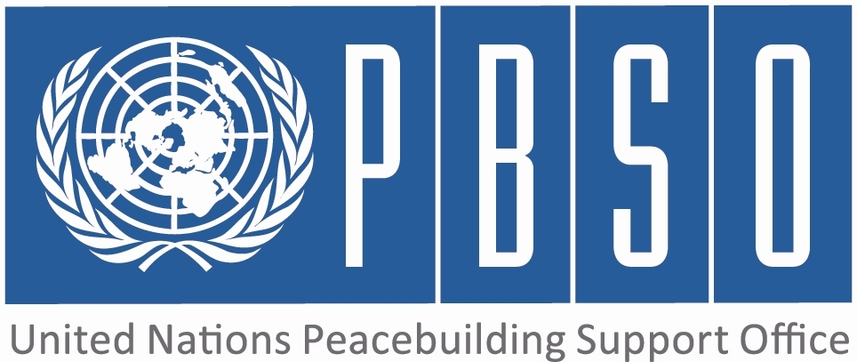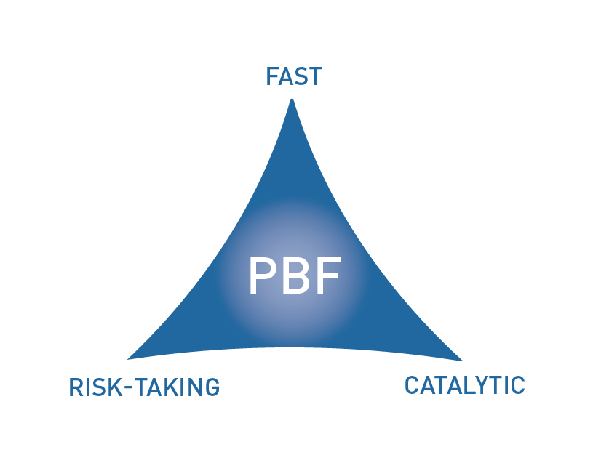
[Kyrgyzstan]

PROJECT HALF YEARLY PROGRESS UPDATE

PERIOD COVERED: JANUARY – JUNE 2015

Project No & Title: | PBF/KGZ/B1 Building Trust and Confidence Among People, Communities and Authorities (Part 1 - PPP Outcome 1)
Recipient Organization(s): | UNHCR
Implementing Partners (Government, UN agencies, NGOs etc): | Government: Ombudsman's Office, Department of Local Self-Governance and Interethnic Relations  NGOs: PU Abad, Spravedlivost, FTI
Location: | Osh, Jalalabad and Batken provinces of the Kyrgyz Republic
Total Approved Budget : | 350 959 USD
Preliminary data on funds committed : | 336 976 USD | % of funds committed / total approved budget: | 96%
Expenditure: | 215 502 USD | % of expenditure / total budget: (Delivery rate) | 61%
Project Approval Date: | 21.11.2013 | Possible delay in operational closure date (Number of months) | 0
Project Start Date: | 01.01.2014 |  | 0
Expected Operational Project Closure Date: | 31.12.2015 |  | 0
Project Outcomes: | Outcome 1  The target population and communities are enabled to solve crucial incidents/grievances/conflicts through or together with authorities, thus increasing dialogues among people, communities and authorities, building up good examples of confidence and trust  Outcome 3  Policy/ legislative changes and institutional building at the national level are taking into account critical human rights needs of people, and thus strengthening human rights orientation in Kyrgyzstan.
PBF Focus Area | 2,4

Qualitative assessment of progress

For each intended outcome, provide evidence of progress during the reporting period.  In addition, for each outcome include the outputs achieved.  (500 words max.) | Outcome 1  The baseline study in which almost 900 people for all UNHCR peacebuilding locations were questioned showed that trust and confidence levels leave room for improvement. In the first six month, dialogue meetings were held in 24 locations with the participation of population and local self-government representatives (LSGs). In addition, eight presentations on the provincial level of PRF project mainly involved local self-government representatives. These meetings gave clear understanding of project activities and ensured support from LSGs for project activities. During a different activity, the budget and expenditures were presented in 20 locations so the population had the opportunity to raise their concerns and influence the decision making process actively for the first time in 2014. This activity was repeated in 2015 in a more institutionalized form. UNHCR IPs observed all budget hearings and more than 80% were conducted according to legal regulations. In addition, UNHCR also installed permanent information stands at local self-government buildings with detailed information on budget and expenditure. As a follow up, communities and local self-government develop jointly with UNHCR ideas for peacebuilding initiatives in order to tackle specific conflicts/grievances (see outcome 2 in A3).  Under project outcome 1, UNHCR provides individual legal assistance to people in order to show that conflict/grievances can be resolved through the existing structures. The aim of the provision of legal aid for individual cases is to allow for problem and grievances solving through dialogue and cooperation rather than through illegal or violent means. The key feature of this outputs is the close involvement of government partners. All legal cases are presented by IPs to a joint selection panel which determines whether the case can serve as a precedent for successful conflict resolution through legal means. These selection committee meetings itself had a huge impact on government partner's ability to solve conflict. In 20 cases, government partners (both Ombudsman's Office and LSGA) decided to follow up cases independently and tried to find a solution. UNHCR IPs rendered assistance if necessary and government bodies were able to demonstrate their ability to solve conflicts and grievances. The selected legal cases are related to HLP disputes, registration of birth and other civil cases, social benefits, and administrative legal procedures. The successful resolution of 123 cases (Target: 60) demonstrated to citizens that legal resolution is indeed possible. At the same time, government agencies used their authority and enhanced their expertise in critical areas of law in order to solve conflicts in the future.  Outcome 3  UNHCR's and its IPs have been very active in conducting advocacy campaigns. These campaigns focused on the rights of landowners and remedies in case of illegal construction, the legal basis for open budget hearings, and additional support for local council and social benefits. Two campaigns involved national decision makers such as representatives of ministries, the President's Office and Members of Parliament. As a result of one campaign, the Ministry of Finance issued an Order on open budget hearings and informed the responsible secretaries during a meeting.  During the of the project's baseline study government partners were closely involved. Representatives of the State Agency of Local Self-Government and Interethnic Relations AND the Ombudsman's Office participated in focus groups meetings with over 900 participants. The results of these hearings and the analysis where shared with both partners, discussed and finally endorsed during a joint meeting. High level representatives signed the foreword of the baseline study and agreed to publish it with the seal of the Kyrgyz Republic. The close involvement of government entities in the analysis raised awareness of specific conflict triggers in southern Kyrgyzstan. The ownership of government partners will also help to address specific issues in the future on the national level. In 2015, additional advocacy campaigns will carry out focusing on the contentious legal issue of land plot allocation and registration, esp. in rural communities.
Do you see evidence that the project is having a positive impact on peacebuilding?  (250 words max.) | During the past 16 month, UNHCR has been able to have a positive impact on peacebuilding in target communities. In 2014, many focused trainings were carried out for local self-government staff on topics like budget planning, conflict resolution, land management and community mobilization. In 2015, the focus has shifted towards the application of the acquired skills. The implementation of community based peacebuilding initiatives allows for targeted resolution of conflicts on the local level. So far, UNHCR has implemented 74 of these projects. While the problems addressed range widely (from trash collection to irrigation water, from increasing local taxes to installation of offices for village heads in rural communities), all projects helped to increase trust between multiethnic communities and authorities. Both local population and authorities have shown that, through joint action, problems can be solved on the local level. Advocacy work and legal assistance additionally bolstered the level of trust between community and authorities. The multi-agency PRF baseline study (conducted by the Secretariat in May 2015) showed that trust and confidence level, both towards authorities and between ethnicities is already significantly higher in UNHCR target communities.
Were there catalytic effects from the project in the period reported, including additional funding commitments or unleashing/ unblocking of any peace relevant processes?  (250 words max.) | UNHCR's approach of community based peacebuilding is already recognized as a best practice among RUNOs and government authorities. While central government structures are highly volatile, structures in villages and small cities tend to be more stable. Here capacity building, paired with financial support for peacebuilding initiatives, individual legal aid and advocacy efforts, is most effective and will have a lasting effect. All peacebuilding initiatives receive co-funding from local or regional budgets to ensure sustainability and ownership. In fact, UNHCR contributes on average only 50% to the total budget of peacebuilding initiatives.  UNHCR cooperates with other RUNOs such as UNICEF, UNDP, WFP and OHCHR with joint project implementation and advocacy work. In addition, (I)NGO partners, esp. the Aga Khan Foundation who will start to implement its own peacebuilding/social cohesion project in 2015, cooperates very closely with UNHCR Kyrgyzstan. A planned tour for ambassadors to Southern Kyrgyzstan is anticipated to result in funding for additional peacebuilding measures.
If progress has been slow or inadequate, provide main reasons and what is being done to address them.  (250 words max.) | Project progress is satisfactory, indeed all target indicators have been already overachieved.
What are the main activities/expected results for the rest of the year?  (250 words max.) | Implementation of 58 peacebuilding initiatives (total 2015), resolution of 90 individual cases (total 2015), activities to strengthen feedback mechanisms on the local level, endline study and advocacy activities will be completed by the end of the year.
Is there any need to adjust project strategies/ duration/budget etc.?  (500 words max.) | No
Are there any lessons learned from the project in the period reported?  (500 words max.) | For successful project implementation, monitoring is essential. UNHCR has a sizeable presence in the south with offices in Osh and Jalalabad. In addition, very frequent field visits (weekly) ensure a trustful relationship between implementing partner, beneficiary and UNHCR.  Furthermore, the community based peacebuilding approach is very appropriate for the Kyrgyz context. In many cases, communities and authorities have a very clear understanding of their conflicts and possible solutions. UNHCR should function as a facilitator, e.g. to bring two neighboring communities together to solve a common problem, but always ensure that all stakeholders are heard properly. The role of local self-government bodies should be central in realization of peacebuilding initiatives rather than the role of NGOs and international organizations providing assistance. If this principle is not being followed, relations between people and authorities may worsen, as the authorities will be perceived to be incapable to solve the local issues, while international agencies and NGOs is more responsive for the community problems.
What is the project budget expenditure to date (percentage of allocated project budget expensed by the date of the report) – preliminary figures only?  (250 words max.) | 215 502 USD
Any other information that the project needs to convey to PBSO (and JSC) at this stage?  (250 words max.) | No

INDICATOR BASED PERFORMANCE ASSESSMENT: Using the Project Results Framework as per the approved project document- provide an update on the achievement of key indicators at both the outcome and output level in the table below. Where it has not been possible to collect data on indicators, state this and provide any explanation in the qualitative text above.

 | Performance Indicators | Indicator Baseline | End of project Indicator Target | Current indicator progress | Reasons for Variance/ Delay  (if any) | Adjustment of target (if any)
Outcome 1  The target population and communities are enabled to solve crucial incidents/grievances/conflicts through or together with  authorities, thus increasing dialogues among people, communities and authorities, building up good examples of confidence and trust | Indicator 1.1  % increase of people’s trust/satisfaction with the work of local government and police | 43 % of focus group participants are dissatisfied with the work of local self-government entities | 10% increase in trust | TBD by the end of the year
 | Indicator 1.2  1.2 % decrease of fear among minorities to face humiliation/discrimination while approaching LSG and state  authorities (including police) with their concerns/grievances | 16% of focus groups report fear among minorities to face humiliation/discrimination while approaching LSG and state  authorities  52 % of individuals questioned during baseline study saw room for improvement for government authorities and police to realize non-discriminatory and equal access | 20% decrease | TBD by the end of the year
 | Indicator 1.3.  % grievances filed on the local level | In 21(3 local self-government representatives did not allow access to registration books) target locations a total of 63 grievances were filed per month with local self-government bodies | 20 % increase | TBD by the end of the year
 | Indicator 1.4.  % increase of filed grievances where formal procedures are followed by locals self-government bodies according the law | 60% of grievances filed were responded to on time (within two weeks), 55% of grievances were answered in a satisfactory manner | 30 % increase of full compliance (time and quality) | TBD by the end of the year
Output 1.1  1.1 At least 60 cases are followed-up throughout  feedback/conflict resolution mechanisms | Indicator 1.1.1  Number of cases registered/followed up/resolved | 0 | 60 | 123 resolved cases
Outcome 3  Policy/ legislative changes and institutional building at the national level are taking into account critical human rights needs of  people, and thus strengthening human rights orientation in Kyrgyzstan. | Indicator 3.1  # laws, decrees, policies on local and national level amended and/or accepted. (The numbers and contents of  advocacy points communicated from the project areas to the national level) | 0 | 3 | 1 Order by Ministry of Finance on Budget Hearings, 1 Revocation of building permits in Osh city, 1 Order by State Registration Service to shift responsibility for registration issues back to local authorities in Nookat,1 Baseline study conducted and endorsed by government
Output 3.1  3.1 Two local NGOs have capacity to conduct  evidence-based advocacy | Indicator 3.1.1  Number of NGO's that have capacity to conduct evidence based advocay | 0 | 2 | 2
Output 3.2  Four lessons-learned and situation analysis, migration surveys and perception surveys are  provided for national level advocacy through  protection sector coordination | Indicator 3.2.1  # and quality of conducted lessons-learned and  situation analysis | 0 | 4 | 3
 | Indicator 3.2.2  # of advocacy efforts | 0 | 4 | 4

Please note that where there are multiple agencies, only one consolidated project report should be submitted.
Approved budget is the amount transferred to Recipient Organisations.
Funds committed are defined as the commitments made through legal contracts for services and works according to the financial regulations and procedures of the Recipient Organisations. Provide preliminary data only. 4 Actual payments (contracts, services, works) made on commitments. 5 PBF focus areas are: 1: Support the implementation of peace agreements and political dialogue (Priority Area 1): (1.1) SSR, (1.2) RoL; (1.3) DDR; (1.4) Political Dialogue; 2: Promote coexistence and peaceful resolution of conflicts (Priority Area 2): (2.1) National reconciliation; (2.1) Democratic Governance; (2.3) Management of natural resources; 3:Revitalise the economy and generate immediate peace dividends (Priority Area 3); (3.1) Short-term employment generation; (3.2) Sustainable livelihoods 4) (Re)-establish essential administrative services (Priority Area 4) (4.1) Public administration; (4.2) Public service delivery (including infrastructure).

