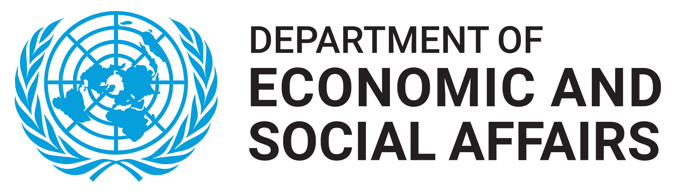 | 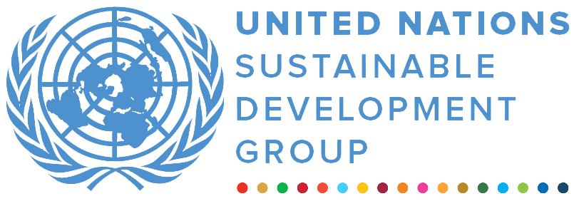 | 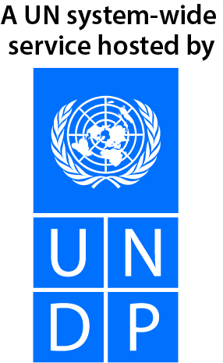
UN Energy Multi-Partner Trust Fund
REPORTING PERIOD: 1 january – 31 December 2021

Programme Title & Project Number |  |  | Country, Locality(s), Priority Area(s) / Strategic Results
- Programme Title: Strengthening UN-Energy coherence for SDG7  - Programme Number (if applicable)  - MPTF Office Project Reference Number: |  |  | (if applicable)  Country/Region : Global
 |  |  | Priority area/ strategic results
Participating Organization(s) |  |  | Implementing Partners
UN DESA  UNOPS |  |  | N/A
Programme/Project Cost (US$) |  |  | Programme Duration
Total approved budget as per project document:  MPTF /JP Contribution:  - by Agency (if applicable) |  |  | Overall Duration (months)
Agency Contribution  - by Agency (if applicable) |  |  | Start Date (15,04, 2021)
Government Contribution  (if applicable) |  |  | Original End Date (31, 12, 2021)
Other Contributions (donors)  (if applicable) |  |  | Current End date(31, 12, 2022)
TOTAL: $811,488
Programme Assessment/Review/Mid-Term Eval. |  |  | Report Submitted By
Assessment/Review - if applicable please attach  Yes No Date: dd.mm.yyyy  Mid-Term Evaluation Report – if applicable please attach  Yes No Date: dd.mm.yyyy |  |  | - Name: Minoru Takada  - Title: Team leader, Sustainable Energy  - Participating Organization (Lead): UN DESA  - Email address: takada@un.org

Purpose
The 2030 Agenda for Sustainable Development, with its 17 Sustainable Development Goals (SDGs), and the Paris Agreement on climate change provide a pathway for a more prosperous, equitable and sustainable future for people and the planet. Despite considerable initial efforts however, the world is at risk of falling short of achieving many SDGs by 2030. At the same time, while COVID-19 is the most urgent threat facing humanity today, climate change remains the biggest threat over the long term and progress towards dealing with it remains grossly inadequate. We must dramatically step up the pace of implementation during the first years of the Decade of Action to deliver the 2030 Agenda as well as the objectives of the Paris Agreement. Energy lies at the heart of both the 2030 Agenda and the Paris Agreement. Sustainable Development Goal 7 (SDG7) represents a first-ever universal goal on energy, with five targets to be achieved by 2030.

Energy is inextricably linked to climate change and many other SDGs, including poverty eradication, food security, health, education, prosperity, gender equality, jobs, transport, ocean, water and sanitation, and the empowerment of women and youth. The Global Sustainable Development Report (GSDR) 2019 identified “energy decarbonization with universal access” as one of the entry points that offer the most promise for achieving the transformations towards sustainable development at the necessary scale and speed. Without urgent action, however, the world will fall short of SDG7 achievement.

Concerted efforts in many countries are expanding electricity access, including through off-grid energy systems. Yet, 759 million people still lack access to electricity at present. 2.6 billion people remain without clean cooking solutions, causing millions of premature deaths annually, disproportionally affecting women. An energy revolution based on renewables and energy efficiency is urgently needed not just to accelerate economic progress and development, but also to slash greenhouse gas (GHG) emissions that are rapidly warming our planet. The energy sector today, dominated by fossil fuels, accounts for almost three quarters of human-caused GHG emissions. Clearly, energy is the decisive factor in cutting in half global CO2 emissions by 2030, thereby helping to avoid an increasing frequency and severity of dangerous and unprecedented weather extremes. These include heatwaves, devastating floods and droughts, which can cause dramatically increased risks to food, water and energy security, population displacement, and loss of lives and livelihoods. Effectively linking energy and climate action will be key to the success of the UNFCCC COP process, including the upcoming COP27 in Egypt and COP28 in the United Arab Emirates.

UN-Energy is the principal interagency mechanism within the United Nations system related to energy, under the auspices of the Chief Executive Board of the United Nations. The need for UN inter-agency collaboration continues to be relevant as 2030 approaches and achieving SDG7— affordable, reliable, sustainable and modern energy for all — is not on track without coordinated effort and attention.

The purpose of the UN-Energy MPTF is to support UN-Energy activities aimed at accelerating progress towards SDG7 achievement in support of the 2030 Agenda and the Paris Agreement, in line with UN-Energy Work Plan priorities for the next biennial period of 2021/2022. The UN-Energy MPTF will support UN-Energy activities under the overall direction of the UN Energy Co-Chairs, namely, the Special Representative of the Secretary-General (SRSG) for Sustainable Energy for All and the Administrator of the United Nations Development Programme (UNDP), with the support of the UN-Energy MPTF Fund Secretariat.

Results
This report presents the activities undertaken and results delivered in 2021.

- Narrative reporting on results:

The UN-Energy MPTF has been instrumental in strengthening global political commitment, mobilizing partnerships for action, enhancing capacities and coordinating a coherent approach by UN-Energy. It is also helping steer international efforts by member states and all stakeholders to sharpen their action for SDG7 and enhance interlinkages between SDG 7 and other SDGs, including climate change, poverty, gender equality, food, education, health, water and jobs.

Objective One: Strengthen UN-Energy Secretariat in coordination of day-to-day functions of UN-Energy, including relevant technical support activities related to the preparation of the High-Level Dialogue.

Outcome 1: Overall planning and coordination

A comprehensive preparatory process consisting of over 30 advocacy events and activities at technical and ministerial level helped identify the priorities and areas where actions and commitments are most needed. The start of this substantive preparatory process was marked by a Virtual Global Launch, which took place on 10 March 2021. This kick-off event featured video messages by over twenty ministerial level “Global Champions” from UN Member States calling for urgent action to achieve affordable, clean energy for all by 2030.

In the lead-up to the Dialogue, Ministerial-level Champions also co-hosted a series of Ministerial Forums on the 5 themes of the High-Level Dialogue during the week of 21 to 25 June 2021. A summary of the Ministerial Thematic Forums was produced and is available on the High-Level Dialogue on Energy website. UN-Energy provided vital technical support for these engagements.

On 24 September 2021, more than 130 global leaders, including Heads of State and Government, Ministers, executive heads of UN entities and international organizations, CEOs and other multi-stakeholder representatives, joined the High-level Dialogue on Energy, announcing ambitious targets, transformational actions and bold investments towards achieving universal energy access and net-zero emissions. One of the main outcomes of the Dialogue is the first-ever Global Roadmap for accelerated SDG 7 action which presents a clear strategy for the achievement of universal energy access and energy transition by 2030, including a set of concrete and practical milestones. UN-Energy members and partners were fully engaged at the leadership in support of the Dialogue.

The Global Roadmap for accelerated SDG7 action emphasizes that the “United Nations system, supported by UN-Energy, should significantly scale up its efforts towards attaining SDG 7 and net-zero emissions. UN-Energy should be strengthened to support UN entities and other partners, including by facilitating coordination and monitoring progress of Energy Compacts, towards implementation of the global roadmap.”

In response to this call for the UN system to significantly scale up action, UN-Energy presented its commitment in the UN-Energy Pledge as part of its Energy Compact, aiming to accelerate action, catalyse multi-stakeholder action, grow the momentum, inform the global agenda, and track and share results.

Outcome 2: Stakeholders’ engagement

The engagement of stakeholders from a broad range of sectors was key for the successful outcomes of the UN High-Level Dialogue on Energy and to establish the way forward on the achievement of the SDG 7 in line with the 2030 Agenda for Sustainable Development and the Paris Agreement.

In this regard, UN DESA, in collaboration with the Dialogue Co-Chairs and the UN-Energy, organized a series of online briefings in the lead up to the event in order to share information with stakeholders about the Dialogue and its preparatory process, including opportunities for stakeholder participation and contribution. Two virtual events were organized in 2021 engaging all interesting stakeholders in the lead up the HLD in September:

High-Level Dialogue on Energy: Online Stakeholders Thematic Debate
In June 2021, as the first meeting in 2021 for stakeholders in the lead up to the High-Level Dialogue on Energy in September, Online Stakeholders Thematic Debate for the UN High-Level Dialogue on Energy was organized by DESA, in collaboration with UN Energy. The event promoted an exchange of views and contributions from stakeholders on the five overarching themes of the High-Level Dialogue. The event was also an opportunity for an informal exchange of ideas between stakeholders and Co-Leads of the Technical Working Groups. Each of the five segments representing targets of the SDG 7, brought together a member of the TWG showcasing the advancement of technical discussions, and a variety of global stakeholders presenting their experiences, successes and challenges in achieving SDG 7. The opening remarks also served to announce the release of the Stakeholders Thematic E-Consultation Summary Report, prepared with the inputs from stakeholders on the five themes of the HLDE to scale up actions in achieving SDG 7 and its targets. The summary of the meeting presents conclusions and recommendations.

High-Level Dialogue on Energy: Deep-dive Stakeholders Workshop – Energy Compacts
In August 2021, as part of the preparatory process for the High-level Dialogue on Energy, the Deep-dive Stakeholders Workshop explored opportunities for catalyzing action in the five thematic areas of the HLDE towards advancing SDG 7 by 2030 and net-zero emissions by 2050. Supported by UN-Energy, the event also served as a chance to provide guidance on the Energy Compacts, and encourage stakeholders to submit their energy commitments. A comprehensive presentation of the main features to be included in the energy commitments has been delivered to participants, and an extensive Q&A session opened the floor to interactive discussion with participants. Finally, the voice was given to three outstanding projects from stakeholders announcing their energy commitments, which demonstrated an exemplary experiences and lessons learned towards the implementation of the SDG 7 from three continents. The summary of the meeting presents its conclusions and way forward.

Outcome 3 – Communications and Outreach

Efforts during this reporting period focused on enhancing communications and outreach activities around SDG7 in line with the Paris Agreement on climate change, working with many partners. For the HLDE, a virtual launch was organized in March with videos from all the Global Champion countries, garnering over 3,000 views on UNTV and wide Twitter coverage. A video Call to Action for Energy Compacts was issued in May, with similar impact, and a joint op-ed by HLDE leadership was placed with the Thompson Reuters Foundation and IPS. A newsletter was sent out regularly to main constituencies and the UN-Energy Twitter account, featuring SDG7 and HLDE content, grew from 5,000 to 7500+ followers.

The High-level Dialogue on Energy website was newly created to feature regular updates on the preparatory process as well as content on SDG7 themes, including articles on the SDG7 Policy Briefs, the SDG7 Tracking Report, Technical Working Group Reports, the call to action on clean cooking, and a series of “Energy Voices” interviews including with several practitioners working on energy access and clean cooking. Websites for UN-Energy and Energy Compacts were developed and expanded. Media outreach – including media advisories, a number of press releases and two press briefings – was conducted for the launch of the Technical Working Group reports, the June Ministerial Forums and the HLDE and related events in September. Over 100 media articles, including most major wire services (e.g. AFP, Reuters, DPA, EFE, Bloomberg, Kyodo, Al-Jazeera) covered the HLDE in September.

Outcome 4: Knowledge sharing, codification of lessons learned and best practices

In preparation of the High-level Dialogue, Technical Working Groups made up of over 160 multi-stakeholder experts elaborated key policy recommendations and milestones. Supported by UN-Energy, each Working Group was led by 3-4 intergovernmental organizations with particular expertise in the respective area. The outcomes of these expert deliberations are captured in five Theme Reports, which present authoritative accounts of the current status, challenges and way forward to achieve the SDG7 and net-zero. These reports are:

THEME REPORT ON ENERGY ACCESS
Download Executive Summary
Download Full Report

THEME REPORT ON ENERGY TRANSITION
Download Executive Summary
Download Full Report

THEME REPORT ON ENABLING SDGS THROUGH INCLUSIVE, JUST ENERGY TRANSITIONS
Download Executive Summary
Download Full Report

THEME REPORT ON INNOVATION, TECHNOLOGY AND DATA
Download Executive Summary
Download Full Report

THEME REPORT ON FINANCE AND INVESTMENT
Download Executive Summary
Download Full Report

Objective Two: Supporting UN-Energy’s engagement in developing and mobilizing voluntary contributions in the form of Energy Compacts, with support of the Sustainable Energy for All in collaboration with UNOPS.

Outcome 5: Successful mobilization and delivery of Energy Compacts and monitoring.

Multi-stakeholder engagement workshops have been organized with Member States to deep dive on specific needs and opportunities for energy sector action at country level, and to provide support for scaling up action through Member State-led Energy Compacts. Examples of these workshops are:
- Deep dive workshop on Energy Action: Brazil (7 June 2021)
- Deep dive workshop on Energy Action: Panama (9 June 2021)
- Deep dive workshop on Energy Action: Honduras (1 June 2021)
- Deep dive workshop on Energy Action: Nigeria (16 June 2021)
Outcomes of these discussions and diagnostics will help lay the ground for the design of joint programmes by UN-Energy organizations to support the provision of access to electricity and clean cooking solutions to priority countries, to be included in the upcoming UN-Energy Action plan (see outcome 4).

In support of the objectives of the High-Level Dialogue on Energy, more than US$400 billion in new finance and investment was committed by governments and the private sector in the form of Energy Compacts announced during the Dialogue and multi-stakeholder Energy Action pre-events on 22 and 23 September. The commitments made aim to provide hundreds of millions of people with clean energy access and speed-up energy transition while creating green jobs to leave no one behind. While the commitments announced were a significant step forward, it was also acknowledged by participants that far more is needed to address energy poverty and decarbonization of energy systems.

More than 150 Energy Compacts from national and local governments, businesses, foundations and international, civil society and youth organizations from every region were submitted for the Dialogue, reflecting actions and finance commitments through 2030.

Together with the efforts to accelerate action by mobilizing Energy Compacts from all multi-stakeholders (see section 1.3. for further details), efforts under this cooperation have also been undertaken to review, synthesize, analyse and communicate the pledges under these commitments. The Energy Compacts announced at the Dialogue include commitments to invest over USD 400 billion in SDG7 action. The Energy Compact Dashboard (available in beta-version) will provide a snapshot of all voluntary commitments submitted to-date, by stakeholder, region and SDG7 targets.

ii) Indicator Based Performance Assessment:
 | Achieved Indicator Targets | Reasons for Variance with Planned Target (if any) | Source of Verification
Outcome 1: Overall planning and day-to-day coordination of all aspects related to the preparatory process

Output 1.1: Successful High-level Dialogue on Energy undertaken in 2021  Indicator 1.1.1: Number of Global Leaders that participate at the High-Level Dialogue on Energy, with technical support from UN-Energy.  Baseline: 0  Planned Target: 100 | 1.1.1 achieved | Exceeded the set target (130) | https://www.un.org/en/conferences/energy2021
Output 1.2: Preparatory events and activities  Indicator 1.2.1: Number of advocacy and preparatory events in preparation for the High-Level Dialogue on Energy, supported by UN-Energy.  Baseline:0  Planned Target: 15 | 1.2.1 achieved | Exceeded the target (30 engagements at technical and high levels) | https://www.un.org/en/conferences/energy2021/Preparatory_Process
Outcome 2: Stakeholder engagement

Output 2.1: Global multi-stakeholder engagements conducted to establish the way forward on the achievement of the SDG 7 in line with the 2030 Agenda for Sustainable Development and the Paris Agreement  Indicator 2.1.1: Number of global stakeholder consultations, in partnership with UN-Energy.  Baseline: 0  Planned Target: 2 | 2.1.1 achieved | Fully delivered | https://www.un.org/en/energy-2021/page/stakeholders-participation
Output 2.2: Joint ambition pledges made by UN-Energy  Indicator 2.2.1: Establishment of UN-Energy Pledge  Baseline: 0  Planned Target: 1 (new UN-Energy Pledge) | 2.2.1 achieved | Fully delivered | https://un-energy.org/wp-content/uploads/2022/01/UN-Energy-Pledge.pdf
Outcome 3: Communication and Outreach
Output 3.1: Global coverages of HLDE and preparatory processes  Indicator 3.1.1: Number of media coverages  Baseline: 0  Planned Target: 50 | 3.1.1 achieved | Exceeded the target (100)
Output 3.2: Fully functional and updated UN-Energy Website  Indicator 3.2.1: Number of viewers accessing UN-Energy website.  Baseline: 1,000  Planned Target: 5,000 | 3.2.1 Achieved | Exceeded the target. | https://un-energy.org
Outcome 4: Knowledge sharing, codification of lessons learned and best practices
Output 4.1: Authoritative Theme Reports supported by UN-Energy compiled in support of the HLDE discussions  Indicator 4.1.1: Number of Theme reports  Baseline: 0  Planned Target: 5 | 4.1.1 achieved | Fully achieved | https://www.un.org/en/hlde-2021/page/theme-reports
Outcome 5: Successful mobilization and delivery of Energy Compacts.
Output 5.1: Energy Compact Workshops to disseminate basic information about Energy Compacts.  Indicator 5.1.1 - Number of introductory Energy Compact workshops organized  Baseline: 0  Planned Target: 10 | 5.1.1Achieved | Exceeded the target (over 40)
Output 5.2: Deep-dive sessions organized for theme-specific audience for Energy Compacts.  Indicator 5.2.1 - Number of deep-dive Energy Compact workshops organized  Baseline: 0  Planned Target: 4 | 5.2.1Achieved | Fully achieved
Output 5.3: Energy Compacts agreed and in place in countries, with clear plans, milestones and targets that chart a pathway to achieving SDG7 goals and targets  Indicator 5.3.1: Number of Energy Compacts Announced  Baseline: 0  Planned Target: 100  Indicator 5.3.2: New Finance/Investments for Energy Compacts announced in support of SDG7  Baseline:0  Planned Target: $200 Billion | 5.3.1 achieved  5.3.2. achieved | 5.3.1 target exceeded (150)  5.3.2 target exceeded ($400 billion) | https://www.un.org/en/hlde-2021/page/new-commitments-un-energy-summit
Output 5.4: Energy Compacts data base established  Indicator 5.4.1: Dashboard established  Baseline: 0  Planned Target: 1 | 5.4.1 achieved | Delivered. | https://www.un.org/en/energycompacts

Strategic Results, as formulated in the Strategic UN Planning Framework (e.g. UNDAF) or project document;
The MPTF Office Project Reference Number is the same number as the one on the Notification message. It is also referred to as “Project ID” on the project’s factsheet page the MPTF Office GATEWAY
The MPTF or JP Contribution, refers to the amount transferred to the Participating UN Organizations, which is available on the MPTF Office GATEWAY
The start date is the date of the first transfer of the funds from the MPTF Office as Administrative Agent. Transfer date is available on the MPTF Office GATEWAY
As per approval of the original project document by the relevant decision-making body/Steering Committee.
If there has been an extension, then the revised, approved end date should be reflected here. If there has been no extension approved, then the current end date is the same as the original end date. The end date is the same as the operational closure date which is when all activities for which a Participating Organization is responsible under an approved MPTF / JP have been completed. As per the MOU, agencies are to notify the MPTF Office when a programme completes its operational activities.
https://www.un.org/sites/un2.un.org/files/launch_hlde_release_final-english.pdf
https://www.un.org/en/conferences/energy2021/Preparatory_Process
https://www.un.org/sites/un2.un.org/files/summary_-_ministerial_thematic_forums_for_hld_energy_of_june2021_advanced_copy.pdf
https://un-energy.org/wp-content/uploads/2022/01/UN-Energy-Pledge.pdf
https://news.trust.org/item/20210615084859-jcyp3
https://www.un.org/en/conferences/energy2021/media
https://www.un.org/sites/un2.un.org/files/clean_cooking_web_article_final.pdf
Note: Outcomes, outputs, indicators and targets should be as outlined in the Project Document so that you report on your actual achievements against planned targets. Add rows as required for Outcome 2, 3 etc.

