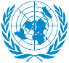
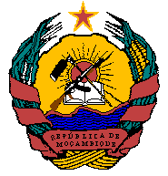
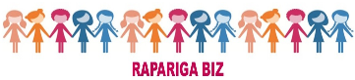

Action for Girls and Young Women’s
Sexual and Reproductive Health and Rights in Mozambique
RAPARIGA BIZ UN JOINT PROGRAMME MOZAMBIQUE
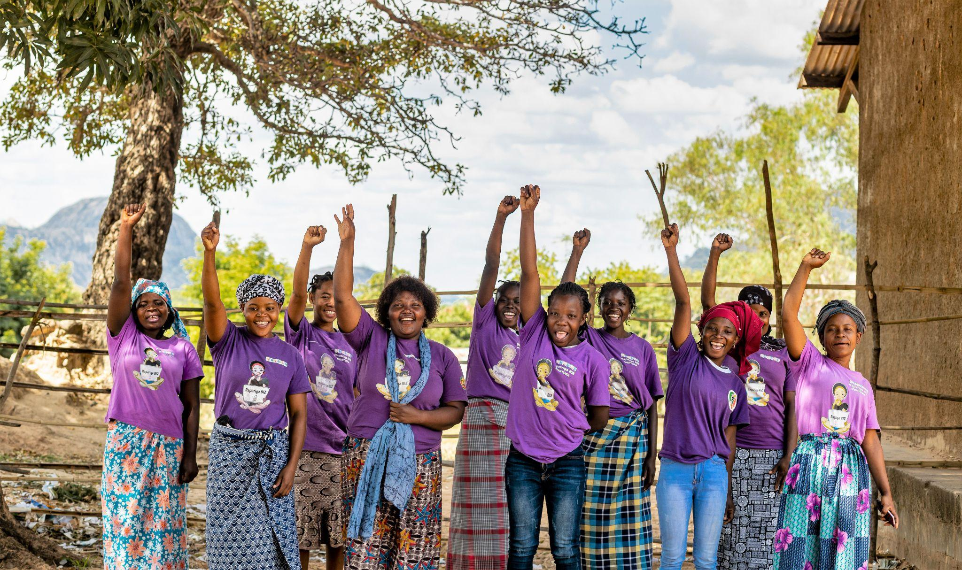
2021 ANNUAL REPORT
Implementing Agency: UNFPA, UNICEF, UN WOMEN, UNESCO
Country/Region or Area: Mozambique/Southern Africa
Project Title: Action for Girls and Young Women’s Sexual and Reproductive Health and Rights in Mozambique
ID MPTF Projects: 00101069 and 00117215
Project Duration: Sweden (2016 – 2022), Canada (2019-2023)
Project Budget (Available in 2021): USD 7,948,953 (NB: this amount includes the disbursement of USD 2,167,823 made by Sweden in December 2021 which effectively was received by PUNOs in January 2022 allowing for partial coverage for 2021 expenses prior to closing of accounts)
Project Donors: Sweden and Canada
Reporting Period: January – December 2021
Contact Person/s:
- UNFPA: Assane Macangira
- UNICEF: Sabine Michiels
- UN WOMEN: Boaventura Veja
- UNESCO: Dulce Domingos Mungoi
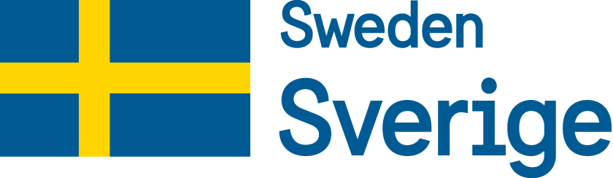
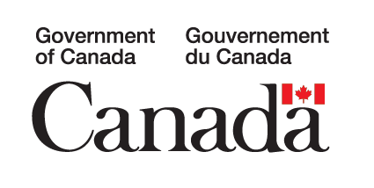

TABLE OF CONTENTS

ACRONYMS 4
I. EXECUTIVE SUMMARY 5
II. INTRODUCTION 6
III. PROGRAMME GEOGRAPHIC AREA AND BENEFICIARIES REACHED 10
IV. PROGRESS REVIEW: OUTCOMES, OUTPUTS AND KEY ACTIVITIES 11
OUTCOME 1: Girls’ and Young Women’s Knowledge, Agency and Capacities Strengthened to Make Informed Decisions on their SRH, Demand for and Uptake of Essential SRH Services 11
Output 1: Increased knowledge, skills and voice of girls’ rights 12
Output 2: Citizenship of girls and young women 15
Output 3: Increased demand for SRH services 16
Output 4: Girls and young women are voicing the issues concerning their lives at district, provincial and national level 18
OUTCOME 1 summary: Challenges, Lessons Learned and Recommendations 23
OUTCOME 2: Availability of Quality Integrated ASRH Services for Girls and Young Women Increased 24
Output 5: Teachers implement the comprehensive sexuality and sexual health rights Education package 25
Output 6: Mobile health clinics and Community Health Workers (CHWs) deliver integrated SRH services at the community level in priority districts 26
Output 7: Integrated ASRH services by health providers are available in school SRH corners 26
Output 8: Coordinated services to GBV survivors 26
Output 9: Access to microfinance, vocational training and small and medium sized enterprises (SME) development for girls and young women 27
OUTCOME 2 summary: Challenges, Lessons Learned and Recommendations 31
OUTCOME 3: An enabling, free and safe environment for increased participation of girls and young women and the promotion of their SRHR created 31
Output 10: Enhanced involvement of men and boys to strengthen their SRHR 33
Output 11: Faith based leaders and youth groups mobilized and active to promote adolescent SRH and rights 34
Output 12: Communities participating in community dialogues on SRHR related to girls and young women 34
Output 13: Strengthened awareness of girls and young women on SRHR including HIV/AIDS and GBV prevention 35
OUTCOME 3 summary: Challenges, Lessons Learned and Recommendations 35
OUTCOME 4: Strengthened governance and coordination for integrated SRH programming 36
Output 14: UPR process and report include ASRH 38
Output 16: Strengthened coordination on ASRH at provincial and district levels (through PGB) 40
Output 17: SRH specific rights and needs of girls and young women included in existing policies and plans 41
Output 18: Enhanced evidences for girls and young women’s SRHR 44
Output 19: Situation at the program site and implementation progress 44
OUTCOME 4 summary: Challenges, Lessons Learned and Recommendations 45
V. MONITORING AND EVALUATION 46
VI. CONCLUSIONS AND RECOMMENDATIONS 46

ACRONYMS

AFR Adolescent Fertility Rate
AGTW Adolescent Girls and Young Women
AIDS Acquired Immunodeficiency Syndrome
APES Community Health Workers (MoH)
ART Antiretroviral Therapy
ASRH Adolescent Sexual and Reproductive Health
CIADAJ Multisectorial Committee for Development of Youth and Adolescents
CNCS National AIDS Commission
CPR Contraceptive Prevalence Rate
CSE Comprehensive Sexuality Education
CSO Civil Society Organization
DHS Demographic Health Survey
DPEDH Provincial Directorate of Education and Human Development
DPGCAS Provincial Directorate of Gender, Children and Social Action
DPS Provincial Health Directorate
EMIS Education Management Information System
e-VAWG Elimination of Violence against Women and Girls
FP Family Planning
GBV Gender-Based Violence
GoM Government of Mozambique
HIV Human Immunodeficiency Virus
HRBA Human Rights Based Approach
IANYD Inter-Agency Network on Youth and Development
IP Implementing Partner
MGCAS Ministry of Gender, Children and Social Action
MICS Multiple Indicators Cluster Survey
MINJUS Ministry of Justice, Religious and Constitutional Issues
MINEDH Ministry of Education and Human Development
MINT Ministry of Interior
MMR Maternal Mortality Ratio
MNCAH Maternal, Newborn, Child and Adolescent Health
MoH Ministry of Health
NCDH National Human Rights Council
PGB Programa Geração Biz
RH Reproductive Health
SAAJ Youth Friendly Services
SBCC Social and Behavior Change Communication
SDGs Sustainable Development Goals
SRHR Sexual and Reproductive Health and Rights
UPR Universal Periodic Review
VAC Violence against Children
VAWG Violence against Women and Girls
YFHS Youth Friendly Health Service

I. EXECUTIVE SUMMARY
This report presents the progress and results achieved in the 6th year (2021) of the Rapariga Biz (RB) Programme. The report includes analysis, lessons learned and recommendations produced by the relevant programme stakeholders and partners, namely: The Government of Mozambique, civil society partners and UN agencies, including UNFPA (lead agency), UNICEF, UNESCO and UN Women. The Office of the Secretariat of State of Youth and Employment (SEJE) is the lead entity within the Government of Mozambique among four line ministries (Health; Education and Human Development; Justice, and Constitutional Affairs; and Gender, Children and Social Action). The programme receives technical and financial assistance from the Embassy of Sweden and the High Commission of Canada. The foundation of RB is the promotion and protection of the Sexual and Reproductive Health and Rights (SRHR) of adolescent girls and young women (AGYW) aged 10-24 in 20 districts across Nampula and Zambezia provinces. The year 2021 is part of the 1.5-year cost-extension to the first phase of the programme (2016-2019/21).

The following key achievements were attained in 2021:
- 91,665 AGYW reached by RB in the 10th cycle of mentorship. Cumulatively, the programme reached 790,671 AGYW with mentorship (73% of the target 1,085,447).
- 4,262 mentors were active in leading mentoring sessions in their communities.
- The boys’ mentorship was launched in Zambezia (Quelimane, Nicoadala and Namacurra districts) and Nampula (Meconta, Cidade de Nampula and Mogovolas districts).
- 4,061 AGYW received support in obtaining birth certificates and identity documents, thus contributing to the total of 71% (599,424 out of 790,671).
- 1,452 (out of 2,000 planned) AGYW identified out-of-school during the 10th cycle were supported to reintegrate into school, reaching the rate of 73%.
- 49% (91,473 out of 186,721) AGYW who accessed AYFS in 20 programme districts adopted at least one modern contraceptive method in addition to male and female condoms. This shows an increase by 3% compared to the previous year when the rate was 46%.
- 1,148 consultations of psychosocial support were provided to girls and young women including programme monitors and focal points, mentors and mentees in Nampula and Zambezia.
- The SMS Biz platform grew by 6.8% with 22,649 new subscribers, reaching a cumulative active user base of over 340,000, of which 75% are aged 15-24.
- 12,194 AGYW had access to microfinancing, vocational training and small and medium enterprise development, exceeding the initial target of 10,000 (122% achievement rate).
- Support provided to the Government in the endorsement of the East and Southern Africa (ESA) Commitment on Comprehensive Sexuality Education (2021-2030).
- There was a low rate of child marriage among the AGYW enrolled in the programme (0.7%), remarkably lower than the target of 5%.
- The program saw a noticeable low rate of early pregnancy among girls and young women aged 10-19 while participating in the mentorship sessions (0.5%), compared to the programme target of below 5%.

II. INTRODUCTION
Rapariga Biz (2016-2019/2022) has been designed to improve the sexual and reproductive health and rights (SRHR) of 1,085,447 girls and young women in Mozambique who live in the provinces of Nampula (10 districts) and Zambézia (10 districts), areas with some of the highest poverty levels in Mozambique, where girls and young women are burdened with a high level of discrimination and are at high risk of child marriage, early pregnancy, maternal mortality, obstetric fistula, violence and HIV.

The programme combines three core components, which aim to complement one another to drive improvements in SRHR by:
- Running a series of girl-focused interventions that equips them with the knowledge to make informed choices related to SRHR as well as additional skills such as vocational training. The approach relies on a mentorship model whereby trained mentors provide a safe space for girls to explore questions related to SRHR.
- Supporting health services, including youth-friendly clinics (YFS/SAAJs), mobile clinics, and school health corners dedicated to providing SRHR consultations and sexual education for school teachers. The programme also works with the Ministry of Education and Human Development (MINEDH) to develop a comprehensive sexuality education curriculum that will be rolled out to support changing norms and building knowledge around SRHR for adolescents in schools.
- Creating an enabling environment by supporting multi-sectoral approaches and projects such as a sexual health hotline, radio programs focusing on SRHR topics, community dialogues, working with the Ministry of Justice and police officers around gender-based violence (GBV) and the engagement of young men and boys.
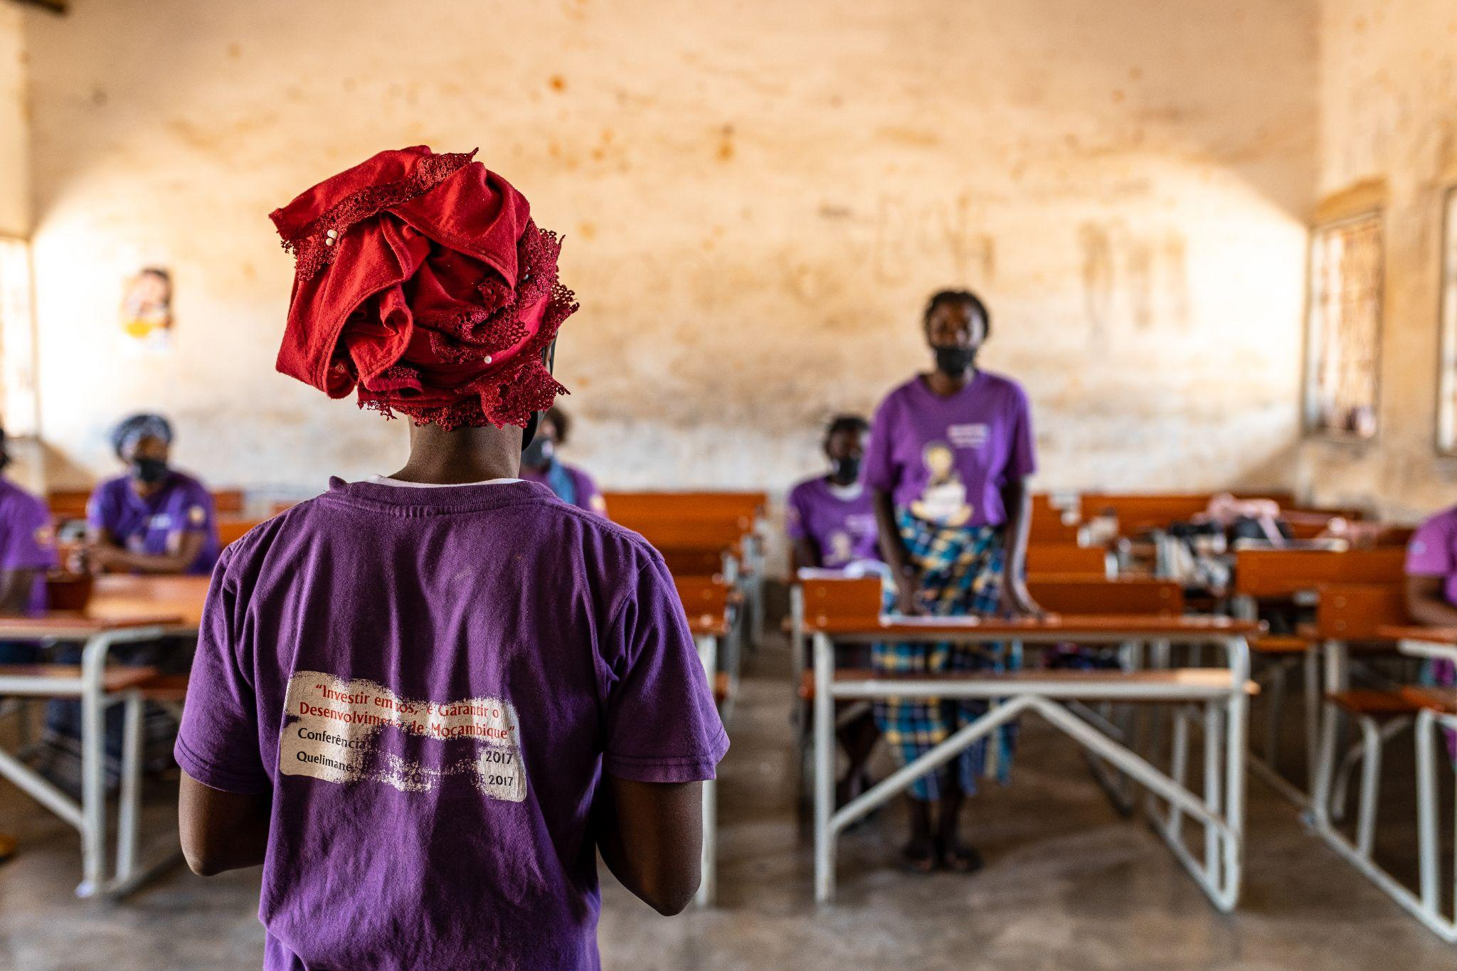
Mozambique ranks among the lowest performing countries in the world on several indicators on girls and women’s rights and well-being. Girls and young women face a wide range of challenges, including entrenched gender discrimination, harmful practices such as child marriage, widespread gender-based violence (GBV) and high rates of adolescent pregnancy, which affects their possibilities to reach their potential. Sweden has, since 2016, been at the forefront of this programme, with Canada and the UK joining as partners thereafter. The table below presents the funds committed by the development partners and received so far by the participating UN organizations (Table 1).

COOPERATION PARTNERS' COMMITMENTS AND NET DEPOSITS (USD)
COMMITMENTS BY DEVELOPMENT PARTNERS: |  | Sweden | UK | Canada | TOTAL
 |  | 20,079,283 | 2,922,830 | 9,549,648 | 32,551,761
NET-DEPOSITS PER YEAR: | 2016 | 3,588,425 | - | - | 3,588,425
 | 2017 | 3,428,680 | - | - | 3,428,680
 | 2018 | 3,260,034 | 1,152,960 | - | 4,424,641
 | 2019 | 2,857,864 | 1,740,640 | 1,881,403 | 6,497,490
 | 2020 | 1,726,413 | - | 3,742,266 | 5,468,679
 |  |  |  | (1,842,683 regular + 1,899,583 COVID-19 top-up)
 | 2021 & 2022 | 1,155,352 | - | 1,965,371 | 3,120,723
 |  | 2,167,823 | - | - | 2,167,823
GRAND TOTAL |  | 18,184,591 | 2,893,600 | 7,589,040 | 28,696,461
Table 1: Cooperation partners’ commitments and contributions (2016-2022)
There are four UN agencies (UNFPA, UNICEF, UNESCO and UNWOMEN) implementing the programme, under the leadership of the Government of Mozambique (GoM), represented by the Secretariat of State of Youth and Employment (SEJE), and the ministries of Health (MISAU); Education and Human Development (MINEDH); Gender, Children and Social Affairs (MGCAS); and Justice and Religious and Constitutional Issues (MJCR), and their respective provincial and district branches. The first phase of the programme ran from 2016 through 2019, initially extended until 2021, but was then extended again through 2022.
This report presents the progress and results achieved in the 6th year (2021) of the programme implementation. Apart from the pre-textual parts (cover, list of acronyms, executive summary and introduction), the report includes the following sections: progress review – outcomes, outputs and key activities (including 4 outcomes and respective 19 outputs). In each outcome, the report highlights the main challenges, lessons learned and recommendations. Finally, the report presents conclusions and key recommendations.
The report also includes analysis and, in some parts, success stories through which some beneficiaries and other stakeholders share, personally, their positive experiences as a result of the programme. Pictures and other figures (graphs and tables) are included to provide details and evidence of the achievements highlighted.

III. FINANCIAL INFORMATION (USD)
DEVELOP. PARTNER | PUNOs | LOCAL BALANCE FROM 2020 | 2021-2022 FUNDS RECEIVED | TOTAL AVAILABLE | LOCAL EXPEND. | IMPLEM. RATE
SWEDEN (A) | UNFPA | 257.00 | 2,387,200.00 | 2,387,457.00 | 2,037,643 | 85%
 | UNICEF | 336,585.01 | 412,668.00 | 749,253.00 | 602,700.00 | 80%
 | UNESCO | 255,820.76 | 74,220.00 | 330,041.00 | 321,917 | 98%
 | UNWOMEN | 678,037.00 | 449,087.00 | 1,127,124.00 | 869,177 | 77%
 | SUB-TOTAL SWEDEN | 1,270,699.77 | 3,323,175.00 | 4,593,875 | 3,831,437 | 85%
CANADA (B) | UNFPA | 959,237.99 | 963,032.00 | 1,922,269.99 | 1,177,184 | 61%
 | UNICEF | 155,000.00 | 589,611.00 | 744,611.00 | 744,611.00 | 100%
 | UNESCO | - | 216,191.00 | 216,191.00 | 157,695 | 73%
 | UNWOMEN | 275,469.00 | 196,537.00 | 472,006.00 | 277,422 | 59%
 | SUBTOTAL CANADA | 1,389,706.99 | 1,965,371.00 | 3,355,077.99 | 2,429,449.00 | 73%
TOTAL (A+B) |  | 2,660,407.00 | 5,288,546.00 | 7,948,953.00 | 6,260,886.00 | 79%

III. PROGRAMME GEOGRAPHIC AREA AND BENEFICIARIES REACHED
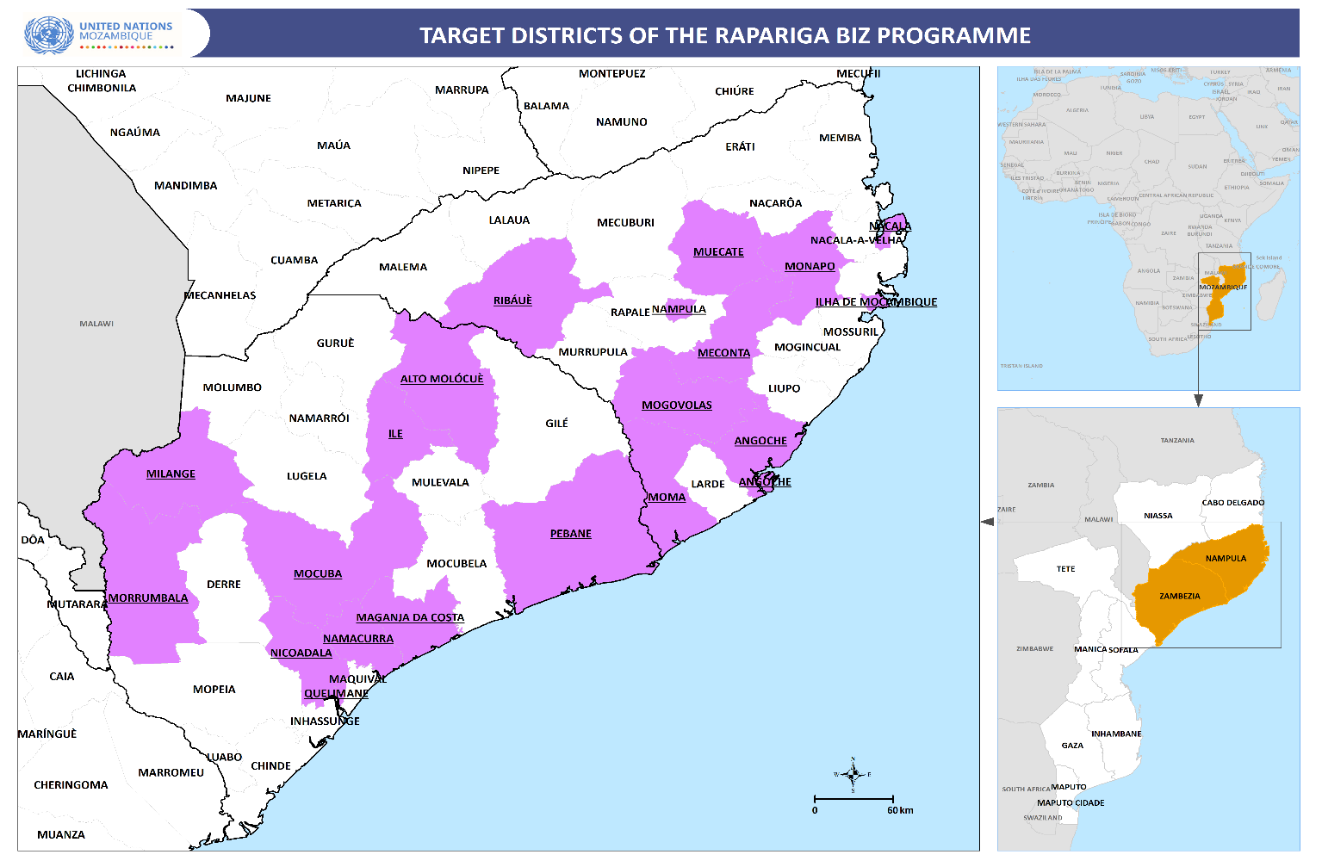 Figure 1: Target districts of the Rapariga Biz Programme, Nampula and Zambezia
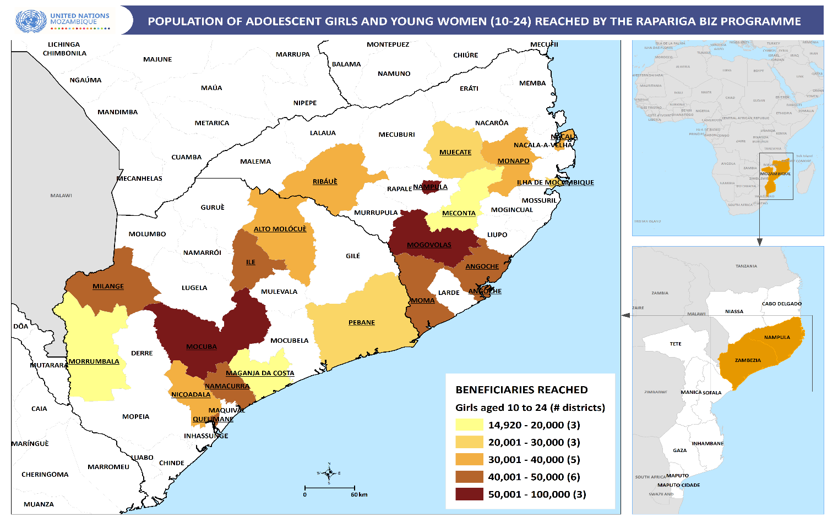
Figure 2: Population of adolescent girls and young women reached by the RB Programme, 2021

IV. PROGRESS REVIEW: OUTCOMES, OUTPUTS AND KEY ACTIVITIES

OUTCOME 1: Girls’ and Young Women’s Knowledge, Agency and Capacities Strengthened to Make Informed Decisions on their SRH, Demand for and Uptake of Essential SRH Services
The overall goal of Rapariga Biz is to ensure that the sexual reproductive health and rights of girls and young women between 10-24 years are fully realized through improved capacities to make informed decisions and improved access to SRH services. Thus, the knowledge and agency of girls and young women to make informed decisions about their SRHR is central to Rapariga Biz’s holistic and rights-based approach reflected in the Theory of Change. Girls’ empowerment and engagement are also important to close a persistent gender gap in socio-economic outcomes, which is one of the core elements of achieving the demographic dividend. The table below presents the main achievements, against the programmed output indicators, baseline and targets for outcome 1. The last column shows the status of the achievement of the target, using the following colors/directions: green/upward (achieved 85% or more, including above the target), yellow/rightward (on track – 60%-84%), orange/leftward (25%-59%, delayed), and red/downward (critical/not done – 0%-24%).
OUTCOME 1: girls and young women’s knowledge, agency and capacities strengthened to make informed decisions on their SRH, demand for and uptake of essential SRH services
Output | Indicator | Baseline as 2020 | Target 2021 | Achieved 2021 | Status
Output 1: Increased knowledge, skills and voicing of girls’ right | Prevalence of adolescent –pregnancy (in Rapariga Biz girls) | 2% (2052 out of 106,819) | < 5% | 0.5% (396 out of 84,039)
 | % of girls and young women empowered with knowledge, skills and voices for girls´ SRHR (numerator= number of girls who have completed mentorship) | 64% (699.006 out 1.085.447) | 80% | 73% (790,671 out of 1,085,477)
 | % of girls and young women integrated into schools and completed school calendar | 67% (1,304 of 1,941) | 100% | 73% (1452 out of 2000)
Output 2: Citizenship of girls and young women | Up-to-date records in civil registers for all programme girls and young women | 67% (470,847 out of 699,006) | 90% | 71% (559,424 out of 790,671)
Output 3: Increased demand for SRH services | Percentage of women (15-24 years) visited AYFS who did not use any contraceptive method | 54% (106.976 out of 198.693) | 40% | 51% (95,483/186,721)
Output 4: Girls and young women are voicing the issues concerning their lives at district, provincial and national level | National and provincial girls conferences attended by girls, young women, decision makers and media | No conferences in 2020 | 2 (1 National and 1 provincial) | 2
 | Child Parliament active on ASRH (National, Provincial and District) | 3 | 1 | 0
 | White papers suggesting mechanisms to reduce child marriage and early pregnancies | 0 (No positioning paper in 2020) | 2 | 2
Table 2: Indicators, baseline (2020), target and achievements 2021, outcome 1

Output 1: Increased knowledge, skills and voice of girls’ rights
Increasing the knowledge, skills and voicing of girls’ rights is the cornerstone of the Rapariga Biz programme, and achieved through a mentorship approach. This approach aims to provide the most vulnerable girls and young women between 10-24 years with skills, empowerment, social networks, leadership, decision making skills, economic empowerment and knowledge and access to information on sexual and reproductive health and rights. The mentorship sessions are led by young female mentors trained by the programme and take place in safe spaces at the community level, identified by the girls and young women themselves.
Similar to the previous year (2020), the year in analysis continued to be affected by the COVID-19 pandemic, which limited the recruitment and training of new mentors in the Rapariga Biz districts. In response, mentoring sessions continued to be facilitated by the existing active mentors. In total, 4,262 mentors were active in 2021, out of which 2,419 (57%) were from Nampula and 1,843 (43%) were from Zambezia.
Cumulatively, during the reporting year, 790,671 adolescent girls and young women were reached, showing an increase of 13% in comparison with the previous year's cumulative number of adolescent girls reached (699,006). The cumulative number of adolescent girls and young women reached in 2021 represents 73% of the programme target of 1,085,477. The table and the figure below show the evolution of girls reached from the start of the programme in 2016 up to 2021, per cycle.

Cycle number | Province |  | Total | Cumulative evolution
 | Nampula | Zambezia
1 | 18,618 | 4,900 | 23,518 | 23,518
2 | 15,120 | 3,080 | 18,200 | 41,718
3 | 30,167 | 26,198 | 56,365 | 98,083
4 | 37,010 | 30,603 | 67,613 | 165,696
5 | 37,007 | 30,647 | 67,654 | 233,350
6 | 57,309 | 39,586 | 96,895 | 330,245
7 | 58,927 | 51,170 | 110,097 | 440,342
8 | 53,760 | 51,240 | 105,000 | 545,342
9 | 70,980 | 82,684 | 153,664 | 699,006
10 | 41,793 | 49,872 | 91,665 | 790,671
Table 3: Number of AGYW reached per province and per mentorship cycle

Figure 3: Evolution of the cumulative number of AGYW reached per cycle (2016-2022)
Contribution to end child marriage
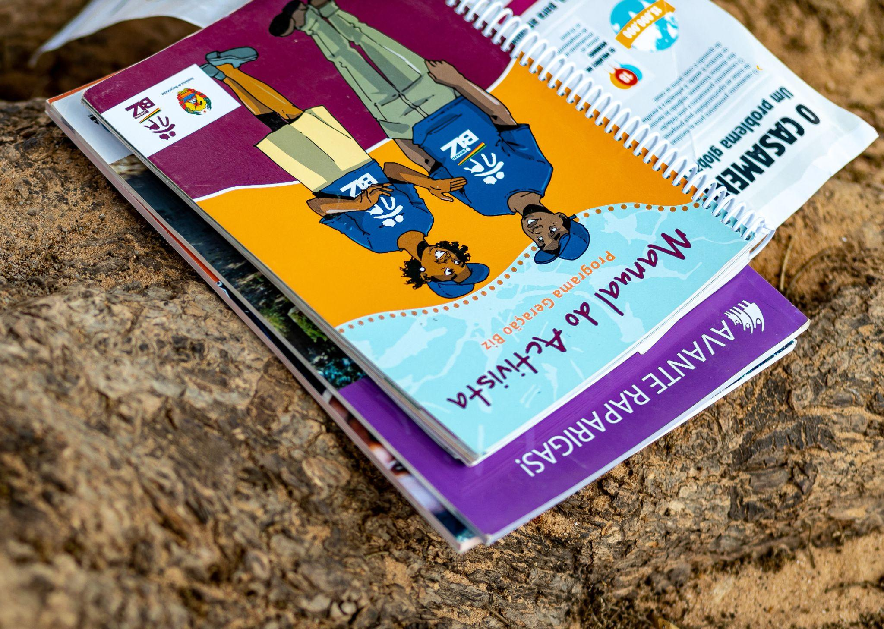
Child marriage continues to be a concern in Mozambique. The country has one of the highest rates of child marriage in the region and globally. According to the InVIC 2019 study, the child marriage rate among adolescent girls and young women is 41%. According to the Demographic Health Survey (DHS) in 2011, child marriage rates in Mozambique is 48% [whereof 62% in Nampula and 47% in Zambezia]. Data collected in Rapariga Biz shows that 566 adolescent girls aged 10-19, out of a total of 84,039, got married while enrolled in the mentorship programme, that represents a child marriage rate among participating girls of 0.7%. This rate represents an increase by 0.2% as compared to the previous year when the child marriage rate was 0.5%. To facilitate dialogue, 10 roundtables were held to reflect on issues related to gender-based violence, and other harmful practices, including child marriage in Nampula (Rapale, Muecate, Cidade de Nampula, Nacala-Porto and Ilha de Moçambique) and Zambezia (Quelimane, Mocuba, Maganja da Costa and Pebane).

The graph below shows the evolution of child marriage rates since the launch of the programme.

Figure 4: Child marriage rates per year (2016-2021) among AGYW enrolled in the mentorship

Contribution to end early pregnancy
Mozambique has one of the highest early and unwanted pregnancy rates in the region at 46.4%, and the targeted provinces of Nampula (60%) and Zambézia (46.4%) (IMASIDA, 2015) are some of the highest rates in the country. In the context of Rapariga Biz, data indicates that the rates of early and unwanted pregnancies among the participants in the safe space mentorship programme are significantly lower compared to provincial and national rates. In 2021, out of 84,039 girls aged 10-19 in 20 target districts, there were 396 cases of early and unwanted pregnancies which represents 0.5%. This shows a reduction by 74% compared to last year when the early and unwanted pregnancy rate was at 1.9%.
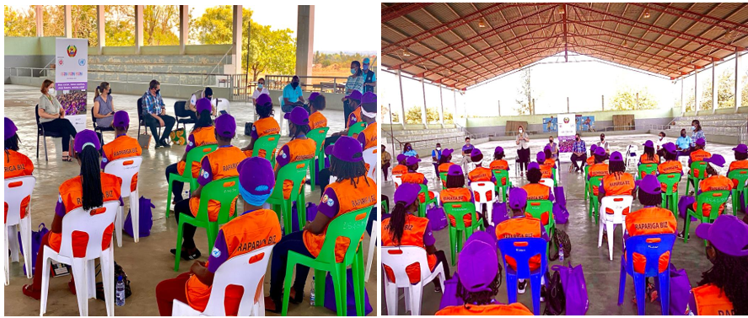
Among other factors, this improvement can be attributed to increased access to contraception at school, health facilities and in the community. The community dialogues in Rapariga Biz districts have also improved parents’ awareness of avoiding and preventing early and forced marriage. This knock-on effect then prevents their daughters from experiencing early pregnancies. Additionally, Figure 5 below depicts the situation of early and unwanted pregnancies since 2016.

Figure 5: Early pregnancy rates (2016-2021) among AGYW in the mentorship programme.
Psychosocial support (PSS)
With the underlying crisis of COVID-19 that prevailed in 2021, PSS continued to be relevant for the monitors, focal points, mentors and mentees, with 1,148 mentors receiving such support.

Output 2: Citizenship of girls and young women
Like in previous years, the programme continued to support adolescent girls and young women to obtain civil registration through the acquisition of personal ID and birth certificates. This is a very important service as individuals without an ID or birth certificate cannot access basic services, including education, justice, social, and health services. Therefore, the provision of civil registration improves social inclusion and citizenship of the beneficiaries of the programme. This is the rationale behind supporting civil registration of girls in the safe spaces to ensure they receive identification cards and in some cases also the so-called “poverty certificates”. In 2021, 4,061 adolescent girls and young women were supported with civil registration. The breakdown of the beneficiaries per province shows that 2,785 (69%) from Nampula and 1,276 (31%) from Zambezia received IDs, birth certificates or poverty certificates. In comparison with the previous year, this variable showed a reduction by 52% (4,061 supported in 2021 against 8,419 in 2020).
School integration
According to IOF (Inquérito do Orcamento Familiar), that is the Household Budget Survey,, by the Statistics National Institute - INE), illiteracy rates among the youth in Mozambique is 22.9% for boys and men and 39.7% among girls and women. As per the completion of education levels among youth, the figures are as follows: 48.1% (primary), 22.5% (secondary), 1.2% (higher education/degree or above), while 28.1% have not completed any school level. Youth attending school stands at 37%, while 16.2% of youth have never studied or gained employment. This data shows that ensuring girls’ access to education continues to be a top priority. Therefore, in 2021, the programme supported school integration of 1,452 girls, of which 913 (63%) were in Nampula and 539 (37%) were in Zambezia. Difference in numbers reached between Nampula and Zambezia is due to the fact that, in Zambezia, this activity was implemented only in some districts (Alto Molocué, Namacurra, Nicoadala, Mocuba and Maganja da Costa). When compared to the previous year, there was an increase by 11% (from 1,304 beneficiaries integrated in 2020 to 1,452 beneficiaries in 2021). The following figure shows the evolution of performance in school integration, from 2016 to 2021.
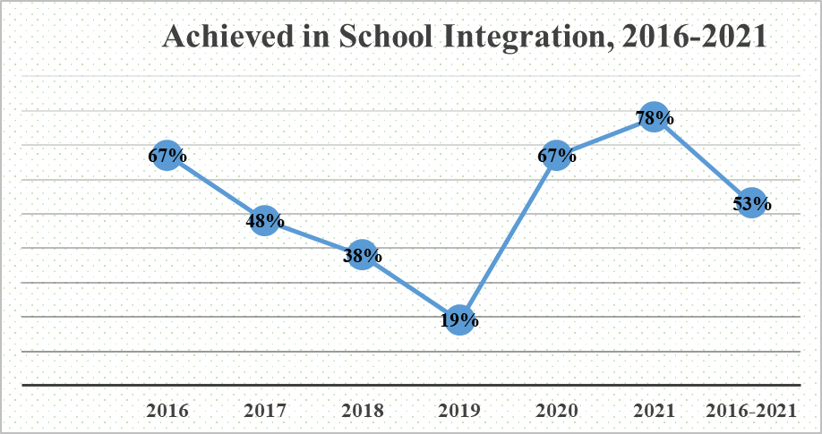
Figure 6: Evolution of school integration, 2016-2021

Output 3: Increased demand for SRH services
In 2021, the world, as a whole, and Mozambique, was heavily affected by the COVID-19 pandemic. This impacted significantly on the demand creation for health services, including adolescent and youth sexual and reproductive health. Under the Rapariga Biz programme, demand creation is reached mainly through the mentoring sessions, community dialogues, and other outreach initiatives (mobile clinics, community health fairs, and awareness raising interventions), as well as through improvement of the enabling environment at community, school and health levels. Thus, while in-person mentorship resumed in 2021, like in the previous year, the programme mentors also resorted to complementary means to promote health-seeking behavior, including through social media, SMS Biz, call centres, community radio, TV and edutainement programmes such as the radio drama series “Ouro Negro”. Home-based visits by mentors were also used to increase demand for ASRH services.
Access to SRH Services and Counseling
Over the reporting year, 186,721 adolescent girls and young women (58,922 in Nampula and 127,799 in Zambezia) accessed AYFS services for counseling, benefitting from specialized and integrated SRH services in the health units of 20 districts of the Rapariga Biz Programme. There is a substantive difference in numbers between Nampula and Zambezia provinces, with Zambezia having more than double the figure than in Nampula. This is, in part, due to the fact that since 2015, Zambezia has benefitted from other projects (DREAMS and Viva+) focused on the renovation and equipping of Youth-Friendly Services (SAAJ), which improved the availability and quality of specific SAAJs in Zambezia.

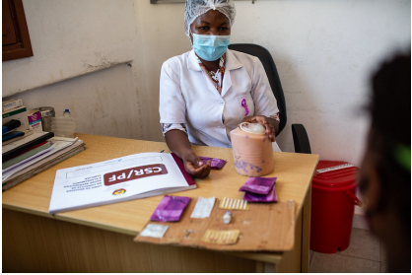
Photo: A MCH nurse at SAAJ/Centro de Saúde Urbano, Mocuba, 2021
Additionally, comparative analysis in relation to the previous year shows that there was a decrease by 6% (from 198,693 in 2020 to 186,721 in 2021) of adolescent girls and young women accessing youth-friendly services. This variation may be attributed to the fact that, in 2020, youth-friendly services became one-stop model service provision points thus catering to necessary consultations and services required by adolescents and youth, including family planning, medical consultations with general practitioners, HIV services, gender-based violence (GBV) and others. However, after some experience with this approach of service provision at the SAAJ, in 2021, efforts were made to ensure that the services only focus on adolescents and youth looking for adolescent and youth-friendly sexual and reproductive health services, leaving other general consultations and triage for other units within the health facility.
Family planning and modern contraceptive adoption
Rapariga Biz programme sees contraception as critical at ensuring that adolescent girls and young women fully access their sexual and reproductive health and rights. To this end, the programme promotes and supports availability, affordability and accessibility of modern contraception by AGYW.
As a means of ensuring continued realization of universal access rights to health services and achievement of ASRHR, health providers from AYFS in programme districts informed and counseled 186,721 adolescent girls and young women (58,922 in Nampula and 114,687 in Zambezia) on the different types of modern contraceptive methods available and 49% (91,238 out of those counseled) girls and young women have adopted at least one modern contraceptive method (in addition to male and female condoms).

Output 4: Girls and young women are voicing the issues concerning their lives at district, provincial and national level
Rapariga Biz works to empower adolescents and youth, especially adolescent girls and young women, to make their voices heard by creating spaces where they can safely express their challenges, ideas and opinions. For this reason, several adolescent and youth-led platforms are supported or initiated under Rapariga Biz to contribute to girls’ participation and advocacy on issues important to their lives. This advocacy model aims to provide the girls and young women with a voice and a range of spaces for participation - from the safe spaces at the community level and the dialogue circles at district levels, to the provincial and national level forums and conferences as well as girls producing radio and TV programmes for their peers or mentors engaging in talk shows. Therefore, the following events were supported last year to ensure that girls and young women are voicing the issues concerning their lives at district, provincial and national level.
Youth Creative Prize
The Youth Creative Prize was created in 2014 by the Ministry of Youth and Sports (now Secretariat of State of Youth and Employment) aimed at promoting entrepreneurship, technological innovation and artistic creativity among youth (15-35 years old). Normally, there is a space of 3-5 months between the launch and the final ceremony for delivery of the awards. Among the competitors of the prize, 15 young people are awarded with a monetary amount of MZM 130,000 (almost USD 2,000) more or less, for each of them, depending on the availability of funds. Additional items of the award include laptops, cellphones and certificates of merit for the outstanding ones.
Private sector, development partners, CSOs and UN agencies have been the main financial supporters of the event. UNFPA has been one of the financial and technical supporters of these events. For the selection of the winners, a jury composed of 5 well renowned and diversified (including different careers, provinces of origin, sex, status etc.) civil society, private sector and artists/sports people is established to select the best 15 candidates for the prize.
In 2021, the event was held in Cabo Delgado, Pemba City. In both events, UNFPA gave its support, as a means to empower youth to express and unleash their artistic and innovative potential. The award ceremony was led by the Secretary of State of Youth and Employment, Oswaldo Petersburgo.
Mozambican Youth Week
Annually, the International Youth Day is celebrated on 12 August to bring youth issues to the attention of the international community and to celebrate the potential of youth as active partners in the global society. The theme of the International Youth Day 2021 was “Transforming Food Systems: Youth Innovation for Human and Planetary Health”, with the aim of highlighting that the success of such a global effort would not be achieved without the meaningful participation of young people.
In Mozambique, the celebrations of the date are normally ongoing for an entire week starting from the 5th of August, which marks the launch of the week, through the 12th of August, the closing of the celebrations. In 2021, the celebrations were organized in coordination with the government, led by the Secretariat of State of Youth and Employment (SEJE), and civil society organizations and networks/platforms. Therefore, UNFPA supported the National Youth Council (Conselho Nacional da Juventude), which, in partnership with SEJE, Coalizão and other youth stakeholders, organized the celebrations of the day. In this scope, two main events took place, namely the launch of the week in Maputo (Praça da Juventude de Magoanine), on the 5th of August of 2021, and the Youth National Conference that was organized in Pemba, on the 12th of August of 2021. Pemba had been strategically selected by the organizers, due to the humanitarian crisis there. UNFPA participated and delivered speeches both during the launch and during the National Conference.
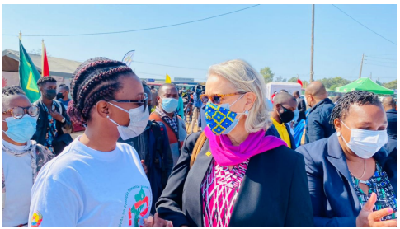
Figure 8: Former UNFPA Representative, Andrea M. Wojnar, and CNJ President, Emília Chambalo, during the celebrations of the International Youth Week, in 2021, Maputo City
International Day of the Girl Child – 11 October 2021
Rapariga Biz supported the celebration of the above mentioned date. The central ceremonies of the event took place in Quelimane, Zambezia, and they were led by the Secretariat of State of Youth and Employment. The First Lady of the Republic also took part in the event. The celebration of the event was preceded by a workshop on the situation of the girl in Mozambique. Adolescent girls and young women participated in the event, and shared their ideas and opinions on the situation of the girl in Mozambique. Youth participants raised their voices and opinions on different thematic areas. Based on the discussions, some recommendations were advanced during the event, including:
- Youth National Council and other youth organizations and networks encouraged to develop and implement projects aimed at supporting the youth in the country;
- Participants advised for more coordinated work to improve the girls’ situation in Mozambique;
- All stakeholders, particularly community members and leaders, as well as culture guardians recommended to reinforce their role in combating GBV and other harmful practices, such as child marriage, in their respective communities and families;
- Education authorities and government as a whole recommended to adopt measures to address sexual harassment and abuse in school settings and promote the right to education for all adolescent girls and young women, including the pregnant ones. No girl should be excluded from school because of being pregnant;
- Participants recommended that the Government to take measures against those who violate the law against child marriage and the law against domestic violence.
Child to Child Media Engagement
In 2021, over 3,330 adolescents from ICS, RM, TVM and a Network of Community Radios (FORCOM) children’s clubs, produced 3,500 media programmes on second decade priority issues broadcast through radio and television in Portuguese and local languages, reaching over 5 million adolescents and their families. In addition, TV Surdo trained 67 adolescents with disabilities aged 10-19 years in television production, who in turn produced programmes to raise awareness about the rights of young people with disabilities that reached over 80,000 people.
Portuguese Language Speaking Countries’ (CPLP) Exchange
In the context of the South-South Cooperation, UNFPA country offices from three lusophone countries, namely Mozambique, Angola and Brasil, organized the Portuguese Language Speaking Countries (CPLP) Exchange entitled “Daqui prali, de lá pra cá”, from 3-5 November 2021. This event, held virtually, aimed at identifying initiatives and best practices on issues related to youth political participation in those countries.
Júnia Quiroga, UNFPA Brasil Deputy Representative stated the following: “This is an important event aimed at sharing best practices and to strengthen activism strategies for organizations working on youth in Angola, Mozambique and Brazil. When we speak of the youth here in Brazil, we should not limit ourselves only in the life stage between childhood and adulthood. We must reiterate that, worldwide, young people represent a huge social transformation and vigor in the fight against inequalities towards sustainable development”.
In his speech, the Youth Secretary, Dr. Fernando Francisco João, highlighted the measures that have been taken by the Angolan Government on youth. In this regard, he said the following: “In order to promote youth’s rights and overcome the challenges they face, the Angolan Government approved the Youth National Policy in 2019, the main instrument to promote youth comprehensive development”.
Furthermore, Dr. Mady Biaye, UNFPA Representative in Angola said as follows: “While we still celebrate the African Youth Day (1 November), in a continent with 65% of young population, it is more important and necessary to transform the African demographic profile into a valuable asset that brings value, using the new technologies in a more systematic way for all.”
In turn, Jenny Karlsen, UNFPA Mozambique Deputy Representative, recommended that the participants “identify synergies with other realities linked to our context, and focus on the priorities for the youth, in order to allow countries like Mozambique to benefit from the demographic dividend, which entails investing in the 3Es – educate, employ and empower.”
AfriYan Mozambique, one of the African adolescent and youth platforms in Mozambique stated that their objective is to promote meaningful participation of youth in all political, social and economic processes at national, regional and global levels.
In short, it was an opportunity in which young people were able to contribute ideas and best practices for the promotion of the youth agenda and initiatives in their respective countries. The table below presents the list of youth organizations represented at the event, per country.

Country | L
Mozambique | - AfriYan  - Associação Coalizão da Juventude Moçambicana  - Associação Moçambicana para o Desenvolvimento da Família (AMODEFA)  - Conselho Nacional da Juventude  - COREM Young Leaders  - Observatório da Juventude
Angola | - AfriYan  - Centro de Apoio aos Jovens (CAJ)  - Instituto Angolano da Juventude  - Juventude do Conselho das Igrejas Cristãs de Angola (JUCICA)  - Juventude Informada Responsável e Organizada (JIRO)
Brazil | - Conselho Nacional de Juventude (CONJUVE)  - Cooperação da Juventude Amazônida para Desenvolvimento Sustentável (COJOVEM)  - Politize!  - Rede de Protagonistas em Ação de Itapagipe (REPROTAI)
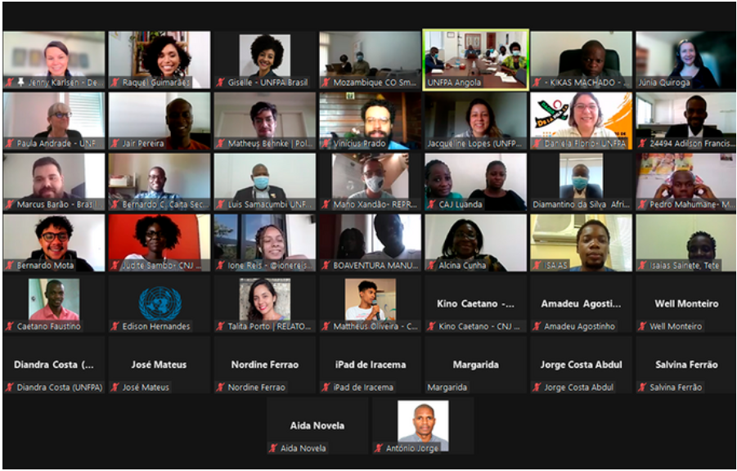
Figure 9: An excerpt of the participants of the lusophone (CPLP) exchange event.
Youth Provincial Observatory in Zambezia
In October 2021, Mocuba district, in Zambezia, hosted the 5th Youth Observatory. The main objective of the event was to get youth’s contribution to the development of the province. The Youth Observatory gave a series of recommendations to be considered by the Government in order to ensure that the youth benefit from the development of the country. The youth also highlighted the need for active citizenship and participation in the governance process. The youth observatory is a platform used by the youth to promote their contributions to the implementation of national plans, policies and priorities. Among others, participants stressed the need to ensure basic needs for the youth, particularly, access to political participation, education, health, justice and housing, as foreseen in the public policies. In short, it was an opportunity for the youth in Zambezia to convey their aspirations, concerns and requests to the local authorities, in particular, and the Government, in general.
Ouro Negro edutainment programme
Ouro Negro continued to reach adolescents and their families through the radio dramas “Os Intxunáveis” reaching some 1.717 million people in Mozambique in the 30 days preceding the listenership survey conducted by Geopoll in 2021.
Twenty storylines targeting adolescents on prevention and mitigation of the secondary impacts of COVID-19 including messages on child marriage, ASRH and teenage pregnancies, HIV and VAC prevention, as well as specific content about young people with disabilities were produced with contribution from the Rapariga Biz Programme. The episodes were broadcast twice per week by 115 radio stations in Portuguese and several local languages: Emakwa, Cisena, Elomwe, Ndao, Tsonga. Ouro Negro radio dramas (Jambolane and InTxunáveis) are being broadcast on 112 radio stations nationwide, encompassing 13 Radio Mozambique (RM) stations, 62 ICS stations, and 37 independent and community radio stations, according to PCI Media monitoring activities conducted between February and March 2021. In adidtion, 1.834 Ouro Negro Live programs were produced, broadcast and uploaded to Soundcloud by 48 radio stations (11 RM & 37 ICS and independent radios stations), in 10 provinces and 37 districts, in 23 local languages.
Ouro Negro da Malta, a new adolescent-led radio program was developed in 2021, which focuses on discussion and understanding among teenagers and young people of the themes addressed in the radio drama series Ouro Negro. The program is produced by teenagers for their peers, in Portuguese, in 6 radio stations in Nampula and Zambézia. While the radio drama is fictional, the program and talk show brings the reality of listeners and adolescents to life through interactive dialogue amongst young people. With support from Coalizão and the Child Parliament in Nampula (Angoche, Namialo and Nacala-Porto) and Zambézia (Pebane, Milange and Mocuba), 24 Rapariga Biz mentors and girls and boys (aged 10-19) were identified and trained as producers of the adolescent-led radio programs.

OUTCOME 1 summary: Challenges, Lessons Learned and Recommendations
While there were the above-mentioned achievements in 2021, it is critical to present some challenges, lessons learned, and respective recommendations.
    - Challenges
- In-person school lessons resumed in a phased-in approach due to COVID-19 – therefore, the start of the 10th cycle of mentorship sessions was done in two different moments;
- The duration of the mentoring sessions was reduced from 1.5 hour to one-hour period;
- The number of mentees per mentoring session was reduced from 30 to 20;
- The programme faced delays in the disbursement of funds during the first half of the year;
- Some delays were registered in the purchase and delivery of school materials and uniforms for the reintegrated girls;
- The Ministry of Health’s official referral and counter-referrals guides from communities to health facilities and the other way around are not yet in use;
- There are differences in the amounts of subsidies for community health workers/activists paid by different programmes in the same districts.

    - Lessons Learned
- As COVID-19 posed challenges for in-person meetings and events, it was critical to boost mentors and mentees’ knowledge and skills in the use of digital platforms.
- Not all in-person meetings and events are necessary. COVID-19 has shown that, in some cases, we can have virtual events with the same results as in-person events, while simultaneously saving money and time.

  - 3 Recommendations
- There is a need to start the use of the Ministry of Health’s official referral and counter-referral guide.
- Government should lead the process on harmonization of activists’ subsidies paid in different programmes.

OUTCOME 2: Availability of Quality Integrated ASRH Services for Girls and Young Women Increased
The agency and demand creation developed under Outcome 1 is influencing the uptake of SRH services and the increased need for the availability of quality integrated ASRH services for adolescents, girls and young women at schools, health facilities and at community levels in the target districts. In Outcome 2 the objective is to make the integrated ASRH quality services available for girls and young women.

OUTCOME 2: Availability of quality integrated ASRH services for girls and young women increased
Output | Indicator | Baseline as 2020 | Target 2021 | Achieved 2021 | Status
Output 5. Teachers implement the comprehensive sexuality and sexual health rights Education package | Number of schools in areas of intervention where SE package was fully implemented (programme areas) | 36 schools | 100 | 894
Output 6. Mobile health clinics and Community Health Workers (CHWs) in 20 priority districts deliver integrated SRH services at the community level | % Outreach ASRH services in communities | NA | N/A | N/A | This was not implemented due to COVID-19
Output 7. Integrated ASRH services by health providers are available in school SRH corners | % Outreach ASRH services in school corners | 60% | 50% | 51%
Output 8. Coordinated services to GBV survivors | Percentage of Programme Districts where multi-sectoral teams implement coordinated actions | 100% | 100% | 100% (20 out of 20)
Output 9. Access to microfinance, vocational training and SME development for girls and young women | # young women economically empowered (with income-generation) | ? | 10,000 | 12,194 (122% achievement)
Table 3: Indicators, baseline (2020), target and achievements 2021, outcome 2

Output 5: Teachers implement the comprehensive sexuality and sexual health rights Education package
UNESCO and UNFPA, together with the Government of Mozambique and Raparia Biz CSO implementing partners supported the preparation for the endorsement of the Eastern and Southern Africa Commitment on Comprehensive Sexuality Education (ESA 2021-2030). The process for the endorsement started with national consultations with key stakeholders involving youth, journalists, Members of the Parliament, religious leaders and civil society organizations; this initial phase took place from October to November 2021. Subsequently, a virtual meeting was held with the East and Southern Africa Permanent Secretaries (Education and Human Development, Health, Gender and Youth), on the 3rd of December 2021. Finally, the Ministerial Endorsement was on the 6th of December 2021 in Durban, during the ICASA Conference.
The document was signed by the four ministries of relevant sectors, namely: Ministry of Health; Secretariat of State of Youth and Employment; Ministry of Gender, Children and Social Affairs, and; Ministry of Education and Human Development. Out of the 22 countries of the region, Mozambique is one of the ten countries that endorsed the ESA Commitment (2021-2030), while two countries needed more time and the remaining ten countries could not join the meeting.
At national level, a roadmap and an action plan for the implementation of the ESA Commitment is being designed with support from UNESCO and UNFPA. A national workshop on CSE was jointly organized in the first quarter of 2022 for the preparation of the roadmap to the implementation of the ESA Commitment 2021-2030.
In addition, 120 (80 women) in service teachers from Nampula and Zambézia actively participated in the draft of radio messages and drama scripts on Comprehensive Sexual Education, Gender Based Violence and prevention of COVID-19. Sixty (60) CSE radio messages in Portuguese and other 4 languages (Chuabo, Lomué, Macua and Sena) broadcast for two months through Radio Mozambique, reaching 6,560,073 individuals including students and caregivers.
Furthermore, 200 (approximately 70% female) students from Nampula and Zambézia primary and secondary schools through virtual training sessions with increased knowledge on Comprehensive Sexuality Education, positive masculinity and prevention of COVID-19 and capable of making informed decisions about their sexuality.
Lastly, during the reporting year, a primary school CSE teacher's guiding manual was developed for teaching of transversal contents, including teaching and learning methodologies in the classroom. The testing of the manual is scheduled for 2022.

Output 6: Mobile health clinics and Community Health Workers (CHWs) deliver integrated SRH services at the community level in priority districts
In 2021, there were no mobile brigades to schools due to COVID-19 related restrictive measures.

Output 7: Integrated ASRH services by health providers are available in school SRH corners
The programme advocates for and supports the government to ensure that all secondary schools in programme targeted districts have at least one school-based health corner providing ASRH services to AGYW. Thus, out of 129 secondary schools, 66 (51%) have school-based health corners providing ASRH services.

Output 8: Coordinated services to GBV survivors
The Ministry of Gender, Children and Social Action continues to be the government entity to lead the response to cases of gender-based violence of adolescent girls and young women under Rapariga Biz. This is done through the multi-sector coordination structure.
While the multisector coordination structure played a great role in the coordination of services to GBV survivors, at the community level, gender-based violence and other harmful practices were addressed through awareness raising on GBV by 145,434 parents which were engaged in 9,316 sessions of community dialogue cycles aimed at addressing GBV and other harmful practices that perpetuate norms around child marriage and gender-based violence.
A total of 21 (12 female) gender focal points were sensitized on school-related gender-based violence, referral mechanisms and the pathways in order to operationalize the mechanism through school committees and management.

As part of supporting the operationalization of Violence Against Children (VAC) multisectoral referral mechanism on prevention, reporting, referral and response to violence against children at schools, including assistance to victims, VAC brochures were printed and distributed under Rapariga Biz to build awareness and train key stakeholders, such as gender focal points. In addition, the Ministry of Education and Human Development was supported with funds to develop an operational plan for the VAC mechanism and a child-friendly VAC brochure, and to train gender focal points in province and district level as well as school health focal points and school directors in the use of the VAC mechanism.

Output 9: Access to microfinance, vocational training and small and medium sized enterprises (SME) development for girls and young women
9,236 adolescent girls and young women from the safe spaces were economically empowered through allocation of business startup kits; financial literacy, business management and entrepreneurship training, and micro-business setup and coaching in the provinces of Nampula and Zambézia.
Rapariga Biz programme implementation in 2021 is consolidating the correlation between girls and young women’s risk of teenage pregnancy, parents’ harmful practices or child marriage and economic disempowerment in line with global evidence. Economic empowerment interventions have contributed to increased professional and business opportunities for 9,236 adolescent girls (mentees) and young women (mentors) in the safe spaces, sustaining their income levels, access, and control over productive assets for their micro and small enterprises at community level. This is also reinforcing their purchasing power and decision-making on their SRHR.
Financial management, incoming, savings and credit
9,236 adolescent girls and young women under Rapariga Biz enhanced their financial management skills, of which 6,240 are running savings groups (Village Savings and Loan Associations - VSLA) in the safe spaces. VSLA members are running small businesses at community level, securing income, and making them self-sufficient resulting in less negative coping strategies and vulnerability to HIV/AIDS, early marriage and other harmful practices.
To that end, 302 training sessions in financial literacy were conducted in the safe spaces with adolescent girls and young women aged 15-24 years (in/out of school, and from both urban and rural areas) from the districts of Quelimane (4,640) and Maganja da Costa (3,360) in the province of Zambezia and Nampula city (610), Nacala Porto (30), Ilha de Moçambique (603) and Rapale (20) in the province of Nampula.
Training sessions developed adolescent girls’ and young women’s knowledge, skills, attitudes and behaviors regarding the management of their day-to-day expenses, and improved their ability in setting financial goals and strategies. This included mastering key concepts of assets, capital formation and wealth creation, principles around good money management, and decision-making on personal financial issues and choices.
As a result of the financial literacy and VSLA methodology trainings, 329 VSLA groups (with cumulative savings of MZN 113,568,000; average savings of MZN 2,000 per cycle per member) were established. The VSLA groups have strengthened economic empowerment and independence among the Rapariga Biz girls and is implemented in alignment with the programme’s Leaving No One Behind (LNOB) principle by allowing the most vulnerable, including persons with disabilities, to efficiently save, invest and run profitable businesses at the community level.
The feedback from participants is positive as per Argentina, 23 years old – a survivor of child marriage and current community facilitator of VSLA groups in Puzuzo, Maganja da Costa - testimony suggests:
In the past, I used to misuse the little money I had. There was no money left to save or invest and I was unable to meet my school needs. At the time my family lived in a grass hut with no hope for change. Through my engagement in the financial literacy sessions, I learned how to manage my money, and started saving in the VSLA group in Puzuzo with the help of my aunt who also became a member. Gradually my life improved. My savings and business income from retail/whole rice sales allowed me to meet my daily needs, return to school (grade 11), build my own house with mixed materials, and improved my nutritional intake, personal hygiene and dignity. My dream is to become a successful business woman. I became an inspiration and role model to other adolescent girls in my community. Whenever I go to the groups, I feel like I am doing a good thing, because I want others to experience the same changes that I have had in my life.”
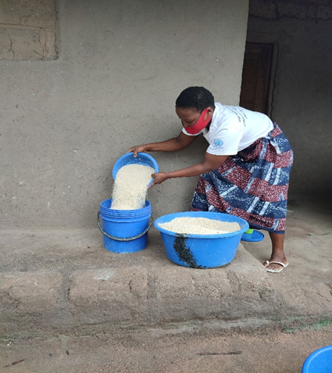
Business Development Service
The Rapariga Biz programme allocated 1,020 business starter kits for micro-enterprises owned by adolescent girls and young women, thus contributing to closing the gender and age gap in the ownership of productive assets and promoting the use of skills developed through training and coaching. Young women are using tools received to sustain their income and act as role models in their respective communities in line with the National Programme “Meu Kit Meu Emprego” led by the State Secretariat of Youth and Employment (SEJE).
Beside self-employment, the beneficiaries of kits also created 350 wage employment for other young women and community members. Furthermore, the feedback from beneficiaries has established that adolescent girls and young women are using the income from the micro-enterprises to enhance financial autonomy, address some of the immediate consequences of poverty (e.g., lack of food, sanitary pads, soap, lotion, etc.) and vulnerability to entering into abusive relationships and negative coping strategies.
Enhanced the capacity of 560 adolescent girls and young women on business management and entrepreneurship skills in the districts of Maganja da Costa (250) and Quelimane (310) in the province of Zambézia, hence long-term livelihood security. The four-days training provided participants with skills to systematically select income-generating activities based on a set of criteria including the assessment of required technical skills, suitability to individual circumstances, current market trends, profitability, and loan repayment plan, risk analysis, among others. The training was complemented by a series of coaching sessions (learning by doing) to 3,058 selected adolescent girls and young women.
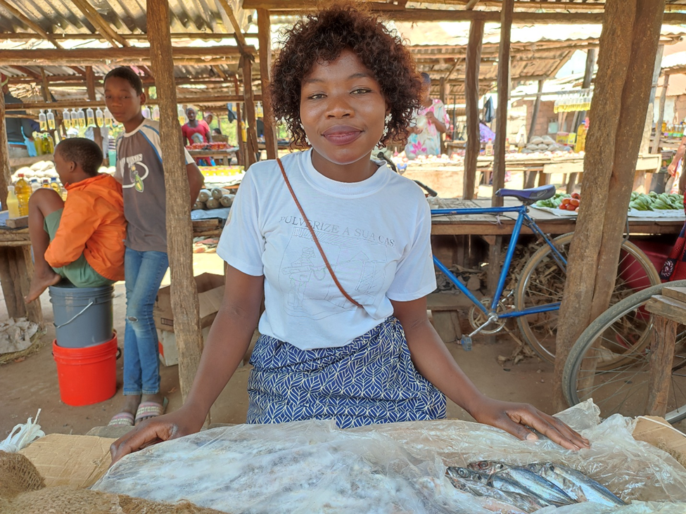
Access to finance is not enough without the right skills – assures Mifa, 21 years old woman entrepreneur and Rapariga Biz mentor from Maganja da Costa.
“I have been running my grocery shop selling fish and packs for approximately 2 years with many challenges. Coaching was key to proving that my business can be profitable. Access to finance is not enough without the right skills. For many years my business was stagnant due to poor management practices and limited marketing skills. I did not know how to utilize the capital to maximize profit. The business management and entrepreneurship training and subsequent coaching sessions helped me in assessing the feasibility of various opportunities and selecting the most realistic and profitable options. My business is thriving. I have hired 1 full-time employee to meet the growing demand for my products, and I am currently looking for a plot to build my own store (and stop renting). On top, the Rapariga Biz programme provided me with financial literacy and a kit of chest freezer which allowed me to sustain my activity in the fishery value chain. My vision is to establish a woodcraft and furniture shop.”
Employment Preparedness
1,141 adolescent girls and young women from the safe spaces in Nampula and Zambézia improve their knowledge on skills for job hunting and preparatory work for interviews. 50 secondary schools’ libraries in Nampula were equipped with employability resource handbooks to promote young women’s readiness for job opportunities. This will indirectly reach an estimated 4,000 additional youth/students.
District | Planned | Achieved | %
Nampula | 260 | 259 | 100%
Rapale | 150 | 142 | 95%
Nacala Porto | 150 | 140 | 93%
Quelimane | 250 | 323 | 129%
Maganja da Costa | 250 | 277 | 111%
TOTAL | 1,060 | 1,141 | 108%

"My name is Rosema Rego. I am 16 years old, and I am a second year student in the Mechanics of Metallic Construction course at the Industrial Institute of Nampula. I am one of 5 girls that make up the class of 24 graduating in Mechanics of Metallic Construction (21%) and I am participating in the Fair as part of the National Week of Technical-Professional Education.
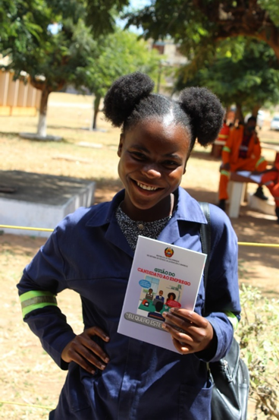
Girls, stop being afraid to pursue engineering. It is wrong to say that women and girls are afraid of engineering fields. All that is needed is to open opportunities for them and for them to take on the dedication! I really like my course [Mechanics of Metallic Construction] and I wouldn't change it for anything. It is a very good course and has many job opportunities because many companies work or are built based on metals like iron and steel.
Girls don't be fooled by gender discrimination and pressure from partners who say, ‘I'll give you everything.’ Focus on your studies first. My professional dream is to work in the logistics operations of the Northern Development Corridor. I am developing enough skills to move forward. The Job Seeker's Guide I have in hand will help me look for my first job with confidence."

Rosema is one of the beneficiaries of the dissemination of the Job Seeker Guidebook - an initiative of the Secretary of State for Youth and Employment in partnership with UN Women that aims to reach over a thousand girls and young women with skills development in order to increase employability and their insertion in the labor market in the provinces of Nampula and Zambezia, under the Rapariga Biz Programme.

OUTCOME 2 summary: Challenges, Lessons Learned and Recommendations
The main challenges, lessons learned and recommendations of outcome 2 are as follows.
2.1.1 Challenges
- Because of COVID-19, limitations continued to implement mobile brigades, as people’s gatherings were also limited.
- Response to GBV requires some investment in infrastructure. There is a limited number of Integrated Care Centres (CAIs) in both provinces. This affects the effectiveness of the GBV response.
- Cultural factors continue to hinder full implementation of CSE in Mozambique. For example, there are still discussions around topics such as masturbation and LGBTI’s rights, as it has been publicly noted over the last months’ debate around 7th grade books with these topics.
2.1.2 Lessons learned
- The debate around the topics included in the 7th grade book (i.e. masturbation and LGBTI rights) showed that parents are not well monitoring their children’s schooling, as these topics have been included in the school books for 18 years, and there had never been a debate around it before. It could also demonstrate a pushback for certain aspects of CSE at the community level.
- The type of business to be adopted as part of economic empowerment initiatives can vary depending on the local context.
2.1.3 Recommendations
- Support Government in the design, implementation and evaluation of the ESA Commitment 2021-2030 national roadmap and action plan.
- Continue to work with parents and culture guardians on issues related to GBV and other harmful practices.
- Promote advocacy for inclusion of and service provision to persons with disabilities, people living with HIV and LGBTI.

OUTCOME 3: An enabling, free and safe environment for increased participation of girls and young women and the promotion of their SRHR created
Families, community members and leaders, religious leaders, parents, midwives, boys and men have played a critical role in promoting an enabling, free and safe environment for increased participation of girls and young women and ensuring they enjoy their sexual and reproductive health and rights. Therefore, the involvement of these actors in the programme have shown to be key to address the barriers and behavioral gaps in the environment surrounding girls and young women at the community related to SRHR. In working with local leaders and other influential players, the emphasis is placed on the communities’ role in keeping adolescent girls and young women in school. For the girls and young women that are out of school, the main focus has been their reintegration to school. Local actors have also been useful in supporting the RB mentors in the identification of safe spaces, resolving intergenerational issues at family level and supporting high attendance of the AGYW in mentorship sessions, as well as contributing to preventing and renouncing child marriage cases in their communities. Thus, to ensure the creation of an enabling environment for the fulfillment of SRHR by the AGYW, outcome 3 is unpacked into the following outputs.
OUTCOME 3: An enabling, free and safe environment for increased participation of girls and young women and the promotion of their SRH rights created
Output | Indicator | Baseline 2020 | Target 2021 | Achieved 2021 | Status
Output 10 - Enhanced involvement of men and boys to strengthen their SRHR | Document with actions proposed exists | 0 | N/A | N/A
 | % Boys and men participating in implementation of SRHR | 0 | 80% | 60% (120 out of 200)
Output 11 - Faith based leaders and youth groups mobilized and active to promote adolescent SRH and rights | % Religious leaders actively involved in implementation of SRHR (from total of 400 religious leaders) | 38% (150 out of 400) | 50% | 48% (191 out of 400)
Output 12 - Communities participating in community dialogues on SRHR related to girls and young women | % of community dialogues held on SRHR | 100% | 100% | 100%
 | Nr of community leaders acting on community dialogues | 420 | 400 | 75%
Output 13 - Strengthened awareness of girls and young women on SRHR including HIV/AIDS and GBV prevention | % New acceptors of Family Planning | 60% in RB (66% Zambezia and 58 Nampula) | 30% | 28 %
 | HIV/AIDS incidence among girls aged 15-24 years | 1.8% Nampula and 3% Zambezia | 7.1% (Zambezia) and 7.1 (Nampula) | Zambezia (3.4%), and Nampula 1.7)
Table 4: Indicators, baseline (2020), target and achievements 2021, outcome 3

Output 10: Enhanced involvement of men and boys to strengthen their SRHR
Boys’ mentorship
During the last quarter of the year in analysis, the programme launched the boys’ mentorship in the 2 provinces of the programme. In Nampula, the boys’ mentorship was launched in Meconta, Cidade de Nampula and Mogovolas, and in Zambezia the approach was implemented in Cidade de Quelimane, Nicoadala and Namacurra. In total, the boys’ mentorship is facilitated by 120 boy mentors and 6 supervisors (with each district being supported by 20 mentors and 1 district supervisor). By the end of 2021, with three months of implementation, the programme had reached 4,755 boys; 2,407 in Nampula and 2,348 in Zambezia. The picture below shows a session of boys’ mentorship in Namacurra districts, Zambezia province, in October 2021.
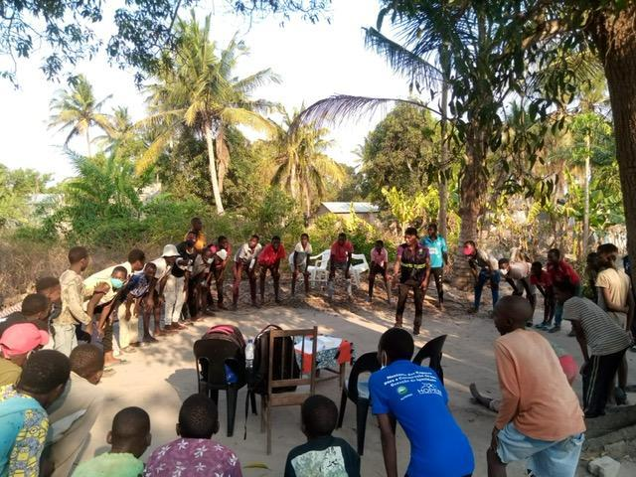
Figure 10: Boys’ mentorship session in Namacurra, Zambezia, October 2021

Hélio Cesar (fictitious name), aged 24, living in Mutauanha neighborhood, Nampula City, father of one son, gave the following testimony on the impact of boys’ mentorship on his life:
“Before I joined the boys’ mentorship, I was a man inside the box, because I thought men were superior to women, and that women could only stay at home to take care of the house and children. For some time, I was ashamed of myself, and I was an absent father and husband. I remember once I had a harsh quarrel with my wife because she had invited me to go to the health facility for an HIV test. That time she was pregnant and the situation started to worsen when she started to lose weight during her pregnancy. We almost split up, because I thought she had tested positive for the HIV test, but she did not have courage enough to disclose her HIV status to me. Things changed when I joined the boys’ mentorship. All topics dealt with during the mentoring sessions touched me because they were related to what was happening in my family. These actions changed my mindset and changed my attitude towards life. As a result of the mentoring sessions, I gained courage and I went for an HIV test, and when I returned home I hugged my wife as I got tested for HIV, and the result was negative, contrary to what I suspected. Nowadays I take care of my family and I am always there to support my family. We now do family planning so that my wife can pursue her schooling, and to avoid unintended pregnancy. Thanks to boys’ mentorship now I consider myself a man in a transformative stage, given that I abandoned some toxic habits and behavior. Today our home is full of joy and peace”.

Output 11: Faith based leaders and youth groups mobilized and active to promote adolescent SRH and rights

140 (28 female) religious leaders from Maputo province benefitted from training sessions conducted by the Council of Religious Leaders (COREM) using an Adolescents Sexual and Reproductive Health and Rights (ASRHR) handbook, which resulted in an increased knowledge on HIV/AIDS and services available in Maputo Province and within the National Health Services. Furthermore, COREM has contributed to the dissemination of HIV combined prevention messages through religious forums and using community radios stations broadcasting of messages and soap operas, targeting adolescents, youth and adults.
Additionally, 6 meetings with 51 religious leaders were held in Nampula and Zambezia. These meetings were aimed at promoting awareness raising on gender-based violence including combating harmful practices, such as the child marriage.

Output 12: Communities participating in community dialogues on SRHR related to girls and young women

A total of 145,434 parents were engaged in 9,316 sessions of community dialogue cycles aimed at addressing harmful practices that perpetuate norms around child marriage and gender-based violence. As a result of the participation in these dialogues, changes reported indicate a 37% increase in the number of participants who demonstrate willingness to abandon child marriage in the communities; 40% increase in the number participants who feel the urgent need to change some of the practices such as initiation rites for young girls, which is a cultural practice that is seen as a preparation for girls to be ready for marriage; 16% increase in the number of participants that can site at least 3 benefits resulting from delayed age of marriage. In 2021, 239 cases of child marriage and abuse were identified, reported to the local authorities for resolution where 89% of the cases had a positive conclusion with the perpetrator sanctioned and the children provided psychological, health and material support to continue their life.
A comparison with achievements registered in the previous year, it is worth mentioning that while in 2020 the number of empowered community leaders and actors was 402, in 2021, the number of leaders empowered reduced to 299, showing a decrease by 26%. Additionally, when it comes to the number of community dialogue sessions held, there was an increase by 353% (from 2,056 sessions held reaching 29,846 community members in 2020 to 9,316 sessions held reaching 145,434 community members in 2021). There are differences between numbers registered in Zambezia and Nampula. The approach used in Nampula involves more people than that used in Zambezia.

Output 13: Strengthened awareness of girls and young women on SRHR including HIV/AIDS and GBV prevention
Counseling for ASRH/HIV and topics relevant to adolescents
In 2021, the platform experienced a growth of 6,8% corresponding to a registration of 22,649 people. The gender ratio is 58% (M) and 42% (F) with an average response rate of 62,2%. Trendiest topics included COVID-19, sexuality, and Family Planning and pregnancy. Seven polls were launched focusing on quality and uptake of health services, mental health and on the new Country Programme Document (CPD) priorities. Based on the success of the SMS Biz peer-to-peer counseling platform, with over 340,000 young users, a new MOU was signed between the Government of Mozambique and 3 main Mobile Network Operators for an additional 5 years. To leverage the effectiveness of this platform, the Secretary of State for Youth and Employment, Ministry of Health and UNICEF repurposed two SMS BIZ counseling hubs with 52 trained counselors to respond to COVID-19. This setup allowed counselors to address more than 500,000 queries on COVID-19 between April and December 2020.

OUTCOME 3 summary: Challenges, Lessons Learned and Recommendations
The main challenges, lessons learned and recommendations related to outcome 3 are described below.
3.1.1 Challenges
- The implementation of the boys’ mentorship was delayed due to prevailing COVID-19 restrictions and started in the last quarter of 2021. The expansion to new districts will therefore only be possible in 2022.
- There is a difference in the approaches used by implementing partners implementing community dialogues.
- HIV response activities were limited in both provinces.

3.1.2 Lessons learned
- The number of people reached through community dialogues varies significantly depending on the approach used.
- The National AIDS Council has not been involved meaningfully in the programme. Involving this partner in the programme can lead to improved HIV prevention and response achievements.
3.1.3 Recommendations
- There is a need to harmonize the approaches of community dialogues by different implementing partners; Fundação para o Desenvolvimento da Comunidade in Nampula, and NAFEZA in Zambezia.
- Expand the boys’ mentorship to additional Rapariga Biz districts.
- Scale up HIV interventions in RB districts.

OUTCOME 4: Strengthened governance and coordination for integrated SRH programming
The overall ownership and leadership of Rapariga Biz sits with the Government through the Secretariat of State of Youth and Employment, and implementation is happening through its multi-sector structures at national, provincial and district levels. The multi-sectoral committees at all levels continue to provide a strategic mechanism for leadership and coordination of the implementation of Rapariga Biz. At the national level, the oversight of the programme is occurring through a steering committee in which all partners and the government participate. The involved UN agencies are providing technical assistance and leadership within the scope of their respective comparative advantages, and through partnership with civil society partners.
The aim of Outcome 4 is to strengthen the governance and coordination for better SRHR programming at all levels from national, to provincial and district. Actions are focused on reviewing and/or formulating policies and programming concerning adolescents and youth, strengthening coordination mechanisms between the national level and the targeted provincial and district levels as well as generating evidence and collecting data to feed into programming, advocacy etc. Cross-sectoral coordination of the investments in youth is also essential for the governance of demographic dividend policies.
OUTCOME 4: Strengthened Governance and Coordination For Integrated SRH Programming
Output | Indicator | Baseline 2020 | Target 2021 | Achieved 2021 | Status
Output 14 - UPR process and report include ASRH | Inclusion of SRHR for girls and women in UPR report and next review cycles | 100% | 100% | 100%
 | # senior police and justice officials trained to implement UPR recommendations | NA | NA | N/A
 | Inclusion of contribution from youth associations and women organizations in the UPR report. | 100% | 100% | 100%
Output 15 - Strengthened inter- ministerial coordination mechanisms on ASRH issues at national level (CIADAJ) | % CIADAJ decisions implemented | 50% | 100% | 100%
Output 16 - Strengthened coordination on ASRH at provincial and district levels (through PGB) | More effective coordination of PGB implementation at provincial and district levels (revitalized committees with regular meetings) | 22 | 26 | 22 (85%)
Output 17 - SRH specific rights and needs of girls and young women included in existing policies and plans | Platform undertaken in the National Assembly SRHR | YES (operational) | YES (operational) | YES (operational)
 | ASRH and GBV integrated into district annual plans and budget | YES (100%) | YES (100%) | YES (100%)
 | Capacity of ministry of education and stakeholders for effective implementation for comprehensive sexual education | YES (100%) | YES (100%) | YES (100%)
Output 18 - Enhanced evidences for girls and young women’s SRHR | Baseline survey available | Done 2016 | NA | NA
 | End-line survey available | Planned for 2022 (end of phase I) | N/A | N/A | N/A
 | Key programme partners participated in inception phase workshop | Done 2016 | NA | NA
 | Qualitative research on sociocultural norms are translated into programmatic adaptation, and evidence based learning | 2 (1 UNICEF and 1 UNFPA) | 2 (1 UNICEF and 1 UNFPA) | 1 (Qualitative longitudinal dropout study by UNICEF), (Reality check not yet completed) - 50%
Output 19 - Situation at the program site and implementation progress | # of joint monitoring visits (National and Provincial) | 22 | 10 | 22 (220%)
 | Knowledge and understanding of attitude and behaviors at programme site regularly monitored and reported towards programme adaptation | 20 (Kiribiz data from 20 Districts) | 20 | 20 (100%)
 |  | 19 PGB discussion on Programme implementation | 20 | 20 (100%)
Table 5: Indicators, baseline (2020), target and achievements 2021, outcome 4

Output 14: UPR process and report include ASRH

Contribution to UPR Good Practices
The UPR Good Practices is a joint publication by the UN Development Coordination Office, OHCHR and UNDP. The publication is a set of articles from different UN Country Offices Agencies selected around the UN system. Mozambique experiences on UPR was selected as one of the good practices to be included in the publication. The Mozambique example showcase is a joint submission by Rapariga Biz UN Agencies - UNFPA, UNESCO, UNICEF and UN Women. A summary of the achievements from the Mozambique example included in the publication is listed below:
- Engagement with the Intersectoral Committee for Adolescents and Youth (CIADAJ), providing both technical and financial support on implementation of UPR recommendations from district to national level using the CIADAJ institutional structure;
- In the 3rd cycle, the UPR was used to leverage the ICPD +25 Commitments. All the commitments were approved by the government to become part of the UPR Recommendations. It means that they will be part of the government’s human rights agenda and priorities until the end of the 3rd cycle in 2024;
- Joint efforts with the government, particularly the Ministry of Education on strengthening the component on Disabilities and Comprehensive Sexual Education in the national curriculum;
- Engagement with CSOs platforms has not only strengthened participation of national actors, but also made possible acceleration on implementation of key UPR recommendations related to adolescents sexual and reproductive health and rights. This progress was made possible through supporting CSO platforms, but also public awareness raising campaigns, such as community radio programmes.
- Link to access to UPR Good Practices Publication: https://www.undp.org/library/un-good-practices-how-universal-periodic-review-process-supports-sustainable-development
Output 15: Strengthened inter- ministerial coordination mechanisms on ASRH issues at national level (CIADAJ and PGB)
Under resolution 16/2013, the Youth Policy was approved, after revoking resolution 4/96, 20 March 2013. The main vision of the policy is to ensure that youth holds an integral and active part in the construction of the Mozambican Nation. For the operationalization of this vision, the mission of the Youth Policy is to “create conditions to ensure youth’s full participation in the national development process, at political, social and economic levels, with focus on different sector policies on youth”. Overall, the policy is aimed at “guaranteeing that Mozambican youth enjoys long-lasting and healthy lives, sustained by a combination of dignified health, education and employment, fair pay and deserved housing”.
In 2016, through Decree 26/2016, 18 July, the CIADAJ (Comité Intersectorial de Apoio ao Desenvolvimento de Adolescentes e Jovens), Multi-sector Committee for the Support to the Development of Adolescent and Youth Regulation was approved. The aim of the Regulation is to monitor and review policies on development of adolescents and youth. The CIADAJ plenary sessions are held annually (once or twice), and are led by the Prime-Minister, in his office. The last CIADAJ plenary session took place on 15 February 2021, with participation of UNFPA and UNICEF. Main minutes and other documents of the last event can be found here. Apart from the ministerial CIADAJ event, UNFPA supported the regional CIADAJ events in Gaza, Manica and Nampula, for the southern, central and northern provinces, respectively. In each of those events, district administrators from all the regions took place. The immediate result of the involvement of administrators in those meetings is that the district authorities are currently more receptive and open in promoting the youth agenda in their districts.
Apart from the CIADAJ regional (3) and plenary (1) sessions supported last year, UNFPA also supported the organization of the 10th CIADAJ National Seminar, in Namaacha, Maputo Province. The event counted on the participation of provincial representatives (2 per province: one from Provincial Service of Justice and Labor and one from Provincial Directorate of Youth, Sports and Employment), representatives from key ministries on youth issues (Agriculture, Health, Education, MGCAS, MJCR, Public Works and Housing), CSO and networks, and UN agencies. Maputo Province and Namaacha authorities were also present in the event. Main recommendations from the seminar were the following:
- Niassa has to be considered for next projects as it has only a few projects on youth implemented there.
- It has been noted that Nampula has been benefiting from different initiatives. So it was recommended to avoid overlap of projects in the same districts.
- We have to consider decentralization of funds to provincial branches of SEJE for specific activities (eg: coordination meetings of the PGB).
- UNFPA and other UN agencies were requested to inform CSO partners to report their activities to the Government at all levels (central, provincial and district).
- SEJE requested to be involved in the selection and review of implementing partners.

During the seminar, important presentations were delivered by different entities. Find here the presentations delivered by different sectors. Some of them include relevant data on youth.
PGB National Meeting and technical meetings
Rapariga Biz also supported the realization of the Geração Biz Programme National Meeting, held in Maputo, and 4 quarterly technical meetings. Technical meetings at the central level were also held with participation of UN agencies. Among others, the meetings were important to reflect on the priorities for the next phase of Rapariga Biz, the main achievements of the Programme, mapping of interventions on youth in Mozambique, and preparation for the next PGB 2023-2033 National Strategy whose design will be technically and financially supported by the Programme.

Output 16: Strengthened coordination on ASRH at provincial and district levels (through PGB)
PGB Provincial Multi-Sectoral Committees
At the provincial level in Nampula and Zambézia, the PGB Provincial Multi-Sectoral Coordination Committee leads and coordinates the Rapariga Biz implementation. It is composed of provincial directors of the ministries involved in PGB plus the Ministry of Justice, Constitutional and Religious Affairs. It is chaired by the Provincial Directorate of Justice and Labor. UNFPA, UNESCO, UNICEF and UN Women are also members of the Provincial Committee. The PGB Provincial Multi-Sector Coordination Committee meets once every quarter, with a focus on reviewing implementation for the past three months and endorsing work plans for the next three months. In these meetings, operational issues affecting the Rapariga Biz implementation are also addressed.
During 2021, the PGB/Rapariga Biz Multi-Sector Coordination Committee had 8 quarterly meetings in Zambezia (4) and Nampula (4) provinces. Additionally, one district multisector committee was held and facilitated by a national representative in each of the 20 districts where the programme is implemented.
In monitoring visits and review meetings held over the last couple of years it was also found that the Government lacked means of transportation to play their leadership and oversight role in the districts. To respond to this, 24 motorcycles were purchased by the programme. Thus, each district implementing the Rapariga Biz programme received one motorcycle for the monitoring and supervision of the programme’s activities. The figure below shows the handover ceremony, led by His Excellency Secretary of State of Youth and Employment, of 11 motors in Quelimane, Zambézia.
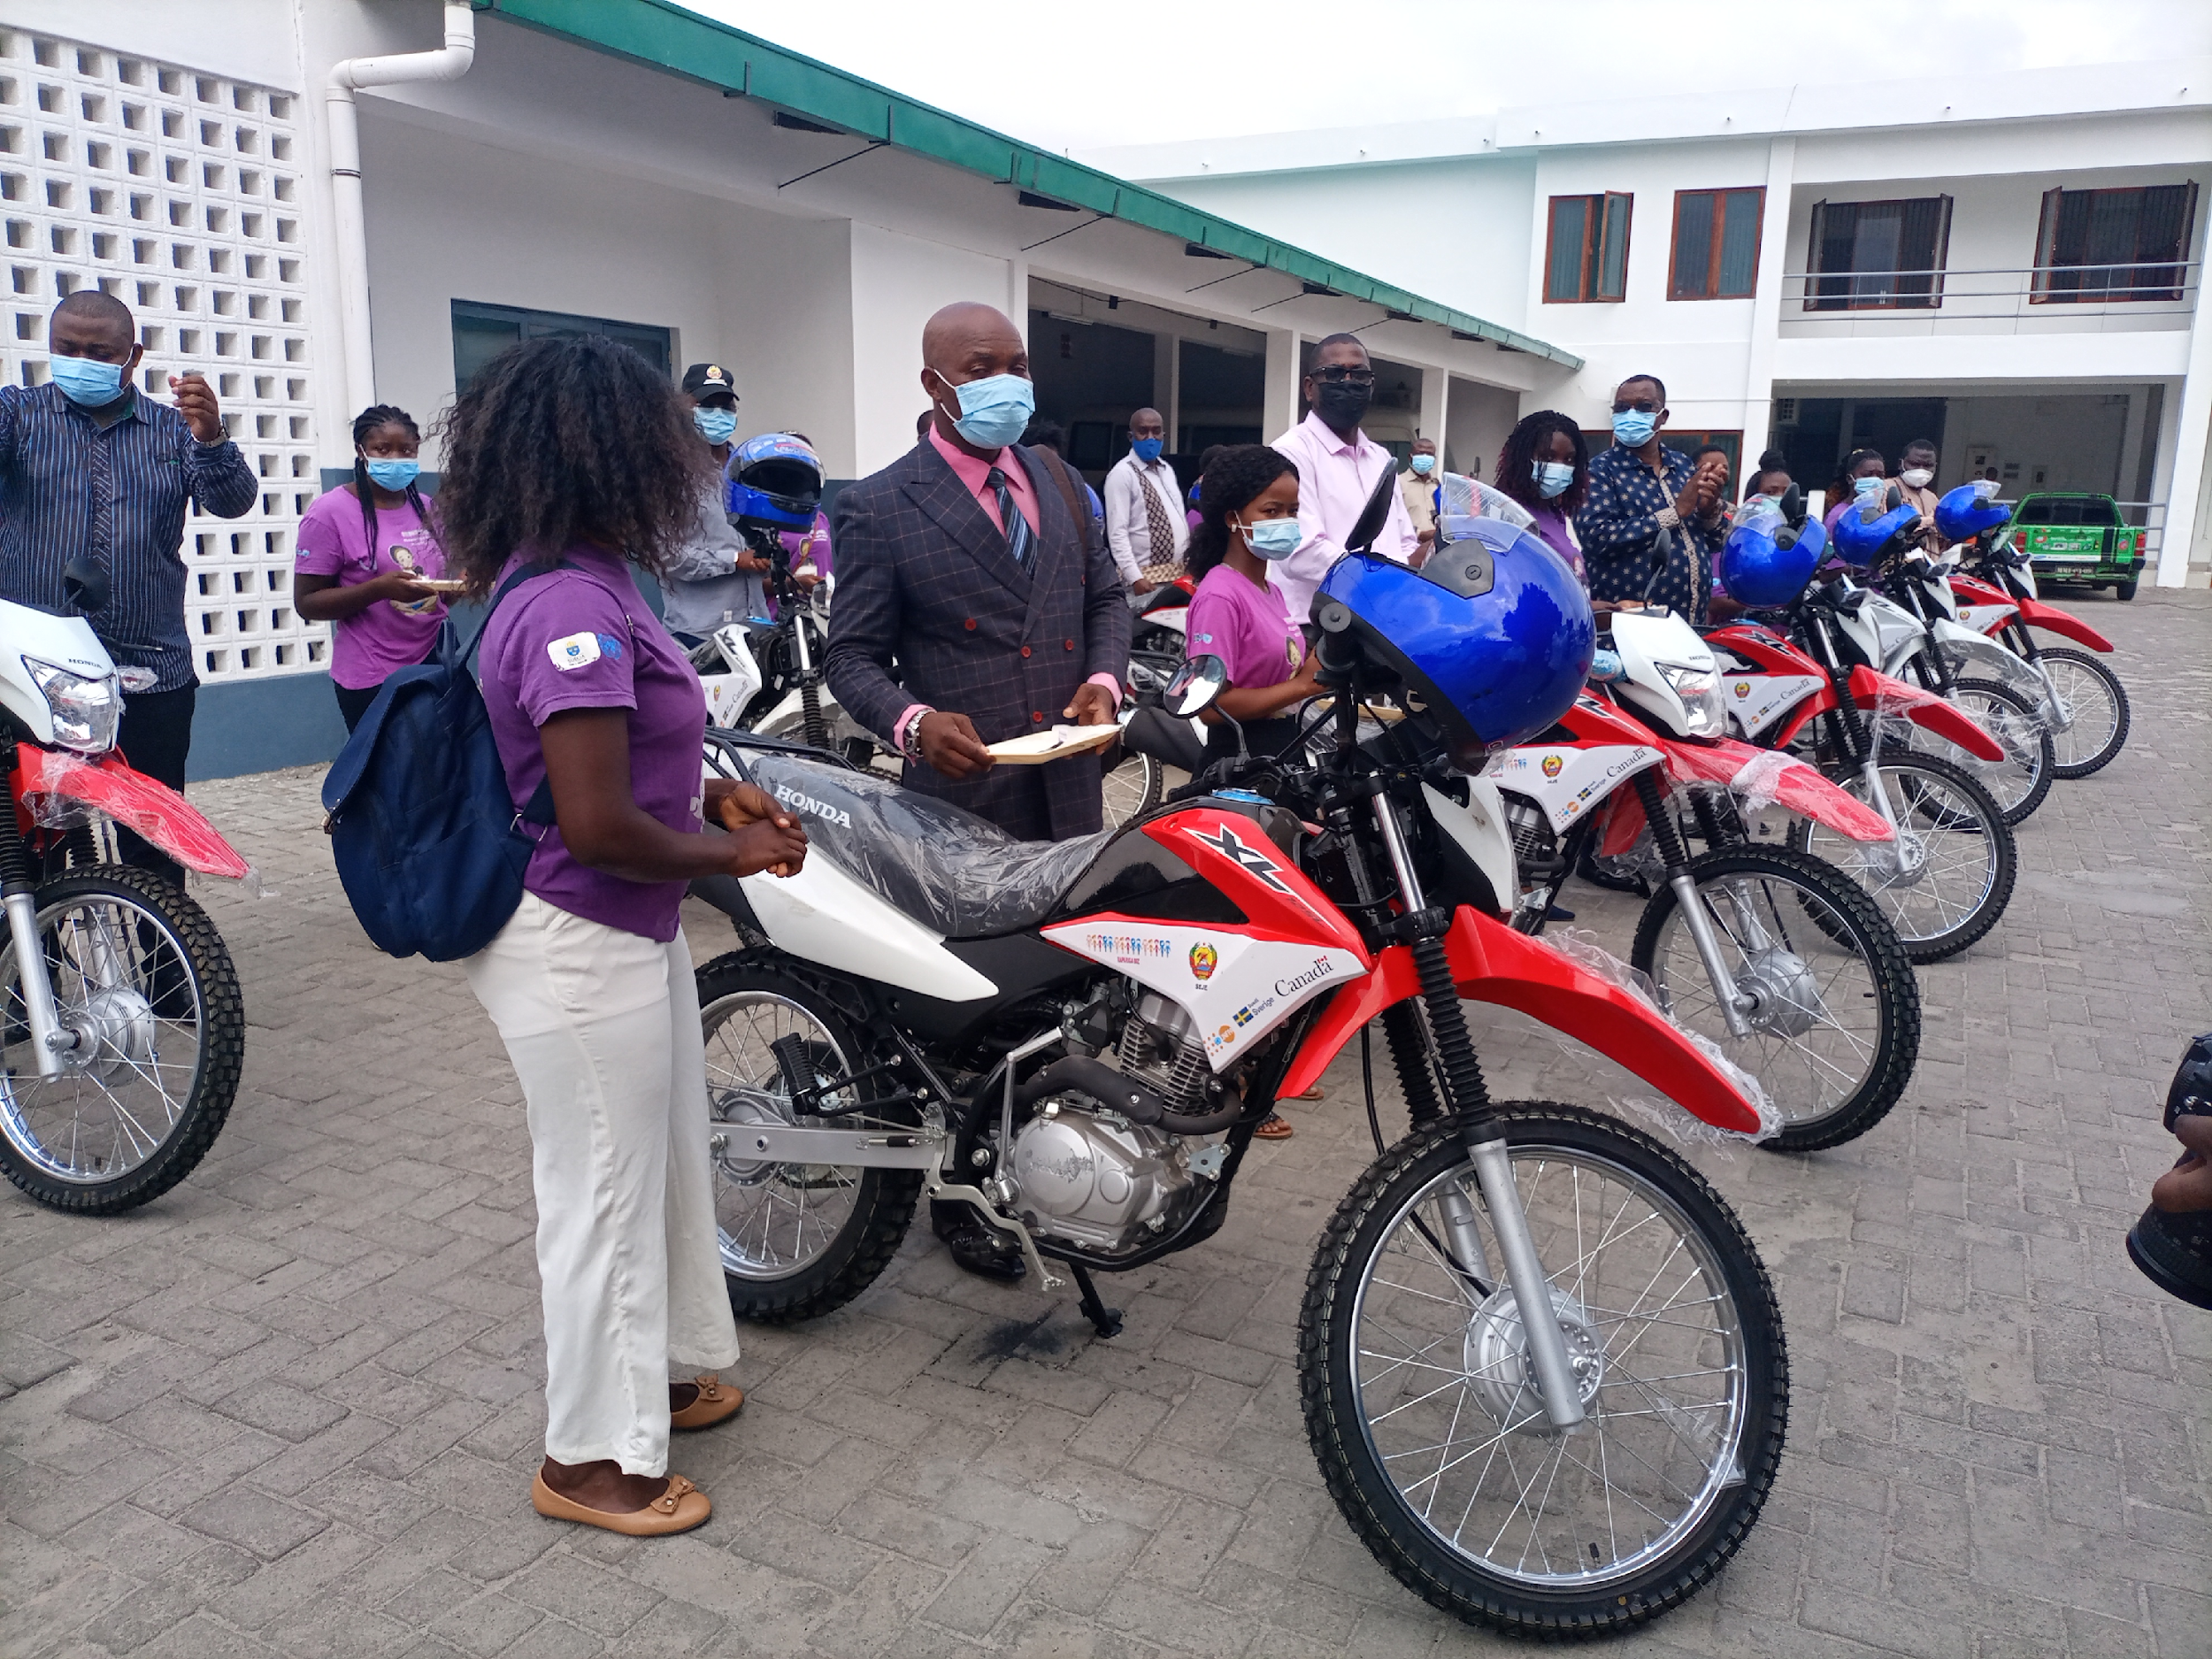
Figure 12: Handover ceremony of 11 motorcycles in Zambezia, November 2021, Quelimane

Output 17: SRH specific rights and needs of girls and young women included in existing policies and plans
The National Development Strategy (ENDE) is the guiding policy for Mozambique's development planning process. It defines the Country's development objectives and priorities, articulates the strategic orientation and guides the designing of all medium and short term development instruments and policies. The instrument was adopted in 2015, and after the first period of implementation, the government and its partners are conducting its revision.
After a national consultation meeting held in Maputo in December 2021, additional consultations on ENDE were held in two districts of each of the provinces of Zambezia, Nampula, Cabo Delgado, Tete and Gaza. In each province, consultations involved at least 30 young people with the aim to gather their opinions on the strategy. The photo below highlights a consultation meeting that took place in Chiuta, Tete province.
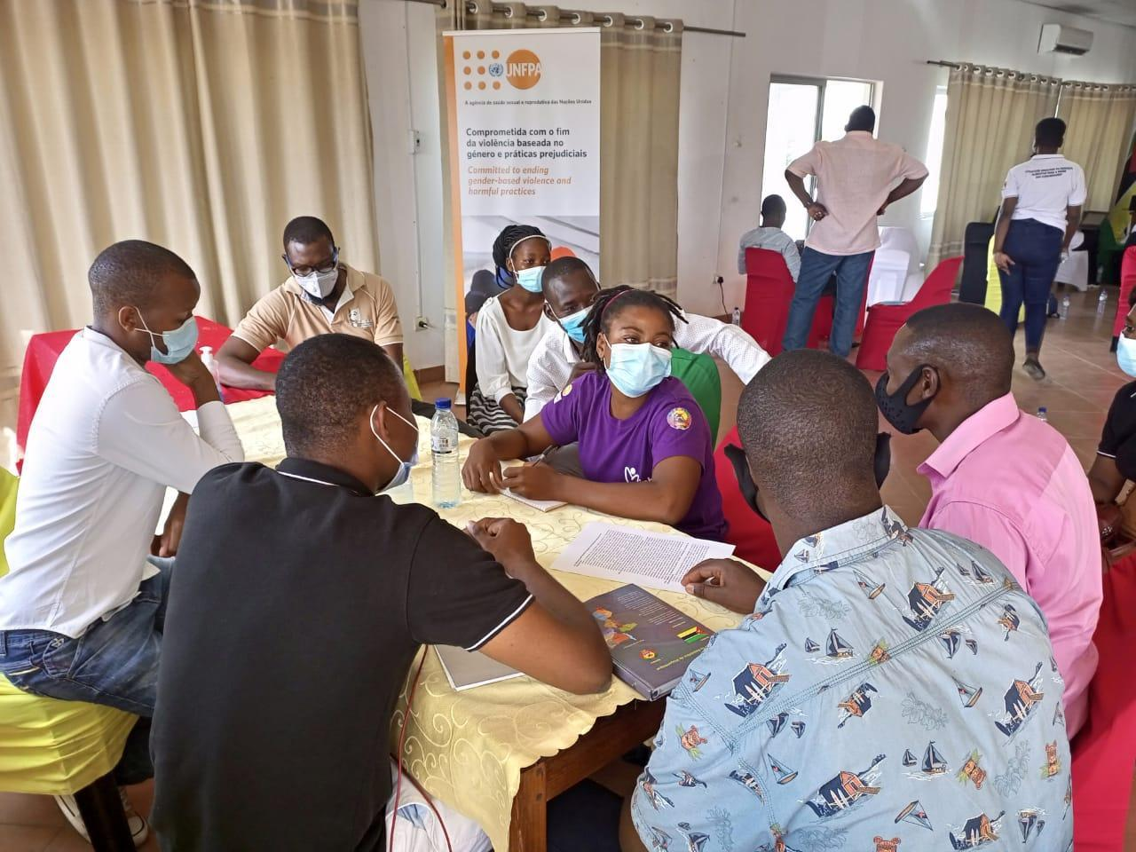
Figure 13: A consultation meeting in Chiuta, Tete
The consultations were led by CNJ, an entity with a mandate over youth organizations in the country. In addition, the Ministry of Economy and Finance were present as the technical coordinator for the elaboration of the development strategy (ENDE), while the Technical Secretariat for Youth (SEJE), the government representative in the area of ​​youth, was also part of the process.
# | Topic | Recommendations for ENDE/ICPD/ODS
1 | Education  (Social transformation pillar) | The government should invest in the expansion of technical-professional schools adequately equipped and with qualified teachers with a view to creating self-employment, valuing know-how (trade).  Establish a long-term curriculum, reintroduction of models for encouraging young people to research/science such as school contests.  Strengthen programs aimed at reducing school dropout with a focus on girls
2 | Employment / Entrepreneurship  (Environment and Circular Economy pillar) | Create favorable environments for self-employment as a way to maximize the value chain, both for agribusiness and other areas with dormant potential.
3 | Industry  (Environment and Circular Economy pillar) | Promote industrialization initiatives in the country through free zones, reduction of taxation, and improve the business environment by reducing bureaucracy both in registration and in other stages of production.  Efforts to reopen factories such as Reopel, Mabor, among others.
4 | Taxation  (economic transformation pillar) | Debt reform and public finance management, transparency and credibility in fiscal management.  Strengthening accountability in public expenditure to reduce opportunities for corruption.  Adopt a medium-term fiscal approach through the introduction of a simple fiscal rule to manage resources based on volatility and dependence on raw materials/commodities;  Accelerate the establishment of the sovereign wealth fund to ensure intergenerational equity.
5 | Corruption  (Governance pillar) | Encourage the use of digital services to improve the efficiency of government services and reduce opportunities for corruption.
6 | Improvement in the provision of public services  (Governance pillar) | Improve the provision of public service through the professionalization of the employee, create strategies to attract and retain employees, increase on-the-job training, dissemination of rules of professional ethics, among other interventions.
7 | Area of ​​Peace and Security  (Governance pillar) | Urgent need to structurally understand the reasons for persistent conflict and lay the groundwork for effective reconciliation and mutual trust.

Additionally, during the reporting period, key global and national policies and strategies were designed, including the Country Programme Document (CPD 2022-2026) for the UN agencies, as well as the United Nations Sustainable Development Goals Country Framework (2022-2026). In both documents, the rights and needs of girls are included. Additionally, the primary teacher’s manual also includes topics on the rights and needs of girls and young women.
Furthermore, the ESA Commitment (2021-2030) also highlights the need to promote SRH specific rights and needs of girls and young women. Below are some clauses of the ESA Commitment:
- “Continue investing in high quality, evidence-based, gender-transformative, age- and culturally-appropriate sexuality education, both in and out of school, that covers a broad range of critical topics on values, the human body, relationships, safety, consent, gender, and health and wellbeing. This investment will equip adolescents and young people with knowledge, skills, attitudes, and values that will empower them to realize their health, well-being, and dignity; develop respectful social and sexual relationships; consider how their choices affect their own well-being and that of others; and understand and protect their rights throughout their lives. This education will be linked to integrated quality youth-friendly HIV, SRH, psychosocial, and GBV services”.
- “Address the structural factors that increase the vulnerability of adolescents and young people and their risk of acquiring HIV and STIs or becoming pregnant, notably gender inequalities, GBV, poverty, climate change, stigma, and discrimination. Further factors are the legal, policy, and social hurdles in accessing health services, social protection services, and education, including issues related to the age of consent to access SRH services”.
- “Ensure the inclusion of adolescent and youth-friendly SRHR within the national Universal Health Coverage packages while strengthening collaboration between the education, health, youth and gender sectors at all levels to strengthen resilient adolescent-responsive health systems and increase access by adolescents and young people to a good quality package of safe, climate smart, effective, acceptable, and affordable adolescents and youth-friendly SRH services and commodities, including menstrual health, psychosocial support, and social protection services”.

Output 18: Enhanced evidences for girls and young women’s SRHR
For this activity, a baseline study took place in 2016, while an end-line survey is planned for the end of phase I of the project (2022). The inception phase workshop was also done in the first year. The reality check by UNFPA is rescheduled for 2022.
A Longitudinal Assessment of School Dropout was conducted, including in Nampula province where the project is implemented through Rapariga Biz and other funds. To date, data collection and interpretation was completed and the first draft of the report was developed. One of the main preliminary findings of the study is about the significance of initiation rites. For example, the 2019 quantitative study demonstrated that the dropout rates for both sexes significantly increase at 13 years of age and older (particularly for girls when they begin their menstrual cycle) and when the initiation rite ceremonies take place.
While the qualitative study is not nationally representative and is only a snapshot of the situation, it demonstrates that the initiation rite ceremony has a significant impact on school attendance; for boys as it coincides with school time, and for girls during their menstrual period. As a result, boys still tend to return to school, while girls stop coming almost immediately.

Output 19: Situation at the program site and implementation progress

High-level visit to Zambezia - 1-4 November 2021
In order to take stock of the situation in program areas and measure program implementation, four (4) Ambassadors and High Commissioners (or their representative) from Sweden, Finland, Canada and the United Kingdom were invited to a high-level visit to Zambezia province from 1-4 November 2021. Visiting Quelimane, Nicoadala, Mocuba and Lugela districts, the visit comprised of the following activities:
- Courtesy meetings with Government and Municipal authorities (Provincial Governor and State Secretariat of Zambezia, Quelimane Mayor, and Nicoadala and Mocuba District Administrators)
- Meetings with service providers and other project stakeholders (nurses, surgeons, mentors and other activists, beneficiaries, community members and leaders, and radio producers).
- Meeting with civil society organisations working on issues related to human rights, including those related to child marriage
- Visit to Rapariga Biz, Obstetric Fistula, Safe Abortion, and Actions for Inclusive and Responsible Governance (AGIR) project sites (including Centro de Saude Urbano SAAJ, Mocuba Rural Hospital, Nicoadala Health Centre, Lugela Community, Radio stations in Mocuba and Quelimane, SMS Biz Hub in Quelimane, Teachers Training Institute in Quelimane, Economic Empowerment interventions site in Quelimane)
- Participation in the National Youth Conference on Peace, in the scope of the African Day, 1 November
- Participation in the handover of 11 motorbikes as part of the Rapariga Biz program
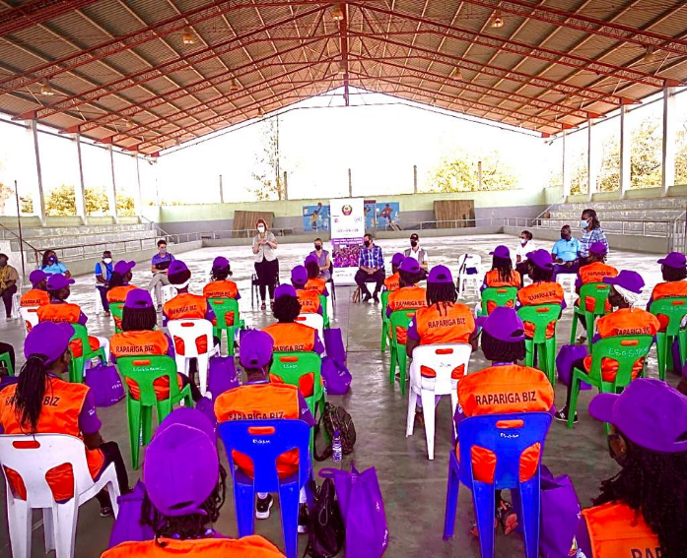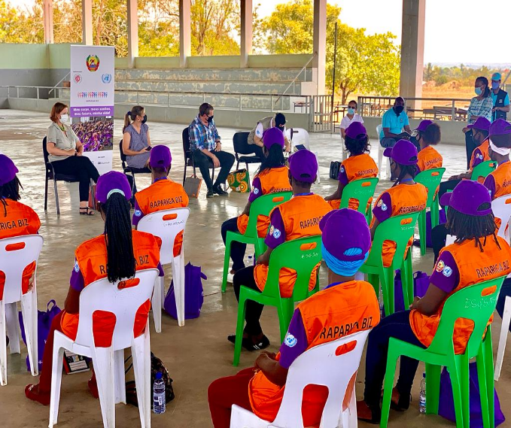
Figure 12: Meeting between RB and the high-level visit to Zambezia, Mocuba, November 2021
High-level visit to Nampula - 16 - 19 November 2021
In November 2021, another high-level visit took place with participation from: the SIDA Deputy Director General and Advisor to the office of the Director General (from Sida HQ), the Head of Cooperation from the Embassy of Sweden in Mozambique, and other technical staff. As part of the visit, invited guests met with programme mentors and service providers in Ilha de Moçambique, and took part in activities implemented in the Corrane Resettlement Centre. Both activities were preceded by meetings with respective local authorities.

OUTCOME 4 summary: Challenges, Lessons Learned and Recommendations
4.1 Challenges
- During Geracao Biz Annual Meeting some key government agencies claimed the need to resume rotational approach on the leadership of the programme as they felt were not that involved in the programme
- The programme carried out a series of studies and researches with critical findings and recommendations. Reflection on and implementation of those recommendations are still a challenge
4.2 Lessons Learned
- COVID-19 has taught us that if used properly, information, communication and technology (ICT) can be a good alternative to in-person meetings. This will allow saving of time and resources.

4.3 Recommendations
- It is recommended that all studies commissioned by UN agencies and their partners should be summarized as evidence base, and a database/repository of all reports kept updated and shared with all RB stakeholders
- It is recommended that the rotation approach can be implemented
- Coordination meetings among UN agencies should consider inviting technical staff from development partners to be of them at least once per month.

V. MONITORING AND EVALUATION
The monitoring and evaluation efforts in the Rapariga Biz Programme systematically tracks the implementation (or lack thereof) of results and achievements against the approved annual plans and targets. From this, a harmonized results framework is prepared, as oriented to the PRODOC results. The results framework is updated annually according to the achieved results and verified once programme activities are implemented.
On a quarterly basis, the team conducts joint planning and review with implementing partners and Government on the programme implementation, which includes joint monitoring visits to the implementation sites to assess progress, document challenges, provide feedback, and verify changes from the activities. Reporting is made quarterly for review by the multi-sector steering committee and annually to inform development partners and other stakeholders.
Improved data quality, availability and utilization
Digital and real-time monitoring systems have been used for data collection, processing and analysis, including the formation of focal points, monitors and local data encoders. This approach has populated data, addressing the required quality assurance, and showcasing evidence about the implementation and results of the programme. Under the KiriBiz data monitoring platform, three new systems have been introduced namely; the mentorship real-time monitoring system; data from the InfoBiz Adolescent and Youth Friday Services and the Health School Corners, and lastly; Comcare monitoring system for psychosocial support data management.

VI. CONCLUSIONS AND RECOMMENDATIONS

2021 was a year that continued facing challenges related to the COVID-19 pandemic, resulting in the delay and cancellation of in-person and group community and school-based activities. In the reporting period, mentors reached 790,761 girls (73% of the target of 1,085,477 adolescent girls and young women to be reached as the PRODOC). It is expected that by June 2022, the mentors will have reached approximately 950,000 out of the 1,085,477 projected girls (88% of the target). The main reasons for not reaching the target include impacts of the COVID-19 pandemic, the saturation (all potential girls reached in the district) of girls in the initial districts and turnover of mentors in some districts.
Additionally, for the first time, the boys’ mentorship began last year, operationalized with 6 supervisors and 20 mentors per district where the activity is present. It is expected that this approach will be expanded not only to other Rapariga Biz districts, but also to other UNFPA interventions and projects, such as My Choice, Safeguard Young People (SYP), the Global Programme to End Child Marriage, and others.
The year was also characterized by commemorating key UN days, including the international youth day/week (12 August), the Day of the Girl Child (11 October), African Youth Day (1 November), and 16 Days of Activism Against GBV (25 November). In short, the programme has four outcomes with 19 outputs. In total, there were 33 indicators and respective targets assessed, which resulted in the following achievements: 25 (76%) out of 33 indicators achieved a ‘green’ score, (85% or more), 5 (15%) out of 33 are ‘on track’ (yellow score), and 3 (9%) out of 33 received a red score (‘critical/not done’).
Based on the findings and recommendations from the monitoring and evaluation of Rapariga Biz, key considerations for the coming year and phase II of the programme are as follows:
- Expand the mentorship programme to remote locations and hard-to-reach villages
- Expand the boys’ mentorship activities to 6 districts: 3 in Nampula and 3 in Zambezia
- Expand the economic empowerment interventions to all RB districts
- Support the design of the Geração Biz Programme Strategic Plan (2023-2033)
- Promote multisector joint visits to provinces and districts
- Reinforce comprehensive sexuality education activities
- Improve the visibility of the programme
- Improve the linkages between RB community work with available services
- Design and implement a strategy focused on the retention of programme mentors
- Ensure complementarity and synergies with like-minded projects
- Support the design of the new National Strategy Against Child Marriage
- Support capacity development initiatives on project planning, management and monitoring and evaluation
- Train PGB provincial coordinators on relevant issues related with the programme

Deposit excluding 1 percent Administrative Agent fee.
Includes funds transferred in early 2022, some of which were used to cover 2021 expenses/activities.
Participating United Nations Organization
This amount includes 2022 disbursements. Official 2021 figures are reported in the 2021 MPTF Office Consolidated Financial Report, and any discrepancies will be addressed in future reporting periods.
This amount includes expenditures under 2022 disbursements. Official 2021 figures are reported in the 2021 MPTF Office Consolidated Financial Report, and any discrepancies will be addressed in future reporting periods.
This amount is locally recorded. Official 2021 figures are reported in the 2021 MPTF Office Consolidated Financial Report, and any discrepancies will be addressed in future reporting periods.
Basic Indicators Report of the Survey on Violence against Children (in Portuguese ‘Relatório de Indicadores Básicos do Inquérito sobre Violência contra a Criança’)
Mother and child health

