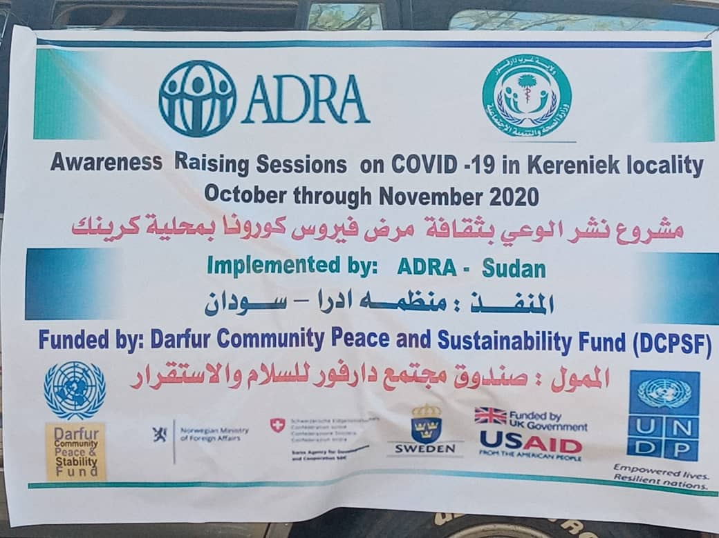

INSTRUCTIONS

- Please fill in all sections of the template. If information is not available, note the reason.
- Kindly submit the Financial report and Activity progress chart as separate files attached to this template and send the report along with any photographs or communication products to dcpsf.sd.team@undp.org.

Section 1 – Contact and Project Details

Organization | Adventist Development and Relief Agency ADRA
Name and job title | Maysa Al-Aqil - Program Director:
Email | Programs@adrasudan.org
Telephone

Project Title | Enhance Community Awareness on COVID 19 in West Darfur
Project Code
State | West Darfur
Localities | Kerenik
Communities/villages | Um Dewain, Salami, Aradeba, Al Temet ,Mazrob , Hemayda, Gadeer, Tarshana ,Um Rakina, Galala , Shotak , Khidirat , Kamkama and Rosi
Project start and end date
(as per the signed contract)
No Cost Extension (NCE) dates, if any
Project Budget
(as per signed contract)
Total Expenditure
Reporting period | 1st July to 30 September 2020

Section 2 – Situation update (1000 words max.)
Context change in Darfur.
- Brief summary of your project; what was your project about (project rationale); main goal, outputs and expected outcomes; project relevance in current Darfur context .
- How your project’s COVID19 emergency response activities have created awareness in the community and promoted peacebuilding (including trends at the state level).
The new novel coronavirus (COVID-19), has rapidly spread to over the globe including Sudan. On 18 March, 2020 one Covid-19 death has been confirmed in Sudan, and 50 suspected cases are in isolation and categorize as active coronavirus cases, 10 reported death cases, 6 where healed in Khartoum, White Nile, Al Gazira and River Nile states as reported by Ministry of Health. The Sudanese Federal Mistry of Health supported with the World Health Organization (WHO), developed a countrywide preparedness and response plan for the corona virus prevention and community transmission.
Government of Sudan restricted population movement from 6 p.m. and put people in isolation in Khartoum, North Kordofan, West Kordofan, River Nile, Red Sea, North Darfur and in Kassala. Starting from 18th April Khartoum will be in complete lock in for 24hours except for some limited 2-4 hours to emergency needs from nearby inhabitants blocks. Sudanese Ministry of Health expected a large spread for the virus in all Sudan states, based on its transmission mode experience worldwide, including West Darfur.
with the limited capacity of Sudan to retain prevention of new novel coronavirus (COVID-19) and the World Health Organization (WHO) rated Sudan as at risk for CoVID-19 spread based on risk profile and capacity of the country to respond to a potential outbreak international and local organization outing to support Sudan Mistry of Health to prevent the spread of new novel coronavirus (COVID-19). National and international organizations support work with federal ministry of Health to covers the lack of isolation units, intensive care units, infection control material, medicines and medical supplies, spread of awareness sessions on corona virus prevent and protection measures, and trained medical staff and volunteers to address quickly spreading outbreaks including of corona virus (covid-19) in all country states. West Darfur State is one of Sudan states remarked as being Fergie to and is expected to be affected by new novel coronavirus (COVID-19 greatly specially that the state has been suffered for conflict and war for long time and was hit strongly by cholera and yellow fever specially in Kereniek the biggest locality in West Darfur. In consultation with state’s Ministry of Health in West Darfur clear needs and gabs need to be addressed in regard to lack of health services, hygiene awareness new novel coronavirus (COVID-19) in Kereniek.
The project aims at improving awareness on COVID 19 Pandemic to stopping the COVID‑19 from spreading and transmission of the virus and ensuring rapid detection and caring for those affected population.

- The project s contributed to spreading awareness on COVID19 throughout the target villages in collaboration with ministry of health, volunteers from the target communities such as community-based reconciliation members, youth and women groups.
A house to house visit approach has proven its inclusiveness and effectiveness that ensure entire target has received the intended messages especially the elder people at home level using simple and local understandable language.
Once again, the joint work in spreading awareness on COVID 19 among diverse communities has created atmosphere of co-existence among target villages.

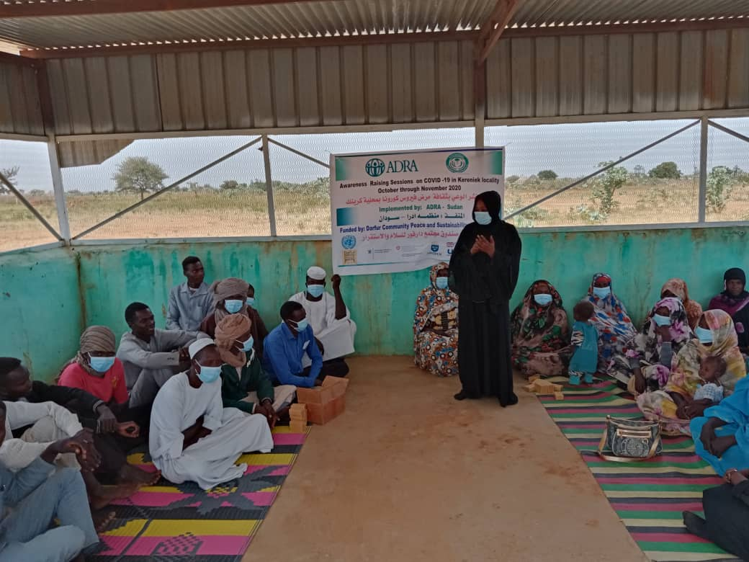
Awareness sessions at village level facilitated by MOH team

Section 3 – Progress review (1500 words max)
Brief narrative of your project key achievements
- Describe the key achievements of your COVID 19 interventions as per planned activities.
- Highlight any achievements towards gender equality and inclusion.
1- The project has collaborated with West Darfur State Ministry of health- health enhancement department at locality level to identify the most vulnerable communities’ areas in Kerenik locality to provide awareness information and disseminate messages on new novel coronavirus (COVID-19) through broadcast in local media, mobile media, printing material and posters. Diverse community strips have participated in the awareness campaigns on COVID-19, for instance community-based reconciliation mechanisms members which consist of five to seven females have actively took part in the awareness. furthermore, most volunteers who participate in the campaign was female groups. The team leader from MOH was a lady who lead the awareness in the target communities. The project has used various means of delivering messages among target groups such as printed messages, signboards and billboards, mobile media. The project has supported isolation center in terms of increasing water storage capacity through provision water storage tanks and water cool keepers. To ensure quality water chlorine tabs also being distributed to water distribution points. Hand sanitizers and face masks given to health work force at Kerenik locality to promote protection against COVID virus spread. Awareness sessions on water points at 18 villages was conducted targeting women, men and youth who come to fetch water.

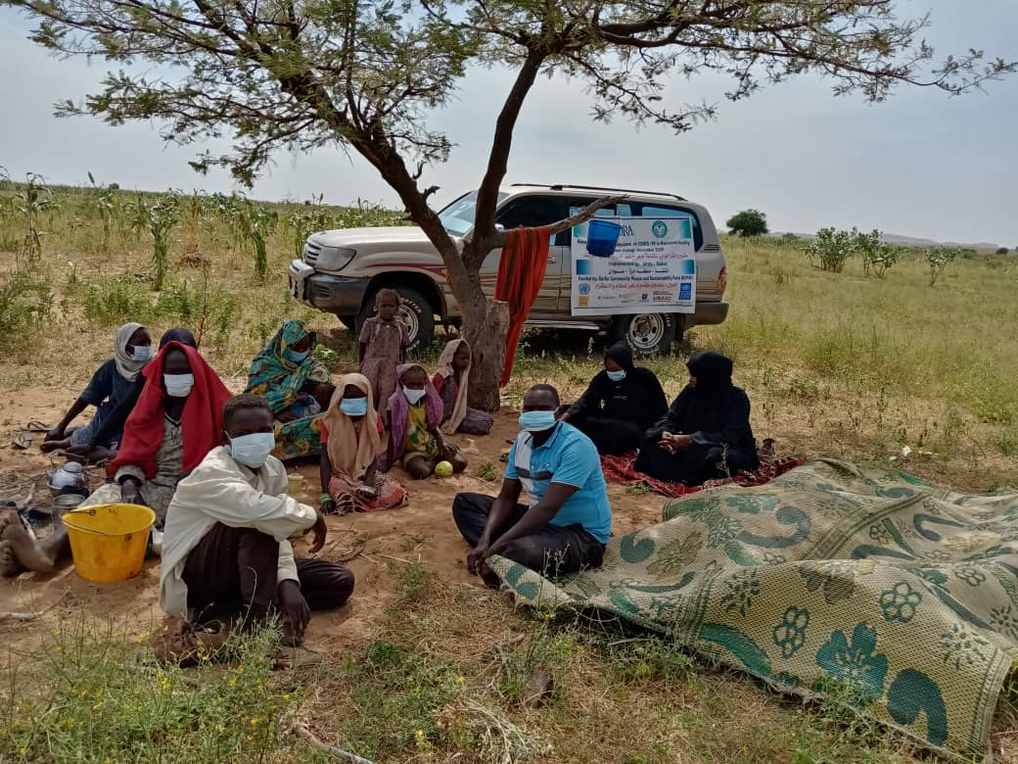

COVID-19 Sessions in the Farms

Section 4 – Inclusion (500 words max. for each section)
Inclusion of women,
Describe initiatives, achievements and challenges in empowering women and in promoting their active participation in your project activities. Please provide specific examples.
2- In most target villages Women have actively involved in identifying most vulnerable who supposed to receive assistance in obtaining protective hygienic items such as hand sanitizers and soap to promote their protection against COVID-19 virus.
This degree of participation was acceptable because these villages have witnessed several trainings and community events during the previous DCPSF project in the locality that make women more familiar with such type of activities. But there’s still more to be done among men to realize the importance of women participation and involvement.

Inclusion of youth,
Describe initiatives, achievements and challenges of including the youth (young men and young women) and in promoting their active participation in your project activities. Please provide specific examples.
Youth, men and women now a days are the most active in all communities.
They volunteer in delivering messages in their respective communities.
Also they participated in spreading of printed messages in different sites of their communities. They attended the mobile media, drama messages and organized places for the mobile drama events.

Inclusion of sedentary pastoralists and farmers
Describe initiatives, achievements and challenges in including pastoralists and farmers in project activities. Please provide specific examples.
Sedentary pastoralist was reach out and involved in spreading awareness on COVID-19
a mong pastoralist community. The target pastoralist target areas were reached through mobile media and from house to house visits.
The main challenge when it comes to pastoralist inclusion is the frequent absence of trained committees therefore members from other committees were participated in delivering message to pastoralist besides the team from MOH.

Section 5 – Partnerships (700 words max.)
Description of Partnerships,
Describe any partnerships formed, including new ones built in the course of project implementation (MoH, donors, UN agencies, implementing agencies – CBOs, NGOs, etc.). Please specify:
- Involvement of local community structures in implementing projects (including women’s CSOs).
- the impact that these partnerships had on achieving results,
- any problems encountered with partners during the implementation.
- Community participation in the awareness campaign on COVID 19 was immense, especially, youth, women groups and trained committees because they have a sense of volunteerism.
- Through these strong relations with the previous trained committees, women groups and volunteers smooth project implementation was happening with huge target coverage.
- No problems or miss understating between implementing partner occurred.

Section 6 – Challenges, lessons learned and innovative solutions (1000 words max.)

- Describe key challenges/gaps (operational, administrative, programmatic and contextual, as well as challenges working towards gender equality, women empowerment, youth and pastoralists/farmers inclusion) to project implementation.
- Describe lessons learned during your project and how solutions offered have turned challenges into opportunities or will minimize the damage.
- Provide any innovative solutions to practical challenges in the field and recommendations for the attention of the DCPSF TS.
- Due to late start of the project the challenge of finding farmers during harvest times is very difficult but the mobile teams have managed to reach out the farmers in their farms, at water points and delivering messages in the evenings.
- The utilization of trained committees and volunteers have best boasted message spreading in the target villages and this reflects the importance of village agents and committees.

Section 7 – Success stories and communication products (max 700 words)

From your achievements/results, please highlight key success items that DCPSF can highlight in its public communication. These include; success stories highlighting beneficiaries, photographs (in high resolution), videos, media/news story links related to your project. If available, women and youth success stories are encouraged in this section. (Items can be shared as attachments; your organisation will be credited for items shared).
The

Message on COVID-19 need to reach all communities however, some target communities are out of local radio coverage in Kerenik locality so the importance of mobile media and from house to house visit idea was introduced by the team to reach out all target groups.
To ensure messages are well understood, it was simplified by the volunteers to make it easier in using local languages.
The use of mobile drama message from village to village targeting small groups has proved its acceptance effectiveness as message deliver in dramatic way that is easy to absorb than other means of messaging.
DCPSF could adopt mobile drama messages among target village to ensure huge coverage and smart understanding of intended messages. Also, CBRMs have shown great interest in participating in the COVID 19 awareness messages in their respective villages.

