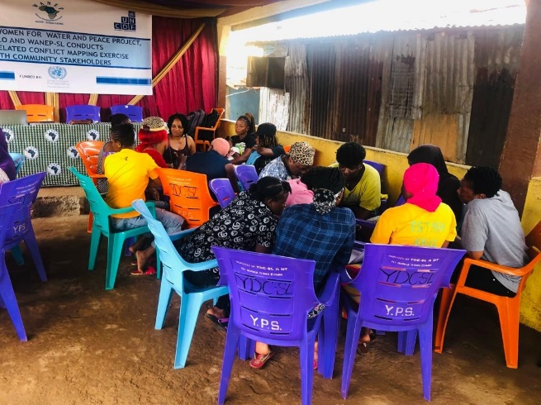

Photos from Peace and Conflict mapping exercise

Photos from conflict management training sessions

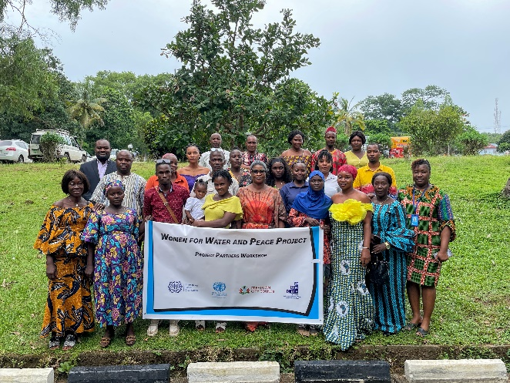 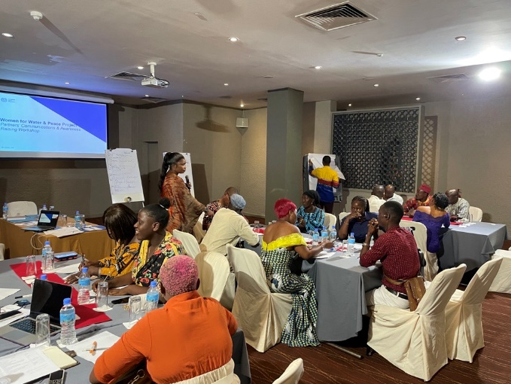

Photos from workshop on SGBV awareness raising with IPs, city councillors and women leaders.