IOM contribution to PBF progress report, Human Impact Stories from International Peace Day

Samira Abd al-Rahman al-Doum Adam, social activist
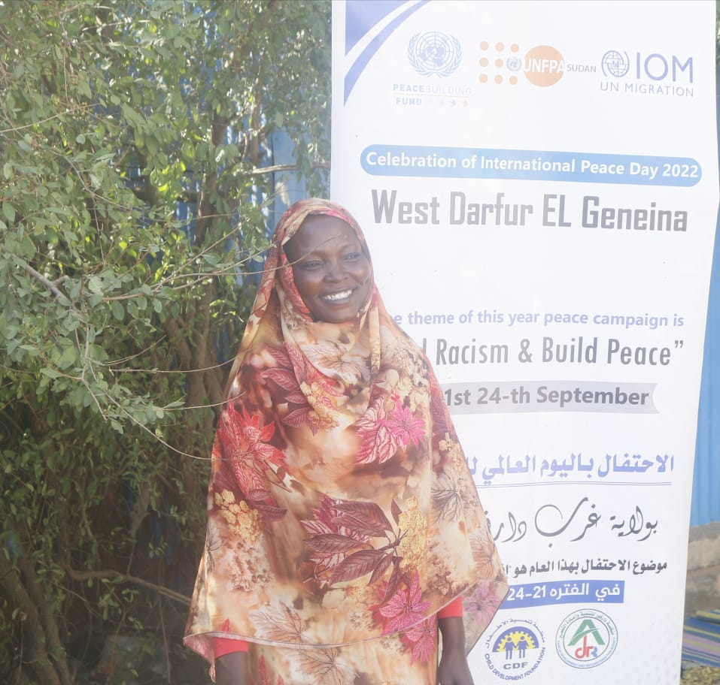
Samira is a 39 year-old mother with 6 children, 5 boys and a girl. Her family is a victim of multiple displacements due to intercommunal violence in West Darfur. They were displaced from Misteri locality to Al Jabal neighborhood in El Geneina locality and then moved to the Ministry of Agriculture IDP gathering site within Geneina town considering the security situation. Her husband is a police officer, and Samira runs a traditional coffee business to supplement the household income. Samira explained that she heard about the celebration of International Peace Day through social media, and she also received an invitation from the Humanitarian Aid Commission (HAC) to take part in the events. She took part in the traditional dance of the Peace Day celebration. She said that she is very happy with the International Peace Day celebration, commenting that it enhances the peacebuilding process among different community members by increasing the understanding of each other’s cultural norms and practices. Samira expects agencies and government to conduct similar events as well as to conduct awareness raising sessions and trainings, as well as supporting small income generating activities for women and vulnerable heads of household.

Muhammad Tibn Ardeeb Ibrahim, youth leader
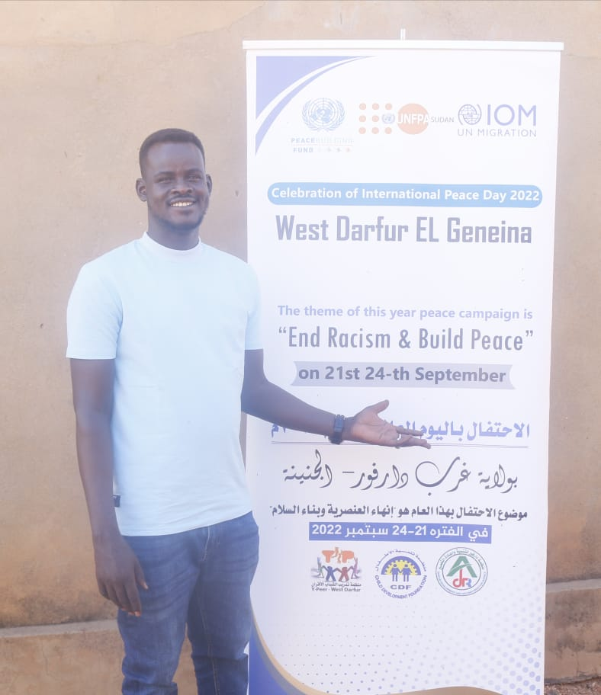
Muhammad is a 32-year-old unmarried man. He is part of the youth peer initiative in West Darfur and his youth group works closely with UNFPA in Geneina. He took part in the mobile theatre production during the International Peace Day celebration. His team performed a drama covering the message of mental health, community dialogues and positive masculinity. As a youth representative, he explained that his team were happy with the events organized for International Peace Day. They think the events contributed to promoting peacebuilding among youth and community members, and they believe continuous similar initiatives will impact on changing the communities’ preconceived notions of ‘the other’, their attitude, and their behavior. Muhammad also highlighted the importance of bringing together youth from different tribal affiliations and providing skills development training, facilitating dialogues, and providing support for sports and cultural activities.

