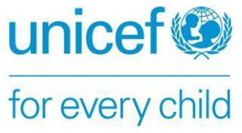 | 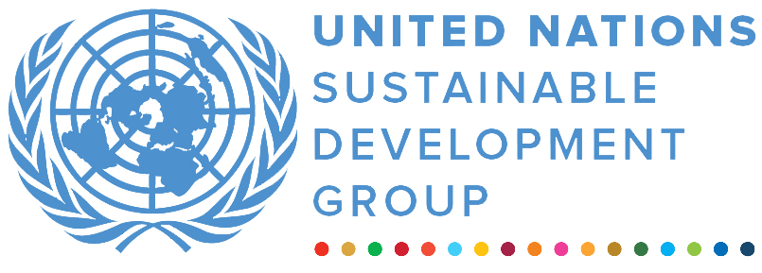 | 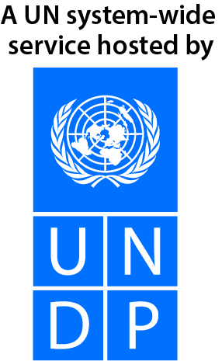
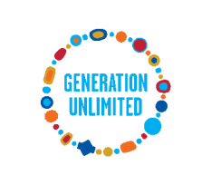
GENERATION UNLIMITED
FINAL NARRATIVE progress report
REPORTING PERIOD: 1 january – 31 December 2022

Programme Title & Project Number |  |  | Country, Locality(s), Priority Area(s) / Strategic Results
- Programme Title: GenU Global Programmes  - Programme Number (if applicable)  - MPTF Office Project Reference Number: 00129772 |  |  | (if applicable)  Country/Region
 |  |  | Priority area/ strategic results : Entrepreneurship
Participating Organization(s) |  |  | Implementing Partners
- UNICEF |  |  | - UNICEF, UNDP, Organization of the World Scout Movement, Plan International, USAID
Programme/Project Cost (US$) |  |  | Programme Duration
Total approved budget as per project document:  MPTF /JP Contribution: 558,937  - by Agency (if applicable) |  |  | Overall Duration (months) 12
Agency Contribution  - by Agency (if applicable) |  |  | Start Date 1 January 2022
Government Contribution  (if applicable) |  |  | Original End Date 31 December 2022
Other Contributions (donors)  (if applicable) |  |  | Current End date 31 December 2022
TOTAL: 558,937
Programme Assessment/Review/Mid-Term Eval. |  |  | Report Submitted By
Assessment/Review - if applicable please attach  Yes X No Date: dd.mm.yyyy  Mid-Term Evaluation Report – if applicable please attach  Yes X No Date: dd.mm.yyyy |  |  | - Name: Jennifer Keane  - Title: Partnership Manager  - Participating Organization (Lead): UNICEF/GenU  - Email address: jkeane@unicef.org

EXECUTIVE SUMMARY
This funding was used to support GenU Global Programmes, in particular implementation of imaGen Ventures which is also being supported by the United Nations Development Programme (UNDP), World Organization of the Scout Movement, Plan International and the United States Agency for International Development (USAID). The funding is part of the unearmarked contribution from The Netherlands to the GenU Trust Fund.

Young people are inheriting a world fraught with immense challenges—from climate change and inequality to a scarcity of skills and meaningful job opportunities. If the world’s 1.8 billion young people are empowered to harness their entrepreneurial spirit and drive innovative social change towards a more equal and sustainable future, they can become vital agents of change for generating pathways to success that benefit us all.
imaGen Ventures is a global programme that provides young people with access to opportunities to develop entrepreneurial skills to catalyze social change and economic growth, and create a more sustainable future by addressing the SDGs. Co-designed with input from young people, the programme aims to nurture a large group of young entrepreneurs who have the mindset, skills, and opportunities to make significant contributions towards achieving the SDGs. imaGen Ventures works with young people to:
- Nurture skills for the future
- Foster an entrepreneurial mindset .
- Support ventures with grants, funding, and mentorship opportunities; and
- Inspire millions to build growth-oriented and socially motivated enterprises.
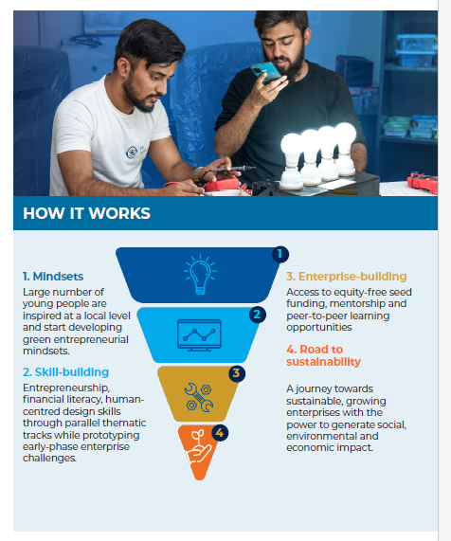

In 2022, funds from the GenU Trust Fund were utilized to provide global imaGen Ventures winning teams from Armenia, Brazil, Egypt, Jordan, Lebanon, Pakistan, Sierra Leone, Uganda and Zimbabwe with seed funding to further develop and scale up their innovative ventures, most of which are tackling the climate crisis.

RESULTS
Since 2018, GenU’s imaGen Ventures programme has provided young people in 60 countries with opportunities to develop the necessary entrepreneurial skills to catalyze social impact and economic growth and to create a more sustainable future by contributing to the Sustainable Development Goals (SDGs). Its tested and holistic youth-centred approach – co-designed, co-created and co-led by young people – is based on the principle of leaving no young person behind. imaGen Ventures works with young people to nurture skills for the future and foster an entrepreneurial mindset. It also supports aspiring ventures with grants, funding, and mentorship opportunities, and inspires millions to build growth-oriented and socially motivated enterprises. Since 2018, 80,000 young people have been skilled and empowered to generate entrepreneurial ideas and ventures. More than 2,500 young entrepreneurs have been provided with grants and incubation support for their ventures with extensive positive effects on peers, communities, and beneficiaries.

imaGen Ventures is a unique Public-Private-Youth programme for the following reasons:

- Partnerships with public, private and youth-led organizations allow the delivery of massively scalable solutions that empower young people worldwide.
- Uses grassroots, community-based approaches to co-design youth-led ventures that have real relevance to young people and their communities.
- Contextualized in every country across various industries and thematic areas corresponding to the SDGs.
- Specific focus on transferrable skills and entrepreneurship competencies for the 21st century.
- Focus on young people from marginalized communities.

For imaGen Ventures 3.0 in 2022, more than 70 national finalist teams across 45 countries pitched their innovative solutions to a global jury comprised of public, private and youth partners who selected 12 global winning teams that were celebrated at a high-level event during COP27. These young people are using their talents to improve their communities and develop new solutions to help achieve the SDGs. From solar -powered lighting systems for schools to innovations for biodegradable plastic to sustainable mini cisterns for rural families, the twelve winning youth ventures represent the brightest ideas of thousands of young innovators.

National and global finalists receive comprehensive incubation and acceleration support. This includes mentorship, peer-to-peer exchange, access to networks and funding opportunities, support for business formalization and other measures depending on the business.

Funding from the GenU Trust Fund was used to provide global winning teams with equity-free seed funding (US$ 16,000 each), which was complemented by a global incubation phase in which they met with topic experts who provided tailored advice in their areas of expertise. The following are snapshots of the winning teams and their solutions which are being supported through the Trust Fund.

Zambezi Ark Technologies, Zimbabwe: Off-grid lighting using recycled products.
The team designed and developed a solely off-grid solar-powered lighting system, which can bring high-quality and reliable lighting to schools and residential buildings. The system eliminates the use of inverters and LED drivers and uses less wiring per lighting point. The team also trains students and teachers on how to make Chigubhu lanterns themselves to ensure sustainability.

Soigel, Egypt: Fertilizer and Aquagel made of sugarcane waste. Concerned with sugarcane waste pollution, of which 10 million tons are burned annually in Egypt, team Soigel has created a high-efficiency organic fertilizer made from recycled sugarcane waste that can absorb CO₂ from the atmosphere. After conducting 40 interviews with farmers, the team identified the need for more effective fertilizers that help increase productivity and mitigate water usage. The Soigel team is now producing three products: 1) an organic fertilizer called ‘Soilizer’, 2) ‘Aquagels’ that control-release water thereby effectively decreasing water usage in farming, and 3) a ‘Loaded Aquagel’ that control-releases fertilizer into the soil. Their vision is to become the largest company in the world to produce organic fertilizer and Aquagel from recycling sugarcane waste and to serve the agricultural community by providing products that are competitive, sustainable, eco-friendly, and highly efficient.

Int-Tech, Pakistan: Biodegradable plastic with sensors that detect the expiry of the foods.
Int-Tech is solving a trio of problems - plastic pollution, food expiry issues, and waste management – through one product: Bio Plastic. Artificially intelligent bio plastic is a biodegradable plastic that can vanish from the environment within three to six months and monitor the expiry of the perishable food products. The transparent bio plastic is used for wrapping of goods, and a sensor sheet strip will detect the expiry of foods and change color when the product starts spoiling. The initial prototype has been proven to be cost-effective at $0.067 per unit and is ready for mass production to enter the market. The team hopes this will revolutionize the packaging and plastic industry in Pakistan and later in other parts of the world and help manage waste of organic food.

Quebrada Agroecológica, Brazil: Natural Resources Management and Access to Water. The Maria da Penha settlement in Brazil suffers from a lack of access to basic services and many residents struggle to lead decent lives. Access to clean water and sanitation, in particular, remain challenging for the community—residents are forced to spend a significant amount of their already small income on purchasing water and many struggle to afford it. Team Quebrada Agroecológica has developed an alternative mini cistern model designed to lower the cost and maintain a sustainable capacity of water in the Maria da Penha settlement. The plan is to then expand this to other communities throughout Brazil. So far, the mini cistern model has benefited over 2,000 families with a cost as low as US $525.

Bio Briquettes, Uganda: Averting Deforestation. Uganda has experienced a 63 percent decline in forest cover over the past 25 years due to tree cutting for firewood, timber, and charcoal. The loss of trees in Northern Uganda has led to irregular dry seasons and drought, as well as unpredictable heavy rainfall. Determined to help avert deforestation, five young people have teamed up to create a venture producing bio-briquettes from organic by-products and household waste to be used as an alternative to charcoal. The bio-briquettes produce more heat and burn three times slower than charcoal, are reusable when not fully burned and can be used in any kind of charcoal stove.

Electric Bike, Jordan: Facilitating access to water in refugee camps. In Azraq Syrian refugee camp, transporting water is often a long journey and commonly done by women and children.
This team has developed a solar-panel-powered
electric bike to improve the quality of life for refugee camp residents and allow them to transfer water to their tent in a way that is fast, convenient, and requires less labor and effort. The bike can run for more than 10 hours on a single charge. The electric bike will address both the lack of transportation options and means to carry water in the camp.

Team Lorem, Sierra Leone: Easy STEM Server. Some 84 percent of households in Sierra Leone lack internet access, limiting children and young people’s ability to connect and learn. Team Lorem has developed ‘Easy STEM Server’, an offline database server that provides quality Science, Technology, Engineering, Math (STEM) content offline, enabling children and young people in Sierra Leone without internet access to learn, grow and develop their skills. The venture provides various learning materials through Massive Open Online Stem Contents (MOOCs) to students without them needing internet data. This is done by storing offline materials such in mini portable database servers. The team has tested the server with 27 engineering students from Fourah Bay College, one of Sierra Leone's main colleges with a top engineering program.

MeDialog, Armenia: Media Literacy Education. Aiming to address the lack of media literacy and in the face of a proliferation of false or misleading information online, the MeDialog venture from Armenia will incorporate VR, board games, a mobile app, a cartoon, and courses in formal education institutions to create a learning package designed to instill critical media literacy skills among young people. The venture will also teach young people about cyberbullying, cybercrime and personal online data.

Khutwa, Lebanon: Sexual education awareness and hotline. ‘Khutwa’ is a tool that aims to help prevent sexual exploitation and violence by providing appropriate educational programs for adolescent girls and boys. These programs focus on sexual awareness, legal guidance and culture, and provide a hotline for reporting and referrals to specialists both virtually and physically. It is the first programme of its kind in north Lebanon. The team aims to cover 70 percent of high-schools in north Lebanon by the end of 2023 by collaborating with civil society organizations, ministry of education, psychologists, educators, social activists, and other experts in related fields.

The announcement of the imaGen Ventures winners at COP27 in Dubai, led by Vicki Aridi, a member of the GenU Young People’s Action Team (YPAT) and Per Heggenes, CEO of IKEA Foundation and a GenU Board Member, can be viewed here: https://youtu.be/gWAcbDxBzMw.

Through comprehensive incubation and acceleration support, these winning teams will be accompanied on their journeys as they further develop their solutions and create positive impacts in their communities and their countries.

Strategic Results, as formulated in the Strategic UN Planning Framework (e.g. UNDAF) or project document;
The MPTF or JP Contribution, refers to the amount transferred to the Participating UN Organizations, which is available on the MPTF Office GATEWAY

