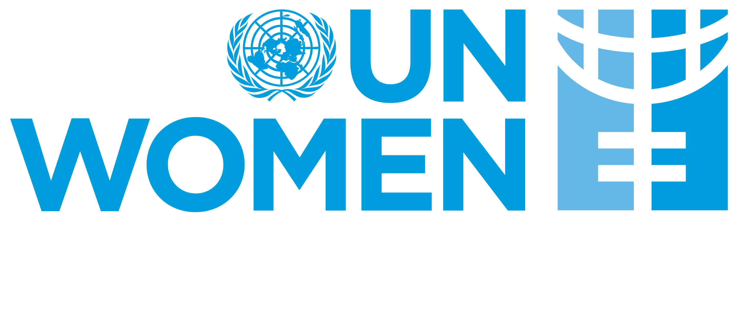 | 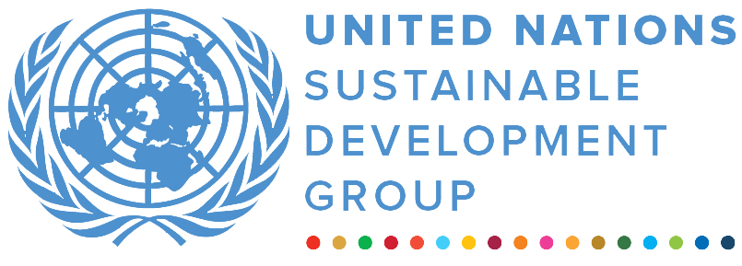 | 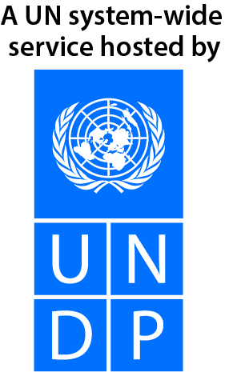
UN Uganda Multi Partner Trust Fund – Emergency Window
Final narrative report
REPORTING PERIOD: 27 May 2021 – 24 May 2022

Programme Title & Project Number |  |  | Country, Locality(s), Priority Area(s) / Strategic Results
Programme Title: Promoting women’s active participation in efforts to prevent the spread of COVID-19 and promote social cohesion, conflict prevention and sustaining peace in Uganda.  - Programme Number: 00127413  - MPTF Office Project Reference Number: 00127167 |  |  | (if applicable)  Country/Region
 |  |  | Priority area/ strategic results
Participating Organization(s) |  |  | Implementing Partners
- Organizations that have received direct funding from the MPTF Office under this programme |  |  | Overcomer’s Women’s Activists
Programme/Project Cost (US$) |  |  | Programme Duration
Total approved budget as per project document:  MPTF /JP Contribution:  - by Agency (if applicable) | US$ 96,417.39 |  | Overall Duration (months) | 12 months
Agency Contribution  - by Agency (if applicable) |  |  | Start Date: | 27 May 2021
Government Contribution  (if applicable) |  |  | Original End Date: | 30 May 2022
Other Contributions (donors)  (if applicable) |  |  | Current End date: | 24 May 2022
TOTAL: | US$ 96,417.39
Programme Assessment/Review/Mid-Term Eval. |  |  | Report Submitted By
Assessment/Review - if applicable please attach  Yes No Date: dd.mm.yyyy  Mid-Term Evaluation Report – if applicable please attach  Yes No Date: dd.mm.yyyy |  |  | - Name: Claire Hawkins  - Title: WPS Program Specialist  - Participating Organization (Lead): UN Women  - Email address: Claire.hawkins@unwomen.org

NARRATIVE REPORT FORMAT

EXECUTIVE SUMMARY
The project which was implemented between November 2021 and May 2022 aimed at promoting positive and favorable attitudes towards women’s participation in peace building, conflict prevention, mediation, negotiation and resolution processes in Adjumani and Yumbe; and to Strengthen coordination and functionality of existing peace and humanitarian structures especially responding to COVID-19 to build a more peaceful and gender equality host and refugee community.

The following results have been achieved:
There is increased knowledge and participation of 140 peace mediators (123 women and 17men) in Adjumani and Yumbe on case reporting, referral pathway, case monitoring and early warning signals and gender-based violence. This helped female mediators in detecting of cases, monitoring, case follow-up and recording as well as coming up with possible solutions that are specific to their communities.
53 (45 men and 8 women) Cultural, religious, clan, opinion leaders and elders from Adjumani and Yumbe have improved knowledge in peace building, conflict mediation and reconciliation. As a result, the cultural leaders, chiefs, clan, elders, religious leaders and opinion leaders are engaged in community awareness creation and sensitization on child marriage, high bride price and land rights.

There is strengthened organizational and technical capacity of the existing structures such as women led organizations, district peace committee, local community leaders, Refugee welfare council, peace mediators, traditional and cultural leaders to effectively and efficiently implement peace and reconciliation interventions in the wake of COVID 19 pandemic. This has increased the collaboration and coordination with other stakeholders, and accessibility in terms of community outreaches, inter agency coordination meetings, zonal coordination meetings and village meetings among the leaders and the committees. It has led to prompt identification of women’s security issues in the community and quick and effective problem solving.

Purpose

This programme contributes to theme 3 of the United Nations Emergency Appeal and facility for the impact of COVID-19 in Uganda on life saving services and Social Protection, Sustainable Development Goals (SDG) - specifically Goal 5 on Gender Equality and Goal 16 on Peace, Justice and strong institutions; as well as security, development and human rights and partner with national level women’s rights organisations engaged in advocacy related to key peace building processes especially during the COVID-19 response.

Results

Outcome 1: Increased women’s participation in promoting peaceful coexistence in COVID-19 response

Women have enhanced capacity in peace building as a result of the support received through this program. This was demonstrated by their ability to detect conflict cases, monitor conflict situations and refer cases for better management during the heightened period of the pandemic that created a fertile ground for conflicts of different kinds. A total of 140 peace mediators (123 women and 17 men) in Adjumani and Yumbe increased their knowledge and participation in case monitoring and early warning signals and gender-based violence following their participation in trainings. This has enhanced the capacity of especially the female peace mediators in detecting of cases, monitoring or case follow-up and recording and also come up with possible solutions that are specific to their communities. The women have demonstrated their capacity by conducting community dialogues and school sensitization on peaceful co-existence.

Table 1: Number of peace mediators trained
District | Women | Men | Total | Refugee | Host
Adjumani | 74 | 06 | 80 | 36 | 44
Yumbe | 49 | 11 | 60 | 37 | 13
Grand Total | 123 | 17 | 140 | 73 | 57

Output 1.1.1. Increased knowledge of 300 women peace builders in advocacy and awareness on peaceful co-existence in the COVID-19 response in Kotido, Yumbe, Amuria, Lamwo, Obongi & Adjumani districts.

Capacity of 140 peace mediators, analysts and monitors has been strengthened which enabled them to support activities on promoting social cohesion (mediation, resolution, and negotiation) in both Adjumani and Yumbe Refugee settlements of Nyumanzi, Olua, Maaji I, Maaji III, Mireyi, Adjumani Town Council, Agojo and Zone 4 Bidibidi in Yumbe. This was a result of their participation in trainings on mediation and conflict prevention, their engagement in community dialogues especially during the 16 days of activism in 2021. As a result, 3 girls between the age of 14 -17 years from Yumbe town council, who are survivors of SGBV were able to access justice when the trained mediators identified the cases, worked with the families of the girls to report the cases to police. Additionally, 2 women survivors of GBV in Agojo Refugee settlement, Adjumani are living in harmony with their families as a result of the mediation conducted by the peace mediators. The peace mediators were able to mediate and provide psychosocial support to the women and their spouses, which enabled the couples to amicably settle their disputes.
Through the female peace mediators, women led community-based organizations active work at the grass roots, 160 vulnerable teenage and breast-feeding mothers both in the host and refugee community in Adjumani and Yumbe were identified and supported with materials such as face masks, soap, jerricans, kitenge piece, basin and sanitary pads. These enabled the young mothers to protect themselves against COVID-19 and also have dignified lives.

Table 2: Number of teenage and breastfeeding mothers supported with essential items
District | 0-17 | 18-35 | 36+ | Total | Refugee | Host
Adjumani | 24 | 47 | 04 | 75 | 40 | 35
Yumbe | 00 | 85 | 00 | 85 | 40 | 45
Grand Total | 24 | 132 | 04 | 160 | 80 | 80

Output 1.2.1. Increased capacity of 400 women peace committees’ members and RWC leaders, and women front line responders on mediation, and equipped with PPEs

Women peace committees have strengthened capacity to document conflict cases and engage in mediation as a result of the support provided through this project. Three peace committees in Yumbe each received 5 plastic chairs, 1 wooden table and 1 wooden chair enabling them to set up a physical place where they can be reached by community members to report cases and seek psychosocial counselling. While in Adjumani, female mediators received torches, raincoats, bags, Umbrella, and stationary items such as counter books, pens and files. As a result of this support, the groups are able to hold planning meetings, record and capture the cases they mediate, as well as ease the movement even during night or rainy seasons to be able to carry out mediation of cases.

In Adjumani, after the training, female peace mediators developed action plans which they continue to implement. The peace mediators have utilised their skills in conflict prevention and mediation to conduct sensitization on strikes in schools while the cultural, religious and opinion leaders have engaged communities in discussions related to bride price, land among others. For instance, the cultural leaders have started conducting community consultations on issues related to bride price, land rights, revisiting madi cultural norms which are harmful to women and girls and restoration and installation of the Ma`di leader (King) and cultural rules and regulations which are harmful to women and girls. The consultations on bride price will contribute towards the drafting of a bi-law. The cultural and religious leaders are utilizing their religious and cultural platforms to conduct sensitizations in their communities. This was achieved through training of 53 (45 men and 8 women) cultural, religious, clan, opinion leaders and elders in Yumbe and Adjumani in peace building, mediation and reconciliation. This has enhanced their capacity in referral pathways, case monitoring and early warning signals and gender-based violence demonstrated.

Output 1.3.1. Strengthened coordination and functionality of existing Government COVID-19 Response Teams, women led CSOs and peace structures in Kotido, Yumbe, Amuria, Lamwo, Obongi & Adjumani)

Capacity of the district peace committees to effectively handle and monitor cases and support referrals has been strengthened as a result of the support received through this project. This enabled the committees in Yumbe and Adjumani to effectively engage in recording cases, providing referrals and case follow-ups. Additionally, the support provided to the District Peace Committee in Adjumani enabled the committee to effectively organise regular meetings and facilitate members to do case follow up and monitoring.

There is enhanced collaboration between Overcomers Women’s Group and the Adjumani District Covid-19 Task force on the standards Operational Procedures and identification of the vulnerable breastfeeding mothers who are at risk of Covid-19 infection. This strengthened collaboration between Overcomers and Government has increased the identification and address of key gender related COVID concerns.

Refugee and host community members from Yumbe and Adjumani have increased awareness on the effects of teenage pregnancies, early marriage, and gender-based violence as a result of the community dialogues that were conducted in host community and refugee settlements in Adjumani and Yumbe districts.
This was achieved during gender responsive sensitizations on the Covid-19 SOPs which highlighted strategies the community could implement to address the effect of Covid-19 on the teenage girls contributing to high numbers of teenage pregnancies due to lockdowns and closure of schools. This has given the community a better understanding the gender dynamics in response to the pandemic.

Table 3: Participation in the 11 dialogues (5 in Adjumani and 6 in Yumbe)
District | Female | Male | PWDs |  | Age
 |  |  |  |  | 0-17 |  | 18-35 |  | 36+
 |  |  | F | M | F | M | F | M | F | M
Adjumani | 225 | 111 | 7 | 2 | 130 | 54 | 73 | 25 | 22 | 32
Yumbe | 174 | 30 | 0 | 0 | 81 | 0 | 90 | 28 | 3 | 2
Total | 399 | 141 | 7 | 2 | 211 | 54 | 163 | 53 | 25 | 34

Challenges, lessons learned & best practices:

Challenges
- Existence of nonfunctional peace structures; A number of peace structures have been established in the communities, but without a plan for sustainability due to lack of funding. This has rendered many of them dormant.
- Peace building and Conflict prevention are long-term processes that require sustained financial resources over a longer-term programme.
- Budget constraints: whereas the project was meant to be implemented in 6 districts, it only managed to reach 2 districts due to resource limitations.

Lessons learned

Economic empowerment is crucial in ensuring that trained peace mediators are in position to sustain peace building and conflict prevention. While it is important that women have skills to enable them engage in meaningful participation in prevention of violence and conflict resolution at all levels, economic empowerment will enhance the sustainability of their work. Establishment of sustainable livelihood opportunities for women peace mediators in refugee settlements and host communities strengthens their resilience and promotes positive coping mechanisms.

Collaboration and coordination with grassroot women rights organizations presents opportunities and a platform to voice issues from the grassroot level. Grassroot organisations are close to the most vulnerable women in the community and their coordination with district teams contributes to efficiency and effectiveness especially in the context of COVID-19. Their collaboration with district coordination teams helps to build synergies as well as secure authority to implement activities swiftly.

Involvement and engagement of traditional, cultural leaders, religious leaders, elders and opinion leaders at the grass roots influences the implementation and promotion of the peaceful co-existence. Cultural and religious leaders have a big influence on communities. When they communicate correct messages, it helps prevent potential violent conflict outbursts in the communities.

ii) Indicator Based Performance Assessment:
Using the Programme Results Framework from the Project Document / AWP - provide an update on the achievement of indicators at both the output and outcome level in the table below. Where it has not been possible to collect data on indicators, clear explanation should be given explaining why, as well as plans on how and when this data will be collected.

 | Achieved Indicator Targets | Reasons for Variance with Planned Target (if any) | Source of Verification
Outcome 1  Indicator 1.1.1a.  Percentage of women meaningfully participating in the peace building committees under the COVID-19 response at household and community level  Baseline: 156  Planned Target: 300  Indicator 1.1.1b.  Number and types of conflict cases mediated by women  Baseline: 42  Planned Target: 200 | 102  Cases: 165  Type: SGBV, GBV, | Women’s participation in peace and security is still low and limited due to traditional and cultural norms which hinder women from participating in community engagements. | IP Progress report
Output 1.1  Indicator 1.1.1b Number of women  mediators trained in conflict monitoring,  reporting and early warning systems  Baseline: 0  Planned Target: 120  Indictor 1.2.1a. Number of women peace committees’ members and female RWC leaders, and women front line responders trained on mediation  Baseline:  Planned Target: 120 | 140 (123 women and 17men) | Good relationship and collaboration with the stakeholders for example RDC, OPM and District Officials; project worked with existing structures. | Training report
 | 62 (50 men and 12 women) | District peace committees are mostly occupied by men hence the low number of women trained. Due to resource constraints implementation was done in only 2 district out of 6 districts. | Progress report
Output 1.2  Indicator 1.2.1.b Number of women peace  committee members and female RWC leaders, who confirm that they are in position to mediate Conflicts.  Baseline:  Planned Target: 120  Indicator 1.3.1.a Number of coordinated efforts initiated by COVID-19 response teams, Women led CSOs and peace structures in establishing or strengthening peace and conflict resolution in the Context of COVID-19 (per region).  Baseline:  Planned Target: 50  Indicator 1.3.1.b Male community leaders  including male cultural and religious leaders and COVID-19 response teams are aware of the gendered impacts of COVID-19 pandemic  Baseline:  Planned Target: 40  Indicator 1.3.1.c Number of gender responsive sensitization sessions for community members on Effects of COVID-19 implemented.  Baseline:  Planned Target: 50 | 12 | Peace Committees are mostly occupied by men | Progress reports on action plans
 | 13  53 (45 men and 8 women)  11 | These are initiatives of peace mediators based on the action plans they developed after the training. Due to resource constraints implementation was done in only 2 district out of 6 districts.  11 community dialogues were conducted (5 Adjumani and 6 Yumbe). Due to resource constraints implementation was done in only 2 district out of 6 districts. | Activity reports

III. Other Assessments or Evaluations (if applicable)

No studies were undertaken during this period.

IV. Programmatic Revisions (if applicable)

While there were no programmatic revisions made and the activities were implemented within the project time frame, due to budget constraints implementation was done in only 2 out of 6 planned districts. Activities were implemented in Yumbe and Adjumani leaving out Lamwo, Kotido, Amuria and Obongi.

Due to resource constraints the programme was implemented in only 2 districts of Yumbe and Adjumani.
Note: Outcomes, outputs, indicators and targets should be as outlined in the Project Document so that you report on your actual achievements against planned targets. Add rows as required for Outcome 2, 3 etc.

