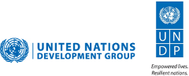
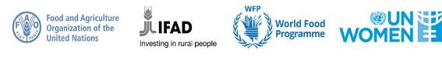

“ACCELERATING PROGRESS TOWARDS THE ECONOMIC EMPOWERMENT OF RURAL WOMEN”

ANNUAL NARRATIVE progress report

REPORTING PERIOD: january 2023 – December 2023

Programme Title & Project Number |  |  | Country, Locality(s), Priority Area(s) / Strategic Results
- Programme Title: Accelerating Progress Towards Economic Empowerment of Rural Women in Rwanda  - MPTF Office Project Reference Number: 00120075 |  |  | Country: Rwanda  Districts: Kirehe, Ngoma, Gisagara, Nyaruguru and Nyamasheke  The strategic result is to secure rural women’s livelihoods and rights in the context of sustainable development and the SDGs. (Focus on Government priority areas of: Economic and social transformation, and Transformational Governance).
 |  |  | Programme Beneficiaries
 |  |  | Direct Beneficiaries: 9,101 (7,342 women and 1,759 men)
Participating Organization(s) |  |  | Implementing Partners
- FAO, IFAD, UNWOMEN, WFP |  |  | - Ministry of Agriculture and Animal Resources (MINAGRI)  - Ministry of Gender and Family Promotion (MIGEPROF)  - INADES Formation Rwanda (IFR)  - Sustainable Agriculture for Food Security and Economic Development, Community Vision Initiative (SAFE)  - Rwanda Development Organization (RDO)
Programme/Project Cost (US$) |  |  | Programme Duration
Total approved budget as per project document:  USD 6,035,000  MPTF/ JP Contribution (2023): USD 191,711.68 |  |  | Overall Duration: 5 years
 |  |  | Start Date (15 02 2020)
Other Contributions (donors)  -Bill and Melinda Gates Foundation (BMGF) 487,996.32 |  |  | End Date (31 12 2024)
Total: US $ 679,708.9
Programme Assessment/Review/Mid-Term Eval. |  |  | Report Submitted By
Assessment/Review - if applicable please attach  Yes No Date: dd.mm.yyyy  Mid-Term Evaluation Report – if applicable please attach  Yes No : Yes (Phase I Final Evaluation Date: (Phase I Evaluation) |  |  | - Name: Andrea Bagnoli  - Title: Representative & Country Director  - Participating Organization (Lead): WFP  - Email address: andrea.bagnoli@wfp.org

LIST OF ABBREVIATIONS AND ACRONYMS

ECD | Early Childhood Development Centers
FAO | Food and Agriculture Organization
GALS | Gender Action Learning System
GEWE | Gender Equality and Women Empowerment
GMO | Gender Monitoring Office
IFAD | International Fund for Agricultural Development
IFR | INADES Formation Rwanda
IGAs | Income Generating Activities
IPs | Implementing Partners
JP RWEE | Joint Programme on Rural Women Economic Empowerment
MFI | Micro Finance Institutions
MIGEPROF | Ministry of Gender and Family Promotion
MINAGRI | Ministry of Agriculture and Animal Resources
MINALOC | Ministry of Local Government
NBC | Nile Basin Club NGO
NST | National Strategy for Transformation
NWC | National Women Council
PHHS | Post-Harvest, Handling and Storage
PSTA | Plan Stratégique pour la Transformation de l’Agriculture (Strategic Plan for Agriculture Transformation)
RCA | Rwanda Cooperative Agency
RDO | Rwanda Development Organization
SACCO | Savings and Credit Cooperatives
SAFE | Sustainable Agriculture for Food Security and Economic Development
SDGs | Sustainable Development Goals
SDF | Sustainable Development Fund
ToTs | Training of Trainers
UNDAP | United Nations Development Assistance Plan
UN Women | United Nations Entity For Gender Equality and the Empowerment of Women
VSLAs | Village Saving and Loan Associations
WEAI | Women’s Empowerment in Agriculture Index
WFP | World Food Programme
YWCA | Young Women Christian Association

EXECUTIVE SUMMARY
The Joint Programme ‘Accelerating Progress towards Rural Women’s Economic Empowerment’ (JP RWEE) is a global initiative with an overarching goal to secure rural women’s livelihoods, rights, and resilience in the context of sustainable development. Specifically, the programme has four interlinked outcome areas which are: Improve food security and nutrition; Increase income to sustain livelihoods; enhance women's participation in decision-making; and enable a more gender-responsive policy environment for the economic empowerment of rural women. The Programme is jointly implemented by Food and Agriculture Organization (FAO), the International Fund for Agricultural Development (IFAD), UN Women and the World Food Programme (WFP).
During the reporting period, the Programme has made key progress towards the achievement of the programme’s desired outcomes and the key achievements include the establishment of 75 Farmer Field and Life Schools (FFLS), the formation of 299 Village Saving and Loan Associations (VSLAs) gathering 8,007 farmers (6,249 women and 1,578 men, 391 youth and 77 people with disabilities) who actively participate in weekly savings meetings.
The groups have collectively saved up to RWF 86,922,737 (USD 71,305.36), and members have utilized loans amounting to RWF 57,184,743 (USD 46,910.38) for investments in micro-projects, household expenses such as health insurance and school fees.
The programme supported the creation of 47 tree nurseries, which generated an estimated revenue of RWF 35,607,000 (USD 29,122.187). Furthermore, the programme strengthened the skills of 2,364 farmers in grafting techniques and trained them on various climate-resilient agriculture practices.
During this reporting period, the programme supported 350 rural women with two selling points. These selling points provided women with decent working environment and serve as a convenient marketplace where they are assured of a sustainable space for the sale of their produce and will generate additional incomes from the rent of more space available in these selling points as well as from individual businesses. The program also trained 288 GALS champions (238 women and 50 men including 22 persons with disabilities) on GALS+ methodology extended to nutrition and climate change.
Strategic and operational engagements involved conducting policy dialogues to advocate for changes and influence decision-making processes. This included a high-level policy dialogue and consultation to shape the Strategic Plan for Agriculture Transformation (PSTA5) alongside the Ministry of Agriculture and Animal Resources, Rwanda Agriculture Board (RAB) and other key agriculture sector partners. Additionally, these efforts collectively enhanced the agri-entrepreneurship and business skills of 300 rural women.
Furthermore, strategic discussions on dissemination and implementation of the revised National Gender Policy were conducted with the Ministry of Gender and Family Promotion (MIGEPROF) along with other National Gender Machinery Institutions. The programme will support National Gender Machinery institutions in the development bridged booklets of the revised National Gender Policy, translating them into Kinyarwanda, and disseminating the booklets to RWEE beneficiaries and surrounding communities.
In addition, the Programme worked on evidence and knowledge generation which will continue to inform areas of focus and during this reporting period, two main studies were conducted: gender sensitive value chain analysis and Gender sensitive market analysis. Key recommendations from the studies include the need to support women farmers in terms of skills, knowledge, technologies, and extension of agriculture advisory services within Maize, Beans, Soya beans, Diary and Bee products value chains. Other recommendations include support to access agricultural inputs, capital and post-harvest infrastructure, which are still a challenge to rural women involved in those value chains.

Purpose

The overall strategic goal of the JP RWEE is to secure rural women’s livelihoods, rights and resilience to advance sustainable development. There are four programme outcomes:

1. Rural women’s improved food and nutrition security.
2. Rural women’s increased income to secure their livelihoods.
3. Rural women’s enhanced leadership and participation in rural institutions and in shaping laws, policies, and programs.
4. A more gender-responsive policy environment is secured for the economic empowerment of rural women.

To ensure the effective implementation of programme activities, JP RWEE is informed by Rwanda’s development priorities as outlined in the National Strategy for Transformation (NST1 2018 – 2024), the Strategic Plan for the Transformation of Agriculture (PSTA4 2018 – 2024), the revised Rwanda National Gender Policy, the Agriculture Gender and Youth Mainstreaming Strategy and other local and decentralized guiding instruments mostly aimed at economic empowerment of rural women. Going forward, guiding documents like NST2 and PSTA5 that are yet to be finalized will be consulted to ensure that the programme responds to the Government priorities and emerging needs of rural households.

- Assessment of Programme Results
- Narrative reporting on results:
Outcome 1: Improved food security and nutrition for rural women and their households that contribute to equitable and sustainable food systems.
During the reporting period, the programme conducted targeting and profiling of new beneficiaries where 9,101 individuals (7,342 women and 1,759 men) are currently enrolled (see table 1 below for the breakdown) and they have been supported around the four outcome areas.
Table 1: Programme direct right-holders by district
District | Female | Male | Total
GISAGARA | 1,568 | 608 | 2,176
KIREHE | 1,274 | 285 | 1,559
NGOMA | 952 | 169 | 1,121
NYAMASHEKE | 2,480 | 378 | 2,858
NYARUGURU | 1,068 | 319 | 1,387
Total | 7,342 | 1,759 | 9,101

The JP RWEE covers five districts namely Kirehe and Ngoma in the Eastern province, Nyaruguru and Gisagara in the Southern province, and Nyamasheke in the Western province. Kirehe, Ngoma, and Nyaruguru districts were extended from phase one of the programme while Gisagara and Nyamasheke were added to the programme mainly due to their level of economic vulnerability, as the two districts rank the highest on poverty and extreme poverty in the country (see figure 1 below).

Figure 1: Poverty ranking by district (Source: NISR – EICV5, 2018)
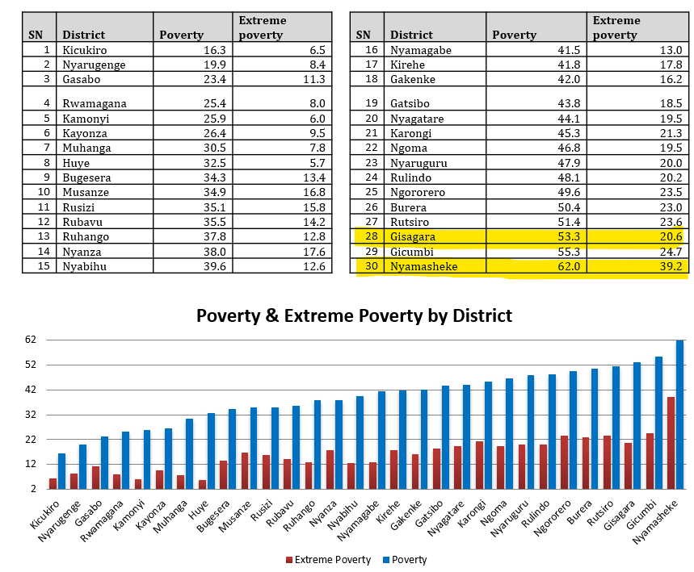

The process of selecting sectors, cells, and villages within the five districts also considered the varying levels of vulnerability, particularly focusing on communities that are more susceptible to adverse conditions affecting agricultural production. This led to the selection of 11 sectors, 28 cells, and 215 villages for the programme coverage. The exercise was conducted in collaboration with government authorities, implementing partners and the four participating UN Agencies.
The process of identifying and selecting direct beneficiaries within the selected communities was supported by grassroots authorities, village committee members and government authorities through citizen assembly meetings (called Inteko z’abaturage in Kinyarwanda) guided by a set of criteria developed in collaboration with all stakeholders.
Among the main selection criteria, there were:
- At least 70% of beneficiaries should be women and girls;
- Only one person per household can be a direct beneficiary of the programme;
- Beneficiaries should be in 1st and 2nd category of wealth ranking (called Ubudehe);
- and where possible identify participants part of special categories in line with the principle of Leaving No One Behind (LNOB), such as: women living with disabilities, women with HIV/AIDS, survivors of gender-based violence (GBV) including teen mothers, female heads of a household, and in general women and men not already part of any group or cooperative nor supported by any other programme or project, and women living in rural areas and already working in agriculture.
The programme increased rural women’s access to resources for climate-resilient agricultural production, food security and nutrition by establishing 75 Farmer Field and Life Schools (FFLS) groups, training 32 FFLS facilitators (24 women and 8 men) and building capacities and skills of 2,364 farmers.
The programme applies the Farmer Field and Life Schools (FFLS) approach, where farmers are organized into small groups of 25 to 35 members. In these groups, they learn good agricultural practices, and discuss about social issues in their communities in a safe and risk-free setting, with the support of a trained facilitator. This setup includes applying climate-resilient practices on demonstration plots. Additionally, the approach provides an avenue for farmers to acquire essential life skills, such as diet and nutrition, food security, hygiene, conflict management, entrepreneurship, and gender/GBV awareness. Dubbed as “schools without walls”, these FFLS groups allow both male and female farmers to learn through observation and hands-on experimentation within their own contexts.
Initially, the programme trained 32 individuals from Kirehe, Ngoma, and Nyaruguru districts including 24 women and 8 men, to become facilitators of the FFLS approach. They received training in climate-resilient agricultural techniques and practices. Consequently, the programme successfully established 75 FFLS groups in the three districts, bringing together 2,364 farmers (1,838 women and 526 men) who were then guided by the facilitators in adopting climate-resilient agricultural practices.
Additionally, in line with the FFLS model, all farmers were equipped with essential life skills training in nutrition, hygiene, and conflict management to enhance their resilience and improve their livelihoods. As farmers continue to adopt these improved agricultural techniques and practices, there is an expectation of a significant enhancement in the agricultural production and yields of rural women, in terms of both quantity and quality.
Ahead of the market and value chain analysis, participating farmers identified two activities for income generation, food security and nutrition: avocado production and chicken rearing. The programme focused on enhancing the skills of 2,364 farmers and FFLS members in fruit tree grafting, with a specific emphasis on grafted avocados due to their adaptability to various climatic conditions in the country, high productivity, and market demand. This initiative resulted in the establishment of 47 tree nurseries collectively nurturing 71,214 avocado seedlings. The revenue generated from this production until November 2023 is estimated at RWF 35,607,000 ($29,122.187).
The active participation of farmers in accessing land and providing labour for the production of grafted avocado tree, coupled with technical and material support from the program, exemplifies a sustainable partnership that propels the program’s interventions as beneficiaries co-invest in the initiative.
The programme marked key progress in preparing the stage for strengthening rural women’s skills and capacities to increase food security, enhance households’ nutrition and reduce food losses and waste. In the effort to address the issue of malnutrition especially among women and children in the two most vulnerable districts of Nyamasheke and Gisagara, the programme procured 20,136 chickens that will be distributed to 5,034 households (four chickens per household) early 2024. This initiative is expected to improve the consumption of animal-sourced foods (ASF), e.g. eggs and poultry meat, among rural women and children, which is currently very low (1.5%) according to the preliminary findings from the programme baseline.
Awareness workshops with stakeholders at district level, and social behavior change communication among beneficiaries will be conducted to emphasize women and children’s consumption of high nutritious foods including animal-based proteins. Furthermore, the organic manure from chicken droppings will also be used in kitchen and home gardens consequently improving vegetable production at household level.
Additionally, in order to promote gender equality and women’s empowerment, the program trained 288 GALS champions (238 women and 50 men including 22 persons with disabilities) trained on GALS+ methodology extended to nutrition and climate change who in turn reached 4,982 indirect beneficiaries (2,835 women, 2,147 men) in Kirehe, Ngoma and Nyaruguru districts. Trained participants reported that they have increased access to productive resources, such as land, and have improved their nutritional practices, including the increased consumption of animal source protein (such as eggs and meat); especially by women and children. Additionally, they strengthened their capacities to cope with climate change shocks.
Outcome 2: Rural women’s income, decent work and economic autonomy increased to secure their livelihoods and build resilience.
During the reporting period, the programme supported women’s cooperatives and female entrepreneurs; where 459 (409 women and 50 men) were trained in entrepreneurship and business management skills. This initiative empowered both women and men to identify and leverage opportunities within agriculture and other sectors, enabling them to make informed decision and manage associated risks.

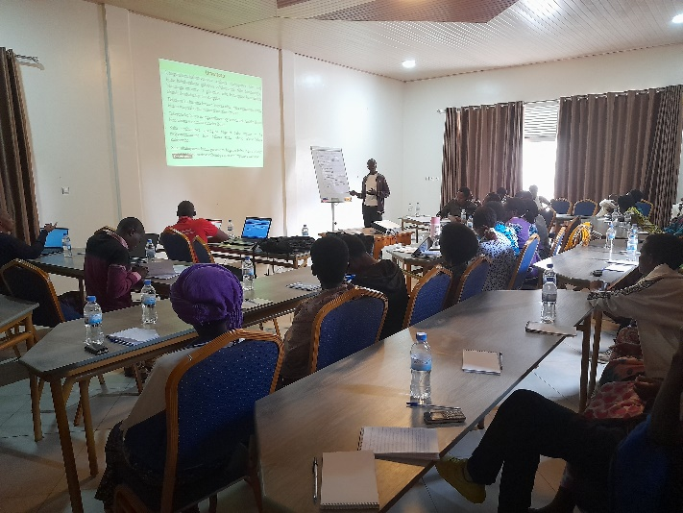
Furthermore, 100 women were trained on tax laws, enhancing their understanding of the tax policies and regulations applicable to businesses in Rwanda. The training provided clarity on their responsibilities regarding the registration of their cooperatives as taxpayers and acquisition of Taxpayer Identification Number (TIN) numbers. The training removed tax-related apprehensions and clarified the various categories of taxpayers and their obligations. Equipped with knowledge about TINs and the use of electronic billing machines (EBMs), these cooperatives are now unlocking new opportunities. They can compete in and supply to larger markets, such as supplying food to schools and engaging with other formal markets that offer premium prices.
Figure 1 - Participants during the entrepreneurship training

Two exchange visits among 12 cooperatives with 38 (women 30 and men 8) were conducted and this exchange visits enhanced the skills of beneficiaries through peer-to-peer learning and knowledge sharing. The main economic activities that the exchange visits focused on are poultry farming, bee keeping as well as management of nursery beds of tree fruits and other farming activities.
In addition, the programme continues to register significant progress in enhancing financial access for women and building their capacities and skills for entrepreneurship. During this reporting period, JP RWEE facilitated the establishment of 299 Village Savings and Loan Associations (VSLAs) across the five districts, distributed as follows: 98 groups in Gisagara district, 51 in Kirehe, 42 in Ngoma, 56 in Nyamasheke, and 52 in Nyaruguru.
VSLAs groups are self-managed groups of 15-25 individual members from within a community who meet regularly (weekly) to save their money in a safe space, access small loans, and carry out micro projects either together as a group or as individual members. The members contribute a minimum share of RWF 500 (≈USD 0.41) weekly, which increases as their income grows.
Currently, 88% of all programme beneficiaries have joined these savings groups, totaling 8,007 members (6,249 women and 1,578 men) who actively participate in weekly savings meetings. Among the members, 391 are youth and 77 are people with disabilities (PWD), aligning with the programme's commitment to the leave-no-one-behind principle. The groups have collectively saved up to RWF 86,922,737 (USD 71,305.36), and members have utilized loans amounting to RWF 57,184,743 (USD 46,910.38) for investments in micro-projects, household expenses such as health insurance and school fees. All beneficiaries continue to receive business and advisory services, focusing on business plan development, market access, and promoting women`s involvement in value addition across various value chains.
Outcome 3: Rural women’s voice and agency increased for full and equal participation and leadership in their households, communities, organizations, and governance systems.
The 299 farmers have transitioned into leadership roles within the context of VSLAs, marking a significant stride towards enhancing women's leadership in communities and offering a platform to facilitate access to training initiatives.
Moreover, in its first year, the programme undertook preparatory work under outcome 3 by identifying 600 women poised to elevate their voice and agency for equal participation and leadership within their households, communities, organizations, and governance systems in the forthcoming years of implementation.
The JP RWEE has significantly increased rural women's leadership and participation in their communities and rural institutions. Thanks to the program's gender-transformative approaches, which cover topics like income, entrepreneurship, investment, women's rights, and social norms, women have developed greater confidence in leadership and management. These approaches have led to collective change, enhancing women's decision-making abilities at both household and community levels. Furthermore, the program has played a crucial role in elevating women's participation and status in the development of laws, policies, and initiatives aimed at women's empowerment.

Outcome 4: Gender-responsive legal frameworks, policies and institutions strengthened to create an enabling environment for rural women to secure their livelihoods, rights, and resilience.
During the reporting period, the programme actively engaged with MINAGRI and MIGEPROF to support the development of the Strategic Plan for Agriculture Transformation (PSTA5) and its gender mainstreaming, as well as to support the implementation of the new National Gender Policy. Country Representatives from the four Participating UN Organizations played a key role in high-level consultation sessions to shape not only the PSTA5, but also the broader National Strategy for Transformation (NST2). These sessions included policy dialogues focusing on the strategic direction of these national guiding frameworks.
Additionally, Rwanda participated to the 51st session of the Committee on World Food Security (CFS) which represented a great and unique opportunity to showcase the JP RWEE model in Rwanda especially for its work with women’s cooperatives. It served as a platform to showcase the JP RWEE model, sharing best practices and lessons learned on holistic and integrated approaches to rural women's economic empowerment within the context of food security and nutrition.
In this policy engagement, Rwanda presented experiences, focusing on women's cooperatives as an empowering approach. This model has enabled women to overcome barriers to gender equality through capacity building in production techniques, including nutrition-sensitive agriculture, climate-smart agriculture, post-harvest handling, and product transformation.
The platform emphasized on how cooperatives facilitate women's access to broader economic opportunities, such as informal and formal credit services, agricultural inputs and technologies, connections to local extension services and development planning processes, as well as market access, including links to sustainable larger-scale markets. The exchanges highlighted the effectiveness of multi-stakeholder partnerships in enhancing food security, nutrition, gender equality, and women's empowerment, aligning with the recommendations outlined in the CFS Voluntary Guidelines on Gender Equality and Women Empowerment in the Context of Food Security and Nutrition in Sub-Saharan Africa and beyond.
Furthermore, the programme conducted Gender-Sensitive Analysis of the Value Chains of Maize, Beans, Soya Beans, Potatoes, Dairy and Bee Products in Rwanda. The study found that the Rwandan government has put in place various programmes, policies, and strategies as well as investments to improve the productivity of the value chains for beans, maize, potatoes, soya beans, dairy and bee products. The findings also indicated that women farmers, in particular, need skills, knowledge, technologies, and advisory services offered through extension services to be adequately informed about the production within these value chains. Access to inputs emerged a key constraint across the value chains; with women being disproportionately affected due to their lack of capital for procuring these inputs.

In addition, capital and resources are essential for the success of the value chains as well as adequate post-harvest infrastructure. Such infrastructure is crucial for reducing post-harvest losses and providing storage solutions, enabling commodities to be sold when market prices are more favorable.
The main recommendations to enhance gender equality in value chains are:
- Enhance the access of women farmers, particularly those producing soya beans, dairy and bee products to advisory services
- Improve access to inputs for women farmers across all six value chains.
- Support women farmers with post-harvest management through the provision of appropriate post-harvest infrastructure and equipment.
- Improve access to finance for farmers, especially women farmers.
- Build the capacity of cooperatives in leadership and governance as well as in entrepreneurship and business management.
- Build the capacity of women farmers, focusing on farming as a business.
- Promoting gender inclusiveness within the community across the six value chains and in their respective segments.
During this reporting period, the programme also conducted Gender-Sensitive Market Analysis of Maize, Beans, Soya Beans, Potatoes, Dairy and Bee Products in five districts in Rwanda. The findings reveal that, among the selected products, there are significant supply and demand imbalances, with many market participants reporting instances of failing to meet current and/or potential demand for their products. There are notable gender disparities in the likelihood of experiencing supply shortages, particularly among females actors in the potato and bee product markets, who face a higher risk of shortages.
The market presence of women varies by product. While women are underrepresented in the bee product market, they have a stronger presence in the bean and maize markets. However, women's participation is predominantly at the production phase, with their involvement in transporting produce being notably lower. In terms of sales, women have reported that men often take over this role, despite men's minimal contribution to the production process. In the dairy sector, women have a relatively strong presence but are less inclined to sell milk outside their village compared to their male counterparts, largely due to transportation difficulties.
The three most commonly reported reasons as to why suppliers fail to satisfy demand are low supply capacities, limited financial resources and transportation difficulties. Transportation is particularly a challenge for female market actors in the markets for potatoes and dairy products, the most highly perishable products covered by the study.
The main recommendations to improve gender sensitivity and enhance gender equality in markets are:
- Encouraging women market actors to form groups or associations to help with joint transportation to markets outside the village and increase their bargaining power to sell produce at better prices than when selling as individuals. Special attention should be given to women actors, who are notably underrepresented in activities such as transportation.
- Promoting the nutritional and other beneficial aspects of products like dairy through advertising and consumer awareness campaigns could stimulate local demand and broaden the market.
- Providing technical support to women market actors in crafting marketing strategies and plans for their products.
- Safeguarding rural women farmers and small-scale retailers from adverse and volatile prices by implementing price regulation and encouraging the formation of groups and cooperatives to enhance their negotiating strength.
- Enhancing women farmers' access to information on market prices, enabling them to navigate through unfavorable and fluctuating price scenarios.
- Assisting farmers and market participants with value addition by processing their produce into higher-value products that attract greater demand and prices, especially supporting women actors who are underrepresented in processing activities.
- Facilitating buyer-supplier market linkages through regular market inventories and connecting suppliers with potential buyers both within and outside their districts. This could be particularly beneficial for women actors who predominantly sell their produce within their neighborhoods, helping them access broader markets and achieve higher prices.
- Strengthening the capacity of rural women farmers in post-harvest handling to meet food safety regulations set by the government and quality standards demanded by customers.
Delays in implementation, challenges, lessons learned & best practices
During this reporting period, the programme invested significant efforts in preparatory works for scale up for phase II which involved identification, targeting and profiling of new beneficiaries, conducting of three important assessment studies (baseline study, market analysis, value chain analysis) and this preparatory work involved high level consultations with line ministries to agree on the scope and coverage of the studies and identify how the findings of the studies will inform the National Strategy for Transformation (NST2) and the Strategic Plan for Agricultural Transformation (PSTA5) which development is ongoing. Other preparatory activities included: development of survey tools and hiring consultants to support the assessments. The assessments went beyond the reporting period but were completed as of the time of submission of this progress report.
Furthermore, farmers face the ongoing challenge of escalating costs of inputs like seeds and fertilizers, complicating their ability to acquire the essential resources needed to sustain or grow their operations. The Joint program will persist in collaborating with relevant stakeholders to address these challenges.
Qualitative assessment
The three important studies (baseline, Market analysis and value chain analysis) conducted at the macro-level, will contribute to evidence-based policy discussions and inform the planning of the programme activities. This is crucial for ensuring that the program's interventions are aligned with national development goals.

II) Indicator Based Performance Assessment:
 | Achieved Indicator Targets | Reasons for Variance with Planned Target (if any) |  | Source of Verification
Outcome 1 Rural women have Improved food and nutrition security
Output 1.1 Rural women have increased access to and control over resources, assets and services critical for their food and nutrition security
Indicator 1.1.1: Number of beneficiaries supported with livestock.  Baseline: 0  Target: 1000 | 20,000 chickens are being distributed to beneficiaries (4 chicken to each household) | This is an ongoing activity |  | Implementing partner report
Indicator 1.1.2: Number of rural women led groups are utilizing climate smart technologies.  Baseline: 0 Cooperatives  Planned: 100 groups | 150 groups of rural women were supported with skills to on climate smart agriculture technologies through Farm field and life skills. | Implemented as planned |  | Implementing partner report
Indicator 1.1.3: Number of rural women and men who have strengthened their knowledge on land rights and land management.  Baseline: 0  Planned Target: 1000 | 2,212 beneficiaries | Implemented as planned |  | Implementing partner report
Output 1.2 Rural women have greater capacity to enhance and control local food security reserves and their production
Indicator 1.2.1: Number of cooperatives supported with skills to manage irrigation equipment  Baseline: 0  Target: 10 | 16 beneficiaries were trained and given skills to manage solar powered irrigation systems which have been established to support 4 cooperatives in Ngoma District | Implemented as planned | Implementing partner report
Outcome 2 Rural women have increased income to secure their livelihoods
Indicator 2.1: Income generated by community saving groups (RWF)  Baseline: 0  Target: 100 | VSLAs have saved a total amount of US$ US $ 71,305.36 | This was saved by the 8,007 farmers (6,339 women and 1,668 men) as newly created VSLAs in 2023 | Implementing Partner Progress report
Output 2.1 Rural women have enhanced entrepreneurship skills and value chains to access markets for their products
Indicator 2.1.1: Number of rural women’s cooperatives and women groups with agriculture production sales to markets.  Baseline:0  Target:10 | 15 groups composed of 1,675 (1,305 women and 370 men) | This is an on-going activity | Implementing partners reports and field reports
Indicator 2.1.2: Number of women trained on entrepreneurship skills and value chain.  Baseline: 0  Target: 500 | 700 (490 women and 210 men) were trained on entrepreneurship skills and business plan development. | This is an on-going activity | Implementing Partner Progress Report
Indicator 2.1.3: Cumulative amounts of loans given out to VSLAs. Members  Baseline:0  Target: 5, 000 | The VSLAs given out a total amount of US (USD 46,910.38) | The loans have been issued for investments in micro-projects, household expenses such as health insurance and school fees | Implementing Partner Progress report

Outcome 3: Rural women have enhanced leadership and participation in their communities and in rural institutions, and in shaping laws, policies and programs
Indicator: 3.1 Number of women agri-extension officers trained in agriculture extension services  Baseline: 0  Planned Target: 100 women | 179 (151 female and 28 male) women agri-extension workers were trained on extension services especially in horticulture | Conducting hands-on session in the community facilitated more beneficiaries to benefit from the initiative | Implementing Partner Progress Report
Output 3.1: Rural women, including young women, have increased capacity to engage in and influence relevant policy forums at national and regional levels
Indicator 3.1.1 Number of champions who are being trained on GALS methodology plus nutrition, climate change and agriculture.  Baseline: 0  Planned Target: 1200 | • 288 GALS champions (238 women and 50 men including 22 persons with disabilities) trained on GALS+ methodology extended to nutrition and climate change  • 4,982 indirect beneficiaries (2,835 women, 2,147 men) | This is an ongoing activity and Partnerships facilitate to reach more beneficiaries | Implementing partners repots

Outcome 4: A more gender responsive policy environment is secured for the economic empowerment of rural women
Output 4.1: Policy makers and parliamentarians have enhanced capacities to effectively mainstream gender into land, food, agriculture, nutrition and rural employment policies, laws, and budgets.
Indicator 4.1.1 Number of stakeholders from private sector reached that can now enhance their capacities to effectively mainstream gender.  Baseline:0  Planned Target: 400 rural women farmers, 200 men farmers and 50 local leaders | Rescheduled/postponed | Will be reported on in the next reporting | N/A
Output 4.2: Greater availability of tools and data to track progress in the economic empowerment of rural women
Indicator 4.2.1 “Assessment on gender sensitive value chain and market analysis”  Baseline: 0  Target: 2 | Two assessments were conducted (The reports and recommendations will be used by different partners to improve and support women participation different value chains) | Implemented as planned | Assessment report
Output 4.3: An enabling environment is promoted to reflect rural women’s priorities in regional policy processes.
Indicator 4.3.1 Number of stakeholders participating in policy dialogue.  Baseline:0  Planned Target: 70 | Around 100 participants have been engaged through meetings and sessions with programme partners | This is an on-going activity | Agencies and implementing partners reports

iii) Evaluation, Best Practices and Lessons Learned
Best practices
Collaboration and Partnership: The Programme enjoys solid engagement with Government most especially the Ministry of Gender and Family Promotion (MIGEPROF), the Ministry of Agriculture and Animal Resources (MINAGRI) and the five Districts where the Programme is operating, and this has been key in ensuring national ownership as well as facilitating implementation of activities at operational level.
Rightsholders enhanced participation: Active participation and involvement of beneficiaries at the center of programme implementation has stood out to be critical in ensuring not only effective inclusion but also delivering on effective perspectives in terms of local development. The main entry points have been through the application of Gender Transformative approaches like GALS and other capacity building initiatives have opened opportunities for rural women.

Exchange and Learning Visits: Through engagements and collaboration with implementing Partners, implementation of the programme activities embarked on experience sharing amongst beneficiaries and this enhanced opportunities in terms of exchanging knowledge and skills, sharing experiences and challenges and through this initiative, rural women have gained more opportunities in terms of skills upgrade and learnings.
Cooperating Partners Engagement: Working with implementing Partners and Local Government authorities has enhanced forward looking measures to ensure programme’s sustainability. This has been achieved through regular engagements with both local non-governmental organizations and local authorities, aimed at building capacities.
Lessons learned:
Creation of Synergies: The approach of leveraging the expertise and building on the comparative advantage of each of the four participating Agencies has demonstrated the effectiveness of joint implementation in producing results. This joint programme, aimed at supporting the most vulnerable and marginalized women in rural communities, showcases how these synergies enhance the principle of “Leave No One behind", ensuring that all members of society benefit from such development initiatives. The Programme will continue to build on Agencies respective comparative strengths towards the common goal of empowering rural communities.

Working in Groups: The programme emphasized supporting women through groups rather than individuals, fostering sustainable and transformative change. This group approach enhances women's social and economic status by developing their social capital and enabling holistic capacity interventions to reach more women, facilitating the scaling of interventions.
Application of Gender Transformative Approaches (GTAs): The use of Gender Transformative Approaches such as GALS, engaging men in women’s economic empowerment at both at household and community levels has created a conducive environment. This approach has also responded to discriminatory gender norms that are deeply embedded within households and the community and has reduced GBV and conflicts, lightened women’s unpaid care load, and opened income generating opportunities for rural women.

A beacon of change for Agnes: Empowering rural women to generate income.
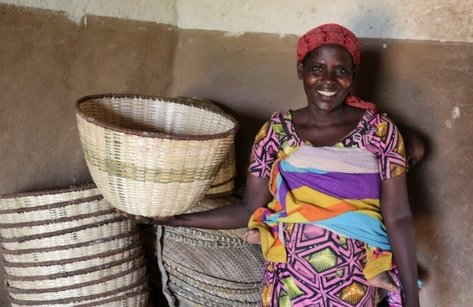
As the sun curved in over the hilly landscape in southern Rwanda, a team of the joint UN programme for rural women economic empowerment (JP RWEE) met Agnes Nibakure. She, a 43-year-old woman, and her husband Emmanuel Bucumi are beneficiaries of the programme supported by the Bill and Melinda Gates Foundation. “The family journey had been marked by some conflicts, rooted in lack of self-confidence to manage the little resources we have including the livestock and food at home,” she said.
Agnes Nibakure holds one of the baskets ready to sell to the local market.
Photo: WFP/JohnPaul Sesonga
Hailing from Rango village, Runyombyi cell, Busanze sector of Nyaruguru district, Agnes got married and started a family at a tender age of 16, with limited knowledge on women’s empowerment. She is now a member of the cooperative Amahoro, comprised of 20 resilient women and 10 supportive men who were transformed by JP RWEE.
Thanks to the training on gender equality and women empowerment provided by JP RWEE, she said: “My life was transformed as I and my colleagues were enlightened, we are no longer victims of domestic violence.” Agnes found a new strength within herself. The conflicts were so severe that her husband had fled home but was motivated by his spouse’s success to return.
The turning point came when Agnes joined the savings group formed as part of the JP RWEE initiative. With a small loan of 10,000 Rwandan francs (RWF, about USD 8) from the savings group, Agnes kickstarted a small-scale business selling potatoes, baskets, and plastic containers in the village market. In just three months, Agnes not only repaid the loan but also doubled her profit.
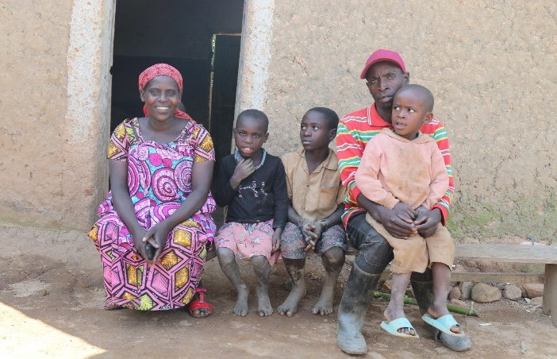
With her entrepreneurial spirit ignited by JP RWEE, Agnes had bigger dreams. She rented a small piece of land and cultivated beans, yielding 30 kilograms for home consumption and earning a steady income from her various ventures. She aspired to register her business, create a brand, and ultimately become a recognized entrepreneur in Rwanda. She hopes to purchase land for agriculture and renovate their home. Her vision extends to buying a bicycle for Emmanuel to reduce transportation costs and streamline their business operations.
Agnes Nibakure and her husband Emmanuel pose for a photo with their children at home. Photo: WFP/JohnPaul Sesonga
Meanwhile, her husband Emmanuel works in a tea plantation, earning a monthly income of 35,000 RWF. They now live together peacefully, and he became a supportive partner due to the JP RWEE’s training on Gender Action Learning Systems (GALS) led by IFAD. He takes charge of household duties even when Agnes is away on business trips. Their shared dream of owning land and improving their living conditions continues, despite the loss of their small plot of land taken away by flooding in 2022 down in the valley.
As JP RWEE implemented by FAO, IFAD, UN Women and WFP entered its second phase, the focus shifted to enhancing rural women's access to finance, ensuring the enduring impact of their newfound knowledge and skills. The goal remains to secure rural women's livelihoods, rights, and resilience, in alignment with Agenda 2030 and the Sustainable Development Goals.

RWANDA: 00120075
Government and local NGOs are prioritized as a mechanism of ensuring both ownership and sustainability.
USD 1 = RWF 1,219.021, UN exchange rate, 1st November 2023, https://treasury.un.org/operationalrates/OperationalRates.php
Implementation have been successful due to joint partnerships and commitment of beneficiaries.
Based on November 2023 exchange rate (USD 1: RWF 1,219.021)
USD 1 = RWF 1,219.021, UN exchange rate, 1st November 2023, https://treasury.un.org/operationalrates/OperationalRates.php
There was a strong partnership with Ngoma District and MIGEPROF

