
CONSOLIDATED ANNUAL FINANCIAL REPORT
of the Administrative Agent

Joint Programme for Quality Education in Pakistan

for the period 1 January to 31 December 2023

UN Multi-Partner Trust Fund Office
United Nations Development Programme
GATEWAY: https://mptf.undp.org

May 2024

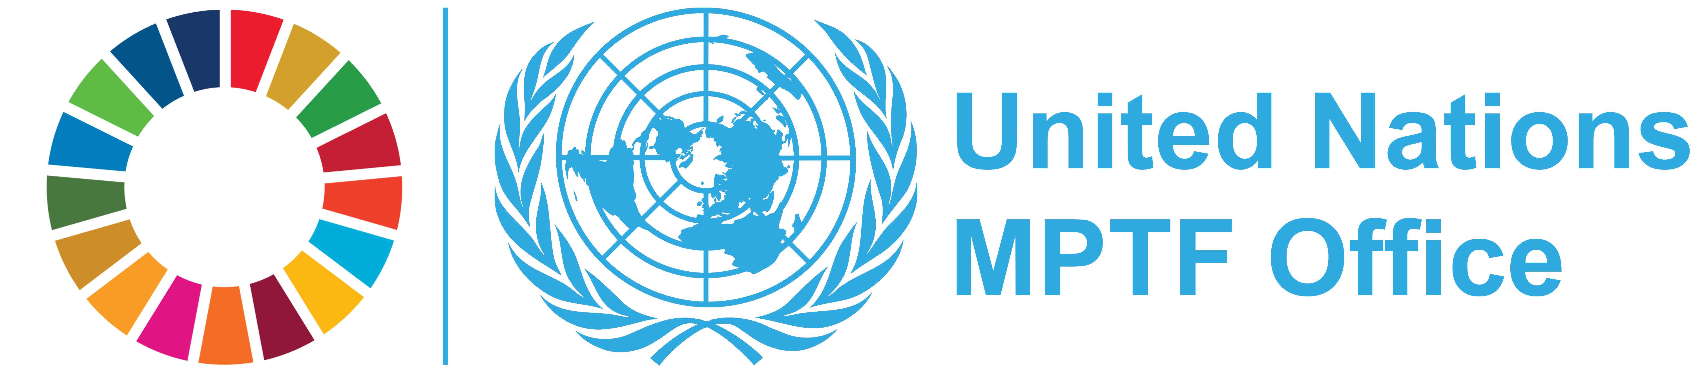

  DEFINITIONS
  Allocation/Total Approved Budget
  Amount approved by the Steering Committee for the Joint Programme. The total approved budget represents the cumulative amount of allocations approved by the Steering Committee.
  Approved Joint Programme
  A Joint Programme including budget, etc., that is approved by the Steering Committee for fund allocation purposes.
  Contributor Commitment
  Amount(s) committed by a contributor to a Joint Programme in a signed donor agreement with the UNDP Multi-Partner Trust Fund Office (MPTF Office), in its capacity as the Administrative Agent. A commitment may be paid or pending payment.
  Contributor Deposit
  Cash deposit received by the MPTF Office for the Fund from a contributor in accordance with a signed donor agreement.
  Delivery Rate
  The percentage of funds that have been utilized, calculated by comparing expenditures reported by a Participating Organization and Non-UN organization against the 'net funded amount'. This does not include expense commitments by Participating Organizations.
  Donor Agreement
  Standard Administrative Arrangement and/or European Commission contribution agreement between contributor/donor and MPTF Office.
  Net Funded Amount
  Amount transferred to a Participating Organization less any refunds transferred back to the MPTF Office by a Participating Organization.
  Participating Organization
  A UN Organization or other inter-governmental Organization that is partner in a Fund, as represented by signing a Memorandum of Understanding (MOU) with the MPTF Office for a particular Fund.
  Joint Programme Expenditure
  The sum of expenses and/or expenditure reported by all Participating Organizations for a Joint Programme irrespective of which basis of accounting each Participating Organization follows for donor reporting.
  Joint Programme Financial Closure
  A Joint Programme is considered financially closed when all financial obligations of an operationally completed Joint Programme have been settled, and no further financial charges may be incurred.MPTF Office will report a Joint Programme financially closed once the financial report(s) has been received and any balance of funds refunded.
  Joint Programme Operational Closure
  A Joint Programme is considered operationally closed when all programmatic activities for which Participating Organization(s) received funding have been completed, and the Steering Committee has approved the final narrative report
  Joint Programme Start Date
  Joint Programme start date as per the programmatic document.
  Transferred Funds
  Funds transferred to Participating Organizations by the Administrative Agent in accordance with the Steering Committee’s request.
  US Dollar Amount
  The financial data in the report is recorded in US Dollars

TABLE OF CONTENTS

Introduction . . . . . . . . . . . . . . . . . . . . . . . . . . . . . . . . . . . . . . . . . . . . . . . . . . . . . . . . . . . . . . . . | 4
1. Sources and Uses of Funds . . . . . . . . . . . . . . . . . . . . . . . . . . . . . . . . . . . . . . . . . . . . . . . . . . | 5
2. Partner Contributions . . . . . . . . . . . . . . . . . . . . . . . . . . . . . . . . . . . . . . . . . . . . . . . . . . . . . . . | 6
3. Interest Earned . . . . . . . . . . . . . . . . . . . . . . . . . . . . . . . . . . . . . . . . . . . . . . . . . . . . . . . . . . . . | 7
4. Transfer of Funds . . . . . . . . . . . . . . . . . . . . . . . . . . . . . . . . . . . . . . . . . . . . . . . . . . . . . . . . . . | 8
5. Expenditure and Financial Delivery Rates . . . . . . . . . . . . . . . . . . . . . . . . . . . . . . . . . . . . . . . . . | 9
6. Cost Recovery . . . . . . . . . . . . . . . . . . . . . . . . . . . . . . . . . . . . . . . . . . . . . . . . . . . . . . . . . . . . | 11
7. Accountability and Transparency . . . . . . . . . . . . . . . . . . . . . . . . . . . . . . . . . . . . . . . . . . . . . . . | 11

INTRODUCTION

  This Consolidated Annual Financial Report of the Joint Programme for Quality Education in Pakistan is prepared by the United Nations Development Programme (UNDP) Multi-Partner Trust Fund Office (MPTF Office) in fulfillment of its obligations as Administrative Agent, as per the Joint Programme Document, the Memorandum of Understanding (MOU) signed between the UNDP MPTF Office and the Participating Organizations, and the Standard Administrative Arrangement (SAA) signed with contributors.
  The MPTF Office, as Administrative Agent, is responsible for concluding an MOU with Participating Organizations and SAAs with contributors. It receives, administers and
  manages contributions, and disburses these funds to the Participating Organizations. The Administrative Agent prepares and submits annual consolidated financial reports and financial statements, for transmission to stakeholders.
  This consolidated financial report covers the period 1 January to 31 December 2023 and provides financial data on progress made in the implementation of projects of the Joint Programme for Quality Education in Pakistan. It is posted on the MPTF Office GATEWAY (https://mptf.undp.org/fund/jpk10).

  2023 FINANCIAL PERFORMANCE
  This chapter presents financial data and analysis of the Joint Programme for Quality Education in Pakistan using the pass-through funding modality as of 31 December 2023. Financial information for this Joint Programme is also available on the MPTF Office GATEWAY, at the following address: https://mptf.undp.org/fund/jpk10.
  1. SOURCES AND USES OF FUNDS
  As of 31 December 2023, 1 contributor deposited US$ 5,457,494 and US$ 5,445 was earned in interest.
  The cumulative source of funds was US$ 5,462,938.
  Of this amount, US$ 5,406,812 has been net funded to 2 Participating Organizations, of which US$ 5,369,992 has been reported as expenditure. The Administrative Agent fee has been charged at the approved rate of 1% on deposits and amounts to US$ 54,575. Table 1 provides an overview of the overall sources, uses, and balance of the Joint Programme for Quality Education in Pakistan as of 31 December 2023.

Table 1 Financial Overview, as of 31 December 2023 (in US Dollars)

 | Prior Years up to 31  Dec 2022 | Financial Year  Jan-Dec 2023 | Total
Sources of Funds
Contributions from donors | 5,457,494 | - | 5,457,494
Sub-total Contributions | 5,457,494 | - | 5,457,494
Fund Interest and Investment Income Earned | 5,401 | 44 | 5,445
Total: Sources of Funds | 5,462,895 | 44 | 5,462,938
Use of Funds
Transfers to Participating Organizations | 5,406,812 | - | 5,406,812
Sub-Total Transfers | 5,406,812 | - | 5,406,812
Administrative Agent Fees | 54,575 | - | 54,575
Bank Charges | 30 | - | 30
Total: Uses of Funds | 5,461,417 | - | 5,461,417
Change in Fund cash balance with Administrative Agent | 1,477 | 44 | 1,521
Opening Fund balance (1 January) | 3,895 | 1,477 | -
Closing Fund balance (31 December) | 1,477 | 1,521 | 1,521
Net Funded Amount | 5,406,812 | - | 5,406,812
Participating Organizations Expenditure | 4,785,979 | 584,013 | 5,369,992
Balance of Funds with Participating Organizations | 620,833 | (584,013) | 36,820

  2. PARTNER CONTRIBUTIONS
  Table 2 provides information on cumulative contributions received from all contributors to this Joint Programme as of 31 December 2023.
  The Joint Programme for Quality Education in Pakistan is currently being financed by 1 contributor, as listed in the table below.
  The table includes financial commitments made by the contributors through signed Standard Administrative Agreements with an anticipated deposit date as per the schedule of payments by 31 December 2023 and deposits received by the same date. It does not include commitments that were made to the Joint Programme beyond 2023.

Table 2. Contributions, as of 31 December 2023 (in US Dollars)

Contributors | Total Commitments | Total Deposits
Government of Canada (Former DFAIT) | 5,457,494 | 5,457,494
Grand Total | 5,457,494 | 5,457,494

  3. INTEREST EARNED
  Interest income is earned in two ways: 1) on the balance of funds held by the Administrative Agent (Fund earned interest), and 2) on the balance of funds held by the Participating Organizations (Agency earned interest) where their Financial Regulations and Rules allow return of interest to the AA.
  As of 31 December 2023, Fund earned interest amounts to US$ 5,445.
  Interest received from Participating Organizations amounts to US$ nil, bringing the cumulative interest received to US$ 5,445. Details are provided in the table below.

Table 3. Sources of Interest and Investment Income, as of 31 December 2023 (in US Dollars)

Interest Earned | Prior Years  up to 31-Dec-2022 | Financial Year  Jan-Dec-2023 | Total
Administrative Agent
Fund Interest and Investment Income Earned | 5,401 | 44 | 5,445
Total: Fund Interest Earned | 5,401 | 44 | 5,445
Participating Organization
Total: Agency Interest Earned | - | - | -
Grand Total | 5,401 | 44 | 5,445

4. TRANSFER OF FUNDS

Table 4 provides additional information on the refunds received by the MPTF Office, and the net funded amount for each of the Participating Organizations.

Allocations to Participating Organizations are approved by the Steering Committee and disbursed by the Administrative Agent. As of 31 December 2023, the AA has transferred US$ 5,406,812 to 2 Participating Organizations (see list below).

Table 4. Transfer, Refund, and Net Funded Amount by Participating Organization (in US Dollars)

  Prior Years
  up to 31-Dec-2022
  Financial Year
  Jan-Dec-2023
  Total
  Participating
  Organization
  Transfers
  Refunds
  Net Funded
  Transfers
  Refunds
  Net Funded
  Transfers
  Refunds
  Net Funded
  UNDP
  2,568,355
  -
  2,568,355
  -
  -
  -
  2,568,355
  -
  2,568,355
  UNICEF
  2,838,457
  -
  2,838,457
  -
  -
  -
  2,838,457
  -
  2,838,457
  Grand Total
  5,406,812
  -
  5,406,812
  -
  -
  -
  5,406,812
  -
  5,406,812

  5.1 EXPENDITURE REPORTED BY PARTICIPATING ORGANIZATION
  5. EXPENDITURE AND FINANCIAL DELIVERY RATES
  All final expenditures reported are submitted as certified financial information by the Headquarters of the Participating Organizations. These were consolidated by the MPTF Office.
  Joint programme expenditures are incurred and monitored by each Participating Organization, and are reported to the Administrative Agent as per the agreed upon categories for inter-agency harmonized reporting. The expenditures are reported via the MPTF Office's online expenditure reporting tool. The 2023 expenditure data has been posted on the MPTF Office GATEWAY at https://mptf.undp.org/fund/jpk10.
  In 2023, US$ was net funded to Participating Organizations, and US$ 584,013 was reported in expenditure.
  As shown in table below, the cumulative net funded amount is US$ 5,406,812 and cumulative expenditures reported by the Participating Organizations amount to US$ 5,369,992. This equates to an overall Joint Programme expenditure delivery rate of 99.32 percent.

Table 5.1 Net Funded Amount and Reported Expenditures by Participating Organization, as of 31 December 2023 (in US Dollars)

 | Approved  Amount | Net Funded  Amount
  Participating
  Organization
  Expenditure
  Delivery Rate %
 |  |  | Prior Years  up to 31-Dec-2022 | Financial Year  Jan-Dec-2023 | Cumulative
UNDP | 2,568,355 | 2,568,355 | 2,084,358 | 451,063 | 2,535,421 | 98.72
UNICEF | 2,838,457 | 2,838,457 | 2,701,621 | 132,951 | 2,834,571 | 99.86
Grand Total | 5,406,812 | 5,406,812 | 4,785,979 | 584,013 | 5,369,992 | 99.32

*The expenditures reported represent payments made against obligations made by PUNOs prior to the operational closure of projects

5.2. Expenditures Reported by Category

Project expenditures are incurred and monitored by each Participating Organization and are reported as per the agreed categories for inter-agency harmonized reporting. In 2006 the UN Development Group (UNDG) established six categories against which UN entities must report inter-agency project expenditures. Effective 1 January 2012, the UN Chief Executives Board (CEB) modified these categories as a result of IPSAS adoption to comprise eight categories.

Table 5.2. Expenditure by UNSDG Budget Category, as of 31 December 2023 (in US Dollars)

Category | Expenditures |  |  | Percentage of Total  Programme Cost
 | Prior Years  up to 31-Dec-2022
  Financial Year
  Jan-Dec-2023
  Total
Staff & Personnel Cost | 401,854 | 18,486 | 420,340 | 8.38
Supplies, commodities and materials | 366,398 | 18,534 | 384,932 | 7.68
Equipment, vehicles, furniture and depreciation | 382,254 | 8,885 | 391,139 | 7.80
Contractual Services Expenses | 1,817,124 | 399,596 | 2,216,720 | 44.21
Travel | 37,189 | 15,174 | 52,364 | 1.04
Transfers and Grants | 1,218,637 | 62,333 | 1,280,971 | 25.55
General Operating | 247,856 | 19,981 | 267,837 | 5.34
Programme Costs Total | 4,471,312 | 542,989 | 5,014,301 | 100.00
¹ Indirect Support Costs Total | 314,667 | 41,024 | 355,691 | 7.09
Grand Total | 4,785,979 | 584,013 | 5,369,992 | -

1 Indirect Support Costs charged by Participating Organization, based on their financial regulations, can be deducted upfront or at a later stage during implementation. The percentage may therefore appear to exceed the 7% agreed-upon for on-going projects. Once projects are financially closed, this number is not to exceed 7%.

  6. COST RECOVERY
  7. ACCOUNTABILITY AND TRANSPARENCY
In order to effectively provide fund administration services and facilitate monitoring and reporting to the UN system and its partners, the MPTF Office has developed a public website, the MPTF Office Gateway (https://mptf.undp.org). Refreshed daily from an internal enterprise resource planning system, the MPTF Office Gateway has become a standard setter for providing transparent and accountable trust fund administration services.
The Gateway provides financial information including: contributor commitments and deposits, approved programme budgets, transfers to and expenditures reported by Participating Organizations, interest income and other expenses. In addition, the Gateway provides an overview of the MPTF Office portfolio and extensive information on individual Funds and Joint Programmes, including their purpose, governance structure and key documents. By providing easy access to the growing number of narrative and financial reports, as well as related project documents, the Gateway collects and preserves important institutional knowledge and facilitates knowledge sharing and management among UN Organizations and their development partners, thereby contributing to UN coherence and development effectiveness.

Cost recovery policies for the Joint Programme are guided by the applicable provisions of the Joint Programme Document, the MOU concluded between the Administrative Agent and Participating Organizations, and the SAAs concluded between the Administrative Agent and Contributors, based on rates approved by UNDG.
The policies in place, as of 31 December 2023, were as follows:

- The Administrative Agent (AA) fee: 1% is charged at the time of contributor deposit and covers services provided on that contribution for the entire duration of the Fund. Cumulatively, as of 31 December 2023, US$ 54,575 has been charged in AA-fees.

- Indirect Costs of Participating Organizations: A general cost that cannot be directly related to any particular programme or activity of the Participating Organizations. Participating Organizations may charge 7% indirect costs based on UNSDG policy, establishing an indirect cost rate as a percentage of the programmable costs for interagency pass-through pool funds. In the current reporting period US$ 41,024 was deducted in indirect costs by Participating Organizations. Cumulatively, indirect costs amount to US$ 355,691 as of 31 December 2023.

Contributors


Government of Canada (Former DFAIT)

UN Participating Organizations
 | 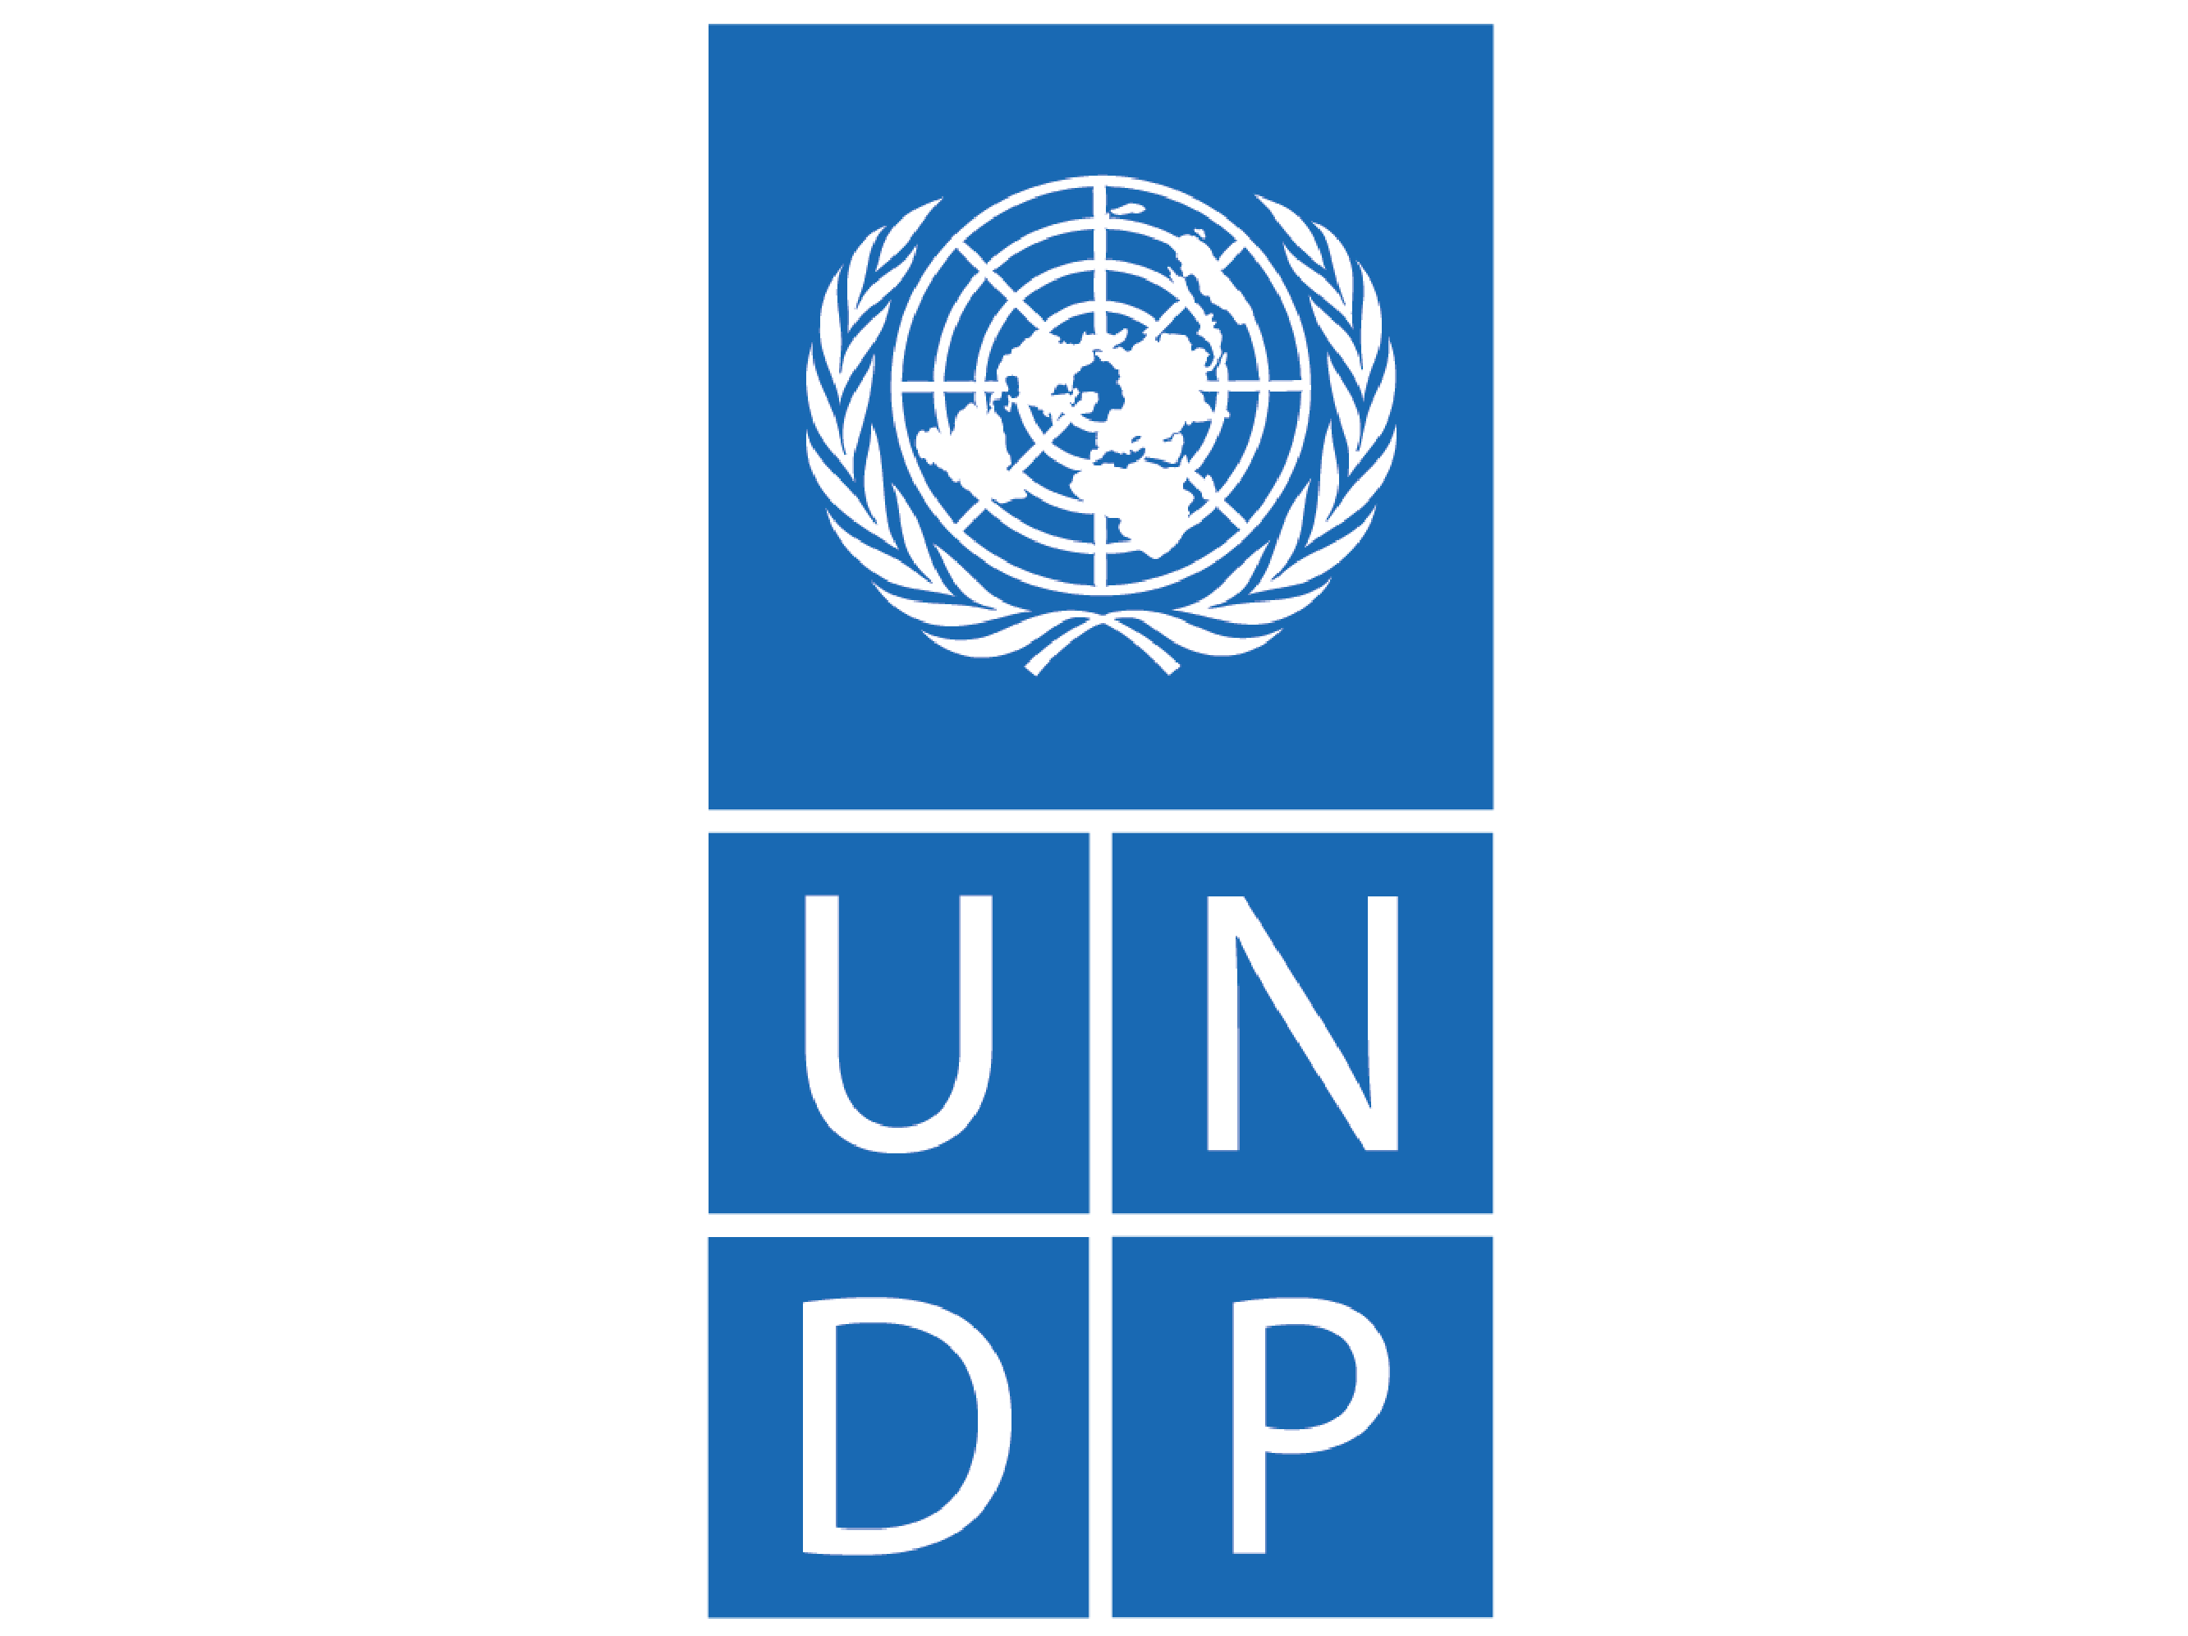 |  | 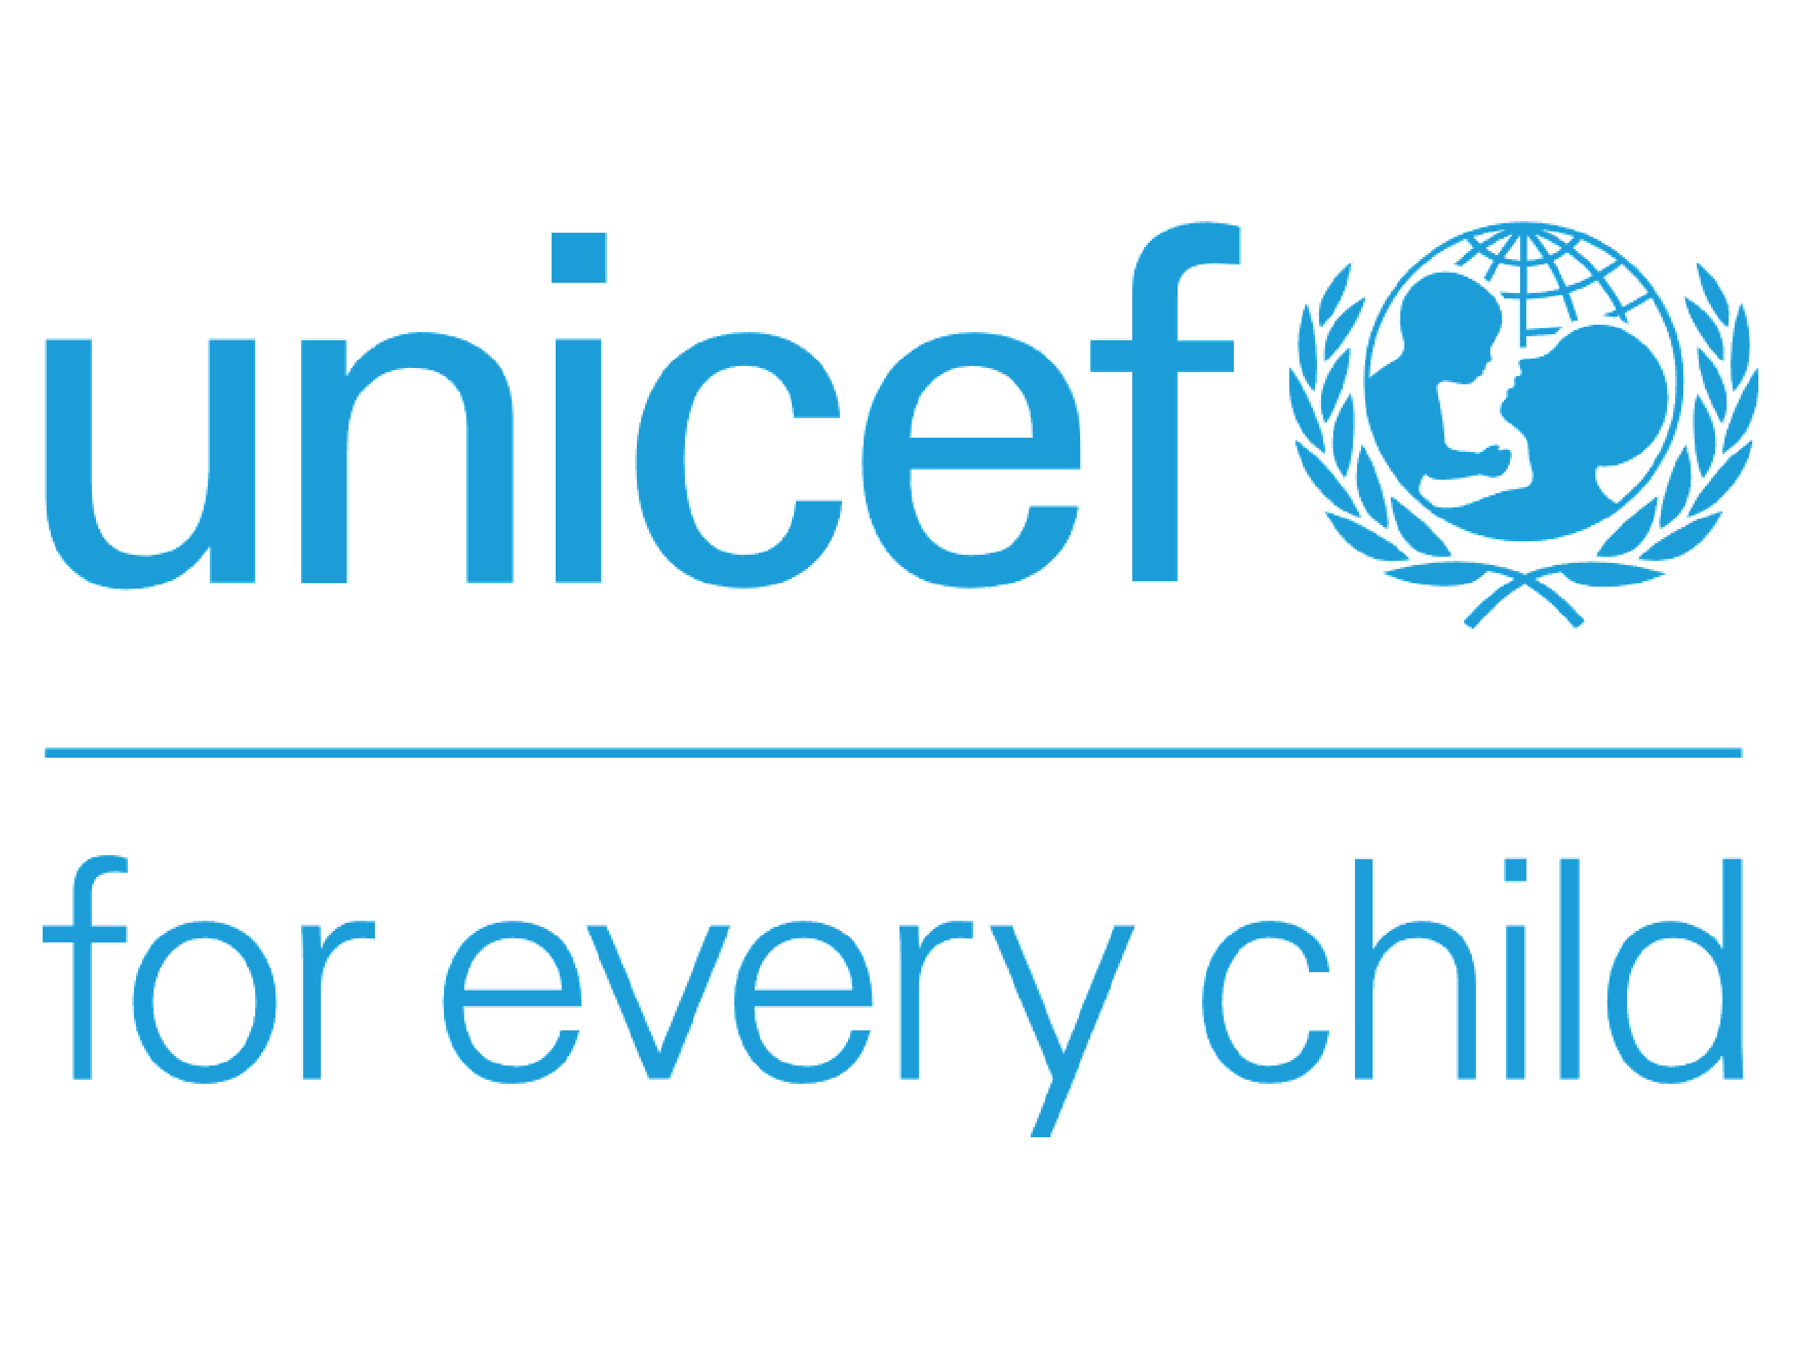

The UNDP expenses mentioned are in line with the Cumulative Project Financial Report for the period ending December 31, 2023. However, a few adjustments are linked to the expenses incurred during FY 2023 and are posted in the following Year. The details are as follows: Breakup of Expense Posted in FY 2024 Nature of Expenses Amount USD] Remarks Exchange Loss recorded (Suppliers Rehmat Karim and United Transport Service) 81.84 The expenses were recorded in December 2023, but the disbursement was made in January 2024, resulting in the exchange loss posted in 2024. Rectification of Over GMS Charges Applied - 2,282.00 Overcharges related to General Management Costs (GMS) were identified, and the necessary corrections were made in 2024. Receipt Accruals Reversal of the supplier United Transport Service - 20.96 The expense initially booked in FY 2023 was reversed in 2024 due to a difference in the accrued liability account balance. Total - 2,221.12

