RAPARIGA BIZ
Action for Girls and Young Women’s
Sexual and Reproductive Health and Rights in Mozambique
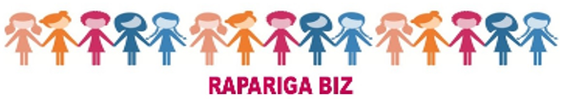

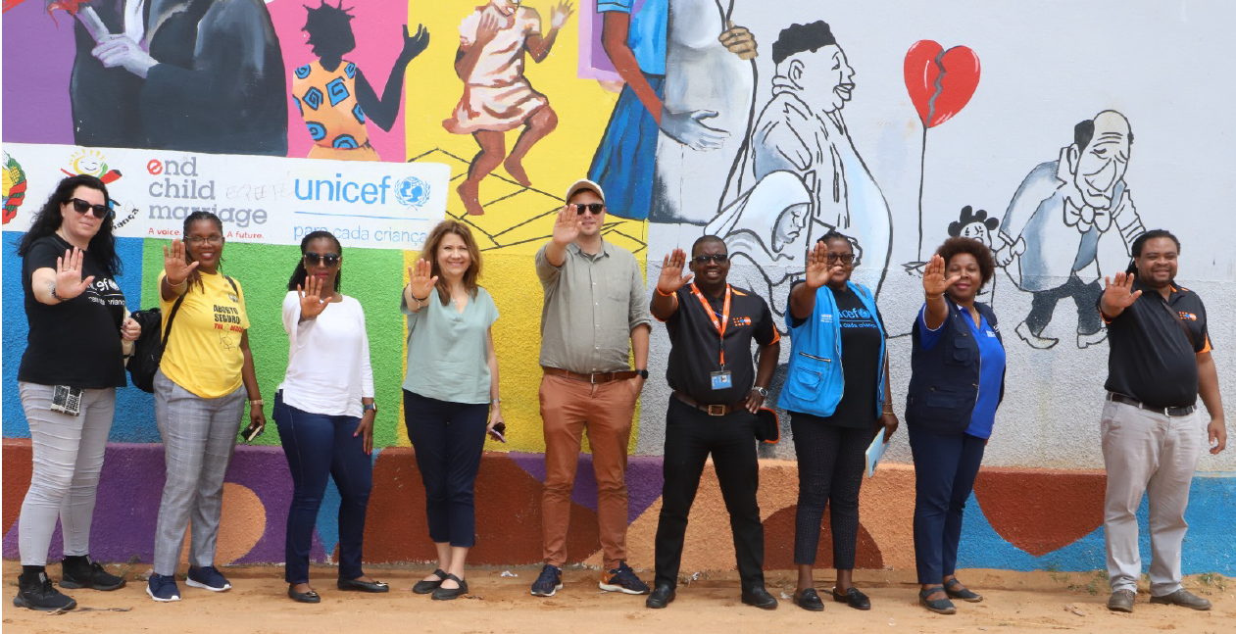

END OF PROJECT REPORT: 2016-2023 - MULTIANNUAL

UN JOINT PROGRAMME
MOZAMBIQUE

PROJECT SUMMARY

Title | Action for Girls and Young Women’s Sexual and Reproductive Health and Rights in Mozambique
ID MPTF Projects | - 00101069  - 00117215  - 00112818
Leading entity | State Secretariat for Youth and Employment (SEJE)
Implementing Agency | - UNFPA  - UNICEF  - UN WOMEN  - UNESCO
Country/Region | - Mozambique/Southern Africa
Duration | - Sweden (2016-2023)  - UK (2018-2019)  - Canada (2019-2023)
Budget | USD 32,051,725
Donors | Sweden, UK and Canada
Reporting Period | May 2016 to September 2023
Contacts | - EJE/INJ  Johane Muabsa - johane.muabsa@inj.gov.mz  - MINEDH  Arlinda Chaquisse - arlinda.chaquisse@mined.gov.mz  - MISAU  Quinhas Fernandes - ferq09@gmail.com  - MGCAS  Angelica Magaia - magaia@mgcas.gov.mz  - MJACR  Dionisio Macule - dionikule@gmail.com  - UNFPA  Assane Macangira - macangira@unfpa.org  - UNICEF  Sabine Michiels - smichiels@unicef.org  - UN WOMEN  Boaventura Veja - boaventura.veja@unwomen.org  - UNESCO  Dulce Domingos Mungoi d.domingos@unesco.org

TABLE OF CONTENTS

ACRONYMS 4
1. EXECUTIVE SUMMARY 6
2. INTRODUCTION 7
3. PROGRAMME GEOGRAPHIC AREA AND BENEFICIARIES REACHED 9
4. PROGRESS REVIEW: OUTCOMES, OUTPUTS AND KEY ACTIVITIES 10
➔ OUTCOME 1: Girls and Young Women’s Knowledge, Agency and Capacities Strengthened to Make Informed Decisions on their SRH, Demand for and Uptake of Essential SRH Services 10
➔ OUTCOME 2: Availability of Quality Integrated ASRH Services for Girls and Young Women Increased 20
➔ OUTCOME 3: An enabling, free and safe environment for increased participation
of girls and young women, and the promotion of their SRHR created 26
➔ OUTCOME 4: Strengthened governance and coordination for integrated SRH programming 31
5. MONITORING AND EVALUATION 42
6. CONCLUSIONS AND RECOMMENDATIONS 43

ACRONYMS

AFR | Adolescent Fertility Rate
AGYW | Adolescent Girls and Young Women
AIDS | Acquired Immunodeficiency Syndrome
APE | Community Health Worker (in its Portuguese acronym)
AT | Antiretroviral Treatment/Therapy
ASRH | Adolescent Sexual and Reproductive Health
CIADAJ | Multisectoral Support Committee for Development of Youth and Adolescents
CNCS | National AIDS Commission
CPR | Contraceptive Prevalence Rate
CSE | Comprehensive Sexuality Education
CSO | Civil Society Organization
DHS | Demographic Health Survey
DPEDH | Provincial Directorate of Education and Human Development
DPGCAS | Provincial Directorate of Gender, Children and Social Action
DPS | Provincial Health Directorate
EMIS | Education Management Information System
e-VAWG | Elimination of Violence against Women and Girls
FP | Family Planning
GBV | Gender-Based Violence
GoM | Government of Mozambique
HIV | Human Immunodeficiency Virus
HRBA | Human Rights-Based Approach
IANYD | Inter-Agency Network on Youth and Development
IFPELAC | Professional Training Institute of Labour Studies Alberto Cassimo
IP | Implementing Partner
MGCAS | Ministry of Gender, Children and Social Action
MICS | Multiple Indicators Cluster Survey
MINJUS | Ministry of Justice, Religious and Constitutional Issues
MINEDH | Ministry of Education and Human Development
MINT | Ministry of Interior
MMR | Maternal Mortality Ratio
MNCAH | Maternal, Newborn, Child, and Adolescent Health
MoH | Ministry of Health
NCDH | National Human Rights Council
PGB | Programme Geração BIZ
PRB | Programme Rapariga BIZ
RH | Reproductive Health
YFS | Youth Friendly Services
SBCC | Social and Behavior Change Communication
SDGs | Sustainable Development Goals
SEJE | Secretariat of State of Youth and Employment
SRHR | Sexual and Reproductive Health and Rights
UPR | Universal Periodic Review
VAWG | Violence Against Women and Girls
VSLA | Village Savings and Loan Association
YFHS | Youth Friendly Health Service

EXECUTIVE SUMMARY

This report presents the end-of-project results achieved throughout phase I (May 2026- September 2023) of the Rapariga BIZ (RB) Programme. The foundation of RB is promoting and protecting the Sexual and Reproductive Health and Rights (SRHR) of adolescent girls and young women (AGYW) aged 10-24 in 20 districts across Nampula and Zambézia provinces. The key relevant programme stakeholders and partners are the Government of Mozambique, civil society partners and UN agencies, including UNFPA (lead agency), UNICEF, UNESCO, and UN Women. The Secretariat of State of Youth and Employment (SEJE) is the lead entity within the Government of Mozambique among four line ministries (Health; Education and Human Development; Justice, Constitutional and Religious Affairs; and Gender, Children and Social Action). The programme received technical and financial assistance from the Embassy of Sweden, the United Kingdom, and the Canada High Commission. Overall, the Programme was implemented for 89 months (7 years and five months, from May 2016 through September 2023). The main achievements registered during the implementation period are the following:

- Cumulatively, the programme reached 1,000,801 AGYW with mentorship (92% of the targeted 1,085,447).
- The programme attained low rates of early pregnancy among girls and young women aged 10-19 who participated in the mentorship sessions. From 2016 through 2023, the average rate of early and unintended pregnancy was 0.6%, while the average rate of child marriage during the same period was 0.9%, compared to the programme target of below 5% for both early pregnancy (with national baseline of 46.4%) and child marriage (with national baseline of 48%).
- SMS BIZ/U-Report reached 831,624 (on the 12th of December 2023) with a ratio of boys to girls of 60% male and 40% female. UNICEF also renewed an additional 2-year contract between Nyaruka and UNICEF Mozambique Country Office, signed in August 2023, to secure the operationalisation of SMS BIZ/U-Report in Mozambique. Several innovative promotional strategies were used to increase user uptake, such as partnering with young artists and digital influencers, using street art to promote SMS Biz in schools and public spaces, and using innovative peer-to-peer invitation systems to increase service uptake.
- TalentBIZ (Fundoo) emerged as a transformative initiative embedded within the U-Report/SMS Biz Platform that has so far equipped around 20,000 young Mozambicans with essential 21st-century skills. The initiative was implemented in collaboration with the Secretary of State for Youth and Employment and aligns with the goals of Mozambique’s youth and employment agenda as the platform fosters entrepreneurship and job opportunities, contributing significantly to the country's socio-economic development. The strategic use of Rapariga BIZ (RB) funds has played a pivotal role in accelerating the impact of TalentBIZ: (i) SMS Biz is a vital component of the TalentBIZ ecosystem, and RB funds were strategically channeled to enhance the reach and accessibility of TalentBIZ, and (ii) RB funds have significantly contributed to the official launch of TalentBIZ in Zambezia and Nampula. These funds allowed the platform to gradually incorporate critical topics, such as mental health support, career guidance, and gender-based violence awareness. This expansion is aligned with the evolving needs of Mozambican youth and ensures the long-term sustainability of the platform's impact.

2. INTRODUCTION
Rapariga BIZ (2016-2023) was designed to improve the sexual and reproductive health and rights (SRHR) of 1,085,447 girls and young women in Mozambique who live in the provinces of Nampula (10 districts) and Zambézia (10 districts), areas with some of the highest poverty levels in Mozambique, where girls and young women are burdened with a high level of discrimination and are at high risk of child marriage, early pregnancy, maternal mortality, obstetric fistula, violence and HIV. The programme combined three core components, which aimed to complement one another to drive improvements in SRHR by:

- Running a series of girl-focused interventions that equip them with the knowledge to make informed choices related to SRHR and additional skills such as vocational training. The approach relies on a mentorship model whereby trained mentors provide a safe space for girls to explore questions related to SRHR.
- Supporting health services, including youth-friendly clinics (YFS/YFSs), mobile clinics, and school health corners dedicated to providing SRHR consultations and sexuality education for school teachers. The programme also worked with the Ministry of Education and Human Development (MINEDH) to develop a comprehensive sexuality education curriculum that will be rolled out to support changing norms and building knowledge around SRHR for adolescents in schools.
- Creating an enabling environment by supporting multi-sectoral approaches and projects such as a sexual health hotline, radio programmes focusing on SRHR topics, community dialogues, working with the Ministry of Justice and police officers around gender-based violence (GBV) and the engagement of young men and boys.
Mozambique ranks among the lowest-performing countries in the world on several indicators of girls and women’s rights and well-being. Girls and young women face a wide range of challenges, including entrenched gender discrimination, harmful practices such as child marriage, widespread gender-based violence (GBV) and high rates of adolescent pregnancy, which affects their possibilities of reaching their full potential. Since 2016, Sweden has been at the forefront of this programme, with the UK and Canada joining in 2018 and 2019, respectively, as partners. The table below presents the funds committed by the development partners and received by participating UN organizations (Table 1).
YEAR | DEVELOPMENT PARTNER |  |  | TOTAL (USD)
 | SWEDEN | CANADA | UK
2016 | 3,588,425.00 | - | - | 3,588,425.00
2017 | 3,428,680.00 | - | - | 3,428,680.00
2018 | 3,260,034.00 | - | 1,164,607.00 | 4,424,641.00
2019 | 2,857,864.00 | 1,881,403.00 | 1,728,993.00 | 6,468,260.00
2020 | 1,726,413.00 | 3,742,266.00 | - | 5,468,679.00
2021 | 1,155,352.00 | 1,965,371.00 | - | 3,120,723.00
2022 | 3,637,783.00 | 1,914,534.00 | - | 5,552,317.00
2023 | - | - | - | -
GRAND TOTAL | 19,654,551.00 | 9,503,574.00 | 2,893,600.00 | 32,051,725.00
Table 1: Cooperation partners’ approved budgets and transfers (2016-2023).
There were four UN agencies (UNFPA, UNICEF, UNESCO and UNWOMEN) that implemented the programme under the leadership of the Government of Mozambique (GoM), represented by the Secretariat of State of Youth and Employment (SEJE) and the Ministries of Health (MoH); Education and Human Development (MINEDH); Gender, Children and Social Affairs (MGCAS); and Justice and Religious and Constitutional Issues (MJCR), and their respective provincial and district branches. The first phase of the programme ran from 2016 through 2019, initially extended until 2021, but was then extended again until March 2023 (Sweden) and September 2023 (Canada).
All funding was channeled to the concerned UN agencies in Mozambique through the United Nations Multi-Partner Trust Fund (UN-MPTF). Three separate Joint Programme funds were set up by the UN-MPTF for the Raparaga Biz effort, one for each of contributors. This set up proved a bit complicated administratively, both for the UN-MPTF and for the 3 UN agencies concerned, as there were separate funds set up for the UK, Canada and Sweden. It would have been more expeditious and administratively simpler having set up a single, pooled fund for all contributors. Having three separate funds increased transaction costs in terms of administration, financial management, monitoring, and reporting. The participating UN agencies had to implement and report on 3 separate projects even though this was a single programme. Effectively, the 3 UN agencies as well as the UN-MPTF will have to follow project closure procedures on 3 separate funds and the contributors will continue to receive separate financial reports on the particular ‘projects’ they funded within this single Joint Programme.
This report presents the progress and results achieved throughout the lifespan of the Programme's first phase. The report includes the following sections: an executive summary, introduction, progress review – outcomes, outputs, and key activities (including four outcomes and the respective 19 outputs). The report highlights the main challenges, lessons learned, and recommendations for each outcome. Finally, the report presents conclusions and key recommendations.
The report also includes analyses and, in some parts, success stories through which some beneficiaries and other stakeholders personally share their positive experiences as a result of the programme. Pictures and other figures (graphs and tables) are included to provide details and evidence of the achievements highlighted.

3. PROGRAMME GEOGRAPHIC AREA AND BENEFICIARIES REACHED

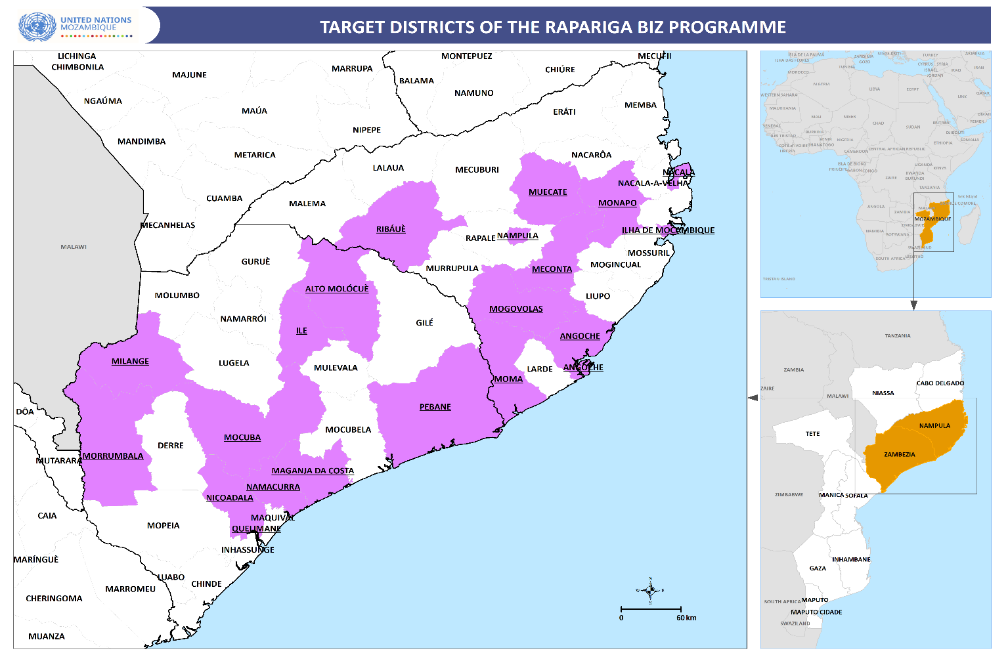 Figure 1: Target districts of the Rapariga BIZ Programme, Nampula and Zambézia

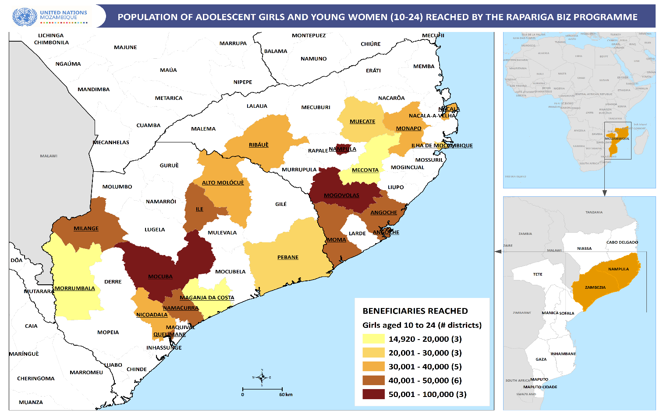
Figure 2: Population of adolescent girls and young women reached by the RB Programme.

4. PROGRESS REVIEW: OUTCOMES, OUTPUTS AND KEY ACTIVITIES

OUTCOME 1: Girls and Young Women’s Knowledge, Agency and Capacities Strengthened to Make Informed Decisions on their SRH, Demand for and Uptake of Essential SRH Services
The Rapariga BIZ’s purpose was to guarantee that the sexual reproductive health and rights of girls and young women between 10-24 years are fully realised through improved capacities to make informed decisions and improved access to SRH services. Therefore, the knowledge and agency of girls and young women to make informed decisions about their SRHR was the cornerstone of the Programme. The table below depicts the main achievements against the programmed output indicators, baseline and targets for outcome 1. The last column shows the status of the achievement of the target, using the following colours/directions: green (achieved 85% or more, including above the target), yellow (on track – 60%-84%), orange (25%-59%, delayed), and red (critical/not achieved – 0%-24%).
OUTCOME 1: girls and young women’s knowledge, agency and capacities strengthened to make informed decisions on their SRH, demand for and uptake of essential SRH services
Output | Indicator | Baseline as 2016 | Target 2023 | Achieved 2023 | Status
Output 1: Increased knowledge, skills and voicing of girls’ right | Prevalence of adolescent –pregnancy (in Rapariga BIZ girls) | 46.4% | 5% | 0.7%
 | % of girls and young women empowered with knowledge, skills and voices for girls´ SRHR (numerator= number of girls who have completed mentorship) | 0.36% | 100% | 92%
 | % of girls and young women integrated into schools and completed school calendar | 0% | 100% | 125%
Output 2: Citizenship of girls and young women | % of updated records in civil registers for all programme girls and young women | 83% | 90% | 53%
Output 3: Increased demand for SRH services | Percentage of women (15-24 years) who visited AYFS and did not use any contraceptive method | 72.9% | 40% | 60.5%
Output 4: Girls and young women are voicing the issues concerning their lives at district, provincial and national level | National and provincial girls’ conferences attended by girls, young women, decision-makers and media | 0 | 3 | 4
 | Child Parliament active on ASRH (National, Provincial and District) | 0 | 4 | 3
 | Provincial and National Forums (including media TV and Radio) are active on issues of ASRH | 0 | 3 | 3

Table 4: Indicators, baseline (2016), target and achievements 2016-2023, outcome 1
- Output 1: Increased knowledge, skills, and voice of girls’ rights
Increasing the knowledge, skills, and voice of girls’ rights was the cornerstone of the Rapariga BIZ programme, achieved through a mentorship approach. This approach aimed at providing the most vulnerable girls and young women between 10-24 years of age with skills, empowerment, social networks, leadership, decision-making skills, economic empowerment, and knowledge and access to information on sexual and reproductive health and rights. The mentorship sessions were led by young female mentors trained by the programme and took place in safe spaces at the community level, identified by the girls and young women.
By the end of 2022, there were 3,280 active mentors, 1,377 (42%) from Nampula and 1,903 (58%) from Zambézia. In total, during phase I of the Programme, 1,000,801 adolescent girls and young women were reached cumulatively, through the mentorship programme. This number represents 92% of the programme target of 1,085,477. The table and figure below show the evolution of girls from the start of the programme in 2016 up to 2023 per cycle.
Cycle number | Province |  | Total | Cumulative evolution
 | Nampula | Zambézia
1 | 18,618 | 4,900 | 23,518 | 23,518
2 | 15,120 | 3,080 | 18,200 | 41,718
3 | 30,167 | 26,198 | 56,365 | 98,083
4 | 37,010 | 30,603 | 67,613 | 165,696
5 | 37,007 | 30,647 | 67,654 | 233,350
6 | 57,309 | 39,586 | 96,895 | 330,245
7 | 58,927 | 51,170 | 110,097 | 440,342
8 | 53,760 | 51,240 | 105,000 | 545,342
9 | 70,980 | 82,684 | 153,664 | 699,006
10 | 41,793 | 49,872 | 91,665 | 790,671
11 | 50,946 | 59,051 | 109,997 | 900,668
12 | 33,259 | 36,383 | 69,642 | 970,310
13 | 13,836 | 16,655 | 30,491 | 1,000,801

Table 5: Number of AGYW reached per province and mentorship cycle.

Graph 3: Evolution of the cumulative number of AGYW reached per cycle (2016-2023)

- Contribution to ending child marriage
Child marriage continues to be a concern in Mozambique. The country has one of the highest rates of child marriage in the region and globally. According to the InVIC 2019 study, the child marriage rate among adolescent girls and young women is 41%. According to the Demographic Health Survey (DHS) in 2011, the child marriage rate in Mozambique is 48% [whereas 62% is in Nampula and 47% in Zambezia]. Therefore, when the Programme was designed, the child marriage target was equal to or below 5%. Data collected in Rapariga BIZ Programme sites on the child marriage rates throughout the lifespan of the Programme are shown in the graph below, with an average of 0.9%:

Graph 4: Child marriage rates per year in RB benefiting from mentorship (2016-2023).
A human interest story with mentees was published on the UNFPA Mozambique website on the International Day of the Girl Child: “Mother, I cannot marry this man. I am too young. I want to continue my studies.” A link to the article is here in both English and Portuguese.
- Contribution to ending early pregnancy
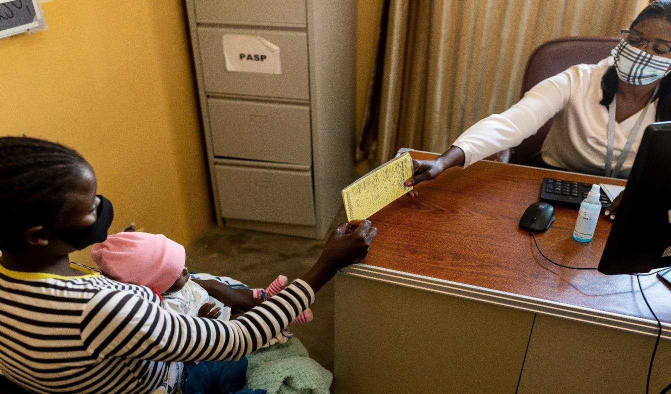
Figure 4: An adolescent girl at a post-natal care unit in Zambezia.
Mozambique has one of the highest early and unplanned pregnancy rates in the region at 46.4%, and the targeted provinces of Nampula (60%) and Zambézia (46.4%) (IMASIDA, 2015) are some of the highest rates in the country. In the context of Rapariga BIZ, data indicates that the rates of early and unplanned pregnancies among the participants in the safe space mentorship programme are significantly lower compared to provincial and national rates. Data collected in Rapariga BIZ Programme sites on the early and unintended pregnancy rates throughout the lifespan of the Programme are shown in the graph below, with an average of 0.6%:

Graph 5: Early pregnancy rates in RB mentorship sites throughout Phase I
Another important target of the Programme was the school reintegration of adolescent girls and young women. In this regard, during phase I of the Programme, the percentage of AGYW reintegrated ranged from 0% in the baseline of 2016 to 125% in 2023. The annual rates of school reintegration from 2016 through 2023 are as follows:

Year | 2016 | 2017 | 2018 | 2019 | 2020 | 2021 | 2022 | 2023
Rate | N/A | 47.7% | 38% | 19% | 67% | 73% | 105% | 125%

Table 6: Annual rates of school reintegration (2016-2023)

Importantly, 2019 was the year with the lowest rate of school reintegration. More research needs to be carried out to determine what is behind this lower rate in 2019. While COVID-19 emerged that year, the effects of the pandemic were only felt starting in 2020.
Furthermore, from the beginning of the Programme until 2022, the SMS BIZ had 472,809 users, 51% male and 49% female, with an average response rate of 62.5%. A new MoU agreement was signed in April 2022 with three main Telecom Companies with two years automatically renewable. The MoU provides unlimited free bulk SMS to adolescents and young people, providing a safe platform where they can ask questions and express their concerns whilst simultaneously serving as an advocacy tool towards the Government, as decision-makers, to be held accountable for finding solutions for issues raised by young people. The picture below shows boys and girls in the SMS BIZ Hub in Nampula.
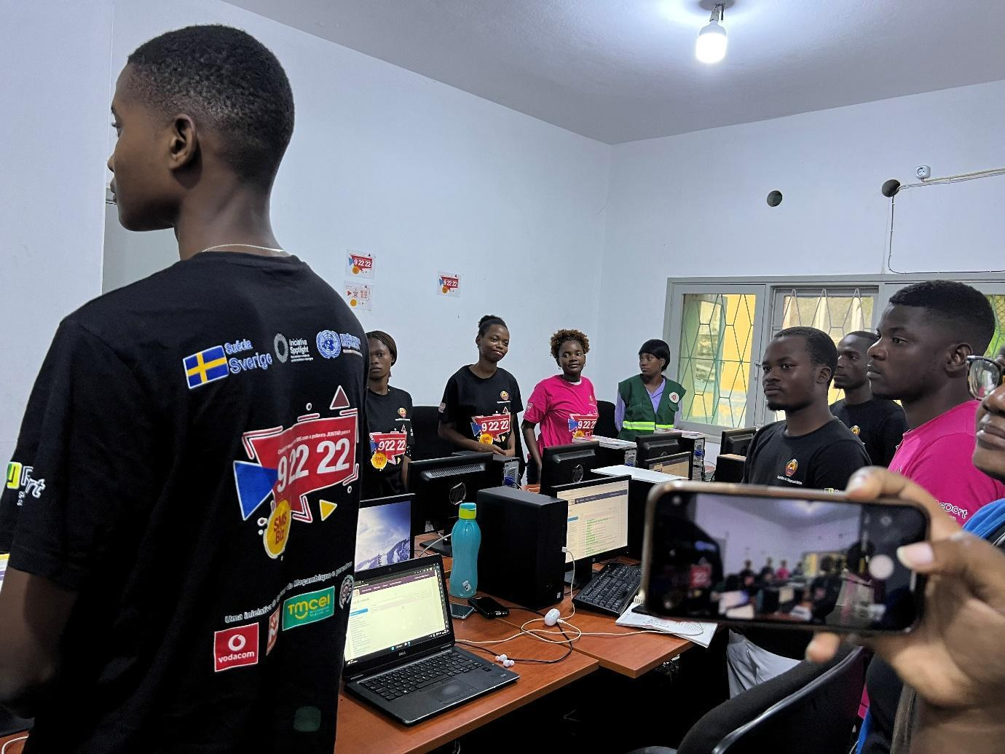
Figure 5: SMS BIZ counsellors in the Nampula SMS BIZ Hub

- Output 2: Citizenship of girls and young women
Like in previous years, the programme supported adolescent girls and young women in obtaining civil registration by acquiring personal IDs and birth certificates. This is a very important service as individuals need an ID or birth certificate to access basic services, including education, justice, social, and health services. Therefore, providing civil registration improves the social inclusion and citizenship of the programme's beneficiaries. This is the rationale behind supporting civil registration of girls in the safe spaces to ensure they receive identification cards and, in some cases, also the so-called “poverty certificates”. The graph below presents civil registration data from 2016-2023.

Graph 6: % of AGYW who benefitted from civil registration 2016-2023

Since 2017, Ouro Negro was part of the Rapariga BIZ Programme through a multi-media strategy that, in 2022, included radio dramas, live talk shows, adolescent-led radio programs, radiophonic theatre in local languages, radio spots and social media platforms. According to the Geopoll data collected in mid-2021, the total number of radio listeners in Mozambique who are aware of any of the Ouro Negro dramas shows or programmes is 5,8 million people. Out of these, 1,7 million listened to any of the Ouro Negro dramas, shows or programmes in the last 30 days. Ouro Negro radio dramas (Jambolane and InTxunáveis) were broadcasted on 115 radio stations nationwide, encompassing 13 Radio Mozambique (RM) stations, 65 ICS stations, and 37 independent and community radio stations. All the episodes can be found here. In addition, a total of 1,380 Ouro Negro ao Vivo programs were produced and broadcast. All sessions are available here.
With complementary funding from the Global Programme to End Child Marriage, Ouro Negro da Malta was developed as an adolescent-led radio program that aims to increase the discussion and understanding among teenagers and young people of the themes addressed in the radio drama Ouro Negro. Since 2021, adolescents have produced the program for their peers in Portuguese on six radio stations, 3 in Nampula and 3 in Zambézia. While the radio drama is fiction, this talk show brings the reality of listeners and adolescents into the broadcasting studio. In the program, adolescents talk about what they know, what they think, and how they live their lives and make decisions about the various issues addressed in the stories of the radio dramas. With the support from Coalizão and Parlamento Infantil in Nampula (Angoche, Namialo and Nacala-Porto) and Zambézia (Pebane, Milange and Mocuba), 23 mentors and girls and boys (aged 10-19) were identified and trained as producers of the adolescent-led radio programs. From July to November 2022, ON da Malta produced 91 programs in Zambezia and Nampula, all of which were uploaded to the ON SoundCloud platform and promoted through the Facebook page of each radio. Most listeners who provided feedback praised community radios for the new educational program and highlighted the importance of the messages and discussions.

- Output 3: Increased demand for SRH services
During the reporting period, the program increased the demand for access and use of information and integrated services on SRH, GBV, STI and HIV through health professionals and sensitization of Activists and Mentors. During this period, the percentage of girls and young women who visited an adolescent and youth health-friendly service who did not use any contraceptive method reduced from 72.9% in the baseline registered in 2016 to 60.5% in 2023. Furthermore, the proportion of adolescent girls and young women in the RB safe spaces who are using modern contraceptives increased from 26.3% in 2016 to 57% in 2023, an increase of 117%.

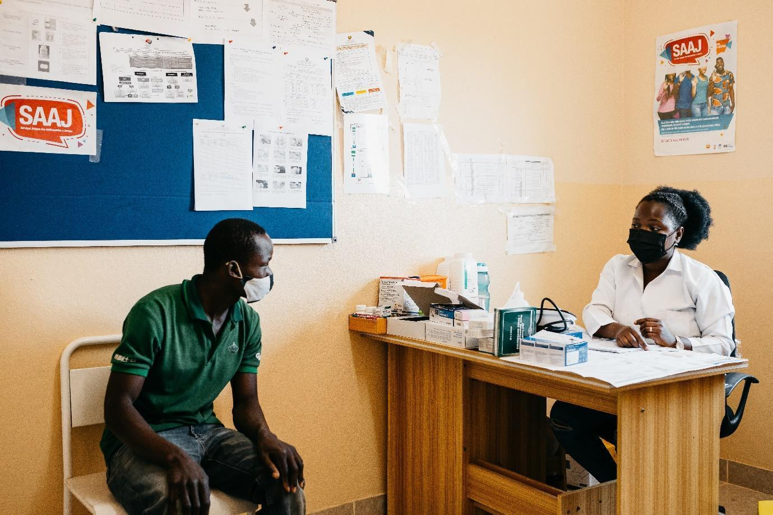
Figure 6: A young man receiving ASRH service in a SAAJ (Youth Health Friendly Service)

- Output 4: Girls and young women are voicing the issues concerning their lives at district, provincial and national level
During Phase I, the programme promoted girls' and young women’s participation in decision-making by voicing their concerns about their lives at district, provincial, and national levels. In this regard, 41 meetings and conferences were held with support from the Programme at the national, provincial and district levels. The evolution of the events during the years of the phase I is as follows:

Graph 7: Number of events supported by the RBP, 2016-2023

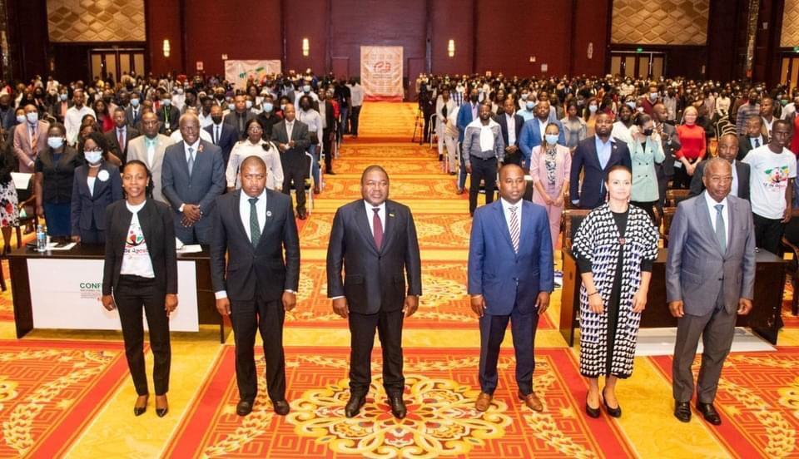
Figure 7: Family photo taken during the 2022 National Youth Conference at Joaquim Chissano Conference Centre in Maputo

- Summary: Challenges, Lessons Learned and Recommendations
The main challenges, lessons learned and recommendations in the 2016-23 period are as follows:
- Challenges

Output 1 - Mentorship
- During the period between 2020 and 2022, COVID-19 affected in-person events, including mentorship sessions, as gatherings were not allowed.
- The monthly subsidy was low compared to other programmes in the same operational geographical areas, leading to the high turnover of mentors.
- Difficulties in reaching hard-to-reach areas, vulnerable adolescent girls and young women, as the main intervention remained in the district headquarters.
- Limited integration of girls and boys with disabilities. The mentorship guide lacks a clear orientation on integrating disability and albinism in the Programme Interventions.
- The duration of the mentorship training was reduced to 6 days. The Ministry of Health advised increasing the number of training days from 6 to 10, minimum. Additionally, it was recommended to improve the content, through inclusion of emerging issues such as humanitarian action, mental health and psychosocial support, menstrual health management, climate change and others.

Output 2 - Citizenship
- Some AGYW living in hard-to-reach areas did not benefit from the Programme’s civil registration intervention.

Output 3 - Demand creation
- The mentors did not use the Ministry of Health’s official referral and counter-referral guides from communities to health facilities and vice versa. This challenge remained throughout Phase I.
- While mentors created demand at school and community levels, the supply/offer side faced challenges in providing quality ASRH. On the one hand, the number of specific SAAJ is limited and primarily located in the district headquarters. On the other hand, the high turnover of health professionals makes it difficult to maintain qualified ASRH staff in the health unit.

Output 4 - Voice
- While the voice of youth was raised on issues concerning them, including child marriage, gender-based violence, access to services and others, mechanisms to hold the duty bearers accountable for those concerns were limited. Rapariga BIZ needed to support the establishment of monitoring mechanisms for issues raised at different youth gatherings and events in Phase II.

- Lessons Learned
- The allocation of implementing partners in specific provinces allowed for positive competition and the achievement of results. Thus, in phase II of the programme, implementing partners will be allocated particular provinces to implement their respective approaches. Additionally, this would allow for comparing results between implementing partners working with the same approach or thematic area.
- Motivational packages for mentors should not be limited to monetary compensation. The Programme should include scholarships, support in finding job opportunities for outstanding girls, economic empowerment activities, etc.

- Recommendations
Output 1: Mentorship
- Propose an increase in the monthly subsidy for the mentors.
- Ensure mentors benefit from the women's economic empowerment initiatives and other compensatory means under the Programme.
- Improve coordination with like-minded programmes to avoid high turnover from Rapariga BIZ and other programmes.
- Allocate implementing partners for specific provinces of the Programme.
- Improve the number of days for training mentors from six (6) to ten (10), minimum.
- Continue to dialogue with the government to ensure that there are harmonized subsidies for community, health, and school activists, as agreed in previous meetings.
Output 2 - Citizenship

- Expand the civil registration activities to the hard-to-reach locations. Alternatively, health mobile brigades can be used to integrate civil registration services.
Output 3 - Demand creation
- Continue to work with the health authorities to improve the offer of AYFS for adolescents and girls. The PGB multisector would be a good window for this dialogue.

Output 4 - Voice
- A monitoring tool and a database of the youth's key messages to relevant duty-bearers are needed for regular follow-up and implementation. The layering system used by other stakeholders working on ASRH and HIV is to be considered for Phase II.

OUTCOME 2: Availability of Quality Integrated ASRH Services for Girls and Young Women Increased
Adolescent and youth agency and demand creation inspired by Outcome 1 were influencing the uptake of SRH services and the increased need for integrated, good-quality ASRH services for adolescents, girls, and young women at schools, health facilities, and the community level in the target districts. The objective of Outcome 2 was to make integrated ASRH quality services available for girls and young women.
OUTCOME 2: Availability of quality integrated ASRH services for girls and young women increased
Output | Indicator | Baseline as of 2016 | Target 2023 | Achieved 2023 | Status
Output 5. Teachers implement the comprehensive sexuality and sexual health rights education package | % of schools in areas of intervention where the SE package was fully implemented (programme areas) | 0% | 100% | 89%
Output 6. Mobile health clinics and Community Health Workers (CHWs) in 20 priority districts deliver integrated SRH services at the community level | % of outreach ASRH services in communities | 30% | 80% | 45%
Output 7. Integrated ASRH services by health providers are available in school health corners | % of outreach ASRH services in school health corners | 25% | 50% | 60%
Output 8. Coordinated services for GBV survivors | Percentage of Programme Districts where multi-sectoral teams implement coordinated actions | 0% | 100% | 100%
Output 9. Access to microfinance, vocational training and SME development for girls and young women | # Young women economically empowered (with income generation) | 0 | 10,000 | 34,183

Table 7: Indicators, baseline (2016), target and achievements 2016-2023, outcome 2
- Output 5: Teachers implement the comprehensive sexuality and sexual health rights education package
When the Programme started in 2016, it was planned that by the end of Phase I, all schools (100%) supported by the Programme should have their teachers implement a comprehensive sexuality and sexual health rights education package. Thus, after seven years of implementation, the programme-supported schools evolved from 0%, the baseline in 2016, to 89% in 2023.
The programme also supported the review of the school curricula, including CSE topics in class. This was done in partnership with the Ministry of Education and Human Development and the National Institute for Education Development (INDE).
Furthermore, Mozambique is one of the first ten countries out of the 23 East and Southern Africa Region countries that signed the ESA Commitment (2021-2030), mainly thanks to the programme's support. Therefore, over the last two years, the Programme supported the development of the ESA Commitment Roadmap and Action Plan.
Additionally, the manual for crosscutting curricular approach issues, Comprehensive Sexuality Education (CSE) and Education for Sustainable Development (ESD) in primary school was tested in the three regions of the country (South, Centre, and North). The manual will serve as a guide for teachers to teach crosscutting issues, including CSE and ESD.
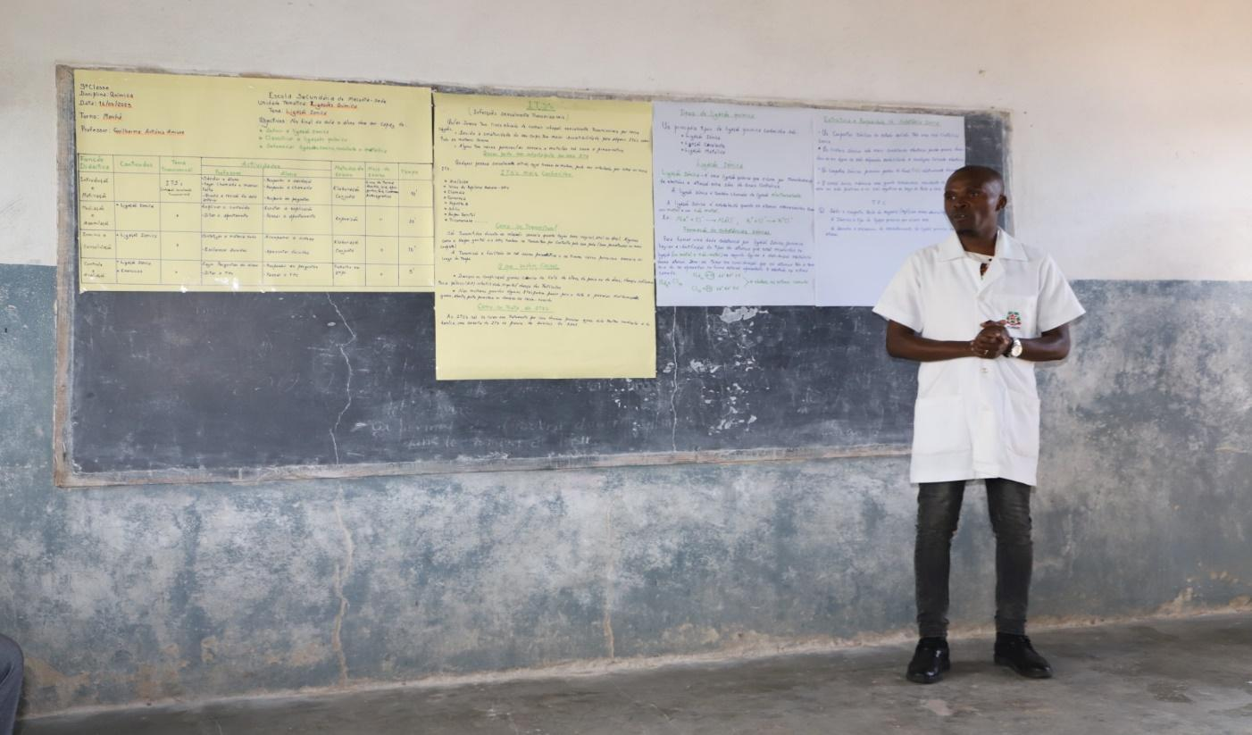
Figure 8: A teacher at Muecate Secondary School (Nampula) teaching the CSE component in the classroom.

- Output 6: Mobile health clinics and Community Health Workers (CHWs) deliver integrated SRH services at the community level in priority districts

Mobile brigades were deployed in Nampula and Zambezia to promote access to sexual and reproductive services by adolescents and youth, including in hard-to-reach and remote areas. At the start of the programme, 30% of the target communities benefitted from mobile brigades, which served as the baseline. It was expected that 80% would benefit by the end of the programme in phase I. However, only about half (45%) of those were achieved.

- Output 7: Integrated ASRH services by health providers are available in school health corners
The programme advocates for and supports the government in ensuring that all secondary schools in districts targeted have at least one school-based health corner providing ASRH services to AGYW. In this indicator, the baseline showed that 25% of outreach ASRH services were available in school corners in 2016. With a target of 50%, and after seven years of implementation, this figure increased from 25% to 60% of the cumulative performance by 2023.
- Output 8: Coordinated services to GBV survivors
When the programme started, coordinated services to support GBV survivors were needed. Therefore, it was planned that by the end of the Programme, all Rapariga BIZ districts would have these services. After more than seven years of implementation, the programme supported the establishment of GBV response services in 100% of Rapariga BIZ districts.
- Output 9: Access to microfinance, vocational training, and small and medium-sized enterprises (SME) development for girls and young women

Voices of Beneficiaries

- Vanessa Armindo Sousa
(...) I recommend that the girls do not lose faith, continue to trust in God and do not get involved in prostitution, and I hope that one day, the same luck I had may knock on your doors before you engage in early and forced marriages... Another thing I would like to suggest to girls in their business is to invest in different businesses, not just one type of business. I humbly want to say thanks very much to UN Women, the Government of Sweden and Canada for the opportunity to change and improve my life in a very positive way; I can say confidently that I’m empowered to make my decisions and plan for my future and of my sons as well as be a contributing member of my community improvement”, Vanessa Armindo Sousa

Vanessa Armindo Sousa, a female, 24 years old, lives in Sangariveira, Quelimane district with her mother who has a chronic illness, her unemployed older brother and her ten-year-old and two-year-old sons. Vanessa has been fatherless since the age of 10, and her mother has been unable to work due to illness since the death of her father; they relied on the support from social protection support from the government and people of good faith (neighbors) who have been providing for them.

- Carla Sebastiana
At a very basic level, we must know how to handle ourselves, pursue income opportunities, pay for our expenses, and plan for the future. Financial education will help us manage our day-to-day expenses now and in the future. Good money management can minimize some of the risks we face and build financial support for the future. These are skills that we adolescent girls and young women need now and will need every day of our adult lives. Investing in financial literacy for adolescent girls sets the stage for the many coming changes. It will increase our ability to manage money, confidence, and readiness for the future. Financial knowledge can open new opportunities to work, build assets, and save. Access to and control over savings can help to protect us against, mitigate, and cope with many risks associated with adolescence and youth by providing resources to draw upon in times of need”, Carla Sebastiana.

Carla Sebastiana, a girl from Maganja da Costa, provided this testimony after attending four financial literacy sessions.

Summary: Challenges, Lessons Learned and Recommendations
The main challenges, lessons learned, and recommendations for Outcome 2 are as follows:
- Challenges

Output 5 - CSE implementation
- Implementing CSE interventions at the school level remains a challenge, as they are not part of the teachers' normal appraisal system.

Output 6 - Community health service outreach for ASRH
- Outreach work and mobile brigades were reduced during the reporting period.
Output 7 - School health corners
- School health corners continue to be available only in some schools, and even in those schools that have school health corners, the services provided there are limited.

Output 8 - Coordinated GBV services
- There is a limited number of Integrated Care Centres (CAIs), YFS (SAAJ) and Gabinete de Atendimento à Família e Menores Vítimas de Violência (GAFMVV) in both provinces to provide integrated services to GBV survivors, which affects the effectiveness of the GBV response.
- The collection of quality GBV data continues to be limited for all the services/sectors assisting victims of violence. In Nampula, a pilot of the Info Violência database system started the registration, management, and coordination of GBV cases, with support from the Spotlight Initiative. However, more effort is needed to consolidate local ownership and ensure that the necessary investments are made in the future to ensure the sustainability of the operation and management of the software after the Spotlight Initiative ends.

Output 9 - Youth economic empowerment activities
- There has been a great demand for different economic interventions; therefore, given the limited budget, many girls could not be reached as these interventions are quite cost-intensive and require a lot of time and money.
- Adolescent girls and young women remain disadvantaged by the lack of access to finance, whether to start or grow their businesses. Credit institutions see technical vocational education training (TVET) trainees as financial risks.

- Lessons learned

- Village Savings and Loan Associations (VSLAs) proved to be the best way to begin accessing financial services and building financial literacy. Offering financial literacy sessions combined with the savings meeting ensured that girls had immediate access to a loan and could save in a simple, friendly, and supportive platform.
- The VSLA methodology allows the poorest girl to save, making it a powerful tool for financial inclusion and women's economic empowerment. It is also a vector for social cohesion, leadership, and strengthening the girls' community network.
- Not all AGYW are ready to participate in Savings groups. Due to their level of poverty, some need different economic empowerment activities, such as cash transfers.
- The allocation of business start-up kits must be followed by vocational training combined with business management training and follow-up with business coaching.
- Private sector engagement will also be very important to the project beneficiaries and the ongoing sustainability of what adolescent girls have learnt during technical vocational education training. Working through key private sector entities (such as the Electricity of Mozambique - EDM) allowed adolescent girls and young women to gain experience through internships, allowing them to understand and interact with the employer environment and supporting their transition to the labour market.
- Increasing knowledge and improving attitudes and skills through CSE will only deliver on health and wellbeing indicators, which are closely linked to ASRHR. The lack of a cohesive strategy to unite these programmes through referral, inter-programme strategies, and support (between teachers and providers) limits the effectiveness of education and health activities. The uptake of services, which remains low, can be improved by referral through education-based school programmes.
- Recommendations

Output 5 - Implementation of CSE
- Continue to advocate in order to ensure that CSE is part of the appraisals of the teachers and other school staff.
Output 6 - Community health service outreach for ASRH
- Increase community outreach and mobile brigades to hard-to-reach potential beneficiaries and their communities.
Output 7 - School health corners
- Train staff of school health corners to provide timely and quality services to AGYW and ABYM at the school level and on transfer to services when needed.
Output 8 - Coordinated GBV services
- Support the expansion of GBV services (including CAI, YFS and GAFMVV) and “Ficha Única” to provide integrated services for GBV survivors.
- Support the expansion of Info Violência to ensure the high-quality collection and analysis of GBV data. Provide capacity building for all programmes working on GBV to ensure that common messaging, data collection, and intervention strategies are complementary.
Output 9 - Youth economic empowerment
- Continue training sessions on financial literacy, VSLA methodology, and vocational training to incorporate additional training on productive skills, entrepreneurship, and leadership in future activities.
- Continue strengthening the engagement of local companies to improve skills transfer through internships for adolescent girls and young women.
- Ensure effective career guidance and counselling are provided to adolescent girls and young women so that they can implement their income-generation activities and self-sustainability initiatives.
- Ensure that technical vocational education training (TVET), economic empowerment initiatives, and coaching systems are accessible and sufficiently good to cover more beneficiaries and prepare adolescent girls and young women to acquire the knowledge and skills required in the world of work.
- Strengthening the economic empowerment initiatives for adolescent girls and young women through tailored approaches. Since adolescent girls and young women tend to have different needs, attitudes, barriers, and preferences than men, failure to tailor approaches can perpetuate inequalities and may put at risk intended development results. Take adolescent girls and young women’s access to finance, for instance. Many adolescent girls and young women lack a formal credit history and collateral, which prevents them from accessing credit.

OUTCOME 3: An enabling, free and safe environment for increased participation of girls and young women and the promotion of their SRHR created
Families, community members and leaders, religious leaders, parents, midwives, boys and men have played a critical role in promoting an enabling, free and safe environment for increased participation of girls and young women and ensuring they enjoy their sexual and reproductive health and rights. Therefore, the involvement of these actors in the programme has shown to be key to addressing the barriers and behavioural gaps in the environment surrounding girls and young women in the community related to SRHR. In working with local leaders and other influential players, the emphasis was placed on the communities’ role in keeping adolescent girls and young women in school. For the girls and young women out of school, the main focus was on their reintegration into school. Local actors were also useful in supporting the RB mentors in identifying safe spaces, resolving intergenerational issues at the family level and supporting high attendance of the AGYW in mentorship sessions, as well as contributing to preventing and renouncing child marriage cases in their communities. Thus, to ensure the creation of an enabling environment for the fulfilment of SRHR by the AGYW, Outcome 3 had the following outputs:
OUTCOME 3: An enabling, free and safe environment for increased participation of girls and young women and the promotion of their SRH rights created
Output | Indicator | Baseline 2016 | Target 2023 | Achieved 2023 | Status
Output 10 - Enhanced involvement of men and boys to strengthen their SRHR | % Boys and men participating in the implementation of SRHR | 20% | 100% | 105%
Output 11 - Religious leaders and youth groups mobilised and active in promoting adolescent SRHR | % Religious leaders actively involved in the implementation of SRHR. | 0% | 50% | 68%
Output 12 - Communities participating in community dialogues on SRHR related to girls and young women | % of community dialogues held on SRHR | 0% | 100% | 100%
Output 13 - Strengthened awareness of girls and young women on SRHR, including HIV/AIDS and GBV prevention | % New acceptors of family planning | 24.4% | 30% | 39.5%
 | HIV/AIDS incidence among girls aged 15-24 years | 2.55% | 7.1% | 10.4%
Table 8: Indicators, baseline (2016), target and achievements 2016-2023, Outcome 3.

- Output 10: Enhanced involvement of men and boys to strengthen their SRHR
The boys’ mentorship, which was launched in late 2021 in six districts (three in Nampula and three in Zambezia), expanded in 2022-23 to 6 new districts, reaching 21,731 adolescent boys and young men (ABYM), out of which 31% (6,749) in the age group of 10-14 years, 46% (9,894) in the age group of 15-19 years, and 23% (5,088) of the age group of 20-24 years.
Through the peer-to-peer male mentorship programme, boys and young men received training and knowledge regarding SRHR, including the use of family planning and prevention and response to STIs and HIV, gender equality, positive masculinities and the prevention and response to GBV. The mentorship programme was appreciated by the boys and young men partaking in the sessions as it provided a safe space to discuss and explore areas that might otherwise be taboo or hard to find accurate information. It also contributed to an environment that enables AGYW to access its SRHR.
A human interest story with programme beneficiaries regarding the boys and young men mentorship “Engaging boys to promote and protect girls’ rights in Nampula” published on the UNFPA Mozambique website in conjunction with the 16 Days of Activism against GBV Campaign. The link to the article in English is here and in Portuguese here.

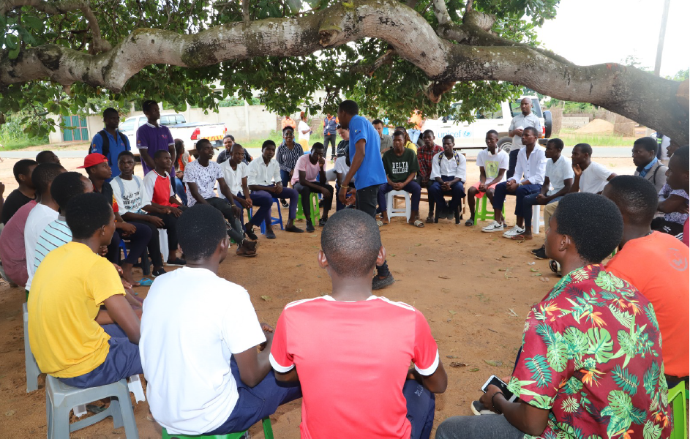
Figure 9: Boys’ mentorship session in the presence of development partners, Muecate, Nampula

- Output 11: Religious leaders and youth groups mobilised and active in promoting adolescent SRH and rights
When the Programme started in 2016, it was planned that at least 400 religious leaders and youth groups would be trained to promote ASRH. Of the 400 trained, at least 50% would promote the ASRH in their communities. Therefore, by the end of the Programme, reports show that 68% of the trained religious leaders promoted ASRH. The training of religious leaders led to the reduction of both early and unintended pregnancies and child marriage, as shown in the previous chapters. The main topics dealt with during the training of religious leaders included but were not limited to, child marriage, disclosure of law 19/2019, gender, teenage pregnancy and sexual and reproductive rights, and contraception and family planning. COVID-19 prevention methods were also discussed.

- Output 12: Communities participating in community dialogues on SRHR related to girls and young women
During the period under review, the community dialogue interventions reached a total of 209 communities (150 in Nampula and 59 in Zambezia). Thus, from a baseline of 0% of communities participating in community dialogues on ASRH, the figure increased to 100%, meaning that all targeted communities included ASRH in their respective community dialogues. These dialogues also played a role in ensuring that this theme influences the GBV gatekeepers in the communities. A community dialogue comprised stakeholders from different sectors (health, education, gender, community leaders and member and service providers). The figure below shows a community dialogue session in Ilha de Moçambique, Nampula Province.
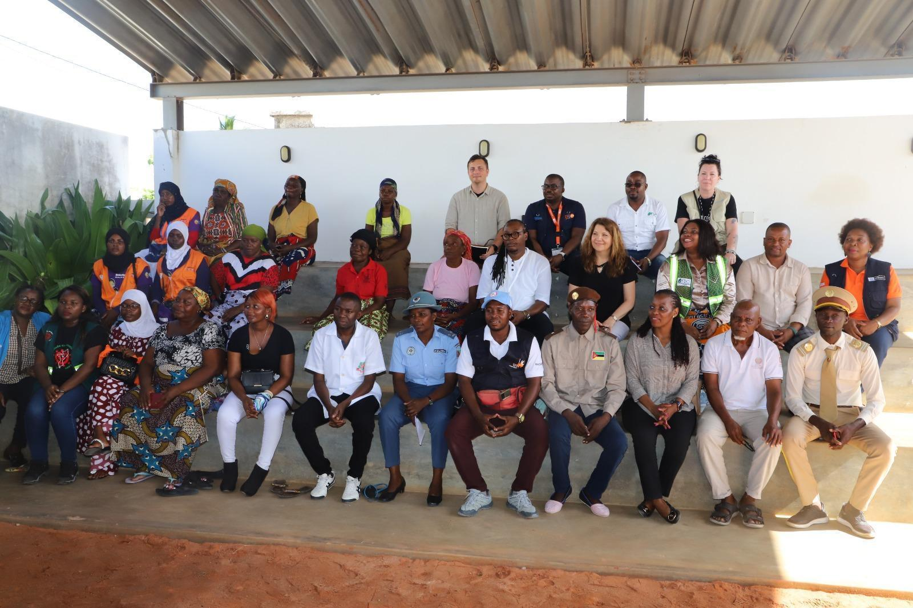
Figure 10: A community dialogue session in Ilha de Moçambique, Nampula, March 2023

- Output 13: Strengthened awareness of girls and young women on SRHR, including HIV/AIDS and GBV prevention
An integrated behaviour change communication multimedia package conceived through a participatory approach with girls and young women was developed and rolled out on SRHR, HIV prevention, GBV, and girls and women's empowerment.
The programme planned, implemented and monitored tailored social and behavior change campaigns reaching 500,000 adolescents and youth to prevent infection and transmission and mitigate the secondary impact of COVID-19 on adolescents and youth, especially the most vulnerable (AGYW, adolescents with disabilities, adolescents living in hard-to-reach areas).
As part of a newly launched Art for Social Change Initiative, a participatory production workshop was held with 17 young local artists in Quelimane, Zambezia, in July 2022. The artists were selected based on their ability to influence positive attitudes and behavior change by tapping into their talents, social activism and knowledge of adolescents and young people in Zambezia. As a result, three products were created, including one play on intergenerational violence, one song on sexual exploitation of minors and one poem on drug and alcohol consumption. All creative materials have been recorded in the studio and packaged into a short video or film. These materials were disseminated through social media, TV, and radio and through community projections conducted by ICS Multimedia Mobile Units to ensure a broad reach. For example, in Nampula province, with funding from the Navarra Government, the young artists produced “Quero Voar”, “I want to fly”, a powerful and highly emotional song on child marriage which was subsequently launched through UNICEF media partners and social media pages on October 11th, 2023 Int. Day of the Girl Child has reached over 5 million people. The song produced is available here: Quero Voar (I Want to Fly).

Summary: Challenges, Lessons Learned and Recommendations
The main challenges, lessons learned, and recommendations related to Outcome 3 are described below.
- Challenges
Output 10 - Mentorship of boys and young men

- The implementation of the boys’ mentorship was expanded to six new districts, reaching 12 districts in total. However, it did not reach all the program districts.
- The motivations of boys to participate in the mentorship sessions are not commensurate with those of adolescent girls and young women.
Output 11 - Religious leaders

- With so many religious sects emerging, sometimes it is challenging to capture all the religious sects and confessions.
Output 12 - Community Dialogues
- Community dialogues continue to be carried out without a harmonized and curriculum-based approach approved by the Ministry of Health.

Output 13 - Counseling on ASRH and SMS BIZ

- While counselling on other ASRH, such as contraception, GBV and other topics, were dealt with comprehensively, HIV, menstrual health, substance abuse, psychosocial support and mental health need to be scaled up in the Programme.

- Lessons learned
- Boys and young men’s mentorship in safe spaces has proven to be an effective avenue and tool for reaching and engaging boys and young men as role models in promoting gender equality, positive masculinity, and bodily autonomy.
- Working with families and communities, including men and boys, is an integral part of the community-based approaches and social behaviour change strategies adopted by the Programme to promote an enabling, free, and safe environment for increased participation and autonomy of girls and young women and the promotion of their SRH rights.
- The number of people reached through community dialogues varies significantly depending on the approach used.
- The National AIDS Council has not been involved meaningfully in the programme. Involving this partner in the programme can lead to good HIV prevention and response achievements.
- Recommendations

Output 10 - Mentorship of boys and young men

- Expand the boys’ mentorship to additional Rapariga BIZ districts.
- Measure the contribution of the boys’ mentorship programme to the empowerment of girls and young women to ensure that the programme meets its stated aim. Based on the findings, redesign the boys’ mentorship programme accordingly.
- Promote the engagement of men and boys in the mentorship programme through religious leaders and community dialogues to mitigate negative associations and false narratives about the gatherings of adolescent boys and young men (stemming from the conflict in the north of the country).
Output 11 – Religious Leaders

- Strengthen and expand the work with religious leaders to increase community acceptance and positive perceptions of the mentorship programme, prevention of child marriage, early pregnancy and GBV, as well as CSE in schools.

Output 12 - Community Dialogues

- There is a need to harmonise the approaches of community dialogues by different implementing partners: Fundação para o Desenvolvimento da Comunidade in Nampula and NAFEZA in Zambézia.
- Continue to do outreach through community dialogues to parents, community, and religious leaders to create positive perceptions and awareness of the value and need for changing social and cultural norms and the use of ASRH by young people.
- Strengthening the capacity of local/community and traditional leaders on the content of the child marriage law, including the proceedings in case of an infraction of the law, is necessary.
Output 13 - Counseling on ASRH and SMS BIZ

- Use the new MOU with mobile phone companies to expand access to young people via phone and other social media at a reduced cost.
- Scale up HIV interventions in RB districts.

OUTCOME 4: Strengthened governance and coordination for integrated SRH programming
The overall ownership and leadership of Rapariga BIZ was with the Government through the Secretariat of State of Youth and Employment, and implementation was through its multi-sector structures at national, provincial and district levels. The multi-sectoral committees at all levels provided a strategic mechanism for leadership and coordination of the implementation of Rapariga BIZ. At the national level, the programme was supervised through a steering committee in which all partners and the government participated. The UN agencies involved provided technical assistance and leadership within the scope of their respective comparative advantages and through partnerships with civil society partners.
The aim of Outcome 4 was to strengthen the governance and coordination for better SRHR programming at all levels, from national to provincial and district. Actions focused on reviewing and/or formulating policies and programming concerning adolescents and youth, strengthening coordination mechanisms between the national and targeted provincial and district levels, generating evidence and collecting data to feed into programming, advocacy, etc. Cross-sectoral coordination of the investments in youth was also essential for the governance of demographic dividend policies.
OUTCOME 4: Strengthened Governance and Coordination For Integrated SRH Programming
Output | Indicator | Baseline 2016 | Target 2023 | Achieved 2023 | Status
Output 14 - UPR process and report include ASRH | Inclusion of SRHR for girls and women in UPR report and next review cycles | 0% | 100% | 100%
 | Inclusion of contributions from youth associations and women organisations in the UPR report. | 0% | 100% | 100%
Output 15 - Strengthened inter-ministerial coordination mechanisms on ASRH issues at the national level (CIADAJ) | % of CIADAJ decisions implemented | 0% | 100% | 100%
Output 16 - Strengthened coordination on ASRH at provincial and district levels (through PGB) | More effective coordination of PGB implementation at provincial and district levels (revitalised committees with regular meetings) | 3 | 22 | 22
Output 17 - SRH-specific rights and needs of girls and young women included in existing policies and plans | SRHR Platform adopted in the National Assembly | No | YES (operational) | YES (operational)
 | ASRH and GBV integrated into district annual plans and budget | No | YES | YES
 | The capacity of the Ministry of Education and stakeholders for effective implementation of comprehensive sexual education | No | YES | YES
Output 18 - Enhanced evidence for girls' and young women’s SRHR | Baseline survey available | Done 2016 | NA | NA
 | End-line survey available | N/A | Yes | Yes (End-of-Project evaluation)
 | Key programme partners participated in the inception phase workshop | Done 2016 | NA | NA
 | Qualitative research on sociocultural norms is translated into programmatic adaptation and evidence-based learning | 0 | 3 | 3 (1 Qualitative longitudinal dropout study by UNICEF and two reality checks by UNFPA completed
Output 19 - Situation at the programme site and implementation progress | # of joint monitoring visits (National and Provincial) | 0 | 22 | 22
 | Knowledge and understanding of attitudes and behaviours at the programme site are regularly monitored and reported towards programme adaptation | 20 (KiriBIZ data from 20 Districts) | 20 | 20
 |  | 0 | 20 | 20

Table 9: Indicators, baseline (2020), target and achievements 2021, outcome 4.
- Output 14: UPR process and report include ASRH

- Contribution to UPR Best Practices

The UPR Best Practices is a joint publication by the UN Development Coordination Office, OHCHR and UNDP. The publication is a set of articles from different UN Country Offices Agencies selected around the UN system. The Mozambique UPR experiences were selected as among the best practices to be included in the publication. The Mozambique example showcase was a joint submission of Rapariga BIZ by the UN Agencies - UNFPA, UNESCO, UNICEF, and UN Women. A summary of the achievements from the Mozambique example included in the publication is listed below:
- Engagement with the Intersectoral Committee for Adolescents and Youth (CIADAJ), providing both technical and financial support on implementing UPR recommendations from the district to national level using the CIADAJ institutional structure.
- In the third cycle, the UPR was used to leverage the ICPD +25 Commitments. The government approved all the commitments to become part of the UPR Recommendations. This means that they will be part of the government’s human rights agenda and priorities until the end of the third cycle in 2024.
- Joint efforts with the government, particularly the Ministry of Education and Human Development, on strengthening the component on Disabilities and Comprehensive Sexual Education in the national curriculum.
- Engagement with CSO platforms not only strengthened the participation of national actors but also made possible an accelerated implementation of key UPR recommendations related to adolescents' sexual and reproductive health and rights. This progress was made possible through supporting CSO platforms and public awareness-raising campaigns, such as community radio programmes.
- A link to access the UPR Good Practices Publication is here.
- Output 15: Strengthened inter-ministerial coordination mechanisms on ASRH issues at national level (CIADAJ and PGB)
- Programme complementarities, synergies, and convergence
In the provinces where Rapariga BIZ is implemented, other programmes focusing on the empowerment of women and girls were implemented, namely the Global Programme to End Child Marriage - GPECM (Nampula and Zambézia), the Safeguard Young People (SYP) Programme (Nampula), the Nexus Project (Nampula), and the Spotlight Initiative (Nampula). These programmes have synergies and complement one another depending on the respective projects' scope, approach, and focus. They all contribute to strengthening the multisector coordination mechanisms on ASRH at the national and provincial levels. The GPECM, for instance, is a catalytic intervention that complements and supports Rapariga BIZ, particularly on issues related to child marriage. Meanwhile, the Spotlight Initiative in Nampula has significantly contributed to an improved multisectoral and coordinated response to GBV, complementing the Rapariga BIZ, mostly on renovation and equipment of youth health friendly services (SAAJ) and integrated care centres (CAI), as mobile brigades. Furthermore, the multisector PGB provincial and district meetings also involved all programmes in the provinces, aimed at doing joint planning and review exercises, which, in turn, improved the programme delivery. The Nexus Project has been instrumental in providing services in humanitarian settings, particularly for the IDPs fleeing from the conflict in the North of Mozambique.
- Youth Policy
Under resolution 16/2013, the Youth Policy was approved after revoking resolution 4/96 of March 2013. The vision of the policy is to ensure that youth hold an integral and active part in the construction of the Mozambican Nation. To operationalise this vision, the mission of the Youth Policy is to “create conditions to ensure youth’s full participation in the national development process, at political, social and economic levels, with focus on different sector policies on youth”. The policy aims to " guarantee that Mozambican youth enjoys long-lasting and healthy lives, sustained by dignified health, education and employment, fair pay and decent housing”.
- Multi-sector Committee for Support to Adolescent and Youth Development
In 2016, through Decree 26/2016 of 18 July, the CIADAJ (Comité Intersectorial de Apoio ao Desenvolvimento de Adolescentes e Jovens), Multi-sector Committee for Support to Adolescent and Youth Development Regulation was approved. The aim of the Regulation is to monitor and review policies on the development of adolescents and youth. The CIADAJ plenary sessions are held annually (twice per year) and are led by the Prime Minister in his office. During the reporting period, UN agencies supported and participated in all CIADAJ events, including the Plenary Sessions led by the prime minister and the national and regional workshops.
- PGB National Meeting and technical meetings
Rapariga BIZ also supported the realisation of the Geração BIZ Programme National Meetings. Thus, 7 PGB meetings were organised with support from and participation of the UN. The meetings were important for reviewing the main activities and progress during the previous years and planning for the following years. These meetings were also important for sharing best practices, lessons learned, and challenges of the ASRH programmes and projects throughout the country.

- Youth Partners Group (YPG)
In June 2020, UNFPA established a National Youth Partners Group to serve as a platform for strategic advisory and multi-sector coordination among key stakeholders, including the government, development partners, development banks and UN agencies to harness the demographic dividend and maximise the investments in the “youth agenda” in Mozambique. This group was established based on a request from SEJE. In 2021, the YPG continued to hold regular coordination meetings on the technical/deputy level, and the membership base expanded substantially from 12 members at the beginning of the year to over 20 at the end of the year. The Youth Partners Group is co-led by the Secretary of State of Youth and Employment and the UNFPA Resident Representative. By the time of reporting, three (3) sessions they co-led had taken place.

- Output 16: Strengthened coordination on ASRH at provincial and district levels (through PGB)
- PGB Provincial Multi-Sectoral Committees
At the provincial level in Nampula and Zambézia, the PGB Provincial Multi-Sectoral Coordination Committee led and coordinated the Rapariga BIZ implementation. It was comprised of provincial directors of the ministries involved in PGB plus the Ministry of Justice, Constitutional and Religious Affairs. It was chaired by the Provincial Directorate of Justice and Labour. UNFPA, UNESCO, UNICEF and UN Women were also members of the Provincial Committee. The PGB Provincial Multi-Sector Coordination Committee met once every quarter, focusing on reviewing the implementation of activities and a summary of the achievements during the previous three months and endorsing work plans for the next three months. These meetings also addressed operational issues affecting the Rapariga BIZ implementation.
During 2016-2023, quarterly PGB/Rapariga BIZ Multi-Sector Coordination Committee meetings took place in Zambézia and Nampula provinces. Additionally, the Rapariga BIZ Programme provided motorcycles to all 20 Rapariga BIZ districts to coordinate, monitor, and supervise ASRH activities.
The figure below shows the handover ceremony, led by His Excellency the Secretary of State of Youth and Employment, of 11 motorbikes in Quelimane, Zambézia, in 2021.
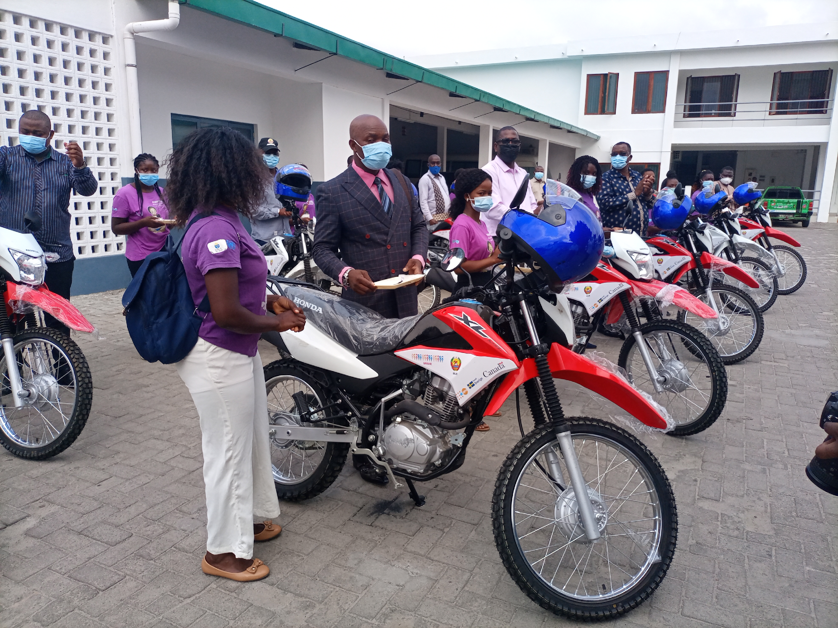
Figure 11: Handover ceremony of 11 motorcycles in Zambézia, November 2021, Quelimane.

- Design of the PGB National Strategy (2023-2033)
The mapping of the ASRH intervention in Mozambique has, among other things, led to the conclusion that many interventions, including in the Rapariga BIZ provinces, need to be coordinated, as in some cases, there is duplication of efforts. Furthermore, the previous PGB strategy has been out of date since 2017. Therefore, the Government of Mozambique, led by the Secretariat of State of Youth and Employment in collaboration with the UN and CSO, deemed it necessary to review the outdated PGB strategy for the coming ten years (2023-2033). Basically, this strategy will be the guiding instrument for all ASRH interventions in Mozambique. At the programme level, the strategy is expected to contribute to the improvement of synergies and complementarity among ASRH programmes and projects in Mozambique, as well as to enhance their sustainability and reinforce ownership by national and local actors. Politically wise, it is expected that the strategy will prompt the harmonisation of different interventions supported by different development partners and their alignment to the national agenda, policies and priorities as foreseen in the Paris Declaration (2005), the Accra Agenda for Action (2008) and the Busan Declaration (2011) on Aid Effectiveness/Effective Development Cooperation.
The UN agencies see this strategy as a key document to support the implementation of the Rapariga BIZ in an integrated approach with other ASRH programmes. Thus, in 2022-23, the UN agencies supported the design of the PGB strategy technically and financially.

- Output 17: SRH-specific rights and needs of girls and young women included in existing policies and plans
The National Development Strategy (ENDE) is the guiding policy for Mozambique's development planning process. It defines the country's development objectives and priorities, articulates the strategic orientation, and guides the design of all medium- and short-term development instruments and policies. The instrument was adopted in 2015, and after the first period of implementation, the government and its partners conducted a review of the strategy.
After a national consultation meeting in Maputo in December 2021, additional consultations on ENDE were held in two districts of each of the provinces of Zambézia, Nampula, Cabo Delgado, Tete, and Gaza. In each province, at least 30 young people participated in consultations to gather their opinions on the strategy. The photo below highlights a consultation meeting in Chiuta, Tete province.
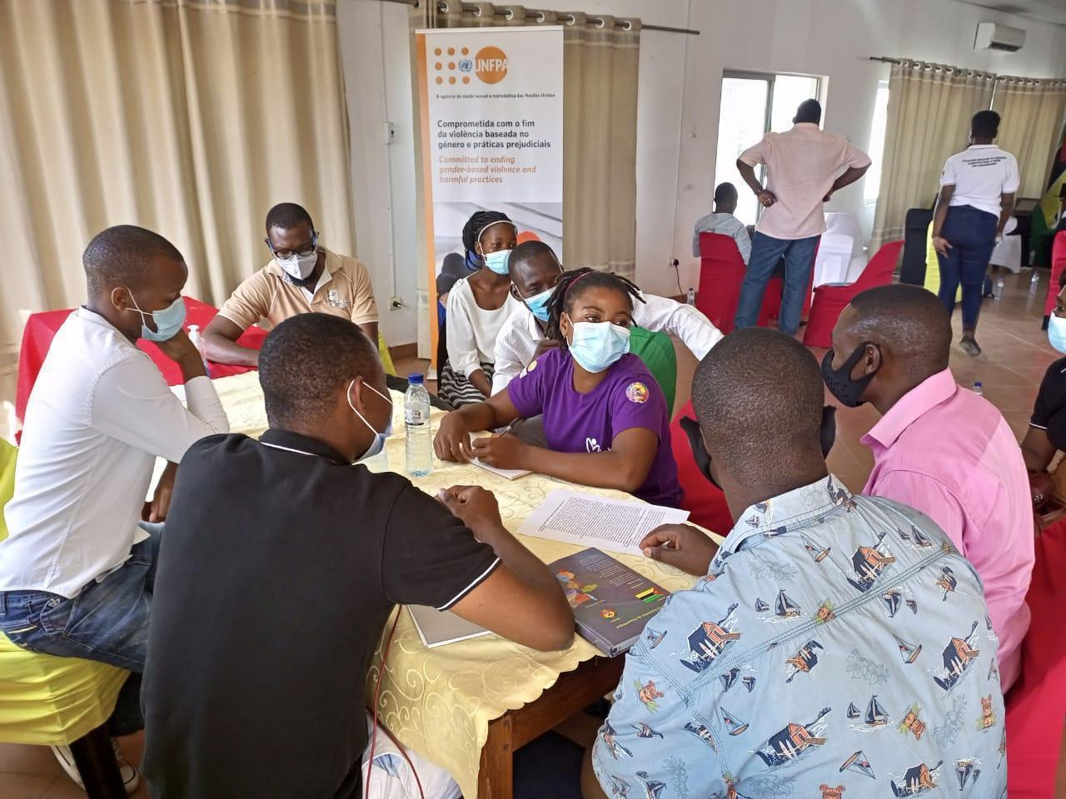
Figure 12: A consultation meeting in Chiuta, Tete
CNJ, an entity mandated to lead youth organisations in the country, led the consultations. In addition, the Ministry of Economy and Finance was present as the technical coordinator for the elaboration of the development strategy (ENDE), while the Secretariat of State for Youth and Employment (SEJE), the government representative for ​​youth, was also part of the process. The table below summarizes the outcomes of youth consultations:

# | Topic | Recommendations for ENDE/ICPD/ODS
1 | Education (Social transformation pillar) | The government should invest in expanding technical-vocational schools equipped with qualified teachers to create self-employment and value know-how (trade).  Establish a long-term curriculum.  Reintroduction of models for encouraging young people to engage in research/science, such as school contests.  Strengthen programmes aimed at reducing school dropout with a focus on girls
2 | Employment / Entrepreneurship  (Environment and Circular Economy pillar) | Create favourable environments for self-employment to maximise the value chain, both for agribusiness and other areas with dormant potential.
3 | Industry  (Environment and Circular Economy pillar) | Promote industrialisation initiatives in the country through free zones, reduce taxation, and improve the business environment by reducing bureaucracy in registration and other production stages.  Efforts to reopen factories such as Reopel and Mabor, among others.
4 | Taxation (Economic Transformation pillar) | Debt reform and public finance management, transparency, and credibility in fiscal management.  Strengthening accountability in public expenditure to reduce opportunities for corruption.  Adopt a medium-term fiscal approach by introducing a simple fiscal rule to manage resources based on volatility and dependence on raw materials/commodities.  Accelerate the establishment of the sovereign wealth fund to ensure intergenerational equity.
5 | Corruption  (Governance pillar) | Encourage the use of digital services to improve government services' efficiency and reduce corruption opportunities.
6 | Improvement in the provision of public services  (Governance pillar) | Improve the provision of public service through the professionalisation of the employee, create strategies to attract and retain employees, increase on-the-job training, and disseminate rules of professional ethics, among other interventions.
7 | Area of ​​Peace and Security  (Governance pillar) | Urgent need to structurally understand the reasons for persistent conflict and lay the groundwork for effective reconciliation and mutual trust.

Table 11: List of key recommendations from the youth for the ENDE.

Additionally, between 2016 and 2023, the Programme supported the Government of Mozambique's endorsement of the ESA Commitment (2021-2030). In 2023, UN agencies supported the design of the ESA Commitment National Roadmap and Action Plan. The ESA Commitment (2021-2030) also highlights the need to promote SRH-specific rights and needs of girls and young women. Below are some clauses of the ESA Commitment:

- “Continue investing in high quality, evidence-based, gender-transformative, age- and culturally appropriate sexuality education, both in and out of school, that covers a broad range of critical topics on values, the human body, relationships, safety, consent, gender, and health and wellbeing. This investment will equip adolescents and young people with knowledge, skills, attitudes, and values that will empower them to understand their health, well-being, and dignity; develop respectful social and sexual relationships; consider how their choices affect their well-being and that of others; and understand and protect their rights throughout their lives. This education will be linked to integrated quality people-friendly HIV, SRH, psychosocial, and GBV services”.
- “Address the structural factors that increase the vulnerability of adolescents and young people and their risk of acquiring HIV and STIs or becoming pregnant, notably gender inequalities, GBV, poverty, climate change, stigma, and discrimination. Further factors are the legal, policy, and social hurdles in accessing health services, social protection services, and education, including the age of consent to access SRH services”.
- “Ensure the inclusion of adolescent and youth-friendly SRHR within the national Universal Health Coverage packages while strengthening collaboration between the education, health, youth and gender sectors at all levels to strengthen resilient adolescent-responsive health systems and increase access by adolescents and young people to a good quality package of safe, climate-smart, effective, acceptable, and affordable adolescent and youth-friendly SRH services and commodities, including menstrual health, psychosocial support, and social protection services”.

- Output 18: Enhanced evidence for girls' and young women’s SRHR
For this activity, a baseline study was conducted in 2016. The inception phase workshop was also held in the first year. In addition, two reality checks were conducted, and reports were produced. Furthermore, a longitudinal assessment of school dropout was conducted, including in Nampula province, where the assessment was implemented through Rapariga BIZ and other funds. One of the main preliminary findings of the study concerns the significance of initiation rites. For example, the 2019 quantitative study demonstrated that the dropout rates for both sexes significantly increase at 13 years of age and older (particularly for girls when they begin their menstrual cycle) and when the initiation rite ceremonies take place. While the qualitative study is not nationally representative and only offers a snapshot of the situation, it demonstrates that the initiation rite ceremony significantly impacts school attendance for boys as it coincides with school time and for girls during their menstrual period. Therefore, boys tend to return to school, while girls stop attending almost immediately.

- Output 19: Situation at the programme site and implementation progress
To see the level of Programme implementation on the ground, all 20 districts of the Programme received technical visits from 2016 to 2023. Additionally, high-level visits have been carried out to both Nampula and Zambezia, including by the Ambassadors of the development partners, high-level visit to Zambezia by four Ambassadors or their representatives in Zambezia (in 2021), the visit from the Office of the Ombudsman from Sweden to Zambezia, in 2020, and the visit of the Deputy Director General of the SIDA HQ to Nampula in 2021.

Summary: Challenges, Lessons Learned and Recommendations

- Challenges
Output 14 – The UPR process and report include ASRH
- The 2nd cycle of the Mozambican UPR process finished in October 2021, followed by the adoption session of the 3rd cycle. UNFPA supported the delivery of a statement to youth champions. A remaining challenge is to ensure its approval and adoption by the government, through the Ministry of Justice, Constitutional and Religious Affairs, of the Youth and ASRHR UPR National Action Plan for this new/3rd cycle. In addition, a database is needed for monitoring and tracking its implementation, which is essential to ensure a proper follow-up on recommendations.

Output 15 – Strengthening of inter-ministerial coordination mechanisms

- The final evaluation of the programme pointed out that the government's capacities and resources are limited. The indicators that were used do not capture the coordination system's performance, which was considered poor. Decision-making took place, but activities were not coordinated effectively across organisations / implementing partners.
- Using a series of consultations, national-level coordination meetings concluded that Nampula Province benefited from numerous projects, so it was necessary to reflect on the overlap. Conversely, Niassa had few programme opportunities and should be considered for future expansion of the RBP.
- Reporting of UN and CSO activities in the provinces needed to be improved to allow government oversight and leadership through SEJE of youth programming in the country. SEJE requested to be involved in the selection and review of implementing partners.

Output 16 – Strengthening of coordination at provincial and district levels (through the PGB)

- Capacities and resources are limited at the district level. Some coordination mechanisms, such as the PGB multi-sector coordination mechanism, are not replicated at the district level. Heavy workloads and competing programmatic requirements make it difficult to routinely manage the consistency of communication and coordination. There is a lack of alignment between the RB planning and budgeting schedule and that of the government. Different expectations, needs, and limited time for partners may not be conducive to effective information sharing and coordination in the meetings.
- During the Geracão BIZ Annual Meeting, key government institutions claimed the need to resume the rotational approach to the programme's leadership as they felt they were not sufficiently involved in it.
- It is unclear to what extent the support for supervisory transport, provided by the Rapariga BIZ programme through the procured motorbikes, has translated into better government supervision of the programme.

Output 17 - SRH-specific rights and needs of girls and young women included in existing policies and plans

- None reported.

Output 18 - Enhanced evidence for girls' and young women’s SRHR

- The programme conducted a series of studies and research with critical findings and recommendations. Reflection on and implementation of the recommendations remains a challenge.

Output 19 - Situation at the programme site and implementation progress

- None reported.
- Lessons Learned
- Coordination between partners, government, and civil society in large programmes remains challenging despite the recognition of the problem and numerous efforts to consolidate the coordination mechanisms better.
- COVID-19 has taught that, if used properly, Information and Communication Technology (ICT) can be a good alternative to in-person meetings, saving time and resources.
- The rotation agreed upon by the national institutions for PGB does not necessarily imply applicability to the Rapariga BIZ programme but, rather, to the entire PGB through an overarching approach.
- The sustainability of the results achieved under the Programme depends upon obtaining government ownership and buy-in, including in terms of programming capacities and adequate funding allocation.
- Joint advocacy efforts between different actors are essential to effectively implementing the UPR recommendations. Implementation ought to be a collaborative process involving the government and other key actors, such as UN agencies, CSOs, and members of parliament. In this regard, the model of the Rapariga BIZ multi-sectorial and multi-partner structure was essential to ensure the implementation of key recommendations from the 2nd UPR cycle, such as the approval of the Child Marriage Law.

- Recommendations
Output 15 – Strengthening of inter-ministerial coordination mechanisms
- Support the decisions based on consensus concerning the national coordination of the PGB, where the RBIZ is anchored.
- Revise the indicator framework to better capture the coordination system's performance. Design a reflection process within the programme to review, improve, analyse, and respond to emerging information about the coordination mechanism's functionality and performance.

Output 16 – Strengthening of coordination on ASRH at provincial and district levels (through the PGB)
- Continue to support provincial and district-level district-level PGB coordination mechanisms, including through clarified terms of references and training. Monitor government-level supervision of the programme to demonstrate government engagement and ownership for future sustainability.
- Provincial and district-level coordination can be improved, including through stronger engagement of civil society organisations and better understanding among stakeholders through clear terms of reference, in part because there is a high turnover of staff.
Output 17 - SRH-specific rights and needs of girls and young women included in existing policies and plans
- Develop measures (beyond counting) for the added value of specific policy changes, including achievements and challenges.

Output 18 - Enhanced evidence for girls' and young women’s SRHR
- As part of a comprehensive knowledge management, it is recommended that all studies commissioned by UN agencies and their partners are summarized as evidence base and form part of a database/repository of all reports kept updated and shared with all RB stakeholders.

Output 19 - Situation at the programme site and implementation progress
- The coordination meetings among UN agencies should consider inviting technical staff from development partners to join them at least once per month.

5. MONITORING AND EVALUATION
The monitoring and evaluation efforts in the Rapariga BIZ Programme systematically tracked the implementation (or lack thereof) of results and achievements against the approved annual plans and targets. A harmonised results framework was prepared based on the annual plans and oriented towards the ProDoc results. The results framework was updated annually, following the results achieved, and verified once the programme activities are implemented.
On a quarterly basis, the team conducted joint planning and review meetings with implementing partners and the Government regarding the programme's implementation, reflected on programme progress, documented challenges, provided feedback, and verified changes in the activities. Reports were elaborated quarterly for review by the multi-sector steering committee and annually to inform and demonstrate accountability to development partners and other key stakeholders.
The restrictive measures imposed due to the COVID-19 situation in 2020-2022 led to a reduction of joint monitoring visits to the programme implementation sites during those years, and new monitoring and evaluation approaches were adopted, such as periodic remote monitoring (weekly, monthly and quarterly meetings through digital platforms “Zoom”, “Microsoft Teams” and “Googlemeet”) to assess the level of implementation of the Programme’s interventions at the local level with participation at two levels between (1) UN agencies and (2) UN Agencies and Implementing Partners, the Government and CSOs.
- Improved data quality, availability, and utilisation
Digital and real-time monitoring systems, including training focal points, monitors, and local data encoders, were used for data collection, processing, and analysis. This approach addressed the required quality assurance and showcased evidence concerning the programme's implementation and results. The real-time monitoring system of the mentoring system Kiri-BIZ was implemented and utilised to report progress and showcase mentorship results.
As far as adolescent and youth SRH and rights awareness are concerned, the SMS BIZ platform contributed to the availability of and access to data on SRHR for adolescents and young people in the areas of implementation of the Rapariga BIZ Programme (Nampula and Zambézia) and across the country, thus contributing to reducing the number of HIV infections. The conversation via SMS was open, free and kept confidential.

6. CONCLUSIONS AND RECOMMENDATIONS
In short, the programme has four outcomes with 19 outputs. In total, 32 indicators and respective targets were evaluated, which resulted in the following achievements: 29 indicators (91%) achieved a ‘green’ score (85% or more achievement rate); one indicator (3%) is listed as ‘on track’ and received a yellow score (60%-84% achievement rate), and two indicators (6%) are delayed and received an orange score (25%-59%).
Based on the experiences and findings from the monitoring and evaluation of Rapariga BIZ, priority actions and recommendations are as follows:
- Expand the mentorship programme to better target remote locations and hard-to-reach villages to reach the most vulnerable and far left behind (LNOB). Develop a strategy to support mentors from other regions who work in distant locations. Increase community support for these mentorship programmes in remote villages to increase the acceptability and participation of AGYW;
- Expand the mentorship activities of boys to all 20 districts.
- Disseminate and support the implementation of the Geração BIZ Programme Strategic Plan (2023-2033) to ensure alignment with international perspectives, respond to national needs and fulfil Mozambique’s voluntary commitments at the international level.
- Promote multisector joint visits to provinces and districts to gather different perspectives of the programme and as an opportunity to learn different experiences, reaching a consensus on overcoming challenges.
- Reinforce and strengthen comprehensive sexuality education activities to equip children and young people with knowledge, skills, attitudes, and values that will empower them to realise their health, well-being, and dignity; develop respectful social and sexual relationships; and consider how their choices affect their own well-being and that of others.
- Design and implement a strategy focused on the retention of mentors.
- Continue to improve the complementarity and synergies with like-minded projects, including the Global Programme to End Child Marriage, the SYP Programme, the Nexus Project, and the Spotlight Initiative, especially in convergent provinces and districts.
- Revise the mentorship guide to adapt it for humanitarian situations, as well.
- Support comprehensive capacity development on project planning, management monitoring and evaluation; include PGB provincial coordinators regarding relevant technical issues related to the programme. In addition, strengthen the monitoring and evaluation of programme coordination mechanisms.
- Make the Programme more responsive to people with disability, people living with HIV and LGBTI.

Basic Indicators Report of the Survey on Violence against Children (in Portuguese ‘Relatório de Indicadores Básicos do Inquérito sobre Violência contra a Criança’)

