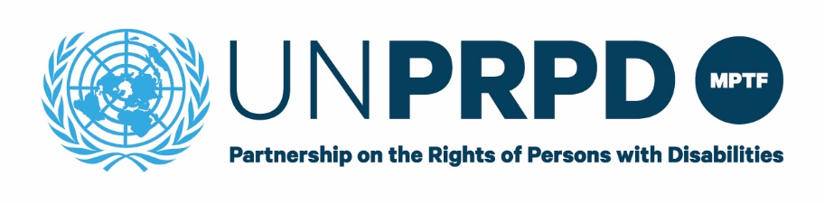

**END OF PROJECT REPORT**

**Title of Project-** “Advancing the rights of people with disabilities”

**Name of Country-** Djibouti

**Reporting Period-** From November 2019, until December 31, 2021

**DISCLAIMER**

*This publication was made possible thanks to funds from the UNPRPD MPTF however it does not necessarily reflect the official position of the UNPRPD MPTF.*

*This publication may be freely used for non-commercial, fair use purposes, with proper acknowledgement of partners and UNPRPD MPTF. Any other use must be authorized in writing by the UNPRPD programme following a written request for permission. Any use of the content, in whole or in part, in all hard or soft copy including in any online display, shall include attribution to partners as the original publisher with UNPRPD MPTF fun*ds

# Introduction

*The purpose of this report – which is consistent with the UNDG Standard Progress Report format – is to provide information on the progress made by the project towards the realization of its stated objectives. In keeping with the UN system on-going efforts to strengthen result-orientation, the report should focus on systemic, structural transformation rather than process, highlighting how the different elements of the result chain described in the approved project document contributed to advance the rights of persons with disabilities in keeping with the Convention on the Rights of Persons with Disabilities. [1]*

*Reporting teams are encouraged to attach annexes containing additional relevant information (including assessments, evaluations and studies undertaken or published) and share videos, photographs (high resolution image files) or other multi-media materials illustrating the work and impact of the project. It is recommended, however, that all annexes be clearly referenced, using footnotes or endnotes within the body of the narrative.*

*Please note the report should be accessible.[2]*

# Overall progress

Despite the creation of the ANPH dedicated to promoting and protecting the rights of people with disabilities in Djibouti, there was no strategy formulated to ensure a better inclusion of people with special needs, adapted to the local context and with clear actions to carry out the ANPH's missions. It was essential to undertake the formulation of such a document using an all-government, all-society, participatory and inclusive approach. This document endorsed by all rights holders and duty bearers will constitute a structured summary of the priority actions to be undertaken to improve the provision of services and quality of life for people with disabilities, to promote access to livelihoods and to build an inclusive society.

The innovation of this strategy lies in the participation of many stakeholders throughout the formulation process to ensure a contextualized strategy. To achieve this, a series of workshops was organized, each workshop being composed of high-level officials, programme officers from the United Nations system agencies, members of the ANPH, representatives of civil society and particularly of the network of associations of people with disabilities and other experts.

An international consultant expert in disability strategy formulation has been recruited to develop the national strategy. A first week of meetings with different ministries and partners provided all essential elements for the elaboration of this strategy. The UNDP and ANPH teams met the focal points in charge of disability from the different ministries, government agencies and partners. These meetings were held to present the methodological approach and the strategy formulation schedule. This one-week consultations allowed to gather the preliminary information of the different stakeholders.

After these meetings, a 2-day workshop was held in November 4 and 5, 2020 with the aim of shedding more light on the various achievements and the difficulties linked to the issue of disability, as well as on the different expectations of stakeholders in the field. The creation of working groups was decided in order to capitalize, in a limited time frame and in the context of the COVID-19 crisis, on the expertise available within the different ministries and the UN agencies, in order to bring out a common strategic vision, the result of this collaborative approach. The incoming data from each working group of the various workshops are:

* The preliminary work in the framework of this project and in this case the results of the national disability prevalence survey conducted in 2019;
* The data available within each Ministry whose representatives are the guarantors;
* Data from the Djibouti National Institute of Statistics (INSD);
* Official studies and reports of the different UN agencies represented.

4 working groups inspired by the most recurrent issues mentioned during the previous meetings were proposed to develop a strategy on “health”, “education and training”, “livelihoods” and “social protection”. Each workshop started with a presentation of the 2019 national disability prevalence survey as well as a presentation by each representative of the Ministries on how disability is mainstreamed in the national policy. The discussions within each group led to the emergence of a list of priority actions to be included in the formulation of the strategy.

This was followed by consolidation and synthesis work carried out under the leadership of the international consultant supported by UNDP and ANPH. On November 17, 2020, a feedback day was organized with all those who had contributed to the reflection and formulation workshops. The aim was to present the drafted strategy to refine the priorities selected. Following this, the national disability strategy for the period 2020-2024 was finalized and presented to the President of the Republic of Djibouti and to all the country's high authorities on the International Day of Persons with Disabilities on 2nd December 2020 due to scheduling constraints. In 2021, the Action Plan developed for the strategy was approved by presidential decree. UNDP has also initiated a resource mobilization strategy with ANPH to find the necessary funding for the implementation of the strategy.

H.E. the President of the Republic acknowledged and thanked the work done in the preparation of the strategy by all: the government, the civil society with the national network of disabled people as well as the development partners. As a recognition to all efforts and hard work, an officer's medal in the order of 27 June was awarded to UNDP Resident Representative Fatima Elsheikh. At the last steering committee of the project held on December 22, 2020, it was agreed to translate the developed strategy into a budgeted action plan in the first part of 2021 to implement the national priorities while improving it.

In addition, UNICEF has started the development and implementation of public campaigns to reduce stigma. A detailed action plan has been signed with ANPH for the period 2020-2021. C4D aspects have been integrated into the national strategy since its formulation. Finally, the public campaign has been planned and scheduled for May 2021. A national formative research ran from February 7, 2021 to February 11, 2021 in Djibouti and the five regions. 100 households were targeted and participants to the focus group discussions were people living with disability and people without disability. The objective of the research was to identify social and behavioral drivers of stigma on disability in Djibouti. Data on social drivers like beliefs, values, self-efficacy, and norms around gender socialization and decision-making patterns was collected. Children living with disabilities face widespread stigma, they are often excluded from their communities, they are hidden in their homes and their families are labeled. The focus group discussions also revealed gender inequalities, negative perceptions of people with disabilities related to their functionality, stigma affects socialization, education and even marriage of people with disabilities, especially women. The report found that parents show neglect of their children with disabilities. Disability is seen as divine punishment. For many parents, especially the mother, the child's disability is a difficult weight to carry. Then there is the stigmatization of the entourage through mockery and degrading quality of human integrity. Fortunately, the perception of disability in Djibouti is a positively evolving image because of a strong political will pushing for a profound societal transformation.

UNICEF and ANPH organized a workshop to discuss the findings which will serve as a basis for the launch of the public campaign. Among the recommendations were to mobilize and train media on inclusive communication, conduct community dialogues to debunk the misconceptions around disability, sensitize the communities on the rights of people with disabilities, positive modeling on disability by showcasing positive stories of disabled children, young people and adults. UNICEF organized a workshop with 25 religious leaders of the High Islamic council to discuss the perception of the religion on disability. Religious leaders stressed the importance of people with disabilities rights though an Islamic perspective. Another workshop with the national union of the press gathered 25 journalists from social, television and radio media to engage them on rights of people with disabilities.

Moreover, capacity building of ANPH member and associations of the Network of People Living with Disabilities on Sexual and Reproductive Health/Gender Based Violence has been achieved. It is within the framework of the promotion of sexual and reproductive health, gender-based violence in relation to human rights and the promotion of gender equality, that UNFPA in collaboration with ANPH carried out a 5-day training of trainers for 32 people living with a disability and composed of women, youth and men as well as ANPH staff members. The training focused on two modules: sexual and reproductive health and gender-based violence. In addition to the four days of theoretical training, a visit to the GBV referral center was organized on the last day of the training.

In addition, a harmonization of the legal framework for the promotion and protection of the rights of people with special needs has been initiated. For this purpose, an analysis of the situation on the implementation of legal provisions relating to the guarantee of the right to access to basic social services as well as the texts relating to the protection of the rights of people living with disabilities was undertaken. Then, a draft law was formulated to harmonize the legal provisions with a focus on reproductive rights. This law will then go through a validation circuit in order to be finally presented to parliament.

# Also, an advocacy against violence against women and girls with disabilities was conducted as part of the 16 Days of Activism against GBV in December 2020. This required a significant mobilization of national sectors at the governmental and non-governmental levels, including civil society as well as the national human rights commission, and the high-level involvement and multi-sectoral commitment of national institutions for an adapted response to the protection of women and girls against gender-based violence, especially those with disabilities. The 16 days of activism were an opportunity to promote the rights of people living with disabilities with a focus on the promotion of sexual and reproductive rights through the protection against all forms of violence against women and girls.

Finally, within this capacity building framework that UNFPA has also provided IT equipment and materials to the ANPH in order to meet the needs and facilitate the implementation and realization of the activities undertaken by the staff of the agency.

# Progress towards impact and specific outcomes

## Table 1. Progress against impact indicators

| **Impact**  What rights will be promoted? For who ? |
| --- |
| Promotion of the full implementation of the CRPD to advance the rights of people with disabilities in Djibouti by facilitating awareness, political dialogue, coalition building and development capacity.  Specifically, based on some of the evidence analyzed and preliminary discussions with representatives of rights holders and duty bearers, the following rights may require increased attention:  - Right to an adequate standard of living for themselves and their families (CRPD art. 28)  - Right to work (art. 27)  - Right to education (art. 24)  - Right to health (art. 25)  - Right to live independently and to be included in the community (art. 19)  - Right to participate in political and public life (article 29)  - Right to freedom of expression and opinion and access to information (art. 21)  - Right to personal mobility (art. 20)  - Rights in matters of family life (art. 23)  All people with disabilities and their families are expected to benefit from this project. |

### Impact Indicators

| **Indicator** | **Start Level** | **Target** | **End level** | **Means of verification** |
| --- | --- | --- | --- | --- |
| Promoting the rights of people with disabilities in Djibouti | About 10,000 people with disabilities | About 85,000 disabled people, ie all disabled people identified in Djibouti by the national survey. | About 85,000 disabled people, ie all disabled people identified in Djibouti by the national survey. | National survey  Sensitization  Capacity Building  Strategy development |

*\* Please provide sex disaggregation here.[3]*

## Table 2. Progress against outcome indicators

*(Add a table for each outcome in the approved project document)*

| **Outcome 1** |
| --- |
| A national profile of people with disabilities through data collection and analysis. A national survey on the prevalence of Handicap was carried out by the National Institute of Statistics in Djibouti requested by the UNDP and the National Agency for People with Disabilities from December 03 to December 30, 2019. There was a training of 70 agents of the national survey from 07 to 17 November 2019 on the issue of Disability in general |
| **Type of Lever:** Information spots were broadcast on television and radio to inform population about the national survey |

### Outcome 1 Indicators

| **Indicator** | **Start level** | **Target** | **End level** | **Means of verification** |
| --- | --- | --- | --- | --- |
| Number of people trained during the training of agents of the National Survey on the Prevalence of Disability | 70 people  (40 Men and 30 Women) | 70 people  (40 Men and 30 Women) | 70 people  (40 Men and 30 Women)  The benchmark has been reached | Training report and attendance list |
| Number of households whose data were collected and analyzed with the commitment of rights holders and duty bearers | 10,000 households | 10,000 household | 10,000 households (51.2% Women and 48.8% Men) | National Disability Survey 2019  National Institute of Statistics in Djibouti website[4] |

| **Outcome 2** |
| --- |
| The development and implementation of public campaigns to reduce stigma. UNICEF has implemented an awareness and communication campaign throughout the country. Posters, brochures and videos were prepared during this campaign in order to change the way we look at disability and to think together about new solutions. UNICEF also conducted a campaign on local radio and television stations to publicize the daily lives of people with disabilities and their families, to combat prejudice against them and to defend their rights. |
| **Type of Lever:** Combat the stigma, stereotypes, harmful practices and cultural beliefs suffered by people with special needs. |

### Outcome 2 Indicator

| **Indicator** | **Start level** | **Target** | **End level** | **Means of verification** |
| --- | --- | --- | --- | --- |
| * Number of people with disabilities who have been sensitized * Number of persons from civil society informed about the harmful prejudices to people with disabilities and the way to improve cultural norms, beliefs, attitudes and values | About 10,000 people with disabilities and their families | About 85,000 disabled people, ie all disabled people identified in Djibouti by the national survey | General population made aware through national television  workshop with 25 religious’ leaders of the High Islamic council to discuss the perception of the religion on disability | Project record  Assessment thru randomized interviews |

| **Outcome 3** |
| --- |
| Promotion and capacity building of associations of people with disabilities, including the National Network of People with Disabilities. These capacity building activities consist of supporting associations of people with disabilities in their role and participation in their inclusion and social development. UNFPA in partnership with ANPH trained 20 agents of the ANPH (women, men and youth) so that they can relay the training to other members of their associations**.** |
| **Type of lever:** Improvement of technical knowledge of associations of people with disabilities |

### Outcome 3 Indicator

| **Indicator** | **Start level** | **Target** | **End level** | **Means of verification** |
| --- | --- | --- | --- | --- |
| Number of people who benefited from capacity building | 20 people from disabled people's associations | 20 people from disabled people's associations | 32 people from disabled people's associations trained | Project record  Post training survey |

| **Outcome 4** |
| --- |
| The development of the national strategy for the promotion and protection of the rights of persons with disabilities. This activity started on December 02, 2019. A consultant has been recruited by the ANPH to work on the formulation of the national strategy. In 2021 the strategy was approved by all stakeholders and the action plan of the strategy was approved by presidential decree. |
| **Type of lever:** Increase the capacity of duty bearers to implement national policy and provide better access to services. Focus groups were organized bringing together several associations and a group of actors for the promotion of the rights of people with disabilities, as well as semi-structured interviews with representatives of the government sectors concerned. |

### Outcome 4 Indicator

| **Indicator** | **Start level** | **Target** | **End level** | **Means of verification** |
| --- | --- | --- | --- | --- |
| National strategy for the promotion and protection of the rights of people with disabilities formulated and officially validated by rights holders and duty bearers | No existing strategy | Development of a national strategy in the country | A national strategy is formulated and adopted | Workshops, documentation, formulated strategy |

*\* Please provide sex disaggregation here.[5]*

# 3. Progress towards specific outcomes

**Outcome 1**

A national profile of people with disabilities through data collection and analysis. A national survey on the prevalence of Handicap was carried out by the National Institute of Statistics in Djibouti requested by the UNDP and the National Agency for People with Disabilities from December 03 to December 30, 2019. There was a training of 70 agents of the national survey from 07 to 17 November 2019 on the issue of Disability in general

**Type of Lever:** Information spots were broadcast on television and radio to inform population about the national survey

**Outcome 2**

The development and implementation of public campaigns to reduce stigma. UNICEF has implemented an awareness and communication campaign throughout the country. Posters, brochures and videos were prepared during this campaign in order to change the way we look at disability and to think together about new solutions. UNICEF also conducted a campaign on local radio and television stations to publicize the daily lives of people with disabilities and their families, to combat prejudice against them and to defend their rights.

**Type of Lever:** Combat the stigma, stereotypes, harmful practices and cultural beliefs suffered by people with special needs.

**Outcome 3**

Promotion and capacity building of associations of people with disabilities, including the National Network of People with Disabilities. These capacity building activities consist of supporting associations of people with disabilities in their role and participation in their inclusion and social development. UNFPA in partnership with ANPH trained 20 agents of the RNPH (women, men and youth) so that they can relay the training to other members of their associations**.**

**Type of lever:** Improvement of technical knowledge of associations of people with disabilities

**Outcome 4**

The development of the national strategy for the promotion and protection of the rights of persons with disabilities. This activity started on December 02, 2019. A consultant has been recruited by the ANPH to work on the formulation of the national strategy. In 2021 the strategy was approved by all stakeholders and the action plan of the strategy was approved by presidential decree.

**Type of lever:** Increase the capacity of duty bearers to implement national policy and provide better access to services. Focus groups were organized bringing together several associations and a group of actors for the promotion of the rights of people with disabilities, as well as semi-structured interviews with representatives of the government sectors concerned.

# 4. Equality between men and women

Since October 2019, only one result has been implemented which is the national survey which targeted 10,000 households of which 50.2% were women. All data collected has been disaggregated by sex and that each outcome/output has gender equality as a significant objective. The preliminary report was produced in February 2020 summarizing the preliminary results of the national survey on the prevalence of disability. However, we are awaiting the final investigation report which will be finalized in April 2020. It is indeed in capacity building activities and awareness campaigns or specific actions will be undertaken by the project to directly contribute to the empowerment of women and girls with disabilities.

# 5. Full and effective participation of persons with disabilities

In the first result of the project, a national profile of people with disabilities through data collection and analysis. A workshop to validate the questionnaire, the methodology and the schedule of the survey took place and which brought together associations of people with disabilities. The associations of disabled people who participated in the validation workshop are the Association Vivre plus fort, the Association Action Handicap and the Association Djiboutienne des Aveugles. The members of these associations have visual, hearing and motor impairments.

In addition, the national network of people with disabilities is involved in the implementation of the project results.

## Table 3. Meaningful participation of persons with disabilities

| **Meaningful participation objective** |
| --- |
| The disability dimension is integrated in the planning and implementation of UNDP programmes and projects. |

### Indicators- Meaningful participation of persons with disabilities

| **Indicator\*** | **Baseline\*** | **Target\*** | **End line\*** | **Means of verification** |
| --- | --- | --- | --- | --- |
| [….] | [….] | [….] | [….] | [….] |
| [….] | [….] | [….] | [….] | [….] |

*\* Please provide sex disaggregation here as relevant or include indicators on meaningful participation of representative organizations of women and girls with disabilities as well as disaggregate by type of disability.*

# 6. Partnership-Building

UNDP Djibouti collaborates and coordinates with UN agencies (UNFPA and UNICEF) as needed towards the realization of innovative approaches to achieve outcomes of the project. This project is implemented in close collaboration with the Government of Djibouti. The Ministry of Social Affairs and Solidarity (MASS) was designated as the focal point for the project by the Ministry of Foreign Affairs. The National Agency for Persons with Disabilities, independent agency directly attached to the Office of the President, specifically, will play an important role of empowering persons with disabilities through advancing their rights, reducing cultural prejudices and stigma and increasing their employability. In addition, the National Network of Persons with Disabilities is the key partner from civil society.

The partnership with UNICEF has enabled participation in the global *Generation Unlimited Youth Challenge* initiative launched at the end of 2019. The Generation Unlimited is an opportunity to identify solutions that can have a positive impact on education, skills, training, employment opportunities and the empowerment of youth. One team (young woman and men deaf-mute) has been selected between the 5 finalists (out of 14 teams) and came up with a solution to make university accessible for deaf-mute persons. They received 1,000 USD in seed funding and mentorship. In 2020, the 5 finalist teams were given support and mentoring to develop their idea and concept. Discussions with the University of Djibouti to assess the needs for better inclusion of people with visual and hearing disabilities are continuing in 2021. The next step will consist in mobilizing the necessary resources to achieve.

# 7. Promoting ONE UN approach to disability Inclusion

The United Nations country team in Djibouti which designated UNICEF, UNFPA and UNDP was tasked with promoting respect for the principles of the CRPD and improving the scale and efficiency of the United Nations in its participation in disability issues. The UNCT was urged to make a concerted effort to mainstream disability into its work and encouraged to continue to ensure that development programmes, including internationally agreed development goals, policies, processes and mechanisms, are inclusive and accessible to people with disabilities.

**8. Linkages to national development agenda**

To ensure that “no one is left behind”, the 2030 Agenda hat notes the importance of disaggregating data by characteristics associated with exclusion and vulnerability, including disability. The SDGs contain 17 goals, with 169 targets, including a number of specific disability-related indicators under goals 4 (education), 8 (jobs and growth), 10 (inequality), 11 (sustainable cities and communities) and 17 (Partnership for Goals - data collection and monitoring of the SDGs). Through the national survey, we learned that the prevalence of disability in Djibouti was high (8.5%). So we had to look more at the issue of disability in order to adopt an inclusive approach. Internationally comparable disability statistics provide a basis for monitoring the achievement of the Sustainable Development Goals. In addition, the development of the first national disability strategy is a key step in the national planning process to develop policies, programs and services for people with disabilities and to monitor the functioning level of the population and to assess the results and dissemination of programmes such as social protection. Finally, the national strategy formulated is a start of a journey and reannouncing the national commitments. It is now important to support translating this commitment to actions at both personal and institutional level. At the last steering committee of the project held on December 22, 2020, it was agreed to translate the developed strategy into a budgeted action plan in the first part of 2021 to implement the national priorities while improving it.

Through the formative research, we learned that the perception of disability in Djibouti is a positively evolving image because of a strong political will pushing for a profound societal transformation.

**9. COVID-19**

N/A

# 10. Creation of knowledge and communications materials

Within the framework of the joint project "Advancing the rights of persons with special needs in Djibouti", the Djiboutian Agency for Persons with Disabilities (ANPH) initiated focus groups throughout the country to determine the socio-behavioral complexity of the issue of disability with the aim of responding to the need to better understand certain actions related to the issue of disability, particularly those affecting children. The results of these focus groups contributed to the development and implementation by the ANPH and UNICEF of a campaign to promote inclusion and fight against stigmatization and discrimination of people with disabilities, especially children, through:

- The promotion of the rights of people with disabilities,

- The promotion of a positive perception of people with disabilities and a higher social awareness of them,

- And promoting the recognition of the skills, merits, and abilities of people with disabilities and their contributions in the workplace.

A workshop on the role of the media in communicating about disability was also organized with the objective of revisiting the importance of informing and sensitizing the population on the issue of inclusion. In parallel, another workshop on the perception of disability according to Islam was organized in the framework of the awareness campaign on the rights of disabled people.

A round table dedicated to education brought together all the partners and stakeholders, whether teachers, coaches, representatives of associations, social workers, and professionals of the social environment in the service of disabled children to address the issue and expectations of disabled children and inclusion.

The project supported the design of a Djiboutian dictionary of sign language through a series of workshops led by the ORULSD committee (Research Organization for the Unification of Djiboutian Sign Language), in order to promote communication for better understanding of hearing impaired and deaf-mute people and the rest of the population.

A national campaign against stigmatization and discrimination supported by the UNCIEF and implemented by the ANPH was organized with a handing-over of kits and equipment to children with special needs (EABS). In the same framework and in connection with the world children day.

5 TV spots on inclusion, accessibility and professional insertion have been produced and broadcasted as well as a series of three videos collecting reactions from the population on the issue of disability.

Three video reports were also produced on rehabilitation and insertion.

In connection with the World Children's Day, a discovery day for children with special needs was held at the National Assembly with the support of UNICEF. The objective was to introduce children with special needs to the practice of dialogue and democratic debate.

In terms of communication supports, it is worth noting the realization of TV spots, billboards and proximity posters around child rights including those living with a disability. These tools were disseminated on a large scale in order to reach the largest number of people in the country.

|  |  |  |  |  |  |
| --- | --- | --- | --- | --- | --- |
| **Name of product** | **Type of product (report, guidelines, assessment etc.)** | **Purpose and process**  **Describe what was the purpose of the product who participated in the development of product (OPDs, NGOs, Academia etc) and if the product was tested/ validated.** | **Link /attachment** | **Accessible formats** | **Validation**  **Has the product been validated by national actors. If yes by whom?** |
| […] | […] | […] | […] | […] | […] |
| […] | […] | […] | […] | […] | […] |

* What communications strategies did the project adopt?
* Please list type of communications materials.

| **Name of Product** | **Type of Product (Toolkit, Video, Poster, publication etc.)** | **Purpose** | **Dissemination** | **Links/ Attachments** | **Language** | **Accessible formats** |
| --- | --- | --- | --- | --- | --- | --- |
| TV spots on inclusion and insertion | video | promoting the right to inclusion and insertion | Via the National TV and social media | <https://fb.watch/cnyTu6_eKN/>  <https://fb.watch/cnyRxqsMFR/>  <https://fb.watch/cnyX9-_zN6/>  <https://fb.watch/cnz0oP1cKU/>  <https://fb.watch/cnz9dTJimu/> | French/ local language speakers | MP4 |
| 03 videos collecting reactions | Videos | collecting reactions from the population on disability | Via social media | <https://fb.watch/cnyxH14ssW>/  <https://fb.watch/cnyz0mDJur/>  <https://fb.watch/cnyzT5xjod/> | French/ local language speakers | MP4 |
| 02 video roundtables on inclusive education and employement | Video | Addressing the issue of inclusive education and employment of youth with disabilities through testimonials | Social media | <https://fb.watch/cnyq17v9tx/>  <https://fb.watch/cnyucakcaF/> | French and local languages | MP4 |
| 03 video reportage | Video | Addressing disability issues and promoting the right to inclusion and insertion | Nations TV and social media | <https://fb.watch/cnyDxFrZMg/>  <https://fb.watch/cnyGBfwSTW/>  <https://fb.watch/cnyNZ69leq/> | French/ local language speakers | MP4 |
| Child rights posters | Poster | Promoting child rights including the rights of children with disabilities | Schools, community development center |  | French | Paper |

# 11. Challenges

COVID-19 pandemic had a negative impact on the project's implementation and slowed down the project's activities

# 12. Project follow up and Sustainability

UNDP in partnership with UN agencies are planning to mobilize more funds for the implementation of the activities of the action plan resulting from the strategy. It is planned to develop a resource mobilization strategy and to create new partnerships. This resource mobilization strategy will be presented to all national and international partners for advocacy.

A disability mainstreaming monitoring tool will be developed to ensure that the disability aspect is integrated into programs and projects in Djibouti.

**13.** **Detailed expenditure in relation to sections 5 and 6 above.**

| **Category** | **Activities** | **Budget Allocated** | **Total expenditure** |
| --- | --- | --- | --- |
| Direct impact on empowerment of women and girls with disabilities | National survey on the prevalence of Handicap. Collection and analysis of sex-disaggregated data | 80,000 USD | 80,000 USD |
|  | Gender analysis and support for discussions and technical events in the public campaign | 45,000 USD | 0 USD |
|  | Empowerment of women, youth and children with disabilities (mentoring, training sessions and networking event) | 20,000 USD | 10,000 USD |
| Direct Impact on DPOs’ capacity | Capacity building of the National Disability Network and other DPOs | 54,000 USD | 54,000 USD |
|  | Support for discussions and technical events | 45,000 USD | 45,000 USD |
| Accessibility costs | Transportation, translation, printing and linguistic interpretation services (including sign language and Braille) | 30,000 USD | 28,000 USD |
|  | Creation of accessible reception offices for people with disabilities in the districts of Djibouti | 30,000 USD | 30,000 USD |

# 14. Life stories and testimonies

Please provide one or more life stories or direct testimonies to illustrate the results described in sections 2-6. To the extent that is possible, reporting teams are encouraged to share photos, video and other materials to accompany the stories described in this section. Also include testimonies from other stakeholders involved in the project and their perception of the value added of the UNPRPD intervention- representatives of government, civil society including organization of persons with disabilities (DPOs) and private sector as relevant.

| **Name** | **Sex** | **Designation et Organization** | **Is this a testimony from a person with a disability? If so, what kind of disability do they have?** | **Testimony** | **Photo Shared (Y/N)** | **Consent for Use of Photo obtained (Y/N)** | **Photo Caption** | **Photo Credit** |
| --- | --- | --- | --- | --- | --- | --- | --- | --- |
| Nima AHmed Youssouf | F | Entrepreneur, “*Cafétéria Idil Idèle Fidèle*” | Yes, motor | See realized video | Video available | Y |  | PNUD Djibouti |
| Ali Gueda Boulsa | M | Social activist, volunteer | Yes, motor | See realized video | Video available | Y |  |  |
| Abdallah Hassan | M | Fisherman | Yes, motor | See realized video | Video available | Y |  |  |
| Kadia Hussein | F | Painter artist | Yes, hearing and communication | See realized video | Video available | Y |  |  |

# 15. Photos depicting Project related impact and outcomes[6]

*Please share photos depicting project related impact and outcomes in high resolution image files with appropriate consents of subjects having been taken as well as with the associated credits and along with permission for use in UNPRPD publications and communications materials including website. For photos of children due protocols should be followed for ensuring safety and obtaining consent. Kindly list below the following for photos shared.*

Photo 1: Presentation of the medal officer's medal in the order of 27 June by the President of the Republic of Djibouti, His Excellency Ismail Omar Guelleh to UNDP Resident Representative, Fatima Elsheikh

Photo 2: Souvenir photo from the celebration of the International Day of Persons with Disabilities on 2 December 2020 where the national strategy was launched. From left to right: Fatima Elsheikh – UNDP Resident Representative, His Excellency Ismail Omar Guelleh - President of the Republic of Djibouti, Doualeh Said Mahamoud – General Director of the ANPH, Guelleh Idriss Omar - Director of Multilateral Relations, Ministry of Foreign Affairs and Cooperation

Photo 3: Launch of the 2-day workshop held in November 4 and 5, 2020 by UNDP with the aim of shedding more light on the various achievements and the difficulties linked to the issue of disability

Photo 4: Deaf-mute youth working session to develop their idea of improving access to university for people living with the same disabilities (summer 2020)

Photo 5: Ceremony for the finalists of the Generation Unlimited youth challenge

Photo 6: Biometric registration session initiated by the ANPH in 2020

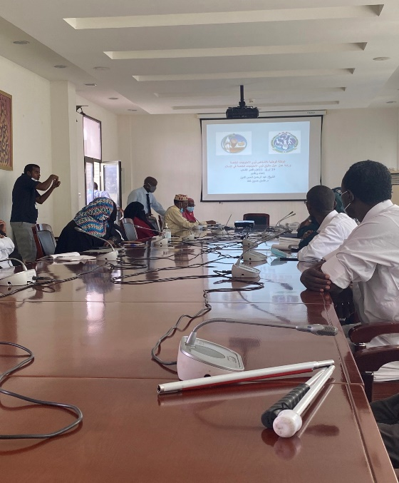

Photo 7: On 7 February 2021, a focus group in Djibouti with a group of women organized by ANPH with support from UNICEF

Photo 8: Workshop on 26 December 2020 with clerics from the High Islamic Council on the rights of people with special needs

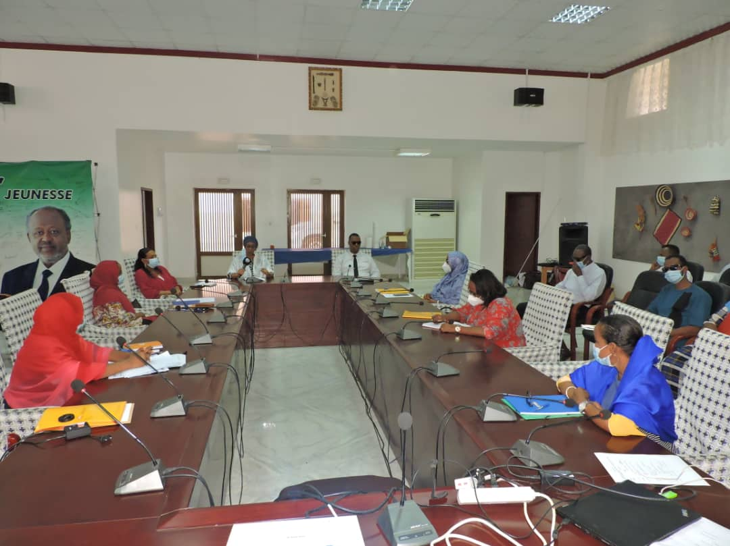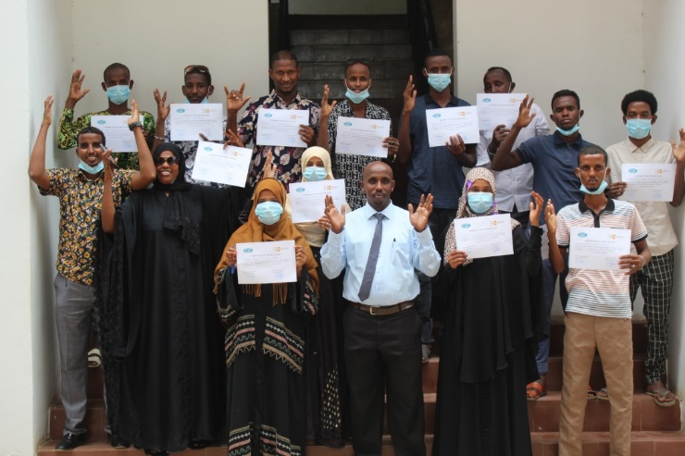

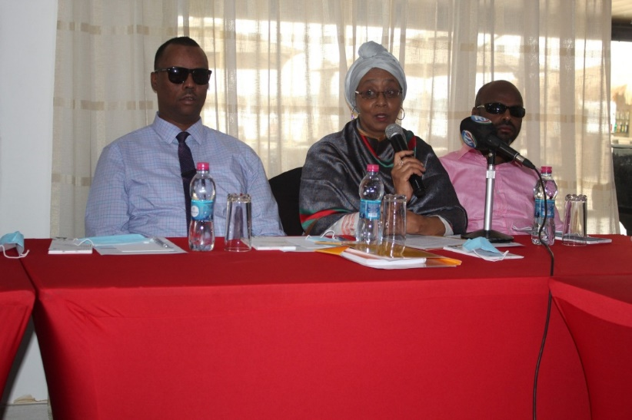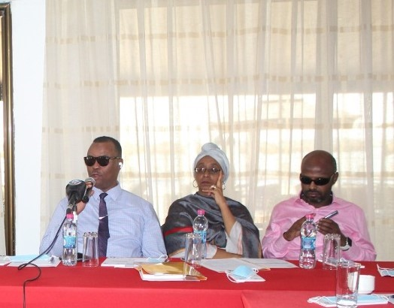

Photo 9: Launch of a 5-day training of trainers for 32 people living with a disability and composed of women, youth and men as well as ANPH staff members on Sexual and Reproductive Health/Gender Based Violence

Photo 10: Presentation of certificates following the training of trainers on sexual and reproductive health/gender-based violence.

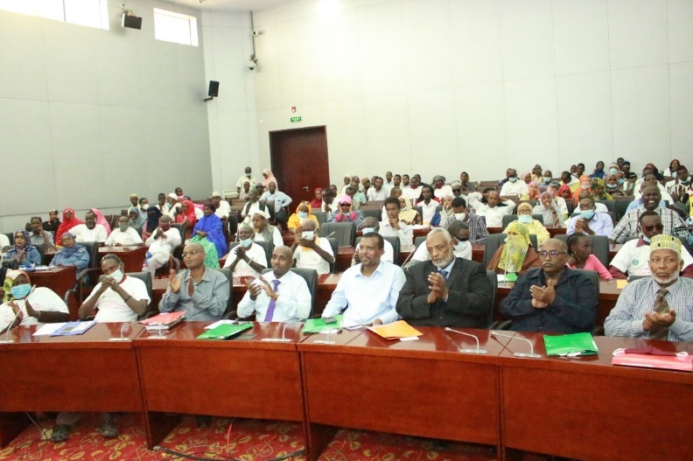

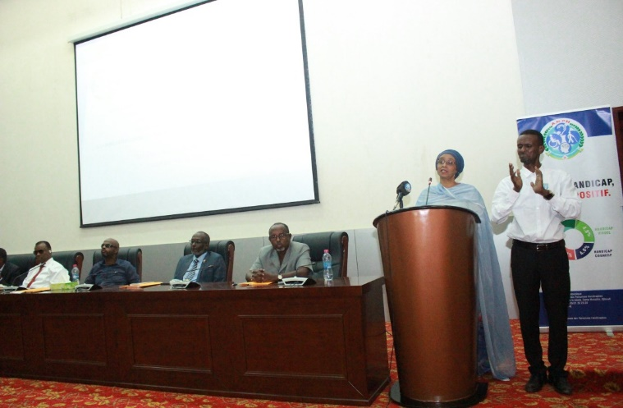

Photo 11: Workshop on the harmonization of the legal framework for the promotion and protection of the rights of people with special needs (1/2)

Photo 12: Workshop on the harmonization of the legal framework for the promotion and protection of the rights of people with special needs (2/2)

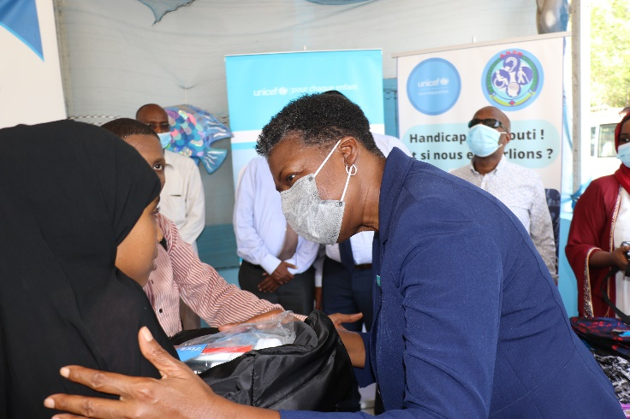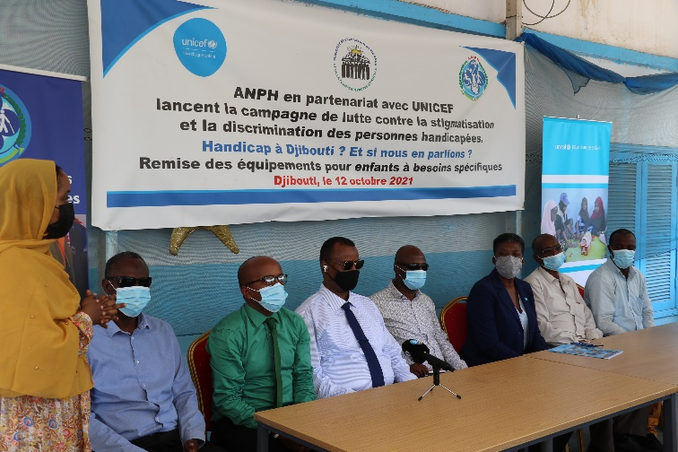)

Photo 13: Advocacy against violence against women and girls with disabilities was conducted as part of the 16 Days of Activism against GBV in December 2020 (1/2)

Photo 14: Advocacy against violence against women and girls with disabilities was conducted as part of the 16 Days of Activism against GBV in December 2020 (2/2)

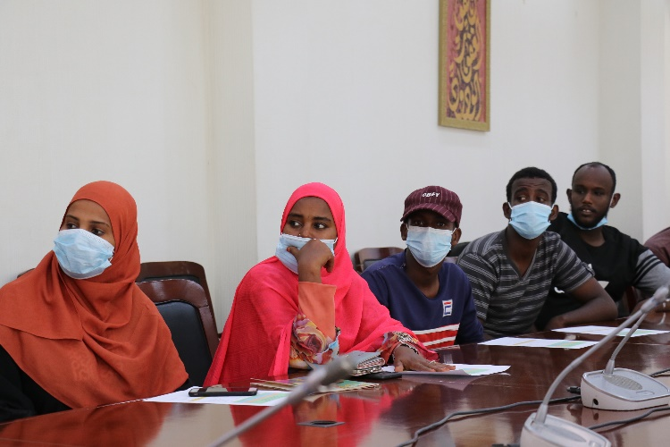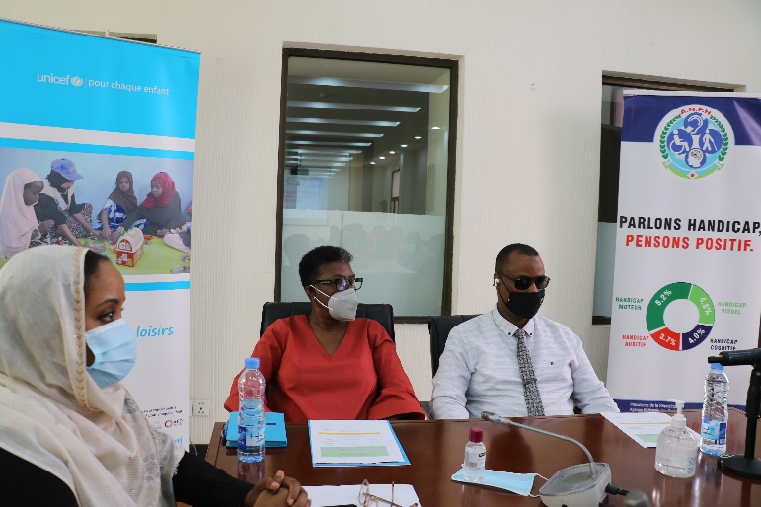

Photo 15: Launching ceremony of the campaign against stigmatization and discrimination of disabled people, organized in Djibouti in October 2021 (1/2)

Photo 16: delivery of school kits to disabled children during the launch of the campaign against stigmatization and discrimination of people with disabilities, organized in Djibouti in October 2021 (2/2)

| **Photo**  **No.** | **Photo Description** | **Consent for Use of Photo obtained (Y/N)** | **Photo Credit** |
| --- | --- | --- | --- |
| 1 | Presentation of the medal officer's medal in the order of 27 June by the President of the Republic of Djibouti, His Excellency Ismail Omar Guelleh to UNDP Resident Representative, Fatima Elsheikh | Y | Office of the President |
| 2 | Souvenir photo from the celebration of the International Day of Persons with Disabilities on 2 December 2020 where the national strategy was launched. From left to right: Fatima Elsheikh – UNDP Resident Representative, His Excellency Ismail Omar Guelleh - President of the Republic of Djibouti, Doualeh Said Mahamoud – General Director of the ANPH, Guelleh Idriss Omar - Director of Multilateral Relations, Ministry of Foreign Affairs and Cooperation | Y | Office of the President |
| 3 | Launch of the 2-day workshop held in November 4 and 5, 2020 by UNDP with the aim of shedding more light on the various achievements and the difficulties linked to the issue of disability | Y | UNDP |
| 4 | Deaf-mute youth working session to develop their idea of improving access to university for people living with the same disabilities (summer 2020) |  | UNDP |
| 5 | Ceremony for the finalists of the Generation Unlimited youth challenge |  | UNDP |
| 6 | Biometric registration session initiated by the ANPH in 2020 |  | UNDP |
| 7 | On 7 February 2021, a focus group in Djibouti with a group of women organized by ANPH with support from UNICEF | Y | UNICEF |
| 8 | Workshop on 26 December 2020 with clerics from the High Islamic Council on the rights of people with special needs | Y | UNICEF |
| 9 | Launch of a 5-day training of trainers for 32 people living with a disability and composed of women, youth and men as well as ANPH staff members on Sexual and Reproductive Health/Gender Based Violence | Y | UNFPA |
| 10 | Presentation of certificates following the training of trainers on sexual and reproductive health/gender-based violence. | Y | UNFPA |
| 11 | Workshop on the harmonization of the legal framework for the promotion and protection of the rights of people with special needs (1/2) | Y | UNFPA |
| 12 | Workshop on the harmonization of the legal framework for the promotion and protection of the rights of people with special needs (2/2) | Y | UNFPA |
| 13 | Advocacy against violence against women and girls with disabilities was conducted as part of the 16 Days of Activism against GBV in December 2020 (1/2) | Y | UNFPA |
| 14 | Advocacy against violence against women and girls with disabilities was conducted as part of the 16 Days of Activism against GBV in December 2020 (2/2) | Y | UNFPA |
| 15 | Launching ceremony of the campaign against stigmatization and discrimination of disabled people, organized in Djibouti in October 2021 (1/1) | Y | ©UNICEF/Djibouti 2021/Faycal Oulmi |
| 16 | Delivery of school kits to disabled children during the launch of the campaign against stigmatization and discrimination of people with disabilities, organized in Djibouti in October 2021 (2/2) | Y | ©UNICEF/Djibouti 2021/Faycal Oulmi |
| 17 | Closing of the workshops organized within the framework of the elaboration of the Djiboutian sign language dictionary in July 2021 (1/1) | Y | ©UNICEF/Djibouti 2021/Faycal Oulmi |
| 18 | Participants to the workshops organized within the framework of the elaboration of the Djiboutian sign language dictionary in July 2021 (2/2) | Y | ©UNICEF/Djibouti 2021/Faycal Oulmi |

# 16. Risk Reporting

Please describe any risks to the project’s implementation experienced during the project’s implementation and how these were managed. If other risks were identified during the project implementation period, please add them to the table.

| ***Type of risk*** | ***Risk*** | ***Occurrence***  ***(Y/N)*** | ***Impact on result*** | ***Mitigation strategies*** | ***Risk treatment owners*** |
| --- | --- | --- | --- | --- | --- |
| Programmatic | Limited resources to achieve results. | N | Medium - Limited achievement of results | Commitment to promote ownership and accountability and facilitate the mobilization of resources to support the implementation of national policy.  Definition of ambitious but realistic objectives in national policy and continuous management of expectations | Project stakeholders (UNDP, UNICEF, UNFPA, MASS, ANPH, RNPH) |
| Environment | Covid-19 pandemic | Y | High - Limited achievement of results | Telecommuting, Business continuity plan, planning review | Project stakeholders (UNDP, UNICEF, UNFPA, MASS, ANPH, RNPH) |

* Please specify here the type of risk and refer to the following definitions:

Contextual: risk of state failure, return to conflict, development failure, humanitarian crisis; factors over which external actors have limited control.

Programmatic: risk of failure to achieve the aims and objectives; risk of causing harm through engagements.

Institutional: risk to the donor agency, security, fiduciary failure, reputational loss, domestic political damage etc.

**Annex 1.**

**The UNPRPD MPTF approved in June 2020 it’s New Strategic and Operational Framework 2020-2025. As the Fund has now the obligation to report against the new results framework, we are requesting projects that were approved before June 2020 to reflect on which Fund’s outcome/outputs/indicators their project is contributing. Annex 1.**

**The UNPRPD MPTF approved in June 2020 it’s New Strategic and Operational Framework 2020-2025. As the Fund has now the obligation to report against the new results framework, we are requesting projects that were approved before June 2020 to reflect on which Fund’s outcome/outputs/indicators their project is contributing.**

| **REPORTING AGAINST UNPRPD MPTF RESULTS FRAMEWORK** |  |  |
| --- | --- | --- |
| **Outcome 1: National Stakeholders are equipped with the knowledge and practical tools for disability inclusive policies and systems** | **Yes/No** | **Brief Description** |
| **Outcome indicators** |  |  |
| 1.1 # of stakeholders in UNPRPD supported countries[7] with increased knowledge and capacities to design/reform and deliver inclusive policies and systems (disaggregation by stakeholder Gov/ UN/OPDs/other) | Yes | 70 people (40 Men and 30 Women from government) trained during the training of agents of the National Survey on the Prevalence of Disability  32 people from disabled people's associations benefited from capacity building on Sexual and Reproductive Health/Gender Based Violence. |
| 1.2 # of stakeholders in UNPRPD supported countries with strengthened evidence-based knowledge and capacities to assess and respond to gaps in relation to preconditions to CRPD implementation and inclusive SDGS achievement | Yes |  |
| 1.3 # and % of UNPRPD supported countries that have developed and/or strengthened national guidelines, protocols, and/or standards to design and implement policies and systems | Yes | First national disability strategy for 2020-2024 designed and validated |
| 1.4 # of stakeholders in UNPRPD supported countries used UNPRPD’s situational analysis to inform their future actions around disability inclusion. (disaggregation by stakeholder Gov/ UN/OPDs) | No |  |
| 1.5 # and % of UNPRPD supported countries that undertook multi stakeholder capacity building initiatives on disability inclusive policies and systems | Yes | 2-day workshop with the different ministries, the civil society’s members (NGOs and individuals) and the UN agencies. The incoming data were:  - The preliminary work in the framework of this project and in this case the results of the national disability prevalence survey conducted in 2019;  - The data available within each Ministry whose representatives are the guarantors;  - Data from the Djibouti National Institute of Statistics (INSD);  - Official studies and reports of the different UN agencies represented. |
| **Output 1.1 - Capacity of the national stakeholders is enhanced to develop and implement gender responsive and disability inclusive policies and systems for the CRPD and SDGs implementation** | **Yes/No** | **Brief Description** |
| **Output Indicators** |  |  |
| 1.1.1. # of trainings developed and delivered to support national CRPD /inclusive SDG implementation disaggregated by geography (country, regional and global), topic(thematic area, specifics modules on women with disabilities and underrepresented groups needs and rights, and specific modules on instruments for planning and implementation of UN development activities both in development and humanitarian settings). | Yes | Capacity building workshop on Sexual and Reproductive Health/Gender Based Violence.  Advocacy against violence against women and girls with disabilities conducted as part of the 16 Days of Activism against GBV |
| 1.1.2. # of participants (disaggregated Gov (type of ministry)/ UN/OPDs/other) (disaggregated by sex/type of disability/rural urban) participating in capacity building activities funded or provided by UNPRPD programmes | Yes | 33 members of the government trained on the results of the national disability prevalence survey conducted in 2019 () |
| 1.1.3. # of OPDs (disaggregated by type umbrella- disability specific- women-other) that benefitted from capacity building activities (type of activities) funded by UNPRPD programmes to strengthen the capacity of organizations of persons with disabilities. | Yes | 32 people from disabled people's associations benefited from capacity building on Sexual and Reproductive Health/Gender Based Violence. |
| 1.1.4. # of OPDs that have been trained to participate in planning and monitoring of national development plans related to UN/government /other | No |  |
| 1.1.5. # of capacity building activities (disaggregated by type of capacity building) funded by UNPRPD programmes, directed at women and girls with disabilities on their rights and requirements and/or directed at underrepresented groups of persons with disabilities on their rights and requirements. (Number of participants, disaggregated by age, disability and geographical location. |  |  |
| **Output 1.2- Knowledge products are developed and piloted, particularly to address gaps on the preconditions to implement CRPD and disability inclusive SDGs** | **Yes/No** | **Brief Description** |
| **Output Indicators** |  |  |
| 1.2.1. #of knowledge products (disaggregated by product: tools, guidelines, protocols, reports) developed, piloted and disseminated to the relevant stakeholders to inform inclusive practices | Yes |  |
| 1.2.2 # of knowledge products developed that address gaps related to inclusion of women and girls with disabilities and underrepresented groups of persons with disabilities |  |  |
| 1.2.3. # of actors involved in developing and testing of knowledge products (disaggregated by product tools, guidelines, protocols, reports) disaggregated by actor (GOV/ OPDs (disaggregated by type of representation)/ NGOs/Other) |  |  |
| **Output 1.3 - Evidence generation, learning and exchange mechanisms are developed and functional, based on country level experiences, to increase understanding and inform innovative practices.** | **Yes/No** | **Brief Description** |
| **Output Indicators** |  |  |
| 1.3.1. # of learning and evidence generated to inform inclusive policies and systems disaggregated by type e.g. situational analysis, thematic reports, peer reviewed evidence evaluations and assessments, learning reports, case studies etc. |  |  |
| 1.3.2. # actors involved in learning and evidence generated to inform inclusive policies and systems disaggregated by actor (GOV/OPDs, NGOs, etc) |  |  |
| 1.3.3. # of established mechanisms/ instances promoting learning and exchange across countries (disaggregation by region/ group of countries/ theme and participants (disaggregation by sex, disability, representation of OPDs, UN ,GOV/other) |  |  |
| 1.3.4. # of reports, case studies and/or other sources of evidence addressing the situation of women with disabilities and underrepresented groups of persons with disabilities disaggregated by disability specific or mainstream and women or underrepresented) |  |  |
| **Outcome 2: Gaps in achievement of essential building blocks or preconditions to CPRD Implementation in development and humanitarian (gender equality, data accessibility, support services, etc.) are addressed** | **Yes/No** | **Brief Description** |
| **Outcome indicators** |  |  |
| * 1. # and % of UNPRPD supported countries with inclusive and non-discriminatory laws, national policy/plan for persons with disabilities. |  |  |
| * 1. # and % of UNPRPD supported countries with inclusive service delivery systems and processes across the sectors. |  |  |
| * 1. # and % of UNPRPD supported countries with enhanced or newly established mechanisms supporting formal participation of OPDs to support CRPD implementation. |  |  |
| * 1. # and % of UNPRPD supported countries with enhanced and or newly established multi-stakeholder national and/or sub-national coordination and monitoring mechanisms established to monitor CRPD and include multi-sectoral representation and representation of OPDs |  |  |
| * 1. # and % of UNPRPD supported countries that have mechanisms in place to support quality, disaggregated and globally comparable data on disability in line with international standards to inform laws, policies and programmes |  |  |
| **Output 2.1 - Legislative and policy frameworks are newly developed, reviewed, or reformed to promote equality and non-discrimination, based on CRPD standards, and are translated into plans as relevant.** | **Yes/No** | **Brief Description** |
| **Output Indicators** |  |  |
| 2.1.1. # of newly produced, reviewed, or reformed laws and policies disaggregated by type (disability specific /mainstream) disaggregate by review reformed and developed | Yes | Draft law formulated to harmonize the legal provisions with a focus on reproductive rights |
| 2.1.2. # of developed and or adopted national action plan/strategy to ensure that persons with disabilities, have access to quality and affordable services,(disaggregation by service) | Yes | First national disability strategy for 2020-2024 designed and validated |
| 2.1.3. # of national strategies and plans with measures in place to ensure disability sensitive budgeting and financial management |  |  |
| 2.1.4. # laws and policies (mainstream and targeted) changes addressing rights and inclusion of most marginalized groups (disaggregation women and underrepresented by different groups) | Yes | A decree to promote the employment of disabled people |
| 2.1.5. # of laws and policies and plans on VAWG and or SRHR that adequately respond to the rights of women and girls with disabilities (disaggregation by plan-laws-policies and VAWG-SRHR) |  |  |
| 2.1.6. # of developed/strengthened multi-stakeholder coordination mechanisms supporting legal, policy and plans changes (disaggregation by stakeholder Gov/ UN/OPDs/other). |  |  |
| 2.1.7. # of organizations of persons with disabilities taking part in consultation processes related to legislative and policy changes, disaggregated by kind of organization of persons with disability, constituency represented among persons with disabilities and geographical location. |  |  |
| **Output 2.2 –Service delivery systems implementation and processes across the sectors are reviewed/reformed/developed to ensure disability inclusion** | **Yes/No** | **Brief Description** |
| **Output Indicators** |  |  |
| 2.2.1. # of reviewed, newly developed or strengthened service delivery systems and processes disaggregated by precondition (add as footnote) type of change (reviewed developed or strengthened) and sector. |  |  |
| 2.2.2. # of reviewed, newly developed or strengthened national implementation systems and processes addressing the rights for women with disabilities in particular around Sexual and Gender Based Violence and SRH services. |  |  |
| 2.2.3. # of reviewed, newly developed or strengthened national implementation systems and processes addressing the rights the most marginalized groups of persons with disabilities (disaggregation by group (women, underrepresented, etc) |  |  |
| 2.2.4. # of supported multi-stakeholder coordination mechanisms supporting targeted services delivery systems and processes changes (disaggregation by stakeholder Gov/ UN/OPDs/other). |  |  |
| 2.2.5. #and of organizations of persons with disabilities taking part in consultation processes, disaggregated by kind of organization of persons with disability, constituency represented among persons with disabilities (including Women and underrepresented groups) and geographical representation e.g. national/local. |  |  |
| **Output 2.3 National data collection systems, accountability and monitoring mechanisms, and inter-ministerial coordination systems are reviewed/reformed/developed to ensure disability inclusion** | **Yes/No** | **Brief Description** |
| **Output Indicators** |  |  |
| 2.3.1. # of strengthen /developed national and/or sub-national coordination and monitoring mechanisms for CRPD implementation in line with article 33 |  |  |
| 2.3.2. # of OPDs involved in government monitoring and accountability mainstream mechanisms (disaggregation by type of OPDs and type of government mechanism) |  |  |
| 2.3.3. # of national mechanisms, institutions, services, programmes, collecting disaggregated data on persons with disabilities (disaggregated by mechanism institution service) according to international standards |  |  |
| 2.3.4. # of national coordination, accountability and monitoring mechanisms related to GBV and SRH mainstreaming disability. |  |  |
| **Outcome 3: National development and humanitarian plans and monitoring processes include disability mainstreaming** | **Yes/No** | **Brief Description** |
| **Outcome 3 Indicators** |  |  |
| * 1. % # of UNPRPD supported countries with instruments for planning, implementation and monitoring of UN development and humanitarian activities inclusive of disability (disaggregation by process planning-implementation and monitoring) |  |  |
| * 1. % # of UNPRPD supported countries with adopted national SDGs plans and budgets that are inclusive to persons with disabilities including women with disabilities and underrepresented groups |  |  |
| * 1. % # of UNPRPD supported countries with formal participation of persons including women and underrepresented groups with disabilities in mechanisms for planning implementing and monitoring the SDGs and/or UN development and humanitarian Instruments (disaggregation UN instruments and SDGs national plans) |  |  |
| * 1. % # of UNPRPD supported countries with inclusive national implementation and monitoring of COVID 19 response and recovery plans |  |  |
| **Output 3.1 - Disability inclusion is strengthened in instruments for planning and implementation of UN development activities at the country level including in humanitarian settings** | **Yes/No** | **Brief Description** |
| **Output Indicators** |  |  |
| 3.1.1. # of Common Country Analysis (CCA) including disaggregated data and analysis of the situation of persons with disabilities. Disaggregated by type of analysis e.g. thematic focus versus cross cutting comprehensive inclusive analysis |  |  |
| 3.1.2. #UNSDCF where disability inclusion has been mainstreamed and/or targeted |  |  |
| 3.1.3. # of UNSDCF with at least 3 indicators related to disability |  |  |
| 3.1.4. # of UNSDCF related financial tools with explicit allocations for disability inclusion |  |  |
| 3.1.5. # of joint programmes funded through MPTFs funds where the rights of persons with disabilities have been addressed (disaggregation by disability group) through collaboration with UNPRPD programmes |  |  |
| **Output 3.2 - 'Disability Inclusion in National Development and Humanitarian Planning, Implementation and Monitoring mechanisms is strengthened.** | **Yes/No** | **Brief Description** |
| **Output Indicators** |  |  |
| 3.2.1. # of national and subnational SDGs implementation plans integrating targeted and mainstream actions towards persons with disabilities. |  |  |
| 3.2.2 # of adopted/ implemented COVID 19 inclusive response and recovery plans and frameworks containing systematic mainstreaming of persons with disabilities including the most marginalised. |  |  |
| 3.2.3. % and # Humanitarian Response Plans (HRPs) and Humanitarian Needs Overviews (HNOs) addressing persons with disability needs and rights; |  |  |
| 3.2.4. # of SDGs implementation data collection, monitoring and accountability processes assessing progress against specific disability-inclusion targets |  |  |
| **Output 3.3 - Systematic engagement of OPDs is strengthened/enhanced in the national development coordination mechanisms and accountability frameworks (government/UN/Independent) around SDGs** | **Yes/No** | **Brief Description** |
| **Output Indicators** |  |  |
| 3.3.1. # of UN led national and/or regional coordination mechanisms with established consultation processes undertaken to ensure the active involvement of persons with disabilities, including through their representative organizations, in the design, implementation and monitoring of instruments for planning and implementation of UN development activities at the country level |  |  |
| 3.3.2. # of governmental coordination mechanisms with established consultation processes undertaken to ensure the active involvement of persons with disabilities, including through their representative organizations, in the planning, implementation and monitoring of SDGs |  |  |
| 3.3.3. # of OPDs formally participating in UN supported development processes and national SDGs coordination, planning and implementation processes. (disaggregation by type of OPD and process) |  |  |
| 3.3.4. # of identified persons with disabilities including through their representative organizations participating in the State’s formulation/implementation of COVID-19 policy responses affecting them |  |  |

1. The following definitions, which are based on the UN Development Group Harmonized RBM Terminology, were used in the “Template for Programme Proposals”, utilized by UN Country teams to developed the approved project documents:

   Impact: Positive and negative long-term effects on identifiable population groups produced by a development intervention, directly or indirectly, intended or unintended. These effects can be economic, socio-cultural, institutional, environmental, technological or of other types.

   Outcome: The intended or achieved short-term and medium-term effects of an intervention’s outputs, usually requiring the collective effort of partners. Outcomes represent changes in development conditions which occur between the completion of outputs and the achievement of impact.

   Outputs: The products and services which result from the completion of activities within a development intervention.
2. **Prior to the submission of this report, please check that the document is accessible to persons using screen readers.** In a window system it is possible to do this by going to the File Menu, clicking Check for Issues and then Check Accessibility. If errors, warnings and tips show up in the report of the accessibility checker, please follow the instructions in the checker to make the necessary corrections. On a Mac, click on review and select check accessibility. When the document is accessible the checker will display a report stating *“No accessibility issues found. People with disabilities should not have difficulty reading this document.”* Please see [Windows Accessibility Checker](https://support.office.com/en-us/article/Use-the-Accessibility-Checker-on-your-Windows-desktop-to-find-accessibility-issues-a16f6de0-2f39-4a2b-8bd8-5ad801426c7f) ; [Apple Mac Accessibility Checker](https://support.office.com/en-us/article/Use-the-Accessibility-Checker-on-your-Mac-to-find-and-resolve-accessibility-issues-3b84295e-d55b-49f1-b443-523ec45a5232) for more information.

   .
3. As relevant and appropriate, kindly please also disaggregate by type of disability, age, ethnicity, rural/urban location.
4. <http://www.insd.dj/>
5. As relevant and appropriate, kindly please also disaggregate by type of disability, ethnicity, age, rural/urban location.
6. Please see Annex 5 UNPRPD Quality Assurance Framework photography notes.
7. Throughout all the Logframe countries will always have to be disaggregated by *(disaggregation lower- and middle-income countries, fragile and humanitarian contexts, least-developed countries and countries within the bottom 50 of the Human Development Index*